Impact of Water Quality on the Growth Performance of *Clarias gariepinus* in Fish Farms within Fako Division,

Cameroon

# ABSTRACT

|  |
| --- |
| Aquaculture in South-West Cameroon has evolved although not exponentially due to a qualified workforce. The problem of water quality in fish farms that could be associated with poor feeding and water quality management impacts the life of aquatic animals. Fish needs a healthy environment for its optimal growth and development (case study of Catfish). The objective of this studied was to determine the impact of water quality on the growth performance of *Clarias gariepinus* in some fish farms within Fako Division-South West Region of Cameroon. *Material and methods:* The method used in this research topic is descriptive, with 4 different localities, namely IRAD Batoke (A), Bakingili (B), Cornelius Fish Center (C) and Oumarou fish farm (D) Mile 2 Limbe. Collection of physicochemical and biological data was conducted from the period of March 8th to May 15th 2023 in Fako Division.  *Results:* The results revealed highest mean temperature value (28.22±0.94ºC) in IRAD Batoke broodstocks tanks while Cornelius fish Center had the highest mean pH, electrical conductivity and total dissolved solid with values of 8.16±1.25; 0.84±0.35 ms/cm; and 0.38±1.8 ppt in the broodstocks tanks and table fish tanks. The highest dissolved oxygen (<8 mg/l); highest nitrite level (<0.025 mg/l) and highest Ammonium (<0.05 mg/l) were noted in three localities except the Bakingili locality. The physicochemical parameters of water had no negative impacts on the growth performance of this species. *Conclusion:* The results of physicochemical parameters such as water temperature, pH, and electrical conductivity, total dissolved solid, NH4, NO2, O2 obtained during the study experienced a relative variation and were very suitable for the growth and development of *Clarias gariepinus*. |

*Keywords: South West Region; TANKS; physicochemical parameter of water; Clarias gariepinus; growth performance.*

# INTRODUCTION

Fish need a decent environment for their living and livelihood. Fish species that have additional organs as a means of breathing such as catfish can tolerate fairly extreme water conditions, but in order to develop optimally, water quality parameters need to be within their recommended ranges. Decreasing water quality will disrupt growth and enhance the proliferation of disease- causing agents that grow and develop in low- quality waters. Ayuniar and Hidayat [1] stipulated that fish farming activities will be successful if we can manage the water quality of the cultivation media, seeds, and feed provided. Catfish can survive in unfavorable environmental conditions; according to Dauhan and Efendi [2] the water quality parameters of water to be used for the culture should be those that can support growth adequately. Physical parameters that need to be considered are temperature, pool water depth, turbidity level, TSS, or the presence of dissolved solids. Chemical parameters that also need to be controlled are DO, carbon dioxide, water pH value, the amount of Nitrate, Phosphate, and ammonia presence [3,4,5,6].

Physiologically, dissolved oxygen and temperature are essential for sustaining aquatic lives [7]. Additionally, nutrients enrichment mostly phosphorus and nitrogen stimulates unnecessary primary production, which can reduce oxygen. The changes in physical characteristics like temperature, conductivity, transparency and chemical elements of water (dissolved oxygen, and nitrite) provides valuable information on the quality of the water. According to Valetta [8] increase in temperature is known to speed up biochemical activities of metabolism; stimulated by heat energy. Turbidity is also a key water- quality characteristic because its effects on light transmission and water clarity define habitat characteristics. Furthermore, water pH regulates aquatic chemistry, which can affect water use and habitats. The health of an aquatics ecosystem is highly depended on the physicochemical and biological characteristics of the water [9,10].

Changes in fish populations can be indicators of aquatics ecosystem health [11].

The existence and richness of fish species can be associated to the physical and chemical properties of water [12]. Reduced water quality is reported to affects fish communities by impacting habitat, food availability, and dissolved oxygen levels, which in turn influence their growth potential and reproductive abilities [13]. Thus, the present study was designed to determine the impact of water quality on the growth performance of *Clarias gariepinus* in some fish farms in the South West Region precisely Fako Division in Limbe 1, Limbe 2 (IRAD Batoke) and Bakingili Subdivision (Fig. 1).

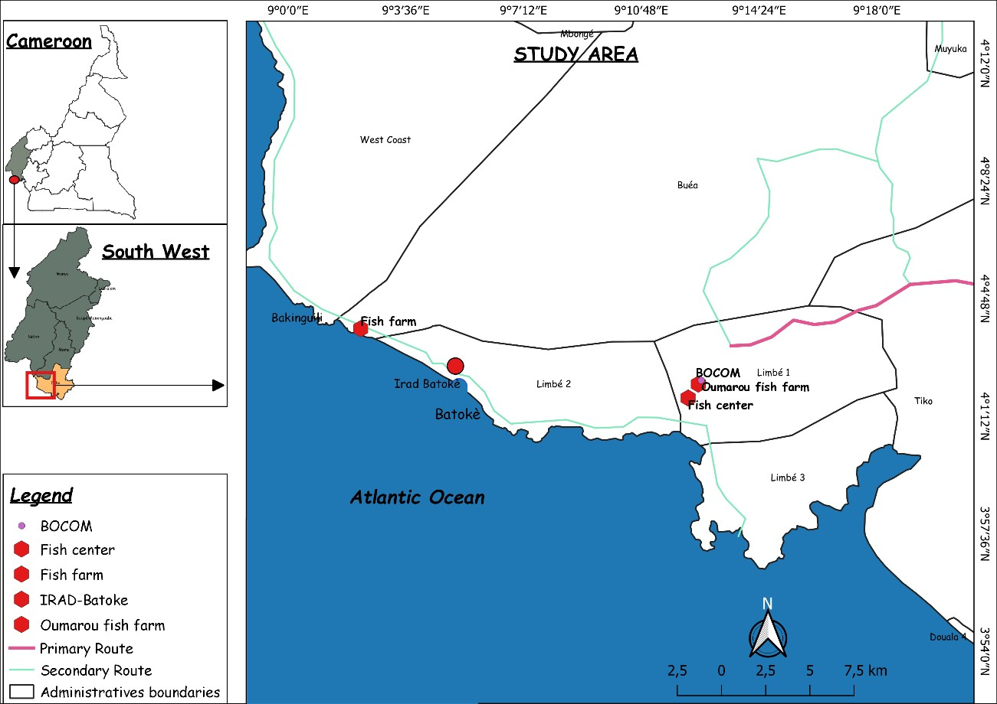

**Fig. 1. Location of study Area (Tabe, 2023)**

# MATERIALS AND METHODS

Physical parameters (temperature, pH, electrical conductivity, total dissolved solid) were measured *insitu* using Hannah portable meter model HI98129. Transparency of the water was detected by eye observation while chemical parameters (NH4; NO2; O2 were measured *exsitu* using a Pro JBL AQUATEST Kit. The data collection was done from Tuesday to Friday; a day each per farm from 7- 8 am.

# Experimental Protocol

The Multiparameter was deepen into each fish tank to determine temperature, pH, electrical conductivity and total dissolved solid. The multiparameter was rinsed each time prior to using in another tank.

Thereafter, water was collected from each fish farm and transported in an ice chest to IRAD- Batoke Laboratory for analysis using a Pro JBL AQUATEST KIT.

To determine the biological parameters, the tanks were emptied very early in the morning before feeding and the fish were captured using

a deep net and introduced into well-cleaned tanks. Using an electronic scale, the fish in each tank were weighed to determine the total weight (biomass) of fish then a count was made in order to have the total number of fish in the respective tanks. Using an ichthyometer, the total length

and the standard length were measured for a sample of 10-20 fish. This was done at the beginning and at the end of the experiment in order to have the initial and final weights. In the end this allowed us to calculate weight gain and Condition factor as follows:

* The initial average weight (Wi) and the final average weight (Wf); which corresponds to the total initial and final weight (biomass) divided by the total initial and total final fish number respectively.
* To calculate the total weight gain, it had being giving by the formula:

Total weight gain = Wf-Wi

At the end of the experiment, each fish was weighed and length measured. These individual data made it possible to calculate the K-factor using the formula:

## K=W/L3

W= fish weight (g)

L = total length of fish (cm)

# Statistical Analysis

The data collected was processed using Microsoft Office Excel 2013. One-way analyzes of variance (Anova) and, the Kruskal-Wallis test was performed to test for significance p < 0.05 using Statistical Package for Social Science (SPSS).

# RESULTS AND DISCUSSION

* 1. **Results**

## Physicochemical parameters measured insitu

The results for be seen in Fig. 2 and Fig. 3 below.

The values of the different physicochemical parameters insitu in the various tanks such as T(0C), pH, EC (ms/cm) and TDS (ppt)) in the fish farms of IRAD Batoke (five tanks fingerlings, four tanks juvenile and four tanks broodstock) (Fig. 2 A, B & C); Bakingili (one tank fingerlings and two

tanks table fish) (Fig. 2 D & E); Cornelius fish center (two tanks juvenile, one tank table fish and one tank broodsock) (Fig. 2 F,G & H) and Oumarou fish farm (one tank table fish and seven tanks broodstock) (Fig. 2 I & J) were not significantly different (P>0.05) as seen Fig. 2.

The comparative studies of physicochemical parameters *insitu* among the four different fish farms as seen in Fig. 3 such as

### Fingerlings tanks Batoke (5t) Compared to fingerlings tanks Bakingili (1t)

As illustrated on Fig. 3A below, the parameters variation for mean temperature was relatively high in Batoke fingerlings, but not significantly different (P= 0.611) from those of the fish farm in Bakingili while the Bakingili Station had a higher pH with P=0.280, which was equally not different from those of the fish farms in IRAD-Batoke.

### Comparison of juveniles tanks Batoke (4t) / Cornelius Fish Center (2t)

From the Fig. 3B below, the mean temperature, were higher in Batoke juveniles tanks, but not significantly different (P=0.201) from those in Cornelius fish center, while the Cornelius Fish Center had a higher pH, EC, and TDS with P=0.172, P=0.395, P=0.000 respectively.

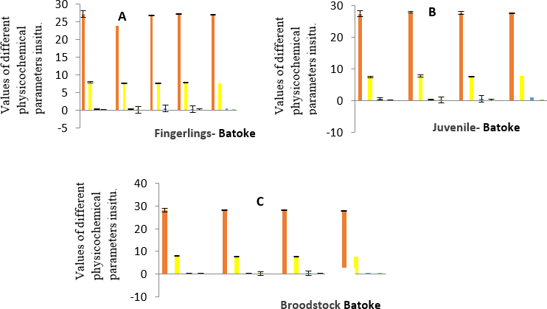

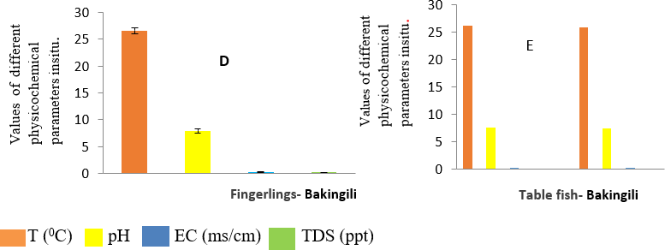

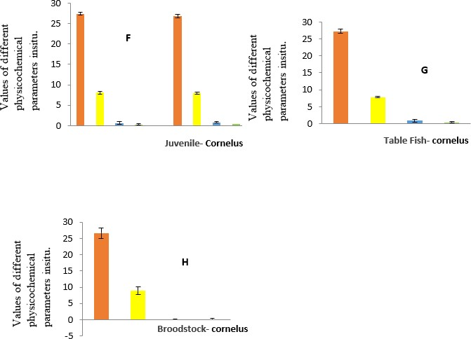

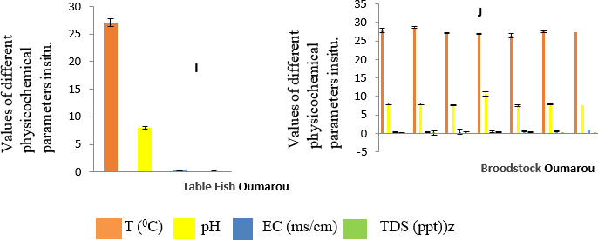

## Fig. 2. Physicochemical parameters of water in tanks among four fish farms studied

### Table Fish Tanks Bakingili (1t)/ Cornelius Fish Center (1t) /Dr Oumarou (1t)

From Fig. 3C below, according to the parameters variations of table fish, the mean Temperature and EC were significantly higher with P=0.002 and P=0.000, respectively in Cornelius fish farm while the station of Oumarou had significantly (P=0.034).

### Comparison Broodstocks Tanks Batoke, Cornelius and Dr Oumarou Fish Farms

From Fig. 3D below, according to the parameters variations, the mean temperature was significantly (p=0.000) higher in Batoke fish farm and but EC was higher, but not significantly different (P=0.472). While the station of Oumarou had a higher pH, which was however not significantly different with p=0.588.

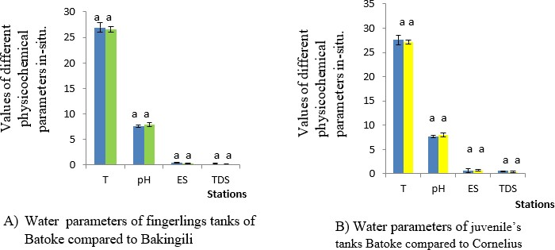

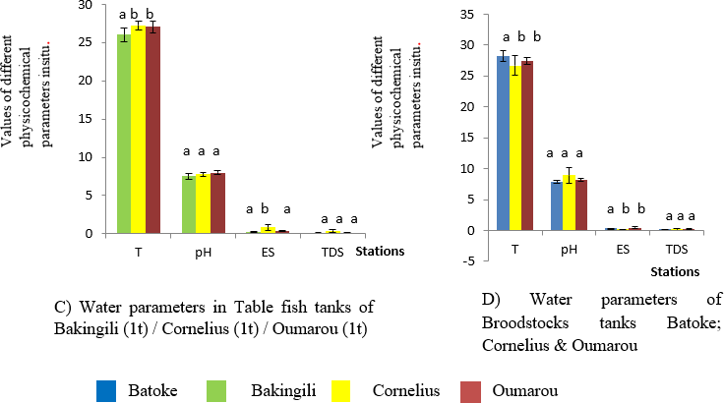

## Fig. 3. comparative analysis of water parameters of tanks in four different localities of Fako Division, South West Region of Cameroon

*p < 0. 05, compared with same parameter (T (0C), pH, EC (ms/cm), TDS (ppt) The values that affects the same letters had no significant different*

## Physicochemical parameters ex-situ

The results of water quality parameters for physicochemical measured situ such as dissolved oxygen, nitrite and ammonium for catfish broodstock tanks for the various farms is presented in Table 1.

* + 1. **Evolution of biological parameters of Africa catfish (*Clarias gariepinus)***

Some biological parameters of Africa catfish were collected during the research period in the four (04) different fish farms and their results obtained; as shown on Table 2. The result showed that growth performance of *Clarias gariepinus* for all the tanks of different stations was favourable. The growth of fingerlings for Batoke fish farm was remarkable greater than that of Bakingili fingerlings.

# Discussion

Based on the results of water temperature measurements during the study, the results were relatively constant and were very suitable for *Clarias gariepinus* growth and development. Water temperature in IRAD Batoke station was 26.92±0.94ºC, in Bakingili was 26.58±0.61ºC for the fingerlings tanks. According to the suitable temperature range for *Clarias gariepinus* farming this varies from 23-30 ºC [14]. So based on research that has been carried out, the temperature range during the research period on *Clarias gariepinus* farming still meets the feasibility conditions and is good enough for *Clarias gariepinus* farming. Too high temperature will damage the process of growth by preventing enzyme activity in cells. Temperatures less than the ideal range can cause a decrease in processing efficiency, increasing the toxicity of an aquatic organism pollutant [11]. Temperature values at the four different studied fish farms are still classified as supporting the growth rate of *Clarias gariepinus* and do not have adverse effect on the other parameters.

The results of water pH during the period of measurement with the highest mean pH recorded in Cornelius Fish Center Farm had the

mean pH value of 8.16±1.25 in the juveniles tanks**.** Hence, the pH range measured in this study is still classified as the optimum pH to support *Clarias gariepinus* life. According to a suitable pH for *Clarias gariepinus* farming ranges from 6.5 to 8.5 pH which is high or above 8.5, can cause increased toxicity in the water, but if the pH is low or below 6.5, it can inhibit the growth rate of *Clarias gariepinus*. Ndubusi et al.

[15] stated that microorganisms generally have growth conditions with a pH of 4-9.5. Ammonium compounds that can be ionized are found in waters that have a low pH. Ammonium is not toxic, but at high pH conditions, there is more ammonia that is not ionized and is toxic. So, based on research that has been carried out, the pH range during research on *Clarias gariepinus* maintenance in the four stations met the recommendation and is good enough for catfish farming.

The highest mean electrical conductivity recorded during the period of experiment was 0.84±035ms/cm in Cornelius fish farm in table fish tanks. Also, the highest mean for total dissolved Solid of 0.38±18ppt recorded in Cornelius table fish farm.

Dissolved oxygen measurements were within the recommended range reported by [16] for *Claris gariepinus* in all farms except in the fish farm in Bakingili.

The values for nitrite obtained in IRAD Batoke, Cornelius fish center and Oumarou fish farm were <0.025mg/l; <0.01mg/l and <0.01mg/l, respectively. According to Chapman and Kimstach [17] mean concentration of 1.8 mgL−1 of nitrite was found to be the upper recommended limit for *Clarias gariepinus* survival and growth. Nitrite concentration in reservoirs range from less than 1.0 mgL−1 to 5.0 mgL−1.

Ammonium measurements obtained in the broodstock tanks at IRAD were <0.05mg/l;

<0.05mg/l and <0.05mg/l, respectively with all being within the recommended range as reported by Viveen et al*.* [16].

**Table 1. Physicochemical parameters ex-situ for catfish (*Clarias gariepinus*) tanks**

|  |  |  |  |
| --- | --- | --- | --- |
| **Parameters** | **IRAD Batoke** | **Cornelius** | **Oumarou fish farm** |
| **NH4** | <0.05 mg/l | <0.05 mg/l | <0.05 mg/l |
| **NO2** | <0.025 mg/l | <0.01 mg/l | <0.01 mg/l |
| **O2** | <8 mg/l | < 8 mg/l | < 8 mg/l |

*Nchegang et al.; Asian J. Fish. Aqu. Res., vol. 26, no. 7, pp. 98-107, 2024; Article no.AJFAR.119262*

## Table 2. Biological parameters of Africa cat fish

|  |  |  |  |  |  |  |  |
| --- | --- | --- | --- | --- | --- | --- | --- |
| **Clarias gariepinus** | **Stations** | **Biological Parameters** | | | | | |
|  | **Mean number of**  **fish per tank** | **Initial mean**  **Weight(g)** | **Final mean**  **Weight(g)** | **Total weight**  **Gain(g)** | **Total length(cm)** | **Standard**  **length(cm)** |
| **Fingerlings** | Batoke | 6864 | 4.65 | 44 | 39.54 | 11.23±2.33 | 9.21±2.14 |
|  | Bakingili | 2000 | 3.46 | 38.50 | 35.04 | 9.31±1.01 | 8.31±1.25 |
| **Juveniles** | Batoke | 1200 | 94.67 | 243.11 | 148.44 | 24.27±9.41 | 21.04±8.44 |
|  | Cornelius | 5000 | 98.25 | 260.50 | 162.25 | 23.54±8.08 | 19.62±6.60 |
| **Table fish** | Bakingili | 60 | 205 | 1307 | 1102 | 34.86±5.82 | 31.67±6.23 |
|  | Cornelius | 10000 | 212 | 535 | 323 | 36.12±9,54 | 33.07±7.55 |
|  | Oumarou | 30 | 245 | 376 | 131 | 37.34±9.78 | 33.64±7.78 |
| **Broodstocks** | Batoke | 35 | 1519.5 | 2048.50 | 529 | 75.24±25.53 | 67.12±25.94 |
|  | Cornelius | 100 | 2400 | 3700 | 1300 | 68.26±9.42 | 59.23±23.59 |
|  | Oumarou | 145 | 1134.14 | 2177.14 | 1043 | 78.44±12.79 | 66.92±13.91 |

The biological data collected revealed favourable growth performance as culture conditions in the various farms were within the optimal levels for

*C. gariepinus*. This was due to the fact that physicochemical parameters of water were carefully monitored and controlled. However, there was an exceptional case for the growh performance of fingerlings tanks in IRAD Batoke

**/** Bakingili; for which the growth performance was more favourable in Batoke fingerlings compared to Bakingili. This could be due to the methods of feeding, since IRAD Batoke Station feeds appropriately with high quality feeds which are extruded compared to Bakingili and the other fish farms (Cornelius and Oumarou) where feeds of variable quality (locally pelleted feeds often used with extruded feeds from time to time). We could also add the factor of human resource. Batoke fish farm, which is being run by the research station, has skilled personnel who have mastery of the fundamentals of fish production, unlike the other farms which are owned and managed by individuals who have not obtained adequate trainings.

# CONCLUSION

This study revealed a strong correlation between fish tanks, water quality parameters and the growth performance of the fish in all the studied localities. Thus the need to maintain healthy water quality through appropriate feeding and water quality management approaches.

The study also revealed that, although the African catfish can tolerate poor water conditions, optimal water quality is crucial for its optimal growth and development. These findings are relevant to the fish production sector for the sustainable production of the African catfish.

**DISCLAIMER (ARTIFICIAL INTELLIGENCE)**

Author(s) hereby declare that NO generative AI technologies such as Large Language Models (ChatGPT, COPILOT, etc) and text-to-image generators have been used during writing or editing of manuscripts.

# REFERENCES

1. Ayuniar LN, Hidayat JW. Monitoring of water quality in the catfish (Clarias sp.) farming in Tuban Regency. Envi Science. 2018;2:68-74.
2. Dauhan RES, Efendi E. Monitoring of water quality in the catfish (*Clarias* sp.) farming in Tuban Regency. E-Jurnal Rekayasa dan Teknol. Budid. Perair. 2014;3:297-302.
3. Andriani Yuli, Rusky I Pratama, Putri Widyanti Harlina. Freshwater lobster (*Cherax quadricarinatus*) cultivation in Cangkuang District, Bandung Regency, West Java, Indonesia: A Case Stud. Asian Journal of Research in Zoology. 2023; 6(4):18-26. Available:https://doi.org/10.9734/ajriz/2023

/v6i4118

1. Magar Keshab Kumar Budha, Shubh Pravat Singh Yadav, Bishnu Yadav, Sumit Kumar Sah, Balmiki Chaudhary. Economic analysis and farmers characterization for Fish Production in Dhangadhimai Municipality, Siraha District, Nepal. Asian Journal of Advances in Agricultural Research. 2022;19(3):36-49. Available:https://doi.org/10.9734/ajaar/202 2/v19i3377
2. Føre M, Frank K, Norton T, Svendsen E, Alfredsen JA, Dempster T, Eguiraun H, Watson W, Stahl A, Sunde LM, Schellewald C. Precision fish farming: A new framework to improve production in aquaculture. biosystems engineering. 2018;173:176-93.
3. Godoy AC, Corrêia AF, Boscolo WR, Bittencourt F, Signor A, de Oliveira JD, Feiden A. Water quality in a reservoir used for fish farming in cages in winter and summer periods. Water, Air, & Soil Pollution. 2018;229:1-9.
4. Abdulraheem SO, Otubusin OT, Agbebi O, Olowofeso KA, Adeyemi ASS. Induced breeding of african catfish (*Clarias gariepinus*) under varying brood stock

ratios. Global Journal of Science Frontier Research Agriculture and Veterinary Sciences. 2012;12(8)1.

1. Valletta Malta. Water quality management in warm water fish ponds: A systems approach. Cont. J. Biological Science. 2013;6(1):16–25.
2. Venkateshraju K, Ravikuamr P, Soma Shankar RK, Prakash KL. Physicochemical and bacteriological investigations of the river Cauvery of kollegal stretch in Karnataka, Kathamandu University, Journal of science and engineering and technology. 2010;6(1):50-59.
3. Ramkumar T, Venkatramanan S, Anitha MaryI, Tamilselvi M, Ramesh G. Hydro geochemical Quality of Groundwater in Vedaraniyam Town, TamilNadu, India. Research Journal of Environment and Earth Sciences. 2019;2(1):44-48.
4. Moyle PB. Biodiversity, biomonitoring, and the structure of stream fish communities. In: S. Loeb, A. Spacie (Eds.). Biological Monitoring of Freshwater Ecosystems. Lewis Publishing, Inc., Boca Raton, Florida. 1994;171-186
5. Deacon JR, Mize SV. Effects of water quality and habitat on composition of fish communities in the upper Colorado River

basin. U.S. Geological Survey Fact Sheet. 1997;122:6.

1. Shetty A, Venkateshwarlu M, Muralidharan

M. Effect of water quality on the composition of ﬁsh communities in three coastal rivers of Karnataka, India.Biol. 2015;238.

1. Teugels GG. A systematic revision of the African species of the genus *Clarias* (family: Clariidae). Ann. Sci. Zool. Mus. R. Afr. Centre. 1986;247:15-48.
2. Ndubuisi C, Ayanwu Jonathan C, Uche C. Effects of pH on the growth performance and survival rate of *Clarias gariepinus* International Journal of Research in Biosciences. 2015;4(3):14-20.
3. Viveen WJAR, Richter CJJ, Oordt PGWJv., Janssen JAL, Huisman EA. Manuel pratique de pisciculture du poisson-chat africain *(Clarias gariepinus).* Départment de Pisciculture et de Pêche de l'Université Agronomique de Wageningen (Pays-Bas). 1985;92.
4. Chapman D, Kimstach V. Selection of water quality variables. Water quality assessments: A guide to the use of Biota, Sediments and Water in Environment Monitoring, Chapman Edition, 2nd Edition, E and FN Spon, London. 1996;59-126.