Design Principle of Hue Imperial Palace, Nguyen Dynasty (1802-1945), Vietnam

Analyzing design methods of the Wooden Frames

_______________________________________________________________________________________
Abstract

In this chaper, the authorswould examine the designing methods of the Wooden-frame of the Twin-Buildings highest class in the constructional institution of the Nguyen imperial dynasty, used only for special functions such as the palaces for residences, worshiping halls of the ancestors and the mausoleum temples of the succeed Emperors. It is also a most difficult technique in designing and construction among the Monuments.
Mainly basing on the historic documents of the Nguyen dynasty, surveying on the remaining Twin-Buildings, dimensional analyzing, investigation on the traditional designing method, interviewing with the traditional master carpenters, and proceeding the study results on the designing method of Floor-plan, we try to re-determined the designing method of Wooden-frame of the Twin-Buildings. Through this study, the architectural proportion, designing principle and designing processes of the Wooden-frame have been defined concretely. The study results could provide an important database and knowledge for the restoration and re-construction works of the Monuments.
Keywords: Design Principle, Wooden Frame, Hue Imperial Palace, Nguyen Dynasty, Vietnam.

- Introduction
….
- Literature review
  - Wooden-frame and spartial components of the Twin-Buildings seen from historic documents
The drawings by hand-sketching recored in historic document “Dien Duong Danh Hieu Do Thuc” (殿堂名號圖式) explained in both longtitudinal and latitudinal sections of the Twin-Buildings which show the architectural fearture, concepts and name of timbers (fig.1, 2).
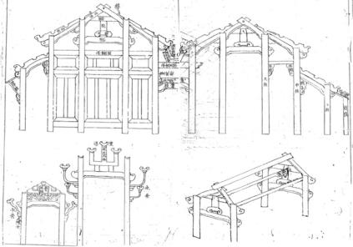 | 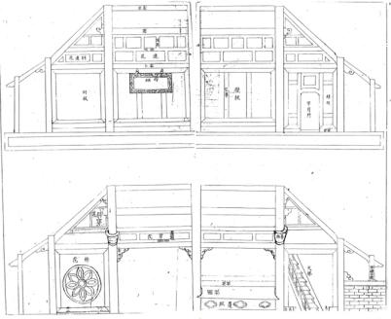  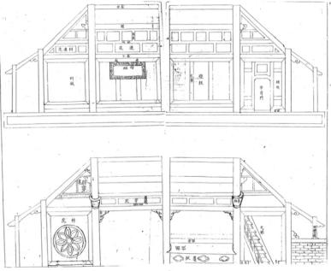
Fig.1 Transversal longitude structure | Fig.2 Transversal latitude structure
According to these, the concepts written in Chinese characters concerning to wooden-structure and timbers are partly appeared such as: the “大柱” big column, the “中柱” medium column, the “小柱” small column, the “交架” upper structure of main building, the “重花柱架” upper structure of front building, the “承霤架” structure of drainage gutter, the “梁架” transversal wooden structure, the “傾架” diagonal beam, the “貞” big beam, the “穿” main-tie beam, the “上蛇” head-tie beam, the “中蛇” neck-tie beam and the “下蛇” lower-tie beam etc., those suggested to understand clearly the architectural fearture and components of the architecture [22-24].
Additionally, based on others literary references, components of the spatials explained on the floor-plan will be referred to as: the “正中間” central compartment (hereafterby A), the “次間” sub-compartment (hereafterby B), the “内廂” inter wing (hereafterby C) and “外廂” exter wing (hereafterby D) in the ridge direction (latitude); The “承霤” drainage gutter (hereafterby G) placed between two buildings to unify the both interiors, spatial from drainage gutter forwards to front side of the building is defined as the “前楹” front building, spatial from drainage gutter backwards to back side of the building is defined at the “正楹” main building, the “正楹梁心” big beam of main building (hereafterby E), “前楹梁心” big beam of front building (hereafterby F), the “前後上傾” front/back upper-diagonal beams (hereafterby H), “前後下傾” front/back lower-diagonal beams (hereafterby I) in the beam direction (longitude), “前後決” front/back corners and “左右決” left/right corners (hereafterby K) at the four outermost-corners (fig.3). Besides, the above-mentioned A officially defined as the “振心” central-span, E defined as the “梁心” big beam-span of the main building [25-27].
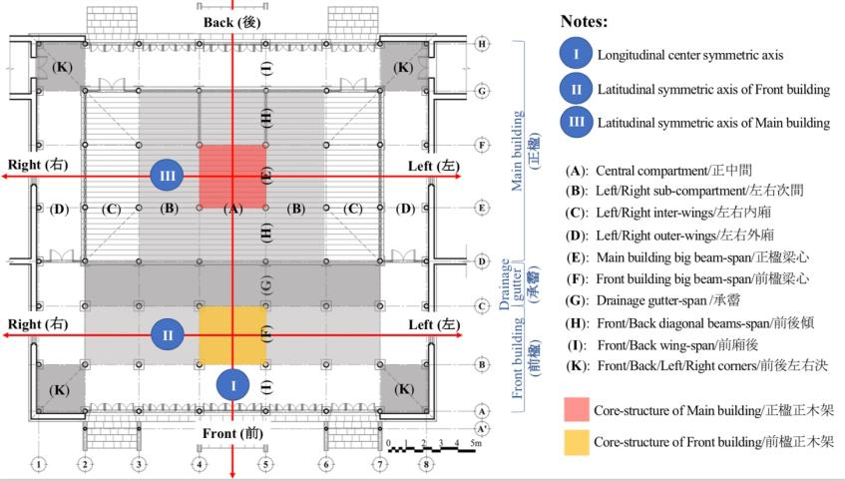
Fig.3 Illustrated drawing of spatial concepts on floor-plan of the Twin-Buildings (Drawing of SAD temple)
  - Components of the Wooden Frame
The wooden-frame (木架) of the Twin-Building is composed of big columns, medium columns and small columns, the upper part of the big columns is connected by big beams, tie beams and the diagonal beams are placed diagonally from the top of medium columns toward the ridge beam of the main building, and/or from the top of small columns toward to the big columns of front building, and/or from the top of small columns toward to the medium columns of the main building. Furthermore, the upper structure of front building is placed on the big beams of the front building while the upper structure of main building is placed on the big beams of the main building. In the outermost-four sides of the Twin-Buildings (front/back-lower diagonal beams and left/right wings), the lower diagonal beams connect the small columns to the big columns in the front building and to the medium columns in the main building (fig.4, 5, 6, 7).
The above components of the wooden-frame are secured by connecting the tops of the columns with penetrating main-tie beams, head-tie beam, neck-tie beam and lower-tie beam, agained the deformation by filling the gaps with the transoms and wooden-panels. The roof-tiles supported by the purlins and rafters which laying regularly on the diagonal beams from top to end along the diagonal beams. In addition, there is a ceiling placed in the middle height of the main building to device the spatial into upper space and lower space.
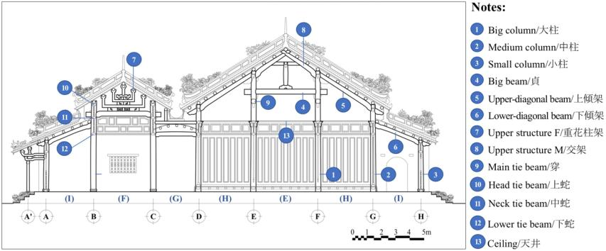
Fig.4 Illustrated drawing of timber components on transversal longitude structure (Drawing of SAD temple)
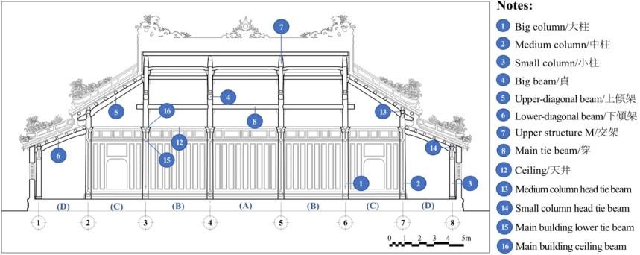
Fig.5 Illustrated drawing of timber components on transversal latitude structure (Drawing of SAD temple)

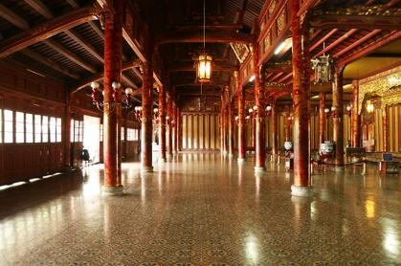 | 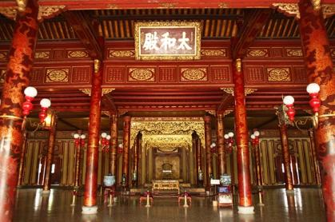
Fig.6 Wooden-frame of front building (THD palace) | Fig.7 Wooden-frame of main building (THD palace)

  - Specifics of the Wooden Frame
Firstly, the core-structure (正木架) of the wooden-frame placed at the central position of front building and main building (fig.3) which is compossed of the four principle timbers: Column – Diagonal beam – Tie beam – Big beam (which included four columns, four diagonal beams, two main-tie beams and two big beams). Connection of column and big beam creates a horizontal linkage (in longitude), connection of column and main tie beam creates a vertical linkage (in latitude), connection of columns and diagonal beam creates a diagonally linkage (according to the roof pitch). Those main timbers connect to each other by the joins system which normally called “Mong” work together to form a whole wooden-frame of the building.
Secondary, each of longitudinal transverse structures (梁架) plays the role as a unit of construction setting parallel in longitude to create the horizontal linkages. Those longitudinal transverse structures connect to each other successively in latitude by the main-tie beams, head-tie beams and lower-tie beams to form the compartments which symmetrically arranged at both left and right side of the longitudinal symmetric axis at center of the building.
Thirdly, the linkage of column and diagonal beam is commonly used, and its is quite usefull to form the whole wooden-frame. Technical origin of the diagonal beam is unknown, but basing on the works of knowledgeable master carpenters and their expriences, it is considerable that the diagonal beam has been created, and used since long time ago. The diagonal beam connects two or three columns (big column, medium column and/or small column) at their top, the slope of diagonal beam is also the roof pitch.
Fourthly, the structure of drainage gutter (承霤) is only available in the type of Twin-Buildings, this is the creation to solve the requirement of expanding interior space, increasing the architectural scale without having to increase the height of building. The structure of drainage gutter has function to connect both wooden-frames of the front building and main building that created a unified architectural interior space. It is possible that the creation of this structure has a short history, so it has not been improved, weakly and often damaged.
Fifthly, wooden-frame has enough loading capacity to stand the weight itself and the weight of roof-tiles, the dead weight of whole building has transferred equally straight down to the platform via the columns. Surface of the column-boots directly putting on the upper surface of the basement stones withough having any linkage. It is considerable that the dead weight of building creates enough friction to keep the wooden-frame standstill at its designed position.
According to those specifics above, wooden-frame of the Twin-Buildings would flexible to be partly restored or changed as well as assembling, dismantling and/or re-assembling in case of moving to re-use in other places.
  - Targeted buildings, measurement method and units for analyzing
Table 1 shows a list of Twin-Buildings that were subjects to the measuring survey. They include five main Imperial Palaces (abb., the Palaces), four Imperial Shrine (abb., the Shrines) located at the Imperial City and inside the Citadel, and five Mausoleum Temples (abb., the Temples) located at the complex of Imperial Mausoleums. Among the Palaces, the Shrines and the Temples, Can Thanh Dien Palace, Can Chanh Dien Palace, Thai To Mieu Shrine and Phung Tien Mieu Shrine have lost their wooden structure and roofs (only ruins of their platform are remained) while the wooden structure and roofs of the others still existed. We will refer to the above three types of Palaces, Shrines, and Temples collectively as the Twin-Buildings and analyze in total of 10 wooden-frames based on the results of measuring surveys (fig.8 – fig.17).
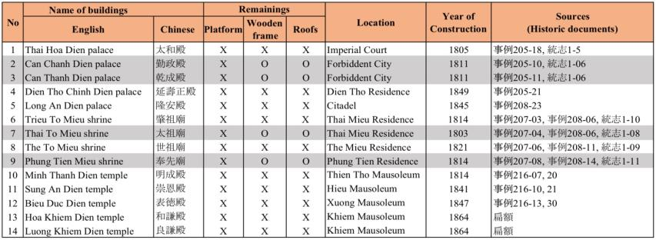
Table 1. List of targeted buildings

Note: remaining (X), lost (O)
We conducted a transverse cross-section measuring survey of column spacing in the above-mentioned 10 wooden-frames, and obtained the center-to-center measurements between column bases and big beams, and the heights of each element. The four buildings in which only the platform now exists were analyzed using the center-to-center measurements of their basement stones.
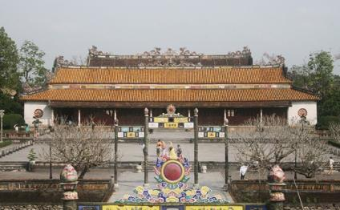 | 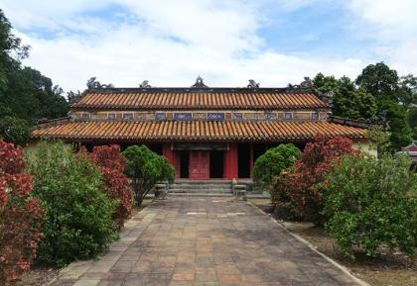
Fig.8 Thai Hoa Dien palace (Hue Imperial City) | Fig.13 Minh Thanh Dien temple (Thien Tho Mausoleum)
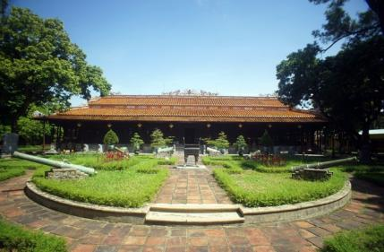 | 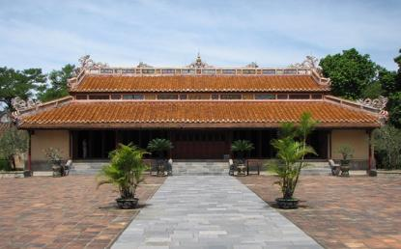
Fig.9 Long An Dien palace (Hue Citadel)* | Fig.14 Sung An Dien temple (Hieu Mausoleum)
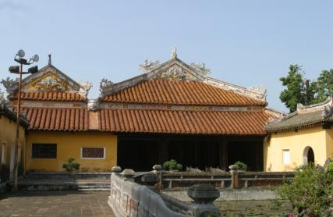 | 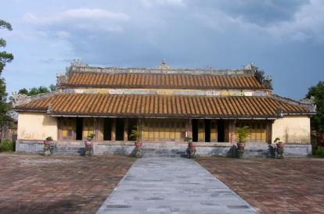
Fig.10 Dien Tho Chinh Dien palace (Hue Imperial City) | Fig.15 Bieu Duc Dien temple (Xuong Mausoleum)
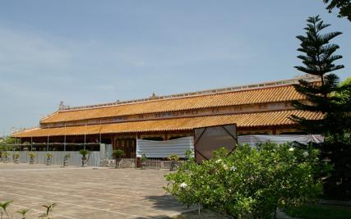 | 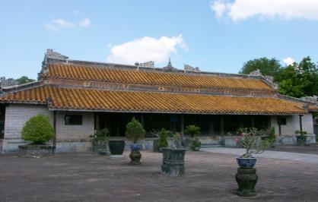
Fig.11 The To Mieu shrine (Hue Imperial City) | Fig.16 Hoa Khiem Dien temple (Khiem Mausoleum)
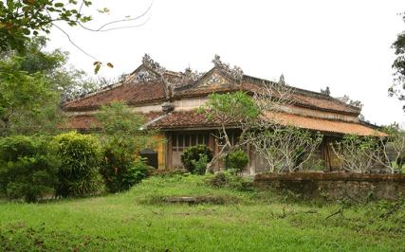 | 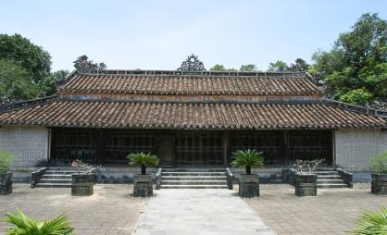
Fig.12 Trieu To Mieu shrine (Hue Imperial City) | Fig.17 Luong Khiem Dien temple (Khiem Mausoleum)
Identifying the specific unit of measurement used in the construction of the buildings should be a priority concern in restoration designing. It was not uncommon for different buildings to be constructed according to a different measure, so a “building-specific measure” should be ascertained for each building. In this study, we will estimate building-specific measures based mainly on the analysis of the floor-plan and transverse cross-section of the above-mentioned Twin-Buildings. Before we do so, let us take a look at the specific units of measurement used during the Nguyen dynasty.
Several items provide a reference of the official measurement units used in the Nguyen dynasty that are preserved in the museums in Vietnam. As the previous-mentioned study results, the official measures units of the Nguyen dynasty were available in several different types for different applications. Among them, the “Quan Moc Xich” ruler (官木尺) and the “Lu Ban Xich” ruler (魯班尺) were used for the construction of buildings. The measures are based either on a decimal or octal number system, but it seems unlikely that the two number systems were used separately in different situations. Accordingly, we shall assume that a “Quan Moc Xich” ruler = 424 ~ 428mm/unit (abb., the Large Ruler) and a “Lu Ban Xich” ruler = 382 ~ 384mm/unit (abb., the Small Ruler) were used during the early periods of the Nguyen dynasty.
- Analyzing design methods of the Wooden Frames
Before reconstructing the original designning procedure and designing method based on actual measuring results, it is necessary to replicate the line that serves as a reference, or the designing reference lines.
The carpenters who engaged in the restoration works of the Monuments are knowledgeable of traditional techniques utilize a design reference line system called “Muc Dat” (1/1 scale ink-line drawn on the ground). We also refer to it as appropriate in the analysis discussed here in this study. Hardly any possible traces of design reference lines have been found in the buildings that are in existence today, except for an element on the underside of the roof of the Thai Hoa Dien palace which shows a line made in ink. Though it is difficult to determine whether the line was made during initial construction or during later restoration, it is highly likely that it represents the design method that was used in ancient times.
When design the wooden-frame, the horizontal lines and vertical lines are needed as a reference for aligning the components. Particularly important are: the Reference desing horizontal line (1), the line of top-end edge of lower roof (2), the line of surface of Floor-plan (3), reference designing vertical line (4), the Main building big-beam center line (5), the Front building big-beam center line (6), the Drainage gutter-beam center line (7), the Column center line (8), the Main building upper-roof pitch line (9), the Front building upper-roof pitch line (10), the Front/Back lower-roof pitch line (11) and the Total height of Main building (12). The manner in which they are set and intersect with each other determines the length and height of each component (fig.18).
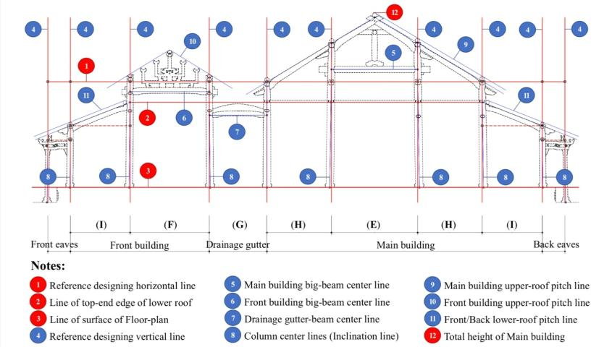
Fig.18 Explained drawing of designing reference lines on transerve cross-section

  - Designing reference horizontal lines
The span of columns differs between the top and bottom of the columns due to the inward inclination of columns in the beam direction. Therefore, the first issue is in determining what the span is based on. Since there is no structural element connecting the column bases in the beam direction and the wooden-frame is mainly supported by diagonal beams, it can be reasonably assumed that the span between columns is determined at the top of columns. Additionally, if the measuring diagram is studied from the perspective that the wooden-frame was designed in consideration of the heights of the front building and main buildings in the beam direction, then it is natural to assume that the reference line for spans in the beam direction is (in principle) the line that connects the bottom of the big column head tie beams in the front building and the top of the medium column head tie beams in the main building (fig.18, no.1). In the majority of the “10 units Twin-Building” whose wooden structure still existed, the height of the center or bottom edge of the main tie beam is set at the point where the above-mentioned horizontal line intersects with the center of the big columns in the main building. Let us call this horizontal line the “Designing reference horizontal line for the height of elements in the beam direction” (L1, abb., the Designing horizontal line).
In the Luong Khiem Dien temple, however, this line corresponds to the center of the medium column head tie beams in the main building, and in the Minh Thanh Dien temple, it is roughly the same height as the bottom of the medium column head tie beams in the main building. The big beams in the front building and the beams in the drainge gutter are set below the horizontal line, and the big beams and main tie beams in the main building are set above it. In the Minh Thanh Dien temple only, the big beams in the main building are set above the horizontal line. The center line of the main tie beams is set so that it coincides with the point of intersection of the Designing horizontal line and the center lines of the big columns in the main building, and probably provides the Designing horizontal line for column spans in the ridge direction.
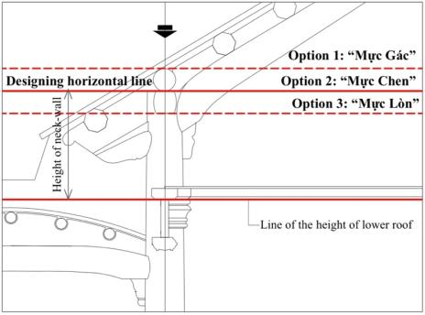
Fig.19 Three options of Designing horizontal line
In the traditional designing method of Vietnamese*, the Designing horizontal line in the beam direction is considered important as the line that passes through the center line of big beams, and three options of that line are used separately in accordance with the size of the structure. Option 1 called “Muc Gac” (line passes through the top-edge of the purlins), option 2 called “Muc Chen” (line passes through the top-edge of head tie beams and the bottom-edge of purlins) and option 3 called “Muc Lon” (line passes through the bottom-edge of head tie beams). As our analyzing result, opption 2 is used as the main reference line, option 1 and option 3 are used optionally to make adjustments according to column spans and height. In terms of these three line-options (fig.19), the Designing horizontal line in the beam direction of the Twin-Buildings would correspond to the option 2 in the main building and to the option 3 in the front building. The height of this Designing horizontal line from surface of the floor-plan was probably specified arbitrarily for each building (table 2, fig. 20, 21).
Table 2. Height of the Designing horizontal lines
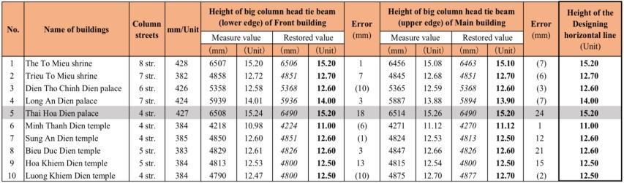

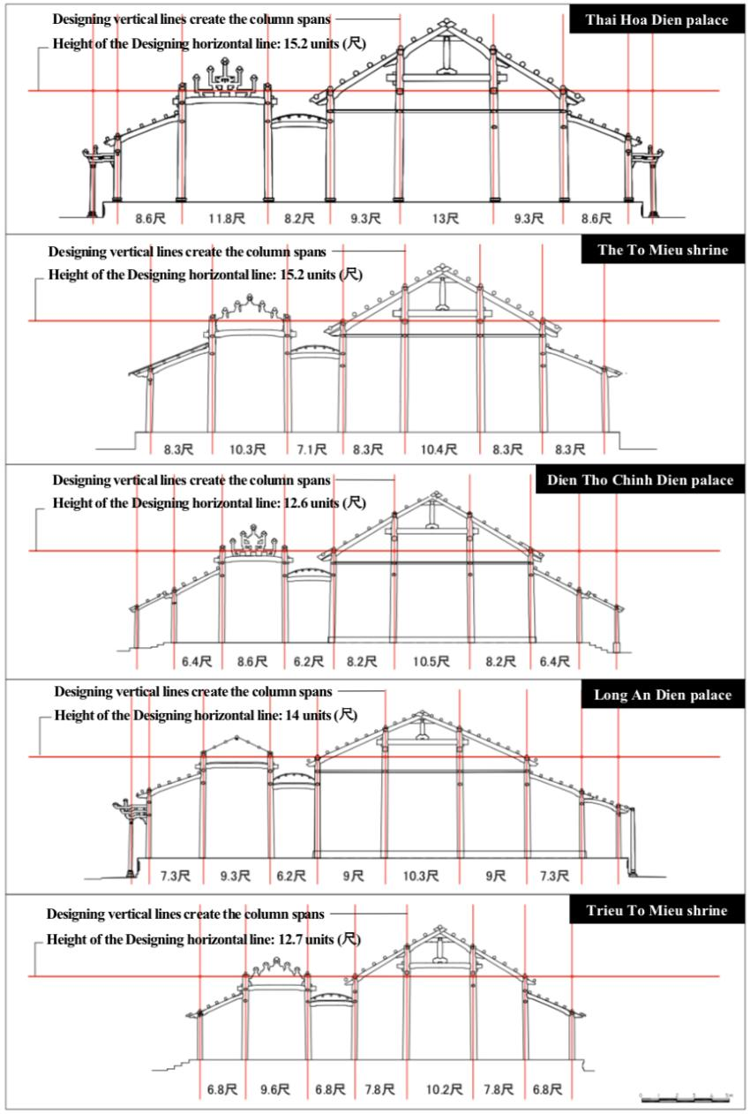
Fig. 20 Designing horizontal lines of the Palaces and Shrines
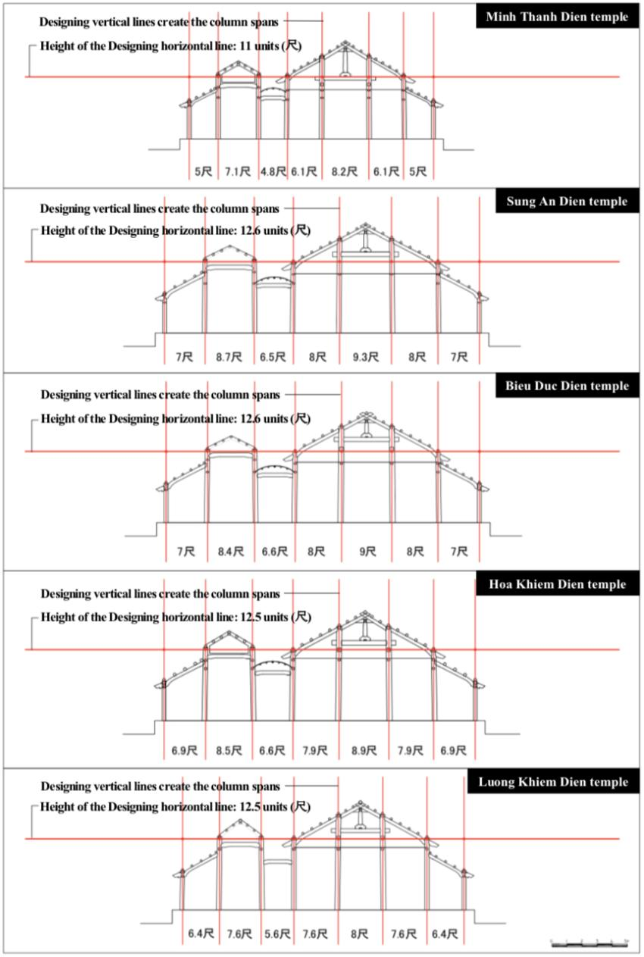
Fig. 21 Designing horizontal lines of the Temples

  - Designing reference vertical lines
As mentioned earlier, the wooden-frame in the beam direction was constructed by firstly establishing the span of E, and this was used as a reference for sequentially establishing the spans of F, H, G, and I. It is assumed that spans established based on E were then applied along the Designing horizontal line in the beam direction, lines were extended vertically down from them, and inclinations were added at the bottom of columns (fig.18, no.4).
Accordingly, in the ridge direction, the Designing reference vertical lines for columns spans are also important, distance between two vertical lines create the spatial compartments, and a group of them defines the column rows. Let us call these vertical lines the “Designing reference vertical lines for column spans in the beam and ridge direction” (abb., the Designing vertical lines).
  - Positional relationship between big beam and main tie beam in the main building
Basically speaking, none of the Twin-Buildings show a proportional relationship between column height and column span in the main building. However, as will be discussed later, a certain relationship exists between the column spans in the ridge direction and the height of the top-end edge of the lower roof (perhaps also the height of the main building ceiling). The height from the Designing horizontal line to the top of the big column head tie beam, the distance from the Designing horizontal line to the center line of the big beam is commonly designed in concrete numbers. Either one of the measurements must have been arbitrarily established first. Additionally, the position of the center line of the main tie beam is such that the height downward from the center line of the big beam ranges from 1 unit up to 1.8 units. As an exception, the center line of the main tie beam is 0.1 unit higher than the center line of the big beam in the Sung An Dien temple (table 3).
Table 3. Relationship between the height of big beam and main tie beam in main building
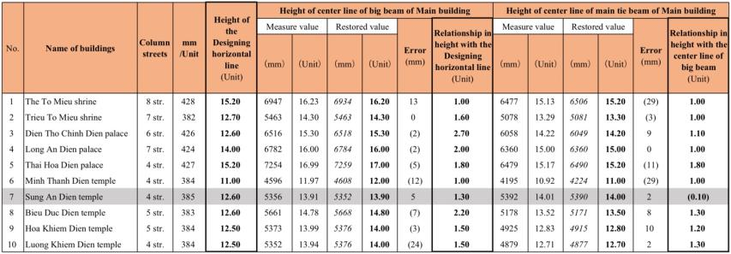

From the above, it is clear that the above-mentioned three options of Designing horizontal line served an important purpose:
1) Marking the position for establishing column spans in the beam direction, and also provides a reference for establishing the height of elements.
2) Marking the design position of column spans in the ridge direction, and naturally provides the point of origin for the inclination of the outermost frame in the ridge direction.
3) Column inclinations of the front building and main building originate from the Designing horizontal line, or the Designing vertical lines extended down from the point of intersection of the center lines of the big beam and big column in the main building.
  - Design method of the Front Building
The height of the big columns in the front building is equal to the Designing horizontal line plus the thickness of a head tie beam. The thickness of big column head tie beams in the front building, big column and medium column head tie beams in the main building is in range from 0.4 units up to 0.6 units. In the Bieu Duc Dien temple only, its height in the main building is 0.25 units (smaller than all the others). The distance from the Designing horizontal line to the height of the center line of the big beam in the front building ranges from 1.2 units up to 1.8 units, or the distance to the lower edge of the big beam ranges from 1.1 units up to 2.2 units. Meanwhile, the height from the center line of the big beam in the front building to the surface of floor-plan is also established by actual measurement, ranges from 9.3 units up to 13.8 units, or the height to the lower edge of the big beam ranges from 11 units up to 13 units. Either one of the actual measurements must have been arbitrarily established first (table 4). As in the main building, column inclinations in the front building also originated from the point where the center lines of the big beam and big columns intersect.
Table 4. Relationship between the height of Designing horizontal line and big beam in front building
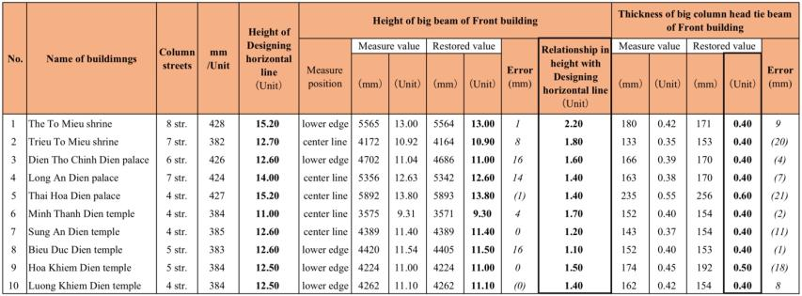

  - Designing method of the Drainage Gutter
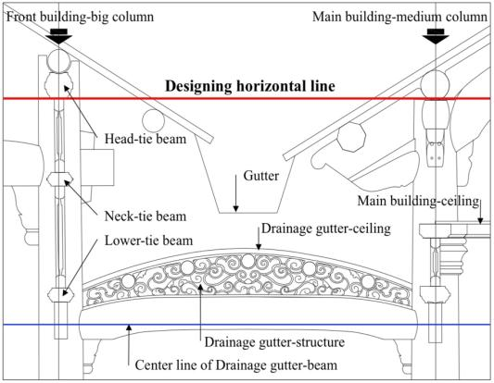
Fig.22 Position and components of drainage gutter-structure
The height of the ceiling in the drainage gutter, which corresponds to the position of the drainage gutter in the valley of the front building roofs and main building roofs, is naturally lower than the main building ceiling. The point where the center line of the beams in the drainage gutter intersects with the medium column center line is not the point of origin of column inclinations, but is possibly established based on the height of the lower tie beams. In the relevant Twin-buildings, the height of the beams in the drainage gutter is roughly the same as the center or top of the lower tie beams. The position of the structure of drainage gutter (承霤架) falls within the height of the lower tie beams and the height of the main building ceiling (fig.22). The lower edge of the beams in the drainage gutter is aligned between the third or fourth purlin from the top of the lower roofs or the center of the big beams in the drainage gutter is aligned between the fourth or fifth purlin.
  - Relations between head-tie beams, neck-tie beams and lower-tie beams of the Front Building
The columns are all connected to each other in the ridge direction by head-tie beams that receive the load of the purlins, but only the big columns in the front building are extended a certain length above the top of those tie beams to directly support the purlins, and the heights of the columns are not all the same. In the main building, the point where the outer line of the diagonal beams, or the roof pitch line, and the center of the column-top intersect is the designed height of the columns and also the designed height of the top of the head-tie beams. It seems that the heights of the neck and lower-tie beams were established according to the distance from this height (fig.23). In the front building, the distance from the top of the head-tie beam to the bottom of the neck-tie beam ranges from 2.4 up to units 2.6 units; the distance from the top of the head-tie beam to the center of the neck-tie beam is 2 units, or/and the distance from the top of the head-tie beam to the top of the neck-tie beam ranges from 2 units up to 2.1 units (table 5).
Table 5. Relationship among the height of head-tie beam, neck-tie beam and lower-tie beam
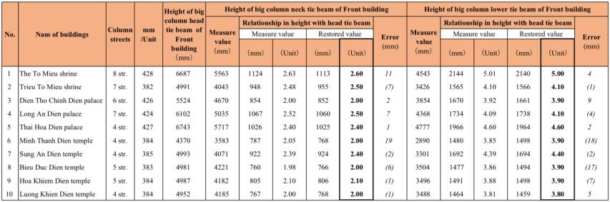

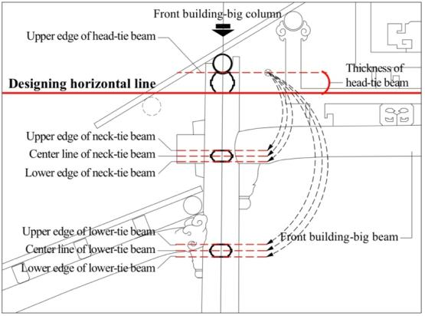
Fig.23 Positional relationship among the tie beams
A transom is installed between each of the tie beam, and the distance from the top of the head-tie beam to the neck-tie beam in each Twin-Building is about half the distance from the top of the head-tie beam to the lower-tie beam, ranges from 3.8 unit up to 4.4 units (in the Temples) or 4.1 units up to 5 units (in the Palaces and the Shrines). In the majority of the Twin-Buildings, the height of the lower-tie beam in both the front building and main building are the same, but in only in the Thai Hoa Dien palace, it is lower than the others, measuring 10.4 units from the top of the head-tie beam of the big columns to the bottom of the lower-tie beam. This was probably because a throne had been installed between the big columns in the center of the Thai Hoa Dien palace, and the thickness of the transom located behind it was adjusted accordingly.
  - Relations between the height of Front building and Main Building in transerve cross-section
Table 6. Relationship between the height of neck-tie beam in front building and ceiling in main building
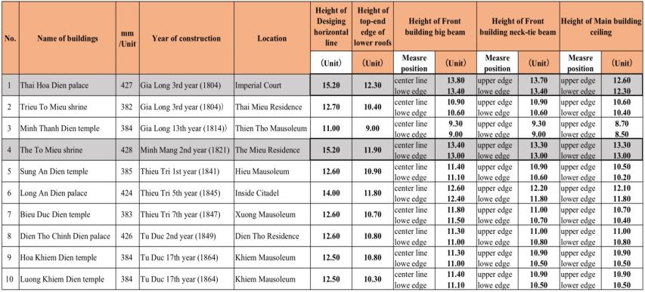
Height of the neck-tie beam in the front building and the ceiling beam in the main building are important in the relationship between the height of front building and main building, in terms of the building’s transverse cross-section. In the majority of the Twin-Buildings, the neck-tie beam in the front building is roughly the same height as the ceiling beam in the main building, and in the Twin-Buildings inside the Imperial City, it is roughly the same height as the big beam in the front building (table 6).
In the Thai Hoa Dien palace and The To Mieu shrine which located inside the Imperial City, the Designing horizontal line in the beam direction is the same height (both 15.2 units), and the height of the big beam in front building is also extremely similar (height of the center line of the big beam in the The To Mieu shrine front building = height of the bottom of the big beam in the Thai Hoa Dien palace front building=13.4 units). The ceiling beam in the Thai Hoa Dien palace is 0.7 units lower than it in the The To Mieu shrine, but the height of the ceiling beam component is the same (both 0.3 units). These relationships between the height of the Designing horizontal line and the height of the big beam and neck-tie beam in front building and the ceiling beam in main building are related to the scale of the architecture.
  - Relations between the height of the lower roof (h) and the height of ceiling (L2) in the Main Building
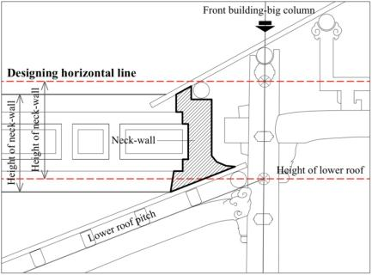
Fig.24 The neck-wall and its relation to height of lower roof
There is a neck-wall (古檐壁) in the space between the top-end edge of the lower roof and the Designing horizontal line on the outer side, and its height is an important element in elevation-front view of the building (fig.24). Its height seems to be specifically established in relation to the Designing horizontal line, and designed in range from 1.7 units up to 3.3 units (table 7). In the Temples, where the front building is 5 to 7 spans wide (in the ridge direction), the height of the neck-wall is 1.92 units on average, while in the Palaces and Shrines where the front building is 7 to 11 spans wide, it is 2.5 units on average. The neck-wall becomes higher in accordance with the wide-scale of the building in the ridge direction, and was probably established in consideration of the elevation-front view of the building to agree with the aesthetic.
Table 7. Height of the neck-walls
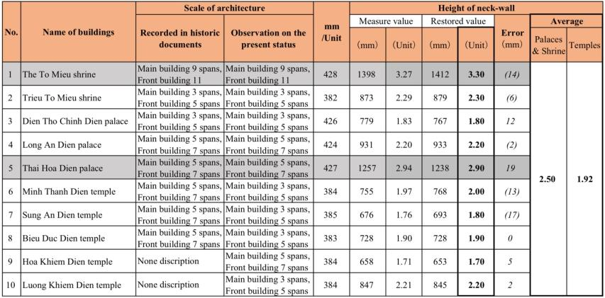

Additionally, the top-end edge of the lower roof (top of the diagonal beam or bottom of the rafters) is roughly the same height as the ceiling beam in the main building. The height from surface of the floor-plan to the top of the head-tie beam of the small columns, which provides a reference for the bottom-end edge of the lower roof, ranges from 6.8 units up to 9.3 units.
  - Relations between column spans and the height of lower roof
In relation to the elevation-front view, the column spans in the ridge direction (central-span A or sub-span B) and the top-end edge of the lower roof, or/and the height of the main building ceiling, which is roughly the same height as the top-end edge of the lower roof, seem to be closely related to each other. In fact, span of A in the Minh Thanh Dien temple is equal to the height of the top-end edge of the lower roof = 9 units (table 8, 9; fig.25), and span of B in the Thai Hoa Dien palace is equal to the height of the top-end edge of the lower roof or the bottom of the ceiling beam in the main building =12.3 units (table 8, 9; fig.26). Both are earliest buildings built in the beginning of Gia Long period. However, in the case of The To Mieu shrine and the others Twin-Buildings, span of A or B is un-equal to the height of the lower roof (table 8, 9; fig.27).
Thoughtly, during the Gia Long Period, the transverse cross-section was designed by establishing the height of lower roof firstly based on the column spans (A or B), then establishing the height of the Designing horizontal line secondary to define the height of other elements. After the Gia Long period, however, the height of lower roof may have been established based on the height of the Designing horizontal line instead.
Table 8. Relationship between height of lower roof and main building ceiling
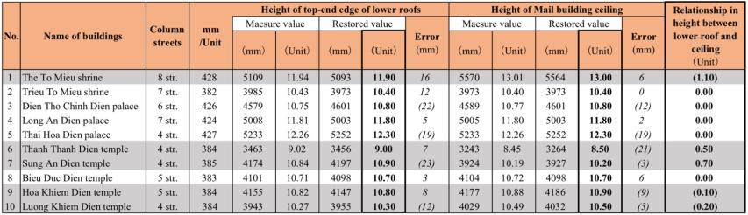
Table 9. Relationship between column span and height of lower roof
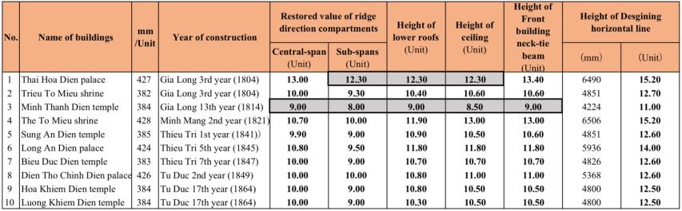
In terms of the largest height in the beam direction, height of the main building (L), measured from the surface of floor-plan or floor-wooden board to the top of the ridge beam, tends to be twice the height of the ceiling beam (L2), or the height of the top-end edge of the lower roof (h), and the distance (h1) from the big beam in front building to the top of the front building ridge beam tends to be 1/2 the height of the ceiling beam or/and the height of the top-end edge of the lower roofs. In the Long An Dien palace only, the distance from the ceiling beam to the main building ridge beam is 3/4 the height of ceiling beam, and the distance from the center line of the big beam to the front building ridge beam is 1/2 the height of the ceiling beam.
The wooden-frame of Long An Dien palace is a very special case by the following reasons: Firstly, this building was built under Thieu Tri period right after the construction policies offered by Emperor Minh Mang had took effective, so that the upper-roof pitch of this building is smaller than that of other Twin-Buildings, and upper-roof pitch and lower-roof pitch seem to be the same, those strange features of the roof-pitch of Long An Dien palace will be explained more clealy in the table 12 below. Secondly, this bulding was the main building of the Bao Dinh Cung residence used for resting of Emperor ThieuTri, located at Northern side of the Imperial City, had been moved to its current location in Eastern side-nearby the Imperial City under Khai Dinh period, has been used as the imperial museum up to now, so there may have been many changes during the reconstruction work (fig.20, Long An Dien palace).
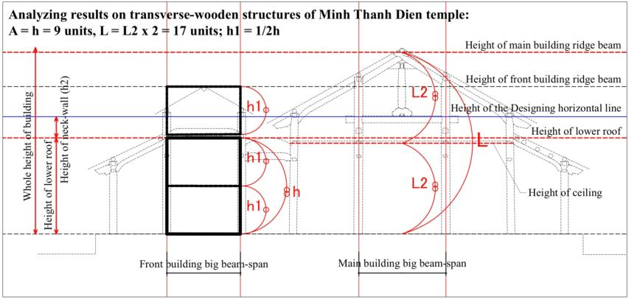
Fig.25 Proportional analyzing on the transverse cross-section of Minh Thanh Dien temple
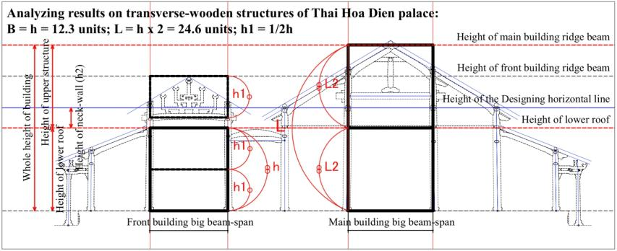
Fig.26 Proportional analyzing on the transverse cross-section of Thai Hoa Dien palace
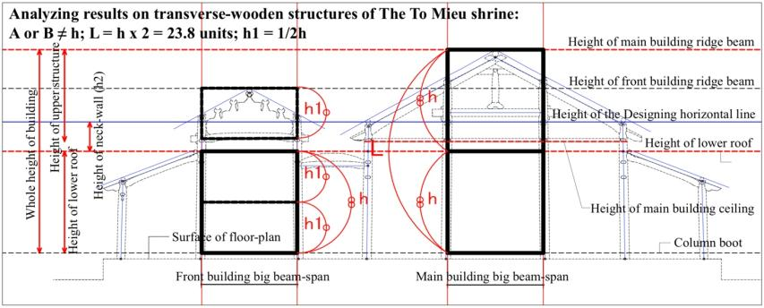
Fig.27 Proportional analyzing on the transverse cross-section of The To Mieu shrine

  - Column inclination
Traditionally, the columns of the Architecture are not really designed in vertical direction but there is inclination as the rule traditionally called as “Thuong Thu – Ha Thach” (means distance center-to-center of column in top is usually smaller than that at the bottom, thus column center line has an inclination). Though it is in purpose to reduce the pressure of the roofs loading weight, and perhaps, in purpose of aesthetic sensation adjustment which have been applied since ancient time in the Eastern. There are four types of column inclinations have been confirmed: inward inclination traditionally called “Thach noi”, outward inclination “Thach ngoai”, parallel inclination “Thach dong” and square-inward inclination “Thach gu dau” (fig.28).
Inward inclinations are seen in the E span and F span; outward inclinations are seen in the G span (drainage gutter); parallel inclinations are seen in the H span and square inclinations are seen in the columns at the corners of both longitudinal and latitudinal directions. Column inclinations are sometimes regarded as a structural measure. The results of measuring surveys show that the inclination width of the big columns in the main building is generally larger than that in the front building, ranges from 0.1 to 0.15 units in the front building and 0.15 to 0.25 units in the main building (table 10). The ratio of column inclination width to column height falls within the range of 0.8% – 1.4%.
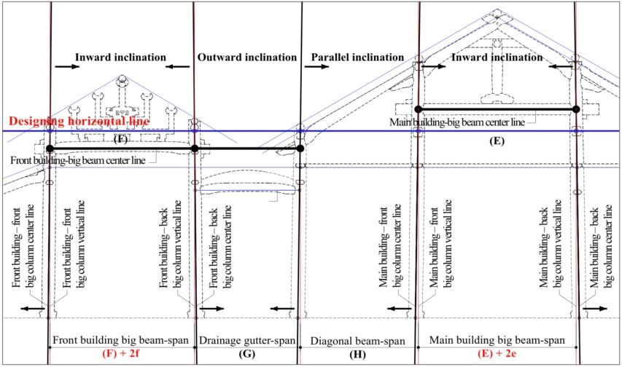
Fig.28 Explained drawing of the column inclination on the transverse cross-section

Table 10. Column inclination on transverse cross-sections
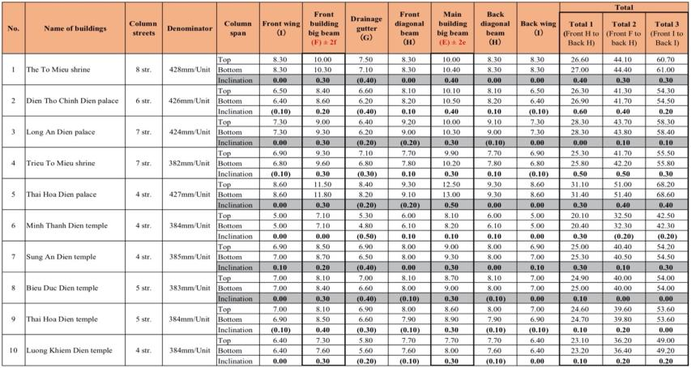

  - Roof pitch and height of ridge beam
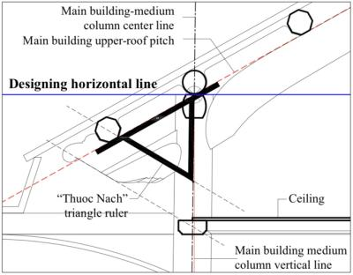
Fig.29 Roof pitch established by using carpenter’s tool
The upper roof pitch of the main building is larger than that of the front building. The pitch of the lower roof is either the same as in the corner of the upper roof of either the front building or main building (in the Palaces and the Shrines), or it is smaller or equal to that pitch of the upper roof of the main building (in the Temples).
In analyzing the method by which the roof pitch was established, dividing the height of the roof by column span always produces a fraction in all of the Twin-Buildings, so this could not have been how the roof pitch was established. According to traditional construction technique of the middle region of Viet Nam, the roof pitch was established by using a triangle carpenter’s tool called “Thuoc Nach” (fig 29). When this is applied to the survey results, the pitch of the upper roof of the main building ranges from 58% to 62%, and the pitch of the lower roof ranges from 42% to 46% (tables 11, 12).
Table 11. Roof pitch established by the “Thuoc Nach” triangle carpenter’s tool
Table 12. Roof pitch according to measurement results
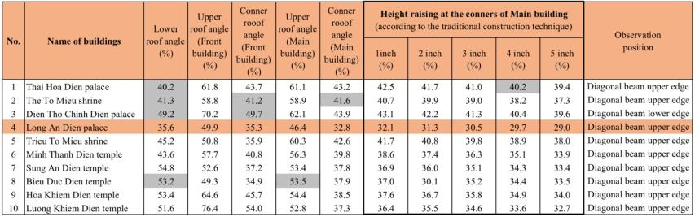

This method of establishing roof pitch undermines the need to establish the design height of the ridge beam, but as discussed earlier, the height of the front building and main building ridge beams may have been established according to the intentioned-total height of the Twin-Buildings. In all of the Twin-Buildings, the difference between the roof pitch in the front building and main buildings, and the difference in roof pitch among each Twin-Building probably came from the difference in the overall height plan.
- Findings and Discussion
As a result of analyzing on each Twin-Building in relation to the confirmed traditional design method of the middle region of Viet Nam, there were two designing methods applied for wooden-frame have been emerged which can be explained via designing process of the transverse cross-section below.
  - Early designing method (Gia Long period)
    - First step
The height of the top-end edge of lower roof is established firstly based on dimention of span A or B, then following the scope of the lower structure is determined. By adding the height of the neck-wall onto the top-end edge of the lower roof in accordance with the scale of the elevation-front view of the building in ridge direction, the height of the Designing horizontal line in the beam direction can be established concurrently (fig.30). The spans E or/and F will be established from span A or B, then spans H, G and I will be established base on E and F (fig.30).
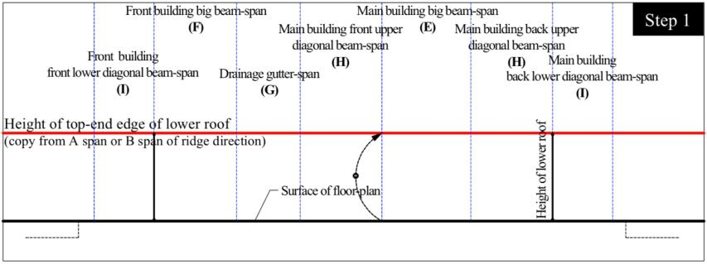
Fig.30 Estimated first step of early designing method (Gia Long period)

    - Second step
Column spans are applied along the Designing horizontal line in the beam direction, and the Designing vertical lines are extended downward from them as reference lines for column inclinations. The height of the medium columns in the main building is made to be the same as the height of the Designing horizontal line, and the height of the big columns in the front building is that height plus the thickness of a head-tie beam. The Designing horizontal line corresponds to the above-mentioned “Muc Chen” (option 2) in the main building and the “Muc Lon” (option 3) in the front building. The height of the entire building (height of the ridge beam of main building) is twice the height of the top-endedge of the lower roof. Here the position of the column bases is determined (fig.31).
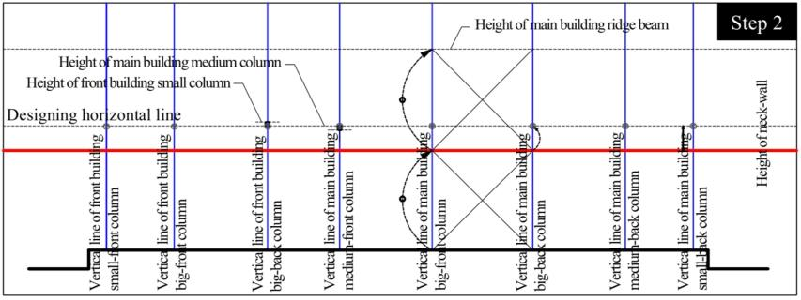
Fig.31 Estimated second step of early designing method (Gia Long period)

    - Third step
Using the “Thuoc Nach” triangle carpenter’s tool at the point where the center line of the medium columns and the Designing horizontal line intersect, the pitch of the upper roof of the main building is established for the range within the height of the entire building (from the top to bottom edges of the main building ridge beam). The height of the top-end edge of the lower roof becomes the height of the bottom of the ceiling beam in the main building (fig.31, 32).
    - Fourth step
The heights of the big beam in the front building and main buildings are established by actual measurements from the Designing horizontal line, and the point where the center lines of the big beams and big columns intersect becomes the point of origin of column inclinations between the E (in main building) and the F (in front building). The inclinations of medium column and small column duplicate the inclination of the big columns, or they gradually widen. The point where the Designing horizontal line and the center lines of the big columns in the main building intersect becomes the height of the center line of the main-tie beams, and the position of the main-tie beam is established in actual measurements from the height of the big beam in the main building. The center line of the main-tie beam becomes the Designing horizontal line for column spans in the ridge direction (fig.33).
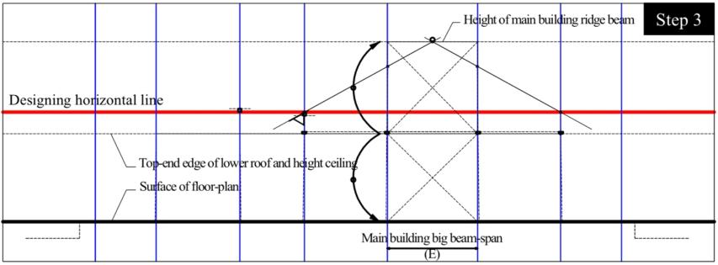
Fig.32 Estimated third step of early designing method (Gia Long period)

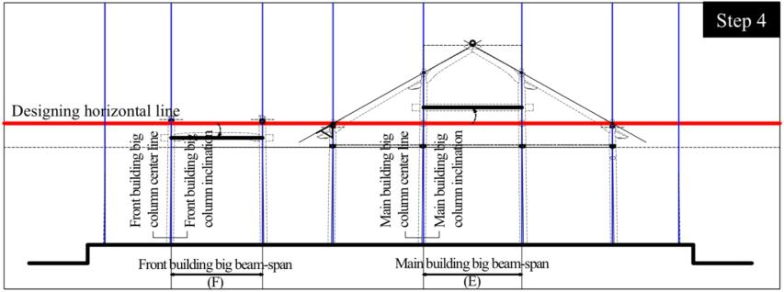
Fig.33 Estimated fourth step of early designing method (Gia Long period)

    - Fifth step
The upper-roof pitch of the front building is established so that the height from the big beam in the front building to its ridge beam is half the height of the top-end edge of the lower roof (fig.34).
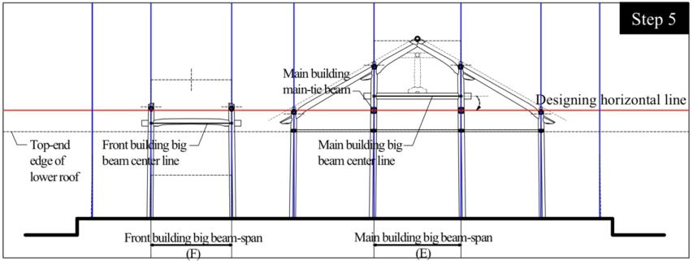
Fig.34 Estimated fifth step of early designing method (Gia Long period)

    - Sixth step
The lower-roof pitch is made so that it is the same as either the pitch in the corner of the upper roof in the front building or main building, or the roof pitch that includes the curvature at the corner. The height of the small columns is established by applying the span under the eaves to the pitch of the lower roof (fig.35).
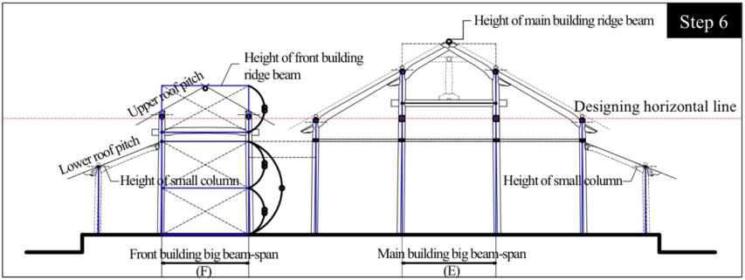
Fig.35 Estimated sixth step of early designing method (Gia Long period)

    - Seventh step
The heights of the neck-tie beam and lower-tie beam are established in reference to the big column head-tie beams and the big beam in the front building. The neck-tie beam is the same height as the bottom of the big beam in the front building or the ceiling beam in the main building, and the height from the big column head-tie beam to the lower-tie beam in the front building is twice the height up to the neck-tie beam (fig.36).
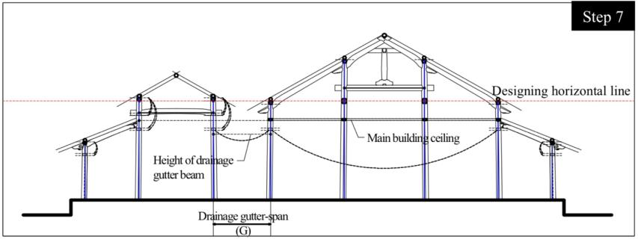
Fig.36 Estimated seventh step of early designing method (Gia Long period)

    - Eighth step
The height of the beam in the drainage gutter is set at the same height as the lower-tie beam. As a result, the drainage gutter is installed between the main building ceiling and the lower-tie beam in the front building (fig.37).
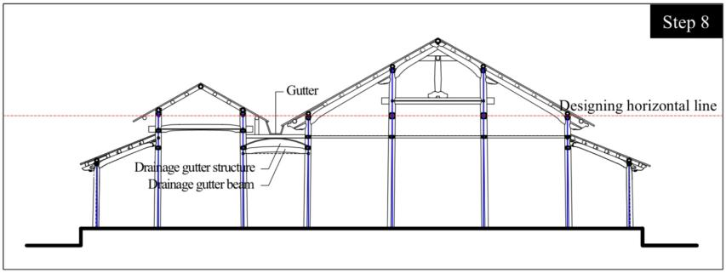
Fig.37 Estimated eighth step of early designing method (Gia Long period)

  - Later designing method (Minh Mang period)
    - First step
Firstly, the height of the Designing horizontal line is provisionally established in concrect number of unit by using the Large ruler (for the Palaces and the Shrines) or the Small ruler (for the Temples), then the column spans are applied to be vertically extended downward in order to produce the Designing vertical lines for column inclinations (fig.38).
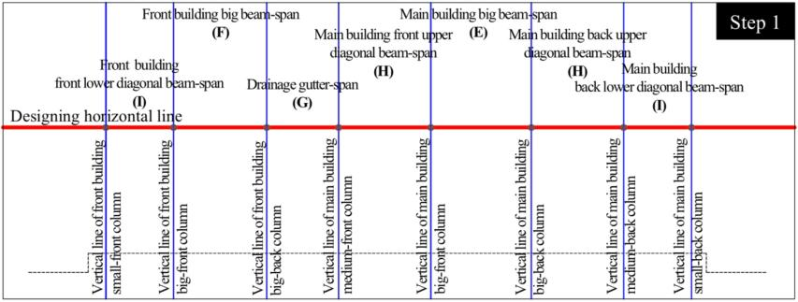
Fig.38 Estimated first step of later designing method (Minh Mang period)

    - Sencond step
The medium columns in the main building are set at the height of the Designing horizontal line, and the height of big columns in the front building is made to be the same as the height of the medium columns plus the thickness of a head tie beam. The Designing horizontal line corresponds to the “Muc Chen” (option 2) in the main building and the “Muc Lon” (option 3) in the front building. The upper-roof pitch of the main building is established using the triangle carpenter’s tool at the point where the center line of the medium columns and the Designing horizontal line intersect, and the ideal height of the bottom edge of the main building ridge beam is derived from there (fig.39).
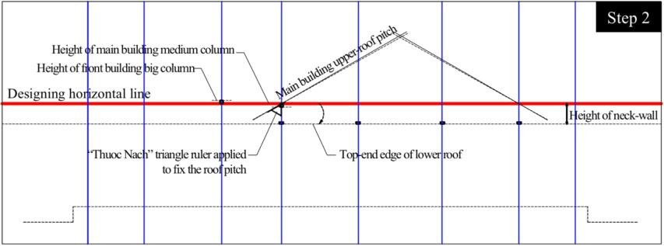
Fig.39 Estimated second step of later designing method (Minh Mang period)

    - Third step
The height of the top-end edge of the lower roof and the height of the ceiling beam in the main building are derived from the height of the neck-wall that is established according to the wide-scale of the building in the ridge direction below the Designing horizontal line. The height from the top-end edge of the lower roof to the top edge of the main building ridge beam (adjusted so that it is an arbitrary measurement) and the height from the bottom-end edge of the lower roof to the surface of floor-plan (or the floor-wooden board in the main building) are made to be the same, and the height of the main building ridge beam is adjusted so that it is twice the height of the top-end edge of the lower roof. The position of the column bases is set, as are the height from the surface of floor-plan to the Designing horizontal line for the heights of elements in the beam direction and the height of each column.
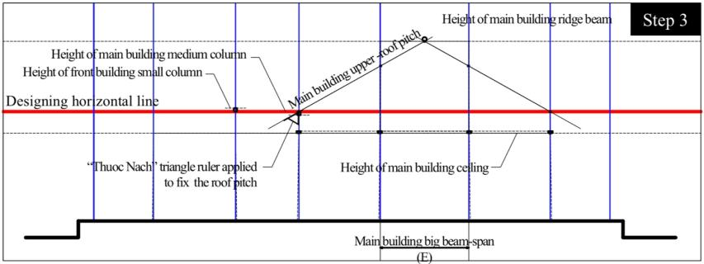
Fig.40 Estimated third step of later designing method (Minh Mang period)

    - Fourth step and the rests
From fourth step (fig.41) and the rests are the same as the early method was used in Gia Long period.
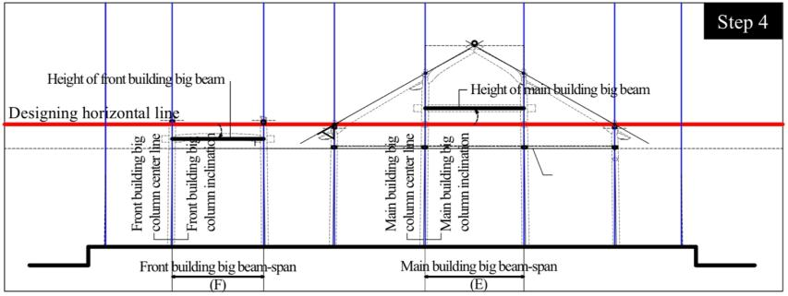
Fig.41 Estimated fourth step of later designing method (Minh Mang period)

4.3 Re-determined construction process of the Wooden Frame
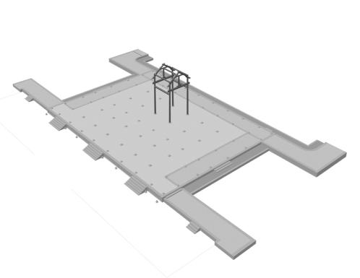 | 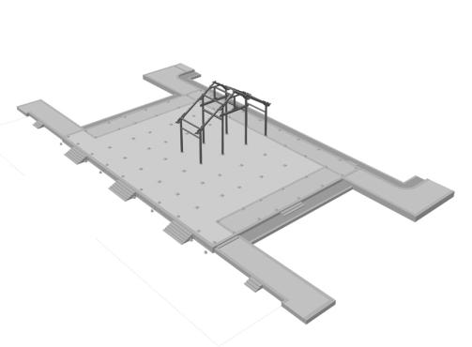
Firstly, the core-structure of the main building is assembled including four big columns, four upper-diagonal beams, two big beams (in beam direction) and two main-tie beams (in ridge direction). A pair of the head-tie beam is installed at the top of the big columns to create the the horizontal linkages in latitudinal direction of the main building. | Secondary, four medium columns connected the four middle-diagonal beams in pairs are installed concurrently connect to the top of the four big columns of the main building. The head-tie beams and neck-tie beams of the medium columns are installed as the same way to create the horizontal linkages in latitudinal direction.
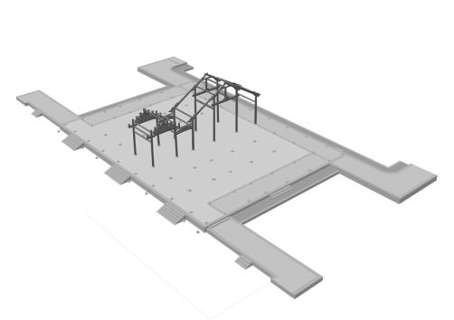 | 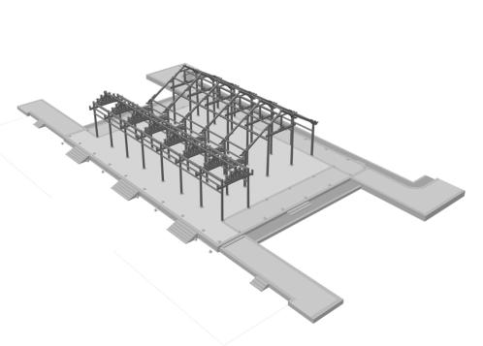
Thirdly, the core-structure of the front building is assembled concurrently with the structure of drainage gutter connect to the core-structure of the main building in longitude. the pairs of head-tie beam, neck-tie beam and lower-tie beam are installed to create the the horizontal linkages in latitudinal direction of the front building. | Fourthly, the longitudinal transverse structures of both front building and main building are assembled successively in latitude by the main-tie beams, head-tie beams and lower-tie beams to form the compartments which symmetrically arranged at both left and right side of the longitudinal symmetric axis designed at center of the building.
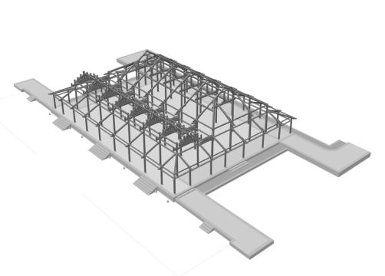 | 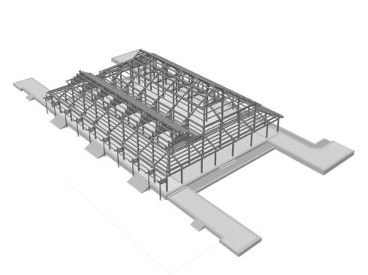
Fifthly, the middle-diagonal beams connected the top of medium columns in the left and right inter-wings of the main building are assembled, then the lower-diagonal beams connected the top of small columns which linked together by the head-tie beams and lower-tie beams are assembled in the four outermost-sides to from the scope of lower roofs. | Sixthly, the front eave is assembled, then the purlins and its other relevant components are laying down regularly on the upper-diagonal beams, middle-diagonal beams and lower-diagonal beams from top to end along the roof pitch. The purlins are secured by connecting the joints to each other placed on the upper edges of the diagonal beams.
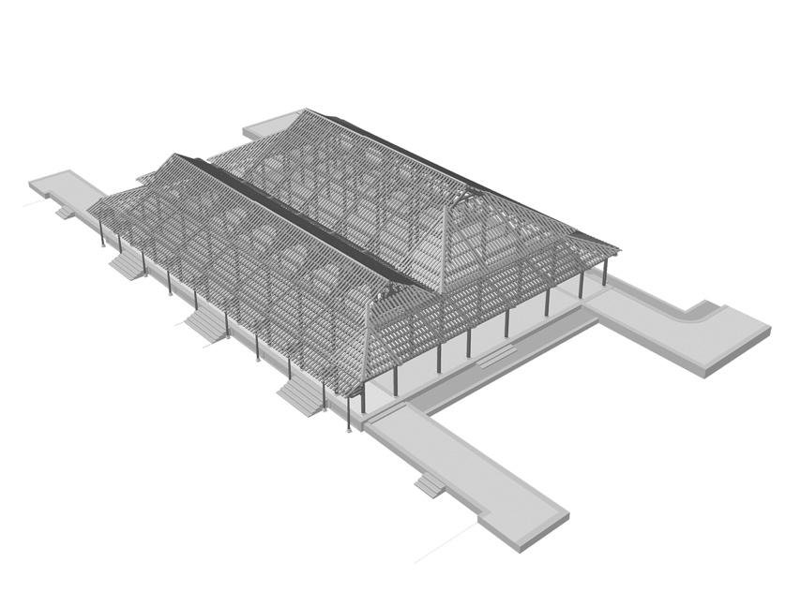
Finally, the rafters are laying down regularly across the purlins to prepare the baseform for roof-tiles. The transoms between each of the interior spatials and doors are finally installed.

- Conclusion
As a result of conducting a comparative analysis of the relevant Twin-Buildings and a chonological observation, it was found that the were two types of designing methods for the wooden-frame: The early designing method used in the Gia Long period and the later designing method used in Minh Mang period.
By the characteristics of designing method used in Gia Long period, total height of the building will depend on the scale of its floor-plan which controlled by master site-planning of the residence in which the building is located. This method will be inconvenient if the building is constructed not agrees with the scale of previous site planning. However, the characteristic of designing method used in Minh Mang period allows to determine the total height of building without depending on the scale of its floor-plan (but still meets the harmony of the overall height in the residence), creating flexibility in operation of construction in terms of the site planning has been controlled previously.
To clearify why there were two designing methos had been created in a short period of only 20 years, we based on a synthesis of research from historical, cultural, social and polictical perspectives, then intentially considered that the Gia Long period was the postwar peace period, so it is understandable to inherit the construction techniques that existed before to quickly stabilize the country. However, in the Minh Mang period (after 20 years experienced), the standardization and simplification of architectural designing method and construction technique are necessary to ensure the construction progress of the capital city and minimize construction costs. Therefore, the designing method used in Minh Mang period (from an industrialization perspective) will be the more optimal method than the method used in Gia Long period. This is evidenced through the history of planning and construction of the Monuments.
References
- Trần Quốc Vượng, 2003. “Xứ Huế dưới góc nhìn Chính trị Văn hoá” (Hue area observed from the Geo.Politics angel), Tạp chí Di sản Văn hoá (Vietnam national Cultural Heritage magazine), No 3, Hanoi 2003, p. 5.
- Li Tana, 1998. Nguyen CochinChina – Southern Vietnam in the Seventeenth and Eighteenth Centuries, Cornell University, Seap, New York 1998, pp. 11-17, 139-154.

- Cabinet of Nguyen dynasty, 欽定大南會典事例正編, 工部, 巻205; 大南一統志, 京師, 卷1.
- UNESCO World Heritage List, Website: https://whc.unesco.org/en/list/678 (Description is available under license CC-BY-SA IGO 3.0)
- Cabinet of Nguyen dynasty, 欽定大南會典事例正編, 工部，巻205, 207, 208, 209, 210, 222; 欽定大南會典事例続編, 工部，巻44; 大南寔録正編, 紀1 – 6.
- Cabinet of Nguyen dynasty, 大南一統志, 京師, 卷1; 大南寔録, 紀1, 巻23.
- Cabinet of Nguyen dynasty, 大南寔録, 紀1, 巻43.
- Cabinet of Nguyen dynasty, 大南寔録, 紀1, 巻59; 大南寔録, 紀2, 巻64, 73, 169; 欽定大南會典事例正編, 工部，巻205.
- Cabinet of Nguyen dynasty, 欽定大南會典事例続編, 工部，巻44.
- Cabinet of Nguyen dynasty, 欽定大南會典事例続編, 工部，巻44.
- Cabinet of Nguyen dynasty, 大南一統志, 京師, 卷1.
- Thái Văn Kiểm, Cố Đô Huế, Sài Gòn 1960, pp. 64.
- Nguyễn Bá Chí, Compte-rendud’une mission a Hué, DÂN VIỆT NAM, No. 1, Ecole Française d’Extrême-Orient, Hanoi,1948, pp. 81-85..
- Cabinet of Nguyen dynasty, 欽定大南會典事例正編, 工部，巻205.
- Cabinet of Nguyen dynasty, 欽定大南會典事例続編, 工部，巻222.
- Nakazawa Shin-Ichiro, “ものさしの用い方と単位長さについて” (Regarding to the Traditional Rule and Unit for measurement) ヴィエトナム・フエ・阮朝王宮の復原的研究（No. 5）, 日本建築学会大会学術講演梗概集F-2,1996, pp. 491-492; Phan Thanh Hải, “Hệ thống thước đo thời Nguyễn” (Measurement units of the Nguyen dynasty), Magazine of Hue Study, Vol. 5, Hue Research Center 2003, pp. 319-327; Nguyễn Đình Đầu, “Nghiên cứu Địa bạ triều Nguyễn” (Study on the Land Register of Nguyen dynasty), Thua Thien province, Ho Chi Minh City Publisher, 1997, pp. 42-43.
- Cabinet of Nguyen dynasty, 欽定大南會典事例正編, 欽定大南會典事例正編, 大南寔録正編, 大南一統志.
- Cabinet of Nguyen dynasty, 欽定大喃會典事例正編、巻205、葉29.
- Le Vinh An, “太和殿の基壇葛石” (Regarding to the Boundary Stones of Thai Hoa Dien Palace), ヴィエトナム・フエ阮朝王宮の復原的研究（No.139）, Japan 2008.
- Le Vinh An, Reconstruction study on the Plan and Section of the “Can Chanh Dien” main palace of the Nguyen dynasty (Doctor thesis), Waseda University, Tokyo 2009, page 77-83, table III.13, 14, 15, drawing III.9, 10, 11, 12.
- Rosowsky DV, Ellingwood BR. Performance-based engineering of wood frame housing: Fragility analysis methodology. Journal of Structural Engineering. 2002 Jan;128(1):32-8.
- Kirkham WJ, Gupta R, Miller TH. State of the art: Seismic behavior of wood-frame residential structures. Journal of Structural Engineering. 2014 Apr 1;140(4):04013097.
- Xue J, Yuan Z, Ren G, Qi L, Zhang W, Wei J., 2022. Seismic performance of glued-laminated wood frame and frame brace structure: Experimental and finite element analysis. Journal of Building Engineering. 2022 May 1;48:103944.
- Meeker L., 2013. Sounding out heritage: cultural politics and the social practice of quan họ folk song in northern Vietnam. University of Hawaii Press; 2013 Sep 30.
- Das JK, Hazarika AK, Kalita U, Khanna S, Kalita T, Choudhury S., 2020. Diversity of edible insects in a Natural World Heritage Site of India: entomophagy attitudes and implications for food security in the region. PeerJ. 2020 Nov 16;8:e10248.
- Sophady H., 2014. The case of Phnom Teak Treang and Laang Spean Cave, Cambodia: The potential for World Heritage Site nomination—The significance of the site for human evolution in Asia, and the need for international cooperation. InHuman origin sites and the World Heritage Convention in Asia 2014 Oct 27 (Vol. 39, pp. 164-178). World Heritage Papers.

