# Multidimensional and Logistic Regression Analysis of Unmet Family Planning Needs Among Women of Childbearing Age in Donga Department, Benin

**Abstract**

This article assesses the unmet needs for family planning among women of childbearing age in the Donga department, Benin, using a mixed method (quantitative and qualitative) based on data from a field survey conducted among 466 women of childbearing age in 280 households and 57 resource people. To this end, multiple correspondence analysis (MCA) and logistic regression were used to identify the profiles of women with unmet needs and the factors associated with them. The results indicate that 89.6% of unmet needs concern birth spacing, while 10.4% concern birth control. The explanatory multivariate analysis made it possible to identify the woman’s age, the ideal number of children, the type of household the woman belongs to, the woman’s area of residence, her level of education, and her main occupation as significant determinants of unmet need for birth spacing. As for unmet needs for birth control, only the woman’s age group and ideal number of children had a significant influence at the 5% threshold. In-depth interviews with resource persons highlighted that education is a central element influencing the unmet need for family planning. Thus, it is recommended to improve awareness about family planning services by promoting education for all, integrating sexual and reproductive health into school curricula, and raising awareness not only among women but also among men.

*Keywords:* Unmet needs, family planning, childbearing age, explanatory factors, logistic regression

# Introduction

Developing countries, including Benin, are characterized by very high fertility. In Benin, the results of the General Housing Population Census show that the total fertility index was

7.1 in 1982 [1]. After ten (10) years, this index declined, but very slowly. The 1992 Census therefore estimates it at 6.1 [2]. The latest 2013 Census estimates the total fertility rate at

5.9 children per woman. In addition, the Benin Demographic and Health Surveys (DHS) reveal high fertility indices, a high ideal number of children, and numerous early pregnancies, even if the latter vary greatly from one socio-economic group to another or whether they are urban/rural residents or inhabitants of different regions[3]. The consequences result in the precarious health of women and children, slow economic growth, poverty, overcrowding of schools and health facilities, overload of infrastructure, and depletion of natural resources[4], rates of unemployment and social inequalities continually and rapidly increasing, contributing to social conflicts. Furthermore, women of childbearing age (15-49 years) occupy more than a quarter (25.1%) of the Beninese population[5].

According to the DHS results, 33.27% of women have unwanted pregnancies, with the use of modern contraception remaining low among them. The modern contraceptive prevalence rate is 15.5% nationally and 6.2% in Donga[6]. The Donga department occupied last place nationally with a rate of 6.2%[7]. There are therefore significant unmet needs for effective family planning in the country and more particularly in the Donga department. The unmet need for family planning concerns women of childbearing age who have declared that they do not want any more children (birth limitation) and those who have declared that they want to wait two years or more before having another child (birth spacing) but who are not using any modern method of contraception. These unmet needs have direct consequences in unwanted pregnancies[8] and strongly contribute to high maternal and infant mortality rates and high growth rates, thus compromising reproductive health and therefore the good of the population[6].

Meeting these unmet needs therefore becomes imperative to reduce the thousands of ma- ternal or infant and child deaths. Thus, numerous interventions have placed and continue to place emphasis on effective family planning, notably the use of modern methods of con- traception in the Donga department. In this sense, major international institutions have financed community development projects integrating family planning in the Donga depart- ment, notably USAID (PIHI-Com), PASS SOUROU (Enabel), ABMS/PSI, PLAN BENIN,

CARE INTERNATIONAL, SNA NGOs, etc. These structures, through their projects and programs, are very active in family planning in the department.

It is therefore normal to question the effectiveness of the community intervention strate- gies used until now in terms of family planning, given the very unsatisfactory results in the department. Satisfying family planning needs requires targeted and integrated actions, in- cluding perfect knowledge of the real factors, and explanatory information for new strategic directions of the programs implemented. Even if writings on the subject exist in Benin, literature specifically concerning the Donga department on the factors of unmet planning needs almost does not exist. This then raises questions for not only researchers but, above all, community stakeholders and public decision-makers.

What are the levels of unmet need for family planning in the Donga department? What are the explanatory factors? This ambition is therefore to answer these questions to guide the intervention strategies of the various projects/programs aimed at filling the unmet needs in family planning for the achievement of the Sustainable Development Goals (SDGs) and the well-being of the Beninese population in general and that of Donga in particular.

# Literature Review

The unmet need for family planning was first estimated by Westoff using data from the World Fertility Survey carried out between 1974 and 1984. At that time, the unmet need referred to the proportion of women in period reproductive health who report having reached the desired number of children but who do not practice contraception and who are exposed to the risk of pregnancy [9]. Using contraceptive prevalence surveys, Nortman (1982) extends the definition of unmet need to women who wish to wait at least two years before their next birth but who do not use any method of contraception. Subsequently, with DHS data, most work on unmet planning needs uses the definition used by Macro International in the context of demographic and health surveys. For Macro International, the unmet need concerns “women currently in unions who are not users of contraception and who have declared that they no longer want children (birth limitation) and those who have declared that they want to wait two years or more before having another child (birth spacing).”

During the Demographic and Health Survey (DHS), fertile women who do not use con- traception but who wish to space their next birth (spacing) or who no longer want children (limitation) are considered to have an unmet need for family planning [6]. This definition therefore targets women in unions and therefore neglects potential applicants other than women in unions. We believe that in the current context of fertility this restrictive definition does not provide lasting solutions to the problems posed by unmet needs for family planning. Indeed, non-married and sexually active women represent a significant and growing part of the population in many countries, particularly in Benin [10, 11].

Increasing urbanization and schooling, as well as exposure to the media, favor the grad- ual decline of traditional norms of sexuality, marriage, and fertility. Sexual and matrimonial practices are diversifying, and the obligation or importance of virginity at the time of child- bearing has disappeared. The frequency of women who are wives and mothers is declining in favor of the emergence of women who are mothers and children. Effective family planning, as a means of satisfying a demand for contraception, therefore does not only concern women in unions but also, and just as much, other women of childbearing age with a potential need, hence their selection for this study. Recent work on the subject in the country [4] highlights the level of education achieved and marital status as factors influencing unmet needs in terms of family planning based on data from the first three DHS in Benin. The secondary level or above has particularly stood out as required for changes to meet potential birth plan- ning needs. The study carried out in Cameroon, Burkina Faso, and the Ivory Coast among women in union identified as major factors: marital status (significant in the 3 countries), the woman’s attitude towards FP (Cameroon and Ivory Coast), the education of the woman and the attitude of the spouse (Cameroon), and as major factors, the factors of westernization (urbanization, occupation of the woman, education) in spacing, while those characterizing relationships within the couple (discussion on family planning, partner’s preference regard- ing fertility, and their attitude towards family planning) would have a greater influence on limitation needs[12].

# Materials and Methods

## Data source

The data used in this study are from a survey that we organized with our funding. The study took place in the Donga department in Benin from June 15 to July 17, 2019. The Donga department occupies the southern zone of the former Atacora department. It covers an area of 11,126 km² with a population of 543,130 inhabitants according to the fourth Population and Housing Census (RGPH-4). It has 281 villages and town districts spread across four communes, namely Djougou, Bassila, Copargo and Ouak´e. On a socio-cultural level, several ethnic groups coexist. The majority of socio-cultural groups are the Yom, the Lokpa, the Dendis, the Anii, the Nagots, the Koura, and the Kotokoli. But why organize a survey when previous work generally uses DHS data? The DHS is a large operation that uses a quantitative research approach. However, in this study, apart from the quantitative aspects, great emphasis is placed on the qualitative and especially sociological aspects of the research question to better understand the real determinants of unmet needs. Thus, we think that even if the EDS contains variables that can make it possible to analyze unmet needs in family planning, we will gain a lot from limiting this study specifically to the unmet need by studying other parameters that allow us to deepen the analyses, especially when it comes to the real determinants. The sampling technique for the quantitative part of the study was inspired by that of the DHS in Benin (a two-stage stratified cluster). The statistical units (women aged 15-49) are chosen from eligible households. An eligible household in this study is household in which there is at least one woman of childbearing age (15–49 years). Based on the sample size previously determined, 5 households are chosen randomly in each sampled village. After the choice of the first, a step of 50 m is observed before the choice of the second household. Thus, the study covered a representative sample of 466 women of childbearing age in 280 households in the four communes of the Donga department. Furthermore, the sample of actors concerned with the qualitative aspect of the study is drawn using the reasoned choice technique. Through such an option, it is the saturation threshold (the level from which all the points discussed will be sufficiently described) that is sought. In total, 57 resource people made up of health authorities, family planning program managers, health workers, social promotion centers, local authorities, civil society organizations, religious leaders, opinion leaders, and communities were affected in this aspect. The qualitative component, carried out through observations, in-depth individual interviews with resource people, and focus group discussions with homogeneous subgroups of women, men, and young people, provided explanations and information that the quantitative component did not. was unable to capture the expected results of this study. In addition, the collection of quantitative data was carried out electronically from smartphones using a digital questionnaire using CS PRO version 6.3 software. A quality control checklist and GPS position ensured the effective presence of investigators in the field and collected quality data.

## Data Analysis

Depending on the objectives of the study and the nature of the variables, we carried out univariate descriptive analyses to analyze the level of unmet needs for family planning, whether in spacing or limitation of births. We then carried out a bivariate analysis to identify possible associations between the study variable and each independent variable.

The cross-tabulations were supported by Chi-square tests to test the significance of the disparities between the different modalities. To detect the effects of factors that could disrupt these relationships (in bivariate), refine the results obtained, and classify them according to statistical units according to their proximity, we used Multiple Correspondence Analysis (MCA) using the R software. After determining the factorial axes, several key elements, including squared cosines, coordinates, and inertia, made it possible to classify women with unmet needs according to their characteristics. This analysis was reinforced by a binary logistic regression to identify the variables that determine the non-satisfaction of the needs for spacing and the limitations of births. The equation of the model to be estimated is written:

ln *p*  =*β* + *β* Resid + *β* Age + *β* Educ + *β* Occup + *β* Relig

(1 *− p*)

0

1

2

3

4

5

+ *β*6IdealParity + *β*7TypeHHold + *ϵ* (1) where *p* represents the probability of having an unmet need for birth spacing/birth limitation;

*Resid*, the place of residence; *Age*, the age of the woman; *Educ*, the level of education; *Occup*, the occupation of the woman; *Relig*, the religion; *IdealParity*, the total number of children wanted by the woman; and *TypeHHold*, the type of household. *β*0*, β*1*, · · · , β*7, the coefficients to estimate. *ϵ* represents the error term.

The coefficients to be interpreted are only those with a significant influence at the 5% threshold. After eliminating the tools and testing the quality of the models confirmed by the information criteria, we identified the net effects of each independent variable on the non-satisfaction of the need for spacing and the limitation of births. The odd ratios have been calculated for further interpretation.

# Results and Discussion

## Simple descriptive analysis

The results presented here concern levels of unmet need for family planning. The first one is related to the need for birth spacing, followed by the need for birth limitation. But first, let’s take a look at women who practice contraception.

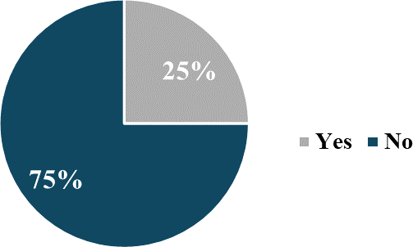

**Figure 1.** Percentage of women who have used a modern method of contraception at least once

From the 466 women interviewed, 117, or a proportion of 25%, declared having used a modern method of contraception at least once. Among the 283 women who are not yet ready to contract a new pregnancy, only 35, or a proportion of 12%, use a modern method of contraception. Furthermore, the rate of use of modern contraceptive methods among all 466 women interviewed is 7.5%. For the 117 women who used modern methods of contraception, Jadelle comes in first with 55.6%. It is followed by the new injectable SAYANA PRESS (17.1%), introduced in the department only 2 years ago. Then comes the male condom (16.2%), the pills (9.4%), and the intrauterine device (7.7%). The figure below describes the distribution of women surveyed according to whether or not they used traditional methods of contraception.

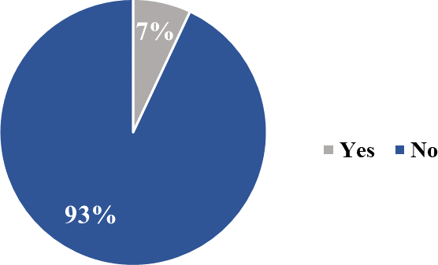

**Figure 2.** Percentage of women who have used a traditional method of contraception at least once

The rate of use of traditional methods of contraception is even lower compared to that of modern methods. Indeed, according to the results, only 7% (33 out of 466) of the respondents adopted a traditional method of contraception at least once. Among women who do not yet want to become pregnant, only 1.4% (4 out of 283) use a traditional method of contraception. An analysis of all women of childbearing age gives a rate of use of traditional contraceptive methods of less than 1% (0.85%). Most of the traditional methods adopted by the 33 women interviewed are herbal teas to drink (51.5%), prepared rings (42.4%), herbal teas to wash (24.2%), and talismans (15.2%). Figure 3 presents the level of unmet need for family planning.

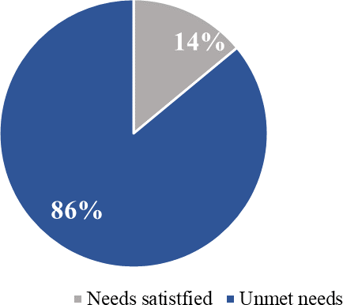

**Figure 3.** Proportion of interviewed women related to the satisfaction of their needs for family planning

Only 14% of the potential needs expressed by the women surveyed are met. In other words, among 100 women wanting to wait at least two years before becoming pregnant or those who no longer want a pregnancy, on average, 86 use neither a modern nor a traditional method of contraception. This fringe is therefore exposed to the risk of contracting a pregnancy while they do not want one (for the moment or forever). A crude analysis gives a rate of unmet needs equivalent to 45.3%. The raw analysis considers all the women interviewed, even those who do not need family planning. It is therefore pointless to analyze unmet needs in a crude manner. This is why, in the remainder of the analysis, we reported unmet needs out of all potential needs.

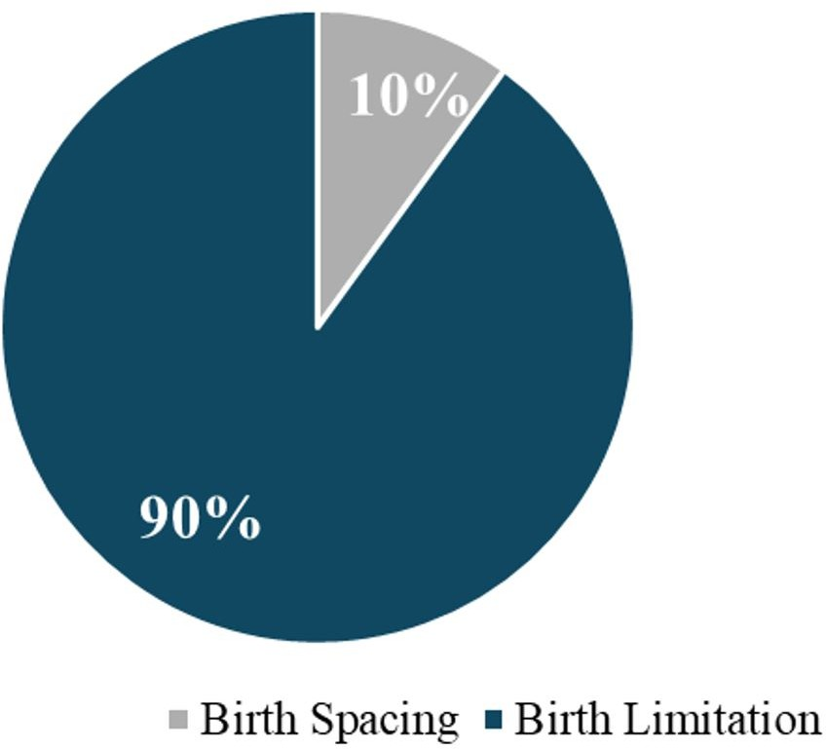

**Figure 4.** Distribution of potential family planning needs according to type

This figure shows that out of all the potential family planning needs expressed by women, the spacing needs (all women who wish to wait at least 2 years before becoming pregnant) represent 90% compared to 10%. of birth control needs (all women who no longer want

children at all). The satisfaction of these needs follows the same trend. Indeed, unmet needs for birth spacing represent 90% of unmet needs compared to 10% of unmet needs for birth limitation.

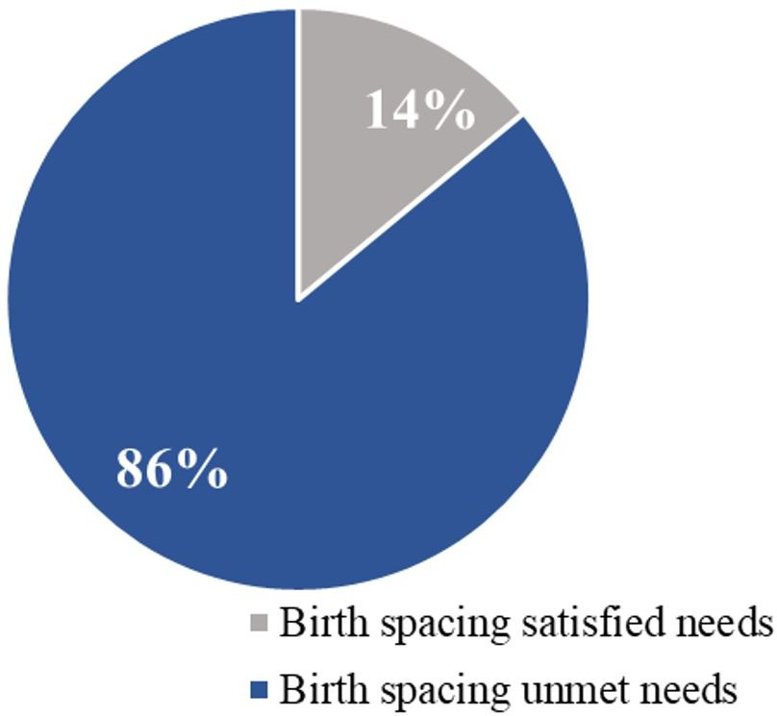

**Figure 5.** Percentage of unmet need for birth spacing

Among women experiencing a potential need for birth spacing, that is, those who want to wait at least two years before becoming pregnant, only 14% have needs met compared to 86% with unmet needs.

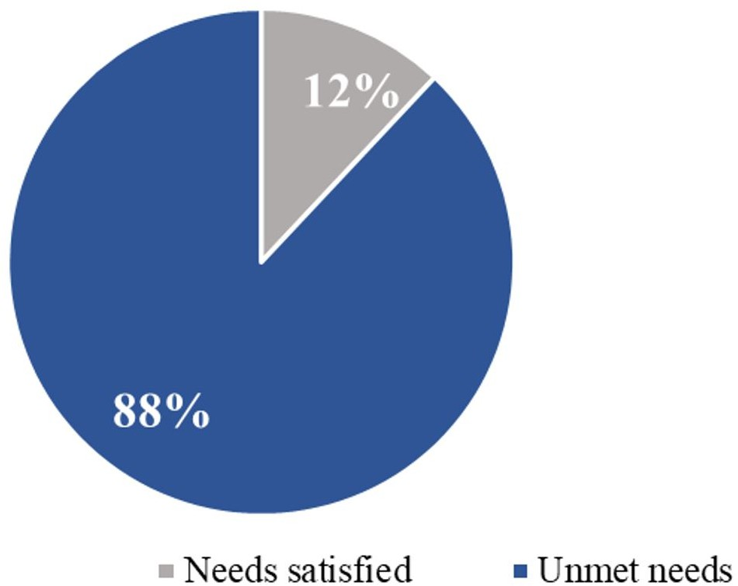

**Figure 6.** Percentage of unmet needs for birth control

Unmet needs for birth control are slightly higher than those for birth spacing. Indeed, while 14% of birth spacing needs are met, it is rather 12% of birth limitation needs are met compared to a significant gap of 88% of unmet needs. In other words, out of 100 women

who no longer want children in their lives, 88 practice sexual intercourse without taking any effective measures (adoption of a contraceptive method) against an unwanted pregnancy.

**Table 1.** Distribution of respondents according to planning needs and differentiation variables

|  |  |  |  |
| --- | --- | --- | --- |
| Variables | Unmet needs (%) | | |
| Unmet needs | Unmet needs for  spacing (%) | Unmet needs for  limitation (%) |
|  | Bassila | 65.8 | 100.0 |
|  | Copargo | 66.7 | 50.0 |
| Municipality | Djougou | 59.2 | 66.7 |
|  | Ouak´e | 80.7 | 100.0 |
|  | Total | 65.7 | 88.0 |
|  | Peri-urban | 64.0 | 90.9 |
| Place of residence | Rural  Urban | 64.3  77.6 | 81.8  100.0 |
|  | Total | 65.7 | 88.0 |
|  | 15-24 | 76.5 | 100.0 |
| Age group | 25-34  35-49 | 53.6  55.0 | 100.0  85.0 |
|  | Total | 65.7 | 88.0 |
|  | Never went to school | 57.0 | 83.3 |
| Educational level | Primary  Secondary and above | 69.9  77.2 | 90.0  100.0 |
|  | Total | 65.7 | 88.0 |
|  | Christian | 72.5 | 66.7 |
| Religion | Muslim | 64.2 | 90.9 |
|  | Endogenous religion/none | 100.0 | N/A |
|  | Total | 65.7 | 88.0 |
|  | Jobless | 64.7 | 70.0 |
| Occupation | Employee  Self-employment | 54.5  49.7 | N/A  100.0 |
|  | Pupil/student/apprentice | 89.6 | 100.0 |
|  | Total | 65.7 | 88.0 |
| Marital status | In union  Not in union | 50.6  85.1 | 85.7  100.0 |
|  | Total | 65.7 | 88.0 |
|  | 0-2 | 68.4 | 100.0 |
| Parity achieved | 3 to 5 | 56.5 | 87.5 |
|  | 6 and above | 74.2 | 85.7 |
|  | Total | 65.7 | 88.0 |
| Type of union | Monogamous  Polygamous | 47.7  55.3 | 78.6  100.0 |
|  | Total | 51.4 | 87.0 |

Whether in spacing or limiting births, unmet planning needs vary from one municipality

to another. Thus, the unmet needs for spacing are more important in the municipalities of Bassila (92.1%), Copargo (86.1%), Djougou (84.0%), and Ouak´e (82.9%). As for unmet needs for limitation, the municipalities of Bassila and Ouak´e come first with a proportion of 100% each. This means that all women of childbearing age who have declared that they no longer want children in these municipalities are not using any effective method of contraception. For Djougou, this rate is 66.7% and 50Furthermore, unmet needs for spacing are much higher in rural areas (87.4%) than in peri-urban (84.0%) and urban (83.3%) areas. This distribution is easily understood when we know that there is more accessibility to information and family planning services in urban areas (capitals of municipalities) and peri-urban areas (capitals of districts) than in rural areas (villages/hamlets). As for unmet needs for limitation, they are distributed in the opposite direction: urban area (100%), peri-urban area (90.9%), and rural area (81.8%). This inverse distribution of unmet needs for limitation is also understandable when we know that the need for birth control is higher in urban areas than in rural areas, where women want many children. It is very rare to see women of childbearing age in rural areas who want to limit their births. Moreover, a saying in our villages goes, “A woman must produce the number of children that God has placed in her womb,” a way of saying that limiting births is considered a sin in many rural areas.

The unmet need for birth spacing decreases with age. Indeed, according to the results,

women aged 15–24 have more unmet need for spacing (91.7%) than those aged 25–34 (74.5%) and those aged 35–49 (72.0%). Furthermore, unmet needs for birth control also follow the same trend. They are estimated at 100% among women aged 15-24 to 85.0% among those in the 35-49 age group. Compared to educated women, uneducated women experience a greater unmet need for birth spacing. Indeed, the unmet need for spacing is estimated at 87.9% among women who have never been to school, 86.1% among those with a primary level, and 80.4% among those with a secondary level and above.

On the other hand, the need for birth control has evolved in the opposite direction. 100% unmet need for limitation among women with secondary level and above, 90% among those with primary level, and 83.3% among those who have never been to school. This situation is explained by the fact that educated women more often tend to limit births than uneducated women. The need for limitation therefore evolves with level, while the adoption of contraception remains low at all levels. The level of education therefore influences the satisfaction of family planning needs.

Furthermore, there are more unmet needs for birth spacing among Christian women than among Muslim women surveyed (respectively 92.5% versus 83.8%). On the other hand, unmet needs for birth control are higher among Muslims than among Christians (90.9% versus 66.7%). Women who are not working and those in an apprenticeship situ- ation (pupils, students, or apprentices) experience more unmet needs for child spacing than those who are self-employed or employed. The unmet needs for spacing are 88.8% among pupils/students/apprentices, 80.5% among women who do not work, 76.6% among women who are self-employed and only 33.3% among employed women. As for unmet needs in lim- itation, they are 100% among pupils/students/apprentices and those who are self-employed, and 70% among women who do not work. There are more unmet needs for birth spacing among women not in union than those in union (respectively 88.8% versus 80.5%). The same applies to unmet needs for birth control. They are 100% among women not in union and 85% among women in union.

Women who would like to have six or more children during their reproductive life experi-

ence more unmet needs for birth spacing (87.5%) than women who want to have at most two children next (87.2) and those who want to have between three and five children (79.6%). As for the distribution of unmet needs for birth control, they decrease according to the ideal number of children. In other words, the more children women want, the less they experience the unmet need for limitation (100% for women who want at most two children, 87.5% for three to 5 years and 85.7% for six or more children).

Unmet needs for birth spacing are slightly high among women living in a monogamous regime and those living in a polygamous regime (respectively 79.5% versus 77.4%). On the other hand, unmet limitation needs are distributed in the opposite direction. While the un- met need for limitation is estimated at 100%, among women from polygamous households, it is 78.6% compared to those from monogamous households. It would be more interesting to project these results according to the factor axes.

## Multidimensional Analysis

The figure 7 below classifies women with unmet birth spacing needs (unmet need for spacing) according to their socio-demographic profiles.

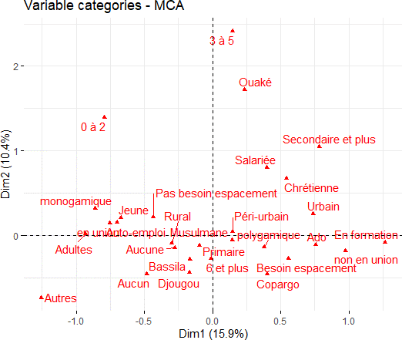

**Figure 7.** Profile of women with unmet need for spacing

This figure shows that women from peri-urban or urban areas who are educated, in training, or already have many children experience more need for birth spacing. On the other hand, those from rural areas, young people, and adults in union and without education

express fewer needs for birth spacing. With less access to family planning services, the vast majority of women think that it is God who gives the child, and it is not up to a woman to want to delay a pregnancy. This confirms the differential analysis made above. Then, we visualize in the figure below the classification of women with unmet needs for birth limitation (unmet need for limitation) according to their socio-demographic profiles.

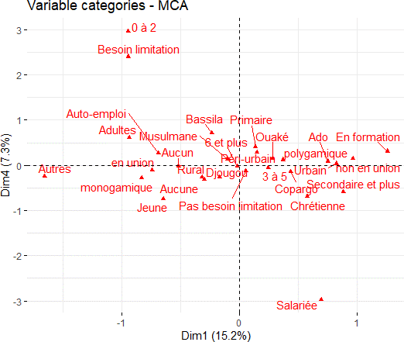

**Figure 8.** Profile of women with unmet need for limitation

Conversely, the group representing women with more unmet needs for birth control is made up of women living in rural areas, young and adult, who have no level of education, live in a monogamous household, and work for their accounts. In addition, the group representing women whose birth control needs are met includes respondents from urban/peri-urban areas, adolescents, educated (primary, secondary, and above), living in a polygamous regime, in a training situation, and who would like to have at least six (06) during their reproductive life.

## Logistic Regression Analysis

**Table 2.** Logistic Regression Analysis of Factors Influencing Unmet Needs for Birth Spacing Among Women of Childbearing Age in Donga Department

|  |  |  |  |  |
| --- | --- | --- | --- | --- |
| Unmet needs for birth spacing | Coefficient | P*>*z | Marginal effects | Odd Ratio |
|  |  |  |  |
| Place of residence | Rural  Peri-urban Urban | Ref.  -0.320721  -1.183586 | 0.276  0.01 | 0.7256257  0.3061789 |
| Groupe d’ˆage | Teen-Youth  Youth Adults | Ref.  -0.6585338  -2.19311 | 0.086  0.000 | 0.5176097  0.1115692 |
| Niveau d’instruction | None  Primary  Secondary and above | Ref.  0.0234455  -0.7913498 | 0.941  0.065 | 1.023723  0.4532326 |
| Occupation | Unemployed  Employee  Self-employment Training | Ref.  -0.7833  -0.6458834  1.224222 | 0.05  0.046  0.001 | 0.45  0.5241992  3.401518 |
| Type de foyer | Monogamous  Polygamous | Ref.  1.6042 | 0.000 | 4.973881 |
| cons | -14.05943 | 0.802 |  | 7.84E-07 |

The regression analysis results provide significant insights into the unmet needs for birth spacing among women of childbearing age in the Donga department of Benin. One of the key findings is the influence of place of residence on unmet needs for birth spacing. Women residing in urban areas are significantly less likely to have unmet needs compared to those in rural areas, with an odds ratio of 0.31, indicating a 70% reduction in the likelihood of unmet needs. This statistically significant finding (p-value = 0.01) suggests that urban women have better access to family planning resources and information. In contrast, the difference for peri-urban women, though indicating a reduced likelihood of unmet needs, is not statistically significant (p-value = 0.276), suggesting that their situation is closer to that of rural women. Age is another crucial factor affecting unmet needs for birth spacing. Adult women exhibit significantly lower unmet needs compared to teenagers, with an odds ratio of 0.11 (p-value ¡ 0.01), highlighting a drastic 89% reduction in likelihood. This could be attributed to greater experience, awareness, and possibly better access to family planning services among older women. Youth also show a reduction in unmet needs compared to teenagers, with an odds ratio of 0.52, but this finding is only marginally significant (p-value = 0.086), indicating that

while younger women are better off than teenagers, they still face considerable challenges.

Education level also plays a role, though its impact varies. Women with secondary edu- cation and above are less likely to have unmet needs compared to those with no education, with an odds ratio of 0.45, suggesting a 55% reduction in unmet needs (p-value = 0.065). However, this is only marginally significant, implying that higher education might offer some benefits, but other factors could also be at play. On the other hand, primary education

does not show a significant difference from no education in terms of unmet needs (p-value = 0.941).

Employment status significantly impacts unmet needs for birth spacing. Employed women are less likely to have unmet needs compared to unemployed women, with an odds ratio of

0.45 (p-value = 0.05), indicating a 55% reduction. Similarly, self-employed women show a 48% reduction in unmet needs (odds ratio = 0.52, p-value = 0.046). These findings suggest that the financial stability and autonomy associated with employment may facilitate better access to family planning services. Conversely, women undergoing training are significantly more likely to have unmet needs, with an odds ratio of 3.40 (p-value = 0.001), indicating a 240% increase in likelihood. This might reflect the instability and time constraints faced by women in training.

Lastly, the type of household significantly influences unmet needs for birth spacing. Women in polygamous households are substantially more likely to have unmet needs com- pared to those in monogamous households, with an odds ratio of 4.97 (p-value ¡ 0.01), in- dicating nearly a fivefold increase. This significant finding suggests that the dynamics and resource allocation in polygamous households could hinder access to family planning services. Moreover, the regression analysis results offer significant insights into the unmet needs for birth limitation among women of childbearing age in the Donga department of Benin.

**Table 3.** Logistic Regression Analysis of Factors Influencing Unmet Needs for Birth Limitation Among Women of Childbearing Age in Donga Department

|  |  |  |  |  |
| --- | --- | --- | --- | --- |
| Unmet needs for birth limitation | Coefficient | P*>*z | Marginal effects | Odd Ratio |
|  |  |  |  |
| Place of residence | Rural  Peri-urban Urban | Ref.  0.6814432  0.9702338 | 0.276  0.267 | 1.976729  2.638561 |
| Age | Teen-Youth  Youth Adults | Ref.  0.6048848  3.344215 | 0.677  0.007 | 1.831041  28.33833 |
| Education level | None  Primary  Secondary and above | Ref.  0.6066034  0.4433302 | 0.207  0.701 | 1.834191  1.557887 |
| Occupation | Unemployed  Employee  Self-employment Training | Ref.  -0.31345  0.0932051  0.2033657 | 0.7342  0.883  0.885 | 0.91019  1.097687  1.225521 |
| Ideal number of children | Less than 3  3 to 5  6 and above | Ref.  -2.832152  -3.61224 | 0.044  0.002 | 0.058886  0.0269913 |
| Type de union | Monogamous  Polygamous | Ref.  -0.8720303 | 0.178 | 0.4181018 |
| cons | -1.252265 | 0.464 |  | 0.2858566 |

One key finding is the impact of the place of residence. Women residing in peri-urban and urban areas have higher odds of having unmet needs for birth limitation compared to those

in rural areas, with odds ratios of 1.98 and 2.64, respectively. However, these results are not statistically significant, indicating that the observed differences might be due to chance.

Age is a crucial factor influencing unmet needs for birth limitation. Adult women exhibit significantly higher odds of unmet needs compared to teenagers, with an odds ratio of 28.34, indicating a substantial increase. This finding is statistically significant (p-value = 0.007), suggesting that adults face considerably more challenges in meeting their birth limitation needs. In contrast, youth women have higher odds compared to teenagers, but this difference is not statistically significant, indicating that the challenges faced by youth women might not be as pronounced or reliable.

The level of education also affects unmet needs for birth limitation, though its impact varies. Women with primary education have higher odds of unmet needs compared to those with no education, but this finding is not statistically significant. Similarly, women with secondary education and above have higher odds compared to those with no education, but this result is also not statistically significant. These findings suggest that education level alone may not be a strong determinant of unmet needs for birth limitation in this context.

Employment status shows varied impacts on unmet needs for birth limitation. Employed women have slightly lower odds of unmet needs compared to unemployed women, but this result is not statistically significant. Self-employed women have slightly higher odds, and women in training have even higher odds, but neither finding is statistically significant. These results indicate that employment status might not have a strong or consistent influence on unmet needs for birth limitation among these women.

The ideal number of children significantly influences unmet needs for birth limitation. Women who consider 3 to 5 children as ideal have significantly lower odds of unmet needs compared to those who consider less than 3 children as ideal, with an odds ratio of 0.06. This finding is statistically significant (p-value = 0.044). Similarly, women who consider 6 or more children ideal have even lower odds, with an odds ratio of 0.03 (p-value = 0.002). These results suggest that cultural norms and personal preferences regarding family size are crucial factors in determining unmet needs for birth limitation.

Finally, the type of union, whether monogamous or polygamous, also influences unmet needs, although the results are not statistically significant. Women in polygamous unions have lower odds of unmet needs for birth limitation compared to those in monogamous unions, with an odds ratio of 0.42. This suggests a potential influence of household dynamics on family planning needs, although the lack of statistical significance indicates that further research is needed to confirm this finding.

# Conclusion

The results indicate that several women interviewed are at risk of contracting a surprise pregnancy. Indeed, among women who are not yet ready to contract a new pregnancy, only 14% use a modern method of contraception, compared to 86% at risk of contracting a sur- prise pregnancy. In all the potential needs for family planning expressed by women, unmet needs for birth spacing represent 89.6% of unmet needs compared to 10.4% of unmet needs for birth limitation. Unmet needs for birth control are slightly higher than those for birth spacing. There are several motives or reasons behind surprise pregnancies: ignorance or lack of awareness of the benefits of family planning and fear of the side effects of modern methods

of contraception. The majority of women interviewed (53.9%) prefer natural methods of con- traception described as ineffective, given their complexities in terms of the need for vigilance for the correct calculation of the fertile period or the need for good memory to avoid errors. forgetfulness and pressure on oneself to effectively practice periodic abstinence.

The study highlights significant disparities in unmet needs for birth spacing based on res- idence, age, education, employment, and household type. Urbanization, adulthood, higher education, and employment are associated with reduced unmet needs, while being in train- ing or in a polygamous household increases the likelihood of unmet needs. These findings underscore the need for targeted interventions to address the specific challenges faced by different groups, particularly in rural and peri-urban areas, among teenagers, women with lower educational attainment, and those in polygamous households.

Furthermore, the analysis highlights several significant factors affecting unmet needs for birth limitation. Adult women face considerably higher unmet needs compared to teenagers, while cultural norms around ideal family size significantly reduce unmet needs for those pre- ferring larger families. Other factors such as place of residence, education level, employment status, and type of union show trends that warrant further investigation but do not have sta- tistically significant impacts in this study. These findings underscore the need for targeted interventions, particularly focusing on adult women and addressing cultural norms related to family size, to effectively meet the birth limitation needs in the Donga department.

**Data availability:** The data can be obtained from the corresponding author (on request).

**Ethics Statement:**This research does not require ethical approval.

# References

1. I. N. de la Statistique et de l’Analyse E´conomique, *Rapport premier recensement g´en´eral de la Population et de l’Habitat*. Cotonou: INSAE, 1983.
2. ——, *Rapport deuxi`eme Recensement G´en´eral de la Population et de l’Habitat (RGPH2)*. Cotonou: INSAE, 1993.
3. J. BREMNER, “Understanding population projections: assumptions behind the num- bers,” *Population Reference Bureau*, 2014.
4. M. A. Sanni, “Niveaux et tendances des besoins non satisfaits deplanification familiale au b´enin: Facteurs explicatifset changements dans le temps,” *African Population Studies*, vol. 25, no. 2, 2011.
5. M. de la Sante, *Strat´egie Nationale Multisectorielle de la Sant´e Sexuelle et de la Re- production des Adolescents et Jeunes 2018-2022, plan op´erationnel*, Cotonou, DSME, B´enin, 2017.
6. Institut National de la Statistique et de l’Analyse E´conomique (INSAE) et ICF, *Enquˆete D´emographique et de Sant´e au B´enin, 2017-2018*. Cotonou, B´enin et Rockville, Mary- land, USA: INSAE et ICF, 2019.
7. Direction D´epartementale de la Sant´e Donga, *Enquˆete Lot Quality Assessment Survey (LQAS)*, 2018.
8. Direction D´epartementale de la Sant´e Mono, *Grossesse en milieu scolaire : Pr´evalence et facteurs associ´es dans les d´epartements du Mono-Couffo, Recherche Action*, Lokossa, 2018.
9. C. F. Westoff and A. Bankole, “Tendances de la demande de limitation des naissances dans les pays en voie de d´eveloppement,” *Perspectives Internationales sur le Planning Familial*, pp. 29–35, 2000.
10. M. D. Baranon, T. C. Kollie, M. A. S. Ishag, M. A. Ofori, Y. Bouzir, and A. K. Lan- gat, “Premarital fertility in benin: Trends and disparities,” *Int. J. Res. Publ. Rev. J. homepage* [*www.*](http://www/) *ijrpr. com ISSN*, vol. 4, no. 7, pp. 35–39, 2023.
11. M. D. Baranon, A. T. Nahini, C. Ayena, A. M. Soglo, and T. C. Kollie, “Spatio-temporal trends and patterns of synthetic fertility index across african countries: A comprehensive analysis from 1950 to 2023,” *East African Journal of Interdisciplinary Studies*, vol. 7, no. 1, pp. 89–105, 2024.
12. E. M. Akoto, B. O. Tambashe, A. Amouzou, and A.-M. R. Djangone, “Besoins non- satisfaits en planification familiale et transition contraceptive au burkina faso, au camer- oun et en cˆote d’ivoire,” 2002.