Balance Circumstances of Planetary Atmospheres and Causes of Gaseous Escape and Collapse of Earth's Ozone Layer

**Abstract:** Understanding the mechanism of the planetary atmosphere and the forces involved in balance circumstances may help to know how gaseous escape occurs and guide the ways to reducing its rate via preserve the most important factors of Earth’s ecosystem, where the balance circumstances of the planetary atmosphere can be defined as the balance among a group of dynamic and static forces that determines the volume and pressure of gases of the planetary atmosphere. The first force is the gravitational force of the planet that attracts gases from space to confine them within the range of the planet's gravitational field, and the value of this force varies in the planets of the solar system, due to the differences in their masses. The second main force is the thermodynamic effects that generated as a result of the gaseous expansion that depends on the value of their temperature due to the increase in the kinetic energy resulted of the atomic and molecule collision of the gaseous elements of the atmosphere and their values change according to the value of the planet's temperature that resulting of their differences in their distances from the Sun, all planetary atmospheres have a specific state of equilibrium within the different circumferences, physic characteristics of elements and amount of gases in the atmosphere, the total result of these forces is determines the specific feature of the balance circumstances of each planetary atmosphere according to the value of the planet's gravitational force and the value of generated dynamic forces due to the expansion of gases according to the temperature of the planet as well as the physical characteristics of atmospheric elements such (boiling, liquefaction and solidification temperature) that differs according to the physical properties of elements that are strongly affected by their mass weight, and this permits certain elements to be existed in the range of their gravity according to the value of their gravitational force and the value of the generated dynamic forces due to the rates of gases expansion as a result of the sharp increase in temperature, in the state of failure of the balance that leads to the escape of light gases to space, other sorts of elements existed in their atmosphere, that have greater mass weights due to their higher influence of the gravitational force, in the state of failure of the balance that leads to the escape of light gases to space, due to overcome the thermodynamics effects upon the gravity effect leads to form a new feature in the balance to determine sorts of elements may existed in their atmosphere, that have greater mass weights to be effected by its gravitational force, creating a new system in the planetary atmosphere have different standards in the balance circumstances, this leads to the expansion of the volume of the atmosphere of the first layer (Troposphere) and leads spreading of atmospheric elements to the second and third layers (Stratosphere and Mesosphere) gradually as an atomic diffusion under pressure leading to the gaseous escape and the collapse of the Ozone layer of the atmosphere of Earth, therefore atmospheric gases cannot be considered as a merely free gases in space, as much as they can be likened to the pressure vessel limited by the planetary gravitational force, and any imbalance in the balance factors leads to failure in the system of the pressure vessel of the planetary atmosphere.

Keywords: planetary atmospheres, balance circumstances, gaseous escape, system of the planetary atmospheres.

1. **Introduction:** Studying the physical properties of gases under different conditions and values of temperatures and pressures according to the thermodynamics laws guides us in understanding the mechanism of balance circumstances in the atmosphere of the planets of the solar system, which is in a state of balance between the magnitude of the planet’s gravitational force and the extent of the thermodynamic effect of atmospheric gases, which is strongly affected by the rates of the temperature of the planet which is determined by the planet’s distance from Sun, Emphasis should be placed on secondary factors such as the effect of the atomic gravitational field of gaseous elements, as an extreme drop in temperature in planets far from the Sun leads to decreased rates of motion and activity of atoms, this leads to the activation of the force of the atomic gravitational field to attract atoms to each other reducing the distances among them and increase their density, causes the formation of high-density masses of gases attracted forcedly by the gravity force of planet greater than the effects of the same gases on planets have a higher temperature, that rises the atomic kinetic activity which leads to decrease their density, therefore planets that are fared from the Sun such as (Saturn, Jupiter, Uranus and Neptune) have a thick atmospheres, while the planets that are close to the Sun such as (Mercury, Venus, Earth, and Mars), their temperature rates rises and suffer of higher rates of gaseous escape, due to the increase in the thermodynamic activity of gases at high rates of temperature, causing high-pressure force that overcame planet’s gravitational force. The rising pressure in the lower atmospheric layers such as (Troposphere) affected by increasing temperature, and reduction of density and an increase in the volume of gases in the Troposphere leads to rise these expanded gases to heights altitudes such as the (Stratosphere) leads to rebalance the atmospheric pressure according to the value of the gravity force of the planet. The value of the generated pressure due to of this expansion rises the value pressure in the Troposphere layer pushes gases toward the upper layers in the Mesosphere and Thermosphere that cause rushing gases of these layers towards space in atomic diffusion under pressure, which causes gaseous escape from Earth's atmosphere to the space. The effect of atomic diffusion leads to an acceleration of the spread of atmospheric elements in the lower layers (Troposphere and Stratosphere) towards the upper layers (Mesosphere and Thermosphere) as a result of a decrease in their concentration in the higher layers after the gaseous escape in large quantities from (Mesosphere and Thermosphere) to the space, due to the effect inertia feature of materials, also due to the acceleration of the speed of the Earth in space in its orbit around the Sun, where the elliptical orbit of Earth results changes in Earth’s velocity, because Earth’s speed gets to its minimum rates when the Earth is at the farthest distance from the Sun 152 million km and equal 29.29 km/sec after that point speed begins to accelerate gradually, where the speed reaches the highest value when the distance gets the closest value to the Sun at 147 million km and equal to 30.29 km/sec, these changes in the speed confuses the stability state of the gases in the atmosphere, especially at the point where the speed begins to accelerate to higher limits, because the mass of gases in the atmosphere generates momentum that obstructs their acceleration with the same value of the acceleration of Earth and resist that speed change momentarily, leads to the failure of catching gases of the atmosphere up with the Earth leaving them behind its path in the space, causing the phenomenon of gaseous escape, in the meantime, the mechanical effect of the bombardment of solar energy particles on the upper layers of the atmosphere (Mesosphere and Thermosphere) pushes gases elements away, especially in the limits of the apogee of the Earth when the distance between the Earth and the Sun is as at closest value (147 km million), where the density of solar particles increases in the space to its higher rates. Planets that have close distances to the Sun such as(Mercury, Venus, Earth, and Mars) suffers of greatest rates of gaseous escape from the planetary atmosphere, and escaped gases are often from the group of light elements (low mass weight) in the periodic table, so any increase in temperature may increase the value of generated pressure and volumetric expansion of the gases of the atmosphere, forms a pressure upon the upper layers of the atmosphere, which causes the displacement of gases in the upper layers to areas in the higher altitudes (lower gravity forces) leads them to be rushed into the space resulting the gaseous escape, where the time factor which represents the age of the planet, the temperature of the surface of the planet, which is affected forcedly by their distances from the Sun, the time range of exposure of the surface of the planet to Sun radiation (number of hours of the day and night) resulting from the speed of spinning of the planet, and the amount of heat gain and heat loss, speed of rushing in their orbit around the Sun, because of the balanced circumstances of the planetary environment based upon two main factors, the first effect of the gravity force of planets that works to confine gases within its gravitational field range, and the second is the effect of the thermodynamic

processes of gases at high rates temperature which works against the effect of gravity which pushes the gases of the atmosphere to expand and overcome the effects of gravity force and to be escaped to the space. The relationship between these two forces on the value of atmospheric pressure and the rate of planetary gaseous escape, rushing of the solar system in space in its orbit around the centre of the galaxy Milky Way it collides with clouds of gases, which mostly consists of Hydrogen and its isotopes (Deuterium and Tritium) Helium and some other elements, a high percentage of these materials gets attracted to the gravitational field of the Sun due to its immense gravity force, to be consumed in its core to generate the heat by nuclear fusion, some percentage of them collides with the gravitational field of the planets in the solar system (Saturn, Jupiter, Uranus and Neptune and Pluto).

# The factors that have influenced upon state of balance circumstances of the planetary atmosphere:

There are many physical factors, material properties, and thermodynamic effects as well as the planetary gravitational force, as shown in Illustration 1, where the effects of the planetary gravitational force and the thermodynamic effect of atmospheric gases upon the value of atmospheric pressure collectively participate in balanced circumstances of the planetary atmosphere, these effects can be summarized in a set of points as follows:

1. **The effects of the gravity force upon the value of atmospheric pressure:** The greater mass of the planet creates the greater gravitational force that pulls and confine gases from the space in greater pressure towards the surface reducing the possibility of escaping gases from the atmosphere, according to the equation for universal gravitation theory of Newton[1], the greater mass creates a greater gravitational force in space, which attracts gases from space with a greater force toward the surface, according to the equation for the universal gravitation theory of Newton:

F= G. (m1.m2)/ d2 …….1

Where F is the gravitational force acting from the planet to the material of gases, m1 = mass of the planet, m2 = mass of atmospheric gases, and d is the distance between the centres of the planet to the centres of different elevations of the atmosphere and G is the gravitational constant = 6.674×10−11 N⋅m2/kg2.

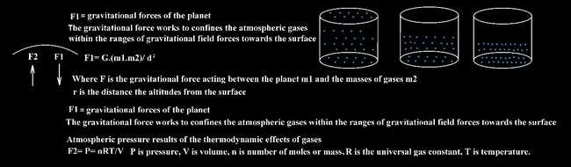

*Illustration 1 shows the effects of the two forces of the planetary gravitational force and the thermodynamic effect of atmospheric gases on the value of atmospheric pressure.*

1. **The effects of the thermodynamic of gases upon atmospheric pressure:** The first group of the solar system planets (Mercury, Venus, Earth, Mars) which are close to the Sun, due to the increase of their distances from the Sun, decreases received heat from Sun that have the thermodynamic effects upon gases of the atmospheric to expand at the limits of gravity fields to generate a specific value of atmospheric pressure, according to the universe ideal [2] gas equation:

PV=nRT 2

Environmental factors that represent variables and constant in the ideal gas equation PV = nRT where P is pressure, V is volume, n is the amount of substance (n amount of gases in the atmosphere), T is the temperature and R is a constant = 8.31446261815324 [J](https://en.wikipedia.org/wiki/Joule)[⋅K](https://en.wikipedia.org/wiki/Kelvin)−1[⋅mol](https://en.wikipedia.org/wiki/Mole_(unit))−1, as shown in the Illustration 2 the effects of the planetary gravitational force and the thermodynamic effect of atmospheric gases on the value of atmospheric pressure.

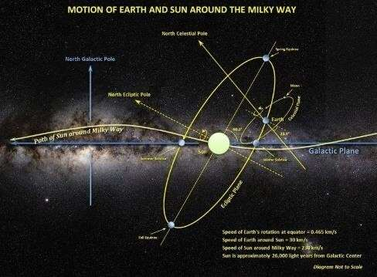

*Illustration 2 shows the motion of solar system around the centre of Milky Way [3].*

1. **The effect of rates temperature:** The nature and state of balance of the planet’s atmosphere play the main role in sort of the planet’s atmosphere and then the nature of the conditions on the surface, because the value of their pressure determined by the rates of the temperature of the environment of Earth due to their thermodynamic properties which may be calculated via the ideal gas equation PV = nRT, where P is pressure, V is volume, n is the amount of substance, T is the temperature and R is a constant (8.31446261815324 [J](https://en.wikipedia.org/wiki/Joule)[⋅K](https://en.wikipedia.org/wiki/Kelvin)−1[⋅mol](https://en.wikipedia.org/wiki/Mole_(unit))−1), therefore, the significant increase in temperature due to the planet’s decrease the approaching distance to the Sun or the effects of global warming leads to an increase in the volume and pressure of gases Troposphere, leading them to be raised from their original layers in the lower layers such as Troposphere, to ne rush towards higher altitudes such as Stratosphere to restore a state of balance between the magnitude of the planet's gravity force and the thermodynamic effect the atmospheric gases to restore standard value of the atmospheric pressure to the stable value that equal 101.325 kPa. The temperature factor plays an effective role in determining the amount of planetary atmospheric pressure in addition to rest of factors such the values of the gravitational force of the planet and the amount of available gases in the atmosphere, this is the reason why the atmospheric pressure on Mars planet drops to 4% of value than Earth's atmospheric pressure, because the low temperatures, on Mars winter, is around (-153 Centigrade Celsius) leads the atmospheric gases to shrink and reduce their generated pressure upon the surface, so that phase transformation of atmospheric gases guide them to be transfer (some gases such as carbon dioxide) into solid phase (Carbon frost), get its effect completely out from the rest of effect of rest gases in the Mars atmosphere, in addition the low value of the gravity force of the Mars, which is (3.721 m/s²), which is unable to attract some relatively low weight elements gases such as Oxygen (atomic mass 15.999 u) and Nitrogen (atomic mass14.0067 u), which are abundantly available in the Earth’s atmosphere due to the relatively high value of the Earth’s gravity force that equal 9.807 m/s², which is able to attract these two gases forcedly to confine them within the Earth's atmosphere elements. There is a proportional relationship between the temperature rate of the planet and the rate of gaseous escape from the atmosphere, as the higher temperature rate of the planet (because of its distance from its star and the eruption rate of the star), according to the proportional relationships among the volume, the temperature, the pressure, and the amount of a gas can be combined into the ideal gas equation PV = nRT.
2. **The effect amount of gases:** increasing the amount of gases in the atmosphere leads to increase the thermodynamic effects, due to increase in the rates of the kinetic energy resulted of the atomic and molecule collision of the gaseous elements of the atmosphere and their values change according to the amount of gases, for example large quantities emission of high molecular weight of industrial gases into the atmosphere disturbs the state of balance and raises the pressure, which leads to pushing light gases such as Oxygen and Nitrogen into the higher layers to restore the value of the atmospheric pressure and restore the state of balance between the two mentioned forces. The specific conditions of balance circumstances of the planetary atmosphere of each planet lead to the formation of different environmental conditions of the values of atmospheric pressure and creating specific environment conditions for each planet and different rates of gaseous escape, where the rates of the gaseous escape in the Earth's atmosphere at moderate rates due to the moderate rates of gaseous expansion which results from the thermodynamic effects of gases at the limit of the temperature of Earth (average 15 °C) this expansion overcoming the value of the Earth's gravitational force that equal 9.807 m/s² and pushes gases towards space at moderate rates comparing with the rates gaseous escape from the atmosphere of Mercury, Venus, and Mars.
3. **The range of the active gravity field:** The gravitational force of the planet that attracts gases from the space to confine it within the range of the planet's gravitational field which considered V or the volume in the ideal gas question, therefore atmospheric gases cannot be considered as a merely free gases in space, as much as they can be likened to the pressure vessel limited by the planetary gravitational active field, and any causes results disturb the balance factors leads to the failure in the system of the pressure vessel of the planetary atmosphere.
4. **Physical characteristics of gases:** The atmospheres of the planets are at state of balance between the value of the gravity force and the value of the thermodynamic forces of their atmospheric gases generated within their various circumstances, where the thermodynamic effects are affected by the physical properties of the elements of the atmosphere and the amount of gases that present in the atmosphere, and the final result of these forces determines the specific character of the equilibrium conditions for each planetary atmosphere, the rates of the generated thermodynamic forces are the result of the expansion of gases according to the planet's temperature, as well as the physical properties of their elements such as (boiling, liquefaction, and solidification temperature), which differ according to their atomic mass, and this allows the presence of certain elements in the atmosphere according to the value of the gravity force and the limits of thermodynamic forces generated according to their temperature rates.

# The similarities and differences between the gravity force and the thermodynamic action that forms the planetary balance circumstances:

|  |  |  |
| --- | --- | --- |
|  | **Effects of Gravity force.** | **Effects of Thermodynamic processes.** |
| 1.  2. | The value is stable at any point in the gravity field according to the value mass of the planet.  Mathematical relationship is:  F= G. (m1.m2)/ d2  Where m1is mass of Earth, m2 is the mass of atmospheric gases, d is the distance between the centre of Earth and the middle of the atmospheric layer and G is the gravitational  constant = 6.674×10−11 N⋅m2/kg2 | The value is variable and depends upon variables mentioned in the ideal gas relationship such as T temperature, n is the amount of substance.  Mathematical relationship is: PV=nRT  Where P is pressure, V is volume, n is number of moles or mass R is the universal gas constant, T is the temperature and R is a constant = 8.31446261815324 [J](https://en.wikipedia.org/wiki/Joule)[⋅K](https://en.wikipedia.org/wiki/Kelvin)−1[⋅mol](https://en.wikipedia.org/wiki/Mole_(unit))−1. |

|  |  |  |
| --- | --- | --- |
| 3.  4.  5.  6.  7.  8.  9. | Its value is not affected by the distance of the planet from the Sun.  The affected elements are gases with the higher molecular weight due to their greater influence by the gravity force.  Mass of atmospheric gases represents (m2) in the equation F= G. (m1.m2)/ d2  Affected by the gravity of the planet and molecular weight of gases.  Can exist without the gases and their effects on the thermodynamic action  An extreme increase in its value leads to the confinement the atmospheric gases in a greater density and in lower ranges in the space of the planet as in the planet Jupiter.  The direction force is towards the surface of the planet (1D) | Its value is affected by the distance of the planet from the Sun due to the changes in the intensity of radiation and heat in each distance from the Sun.  The affected elements are the greater thermal expansion coefficient.  Mass of atmospheric gases represents (n) the amount of substance in the equation PV=nRT  Affected by the temperature and the physics characteristics of gases.  Cannot exist without the effect of the gravity force of the planet that confines gases, therefore it’s the reactionary force of the effects of gravity force on the masses of gases.  An extreme increase leads to the collapse of the equilibrium system as in the planet Mercury.  The direction force is toward all dimensions in the atmosphere (3D). |

*Table 1 the common and different factors between the two effects the gravity and the thermodynamics processes upon the planetary atmosphere.*

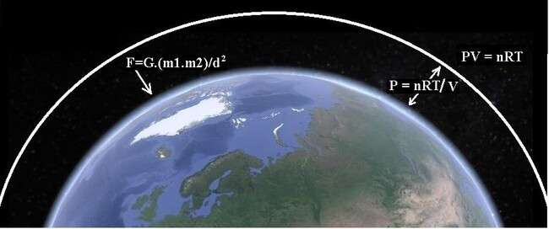

*The illustration 3 shows the balance circumstances between the two main forces in Earth’s atmosphere the gravity force of Earth’s mass to the gases and thermodynamic processes to rise the pressure and the volume gases.*

According to the second law of thermodynamics states that a spontaneous process will increase the entropy of the universe, because entropy is typically defined as either the level of randomness of a system and measure of the energy dispersal of the molecules in the system according to Ludwig Boltzmann theory [4], the entropy for the gases depend on the kinetic energy at a particular thermodynamic state to expand and the resulting increase in the number of possible arrangements is an increase in the randomness of the system and increases the entropy, this could be calculated via Boltzmann equation:

S = k.lnW 3

Where k is the Boltzmann constant (k = 1.380 649×10−23 J K−1) and ln is the natural logarithm function W is the number of real microstates corresponding to the gas's microstate, therefore any change that results in a higher temperature, more molecules, or a larger volume yields an increase in entropy, as a substance is heated, it gains kinetic energy, increasing molecular motion and a broader distribution of molecular speeds. This increases the number of microstates possible for the system increasing the number of molecules in the system also increases the number of microstates to be more arrangements possible of the molecules as well, increasing the volume of a substance increases the number of positions where each molecule could increase the number of microstates, therefore any changes that result in the higher rates of temperature or more molecules or a larger volume increases entropy. The increase in the entropy of the atmospheric gases as a result of the rising the rates of the temperature leads to an increase in their total volume to be extended above their original altitudes in the atmosphere, and to restore the value of pressure and the balance circumstances between the value of the gravity force and the thermodynamic effects of the atmospheric gases, for this reason, we find that the value of atmospheric pressure on the Earth at sea level is relatively stable around the limit 101.325 kPa despite the increase and decrease in the Earth's temperatures during the four seasonal changes. On Earth`s atmosphere the water (H2O) is the only material that changes its phases among the gas, liquid, and solid phases, but on another planets this transformations occurs with the rest of the elements such as Nitrogen, Oxygen, Argon, and carbon dioxide, where the phase transformation of these elements occurs in the atmospheres such as the planets fared of the Sun such as (Saturn, Uranus, Neptune, and Pluto), where the temperature drops to an extreme range within the limits of their liquefaction temperatures. The effect of the sharp rise in the temperature on the rate of gaseous escape from the Earth’s atmosphere into space is evident. For the first four planets of the solar system (Mercury, Venus, Earth, and Mars) Illustration

3. Shows how the interaction between the two forces (the planetary gravitational force and the thermodynamic effect of atmospheric gases) determines the state of the planetary atmosphere.

1. **The total value of the atmospheric pressure on the surface of the Earth is result of the effects of the gravity force upon the mass of all layers of the atmosphere and the thermodynamic effects of atmospheric gases:** The atmospheric pressure of the Earth's atmosphere is the reaction of the gravity force of Earth to the mass gases of the atmosphere towards the surface, the rest of affecting factors of upon value atmospheric pressure are physics characteristics (coefficient of thermal expansion and contraction of atmospheric gases), which generate pressure and expansion as a result of thermodynamic processes increasing the atomic collision of the elements and gases in the atmosphere, and the temperature value that determines the Earth's distance from the Sun, and according to the ideal gas equation PV = nRT, where P is pressure, V is volume, n is the amount of substance, R is the universal gas constant, and T is temperature), when temperatures rise in warm seasons, the pressure and volume rise gases, rising the higher altitudes of the atmospheric layer and pushing towards the Stratosphere or Mesosphere and even to the Thermosphere, cause gaseous escape from the atmosphere of planet towards the space, overcoming the gravitational force of the planet, because it has become at a fared distances from the surface in which the values of the gravitational force decrease, because the value of the force of the atmospheric pressure on the surface of the Earth is the result of the attraction force of the Earth to the masses of gases of the atmosphere, the values of the atmospheric pressure at the level of the surface is the summation of the attraction forces of the Earth to the materials of all layers the atmosphere (Troposphere, Stratosphere, Mesosphere, Thermosphere), therefore to calculate the value of Earth's attractive force to the material of each layer of the atmosphere, first, the volume of the spherical layer should be calculated, where the density of each layer through the relationship density = masses/volume.

D = M/V…….4

Where D is density, M is mass, and V is volume, and the density is commonly expressed in units of grams per cubic centimetre.

We calculate the mass of each layer and then it is possible to calculate the Earth's attractive force to each layer, where the summation is equal to atmospheric pressure at sea level. The pressure of the atmospheric gases on the surface of the planets is a reaction force of the gravity force that attracts gases towards the surface, and because gases are compressible fluids, the values of atmospheric pressure change according to their distances from the surface of the planet due to decreasing the decreasing quantities of gases in the higher layers which get attracted towards the surface, until the atmospheric pressure reaches to zero pressure in space afar from the surface when there are no quantities of gases attracted via the influence of gravity to the surface and because of the effects of the thermodynamic factor of the gases their volumes decrease with the decreasing of their temperatures, which leads to decreasing the atmospheric pressure in the surface, therefore in the cold planets the thickness of the atmosphere layers decreases to composed of dense and cold gases that compress more easily due to the effect of the gravity force of the planet, therefore when the temperature rises temperatures (in the summer) the volumes of the atmospheric gases expand, because the Earth's atmosphere is not a firmly closed pressure vessel and it`s, but merely confined due to the value of gravity force, therefore it’s not possible to raise the values of pressure absolutely due to the thermodynamic effects of atmospheric gases, while Earth's atmosphere is not a firmly closed pressure vessel, but merely confined due to the value of gravity force, it’s not possible to raise the values of pressure absolutely due to the thermodynamic effects of atmospheric gases and the range of the value of the gravity force of the Earth, the illustration 4. Represents the actual dimensions of the thicknesses of Earth’s atmospheric layers Troposphere = 0 to 14.5 km, Stratosphere = 14.5 to 50 km, Mesosphere = 50 to 85 km, Thermosphere

= 85 to 600 km, Exosphere =600 to 10,000 compared to the Earth's radius = 6,371 km [5].

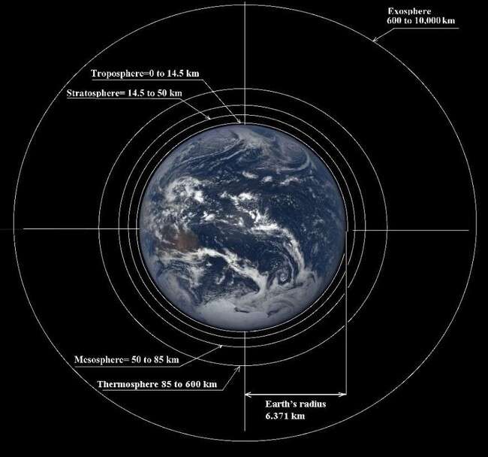

*The illustration 4 shows the actual dimensions of the thicknesses of Earth’s atmospheric layers Troposphere, Stratosphere, Mesosphere, Thermosphere and Exosphere compared to the Earth's radius.*

**Calculating the volumes of atmospheric gases according to thermodynamic theories:** Generally, Earth's atmosphere has a stable value of pressure at sea level despite the differences in the values of their volumes due to the differences in the rates of expression in the different ranges of temperatures due to their differences in their distance from the equator latitude and the Arctic and Antarctic regions, and if any changes occur in the values of their volumes as a result of changing the temperatures during the four season cycles, which leads gases to expand and contract to occupy a different volume and cause a temporary imbalance of gaseous pressure in the atmosphere, that will be equalized by moving air currents between these areas of different pressures generating wide storms and hurricanes, paradoxically, the movement of air currents on the water surfaces leads to a decrease in the temperatures of air as a result of the phase transformation of the water from the liquid phase to the gaseous phase absorbs heat to achieve this phase transformation of water in the nature, because these the phase transformation of the water occurring in the limits lower than the boiling point temperature of water under the influence of atomic or molecular diffusion, therefore this process leads to the absorption of a large amount of heat from the atmosphere to complete the requirements of these phase transformations. This leads to a further decrease in atmospheric temperatures more contractions in the volumes of atmospheric gases and more imbalances in the values of atmospheric pressure, so these currents gradually grow to form extreme changes in the values of pressure in the atmosphere leading huge masses of air to move creating destructive hurricanes, note that the origin of hurricanes is the surfaces of the oceans, where the phase transformations of the water from the liquid phase to the gaseous phase occur at the low rates of temperature which cause a decrease in temperatures, volume, and pressure of atmospheric gases, and thus the phase transformations of the water in the low rates of temperature the main resource of the energy supplies to form and growth of hurricanes.

# Steps to calculate the summation of the Earth's gravitational force to the layers of Earth's atmosphere:

1. Determine the rate of elevation of each atmospheric layer.
2. Determining the average density of each atmospheric layer.
3. Calculating the volume of each atmospheric layer through the relationship of calculating the Volume of spherical shell [6]:

Volume of spherical shell =4/3π(R³−r³) ……5

R is radius of the outer layer, r is radius of the inner layer.

1. Calculate the mass of each atmospheric layer via the relationship:

Density = Mass / Volume or Mass= Density × Volume

1. Calculating the Earth's gravitational force for the masses of each atmospheric layer via Newton's law of universal gravitation:

F= G. (m1.m2)/ d2

Where F is the gravitational force acting between Earth to the masses of each atmospheric layer

d is the distance between the centres Earth and the diddle of the elevation of each atmospheric layer, G is the gravity constant = 6.674×10−11 N⋅m2/kg2

1. Calculate the summation of the Earth's gravitational force for all atmospheric layers.
2. Calculate the applied pressure to Earth's surface through the relationship: Pressure = Force/Areas

Considering the areas the spherical areas of the Earth's surface and the result of this calculation represents the atmospheric pressure at sea level.

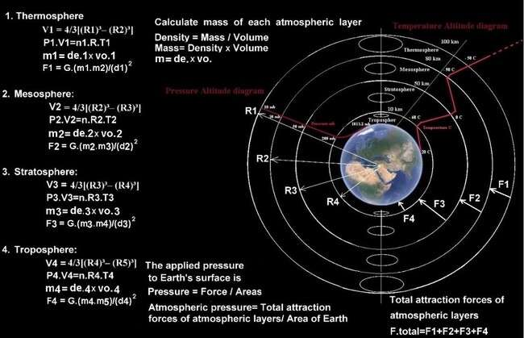

*The illustration 5 shows the layers of Earth's atmosphere with required data to calculate the summation of the Earth's gravitational force to the layers of Earth's atmosphere.*

Volume of spherical shell: V1 = 4/3[(R1)³– (R2)³] The mass of atmospheric layer m1=de.× V

The thermodynamic effects P1.V1=n1.R.T1

|  |  |  |  |
| --- | --- | --- | --- |
|  | **The thermodynamic effects of atmospheric gases:**  **P.V=n.R.T** | **The gravitational effects upon atmospheric layer:**  **F= G**. (**m1**.**m2)/** 𝐝𝟐 | **Calculate the volume and mass of each atmospheric layer: V1 = 4/3[(R1)³– (R2)³]**  **Mass= Density** ×**Volume** |
| 1. | Thermosphere | F1= G. (m1.m2)/ (d1)2 | V1 = 4/3[(R1)³– (R2)³] m1=de.1× V1  V2 = 4/3[(R2)³– (R3)³] m2= de.2× V2  V3 = 4/3[(R3)³– (R4)³]  m3= de.3×vo.3  V4 = 4/3[(R4)³– (R5)³] m4= de.4× V4 |
|  | P1.V1=n1.R.T1 |  |
| 2. | Mesosphere | F2= G. (m1.m3)/ (d2)2 |
|  | P2.V2=n2.R.T2 |  |
|  |  | F3= G. (m1.m4)/ (d3)2 |
| 3. | Stratosphere  P3.V3=n3.R.T3 |  |
| 4. | Troposphere | F4= G. (m1.m5)/ (d4)2 |
|  | P4.V4=n4.R.T4 |  |

*Table 2 the main equations could be considered to calculate the summation of the Earth's gravitational force to the layers of Earth's atmosphere.*

F.total is the summation of gravity forces between the masses of atmospheric layers and Earth.

F.total = F1 + F2 + F3 + F4 6

Atmospheric pressure = Total weight of all atmospheric layers/ Area of the surface of Earth. Atmospheric pressure = F.total / Area of the surface of Earth (The area of Earth 510.1 million km²)

= atmospheric pressure at the level of sea

|  |  |  |
| --- | --- | --- |
| P1 is pressure in the Thermosphere layer. P2 is pressure in the Mesosphere layer.  P3 is pressure in the Stratosphere layer. P4 is pressure in the Troposphere layer.  V1 is the volume of the Thermosphere layer.  V2 is the volume of the Mesosphere layer.  V3 is the volume of the Stratosphere layer. | m1 is the mass of Earth. m2 is the mass of the Thermosphere layer. m3 is the mass of the Mesosphere layer.  m4 is the mass of the Stratosphere layer. m5 is the mass of the Troposphere layer.  d1 is the distance between Earth and Thermosphere layer. d2 is the distance between Earth and Mesosphere layer. d3 is the distance between  Earth and Stratosphere layer. | V1 is the volume of the Thermosphere layer.  V2 is the volume of the Mesosphere layer.  V3 is the volume of the Stratosphere layer.  V4 is the volume of the Troposphere layer.  R1 is altitude of Thermosphere R2 is altitude of Mesosphere R3 is altitude of Stratosphere R4 is altitude of Troposphere R5 is radius of Earth = 6378 km. |

|  |  |  |
| --- | --- | --- |
| V4 is the volume of the Troposphere layer.  n1 is number of moles is the Thermosphere layer.  n2 is number of moles is the Mesosphere layer.  n3 is number of moles is the Stratosphere layer.  n4 is number of moles is the Troposphere layer.  T1 is temperature at Thermosphere.  T2 is temperature at Mesosphere.  T3 is temperature at Stratosphere.  T4 is temperature at Troposphere.  n is the amount of substance. R is a constant  8.31446261815324 [J](https://en.wikipedia.org/wiki/Joule)[⋅K](https://en.wikipedia.org/wiki/Kelvin)−1[⋅mol](https://en.wikipedia.org/wiki/Mole_(unit))−1 | d4 is the distance between Earth and Troposphere layer. d5 is the radius of Earth.  F1 is the gravity force between the mass of the Thermosphere and Earth.  F2 is the gravity force between the mass of the Mesosphere and Earth.  F3 is the gravity force between the mass of the Stratosphere and Earth.  F4 is the gravity force between the mass of the Troposphere and Earth.  G is the gravitational constant  = 6.674×10−11 N⋅m2/kg2  The mass of Earth M = 5.9722×1024 kg. |  |

*Table 3 symbols of the calculations in the table 2.*

Therefore, when the planetary atmospheric pressure increases it pushes the gases towards higher altitudes and overcome the effects the gravitational force of the planet to rebalance the atmospheric pressure that determines by the gravitational force of the planet and the thermodynamic effect of atmospheric gases.

1. **Comparison among the atmospheric balance circumstances of the atmospheres of the planets Mercury, Venus, Earth, and Mars which have close distances to the Sun:** The planet Earth has mass (5.973 x1024 kg) and the gravity acceleration force (9.807 m/s²) has an effective dynamic atmosphere resulting from the gaseous interference between the surface and the atmosphere (steam) as a result of the phase transportation due to atomic diffusion[7] at a rate of temperature lower than the boiling temperature water, Earth’s atmosphere composes generally of [Oxygen](https://en.wikipedia.org/wiki/Oxygen) 20.95% , and [Nitrogen](https://en.wikipedia.org/wiki/Nitrogen) 78.08% and some another elements in low rates such as argon 0.93%, carbon dioxide 0.04%, in the meantime the air also contains a variable amount of water vapour on average around 1% at sea level, the effects of the two forces of the planetary gravitational force and the thermodynamic effect of atmospheric gases on the value of atmospheric pressure as in the illustrations 2 in the limits of the temperature of the environment of Earth, we find that the physics properties of Oxygen and Nitrogen guide lead them to be in a gaseous phase in the rates of the temperature of the environment of Earth, composing a pressure which represents as atmospheric pressure of Earth around 1013.25 mill bars as the effect of the gravitational force of the Earth to the masses of these gases. The distance between the Earth and the Sun around 152.09 million km is not allowing the temperature of the Earth to reach to those high rates as on the planet Venus, this is why this couldn’t happen on the Earth, therefore the atmospheric pressure on the Earth 101.325 kPa is lower than the atmospheric pressure on the planet Venus (9100 kPa) despite of the higher gravity force on the surface of the Earth which around 9.807 m/s². The condition of the specific balance on the Earth remains for the elements that have the specific physical properties that allow them to expand and contract according to the available thermal ranges on the Earth, such as Oxygen and Nitrogen, where the molecules weight of Oxygen is 31.9988 g/mol and the molecules

weight of Nitrogen is 28.02 g/mol. and the illustration 6 the Nitrogen phase illustration 6 we find that state Nitrogen of supper fluid that starts at temperature -146.9 °C where the rate of temperature of Earth`s atmosphere is around 14 °C. In the illustration 7 Oxygen phase diagram shows that Oxygen is on the state of supper fluid and starts at temperature -118.57 °C where the rate of temperature of Earth`s atmosphere is around 14 °C.

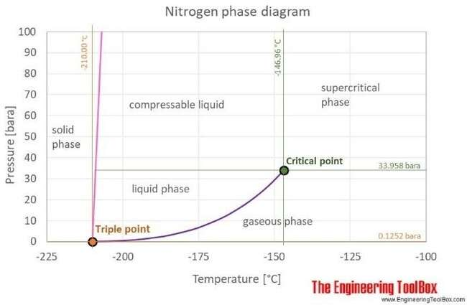

*The illustrations 6 shows Nitrogen phase diagram.*

In the illustration 7 Oxygen phase diagram [9] shows that Oxygen is on the state of supper fluid and starts at temperature -118.57 °C where the rate of temperature of Earth`s atmosphere is around 14 °C.

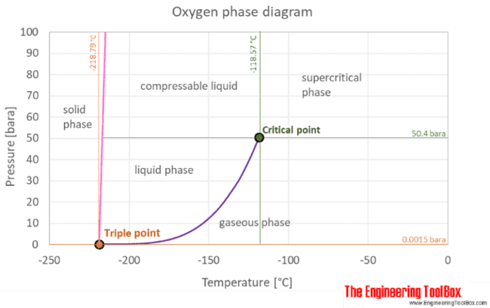

*The illustrations 7 shows the Oxygen phase diagram.*

The state of the balance circumstances of the planetary atmosphere depends on the value of the gravitational force of the planet and the average temperature of the planet as well as the type of gases in the atmosphere, which have suitable thermodynamic properties to the limits of the temperature of the planet and the gravitational force, the state of qualitative equilibrium in the Earth's atmosphere, to the elements that have physical properties that allow them to expand and contract according to the available thermal ranges on the Earth, such as Oxygen and Nitrogen according to the current rates of temperature,

and gravity on the Earth to specify the atmospheric pressure as a balance between the gravity force and the thermodynamic properties and physics circumstances, fortunately we find the order of the first group of planets of the solar system (Mercury, Venus and Earth) their masses increase according to their distance from the Sun, the illustration 8 shows the values of gravitational force and atmospheric pressure on planets Mercury, Venus, Earth, and Mars which have close distances to the Sun.

**Mercury**: Collapse of the balance circumstances due to high temperatures (the thermodynamic effect) and the decrease in the value of the planetary gravity force which is unable to confine gases in the limits of the planetary gravity field.

**Venus**: Sharp increase in the value of atmospheric pressure due to high rates of temperatures (the thermodynamic effect) within the presence of a moderate value of the planetary gravity force able to confine gases in the limits of the gravity field.

**Earth**: State of a unique balance between the two forces (the planetary gravity force and the thermodynamic effect of atmospheric gases) that supports and sustains life on Earth.

**Mars**: Reduction in the atmospheric pressure due to the sharp drop in temperature (the thermodynamic effect) and the value of the planetary gravity force.

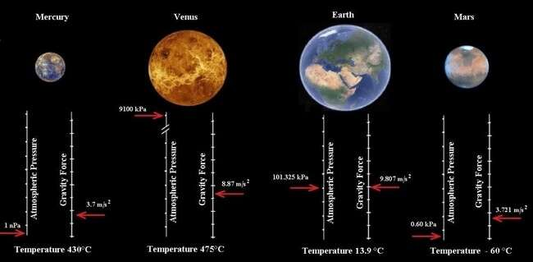

*Illustration 8 shows the values of gravitational force and atmospheric pressure on planets Mercury, Venus, Earth, and Mars which have close distances to the Sun.*

But the reason for the rising of the atmospheric pressure of planet Venus to 9100 kPa where it`s about 48 above the value of the atmospheric pressure of the Earth’s atmosphere despite its low-value gravity force of 8.87 m/s² than what is on the Earth 9.807 m/s² is due to rise in temperature rate to 475°C that rise thermodynamic effects to expand gases and rise the pressure of the atmospheric gases in its middle limit gravity force because that value is able of confining those expanded gases in limits the gravity field of planet Venus.

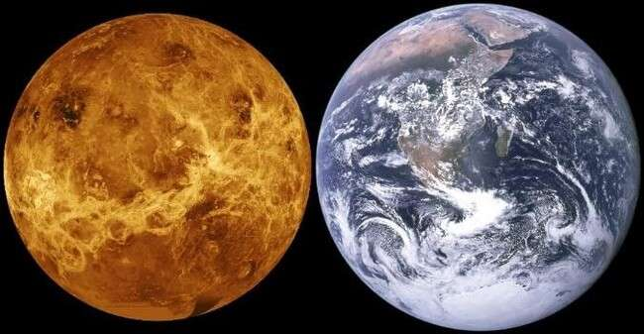

*The image 1 shows the relation of the size of Venus to size Earth.*

|  |  |  |  |
| --- | --- | --- | --- |
|  |  | Venus | Earth |
| 1. | Mass | 4.867 ×1024kg | 5.973 x1024 kg |
| 2. | Gravity | 8.87 m/s² | 9.807 m/s² |
| 3. | Temperature | 464°C | 13.9 °C |
| 4. | atmospheric pressure | 9100 kPa | 101.325 kPa |

*Table 4 shows data comparison between Venus and Earth [10].*

The distance between Venus and the Sun around 108.18 million km leads to increasing temperatures on the planet Venus which is around 464°C leading to the expansion of atmospheric gases of the planet Venus due to the thermodynamic effects of atmospheric gases, where the atmospheric pressure on the planet Venus is (9100 kPa) and greater than the atmospheric pressure on the planet Earth 92 times, the mass of Venus is less than the mass of the Earth, where the mass of Venus is 4.867 ×1024 kg and gravity force on the surface is 8.87 m/s², it’s the effect of the thermodynamic factor of the of gases. The gravity force factor of Venus upon these gases determines their volume within the gravitational field zone so that it is more like a pressure container for these gases affected by the gravitational field zone to prevent these gases from expanding their volumes leading to a rise in atmospheric pressure due to the effect of the thermodynamic of gases. Illustration 9 shows the pressure and temperature axes of the Carbon dioxide (CO2) phase diagram[11] that Carbon dioxide is in the state of supper fluid starts temperature

31.1°C where the rate of temperature of Venus`s atmosphere is around 474 °C.

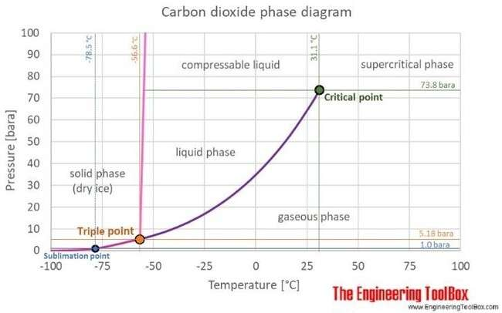

*The illustration 9 shows Carbon dioxide (CO2) phase diagram. [12]*

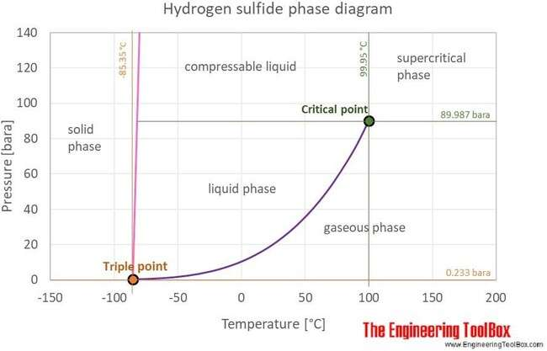In the illustration 10 shows Hydrogen sulphide [H](https://en.wikipedia.org/wiki/Hydrogen)2[S](https://en.wikipedia.org/wiki/Sulfur) diagram [12] where hydrogen sulphide is on the state of supper fluid and starts at temperature 99.95 °C where the rate of temperature of Venus`s atmosphere is around 475 °C.

*The illustration 10 shows Hydrogen sulphide phase diagram. [13]*

The planet Mars has an atmosphere composes [13] of 3% Nitrogen molecular (N2), 1.6% Argon (Ar), 0.16% molecular Oxygen (O2), and 0.06% Carbon monoxide (CO), where generally composes of 95% Carbon dioxide (CO2) which has molecular weight 44.01 g/mol, and low rates of Oxygen (O2) molecular weight Oxygen gas is 15.999 u and Nitrogen (N2), 14.0067 u this is due to its mass (6.39×1023 kg) and the gravity acceleration (3.721 m/s²), therefore there isn’t a capability to attract Nitrogen (N2) and Oxygen (O2) forcedly as it occurs on the Earth which composes its atmosphere of Nitrogen (N2) 80% and Oxygen (O2) 20 % due to the relatively high gravity force of Earth, where the mass of Mars is about

% 64 of Earth`s, leads to generate gravity force less than the Earth's gravity force prevent it to attract these two gases forcedly therefore these two gases represents as a light gases and rises upward of the atmosphere of Mars and gets escaped to the space, and this drop in the value of the gravity force of Mars lead to a significant drop in the atmospheric pressure of the Mars to reach (0.60 kPa) which represents 1% of Earth's atmosphere raising the gaseous escape of the atmosphere of Mars to the space at a very high rates.

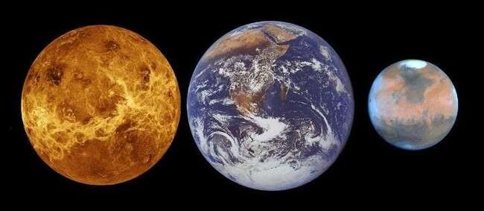

*The image 2 shows the different of the masses among the planets Mars, Earth and Venus.*

|  |  |  |  |
| --- | --- | --- | --- |
|  | Factors | Earth | Mars |
| 1. | Distance from the Sun | 152.09 million km | 208.22 million km |
| 2. | Average of temperature | 13.9 degrees Celsius | Minus 60 degrees Celsius |
|  | (Celsius) |  |  |
| 3. | Atmosphere composition | 78% Nitrogen, 21% | Carbon Dioxide 95.3%, |
|  |  | Oxygen, and one percent | Nitrogen. |
|  |  | other gases. |  |
| 4. | atmospheric pressure | Pressure at sea level on | Pressure at surface level |
|  |  | the Earth is 1013.25 mill | is 6.518 mill bars |
|  |  | bars. |  |
| 5. | Mass of the planet. | 5.9736 x 1024 kg | 6.39 × 1023 kg |
| 6. | Gravitational acceleration | 9.807 m/s² | 3.721 m/s² |
|  | on the surface. |  |  |
| 7. | Speed of rushing around | 107,000 km/h | 86,871 km per hour |
|  | Sun |  |  |

*Table 5. Comparison the data between Earth and Mars in their orbit around the Sun.*

The thermodynamic factor that works to reduce the value of the atmospheric pressure of Mars (PV = nRT, P is pressure, V is volume, n is the amount of substance, R is the universal gas constant, T is temperature) effected of the reduction of the temperature of Mars to be around - 60 °C due to it’s a fared distance of Sun around 208.22 million km, checking the Carbon dioxide (CO2) phase diagram in the illustration 9. the environment circumstances of the Mars is in the triple point to combine three phases of this material (solid phase, liquid phase and gaseous phase), when gases getting to the solid phase or the liquid phase due to the dropping temperature cancels their physics effects of forming any pressure on the atmosphere, finally, it descend the atmospheric pressure to (0.60 kPa) or 1% of Earth's atmosphere, causes the high rates of gaseous escape from the atmosphere towards space, as it happens in the planet Mercury which has mass (3.285×1023 kg) and gravitational acceleration force (3.7 m/s²) is the reason behind the collapse of the balance circumstance of the atmosphere as a result of the influence of highly thermodynamics effects overcoming the effect of gravitational force of the planet.

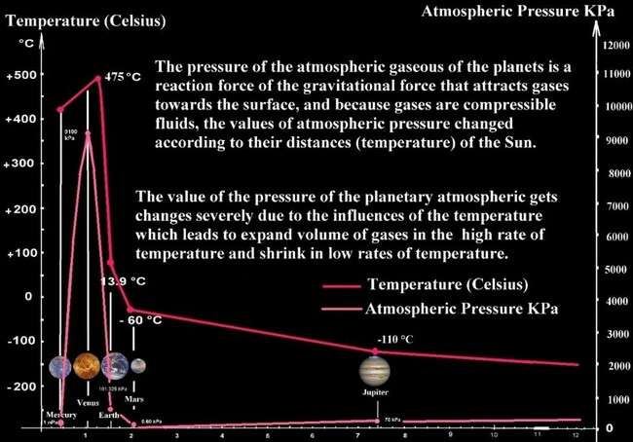

*The illustration 11 shows the relationship among the distance, mass and pressure of the first group of planet of the solar system.*

The temperature of the atmosphere is affected forcedly by the distance of the planet from its orbiting star and also the amount of mass and value of the activity of the star, whereas in the fared planets of the solar system the heat of the Sun and in which the temperatures drop in extreme rates. Rising temperature leads to an increase in the volume of gases which leads to the rise of the region of gases occupied in the atmosphere to the heights altitudes where the value of the planet's gravity decreases on the mass of these gases, so the possibility of their escape from the atmosphere increases. Where the temperature of the atmosphere is affected forcedly by the distance of the planet from its orbiting star and also the amount of mass and value of the activity of the Sun. In contrast, in the fared planets of the Sun and which the temperatures drop at extreme rates, we find the absence of Oxygen and Nitrogen that are abundantly available in the Earth’s atmosphere because of their liquefaction. Hence, it is possible to find them in a liquid or solid state on the surface, and unavailable in the gaseous phase in the atmosphere of those planets, where often composes of Hydrogen and Helium, which have a very low liquefaction degree and around the temperature of the atmosphere of those fared planets. The gaseous escape from the atmosphere for a long time leads to form new balance circumstance of the planetary atmosphere that is composed of higher atomic masses elements and compositions that released from the materials of the crust due to extremely high temperatures as occurs with the planet Venus, where the atmosphere of Venus composes of Carbon dioxide (CO2) molecule weight and Sulfuric acid (H2SO4) molecule weight is 98,079 g/mol note that the molecule's weight of Carbon dioxide molecule weight is 44,01 g/mol that often got released from the rocks of the surface due to the extremely high temperature as well as the volcanic emissions, because the planetary gravitational force is relatively high (due to the relatively large masses) and the thermodynamic effect of atmospheric gases is also high (due to the high temperature), the state of balance circumstances between the two forces lead to the confinement of (the light elements in the gaseous phase) in the limits of gravitational force leading to rise in atmospheric pressure on the surface of the planet, moderate rates of gaseous escape from the atmosphere into space.

|  |  |  |  |
| --- | --- | --- | --- |
|  | Gas | Boiling temperature | Freezing temperature |
| 1. | Oxygen O2 | -183 °C | -218.8 °C |
| 2. | Nitrogen N2 | -195.8 °C | -210 °C |
| 3. | Carbo dioxide CO2 | -78.46 °C | -78 °C |
| 4. | Methane CH4 | -161.6 °C | -182 °C |
| 5. | Hydrogen H2 | -252.87 °C | -252.9 °C |
| 6. | Argon Ar | -185.8 °C | -189.4 °C |

*Table 6 Boiling and freezing of temperature of gases [15] Oxygen, Nitrogen, Carbo dioxide CO2, Methane CH4, Hydrogen H2, Argon Ar.*

The atomic diffusion[16] occurs due to moving atoms and molecules of materials from a high density zone to the lower density zone, therefore atomic diffusion occurs strongly from the Troposphere and Stratosphere to the Exosphere, Thermosphere and Mesosphere, after the gaseous escape from the thermosphere and Mesosphere) to space due to inertia effects when the speed of Earth accelerates the mass and momentum of the gases prevent them to be accelerates at the speed of the Earth and increase in the percentage of radiation and solar energetic particles when the Earth approaches the Sun, which causes friction of these particles with the gases and pushes them towards space to restore the amount of atmospheric pressure in (Exosphere, Thermosphere, and Mesosphere), remember the atomic diffusion theory is the movement of molecules or atoms from the region of high concentration (high chemical potential) to the region of low concentration (low chemical potential) as a result of the random motion of the molecules or atoms where diffusion is driven by the gradient in the chemical potential of the diffusing species, affected by the factors such gradient, value, concentration, pressure, temperature, distance, where the gradient is the change in the value of the concentration, change in pressure over distance is called pressure gradient, and change in temperature over distance is called temperature gradient[17]. This fully applies to the concept of diffusion under pressure which claims (if the diffusion takes place in a closed vessel the pressure difference drives the heavy gas into the light-gas region at a faster rate).

|  |  |  |  |
| --- | --- | --- | --- |
|  |  | Mercury | Earth |
| 1. | Mass | 3.285×1023 kg | 5.973 x1024 kg |
| 2. | Gravity | 3.7 m/s² | 9.807 m/s² |
| 3. | Temperature | 430°C | 13.9 °C |
| 4. | atmospheric  pressure | 1 [nPa](https://en.wikipedia.org/wiki/Pascal_(unit)) | 101.325 kPa |

*Table 7 data comparison between Mercury and Earth.*

The planet Mars has an atmosphere composed of 95% by volume of Carbon dioxide (CO2), 2.6% molecular Nitrogen (N2), 1.9% Argon (Ar), 0.16% molecular Oxygen (O2), and 0.06% Carbon monoxide (CO), [18] where generally composes of 95% Carbon dioxide (CO2) which has molecular weight 44.01 g/mol, and low rates of Oxygen (O2) molecular weight Oxygen gas is 15.999 u and Nitrogen (N2), 14.0067 u this is due to its mass (6.39×1023 kg) and the gravity acceleration (3.721 m/s²). Therefore there isn’t a capability to attract Nitrogen (N2) and Oxygen (O2) forcedly as it occurs on the Earth which composes its atmosphere of Nitrogen (N2) 80% and Oxygen (O2) 20 % due to the relatively high gravity force of Earth, where the mass of Mars to Earth is about (0.64169) which leads to generate gravity force less than the Earth's gravity force prevent it to attract these two gases forcedly therefore these two gases represents as a light gases and rises upward of the atmosphere of Mars and gets escaped to the space, and this drop in the value of the gravity force of Mars lead to a significant drop in the atmospheric pressure of the Mars to reach (0.60 kPa) which represents 1% of Earth's atmosphere raising the gaseous escape of the atmosphere of Mars to the space at a very high rates, in the meantime the thermodynamic factor works to reduce the value of gases in the atmospheric pressure of Mars affected by the reduction of the temperature of Mars to be around - 60 °C due to its fared

distance from the Sun around 208.22 million km, checking the phase diagram Carbon dioxide (CO2) in the illustration 9 we find environmental circumstances of Mars are in the triple point to combine three phases of this material (solid phase, liquid phase and gaseous phase). When gases to the solid phase, the liquid phase due to the temperature reduction cancels their physics effects of forming any pressure on the atmosphere and finally gets the atmospheric pressure to drop to reach (0.60 kPa) 1% of Earth's atmosphere.

# 5.0 Factors causing gaseous escape from the Earth's atmosphere:

1. **The effect of the type of the orbit of the planet upon the gaseous escape**: If the orbit of the planet is circular around the Sun leads to stability of the planetary atmosphere, but each planet's orbit around the Sun is an elliptical [19], therefore planet’s velocity changes, where the planet’s speed is at its lowest value (perigee) at the farthest distance from the Sun, after that point, the speed of planets start to be accelerated gradually and the speed reaches to the highest value in (apogee), where the distance is the closest distance to the Sun, these change in speed confuses the stability state of the gases of the atmosphere of the planet, especially when the speed of the planet Sun accelerates, as shown in the illustration 16 because the mass of gases generates momentum that obstructs the planet's acceleration, this leads to the failure to catch up a quantity of atmospheric gases with the planet to remain behind the planet in the space, this related to inertia phenomenon[20], where the momentum of masses of the atmospheric gases resists changes in the speed motion of Earth during the acceleration period, causing the phenomenon of escaping gaseous from the atmosphere, when the speed of the Earth starts to increase from lowest value (perigee) in Earth`s the farthest distance from the Sun, where after that point Earth`s speed begins to be accelerated gradually to reaches the highest value in (apogee), when the distance is the closest distance to the Sun, the mass of gases in the highest altitudes prevents them to be accelerated with the same acceleration rates of the Earth, a big quantities of compressible gases, we can speculate the shape of the aerobic bubble of the Earth’s atmosphere layers, thickness of Earth’s atmosphere is the shortest distance possible on the front side of the Earth’s the direction in the orbit, and increases gradually towards the back of the of rushing direction where the longest distance is on the back side of the direction in orbit around the Sun.
2. **The effect of inertia:** The phenomenon related to inertia where the momentum of masses of the atmospheric gases resists changes in the speed motion of Earth during the acceleration period, these procedures occur in the planets that have elliptical orbits, because when the speed of the Earth starts to increase from lowest value (perigee) when the Earth is at the farthest distance from the star which revolves around, and after that point, the planet speed begins to accelerate gradually from and the planet's speed reaches the highest value (apogee), when the distance is the closest distance to the Sun, the mass of gases in the highest altitudes prevents them from being accelerated with the same acceleration rates as the higher speed of the planet when the planet starts to be accelerated in its elliptical orbits around the Sun, which lets them lag in space behind the direction of rushing of the planet in their orbits and to be missed in the space, Earth`s orbit around the Sun is elliptical and therefore the velocity of the rushing of the Earth changes, where Earth’s speed is at lower value (Perigee) when the planet is at the farthest distance from the Sun 152 million km/s, where the speed is 29.29 km/s, after that point Earth's speed begins to accelerate gradually and reaches to highest value (Perigee) when the distance is as closest to the Sun 14.7 million km where the speed is 30.29 km/s, these changes in speed confuse the stability state of the gases in the atmosphere of the Earth, especially at the point where the speed of the Earth starts to accelerate, where the mass of gases generates momentum that obstructs them from being accelerated with the acceleration of Earth, is called the inertia phenomenon) this leads to the missing a large quantity of atmospheric gases that remains backward causing gases to escape from the atmosphere in space behind the direction of Earth around the Sun, causing the phenomenon of gaseous escape from Earth’s atmosphere, especially of the high layers of Mesosphere, Thermosphere and Exosphere where the value of the gravity force is relatively lower. As shown in the illustration 16 the differences in

thicknesses of the layers due to Earth's rushing in space, which leads to a decrease in those thicknesses on the front side of the Earth's rushing, and it’s the increase on the opposite side because air is a liquefied substance and compressible fluid without a mechanical resistance, we could expect the real shape of the layers of Earth as shown in the illustration.

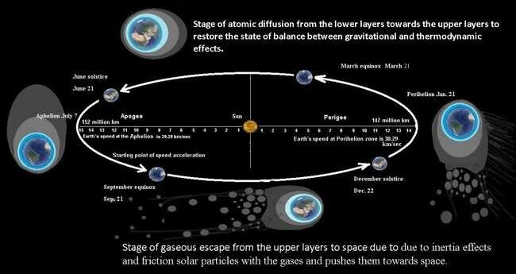

*The illustration 12 shows the two stages of gaseous scape from Earth`s atmosphere that starts with the inertia effects and the collusion of solar particles then stage of the atomic diffusion from the low layers to upper layers.*

Stages of gaseous escape from the Earth's atmosphere into space, the stage of gaseous escape from the upper layers (Thermosphere and Mesosphere) to space due to inertia effects when the speed of Earth gets accelerated the mass and momentum of the gases prevent them from accelerating at the speed of the Earth and increase in the percentage of radiation and solar energetic particles when the Earth approaches the Sun, which causes friction of these particles with the gases and pushes them towards the space. The thicknesses decrease in the front of rushing direction the Earth, and the increase in the opposite side because air is compressible fluid and relatively low mechanical resistance, we could expect the real shape of the layers of Earth as shown in the illustration 12.

1. **The effects of industrial gases and volcanic emissions upon balance circumstances of Earth`s atmosphere::** When the high molecules weight industrial gases[21] such as Carbon dioxide CO2, Methane (CH4), Sulphur hexafluoride (SF6), Nitrogen trifluoride (NF3) high molecular weight are emitted to the atmosphere in large quantities will confuse the effect (n) of the relationship PV=nRT, from what leads to an increase in the magnitude of (PV) which will overcome the magnitude of the gravitational force to the masses of atmospheric gases in the Troposphere layer, what causes confusion in the state of balance between the gravitational force and the thermodynamic effects, and because the magnitude of the Earth's gravitational force is the constant that attracts the gaseous masses towards the surface and that results a specific value of pressure on the Troposphere layer, this will rush of the light elements in the layer (Nitrogen and Oxygen) to the higher layers (stratosphere and mesosphere), in order to restore stability to the state of balance between the two mentioned forces in the Troposphere layer, and this is the main reason behind the phenomenon of gaseous escape of light elements such as oxygen and nitrogen and the collapse of the ozone layer in the Earth's atmosphere. When huge quantities of relatively heavy molecular weight industrial gases and volcanic emissions [22] (such as Carbon dioxide molecular weight 44.01 g/mol and sulfuric dioxide molecular weight 64.066 g/mol) are emitted and are forcedly affected by the gravity force due to their relatively higher mass to the atmosphere. This will lead to an increase in the amount of matter of gases in the atmosphere, which represents (n) in the relationship of ideal gases relationship PV=nRT which has a direct relationship with pressure and the

volume (PV), this will lead to a rising value of air pressure and volume in the Troposphere more than its original value which is restricted according to the value of the gravitational force to the masses of gases and the thermodynamic effects of the atmospheric gases in the equilibrium state of the mentioned forces, this will lead the lighter gases molecular weight such as Oxygen molecular weight of 15,999 u and Nitrogen molecular weight of 14.0067 u which are less affected by the force of gravity due to their lower mass weight (lower mass) to be rushed to the (Stratosphere and Mesosphere), which causes damage to the Ozone layer, which is formed from triple Oxygen O3 and due to the rise of the triple molecular Oxygen to high altitudes the atmospheric pressure is less than the physical conditions for the formation of triple Oxygen to form Ozone gas despite its exposure to the ultraviolet rays of the sun, this is the main physics factor for the results gap in the Ozone layer in the Earth's atmosphere, we conclude that the process of gaseous escape from the Earth’s atmosphere is the result of the expansion of the gases of the Thermosphere and their rushing towards the upper layers to Troposphere, and pushing the gases of the upper layers to escape to Stratosphere and Mesosphere towards space, of the triple Oxygen O3 molecules (molecular weight 48 g/mol) in the first layers to the higher altitudes where devoid the conditions of forming the triple Ozone molecule, so the triple Oxygen molecule decomposes into the binary molecule or the singular atoms as found at high altitudes Stratosphere and Mesosphere, leaving a gap in the Ozone layer of the atmosphere of the Earth in addition to the chemical factor of the chemical reactions of the active industrial gases and even due to collision the energetic solar particle with Earth’s atmosphere, therefore the erosion of the Ozone layer in the Earth's atmosphere is not considered an escape of gases as much as a disturbance in the qualitative balance system of gases in the Earth’s atmosphere. The illustration 13 shows how the large molar of gases of such as Carbon dioxide CO2, Methane (CH4), Sulphur hexafluoride (SF6), Nitrogen trifluoride (NF3), Nitrous oxide (N2O) etc., that are highly affected by the gravity force of the Earth due their high density and masses that represents

(n) leads in the relationship PV=nRT to change in value PV, the pressure and volume to increase the value of atmospheric pressure in the Troposphere is what causes the imbalance in the state of the balance circumstances between the two effected forces (the gravity force of the Earth and the effects of the thermodynamic processes of the gases), and this replacement leads pushing the elements of lighter molar masses, such as Oxygen (O2) = 32.0 g/mol and Nitrogen (N2) = 28.014 g/mol) to move from Troposphere to the higher layer Stratosphere and Mesosphere to restore the state of balance in these mentions forces in the Troposphere, to return the value of the atmospheric pressure in the Troposphere to its original value around 101.325 kPa.

|  |  |  |
| --- | --- | --- |
|  | Gases of  the industrial emissions | Molecules weight  (molar mass) g/mol |
| 1. | [Methane (CH4)](https://www.epa.gov/ghgemissions/overview-greenhouse-gases#methane) | 16.04246 g/mol |
| 2. | Carbon dioxide (CO2) | 44.01g/mol |
| 3. | Nitrous oxide (N2O) | 44.013 g/mol |
| 4. | Nitrogen trifluoride (NF3) | 71.002 g/mol |
| 5. | Sulphur hexafluoride (SF6) | 146.06 g/mol |

*Table 8 high molar mass gases of the industrial emissions in Earth`s atmosphere*

High percentages of industrial residues are in the gas phase, and it is clearly seen in the emissions of petroleum refineries, car smoking, and heavy machines global greenhouse gas emissions, which add around 50 billion tonnes annually of gases to the Earth's atmosphere.

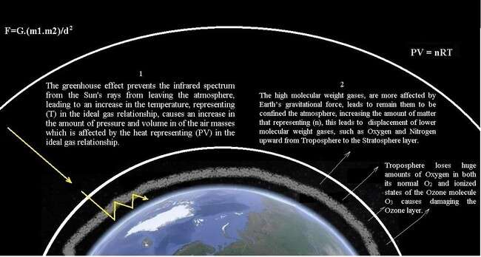

*The illustration 13 shows the effects of the greenhouse and the displacement of lower molecular weight gases to the higher altitudes, such as Oxygen and Nitrogen upward, restoring the value of atmospheric pressure to the value that is equivalent to the effect of the Earth’s gravitational force upon the mass of confined gases in the Troposphere layer, restoring the state of balance in the Troposphere layer, the Troposphere loses huge amounts of oxygen in both its normal (O2) and excited and ionized states of the ozone molecule (O3), ultimately damaging the Ozone layer, which protects living organisms from the fatal effects of the ultraviolet of Sun rays spectrums.*

|  |  |  |
| --- | --- | --- |
|  | Sector | Gas emissions |
| 1. | Energy | % 73.2 |
| 2. | Agriculture, | % 18.4 |
|  | forestry, landuse |  |
| 3. | Industry | % 5.2 |
| 4. | Waste | % 3.2 |

*Table 9 the gas emissions to the atmosphere yearly by the industry.*

Since the middle of the 20th century, the annual emissions from burning fossil fuels have increased every decade from 11 billion tons of carbon dioxide per year in the 1960s to 36.6 billion tons in 2022 according to the Global Carbon Budget 2022. After the losses of quantities of gases in the upper layers

(Mesosphere and Thermosphere) due to the acceleration of Earth in its elliptical or the collision of the energetic solar particle with Earth’s atmosphere, this leads to an imbalance in the state of gaseous equilibrium between the upper and lower layers, which guides to spread atoms and molecules from high density to low-density zones causes the activation of atomic diffusion from the lower layers (Troposphere, Stratosphere) towards the higher layers (Mesosphere and Thermosphere) to restore the state of equilibrium in the upper layers (Mesosphere and Thermosphere) which guides to spread of atoms and molecules from the high density zone of the lower layer (Troposphere, Stratosphere) to low- density zones in the higher layers (Mesosphere and Thermosphere), note that the loss of gases from the upper layers to (Mesosphere and Thermosphere) occurs in every location of Earth in its orbit around the Sun, but the peak of its activity in the phases the point of starting the acceleration and the shortest distance to the Sun. These industrial gases with large molecular weight displace light gases such as Oxygen and Nitrogen from the Troposphere to the Stratosphere (to restore the balance stat between the gravitational force and thermodynamic effect of gases in the Troposphere and maintain the standard value of atmospheric pressure in the Troposphere around 101,325 Pa), these industrial gases have a second effect in increasing the temperature, which leads to the activate the variable T in the relationship (PV=nRT) due to the effect of global warming, this leads to increasing the volume of air in the Troposphere, which accelerates the process of displacement of small molecular weight gases into the Stratosphere, for example, HFC-23 is a by-product of refrigerant manufacture have around 14,700 times as powerful as carbon dioxide at warming the globe, this accelerate the process of forming gap in the Ozone layer.

# Some quoted data with respect of rates of greenhouse gas emission and ozone depletion in the last twenty years since the beginning of the 21st century:

**1. Green House Gas (GHG) emissions of all world countries:** China, the United States, India, the EU27, Russia and Brazil were the world’s largest GHG emitters in 2023. Together they account for 49.8% of global population, 63.2% of global gross domestic product, 64.2% of global fossil fuel consumption and 62.7% of global GHG emissions. Among these top emitters, in 2023 China, India, Russia and Brazil increased their emissions compared to 2022, with India having the largest increase in relative terms (+ 6.1%) and China the largest absolute increase by 784 Mt CO2. With only two exceptions, 2009 (global financial crisis) and 2020 (COVID-19), global GHG emissions have grown steadily since the beginning of the 21st century, mainly due to the increase in fossil CO2 emissions by China, India, and other emerging economies. Based on the emission estimates for 2023 provided by EDGAR, global GHG emissions increased by 1.9% compared to 2022, reaching 53.0 Gt CO2.

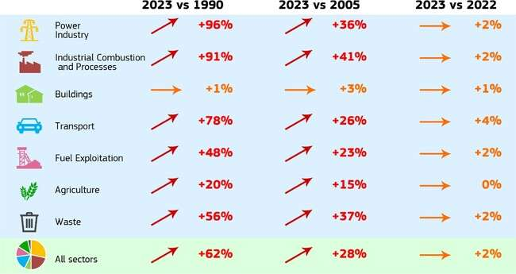

*The illustration 14 shows Global emission trends by sector and years.*

In 2023, the majority of GHG emissions consisted of fossil CO2 accounting for 73.7% of total emissions, while CH4 contributed for 18.9% to the total, N2O for 4.7% and F-gases for 2.7%. Global fossil CO2 emissions increased by 72.1% since 1990. The increases in CH4 and N2O emissions have followed a somewhat slower pace: CH4 increased by 28.2% and N2O by 32.4% between 1990 and 2023, while F-gases have seen a four-fold increase (+294%) in the same period. As far EU27 is concerned, its GHG emissions, excluding LULUCF, were 33.9% lower than in 1990 reaching 3.22 Gt CO2. In 2023, EU27 emissions decreased by 7.5% (-261 Mt CO2) and the EU27’s share of global emissions decreased from 6.8% in 2022 to 6.1% in 2023. In 2023, all EU27 countries except Croatia and Cyprus experienced a decrease in their emission levels compared to the previous year. In terms of contribution to the EU27's GHG emissions in 2023, Germany remained the largest emitter, followed by France, Italy, Poland and Spain. In the EU27, all sectors experienced a decrease in their GHG emissions in 2023 compared to 2022. The largest relative drop was observed in the power industry sector, in which emissions decreased by 20.1%. The industrial combustion and processes showed the second-highest decrease, falling by 8.1% below the 2022 levels. The data are presented in the table below for key years, to allow easy comparison of different countries. Data for individual GHG (fossil CO2, CH4, N2O and F- gases) are available in the excel file in the download section (data sheet GHG by sector and country).[23]

1. **Related data in respect of the Antarctic ozone hole via the European Centre for Medium-Range Weather Forecasts (ECMWF) operates services from the EU’s Copernicus Earth observation.** The development of the Antarctic ozone hole in 2024 started later than average, mainly due to the disruption of the polar vortex following two sudden stratospheric warming episodes in July, in the illustration 14 shows the time series of daily ozone hole area between 1 July and 8 December 2024*.* As the polar vortex became established through August, the chemical depletion of stratospheric ozone over Antarctica was able to take effect, as it does every year. The area of the ozone hole kept increasing throughout September, closely following the 1979-2021 average, reaching its maximum size of 22 million km2 by the end of the month. Not only is this smaller than the area in 2023 and 2022, when the maximum area was around 25 million km2, but the maximum occurred later than in 2023 and is in line with the historical average. While some of the recent year’s ozone holes were notable for closing later in the year on average, the 2024 closure has been more typical. The ozone hole area steadily decreased in size throughout October, in line with the average, but stabilised through November with an approximate area of 10 million km2 per day during the month. The polar vortex broke down in the first

week of December, quickly bringing the 2024 ozone hole closure in line with the 1979-2021 average closure date.

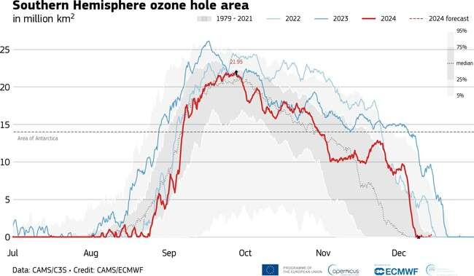

*The illustration 15 shows the time series of daily ozone hole area between 1 July and 8 December, where the red line shows the data for 2024 and the dotted line the forecast for the following 5 days. The thicker, darker blue line is the evolution of the ozone hole during 2023, and the lighter blue line represents 2022. The grey colours represent the percentile values and the median between 1979 and 2021 (Credit: CAMS/ECMWF).*

Once the ozone depletion started to be significant, the ozone hole quickly reached an area of 15 million km2, the area of Antarctica, in the first days of September. It reached its peak extent of about 22 km2 by the end of the month, also slightly later than in 2023, in line with the average, and it was smaller than in 2023 and 2022 when the area reached approximately 25 km2 Global warming and the greenhouse effect tend to cool the stratosphere favouring the formation of Polar Stratospheric Clouds and ozone depletion, in the illustration 15 the ozone hole above the Antarctic in line with the 1979-2024 average date. [24]

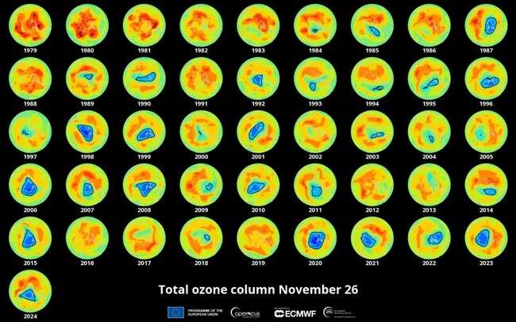

*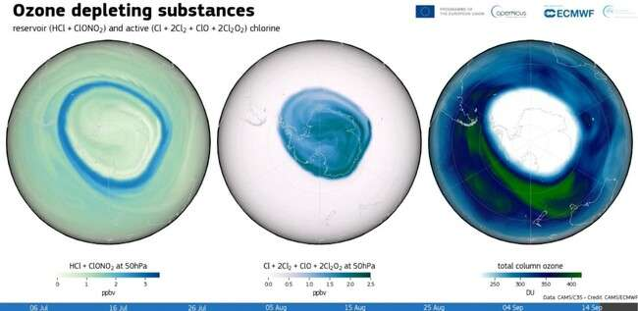The illustration 16 is data of the ozone hole above the Antarctic in line with the 1979-2024 average date. Atmosphere Monitoring Service, the Copernicus Programme*

*The illustration 17 is for Ozone depleting substances, the CAMS suite provides forecasts and analysis of ozone and a number of ozone depleting substances, allowing to represent the ozone hole depletion process. Credit: CAMS*

1. **The double effect of the industrial gases upon the ozone layer:** The illustration 17 shows the double effect of the presence of industrial gases in the atmosphere upon the Ozone layer, where the first is (the greenhouse effect), as it prevents the infrared spectrum from Sun's rays from leaving and keeping

it in the atmosphere, leading to an increase in the temperature, representing (T) in the ideal gas relationship PV=nRT, this causes an increase in the amount of pressure and volume in of the air masses which is affected by the heat representing (PV) in the ideal gas relationship, the second is that these gases have a high molecular weight, so they are more affected by the effect of the Earth’s gravitational force, so they remain confined within the atmosphere, which increases the amount of matter, representing (n) in the ideal gas relationship, this leads to the displacement of lower molecular weight gases, such as Oxygen and Nitrogen upward, restoring the state of balance in the Troposphere layer, restoring the value of atmospheric pressure to the value that is equivalent to the effect of the Earth’s gravitational force upon the mass of confined gases in the Troposphere layer. Thus, the troposphere loses huge amounts of oxygen in both its normal (O2) and excited and ionized states of the ozone molecule (O3), ultimately damaging the Ozone layer, which protects living organisms from the fatal effects of the ultraviolet of Sun rays spectrums.

Emissions of industrial[25] high molecules weight such as Sulphur hexafluoride (SF6) = 146.06 g/mol, Nitrogen trifluoride (NF3) = 71.002 g/mol, Nitrous oxide (N2O) = 44.013 g/mol and Carbon dioxide (CO2) = 44.01 g/mol into the atmosphere gases composition leads to a disturbance in the state of balance between the amount of the Earth’s gravity force and the thermodynamics effects at the Troposphere at the height (0-14.5 km), pushing a large percentage of low weight gases Nitrogen (N2) = 28.02 g/mol and Oxygen (O2) = 31.999 g/mol towards the Stratosphere at the height 14.5 to 50 km, the value of atmospheric pressure (101.325 kPa) in Troposphere at the height 0 to 14.5 km, so that the state of balance between the effects of gravity and gases thermodynamics effects at the Earth’s temperature average 14 degrees Celsius)which is determined by the Earth’s distance from the Sun. The relatively high temperature of the Earth causes the physical activity of the atoms of gases and expands in volume of the atmosphere, this causes a reduction in the effect of atomic gravity on the atoms of the gases so that the volume of one cubic meter in space around the Earth contains a lower value of gas matter. Here we can count that the nature of the planetary atmosphere is one of the aspects of the age of the planet’s formation, as the greater the amount of heavy elements in the planet’s atmosphere indicates the older age of the planet’s formation, not only in terms of traditional chronological age, but also due to thermal effects that accelerate the chemical and physical processes to accelerate the passage of the atmosphere to its older formation ages.

Therefore, we find that the atmosphere of Venus is filled with heavy gases due to the high temperature of the planet, which led to the release of these gases from the crustal rocks into the atmosphere, displacing light gases such as Oxygen and Nitrogen into the space causing gaseous escape. This will also happen with the Earth’s atmosphere after a few billions of years when the Earth is in the advanced stages of formation. Gas escape is a natural path during the planet’s formation ages, which is forcedly affected by the rate of temperature and availability of those gases as a result of geological activities or industrial emissions. The volume of one cubic meter of any gas in space contains a larger amount of the substance of that gas due to the physical inertness of atoms, leads to the activation of the atomic gravitational field, which causes the attraction of their atoms, therefore, we find low atomic weight elements such as Hydrogen and Helium are available in abundance in distant planets such as Uranus and Neptune, despite of their moderate gravitational force value and close to the value of the Earth's gravitational field, while these two components are absent in the Earth's atmosphere. In the meantime the volume of one cubic matter of any gas in space around the Earth contains a lower amount of the substance of that gas representing (n) in the ideal gas relationship, due to the relatively high temperature increasing the physical activities of atoms and expansion of their volume, which leads reduction of the effects of their atomic gravitational field, due to the increase the distances among their atoms, therefore the low atomic weight elements such as Hydrogen and Helium are unavailable in Earth`s atmosphere.

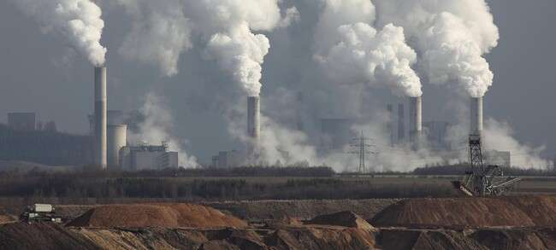

*The image 3 is for part of the emissions of power plants that are fuelled by fossil fuels.*

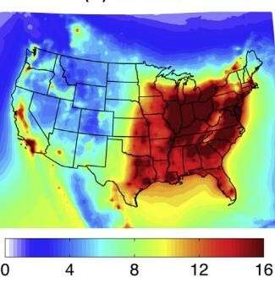

*The illustration 18 is map of the America where all the red represents the quality of the air in that area and how harmful it is to show air pollution all across the world from industrial companies used to produce toxic air to enter the atmosphere.* [27]

1. **The stages of the transfer of triple oxygen from the O3 phase into dioxygen O2 or the atomic oxygen O causing decomposition of the ozone layer:** The effect of the heavy industrial gases (high molecular weight gases) released into the atmosphere on the displacement of low molecular weight gases (O3, O2 and N2) and move from Troposphere towards the upper layers of the atmosphere such as

Stratosphere, and the Exosphere. Where Archimedes' principle applies the volume of the sinking object is equal to the volume of the displaced fluid, but here the volume of the sinking part represents the volume of heavy industrial gases (high molecular weight) released towards the Troposphere and the volume of displaced fluid represents the displacement of low molecular weight gases of towards Stratosphere. This transformation of gases from the Troposphere to the Stratosphere occurs to restore the balance in the Troposphere between the value of the Earth's gravitational force and the thermodynamic effect of gases in the altitude of the Troposphere layer because rushing these great quantities of high molecular weight gases towards the Troposphere leads to an increase in the value of pressure in the pressure container of the Earth's atmosphere, therefore the displacement of low molecular weight gases (O3, O2 and N2) towards the Stratosphere returns the value of the atmospheric pressure in the Troposphere to its original value that is limited by the amount of the Earth's gravitational force at the altitude of Troposphere layer and the thermodynamic effects of the existent gases in that layer. This is in addition to the chemical effects of these industrial gases upon gases the existent gases in the Troposphere, which causes chemical reactions due to the chemical activity of the industrial gases, as well as the effect of global warming, which leads to an increase in the temperature of the atmosphere and the expansion of gases from Troposphere upward Stratosphere to restore the original value of the atmosphere pressure at the Troposphere layer. Where the physical conditions that lead to the formation of triple Oxygen (Ozone) are absent, this leads to the decomposition of triple Oxygen into binary or atomic Oxygen, thus causing the dissolution of the Ozone layer of the Earth’s atmosphere.[25]

1. **Volcanic activities:** Most of the gases in the Earth’s atmosphere are caused by the gaseous escaping from the hot rocks towards the Earth’s atmosphere during its formation about 4.543 billion years ago and this process has been continuous until nowadays and it appeared during the volcanic activities where most of these gases are (Carbon monoxide, Carbon dioxide, Sulphuric monoxide, Sulphuric dioxide, Oxygen, Nitrogen, Argon and water vapour [28], where the chemical activity of the emissions led to the decomposition complex components of these emissions such Carbon monoxide, Carbon dioxide, Sulphuric monoxide, Sulphuric dioxide upon the surface of the Earth and the deposition of the heavy elements such as Sulphur and Carbon upon the surface, and the release of Oxygen and Nitrogen into the atmosphere. Volcanic activities where most of the gases in the Earth’s atmosphere are caused by the gaseous escaping from the hot rocks towards the Earth’s atmosphere during its formation about

4.543 billion years ago and this process is continuous until nowadays and it appears during the volcanic activities where most of these gases are (Carbon monoxide, Carbon dioxide, Sulphuric monoxide, Sulphuric dioxide, Oxygen, Nitrogen, Argon, and water vapour, where the chemical activity of the emissions led to the decomposition complex components of these emissions such Carbon monoxide, Carbon dioxide, Sulphuric monoxide, Sulphuric dioxide upon the surface of the Earth and the deposition of the heavy elements such as Sulphur and Carbon upon the surface, and the release of Oxygen and Nitrogen into the atmosphere. There are about 1,350 potentially active volcanoes worldwide but we will choose a specific sample in this research, such the volcano Cumbre Vieja in La Palma island, Spain which lasted from 19 September to 13 December 2021 at 85 days and the most dangerous volcano, Hole of Mount Semeru Balkh volcano, is 3676 km in Indonesia as well as Tonga island blast, which is estimated to be a 10 megatons explosion. Through our long observations of several volcano eruptions around the world, we recognized several important notes that could help us to understand the mechanism of how volcanoes erupt, in which the fundamental issue depends upon immense amounts of gases released from the rocks in the materials lying underneath due to exposure to the heats of the magma to form a gap of gases in the tunnels of melted rocks.

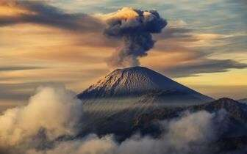

*The image 4* [*Mount Semeru, East Java*](https://bromoeastjava.wordpress.com/2016/11/10/semeru-volcano/) *is the highest volcano in Java Island Indonesia with an altitude 3,676 meters above sea level.*

The pressure of gases in these gapes increases due to increasing the amount of released gases and also due to the increase in the value of their heats. Therefore, once the pressure of gases is in these gaps getting to tremendous values, it will be able to result in a failure in the toughness of the rocky crust that covers volcanoes and to get out carrying multiple sorts of particles from the magma, the hot rocks, and the cool rocks, which lie in the upper layers in the tunnels of volcanoes. These gapes of gases are not linking with each other directly, where some of them are in the upper crust and some of them are behind the melted rocks in these tunnels, pushing the melted rocks to the upper side after the explosion occurs in the gate of the tunnels via the first group of gapes of gases in the upper side. This is why sometimes we find the results: some volcano eruptions are merely explosions that occur in the crust and release gases; these melted rocks will stay in their places underneath, while sometimes we find another volcano eruptions are explosions that occur in the crust with a pushing out of melted rocks into their places underneath, while sometime we find another volcano eruptions are explosions that occur in the crust with a pushing out of melted rocks into their gates because of the existence of gaps of gases behind the melted rocks in the materials that lie underneath pushing these melted rocks due to their high value of pressure. Therefore, the duration of the volcano eruptions determines the resources of volcanic ashes that come out of volcanoes, where as much as the eruption takes a longer time, as much as these ash resources are from deeper layers of the materials lying underneath.

**6.0 Factors that lead to the form of airglow[29] around planets:** There are some explanations for this phenomenon which state that airglow when the atmospheres of planets including Earth and Mars glow during day and night as sunlight interacts with atoms and molecules within the planetary atmospheres and light up as airglow, in the image 5 shows [Airglow in Earth's atmosphere observed](https://www.esa.int/ESA_Multimedia/Images/2020/06/Airglow_observed_from_the_International_Space_Station) [from the International Space Station](https://www.esa.int/ESA_Multimedia/Images/2020/06/Airglow_observed_from_the_International_Space_Station) on Earth in the atmosphere of Earth occurs due to glowing Oxygen when the energetic solar particles from the Sun hit the upper atmosphere this Oxygen driven emission such light of polar auroras of green hue wavelength of light (557.7 nanometre).

[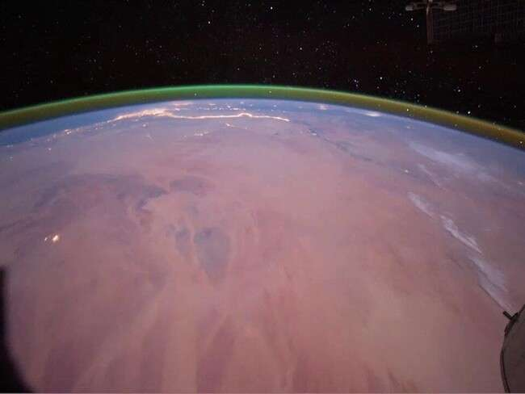](https://www.esa.int/ESA_Multimedia/Images/2020/06/Airglow_observed_from_the_International_Space_Station)

*Image 5 shows* [*Airglow in Earth's atmosphere observed from the International Space Station*](https://www.esa.int/ESA_Multimedia/Images/2020/06/Airglow_observed_from_the_International_Space_Station) *On Earth.*

1. **The effect of the total internal reflection to form the airglow in Earth’s atmospheres**: The airglow known that occurs due to glowing Oxygen is produced during polar auroras when energetic electrons from interplanetary space hit the upper atmosphere. The aurora, however, is just one way in which planetary atmospheres light up. There is another factor that causes this phenomenon, as all conditions are available for the total internal reflection due to the difference in density of the atmospheric layers between the Troposphere and Stratosphere, where the sun's rays coming from the horizon collide with the layer between the Troposphere and Stratosphere) and due to the reduction of the density of the Stratosphere than the Troposphere leads to the occurrence of the phenomenon of total internal reflection due to the light reflection of the layer between (Troposphere and Stratosphere), so leads the area between them to be illuminated to appear as airglow around the Earth. This is why the intensity of the airglow increases during the day and decreases during the night because the resource of the light is from the Sun rays coming from beyond the horizon, therefore we could call this the atmosphere lensing and its colour changes in the atmosphere of Earth according to the observation angle due to the differences in the angles of light reflection according to its frequency energy, when we return to the basic concepts of the properties of light, we find that one of these properties is the refraction of light during the transition from the highly dense medium to the least dense medium.

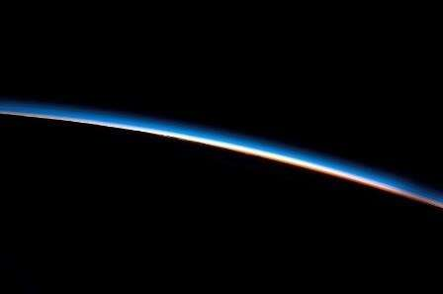

*Image 6 shows the blue airglow on Earth.*

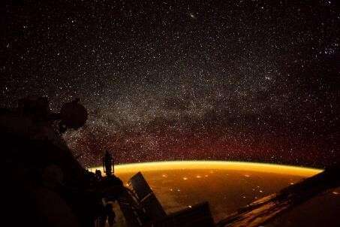

*Image 7 shows the yellow airglow on Earth.*

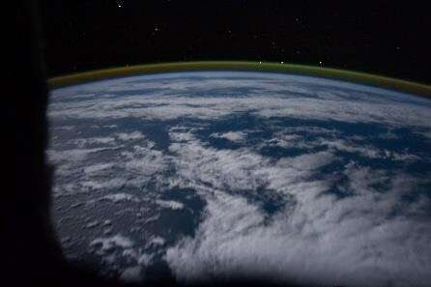

*Image 8 shows the green airglow on Earth.*

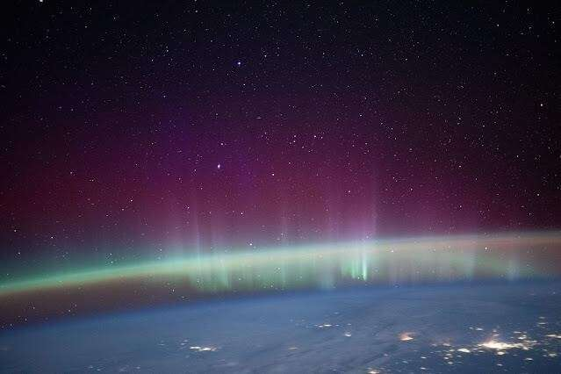

*Image 9 is for the distortion of the airglow on the Earth is due to the effect of two factors, first is the collision of cosmic particles with the atmosphere and second is the effect of light reflection.*

# The effect of the total internal reflection [30] to creates airglow in Earth's atmospheric layers between the Troposphere and Stratosphere.

n1.Sin (𝜃1) = n2 Sin (𝜃2) 8

Could described as Snell’s low

n1= the reflection index of the first medium (Troposphere layer). n2= the reflection index of the second medium (Stratosphere layer).

𝜃1= angel of the incident.

𝜃2= angel of the reflection.

The total reflection occurs when the angel of the incident 𝜃1 is greater than the reflection angle 𝜃2, where Sin (𝜃1) = n1/ n2.

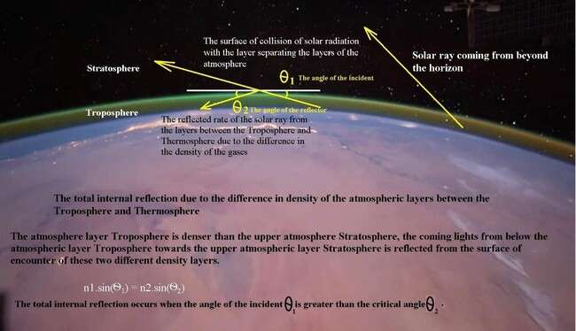

*The illustration 19 shows how the total internal reflection [30] creates airglow in Earth's atmospheric layers between the Troposphere and Stratosphere.*

Because the atmosphere layer Troposphere is denser than the upper atmosphere Stratosphere, the coming lights from below the atmospheric layer Troposphere towards the upper atmospheric layer Stratosphere are reflected from the surface of encounter of these two different density layers, this is why the airglow of Earth's atmosphere could be visible only at specific altitudes where the reflected rays are at the same angle in the observation direction, in the meantime the reflected lights analyses according to its frequency energies to different angles. The evidence is that the intensity of Luminosity of the airglow dims at night because it often depends upon the Sun’s light, while its Luminosity increases during the day due to the presence of high proportions of the Sun’s light, note that this phenomenon occurs clear when we see the sky from under the water, where we see the surface is such a mirror reflecting the ground image of the swimming pool, but we do not see the sky except when the angles of sight is zero or exactly in a straight line. The atmospheric glow reflects the value of the gravity force of the planet, where as much as the value of gravity in the atmosphere is at a higher rate leading to generates the higher value of the gravity force of the planet because it will attract larger quantities of

gases from the space and increasing the thickness of the atmosphere, generating visible light below the 20 km altitude level to have a good probability of producing airglow.

# The resemblance of the emergence of a comet's tail with a planetary gaseous escape phenomenon according to the thermodynamic concept of gases:

**The fireball spots during the impact of Comets or Meteors:** Fireball spots in Earth’s atmosphere during the impact of Comets or Meteors with the highest density of the atmosphere layer (Troposphere) which represents the elevation of the atmosphere glow of Earth, where before their impact with Troposphere they merely burning quietly in the upper layers (Stratosphere) which has a lower density of gases. Often rocky objects usually burn up between 15 to 20 kilometres above the ground creating fireballs at that altitude. Meteors light up almost as soon as they hit Earth's atmosphere when we see a meteor it means look at a piece of dust burning bright about 80 to 120 km in altitude above Earth's surface due to the friction the materials of a meteor with the gases of the atmosphere at the high altitudes, but when this meteor gets closer to the Earth will impact with the higher density gases layers of the atmosphere, the style motion of meteors will be changed from friction to the collision with the high- density gases of the atmosphere which results from totally crash of meteor which often results from an explosion and some damages on the surface of the Earth due to the expanding gases via effects of the high temperature created during the collision.

**Comets:** solid body the nucleus is solid body around tens km made of ice, rock, dust, and frozen gases as they fracture and disintegrate leaves a trail millions of km of solid debris and gases.

**Asteroids**: small rocky iron or ice debris flying in space around 1 to 100 km.

**Meteoroid**: are small asteroids from 1 micron to 1 meter.

**Meteorite**: fragments of a meteoroid or an asteroid of a few grams to several dozen that survive passage through the atmosphere and hit the ground.

**The gaseous escapes from Comets and asteroids:** Looking closely at image 10 Comet Hyakutake of an asteroid with two tails allows us to understand the reason behind the presence of two tails instead of one tail, as the first tail is caused by the phase transformation of frozen gases on the surface of the asteroid, such as Methane and Ammonia, precipitated on the surface into the gaseous phase “sublimation phenomenon” when the temperature of the asteroid rises as it approaches the Sun, whereas the first tail which consists of gases, has a low momentum as a result its low mass weight of than the relatively high mass weight of sand (silicates) of which the second tail is composed, thus the tail that consists of sand particles are greatly affected by the solar particles bombardment, and be pushes forcedly away more than the gases particles of the first tail, so the second tail takes sharper angle than the first. The effects of extreme reduction of the temperature upon the physics the environment feature of fared planets and Comets due to their a fared distances of the Sun, where Comets and asteroids are completely frozen when they are far from the Sun, and most are just a few kilometres across and appearance changes as it approaches the Sun, when solar heat warms the comet, while gets completely frozen when they are far from the Sun, and most are just a few kilometres across, because the comet's nucleus is the snowball that is essentially the entire comet when it is frozen and far from the Sun, the crust called (coma) is that is relatively large where dusty atmosphere surrounding the nucleus, formed of sublimated gases and dust where the tail consists of gas and dust that can extend hundreds of millions of kilometres away from the coma. Most comets have two tails, the first is a plasma tail made of ionized gas, and the second is a dust tail made of small solid particles, their tails point away from the Sun and expansions of the coma away from the Sun, regardless of the direction in which the comet is traveling, forming two tails is due to escaping gases and dust are influenced by the Sun in slightly different ways, and point in slightly different directions. Gaseous escape from the comet are ionized by the ultraviolet photons from the Sun, the solar wind carries them straight outward away from the Sun, these gases form the plasma tail, where dust size particles that escape from the comet experience a much weaker push from the Sun caused by the pressure of sunlight itself (called radiation pressure), and the charged

particles of the solar wind while the dust tail also points generally away from the Sun has a slight curve back in the direction the comet came from. Most comets remain frozen balls of ice in the outer reaches of our solar system and some of them inward warm up as they get closer to the Sun and grow the long tails that we characteristically see as they flash through the sky.

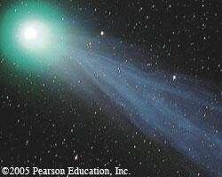

*Image 10 Comet Hyakutake came as close as 9.3 million miles of Earth in March 1996.*

Often asteroids move in an elliptical orbit around the sun, having different distances to the Sun, where they get their closest distance to the Sun then begin to move away gradually to very distant regions around Jupiter or Saturn zones, where the zones are rich of gaseous elements due to the effects of their gravitational fields or they may reach farther distances in the final limits of the solar system where temperatures drops to a several hundred degrees under zero, asteroids quickly lose their heat gained from the Sun due to their small mass, and they turn into best the deposition zone for light elements such as Methane, which have a low physics activities due to the extremely low temperatures, thus these light elements starts to deposit upon the surface of comets due to the effects of the force of the gravitational field of the asteroids, forming an ice crust above these asteroids of frozen gases of Hydrogen, Helium and Methane around the asteroids. When the asteroids approach closer distances to the sun during their orbit around the sun, their temperatures begin rise gradually, and the ice crust the frozen gases around the asteroids begins to heat up, and transfer into the gaseous phase via sublimation influences, where due to the small masses of these asteroids, their gravitational field will not be able to confine them within their gravitational field zones. These gases begin to escape from the range of their gravitational fields, forming a tail behind them to appear as comets, and what increases the state of the escape of gases from these asteroids is their speeds acceleration during their rushing in their elliptical orbit towards the Sun, where the momentum of the masses of the materials of gases prevents them of accelerating their speeds with the speed acceleration of the asteroids, this is exactly what happens during the gaseous escape from the atmosphere of the planets but at slower speeds due to the huge values of masses of the planets, which generate high values of gravitational force able to confine gases within their gravitational field zone, similar to the known pressure vessels used in our industrial purposes. But the limits of the pressure vessels of the atmosphere of planets are not confined via the metal cover used in our industrial pressure vessels, but via the gravity field forces of those planets, and gaseous escape of the planet’s atmosphere also occurs, but at low rates. We conclude from these results that the gaseous escape from the planetary atmospheres occurs naturally, rebalancing the effects of gravitational field forces of the planet with the atmospheric pressure already generated as a result of the attraction of the gas elements towards the surface maintaining the atmospheric pressure values to their natural limits, resulting from the effect of the values of the gravitational field forces upon the mass of the materials of gases, where the value of the atmospheric pressure gets within the limits of the equilibrium system of the atmosphere to determine within a certain range according to the available energy (heat and wind) in

the material of the Earth, in the meantime the rates of atomic energy also has a major role in controlling the rate of atomic spread in the material of the environment, therefore any increase in the rates of atomic (molecules) energy guides to increase the speed of water molecules in the water surfaces to increase the rates of the atomic diffusion of the water to the air results in confusion in the value of atmospheric pressure in specific regions, where quickly equalized by generating winds and storms and hurricanes among those regions in order lead the energy to stability on the materials of the surface of the planets and the equalize of atmospheric pressure values in the restricted value which eventually resulted via the effects of the gravitational force of the mass planets upon the mass of gases towards the surface of the planets.

Fireball spotting is due to the impact of the comet with the high density of the atmosphere layer Troposphere which creates the air low where it was merely burning in the upper low-density layers, while rocky objects usually burn up between 15 to 20 kilometres above the ground, fireball occurred at an altitude of 46 kilometres. The fireball advanced in a southwest direction until it extinguished at an altitude of 69 kilometres above sea level, Meteors light up almost as soon as they hit Earth's atmosphere. On average, when you see a meteor, you're looking at a piece of dust burning bright about 50 to 75 miles (80 to 120 km) in altitude above the Earth's surface, generating visible light below the 20 km (12 miles) altitude level to have a good probability of producing a meteorite fall.

# The influences of the variation in the values of gravity forces and thermodynamics processes of atmospheric gases upon the equilibrium state and the rates of gaseous escape of the planetary atmospheres:

There are three probabilities of the diversity of the values of gravity forces and thermodynamics processes of atmospheric:

# When the effects of the thermodynamic process of the atmospheric gases are greater than the effects of the gravitational acceleration force of the planet (F1 < F2):

When the gravitational acceleration force F1 of the planet is at very low and less than the effects of the thermodynamic effects F2 of the atmospheric gases, this will certainly collapse the atmosphere of the planet due to increasing the gaseous escape, because the gravitational acceleration force will not be able to confine gases of the atmosphere to the surface, as it occurs on the mass Mercury planet 3.3011×1023 kg generate low gravity force around 3.7 m/s² in the meantime temperature rises to very high rates around 430°C which exiting the thermodynamic processes which guides to generate great value of pressure to expand atmospheric gases above the ranges of the gravitational fields, and its gravitational value (3.7 m/s²) is devoid of atmosphere, which means that the rate of gaseous escape is very high due to the weakness of the value of the gravitational field generated by its small mass resulting collapse of the balance of the atmosphere of the planet when the planetary gravitational force is low (due to small mass of planet) and the thermodynamic effect of atmospheric gases is (high temperature), the thermodynamic effect of the atmospheric gases will overcome the effect of the planetary gravitational force, which leads to the generation of high pressure that pushes the atmospheric gases towards the upper layers of the atmosphere.

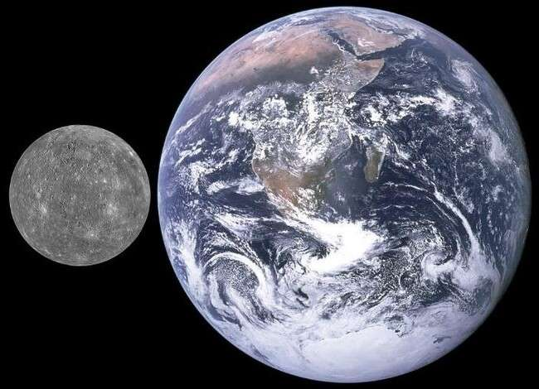

*The image 11 shows the relation of the size of Mercury to size Earth. [31]*

In group of planets that are close to the Sun (Mercury 430 °C, Venus 475 °C, Earth 14 °C, and Mars - 60 °C) the temperatures rise relatively in their environments leading to the expansion of the volume to generate higher rates of pressure increases able to overcome their influence on the gravitational fields of the planets, this causes the presence of heavier elements such as Oxygen, Nitrogen, Argon and Carbon dioxide, which has high atomic or molecular weight and are affected forcedly by the gravitational force of the planets, where their attraction towards the surface with relatively higher force leads to the displacement of lighter elements (Hydrogen and Helium) towards higher altitudes to be escaped from the atmospheres of the planets (Mercury, Venus, Earth, and Mars).

The gaseous escape of Mercury is Sodium tails as shown in image 12 where the observation of the atmosphere of Mercury indicates the existence of a high concentration of Sodium in the exosphere of planet Mercury, as the solar wind encounters Mercury, it slows down, piles up, and flows around the planet (grey ball). This figure shows the density of protons from the solar wind, as calculated by modelling the planet's magnetic sheath, or magnetosphere. The highest density, indicated by red, is on the side facing the sun; yellow indicates a lower density and dark blue is the lowest. The tiny planet endures endless assaults by intense sunlight, powerful solar wind, and high-speed miniature meteoroids called micrometeoroids. The planet's flimsy covering, the exosphere, nearly blends in with the vacuum of space, making it too thin to offer protection. Because of this, it's tempting to think of Mercury's exosphere as just the battered remains of the ancient atmosphere, the exosphere is constantly changing and being renewed with sodium, potassium, calcium, magnesium, and other species that are liberated from Mercury's soil by barrages of particles, both these particles and Mercury's surface materials respond to sunlight, the solar wind, Mercury's magnetic sheath (the magnetosphere), and other dynamic forces, the exosphere may not look the same from one observation to the next. Far from being dead, Mercury's exosphere is a place of amazing activity that can tell astronomers a lot about the planet's surface and environment.

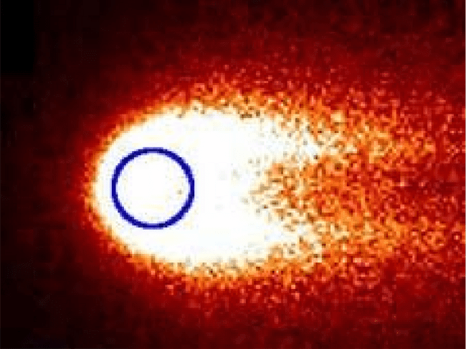

*Image 12 Shows the large whitish-reddish mass is the sodium in the exosphere around Mercury [32], the large whitish-reddish mass is the sodium in the exosphere around Mercury (dark blue circle), Image Credit: NASA/GSFC/Mehdi Benna Pity.*

The image 12 still was taken from an animation showing the seasonal effects of sodium in Mercury's exosphere. (For the animation, a simple, uniform source of sodium is assumed) going their separate ways. shows the large whitish-reddish mass is the sodium in the exosphere around Mercury (dark blue circle). In the upper left corner, Mercury's position (purple ball) in its orbit (light blue circle) around the sun (yellow ball) is shown. (TAA stands for true anomaly angle the angle between Mercury, the sun, and the closest point to the sun along the orbit, which is known as the perihelion point), as Mercury orbits, the distance between the planet and the sun changes and so does the speed at which Mercury is moving relative to the sun. These changes, in turn, affect both the brightness of the sodium emission and the amount of radiation pressure a sodium atom experiences. These factors yield the greatest amount of sodium in the exosphere when Mercury is at a middle distance from the Sun, The atoms and molecules in Earth's atmosphere bounce around and collide all the time, but this doesn't happen much in Mercury's exosphere. Instead, the species tend to follow their paths and are more likely to collide with the planet's surface than with each other. Therefore we may assume that the absence of the atmosphere on the planet Mercury is due to the collapse of the balance circumstance between the gravity force and the thermodynamic effect of atmospheric gases due to the excessive rising in temperatures on the surface of the planet Mercury that led to expanding the volume of gases to great values to rush those gases towards the space overcoming the force of gravity the planet Mercury, due to increasing its temperature extremely around (427 °C) while the gravity force is at a very low limit (3.7 m/s²) due to its low value of mass (3.285×1023 kg), thus the thermodynamic effect of the atmospheric gases overcame the value of the gravitational force of the planet, which finally led of gaseous escape extremely in the first ages of the formation of the planet Mercury.

# When the effects of the gravitational acceleration force of the planet are greater than the effects of the thermodynamic processes of the atmosphere gases (F1 > F2):

If the effects of the gravitational acceleration force F1 of the planet is greater than the effects of the thermodynamic processes of the atmospheres gases F2, the gravitational acceleration force will be able to confine the atmospheres gases in the low altitudes of the low ranges of the planetary gravitational field and will not have any gaseous escape, exactly what occurs on the Jupiter planet which has a great gravitational acceleration force around 24.79 m/s²), in the meantime low temperature is around -110 °C reducing the thermodynamic effects which leads gases to shrink, and this low limit of temperature in the Jupiter planet will guides the atmospheric gases to shrink to be liquidize and reduces the pressure due to the thermodynamic processes, therefore we find that the atmospheric pressure in the Jupiter planet is 70 kPa lower than atmospheric pressure on Earth (at sea level), despite of the great gravitational

acceleration force which confine gases toward the surface of the planet. The fared planets which have a very distances from the Sun (Jupiter -140 °C, Uranus -195 °C, Neptune -200 °C, and Pluto -232 °C), the elements of their atmosphere elements liquefy or even freeze due to the effect of the reduction of the temperature and separate from the gaseous atmosphere to form a liquid or solid layers of these elements on the surface of the planet and stop their influence on creating atmospheric pressure and their role gets cancel in the formation of planetary atmospheric, checking the liquefaction and solidification temperature of the gaseous elements in the periodic table of elements, we can predict the type of elements that form regions surrounding the planets after knowing the temperatures on their surfaces, it is logical to expect the presence of meteors consisting of solid Nitrogen and Oxygen that strike the surfaces of very distant planets such as Neptune and Pluto, a solid state phase even when the pressure is zero, and during their collides with the surface of those fared planets, will form layers of ice (solid- state) of these elements, although the gravitational force of those planets is low, because at extremely low temperatures, these elements are attracted to each other in distant space due to the effects of the atomic gravity fields of these elements and approach their atoms each other more when in the gaseous phase.

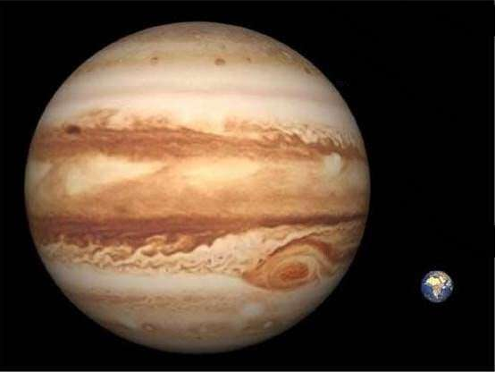

*The image 13 shows the relation of the size of Jupiter to size Earth. [33]*

Planets of the first orbits of the solar system (Jupiter -140 °C, Uranus -195 °C, Neptune -200 °C, and Pluto -232 °C) get higher percentages of gases to confine them with the composition of their atmosphere gases, what encourages this is the extreme decrease in temperatures in the planets in the first orbits of the solar system, which leads to a significant reduction in the volume of these gases and an increase in their density, causing a decrease in their influence on the gravitational fields of the planets. Planet Jupiter has a mass (1.898 × 1027 kg) and an amount of gravity (24.79 m/s2), which is 2.4 times that of Earth, the planetary gravitational force is very high (the masses of the planet are large) and the thermodynamic effect of atmospheric gases is low (the temperature is low) this leads to a decrease in the value of atmospheric pressure because:

1. Gases shrink due to the low temperature, which leads to a decrease in the value of pressure generated due to thermodynamic effects.
2. The pressure is distributed over a wide area, which leads to a decrease in the value of the generating force, as in the relationship:

Pressure = Force / Area

Therefore the gaseous escape is non-existent in the planet Jupiter atmosphere and the evidence is the presence of the elements Hydrogen and Helium at a very dense rate in the atmosphere, confined due to

influence of the massive gravitational force where these elements Hydrogen and Helium does not exist in the atmosphere of the planets Mercury, Venus, and Earth which have lower values of mass and gravity than Jupiter, the effect of the gravitational force of the planet is greater than the effect of thermodynamic gases, especially in the temperature of the surface of Jupiter within the limits of (-110

°C) where the physical activities of the atoms decrease extremely, leads increasing of their density, their size and pressure decrease, occupying small volumes being more affected by the influence of the gravitational force of its gravitational field of Jupiter, because the thermodynamic processes related to the phase transformations of gases from the liquid phase to the gas phase are closely related to the atomic diffusion, supported by the atomic dynamic forces of the properties of the elements in the conditions of those transformations, so the atomic diffusion occurs with extreme violence. If the effects of the gravity force of the planet F1 is greater than the effects of the thermodynamic processes of the atmosphere gases F2, the gravitational force will be able to confine the atmosphere gases in the low altitudes of the ranges of the planetary gravity field and will never get any losses of gases to the space preventing the gaseous escape exactly what occurs on the Jupiter planet which has a great gravity force around 24.79 m/s2, while the temperature drops around -110 °C preventing the thermodynamic processes that lead gases to expand, this low limit of temperature in Jupiter planet will guide the atmospheric gases to shrink and even to liquidize and reduce the generated pressure due to the thermodynamic processes, therefore we find that the atmospheric pressure in the Jupiter planet is 70 kPa slightly less than atmospheric pressure on Earth`s sea level, despite of the great gravity force which confines gases toward the surface of the planet forcedly.

|  |  |  |  |
| --- | --- | --- | --- |
|  |  | Jupiter | Earth |
| 1. | Mass | 1.898 × 1027kg | 5.973 x1024 kg |
| 2. | Gravity | 24.79 m/s2 | 9.807 m/s² |
| 3. | Temperature | -110 °C | 13.9 °C |
| 4. | atmospheric  pressure | 70 kPa | 101.325 kPa |

*Table 10 data comparison between Jupiter and Earth.*

Note that Jupiter has mass (1.898 × 1027 kg) and gravitational acceleration (24.79 m/s2) while the value of atmospheric pressure is (70 kPa) less than the atmospheric pressure on the planet Earth about (101.325 kPa) dropping temperatures on the surface of Jupiter to the limits (-110 °C) of liquefaction of Oxygen the gas of critical temperature (-90°C) and Nitrogen (-147°C)) leads to the formation of liquid surfaces of these two elements upon the surface of Jupiter, exactly like the water surface on Earth, which considered the best solvent areas for gases in the atmosphere of Jupiter (Hydrogen and Helium) which plays an important role in dissolving these two elements (Hydrogen and Helium) of the atmosphere in the in those liquid surfaces of, which causes the decrease in atmospheric pressure of Jupiter. These temperatures are within the limits of the temperatures of liquefaction, freezing, and evaporation of Oxygen and Nitrogen gases, therefore, it is likely that these swirling shapes in the atmosphere of Jupiter are the result of the explosions accompanying the processes of phase transformation among solid, liquid and gas phases of Oxygen and Nitrogen, as is occurs in our laboratories when observing these phase transitions of these two gases, because these temperatures rates on Jupiter are within the limits of the temperatures of freezing, liquefaction, and evaporation of Oxygen and Nitrogen gases, therefore the influence of the planetary gravitational force dominates over the thermodynamic effects and leads to preventing gaseous escape from the atmosphere into space. The planetary gravitational force is high (large mass) and the thermodynamic effect of atmospheric gases is very low (temperature is very low), the effect of the gravitational force will overcome the thermodynamic effect, preventing the gaseous escape, dropping the temperature extremely will lead to the freezing of light elements, and prevent the chances of the formation of liquid surface for these gases on the surface, and preventing the solubility of atmospheric gases in any liquid surface, which leads to the sharp increase in atmospheric pressure.

The planet Neptune, which has a mass of (1.024 × 1026 kg) and a gravitational value (11.15 m/s² and its temperature rate around (-200 °C) that’s mean around (-180°C to -240°C), note that Oxygen freezing temperature of (-218.8 °C) and freezing temperature of Nitrogen (-210 °C), therefore it’s not possible to find these two elements as liquid phase on the surface of planet Neptune, this absences of the liquid surfaces and the absence of the opportunity of dissolve atmospheric gases to in those liquid surfaces, leads to increase the value of the atmospheric pressure to tremendous values to reach around 10 GPa or about 100,000 times of Earth's atmosphere, this is why Neptune atmosphere is made up mostly of Hydrogen and Helium with just a little bit of methane, note that the location of the Neptune is at the second orbit around the Sun, grant it the biggest shares of the attracted gases from the space during rushing the solar system in the space in the orbit around the centre of Milky Way galaxy to increase the variable (n) the amount of substance in the equation PV=nRT which has proportional relationship with the value of generated pressure, P is pressure, V is volume, n is amount of substance, R is ideal gas constant and T is temperature.

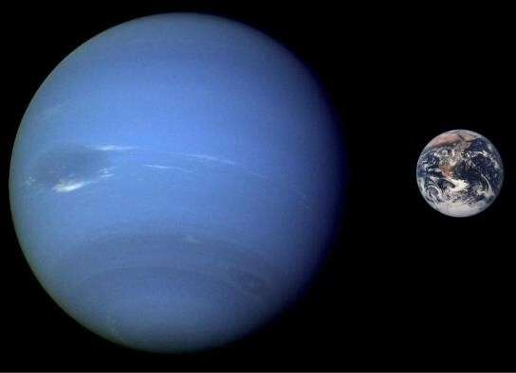

*The image 14 shows the relation of the size of Neptune to size Earth.*

|  |  |  |  |
| --- | --- | --- | --- |
|  |  | Neptune | Earth |
| 1. | Mass | 1.024 × 1026kg | 5.973 x1024 kg |
| 2. | Gravity | 11.15 m/s² | 9.807 m/s² |
| 3. | Temperature | -200 °C | 13.9 °C |
| 4. | atmospheric  pressure | 10 GPa or about 100,000  times of Earth's atmosphere | 101.325 kPa |

*Table 11 data comparison between Neptune and Earth.*

The reason behind the extremely high atmospheric pressure of the planet Neptune which is equal to 10 GPa is due to the presence of a large amount of elements in its atmosphere, which causes a double effect:

1. It increases the thermodynamic effect in the atmosphere and represents the amount of substance (n) in the ideal gas equation: PV=nRT.
2. Increases the effect of the gravity field where it represents (m2) Newton's law of universal gravitation: F= G. (m1.m2)/ d2.

The reason for the existence of a huge amount of elements in the atmosphere of the planet Neptune is because of the ability of the value of the planet gravitational which is equal to 11.15 m/s² to attract those elements that are in a low thermodynamic activity due to the decrease in entropy in extremely low temperature. The second reason is that the planet Neptune location occupies the second orbit of the

planets of the solar system, where elements coming from space pass through the gravity field of the planet Neptune before passing the gravity field of the rest of the planets. This gives a great opportunity to the planet Neptune to attract a great amount of these elements and higher than the shares of attracted elements of the rest of the planets, where the high gravitational force of the Sun in the low altitudes leads to attracting these gases to the Sun before they are attracted to the planets (Mercury 46.098 million km, Venus 108.18 million km, Earth 152.09 million km, and Mars 208.22 million km), note that these elements are just gaseous clouds in space that collide with the gravitational field of the solar system during the traveling within its trajectory around the galactic centre of the Milky Way galaxy at an average speed of 230 km/s as shown in the illustration 1. But this does not happen with the planet Pluto, which occupies the first orbit of the solar system, due to the meagre value of the gravitational force of the planet Pluto (0.62 m/s²) which prevents it from attracting a large quantity of these gases from the space to its gravitational range, led the value of the atmospheric pressure of the planet Pluto remains low equal 10 μbar.

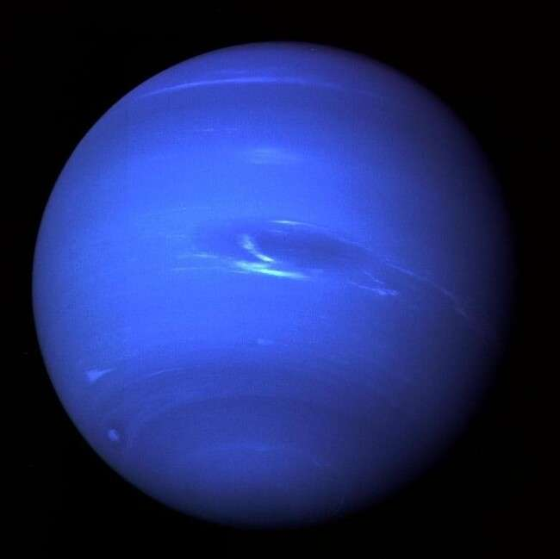

*Image 15 Neptune planet was taken by Voyager 2 less than five days before the probe's closest approach to the planet on Aug. 25, 1989. The picture shows what's called the Great Dark Spot — a storm in Neptune's atmosphere and the bright, light blue smudge of clouds that accompanies the storm. (NASA/JPL-Caltech)*

1. **The presence elements Hydrogen and Helium in the atmosphere of planets which have a very far distances of the Sun, such as Neptune:** Therefore it’s able to predict the presence of the elements Hydrogen and Helium in the atmosphere of planets which a fared from the sun, such as Neptune, because the influence of the thermodynamic factor of gases leads them to condense to the liquid phase due to the extremely low rates of temperature leading them to form intense masses that allow the attractive force of planets to confine them in the limes the planetary gravitational field, and these conditions do not exist in the circumstances of rest of the planets which are close distances to the Sun, which have relatively high temperatures rates, which leads these gases to expand to at high rates and granting them its extreme low density, which makes it difficult for the planetary gravitational forces to have any influence upon them, as we find in the Earth’s atmosphere the Hydrogen and Hilum ascending up (in balloons) toward a very high altitudes and escaping to the outer limits of atmosphere. The thermodynamic factor of gases leads them to expand extremely due to the extremely relatively high rates of temperature leading them to have a very low density preventing the planetary gravitational force from doing their gravitational effects upon the materials of these gases and causing the failure of the

capability of the gravitational effects in the equilibrium circumstances of the atmosphere. Note that this thermodynamic effect of gases at extremely low temperatures occurs in the dense gas clouds of the early stages of star formation, where the clouds begin to shrink as a result of the effect of the atomic gravitational field of the Hydrogen element which available abundantly in those clouds lead it to shrink, forming the first nuclei of the formed stars, and these Hydrogen clouds are in cold deep space in within the limits of absolute zero, where the atoms are at their lowest kinetic activity, so the force of the atomic gravitational field of the Hydrogen overcomes the force of the propulsion force of the collisions among the atoms, this guides the Hydrogen clouds to contract. But these conditions are not available in the atmosphere circumstance of the Earth nor the rest and close planets to the Sun where temperatures rise to several handed above the absolute zero. From what leads to an increase in the kinetic activity of Hydrogen atoms and an increase in their atomic collisions, which leads to an increase in the volume of the atmospheric gases in high rates of temperature, what makes the problem more complex is the presence of heavy elements (high mass weight) in the planetary atmosphere such as Oxygen, Nitrogen, and Argon, which are affected harder by the force of the planetary gravitational field due to their relatively high mass weights, these relatively high mass weights gases (Oxygen, Nitrogen, and Argon) descend towards the surface of the planet with a great force, and leads to the displacement of light gases (relatively high mass weights) such as Hydrogen and Helium towards the upper zones of the atmosphere, in this case it’s possible to apply Archimedes rule of (the volume of the submerged part of the object is equal to the volume of the floating part of the object). Here, the submerged body represents the relatively high mass weights gases in the atmosphere such as oxygen, Nitrogen, and Argon), and the volume of the floating body is the light gases (relatively low mass weights) such as Hydrogen and Helium, and this causes the displacement of the light gases towards the upper zones of the atmosphere and occupying very high zones of the atmosphere, especially if the proportions of the heavy gases such (Oxygen, Nitrogen, and Argon) are at high rates as it’s in the atmosphere of the Earth, which eventually causes the escaping of the light gases (relatively low mass weights) such Hydrogen and Helium from the atmosphere towards the space.

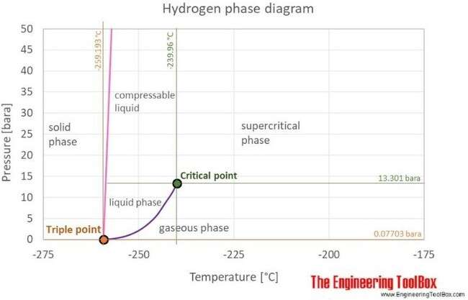

*The illustration 20 shows the Hydrogen phase diagram. [35]*

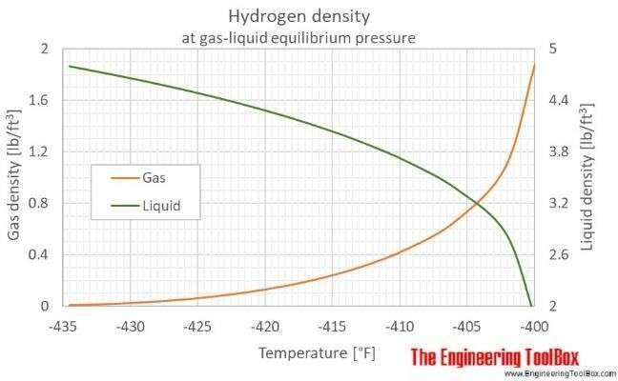

*The illustration 21 shows the Hydrogen - Density and Specific Weight vs Temperature and Pressure*

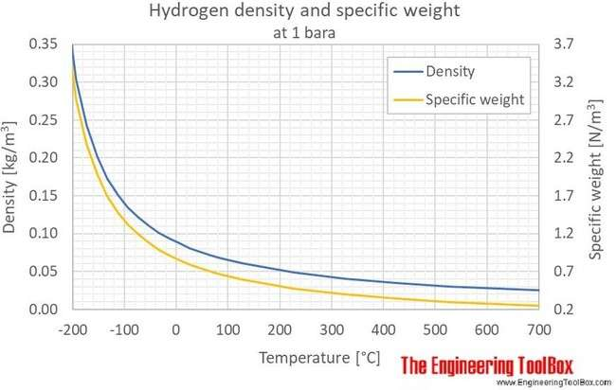

*The illustration 22 shows the Hydrogen - Density and Specific Weight vs. Temperature and Pressure. [36]*

1. **The comparison between the planetary atmosphere circumstances of the Earth and Pluto:** When the planetary gravitational force is very low 0.62 m/s² (due to its very small mass 1.303×1022 kg) and the thermodynamic effect of atmospheric gases is also very low (due to extreme reduction of the temperature -232 °C) the effects of both forces gravitational force F1 and the thermodynamic effect F2 work on decrease its atmospheric pressure, leads to generate very low atmospheric pressure (about 1 Pa or 10 μbar) about 1/100,000 of Earth's atmospheric pressure.

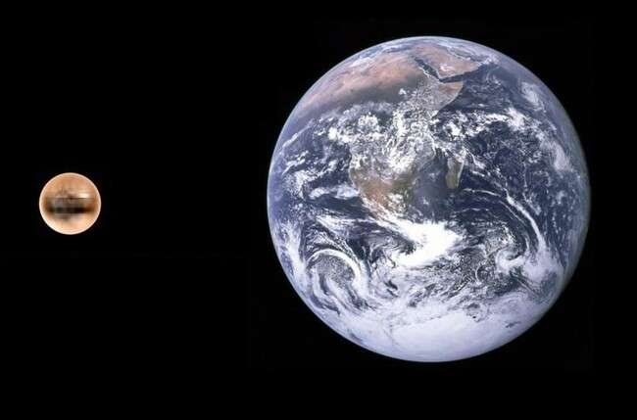

*The image 16 shows the relation of the size of Pluto to size Earth.[36]*

|  |  |  |  |
| --- | --- | --- | --- |
|  |  | Pluto | Earth |
| 1. | Mass | 1.303 × 1022 kg | 5.973 x1024 kg |
| 2. | Gravity | 0.62 m/s² | 9.807 m/s² |
| 3. | Temperature | -232 °C | 13.9 °C |
| 4. | atmospheric pressure | 10 μbar, roughly 1/100,000 of  Earth's atmospheric pressure. | 101.325 kPa |

*Table 12 data comparison between Pluto and Earth.*

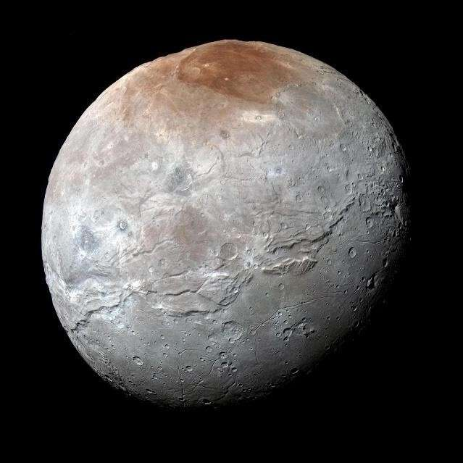

*Image 17 NASA's New Horizons captured this high-resolution enhanced colour view of Charon just before the spacecraft made its closest approach to Pluto on July 14, 2015. Credits: NASA/Johns*

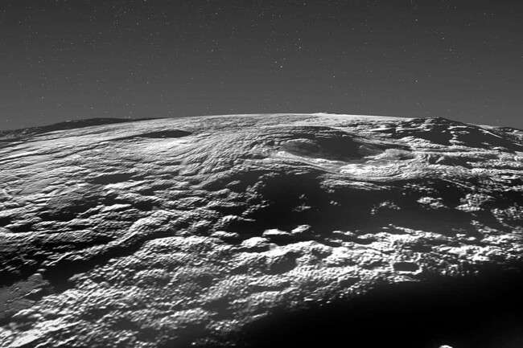

*Image 18 shows Pluto’s icy surface, NASA/Johns Hopkins University Applied Physics Laboratory/Southwest Research Institute/Isaac Herrera/Kelsi Singer.*

The freezing temperature of Oxygen at −218.79 °C and Nitrogen at -210 °C causes of forming icebergs on the surface of planet Pluto at -232 °C, therefore the low value of gravity of the planet Pluto at

0.62 m/s² cannot attract Hydrogen and Helium gases to confine them in the range of their gravity fields, what leads to the gaseous escapes of Hydrogen and Helium reach high rates towards space. Pluto has huge ice volcanoes that may still be active to this day. The comprehensive analysis of data from NASA’s New Horizons spacecraft, which flew past Pluto in 2015, has revealed that a large area of its surface at least 180,000 square kilometres is made up of ice that seeped out from underground via volcanism relatively recently. Velocity distribution data for gas of rubidium atoms confirming the existence of the new phase of matter, the Bose-Einstein condensate in the esteem low temperature with new physic characteristics such the superconductivity effect or Meissner effect, and this may represent one of the fundamental features of material in the environment of deep space.

# When the effects of the gravitational force of the planet are equal to the effects of the thermodynamic process of the atmosphere gases (F1= F2):

When the effects of the gravitational force of the planet F1 are equal to the effects of the thermodynamic process of the planetary atmosphere gases F2, the gravitational acceleration force will be able to confine the atmosphere gases of the planetary gravitational field strongly where the thermodynamic effects at low rates of gaseous escape as it occurs on the Earth and Venus which the gravitational acceleration force of Earth is 9.807 m/s² while the temperature rate reaches 14 °C, and the gravitational acceleration force of Venus is 8.87 m/s² while the temperature rate reaches 475 °C, this grants the opportunity to the thermodynamics processes to create high rates of pressure due to the expansion of atmospheric gases in the high gravity force range to be confined in their gravity fields, the tail of Venus is the evidence of the gaseous escape from the atmosphere, when the solar wind nearly breaks off Venus the Ionosphere layer of Venus the expands into space, the sheath of electrons and ions enveloping Venus at a height of 150 to 300 kilometres can expand into space like a tail. This exceptional deformation occurs on the planet’s night side, when the solar wind, the flow of charged particles from the Sun, nearly comes to a stop, data obtained by instruments on board ESA's spacecraft Venus Express.

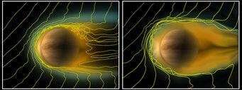

*The Image 19 shows the Gas trail in space of Venus is surrounded by an ionosphere at a height of 150 to 300 kilometres© ESA/Wei et al (2012)[40]*

Venus is surrounded by an ionosphere, a sheath consisting of electrons and ions, this is referred to as plasma, where the charged particles are created on the planets’ day sides when ultraviolet light with extremely short wavelengths and X-rays enter the outer layers of the atmosphere, on Earth, the particles are trapped by the strong magnetic field forcing them to rotate together with the Earth. The electrons and ions in the ionosphere flow from the day side to the night side by the high plasma pressure on the day side, such as compressed gas escaping from a pressure vessel and the plasma travels from the region with high pressure to one with lower pressure. The new measurements prove that the night-side ionosphere protrudes approximately 15000 kilometres into space, where the tail could be much longer. It might measure up to millions of kilometres.

1. **The effect of mass weight of the elements of gases of the atmosphere:** Elements that have a low mass weight in periodic table such as (Hydrogen and Helium) are less affected by the force of planet's gravity field, therefore they occupy regions at high altitudes in the atmosphere, therefore are more candidates for escape from the atmosphere, as well as the rest of the elements occupy regions in the atmosphere according to their mass weight, in respect to the Earth`s atmosphere the mass number of Nitrogen is 14 and the mass number of Oxygen is 16 therefore we find Nitrogen gas covering the higher layers of Earth's atmosphere and above the Oxygen gas, therefore the escape ability of Nitrogen to the space is at a higher value than the value of the escape-ability of Oxygen from Earth's atmosphere to the space, if the atmosphere lose big ratio of gases for a long term next several million years and that could not change the value of atmosphere pressure, because any reduces in the value of atmosphere pressure of the Earth will have the effect to reduce the boiling temperature of the water of Earth's oceans and water surfaces to evaporate and transfer to steam substituting the position of the lost gases, also reducing atmosphere pressure will urge the rest of dissolved gases either in the oceans or even in the soft ground to be released to the atmosphere, in the meantime the ultraviolet ray of the sun rays able to break water molecules in the atmosphere to Hydrogen and Oxygen that may also substitute the value of lost Oxygen of the atmosphere. Therefore when we see the aurora we find the violet colour is above the green colour because the violet colour is the effect of the collision of cosmic particles with Oxygen which is occupy higher altitudes, while the green colour is the effect of its collision with Nitrogen which occupy lower altitudes in the atmosphere. This is why (Hydrogen and Helium) represents the main shares of the atmospheric gases of (Jupiter -140 °C, Uranus -195 °C, Neptune -200 °C, and Pluto -232 °C), due to the low temperature that reduces the thermodynamic effects to be shrank to extremely small volumes and reduce their generated pressure, causes of their attraction towards the surface with a relatively higher forces, leads to the displacement of light elements (Hydrogen and Helium) towards the higher altitudes therefore and do not form a proportion of the components of the atmospheric gases of the planets (Mercury 430 °C, Venus 475 °C, Earth 14 °C, and Mars -60 °C). Checking the diagram of the relationship between the density and the temperatures of Hydrogen, we notice that in very low

temperatures within the limits of the temperatures of the distant planets such as (Jupiter -140 °C, Uranus

-195 °C, Neptune -200 °C, and Pluto -232 °C), we find that the density of this element is very high at low temperatures, and its density is very low at average temperatures among the planets close to Sun. The illustration 18. Shows the thermodynamic effects, mass of the planet and entropy of atoms upon the balance circumstances of planetary atmospheres, the relationship between the temperature and pressure according to the universal ideal gases theory of planets of solar system when the planetary gravitational force is high (large mass) and the thermodynamic effect of atmospheric gases is very low (temperature is very low), the effect of the gravitational force will overcome the thermodynamic effect, preventing the gaseous escape, dropping the temperature extremely will lead to the freezing of light elements, and prevent the chances of the formation of liquid surface for these gases on the surface, and preventing the solubility of atmospheric gases in any liquid surface, which lead to the sharp increase in atmospheric pressure, as happens on the planet Neptune, which has a mass of (1.024 × 1026kg) and a gravitational value (11.15 m/s² and its temperature rate around (-200 °C) that’s mean around (-180°C to -240°C), note that the freezing temperature of Oxygen (-218.8 °C) and Nitrogen (-210 °C) therefore it’s not possible to find these two elements as liquid phase on the surface of planet Neptune, this absences of the liquid surfaces and the absence of the opportunity of dissolve atmospheric gases to in those liquid surfaces, leads to increase the value of the atmospheric pressure to tremendous values to reach around 10 GPa or about 100,000 times of Earth's atmosphere, note that the location of the Neptune is at the second orbit around the Sun, grant it the biggest shares of the attracted gases from the space during rushing the solar system in the space in the orbit around the centre of Milky Way galaxy to increase the variable (n) the amount of substance in the equation PV=nRT which has proportional relationship with the value of generated pressure, P is pressure, V is volume, n is amount of substance, R is ideal gas constant, T is temperature.

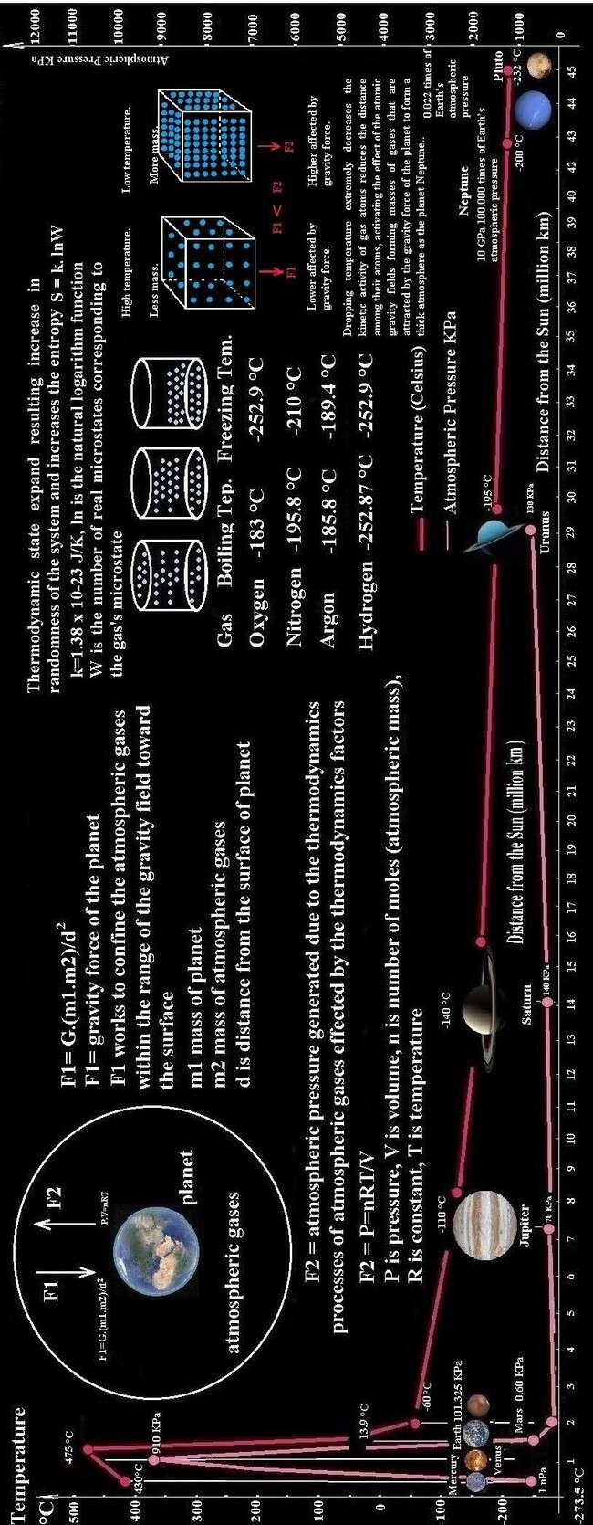

*The illustration 23 shows the effect of temperature, mass of the planet and entropy of atoms upon the balance circumstances of planetary atmospheres.*

Dropping temperature extremely decreases the kinetic activity of gas atoms reduces the distance among their atoms, activating the effect of the atomic gravity fields forming masses of gases that are attracted by the gravity force of the planet to form a thick atmosphere as the planet Neptune knows the atmospheric pressure (10 GPa) despite the decrease in the thermodynamic activities of gases at low temperatures (-200 °C) due to the effect of the gravity force of planet Neptune to confine those gas masses toward the surface forcedly. For a conventional substance (inset), there exists a triple point (TP), where solid, liquid, and gas coexist. Helium lacks such a point. The shaded region illustrates where Bose-Einstein condensation is predicted to occur for an ideal gas. The illustration 4. shows how the thermodynamic effects of gases decrease with the increase in planetary distances from the sun, due to the decrease in the received heat from the sun, gives the planetary gravitational force the possibility to overcome the effects of thermodynamics to confine atmospheric gases to narrower limits in the planetary gravitational fields, and then lead these gases to liquefy and freeze due to the reduction of atomic entropy of atmospheric gases, to be out of the forces acting in the atmosphere of the planet. Where in the fared planets from the Sun (Jupiter 742.46 million km, Saturn 1.4754 billion km, Uranus 2.9455 billion km, Neptune 4.4742 billion km, and Pluto 7.3 billion km), the reduction of temperature leads to a shrinking volume of atmospheric gases, reducing the thermodynamic effect upon the value of atmospheric pressure on the surface of the planet, as long as these gases are in the gaseous state, where the effects of the gravity force of the planet keeps their impact upon the masses of atmospheric gases to confine them in the range of the gravity field of the planet, and when the temperature drops to extremely to low rates and results phase transformation of some elements such as Oxygen −183 °C and Nitrogen -195.8°C from the gas phase to the liquid phase, leads to form swamps of liquidized gases of Oxygen and Nitrogen on the surface of the fared planets where atmospheric pressure drops due to the reduction of the thermodynamic effects of many gases from the total thermodynamic effects of the rest of atmospheric the elements such Hydrogen and Helium may be found in the gaseous phase in the atmospheres of these cold planets have a low liquefaction temperature, such as Oxygen −183 °C and Nitrogen -195.8 °C remain in the gaseous state in the atmosphere within the limits of the extremely low temperature of the planet Jupiter around -110 °C, where its high gravity force of 24.79 m/s² is able to attract and confine them within the range of its gravitational field, note that the liquefaction temperature of Oxygen −183 °C and Nitrogen -195.8°C is are at in the standard laboratory conditions or at Earth`s circumstances, (temperature 20 degrees Celsius, pressure 1 atm 101.325 kPa, where their values change according to the surrounding conditions. The huge size of Saturn (at around 10 times the diameter of Earth) while Saturn's gravity is only 1.08 times the gravity of Earth, because the solid part of Saturn is nearly the same mass as Earth, but the extremely low-temperature causes condensed gases of the atmosphere to compose a thick clouds results form a huge size of the Saturn, due to the thermodynamic laws due to effects of temperature upon the material characteristics of gases.

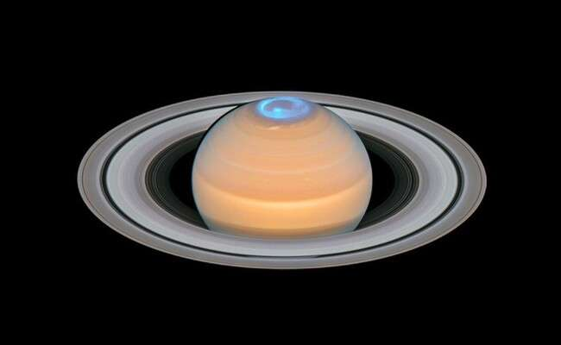

*Image 20 shows a composite of observations made of Saturn in early 2018 in the optical and of the auroras on Saturn’s North Pole region, made in 2017. ESA/Hubble, NASA, A. Simon (GSFC) and the OPAL Team, J. DePasquale (STScI), L. Lamy (Observatoire de Paris) [41]*

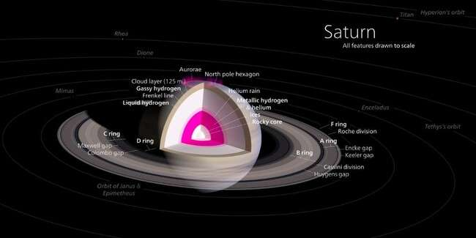

*The illustration 25 shows the atmospheric layers of Saturn.[42]*

Increasing the amount of gases in the atmosphere causes increasing atmospheric pressure because of its effect upon both relationships F= G. (m1.m2)/ d2 in the meantime in the relationship PV=nRT because, in the first relationship, it represents m2. In contrast, the second relationship represents the amount of substance, this is also evident in the extreme increase in the atmospheric pressure of the planet Neptune (10 GPa and about 100,000 times that of Earth's atmosphere), as a result of the increase in the amount of gases in the atmosphere, which increases the effect of the gravity force to confine the downward at the range of the gravity field, it increases its effect on the thermodynamic factor which leads to an increase in pressure as a result of the increase in the amount of gases. The thermodynamic action of gases in the high rates of temperatures guides to rise the value of pressure due to the expansion of gases push gases in the opposite directs of the gravity force and this force able to overcome the value of the

planetary gravity force therefore, the different values of the gravitational forces of the planets, which stem from the difference in the values of their masses and the differences in their temperature rates which resulting from the differences in their distances from the Sun, cause the different conditions of the equilibrium state in the atmosphere of each planet, which leads to the formation of different environmental conditions of the values of atmospheric pressure and creating specific alien environment conditions for each planet. Therefore rising the temperature leads to increase the volume of gases which leads to the rise of the region of gases occupied in the atmosphere to the heights altitudes, where the value of the planet's gravity decreases on the mass of these gases, so the possibility of the gaseous escape increase, therefore drop in temperature leads the atomic vibration decreases, thus randomness of molecules also decreases and this leads a decrease of entropy as mentioned in the 3rd law of thermodynamics states that the value of entropy of a purely crystalline substance is zero at absolute zero temperature, were we have a pure crystalline solid substance and if it’s temperature is absolute zero then it’s entropy will be zero, where molecules move very fast throughout the container or the atmosphere, has more randomness which means it has more entropy, note that the entropy of the universe keeps on increasing for all the process occurring on its own, absolute zero is so much cold temperature that all the atoms and molecules of a substance gets freeze up, the atoms and molecules of any substance will not be able to move, vibrate or oscillate inside the substance.

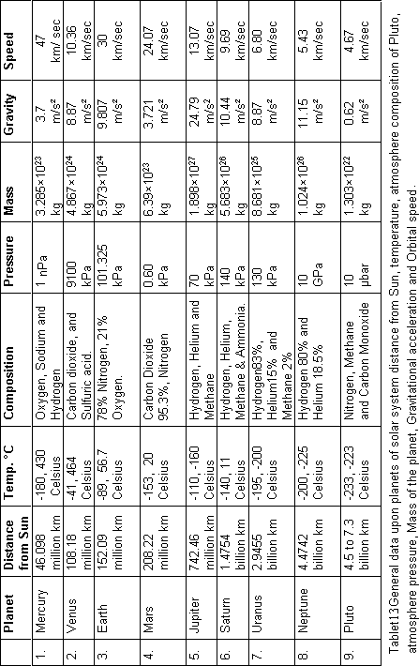

*Table 13 shows data of planets of solar system.[43]*

Therefore the physical characteristics of (Hydrogen and Helium) get changed according to their temperature and their distance from the Sun therefore it have a different physical characteristics in each planet of the solar system

1. The elements and compounds that form the atmosphere of Venus (Carbon dioxide and Sulfuric acid) have a high molecular weight that is more affected by the gravitational force of the planet.
2. The amount of gases that form the atmosphere is large which represents (n) in the equation ideal gas relationship PV = nRT where P is pressure, V is volume, n is the amount of substance, R is the universal gas constant, and T is temperature. Therefore, the sharp rise in the temperatures of the atmosphere of Venus led to an extreme increase in the atmospheric pressure, as the high molecular weight prevented those gases from rising to high altitude as a result of their influence by the gravitational force of Venus, which confined these hot gases within their gravitational zone at high pressure.
3. **Solubility of gases at extreme low temperature:** Dropping temperatures leads to increase in the solubility of gases in liquids, which leads to decrease proportions of these gases in the atmosphere in their gaseous state due to their soluble in the existing liquids on the surface either the water surfaces in the liquid state or liquidized gases due to the extremely low temperatures, this causes the melting of other gases which have liquefaction temperature is higher than the liquefaction temperature of the solvent elements, to obtain a mixture of liquids for the gaseous elements at low rates temperatures, and this is clearly seen in Saturn (gravitational acceleration force 10.44 m/s² temperature -140°C Celsius) and Jupiter (gravitational acceleration force 24.79 m/s², temperature -110°C Celsius), their high gravitational acceleration forces and the low temperature rates leads to the formation surfaces liquids elements that are similar to the water surfaces on Earth, but consist of relatively light elements such as Oxygen and Nitrogen, it also causes the presence of Hydrogen gas (Atomic mass 1.00784 u) in abundance confined in the high gravitational field of the Jupiter planet at low altitudes from the surface. As for the fared planets of the solar system such as Uranus (gravitational acceleration force 8.87 m/s², temperature -195°C Celsius), Neptune (gravitational acceleration force 11.15 m/s², temperature -200°C Celsius), and Pluto (gravitational acceleration force 0.62 m/s², temperature -232°C Celsius) , we find that these elements are in the solid state and represent thick ice on the surface and to be part of the crust materials as a result of the extreme drop in temperatures, due to the effects of the thermodynamic factor of the gases in those physical conditions which changes the physical properties of those elements and finally leave their effects completely from the rest of effects of the rest of gases in the planet’s atmospheric pressure. Therefore the gas giant planets have circumstances that prevent gas from escaping such as huge amounts of masses and high gravity force, as extremely low temperatures which drop due to the extremely long distances of their stars, this leads to the reduction in the volume of gases guides the formation of dense atmosphere of cold gases at very high altitudes from the solid surface of the planet, although the rates of temperatures of gases in the upper layers are low, the rates of expansion of the gases in the first layer is in high rates and pushes the expanding gases forcedly towards the upper layers.

**The factor of the chemical activity of elements:** In the first group of planets of the solar system which have close distances to the sun (Mercury, Venus, Earth, and Mars) the temperatures rise to the limits of the chemical activity of materials, because this heat provides the electrons of the atoms required energy needed to jump among the orbits of the atom, which urge to activate the chemical activation of the substance. For this reason, we find that most of the elements in Earth (metals and non-metals) are in the form of oxides and chemical compounds only chemically inert elements such as gold can be found free (pure) and the elements of the atmosphere are in continuous chemical interaction with Earth’s substance in the formation of nitrogen compounds that move from the atmosphere to Earth’s substance which absorbed by plants or the respiration process of creatures, which leads to the transfer of atmospheric Oxygen to the biological building of creatures and many others examples, this transition of elements from the gaseous state of the atmosphere to other phases in the surface leads to their exit from the atmosphere zone, then absence of their effects upon the amount of atmospheric pressure, but in the planets which a fared distances from the Sun (Jupiter, Uranus, Neptune and Pluto), where their temperatures drops in an extreme rates, leads to inactivity of their chemical properties of the elements of the atmosphere and the elements of the surface of the planet, the chemical reactions do not occur, so these elements remain present in the atmosphere, and this is also one of the reasons for the extremely

high atmospheric pressure on Neptune which has temperature rate (-200 °C) and the atmospheric pressure (10 GPa) or about 100,000 times of Earth's atmosphere.

1. **The effect of the amount of heat gained and heat lost (heat content) of the surface of the planet upon the stability of atmosphere:** The thermal content of the planet has an effect upon the duration while the surfaces of the planet are at the limits of temperature that obtained from the solar radiation, to activate the thermodynamic processes of gases leading to gaseous expansion and increase pressure (temporarily) that causes the movements of air masses to lead winds and storms, and even gases expansion that leads to the rush of gases from Thermosphere layer towards Troposphere, Stratosphere, Mesosphere and finally causes the gas escape to the space, therefore as much as mass of the planet are greater will lead to increase in the heat content and prolonging the period of the while the surface is hot the effect of thermodynamic processes will increase and vice versa when the masses of the planet are smaller, that will lead to shortening the period while the surface is hot thus the effect of thermodynamic processes will be reduced upon the atmospheric gaseous, the amount of energy required to change the state of a sample of matter depends on three things depends upon what the substance is, how much substance is undergoing the state change, phase change that is occurring, the mathematics related to the heat gain and heat loss could be calculated via the following equation:

Q = m.C.∆T 9

Q = the quantity of heat transferred to or from the object, m is the mass of the object, C is the specific heat capacity of the material the object is composed, ΔT is the resulting temperature change of the object. Note that during the heat gain and heat loss on the surface of the planet, many thermodynamic processes occur with the sorts of elements on the surface of the planet and the atmosphere, in the case of melting, boiling, and sublimation the energy would have to be added to the sample of matter to cause the change of phase such phase changes are referred to as being endothermic, where the freezing, condensation, and deposition are exothermic, energy is released by the sample of matter when these phase changes occur.

These mentioned processes represent the main energy resources of the thermodynamic processes in the atmosphere, in the meantime the spinning speed of the planet has a role in the time period of heat gain and heat loss, because the increase in spinning speed has an effect upon creating turbulences in the air masses guides an atmosphere of instability supplies gases to the atmosphere the kinetic energy that activates the thermodynamic processes such the atomic diffusion which accelerate the phase transfers from the liquid phase to the gas phase at lower limits of temperature than the boiling temperature of the liquids exactly what happens in Earth’s nature where all the water transfers from the liquid phase to the gas phase in lower limits of temperature the boiling temperature of the water (100 °C) or even the vice versa, in the phase transformation from the gaseous phase to the liquid phase as a result of the collision of air currents loaded with clouds with heights mountainous, which gives an opportunity for vapour particles to collide with each other to form larger heavy grains that cannot resist gravity of the Earth so they begin to descend down as rain falls, the same these examples occur on all planets, but with another compounds and elements have diverse phase transition temperatures and their activities interact with the conditions of the environment of those planets in the same concept of the known thermodynamic laws or gases. The effect of the heat content (heat gain) factor on the thermodynamic processes of atmospheric gases leads to gaseous expansion and pressure generation that causes the movement of winds and hurricanes as well as the duration of the age of the geological activities of planets. The thermal content of the planet which come of heat gain obtained from solar radiation has an effect upon the length of time for the surface of the planet to remains in the high rates temperature, therefore, the thermodynamic processes lead to the gaseous expansion and rise the pressure that causes the movement of air masses to neutralization the energy generates winds and hurricanes, and even expansion that leads to the rush of gases towards the top causing the gaseous escape to the space, because increase the value of mass of the planet leads to an increase in the heat content prolonging the heating period of the surface

of the planet and prolonging the period of the thermodynamic processes for longer time and vice versa, when the mass of the planet is lower, that leads shorten the period when the surface of the plane is hot and shorten the period of the thermodynamic processes for shorter limits of the gases of the atmosphere which leading to gaseous expansion and rise the pressure, the movement of winds and hurricanes as well as the expansion of gases towards the higher altitudes causing the gaseous escape from the atmosphere towards the space, note that the effect of thermal content has also an effect upon the length of the age of the geological activities of the planet, because increase in the mass of the planet increase the value of the thermal content which already came during the formation of the planet leading planet's core to remain hot for longer time and prolonging the period of geological activities of the planet's age.

1. **Conclusion:** The balance circumstances of the planetary atmosphere depend upon the value of the gravity force of the planet and the thermodynamic effects of elements which mainly depend upon the value of temperatures of the planet and physic properties of elements, where the thermodynamics laws and effects causes the expansion and contraction of air masses of planetary atmosphere leading the movement of air masses to restore the balance circumstances between the gravity and the thermodynamics effects when any temporary changes occur in the value of the temperature, generating winds and storms in the range of the balance circumstances between the these two mentioned forces, for example: The elements Oxygen and Nitrogen are in the range of the balance circumstances of the planet Earth, due to the value of the moderate value of gravity force and temperature, where carbon dioxide is for the same mentioned circumstances for the planet Venus and carbon dioxide and Argos for planet Mars and element Sodium for the planet Mercury which already sufferers of the collapse of the balance circumstances in its atmosphere, due to the wide differences between the low gravity force of the planet and the high thermodynamics effects of gases, due to the extremely high temperature of Mercury that comes of its close distance from the Sun. There is a reversal relationship between the mass of the planet and the weight number of elements of the atmosphere, where the low and middle masses planets generate moderate values of gravity force, especially the have moderate distance from the Sun (Mercury, Venus, Earth and Mars) that have relatively high temperature, are unable to attract low weight elements such as Hydrogen and Helium in the limits of their gravity fields, but we find these two elements in the great mass of planets such Jupiter which have great gravity force which is able to confine them in the limits of its gravity field, in the meantime the fared planets from the Sun such Uranus, Neptune and Pluto where their temperature reduces extremely the thermodynamics effects of gases reduces extremely in their atmospheres and results contraction of the volume of gases extremely, descending the value of generated pressure to be liquidized in the extremely low temperature of the planet, to be confined in their middle value for gravity force, forming clouds in their atmosphere.

The effect of the inertia phenomenon where the momentum of masses of the atmospheric gases resists changes in the speed motion of Earth during the acceleration period, causing the phenomenon of escaping gaseous from the atmosphere when the speed of the Earth starts to increase from lowest value (perigee) in Earths the farthest distance from the Sun, where after that point Earths speed begins to be accelerated gradually to reach the highest value in (apogee) when the distance is the closest distance to the Sun, the mass of gases in the highest altitudes prevents them from being accelerated with the same acceleration rates of the Earth, a big quantity of compressible gases, we can speculate the shape of the aerobic bubble of the Earth’s atmosphere layers, the thickness of Earth’s atmosphere is the shortest distance possible on the front side of the Earth’s the direction in orbit, and increases gradually towards the back of the of rushing direction where the longest distance is on the back side of the direction in orbit around the Sun.

**When the effect of the thermodynamic process of the atmospheric gases is greater than the effect of the gravitational acceleration force of the planet (F1 < F2):** When the gravitational acceleration force of the planet is at very low rates and less than the effects of the thermodynamic process of the gases of the atmosphere this will certainly collapse the atmosphere of the earth due to increasing the gaseous escape, because the gravitational acceleration force will not be able to confine gases of the atmosphere to the surface, as it occurs on the mass Mercury planet 3.3011×1023 kg generate low gravity force around 3.7 m/s² in the meantime temperature rises to very high rates around 430°C which exiting

the thermodynamic processes which guides to generate great value of pressure to expand atmospheric gases above the ranges of the gravitational fields, and its gravitational value (3.7 m/s²) is devoid of atmosphere, means that the rate of gaseous escape is very high due to the weakness of the value of gravitational field generated by its small mass results collapse the balance of the atmosphere of the planet.

**When the effect of the gravitational acceleration force of the planet is greater than the effects of the thermodynamic processes of the atmospheres gases (F1 > F2):** If the impact of the gravitational acceleration force of the planet is greater than the effects of the thermodynamic processes of the atmospheres gases, the gravitational acceleration force will be able to confine the atmospheres gases in the low altitudes of the ranges of the planetary gravitational field and will never get any losses of gases to the space preventing the gaseous escape exactly what occurs on the Jupiter planet which has a great gravitational acceleration force around 24.79 m/s²), while the temperature drops around -110 °C which preventing the thermodynamic processes which leads gases to expand, and this low limit of temperature in the Jupiter planet will guides the atmospheric gases to shrink and even to liquidize and reduces the generated pressure due to the thermodynamic processes, therefore we find that the atmospheric pressure in the Jupiter planet is 70 kPa slightly less than the average atmospheric pressure on Earth at sea level, despite of the great gravitational acceleration force which confine gases toward the surface of the planet.

**When the effect of the gravitational force of the planet is equal to the impact of the thermodynamic process of the atmosphere gases (F1= F2):** If the effects of the gravitational force of the planet are equal to the effects of the thermodynamic process of the gases of the atmosphere, the gravitational acceleration force will be able to confine the gases of the atmosphere in several layers and altitudes in the ranges of the planetary gravitational field and that will guides to partially gaseous escape as it occurs on the Earth which has middle gravitational acceleration force around 9.807 m/s² while the temperature rises around 13.9 °C which granting the opportunity to the thermodynamic processes to expand atmospheric gases regularly during the season revolution and due to the global warming. Where the planets of the first orbits of the solar system get a large percentage of gases to confine them with the composition of their atmospheric gases, what encourages this is the extreme decrease in temperatures in the planets in the first orbits of the solar system, leading to a significant reduction in the volume of these gases and an increase in their density, which leads to their influence in the gravitational field. The balanced circumstances of the planetary atmosphere permit certain elements in the range of their gravity due to them according to their gravitational force and the value of the dynamic forces generates the expansion of gases as a result of the sharp rise in temperature, in the state of failure of this balance that leads a gaseous escape to space, other sorts of elements get to have existed in their atmosphere, that have greater mass weights because they are more affected by the influence of the gravitational force, creates a new system in the planetary atmosphere has different balance circumstances, such changes in the value of the generated dynamic forces of the gases (due changes in temperature or an increase in emitted gases) as occurs in the Earth’s atmosphere due to global warming and an increase in industrial gases emitted into the atmosphere. This leads to the expansion of the volume of the atmosphere of the first layer (Troposphere) leading to the spread of atmospheric elements to the second and third layers (Stratosphere, Mesosphere) gradually leading to the gaseous escape and the collapse of the Ozone layer.

Gaseous escape is a natural phenomenon in most planets, moons, and asteroids which have moderate amount of mass, where their gravitational force is at a medium rates and unable to overcome the effects of the thermodynamic processes of atmospheric gases, it is a phenomenon associated with the history of the formation of the planets related to the gases which got released from the materials of the planets during their formation especially during the hot decades of ancient ages of the formation the planet, gaseous escape phenomenon continues as long as the factors causing it exist, such as the atomic diffusion, temperature and high rates of atmospheric pressure as well as the instability of the value of the velocity of the planet in the elliptical orbit, where it could be considers to estimate the age of the formation of the planet via evaluating the thickness of the atmospheric layers and the value of the

atmospheric pressure to determine the amount of gases which got escaped in during their ancient ages of the history of the formation of the planet.

# Factors that resulted in the gaseous escape from the Earth's atmosphere into space are:

1. The factor of the increase in the rates of radiation and solar energetic particles when the Earth approaches the Sun, causes friction of these particles with the gases and pushes them towards space, and increasing the speed of the Earth’s orbit around the Sun leads to the lag of quantities of gases from the upper layers (Exosphere, Thermosphere, and Mesosphere) in space behind the direction of the Earth’s launch due to the mass and momentum of the gases that prevent them from accelerating their speed with the acceleration of the Earth, this leads to an imbalance in the amount of pressure in (Exosphere, Thermosphere and Mesosphere), which activates the process of atomic diffusion from (Troposphere and Stratosphere) to the (Exosphere, Thermosphere and Mesosphere) to restore the amount of atmospheric pressure at those heights.
2. Terrestrial factors such as the release of industrial and volcanic gases of high molecular weight into the atmosphere disturb the state of the natural balance between the gravity force and the amount of atmospheric pressure, which leads to moving gases of less weight, such as Oxygen and Nitrogen towards the higher layers to return the natural value of atmospheric pressure in the lower layers (Troposphere and Stratosphere).
3. The factor of global warming that leads to the expansion of gases in the lower layers (Troposphere and Stratosphere) to create pressure leads to a rush of relatively lower-weight gases towards the higher layers upwards which causes the collapse of the Ozone layer. Global warming has obvious effects on increasing the rates of gaseous escape from Earth’s atmosphere, and this can be clarified by applying the ideal gas relationship in calculating the rates of the expansion of Oxygen and Nitrogen gases within the increasing temperature limits to calculate the increase the expansion rates of their volume, where during the expansion of the aerobic bubble of the lower layers of Earth’s atmosphere, will create pressure upon the gases in the upper layers, which will push them to higher altitudes, reaching a range of low values of the Earth's gravitational force, and escape gradually into space in the phenomenon of gaseous escape from the atmosphere, although the upper layers have lower temperatures, the expansion that occurs in the lower layers will exert direct mechanical pressure on the gases of the upper layers, this expansion in the volume of gases of the atmosphere can be calculated in the hottest regions in the world such as the Sahara desert in African, that represents the hottest area in the world, the atmospheric air that passes from these regions is exposed to extreme heating and expansion. This also happens in other areas of the world, but at different rates according to their rates of temperatures and the type of material on the surface, whether it is dry or water because this affects the values of these materials' thermal content (heat gain) and the extent of their impact by solar radiation, we can predict the outer shape of the Earth's atmosphere by estimating the momentum generated for each layer, where it should be an elliptical shape, with decreasing radius of the elliptical shape in the front side of the direction of the Earth's rushing in its orbit around the Sun, and increasing in the opposite side the forming a long tail of the light gases which are the most likely to escape and exactly like comets long tail.
4. **The effect of type of orbit:** when the speed of planets gets accelerated their velocity in their elliptical orbit around their stars. Will urge gaseous escape from their atmospheres, and for this reason, the age of the planet and the decrease in the values of its masses as well as the value of their gravity forces play a major role in determining the thickness of the atmosphere of these planets. We also find the decay of the atmosphere of Mars which has mass 6.39 × 1023 kg and gravitational values 3.721 m/s², and that is

0.375 that on Earth, its atmosphere is thin layer and about 0.6% of the pressure of the atmosphere Earth

=101.3 kPa and consists of 95% by volume of carbon dioxide CO2, 2.6% molecular nitrogen N2, 1.9% argon Ar, 0.16% molecular Oxygen O2, and 0.06% carbon monoxide CO, where the other elements that are available abundance in the Earth's atmosphere were escaped into the space since the first eras of the formation of the planet Mars, this is because the mass of the Earth is 5.973 x1024 kg and relatively larger

and its gravity 9.807 m/s² can attract relatively light gases such as (Oxygen and Nitrogen) therefore these two important elements are available abundance in the Earth's atmosphere, but the factors that we mentioned for the gases escape are also available in Earth physics circumstances, therefore this will also happens with the Earth’s atmosphere, but over the next billions of years. After the losses quantities of gases in the upper layers (Mesosphere and Thermosphere) due to the acceleration of Earth in its elliptical or the collision of the energetic solar particle with Earth’s atmosphere, this leads to an imbalance in the state of gaseous equilibrium between the upper and lower layers, which guides to spread atoms and molecules from high density to low density zones causes the activation of atomic diffusion from the lower layers (Troposphere, Stratosphere) towards the higher layers (Mesosphere and Thermosphere) to restore the state of equilibrium in the upper layers (mesosphere, thermosphere) which guides to spread atoms and molecules from high density zone the lower layer (Troposphere, Stratosphere) to low density zones the higher layers (Mesosphere and Thermosphere), note that the loss of gases from the upper layers due to (Mesosphere and Thermosphere) occurs in every location of Earth in its orbit around the Sun, but the peak of its activity in the phases the point of starting the acceleration and the shortest distance to the Sun. The circular orbit around the star gives a stable speed for planet rushing and grants to the stability of the atmosphere, but if the orbit is elliptical, the planet’s velocity changes, whereas the planet’s speed is less value when the planet is at the farthest distance from the star which revolves around, after that point, the planet speed begins to accelerate gradually with constant acceleration value, and the planet's speed reaches the highest value when the distance is as closest to the star that revolves around it, this speed changes confuses the stability state of the gases in the atmosphere of the planet, especially at the point where the planet begins speed to accelerate, where the mass of gases generates momentum that obstruct the planets acceleration, this leads to the failure of a quantity of atmospheric gases to catch up with the planet and remain behind in the orbit, causing the phenomenon of escaping gaseous from the atmosphere.

1. **The effects of industrial gases and volcanic emissions upon the balance of Earth's atmosphere:** When huge quantities of relatively heavy molecular weight industrial gases and volcanic emissions (such as carbon dioxide molecular weight 44.01 g/mol and sulfuric dioxide molecular weight 64.066 g/mol) are emitted and are forcefully affected by the gravity force due to their relatively higher mass to the atmosphere. This will lead to an increase in the amount of matter of gases in the atmosphere, which represents (n) in the relationship of ideal gases relationship PV=nRT which has a direct relationship with pressure and the volume (PV), this will lead to rise value of air pressure and volume in the Troposphere more than its original value which restricted according to the value of the gravitational force to the masses of gases and the thermodynamic effects of the atmospheric gases in the equilibrium state of the mentioned forces, this will lead the lighter gases molecular weight such as Oxygen molecular weight of 15,999 u and Nitrogen molecular weight of 14.0067 u which are less affected by the force of gravity due to their lower mass weight (lower mass) to be rushed to the (Stratosphere, Mesosphere), which causes damage to the Ozone layer, which is formed from triple atoms of Oxygen, due to rises the triple molecular Oxygen to high altitudes in which the atmospheric pressure is less than the physical conditions for the formation of triple Oxygen (O3) to form Ozone gas despite its exposure to the ultraviolet rays of the sun, this is the main physics factor for the results gap in the Ozone layer in the Earth's atmosphere, we conclude that the process of gaseous escape from the Earth’s atmosphere is the result of the expansion of the gases of the Thermosphere and their rushing towards the upper layers to Troposphere, and pushing the gases of the upper layers to escape to Stratosphere, Mesosphere and towards space, of the triple Oxygen molecules (molecular weight 48 g/mol) in the first layers to the higher altitudes where devoid the conditions of forming the triple Ozone molecule, so the triple Oxygen molecule decomposes into the binary molecule or the singular atoms as it found at high altitudes Stratosphere, Mesosphere leaving a gap in the Ozone layer of the atmosphere of the Earth in addition to the chemical factor of the chemical reactions of the active industrial gases and even due to collision the energetic solar particle with Earth’s atmosphere. These industrial gases with large molecular weight displace light gases such as Oxygen and Nitrogen from the Troposphere to the Stratosphere (to restore the balance stat between the gravitational force and thermodynamic effect of gases in the Troposphere

and maintain the standard value of atmospheric pressure in the Troposphere around 101,325 Pa), these industrial gases have a second effect in increasing the temperature, which leads to the activate the variable T in the relationship (PV=nRT) due to the effect of the global warming, this leads to increasing the volume of air in the Troposphere, this accelerates the process of displacement of small molecular weight gases into the Stratosphere, for example, HFC-23 is a by-product of refrigerant manufacture have around 14,700 times as powerful as carbon dioxide at warming the globe, this accelerates the proses of forming a gap in the Ozone layer.

# Resources that supply gases to the atmosphere of planets:

1. **Volcanic activities:** Most of the gases in the Earth’s atmosphere are caused by the gaseous escaping from the hot rocks towards the Earth’s atmosphere during its formation about 4.543 billion years ago and this process has been continuous until nowadays and it appeared during the volcanic activities where most of these gases are (Carbon monoxide, Carbon dioxide, Sulphuric monoxide, Sulphuric dioxide, Oxygen, Nitrogen, Argon and water vapour, where the chemical activity of the emissions led to the decomposition complex components of these emissions such Carbon monoxide, Carbon dioxide, Sulphuric monoxide, Sulphuric dioxide upon the surface of the Earth and the deposition of the heavy elements such as Sulphur and Carbon upon the surface, and the release of Oxygen and Nitrogen into the atmosphere. Volcanic activities where most of the gases in the Earth’s atmosphere are caused by the gaseous escaping from the hot rocks towards the Earth’s atmosphere during its formation about

4.543 billion years ago and this process is continuous until nowadays and it appears during the volcanic activities where most of these gases are (Carbon monoxide, Carbon dioxide, Sulphuric monoxide, Sulphuric dioxide, Oxygen, Nitrogen, Argon, and water vapour, where the chemical activity of the emissions led to the decomposition complex components of these emissions such Carbon monoxide, Carbon dioxide, Sulphuric monoxide, Sulphuric dioxide upon the surface of the Earth and the deposition of the heavy elements such as Sulphur and Carbon upon the surface, and the release of Oxygen and Nitrogen into the atmosphere.

1. **The effect of the planetary gravitational field:** The planet’s rotation around the Sun in its elliptical orbit leads to a change in the locations of the planet in space and its distance from the Sun grants planets opportunities to pass through regions of high-density gas clouds of gases and affected by their force of the gravitational field to be confined into the limits of the active planetary gravity forces to be added to the composition of the gases of the planetary atmosphere.
2. **Meteors:** The combustion of meteors during their penetration into the atmosphere generates another amount of gases that are also added to the composition of the gases of the planetary atmosphere. The reason behind the explosion of meteors in the atmosphere of the Earth is that these meteors enter the zone of the high-density atmosphere layers Stratosphere and Troposphere that are closer to the surface of the Earth, which leads to changing the state of these meteors from the friction to the state of collision, which accuses an explosion at depends on the mass of the meteors and the speed collusion with the high density of gases. There is another factor that causes the airglow, because all conditions are available for the total internal reflection due to the differences in density of the atmospheric layers between the Troposphere and Stratosphere, where Sun's rays coming from the horizon collide with the layer between the Troposphere and Stratosphere) and due to the lower density of the Stratosphere than the Troposphere leads to the occurrence of the phenomenon of total internal reflection, what causes the light to reflect of the layer separating (Troposphere and Stratosphere), so the area between them is illuminated to be shown as airglow around the Earth, we could call this the atmosphere lensing and its colour changes in the atmosphere of Earth according to the observation angle due to the differences in the angles of light reflection according to its frequency energy, the basic concept of the properties of light is the refraction of light during the transition from the high dense medium to the least dense medium.
3. **Industrial emissions:** High percentages of industrial residues are in the gas phase, and it is seen in the emissions of petroleum refineries, car smoking, and heavy machines global greenhouse gas emissions, which add around 50 billion tonnes annually of gases to the Earth's atmosphere, high

percentages of industrial residues are in the gas phase, and it is seen in the emissions of petroleum refineries, car smokes, and heavy machines global greenhouse gas emissions, add around 50 billion tonnes annually of gases to the Earth's atmosphere.

1. **Type of planetary orbit:** The planet’s rotation around the Sun in its elliptical orbit leads to a change in the locations of the planet in space, and its distance from the Sun grants planets opportunities to pass through regions of high-density gas clouds of gases and be affected by the force of the gravitational field to be confined into the limits of the active planetary gravity forces to be added to the composition of the gases of the planetary atmosphere. The combustion of meteors during their penetration into the atmosphere generates another amount of gases that are also added to the composition of the gases of the planetary atmosphere. The occurrence of tails behind meteors is one of the forms of gaseous escape that becomes clear when the thermodynamic effect of gases overcomes the gravity force, where the thermodynamic effect of gases increases when these comets approach close distances to the sun and while their temperature increases, which results in phase transformation of materials (methane, ammonia, etc.) from the solid state to the gaseous phase, were these materials attracted to the meteors when they were at far distances from the sun where the temperature was reduced to extremely low rates. In the same way, gaseous escape occurs for the planets in the solar system, especially for planets with close or moderate distances, but gaseous escape occurs at lower rates due to the relatively high rate of gravity force of the planets.
2. **Disclaimer**

This paper is an extended version of a preprint document of the same author. The preprint document is available in this link: <https://easychair.org/publications/preprint/LmzVp>

References:

1. Isaac Newton vs. Robert Hooke on the law of universal gravitation, Author Nicolae Sfetcu in 2019, ISBN: 9786060332060, Published on March 8, 2019, Publisher: MultiMedia Publishing.
2. Physical Chemistry, By Robert G. Mortimer· 2008, ISBN: 9780080878591, 0080878598, Published on May 29, 2008, Publisher: Elsevier Science, Author: Robert G. Mortimer.
3. Motion of the Sun, Earth, and Moon around the Milky Way.

https://commons.wikimedia.org/wiki/File:Motion_of_Sun,_Earth_and_Moon_around_the_Milky_Wa y.jpg

1. The Laws of Thermodynamics, An Anthology of Current Thought, Editor Jennifer Viegas ISBN: 9781404204096, 1404204091
2. Earth’s Atmosphere: A Multi-layered Cake, NASA Science Editorial Team, OCT 02, 2019 https://science.nasa.gov/earth/earth-atmosphere/earths-atmosphere-a-multi-layered-cake/
3. Mathematics - Writing an Expression for the Volume of a Spherical Shell

[https://math.stackexchange.com/questions/2623780/writing-an-expression-for-the-volume-of-a-](https://math.stackexchange.com/questions/2623780/writing-an-expression-for-the-volume-of-a-spherical-shell) [spherical-shell](https://math.stackexchange.com/questions/2623780/writing-an-expression-for-the-volume-of-a-spherical-shell)

1. Surface diffusion, atomic jump rates and thermodynamics, Author: David A. Reed, Gert Ehrlich.
2. Engineering Tool Box. Nitrogen - Thermophysical Properties, Chemical, Physical and Thermal Properties of Nitrogen - N2.

https://[www.engineeringtoolbox.com/nitrogen-d_1421.html](http://www.engineeringtoolbox.com/nitrogen-d_1421.html)

1. Oxygen - Thermophysical properties, Chemical, Physical and Thermal Properties of Oxygen - O2.

<https://www.engineeringtoolbox.com/oxygen-d_1422.html>

1. The Compact NASA Atlas of the Solar System, Cambridge University Press

[https://books.google.nl/books?hl=en&lr=&id=UYDph90f8PAC&oi=fnd&pg=PA19&dq=solar+syste](https://books.google.nl/books?hl=en&lr&id=UYDph90f8PAC&oi=fnd&pg=PA19&dq=solar%2Bsystem%2Bdata%2Bnasa&ots=WHKppwU2O4&sig=nkDTq_ek7N9TOGrT6sC1VeqReR4%23v%3Donepage&q=solar%20system%20data%20nasa&f=false) [m+data+nasa&ots=WHKppwU2O4&sig=nkDTq_ek7N9TOGrT6sC1VeqReR4#v=onepage&q=solar](https://books.google.nl/books?hl=en&lr&id=UYDph90f8PAC&oi=fnd&pg=PA19&dq=solar%2Bsystem%2Bdata%2Bnasa&ots=WHKppwU2O4&sig=nkDTq_ek7N9TOGrT6sC1VeqReR4%23v%3Donepage&q=solar%20system%20data%20nasa&f=false)

[%20system%20data%20nasa&f=false](https://books.google.nl/books?hl=en&lr&id=UYDph90f8PAC&oi=fnd&pg=PA19&dq=solar%2Bsystem%2Bdata%2Bnasa&ots=WHKppwU2O4&sig=nkDTq_ek7N9TOGrT6sC1VeqReR4%23v%3Donepage&q=solar%20system%20data%20nasa&f=false)

1. Engineering Tool Box, CO2 phase diagram - States of matter. <https://www.engineeringtoolbox.com/CO2-carbon-dioxide-properties-d_2017.html>
2. Engineering Tool Box, H2S Hydrogen sulfide - Thermophysical Properties <https://www.engineeringtoolbox.com/hydrogen-sulfide-H2S-properties-d_2034.html>
3. Martian atmosphere - Mars Education - Arizona State University <https://marsed.asu.edu/mep/atmosphere>
4. Volcanos of Venus, Oregon State University. <https://volcano.oregonstate.edu/venus>
5. Study Package for CBSE Science Class 9 with Objective Questions 2nd Edition, 2019, publisher- Disha Publications, author Disha Experts
6. Atomic Diffusion in Stars Hardcover – 5 Nov. 2015, auteurs: Georges Michaud, Georges Alecian and Jacques Richer.
7. Atomic Physics, auteur: C.J. Foot, published in 2005.
8. The Atmosphere and Climate of Mars 2017, , Published in June 29, 2017, Publisher: Cambridge University. Editors:François Forget, Michael D. Smith, R. Todd Clancy, Richard W. Zurek, Robert M. Haberle, ISBN:9781108179386, 110817938X
9. Solar system resources, Orbits and Kepler’s Laws, Kepler's First Law, s <https://science.nasa.gov/resource/orbits-and-keplers-laws/>
10. Inertia Is Gravity, author: Guy Cavet Myhre, 2004, published in December 2004. ISBN: 9781420807127, 1420807129
11. Breakdown of carbon dioxide, methane, and nitrous oxide emissions, authors: Hannah Ritchie, Pablo Rosado, and Max Roser, published in June 2020 and last revised in January 2024. https://ourworldindata.org/emissions-by-sector
12. Volcanic Degassing, Publisher: Geological Society. Editors: Clive Oppenheimer, David M. Pyle, Jenni Barclay. Contributor: Geological Society of London. Published: 2003, ISBN: 9781862391369, 186239136X
13. EDGAR- Emission Database of Global Atmospheric Research, GHG emissions of all world countries - Report 2024, <https://edgar.jrc.ec.europa.eu/report_2024>
14. ECMWF The Copernicus Programme, Atmosphere Monitoring Service, 10th December 2024. <https://atmosphere.copernicus.eu/copernicus-antarctic-ozone-hole-2024-returns-business-usual>
15. Factory Emissions, How Factories Are Impacting the Quality of the Air We Breathe, Porter Phillips, 8 April 2021. <https://storymaps.arcgis.com/stories/7221608f86ae406f802d294a51f690f3>
16. Council of the European Union, Industrial emissions

[https://www.consilium.europa.eu/en/policies/industrial-](https://www.consilium.europa.eu/en/policies/industrial-emissions/#%3A~%3Atext%3DIndustrial%20processes%20and%20activities%20generate%2Chealth%2C%20the%20environment%20and%20nature) [emissions/#:~:text=Industrial%20processes%20and%20activities%20generate,health%2C%20the%20](https://www.consilium.europa.eu/en/policies/industrial-emissions/#%3A~%3Atext%3DIndustrial%20processes%20and%20activities%20generate%2Chealth%2C%20the%20environment%20and%20nature) [environment%20and%20nature](https://www.consilium.europa.eu/en/policies/industrial-emissions/#%3A~%3Atext%3DIndustrial%20processes%20and%20activities%20generate%2Chealth%2C%20the%20environment%20and%20nature)

1. Air Pollution: How to Deceive People with Maps <https://www.acsh.org/news/2017/10/16/air-pollution-how-deceive-people-maps-11969>
2. Volcanic Gases Released by Volcanoes | Characteristics & Effects <https://study.com/academy/lesson/volcanic-eruption-gases-released-their-effects.html>
3. NASA Watches Airglow, the Colours of the (Upper Atmospheric) Wind

[https://www.nasa.gov/solar-system/why-nasa-watches-airglow-the-colors-of-the-upper-atmospheric-](https://www.nasa.gov/solar-system/why-nasa-watches-airglow-the-colors-of-the-upper-atmospheric-wind/) [wind/](https://www.nasa.gov/solar-system/why-nasa-watches-airglow-the-colors-of-the-upper-atmospheric-wind/)

1. Total Internal Reflection, Definition: What is Total Internal Reflection? <https://www.sciencefacts.net/total-internal-reflection.html>
2. Mercury and Earth, size comparison. Credit: NASA / APL (from MESSENGER) <https://www.universetoday.com/22150/how-does-mercury-compare-to-earth/>
3. Mercury’s Seasonal Sodium Exosphere: MESSENGER Orbital Observations. Timothy A. Cassidya, Aimee W. Merkela, Matthew H. Burgerb, Rosemary M. Killenc, William E. McClintocka, Ronald J. Vervack, Laboratory for Atmospheric and Space Physics, University of Colorado, Boulder, CO 80303, USA. Goddard Earth Sciences, Technology, and Research, Morgan State University, Baltimore, MD 21251, USA.
4. Jupiter compared to Earth. Image credit: NASA <https://www.universetoday.com/65365/how-many-earths-can-fit-in-jupiter/>
5. The size of Neptune to size Earth.

[https://www.shutterstock.com/image-illustration/comparison-between-planets-earth-neptune-on-](https://www.shutterstock.com/image-illustration/comparison-between-planets-earth-neptune-on-163387424) [163387424](https://www.shutterstock.com/image-illustration/comparison-between-planets-earth-neptune-on-163387424)

1. Hydrogen - Thermophysical Properties, Chemical, Physical and Thermal Properties of Hydrogen H2. <https://www.engineeringtoolbox.com/hydrogen-d_1419.html>
2. Hydrogen - Density and Specific Weight vs Temperature and Pressure

[https://www.engineeringtoolbox.com/hydrogen-H2-density-specific-weight-temperature-pressure-](https://www.engineeringtoolbox.com/hydrogen-H2-density-specific-weight-temperature-pressure-d_2044.html) [d_2044.html](https://www.engineeringtoolbox.com/hydrogen-H2-density-specific-weight-temperature-pressure-d_2044.html)

1. Science NASA, Pluto Facts.

[https://science.nasa.gov/dwarf-planets/pluto/facts/#:~:text=ocean%20deep%20inside.-](https://science.nasa.gov/dwarf-planets/pluto/facts/#%3A~%3Atext%3Docean%20deep%20inside.-%2CSize%20and%20Distance%2CEarth%20is%20from%20the%20Sun)

[,Size%20and%20Distance,Earth%20is%20from%20the%20Sun.](https://science.nasa.gov/dwarf-planets/pluto/facts/#%3A~%3Atext%3Docean%20deep%20inside.-%2CSize%20and%20Distance%2CEarth%20is%20from%20the%20Sun)

1. *NASA/Johns University Applied Physics Laboratory/Southwest Research Institute.*
2. *NASA/Johns Hopkins University Applied Physics Laboratory/Southwest Research Institute/Isaac Herrera/Kelsi Singer.*
3. Scientists View Changes in Venus’s Ionosphere <https://scitechdaily.com/scientists-view-changes-in-venuss-ionosphere/>
4. Saturn and its northern auroras (composite image) <https://esahubble.org/images/heic1815a/>
5. Physics org. the Planet Saturn, by Matt Williams, Universe Today, AUGUST 3, 2015 <https://phys.org/news/2015-08-planet-saturn.html>
6. Solar System Fact Sheet.

<https://www.pbslearningmedia.org/resource/buac68-sci-solarsystemsheet/solar-system-fact-sheet/>

1. Solubility of Gases and Liquids, a Graphic Approach Data Causes Prediction, By W. Gerrard · 2013, ISBN: 9781489926449, 1489926445
2. Physics, By David P. Young (Physics professor), Shane Stadler 2022. <https://www.google.nl/books/edition/Physics/tH49EAAAQBAJ?hl=en&gbpv=0>