Establishment of an Efficient and Practical Virus-free Seedling Supply System using Shoot Apex culture, RT-PCR and Clonal Propagation in Sweet Potato (*Ipomoea batatas*)

ABSTRACT

|  |
| --- |
| **Aims:** Sweet potato (*Ipomoea batatas*) cv. “Miyazakibeni” was used as material for shoot apex culture, reverse transcription-polymerase chain reaction (RT-PCR) and clonal propagation to establish an efficient and practical virus-free seedling supply system in production of vegetatively reproductive plants.  **Study Design:** At first, efficient plant regeneration was achieved from shoot apex culture of sweet potato. Secondly, RT-PCR method was used to detect the sweet potato feathery mottle virus (SPFMV) viral infection of tuber surface of edible sweet potato using the RNAs from the plants obtained from shoot apex culture. Finally, the virus-free plants verified by RT-PCR were propagated clonally by culture of suckers cut from stems of the virus-free plants.  **Place and Duration of Study:** Faculty of Environmental and Horticultural Science, Minami Kyushu University, between June 2008 and December 2012.  **Methodology:** The best efficiency for material sterilization was tested using different concentrations (0.1% - 1.5%) of sodium hypochlorite solution (SHS) and the treated times (5 min – 20 min). Theshoot apexes less than 0.3mm in size were cultured on Komamine and Nomura (1998) (KN) medium and Murashige and Skoog (1962) (MS) medium. The regenerated plants were used for RNA extraction and then, used for RT-PCR for detection of SPFMV. Based on the result of RT-PCR, the suckers cut from stems of virus-free plants were cultured and propagated clonally and routinely within a short period.  **Results:** The combination of 0.3% of SHS and 10 and/or 20 min gave the best result (100%) of surviving rate for material sterilization. The culture of shoot apexes less than 0.3 mm in size gave plant regenerating rates of 82% and 65% on KN and MS medium, respectively. The results of RT-PCR of RNAs from plants obtained from shoot apex culture and plants of SPFMV infection showed that SPFMV virus was clearly removed by shoot apex culture conducted in this study. For clonal propagation, 80-100% of suckers cut from the stems of the virus-free plants detected grew into complete plants after 6 weeks of culture, indicating that the virus-free plants could be routinely propagated 5 times in number each time and repeatable by the short circle. The sweet potato produced in field showed no symptom called as russet crack-like symptom (RC-LS) even after cultivation two seasons.  **Conclusion:** Overall, an efficient and practical virus-free seedling supply system was established in sweet potato by the three steps of 1) virus-free plant regeneration from shoot apex culture, 2) quick detection of SPFMV using RNA of the regenerated plants by RT-PCR, and 3) the verified virus-free plants were propagated clonally and routinely within a short period using culture of suckers cut from the stems of virus-free plants. |

*Keywords: Ipomoea batatas (L.) Lam.; clonal propagation; reverse transcription-polymerase chain reaction; shoot apex culture; sucker culture.*

**1. INTRODUCTION**

Sweet potato (*Ipomoea batatas* (L.) lam.) is an important economic root crop and widely cultivated in most tropical and subtropical regions of the world, despite being native to Central America. It ranks as the seventh most important staple crop globally and the fifth in developing countries after rice, wheat, maize and cassava [1]. The crop mainly provides its edible starchy sweet tuberous root that can be processed in many types, for examples, boiled, baked, fried, prepared into chips or ground into flour. The leaves of sweet potato can be consumed by human beings and animals as it is rich in vitamins and minerals. Up to now, as the progress of biotechnology, the crop attracts a lot of interests to industry business, like the productions of alcohol, starch, livestock, pharmaceutical and textile industries [2,3]. Recently, it is recognized as a major biofuel crop because industrial sweet potato roots have much higher starch content, which have the potential to produce 30% more starch per acre compared to corn [4].

Sweet potato is cultivated as one of the important staple foods and cash crop in southern farming region in Japan and used as edible or materials from which the ‘Shochu’, clear liquor (Japanese alcohol) is distilled. Commercial value of edible sweet potato attached usually not only to its taste but also to its visual appeal. However, russet crack-like symptom (RC-LS) with chapped and cracked band started to appear on Japanese sweet potato since mid 1970s [5]. The RC-LS reduced commercial value significantly and becoming a serious issue in agricultural production.. And Wambugu [6] reported that in Kenya, up to 80% of the yield of sweet potato can be destroyed by crop diseases such as the *Sweet potato feathery mottle virus* (SPFMV). The causative agent was reported to be a SPFMV-S, genus *Potyvirus*[7], andin which there are various strains existed in the world [8,9]. So far, three strains of SPFMV have been reported in Japan as severe (SPFMV-S) [7], ordinary (SPFMV-O) [10] and Tokunoshima (SPFMV-T) [11]. Although these strains cause a variety of damages on sweet potato, the degree of damage has only been elucidated for SPFMV-S [12] because of SPFMV-S causing severe damage on sweet potato.

The RC-LS occurs recurrently due to high frequency of virus in stocks. In case of not severe infection, the surface color fades with some degree of horizontal stripes, and the RC-LS can’t be detected when tuber surface is smeared with soil during harvest. The RC-LS is usually observed in tuber surface, but not in the inside of tuber. The RC-LS in stems and leaves can’t be recognized and does not inhibit the growth of sweet potato [5].

To produce virus-free plants, some attempts of shoot apex culture have been carried out using Murashige and Skoog (MS) medium [5,13], and the combination of shoot tip culture and cryotherapy to eliminate sweet potato chlorotic stunt virus (SPCSV; Closteroviridae) and SPFMV [14]. However, problems such as low recovered rates of virus-free plants from shoot apex culture need to be addressed. Then, for virus detection, even the plants be achieved, some problems exist. For examples, 1) the method of naked eye viewing takes a long time to distinguish appearance of RC-LS on the tuber surface, sometime tuber harvested in the first season does not show RC-LS even the virus exits there, and it appear in 2nd season; 2) observation of string-like virus particle using transmission electronic microscopy requires a lot of work to prepare material. Recently, PCR-based molecular biological method was used to detect virus, for example, reverse transcription-PCR (RT-PCR) [12]. The RT-PCR method is expected to detect virus quickly and exactly. More, it is essential and important after obtaining plants from shoot apex, and passing the virus free test by RT-PCR, that how the little plants can be propagated clonally, quickly and routinely within a short period for real production. The virus-free seedling supply is a problem, but not yet solved. However, the establishment of virus-free seedling supply system in sweet potato promise that not only the provision of human beings but also the biomass in the world.

The objectives of this study were to establish an efficient and practical seedling supply system through three steps by 1) using shoot apex culture to get the candidate virus-free sweet potato plants, 2) using RT-PCR to rapidly and precisely detect the presence of SPFMV virus in the plants, and 3) using culture of suckers cut from the tested virus-free plants to ultimately develop a clonal propagation protocol in a short period and large quantities.

2. materialS and methods

**2.1 Plant Material**

Sweet potato, *Ipomoea batatas* (L.) lam. cv. “Miyazakibeni”, mainly cultivated in southern Kyushu in Japan was provided kindly from Horticulture branch, The Miyazaki Prefectural Agricultural Experimental Station (Miyakonojo, Japan) with SPFMV infected and healthy tubers (Fig. 1A). The tubers were planted in vermiculite sterilized under 120ºC, 15 min and cultivated in a growth chamber of 25ºC, 3.3 μmol m-2 s-1 on 16 h photoperiod. Buds germinated from infected tubers were visually indistinguishable (Fig. 1B), and used for shoot apex culture.

**2.2 Shoot Apex Culture**

The young runner including growing point (meristem) and some leaves were cut, treated with 0.1-1.5% concentration of sodium hypochlorite solution (SHS) 5, 10, 15 and 20 min, respectively, and washed with sterilized water. Then, shoot apex including growing point and one small initial leaf 0.1-0.3 mm in size (Fig. 1C) was taken out, with the aid of a dissecting microscope, and cultured on MS (Murashige and Skoog) [15] medium supplemented with 0.05 μM 1-naphthaleneacetic acid (NAA) and 4.44 μM 6-benzylaminopurine (BAP). As a challenge, it was also cultured on KN (Komamine and Nomura ) [16] medium supplemented with 0.05 μM NAA and 4.44 μM BAP (Table 2). They grew in a growth chamber at 25ºC, 3.3 μmol m-2 s-1, 16 h. The recovered rates of plants were investigated after 3 months of culture.recovered.

# 2.3Acclimatization

The recoveredrecoverd plants from shoot apex were taken out from experimental tubes, and acclimated using one of the following 3 methods: 1) directly transplanted into pot of sterilized soil; 2) directly transplanted into pot of sterilized vermiculite; 3) directly transplanted into sterilized vermiculite of pot sealed up with vinyl bag. After transplanting, the pots were cultured in a growth chamber at 25ºC, under a light intensity of 3.3 μmol m-2 s-1, with a 16h photoperiod.

**2.4 Detections of Recovered Virus-free Plants by RT-PCR**

The RT-PCR was performed using the following protocol. Mature leaves (500 mg), were used to isolate total RNA from infected plants and recoveredrecoverd plants of “Miyazakibeni”, respectively, following the manufacture’s protocol of ISOGEN RNA extraction kit (Nippon Gene, Toyama, Japan). The concentrations of RNAs were checked by electrophoresis on 2% agarose gels.

Primer C1 (upstream): GGACAAGCCCCATCAAATG (bases 1024 to 1043) and primer C2 (downstream): CTGGAATGGTTGCGGGTTGC (bases 1265 to 1284) [10] were used for RT-PCR of SPFMV-S and SPFMV-O RNAs as the nucleotide sequence in this region is highly conserved between the two strains.

RT-PCR was performed with DNA Engine PTC 200 (MJ Japan). Takara RNA LA PCRTM Kit (AWV) Ver. 1.1 (Takara, Japan) was used for RT-PCR reaction. RNAs of 150 ng were used in infected and recovered plants, respectively. RT-PCR reactions were performed according to the manufacture’s protocol. RT-PCR products were subjected to electrophoresis on 2% agarose gels for visualization.

# 2.5 Propagation by Sucker Culture in Large Quantities

It becomes important that how the pathogen-free plants can be propagated quickly and efficiently in large quantities. To propagate in large quantity, the plants which were confirmed by RT-PCR to be virus-free, the suckers of the plants were chosen as plantlets for in vitro culture. The plants with 4-5 leaves (Fig. 2A) were used as materials for clonal propagation according to the following diagram (Fig. 1). They were cultured onto bio-pots in a growth chamber under the conditions of 25ºC, 3.3 μmol m-2 s-1, with a16h photoperiod. The propagation rates of the plantlets from different parts of the plants were investigated after 3 weeks of culture.

a) The leaves of virus-free plants detected were cut off into a stem (Fig. 2B)

↓

b) The stem was cut into upper, middle and lower parts (Fig. 2C)

↓

c) The suckers were cut from the parts, respectively (Fig. 2D), and cultured on phytohormone-free MS medium

↓

d) Elongated and rooted plants were achieved

↓

[Cycling from a) to d) for clonal propagation of the virus-free plants in large quantity]

↓

e) Whole plants were naturalized and finally transferred to soil for production

**Fig. 1. A diagram of clonal propagation of virus-free plants by sucker culture in**

**sweet potato**

3. results and discussion

# 3.1 Effect of Sterilization Method

Even though some methods established concerning the shoot apex culture [5,13], a critical and detailed procedure is still needed for practical application in agricultural production of sweet potato with an efficient virus-free seedlings supply system.

Here, we re-evaluated every step for the culture procedure. At first, effect of SHS concentration on shoot apex culture was investigated (Table 1). Surviving rates of 100% were achieved in the treatments of 0.3 to 0.8% among the range of 0.1 to 1.5% with 15 min. Then, 100% of surviving rates were gained with 0.3% concentration on shoot apex culture in 10 and 15 min among the range of 5 to 20 min (Table 2). These results clearly show that applying 0.3% SHS for 10 min can stop the infection of unwanted bacteria perfectly, when young seedlings cultured in artificial conditioner were used.

**Table 1. Effects of sodium hypochlorite solution (SHS) on shoot apex culture of sweet potato (15 min of sterilization, observed after 3 weeks of culture)**

|  |  |  |
| --- | --- | --- |
| **SHS %** | **No. shoot apex plated** | **Surviving rates %** |
| 0.1 | 60 | 80 |
| 0.2 | 60 | 90 |
| 0.3 | 60 | 100 |
| 0.4 | 60 | 100 |
| 0.5 | 60 | 100 |
| 0.6 | 60 | 100 |
| 0.7 | 60 | 100 |
| 0.8 | 60 | 100 |
| 0.9 | 60 | 93 |
| 1 | 60 | 80 |
| 1.1 | 60 | 80 |
| 1.2 | 60 | 60 |
| 1.3 | 60 | 40 |
| 1.4 | 60 | 10 |
| 1.5 | 60 | 10 |

**Table 2. Effects of sterilizing time (sodium hypochlorite solution = 0.3%) on shoot apex culture of sweet potato (observed after 3 weeks of culture)**

|  |  |  |
| --- | --- | --- |
| **Sterilizing time (min)** | **No. shoot apex plated** | **Surviving rates %** |
| 5 | 60 | 60 |
| 10 | 60 | 100 |
| 15 | 60 | 100 |
| 20 | 60 | 91.7 |

## 3.2 Comparison of Different Media

The effects of three kinds of media on shoot apex culture were compared phytohormone-free MS, MS medium- and KN medium-supplemented with NAA and BAP. Here, we used KN medium with the same phytohormone combinations as those in the MS medium used by Nagata [5]. The surviving rate of 82% in KN medium was the highest among the tested media (Table 3).

**Table 3. Comparison of different media and phytohormones on shoot**

**apex culture of sweet potato (Observed after culture of 4 months)**\*

|  |  |  |  |  |  |
| --- | --- | --- | --- | --- | --- |
| **Media** | **Phytohormones (μM)** | | **No. shoot apex** | **No. surviving** | **%** |
|  | **BAP** | **NAA** | **plated (A)** | **(B)** | **(B/A)** |
| KN | 0.05 | 4.44 | 40 | 33±1.5 | 82 |
| MS | 0.0 | 0.0 | 40 | 4±1.2 | 10 |
| MS | 0.05 | 4.44 | 40 | 26±1.6 | 65 |

*NAA: 1- naphthaleneacetic acid; BAP: 6-benzylaminopurine;*

*\*Data shown represent means ±SD derived from four experiments*

When comparing the components of KN and MS media (Table 4), we found that Glycine and *myo*-inositol, absent in KN but present in MS medium, and nitric ammonia in MS are changed to chlorine ammonia in KN medium. Comparing the dosages of KN and MS, we found that 1) there are no changes in FeSO4・7H2O, Na2EDTA and Nicotinic acid between the two media, but the amount of KNO3 and Thiamine in KN are 3 times higher than MS. It is well known that the components and dosages of various compounds varied for different kinds of plants. KN medium compared with that of MS medium, gave the best result of surviving rate (82%) in this study, indicating that KN medium is more suitable to shoot apex culture of sweet potato.

**Table 4. Comparison of chemical components between KNand MS media\***

|  |  |  |  |
| --- | --- | --- | --- |
| **KN components** | **mg l-1** | **MS componentsmg l-1** | |
| KNO3 | 5,560 | KNO3 | 1,900 | |
| NH4Cl | 268 | NH4Cl | 1,650 | |
| CaCl2・2H2O | 220 | CaCl2・2H2O | 440 | |
| MgSO4・7H2O | 185 | MgSO4・7H2O | 370 | |
| KH2PO4 | 68 | KH2PO4 | 170 | |
| H3BO3 | 2.4 | H3BO3 | 6.2 | |
| MnSO4・H2O | 7.14 | MnSO4・H2O | 16.9 | |
| ZnSO4・7H2O | 4.05 | ZnSO4・7H2O | 8.6 | |
| KI | 0.375 | KI | 0.83 | |
| Na2MoO4・2H2O | 0.127 | Na2MoO4・2H2O | 0.25 | |
| CuSO4・5H2O | 0.01 | CuSO4・5H2O | 0.025 | |
| CoCl2・6H2O | 0.01 | CoCl2・6H2O | 0.025 | |
| FeSO4・7H2O | 27.8 | FeSO4・7H2O | 27.8 | |
| Na2・EDTA | 37.3 | Na2・EDTA | 37.3 | |
| Nicotinic acid | 0.5 | Nicotinic acid | 0.5 | |
| Pyridoxine・HCl | 0.05 | Pyridoxine・HCl | 0.5 | |
| Thiamine・HCl | 0.3 | Thiamine・HCl | 0.1 | |
| Sucrose | 20,000 | Glycine | 2 | |
|  |  | *myo*-inositol | 100 | |
|  |  | Sucrose | 30,000 | |

*\*KN: Komamine & Nomura medium (1998); MS: Murashige & Skoog medium (1962)*

**3.3 Shoot Apex Culture**

Wang and Valkonen [14] reported that using shoot tip (0.5-1.5mm including 2-4 leaf primordia) culture, eliminate SPCSV, however, elimination of SPFMV failed in 90-93% of the largest shoot tips (1.5 mm). In this study, we used the shoot tip (0.1-0.3 mm including growth point and one small initial leaf was cultured on KN medium (Fig. 2C) for shoot apex culture, SPFMV was immunolocalized up to the fourth-youngest leaf primordium [14]. The shoot apex began to grow after 3 weeks of culture with an elongated initial leaf (Fig. 2D). Two initial leaves with growth point were observable after 6 weeks (Fig. 2E). Leave-like shoots were obtained after 9 weeks (Fig. 2F). And the complete plants with roots were achieved on phytohormone free MS medium after 12 weeks (Fig. 2G). In this study, the period of from shoot apex cultured to complete plants obtained was about 3 months that was half time taken in that of MS medium reported previously [5]. From the results of shoot apex culture, it is considered based on the culture efficiencies between KN and MS, that the protocol using KN medium in this study has the advantages not only in the higher rate of recovered plant but also in the shorter required time, indicating that KN medium is more suitable to shoot apex culture of sweet potato than that of MS.

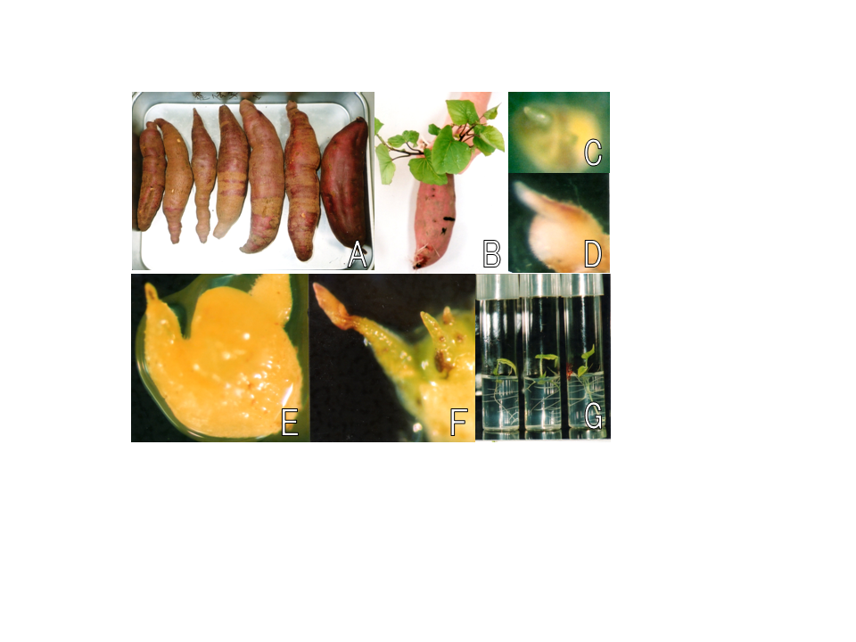

Fig. 2. Recovered of sweet potato feathery mottle virus (SPFMV)-free sweet potato using cultures of shoot apex. A) Sweet potato with russet crack-like symptom (RC-LS) (left six tubers) and healthy one (right one tuber) used in this study; B) New plants growing from RC-LS-infected tuber; C) Shoot apex 0.1-0.3 mm in size token from RC-LS plant and cultured on Komamine& Nomura (1998) medium supplemented with 0.05 μM NAA and 4.44 μM BAP; D) Elongated initial leaf after 3 weeks of culture; E) Meristem and growing of two initial leaves after 6weeks of culture; F) One big leaf and two initial leaves after 9weeks of culture; and G) The complete plants after12 weeks of culture on phytohormone-free MS medium

# 3.4 Acclimation

All of the three methods conducted in this study for acclimation of recovering plants gave the same taking rates (100%) in final. However, methods of 1) directly transplanted into pot of sterilized soil and 2) directly transplanted into pot of sterilized vermiculite needed a long time (2-3 weeks) for recovered as the plant growth environments (humidity and airtight) were changed too much from *in vitro* to *in vivo*. On the other hand, the method of 3) directly transplanted into sterilized vermiculite of pot sealed up with vinyl bag showed quick growth of bud, and needed only one week for recovered. This method was also conducted successfully in other plants, bahiagrass (*Paspalum notatum*) [17], guinea grass (*Panicum maximum*) [18]. Therefore, the 3rd method was thought to be the best for recovered plants of sweet potato with short time, and easily operating in large quantity.

**3.5 Virus Detection**

The recovered candidate virus-free plants were provided for virus detection using RT-PCR method. As a control, the infected SPFMV plant was also used for RNA extraction. Total RNAs were extracted efficiently using ISOGEN RNA extraction kit (Fig. 3A) from both of the leaves. The result of RT-PCR indicated that 200-300 bp of the specific fragment of SPFMV was amplified (Fig. 3B) in sample of leaves of P (a sufferer of SPFMV), and there were not specific bands of the fragments in F1 and F2 (the leaves of recovered plants by shoot apex culture). The above results of RT-PCR have made it clear that SPFMV could be precisely detected, and together, that whether the SPFMV of the recovered plants have already been removed or not could be confirmed exactly within a short time.

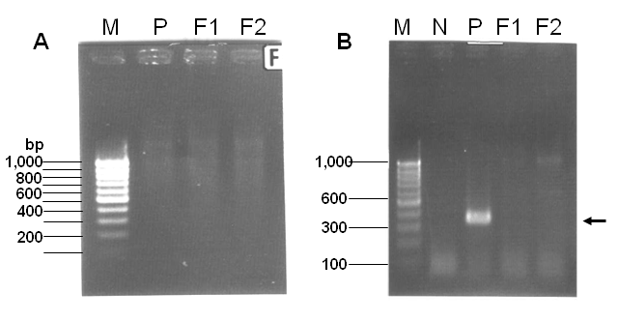

Fig. 3. A) Agarose gel electrophoresis of RNAs extracted from leaves of SPFMV sufferer (Lane P) and the recovered plants (Lanes F1 and F2) of “Miyazakibeni”. Lane M: 100 base ladder marker; B) Agarose gel electrophoresis of DNA fragments amplified from RNAs using RT-PCR with primer C1: GGACAAGCCCCATCAAATG and primer C2: CTGGAATGGTTGCGGGTTGC. The arrowhead indicates SPFMV-specific fragment. Lane M: 100 base ladder marker; Lane N: negative control (neither DNA nor RNA presents in the reaction mixture); Lane P: positive control (DNA amplified from RNAs of sufferer of SPFMV leaves of “Miyazakibeni”; Lanes F1, F2: DNAs amplified from RNAs of leaves of the recovered plants of “Miyazakibeni”

Nagata et al.[12] reported that RT-PCR method could be used to detect the nucleotide sequence of SPFMV-S and –O, which were bought from Takara chemicals (Takara, Japan). In this study, we practiced the method of RT-PCR on the recovered plants from shoot apex culture of the sufferer of SPFMV, “Miyazakibeni”, apopular variety in southern Japan. Up to now, two seasons of cultivation of the recovered plants were needed for detecting SPFMV presence in the field by observing the surface of the tubers. From today, the RT-PCR method described in this study has provided a rapid and precise method to detect virus-free recovered plants within a day, meaning that you do not need to cultivate the candidate virus-free plants for two seasons to detect if the virus is removed or not. It was somewhat exciting for farmers because it is available for agricultural production. Our results agreed with that of Nagata [12] that SPFMV-S and –O could be checked efficiently using the primers based on the nucleotide sequence of SPFMV-S and –O. However, as indicated by Usugi et al. [11], that there must be different strains of SPFMV in the field, the universal primers for detecting SPFMV strains should be developed as much haste as possible. In addition, using the same method established in this study, it is expected that the RT-PCR method could be spread in usage in other virus species which nucleotide sequence is known, and other vegetatively reproductive plants.

Recently, some new technologies have been developed for elimination of virus diseases in sweet potato, as well as shoot apex culture [14]. Cuellar et al. [19] using the transformation of an SPFMV-resistant sweet potato variety with the double-stranded RNA (dsRNA)-specific class 1 RNA endoribonuclease III (RNA3) of SPCSV broke down resistance to SPFMV, leading to high accumulation of SPFMV antigen and severe disease symptoms similar to the synergism in plants co-infected with SPCSV and SPFMV. Anyway, either molecular or tissue culture biotechnology is needed for elimination of virus in sweet potato, and essential to be expanded to real agricultural production In particular, an efficient, simple and practical system of virus-free seedling supply system is urgent for Africa area with the meaning not only in food supply stability but also in the peace security [6].

# 3.6 Clonal Propagation Method in Large Quantities

For the practical purpose in sweet potato production, a large scale production of virus-free seedlings is necessary. As shown as in Fig. 4A-D, suckers cut from upper, middle and lower parts of the recovered plant stems, which were confirmed to be SPFMV-free based on the result of RT-PCR, were cultured on phytohormone-free MS medium in a growth chamber at 25℃, 3.3 μmol m-2 s-1, 16h photoperiod. The suckers cut from the three parts of the stems, were shown in Fig. 4. It is clear from that the young bud could not be observed in sucker from lower part (Fig. 4E), and on the other hand, the bud clearly in that from middle (Fig. 4F) and upper parts (Fig. 4G). After 6 weeks of culture, the complete plants were obtained from the upper, middle and lower parts of SPFMV-free plants, respectively (Fig. 4H). Even though there were no differences in morphology among the recovered plants from different parts of stem, the suckers from the middle part gave the highest rates (100%) of recovered plants among the three parts (Table 5).

It is also considered that as the plants usually come from the young buds, and the sucker from lower part usually assumed the young bud with too small size to observe with naked eye (Table 5, Fig. 4E), the recovery rate was lower than that of middle part. For the lowest rate in sucker from upper stem, it is considered that even their sucker has the biggest size, however, they have no thick stem to help to absorb nutrition from medium, and maybe they are not buds but meristem and so that they need phytohormones in medium like shoot apex culture (Fig. 2, and Table 3).

The results of clonal propagation by sucker culture indicated the possibility that about 5 seedlings per plant (5 suckers/ SPFMV-free plant) could be obtained within 6 weeks of cycle. Using this method, virus-free plants obtained from shoot apex culture can be clonally propagated by sucker culture in short cycle and in large quantities, which is available to apply in practical production of sweet potato.

After two seasons of cultivation of SPFMV-free plants in farm (Fig. 4L), the tubers were obtained and observed for symptom analysis. No RC-LS detected by naked eye, and the tubers looked smooth and shiny could be potentially increased for its high commercial value (Fig. 4K), when compared with the SPFMV-infected one (Fig. 4I and J). In general, the SPFMV-free plants could be kept and used continually for over five seasons of cultivation in production. Virus-free sweet potato production using shoot apex culture have provided increasing productivity for raw material of starch [20], and increasing yield, quality and brewing characteristics for ‘Shochu’ usage [21], as well as the virus-free seedlings. And more, when the sequence fragments of long terminal repeat (LTR), reverse transcriptase (RT) and *Gypsy*-like RT and envelop (ENV)-like domains of LTR retrotransposons, and two partial sequences of non-LTR long interspersed element (LINE) were isolated in the clonally-propagated allohexaploid sweet potato (*Ipomoea batatas*) genome, the continuous clonal propagation of sweet potato may have contributed to such a multitude of copies of some of these genomic elements [22,23]. Clonal propagation of sweet potato indicated from different points of view, that it can contribute to elimination of virus for tuber production, increasing yield of leaves and tubers for human beings and animals, and contents of starch for alcohol production, reservation of genetic characteristics for molecular breeding, and so on. Using the rapidly and precisely clonal propagation system of virus-free recovered plants established in this study, the production of high quality and high commercial value of sweet potato will be more possible not only in southern Japan but also in Eastern Asia, Africa and moreover in the world.

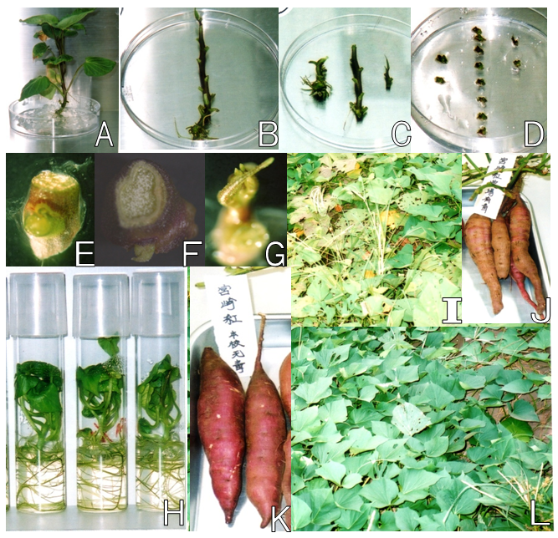

Fig. 4. Clonal propagation in large quantity using sucker culture from stems of detected virus-free plants. A) The recoveredrecovered plant used as material for shoot apex culture; B) Stem from A); C) Stem cut into upper, middle and lower parts; D) Suckers cut from the upper (right), middle (center) and lower (left) parts; E-G) For easy visualization, the suckers from lower, middle and upper, were expanded in size, respectively; H) The complete plants grown from the suckers of E-G, respectively, after 6 weeks of culture; I-J) The growing plants of SPFMV- sufferer in the field, and its tubers; K-L) Tubers obtained from the recovered SPFMV-free plants after cultivation of two seasons, and the recovered plants growing in the field.

**Table 5. Effects of different parts of stem with sucker on clonal propagation**

**in large quantities to produce virus-free plants of sweet potato**

|  |  |  |  |
| --- | --- | --- | --- |
| **Explants** | **No. suckers plated** | **Sucker’s size (mm)** | **Rates of plants (%)** |
| Upper stem | 60 | 1 | 36(60) |
| Middle stem | 99 | 0.5 | 99(100) |
| Lower stem | 80 | 0.1-0.2 | 64(80) |

4. Conclusion

Overall, we have established an efficient and practical seedling supply system in sweet potato production by means of three steps of 1) obtaining virus free plant using apex shoot culture, 2) detection of SPFMV virus of recoveredrecovered plants using RT-PCR method, and 3) clonal propagation of the virus-free recoveredrecovered plants detected using culture of suckers cut from the stems. It will promise sustainable and stable production of sweet potato with the system and its application will be expected to expand easily and quickly in sweet potato and other vegetatively reproductive plants, like potato, garlic and so on, in the world.

**COMPETING INTERESTS**

Authors have declared that no competing interests exist.

References

1. Feng C, Yin Z, Ma Y, Zhang Z, Chen L, Wang B, Li B, Huang Y, Wang Q. Cryopreservation of sweet potato (*Ipomoea batatas*) and its pathogen eradication by cryotherapy. Biotechnology Adv. 2011;29(1):84-93.
2. Woolfe JA. *In*Ahn, 1993 "Sweet potato: an untapped food resource", Cambridge Univ. Press and the International Potato Center (CIP). Cambridge, UK; 1992.
3. David PP, Trotman AA, Mortley DG, Bonsi CK, Loretan PA, Hill WA. Foliage removal influences sweetpotato biomass yields in hydroponic culture. Hort Sci. 1995;30(5):1000–1002.
4. FAO. FAOSTAT Database result records of sweet potato production 2002/2004;2004.
5. Nagata R. The technique to produce virus-free plants of sweet potato, Ipomoea batatas (L.) Lam., and its effect. Bull Miyazaki Agri ExpStaJpn. 1990;25:77-90. (in Japanese)
6. Wambugu FM. Development and transfer of genetically modified virus-resistant sweet potato for subsistence farmers in Kenya. Natr Rev. 2003;61(6 Pt 2):S110-3.
7. Usugi T, Nakano M, Onuki M, Maoka T, Hayashi T. A new strain of sweet potato feathery mottle virus that causes russet crack on fleshy roots of some Japanese cultivars of sweet potato. Ann PhytopatholSocJpn. 1994;60:545-554.
8. Abad JA, Cocking MA, Moyer JW. Comparison of the capsid protein cistron from serologically distinct strains of sweet potato feathery mottle virus (SPFMV). Arch Virol. 1992;126:147-157.
9. Usugi T, Nakano M, Shinkai A, Hayashi T. Three filamentous viruses isolated from sweet potato in Japan. Ann Phytopathol SocJpn. 1991;57:512-521.
10. Mori M, Usigi T, Hayashi T, Nishiguchi M. Nucleotide sequence at the 3’-terminal region of sweet potato feathery mottle virus (ordinary strain, SPFMV-O) RNA. Biosci Biotech Biochem. 1994;58:965-967.
11. Usugi T, Maoka T. Properties of sweet potato feathery mottle virus Tokunoshima strain (SPFMV-T). Ann Phytopathol Soc Jpn. 1993;59:331-332.
12. Nagata R, Mori M, Hanada K, Nishiguchi M. An improved method of reverse transcription and polymerase chain reaction (RT-PCR) to efficiently detect potyvirus, sweet potato feathery mottle virus (SPFMV) RNA in sweet potato. J Gen Plant Path. 2001;67:164-168.
13. Nagata R. The utility of meristem culture plants as controlling the russet-crack like symptom of sweet potatoes and the prevention of re-infection of them. Agri Tech. 1991;46:71-74. (in Japanese)
14. [Wang QC](http://www.ncbi.nlm.nih.gov/pubmed?term=Wang%20QC%5BAuthor%5D&cauthor=true&cauthor_uid=18786569), [Valkonen JP](http://www.ncbi.nlm.nih.gov/pubmed?term=Valkonen%20JP%5BAuthor%5D&cauthor=true&cauthor_uid=18786569). Elimination of two viruses which interact synergistically from sweetpotato by shoot tip culture and cryotherapy. [J Virol Methods.](http://www.ncbi.nlm.nih.gov/pubmed/18786569) 2008;154(1-2):135-45.
15. Murashige T, Skoog F. A revised medium for rapid growth and bioassays with tobacco tissue culture. Physiol Plant. 1962;15:473-479.
16. Komamine S, Nomura K. Entrance of Plant Cytological technology. Gakkai Publishing House Tokyo. 1998;22-23. (In Japanese)
17. Chen LZ, Amani E, Guan LM, Adachi T. Somatic embryogenesis and plant regeneration from leaflets of “Nanou” bahiagrass. Plant Biotech. 2001;18:119-123.
18. Chen LZ, Okabe R, Guan LM, Adachi T. A simple and efficient culture of leaflets for plant regeneration in guinea grass (*Panicum maximum*). Plant Biotech. 2002;19:63-68.
19. Cuellar WJ, Kreuze JF, Rajamaki ML, Cruzado KR, Untiveros M, Valkonen JP. Elimination of antiviral defense by viral RNase III. Proc Natl Acad Sci USA. 2009;106(25):10354-8.
20. Higashi T. Productivity increasing effect of stem tip culture seedling of sweet potato for raw material of starch. Kyushu Agricultural Research Information. 1998;13:67-68. (in Japanese)
21. Nagata R. Yield, quality and brewing characteristics of sweet potato for virus-free raw material. Kyushu Agricultural New Technology. 1994;7:257-260. (in Japanese)
22. Tom Okpul, Robert M. Harding, Mark J. Dieters, Ian D. Godwin. Occurrence of LINE, *gypsy*-like, and *copia*-like retrotransposons in the clonally propagated sweet potato (*Ipomoea batatas* L.).Genome. 2011;54:603-609.
23. Yamashita H, Tahara M. A LINE-type Retrotransposon Active in Meristem Stem Cells Causes Heritable Transpositions in the Sweet Potato Genome. Plant Molecular Biology. 2006;61(1):79-84.

_________________________________________________________________________