# Proline Accumulation and Drought Tolerance in Green Gram

# (*Vigna radiata* L.)

## ABSTRACT

|  |
| --- |
| Green gram (*Vigna radiata* L.), a key legume crop in Asia, playa a vital role in sustainable agriculture by fixing atmospheric nitrogen and providing essential nutrients. Despite its significance, productivity is often hindered by various factors, including drought, which affects key physiological and biochemical processes, ultimately leading to reduced yields. This study aimed to identify drought-tolerant green gram genotypes by evaluating 50 accessions for root, shoot and biochemical parameters under controlled moisture stress conditions.  An increase in root length and diameter under stress was observed, aiding in nutrient uptake and osmoregulation. Conversely, shoot length and dry weight decreased due to moisture limitations. However,genotypes such as VBN 3 and PLM 38 demonstrated resilience by maintaining higher dry weights. Biochemical analysis revealed that proline accumulation, which positively correlates with drought tolerance, increased in most genotypes, particularly in IC 395518 and ML 1415. This suggests its crucial role in maintaining cell turgor and mitigating stress effects. Chlorophyll content decreased under stress, whereas total phenolic content increased in some genotypes, further indicating drought tolerance. Correlation and path analysis revealed that strong positive relationships between root traits and proline content, emphasizing their significance in drought tolerance.  The study concludes that genotypes with robust root systems and higher proline accumulation exhibit greater drought resistance. These findings underscore the importance of breeding programs targeting these traits to enhance green gram productivity in the face of changing climates. |

*Keywords: Moisture stress; Proline; Root length; Shoot length; Dry weight.*

**1. INTRODUCTION**

Green gram (*Vigna radiata* L.) is a highly significant grain legume in Asia. Among the 13 food legumes cultivated in India, it ranks as the third most important pulse crop, following chickpea and pigeon pea [1]. This crop is diploid, self-pollinating, fast-growing, and has a short growth duration [2].

Green gram possesses wide adaptability and requires minimal input resources [1]. Its robust root system architecture plays a crucial rolein fixing atmospheric nitrogen (30-50 kg ha-1) through symbiosis with *Rhizobium* bacteria [3], significantly enhance soil fertility and sustainable agricultural yields. Additionally, as a rich source of vegetable proteins, micronutrients, and antioxidants such as flavonoids and phenolics, green gram serves multiple purposes, including food, animal feed, fodder, and green manure [4].

Despite its economic importance, green gram productivity remains stagnant due to unpredictable weather patterns and various environmental stresses. Among these, drought poses the greatest challenge to green gram cultivation, severely impacting its growth and development [5].

Drought stress impacts various physiological processes crucial for growth and molecular functioning, leading to a reduction in pod yield [6]. Initially, drought stress hampers seed germination and disrupts seedling establishment by affecting cell division and elongation, thereby impeding crop growth. It also disturbs assimilate balance, reduces sucrose content, and ultimately decreases dry matter allocation [7].

Traits such as plant height, seed weight, root architecture and crop yield are significantly reduced under the drought stress conditions in green gram and other legumes. Zare *et al*. [8] reported a significant yield reduction of 51% to 85.5% due to drought stress in green gram, with flowering and post-flowering stages being more sensitive than the vegetative stage. Hence, there is an need to develop drought tolerant varieties to enhance crop productivity, especially under the changing climatic conditions.

**2. MATERIALS AND METHODS**

The experimental material consisted of 50 different green gram (*Vigna radiata*) accessions collected from the National Bureau of Plant Genetic Resources, New Delhi; Tamil Nadu Agricultural University, Coimbatore; Sardarkrushinagar Dantiwada Agricultural University, Gujarat; National Pulse Research Centre Vamban; and RARS Pattambi under Kerala Agricultural University, along with various other local accessions. The experiments were conducted at the College of Agriculture, Vellayani, located at 8.5° N latitude, 76.9°E longitude and an altitude of 96 m above mean sea level. The study was conducted during February to April 2024 in Completely Randomized Design (CRD) with three replications. Four seeds of each accession were sown in pot. The moisture stress was imposed by withholding irrigation for 15 days at critical growth stages, *viz*., flowering and podding stage of the crop (reproductive stage). Soil moisture was measured during this period using the gravimetric method. A control pots with all genotypes was maintained under irrigated conditions. Observations were recorded 15 days after drought on various traits, including, seedling shoot length (cm), seedling root length (cm), seedling dry weight (g), root diameter (cm) and root dry weight (g). Various biochemical parameters indicating drought tolerance were also assessed.

**2.1 Estimation of Proline (μmol g-1)**

Proline levels were determined using the acid ninhydrin method proposed by Bates et al*.* 1973 [9]. To prepare the sample extract, 0.5 grams of fresh leaf tissue were homogenized in 10 ml of 3% aqueous sulphosalicylic acid. The mixture was then flitered, and 2 ml of the filtrate was combined with 2 ml each of acetic acid and acid ninhydrin in a test tube. The mixture was heated in the water bath at 100°C for one hour. Subsequently, the reaction was stopped by immersing the test tubes in an ice bath for 10 minutes. Afterward, 4 ml of toluene was added, and the mixture was stirred thoroughly. The toluene-containing chromatophore was gathered, brought to room temperature, and its absorbance at 520 nm was measured using toluene as a reference. The proline content in the sample was determined by preparing a series of proline standards using L-proline powder and constructing a standard curve.

$$Proline content \left(μmol/g \right)=\frac{\left(μ proline/ml× ml toluene\right)}{115.5}×\frac{5}{g sample}$$

**2.2 Estimation of Chlorophyll (mg/g**)

The chlorophyll content in leaves was determined following the procedure of Yoshida et al. in 1971 [10]. A 0.5 g sample from the third fully expanded leaf was finely chopped and placed into a test tube. These samples were then allowed to incubate overnight with a 10 ml mixture of 80% acetone and DMSO in a 1:1 volume ratio. The resulting solution was transferred to a measuring cylinder and diluted to a total volume of 25 ml with the 80% acetone and DMSO mixture. Absorbance measurements were taken at 480 nm, 510 nm, 645 nm, and 663 nm against a blank consisting of only the 80% acetone and DMSO mixture. The chlorophyll content was calculated in mg/g using the provided equations.

$$Chlorophyll a (mg/g) = (12.7 × A663 - 2.69 × A645)×\frac{1 × V }{1000×fresh weight}$$

$$Chlorophyll b (mg/g) =(22.9 × A645 – 4.68 × A663) ×\frac{1 × V}{1000×fresh weight}$$

$$Total chlorophyll (mg/g) = (20.2 × A645 + 8.02 ×A663) × \frac{1 × V }{1000×fresh weight}$$

Where, A = absorbance at specific wavelength,

V = final volume of chlorophyll extract in 80% Acetone: DMSO mixture;

W = fresh weight of tissue extracted

**2.3 Total Phenol Content (mg g-1)**

The phenol content in seeds was determined following the method recommended by Sadasivam and Manickam in 1996 [11]. Initially, 0.5 g of leaf was homogenized in 5 ml of 80% ethanol. The resulting homogenate was then centrifuged at 10,000 rpm for 20 minutes, and the supernatant obtained was evaporated to dryness. The residue was subsequently dissolved in 5 ml of distilled water. A 2 ml aliquot was pipetted into test tubes and the volume was adjusted to 3 ml with distilled water. To this solution, 0.5 ml of Folin-Ciocalteau reagent was added. After 3 minutes, 2 ml of 20% Na2CO3 solution was added to each tube and thoroughly mixed. The tubes were then placed in boiling water for 1 minute, cooled, and absorbance readings were recorded at 650 nm against a reagent blank. The phenol content of the sample was determined from a standard curve prepared with various concentrations of catechol.

$$Phenol content (mg/g) =\frac{concentration of catechol in mg/ml x volume of extract in ml}{weight of plant extract in g}$$

All the observations were subjected to standard statistical procedures using GRAPES software version 1.1.0 [12].

**3. RESULTS AND DISCUSSION**

**3.1 Assessment of Variability**

The mean values of 50 genotypes for the various characteristics, namely root length, shoot length, root diameter, total plant dry weight, root dry weight, proline content, total chlorophyll content, and total phenol content, are presented in Table 1 and Fig. 1. The average soil moisture content in the treatment pot was 24.39% on the 8th and 1.72% on the 15th day. In contrast, the control pot recorded an average moisture content of 27.32% on the 8th and 30.8% on the day.

**3.1.1 Root parameters**

A wide variation was recorded among the genotypes with respect to various parameters, indicating ample scope of selection. A significant difference was observed among genotypes for root length which ranged from 6.85 to 48.40 cm. Root length was found to be higher in majority of genotypes under moisture stress conditions than control conditions. This finding aligns with the results ofPrakash et al*.* [13] in black gram. The genotypes IC 148530 and IC 395518 recorded longer root length under stress conditions. Under moisture stress conditions, an increase in root diameter was recorded in most genotypes compared to control conditions. This observation was consistent with the reports ofPrakash et al*.* [13] and Zhou et al*.* [7] in green gram. A thicker root system enables plants to acquire nutrients more efficiently and increases the reserve of non-structural carbohydrates, which, in turn, aid in osmoregulation and osmoprotection. In this study, PLM 38 and EC 396142 recorded greater root diameter under moisture stress conditions. Genotypes with superior root architecture are better equipped to withstand drought. A similar observation was made by Amarapalli [14] in green gram.

**Table 1. Differences between green gram germplasm with respect to morpho-physiological and biochemical characters under moisture stress**

| **Sl. No.** | **Genotypes** | **RL** | **SL** | **RD** | **TPDW** | **RDW** | **PRO** | **TC** | **PHE** |
| --- | --- | --- | --- | --- | --- | --- | --- | --- | --- |
| 1 | Andhra local | 30.16 | 10.00 | 0.46 | 2.30 | 0.40 | 15.11 | 0.07 | 3.40 |
| 2 | TM 96 | 27.59 | 34.78 | 0.44 | 0.17 | 0.25 | 0.85 | 0.41 | 3.35 |
| 3 | IPM 205 7 | 18.64 | 22.74 | 0.43 | 2.75 | 0.33 | 10.90 | 0.53 | 1.80 |
| 4 | Thiruvalla local | 29.67 | 8.48 | 0.49 | 3.33 | 0.32 | 30.29 | 0.81 | 2.56 |
| 5 | EC 396143 | 20.37 | 10.33 | 0.54 | 2.17 | 0.35 | 15.44 | 0.14 | 2.30 |
| 6 | IPM 031 | 25.69 | 35.77 | 0.37 | 1.13 | 0.51 | 6.89 | 0.69 | 1.89 |
| 7 | C4 PDM 139 | 25.97 | 11.93 | 0.45 | 2.69 | 0.95 | 26.90 | 1.08 | 2.65 |
| 8 | ML 1415 | 34.37 | 5.20 | 0.38 | 3.76 | 0.32 | 35.60 | 0.97 | 5.18 |
| 9 | Co GG 912 | 7.31 | 34.67 | 0.37 | 1.31 | 0.15 | 23.98 | 2.51 | 6.27 |
| 10 | Co 8 | 32.33 | 12.36 | 0.42 | 3.00 | 2.76 | 28.45 | 0.87 | 2.79 |
| 11 | IC 395518 | 43.00 | 5.54 | 0.43 | 3.29 | 0.45 | 37.61 | 0.14 | 3.83 |
| 12 | GM 4 | 26.54 | 28.11 | 0.34 | 2.35 | 0.62 | 9.06 | 0.44 | 1.46 |
| 13 | VBN 4 | 13.25 | 44.33 | 0.39 | 3.40 | 0.22 | 4.24 | 2.58 | 1.00 |
| 14 | IPM 312 20 | 19.66 | 32.46 | 0.43 | 2.21 | 0.27 | 16.86 | 1.21 | 1.82 |
| 15 | IC 148530 | 48.40 | 6.58 | 0.54 | 3.40 | 0.66 | 34.12 | 1.41 | 2.90 |
| 16 | Co 9 | 15.90 | 38.67 | 0.49 | 0.27 | 0.40 | 0.65 | 0.68 | 0.54 |
| 17 | VBN 2 | 12.98 | 48.22 | 0.42 | 5.41 | 0.35 | 5.05 | 0.75 | 5.11 |
| 18 | VBN 3 | 9.87 | 45.33 | 0.44 | 6.26 | 0.32 | 0.26 | 0.40 | 0.04 |
| 19 | PLM 963 | 15.30 | 37.33 | 0.41 | 3.78 | 0.30 | 7.68 | 1.23 | 3.72 |
| 20 | VBN 1 | 18.58 | 4.69 | 0.48 | 2.61 | 0.28 | 23.22 | 0.60 | 2.20 |
| 21 | IC 553601 | 28.77 | 37.48 | 0.41 | 3.55 | 0.61 | 18.95 | 1.94 | 2.28 |
| 22 | EC 398884 | 32.19 | 29.33 | 0.46 | 1.60 | 0.76 | 3.64 | 0.63 | 3.39 |
| 23 | C5 SML 668 | 28.13 | 8.65 | 0.33 | 2.77 | 0.37 | 31.84 | 1.68 | 5.17 |
| 24 | C2 IPM2 14-1 | 16.76 | 39.35 | 0.39 | 2.94 | 0.32 | 5.28 | 3.07 | 1.36 |
| 25 | GM 6 | 16.76 | 39.35 | 0.45 | 2.94 | 0.62 | 7.91 | 0.52 | 1.14 |
| 26 | GM 7 | 20.77 | 27.16 | 0.45 | 2.75 | 0.54 | 15.20 | 0.47 | 2.18 |
| 27 | GM 8 | 23.62 | 39.30 | 0.45 | 2.27 | 0.42 | 6.56 | 1.16 | 1.30 |
| 28 | IC 148531 | 24.73 | 24.83 | 0.45 | 0.85 | 0.51 | 9.98 | 2.74 | 2.35 |
| 29 | IC 597670 | 13.91 | 36.79 | 0.4 | 2.94 | 0.11 | 0.85 | 0.24 | 0.22 |
| 30 | IC 607183 | 9.59 | 39.22 | 0.37 | 1.08 | 0.10 | 8.40 | 0.28 | 9.47 |
| 31 | VBN 5 | 28.33 | 9.42 | 0.61 | 3.19 | 0.58 | 29.00 | 0.93 | 2.31 |
| 32 | C2 IPM2 14-2 | 6.85 | 30.55 | 0.35 | 1.66 | 0.09 | 10.60 | 1.06 | 8.24 |
| 33 | Kayamkulam local | 23.48 | 6.50 | 0.52 | 2.62 | 0.29 | 25.22 | 0.90 | 2.92 |
| 34 | GM 9 | 22.24 | 33.31 | 0.44 | 2.62 | 0.65 | 13.16 | 0.52 | 1.18 |
| 35 | Trivandrum local | 21.41 | 35.49 | 0.37 | 2.39 | 0.75 | 14.26 | 1.99 | 3.78 |
| 36 | Kozhikode local | 23.22 | 7.33 | 0.63 | 0.67 | 0.22 | 5.36 | 2.68 | 1.86 |
| 37 | IC 148516 | 17.40 | 27.50 | 0.45 | 0.96 | 0.18 | 7.91 | 3.31 | 1.48 |
| 38 | EC 396142 | 20.37 | 10.33 | 0.72 | 2.17 | 0.47 | 15.44 | 0.14 | 2.30 |
| 39 | HDM 12 | 32.11 | 38.55 | 0.35 | 0.78 | 0.37 | 1.98 | 0.46 | 3.43 |
| 40 | EC 314302 | 13.91 | 36.79 | 0.38 | 2.94 | 0.19 | 24.28 | 1.26 | 1.93 |
| 41 | IC 520034 | 12.02 | 28.37 | 0.35 | 2.08 | 0.23 | 2.49 | 0.94 | 0.13 |
| 42 | EC 165632 | 14.53 | 55.00 | 0.43 | 5.12 | 0.41 | 19.56 | 1.64 | 2.45 |
| 43 | PLM 38 | 14.53 | 55.00 | 0.76 | 5.12 | 0.39 | 23.00 | 1.86 | 2.68 |
| 44 | PLM 794 | 21.92 | 4.33 | 0.60 | 1.19 | 0.46 | 2.59 | 2.73 | 2.13 |
| 45 | IC 548369 | 32.95 | 35.38 | 0.36 | 0.10 | 1.13 | 0.30 | 1.26 | 2.69 |
| 46 | IC 606545 | 19.90 | 15.96 | 0.47 | 1.12 | 0.41 | 14.2 | 1.99 | 1.94 |
| 47 | IC 418452 | 32.93 | 8.27 | 0.61 | 2.67 | 0.56 | 24.7 | 0.36 | 2.81 |
| 48 | EC 272458 | 11.61 | 49.33 | 0.38 | 3.17 | 0.32 | 2.75 | 0.29 | 7.39 |
| 49 | IC 488962 | 35.79 | 26.17 | 0.38 | 4.03 | 0.84 | 2.83 | 0.43 | 1.28 |
| 50 | C1 IPM02 3 | 21.79 | 34.16 | 0.38 | 3.16 | 0.40 | 6.80 | 0.95 | 1.36 |
|  | Mean | 22.84 | 26.27 | 0.44 | 2.48 | 0.47 | 13.59 | 1.13 | 2.76 |
|  | SE(d) | 3.96 | 3.01 | 0.03 | 0.49 | 0.12 | 3.01 | 0.56 | 0.51 |
|  | CD (5%) | 7.49 | 3.39 | 0.06 | 0.95 | 0.26 | 4.49 | 1.12 | 1.02 |
|  | CV | 21.28 | 14.07 | 9.23 | 24.24 | 32.36 | 27.16 | 60.68 | 22.83 |

*RL – Root length (cm); RD – Root diameter (cm); SL – Shoot length (cm); TPDW – Total plant dry weight (g); RDW – Root dry weight (g); PRO – Proline content (μmol g-1); PHE – Total phenol content (mg g-1); TC – Total Chlorophyll (mg g-1)*

**3.1.2 Shoot parameters**

A reduction in shoot length was recorded under moisture stress condition compared to control conditions in all genotypes. Similar findings were reported by Ranawake et al*.* [15] in green gram and Pandiyan et al*.* [16] in black gram and green gram. The decrease in shoot length could be attributed to deeper root growth, which is promoted by shorter plant height and enables the plant to absorb more moisture under water stress conditions. Genotypes with longer shoot lengths relative to their root lengths tend to be more sensitive to moisture stress. In the present study, PLM 38, VBN 3, EC 272458, IC 606545, IC 520034, C2 IPM2 14-2, IC 597670 and Co 9 exhibited longer shoot lengths but had shorter root lengths, making them more sensitive to moisture stress conditions.

**3.1.3 Dry weight**

Seedling dry weight reduced under moisture stress condition compared to control in majority of the genotypes, which was in agreement with the observations of Kaur et al*.* [17] in green gram and Meena [18] in chickpea. The decrease in the plant dry weight could be attributed to the reduction in shoot and root length, likely resulting from inhibited cell division and differentiation under moisture stress conditions. The genotypes with higher root and shoot length, namely VBN 3, IC 553601 and PLM 38, recorded higher plant dry weight under moisture stress conditions compared to control.. A similar observation was made by Kumar et al*.* [19] in pigeon pea. An increase in root dry weight was observed in some genotypes under moisture stress condition compared to control pots. The genotypes TM 96, IPM 031, C4 PDM 139, Co 8, IC 553601, Trivandrum local and IC 548369 recorded higher root dry weight, which wasconfirmed with findings of Prakash et al*.* [13] and Santos et al*.* [20] in green gram. The increase in root dry weight may be due to increased allocation of dry matter to roots under stress conditions. Conversely, C2 IPM 2 14-2, Andhra local, ML1415, GM 6, IPM 2057, VBN 1, GM 8, GM 7, and IC 148516 showed the decrease in root dry weight under stress conditions. A similar observation was reported by Dien et al*.* [21] in rice.

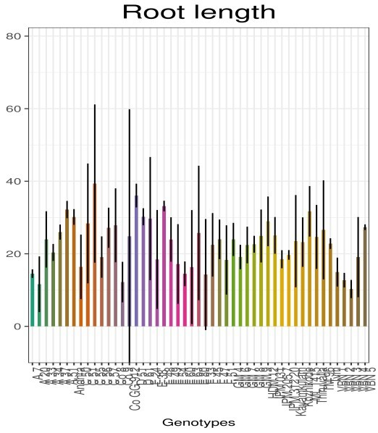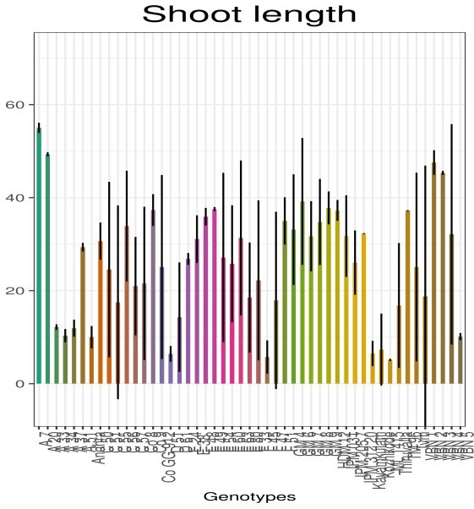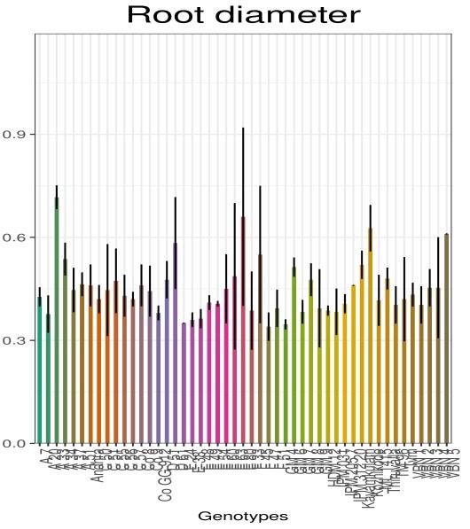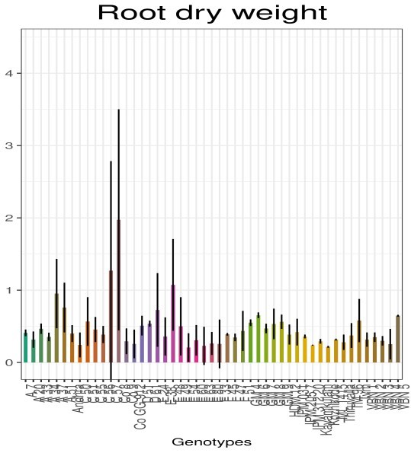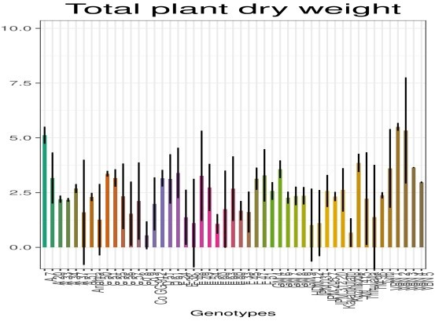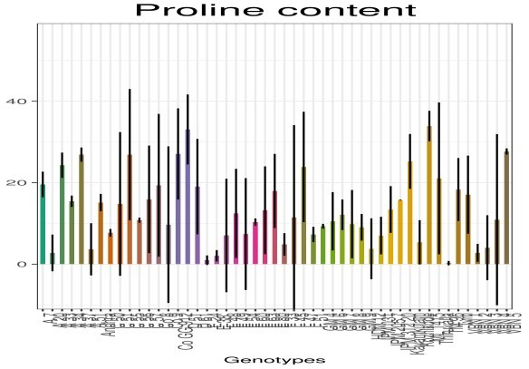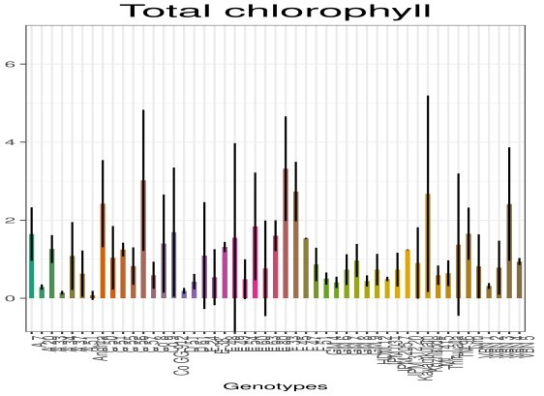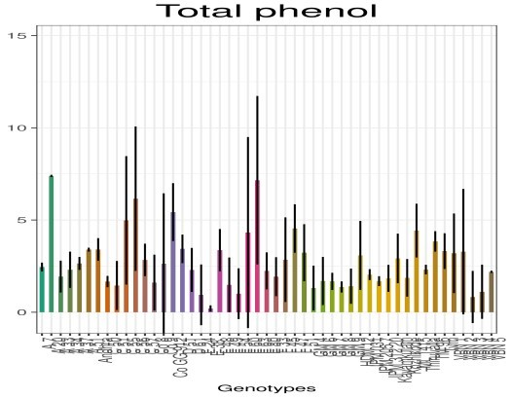

**Fig. 1. Morpho-physiological and biochemical characterization of green gram genotypes under drought**

**3.1.4 Biochemical parameters**

Proline levels are a key factor in enhancing water stress tolerance in plants. An increase in proline content was observed in the majority of genotypes compared to the control condition. This agreement was with the findings of Naidu et al. [22] and Bangar et al. [23] in green gram. The increase in levels of proline content can be used by plants to combat moisture stress conditions by maintaining cell turgor and preventing electrolyte leakage thus keeping reactive oxygen species (ROS) levels stable. In the present study, IC 395518, ML 1415, IC 148530 and C5 SML 668 recorded higher proline content under stress conditions. This suggests their ability to tolerate moisture stress, indicating that varieties with elevated proline levels are more capable of withstanding its negative impacts and achieve higher yields.

A reduction in chlorophyll content was observed in the majority of genotypes under moisture stress condition than control. Similar results were reported by Pandiyan et al*.* [16] in green gram and black gram and Jincy et al*.* [24] in green gram. The decrease in chlorophyll content during moisture stress might be caused by photo-oxidation and degradation of chlorophyll. The genotypes IC 148516, C2 IPM2 14-1, IC 148530, PLM 794, Kozhikode local, VBN 4, and Co GG 912 recorded higher chlorophyll content indicating their level of tolerance to drought.

Green gram is rich source of polyphenolics, with phenolic acids being the major phenolic constituents.. Under moisture stress conditions, an increase in phenol content was observed in some of the genotypes. This was in accordance with reports of Varela et al*.* [25]. In the current study, the genotype IC 607183 recorded higher total phenol content, reflecting their ability for drought tolerance.

**3.2 Correlation Studies**

The correlation coefficient measures the extent and direction of association between characters, aiding ineffective selection. The genotypic correlation matrix with respect to the various characters has been estimated and is presented in Table 2 and Fig. 2. Root length exhibited the highest positive correlation with root diameter (0.949), followed by proline content (0.700) and root dry weight (0.636), while a significant negative correlation was observed with shoot length (-0.331).. Root diameter expressed a significant positive correlation with all the characters considered except for shoot length which had a nonsignificant correlation. The proline content of the drought affected seedlings were positively correlated with root diameter (0.747), root length (0.700), total plant dry weight (0.424), phenol content (0.356), root dry weight (0.325) and total chlorophyll (0.155) while a significant negative correlation was recorded for shoot length (-0.465). The root diameter (0.509) of the affected plants alone exhibited a significant positive correlation with the biochemical parameter, total chlorophyll content. The phenol content of the affected plants also did not show a very high correlation with any of the biometric parameters. Proline content of the drought affected plants can be considered as a reliable indicator of drought tolerance. Proline accumulation in stressed plants was earlier reported by Anaytullah et al. [26] and Baroowa and Gogoi [6]. Fahramand et al. [27] observed the increased proline accumulation in tolerant genotypes than that of other amino acids; therefore, proline can be used as a criterion for screening drought tolerant varieties.

A notable connection of chlorophyll content with proline was earlier reported by Bangar et al., [23]. Prakash et al. [13] evaluated black gram genotypes for drought tolerance based on root dynamics and observed higher values in root parameters viz. root length and dry weight of root under severe water stress. Chlorophyll content exhibited a notable connection with proline and protein content. Plant height showed a strong correlation with leaf area, seed count per pod, and pod count per plant. Leaf area displayed a negative correlation with proline but demonstrated positive associations with RWC, protein content, and yield components [23]. Santos et al. [20] reported that when subjected to moisture stress, drought tolerant cowpea genotypes recorded increased root dry weight of 24.57%. Sivakumar et al. [28] reported that proline could be used as biochemical marker for drought tolerance. Proline accumulation in stressed plants was reported by Anaytullah et al. [26]. Baroowa and Gogoi [6] observed an accumulation of proline in leaves during stressed period and decreased in the subsequent recovery stages. Fahramand et al. [27] observed the increased proline accumulation in tolerant genotypes than that of other amino acids; therefore, proline can be used as a criterion for screening drought tolerant varieties. According to Dutta and Bera [29] proline content increased with decreasing water potential at all stages of observation irrespective of cultivars tested.

**Table 2. Genotypic correlation matrix of drought related characters in green gram**

|  |  |  |  |  |  |  |  |  |
| --- | --- | --- | --- | --- | --- | --- | --- | --- |
|  | **RL** | **SL** | **RD** | **RDW** | **TPDW** | **PRO** | **TC** | **PHE** |
| **RL** | 1 |  |  |  |  |  |  |  |
| **SL** | -0.331** | 1 |  |  |  |  |  |  |
| **RD** | 0.949** | -0.061 | 1 |  |  |  |  |  |
| **RDW** | 0.636** | 0.035 | 0.387** | 1 |  |  |  |  |
| **TPDW** | 0.206* | 0.331** | 0.472** | 0.196* | 1 |  |  |  |
| **PRO** | 0.7** | -0.465** | 0.747** | 0.325** | 0.424** | 1 |  |  |
| **TC** | 0.004 | 0.105 | 0.509** | -0.014 | -0.138 | 0.155* | 1 |  |
| **PHE** | 0.131 | 0.205* | 0.192* | 0.038 | 0.127 | 0.356** | 0.037 | 1 |

*RL – Root length (cm); RD – Root diameter (cm); SL – Shoot length (cm); TPDW – Total plant dry weight (g); RDW – Root dry weight (g); PRO – Proline content (μmolg-1); PHE – Total phenol content (mg g-1); TC – Total Chlorophyll (mg g-1)*

*\*Significant at 5% level; **significant at 10% level*

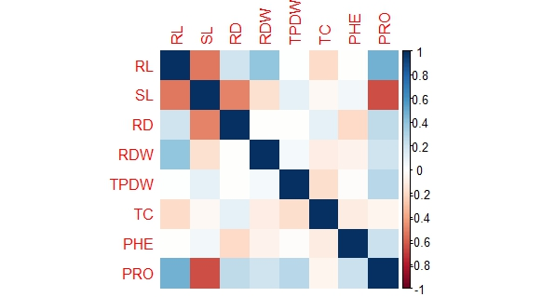

**Fig. 2. Genotypic correlation of drought related characters in green gram**

**3.3 Path Analysis**

Path coefficient analysis divides the correlation coefficient into direct and indirect effects, provides information about the influence of one variable on another. Proline can be used as a criterion for screening drought tolerant varieties, hence the direct and indirect effects of the various characters on proline content was estimated and is presented in Table 3.

The highest positive direct effect on proline content was recorded by total plant dry weight (0.5080) followed by phenol content (0.3790) and root diameter (0.2010). A very high negative direct effect was imposed by shoot length on proline content (-0.7080). Although total plant dry weight had a very high direct effect, it was negatively affected by shoot length by its indirect effect (-0.2350) on proline content. The character root length (0.0450) had very small direct effect on proline content but it exhibited indirect effect through shoot length (0.2320), root diameter (0.1890) and root dry weight (0.1060). The residual effect of the path analysis was 0.2683, indicating that almost 73% of the factors affecting proline content of the plant has been included in the study.

Proline accumulation as a mechanism to mitigate the adverse effects of drought in various plants have been previously reported by Man et al. [30]; Saha et al*.* [31]; Furlan et al*.* [32]; Kijowska-Oberc et al. [33] and Nutthapornnitchakul et al*.* [34].

**Table 3. Direct and indirect effects of drought related characters on proline content in green gram**

|  |  |  |  |  |  |  |  |  |
| --- | --- | --- | --- | --- | --- | --- | --- | --- |
|  | **RL** | **SL** | **RD** | **RDW** | **TPDW** | **TC** | **PHE** | **Genotypic correlation with main variable** |
| **RL** | **0.045** | 0.232 | 0.189 | 0.083 | 0.106 | -0.001 | 0.049 | **0.703** |
| **SL** | -0.015 | **-0.708** | -0.011 | 0.005 | 0.168 | 0.019 | 0.078 | **-0.463** |
| **RD** | 0.043 | 0.040 | **0.201** | 0.051 | 0.240 | 0.092 | 0.074 | **0.740** |
| **RDW** | 0.029 | -0.026 | 0.078 | **0.131** | 0.100 | -0.002 | 0.014 | **0.325** |
| **TPDW** | 0.009 | -0.235 | 0.095 | 0.026 | **0.508** | -0.025 | 0.048 | **0.427** |
| **TC** | 0.000 | -0.076 | 0.103 | -0.002 | -0.071 | **0.179** | 0.014 | **0.148** |
| **PHE** | 0.006 | -0.146 | 0.039 | 0.005 | 0.065 | 0.007 | **0.379** | **0.354** |

*RL – Root length (cm); RD – Root diameter (cm); SL – Shoot length (cm); TPDW – Total plant dry weight (g); RDW – Root dry weight (g); PHE – Total phenol content (mg g-1); TC – Total Chlorophyll (mg g-1)*

**Residual effect = 0.2683**

**4. CONCLUSION**

This study highlights the significant variation in traits for screening against drought tolerance among 50 green gram genotypes, emphasizing the importance of root architecture and proline accumulation in withstanding moisture stress. Genotypes with longer roots and higher proline levels, such as IC 395518, ML 1415 and Co 8 exhibited greater drought resilience, suggesting their potential for breeding programs aimed at improving green gram productivity under adverse environmental conditions. The study's findings provide valuable insights for developing drought-tolerant varieties, which are crucial for enhancing crop yields in the face of unpredictable weather patterns and climate change, ultimately contributing to sustainable agriculture and food security.

**DISCLAIMER (ARTIFICIAL INTELLIGENCE)**

Author(s) hereby declare that NO generative AI technologies such as Large Language Models (ChatGPT, COPILOT, etc.) and text-to-image generators have been used during the writing or editing of this manuscript.

**REFERENCES**

1. Nair RM, Schafleitner R, Kenyon L, Srinivasan R, Easdown W, Ebert RW. Genetic improvement of mungbean. J. Breed. Genet. 2019;44:177-190.
2. Singh DP, Singh BB, Pratap A. Genetic improvement of mungbean and urdbean and their role in enhancing pulse production in India. Indian J. Genet. 2016;76(4):550-567.
3. Allito BB, Nana EM, Alemneh AA. Rhizobia strain and legume genome interaction effects on nitrogen fixation and yield of grain legume: a review. Mol. Soil Biol.. 2015;20:1-6.
4. Arnoldi A, Zanoni C, Lammi C, Boschin G. The role of grain legumes in the prevention of hypercholesterolemia and hypertension. Crit. Rev. Plant Sci.. 2015;34(1-3):144-168.
5. Basu PS, Pratap A, Gupta S, Sharma K, Tomar R, Singh NP. Physiological Traits for Shortening Crop Duration and Improving Productivity of Green gram (*Vigna radiata* L. Wilczek) under High Temperature. Front. Plant Sci.. 2019;10:1508.
6. Baroowa B, Gogoi N. Effect of induced drought on different growth and biochemical attributes of black gram (*Vigna mungo* L.) and green gram (*Vigna radiata* L.). J. Environ. Res. Develop. 2012; 6(3A).
7. Zhou R, Kong L, Wu Z, Rosenqvist E, Wang Y, Zhao L, Zhao T, Ottosen C. Physiological response of tomatoes at drought, heat and their combination followed by recovery. Physiol. Plant*.* 2019;165:144–154
8. Zare M, Dehghani B, Alizadeh O, Azarpanah A. The evaluation of various agronomic traits of mungbean (*Vigna radiata* L.) genotypes under drought stress and non-stress conditions. Int. J. Farming Allied Sci.. 2013;*2*:764–770.
9. Bates LS, Waldren RP, Teare ID. Rapid determination of free proline for water-stress studies. Plant and Soil. 1973;39(1):205-207.
10. Yoshida S, Forno DA, Cock JH. Laboratory Manual for Physiological Studies of Rice. International Rice Research Institute. 1971; 2nd Ed.
11. Sadasivam S, Manickam A. Biochemical Methods for Agricultural Sciences. Wiley Eastern Ltd., New Delhi. 1996;246.
12. Gopinath PP, Parsad R, Joseph B, Adarsh VS. GRAPES: General Rshiny based analysis platform empowered by statistics.2020.

Available:https://[www.kaugrapes.com/home](http://www.kaugrapes.com/home)

1. Prakash M, Elangaimannan R, Sunilkumar B, Narayanan GS. Evaluation of black gram genotypes for drought tolerance based on root dynamics and gas exchange parameters. Legume Res. 2018;41(3):384-391.
2. Amarapalli G. Studies on the effect of water stress on root traits in green gram cultivars. Legume Res.. 2022;1-7.
3. Ranawake AL, Dahanayaka N, Amarasingha UGS, Rodrigo W, Rodrigo UTD. Effect of water stress on growth and yield of mung bean (*Vigna radiata* L.). Trop. Agric. Res. Ext. 2011; *14*, 76–79.
4. Pandiyan M, Senthil N, Balaji T, Veeramani P, Savitha BK, Sendhilvel V, Gopilkrishnan, A. Studies on performance of drought tolerant genotypes under drought and normal conditions through morpho, physio and biochemical attributes of black gram (*Vigna mungo* L.) and green gram (*Vigna radiata* L.). Int. J. Adv. Res.. 2017;5(2):489-496.
5. Kaur AJG, Devendra J. SSR marker assisted evaluation of Genetic Diversity in Mungbean (*Vigna radiata* L.) genotypes. Braz. Arch. Biol. Technol. 2017;61:1678-4324.
6. Meena H. Morpho-physiological attributes of drought tolerance in chickpea genotypes at seedling stage. M.Sc. (Ag) thesis, Sri Karan Narendra Agriculture University, Jobner. 2017;111.
7. Kumar RR, Karjol K, Naik GR. Variation of sensitivity to drought stress in pigeon pea (*Cajanus cajan* [L.] Millsp) cultivars during seed germination and early seedling growth. World J. Sci. Technol. 2011; 1(1):11-18.
8. Santos R, Carvalho M, Rosa E, Carnide V, Castro I. Root and agromorphological traits performance in cowpea under drought stress. Agron. 2020;10(10):1-20.
9. Dien DC, Yamakawa T, Mochizuki T, Htwe AZ. Dry weight accumulation, root plasticity, and stomatal conductance in Rice (*Oryza sativa* L.) Am. J. Plant Sci.. 2017; 8(12).
10. Naidu TC, Raju N, Yanan A. Screening of drought tolerance in greengram (*Vigna radiata* l. Wilczek) genotypes under receding soil moisture. Agricul. Food Sci. 2008.
11. Bangar P, Chaudhury A, Tiwari B, Kumar S, Kumari R, Bhat K.V. Morphophysiological and biochemical response of mungbean [*Vigna radiata* (L.) Wilczek] varieties at different developmental stages under drought stress. Turk. J. Biol.. 2019;43(1):58-69.
12. Jincy M, Prasad VBR, Senthil A, Jeyakumar P, Manivannan N. Physiological divergence in green gram [*Vigna radiata* (L.) Wilczek] genotypes for drought and high temperature stress tolerance during flowering phase. Legume Res. 2020;1:1-8.
13. Varela MC, Arslan I, Reginato MA, Cenzano AM Luna MV. Phenolic compounds as indicators of drought resistance in shrubs from Patagonian shrublands (Argentina). Plant Physiol. and Biochem. 2016;104:81-91.
14. Anaytullah, Bose B, Yadav RS. PEG induced moisture stress: Screening for drought tolerance in rice. Indian J. Plant Physiol.2007;12(1): 88-90.
15. Fahramand M, Mahmoody M, Keykha A, Noori M, Rigi K. Influence of abiotic stress on proline, photosynthetic enzymes and growth. Int. Res. J. Appl. Basic Sci*.*. 2014;8:257–265.
16. Sivakumar P, Sharmila P, Saradhi PP. Proline suppresses Rubisco activity in higher plants. Bioche. Biophys. Res. Commun.1998;252(2):428-432.
17. Dutta P, Bandopadhyay P, Bera AK. Identification of leaf based physiological markers for drought susceptibility during early seedling development of mungbean. Am. J. Plant Sci*.* 2016; 7:1921–1936.
18. Man D, Bao Y, Han L, Zhang X. Drought Tolerance Associated with Proline and Hormone Metabolism in Two Tall Fescue Cultivars. Hort. Sci. 2011;46(7):1027-1032
19. Saha S, Begum H, Nasrin S. Effects of Drought Stress on Growth and Accumulation of Proline in Five Rice Varieties (*Oryza Sativa* L.). J. Asiat. Soc.. 2019;45:241-247.
20. Furlan AL, Bianucci E, Giordano W, Castro S, Becker DF. Proline metabolic dynamics and implications in drought tolerance of peanut plants. Plant Physiol. Biochem. 2020;151:566-578.
21. Kijowska-Oberc J, Dylewski Ł, Ratajczak E. Proline concentrations in seedlings of woody plants change with drought stress duration and are mediated by seed characteristics: A meta-analysis. Sci Rep*.*. 2023;13:15157.
22. Nutthapornnitchakul S, Sonjaroon W, Putthisawong N, Thumthuan N, Tasanasuwan P, Jantasuriyarat C. Effect of drought stress on proline gene expression, enzyme activity, and physiological responses in thai mulberry (*Morus* spp.). J. Biosci*.* 2024;31(3): 559-571.