STUDYING THE FERTILITY STATUS OF THE SOIL IN SOME AREAS OFAGRICULTURAL EXPANSION WITHIN WESTERN DESERT FROM IRAQ

# Abstract

The agricultural expansion plans for any area require a scientific study of all land resources, economic and social conditions, water resources, soil fertility, climatic conditions, optimum utilization and mapping of the fertility status of the study areas. The preparation of such studies requires a field survey of these resources based on previous studies in soil and geology. The current work is an attempt to develop a database on these soils in the case of future investment. The study included the implementation of a survey of the culture in the period from February 2012 to January 2013 for three areas within the Western desert environment are: Dum AlKsfa, Dum Al Shamia and Dum Gbab Western: 11,480, 27,120, 140,840 square dunam, respectively. Morphological, physical and chemical tests of the surface layer soil samples for more than 10 auger holes for each site and three pedons representing each region was studied. In addition to montoring the climate change during all months of the year. Study concluded that; Based on the climatic data of the study areas, soil moisture is present in the dry climate of the Torric moisture regim, and the temperature of the soil within the hyperthermic range belongs to the soil of the study area to the Ardisols. The pH of the soil was Slightly Alkaline. The salinity of the soil of the study areas was that the soil of the Dum Al Shamia and Dum Gbab western area was normal and the Dum Alksfa saline soils. The average values of the major nutrients, total nitrogen (0.4- g/kg 0.6) and phosphor (1.38-6.7mg.kg-1) and potassium (0.31-0.4cmol kg-1) and The iron (0.5 mg/l), zinc (0.2-1.1 mg/l) copper (0.5-0.7 mg/l). Organic carbon was low in all regions under international critical limits. Therefore, this study focuses on three areas within the Western Desert of Iraq. These areas were chosen for a study, with all possible recommendations for the conservation of arable land, which is one of the most scarce resources.

***Key words*** *:* Agricultural expansion, western desert, fertility, soil survey.

# Introduction

The world’s population now stands at 7 billion and could exceed 9 billion in 2050, leading to an increase in demand for world food. The total area of the land includes marginal lands, such as deserts, high mountains, swamps, areas that were arable, Sustainable management of soil. Agricultural expansion is the main pillar for increasing agricultural production (Ustaoglu and Williams, 2017) and for agricultural development, multiple mechanisms and successive implementation procedures. Soil assessment comes at the forefront of these operational steps, which aims at assessing the productivity of productive soil and determining the limits of agricultural exploitation in order to plan its exploitation to achieve the maximum possible utilization. Fertility in some areas of the Western Desert of Iraq as one of the promising areas, which were included

within the map of promising areas issued by the Directorate of Agriculture of Anbar province (the investment map of the Directorate of Agriculture Anbar Province, 2008).

The agricultural expansion plans for each country require a scientific study of all natural land sources, economic and social conditions, water sources, agricultural conditions and prevailing climatic conditions. The preparation of such studies makes the development of a land assessment system based on modern epidemiological studies (Erian, 1986).

The identification of the optimal use of land requires a comprehensive and integrated study of the various factors that affect their suitability or appropriateness for a specific use, as well as determining the factors limiting the validity of a specific land for specific use, and requiring a comprehensive survey of all land resources to provide

basic information to assess the suitability of land for different uses (Alioui, 1985).

There is a global campaign for sustainable agriculture that involves improving agricultural resources to meet human needs while conserving the environment and conserving land resources (FAO, 1989). In a study on the environmental and fertility properties of some types of desert land in Egypt, Zaghloul *et al*., 2012, confirmed the decrease in the ratio of both cationic and organic matter. The large NPK elements in the surface layer of soil are insufficient to meet the needs of plants in the three studied areas, The content of micro-soft elements in the surface layer was found to be low and critical in both the Jaradah and Khmisa regions, while at the level sufficient for the needs of plants in the Yellow Mountain region.

Bolbol and others (2013) found that the Capability Classification System (FCC) is used to classify arable land and that there are differences between land units in nutrient availability and availability On the nature of the presence of calcium carbonate and the characteristics of soils and their impact on the availability of availability within the soil of the two provinces.

Phosphorus is one of the plant’s essential nutrients. It requires concentrations of between 0.003 ppm in soil solution (Kirby and Mengel, 1987). Plants differ in their need for phosphorus depending on the type of crop and the growth stage. The symptoms of its lack are not indicative of its absence This may be due to several factors, including: the quantity and type of clay minerals, and the quantity of clay minerals in the soil, PH, ionic effect, and impact T organic matter as well as the contact between the phosphate ions and the time of the components of the soil return( Hamshm, 2008)

Bilal *et al.*, 2014 evaluated land in agricultural development areas in Assiut, Sohag and Qena governorates based on soil fertility and physiographic characteristics of the region using remote sensing and geographic information system (GIS). The objective of this evaluation was to determine the capacity of these soils on agricultural investment, Based on the fertility status in those soils.

The assessment of land in terms of its ability and

**Table 1:** The characteristic of the regions under study.

suitability to various crops is one of the important pillars in planning for the development of the promising areas. (Dahabi and others, 2015).

In their study of natural resources in northern Alexandria and Kafr El-Dawar, (Ismail *et al*., 2016), explained that extracting information on the nature of soil and its fertility characteristics and distribution is very important in the exploitation of these lands for the purposes of sustainable agricultural development.

In a study of soil fertility at a farm for agricultural experiments at the University of McCordy, Nigeria Ibrahim, *et al.*, 2015 found that by analyzing the chemical and physical properties of the soil and the depths of 0-15 cm for sandy soil pH 5.56-6.17 and that the soil was generally Low fertility characteristics were suggested to maintain soil fertility by adding mineral nutrients to fertilizer (NPK).

The objective of this study is to evaluate some of the desert soils to be developed in the future and to know the critical boundaries of the available major nutrients and some minor elements and to make recommendations that guide investment operations and agricultural expansion in western Iraq.

# Materials and Methods

## Description of area under study

The area of under study is located in the southwestern side of Lake Qadisiya in three selected districts in the Western Desert of Iraq: Dum Alkasfa, Dum Alshamiya and Dum Gbabwestern. The territory of this region of the deposition of calcareous and gypsum successive in i Her Bugs (1960, Buringh). Table 1 Characteristics of the sites of the study areas.

## Field visits

Screening soil and collecting observations was done during farm visits from May 2012 to June 2013 using auger hole. Free lance soil survey was used to collect soils from the area under study. The collected samples used to study the relation between soil composition and topography, salinity, pH, color etc. the soils differentiated using Soil Survey Division Staff 1993 and Munsell color chart, As shown in fig. 1 the holes under study in the three area clearly represent using DEM.

## Physical measurements

|  |  |  |  |  |  |
| --- | --- | --- | --- | --- | --- |
| **No.** | **Region** | **Area** | **GPS** | | **The high from**  **Sea level** |
| **East** | **North** |
| 1 | Dum Alkasfa | 11.480 | 42°16201.912 2 | 34°11246.972 2 | 165 |
| 2 | Dum Alsamia | 27.120 | 42°02230.822 2 | 34°16227.812 2 | 203 |
| 3 | Dum Gbabwestern | 140.840 | 41°30218.952 2 | 34°20227.162 2 | 293 |

Physical properties were estimated according to the methods in Page et al (1982). Volumetric distribution of soil septoirs: according to mechanical analysis and determination of soil texture in a hydrometer method and particle size

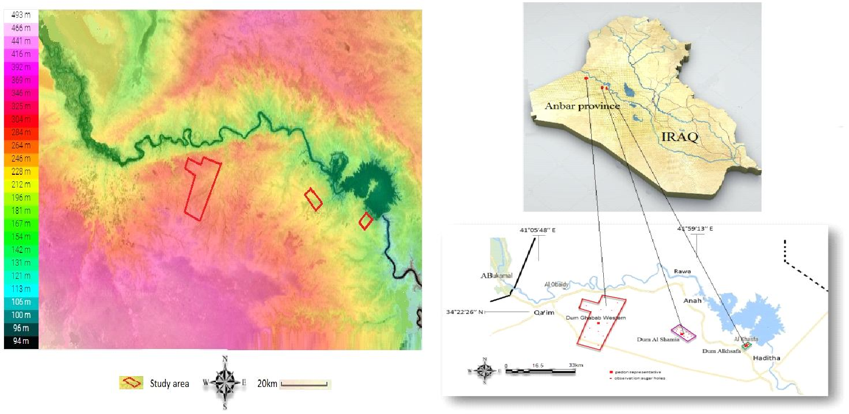

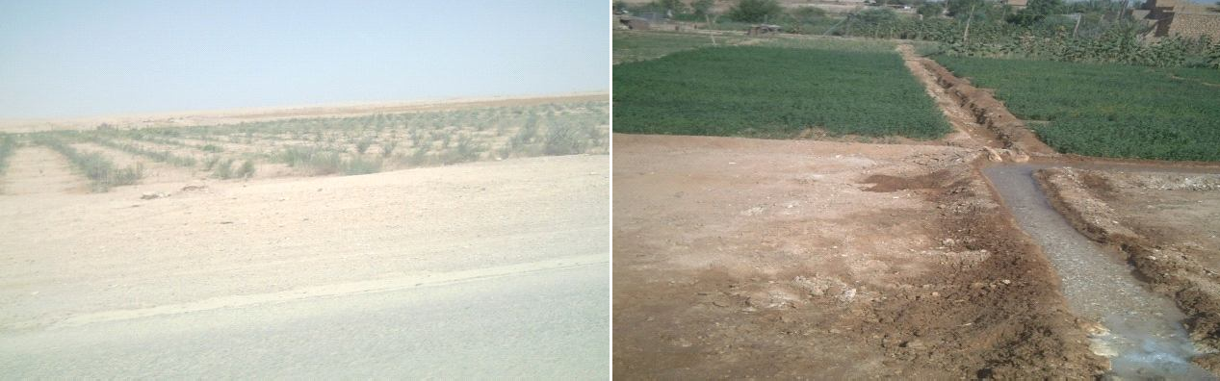

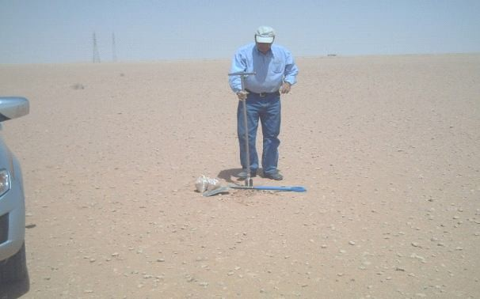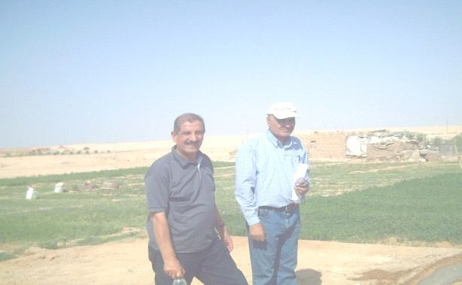

**Fig. 1:** The field visit of the group to the region understudy.

distribution was determined by the hydrothermetric method (Bouyoucousasv, 1951).

## Chemical characterizations

**Electrical conductivity:** A suspension of air-dried (or fresh) soil, fresh sludge or fresh biowaste is made up in 5 times (soil) or 10 times (sludge and biowaste) its volume with water, to dissolve the electrolytes. The specific electrical conductivity of the filtered extract is measured and the result is corrected to a temperature of

20oC. (Richards, 1954).

**Soil reaction pH**: It is a measure of hydrogen ion concentration in soil solution. It strongly affects the availability and solubility of minerals and nutrients, and is regarded as a useful indicator of other soil parameters. Most minerals and nutrients are more soluble in acid soils than in neutral or slightly alkaline soils (Richards, 1954).

**Carbonate content of the soil:** g of fine crushed soil sample was placed into conical flask, 10 ml of 1 N

HCl and 50 ml distilled water were added, heated until boiling for 2 mins. Then, left until cool and 3 drops of phenolphthalein indicator was added and titrated against 1 N NaOH. Then, the percent calcium carbonate was calculated according to (Balázs *et al.*, 2005). (Jackson,1958).

**Gypsum content of the gypsum**: It was estimated by sedimentation method using a mixture of acetone 80% and acetic acid 20% and a few drops of calcium nitrate and the method proposed by Zubaidi and others in Rahi *et al.*, (1991).

## Soil content of organic matter

Estimated in a manner (Walkely and Black, 1934) and described in Jackson (1958).

## Analysis of micronutrient and small nutrients

It’s estimated at the National Research Center - Arab Republic of Egypt - Duke - German Technical Cooperation (Micro nutrients program and problems of plant nutrition).

## Calcium and Magnesium Determination

Dissolves in water extract (5:1) and alternates in ammonium chloride extract (20:1) in a calibrating method with the ferrosin solution.

**Soluble sodium and potassium Determination:** Sodium and Potassium The initial and residual metal ion concentration in aqueous solutions has been determined using Atomic Absorption Spectrometer (AAS) operating with an air-acetylene flame. A definite liquid solution was prepared and exposed to injection part; the sodium concentration displayed against calibration curves which previously done before the element’s measurements.

# Results and Discussion

## Classification of the soil of the study area

The soil of the areas under study is considered to be Coars loamy family. It’s clear from table 2 that the area under study is ordered under Aridisols, and sub ordered under Calcigysids for Dum Alshamia and Dum Gbabwestern, while sub ordered under Gypsids for Dum Alksfa. It’s also seen from table 2, the soil sub-grouped under Typic calcigyside for either Dum Alshamia and Dum Gbabwestern, while sub-grouped under Typic Haplo

**Table 2:** The distinguish soil of the area under study.

Gypsides for Dum Alkasfa.

## Climate study

Two weather station located at south desert of Iraq (Al-Qaim and Haditha stations) used to study the climate of the area under study. It is clear at table 3 that the climate of the study area is desert are dry and hot summers while dry, cold and high evaporation during winter. The average temperature for the months of June, July and August (summer) is 32.4°C and at Al-Qaim and Haditha stations and 33.1°C. The average temperature for the winter months (December, February and February) reached 9.2°C and 9.4°C for monitoring stations Al-Qaim and Haditha respectively. The highest monthly temperature was recorded in July, while the lowest monthly temperature was in January, and the lowest monthly average temperature of 15.0°C and

15.5°C at the monitoring stations And modern, respectively While the highest value of the monthly average of the maximum temperatures recorded in the summer amounted to 40.2°C and 41.7°C at the existing and modern, respectively. The annual precipitation was 124.9 and 129.7 at Al Qaim and Haditha stations, respectively, at an annual rate of 121.8, indicating the lack of rainfall in the region and its concentration in the winter and its absence during the summer months. Rain falls from October to May, while the months from June to August are dry. The level of evaporation from the sea surface was 3055.0 mm and 3188.1 mm at the modern monitoring stations respectively.

It is noted that the maximum evaporation recorded during the summer accounted for 45.7% of the total annual evaporation, and these values are very high and affecting the environment in the region. And that the factors of high temperatures and wind speed are among the most important factors in the increase in evaporation in the region. The highest relative humidity in the region was 69.5% and 69.4% in Al Qaim and Haditha respectively, and in the summer, reaching a low of 28.4% and 23.4% at Al Qaim and Haditha respectively. The above indicators directly affect the identification of vegetation in the area as well as a specific factor for the cultivation of economic crops based on rainfall, because the climate factor is very important in determining the assessment of the territory of the region on the basis of its suitability for crop growth and the fact that agriculture

|  |  |  |  |  |  |
| --- | --- | --- | --- | --- | --- |
| **Location** | **Order** | **Suborder** | **Great group** | **Sub group** | **Family** |
| Dum Gbab western | Aridisols | Calcigypsids | HaploCalcid | TypicCalcigypsid | Coarse loamy; Mixed; Hyperthermic;  TypicCalcigypsid |
| Dum Alshamia | Aridisols | Calcigypsids | HaploCalcid | TypicCalcigypsids | Coarse loamy Mixed;  Hyperthermic; TypicCalciargids |
| Dum Alksfa | Aridisols | Gypsids | HaploGypsids | TypicHaploGypsids | Fine loamy; Mixed; Hyperthermic; TypicHaploGypsids |

in the region is irrigated. Therefore, the rainfall factor is excluded from the assessment process. The annual rate of wind speed for the monitoring period 1985-2011 was 3.0m1 and 3.2m1-at current and current stations respectively. With variations in the values of this indicator per month, the months of June, July and August recorded the highest values in all monitoring stations, and the direction of the prevailing winds in the region is the North West, which is 60.2% in the city of Al- Qaim compared to the rates of occurrence in other directions.

|  |  |  |  |  |  |  |  |  |  |  |  |  |  |  |  |
| --- | --- | --- | --- | --- | --- | --- | --- | --- | --- | --- | --- | --- | --- | --- | --- |
| **Al Qaim Station** | **hours Actual solar brightness** | | 5.7 | 5.7 | 5.7 | 5.7 | 5.7 | 5.7 | 5.7 | 5.7 | 5.7 | 5.7 | 5.7 | 5.7 | 5.7 |
| **Wind speed m/s** | | 2.1 | 2.4 | 2.5 | 2.6 | 3.8 | 4.5 | 4.3 | 4.4 | 3.1 | 2.6 | 1.9 | 1.8 | 3.2 |
| **Evapo- ration mm** | | 65.3 | 93.3 | 187.2 | 259.4 | 351.3 | 449.3 | 516.9 | 491.4 | 336.9 | 234.8 | 121.6 | 80.1 | 3188.1 |
| **Relative humidity**  **%** | | 73.4 | 63.3 | 54.9 | 45.0 | 35.4 | 29.8 | 28.4 | 30.6 | 36.3 | 45.6 | 60.7 | 71.9 | 47.9 |
| **Amount of falling rain**  **Relative** | | 23.2 | 23.5 | 18.9 | 12.9 | 4.8 | 0.3 | 0.0 | 0.0 | 0.1 | 7.6 | 17.9 | 15.7 | 124.9 |
| **Temperature C** | **Monthly rate** | 7.8 | 10.4 | 14.8 | 20.6 | 26.4 | 30.9 | 33.6 | 32.7 | 28.5 | 23.0 | 14.7 | 9.3 | 20.1 |
| **Min** | 2.6 | 5.0 | 8.3 | 13.3 | 18.3 | 22.8 | 25.4 | 24.6 | 20.5 | 15.5 | 8.1 | 4.1 | 14.0 |
| **Max** | 12.9 | 16.4 | 21.6 | 28.0 | 33.9 | 38.5 | 41.2 | 40.9 | 36.6 | 30.6 | 22.0 | 15.7 | 28.2 |
| **Haditha Station** | **hours Actual solar brightness** | | 6.1 | 6.1 | 6.1 | 6.1 | 6.1 | 6.1 | 6.1 | 6.1 | 6.1 | 6.1 | 6.1 | 6.1 | 6.1 |
| **Wind speed m/s** | | 2.1 | 2.4 | 2.6 | 2.5 | 3.7 | 4.3 | 4.2 | 4.2 | 3.1 | 2.6 | 1.8 | 1.9 | 3.0 |
| **Evaporation mm** | | 62.2 | 92.6 | 159.9 | 227.8 | 352.5 | 453.0 | 510.2 | 457.7 | 339.8 | 224.7 | 110.3 | 64.2 | 3055.0 |
| **Relative humidity**  **%** | | 73.5 | 62.3 | 52.9 | 41.8 | 32.9 | 24.8 | 23.4 | 25.2 | 28.8 | 42.4 | 58.3 | 72.4 | 44.9 |
| **Amount of falling rain**  **Relative** | | 18.4 | 22.8 | 18.4 | 14.5 | 6.6 | 0.2 | 0.0 | 0.0 | 0.4 | 6.7 | 18.8 | 23.0 | 129.7 |
| **Temperature C** | **Monthly rate** | 8.0 | 10.3 | 14.0 | 21.2 | 27.3 | 29.9 | 33.1 | 34.2 | 29.8 | 23.7 | 15.1 | 9.8 | 21.4 |
| **Min** | 2.8 | 4.5 | 7.6 | 14.0 | 19.1 | 22.0 | 26.0 | 25.7 | 21.4 | 16.4 | 9.2 | 5.1 | 14.5 |
| **Max** | 13.9 | 16.4 | 21.3 | 28.3 | 35.0 | 39.8 | 42.8 | 42.6 | 38.5 | 31.7 | 22.4 | 16.1 | 29.1 |
| **Month** | | | January | February | March | April | May | June | July | August | September | October | November | December | Annual rate |

Soil tissue The results in table 4 indicate that the ratio of the representative silt to soil sand was 39.8, 22.4 and 52.0% for Dum Alkasfa, Dum Alshamia and Dum Gbab western, respectively, and 50.0, 49.6 and 38.9% for Dum Alkasfa, Dum Alshamia and Dum Gbab western, Respectively, indicating that the mix texture is generalized and varied by depth and location. This confirms the previous studies presented by Buringh, 1960, and Altai, 1968, respectively. And Yahya, 1971, when they studied the soil of these areas and elsewhere in the physical unit Demographic (unit lower valleys) in the western desert of Iraq, it is likely that the dominance of sand and silt in most of the soil surface due to the material originally formed from them.

## Physico-chemical properties

Table 5 illustrate the physico-chemical properties of the soil under study; the characterization include soil pH, soil conductivity, gupsum content, organic carbon content and cataionic exchange capacity CBC.

## Soil pH

Table 5 and fig. 2 shows that the pH values ranged from 7.7.7.5 and 7.4 for the Dum Alksfa, Dum Alshamia and Dum Gbabwestern regions, respectively, within Slightly Alkaline, the high calcium carbonate content within the soil area of the study affected the pH of the soil and the effect of these Characterize the availability of nutrients in those soils, where the soil pH affects the availability of nutrients, especially phosphorus, micronutrients and biological activity. The pH of the soil is due to the soil’s original material, the type of vegetation, and the climate (especially the amount of precipitation). It is derived from limestone and gypsum rocks and developed under rain and pastures.

**Table 3:** Climate characteristics of the area under study.

## Soil salinity

Soil salinity is the state of the soil in terms of

**Table 4:** Soil tissue characteristics.

|  |  |  |  |  |  |  |  |
| --- | --- | --- | --- | --- | --- | --- | --- |
| **Parameters (Physio- chemical Properties)** | | **Dum Alksfa** | | **Dum Alshamia** | | **Dum Gbab western** | |
| **Range** | **Average** | **Range** | **Average** | **Range** | **Average** |
| Texture | Sand % | SIL | 39.8 | SICL | 22.4 | L | 52.0 |
| Silt % | 50.0 | 49.6 | 38.9 |
| Clay % | 10.01 | 28.0 | 9.18 |

**Table 5:** Physico-chemical properties of soil under studies.

|  |  |  |  |  |  |  |
| --- | --- | --- | --- | --- | --- | --- |
| **Parameters (Physio- chemical Properties )** | **Dum Alksfa** | | **Dum Alshamia** | | **Dum Gbab western** | |
| **Range** | **Average** | **Range** | **Average** | **Range** | **Average** |
| Soil pH |  | 7.7 |  | 7.5 |  | 7.4 |
| EC dS.m-1 | 9.2-3.2 | 6.4 | 4.2-2.3 | 3.2 | 3.4-2.3 | 2.9 |
| CaCO3 % | 204.3-312.7 | 258.5 | 135.4-148.5 | 141.9 | 264.1-197.5 | 230.8 |
| Gupsum gm kg.-1 | 15.6-38.1 | 26.8 | 6.2-34.1 | 20.1 | 5.6-24.1 | 14.8 |
| Organic carbon g.kg-1 | 0.3-0.9 | 0.6 | 4.6-9.4 | 7.0 | 0.5-4.2 | 2.3 |
| CEC cmol.kg-1 | 7.45.6- | 6.3 | 17.5-25.9 | 21.8 | 7.7-12.5 | 10.1 |

water-soluble salts in the marshl and area, which hinder crop growth. The severity of the effects to address the problem depends on soil testing to determine the quantity and type of salts present, that high salt content increases the ammonia capacity of the soil solution and prevents the absorption of crops from water. (SAR) is the ratio of sodium to beneficial calcium and magnesium acetate soils where, when SAR exceeds 13, the soil is sodic if it exceeds 13 and EC, greater than 4, and the soils Management Guide, 2008).

Salinity was assessed for the soil condition in the study areas as shown in table 5 and fig. 2, with salinity ranges between 2.3-9.2, 4.2.2.3 and 3.4.2.3 (6.4, 3.2 and 2.9) Dum Alksfa, Dum Alshamia and Dum Gbab western, respectively.

The results of the present study indicate that the soil of the Dum Alshamia area and Dum Gbab western is normal salinity, and the soil of the Dum is classified as saline soils (Bohn, 1985).

## (CaSO , CaCO ) measurements

illustrates the statistical distribution of some of the chemical characteristics of the study areas.

## Cationic Exchange Capacity (CEC)

Table 5 indicates the values of the exchange capacity of positive ions for the soil of the study, as shown in table 5, ranged from 6.3 to 21.8 cmol.kg-1 soil, with an increase in the values of this

characteristic at the site of Dum Alshamia. This is due to the heterogeneity of soil content The results showed that, compared to the ESU, 1991, the study showed that the assessment of the study areas for the cation exchange capacity was medium for the dum zone And the Dum

Gababwestern and Alia High in the area of Dum Alshamia.

## Organic carbon

The organic carbon (Table 5 and Fig. 2) of the soil was generally less than 10 g.kg-1 (Table 6 between 0.3 - 0.9), (4.6 - 9.4) and (0.5 - 4.2) any rates (0.6), (7.0) and

(2.3), Dum Alkasfa, Dum Alshamia and Dum Gabab western, respectively. The decrease in the soil content of the study of organic matter is due to the prevailing climatic conditions in the region, the most important of which is the high temperature and the lack of rainfall that does not exceed 125 mm annually, as these factors determine the accumulation of organic matter in the soil. In addition to the effect of vegetation of the area, which is very little and consists mostly of short grass.

## Soil Fertility Status

The soil fertility was evaluating Table 6 through determination of macro and micronutrients include nitrogen, phosphorous, potassium, Calcium and

**4 3** magnesium. While iron, zinc and copper was evaluated

As for the soil content of carbonates for the three regions, the values ranged between 141.9 - 312.7% with the highest content recorded at the site of the Dum Alksfa, which was a rate of pidon 258.5% compared to other sites, which showed the lowest content as an average of this component was 135.4%.

The soil content of gypsum soils showed that it ranged between 5.6 - 38.1 gg-1 soil, with the highest content of this component at the site of the day of the day was 26.8

g. Kg-1 soil as compared to the location of Dum Gbabwestern, which recorded the lowest content of 14.8

g. Fig. 2 illustrates the statistical distributions of some of the chemical characteristics of the study areas. Table 5

to macronutrients.

## Total nitrogen

Total nitrogen was high (Table 6 and Fig. 3) in all types of soil studied as follows: The total softness of the plant ranged between 0.6-0.2, 0.6-0.4 and 0.8-0.4, *i.e.* (0.4 ), (0.5), and (0.6) g/kg for the Dum deserts, Dum Al Shamia and Dum Gbab western, respectively. The result is consistent with the previous study of Moses and others. (2017) for the distribution of some medicinal plants in the current study areas, Fig. 3 illustrates the statistical distributions of some large and small nutrients within the selected areas of study.

**Table 6 :** The macro and micronutrients at the area under investigation.

|  |  |  |  |  |  |  |
| --- | --- | --- | --- | --- | --- | --- |
|  | **Dum Alksfa** | | **Dum Alshamia** | | **Dum Gbab western** | |
| **Macronutrients** | | | | | | |
| N g/kg | 0.6 -02 | 0.4 | 0.6 -0.4 | 0.5 | 0. 8 -0.4 | 0.6 |
| P mg.kg-1soil | 1.8-5.9 | 3.8 | 1.2 -1.7 | 1.38 | 4.6- 8.9 | 6.7 |
| K cmol kg-1 | 0.2-0.5 | 0.31 | 0.3-0.4 | 0.33 | 0.4-0.5 | 0.4 |
| Ca cmol.kg-1 | 1.2-1.8 | 1.50 | 1.3- 1.6 | 1.45 | 1.0-1.2 | 1.06 |
| Mg cmol.kg-1 | 0.10-0.30 | 0.20 | 0.09-2.0 | 1.03 | 0.60-0.84 | 0.74 |
| **Macronutrients** | | | | | | |
| Fe mg/l | 0.4- 0.6 | 0.5 | 0.2-0.7 | 0.5 | 0.3- 0.6 | 0.5 |
| Zn mg/l | 0.05- 0.4 | 0.2 | 0.6-0.9 | 0.7 | 0.4-1.9 | 1.1 |
| Cu mg/l | 0.2-0.7 | 0.5 | 0.09-1.4 | 0.7 | 0.3-1.2 | 0.7 |

the study area can only be achieved through the use of external inputs such as the use of organic and inorganic fertilizers as well as appropriate management techniques to increase natural data in the region. The study showed that the soil showed good levels of mud accumulation with the soil, which enhances the properties of the soil and makes its chemical properties more encouraging in the establishment of agricultural development and the need to apply administrative methods and techniques for investment and sustainability.

## Quantity of available P

The amount of phosphorus available for soil was generally less than 10 mg.kg-1 (Table 5 and Fig. 3), in the study areas (1.8 - 5.9), 1.2 (-1.7) and 4.6 - 8.9 (3.8),

(1.38) (6.7) mg.kg-1 for Diom Al-Khosafa, Diom Al Shamia and Diom Jabbab Al Gharbia regions respectively. The area of Diom Ghabab Al Gharbia has the highest value compared with the other study areas due to the nearby geophysical geological formations. (Esu, 1991).

## Amount of calcium and magnesium

Table 5 and fig. 3 showed that the calcium values in the study areas were (1.50), (1.45) and (1.06) cmol.kg-1 and that the magnesium values were (0.20), (1.03) and (0.74) mol.kg- (Esu, 1991), the amount of calcium in all areas of the study is low. As for the quantities of magnesium, it is low in the area of Dum Alkasfa and Dum Gbab western and high value high in the area of Dum Alshamia.

## Quantities of micronutrients Fe, Cu, Zn

The mean values of the small nutrients (Table 5 and Fig. 3), in the study areas were iron (0.5), 0.5 and 0.5 mg

/ l, zinc (0.2), 0.7 and 1.1 mg / l, copper And Johnson and Fixen (1990) and Soltanpour (1985), all the study areas with content The zinc component was low in Dum Alkasfa and Dum Alshamia and High in Dum Gbab Western region. The amount of copper available is moderate in all three studied areas.

# Conclusions and recommendations

In general, the soil in the region has a marginal potential for agricultural production, given the dry conditions and difficulty of agricultural exploitation in desert soils. However, the use of management methods will improve agricultural productivity and optimal production. The chemical characteristics of the three sites, as shown on surface maps, In the nutrients needed for optimal production, although the territory of the Western Dum Jabbab looks more appropriate compared to other lands. Therefore, sustainable agricultural production in

Soil tests and analysis revealed that organic carbon was low, total nitrogen was well available in all areas of

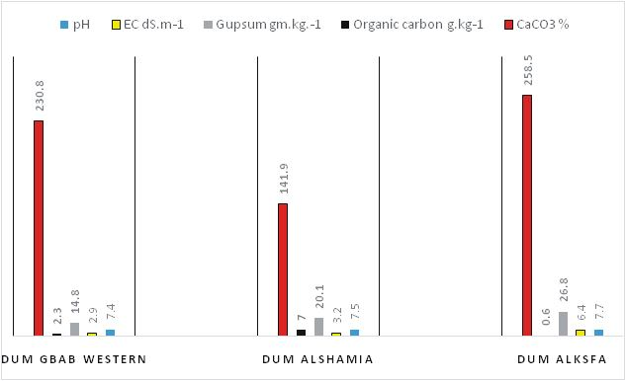

**Fig. 2:** The mathematical distribution for chemical characteristics to the soil of the area under study.

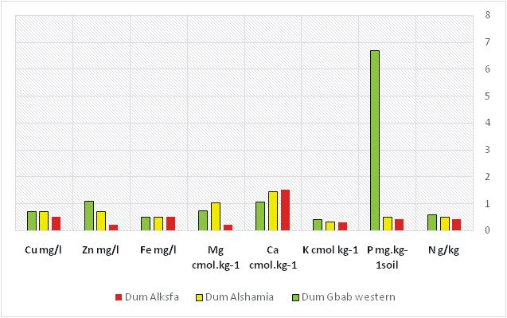

**Fig. 3:** Elemental distribution at the soil of the area under study.

study. Calcium was low in all areas of study and magnesium was quantified between high and low areas of study. The results of this study provide basic information and baseline data for further research and development efforts in soil fertility management for the sustainable use of soil resources in the region. However, A more detailed study and analysis of the studied soil should be undertaken to complement reliable and reliable results and to establish a database of land resources for the study area to assist decision-makers in developing sustainable agricultural development plans for the future. Without harming the ecosystem.

# References

Black, C.A., D.D. Evans, L.L. White, L.E. Ensminger and F.E. Clark (1965). Method of soil analysis.Part 1. In Agronomy Series (9). Am. Soc.Agron.

Bohn, H. L., McNeal, B. L. and OConnor, G. A. (1985). Soil chemistry, 2nded.John Wiley and Sons, New York.

Bolbol1, H., M.K. Eghbal1, H. Torabi2 and N. Davatgar (2013). Fertility capability classification of paddy soils in comparison with the soil taxonomy inguilan province, Iran. International Journal ofAgriculture: Research and Review, **3 (4):** 873-880.

Bouyoucous, C.A. (1951). A re-calibration of the hydrometer for making mechanical analysis of soils. *Agronomy Journal*, **43:** 434-438.

Buday, T. (1980). The Regional Geology of Iraq, Vol 1: Stratigraphy and Paleogeography. Publications of Geological Survey of Iraq, Baghdad, 445 p

Buringh, P. (1960). Soils and Soil Conditions in Iraq. Ministry of Agriculture, Baghdad.

Chude, V.O., S.O. Olayiwola, A.O. Osho and C.K. Daudu (2011). Fertilizer Use and management practices for crops in Nigeria fourth edition federal Fertilizer department, federal ministry of agriculture and rural development, Abuja, Nigeria, 1-59.

Day, P.R. (1965). Particle fractionation and particle size analysis. In. C.A. Black *et al*., (ed.) Methods of soil analysis, part 1. Agro. **9:** 545-567.

Erian, W.F. (1986). Land evaluation approaches for agriculutural purposes to fulfill Egyptin conditions using photo- interpretation maps. PhD thesis. Cairo University.

Esu, I.E. (1991). Detailed soil survey of NIHORT Farm at Bunkure, Kano State, Nigeria. Institute for Agricultural Research, Ahmadu Bello University, Zaria, Nigeria, 1-72.

FAO, Food and Agriculture Organization (1989) Sustainable agricultural production: Implication for international agricultural research. Technical Advisory Committee, CGIAR, FAO research and technical paper No 4. Rome Italy.

Guest, E.R. (1966). Flora of Iraq. Volume one. Introduction to the Flora, an account of the geology, Soils, Climate and ecology of Iraq with gazetteer, glossary and biolography.

Min. Agric. Iraq. 313pp.

Ibrahim, M.M, S. Idoga (2015). Soil Fertility Status of the Research Farm of the University of Agriculture, Makurdi, Benue State, Nigeria. Department of Soil Science, University of Agriculture, Makurdi, Nigeria.

Ibraim, S.B and V.K. Sissakian (1975). Report on the AL-Jezera area (Rawa-Baiji-Tikrit-AL-Bagdadi) General Directorate of Geological survey Department, Baghdad, p.11.

Jackson, M.L. (1958). Soil chemical analysis. Univ. of Wisconsin, Madison.

Jassim, S.Z., A.Y. Tamr and K.H. Bassam (1986). Excursion guid7th. Iraq Geol. Congr. Baghdad, Iraq, 46P.

Jassim, S.Z., A.Y. Tamr and K.H. Bassam (1986). Excursion guid7th. Iraq Geol. Congr. Baghdad, Iraq, 46P.

Jenny, H.I. (1941). Factors of soil formation, Asystem of quantitative pedology, Mc Graw – Hillcrop, New Yourk.

Manitoba Agriculture, Food and Rural Initiatives (2008). Soil Management Guide.

Mengel, K. and E.A. Kirkby (1987). Principles of plant nutrition. 4th Edi.. Int. method for determining soil organic matter and a proposed modification of the chromic acid titration method. *Soil Sci.*, **37:** 29-38.

Munsell Color Company (1954). Munsell Soil Color Charts.

Munsell Color Co. Inc. Baltimore.

Osama, T. Al-Taai, A. Dheyaa Al-Hassani and M. Ashwaq (2016). Mehdi Estimating the Soil Erosion by Using Rainfall Data for Selected Stations in Iraq open access liberary journal, 14.

Page, A.L., R.H. Miller and D.R. Kenncy (1982 ). Method of soil analysis. Part 2 Agronomy 9.

Parsons, R.M. (1955). Ground water Resources of Iraq.

Dulaimliwa Baghdad, **10:** 12. Potash Institute. Bern, Switzerland.

Richard, L.A. (1954). Diagnosis and Improvement of saline and alkali soils. U.S. Dept. Agric. Handbook No. 60.

Sissakian, V., K. Buthaina and S. Mohammed (2007). Stratigraphy. Geology of Iraqi Western Desert. Iraqi Bull. Geol. Min. Special Issue, 51-124.

Sissakian, V.K. and S.F. Fouad (2012). Geological Map of Iraq, 4th edit, scale 1: 1000 000, Iraq Geological Survey (GEOSURV), Baghdad, Iraq.

Soil Survey Staff (1993). Soil Survey Manual. USDA – SCS. Agric. Hand book 18. Washington, DC: U.S. Government printing Office.

Soil Survey Staff (2010). Key to Soil Taxonomy.11th Edition, United States Department of agriculture /Natural Resources Conservation Service, USA, 161-195.

Van de universiteit van amsterdam

Walkley, A. and I.A. Black (1934). An examination of the Degtjareff.

Yahia, H.M. (1971). Soils and soil conditions in sediments of the ramadi province (iraq).