STUDYING THE FERTILITY STATUS OF THE SOIL IN SOME AREAS OFAGRICULTURAL EXPANSION WITHIN WESTERN DESERT FROM IRAQ

# Abstract

The agricultural expansion plans for any area require a scientific study of all land resources, economic and social conditions, water resources, soil fertility, climatic conditions, optimum utilization and mapping of the fertility status of the study areas. The preparation of such studies requires a field survey of these resources based on previous studies in soil and geology. The current work is an attempt to develop a database on these soils in the case offuture investment. The study included the implementation of a survey of the culture in the period from February 2012 to January2013 for three areas within the Western desert environment are: Dum Al Ksfa, Dum Al Shamia and Dum Gbab Western: 11,480,27,120, 140,840 square dunam, respectively. Morphological, physical and chemical tests of the surface layer soil samples for more than 10 auger holes for each site and three pedons representing each region was studied. In addition to montoring the climate change during all months of the year. Study concluded that; Based on the climatic data of the study areas, soil moisture is present in the dry climate of the Torric moisture regim, and the temperature of the soil within the hyperthermic range belongs to the soil of the study area to the Ardisols. The pH of the soil was Slightly Alkaline. The salinity of the soil of the study areas was that the soil of the Dum Al Shamia and Dum Gbab western area was normal and the Dum Alksfa salines oils. The average values of the major nutrients, total nitrogen (0.4- 0.6 g/kg) and phosphorus (1.38-6.7 mg kg-1) and potassium (0.31-0.4cmol kg-1) and The iron (0.5 mg/l), zinc (0.2-1.1 mg/l) copper (0.5-0.7 mg/l). Organic carbon was low in all regions under international critical limits. Therefore, this study focuses on three areas within the Western Desert of Iraq. These areas were chosen for a study, with all possible recommendations for the conservation of arable land, which is one ofthe most scarce resources.

***Keywords****:* Agricultural expansion, western desert, fertility, soil survey.

# Introduction

The world’s population now stands at 7 billion and could exceed 9 billion in 2050, leading to an increase in demand for world food.The total area of the land includes marginal lands, such as deserts, high mountains, swamps, areas that were arable, Sustainable management of soil. Agricultural expansion is the main pillar for increasing agricultural production (Ustaogluand Williams, 2017) and for agricultural development, multiple mechanisms and successive implementation procedures. Soil assessment comes at the forefront of these operational steps, which aims at assessing the productivity of productive soil and determining the limits of agricultural exploitation in order to plan its exploitation to achieve the maximum possible utilization. Fertility in some areas of the Western Desert of Iraq as one of the promising areas, which were included

within the map of promising areas issued by the Directorate of Agriculture of Anbar province (the investment map of the Directorate of Agriculture Anbar Province, 2008).

The agricultural expansion plans for each country require a scientific study of all natural land sources, economic and social conditions, water sources, agricultural conditions and prevailing climatic conditions. The preparation of such studies makes the development of a land assessment system based on modern epidemiological studies (Erian, 1986).

The identification of the optimal use of land requires a comprehensive and integrated study of the various factors that affect their suitability or appropriateness for a specific use, as well as determining the factors limiting the validity of a specific land for specific use, and requiring a comprehensive survey of all land resources to provide

basic information to assess the suitability of land for different uses (Alioui, 1985).

There is a global campaign for sustainable agriculture that involves improving agricultural resources to meet human needs while conserving the environment and conserving land resources (FAO, 1989). In a study onthe environmental and fertility properties of some types of desert land in Egypt, Zaghloul *et al*. (2012) confirmed the decrease in the ratio of both cationic and organic matter. The large NPK elements in the surface layer of soil are insufficient to meet the needs of plants in the three studied areas, The content of micro-soft elementsin the surface layer was found to be low and critical in both the Jaradah and Khmisa regions, while at the level sufficient for the needs of plants in the Yellow Mountain region.

Bolbol and others (2013) found that the Capability Classification System (FCC) is used to classify arable land and that there are differences between land units in nutrient availability and availability On the nature of the presence of calcium carbonate and the characteristics of soils and their impact on the availability of availability within the soil of the two provinces.

Phosphorus is one of the plant’s essential nutrients.It requires concentrations of about ~~between~~ 0.003 ppm in soil solution (Kirby and Mengel, 1987). Plants differ in their need for phosphorus depending on the type of crop and the growth stage. The symptoms of its lack are not indicative of its absence This may be due to several factors, including: the quantity and type of clay minerals, and the quantity of clay minerals in the soil, pH, ionic effect, and impact ~~T~~ of organic matter as well as the contact between the phosphate ions and the time of the components of the soil return( Hamshm, 2008)

Bilal *et al.*, 2014 evaluated land in agricultural development areas in Assiut, Sohagand Qena governorates based on soil fertility and physiographic characteristics of the region using remote sensing and geographic information system (GIS). The objective of ~~this~~ the evaluation was to determine the capacity of the~~se~~ soils on agricultural investment, based on the fertility status in those soils.

The assessment of land in terms of its ability and

**Table1:**Thecharacteristicoftheregionsunderstudy.

Suitability to various crops is one of the important pillars in planning for the development of the promising areas. (Dahabi and others, 2015).

In their study of natural resources in northern Alexandria and Kafr El-Dawar, Ismail *et al*. (2016) explained that extracting information on the nature of soil and ~~its~~ fertility characteristics and distribution was very important in the exploitation of these lands for the purposes of sustainable agricultural development.

In a study of soil fertility at a farm for agricultural experiments at the University of McCordy, Nigeria Ibrahim, *et al.* (2015) found that by analyzing the chemical and physical properties of the soil and the depths of 0-15 cm for sandy soil pH 5.56-6.17 and that the soil was generally low fertility characteristics were suggested to maintain soil fertility by adding mineral nutrients to fertilizer (NPK).

The objective of this study is to evaluate some of the desert soils to be developed in the future and to know the critical boundaries of the available major nutrients and some minor elements and to make recommendations that guide investment ~~operations~~ options and agricultural expansion in western Iraq.

# MaterialsandMethods

## Description of area under study

The area ~~of~~ under study is located in the southwestern side of Lake Qadisiya in three selected districts in the Western Desert of Iraq: Dum Alkasfa, Dum Alshamiya and Dum Gbab western. The territory of this region ofthe deposition of calcareous and gypsum successive in i Her Bugs (1960, Buringh). Table 1 Characteristicsofthe sites of the study areas.

## Fieldvisits

Screening soil and collecting ~~observations~~ samples were ~~was~~ done during farm visits from May 2012 to June 2013 using auger hole. Free lance soil survey was used to collect soils from the area under study. The collected samples used to study the relation between soil composition and topography, salinity, pH, color etc. the soils differentiated using the Manual of the Soil Survey Division Staff 1993 and Munsell color chart, as shown in Fig. 1 the holes under study in the three area clearly represent using DEM.

## Physical measurements

|  |  |  |  |  |  |
| --- | --- | --- | --- | --- | --- |
| **No.** | **Region** | **Area** | **GPS** | | **Thehigh from**  **Sealevel** |
| **East** | **North** |
| 1 | DumAlkasfa | 11.480 | 42°16201.9122 | 34°11246.9722 | 165 |
| 2 | DumAlsamia | 27.120 | 42°02230.8222 | 34°16227.8122 | 203 |
| 3 | DumGbabwestern | 140.840 | 41°30218.9522 | 34°20227.1622 | 293 |

Physical properties were estimated according to the methods ~~in~~ proposed by Page et al (1982). Volumetric distribution of soil septoirs: according to mechanical analysis and determination of soil texture in a hydrometer method and particle size

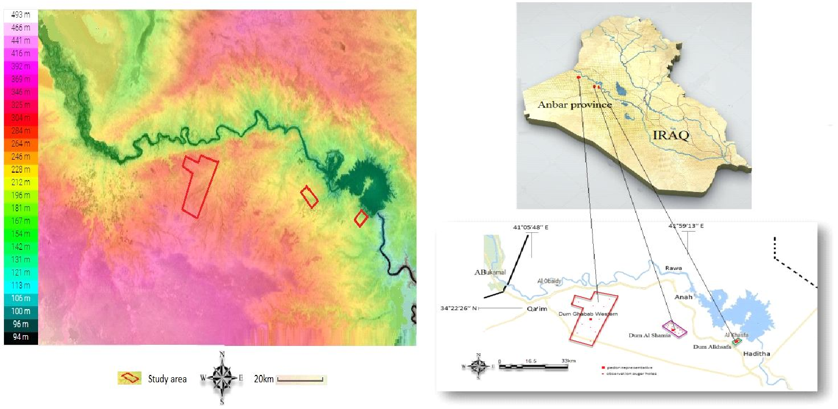

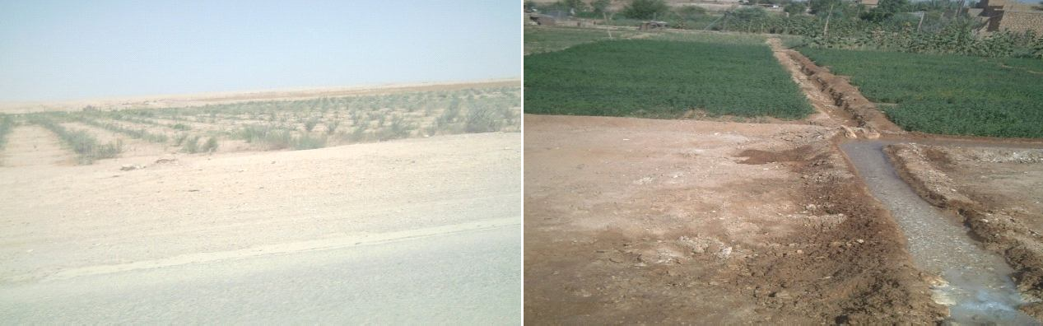

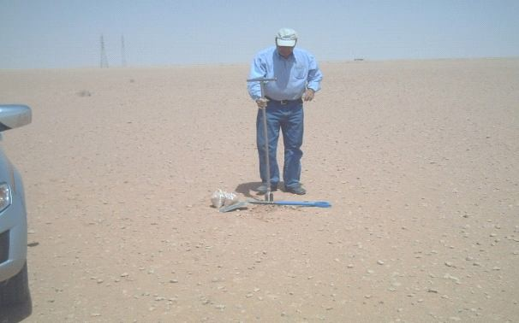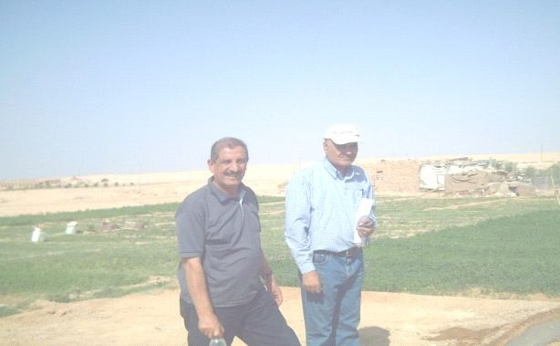

**Fig.1:**Thefieldvisitofthe grouptotheregionunderstudy.

distribution was determined by the hydrothermetric method (Bouyoucous asv, 1951).

## Chemical characterizations

**Electrical conductivity:** A suspension of air-dried (or fresh) soil, fresh sludge or fresh biowaste is made up in 5 times (soil) or 10 times (sludge and biowaste) its volume with water, to dissolve the electrolytes. The specific electrical conductivity of the filtered extract is measured and the result is corrected to a temperature of

20oC. (Richards,1954).

**Soil reaction (pH)**: It is a measure of hydrogen ion concentration in soil solution. It strongly affects the availability and solubility of minerals and nutrients, and is regarded as a useful indicator of other soil parameters. Most minerals and nutrients are more soluble in acid soils than in neutral or slightly alkaline soils (Richards,1954).

**Carbonate content of the soil:** g of fine crushed soil sample was placed in to conical flask, 10 ml of 1N

HCl and 50 ml distilled water were added, heated until boiling for 2 mins. Then, left until cool and 3 drops of phenolphthalein indicator was added and titrated against 1 N NaOH. Then, the per cent calcium carbonate was calculated according to (Balázs*et al.*, 2005). (Jackson,1958).

**Gypsum content ~~of the gypsum~~**: It was estimated by sedimentation method using a mixture of acetone 80% and acetic acid 20% and a few drops of calcium nitrate ~~and the method~~ as proposed by Zubaidi and others in Rahi*et al.*, (1991).

## ~~Soil content of organicmatter~~

## Organic matter content of the soil

Estimated in a manner proposed by Walkely and Black (1934) and described by Jackson (1958).

## Analysis of macro- and micro-nutrients ~~and smallnutrients~~

It’s estimated at the National Research Center-Arab Republic of Egypt - Duke- German Technical Cooperation (Micronutrients program and problems of plant nutrition).

## Calcium and Magnesium Determination

Dissolves in water extract (5:1) and alternates in ammonium chloride extract (20:1) in a calibrating method with the ferrosin solution.

**Soluble sodium and potassium determination:** Sodium and Potassium The initial and residual metal ion concentration in aqueous solutions has been determined usingAtomicAbsorption Spectrometer (AAS) operating with an air-acetylene flame. A definite liquid solution was prepared and exposed to injection part, the sodium concentration displayed against calibration curves which previously done before the elements measurements.

# Results and Discussion

## Classification of the soils of the study area

The soil of the areas under study is considered to be Coarse loam~~y~~ ~~family~~. It’s clear from Table 2 that soils of the area under study ~~is~~ ~~ordered~~ belongs to the order Aridisols, and suborder~~ed under~~ Calcigysids for Dum Alshamia and Dum Gbab western, while sub order ~~edunder~~ Gypsids for Dum Alksfa. It’s also seen from Table 2, the soil sub-grouped under Typic calcigyside for either Dum Alshamia and Dum Gbab western, while sub-grouped ~~under~~ as Typic Haplo

**Table2:**The distinguish soil of the area under study.

Gypsides for Dum Alkasfa.

## Climate study

Data recorded in two weather stations located at south desert of Iraq (Al-Qaim and Haditha stations) were used to study the climate of the area under study. It is clear from ~~at~~ Table 3 that the climate of the study area is desert are dry and hot summers while dry, cold and high evaporation during winter. The average temperature for the months of June, July and August (summer) is 32.4°C and at Al-Qaim and Haditha stations and 33.1°C. The average temperature for the winter months (December, February and February) reached 9.2°C and 9.4°C for monitoring stations Al-Qaim and Haditha, respectively. The highest monthly temperature was recorded in July, while the lowest monthly temperature was in January, and the lowest monthly average temperature of 15.0°C and 15.5°C at the monitoring stations And modern, respectively While the highest value of the monthly average of the maximum temperatures recorded in the summer amounted to 40.2°C and 41.7°C at the existing and modern, respectively. The annual precipitation was124.9 and 129.7 at Al Qaim and Haditha stations, respectively, at an annual rate of 121.8, indicating the lack of rainfall in the region and its concentration in the winter and its absence during the summer months. Rain falls from October to May, while the months from June to August are dry. The level of evaporation from the sea surface was 3055.0 mm and 3188.1 mm at the modern monitoring stations, respectively.

It is noted that the maximum evaporation recorded during the summer accounted for 45.7% of the total annual evaporation, and these values are very high and affecting the environment in the region. And that the factors of high temperatures and wind speed are among the most important factors in the increase in evaporation in the region. The highest relative humidityin the region was 69.5% and 69.4% in Al Qaim and Haditha respectively, and in the summer, reaching a low of 28.4% and 23.4% at Al Qaim and Haditha, respectively. The above indicators directly affect the identification of vegetation in the area as well as a specific factor for the cultivation of economic crops based on rainfall, because the climate factor is very important in determining the assessment of the territory of the region on the basis of its suitability for crop growth and the fact that agriculture

|  |  |  |  |  |  |
| --- | --- | --- | --- | --- | --- |
| **Location** | **Order** | **Suborder** | **Great group** | **Sub-group** | **Family** |
| DumGbabwestern | Aridisols | Calcigypsids | HaploCalcid | TypicCalcigypsid | Coarseloamy;Mixed;Hyperthermic;  TypicCalcigypsid |
| DumAlshamia | Aridisols | Calcigypsids | HaploCalcid | TypicCalcigypsids | CoarseloamyMixed;  Hyperthermic;TypicCalciargids |
| DumAlksfa | Aridisols | Gypsids | HaploGypsids | TypicHaploGypsids | Fineloamy;Mixed;Hyperthermic; TypicHaploGypsids |

in the region is irrigated. Therefore, the rainfall factor is excluded from the assessment process. The annual rate of wind speed for the monitoring period 1985-2011was3.0 m1and3.2 m1-at current and current stations respectively. With variations in the values of this indicator per month, the months of June, July and August recorded the highest values in all monitoring stations, and the direction of the prevailing winds in the region is the North West, which is 60.2% in the city of Al- Qaim compared to the rates of occurrence in other directions.

|  |  |  |  |  |  |  |  |  |  |  |  |  |  |  |  |
| --- | --- | --- | --- | --- | --- | --- | --- | --- | --- | --- | --- | --- | --- | --- | --- |
| **AlQaimStation** | **hours Actual solar brightness** | | 5.7 | 5.7 | 5.7 | 5.7 | 5.7 | 5.7 | 5.7 | 5.7 | 5.7 | 5.7 | 5.7 | 5.7 | 5.7 |
| **Wind speed m/s** | | 2.1 | 2.4 | 2.5 | 2.6 | 3.8 | 4.5 | 4.3 | 4.4 | 3.1 | 2.6 | 1.9 | 1.8 | 3.2 |
| **Evapo- ration mm** | | 65.3 | 93.3 | 187.2 | 259.4 | 351.3 | 449.3 | 516.9 | 491.4 | 336.9 | 234.8 | 121.6 | 80.1 | 3188.1 |
| **Relative humidity**  **%** | | 73.4 | 63.3 | 54.9 | 45.0 | 35.4 | 29.8 | 28.4 | 30.6 | 36.3 | 45.6 | 60.7 | 71.9 | 47.9 |
| **Amount of falling rain**  **Relative** | | 23.2 | 23.5 | 18.9 | 12.9 | 4.8 | 0.3 | 0.0 | 0.0 | 0.1 | 7.6 | 17.9 | 15.7 | 124.9 |
| **TemperatureC** | **Monthly rate** | 7.8 | 10.4 | 14.8 | 20.6 | 26.4 | 30.9 | 33.6 | 32.7 | 28.5 | 23.0 | 14.7 | 9.3 | 20.1 |
| **Min** | 2.6 | 5.0 | 8.3 | 13.3 | 18.3 | 22.8 | 25.4 | 24.6 | 20.5 | 15.5 | 8.1 | 4.1 | 14.0 |
| **Max** | 12.9 | 16.4 | 21.6 | 28.0 | 33.9 | 38.5 | 41.2 | 40.9 | 36.6 | 30.6 | 22.0 | 15.7 | 28.2 |
| **HadithaStation** | **hours Actual solar brightness** | | 6.1 | 6.1 | 6.1 | 6.1 | 6.1 | 6.1 | 6.1 | 6.1 | 6.1 | 6.1 | 6.1 | 6.1 | 6.1 |
| **Wind speed m/s** | | 2.1 | 2.4 | 2.6 | 2.5 | 3.7 | 4.3 | 4.2 | 4.2 | 3.1 | 2.6 | 1.8 | 1.9 | 3.0 |
| **Evaporation mm** | | 62.2 | 92.6 | 159.9 | 227.8 | 352.5 | 453.0 | 510.2 | 457.7 | 339.8 | 224.7 | 110.3 | 64.2 | 3055.0 |
| **Relative humidity**  **%** | | 73.5 | 62.3 | 52.9 | 41.8 | 32.9 | 24.8 | 23.4 | 25.2 | 28.8 | 42.4 | 58.3 | 72.4 | 44.9 |
| **Amount of falling rain**  **Relative** | | 18.4 | 22.8 | 18.4 | 14.5 | 6.6 | 0.2 | 0.0 | 0.0 | 0.4 | 6.7 | 18.8 | 23.0 | 129.7 |
| **TemperatureC** | **Monthly rate** | 8.0 | 10.3 | 14.0 | 21.2 | 27.3 | 29.9 | 33.1 | 34.2 | 29.8 | 23.7 | 15.1 | 9.8 | 21.4 |
| **Min** | 2.8 | 4.5 | 7.6 | 14.0 | 19.1 | 22.0 | 26.0 | 25.7 | 21.4 | 16.4 | 9.2 | 5.1 | 14.5 |
| **Max** | 13.9 | 16.4 | 21.3 | 28.3 | 35.0 | 39.8 | 42.8 | 42.6 | 38.5 | 31.7 | 22.4 | 16.1 | 29.1 |
| **Month** | | | January | February | March | April | May | June | July | August | September | October | November | December | Annualrate |

Soil tissue

The results in Table 4 indicate that the ratio of the representative silt to soil sand was 39.8, 22.4 and 52.0% for Dum Alkasfa, Dum Alshamia and Dum Gbab western, respectively, and 50.0, 49.6 and 38.9% for Dum Alkasfa, Dum Alshamia and Dum Gbab western, respectively, indicating that the mix texture is generalized and varied by depth and location. This confirms the previous studies presented by Buringh, 1960, and Altai,1968,respectively. And Yahya,1971, when they studied the soil of these areas and elsewhere in the physical unit Demographic (unit lower valleys) in the western desert of Iraq, it is likely that the dominance of sand and silt in most of the soil surface due to the material originally formed from them.

## Physico-chemical properties

Table 5 illustrate the physico-chemical properties of the soil under study; the characterization include soil pH, soil conductivity, gypsum content, organic carbon content and cationic exchange capacity CBC.

## Soil pH

Table 5 and Fig. 2 shows that the pH values ranged from 7.7.7.5 and 7.4 for the Dum Alksfa, Dum Alshamia and Dum Gbab western regions, respectively, within Slightly Alkaline, the high calcium carbonate content within the soil area of the study affected the pH of the soil and the effect of these Characterize the availability of nutrients in those soils, where the soil pH affects the availability of nutrients, especially phosphorus, micronutrients and biological activity. The pH of the soil is due to the soil’s original material, the type of vegetation, and the climate (especially the amount of precipitation). It is derived from limestone and gypsum rocks and developed under rain and pastures.

**Table3:**Climatecharacteristicsoftheareaunder study.

## Soil salinity

Soil salinity is the state of the soil in terms of

**Table4:**Soil tissue characteristics.

|  |  |  |  |  |  |  |  |
| --- | --- | --- | --- | --- | --- | --- | --- |
| **Parameters(Physio- chemicalProperties)** | | **DumAlksfa** | | **DumAlshamia** | | **DumGbabwestern** | |
| **Range** | **Average** | **Range** | **Average** | **Range** | **Average** |
| Texture | Sand% | SIL | 39.8 | SICL | 22.4 | L | 52.0 |
| Silt% | 50.0 | 49.6 | 38.9 |
| Clay% | 10.01 | 28.0 | 9.18 |

**Table5:**Physico-chemicalpropertiesofsoilunderstudies.

|  |  |  |  |  |  |  |
| --- | --- | --- | --- | --- | --- | --- |
| **Parameters(Physio- chemicalProperties)** | **DumAlksfa** | | **DumAlshamia** | | **DumGbabwestern** | |
| **Range** | **Average** | **Range** | **Average** | **Range** | **Average** |
| SoilpH |  | 7.7 |  | 7.5 |  | 7.4 |
| ECdS.m-1 | 9.2-3.2 | 6.4 | 4.2-2.3 | 3.2 | 3.4-2.3 | 2.9 |
| CaCO3% | 204.3-312.7 | 258.5 | 135.4-148.5 | 141.9 | 264.1-197.5 | 230.8 |
| Gupsumgm.kg.-1 | 15.6-38.1 | 26.8 | 6.2-34.1 | 20.1 | 5.6-24.1 | 14.8 |
| Organiccarbong.kg-1 | 0.3-0.9 | 0.6 | 4.6-9.4 | 7.0 | 0.5-4.2 | 2.3 |
| CECcmol.kg-1 | 7.45.6- | 6.3 | 17.5-25.9 | 21.8 | 7.7-12.5 | 10.1 |

water-soluble salts in the marshl and area, which hinder crop growth. The severity of the effects to address the problem depends on soil testing to determine the quantity and type of salts present, that high salt content increases the ammonia capacity of the soil solution and prevents the absorption of crops from water. (SAR) is the ratio of sodium to beneficial calcium and magnesium acetate soils where, when SAR exceeds 13, the soil is sodic if it exceeds 13 and EC, greater than 4, and the soils Management Guide, 2008).

Salinity was assessed for the soil condition in the study areas as shown in table 5 and fig. 2, with salinity ranges between 2.3-9.2, 4.2.2.3 and 3.4.2.3 (6.4, 3.2 and 2.9) Dum Alksfa, Dum Alshamia and Dum Gbabwestern, respectively.

The results of the present study indicate that the soil of the Dum Alshamia area and Dum Gbab western is normal salinity, and the soil of the Dum is classified as saline soils (Bohn, 1985).

## (CaSO,CaCO)measurements

illustrates the statistical distribution of some of the chemical characteristics of the study areas.

## CationicExchangeCapacity(CEC)

Table 5 indicates the values of the exchange capacity of positive ions for the soil of the study, as shown in table 5, ranged from 6.3 to 21.8 cmol.kg-1 soil, with an increase in the values of this

characteristic at the site of Dum Alshamia. This is due to the heterogeneity of soil content The results showed that, compared to the ESU, 1991, the study showed that the assessment of the study areas for the cation exchange capacity was medium for the dum zone And the Dum

Gabab western and Alia High in the area of Dum Alshamia.

## Organic carbon

The organic carbon (Table 5 and Fig. 2) of the soil was generally less than 10 g kg-1 (Table 6 between 0.3 - 0.9),(4.6-9.4)and(0.5-4.2) any rates (0.6), (7.0) and

(2.3), Dum Alkasfa, Dum Alshamia and Dum Gabab western, respectively. The decrease in the soil content of the study of organic matter is due to the prevailing climatic conditions in the region, the most important of which is the high temperature and the lack of rainfall that does not exceed 125 mm annually, as these factors determine the accumulation of organic matter in the soil. In addition to the effect of vegetation of the area, which is very little and consists mostly of short grass.

## Soil Fertility Status

The soil fertility was evaluated through determination of macro and micronutrients that include nitrogen, phosphorous, potassium, calcium,

**4 3** magnesium, iron, zinc and copper

As for the soil content of carbonates for the three regions, the values ranged between141.9 - 312.7% with the highest content recorded at the site of the Dum Alksfa, which was a rate of pidon 258.5% compared to other sites, which showed the lowest content as an average of this component was 135.4%.

The ~~soil~~ gypsum content of soils showed that it ranged between 5.6 - 38.1 gg-1 soil, with the highest content of this component at the site of the day of the day was 26.8

g. Kg-1 soil as compared to the location of Dum Gbab western, which recorded the lowest content of 14.8

g. Fig.2 illustrates the statistical distributions of some of the chemical characteristics of the study areas. Table 5

(Table 6).

## Total nitrogen

Total nitrogen was high (Table 6 and Fig. 3) in all types of soil studied ~~as follows~~: The total softness of the plant ranged between 0.6-0.2, 0.6-0.4 and 0.8-0.4, *i.e.* (0.4 ), (0.5), and(0.6) g/kg for the Dum deserts, Dum Al Shamia and Dum Gbab western, respectively.The result is consistent with the previous study of Moses and others. (2017) for the distribution of some medicinal plants in the current study areas, Fig. 3 illustrates the statistical distributions of some large and small nutrients within the selected areas of study.

**Table6:**Themacroandmicronutrientsattheareaunder investigation.

|  |  |  |  |  |  |  |
| --- | --- | --- | --- | --- | --- | --- |
|  | **DumAlksfa** | | **DumAlshamia** | | **DumGbabwestern** | |
| **Macronutrients** | | | | | | |
| N g/kg | 0.6-02 | 0.4 | 0.6-0.4 | 0.5 | 0.8-0.4 | 0.6 |
| Pmg.kg-1soil | 1.8-5.9 | 3.8 | 1.2-1.7 | 1.38 | 4.6-8.9 | 6.7 |
| Kcmolkg-1 | 0.2-0.5 | 0.31 | 0.3-0.4 | 0.33 | 0.4-0.5 | 0.4 |
| Cacmol.kg-1 | 1.2-1.8 | 1.50 | 1.3-1.6 | 1.45 | 1.0-1.2 | 1.06 |
| Mgcmol.kg-1 | 0.10-0.30 | 0.20 | 0.09-2.0 | 1.03 | 0.60-0.84 | 0.74 |
| **Macronutrients** | | | | | | |
| Femg/l | 0.4-0.6 | 0.5 | 0.2-0.7 | 0.5 | 0.3-0.6 | 0.5 |
| Znmg/l | 0.05-0.4 | 0.2 | 0.6-0.9 | 0.7 | 0.4-1.9 | 1.1 |
| Cumg/l | 0.2-0.7 | 0.5 | 0.09-1.4 | 0.7 | 0.3-1.2 | 0.7 |

the study area can only be achieved through the use of external inputs such as the use of organic and inorganic fertilizers as well as appropriate management techniques to increase natural data in the region. The study showed that the soil showed good levels of mud accumulation with the soil, which enhances the properties of the soil and makes its chemical properties more encouraging in the establishment of agricultural development and the need to apply administrative methods and techniques for investment and sustainability.

## Quantity of available P

The amount of phosphorus available for soil was generallylessthan10mg.kg-1(Table5andFig.3),in the study areas(1.8-5.9),1.2(-1.7) and 4.6-8.9(3.8),

(1.38) (6.7) mg.kg-1 for Diom Al-Khosafa, Diom Al Shamia and Diom Jabbab Al Gharbia regions, respectively. The area of DiomGhabab Al Gharbia has the highest value compared with the other study areas due to the nearby geophysical geological formations. (Esu, 1991).

## Amount of calcium and magnesium

Table 5 and Fig. 3 showed that the calcium values in the study areas were (1.50), (1.45) and (1.06) cmol.kg-1 and that the magnesium values were (0.20), (1.03) and (0.74) mol.kg- (Esu, 1991), the amount of calcium in all areas of the study is low. As for the quantities of magnesium, it is low in the area of Dum Alkasfa and Dum Gbab western and high value high in the area of Dum Alshamia.

## QuantitiesofmicronutrientsFe,Cu,Zn

The mean values of the small nutrients (Table 5 and Fig.3),in the study are as were iron(0.5),0.5and0.5mg

/l, zinc (0.2),0.7and1.1mg/l, copper And Johnson and Fixen (1990) and Soltanpour (1985), all the study areas with content The zinc component was low in Dum Alkasfa and Dum Alshamia and High in Dum Gbab Western region. The amount of copper available is moderate in all three studied areas.

# Conclusions and recommendations

In general, the soil in the region has a marginal potential for agricultural production, given the dry conditions and difficulty of agricultural exploitation in desert soils. However, the use of management methods will improve agricultural productivity and optimal production. The chemical characteristics of the three sites, as shown on surface maps, In the nutrients needed for optimal production, although the territory of the Western Dum Jabbab looks more appropriate compared to other lands. Therefore, sustainable agricultural production in

Soil tests and analysis revealed that organic carbon was low, total nitrogen was well available in all areas of

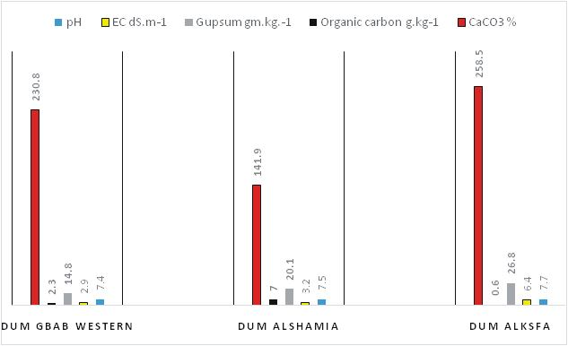

**Fig.2:**Themathematicaldistributionforchemicalcharacteristics to the soil of the area under study.

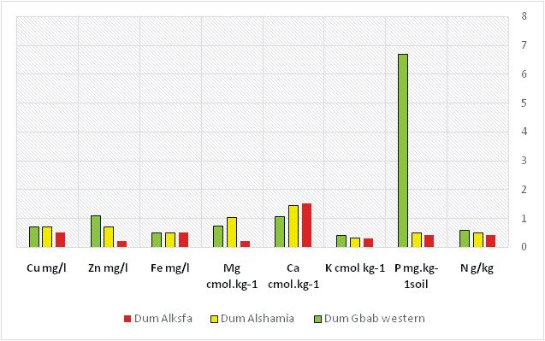

**Fig.3:**Elementaldistrbutionatthesoiloftheareaunder study.

study. Calcium was low in all areas of study and magnesium was quantified between high and low areasofstudy. The results of this study provide basic information and baseline data for further research and development efforts in soil fertility management for the sustainable use of soil resources in the region. However, a more detailed study and analysis of the studied soil should be undertaken to complement reliable and reliable results and to establish a data base of land resources for the study area to assist decision-makers in developing sustainable agricultural development plans for the future without harming the ecosystem.

# References

Black,C.A., D.D.Evans,L.L.White,L.E.Ensminger andF.E. Clark(1965).Methodofsoilanalysis.Part1.InAgronomy Series (9).Am. Soc.Agron.

Bohn, H.L., B.L. McNeal and G.A. OConnor (1985). Soil chemistry,2nded.JohnWileyand Sons, NewYork.

Bolbol1,H.,M.K.Eghbal1,H.Torabi2andN.Davatgar(2013). Fertility capability classification of paddy soils in comparisonwiththesoiltaxonomyinguilanprovince,Iran. InternationalJournalofAgriculture:ResearchandReview, **3(4):**873-880.

Bouyoucous, C.A. (1951).Are-calibrationofthe hydrometer for making mechanical analysis of soils. *Agronomy Journal*,**43:**434-438.

Buday, T. (1980). The Regional Geology of Iraq, Vol 1: Stratigraphy and Paleogeography. Publications of Geological SurveyofIraq, Baghdad, 445 p

Buringh, P. (1960). Soils andSoil Conditions in Iraq. Ministry of Agriculture, Baghdad.

Chude,V.O.,S.O.Olayiwola,A.O.OshoandC.K.Daudu(2011). Fertilizer Use and management practices for crops in NigeriafourtheditionfederalFertilizerdepartment,federal ministry of agriculture and rural development, Abuja, Nigeria,1-59.

Day,P.R.(1965).Particlefractionationandparticlesizeanalysis. In.C.A.Black*etal*.,(ed.) Methodsofsoilanalysis,part1. Agro.**9:**545-567.

Erian,W.F.(1986).Landevaluationapproachesforagriculuturalpurposes to fulfill Egyptin conditions using photo- interpretation maps. PhD thesis. Cairo University.

Esu, I.E. (1991). Detailed soil survey of NIHORT Farm at Bunkure,KanoState,Nigeria.InstituteforAgricultural Research,AhmaduBelloUniversity,Zaria,Nigeria,1-72.

FAO,FoodandAgricultureOrganization(1989)Sustainable agricultural production: Implication for international agricultural research. Technical Advisory Committee, CGIAR,FAOresearchandtechnicalpaperNo4.Rome Italy.

Guest,E.R.(1966).FloraofIraq.Volumeone.Introductionto theFlora, anaccountofthegeology,Soils, Climateand ecologyof Iraqwithgazetteer,glossaryand biolography.

Min.Agric.Iraq.313pp.

Ibrahim, M.M, S. Idoga (2015). Soil Fertility Status of the Research Farm of the UniversityofAgriculture, Makurdi, Benue State, Nigeria. Department of Soil Science, UniversityofAgriculture, Makurdi, Nigeria.

Ibraim,S.BandV.K.Sissakian(1975).ReportontheAL-Jezera area (Rawa-Baiji-Tikrit-AL-Bagdadi)General Directorate ofGeological survey Department, Baghdad, p.11.

Jackson,M.L.(1958).Soil chemicalanalysis.Univ.ofWisconsin, Madison.

Jassim,S.Z.,A.Y.TamrandK.H.Bassam(1986).Excursion guid7th.IraqGeol.Congr.Baghdad,Iraq,46P.

Jassim,S.Z.,A.Y.TamrandK.H.Bassam(1986).Excursion guid7th.IraqGeol.Congr.Baghdad,Iraq,46P.

Jenny, H.I. (1941). Factors of soil formation, Asystem of quantitativepedology, McGraw– Hillcrop, NewYourk.

ManitobaAgriculture,FoodandRuralInitiatives(2008).Soil Management Guide.

Mengel,K.andE.A.Kirkby(1987).Principles ofplantnutrition. 4thEdi..Int.methodfordeterminingsoilorganicmatter anda proposedmodificationofthechromic acidtitration method. *Soil Sci.*, **37:** 29-38.

MunsellColorCompany(1954).MunsellSoilColor Charts.

MunsellColorCo.Inc.Baltimore.

Osama, T. Al-Taai,A. Dheyaa Al-Hassani andM. Ashwaq(2016).MehdiEstimating theSoil Erosion byUsingRainfall Data for Selected Stations in Iraq open access liberary journal,14.

Page,A.L.,R.H.MillerandD.R.Kenncy(1982).Methodofsoil analysis. Part 2 Agronomy 9.

Parsons,R.M.(1955).GroundwaterResourcesofIraq.

Dulaimliwa Baghdad,**10:** 12. PotashInstitute.Bern,Switzerland.

Richard,L.A.(1954).DiagnosisandImprovementofsalineand alkalisoils.U.S.Dept.Agric.HandbookNo.60.

Sissakian, V., K. Buthainaand S.Mohammed (2007).Stratigraphy. GeologyofIraqiWesternDesert. IraqiBull.Geol.Min. SpecialIssue,51-124.

Sissakian,V.K.andS.F.Fouad(2012).GeologicalMapofIraq, 4th edit, scale 1: 1000 000, Iraq Geological Survey (GEOSURV),Baghdad,Iraq.

SoilSurveyStaff(1993).SoilSurveyManual.USDA–SCS. Agric. Hand book 18.Washington, DC: U.S. Government printingOffice.

SoilSurveyStaff(2010). KeytoSoilTaxonomy.11th Edition, UnitedStates Departmentofagriculture/Natural Resources Conservation Service, USA, 161-195.

Vandeuniversiteitvanamsterdam

Walkley, A. and I.A. Black (1934). An examination of the Degtjareff.

Yahia,H.M.(1971).Soilsandsoilconditionsinsedimentsof the ramadi province (iraq).