**Title: A 5 - month - old boy with hard skin and joint rigidity**

**Abstract**

A5 - month - oldboypresented withhard skin since born and later showed nodules in different size with lack of subcutaneous fat, associated with joint rigidity. Skin biopsy reveals sclerodermiform appearance. Exome study confirmed the diagnosis of progeria, with positive PCNA gene. In the last years, lonafarmib give hope to progeria patients, increasing the rate of weight gain and decreasing vascular stiffness, bone structure and audiological status in some children. Under clinical trial, a new drug called progerinin have the main objective to reduce the vascular rigidity in association with lonafarmib. This association is the big hope for patients suffering from progeria.

**Keywords:** hard skin, joint rigidity, progeria, lonafarnib

**Introduction**

Stiff skin syndrome is a scleroderma like disorder that presents in infancy or early childhood with rock-hard skin, limited joint mobility, and mild hypertrichosis in the absence of visceral or muscle involvement, immunologic abnormalities, or vascular hyperreactivity [7]. Clinical manifestations are usually present at birth, but they can also appear during the first 6 years of life. Patients with Congenital fascial dystrophy have clearly circumscribed areas of hardened skin with no visible changes to the skin surface; these areas arise particularly around the pelvic or shoulder girdles and on the proximal areas of the thighs. Less common findings include hypertrichosis, hyperpigmentation in the affected areas, and the presence of subcutaneous nodules on the distal phalanges of the fingers [8]. The main problem caused by this condition is limitation of joint movement. In the majority of patients this limitation is mild and does not interfere excessively with daily life; however, changes can sometimes be very widespread and can even limit lung capacity.2 If the symptoms are mild, the diagnosis may not be made until adult life [8,9]. We report a case of a 5 months old boy with hard skin and joint rigidity syndrome.

**Case Presentation**

A 5 - month - old boy is referred to the Center of diagnosis and evaluation of rare disorder, with hard skin in the whole body (Fig 1).

According to the parents, since born the skin showed this characteristic, which has gradually became harder with the appearance of nodules of different size , predominantly in the lower limbs. The patient is the only child of an unrelated healthy couple born at 39 weeks of gestation via cesarean section. Birth weight was 2.890 g (P15); length: 48,5 cm (P15); head circumference: 34 cm (P15-50). Apgar 9/10/10. Fetal ultrasound was reported as normal. There is no family history of this skin presentation.

A physical examination reveals a smiling infant, with thin upper lips, epicanthus, multiple hard skin nodules shape, spread in the body, with predominance in the tight and abdominal region, sparing the back and most of the upper limbs. The joints showed stiffness and limited movement. The rigidity is so severe that we cannot make the flexion of the limbs and Ortolani maneuvers of the hips or the crease sign. Red and white blood count, platelets, urea, creatinine, glycose, ASL, AST , heart and abdominal ultrasound were all normal.,

With this kind of presentation, we have mainly three possible diagnosis: scleroderma (SD) , progeria (PG) or progeroid syndrome (ataxia-telangiectasia like disorder 2)

The exome study are the keys for the diagnosis. (1,2)

**Diagnosis**

The diagnosis of SD is made based on clinical presentation, with hard and brilliant skin There are two different types: localized scleroderma and systemic sclerosis. In the local form, the disease mainly is limited to the skin, although can also cause uveitis and arthritis. The systemic type the disease cause hard skin and other organs involvement. The incidence is 3/100000 cases. In children, girls are more affected than boys. The disease is probably has an immune cause and some families are more affected . The skin biopsy is important for the diagnosis. The treatment is based on steroids, methotrexate and immunomodulators.

Progeria is a rare autosomal dominant genetic disease characterized by premature aging in children. Also known as Hutchinson-Gilford syndrome, it affects about 1 in 4 to 8 million people worldwide. Within a year of birth, people suffering from it start showing several features such as very low weight, scleroderma, osteoporosis and loss of hair. Their life expectancy is highly reduced and the average life span is around 14.6 years.(2)

The main cause of death is myocardial infarction. In homozygous carriers of progeria, symptoms are similar to those seen in heterozygous carriers. Farnesyltransferase is an enzyme that plays a crucial role in the protein modification process. In progeria, a mutation occurs in the LMNA gene, which codes for a protein called lamin A. This mutation results in the production of an abnormal form of lamin called progerin. This leads to distortion of nuclear shape and interferes with several cellular functions, contributing to the symptoms of progeria.(Fig 2)

In scleroderma and progeria, the skin biopsy will show sclerodermiform appearance.

Ataxia-telangiectasia like disorder 2, is an autosomal recessive disorder, with short stature, microcephaly, sensorineural hearing loss, conjunctival telangiectasia, photophobia, cutaneous photosensitivity and premature aging in some patients, ataxia, neurodegeneration. The gene affected is PCNA.(2)

Our index case, the result of exome confirmed the diagnosis of progeria, with positive LMNA gene, heterozygous carrier.

**Discussion**

Clinically, the patient appears with premature aging. Homozygous carriers show visible signs of premature aging, such as wrinkled skin, hair loss, loss of subcutaneous fat, and stiff joints. Ophthalmic manifestations included reduced brow hair, madarosis, and reduced accommodation. Most patients had relatively good acuity; however, advanced ophthalmic disease was associated with reduced acuity.(3)

The growth of children with progeria is significantly delayed compared to other children of the same age. Progeria causes premature aging of arteries, which can lead to heart problems such as arteriosclerosis and coronary disease. Homozygous carriers may experience stiffness and limited movement in their joints, which can make it difficult to perform daily activities. Due to accelerated metabolism and loss of subcutaneous fat, homozygous carriers may have difficulty maintaining a healthy body weight. In addition, homozygous carriers may present other symptoms common to progeria, such as short stature, high-pitched voice, dental problems and brittle nails.

Genetic counseling is important to provide information about the risk of progeria recurrence in future pregnancies and to discuss family planning options. Most cases are new mutation and the risk of recurrence is low. Patients with progeria are at increased risk of developing medical complications such as heart, diabetes and vision problems and we need to monitor and treat those complications.

**Treatment**

Until recently, Some medications are prescribed to help control specific symptoms of progeria. For example, medications to control blood pressure may be administered to reduce the risk of heart complications, while vitamin supplements may be recommended to ensure adequate nutrition. Aggressive ocular surface lubrication is recommended, including the use of tape tarsorrhaphy at night.

Physical and occupational therapy are essential to help patients maintain mobility,, flexibility and functional independence. These therapies may include stretching exercises, muscle strengthening, and techniques to improve coordination and dexterity. Progeria can have a significant impact on the mental and emotional health of patients and their families. Therefore, psychological and emotional support for both patients and their caregivers is critical to helping them cope with the emotional challenges associated with the condition.

**What news?**

Lonafarnib (Zokinvy/M) is an orally active farnesyltransferase inhibitor developed by Eiger BioPharmaceuticals under license from Merck & Co. for the treatment of hepatitis D virus (HD) infections, progeria and progeroid laminopathies. In progeria, lonalarnib inhibit farnesyltransterase to prevent farnesylation and subsequent accumulation of progerin and progerin-like proteins in the nucleus and cellular cytoskeleton. Its indicated in patients ≥ 12 months of age with a body surface area (BS) of 0.39 m2. The starting dose is 115 mg/m2 twice daily taken with morning and evening meals to reduce the risk of gastrointestinal (GI) adverse reactions. After 4 months of treatment. lonafarnib dosage is to be increased to 150 mg/m2 twice daily. Additional study, showed that treatment with lonafarmib for more than two years, increased the rate of weight gain and decreased vascular stiffness, bone structure and audiological status in some children with progeria, with all patients improving in at least one of these outcomes.(4)

Our patient started this drug in January this year and so far we cannot conclude any of those findings.

**Clinical trial**

Ghrelin administration effectively rescues molecular and histopathological progeroid features, prevents progressive weight loss in later stages, reverses the lipodystrophic phenotype and extends lifespan of these short-lived mice.(5)

Doxycycline treatment prolongs lifespan and ameliorates progeroid features of Zmpste24 KO mice, including the decline of body and tissue weight, exercise capacity and cortical bone density, and the shortened colon length.(6)

In January this year, Boston Children Hospital started a phase 2A of a new drug, called progerinin, according to Progeria Research Foundation.

In healthy adult patients , no side effects was found.

In rats, using lonafarmib, 25% of them survived and with progerinin, this percentage increased to 50%.

The objective of this clinical trial is to observe the action of the drug on the arteries of patients with progeria.

The inclusion criteria included: age of 12 months or more, not taking lonafarmib before, if they are taking lonafarmib for 4 months , they will continue treatment during the clinical trial with progerinin, normal function of liver and kidneys.

**Patient course**

Without any treatment, the patient will die in the early stage of life with myocardial infarction, secondary to premature atherosclerosis. The joint stiffness will also limit his movements. Even with this limitations, he can walk daily. The physiotherapy and speech therapy are very important in this stage of the disease.

With the new drug, lonafarmib, in the dose of 115 mg/m2 twice daily, is supposed to reduce those side effects and improve his quality of life.

**Conclusion**

Progerinin is a new hope for this and other patients. After the conclusion of the trial with two affected patients with progeria, maybe he and others children can start the treatment with this new drug, combined with lonafarmib avoiding some of clinical symptoms and reducing the risk of sudden death cause by heart attack.

**References**

1 - Talukder P, Saha A, Roy S, Ghosh G, et al.

[Progeria-a Rare Genetic Condition with Accelerated Ageing Process.](https://pubmed.ncbi.nlm.nih.gov/35445924/)

Appl Biochem Biotechnol. 2023 Apr;195(4):2587-2596. doi: 10.1007/s12010-021-03514-y.

2 - Worm C, Schambye MER, Mkrtchyan GV, Veviorskiy A, et al.

[Defining the progeria phenome.](https://pubmed.ncbi.nlm.nih.gov/38345566/)

Aging. 2024 Feb 9;16(3):2026-2046. doi: 10.18632/aging.205537.

3 - Mantagos IS, Kleinman ME, Kieran MW, Gordon LB.

[Ophthalmologic Features of Progeria.](https://pubmed.ncbi.nlm.nih.gov/28756152/)

Am J Ophthalmol. 2017 Oct;182:126-132. doi: 10.1016/j.ajo.2017.07.020.

4 - Dhillon S.

Lonafarmib: first approval

Drugs 2021Feb; 81 (1). doi: 10.1007/s40265-020-01464-z

5 Ferreira-Marques M, Carvalho A, Franco AC, Leal A, et al.

[Ghrelin delays premature aging in Hutchinson-Gilford progeria syndrome.](https://pubmed.ncbi.nlm.nih.gov/37858983/)

Aging Cell. 2023 Dec; 22 (12):e13983. doi: 10.1111/acel.13983.

6 - Wang M, Zhang J, Qiu J, Ma X, Xu C et al.

[Doxycycline decelerates aging in progeria mice.](https://pubmed.ncbi.nlm.nih.gov/38686927/)

Aging Cell. 2024 Jul; 23 (7):e14188. doi: 10.1111/acel.14188.

7. Liu, T., McCalmont, T. H., Frieden, I. J., Williams, M. L., Connolly, M. K., & Gilliam, A. E. (2008). The stiff skin syndrome: case series, differential diagnosis of the stiff skin phenotype, and review of the literature. Archives of dermatology, 144(10), 1351-1359.

8. Marsol, B., & Fernández-Figueras, M. (2014). Congenital fascial dystrophy or stiff skin syndrome: a case report. Actas Dermo-sifiliograficas, 105(8), 805-807.

9. Myers, K. L., Mir, A., Schaffer, J. V., Meehan, S. A., Orlow, S. J., & Brinster, N. K. (2016). Segmental stiff skin syndrome (SSS): a distinct clinical entity. Journal of the American Academy of Dermatology, 75(1), 163-168.

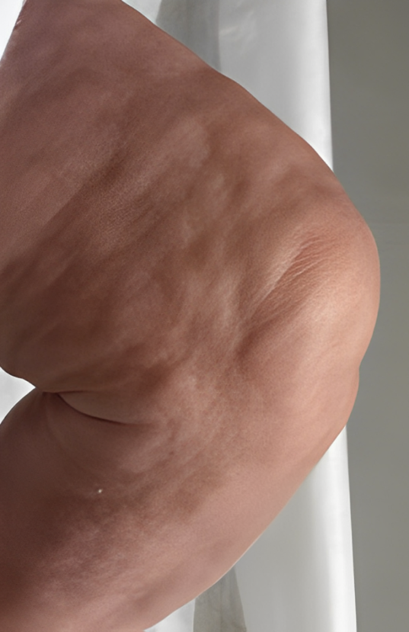

Figure 1 – hard skin

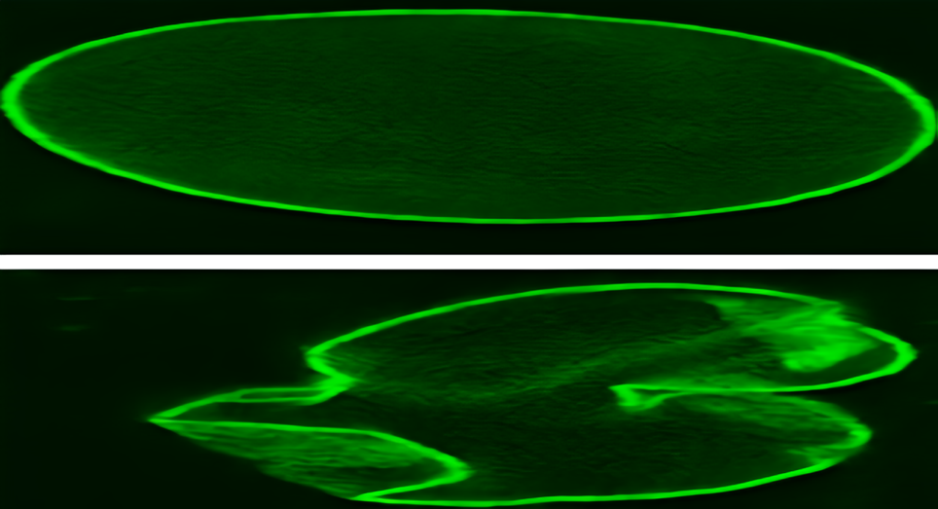

Figure 2 – Effect of progerin in the nuclear shape, causing distortion