Congenital Mesoblastic Nephroma: A Case Report

# Abstract

~~Background: Congenital Mesoblastic Nephroma (CMN) is a mesenchymal re- nal tumour of early life. With a median diagnosis of two months and over 90% of cases occurring within the first year of life, it is the most prevalent non- Wilms’ renal tumour. Even though imaging can be used as a diagnosing tool, it is frequently identified in the neonatal period when the baby has an ab- dominal mass. There are three different histologic types: mixed, cellular, and classic. Radical nephrectomy is the usual mode of treatment, though adjuvant chemotherapy may be necessary for the cellular type, which may be aggressive. Case presentation:~~ We report on a case of a 2-day-old term male neonate born ~~to a 27-year-old mother through spontaneous vertex delivery (SVD). He pre- sented~~ with a right-sided abdominal mass ~~from birth.~~ An abdominal ultrasound scan revealed a huge, well-circumscribed heterogeneous soft tissue mass in the right hemi-abdomen extending to the left side, measuring 10.2 cm by 8.0 cm. He underwent a right radical nephrectomy ~~with a tumour weight of 450 g and a size of 18 cm × 15 cm × 6 cm~~. Histopathological diagnosis was Congenital Mesoblastic Nephroma (cellular type) Stage 1. ~~Conclusion: Any infant with a renal tumour should be evaluated for congenital mesoblastic nephroma. De- tailed investigation and complete resection are fundamental for ensuring an excellent outcome.~~

# Keywords

Congenital, Mesoblastic Nephroma, Nephrectomy, Neonate

# Introduction

Congenital mesoblastic nephroma (CMN), a benign mesenchymal renal tumour,

accounts for 2% - 3% of renal tumours in children and is the most prevalent renal tumour in neonates and infants under six months of age [1]. It was first described in 1967, distinguishing it from other renal tumour such as Wilm’s tumour [8,9,10]. Three pathogenic variations of CMN exist: the mixed form, the more aggressive cellular CMN, and the classic CMN [1]. The prognosis for classic CML is generally good. However, cellular CML carries a risk of malignancy and can metastasize and recur [2]. However, if full resection is achieved, surgical resection combined with nephrectomy is seen as an appropriate therapy for all subtypes.

# Case Report

## Clinical Presentation

This two-day-old Nigerian male baby, born to a 27-year-old mother, was referred from a primary health center due to the paleness of his body after delivery, vomiting observed shortly after birth, and abdominal distention noted on the second day of life. The vomiting was triggered by feeds, with approximately three episodes occurring in the first two days. The vomitus was initially mixed with altered blood but cleared by the next day. The abdominal distention was first noticed by his grandmother, necessitating their visit to a primary health center. The pregnancy was supervised at a health facility; however, the mother also sought the services of a Traditional Birth Attendant (TBA), where she received herbal-based mixtures during the last three months of her pregnancy. Two prenatal scans conducted at the fourth and eighth months of pregnancy were reported to be normal. Labor was prolonged, and the delivery was a spontaneous vertex delivery by a TBA at term. He cried after five minutes of resuscitation and weighed 4 kg at birth.

Examination findings included severe pallor and respiratory distress. He had a respiratory rate of 51 cycles per minute, a heart rate of 180 beats per minute, a blood pressure of 73/30 mmHg, a temperature of 37˚C, and an SPO2 of 97% in room air. His abdomen was distended and tense, with visible anterior abdominal wall veins. An abdominal girth of 36 cm was measured 5 cm from the xiphisternum, and a firm mass was palpated in his right lumbar region. Other abdominal organs were difficult to palpate. The remaining systemic examination findings were essentially normal. There were no clinical signs suggestive of coexisting congenital anomalies. A provisional diagnosis of Wilms’ tumor was made.

## Laboratory and Radiologic Findings

Blood investigations reported a Packed Cell Volume of 11%, white cell count of

22.4 × 109/L, platelets of 134 × 109/L, creatinine was 180 μmol/L and urea of 12.6 mmol/L.

An abdominal ultrasound scan revealed a large, well-circumscribed heterogeneous soft tissue mass in the right hemi-abdomen, extending to the left side, measuring 10.2 cm by 8.0 cm. Doppler interrogation indicated internal and peripheral flow within the mass. The right kidney was not clearly visualized. The left kidney appeared normal in size (3.6 cm × 1.9 cm), position, and echotexture, with good cortico-medullary differentiation (**Figure 1**& **Figure 2**).

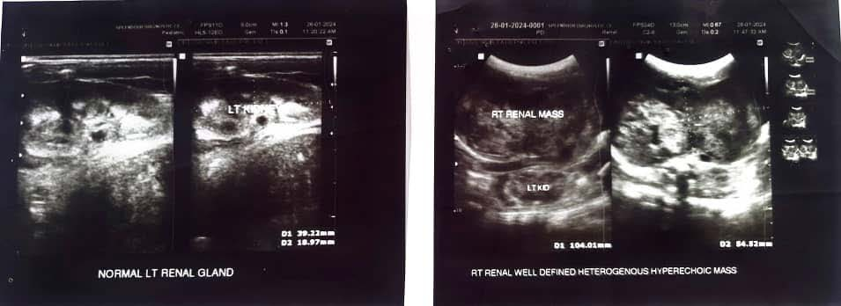

**Figure 1.** Ultrasound findings showing a normal left kidney vs a right well-defined heterogenous mass.

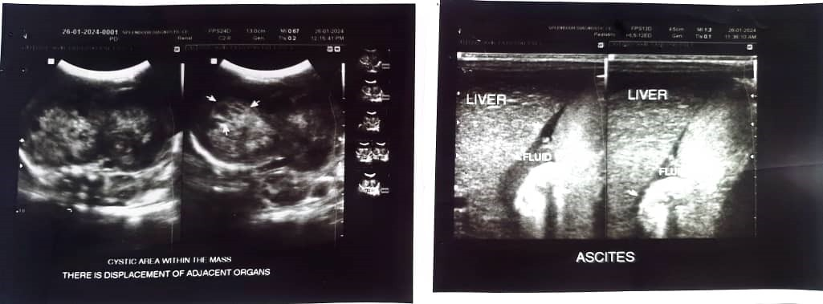

**Figure 2.** Ultrasound findings of cystic areas within the mass and displacement of adjacent structures.

## Surgery

A large lobulated right kidney was found intraoperatively. A tentative diagnosis of Congenital Mesoblastic Nephroma was made, considering Wilms’ tumour as a differential. The liver, pelvic organs, and contralateral kidney appeared grossly normal. She recovered from surgery without any complications, and her urine production was normal. The patient underwent a total right nephrectomy on the twelfth day of life.

## Pathology

### Gross Anatomy

The mass was sent for histologic analysis and was grossly described as soft to firm tissue with a multilobulated external surface. A 15 × 13 cm fleshy tumor with a grayish-white color was observable on the sliced surface. Numerous cysts were present within the partially solid remnant of renal tissue, the largest of which measured 1 cm by

0.7 cm and contained serous fluid. Areas of the solid surface were necrotic. No lymph nodes or perinephric fat were seen (**Figure 3**& **Figure 4**).

### Microscopy

Histology sections of the kidney show an unencapsulated cellular tumor consisting of spindle-shaped cells arranged as intermingling fascicles, with a few foci of collagen deposition. These cells exhibit a moderate amount of cytoplasm and plump vesicular to hyperchromatic nuclei that are mildly pleomorphic, with brisk mitosis noted.

A clear boundary exists between the tumor cells and the normal kidney tissue. The renal sinus is free of tumor cells.

A histological diagnosis of *CONGENITAL MESOBLASTIC NEPHROMA (CEL- LULAR TYPE) STAGE 1* was made (**Figure 5**& **Figure 6**).

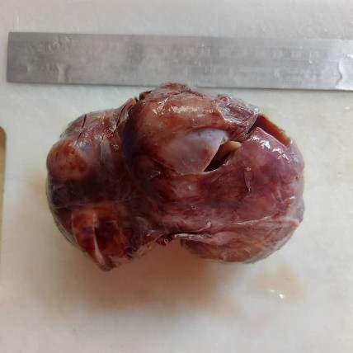

**Figure 3.** Gross picture of the right renal mass with an external greyish white to tan multi-lobulated surface.

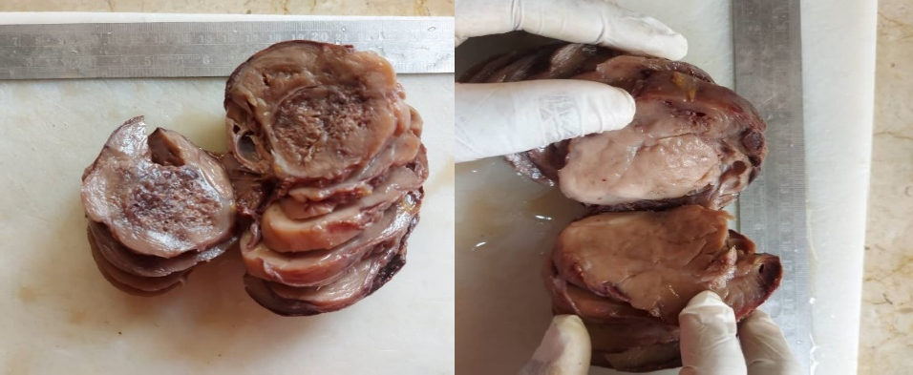

**Figure 4.** The cut surface of the kidney showing a greyish-white fleshy tumour and necrotic areas.

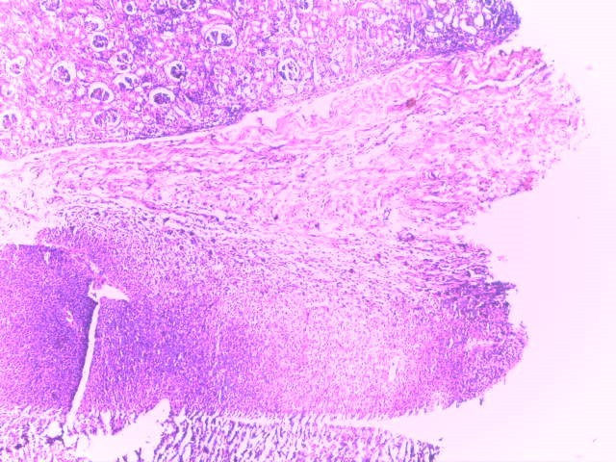

**Figure 5.** Section showing demarcation of tumour from normal-appearing renal parenchyma (×40).

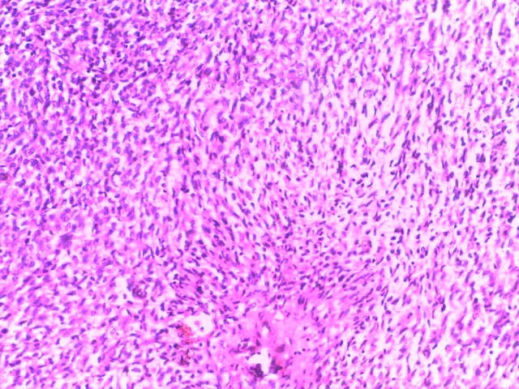

**Figure 6.** Section showing fascicles of spindle-shaped pro- liferation with collagen deposition (×200).

## Follow-Up

He has been, and is still, on multidisciplinary follow-up with the pediatric oncologists, pediatric nephrologists, and pediatric surgeons. He has no complaints, exhibits normal growth, and shows no problems with development. A repeat abdominal ultrasound scan three months after surgery reported normal findings with no signs of tumor recurrence. His last hospital visit at seven months of age indicated that he was stable, with no evidence of metastasis.

No other accompanying anomalies have been identified. Karyotyping and ge- netic studies were requested for possible aneuploidies which is seen in a lot of cases of CMN, however these are yet to be done due to logistic reasons.

# Discussion

Congenital Mesoblastic Nephroma (CMN) is a mesenchymal renal tumor of early life. With a median diagnosis age of two months and over 90% of cases occurring within the first year, it is the most prevalent non-Wilms’ renal tumor [[2].](%5Cl%20%22_bookmark7%22) Up to 90% of cases are identified by the time the child reaches one year, with the majority of diagnoses occurring in the first three to six months of life [[3]](%5Cl%20%22_bookmark8%22)[[4].](%5Cl%20%22_bookmark9%22) The right kidney-to-left kidney ratio is approximately 1:1, while the male-to-female ratio is about 1.5:1 [[5].](%5Cl%20%22_bookmark10%22) Three subtypes have been identified: mixed, cellular, and classic. As seen in our patient, the cellular type is more prevalent than the others. The cellular type (66%) resembles infantile fibrosarcoma, the classical type (24%) resembles infantile myofibromatosis, and the mixed type (10%), which is a combination of the two, resembles composite fibromatosis [[1].](%5Cl%20%22_bookmark6%22) A greater number of cases are expected to be detected before delivery as prenatal ultrasonography becomes more widely utilized [[6].](%5Cl%20%22_bookmark11%22)

Congenital mesoblastic nephroma, Wilms’ tumour, and considerably less common lesions such as a malignant rhabdoid tumour, clear cell sarcoma of the kidney (CCSK), and ossifying renal tumour of infancy are among the differential diagnoses for solid renal tumours [2]. While CMN is more common in younger infants,

Wilms’ tumour (WT) is the most common paediatric renal tumour and might be mistaken for cellular CMN at imaging. Neuroblastoma is another congenital tumour that may invade the kidney, typically the upper pole. It very seldom develops within the renal parenchyma. It can be identified by its propensity to enter the spinal canal, encase vessels, and cross the midline [7].

Making a differential diagnosis between WT and CMN is essential for creating the best possible treatment plan. An analysis of imaging features and clinical symptoms shows that WT is similar to CMN, particularly the cellular form; however, fewer than 2% of patients with WT present before the age of three months. Cancers with bilateral growth and congenital syndromes or abnormalities are more suggestive of WT. In-depth morphological data from electron microscopy can facilitate the necessary differential diagnosis.

Although CMN is often a benign tumor, there is a possibility of local recurrence and distant metastases, with the lungs being the primary site of metastasis. Other sites, including the liver, bone, or brain, have been reported in 5% to 10% of cases. Total radical nephrectomy is curative for most patients [3]. Wide surgical margins are necessary due to the infiltrating boundaries and the tendency to infiltrate the perinephric fat and hilum. Incomplete resection may lead to local recurrence. Chemotherapy and other multimodal therapies are therefore reserved for cancers that cannot be surgically removed or those with residual tumors [4].

Routine follow-up abdominal ultrasonography scans are advised. In our case, the tumor was completely resected following a radical nephrectomy. A repeat abdominal ultrasonography scan at three months of age revealed normal findings, with no evidence of metastasis; therefore, an excellent recovery is anticipated. He is currently being monitored by the hospital's oncology unit. Follow-up visits have occurred regularly at monthly intervals, and he is in stable condition at seven months of age.

# Conclusion

In infants, congenital mesoblastic nephroma (CMN) is the most prevalent type of renal tumor and is often benign. Since it can be identified early in pregnancy, it is advisable to promote fetal anomaly screening using ultrasound to prevent late presentation. While CMN is usually benign, patients must undergo routine monitoring for any possible paraneoplastic syndromes. Proper follow-up is necessary in the first few years of life, as certain forms of mesoblastic nephromas can potentially develop into malignancies.

# Consent

Informed written consent was obtained from the patient’s parents. This report, however, does not contain any personal information that could lead to the identification of the patient.

# References

1. Pachl M, Arul GS, Jester I, Bowen C, Hobin D, Morland B. Congenital mesoblastic nephroma: a single-centre series. Ann R Coll Surg Engl. 2020 Jan;102(1):67-70. doi: 10.1308/rcsann.2019.0111.
2. Puri A, Mishra K, Anand,R. Non-Wilms’ Renal Tumors. In: Sarin YK (ed) Wilms’ Tumor, Springer Nature, Singapore, 2022; pp 355-377.

<https://doi.org/10.1007/978-981-19-3428-5_39>

1. Wang ZP, Li K, Dong KR, Xiao XM, Zheng S. Congenital mesoblastic nephroma: Clinical analysis of eight cases and a review of the literature. Oncol Lett. 2014 Nov;8(5):2007-2011. doi: 10.3892/ol.2014.2489.
2. Gooskens SL, Houwing ME, Vujanic GM, Dome JS, Diertens T, Coulomb-l'Herminé A, Godzinski J, Pritchard-Jones K, Graf N, van den Heuvel-Eibrink MM. Congenital mesoblastic nephroma 50 years after its recognition: A narrative review. Pediatr Blood Cancer. 2017 Jul;64(7). doi: 10.1002/pbc.26437.
3. England RJ, Haider N, Vujanic GM, Kelsey A, Stiller CA, Pritchard-Jones K, Powis M. Mesoblastic nephroma: a report of the United Kingdom Children's Cancer and Leukaemia Group (CCLG). Pediatr Blood Cancer. 2011 May;56(5):744-8. doi: 10.1002/pbc.22871.
4. Do AY, Kim JS, Choi SJ, Oh SY, Roh CR, Kim JH. Prenatal diagnosis of congenital mesoblastic nephroma. Obstet Gynecol Sci. 2015 Sep;58(5):405-8. doi: 10.5468/ogs.2015.58.5.405.
5. Littooij AS, de Keizer B. Imaging in neuroblastoma. Pediatr Radiol. 2023 Apr;53(4):783-787. doi: 10.1007/s00247-022-05489-2.
6. Chaudry G, Perez-Atayde AR, Ngan BY, Gundogan M, Daneman A. Imaging of congenital mesoblastic nephroma with pathological correlation. Pediatr Radiol. 2009 Oct;39(10):1080-6. doi: 10.1007/s00247-009-1354-y.
7. Hutabarat, R. A., Ibrohim, I. S., Ali, M. I. A., & Elisha, J. (2024). A Case Report on Congenital Mesoblastic Nephroma. *Journal of Cancer and Tumor International*, *14*(4), 97–103.
8. ~~Gooskens, S. L., Houwing, M. E., Vujanic, G. M., Dome, J. S., Diertens, T., Coulomb‐l'Herminé, A., ... & van den Heuvel‐Eibrink, M. M. (2017). Congenital mesoblastic nephroma 50 years after its recognition: a narrative review.~~*~~Pediatric blood & cancer~~*~~,~~*~~64~~*~~(7), e26437.~~