

**Ka,e Measurement in X-ray Beams for Optimizing Diagnostic Reference Levels**



**ABSTRACT**

**Aims:** This experimental study aimed to quantify the entrance surface air kerma (Ka,e) of X-ray beams in radiographic examinations, comparing the obtained values with national and international Diagnostic Reference Levels (DRLs).

**Place and Duration of Study:** The research was conducted at the Department of Medical Physics and Radiology of the Franciscan University (UFN) between June 2023 and August 2024.

**Methodology:** The X-ray beam evaluation used a dosimetric set to measure the Air Kerma Rate (KAIR) and determine the X-ray tube output. A phantom without water and another filled with water were employed to calculate the backscatter factor (BSF) and estimate Ka,e for the main radiographic examinations.

**Results:** The results identified anatomical regions with the highest radiation exposure, reinforcing the need for optimization. It was observed that, although Ka,e values were within national limits, they exceeded the reference values of the United Kingdom and Japan in the skull, abdomen, and lumbar spine regions. This difference highlights the importance of periodically updating DRLs in accordance with international recommendations and technological advancements. Dose optimization requires continuous assessment of image quality, proper selection of technical parameters, and implementation of specific dose protocols. Ongoing training for radiology professionals is essential to ensure the correct application of imaging techniques and reduce patient exposure to ionizing radiation.

**Conclusion:** This study emphasizes the need for a multidisciplinary approach to dose optimization, combined with quality assurance programs and continuous professional training, ensuring greater patient safety and high-quality diagnostic imaging.

*Keywords: Radiation dose, Diagnostic Reference, Levels (DRLs), X-ray imaging, Dose optimization, Radiological safety.*

1. **INTRODUCTION**

The characterization of the X-ray beam (kVp, mAs, filtration, focus-skin distance), the patient's anthropometric characteristics (thickness, beam projection) and the anatomical region of interest allows an estimation of skin entrance dose (Ka,e) [1]. Currently, the comparison of values obtained with Diagnostic Reference Levels (DRLs) makes it possible to identify opportunities to reduce the dose of ionizing radiation, contributing to safe and efficient radiological practice [2].

DRLs are reference values established by the International Commission on Radiological Protection (ICRP) for the amount of radiation used in imaging examinations, such as radiography and computed tomography [1,2]. These indicators are recommended for identifying unusually high radiation doses in typical diagnostic radiology procedures [2]. However, exceeding a DRL does not necessarily imply that the exam is inadequate, nor does meeting a DRL guarantee that the practice is correct, as image quality (IQ) must also be considered [3].

These values serve as a benchmark to assess whether the radiation dose applied in an examination falls within an acceptable range, thereby contributing to the safety of both patients and healthcare professionals, as exposure to ionizing radiation, even at low doses, can pose health risks [2,3].

Other studies, such as those by Alvarez *et al.* [4] and Diop *et al.* [5], highlight that DRL values account for various factors, including beam geometry, the anatomical region of the patient, tissue thickness, and the contribution of scattered radiation. The optimization of radiation protection, therefore, requires radiology professionals to balance dose and image quality, considering both DRLs and diagnostic needs.

The application of the ALARA principle (As Low As Reasonably Achievable) is fundamental in this context, aiming to reduce the patient's radiation dose to the lowest possible level without compromising image quality.

To achieve this balance, it is necessary to adopt practices such as the appropriate selection of technical parameters, precise collimation, and dose reduction techniques, including filtration and image processing. In this regard, DRLs act as an essential tool for managing good radiological protection practices, provided they are properly understood and applied by radiology technicians and technologists [1-3].

Considering the principle of ALARA radiological protection, this study aims to characterize the X- ray beams used in radiographic examinations, focusing on the estimation of Ka,e. The results will be compared with Brazilian and international DRLs.

1. **MATERIALS AND METHODS**
   1. **Equipments**

In this study, an Intercal MAAF radiographic system was utilized, operating in a voltage range (kV) between 40 and 120 and a current range of 100-630 mA, coupled with a high-frequency generator. For the X-ray beam measurements, a dosimetry system from RADCAL, model 9015, calibrated in a reference laboratory, was employed.

* 1. **Methodology**

The research was structured to systematically evaluate the radiographic output, air KERMA (KAIR), backscatter factor (BSF), and entrance skin dose (Ka,e), as illustrated in Figure 1.

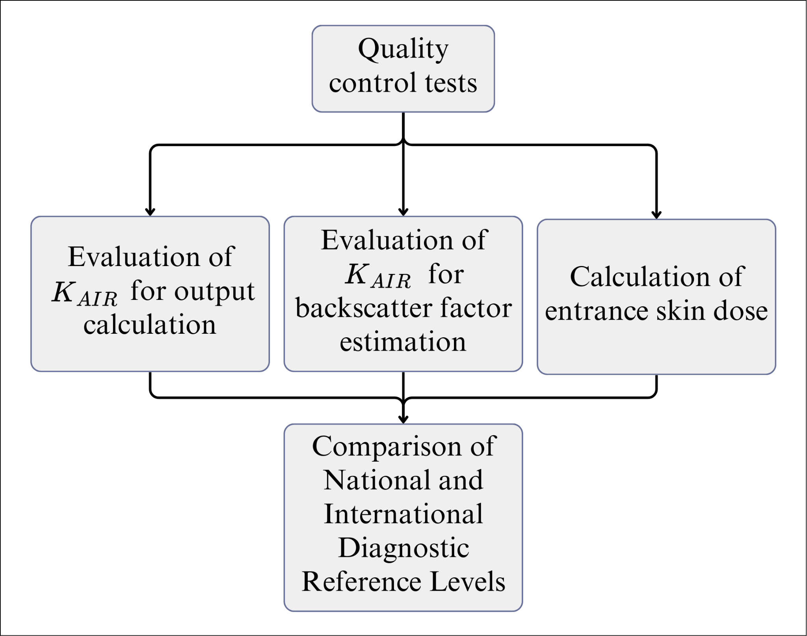

**Fig. 1. Representation of the methodology in the form of a flowchart**

* 1. **Quality Control of the Radiographic Equipment**

Before the start of the study, quality control (QC) procedures for the radiographic equipment were carried out according to current guidelines and regulations [6,7] to ensure accurate and reliable results. Performing these procedures helps identify any technical failures and/or deviations in the operating parameters of the radiographic equipment.

* 1. **Air KERMA Measurements**

Air KERMA was measured for nine different voltage values selected on the control panel of the radiographic unit. The radiation field size was standardized at 25 cm × 25 cm, and three measurements were recorded for each voltage setting while maintaining a constant tube current (mA) and exposure (mA.s)mAs. The selected electrical parameters used in the measurements are detailed in Table 1.

**Table 1. Selected electrical parameters for Air KERMA measurements**

|  |  |  |  |  |  |  |  |  |  |
| --- | --- | --- | --- | --- | --- | --- | --- | --- | --- |
| **Electrical Factors** |  |  | **Selected Electrical Parameters** | | | | |  |  |
| Voltage (kV) | 40 | 50 | 60 | 70 | 81 | 90 | 102 | 109 | 120 |
| Electric current (mA) | 200 |  |  |  |  |  |  |  |  |
| mA.s | 40 |  |  |  |  |  |  |  |  |

To obtain the measurements of KAIR, a dosimetry set and a phantom object (PO) consisting of a plastic box measuring 39 x 26.5 x 22.0 cm³ (length, width, and height, respectively) filled with water were used to simulate the patient on the table. A radiation field of 25 cm x 25 cm was opened, the distance between the tube focal point and the table was adjusted to 100 cm, and the Source-to-Image Distance (SID) used was 80 cm.

Fig.(Figure) 2 depicts the X-ray tube, typical beam geometry for obtaining the typical radiographic examination, and identification of the main parameters used for medical exposure measurements.

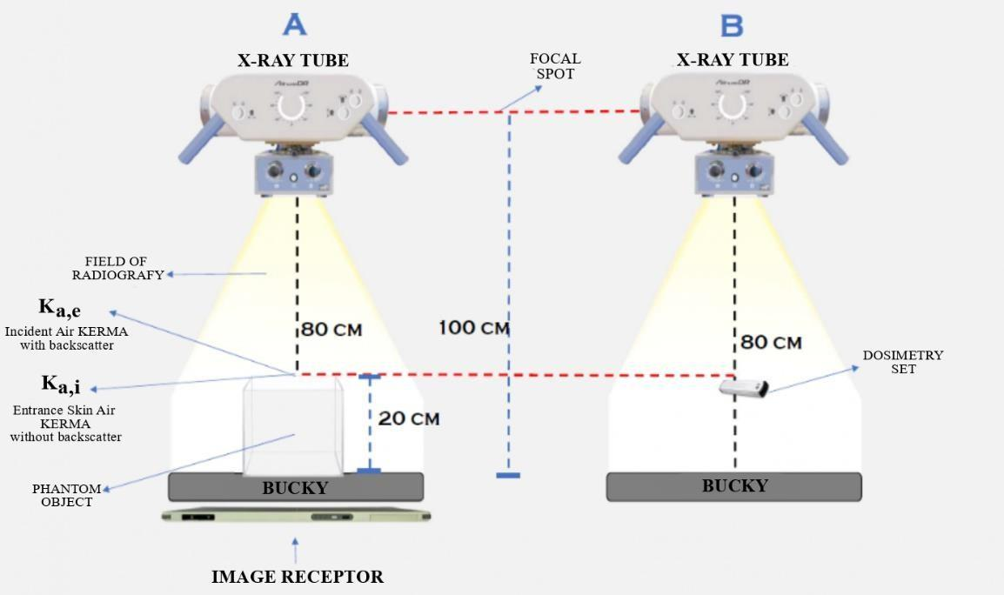

**Fig. 2. Illustration of the geometry adopted for measurements of KAIR, Ka,i, Ka,e, and backscatter (BSC)**

The output value was determined by the ratio between the average KAIR readings obtained for each kV and mA.s value used. Furthermore, potential differences between the nominal and actual values of kV and mA.s across the entire operating range of the radiographic equipment were also checked, according to Equation 1.

$Output=\frac{K_{AIR}}{mA.s}$ (1)

During the radiographic examination, the X-ray beam consists partly of primary radiation, which penetrates a specific region of the patient and registers information of the internal anatomy of interest on the detector due to transmitted radiation. Additionally, it includes scattered radiation (backscatter), which contributes to the overall radiation dose received by the patient [8].

* 1. **Measurements of the Backscatter Factor**

To quantify the backscatter factor, the radiation detector was positioned as illustrated in Figure 2, ensuring accurate alignment. Measurements of KAIR were performed under two conditions:

1. **Without phantom water fill:** With the dome positioned over the table at 80 cm. Three readings were taken for each kV setting, totaling 27 measurements (Fig. 2(A)).
2. **With phantom water fill:** A plastic box was filled with water to a thickness of 20 cm during the measurement. Again, three readings of KAIR were taken for each voltage value, totaling an additional 27 readings with the addition of water (Fig. 2(B)).

Due to the relevance of BSF in calculating Ka,e, it was decided to calculate the ratio between the average of KAIR readings obtained with the dosimetry set with and without water, according to Equation 2:

$BSF=\frac{K_{{AIR}_{water}}}{K_{{AIR}_{air}}}×\frac{{\left[\frac{μtr}{ρ}\right]}_{water}}{{\left[\frac{μtr}{ρ}\right]}_{air}}$ (2)

where $K_{{AIR}_{water}}$ represents the reading on the surface of the phantom filled with water, $K_{{AIR}_{air}}$ the reading at the same position without water, and ${\left[\frac{μtr}{ρ}\right]}_{water}$ refers to the mass energy transfer coefficient in water and air.

* 1. **Evaluation of Entrance Skin Dose**

The evaluation of Ka,e is critical in quality control procedures, ensuring compliance with DRLs, ensuring that radiation doses used in diagnostic procedures are appropriate while minimizing adverse health effects. Furthermore, these evaluations are of utmost importance to enhance the quality and safety of radiological procedures, identifying opportunities to reduce radiation dose without compromising IQ or diagnostic information obtained [9].

According to ICRP Publication 135 of 2017 [1], the radiation metric used as a measure of DRLs should be easily measurable or available, such as Ka,e in diagnostic radiology. In this study, Ka,e was calculated through the assessment of output, determined in units of mGy/mA.s, at a FSD of 80 cm. According to Metaxas et al. [10], with this value, it should be corrected for the desired FSD using the inverse square law equation (Equation 3):

$K_{a,e}(mGy) =Output \left(\frac{mGy}{mA.s}\right) × {\left(\frac{80}{FSF}\right)}^{2} × (mA.s) × BSF$ (3)

where Output (mGy/mA.s) is the average of the KAIR values obtained from the X-ray equipment, which increases with the square of the approach distance (FDD/FSD)², where FSD is represented by FDD minus the patient's thickness (in the region being radiographed) and depends on the protocol of each examination. Finally, due to the proportionality between tube output and mA.s, the last step to estimate Ka,e is to multiply the X- ray tube output by the selected mA.s value on the control panel of the respective exposure technique and by the BSF.

* 1. **Selection Criteria**

To compare the obtained Ka,e values with the DRLs, the percentage deviation (D%) was calculated using Equation 4.

$D(\%)= \left[\left(\frac{measured value of K_{a,e}}{reference value of DRL}\right)-1\right]×100$ (4)

This comparison allows for assessing whether the measured radiation doses align with established reference levels, facilitating dose optimization in clinical practice.

1. **RESULTS AND DISCUSSION**

Periodic assessment of the X-ray beam during Quality Control tests, conducted by Medical Physics professionals, possibly with the inclusion of other radiology professionals, can improve the safety of both patients and professionals, ensuring a more effective approach to radiological protection practices.

In Table 2, the types of tests applied for the evaluation of the radiographic equipment, along with the respective measured values and achieved results, are listed.

It can be observed in Table 2 that the constancy values of the radiographic equipment showed an error of less than 7% in the worst case, which is below the 10% accepted as the limit by legislation, ensuring good reproducibility of the equipment. The minimum limit for the half-value layer (HVL) at 80 kV is 2.9 mmAl, and since 3.19 mmAl was found, the results were considered acceptable in accordance with the current legislation [6,7].

**Table 2. Summary of Quality Control test results for the digital image radiographic equipment [6,7]**

|  |  |  |  |
| --- | --- | --- | --- |
| **TEST** | **Reproducibility** |  |  |
|  | **Exposure** | **Time** | **kVp** |
| Obtained values | 4.20% | 1.72% | 3.90% |
| Tolerance | ≤10% | ≤10% | ≤5% |
| Result | Conform | Conform | Conform |
| **Test** | **Accuracy** |  | **HVL (mmAl)** |
| Obtained values | -6.48% | -5.02% | 3.19 |
| Tolerance | ≤10% | ≤10% | 2.9 |
| Result | Conform | Conform | Conform |
| **Test** | **Output** |  |  |
|  | **Linearity** |  | **µGy/mA.s** |
| Obtained values | 5.68% |  | 48.77 |
| Tolerance | ≤20% |  | - |
| Result | Conform |  | Conform |

Table 3 lists the selected values of voltage and the product of current by time (kV and mA.s) with the measured average values of KERMA in air and water, as well as the average calculated values of standard deviation (SD), output value (mGy/mA.s) and Backscatter Factor.

As expected, it can be observed in Table 3 that the contribution of scattered radiation increases as the voltage (kV) increases, meaning that the increase in the primary beam energy results in an increased probability of scattered radiation occurrence [11]. This happens because, with higher energy, the radiation is less likely to be attenuated within the patient's body and more likely to escape, resulting in greater lateral scattering, backscattering, and forward scattering [12].

**Table 3. Summary of Quality Control test results for the digital image radiographic equipment [6,7]**

|  |  |  |  |  |  |  |  |
| --- | --- | --- | --- | --- | --- | --- | --- |
| **Selected Values** | |  | **Measured Values** | |  | **Calculated Values** | |
| **Current.time** | **Voltage** | **Readings in air** | | **Readings in water** | | **Output** | **BSF** |
| **(mA.s)** | **(kV)** | **Average**  **(mGy)** | **SD** | **Average**  **(mGy)** | **SD** | **(mGy/mA.s)** | **Air/ Water** |
| 40 | 40 | 1.62 | 0.31% | 1.75 | 0.06% | 0.040 | 1.08 |
| 50 | 2.93 | 0.06% | 3.25 | 1.36% | 0.073 | 1.11 |
| 60 | 4.37 | 0.57% | 4.93 | 0.60% | 0.109 | 1.13 |
| 70 | 5.93 | 0.49% | 6.77 | 0.61% | 0.148 | 1.14 |
| 81 | 7.61 | 0.83% | 8.82 | 0.59% | 0.190 | 1.16 |
| 90 | 8.95 | 0.87% | 10.46 | 0.58% | 0.224 | 1.17 |
| 102 | 10.88 | 4.04% | 12.93 | 2.65% | 0.272 | 1.19 |
| 109 | 12.10 | 3.06% | 14.33 | 1.73% | 0.302 | 1.18 |
| 120 | 13.85 | 3.61% | 16.46 | 4.62% | 0.346 | 1.19 |

According to Diop *et al.* [5], after obtaining the KAIR values for each kV and a fixed mA.s value in the spreadsheet, the output curve (output value) for the X-ray tube can be obtained. Other studies by Tompe & Sargar [13] highlighted that the intensity of the X-ray beam produced in a radiographic tube can be affected by the applied voltage due to two main factors: the number of electrons released and the energy of the photons.

It can be observed in the graph of Figure 3 that the radiographic tube’s output (mGy/mA.s) exhibits a linear increasing trend as a function of kV. This behavior is expected, as the increase in the applied voltage results in higher-energy photons, which in turn increases radiation production. Using the obtained values of output (mGy/mA.s) and BSF in this study, the Ka,e values for a standard individual were calculated based on Equation 3. The backscatter factor (BSF) also shows a gradual variation across the voltage range studied, with values ranging from 1.08 to 1.19. This change is natural, as the BSF depends on the average photon energy and the characteristics of the irradiated medium. The relevant parameters, including anatomical region, projection, and thickness, were determined according to the guidelines outlined in ANVISA (from portuguese *Agência Nacional de Vigilância Sanitária*)'s technical manual for radiodiagnosis [14].

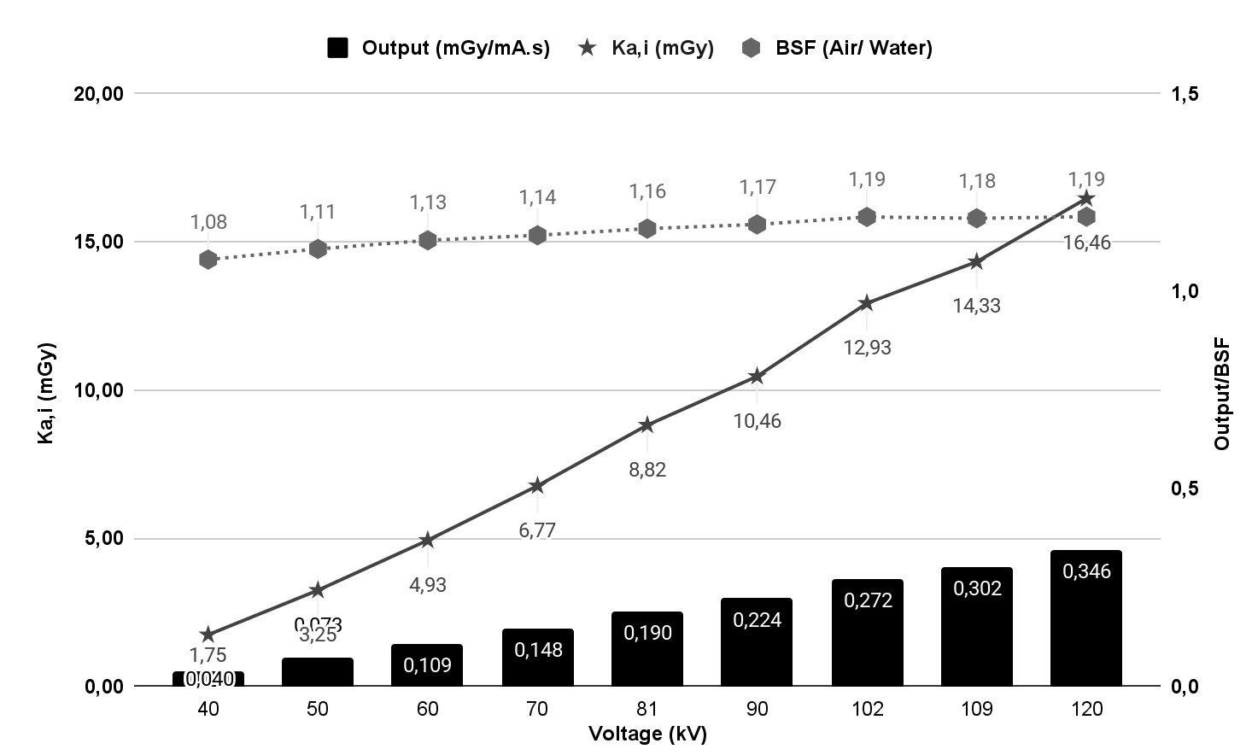

**Fig. 3. Output Values (mGy/mA.s) as a Function of the Voltage Selected on the X-ray Equipment Control Panel**

If scattered radiation is detected by the image receptor, it affects the image and can be a significant cause of its degradation. Scattered radiation creates a grayscale in the image in areas that do not correspond to the anatomical projection, and this can significantly reduce the contrast in the radiograph [12].

Table 4 presents a comparison between the estimated Ka,e values obtained in this study and the Reference Levels established by RDC 330/52 for different radiographic exams in various projections and body regions.

**Table 4. Comparison of the Ka,e estimate with the reference levels established by RDC 330/52 [6,7]**

|  |  |  |  |  |  |  |  |
| --- | --- | --- | --- | --- | --- | --- | --- |
| **RADIOGRAPHIC EXAMINATION** | | | **TECHNIQUE** | | **DOSIMETRY** | |  |
| **Region** | **Incidence** | **Thickness[a] (cm)** | **kV** | **mA.s** | **Ka,e[b] (mGy)** | **DRLs[c] (mGy)** | **D%** |
| Skull | AP | 19 | 81 | 20 | 4.30 | 5 | -14.00% |
| LAT | 15 | 70 | 20 | 2.99 | 3 | -0.33% |
| Chest | PA | 23 | 102 | 2 | 0.17 | 0.4 | -57.50% |
| LAT | 32 | 120 | 5 | 0.60 | 1.4 | -57.14% |
| Abdomen | AP | 23 | 81 | 20 | 4.76 | 10 | -52.40% |
| Pelvis | AP | 23 | 81 | 20 | 4.76 | 10 | -52.40% |
| Lumbar Spine | AP | 23 | 81 | 25 | 5.95 | 10 | -40.50% |
| LAT | 30 | 102 | 50 | 21.14 | 30 | -29.53% |
| LJ | 20 | 70 | 40 | 15.78 | 40 | -60.55% |

*[a]Radiographic thicknesses, considering a typical adult patient (weight from 60 kg to 75 kg and height from 1.60 m to 1.75 m); [b]Ka,e is considered the best indicator of deterministic effects, such as the death of a large number of cells, which can lead to tissue collapse, causing it to cease its functions in the organism; [c]Reference levels for radiographic diagnostic imaging, in terms of Entrance Surface Dose, for a typical adult patient.*

When comparing the Ka,e values obtained in this study with the DRLs established by RDC 330/52, we can observe a significant variation in many cases. For example, for the anteroposterior (AP) skull radiographic exam, the estimated Ka,e value is 4.30 mGy, while the DRL established by RDC 330/52 is 5 mGy. This results in a discrepancy of -14.00% compared to the DRL.

These differences highlight the importance of monitoring and optimizing radiation doses used in radiographic procedures to ensure they comply with standards set by regulatory authorities. When Ka,e values exceed DRLs, it may indicate excessive patient exposure to radiation, increasing the risk of adverse health effects.

In the case of the lateral (LAT) projection of the skull, the Ka,e estimate resulted in a percentage deviation of -14%, indicating an underestimation compared to the established DRL. However, in other projections, such as the posteroanterior (PA) chest and lateral lumbar spine, there are significantly higher percentage deviations, indicating a substantial reduction in Ka,e values compared to the established DRLs.

Suliman's studies [15] conducted a retrospective analysis through image analysis and found that the average Ka,e (mGy) values for radiographic exams of PA chest, LAT chest, AP abdomen, AP pelvis, AP lumbar spine, and LAT lumbar spine were 0.13, 0.27, 0.70, 1.06, 2.33, and 4.18 mGy,

respectively. Our study's results are consistent with chest findings; however, for the abdomen, pelvis, and lumbar spine regions, the values were higher.

Additionally, comparing the obtained doses with the DRLs emphasizes the importance of periodically reviewing and updating DRLs to ensure they align with current clinical practices and evolving imaging technologies. If doses consistently exceed recommended values,(how did it exceed recommended values the are below the values, only skull AP and LAT that are very close to the recommended values) it may indicate a need to review radiological practices. This will help ensure patient safety and the quality of radiographic procedures, contributing to more effective and safer clinical practice.

However, assessing the quality of radiographic images and their suitability for the clinical objective is a complex process that requires the expertise of a radiologist and, therefore, goes beyond the scope of this study.

Table 5 presents a comparative analysis between the Ka,e (mGy) values obtained in this Brazilian study and the internationally recognized Diagnostic Reference Levels (DRLs). The comparison covers the most frequent anatomical regions in clinical practice, considering different radiographic projections common between countries.

**Table 5. Comparison of the Ka,e estimate with international reference levels**

|  |  |  |  |  |  |  |  |
| --- | --- | --- | --- | --- | --- | --- | --- |
| **Ka,e (mGy) versus DRL (mGy)** | | | | | | | |
| **Region (Incidence)** | **Our study** | **France[a]** | **United Kingdom[b]** | **Germany[c]** | **Sweden[d]** | **Italy[e]** | **Japan[f]** |
| Skull (AP) | 4.30 | - | - | - | - | - | 3 |
| Skull (LAT) | 2.99 | - | - | - | - | - | 2 |
| Chest (PA) | 0.17 | 0.3 | 0.15 | 0.3 | 0.3 | 0.4 | 0.3 |
| Chest (LAT) | 0.60 | - | - | - | - | - | - |
| Abdomen (AP) | 4.76 | 5 | 2 | 5 | 5 | 5 | 3 |
| Pelvis (AP) | 4.76 | - | - | - | - | - | 3 |
| Lumbar (AP) | 5.95 | 10 | 5 | 10 | 10 | 10 | 4 |
| Lumbar (LAT) | 21.14 | 30 | 11 | 30 | 30 | 30 | 11 |
| Lumbar (LJ) | 15.78 | - | - | - | - | - | - |

*[a]Talbot; Rehel (2004), [b]Wall (2005), [c]Diop (2022), [d]Hart; Hillier; Wall (2009), [e]Compagnone; Pagan;*

*Bergamini, (2005), [f]Yonekura (2015, p.12) [5,16-20].*

The analysis of the results presented in Table 5, which relates the average Ka,e values obtained in this study with international DRLs, shows variations compared to the DRLs adopted in other countries. For example, for the AP projection skull radiographic exam, the estimated Ka,e value was 4.30 mGy, whereas in some countries like Japan, the corresponding DRL is 3.0 mGy. This indicates a discrepancy of approximately 30% compared to the Japanese standard. Similarly, for other body regions and different radiographic projections, such as the chest, abdomen, and lumbar spine, the Ka,e values estimated in this study show variations relative to the DRLs adopted in different countries. For example, for the chest in the PA projection, the estimated Ka,e value is

0.17 mGy, while in some countries like the United Kingdom, the corresponding DRL is 0.3 mGy.

These differences highlight the importance of evaluating and comparing locally obtained Ka,e values with international reference standards. This allows the identification of areas where radiation doses may be above or below acceptable limits, enabling the implementation of corrective measures to ensure safe and effective radiological practice.

1. **CONCLUSION**

The results obtained demonstrate the need for adjustments in imaging acquisition protocols, as the Ka,e values found in this study, although within the limits established by national DRLs, exceed the reference values of countries such as the United Kingdom and Japan in the areas of the skull, abdomen, and lumbar spine. The methodology adopted in this study can contribute to the ongoing education of radiology professionals, promoting the correct application of imaging techniques and reducing patient exposure to ionizing radiation. Furthermore, this study emphasizes the importance of evaluating radiation dose in diagnostic imaging and the need for a multidisciplinary approach to dose optimization and radiological safety.

**DISCLAIMER (ARTIFICIAL INTELLIGENCE)**

Author(s) hereby declare that NO generative AI technologies such as Large Language Models (ChatGPT, COPILOT, etc.) and text-to-image generators have been used during the writing or editing of this manuscript.

**REFERENCES**

1. Vañó E, Miller DL, Martin CJ, Rehani MM, Kang K, Rosenstein M, Ortiz- López P, Mattsson S, Padovani R, Rogers A. ICRP publication 135: diagnostic reference levels in medical imaging. Annals of the ICRP. 2017;46(1):1- 144.
2. Bonifaz AP, Rodriguez CSC, Esparza RP. Diagnostic reference levels for common X- ray procedures in Peru. Cureus. 2021;13(10).
3. Seeram E, Davidson R, Bushong S, Swan H. Radiation dose optimization research: Exposure technique approaches in CR imaging–A literature review. Radiography. 2013;19(4):331-338.
4. Alvarez M, Milani AL, Souza SP, Marques TGS, Silva MAA, Guassu RAC, Bucci J, Matsuki GB, Pina DR de, Alves AFF. Effective Dose and Dose Reference Level (DRL) in radiology at a tertiary hospital. Brazilian Journal of Medical Physics. 2022; 16: 678-678. Portuguese.
5. Diop AY, Diagne M, Faye NAB, Dieng MM. Establishment of local diagnostic reference levels in conventional radiography: A pilot study in Dakar, Senegal. World Journal of Nuclear Science and Technology. 2022;12(1):28-42.
6. Anvisa - National Health Surveillance Agency (Brazil). Collegiate Board Resolution No. 330, of December 20, 2019, Official Gazette of the Union, Edition: 249, Section: 1, Page: 92,

Published on: December 26, 2019. Portuguese.

1. Anvisa - National Health Surveillance Agency (Brazil). Normative Instruction - in No. 90, of May 27, 2021, Official Gazette of the Union, Edition: 101, Section: 1, Page: 149, Published on: May 31, 2021. Portuguese.
2. Abela N, Couto JG, Zarb F, Mizzi D. Evaluating the use of anti-scatter grids in adult knee radiography. Radiography. 2022; 28(3): 663-667.
3. Abbeyquaye D, Inkoom S, Hammond NB, Fletcher JJ, Botwe BO. Patient dose assessment and optimisation of pelvic radiography with computed radiography systems. Radiation protection dosimetry. 2021;195(1):41-49.
4. Metaxas VI, Messaris GA, Lekatou AN, Petsas TG, Panayiotakis GS. Patient doses in common diagnostic X-ray examinations. Radiation protection dosimetry. 2019;184(1):12-27.
5. Xavier AM. Principles of Radiological Safety and Protection, 3rd Edition. Revised and Expanded, Federal University of Rio Grande do Sul and National Nuclear Energy Commission, 2014. Portuguese.
6. Dance DR, Christofides S, Maidment ADA, McLean ID, Ng KH Diagnostic radiology physics: A handbook for teachers and students. Endorsed by: American association of physicists in medicine, Asia oceania federation of organizations for medical physics, European federation of organizations for medical physics; 2014.
7. Tompe A, Sargar K. X-ray image quality assurance; 2020.
8. Brazil. Ministry of Health. National Health Surveillance Agency. Medical Radiodiagnosis: Equipment performance and safety, Brasília: Ministry of Health, (Series A. Standards and Technical Manuals). Portuguese. 2005;104 .
9. Suliman II. Estimates of patient radiation doses in digital radiography using DICOM information at a large teaching hospital in Oman. Journal of digital imaging. 2020;33(1):64-70.
10. Talbot A. Analysis of data relating to the updating of diagnostic reference levels in radiology and nuclear medicine. Assessment. 2004;2006:2008-02. French.
11. Wall BF. Implementation of DRLs in the UK. Radiation Protection Dosimetry. 2005;114(1-3):183-187.
12. Hart D, Hillier MC, Wall BF. National reference doses for common radiographic, fluoroscopic and dental X-ray examinations in the UK. The British journal of radiology. 2009;82(973):1-12.
13. Compagnone G, Pagan L, Bergamini C. Local diagnostic reference levels in standard X-ray examinations. Radiation Protection Dosimetry. 2005;113(1):54-63.
14. Yonekura Y. Diagnostic reference levels based on latest surveys in Japan. Japan DRLs Report; 2015.