Temporal and Spatial Dynamics of Vaccine-Derived Poliovirus (VDPV) in Democratic Republic of Congo

from 2018 to 2023

# Abstract

**Background:** The Democratic Republic of Congo (DRC) has been facing outbreaks of VDPV since 2017. These wild poliovirus variants are responsible for poliomyelitis, which is in the process of being eradicated globally. In the following lines, we try to show the evolution of VDPV cases across the country in order to understand their chronological dynamics and seasonal influence. **Methods:** We conducted a cross-sectional study of VDPV notified in the DRC from 2018 to 2023. Maps of the spatial dynamics of VDPV cases were produced from attack rates with QGIS® (3.22.8). As for temporal dynamics, time series were decomposed and presented in the form of graphs showing the chrono- logical evolution of VDPV cases and their seasonal trend, using R.4.0 soft- ware package. **Results:** A total of 1196 Cases of VDPV types 1, 2 and 3 were recorded in the biological confirmation databases of the INRB and the Ex- panded Program of Immunization during the study period across25 provinc- es. The eastern part of the country reporting the most cases. The general trend is upwards, with a peak in 2022 of 527 cases, whereas in 2021 there was a notable drop of 31 cases. Analysis of the temporal breakdown suggests a seasonal pattern, with peaks between the months of September and Decem- ber, considered being rainy periods in some provinces. **Conclusion:** During the 6 years of our study (2018 - 2023) almost all the Health Zones were hit by

VDPV epidemics. The eastern part was the most impacted. The seasonal component is well marked suggesting a rise in detection in the rainy season and during pivotal periods of climate change.

# Keywords

Temporal, Spatial, Dynamic, Poliovirus, Vaccine

# Background

Vaccine-derived polioviruses (VDPVs) are rare forms of poliovirus that have evolved genetically from the attenuated virus present in oral polio vaccine (OPV). This process occurs during widespread human-to-human transmission in populations with low immunity, or after prolonged replication in the intes- tines of immunodeficient individuals following vaccination [1].

Poliomyelitis is a highly contagious infectious disease caused by a virus that invades the nervous system and can lead to paralysis and, later, to serious and irreversible after-effects [1]. It is caused by an enterovirus belonging to the Pi- cornaviridae, the wild poliovirus (PVS) with three serotypes, type 1, 2 and 3. Po- liovirus is a single-stranded RNA virus. Each serotype is capable of inducing the disease. The virus persists in the faeces for several weeks. Poliomyelitis is a dis- ease of countries with poor fecal hygiene: the endemic is permanent, with a sea- sonal upsurge in summer and autumn. It mainly affects young children aged between 3 months and 5 years (so-called infantile paralysis [2]. Transmission is essentially feco-oral (via water or food contaminated with excrement), or spreads directly via aerosols or saliva. As there is no curative treatment, physical medicine and rehabilitative surgery are the measures currently recommended. The incubation period is 7 to 10 days (extremes: 4 - 35 days). The fatality rate is 5% - 10% in adolescent and adults, particularly in cases of bulbar involvement.

Indeed, this Region was certified free of wild poliovirus on August 25, 2020, following the combined efforts of all countries in the region through the Global Polio Eradication Initiative (GPEI). However, some countries in the region, in- cluding the Democratic Republic of Congo (DRC), are facing resurgent epidem- ics of circulating type 2 variant polioviruses. The DRC has been experiencing concomitant circulation of type 2 variant polioviruses since May 2017 and type 1 since September 2022. The last case of wild poliovirus had been reported since 2011 in the Lusangi HZ, Maniema Province, which is why the country was certi- fied “wild polio free” in 2015 [3].

The risk of VDPV emergence in the Democratic Republic of Congo (DRC) will remain unless the population’s immunity to poliovirus is increased and maintained [4] [5].

Based on actual and projected costs, as well as the frequency of polio cases from 1988 to 2035, one study shows that low-income countries would realize almost 85% of the savings. A recent study affirms that the Global Polio Eradication Initiative

not only prevents the paralysis and death of many children, but also saves substan- tial resources for developing countries through reduced costs of polio treatment and prevention of disability-related productivity losses, not to mention the signifi- cant benefits that continue to accrue in countries that have eradicated polio. In 2006, for example, estimates indicate that the United States saved over $180 billion thanks to its investment in immunization [6]. It is estimated that 10 to 20 million children and adults worldwide suffer from paralysis because of polio [7].

### Emergence of Vaccine-Derived Polioviruses

Updated polio statistics show an increasing trend in the number of vac- cine-derived poliovirus cases in stool samples (AFP) and environmental samples (ENV), both type 1, 2 and type 3, with the exception of Afghanistan and Paki- stan, which have detected wild cases [8].

The countries that have reported at least one case in the last 2 years are as follows: Americas region: we have Canada and the USA.

European region: Israel, Ukraine, United Kingdom. Southeast Asia region: Indonesia.

Eastern Mediterranean region: Djibouti, Egypt, Somalia, Sudan, Yemen. Africa region: Algeria, Benin, Botswana, Burkina Faso, Burundi, Cameroon,

Central African Republic, Ivory Coast, Congo, DRC, Ghana, Kenya, Madagascar, Malawi, Mali, Mozambique, Niger Nigeria, Tanzania, Togo, Zambia and Zim- babwe [9].

In the Democratic Republic of Congo, this cVDPV2 epidemic began on May 08, 2017 and continues to this day including several patients with acute flaccid paralysis (AFP) and other cVDPV2 isolated from environmental samples (ENV). In 2023, 46 cVDPV2 cases were detected in environmental surveillance sam- ples in the provinces of Kinshasa (41 cases), Haut Katanga (3 cases), Équateur (1

case) and Lualaba (1 case).

The country recorded 24 separate epidemics of cVDPV2 and transmissions linked to emergences from neighboring countries notified in 185 SLAs distrib- uted across 25 provinces, of which 14 are closed and 10 still active.

The year 2023 was marked by the appearance of a case of cVDPV3 in Tshopo province (Lowa HZ). Five other unclassified type 2 cases were recorded in Équateur (Basankusu HZ), Tshuapa (Befale and Mompono HZs), Lualaba (Fungurume HZ) and Haut-Lomami (Kayamba HZ).

Concurrent circulation of variant polioviruses (types 1 and 2) in 2023 has been observed in 5 provinces (Tanganyika, Haut-Lomami, Haut-Katanga, Kasaï Oriental and Lualaba).

The risk analysis around these VDPVs confirms the persistent circulation of cVDPV2, the current epicenters of which are the provinces of Haut Katanga, Haut Lomami, Tanganyika, Sud Kivu and Bas Uélé [8].

# Methods

## Description of the Study Area

Located in Central Africa, straddling the Equator between 5˚20’N and 13˚27’S

latitude on one side, and between 12˚ and 13˚ E longitude on the other, the DRC covers an area of around 2345.409 Km2.

With an estimated population of 127,177,145 in 2023, and shares 9000 km2 of borders with nine other neighboring countries (Republic of Congo Cabinda Enclave to the west, Central African Republic and South Sudan to the north, Uganda, Rwanda, Burundi and Tanzania to the east, Zambia and Angola to the south, and 37 km with the Atlantic coast to the west). The country is divided into 26 provinces, with Kinshasa as the capital. The DRC has a steep altitudinal gradient, from sea level to the summit of the Ruwenzori at over 5000 m. The vast majority of the country (over 85%) lies between 300 and 1000 m above sea level.

On the eastern and southern edges are high plateaus dotted with inselbergs (2000 m in the southern part of the Katanga plateau), massifs with flattened peaks (Monts Mitumba in particular), and sinkholes (Lac Upemba). The latter, generally occupied by lakes (Tanganyika, Kivu, Edouard and Albert), and are dominated by glacier-covered granite moles (Ruwenzori, 5119 m) and the vol- canic formations of the western rift bulge (Virunga chain). To the west, the Ba- téké plateau and ranges of hills parallel to the Atlantic coast border the central basin (**Figure 1**).

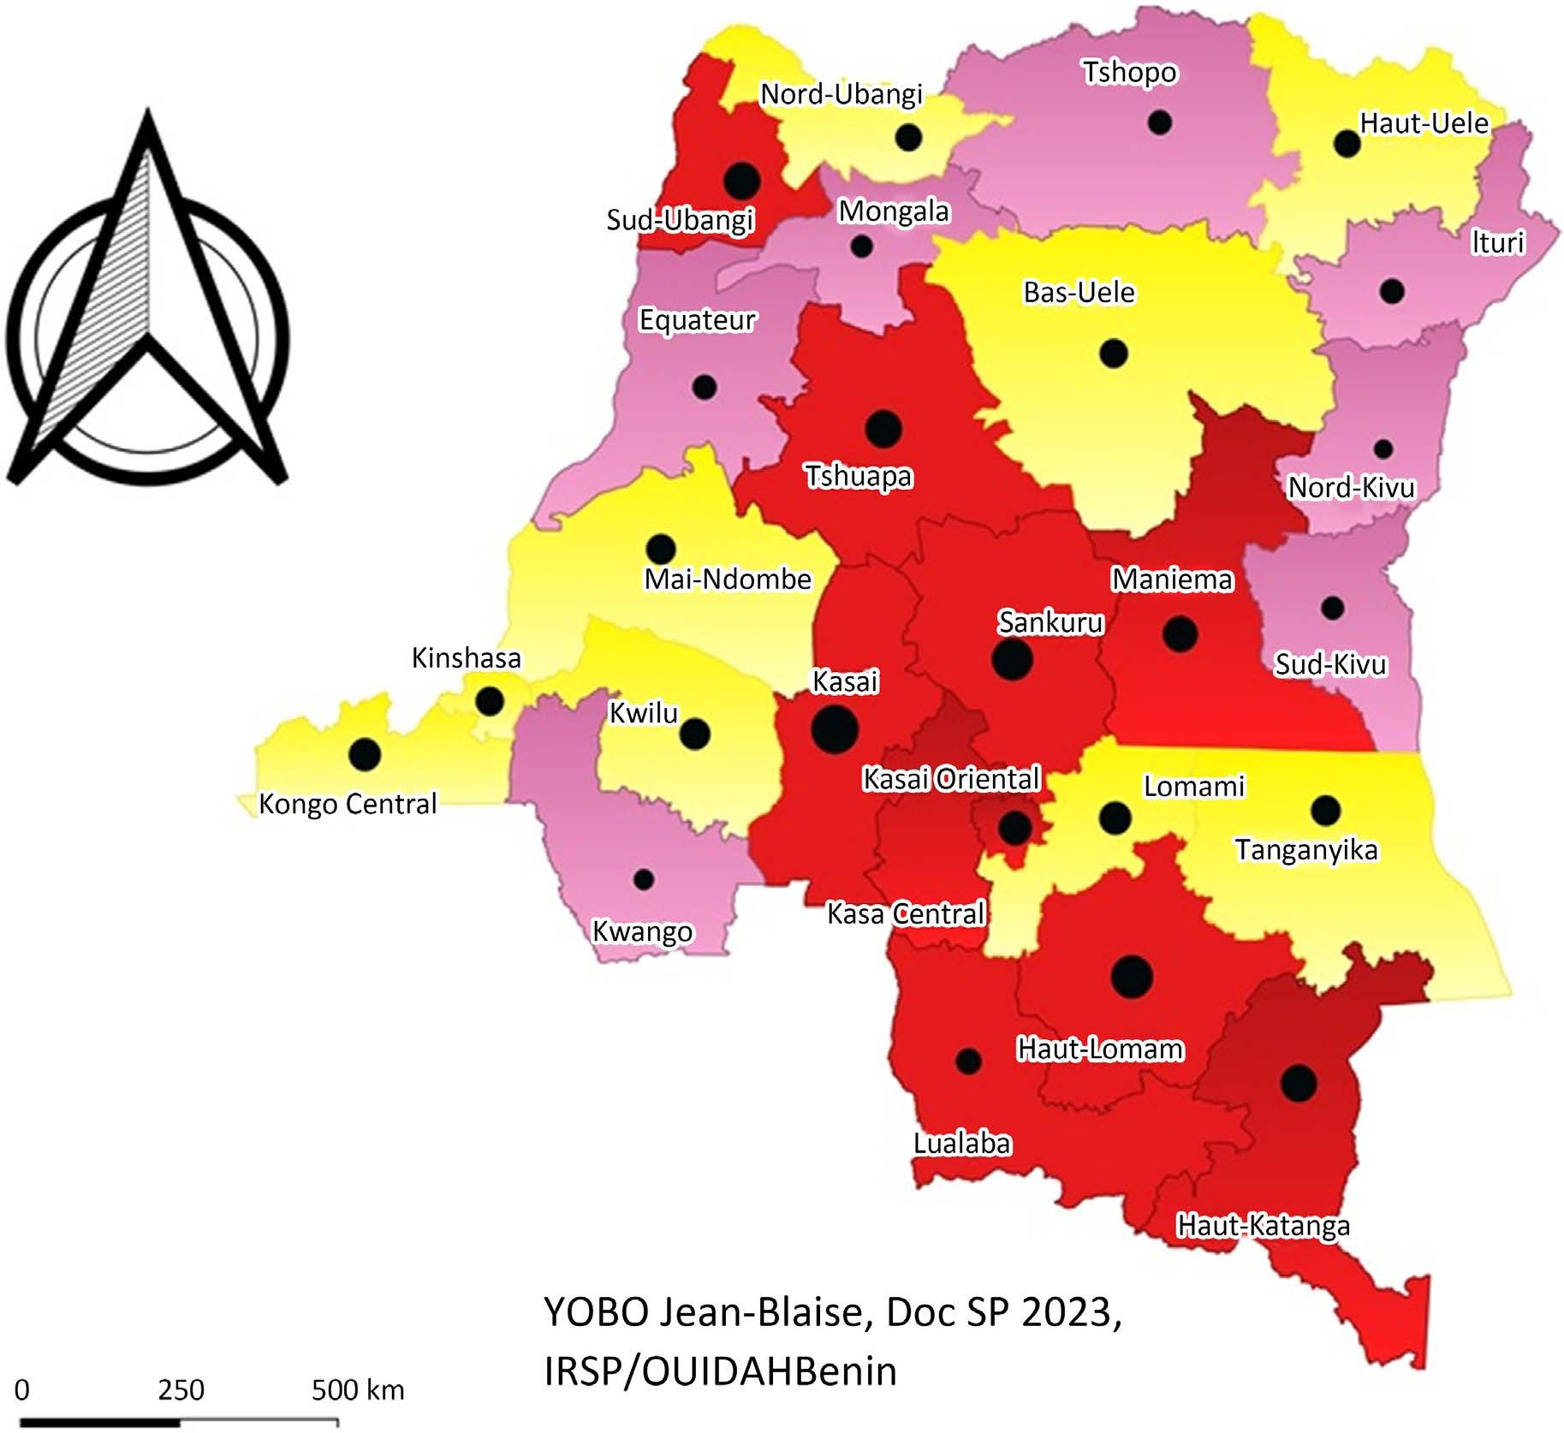

**Figure 1.** Map of democratic republic of congo.

### Climate Overview

The DRC has a full range of climates typical of the humid tropical zone.

Equatorial climate in the center (rainy season of 8 to 10 months) found in the typically equatorial Cuvette, with rainfall of around 2000 mm per year, no real dry season, constantly high atmospheric humidity (70 to 85%), and temperatures barely varying around an average of 25˚C to 27˚C; tropical and humid climate in the north and south found in southern Katanga, where six dry months alternate with six rainy months, with average annual rainfall of 1000 to 1500 mm and total rainfall of around 500 mm.

The far East, from Lake Kivu to Lake Albert, has a mountain climate, with av- erage temperatures ranging from 16˚C to 18˚C [10].

Polio surveillance has traditionally been based on acute flaccid paralysis (AFP) surveillance, with the aim of reliably detecting areas where poliovirus transmis- sion occurs or is likely to occur, and enabling additional targeted polio vaccina- tions where needed. Environmental surveillance directly targets poliovirus de- tection as an additional method in support of the former [11].

### The Strategies for Polio Eradication Are:

Surveillance of Acute Flaccid Paralysis (AFP), Routine Immunization (rEVP) and Supplementary Immunization Activities (SIA). The health information and retro-information circuit is that laid down by the World Health Organization in the 2005 SIMR Guide, and samples are sent from health areas, health zones, EPI branches and then to the INRB [11].

## Study Design

This was a cross-sectional study of acute flaccid paralysis cases notified in the DRC from 2018 to 2023 whose final classification by the laboratory network (INRB, NICD and CDC Atlanta) confirmed a case of VDPV.

### Study Population

The study population in this research consists of all VDPV cases notified in the DRC from 2018 to 2023.

### Inclusion Criteria

All cases of acute flaccid paralysis notified in the DRC from 2018 to 2023 whose stool sample analysis confirmed vaccine-derived poliovirus were included in our study.

### Non-Inclusion Criteria

Not included in this study were all cases of acute flaccid paralysis whose stool sample analyses had not confirmed the presence of VDPV.

## Sampling

To establish the temporal and spatial dynamics of VDPV cases, we considered all cases confirmed during the study period.

## Data Collection

### Collection Techniques

Authorizations from the EPI and the INRB directions enabled us to collect data from the biological confirmation and AFP case databases.

In addition to these databases, we also had to use AFP case investigation forms to fill in some of the missing information on these cases.

### Collection Tools

We mainly used the document review to collect data through the databases. **Data Organization and Analysis**

Data of cases and deaths from 2018 to 2023 were collected at DRC Health Zone level, entered on Excel® spreadsheets with the following headings: Health Zone, province, week, number of cases, Num épid...They were organized by re- taining variables useful for the analyses. Thus, for temporal dynamics, health zone, year, epidemiological week and number of cases were retained. For spatial- ity, the district, year and number of cases were retained, with the addition of the population column for each health zone to calculate attack rates.

### Data Analysis

Maps of the spatial dynamics of VDPV cases were produced from attack rates calculated with QGIS® (3.22.8), using files in Shape file format on backgrounds extracted from WHO Health mapper® software.

As for temporal dynamics, we have broken down time series and presented them in the form of graphs, enabling us to understand the chronological evolu- tion of VDPV cases and their seasonal trend, using Pro software R4.0.

## Study variables

The dependent variable in this study was cases of vaccine-derived poliovirus (VDPV).

A case of VDPV is a patient suffering from Acute Flaccid Paralysis (AFP) whose stool samples have been analyzed for vaccine-derived poliovirus by the laboratory network (INRB, NICD and CDC Atlanta).

The independent variables were:

* Density of health zones
* VDPV attack rate
* Seasonality: dry or rainy season
* Size of health zones.

# Results

### Overall Results

During the 6 years of this study (2018 - 2023), 1196 cases of PVDV, all 3 sero- types combined, were recorded in the INRB and EPI databases. The breakdown of cases by year is as follows: 60 cases in 2018, 128 cases in 2019, 195 cases in 2020, 33 cases in 2021, 537 cases in 2022 and 232 cases in 2023. There was an exponential increase in VDPV cases over the first 3 years, followed by a marked drop in 2021, a significant rise in 2022 and a slight decrease in 2023 (**Figure 2**).

The spatial distribution of cases reveals spatial heterogeneity, probably due to ecological and seasonal disparities in the DRC, with VDPV cases moving around several geographical areas of the country.

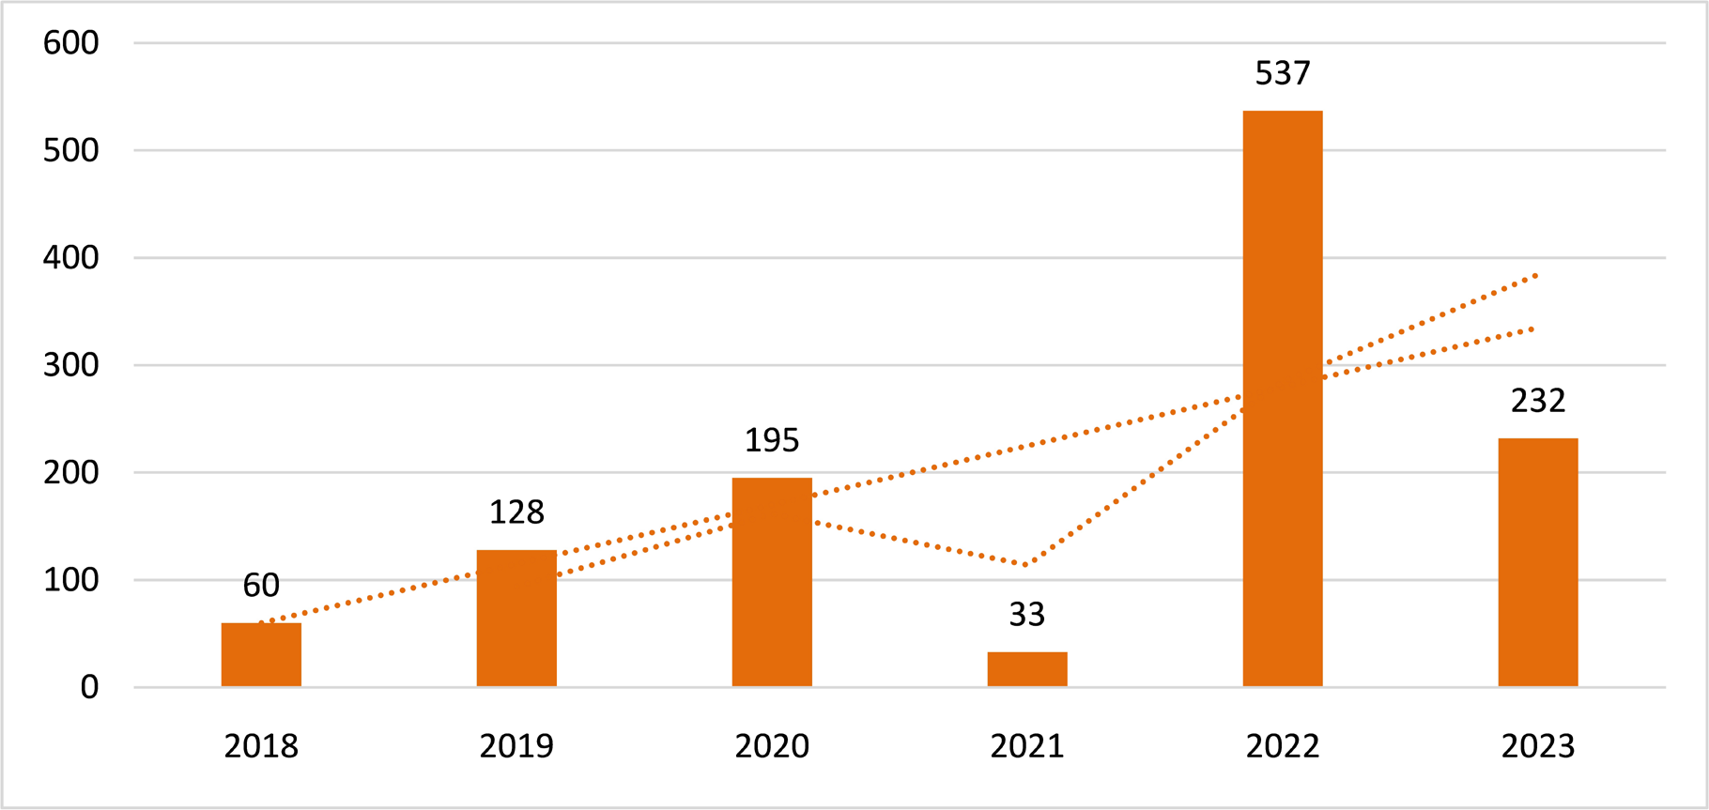

**Figure 2.** Trend curve with moving average over 2 periods.

## Temporal Dynamics

Analysis of the weekly time series of VDVP cases in DRC shows and increasing trend in case notification from 2018 to 2022 a decrease from 2023 on awards (**Figure 3**).

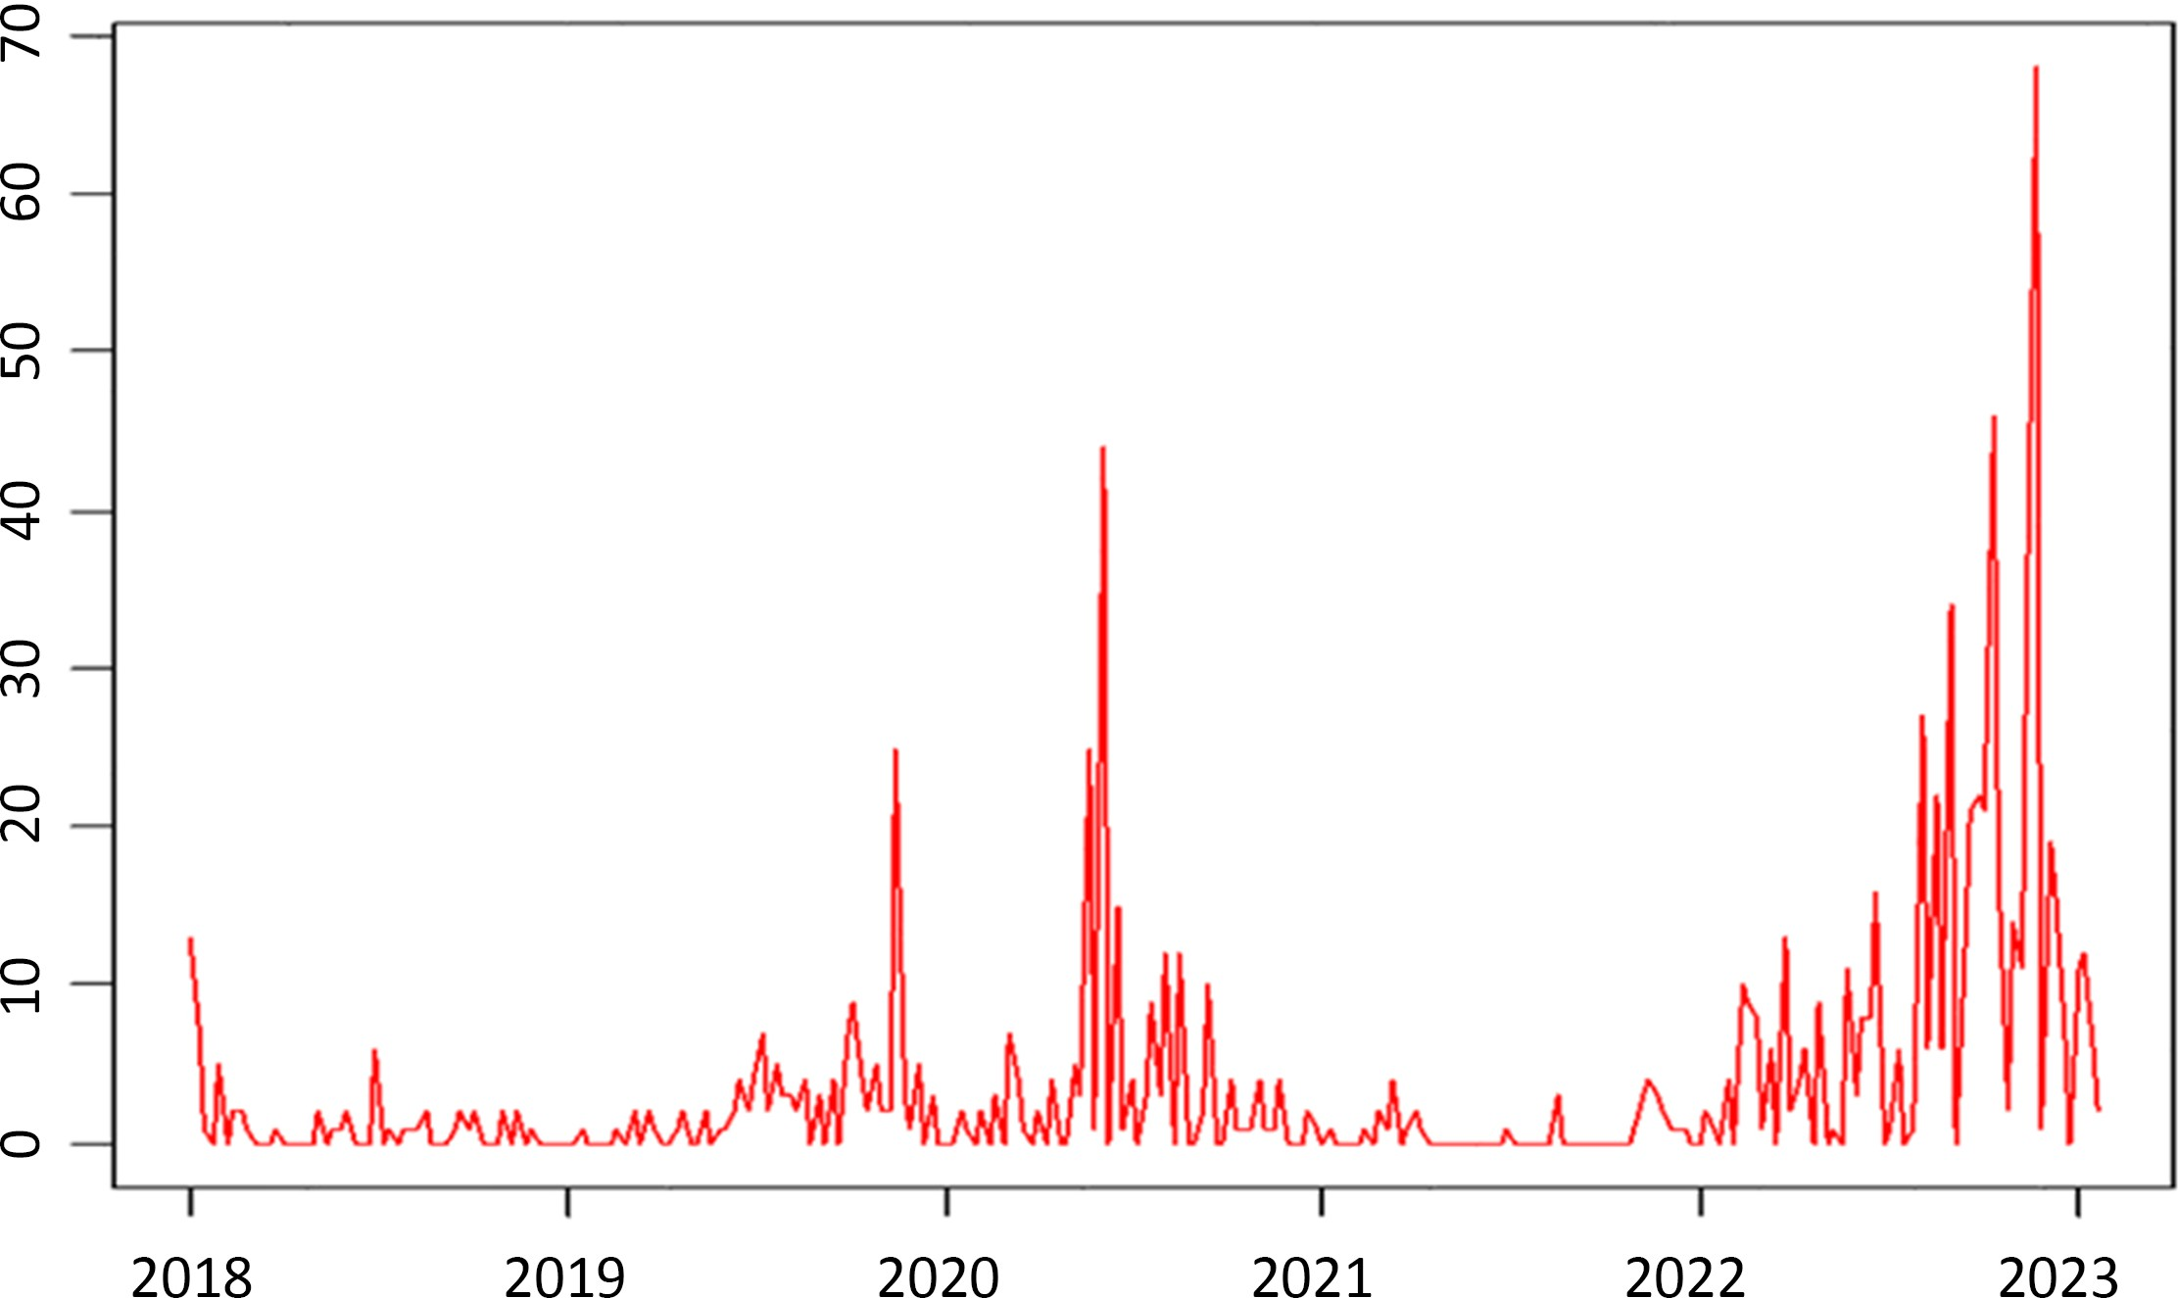

**Figure 3.** Time series of vdpv cases in the DRC 2018 – 2023

Analysis of the temporal breakdown suggests a seasonal pattern, with peaks between the months of September and December, considered being rainfall pe- riods in several provinces.

Observation of residual shows a linear curve with small peaks during this study period.

However, there are very cases during the months of January and February, known as the short dry season (**Figure 4**).

## Spatial dynamics

These 6 thematic maps show VDPV attack rates over the 6 years of our study (**Figure 5**).

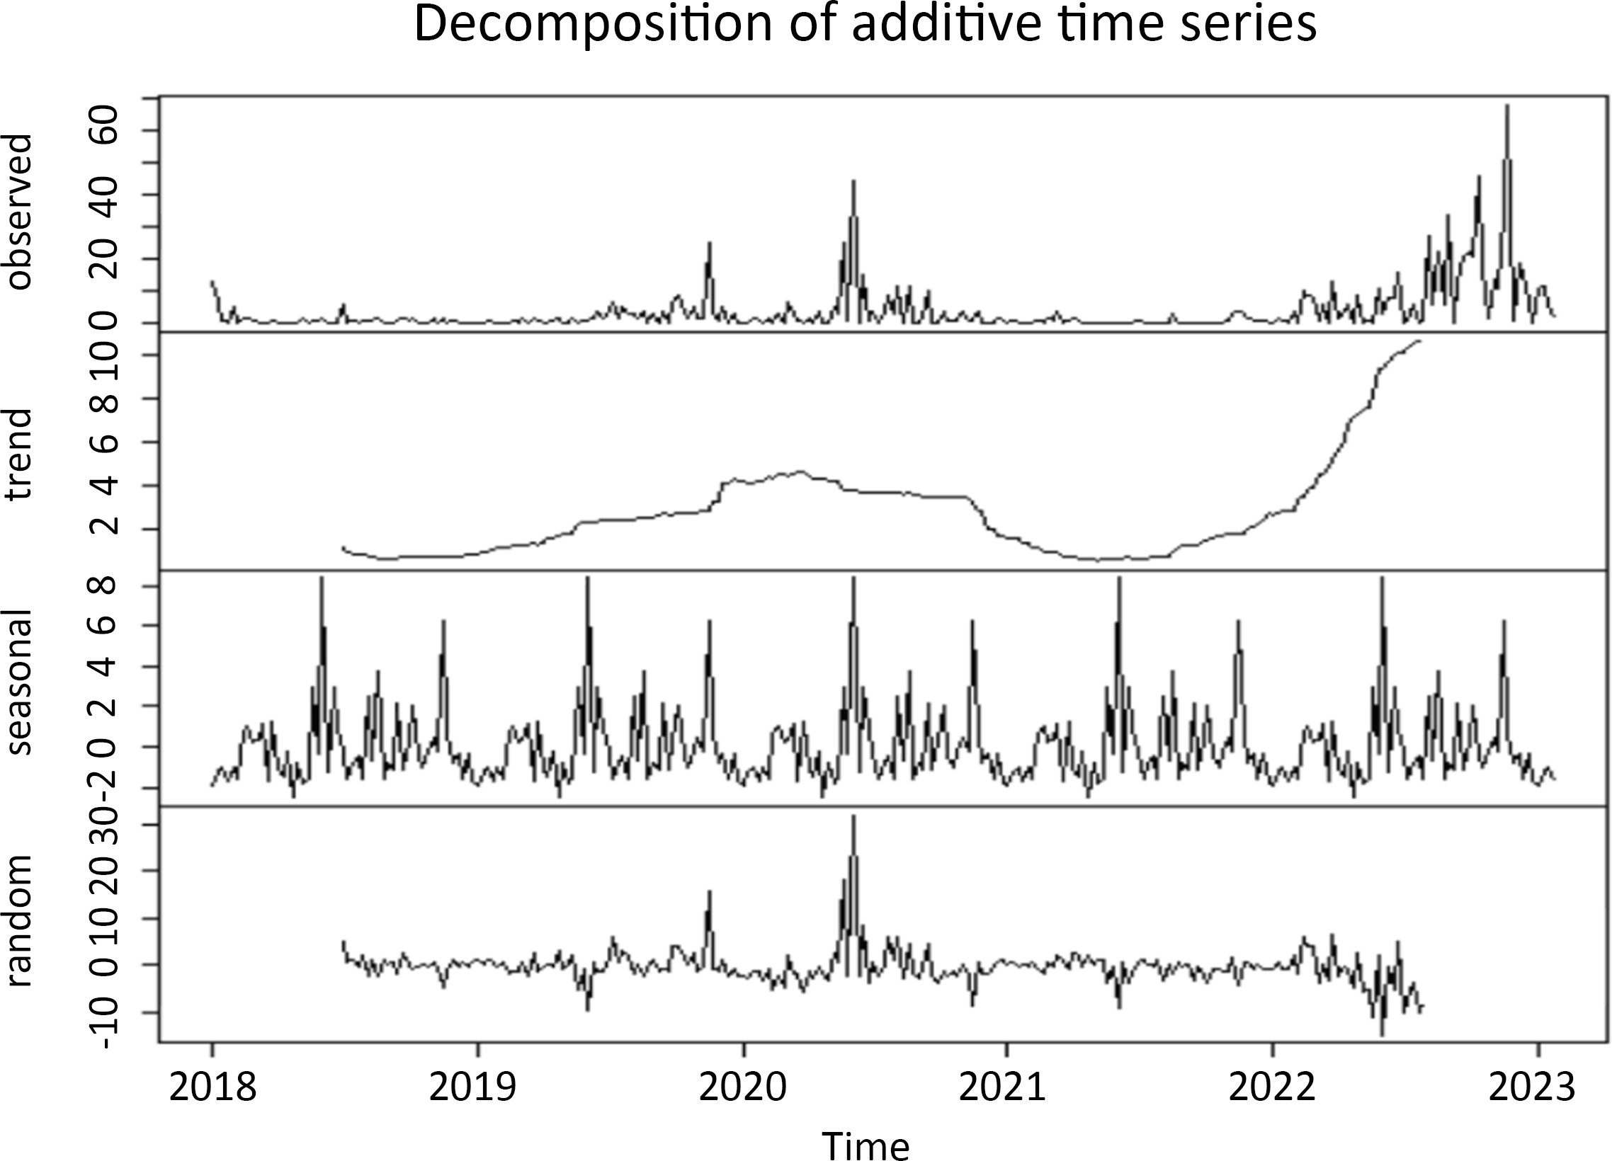

**Figure 4.** Decomposition of time series.

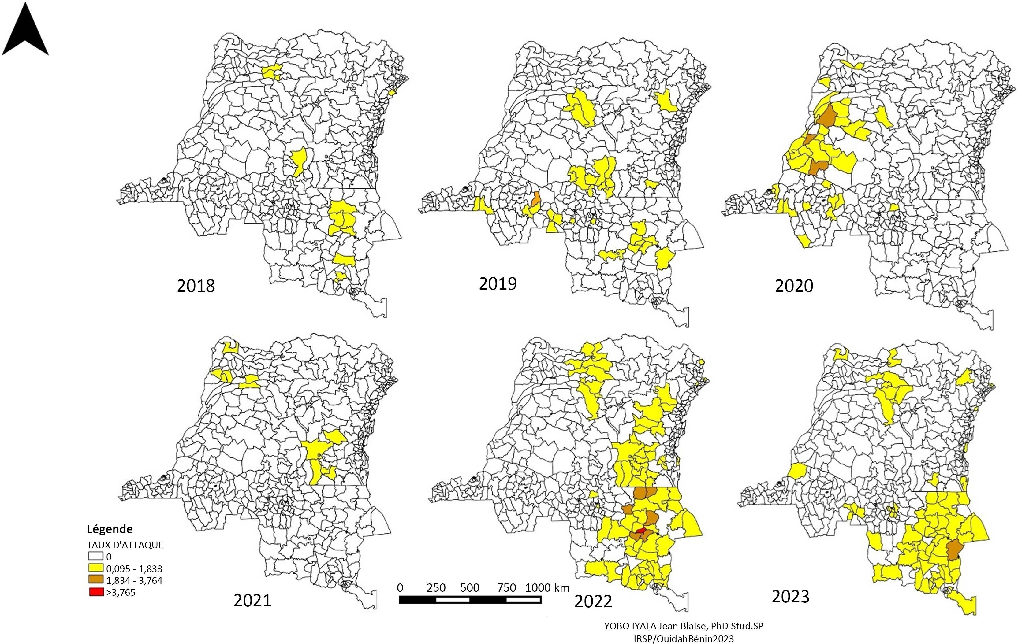

**Figure 5.** The map of spatial dynamics of VDPV in RDC (2018 - 2023).

A total of 1.196 cases of VDPV types one, 2 and only 1 type 3 (ZS Lowa, Tshopo province) were confirmed at the national laboratory during this period.

Map 1 (2018) shows a predominance of VDPV cases in the eastern part of the

DRC, notably in the Health Zones of the provinces of Grand Katanga (Tangan- yika 30 cases, Ht Katanga 4 cases, Ht Lomami 3 cases) and Ituri 2 cases, but also in the central northern part (Mongala 21 cases) and Sankuru 1 case.

Map 2 (2019) shows a scattered distribution of cases in all poles.

In the West, we have cases in the ZS of Kwilu province (11 cases, Kwango 5 cases, Central Kongo and Tshuapa 1 case each).

In the center of the country, several Health Zones in the Greater Kasai prov- inces (Kasai Oriental, Kasai Central and Kasai have reported cases, 56 in all).

As for the 2020 map, we note a concentration of cases in the western part of the country, affecting the Equateur Health Zones with 39 cases, Mai Ndombe with 23 cases, Kwilu with 8 cases, Kinshasa with 5 cases, the rest of Grand Equa- teur with 4 cases and Kwango and Tshopo with 1 case each.

The year 2022 was marked by an exponential rise in VDPV cases, with 528 cases confirmed at the national laboratory.

The eastern part of the country bore the brunt of this annual incidence. Thus, 3/4 of the cases were notified in the health zones of the provinces that had emerged from the former Katanga province (Ht Lomami 190 cases, Tanganyika 167 cases, Ht Katanga 39 cases and Lualaba 11 cases). The remainder of cases were reported by the ZS of Maniema province (65 cases), Sud Kivu (13 cases), Bas Uélé (12 cases), Tshopo (10 cases), Ituri (5 cases), Ht Uélé (2 cases), Nord Kivu (5 cases), Mongala and Kasai Oriental (1 case each).

The last map (2023) seems to mirror the pattern of 2022, with VDPV cases concentrated in the east and a little in the center-north of the country. In total, Greater Katanga alone reported 154 out of 232 cases, in the ZS of the Gd Katan- ga provinces (Tanganyika 64 cases, Ht Katanga 51 cases, Ht lomami 31 cases, and Lualaba 8 cases). The other ZS in the east of the country that reported cases were in the provinces of Sud Kivu 5 cases, Bas Uélé 2 cases, Maniema, Ituri, Nord Kivu, and Ht Uélé each reported 1 case.

The central part of the country was also affected, notably in the ZS of Kasai Oriental (35 cases), Mongala (9 cases), Nord Ubangi (2 cases) and Mai Ndombe (1 case).

# Discussion

The study of the spatiotemporal dynamics of VDPV cases in the DRC (2018 - 2023) highlights a convincing fact, which is spatial heterogeneity; this would be linked to climatic and environmental factors that need to be investigated.

The DRC, a vast country covering the east, west and central parts of Africa, presents a number of epidemiological facies, reflecting the different impacts of this disease caused by an environmental virus.

Over the 6 years of our study, we observed a scattered distribution of cases that spared no geographical region of the country, although Some provinces paid a heavy price, namely those resulting from the break-up of Katanga (Ht Katanga, Ht Lomami, Lualaba and Tanganyika), as well as the eastern part of the country

in general, which has to contend with insufficient human resources, insecurity, poor roads and cold chain equipment, and other childhood vulnerabilities [12], not forgetting the existence of groups historically resistant to vaccination, which pose serious vaccination problems.

There has been intense reporting of cases, with regular peaks often from Janu- ary to March, then from September to November. This period also corresponds to the end of the dry season and the start of the rainy season (lean season), which reinforces the hypothesis of a link with an abrupt change in climate [13]. On the other hand, we might have suspected an excess of AFP case notifications due to the optimization of active case-finding during this period by providers at the be- ginning and end of the year, with the aim of reaching the AFP surveillance benchmark of 3 cases per 100,000 children under the age of 5 per year, and a slackening off when the benchmark was reached. Another study will compare the relationship between case notification by the ZSs and the rate of non-polio enter- oviruses in stools, reflecting the quality of the retrograde cold chain in these ZSs and the conditions under which samples are transported to the INRB laboratory.

A proven seasonal phenomenon is linked to rainy periods, although these do not necessarily correspond to the same months of the year in the DRC. This re- sult is in line with that of Denise Antona’s team, who conducted surveys on en- terovirus surveillance in mainland France from 2000 to 2004 and found an in- crease in enteroviruses of all species in the summer-autumn period, which cor- responds to the rainy season in the DRC [14].

In general, in endemic countries and areas, PVS has a seasonal pattern that varies according to geographical region. In tropical or semi-tropical regions, PV circulation tends to be cyclical and is often associated with the rainy season.

# Conclusions

This study of the temporal and spatial dynamics of VDPV has shown the extent of variant poliovirus epidemics and their heterogeneous distribution in the DRC. Almost all provinces were affected by the three VDPV serotypes during the 6 years of our study. The HZ of Great Katanga were more affected.

The seasonal component is well marked, with an initial rise in cases observed from the end of the dry season onwards. During the 2020 epidemic, the increase in cases began during the short dry season, and during the 2011 - 2012 epidemic, the rise in cases began at the start of the short dry season. A correlation study will shed light on this seasonal evidence. This analysis highlights the contribu- tion of the seasonal component to poliovirus circulation; the variation in relative humidity according to season and health zones can partly explain fluctuations in the number of VDPV cases. This result opens the way to taking into account the seasonal component of PV transmission.

# 

# References

1. Blondel, B., et al. (2008) Genetic Evolution of Poliovirus: Successes and Difficulties in the Eradication of Paralytic Poliomyelitis. Tropical Medicine (March-April), 189-202.
2. Pierre, A. (2023) Poliomyelitis. Réne Labusquiere Center, IMT, University of Bordeaux.
3. Coulliette-Salmond, A.D., Alleman, M.M., Wilnique, P., Rey-Benito, G., Wright, H.B., Hecker, J.W., *et al*. (2019) Haiti Poliovirus Environmental Surveillance. *The American Journal of Tropical Medicine and Hygiene*, **101**, 1240-1248. <https://doi.org/10.4269/ajtmh.19-0469>
4. Alleman, M.M., Chitale, R., Burns, C.C., Iber, J., Dybdahl-Sissoko, N., Chen, Q., *et al.* (2018) Vaccine-derived Poliovirus Outbreaks and Events—Three Provinces, Democratic Republic of the Congo, 2017. *MMWR. Morbidity and Mortality Weekly Report*, **67**, 300-305. <https://doi.org/10.15585/mmwr.mm6710a4>
5. Donaldson, L., Alwan, A., *et al*. (2023) Twenty Second Report of the Independent Monitoring Board (IMB). Global Polio Initiative Polioeradication (GPEI). [https://polioeradication.org/wp-content/uploads/2023/09/22nd-Report-of-The-Inde](https://polioeradication.org/wp-content/uploads/2023/09/22nd-Report-of-The-Independent-Monitoring-Board-IMB.pdf) [pendent-Monitoring-Board-IMB.pdf](https://polioeradication.org/wp-content/uploads/2023/09/22nd-Report-of-The-Independent-Monitoring-Board-IMB.pdf)
6. Yelnik, P.A. (2023) Acute anterior poliomyelitis and post-poliomyelitis syndrome. Department of Physical Medicine and Rehabilitation G.H Lariboisière-F-Widal APHPDénis 75010 PARIS.
7. Delpeyroux, F. (2010) Global Polio Immunization Programme: Eradication or Disease Control. Virology, 14, 307-310.
8. Polio Emergency Operations Committee (2023) Terms of Reference for the response to CVDP2 Round2.
9. (2023) World Health organization, Global Weekly GPEI Report 2023.
10. Ministry of Planning (DRC) (2023) Multisectoral Plan for the Elimination of Cholera, PMSEC (2023-2027).
11. (2023) Technical Guide for Integrated Disease Surveillance and Response, 3rd edition.
12. UNICEF (2021) Poverty and Deprivation in the Democratic Republic of Congo. Haut Katanga Province.
13. Doumtsop, J.G.T., Khalef, I., Diakite, M.L.B. and Boubker, N. (2014) [Epidemiology of AFP and the Performance of the Surveillance System in Mauritania from 2008 to 2012]. *The Pan African Medical Journal*, **18**, Article 305. <https://doi.org/10.11604/pamj.2014.18.305.3362>
14. Kew, O.M., Wright, P.F., Agol, V.I., Delpeyroux, F., Shimizu, H., Nathanson, N., *et al.* (2004) Circulating Vaccine-Derived Polioviruses: Current State of Knowledge. *Bulletin of the World Health Organization*, **82**, 16-23.