# A Study of Spatial and Temporal Variations of Climatic Variables during Sand and Dust Storm Events in Riyadh Using in-Situ Observations

## ABSTRACT

|  |
| --- |
| This study examines the increasing incidence of dust events in Riyadh, Saudi Arabia, emphasizing the significance of understanding climatic factors such as temperature, precipitation, wind speed, and atmospheric pressure. The objective is to analyze the relationship between these variables and dust occurrences from 2007 to 2023, identifying spatial and temporal patterns. A multiple linear regression model was employed to assess data from the National Center for Meteorology, chosen for its effectiveness in uncovering correlations. The results reveal a significant positive correlation between temperature and dust events, where a one-unit increase in temperature leads to a rise of 0.186 dust events. In contrast, increased atmospheric pressure and precipitation result in decreases of 0.099 and 0.253 dust occurrences, respectively, while higher wind speed reduces dust events by 0.457. Over the study period, Riyadh averaged 252 dust events annually from 2007 to 2022, with a notable decline to approximately 47 events in 2023. The highest frequency of dust events occurred in spring and summer, particularly in April and June. The findings highlight the complex interplay between climatic factors and dust storm dynamics, offering valuable insights for addressing this environmental challenge and suggesting avenues for future research. |

*Keywords: Dust and sandstorms; Riyadh; Saudi Arabia; climate variables; spatiotemporal patterns.*

## 1. INTRODUCTION

Dust events are a natural meteorological phenomenon that occurs in desert locations(Prospero et al., 2002), where powerful winds carry dust and sand particles across large distances(Grousset et al., 2003). The size of the phenomenon ranges from dust devils that are just a few tens of meters wide to vast dust plumes that can span hundreds of thousands of square kilometers (N.J. Middleton, 1984, Grigoryev, et al.,1980). The Middle East, especially the Arabian Peninsula, is highly impacted by dust storms, with the African and Asian deserts serving as main dust suppliers (Awad et al., 2016). The Arabian Peninsula has been recognized by (Idso,1976, Chylek, et al., 1995, D'Almeida, 1987) as one of five major global regions where dust storm activity is particularly intense. Prospero (1981) notes that a significant area of dust haze is typically observed in the Arabian Sea during the months of June, July, and August. Various studies have evaluated the aeolian contribution to sediments in the Arabian Gulf, as well as the Arabian and Red Seas (Emery, 1956; Sugden, 1963; Stewart, Pilkey et al., 1965; Kolla & Biscaye, 1977; Khalaf & Al-Hashash, 1983, Washington, et al., 2005). Additionally, some research has been conducted on aerosols over the Arabian and Red Seas (Cailleux, 1961; Aston et al., 1973; Sadasivan, 1978; Prodi, Santachiara et al., 1983, Zender, et al., 2003). Several authors have reported on dust storm frequencies in various parts of the Middle East (Coles, 1938; Katsnelson, 1970; Al-Najim, 1975; Safar, 1980), while (Goudie, 1983) provided a general overview of their distribution across the region. The Arabian Peninsula has enormous dunes, deserts, and topographically complicated terrain with minimal vegetation cover and low precipitation, which creates circumstances conducive to dust particle suspension in the atmosphere. The prevailing northwesterly winds, such as the Al Shamaal winds, play an important role in mobilizing dust across the peninsula (Awad et al., 2016; Mashat et al., 2016). The expansive dunes and deserts of the Arabian Peninsula, along with the surrounding topographically complex terrain, provide the essential conditions for lifting dust into the atmosphere. This region is characterized by very low precipitation levels and sparse vegetation cover, which facilitate the movement of dust particles into the air (Albugami, 2019). In the Sahara, wind is the main carrier of sand. Obstacles like trees and terrain reduce wind velocity and increase pressure drop, promoting sand deposition and dune formation(Middleboe, et al., 2003, Tegen, et al., 2002,Remini et al, 2020). Sahara Desert functions through surface winds and underground water, leading to the formation of vast ergs and significant underground bodies of water (Remini et al, 2021). They occur when extreme surface heating drives the air above to rise, causing hot ascending currents and resulting in pressure and temperature inequalities. The passage of colder breezes to fill the vacuum leads to the lifting of dust and sand particles to higher altitudes, depending on the intensity of the wind (Fisher, 1978, Abballo, 2016). By virtue of their distinctive optical properties, mineral dust aerosols scatter and absorb shortwave (SW) and absorb and re-emit longwave (LW) radiation (e.g., Tegen and Lacis, 1996; Kinne et al., 2003; Dubovik et al., 2006), modifying therefore atmospheric thermodynamics, regional atmospheric circulations and the Earth's energy budget (e.g., Slingo et al., 2006; Sokolik & Toon, 1996; Heald et al., 2014, Carlson, et al., 1980, Hinds, et al.,1975). By modifying the radiative forcing, dust aerosols affect local climatic parameters such as temperature, winds and precipitation (Sharma et al., 2012; Rap et al., 2013; Liu et al., 2014; Chen et al., 2017). The amount of transported dust is directly influenced by the wind's intensity, and numerous internal and external elements contribute to the occurrence and increased frequency of dust storms (Al-Biyati, 2011, Sissakian, et al., 2013).Dust leads to a reduction in tropical cyclone activity over the North Atlantic Ocean, as revealed by a tropical cyclone tracking scheme. The most significant impact occurs in the optical regimes characterized by high absorption and scattering (Beckett, et al. 1956, Strong et al, 2018). While climatic conditions alone do not solely cause dust storms, factors such as temperature, relative humidity, land degradation at local and regional levels, topography, limited rainfall, and geographical location all contribute to the occurrence and frequency of dust storms (Al-Biyati, 2011; Al-Amshi et al., 2020).Severe dust movements significantly reduce visibility, impacting travel speeds and consequently affecting various economies (Asare-Ansah et al, 2022).Another study indicates that daily variations in Aerosol Optical Depth (AOD), along with wind speed, humidity, precipitation, and the spatial distribution of dust sources both within and outside the country, are significant factors(Ayanlade et al, 2019). Human factors, including the mismanagement and deterioration of natural resources, also play a role in the occurrence of dust storms. Identifying the synoptic meteorology associated with dust emissions, transport, and deposition is crucial for understanding the mechanisms driving the dust cycle from source areas to receptors. Dust storms typically occur in conjunction with strong pressure gradients and high wind speeds (Hermida et al., 2018, Al-Hamadi, A. 2020). Atmospheric suspension and transport of sand and dust brings a reasonable amount of electrification in the atmosphere which plays a very important role in the atmosphere-ionosphere coupling (Uluma et al, 2024, Edward et al., 2024). Key parameters such as mean sea pressure level (MSPL), geopotential height anomalies, wind speed, and wind direction have been utilized to assess dust emissions and transport across the Arabian Peninsula (Beegum et al., 2018; Hamidi et al., 2013; Mashat & Awad, 2016; Namdari et al., 2018). The predominant types of synoptic-scale dust storms in the Arabian Peninsula include the northwesterly Shamal wind, as well as pre-frontal and post-frontal winds (Francis et al., 2021; Hamidi et al., 2013; Middleton et al., 2017; Shao, Y et al., 2011). West Asia, particularly the Tigris–Euphrates alluvial plain, is experiencing severe desertification due to a variety of factors, both climatic and human-induced. Key contributors include global warming, land-use mismanagement, agricultural practices, overgrazing, marginal plowing, and the impacts of years of warfare (Hui Cao at, al, 2015). Recent studies have highlighted high wind speeds as a key factor associated with dust storms outbreaks in Saudi Arabia (Alharbi & Abdel-Dayem, 2015; Alharbi & Abdel-Dayem, 2018). Dust storms in the region are most prevalent in spring and originate from the Karakum desert in Turkmenistan and the Sistan Basin in Iran. Synoptic weather conditions, including the configuration of high-pressure and low-pressure systems, influence dust storms activity in northern and southwestern Saudi Arabia (Awad et al., 2016; Al-Dabbas & Al-Nasrawi, 2017). The Jazmurian basin in southeastern Iran also serves as a dust storm source area affecting the northern Arabian Sea and surrounding regions. The occurrence of dust storms is linked to the Asian summer monsoon system and the activity of the Shamal and Levar winds over the Arabian Sea during the summer season (Zhang et al., 2003; El-Askary et al., 2014; El-Askary et al., 2013).

Although dust storms can occur year-round in Saudi Arabia, their spatial and temporal distribution varies. Previous studies have shown regional differences in the peak season of dust storms activity. For instance, in the central region around the Al-Nafud desert, dust storms peak in the spring season (March, April, May) (Rashki et al., 2013), (Kaskaoutis et al., 2013). The (A.S Modaihsh, 1997) revealed that Riyadh, the capital of Saudi Arabia, experiences substantial annual dust accumulation, primarily consisting of loam and silt loam with high levels of CaCO3, electrical conductivity, and pH. Notable trace elements detected include lead (66.8 μg/g), nickel (26.0 μg/g), and manganese (318.9 μg/g), likely from both natural and anthropogenic sources. In another study found that the removal of vegetation cover has contributed to the loosening of the topsoil, which in turn has led to the formation of clay and sand-sized particles (Sissiakan et al, 2013). The dominant minerals in the dust were quartz and calcite, emphasizing the significant dust presence in the region. However, our understanding of how climate factors influence the spatial and temporal variations of dust storms across the entire Arabian Peninsula remains limited. This study aims to analyze the impact of climatic factors, such as temperature (T), precipitation (P), wind speed (WS), wind direction (WD), and atmospheric pressure (AP), on the occurrence of dust storms in the city of Riyadh from 2007 to 2022. Additionally, the study will compare these results with data from 2023 to understand the reasons behind the notable decrease in dust events in Riyadh during this year. It also seeks to provide a comprehensive characterization of the frequency and distribution of dust storms within the city. By exploring the relationship between dust storm occurrences and climatic conditions, the study aims to address existing knowledge gaps in this area. Additionally, it will highlight the regional dynamics of dust storms in Riyadh, offering new insights into their frequency, distribution, seasonality, and diurnal variations. However, there is a lack of comprehensive studies examining the relationship between dust storm occurrences in Riyadh and climatic factors. While some research exists on dust storms in the broader Middle East region, it does not provide an in-depth analysis of their frequency, distribution, seasonality, and diurnal variation. This investigation aims to address this gap and contribute to a better understanding of these dynamics in Riyadh.

## 2. MATERIALS AND METHODS

## 2.1 Study Location

The city of Riyadh, the capital of the Kingdom of Saudi Arabia, is located in the central region according to the administrative division of the country. It is represented in the current study by the climate station at King Khalid International Airport. Riyadh is geographically situated at a longitude of 46.43 degrees east and a latitude of 24.38 degrees north. It is also located at an elevation of 600 meters above sea level(Riyadh Development Authority, 2012). Riyadh has several geographical features that distinguish it from other cities in Saudi Arabia. It is situated in the eastern part of the heart of the Arabian Peninsula, in the middle of the Kingdom of Saudi Arabia, which occupies a central position among the continents of the world. This location gains further significance as it is located in the exact center of the Arabian Peninsula on a sedimentary plateau in the eastern part of the Najd Plateau. The main topographical features of Riyadh are characterized by its valleys, with Wadi Hanifa being the most important one. It cuts through the city from the northwest to the southeast, with a length of approximately 120 kilometers. The depth of the valley ranges from less than 10 meters to over 100 meters, and its width varies between less than 100 meters to nearly 1000 meters (Figs.1, 2) (Riyadh Development Authority, 2012; Almazroui & Islam, 2015; Al-Saud, 2018, Ministry of Environment, Water and Agriculture. 2019).

## 2.2 Dust Storms and Climate Variable Data

Hourly dust storm events data (2007- 2023) for station Riyadh was obtained from the National Center for Meteorology (NCM), which is the official governmental climate agency in Saudi Arabia (Fig. 1). In this study, the standard of the World Meteorological Organization (WMO) was applied in calculating dust cases as in this Volume II to the WMO Technical Regulations, 2025), and this study (H. Halos at,. al, 2017). The basic standard for all Dust cases (DS, SS, BLDU) is that the wind speed is equal to or more than 22 km/h, and the horizontal visibility is equal to or less than 5 km. The standard for dust and sand storms was also applied, that the wind speed is equal to or more than 30 km/h, and the horizontal visibility is equal to 1 km or less. This dataset was used to analyses the frequency of rising dust, dust and sand storms, determine the dust season in Riyadh, determine the rate of each type of rising dust (Blowing dust/ Blowing sand), dust and sandstorms, and determine the percentage of change in dust events over the years. The raw data for Riyadh station was analyzed in Microsoft Excel, including temporal liner trend fitting filtering. Moreover, the SPSS 26 was used to analyze the seasonal variation and multiple regression coefficient in the frequency of dust storm events, as well as meteorological conditions (temperature (T), precipitation (P), wind speed (WS), wind direction (WD), and atmospheric pressure (AP))

Also, using the monthly and seasonally averaged and annul climate data provided by NCM for Riyadh station, covering the period of 2007- 2023, in order to determine the correlation between specific climate variables and occurrence frequency of dust storm events. These climate variables were average temperature and average rainfall events in Riyadh station. To investigate the wind speed (WS) and wind direction (WD) at station and using hourly and daily data from NCM aviation routine weather report at hourly or half- hourly intervals. These data contain observations of the meteorological elements such as surface wind, visibility, and weather code (DS, SS, BLDU), precipitation, air temperature, dew-point temperature, and atmospheric pressure. These reports are based on the coding of the present weather, which is observed and forecasted by the NCM.

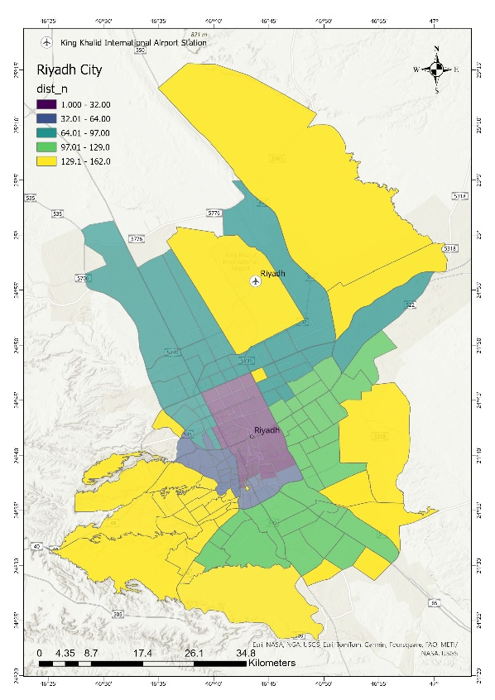

**Fig. 1. Study location**

## 2.3 Statistical Analysis

To going a stronger understanding of the variability in the observed occurrence of dust storm events, 2007 to 2023, we employed regression analyses. The associated coefficients of determination (R^ (2)), and model uncertainty were considered to evaluate the goodness of these fits. Moreover, the multiple regression coefficient analysis was used to investigate the potential existence of significant relationships between the weather variables and the frequency of rising dust, dust and sandstorms occurrence.

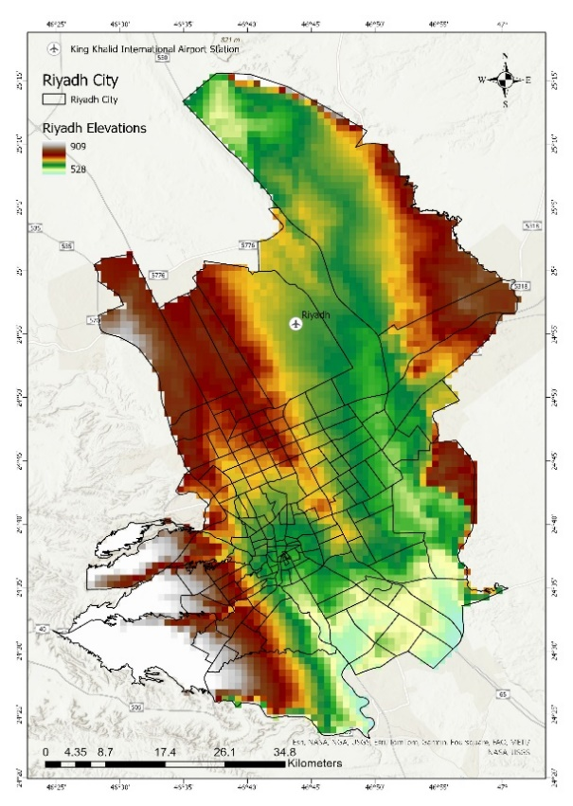

**Fig. 2. Elevation map of Riyadh**

## 3. RESULTS AND DISCUSSION

## 3.1 The General Trend in the Temporal Distribution of Dust and Sandstorm Events (Hourly) is As Follows (Yearly, Seasonal, Monthly)

**3.1.1 Annual variation**

During the study period from 2007 to 2022 comparing with 2023, Riyadh experienced approximately 252 annually average hourly dust and sandstorm events during 2007 to 2022, and in 2023 there were about 47 hour of dust events, according to the standard adopted for monitoring dust and sandstorm events by the World Meteorological Organization. This standard considers wind speeds exceeding 22 km/h and visibility dropping below 5 kilometers to monitor all phenomena that fall under the standard dust events.

In 2007 to 2022, the blowing dust accounted for approximately 93% of dust events, while sandstorms accounted for about 4.36%, and dust storms accounted for approximately 2.14%, and in 2023 blowing dust was 98%, and sandstorms was about -100%, and dust storms was about 2.22% as shown in (Figs. 3, 4). It is evident that some years experienced an increase in dust storm events, such as 2008, 2012, and 2018, with the number of dust and sandstorm events reaching approximately 206, 244, and 297 hour of dust events respectively. On the other hand, the years 2014 and 2023 had the lowest occurrence of dust events, with approximately 96 and 47 hour of dust events respectively.

**3.1.2 Seasonal variation**

The frequency of dust and sand storm events varies from season to season by using hourly data of dust events, as shown in Fig. 5. The highest frequency of dust and sandstorm events in Riyadh during the period from 2007 to 2022 compared with 2023 occurs in Spring and Summer (From March to August). The number of dust and sandstorm events during spring season (from March to May) in 2007 to 2022 was approximately 196 hour of dust events, with blowing dust events accounting for 2830 cases representing 93%. As for the most frequent sandstorm events, they also occur in the spring season (from March to May) with 65 hour of dust events representing 2.14%. Dust storms accounted for about 132 hour of dust events representing 4.36%. In 2023, the dust storms were about 1 case, and the blowing dust was 46 hour of dust events representing -98.5%. As for the most frequent dust storms occur in the spring season with 1 hour of dust events representing 2.2%. Sandstorms accounted for about 0 hour of dust events representing -100%. During this period, the winds are influenced by the seasonal Indian low-pressure system, with a southeast direction, which is of tropical origin. It is observed that wind speeds intensify during daylight hours and calm down during the night.

The summer season (from June to August), which recorded about 62 hour of dust events representing 41%, and in 2023 was about 2 hour of dust events accounting for 4.4%. This is followed by winter season (from December to February), which witnessed approximately 24 hour of dust events accounting for 15% during 2007-2022, and in 2023 was 6 hour of dust events accounting for 13%. Finally, the autumn season (from September to November) is the least in terms of registering dust and sandstorm events with approximately 5 hour of dust events representing 3.13%, and in 2023 was about 2 hour of dust events accounting for 4.4%.

**3.1.3 Monthly variation**

Riyadh is exposed to dust and sandstorm events (hourly) throughout the year, as shown in (Fig. 6). The distribution of dust cases varies significantly across the months. The average number of dust events during the study period 2007 to 2022 were approximately 3,027 hour of dust events. Blowing dust events accounted for around 2,830 hour of dust events, with the highest average of frequency occurring in June, March, April, and May with average of 28, 19, 19, and 14 hour of dust events respectively. Comparing in 2023 the highest blowing dust accounted for around 46 hour of dust events, and highest frequency occurring in May, March, and April with total 16, 13, and 5 hour of dust events respectively. As for dust storms in 2007 to 2022, their average frequency was approximately 132 hour of dust events, they were more frequent in July, April, March, and May, with 22, 21, 20, and 19 hour of dust events respectively, while their frequency decreased in September, November, and December, with 1, 0, and 0 hour of dust events respectively. Comparing in 2023 the total frequency was approximately 1 hour of dust events, it was more frequent in April with totals of 1 dust storm, while their frequency decreased in wholly the year with totals 0 dust storms.

Regarding sandstorms, their average frequency was approximately 65 hour of dust events. They were more frequent in July, April, May, and March, with averages of 23, 16, and 9 hour of dust events respectively. However, their frequency decreased in September, January, and October with totals of 0 hour of dust events respectively. Comparing in 2023, its totals frequency was approximately 0 hour of dust events in all year. It is evident that the highest frequency of dust events occurred between the spring and summer months, while the lowest frequency occurred during autumn and the early months of winter. Therefore, the season for dust events in Riyadh is primarily between the spring and summer seasons.

During the second week of June, the winds become active and predominantly blow from the north. These winds intensify during daylight hours due to solar radiation. This period exhibits characteristics of the seasonal Indian low-pressure system, which extends widely from northwest India to the eastern Mediterranean Sea. Due to the strong winds, especially during midday, the air carries a significant amount of dust, often leading to reduced horizontal visibility during severe SDS events to just a few meters.



**Fig. 3. Annual variation in the frequency of dust and sandstorm events (Hourly) during 2007 to 2022**



**Fig. 4. Annual variation in the frequency of dust and sand storm events (Hourly) during 2023**



**Fig. 5. seasonal variation in the frequency of dust and sandstorm events (Hourly) during the Period from 2007 to 2022 comparing with 2023**



**Fig. 6. Monthly variation in the frequency of blowing dust (Hourly) during the Period from 2007 to 2022 compering with 2023**

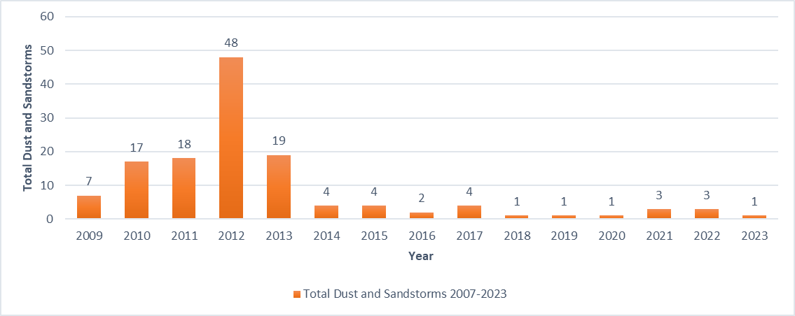

**Fig. 7. Annual frequency of dust and sandstorms (Hourly) during the Period 2007 to 2023**

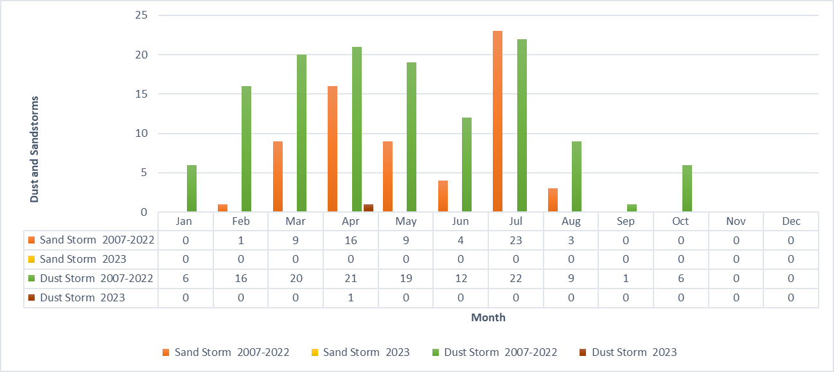

**Fig. 8. monthly frequency of dust and sandstorms (Hourly) during the Period 2007 to 2022 comparing with 2023**

## 3.2 Frequency of Dust and Sandstorm and Blowing Dust Events (Yearly, Seasonal, Monthly)

**3.2.1 Frequency of dust and sandstorms hourly (yearly, seasonal, monthly)**

The total number of hours that witnessed dust and sandstorms in Riyadh from 2007 to 2022 was approximately 197 hour of dust/ sand events, with an annual average of 10 hour of dust/ sand events, in 2023 it was about 1 hour of dust/ sand events coming with TS DS. The annual count of recurring dust and sandstorm events in Riyadh during the study period ranged from 16 hour of dust/ sand events in 2009 to 49 hour of dust/ sand events in 2012, 21 hour of dust/ sand events in 2018, and 1 hour of dust/ sand events in 2023 (Fig. 7).

In terms of seasonal variation, the total for the spring season (March to May) at 2007 to 2022 (March, April, and May) were 94 hour of dust/ sand events, with a monthly average of 9 hour of dust/ sand events, in 2023 was 1 hour of dust/ sand events. During the summer season (June to August) in the period 2007 to 2022, the total is 73 hour of dust/ sand events, with a monthly average of approximately 6 hour of dust/ sand events, in 2023 was 0 hour of dust/ sand events. The winter season (December to February) at 2007 to 2022 had a total of around 23 cases, with a monthly average of 2 hour of dust/ sand events, in 2023 was 0 hour of dust/ sand events. In the autumn season (September to November) during the period 2007 to 2022, the total for dust and sandstorms is approximately 7 hour of dust/ sand events, with a monthly average of 1 hour of dust/ sand events, in 2023 was 0 hour of dust/ sand events. From this analysis, we can conclude that the spring season had the highest recurrence of dust and sandstorm events compared to other seasons, with half of the average dust and sand storm occurrences in Riyadh happening during spring, while the other half is distributed among the remaining seasons. (Fig. 8) illustrates the highest frequency of dust and sandstorms occurrences in Riyadh during the study period 2007 to 2022, with July having 45 hour of dust/ sand events, followed by April with 40 hour of dust/ sand events, and May with 36 hour of dust/ sand events, compared with 2023 had just 1 hour of dust/ sand events in April. These months are characterized by dry soil conditions, low rainfall, and increased susceptibility to erosion, accompanied by high-speed winds, with an average wind speed of 24 km/h and a maximum wind speed of 46 km/h in July. The frequency of storm events decreases in September, October, and January, with 1, 6, and 6 hour of dust/ sand events respectively.

**3.2.2 Frequency of rising dust (blowing dust/ blowing sand) hourly (yearly, seasonal, monthly)**

This phenomenon occurs due to atmospheric instability resulting from intense heating of the Earth's surface layers and changes in the strength of the pressure gradient. This leads to the establishment of air vortices that lift fine dust particles to a height of up to 15 meters. However, they do not travel long distances unless there are extremely unstable conditions. It is possible to observe suspended dust particles in the air (Khalil, Y., 2018). Thus, we can conclude that the difference stays in the wind speed between blowing dust and dust and sandstorms. The wind speed in the case of blowing dust is generally less than 22 km per hour, while in the case of dust and sandstorms, it is 33 km per hour or more. The difference also appears in the horizontal visibility, where the visibility in the case of blowing dust is generally less than 5 km, while in the case of dust and sandstorms, it is 1 km or less due to strong winds (Al-Mousawi et al., 2014).

(Fig. 9) illustrates the varying rates of occurrence of blowing dust in Riyadh during the study years from 2007 to 2022 comparing with 2023. The number of occurrences of blowing dust in 2018, 2013, and 2022 was approximately 276, 224, and 225 hour of dust events respectively, which are the highest years, and in 2023 was 46 hour of dust events. On the other hand, in the years 2007, 2014, and 2023, there were approximately 96, 92, and 46 hour of dust events respectively, which are 2023 the lowest years. In terms of seasonal variation in the total occurrence of blowing dust in Riyadh during the study period, it is evident that the highest rates of occurrence are in the spring months (March to May) due to a noticeable increase in temperature, low rainfall, and increased wind speed, with total occurrence was approximately 1445 hour of dust events. The rate of occurrence decreases in the autumn season (September to November) to 142 hour of dust events (Fig. 10). The highest total occurrence of blowing dust was recorded in the month of June and July in 2007 to 2022 reaching around 573, 358 hour of dust events respectively, in 2023 0 hour of dust events in those months. While the months of March and April recorded approximately 403 and 416 hour of dust events respectively, compared with March and April in 2023 reaching around 13, 5 hour of dust events respectively. The occurrence of blowing dust is lower in the months of September and October in 2007 to 2022 with approximately 39 and 36 hour of dust events respectively, and in 2023 September, October, November, and December 0, 2, 0, and 0 hour of dust events respectively. And, we can see that in 2023 increased on May and October 16, and 2 hour of dust events, compering with 2007 to 2022 average these months were 15, and 1 hour of dust events respectively.

**3.2.3 Dust and sandstorms and rising dust (blowing dust/ blowing sand) occurrences and their seasonal distribution**

Dust and sandstorms and blowing dust are caused by the suspension of fine particles of soil due to wind speeds exceeding 33 km/h, resulting in horizontal visibility dropping to less than 1 km (Khalil, Y., 2018). Based on the visibility range during dust storm events in Riyadh from 2007 to 2023, the severity of dust and sandstorms was classified into four categories as follows: a group with visibility less than 0.1 km (very severe), less than 0.6 km (severe), less than 1 km (moderate), and less than 5 km (light).

**Group 1:** This group includes very severe dust and sandstorms with visibility less than 0.1 km. During the study period, there were 39 storms, accounting for 1.15% of the total number of dust storm cases. Most of these storms occurred in the spring season, particularly in April, with an average of 22 storms, and the fewest occurred in winter with only 4 storms.

**Group 2:** This group includes severe storms with visibility less than 0.6 km. There were approximately 30 storms in this category, accounting for 0.2% of the total number of dust storm cases. Most of these storms occurred in the spring season, especially in April, while they were less frequent in other seasons.

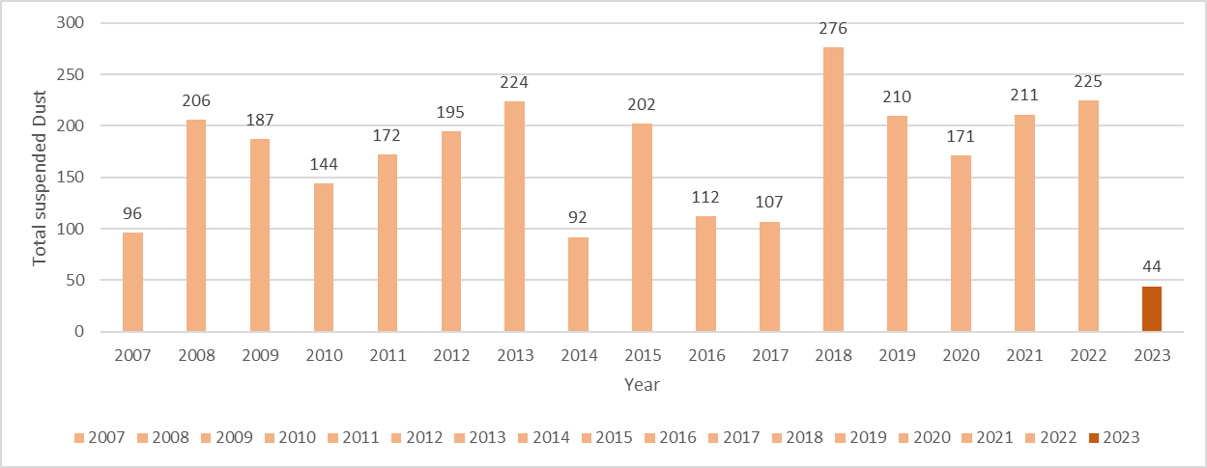

**Fig. 9. Annually frequency of blowing dust particles (Hourly) during the Period 2007 to 2023**

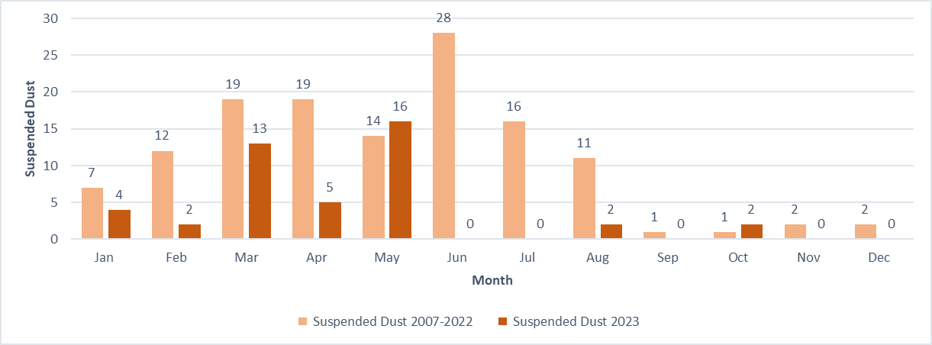

**Fig. 10. Monthly frequency of blowing dust particles (Hourly) during the Period 2007 to 2022 comparing with 2023**

**Table 1. Correlation coefficients between dust events and climate elements during the period from 2007 to 2023**

|  |  |  |  |
| --- | --- | --- | --- |
| **Independent Variable** | **Coefficient (β)** | **p-value (Sig)** | **Standard Error** |
| Air Pressure (X₁) | -0.099 | *0.004* | 0.075 |
| Air Temperature (X₂) | 0.169 | 0.045 | 0.065 |
| Precipitation (X₃) | -0.352 | 0.002 | 0.110 |
| Wind Speed (X₄) | ***0.457-*** | <0.001 | 0.125 |
| Intercept | 28.197 | - | 2.345 |
| R² (Coefficient of Determination) | 0.058 | - | - |

|  |  |
| --- | --- |
|  |  |



**Fig. 11. Correlation Coefficients between Types of Dust Events and Climate Elements during the Period 2007 to 2023**

|  |  |
| --- | --- |
|  |  |
|  |  |

**Fig. 12. Simple Scatter with Fit Line between Types of Dust Events and Climate Elements during the Period 2007 to 2023**

**Group 3:** This group includes moderate dust and sandstorms with visibility less than 1 km. There were 36 storms in this category representing 1.06% of the total. Most of these storms occurred in the spring season, with around 14 storms, while they were less common in the autumn and winter seasons.

**Group 4:** This group includes light blowing dust with visibility less than 5 km. The total number of storms in this category was approximately 208, accounting for 6.16% of the total number of dust storm cases. These storms were concentrated in the spring season, with an average of 92 storms, while they were less frequent in the autumn season (6 storms), followed by the winter season (52 storms), and the summer season (58 storms).

**3.2.4 The relationship between climate elements and dust and sandstorms and rising dust (blowing dust and blowing sand)**

The climatic factors such as temperature (T), precipitation (P), wind speed (WS, and atmospheric pressure (AP) contribute significantly to the formation of dust and sandstorm events. Table 1 and Figs.11, and 12 demonstrate the correlation between climate elements and dust events in Riyadh during the study period from 2007 to 2023. This is done by applying the Multiple linear regression to clarify the nature and strength of the relationship between the studied phenomena and the independent variables that influence them. It is evident that one of the most suitable statistical equations for measuring the strength of the correlation between the climate elements and rising dust, dust and sandstorm events is derived.

As in the Table 1 and Fig. 11 in the context of studying the impact of climatic variables on dust events levels, a multiple linear regression model was applied. The data collected from National Centre of Meteorology included independent variables: air pressure, air temperature, precipitation, and wind speed. The results of the regression analysis indicated that the studied independent variables play a crucial role in explaining the variance in dust events levels. For air pressure, the regression coefficient was -0.099, with a p-value of 0.004. This means that an increase in air pressure by one unit leads to a decrease in airborne dust levels by 0.099. The p-value being less than 0.05 indicates that the effect of air pressure on dust levels is statistically significant, suggesting that more stable weather conditions may reduce the likelihood of dust and sand particles.

Regarding air temperature, the regression coefficient was 0.169, with a p-value of 0.045, indicating that an increase in air temperature by one unit leads to an increase in dust levels by 0.169. Since the p-value is less than 0.05, this suggests that the effect of temperature on dust levels is statistically significant, indicating that rising temperatures increase the likelihood of dust occurrences. Concerning precipitation, the regression coefficient was -0.352, with a p-value of 0.002. This indicates that an increase in precipitation by one unit leads to a decrease in dust levels by 0.352. The p-value being less than 0.05 indicates that the effect of precipitation on dust levels is statistically significant, meaning that increased precipitation helps stabilize soil and reduce dust. Wind speed had a regression coefficient of -0.457 and a p-value of less than 0.001, suggesting that an increase in wind speed by one-unit results in a significant decrease in dust events by 0.457, highlighting the strong impact of wind on dust occurrences. The coefficient of determination (R²) was 0.058, meaning that 5.8% of the variance in dust events occurrences can be explained by the independent variables.

The results of the multiple linear regression model show that increases in temperature are associated with higher levels of rising dust, dust and sandstorm events occurrences, while increases in air pressure and precipitation lead to decreases in these events. Furthermore, wind speed significantly impacts the occurrence of sandstorms, highlighting the importance of climatic factors in understanding and predicting these phenomena. From the data analysis, it can be concluded that improving environmental resource management and implementing effective strategies to combat desertification can help mitigate the negative impacts of rising dust, dust and sandstorm events. Raising awareness about the effects of climate change on environmental health and populations is essential to ensure the sustainability of life in regions prone to these phenomena.

## 4. CONCLUSION

The occurrence of dust and sandstorms and blowing dust in Riyadh is most common during the spring and summer months (March, April, May, June, and July), where their frequency and intensity increase. Most of these storms occur due to strong winds, low rainfall, limited vegetation cover, soil dryness, and lack of cohesion. The study found that the highest frequency of dust and sandstorm occurrences during the study period from 2007 to 2023 was the average in the months of April and June, with approximately 23 and 29 cases respectively, comparing with the total cases in the same months in 2023 were reaching around 6, 0 cases respectively. This was attributed to high wind speeds, high temperatures, soil dryness, and lack of rainfall during these months. Dust and sandstorms are not limited to the spring and summer seasons but can also occur during the autumn and winter seasons. The average frequency of dust and sandstorms in 2007 to 2022 at September, October, November, and December were approximately 2 cases in these months, and in 2023 the total frequency of dust and sandstorms were around 0 in tat months just October had 2 cases.

June recorded the highest frequency of dust storm occurrences during the study period 2007 to 2022, the average with around 29 cases, and in June 2023 wasn’t recorded any dust events, followed by April (2007 to 2022) with average 23 cases, and in April (2023) was the total around 6 cases. The rate decreases during the autumn season in September and October, with an average of about 1 case in (2007 to 2022), and the total in (2023) at the same month reached 2, and 1 respectively. The study showed that the frequency of dust storm occurrences varies from month to month. The study also found a strong positive correlation of 95 between wind speed and the frequency of dust and sandstorms, as well as a correlation of 56 between wind speed and the occurrence of airborne dust. The study revealed that dust and sandstorms cause visibility to drop to less than 5 kilometers in an average of 20 storms during the study period from 2007 to 2022. And in April 2023 had 1 dust storm the horizontal visibility drops down 800 m. The study showed that the horizontal visibility also decreased to less than 5 kilometers in an average of 240 cases.

The analysis indicates a strong relationship between climatic elements and the occurrence of rising dust, dust, and sandstorm events in Riyadh from 2007 to 2023. Specifically, the results from the multiple linear regression model reveal that temperature is a significant factor, with an increase of one unit leading to a rise in dust and sandstorm events by 0.186. This underscores the direct correlation between higher temperatures and increased dust occurrences. Conversely, air pressure and precipitation have opposing effects; an increase in air pressure results in a decrease in dust events by 0.099, while an increase in precipitation decreases dust events by 0.253, highlighting the stabilizing effects of these variables on soil and air quality. Wind speed also plays a crucial role, with an increase leading to a significant rise in dust and sandstorms by 0.457, emphasizing the dynamic nature of wind in influencing dust dispersal. Overall, these findings suggest that effective climate management strategies, including improving environmental resource management and addressing climate change impacts, are essential for mitigating the adverse effects of dust and sandstorm events. Raising awareness of these issues is crucial for ensuring the sustainability of life in regions prone to such climatic phenomena. In conclusion, the climatic factors studied are vital in shaping the dynamics of dust and sandstorm occurrences in Riyadh. The insights gained from this research can inform policymakers and stakeholders in developing strategies to combat desertification and enhance environmental resilience in affected regions.

## DISCLAIMER (ARTIFICIAL INTELLIGENCE)

We hereby declare that No generative AI technologies such as large language models (ChatGPT, COPILOT,etc), and text-to-image generators have been used during the writing or editing of this manuscript.

## REFERENCES

Al-Najim, F. A. (1975). Duststorms in Iraq. Bulletin ofColluvium Science, 16: 437-451.

Abballo, H. M. (2016). Dust storms in Iraq and their effect on the environment. *Journal of Environment Pollution and Human Health, 4*(2), 54-58.

Awad, A. M., Mashat, A. W., & Zaki, E. A. (2016). Dust storms in the Middle East: Sources of origin and their temporal characteristics. Aerosol and Air Quality Research, 16(7), 1710-1727.

Al-Amshi, H., et al. (2020). Analysis of dust storms in Iraq using satellite observations and ground-based measurements. *Journal of Environmental Monitoring and Assessment, 192*(1), 1-13.

A.S Modaihsh, (1997). Characteristics and composition of the falling dust sediments on Riyadh city, Saudi Arabia, Journal of Arid Environments, Volume 36, Issue 2, 1997, Pages 211-223, ISSN 0140- 1963, https://doi.org/10.1006/jare.1996.0225.

Asare-Ansah, A. B., Twumasi, Y. A., Ning, Z. H., Ansah, P. B., Frimpong, D. B., Owusu, F., Apraku, C. Y., Anokye, M., Loh, P. M., Armah, R. N. D., & Oppong, J. (2022). Tracking the Godzilla dust plume using Google Earth Engine platform. *The International Archives of the Photogrammetry, Remote Sensing and Spatial Information Sciences, XLVI-M-2-2022*, 33-38. https://doi.org/10.5194/isprs-archives-XLVI-M-2-2022-33-2022

A. Rap, C.E. Scott, D.V. Spracklen, N. Bellouin, P.M. Forster, K.S. Carslaw, A. Schmidt, G. Mann. Natural aerosol direct and indirect radiative effects, Geophys. Res. Lett., 40 (2013), pp. 3297-3301, 10.1002/grl.50441.

Al-Moussawi, A. S., & Hamidi, M. A. K. (2014). Surface wind characteristics and their effects on the frequency of dust phenomena in the central and southern regions of Iraq. *Geographical Research Journal (Discontinued).* https://journal.uokufa.edu.iq/index.php/kjg/article/view/6912

Al-Biyati, H. K. (2011). Dust storms: Causes, effects, and reduction strategies. *Journal of Environmental Protection, 2*(05), 612- 620.

Al-Dabbas, M. A., & Al-Nasrawi, H. A. (2017). Determination of dust storm frequency in the Middle East using long-term satellite data. *Journal of Atmospheric and Solar-Terrestrial Physics, 159*, 1-9.

Almazroui, M., & Islam, M. N. (2015). Climate of Saudi Arabia: An overview. *Arabian Journal of Geosciences, 8*(3), 1234-1245. https://doi.org/10.1007/s12517-014-1345-6

Alharbi, B. M., & Abdel-Dayem, A. M. (2015). Dust storms in Saudi Arabia: Implications on solar energy. *Renewable and Sustainable Energy Reviews, 43*, 943-957.

Alharbi, B. M., & Abdel-Dayem, A. M. (2018). Dust storms in Saudi Arabia: A comprehensive review. *Renewable and Sustainable Energy Reviews, 88*, 254-273.

Al-Hamadi, A. (2020). Dust storms in Riyadh: Causes and impacts. *Environmental Science and Pollution Research, 27*(12), 14567-14578. https://doi.org/10.1007/s11356-020-08765-4

Albugami, S., Palmer, S., Cinnamon, J., & Meersmans, J. (2019). Spatial and temporal variations in the incidence of dust storms in Saudi Arabia revealed from in situ observations. *Geosciences, 9*(4), 162. https://doi.org/10.3390/geosciences9040162

Ayanlade, A., Atai, G., & Jegede, M. O. (2019). Variability in atmospheric aerosols and effects of humidity, wind and InterTropical discontinuity over different ecological zones in Nigeria. *Atmospheric Environment, 201*, 369-380. https://doi.org/10.1016/j.atmosenv.2018.12.039

Aston, S. R., et al. (1973). Eolian dust from the lower atmosphere of the eastern Atlantic and Indian Oceans, China Sea and the Sea of Japan. *Marine Geology.*

Al-Saud, A. (2018). Geographical features of Riyadh: A study of the Najd Plateau. *Journal of Geography and Geology, 10*(2), 45-60. https://doi.org/10.5539/jgg.v10n2p45

Beckett, P. H. T., et al. (1956). The climate of Kerman, south Persia. *Quarterly Journal of the Royal Meteorological Society.*

Beaumont, P. (1976). *The Middle East: A geographical study.*

Cailleux, M. A. (1961). Sur une poussière transportée par le vent en Mer Rouge. *Comptes Rendus.*

Carlson, T. N., & Benjamin, S. (1980). Boundary layer dust occurrence. II. Atmospheric dust over the Middle East, Near East and North Africa. *Journal of Atmospheric Sciences, 37*, 193-213.

Coles, F. E. (1938). Dust storms in Iraq. Meteorological Office, Professional Notes No. 84. 14 pp.

Chen, D., Liu, Z., Davis, C., & Gu, Y. (2017). Dust radiative effects on atmospheric thermodynamics and tropical cyclogenesis over the Atlantic Ocean using WRF-Chem coupled with an AOD Data Assimilation System. *Atmospheric Chemistry and Physics, 17*, 7917-7939. https://doi.org/10.5194/acp-17-7917-2017

C.L. Heald, D.A. Ridley, J.H. Kroll, S.R.H. Barrett, K.E. Cady-Pereira, M.J. Alvarado, C.D. Holmes. Contrasting the direct radiative effect and direct radiative forcing of aerosols, Atmos. Chem. Phys., 14 (2014), pp. 5513-5527, 10.5194/acp-14-5513-2014.

Chylek, P., & Wong, J. G. D. (1995). *Geophysical Research Letters, 22*, 929-931.

Dubovik, O., et al. (2006). Application of spheroid models to account for aerosol particle nonsphericity in remote sensing of desert dust. *Journal of Geophysical Research, 111*, D11208. https://doi.org/10.1029/2005JD006619

D'Almeida, G. (1987). *Journal of Geophysical Research, 92*, 3017-3026.

D. Sharma, D. Singh, D.G. Kaskaoutis. Impact of two intense dust storms on aerosol characteristics and radiative forcing over Patiala, Northwestern India, Adv. Meteorol., 2012 (2012), 10.1155/2012/956814.

Emery, K. O. (1956). Sediments and water of the Persian Gulf. *Bulletin of the American Association of Petroleum Geologists.*

El-Askary, H. M., El-Raey, M., & Haleem, M. A. (2014). Dust storms detection and monitoring over Egypt using MODIS data during the period 2001-2012. *Journal of Atmospheric and Solar-Terrestrial Physics, 121*, 67-74.

El-Askary, H. M., Kafatos, M., & Prasad, A. K. (2013). Dust storms over Egypt and Sudan: Temporal and spatial variability. *International Journal of Remote Sensing, 34*(20), 7322-7341.

Edward, U., Uga, C. I., Odhiambo, A. D., Adhikari, B., Gautam, S. P., Boniface, N., George, O., Giri, A., Teferi, D., Belay, N., & Silwal, A. (2024). Variability of ionospheric total electron content over Morocco during the Godzilla sand and dust storm of June 2020. *International Journal of Astrophysics and Space Science, 12*(1), 1-16. https://doi.org/10.11648/j.ijass.20241201.11

Fisher, W. B. (1978). *The Middle East.*

Goudie, A. S. (1983). Dust storms in space and time. *Progress in Physical Geography, 7*, 502-530.

Francis, D., Chaboureau, J.-P., Nelli, N., Cuesta, J., Alshamsi, N., Temimi, M., Pauluis, O., & Xue, L. (2021). Summertime dust storms over the Arabian Peninsula and impacts on radiation, circulation, cloud development and rain. Atmospheric Research, 250, 105364,https://doi.org/10.1016/j.atmosres.2020.105364.

Grigoryev, A. A., et al. (1980). Atmospheric dust observed from space. Part 1-analysis of pictures. *WMO Bulletin.*

Grousset, F. E., Ginoux, P., Bory, A., & Biscaye, P. E. (2003). Case study of a Chinese dust plume reaching the French Alps. *Geophysical Research Letters, 30*(6), 1277. https://doi.org/10.1029/2002GL016833

Hinds, B. D., et al. (1975). Boundary layer dust occurrence. II. Atmospheric dust over the Middle East, Near East and North Africa. *Journal of Atmospheric Sciences, 37*, 193-213.

Hamidi M, Kavianpour MR, Shao Y. Synoptic analysis of dust storms in the Middle East. Asia-Pacific J Atmos Sci. 2013;49(3):279–286,https://link.springer.com/article/10.1007/s13143-013-0027-9.

Halos, H., Al-Jiboori, M. H., & Al-Taai, O. T. (2017). Impact of dust storm intensity on some metrological elements and aerosol optical properties (case study: Baghdad, Iraq). *Current Journal of Applied Science and Technology, 18*(6), 1-10. https://doi.org/10.9734/BJAST/2016/31460

Hui Cao, Farshad Amiraslani, Jian Liu, Na Zhou (2015). Identification of dust storm source areas in West Asia using multiple environmental datasets, Science of The Total Environment, Volume 502, 2015, Pages 224-235, ISSN 0048-9697, https://doi.org/10.1016/j.scitotenv.2014.09.025.

Idso, J. A. (1976). Atmospheric dust and its effects on climate. Washington, DC: U.S. Department of Agriculture.

Kinne, S., et al. (2003). Monthly averages of aerosol properties: A global comparison among models, satellite data, and AERONET ground data. *Journal of Geophysical Research, 108*, 4634. https://doi.org/10.1029/2001JD001253

Kaskaoutis, D. J., Kourtidis, K., & Kallos, G. (2013). Dust storm frequency and its relationship with meteorological parameters over the Eastern Mediterranean. *Atmospheric Chemistry and Physics, 13*(3), 1561- 1573. https://doi.org/10.5194/acp-13-1561-2013

Khalaf, F., et al. (1983). Aeolian sedimentation in the north-western part of the Arabian Gulf. *Journal of Arid Environments.*

Katsnelson, J. (1970). Frequency of duststorms at Be'er Sheva. IsraelJournal of Earth Sciences,19: 69-76.

Khalil, Y. (2018). Climatic characteristics of dust storms in Jordan (1975-2005). *Delta Journal of Science and Technology, 7*, 1-15,https://mmacpanel.delta.edu.sd/includes/magazines/pdf/1_7_6.

Liu, Y., Jia, R., Dai, T., Xie, Y., & Shi, G. (2014). A review of aerosol optical properties and radiative effects. *Journal of Meteorological Research, 28*, 1003-1028. https://doi.org/10.1007/s13351-014-4045-z

L. Hermida, A. Merino, J.L. Sánchez, S. Fernández-González, E. García-Ortega, L. López, (2018). Characterization of synoptic patterns causing dust outbreaks that affect the Arabian Peninsula, Atmospheric Research, Volume 199, 2018, Pages 29-39, ISSN 0169-8095, https://doi.org/10.1016/j.atmosres.2017.09.004.(https://www.sciencedirect.com/science/article/pii/S0169809516304756)

Middleboe, T., & Brandt, J. (2003). Soil moisture controls on dust emissions: Results from bare surfaces. *Journal of Geophysical Research, 108*(D7), 4197.

Ministry of Environment, Water and Agriculture. (2019). *Climate and weather in Saudi Arabia.* Retrieved from https://www.mewa.gov.sa/en/Pages/default.aspx

Middleton, N. J. (2017). Desert dust hazards: A global review. Aeolian Research, 24, 53-63,https://doi.org/10.1016/j.aeolia.2016.12.001.

Mashat, A. W., Awad, A. M., & Zaki, E. A. (2016). Dust storm characteristics in the Middle East and North Africa (MENA) region using multi-sensor MODIS, MISR, and OMI satellite data. Atmospheric Environment, 135, 58-70.

Namdari, S., Karimi, N., Sorooshian, A., Mohammadi, G., & Sehatkashani, S. (2018). Impacts of climate and synoptic fluctuations on dust storm activity over the Middle East. *Atmospheric Environment, 173*, 265-276. https://doi.org/10.1016/j.atmosenv.2017.11.016

N.J. Middleton (1986). Dust storms in the Middle East, Journal of Arid Environments, Volume 10, Issue 2,1986, Pages 83-96, ISSN 0140-1963, https://doi.org/10.1016/S0140-1963(18)31249-7.

Prospero, J. M., Ginoux, P., Torres, O., Nicholson, S. E., & Gill, T. E. (2002). Environmental characterization of global sources of atmospheric soil dust identified with the NIMBUS 7 total ozone mapping spectrometer (TOMS) absorbing aerosol product. *Reviews of Geophysics, 40*(1), 1002. https://doi.org/10.1029/2000RG000095

Prodi, F., Santachiara, G. & Oliosi, F. (1983). Characterisation of aerosols in marine environments (Mediterranean, Red Sea and Indian Ocean). Journal of Geophysical Research, 88C:10, 957-10, 968.

Rashki, A., Kaskaoutis, D. G., & Eriksson, P. G. (2013). A 12-year climatology of dust storm activity over the Red Sea. *International Journal of Climatology, 33*(9), 2375-2393.

Remini, B. (2020). Awesome, the dust of the Sahara in the sky of the America continent: Godzilla, the biggest dust storm in half a century. *Larhyss Journal, 43*, 139-167. https://doi.org/10.1234/larhyss.2020.43.139

Remini, B. (2021). The Sahara: A wind dynamic on surface and water in depth. *Larhyss Journal, 47*, 189. https://openurl.ebsco.com/

Riyadh Development Authority. (2012). *Riyadh city profile.* Retrieved from https://www.rcrc.gov.sa/en/projects/wadi-hanifah/

Safar, M. I. (1980). Frequency of dust in day-time summer in Kuwait. Meteorological Department, State of Kuwait. 107 pp.

Sadasivan, S. (1978). Trace elements in size separated aerosols over sea. *Atmospheric Environment.*

Sokolik, I. N., & Toon, O. B. (1996). Direct radiative forcing by anthropogenic airborne mineral aerosols. *Nature, 381*, 681-683. https://doi.org/10.1038/381681a0

Slingo, A., et al. (2006). Observations of the impact of a major Saharan dust storm on the atmospheric radiation balance. *Geophysical Research Letters, 33*, L24817. https://doi.org/10.1029/2006GL027869

S. Naseema Beegum, Imen Gherboudj, Naira Chaouch, Marouane Temimi, Hosni Ghedira, (2018). Simulation and analysis of synoptic scale dust storms over the Arabian Peninsula, Atmospheric Research, Volume 199, 2018, Pages 62-81, ISSN 0169-8095, https://doi.org/10.1016/j.atmosres.2017.09.003.

Soodabeh Namdari, Neamat Karimi, Armin Sorooshian, GholamHasan Mohammadi, Saviz Sehatkashani, (2018). Impacts of climate and synoptic fluctuations on dust storm activity over the Middle East, Atmospheric Environment, Volume 173, 2018, Pages 265-276, ISSN 1352-2310, https://doi.org/10.1016/j.atmosenv.2017.11.016,https://www.sciencedirect.com/science/article/pii/S1352231017307616.

Sissakian, V., Al-Ansari, N., & Knutsson, S. (2013). Sand and dust storm events in Iraq. *Natural Science, 5*, 1084-1094. https://doi.org/10.4236/ns.2013.510133

Strong, J. D. O., Vecchi, G. A., & Ginoux, P. (2018). The climatological effect of Saharan dust on global tropical cyclones in a fully coupled GCM. *Journal of Geophysical Research: Atmospheres, 123*, 5538-5559. https://doi.org/10.1029/2017JD027808

Shao, Y., Wyrwoll, K.-H., Chappell, A., Huang, J., Lin, Z., McTainsh, G. H., Mikami, M., Tanaka, T. Y., Wang, X., & Yoon, S. (2011). Dust cycle: An emerging core theme in Earth system science. Aeolian Research, 2(4), 181-204. https://doi.org/10.1016/j.aeolia.2011.02.001.

Tegen, I., Harrison, S. P., Kohfeld, K., Prentice, I. C., Coe, M., & Heimann, M. (2002). Impact of vegetation and preferential source areas on global dust aerosol: Results from a model study. *Journal of Geophysical Research: Atmospheres, 107*(D21), ACL 14-1.

Tegen, I., and A. A. Lacis (1996), Modeling of particle size distribution and its influence on the radiative properties of mineral dust aerosol, J. Geophys. Res., 101(D14), 19237–19244, doi:10.1029/95JD03610.

Washington, R., & Todd, M. C. (2005). Atmospheric controls on mineral dust emission from the Bodélé Depression, Chad: The role of the low-level jet. *Geophysical Research Letters, 32*(17), L17701.

Uluma, Edward., Uga, C. I., Odhiambo, A. D., Adhikari, B., Gautam, S. P., Boniface, N., George, O., Giri, A., Teferi, D., Belay, N., & Silwal, A. (2024). Variability of ionospheric total electron content over Morocco during the Godzilla sand and dust storm of June 2020. International Journal of Astrophysics and Space Science, 12(1), 1-16. https://doi.org/10.11648/j.ijass.20241201.11

Zender, C. S., Bian, H., & Newman, D. (2003). Mineral dust entrainment and deposition (DEAD) model: Description and 1990s dust climatology. *Journal of Geophysical Research: Atmospheres, 108*(D14), 4416.

Zhang, X. Y., Gong, S. L., Zhao, T. L., Arimoto, R., Wang, Y. Q., & Zhou, Z. J. (2003). Sources of Asian dust and role of climate change versus desertification in Asian dust emission. *Geophysical Research Letters, 30*(24), 2272.