**A COMPARATIVE STUDY ON CORPORATE SOCIAL RESPONSIBILITY BETWEEN TWO SELECTED COMPANIES IN INDIA**

**Abstract**

Corporate Social Responsibility defies the company’s moral and social responsibility to the stakeholders i.e. environment, people, society and community development at large. Present study aims to exhibit the impact of CSR activities of selected companies on consumer perception. Second part of study highlights the amount of CSR expenditure spent by Dabur India Ltd. And Marico Ltd for the financial years 2018-19 to 2022-23 covering different areas like promotion of preventive healthcare, environmental sustainability, promotion of education and community development. Regarding CSR expenditure, Dabur India Ltd. spent more funds over Marico Ltd for the financial years 2018-19 to 2022-23. We have also shown that Dabur India Ltd. mainly focus on contributing CSR funds in promoting preventive healthcare and promotion of education and Marico Ltd. contributes more fund in environmental sustainability. Both the companies spend more funds during the financial years 2018-19 to 2022-23 than the prescribed limit of CSR expenditure. Regarding, consumer’s perception, we have noticed that male respondents are more aware about the CSR activities over female respondents. Both neglected the CSR areas like disaster management measures, contribution towards the protection of National heritage and benefits of armed force veterans. Both the companies must disclose the CSR reporting in their Annual Reports for the sake of stakeholders and investors at large.

**Keywords: Corporate Social Responsibility, FMCG Companies, Preventive Healthcare, Promotion of education, Environmental sustainability, Community development, Consumer perception**

**Introduction**

Corporate Social Responsibility defies the Company’s moral and social responsibilities to the stakeholders i.e. Employees, Environment, Society, Community development and others (Latapí Agudelo et al., 2019; Chen et al., 2020; Le et al., 2024). It has been a mandatory concept implemented in the Company’s Act, 2013 and amended Company’s Act, 2017. Previously, very few Companies were associated with the concept of Corporate Social Responsibility reporting. Now-a-days, no company can deny to contribute the fund in CSR segment for the development of society and community development at large. The threshold rule as per Company’s Act, 2013 and amended Company’s Act, 2017 for contributing fund for CSR is, **2% of the average net profits for past 3 years. (Source: Company’s Act, 2013& Company’s amended Act, 2017).** The constitution of the CSR committee requires minimum three of more directors. Among those three directors, at least one director must be an independent director. An unlisted public company or a private company shall have its CSR Committee without any independent director if an independent director is not required.

**CSR Development and current status in India**

CSR activities performed by the corporate giants lacked specific guidelines about their measuring yardstick, investment parameters, areas to be covered for CSR activities, etc (Velte, 2022; Fatima & Elbanna, 2023). With the span of time, India became an opened economy from a closed economy, all due to the LPG movement launched in India in the year 1991. Since time immemorial CSR as a term lacked a precise definition, structure, criteria ‘s and transparency. All Central Public Sector Enterprises (CPSE) were following the CSR guidelines issued by the Director of the Ministry of Heavy Industries and Public Enterprises since 2010. However, the Companies Act, 2013 brought an end to the long wait by inserting Sec. 135 under the Companies Act 2013.

**Constitution of the CSR Committee**

* Every company to which CSR criteria is applicable shall constitute a Corporate Social Responsibility of the Board (i.e. CSR Committee).
* Minimum 3 or more directors must form CSR Committee
* Among those 3 directors, at least 1 director must be an independent director.
* An unlisted public company or a private company shall have its CSR Committee without
* any independent director if an independent director is not required.
* In case of a foreign company, the CSR Committee shall comprise of at least 2 persons of which one person shall be a person resident in India authorized to accept on behalf of the foreign company – the services of notices and other documents. Also, the other person shall be nominated by the foreign company.

**CSR Policy**

* Every company to which CSR criteria is applicable shall constitute a Corporate Social Responsibility of the Board (i.e. CSR Committee).
* Minimum 3 or more directors must form CSR Committee
* Among those 3 directors, at least 1 director must be an independent director.
* An unlisted public company or a private company shall have its CSR Committee without
* any independent director if an independent director is not required.
* In case of a foreign company, the CSR Committee shall comprise of at least 2 persons of which one person shall be a person resident in India authorized to accept on behalf of the foreign company – the services of notices and other documents. Also, the other person shall be nominated by the foreign company.

**Literature Review**

**Ms Payal Shastri (2022)** in her study, “**A Comparative study of CSR spending & CSR Reporting practices of selected banks in India**”, analysed and compared the CSR spending of both foreign and national banks according the parameters of CSR spending.

**Vethirajan .C Ramu .C (2019)** in their study, “**Customers Perception of CSR Impact on FMCG Companies – An Analysis**”, showed that CSR is actually about making sure that the company can produce on a sustainable base to ensure the equality to all its stakeholders, since CSR has come a long way in India. Though, both the corporates and NGOs should join together for achieving faster social development within a short period.

**Kumar, Sachin (2015)** in his study, “**Linking Green Marketing with Corporate Social Responsibility: A Critical Analysis of Home Appliances**” highlighted the vision and mission statements of the major eight home appliance companies operating in India, concerning CSR and what are the green marketing published and whether it is executed by them.

**Praveen Kumar (2014)** in his article on “**Corporate Social Responsibility in India”** discussed the present scenario of CSR in India and the challenges available in the Context of India. Major challenges faced in India are 1) the general public is still not aware 2) Lack of transparency 3) Lack of proper government policy 4) The Media is not giving much attention toward CSR 5) CSR initiative is not broadly perceived. 6) The company is not ready to spend on CSR willingly. 7) No availability of proper Guidelines for CSR in India. 8) Education level is low 9) CSR is not monitored by strict law.

**Benjamin James Inyang (2013)** in his study, “**Defining the Role Engagement of Small and Medium-Sized Enterprises (SMEs) in Corporate Social Responsibility (CSR)”,** studied various CSR activities undertaken by SMEs and their role in CSR implementation and how does it help in developing economies. It was found that SMEs were focusing their CSR activities towards community development, employee initiatives, consumerism, environmental actions, and supply chain requirements. The paper suggested that the government should give necessary incentives and support services for effective engagement of SME towards CSR.

**Chopra, Abha; Marriya Shruti (2013)** in his study, “**Corporate Social Responsibility and Education in India”,** focused on CSR programs targeted by the businesses for education sectors. Companies have tried to consider the challenges faced by education like standardized testing, limited budgets, retention of teachers and global workforce competition, etc, and have targeted the areas of the education sector that have a correlation with their business goals.

**Herwina Rosnan et.al. (2013)** in his study, “**Opinion towards Corporate Social Responsibility among Budding Business Leaders‟** had undertaken a study to examine the relationship between four variables named ethical idealism, ethical relativism, acquisitive value and personal devoutness towards CSR based on personal moral philosophy model by Forsyth (1992).The data were analysed through multiple regression analysis and the result was ethical idealism and materialistic values have a significant influence on opinion towards CSR compare to the other two.

**Stoain Ciprian-Dumitru (2007)** in his study, “**Corporate social responsibility versus tax avoidance practices‟** studied major issue of whether companies do tax avoidance & what the influence of stakeholders for those companies practicing tax avoidance and its implications on CSR action.

**Research Gap**

An extensive review of available related literature helps to know that studies related to Indian FMCG sector regarding CSR were being carried out but there was a very less work that was done on the subject of CSR on some other FMCG companies rather the big names like Tata Group or Hindustan Unilever Ltd. Therefore, The present study was carried out to fulfil the existing gap that intended to explore the various aspects of CSR involvement and initiatives , CSR disclosures and reporting standards, and determine the preferred and neglected areas of CSR spending of some other coveted FMCG companies.

**Objectives of the Study**

The research study is based on certain pertinent objectives which are depicted below;

1. Assessment of impact of CSR activities of the selected companies on consumer perception.
2. To compare the performances of Dabur India Ltd. and Marico Ltd. in regard to their CSR expenditure for the financial years from 2018-19 to 2022-23.
3. To analyse the CSR spending area wise/activity wise of Dabur India Ltd. and Marico Ltd. for the Financial years 2018-19 to 2022-23.

**Methodology**

This study is based on both primary as well as secondary sources of data. Primary data is in the form of structured questionnaire with a sample size of 100 ranging from the age group of 20 to 60 years. Respondents include Govt. Employees, private employees, persons engaged in informal sector, persons engaged in business, Students, Housewives and working women. Secondary data is collected from the Annual reports of the respective companies i.e. Dabur India Ltd. and Marico Ltd. Pertinent information have also been collected from reports, journal and other hand Books. Period of the study is 2018-19 to 2022-23. Questionnaire from the respondents have been collected through Google form where virtual representation of data was exhibited.

**Data Analysis and Findings**

1. **Assessment of impact of Corporate Social Responsibility (CSR) activities of the selected companies on consumer perception**

In the first part of the questionnaire, demographic details have been shown comprising of 100 respondents across different age groups, different employment. On the other hand, impact of CSR activities of the two selected companies on consumer perception through different variables has been reflected on the second part of the questionnaire.

**Table 1: Gender wise response from the respondents**

|  |  |
| --- | --- |
| **Gender** | **% of Response** |
| Male | 57 |
| Female | 43 |

**Source: Author’s computation from questionnaire sheet.**

**Figure 1: Gender wise response from the respondents** 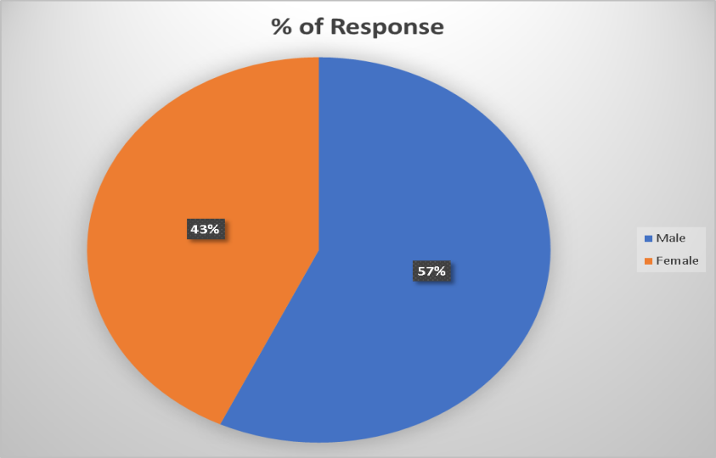  
 **Source: Author’s computation from questionnaire sheet**

From the above depicted Table and figure, we have seen that out of 100 sample respondents, 57% i.e. 57 male opined that there is a impact of corporate social responsibility activities of two companies on them. Rest 43% i.e. 43 female respondents have opined that they have a impact of CSR of two companies on them. It signifies that male respondents have more awareness about the concept of corporate social responsibility reporting and its components over the female respondents.

**Table 2: Age of the respondents**

|  |  |
| --- | --- |
| **Age of Respondents** | **% of Response** |
| 20 Years to 30 Years | 25 |
| 30 Years to 40 years | 30 |
| 40 years to 50 Years | 25 |
| 50 Years to 60 Years | 20 |

**Source: Author’s computation from questionnaire sheet.**

**Figure 2: Age of respondents** 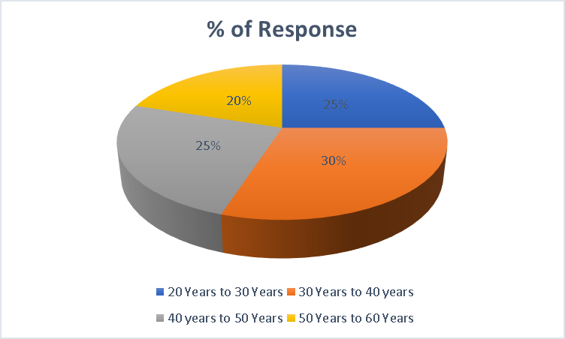

**Source: Author’s computation from Questionnaire sheet.**

Second demographic component is Age of the respondents which comprises of four Age categories i.e. 20 years to 30 years, 30 years to 40 years, 40 years to 50 years and finally 50 years to 60 years. It has been seen from the above table and figure, 30 to 40 years age bracket respondents have 30% response regarding impact of corporate social responsibility activities of two companies followed by 40 to 50 years and 20 to 30 years. 50 to 60 years aged respondents have little knowledge regarding the concept of corporate social responsibility and its activities of the two companies. The main reason regarding 30 to 40 years aged people who give more response regarding impact of corporate social responsibility activity is that they may be employed in any corporate entities and they have gathered continuous knowledge about what is going in the reporting part of any corporate arena.

**Table 3: Educational Qualification of the respondents**

|  |  |
| --- | --- |
| **Educational Qualification** | **% of response** |
| Graduation | 50 |
| Post Graduation | 30 |
| Professional Qualification (CA/CMA/CS/MBA) | 20 |

**Source: Author’s computation from questionnaire sheet.**

**Figure 3: Educational Qualification of the respondents 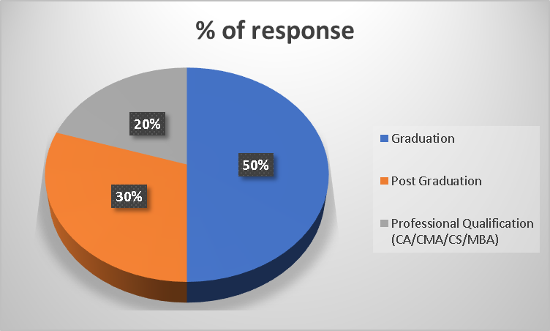 Source: Author’s computation from questionnaire sheet.**

According to educational qualification, we have shown three categories i.e. Graduation, Post graduation and Professional degree holder respondents. From the above table and figure, we have shown that maximum respondents are graduates who have most idea about the impact of corporate social responsibility activities of two selected companies followed by post graduates and professional degree holders. The main reason behind it that probably the graduates are aware of the fact of CSR from their designated syllabus.

Regarding the second part of the questionnaire, we have selected certain variable relating to corporate social responsibility of the selected two companies. Various statements relating to these variables are given to the respondents and responses have been collected through the structured questionnaire. These variables are; 1) Promoting preventive healthcare, 2) Ensuring environmental sustainability, 3) Promotion of education and 4) Community development.

**Table 4: Response regarding promoting preventive healthcare**

|  |  |
| --- | --- |
| Company | Response regarding promoting preventive healthcare |
| Dabur India Ltd. | 60 |
| Marico Ltd. | 40 |

**Source: Author’s computation from Questionnaire.**

**Figure 4: Response regarding promoting preventive healthcare** 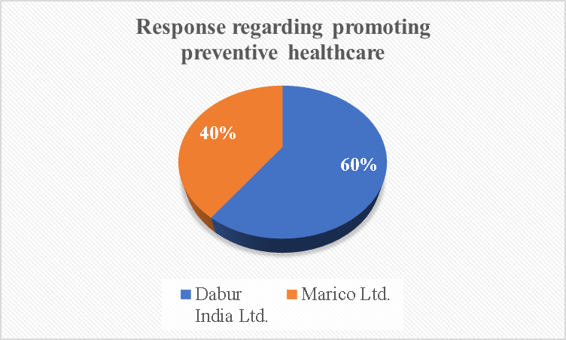  
 **Source: Author’s computation from Questionnaire.**

From the above table and figure, we have seen that most of the respondents will choose Dabur India Ltd. Over Marico Ltd. regarding promoting preventive healthcare. The main reason for that Dabur India Ltd. is an Ayurveda product manufacturing company. On the other hand, Marico Ltd. is daily life and wellness company. Respondents believe that Dabur India Ltd. will introduce new schemes for promoting healthcare system like sanitation programme, set up of more health campus and oral hygiene campus etc.

**Table 5: Responses regarding ensuring environmental sustainability**

|  |  |
| --- | --- |
| Company | Response regarding ensuring environmental sustainability |
| Dabur India Ltd. | 65 |
| Marico Ltd. | 35 |

**Source: Author’s computation from Questionnaire.**

**Figure 5: Responses regarding ensuring environmental sustainability** 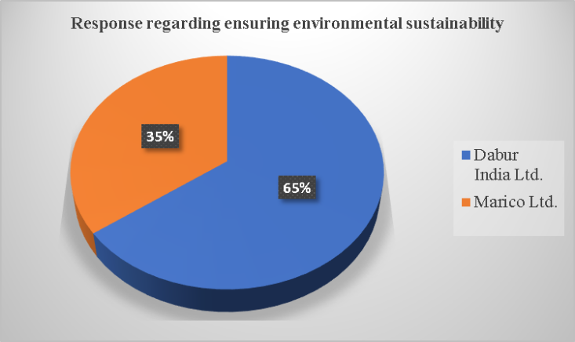  
 **Source: Author’s computation from Questionnaire.**

Regarding ensuring environmental sustainability, 65% people prefer Dabur India Ltd. and 35% choose Marico Ltd. The main reason behind it that recently Dabur India Ltd. launched various schemes for environmental sustainability related issues like water conservation, deforestation, herb cultivation for the farmers, solar energy and plantation drive across different states of India.

**Table 6: Promotion of education**

|  |  |
| --- | --- |
| Company | Promotion of education |
| Dabur India Ltd. | 55 |
| Marico Ltd. | 45 |

**Source: Author’s computation from questionnaire.**

**Figure 6: Promotion of education 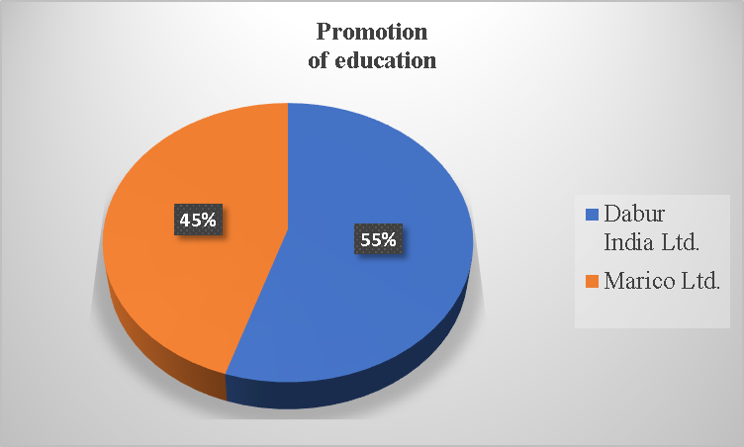 Source: Author’s computation from Questionnaire.**

Regarding promotion of education, we have seen that 55% of the respondents say Dabur India Ltd. Contributes more fund as CSR and 45% say Marico Ltd. The reason is that Dabur India Ltd. provides fund for underprivileged children, improve overall learning facilities in rural schools and build skills that foster employability and inclusive growth.

**Table 7: Response regarding community development**

|  |  |
| --- | --- |
| Company | Community Development |
| Dabur India Ltd. | 60 |
| Marico Ltd. | 40 |

**Source: Author’s computation from questionnaire.**

**Figure 7: Response regarding community development**

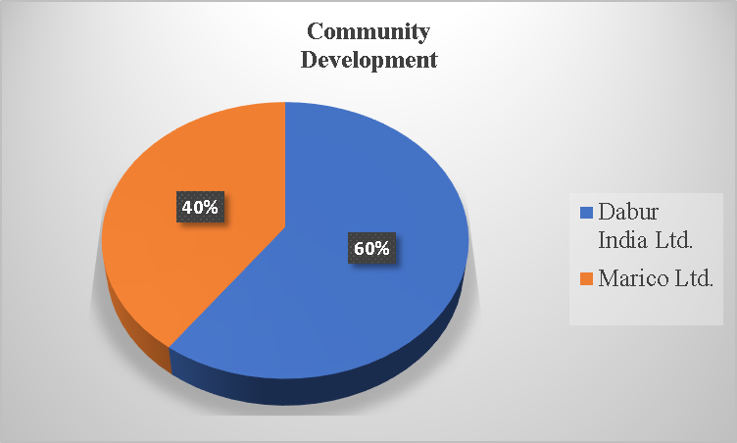  
**Source: Author’s computation from questionnaire.**

Regarding community development, 60% of respondents prefer Dabur India Ltd. and 40% prefer Marico Ltd. The main reason is that Dabur India Ltd. contributes funds for women empowerment like vocational skill training, livelihood programme etc.

1. **To compare the performances of Dabur India Ltd. and Marico Ltd. in regard to their CSR expenditure for the financial years from 2018-19 to 2022-23.**

In this section, we are highlighting the prescribed and actual CSR expenditure incurred by two selected companies.

**Table 8: CSR expenditure for Dabur India Ltd. and Marico Ltd. For the Financial Years 2018-19 to 2022-23.**

|  |  |  |  |  |  |  |
| --- | --- | --- | --- | --- | --- | --- |
| Company | Year | | | | |  |
| Dabur  India Ltd. |  | 2018-19 | 2019-20 | 2020-21 | 2021-22 | 2022-23 |
| Actual CSR (Rs. in Crore) | 26.35 | 27.8 | 28.71 | 30.24 | 33.4 |
|
| Prescribed CSR (Rs. in crore) | 25.43 | 27.6 | 28.52 | 31.16 | 32.34 |
|
| Marico Ltd. | Actual CSR (Rs. in crore) | 18.2 | 19 | 20 | 21.5 | 22.23 |
|
| Prescribed CSR (Rs. in crore) | 18.08 | 18.06 | 19 | 21.5 | 22.23 |
|

**Source: Annual Report/CSR Reporting of Dabur India Ltd. and Marico Ltd. from 2018-19 to 2022-23.**

In this table, we have shown the amount of CSR expenditure spent by Dabur India Ltd. and Marico Ltd. during the financial years 2018-19 to 2022-23. We know as per CSR guidelines, every company must spent 2% of the average profits of last three financial years in as CSR expenditure. We have seen that except 2021-22, Dabur India Ltd. spent more CSR expenditure than the usual prescribed limit. The reason behind it that every year Dabur India Ltd. launched various schemes in each of different activities of corporate social responsibility like promoting preventive healthcare, environmental sustainability, promotion of education and community development programmes. On the other hand, Marico Ltd. spent more CSR expenditure in almost every years except 2021-22 and 2022-23 than the prescribed limit. Marico Ltd. launched various programmes in CSR activities. If we compare between two companies, we have shown that Dabur India Ltd. spent more fund in CSR than Marico Ltd. because of various programmes relating to social commitment are introduced by Dabur India Ltd. over Marico Ltd.

1. **To analyse the CSR spending area wise/activity wise of Dabur India Ltd. and Marico Ltd. for the Financial years 2018-19 to 2022-23.**

In this section, we have highlighted the various areas or activities of corporate social responsibility of two sample companies. Companies spent fund in various areas of CSR like promoting preventive healthcare, environmental sustainability, promotion of education and community development.

**Table 9: Area/Activity wise CSR spending of Dabur India Ltd. and Marico Ltd. for 2018-19 to 2022-23.**

|  |  |  |  |  |  |  |
| --- | --- | --- | --- | --- | --- | --- |
| Year | Promotion of Healthcare (Rs. In crore) | | Environmental sustainability (Rs. In crore) | | Promotion of education (Rs. In crore) | |
|
| Dabur India Ltd. | Marico Ltd. | Dabur India Ltd. | Marico Ltd. | Dabur India Ltd. | Marico Ltd. |
| 2018-19 | 7.29 | 0.47 | 2.55 | 10.38 | 4.22 | 1.46 |
| 2019-20 | 2.93 | 1.43 | 2.48 | 7.94 | 4.79 | 3.8 |
| 2020-21 | 13.03 | 8.6 | 1.1 | 5.16 | 2.35 | 1.18 |
| 2021-22 | 10.88 | 3.16 | 0.5 | 7.11 | 4.35 | 2.6 |
| 2022-23 | 4.46 | 7.5 | 9.12 | 8.6 | 8.6 | 5.37 |

**Source: Annual Report/CSR Reporting of Dabur India Ltd. and Marico Ltd. For 2018-19 to 2022-23.**

From the above table, we have seen that Dabur India Ltd. contributes more funds in promotion of healthcare and promotion of education over Marico Ltd. Because during the financial years 2018-19 to 2022-23 Dabur India Ltd. introduces various schemes relating to promotion of healthcare like sanitation programme, hygiene camp in rural areas etc. Regarding promotion of education, Dabur India Ltd. introduces various projects like related to helping underprivileged children, women gain literacy, improve overall learning environment in rural schools, skill that fosters employability and inclusive economic growth etc. On the other hand, Marico Ltd. contributes more fund to environmental sustainability over Dabur India Ltd. Marico Ltd. launched sustainability 2.0 in 2022 covering 50 key performance indicators across ESG parameters to mitigate environmental risk and climate change, energy efficiency etc.

**Conclusion**

Dabur India Limited is more conscious towards CSR spending as well as CSR reporting practices and in diverse causes.The CSR spending and reporting information by Marico Limited are sometimes inaccurate as CSR wise bifurcation is not always reported in their annual reports.Both neglected the CSR areas like disaster management measures, contribution towards the protection of National heritage and benefits of armed force veterans.

**COMPETING INTERESTS DISCLAIMER:**

Authors have declared that they have no known competing financial interests OR non-financial interests OR personal relationships that could have appeared to influence the work reported in this paper.

**Recommendations**

* Marico Limited should focus more on genuinely contributing towards the causes of CSR more transparently.
* More consciousness should be created about CSR among the ordinary public.
* The neglected areas in CSR should be taken care of by the companies.

**Limitations of the study**

* The results assume that the respondents have given accurate information.
* The information collected will be valid until there is no changes or additions to the provided data.
* The sample of the size of data will be limited to time and resources.

**References**

Shastri, Payal (2022), A comparative study of CSR spending and CSR reporting practices of selected Banks in India, Sachetas, Vol.-1, Issue-4.

Ramu, C. & Vethirajan, C. (2019), Customer perception of CSR impact on FMCG Companies- An Analysis, Impact Journals, Vol.-7, Issue-3.

Inyang, James, Benjamin (2013), Defining the role engagement of Small and Medium Sized Enterprises (SMEs) in Corporate Social Responsibility, International Business Research, Vol.-6, Issue-5.

Rosnan, Herwina, Saihani, Baharin, Shamsul & Yusof, Mohd, Nuryusmawati 2013. Attitudes towards Corporate Social Responsibility among budding business leaders, Procedia- Social and Behavioral Science 107, 52-58.

Dumitru, Ciprian, Stoian (2007), Corporate Social Responsibility versus Tax Avoidance Practices.

[www.dabur.com](http://www.dabur.com)

[www.marico.com](http://www.marico.com)

Company’s Act, 2013 & Company’s amended Act,2017.

Latapí Agudelo, M. A., Jóhannsdóttir, L., & Davídsdóttir, B. (2019). A literature review of the history and evolution of corporate social responsibility. *International journal of corporate social responsibility*, *4*(1), 1-23.

Chen, T., Dong, H., & Lin, C. (2020). Institutional shareholders and corporate social responsibility. *Journal of Financial Economics*, *135*(2), 483-504.

Velte, P. (2022). Meta-analyses on corporate social responsibility (CSR): a literature review. *Management Review Quarterly*, *72*(3), 627-675.

Fatima, T., & Elbanna, S. (2023). Corporate social responsibility (CSR) implementation: A review and a research agenda towards an integrative framework. *Journal of Business Ethics*, *183*(1), 105-121

Le, T. T., Tran, P. Q., Lam, N. P., Tra, M. N. L., & Uyen, P. H. P. (2024). Corporate social responsibility, green innovation, environment strategy and corporate sustainable development. *Operations Management Research*, *17*(1), 114-134.