Original Research Article

Investigation of selection criteria for Ankole cattle beef productivity improvement in Kwimba District of Tanzania

ABSTRACT

Economic and animal performance data collected from Ankole herd of Tanzania Livestock Research Institute (TALIRI)-Lake Zone and progressive farmers were used to analyze economic values of beef traits. Sequential bio-economic modeling methodology involving formulation of profit function was used to estimate economic values of traits influencing investment and revenues of beef production. Fecundity trait studied was calving interval which generated economic value of 833.15. Developmental traits analyzed were age at maturity and age at first calving, which generated economic values of 83.86 and 19, respectively. Weaning weight generated very high positive economic value of 1496.18 contrarily to other studied growth traits (body weight and post-weaning daily gain which generated economic values of -6.09 and -53.69, respectively). Longevity displayed a negative economic value of lowest magnitude (-4.03). Therefore, under the prevailing conditions, selection for growth traits, which is normally prioritized in breeding for beef, showed low potential of impacting profitability improvement. Lowering of the herd mean for calving interval owes to be among the key productivity enhancement strategies for the farm. It was concluded that, in order to realize the benefits of selection, there is the need to parallel the genetic improvement initiative with strategies for lowering production costs, particularly feeds costs.

Keywords: Bio-economic modeling, breeding objective, herd productivity, Sanga, selection
1. INTRODUCTION

In sub-Saharan Africa beef is among the animal proteins most consumed by the rapidly growing population of urban dwellers (IIRR, 2013). Production of beef also stands as an important income and food derivation means to the numerous agro-pastoralists found in the region (IIRR, 2013). In Africa beef is produced pre-dominantly from cattle of indigenous origin, which exhibit variable production coefficients depending on their breeds and strains. In Tanzania, beef accounts for 40% of the livestock sub-sector’s Gross Domestic Product (URT, 2022). However, the country’s sub-sector projections indicate that, sustaining beef production in the future is likely to be infeasible due to low genetic potential of the animals among other factors (FAO, 2021). Over 95% of the beef herd is constituted by Tanganyika Shorthorn Zebu (TSZ) cattle which are among cattle with low mean genetic potential for beef production despite being well adapted to rigorous harsh conditions (Muzzo and Provenza, 2018).
Therefore, there is the need to transform the beef sub-sector into an industry dominated by animals which can exhibit higher production credentials through breeding (Njau et al., 2013). That will in-turn encourage investment in intensified beef production methods, the key transformation which is envisaged to stimulate productivity improvement in the sub-sector (URT, 2022). Beef productivity improvement is crucial because ruminants production currently face challenges of depleting production resources and growing concerns on raising methane emissions, but at the same time required to feed more the growing human population (Weisbjerg et al., 2018).
After experiencing serious drawbacks from crossbreeding TSZ cattle with exotic breeds (Wilson, 2018), crossbreeding with other native breeds has been recommended as one of the promising genetic improvement strategies for TSZ because the strategy doesn’t lead to adaptability challenges (URT, 2017). Ankole cattle, which belong to Sanga group have been among the native breeds considered potential for crossbreeding, and by that virtue the Tanzania Livestock Research Institute (TALIRI) considered establishment of its nucleus in the Lake Zone of Tanzania. Individual animal data recording and performance evaluation of the Ankole nucleus herd has constantly been undertaken since 2007. The data have been used to evaluate individual animals and make decisions regarding development of the nucleus and production of young bulls for dissemination to farmers for crossbreeding with TSZ cattle. Commendable hybrid vigor has been observed among pilot farmers’ herds which have crossbred Zebu cows with Ankole bulls.
TALIRI-Lake Zone considers that, there is the need to develop further the breeding program in terms of intensifying selection within the nucleus so that higher quality germplasm can be disseminated for farmers’ herds improvement (Chasama et al., 2023). The selection which is currently being implemented assumes that all the traits used as selection criteria are of equal relative importance, which is very unlikely to hold in the real sense (Kluyts et al., 2003). This brings-up, the need to identify traits which are most critical from economic grounds and use them as selection criteria according to rationalized weights in order to ensure that genetic gains realized from selection enhances profitability (Laske et al., 2012). In this study, selection criteria for Ankole cattle were analyzed through estimation of economic values (EV), which are used to express traits’ relative importance in selection.

2. material and methods

2.1 Description of the study location
This study was undertaken at Bushini farm of TALIRI-Mabuki, which is in Kwimba District of Mwanza Region (Figure 1). The center of the farm is located at Latitude 3.03⁰ S and Longitude 33.21⁰ E. The area has semi-arid agro-ecology. It has a total area of 1063 hectares, of which 800 hectares have natural pastures dominated by Hyparhenia rufa grass species. The natural pastures is the sole feed resource for feeding all the animals at the farm, which comprises of 37 Ankole cattle, 51 Mpwapwa cattle, 24 Friesian crossbred cattle, 51 Malya goats, 4 Boer goats, 321 Sukuma goats and 60 Malya-Boer crossbred goats.
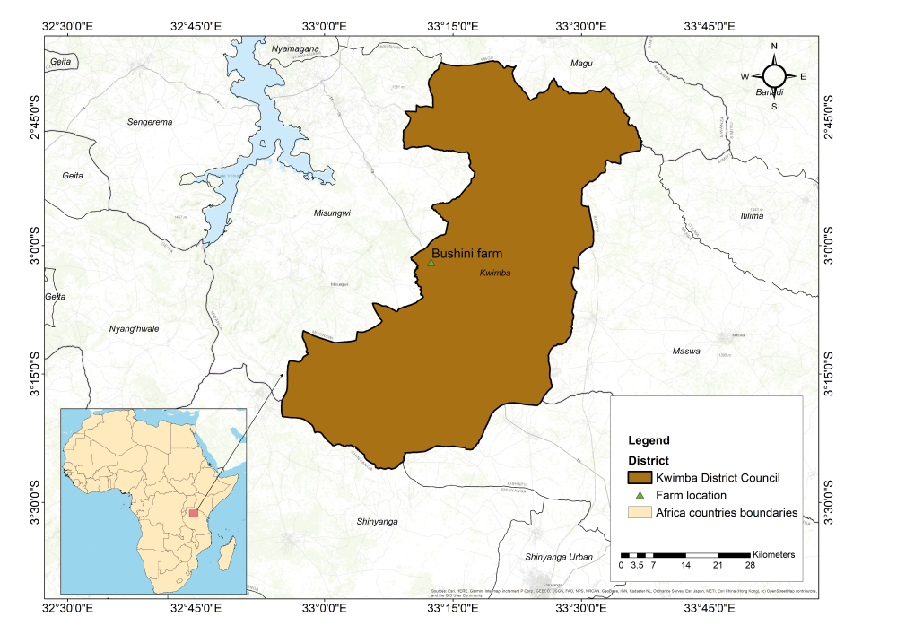Figure 1: Study area map showing location of Bushini farm of TALIRI-Mabuki (Sketched by Chasama G., March 2024)
2.2 Data Collection
Primary Data
Estimation of feeding, veterinary drugs and labor costs was based on the previous production cycle which was demarcated to start in October 2023 and end in September 2024. Feeding costs were estimated by animal category depending on average live weights based on land lease rate and herbage productivity per hectare evaluated during the production cycle. Estimation of costs for veterinary drugs was based on weekly dipping using acaricide, deworming depending on live-weight at three months interval, and average number of treated cases. Estimation of costs of labor was based on casual labor wages. The farm doesn’t incur costs in marketing cattle because animals are sold at farm gate. Indicative prices for beef animals were adopted for estimating revenues from cull cows, heifers and young bulls.
Secondary Data
Most of the secondary data on Ankole cattle management and performance were obtained from the institute Ankole herd (Plate 1) records. Management data were on feeding, breeding, housing and disease control. Performance data were on calving rate, birth weight, weaning age, weaning weight, pre-weaning survival rate, post-weaning survival rate, culling age for males and females, culling rate for males and females, culling weight (at weaning), post-weaning daily gain, age at sexual maturity, weight at sexual maturity, age at first calving, weight at first calving, mortality rate for cows, calving interval, longevity, number of parities per life-time, and weight of cow at culling. Because the farm culls all males at weaning stage, data on age and weight at maturity for males were collected from surrounding progressive farmers who obtained Ankole breeding bulls from the institute and manage their herds similarly to the institute herd.
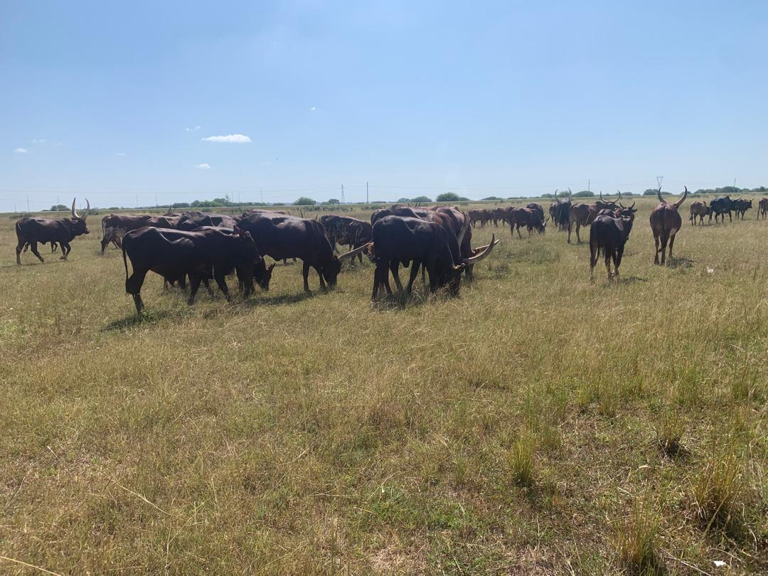
Plate 1. Part of Ankole cattle herd at TALIRI-Mabuki showing the study subjects in the study site (Photo by Chasama G., May 2024)

2.3 Data analysis
Data analysis was done using the sequential bio-economic modeling procedure devised by (Ponzoni and Newman, 1989). The procedure went through specification of production and marketing system, identification of sources of income and costs, determination of biological traits linked to profitability of beef production and derivation of economic values of the traits. This initially involved formulation of profit function using marginal returns analysis, where the biological beef traits were incorporated symbolically (Brascamp and Guy, 1985). Economic values of the traits were estimated by performing stochastic simulation with the developed profit function basing on each trait (Oyama et al., 2002, Davis et al., 2020). The approach eliminated the need for objective determination of fixed costs as income and expenditures were related in a difference form (Brascamp and Guy, 1989).
Annualized total marginal profit was computed using the formula below:
where is the total marginal profit per cow per year (TZS), is the total revenue per cow per year (TZS) (accrued from selling cull cows, bullocks and cull heifers) and is the total variable cost per cow per year (TZS) (incurred in feeding, labor, dipping, de-worming, and treating cows, bullocks, cull heifers and replacement heifers).

3. results
3.1 Specification of management and performance of the Ankole cattle herd
The herd is managed by grazing within the institute grazing resources. No supplementary feeds are provided to the cattle. Calves are separated at grazing and sleeping. Bulls are allowed to have access to cows and heifers all the time. Adult animals are housed in barbered-wire made kraals whereas calves are housed in calf pen. Animal are dipped weekly and dewormed at three months intervals. Treatments are done to animals when disease cases arise. Under the specified management practices, performance of the Ankole herd during the 2023/2024 cycle was as presented in Table 1.

Table 1: Management and performance indices for Ankole cattle at Bushini farm of TALIRI-Mabuki
Performance Characteristics | Unit | Value
Rate of Calving of the herd (RC) | % | 74.36
Birth weight for males | kg | 24
Birth weight for females (BW) | kg | 22.5
Pre-weaning Survival Rate (PrWS) | % | 82.51
Post-weaning Survival rate for growing animals (PoWS) | % | 90.65
Mortality rate for cows (MR_{c}) | % | 5.9
Weaning/culling age for males and females (WA) | days | 240
Culling rate for males (CR_{m}) | % | 100
Culling rate for females (CR) | % | 40
Longevity for cows (L) | days | 3653
Cow parities per lifetime (CPL) | number | 7
Age at First Calving (AFC) | days | 1080
Calving interval (CI) | days | 540
Weaning weight for males (WW_{m}) | kg | 132
Weaning weight for females (WW_{f}) | kg | 126
Age at maturity for males (AM_{m}) | days | 780
Age at maturity for females (AM_{f}) | days | 750
Weight at First Calving (WFC) | kg | 312
Weight at Maturity for males (WM_{m}) | kg | 279
Weight at Maturity for females (WM_{f}) | kg | 261
Weight of cow at culling (WCC) | kg | 384
Post-weaning daily gain for males (PoDGm) | kg/day | 0.31
Post-weaning daily gain for females (PoDGf) | kg/day | 0.3
Ankole cow

4.9 calves born

1.098 replacement heifers
4.04 calves weaned

1.83 heifers
1.83 bullocks

0.059 dead cows

Markets for beef animals
0.941 cull cows
0.732 cull heifers

Figure 2: Model life-time production cycle of Ankole cow at TALIRI-Mabuki farm

3.2 Economic parameters related to Ankole cattle management and marketing
During the production cycle, raising of the Ankole herd at Bushini farm of TALIRI-Mabuki utilized natural pasture which produces herbage at the cost of TZS 35/kg (Table 2). Labor for attending animals was paid at the rate of TZS 2,500 /month/cattle. Health management costs were related to dipping, de-worming and treatments and were estimated at TZS 150/week/head, TZS 625/dose/head, and TZS 80/ml/head, respectively. Valuation of beef off-take was based on the indicative price for beef, which is TZS 6,350/kg live weight.

Table 2: Economic parameters related to Ankole cattle Management and Marketing at Bushini farm of TALIRI-Mabuki
Item | Price unit | Price value
Price of beef output (live animals) | TZS/ kg live weight | 6350
Price of feed (forage) | TZS/ kg of feed | 35
Wages of animal attending labor | TZS/month/head | 2,500
Cost of acaricides for ecto-parasite control | TZS/week/ head | 150
Cost of de-wormer for endo-parasite control | TZS/dose | 625
Cost of veterinary drugs for diseases treatment | TZS/ml/head | 80

3.3 Profitability for beef production
On the basis of a single cow life cycle model, annualized marginal profit for the Ankole herd was estimated at TZS 215,317.75 (Table 3). Major part of the cost was observed to be incurred on feeds and followed by laborers wages. Major part of profit in keeping a cow was derived from its sale and the sale of the bullocks it generates. As they are primarily retained in for herd expansion, heifers’ contribution in profitability (TZS 41,872.38/cow/year) of the herd was remarkably lower than that of bullocks (TZS 110,850.63/cow/year).

Table 3: Beef production profitability analysis for Ankole herd of TALIRI-Mabuki
Variable costs (In TZS) by animal category
Cost item |  | Cows | Young bulls | Replacement heifers | Cull heifers | Total
Feeds |  | 59,511.01 | 2,882.25 | 15,444.43 | 1097.47 | 78935.16
Labor |  | 21,715.38 | 3519.23 | 7601.54 | 1407.69 | 34243.85
Acaricide |  | 5646 | 541.11 | 1947.99 | 360.74 | 8495.84
De-worming |  | 904.81 | 205.29 | 580.67 | 82.12 | 1772.88
Veterinary drugs |  | 289.54 | 187.69 | 304.06 | 225.23 | 1006.52
Total |  | 88,066.74 | 7,335.57 | 25,878.69 | 3,173.25 | 124,454.25
Revenue (In TZS) by animal category
 |  | Cows | Young bulls | Replacement heifers | Cull heifers | Total
Revenue |  | 176,540.16 | 118,186.2 | 0 | 45,045.63 | 339,771.99
Profit (In TZS) by animal category
 | Cows |  | Young bulls | Replacement heifers | Cull heifers | Total
Profit | 88,473.42 |  | 110,850.63 | -25,878.69 | 41,872.38 | 215,317.75
TZS stands for Tanzanian Shilling, kg stands for kilogram

3.4 Traits Captured in the Profit Function and their Economic Values
Life-time output of a cow depends mainly on number and selling weight of the animals it generates. Number of sold animals was found to be a function of Pre-weaning Survival, Post-weaning Survival, Age at Maturity (AM), Age at First Calving (AFC), Calving Interval (CI) and Longevity (L). Weight of sold animals selling was associated with Birth Weight (BW), Weaning Weight (WW), and Post-weaning Daily Gain (PoDG). On the other hand, feed was the major cost item and because its estimation was based on body weight, then the same traits previously linked to body weight of the animals at selling (BW, WW and PoDG) were considered as driving traits in expenditures for feeding. Other cost items varied either with number of animals or both number and weight of animals. For that case the traits which were incorporated numerically in the profit function were Birth weight, Weaning Weight, Reproductive Longevity, Age at Maturity, Age at First Calving, Calving Interval and Post-weaning Daily Gain. The profit function which was developed basing on the performance traits of Ankole cattle and economic indices of the production system took form of the equation below:

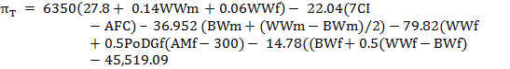

where π_{T} is marginal profit, WWm is weaning weight for males, WWf is weaning weight for females, BWm is birth weight for males, BWf is birth weight for females, AMf is age at maturity for females, AFC is age at first calving, CI is calving interval, and PoDGf is post-weaning daily gain for females.

The economic values generated from stochastic simulation ranged widely between -53.69 TZS/day (Post-weaning daily gain) and 1,496.18 TZS/kg (Weaning Weight) (Table 4). Therefore growth traits lied in both extremes. Developmental traits (AM and AFC) generated positive EV although the magnitudes were low (83.86 and 19, respectively). Calving interval, which inclines more as a fecundity trait also displayed a relatively high EV of 833.15 whereas Longevity was found to bear low EV of -4.03.

Table 4: Economic Values for Beef Traits of Ankole Cattle Herd kept at Bushini farm of TALIRI-Lake Zone
Trait | Unit | Economic Value
Birth Weight (BW) | TZS/Kg | -6.09
Weaning Weight (WW) | TZS/Kg | 1,496.18
Post-weaning Daily Gain (PoDG) | TZS/Kg/day | -53.69
Age at Maturity (AM) | TZS/day | 83.86
Age at First Calving (AFC) | TZS/day | 19
Calving Interval (CI) | TZS/day | 833.15
Longevity | TZS/day | -4.03

4.0 DISCUSSION

Analysis of beef traits economic values for Ankole cattle herd at TALIRI-Mabuki showed WW, CI, AM, and AFC being promising traits to select for in order to improve profitability, with relative economic weight regressing in that order. However, the high and positive EV observed for WW, which is an intermediate stage growth trait seemed to be outlying because BW and PoDG, which are manifested respectively before and after it, had negative economic values. The generation of negative economic values by growth traits observed in the present study deviates from results reported by (Annor 1996) for Ghanaian cattle but concurs with observations made by (Gebretnsae et al., 2018) on economic value of pre-weaning daily gain in Begait cattle of Ethiopian. The observed dominance of negative economic values among growth traits is a reflection of high feeding costs (Hietala et al., 2014). This implies that, when selection is done to improve the herd mean growth performance, the animals will be liable to produce more beef but with higher incremental investment thereby to lower profitability.

The array of economic values estimated under the study showed selection geared to shorten CI can be a responsive selective breeding strategy for the Ankole herd. Calving interval was also reported to bear positive economic value also by (Annor 1996) and (Gebretnsae et al., 2018). The high economic value for CI observed in this study and those reported by (Annor 1996) and (Gebretnsae et al., 2018) all reflect the constraint of high feeding costs in the traditional beef production systems where shortening CI reduces cow maintenance costs for calf production (Burgers et al., 2021). Since the trait has limitation of low heritability and late expression in life, there is the need to capitalize on improving reproductive management to allow timely mating and early conception after calving. This can enhance the exploitation of cows’ longevity in terms of producing many calves which are ultimately disposed for income generation. Therefore, producing many calves and taking off the herd culls at weaning stage owes to be the management strategy for beef productivity enhancement in the farm.

In this study, AM and AFC generated positive economic values, but relatively of low magnitude. No study has been found to report on economic value of AM but (Chasama et al., 2024) also reported AFC with moderate economic value for Tanganyika Shorthorn Zebu cattle. This possibly occurs because the cattle breeds are kept in the same farming system. Inclusion of the developmental traits in selection indices for Ankole cattle under semi-arid therefore shouldn’t be ignored. Life-time productivity of a cow can tremendously be promoted from the side of early entry to reproductive phase (Cooke et al., 2013). Therefore, selection for shorter AM and AFC in the area under the study harbors potential for lowering investment on a female animal to the point of attainment of sexual maturation and producing its first calf. Manipulation of these traits can also be approached from nutrition side but that is discouraged because can end-up to the problem of calving difficulties (Twomey and Croime, 2023). Generation of very low economic value by longevity trait implies that selecting for long stay of cows in the herd is neither detrimental nor beneficial. Considering that evaluation of the trait is also difficult due to its late expression, its inclusion as a selection criterion for the studied herd is not advised. However, there is the need to explore further how this trait can be exploited for selection because in tropical America it has shown to bear moderate to high economic values (Twomey and Croime, 2023).

Collectively, the economic values for growth traits, developmental traits and calving interval reflected the challenge of foraging resources whose lease rate is high due to scarcity of land in neighboring areas surrounding the farm and all over semi arid areas of Tanzania Lake zone (Olago et al., 2006). The implication of the results however shouldn’t discouraging selection for these important traits but instead to consider multi-faceted animal productivity improvement strategies. Improvement of growth performance of the cattle needs to be coupled by interventions which can lower feeds’ cost so that incremental beef resulting from growth performance improvement can be of higher value than the incremental investment. In that way, the findings of the study generally indicate that workability of breeding strategies in translating beef productivity improvement requires also development of alternative feeding strategies which can lower forage costs.

5. Conclusion

The analysis of beef traits of economic importance of Ankole herd at TALIRI-Mabuki farm showed lowering of the herd mean CI to be the most promising productivity improvement strategy. With the prevailing conditions, especially with regard to feeds cost, growth traits showed low potential for selection. Therefore, in order to realize the potential of improving cattle genetics in Tanzania Lake zone there is the need to parallel genetic improvement initiatives with initiatives targeting development of alternative feeding systems for cattle.

disclaimer (artificial intelligence)
Authors hereby declare that no generative AI technologies such as Large Language Models (Chat GPT, COPILOT, etc) and text-to-image generators have been used during writing or editing of this manuscript.

ETHICAL APPROVAL
This research was conducted in compliance with ethics and guidelines for livestock research as stipulated by Tanzania Livestock Research Institute (TALIRI).

References

Annor SY 1996 Development of a breeding objective for beef cattle in Ghana. MSc.Thesis, Massey University, New Zealand.

Brascamp, E.W. and Guy, D.R. (1985). Derivation of economic weights from profit equations. Animal Production 40: 175-180.

Burgers, E.E.A, Kok, A., Goselink, R.M.A., Hogeveen, H., Kemp, B. and Van Knegsel, T.M. (2021). Revenues and costs of dairy cows with different voluntary waiting periods based on data of a randomized control trial. Journal of Dairy Science 105:4171-4188. http://dx.doi.org/10.3168/jds.2021-20707.

Chasama, G.L., Katandukila, J.V. and Hepelwa, A.S. (2023). Adapting selection schemes for indigenous cattle improvement in sub-Saharan Africa-a review. European Journal of Agriculture and Food Sciences 4(1):14-20.

Chasama, G.L., Hepelwa, A.S., Chibwana, F.D., and Katandukila, J.V. (2024). Development of Breeding Objective for Tanganyika Shorthorn Zebu. Tanzania Veterinary Journal 38 (2): 11-20. DOI: https://doi.org/10.4314/tvj.v38i2.2

Cooke, J.S., Cheng, Z., Bourne, B.N. and Wathes, D.C. (2013). Association between growth rates, age at first calving and subsequent fertility, milk production and survival in Holstein-Friesian heifers. Open Journal of Animal Sciences 3(1):1-12 DOI: 10.4236/OJAS.2013.31001.

Davis, R.B., Norberg, E. and Fogh, A. (2020). Estimation of Genetic Parameters for Young Stock Survival in Beef x Dairy Crossbred Calves. Animal 14(3): 445-451.

FAO (2021). Repurposing food and agricultural policies to make healthy diets more affordable In:The state of food security and nutrition in the world 2022. OECD/FAO , Rome.https://doi.org/10.4060/cc0639en.

Gebretnsae M, Solomon G and Mengistu U 2018 Economic values of Begait cattle breeding objective traits under low and medium input production systems in northern Ethiopia. Livestock Research for Rural Development 30(12). Available at www.lrrd.org/lrrd.org/lrrd30/1/gebret30012.html.

Hietala, P., Wolfova, M., Kantanen, J. and Juga, J. (2014). Economic values of production and functional traits, including residual feed intake, in Finnish milk production. Journal of Dairy Science 97:1092-1106. http://dx.doi.org/10.3168/jds.2013-7085.

International Institute of Rural Reconstruction (IIRR) (2013). Moving herds moving markets: making markets work for African Pastoralists. IIRR, Nairobi.

Kluyts, J.F., Neser, F.W.C. and Bredfield, M.J. (2003). Development of breeding objectives for beef cattle breeding: Derivation of economic values. South African Journal of Animal Science 33: 142-158.
Laske, C.H., Teixeira, B.B.M., Dionello, N.J.L. and Cardoso, F.F. (2012). Breeding objectives and economic values for traits of low input family –based beef cattle production system in the State of Rio Grande do Sul. Revista Brasileira de Zootecnia 92:298-305.

Muzzo, B.I. and Provenza, F.D. (2018). A review of strategies for overcoming challenges of beef production in Tanzania. Livestock Research for Rural Development, 30:12. http://www.lrrd.org/lrrd30/12/iddy30199.html.

Njau, F.B.C., Lwelamira, J., Hyandye, C. (2013). Ruminant livestock production and quality of pastures in the communal grazing land of semi-arid central Tanzania. Livestock Research for Rural Development 25:146, 2013.Available at http://www.lrrd.org/lrrd25/8/Njau25146.html.

Olago, D.O., Odada, E.O. and Ochola, W. (2006). Environment for development: An ecosystems assessment of Lake Victoria basin, UNEP/PASS www.start.org/download/publications/environment-development.pdf.
Oyama, K., Katsuta, T., Anada, K. and Mukai, F. (2002). Heritability and repeatability estimates for reproductive traits of Japanese Black cows. Asian-Australian Journal of Animal Science 15(12): 1680-1685.

Ponzoni, R.W. and Newman, S. (1989). Developing breeding objective for Australian beef cattle production. Animal Production 49:35-47.

Twomey, A.J. and Cromie, A.R. (2023). Impact of age at first calving on performance traits in Irish beef herds. Journal of Animal Science 101:skad008. Doi: 10.1093/jas/skad008.

United Republic of Tanzania (URT) (2017). Tanzania livestock sector analysis. Ministry of Livestock and Fisheries. www.http/:mifugo.go.tz./uploads/publications.

United Republic of Tanzania (URT) (2022.) Livestock sector transformation plan. Ministry of Livestock and Fisheries. Available at https://www.mifugouvuvi.go.tz.

Weisbjerg, M.R., Terkelsen, M., Hvelplund, T., Lund, P. and Madsen, J. (2018). Increased productivity in Tanzanian cattle is the main approach to reduce Methane emission per unit of product. Tanzania Journal of Agricultural Sciences 18(1): 13-21.

Wilson, R.T. (2018). Crossbreeding cattle in Africa. Journal of Agriculture and Environmental Sciences 7:16-31.

