# **Rehabilitation Protocol for Brachial Plexus Injury**

**Abstract**

Brachial plexus injury (BPI) is one of the most serious peripheral nerve injuries, with severe physical disabilities and long-term financial and psychological consequences. Rehabilitation is a cornerstone of BPI management. Rehabilitation is inherently patient-centered and demands consistent adherence. The best outcomes are seen when patients are well-informed, motivated, and actively engaged in their recovery. This study discusses a comprehensive Rehabilitation Protocol for Brachial Plexus Injury. Different phases of Conservative Management Rehabilitation Protocol were discussed in the study. Rehabilitation must be individualized and adaptable. To ensure the efficiency of the protocol, therapists must document progress using MRC grading, goniometry for ROM, and validated functional outcome scales (e.g., DASH score).

**Keywords:** Brachial plexus injuries, neural regeneration, Orthotic Support, Passive Range of Motion, Intermittent Galvanic Stimulation

## **Introduction**

Brachial plexus injury (BPI) is one of the most serious peripheral nerve injuries, resulting in severe and persistent impairments of the upper limb and disability in adults and children alike. Rehabilitation intervention can be beneficial to some extent during all stages of recovery [7,9]. Brachial plexus injuries (BPI) are among the most complex peripheral nerve injuries, with significant implications on upper limb function, quality of life, and psychosocial well-being. These injuries result from trauma, traction, or avulsion of the nerve roots forming the brachial plexus, which innervates the shoulder, arm, and hand. The extent and level of injury influence prognosis and dictate the course of treatment, including conservative rehabilitation or surgical intervention.

Rehabilitation is a cornerstone of BPI management. Rehabilitation therapy that has been widely studied focusing on exercise therapy, sensory training, neuroelectromagnetic stimulation, neurotrophic factors, acupuncture and massage therapy, etc., while interventions like hydrotherapy, phototherapy, and neural stem cell therapy are less studied [8]. Rehabilitation is a prolonged, structured process aimed at optimizing neural regeneration, motor control, sensory function, and preventing complications. Rehabilitation requires an interdisciplinary team with a person-centred approach, addressing both physical and psychosocial needs [10]. The protocol described here has been developed by the Department of Burns, Plastic & Reconstructive Surgery (BPS) in collaboration with the Department of Physical Medicine and Rehabilitation (PMR) at AIIMS Bathinda. It incorporates insights from globally acknowledged protocols like the Donor Activation Focused Rehabilitation Approach (DAFRA) and the Birmingham Rehabilitation Protocol to deliver comprehensive, evidence-based care.

Rehabilitation is inherently patient-centered and demands consistent adherence. The best outcomes are seen when patients are well-informed, motivated, and actively engaged in their recovery. The journey is slow and demands patience and precision. As such, therapists, surgeons, and caregivers must work in synchrony to implement phase-wise rehabilitation, tailored to the patient’s condition, surgical status, and functional goals.

## **General Objectives of Rehabilitation**

Regardless of the treatment modality (conservative or surgical), the overarching objectives of BPI rehabilitation include:

* **Maximizing motor and sensory recovery.**
* **Preventing secondary complications**, such as joint stiffness, neuropathic pain, and muscle atrophy.
* **Enhancing functional independence and quality of life.**
* **Educating and empowering patients and caregivers** for home-based care and long-term follow-up.

The rehabilitation protocol is divided into two major tracks:

1. Conservative management.
2. Surgical management (including pre- and post-operative care).

Each is further subdivided into phases that align with the physiological timeline of recovery. The overview is illustrated in **Figure 1**.

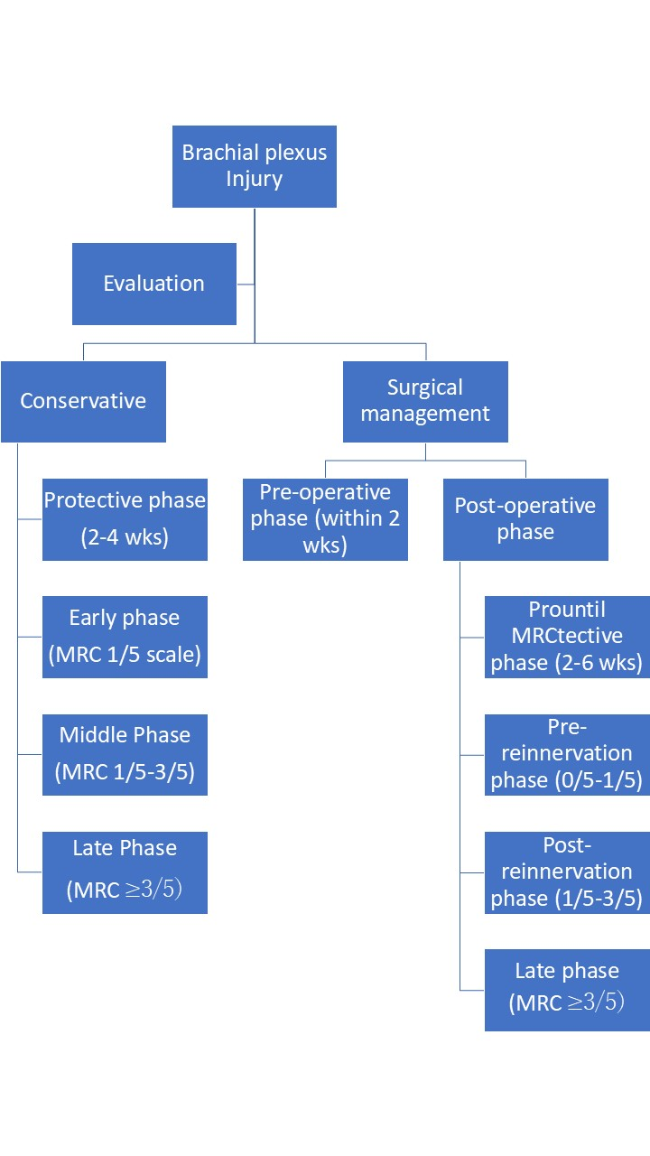

FIGURE 1: Rehabilitation Protocol Flow Chart

## **I. Conservative Management Rehabilitation Protocol**

Conservative treatment is indicated in patients where spontaneous recovery is expected (e.g., neurapraxia, mild axonotmesis), in partial injuries, or in patients unfit for surgery. The aim is to preserve joint and muscle integrity during the period of nerve recovery, facilitate neural regeneration, and progressively enhance motor and sensory function.

### **1. Protective Phase (First 2–4 Weeks Post-Injury)**

**Goals:**

* Protect vulnerable joints and denervated muscles.
* Minimize inflammation, edema, and pain.
* Preserve passive joint mobility.

**Interventions:**

* **Orthotic Support:** Custom or prefabricated orthoses are used to stabilize joints (e.g., wrist cock-up splints, shoulder immobilizers) and prevent contractures and subluxation.
* **Compression and Elevation:** Use of stockinette or elastic wraps to manage edema; limb elevation to enhance venous and lymphatic drainage (see **Figure 2**).

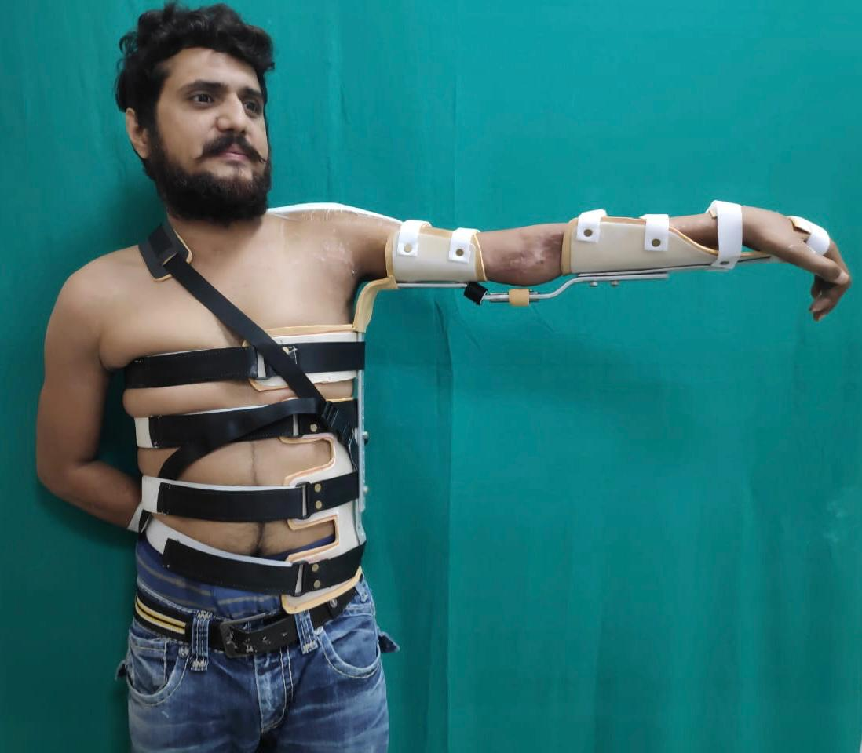

FIGURE 2: Orthotic Support, Positioning And Elevation Of The Limb.

* **Passive Range of Motion (PROM):** Gentle PROM exercises for all affected joints ensure maintenance of joint mobility and prevent stiffness. Care is taken to avoid overstretching or joint stress.
* **Intermittent Galvanic Stimulation (IGS):** Initiated late in this phase to stimulate denervated muscles, enhance blood flow, and delay atrophy (see **Figure 3**).

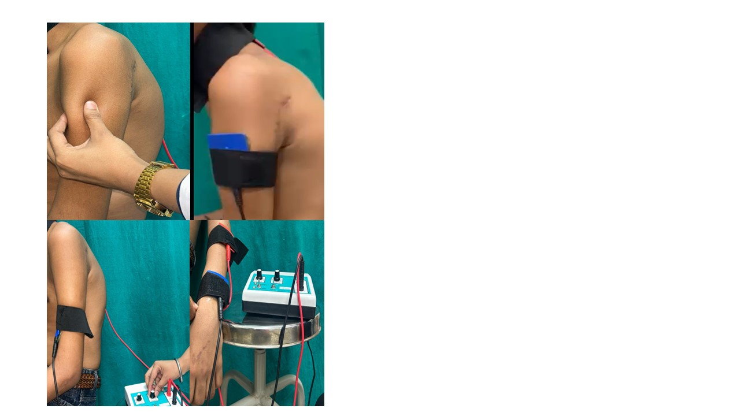

FIGURE 3: Galvanic Stimulation Of Innervated Muscles.

Close monitoring for signs of neuropathic pain or early deformities is essential. Family education is emphasized for continued home-based care.

### **2. Early Phase (Swelling Resolved to MRC Grade 1/5)**

**Goals:**

* Continue joint protection.
* Preserve muscle fiber architecture.
* Facilitate early neural activation.

**Interventions:**

* **Continuation of Orthosis and Limb Positioning:** Proper limb alignment is critical to prevent complications like shoulder subluxation or elbow flexion contracture.
* **PROM and Assisted Movements:** Progressive PROM along with assisted active movements where feasible.
* **IGS:** Regular stimulation sessions maintain muscle readiness for eventual reinnervation.

Throughout this phase, psychological support and realistic goal-setting help maintain motivation and compliance.

### **3. Middle Phase (MRC Grade 1/5 to 3/5)**

**Goals:**

* Build initial voluntary muscle control.
* Improve muscle strength and endurance under gravity-eliminated conditions.

**Interventions:**

* **Faradic Electrical Stimulation:** Initiated when minimal voluntary muscle contraction is evident. It helps in recruiting motor units and facilitating neuromuscular retraining (see **Figure 4**).

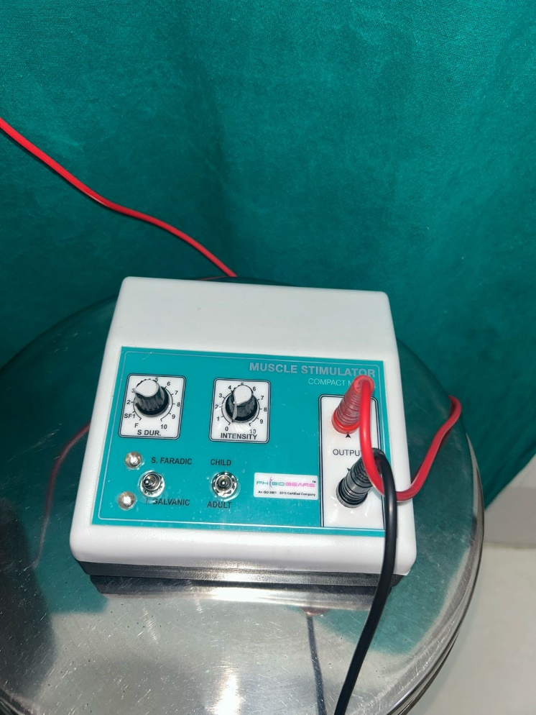

FIGURE 4: Galvanic And Faradic Muscle Stimulation Equipment.

* **Active Range of Motion (AROM):** Movements are encouraged in gravity-minimized planes (e.g., supine position or using slings).
* **Graded Strengthening:** Exercises target weak but reinnervating muscles, avoiding fatigue. Repetition and proper technique are emphasized over intensity.

Therapists closely supervise sessions to ensure the correct pattern of movement, avoiding compensatory strategies.

### **4. Late Phase (MRC Grade ≥3/5)**

**Goals:**

* Enhance strength, coordination, and function.
* Transition to activity-based therapy.

**Interventions:**

* **Progressive Resistive Exercises:** Introduction of low to moderate resistance using bands, weights, or functional activities.
* **Task-Specific Training:** Writing, reaching, or dressing activities help restore ADL (activities of daily living).
* **Endurance Training:** Longer-duration, low-resistance exercises to improve muscle stamina.

The focus shifts toward reintegration into daily routines, school, work, or vocational activities. Long-term follow-up remains critical to track progress and modify the plan as needed.

## **II. Surgical Management Rehabilitation Protocol**

Patients undergoing surgical interventions such as nerve grafting, nerve transfers, or free functional muscle transfer (FFMT) require a more intensive, staged rehabilitation approach. Recovery depends not only on surgical technique but on meticulous post-operative therapy that facilitates reinnervation and cortical adaptation.

### **A. Pre-Operative Phase (2 Weeks Prior to Surgery)**

**Goals:**

* Condition donor muscles to ensure robust function post-transfer.
* Maintain mobility and integrity of the recipient muscle bed.

**Interventions:**

* **Donor Muscle Strengthening:** For example, if the spinal accessory nerve is to be used, trapezius strengthening is prioritized.
* **IGS for Recipient Muscles:** Keeps denervated muscles viable, awaiting reinnervation.
* **Joint Mobility Exercises:** Ensure full passive ROM of joints related to both donor and recipient sites.

Preoperative education is emphasized, including expected timelines, rehabilitation commitment, and outcome expectations.

### **B. Post-Operative Rehabilitation Phases**

#### **1. Protective Phase (2–6 Weeks Post-Operative)**

**Goals:**

* Protect surgical repairs and nerve coaptation.
* Manage postoperative edema and inflammation.
* Maintain passive joint mobility.

**Interventions:**

* **Immobilization:** Specific joints may be immobilized as per the surgical site, especially in FFMT.
* **PROM and Assisted AROM:** Initiated in unaffected joints and gradually expanded under supervision.
* **IG Stimulation of Other Paralyzed Muscles:** Ensures unaffected areas do not deteriorate.
* **Isometric Exercises:** Gentle isometric contractions for donor areas, avoiding tension on coaptation.

Strict precautions are observed to prevent stress on nerve grafts or transfer sites.

#### **2. Early Activation Phase (MRC 0 to 1/5)**

**Goals:**

* Promote cortical recognition of new donor-recipient patterns.
* Begin gentle activation of reinnervating muscles.

**Interventions:**

* **Weaning Off Orthoses:** Encouraged as motor control returns.
* **Mirror Visual Feedback Therapy (MVFT):** Uses visual stimuli to improve motor planning and plasticity.
* **Cortical Re-education Exercises:** Techniques like mental imagery, biofeedback, and donor-recipient correlation training are introduced.
* **IGS and Muscle Stimulation:** Focuses on recipient and associated donor muscles.

Exercises are gentle and goal-directed, avoiding fatigue or strain.

#### **3. Post-Reinnervation Phase (MRC 1/5 to 3/5)**

**Goals:**

* Reinforce voluntary control.
* Encourage independent activation of reinnervated muscles.

**Interventions:**

* **Faradic Re-Education:** Strengthens the emerging voluntary response.
* **AROM in Gravity-Eliminated Planes:** Promotes smooth and efficient movement patterns.
* **Co-Activation Therapy:** Simultaneous contraction of donor-recipient muscles to reinforce neural pathways.
* **Aquatic Therapy:** Useful for pain relief and movement facilitation in a buoyant environment.
* **Constraint-Induced Movement Therapy (CIMT):** Restrains the unaffected limb to force use of the affected side.
* **Desensitization Techniques:** Helps manage allodynia and other sensory anomalies.

#### **4. Functional Recovery Phase (MRC ≥3/5)**

**Goals:**

* Build muscle endurance and functional independence.
* Integrate limb use into daily life and occupational activities.

**Interventions:**

* **Resistive AROM Exercises:** Tailored to individual needs and tolerance levels.
* **Progressive Strength and Endurance Training:** May include isotonic and isokinetic exercises.
* **Real-Life Task Simulation:** Dressing, grooming, typing, lifting objects, etc.
* **Continued CIMT and Neural Mobilization:** Enhances limb function and nerve health.

Patients are assessed for assistive technology, vocational retraining, and support systems to ensure holistic reintegration.

## **III. Training Modes and Parameters**

To ensure compliance and sustainability, rehabilitation must be individualized and adaptable.

**Key Considerations:**

* **Home-Based Protocols:** Empower patients and reduce dependency on frequent hospital visits.
* **Repetitions & Frequency:**
  + **Electrical Stimulation:** 3 sets × 30 contractions × 3 times/day.
  + **ROM Exercises:** 3 sets × 10 repetitions × 3 times/day.
  + **Strength Training:** Begin with high-repetition, low-resistance for endurance, then progress.
* **Pain Management:** Transcutaneous Electrical Nerve Stimulation (TENS) is used as needed.

Therapists must document progress using MRC grading, goniometry for ROM, and validated functional outcome scales (e.g., DASH score).

## **Conclusion**

Rehabilitation in brachial plexus injury is both an art and a science. A phase-wise, protocol-driven approach, as described herein, ensures that patients receive timely, structured, and individualized care. Whether managed conservatively or surgically, success hinges on early initiation, multidisciplinary coordination, and patient adherence.

This protocol integrates global best practices and local clinical experience to guide healthcare providers in delivering holistic rehabilitation. By incorporating electrical stimulation, task-specific training, cortical re-education, and neuroplasticity-based interventions like MVFT and CIMT, it maximizes recovery potential and functional independence.

Ultimately, rehabilitation transforms potential into performance—and injury into opportunity for restoration.

References:

1. Smania N, Berto G, La Marchina E, Melotti C, Midiri A, Roncari L, et al. Rehabilitation of brachial plexus injuries in adults and children. Eur J Phys Rehabil Med. 2012 Sep;48(3):483–506.

2. Saliba S, Saliba EN, Pugh KF, Chhabra A, Diduch D. Rehabilitation considerations of a brachial plexus injury with complete avulsion of c5 and c6 nerve roots in a college football player: a case study. Sports Health. 2009 Sep;1(5):370–5.

3. Li H, Chen J, Wang J, Zhang T, Chen Z. Review of rehabilitation protocols for brachial plexus injury. Front Neurol [Internet]. 2023 Apr 17 [cited 2025 Apr 2];14. Available from: https://www.frontiersin.org/journals/neurology/articles/10.3389/fneur.2023.1084223/full

4. Solomen S, Babu B, Pc M, K S, S AG. Conservative Management of Brachial Plexus Injury Through a Structured Rehabilitation Protocol: A Case Report. rjpt [Internet]. 2021 [cited 2025 Apr 2];1(3). Available from: https://journalgrid.com/view/article/rjpt/408

5. Sim D, Kuo KT, Rodriguez-Silva W, Seal S, Filippi L, Tuffaha S, et al. Evaluation of Rehabilitation Techniques for Traumatic Ulnar Nerve Injuries After Surgical Repair: A Systematic Review. Annals of Plastic Surgery. 2024 Oct;93(4):478.

6. Chagas AC de S, Wanderley D, Barboza PJM, Martins JVP, de Moraes AA, de Souza FHM, et al. Proprioceptive neuromuscular facilitation compared to conventional physiotherapy for adults with traumatic upper brachial plexus injury: A protocol for a randomized clinical trial. Physiotherapy Research International. 2021;26(1):e1873.

7. Li, H., Chen, J., Wang, J., Zhang, T., & Chen, Z. (2023). Review of rehabilitation protocols for brachial plexus injury. *Frontiers in Neurology*, *14*, 1084223.

8. Scott, K. R., Ahmed, A., Scott, L., & Kothari, M. J. (2013). Rehabilitation of brachial plexus and peripheral nerve disorders. *Handbook of clinical neurology*, *110*, 499-514.

9. Evertsson, L., Millkvist, H., Sjerén, S., Rosenberg, L., & Nilsson, I. (2025). A fight on your own–experiences of rehabilitation after traumatic brachial plexus injuries. *Disability and Rehabilitation*, 1-9.

10. Solomen, S., Babu, B., Muralidharan, P. C., Sreejith, K., & Gafoor, A. (2021). Conservative management of brachial plexus injury through a structured rehabilitation protocol: a case report. *RGUHS Journal of Physiotherapy*, *1*(3).