Book Name: | Science and Technology: Developments and Applications
Manuscript Number: | Ms_BPR_5154
Title of the Manuscript: | A REVIEW OF BULLETPROOF VESTS: MATERIALS, TECHNOLOGY, AND APPLICATIONS IN PROTECTIVE CLOTHING
Type of the Article | Book chapter

PART 1: Comments

 | Reviewer’s comment  Artificial Intelligence (AI) generated or assisted review comments are strictly prohibited during peer review. | Author’s Feedback (Please correct the manuscript and highlight that part in the manuscript. It is mandatory that authors should write his/her feedback here)
Please write a few sentences regarding the importance of this manuscript for the scientific community. A minimum of 3-4 sentences may be required for this part. | The Review article gives the information about the bulletproof vests, materials used and its application. The article also provides details regarding the future trends and innovations for improving the quality, durability of the materials used for bulletproof vests.
Is the title of the article suitable?  (If not please suggest an alternative title) | Yes, the title of the article is in line with manuscript.
Is the abstract of the article comprehensive? Do you suggest the addition (or deletion) of some points in this section? Please write your suggestions here. | The abstract needs to be improved with respect to quantitative results of different materials which are being reviewed
Is the manuscript scientifically, correct? Please write here. | Yes, the manuscript is scientifically correct
Are the references sufficient and recent? If you have suggestions of additional references, please mention them in the review form.  - | Latest and more references (ie. 2023, 2024 and 2025) to be cited for various materials.
Is the language/English quality of the article suitable for scholarly communications? | Yes the english language is satisfactory
Optional/General comments | - The introduction part needs to be elaborated  - Figure captions are missing in the manuscript  - Schematic figures are missing eg. STF and other materials in the manuscript  - Kindly mention from where the different materials were procured along with its properties  - Improve the quality of the image, the text is not clear.  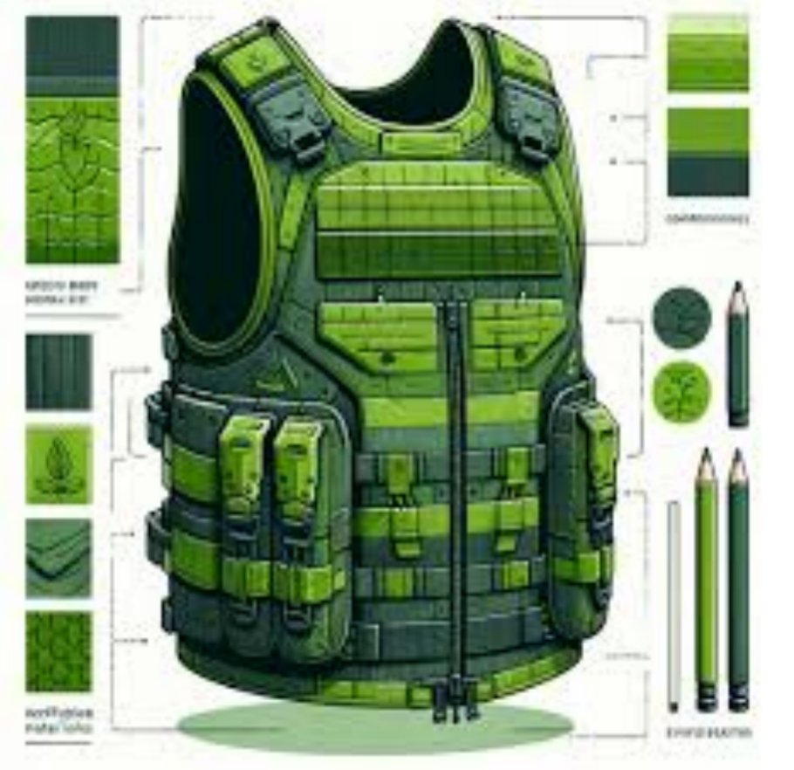

PART 2:

 | Reviewer’s comment | Author’s comment (if agreed with the reviewer, correct the manuscript and highlight that part in the manuscript. It is mandatory that authors should write his/her feedback here)
Are there ethical issues in this manuscript? | (If yes, Kindly please write down the ethical issues here in detail)

Reviewer details:
T Pramod, India

