Influence of Baffle Block and Weir Downstream Slope at Stilling Basin of Solid Roller Bucket Type on Hydraulic Jump and Energy Dissipation

**Abstract.** Weir is a water structure built crossing a river to elevate the water level or the channel that will be directed to the irrigation network. The rise in water level due to damming will result in rapid flow to downstream. The change of flow from supercritical to subcritical will create a hydraulic jump. In order to reduce the energy contained in the flow, it is necessary to build an energy dissipater, which is stilling basin. The purpose of this research was to know the influence of downstream weir slope and the influence of baffle blocks arrangement on hydraulic jumps and energy dissipation on the solid-roller bucket. The research was conducted at Hydraulics Laboratory of Civil Engineering Department, Faculty of Engineering, UMS. This study used an open flume with dimension of 30x60x1000 cm with a channel bed slope of 0.0058, an ogee spillway with a downward slope of 1: 4, 2: 4, 3: 4, 4: 4, and a solid-roller bucket stilling basin with baffle blocks of 5/12 R. The study was conducted on sixteen treatments (downstream slope and placement baffle blocks) with four variations of water discharge, in which the flow turbulence, the length of the whirlpool and energy loss of each discharge were tested. The results show some conclusions. First, the increasing flow triggers the greater turbulence, the length of hydraulic jump downstream of the vortex, and the smaller value of the percentage of energy loss. Second, the most effective baffle block arrangement in reducing turbulence and hydraulic jumps is the one that is placed at the center of the curved radius. Third, the efficiency of energy loss increases with reduced discharge variation, the treatment without baffle blocks is the most effective. Fourth, with the same flow rate of the downstream body weir variation, there is insignificant difference to the flow turbulence and energy loss except for the hydraulic jump length, which is the most effective 4: 4 slope.

# INTRODUCTION

The rise in water level due to flow impediment using a weir leads to the change of flow from supercritical to subcritical, which triggers a hydraulic jump. Stilling basin is constructed to reduce the energy in such a flow. Solid roller bucket type of stilling basin is chosen based on hydraulic phenomena with two whirling mechanisms. The first mechanism moves in clockwise direction, whereas the second moves in counter-clockwise direction. In addition, the arrangement and shape of baffle blocks have significant effect in scouring at downstream of the weir and on the length of hydraulic jump.

The research objectives are to investigate the effect of downstream weir slope, shape and arrangement of the baffle blocks on the turbulence, the length of hydraulic jump, and energy loss at the downstream of the whirl.

# LITERATURE REVIEW

Some studies regarding energy dissipater in stilling basin have been conducted and their brief explanation is presented below.

1. concluded that the placement of baffle blocks gave significant effect on the hydraulic jump. Furthermore, the different arrangements of baffle blocks placement also resulted different lengths of hydraulic jump. Meanwhile, in a spillway model without any baffle blocks, the hydraulic jump was longer than the model with baffle blocks.
2. investigated baffle blocks placed in solid bucket stilling basin and the findings showed that baffle blocks with dimension 2.5 cm and located two rows perpendicularly are the most effective one to dissipate the energy.
3. conducted a research regarding the impact of slope variation in the upstream part of a weir and the use of solid roller bucket stilling basin to the hydraulic jump and local scour. The research concluded that the initial water depth at the start of hydraulic jump was shallower than after the occurrence of hydraulic jump, but the specific energy at the beginning of the hydraulic jump was higher than after the occurrence of hydraulic jump. Using similar discharge with upstream weir slope variations, there is insignificant difference in local scour length.

# THEORETICAL REVIEW

Spillway is one of the components in stream/channel regulator that is constructed to raise the water level. The change of water level causes rapid flow change and high energy, which can trigger channel scouring under the spillway [4-6]. Stilling basin is an alternative water work to reduce the scour. Stilling basin is usually supplemented by baffle blocks or defend blocks to increase the effectiveness of energy dissipater [7].

## Flow Type through Weir

Open channel is a channel with free water surface at all the points along the channel with constant pressure at the water surface, i.e. atmospheric pressure. The flow in closed pipe (closed conduit) where the water is not full, is categorized as open channel flow [8,6].

## Reynolds Number

Viscosity with inertia in a flow results in laminar, turbulent and transition flow characteristics. Laminar flow is a flow with higher viscosity force than inertia force, hence the viscosity influences the flow characteristic. Turbulent flow is resulted when the viscosity force is lower than inertia force. The transition flow lies between laminar and turbulent flow.

(1)

Where: Re is *Reynolds* number, V is velocity (m/s), R is hydraulic radius (m), υ is kinematic viscosity (m2/s).

## Spillway

Weir or spillway is a construction built crossing a river or stream to elevate the water level or to dam the water flow so that the water can be conveyed gravitationally to the designated field. The weir crest is the top of the spillway that is directly interacted with the water flowing over the top of the weir. The shape of the crest will influence the flow characteristic downstream. The ogee and rounded crest shapes are the common types of weir crest applied in Indonesia.

## Roller Bucket Type Energy Dissipater

Energy dissipater, in this case is stilling basin, is a construction build in the downstream of the weir. It can be distinguished in several types and shapes, and has wall at the right and left side as boundary [9]. The function of this construction is to dissipate the water force due to hydraulic jump—which occurs at the downstream of the weir, hence it will not cause a local scour—which is precarious for the structure.

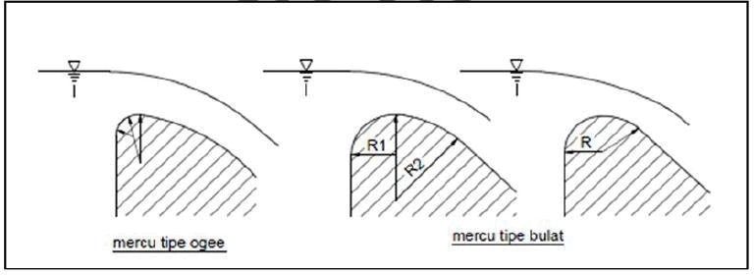

**FIGURE 1.** The Ogee and Rounded Type of Weir Crest [10].

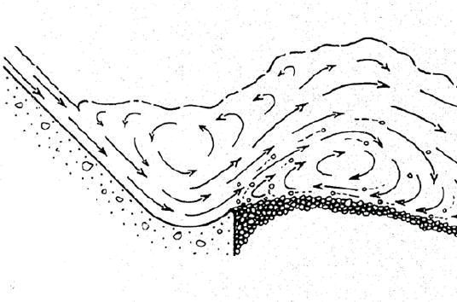

**FIGURE 2.** Water whirl at the Solid Roller Bucket Stilling Basin [7].

## Hydraulic Jump

A hydraulic jump occurs due to the change of flow, from supercritical flow to subcritical flow. Hydraulic jump commonly occurs when the water flow over a spillway or water gate. The length of hydraulic jump is defined as the distance between the water surface at the front of the hydraulic jump and the point on the surface of water wave flowing toward downstream. The length of hydraulic jump is theoretically difficult to determine, however it can be estimated using experiment in the laboratory.

## Specific Energy

Specific energy in a channel cross section is defined as energy of the water per kilogram force (kgf) at every channel cross section (m), measured to the channel’s bed.

(2)

where: Es is specific energy (m), H is water depth (m), Θ is the slope of channel’s bed (˚), V is flow velocity, g is gravity acceleration (9.8 m2/s).

# RESEARCH METHOD

## The Design of Spillway Model

The spillway was designed using maximum discharge (Q) to obtain various flows. The calculation of spillway design using the given data is shown below:

1. Maximum discharge (Q) = 0.005 m3/s
2. Channel width (b) = 0.3 m
3. Spillway height (p) = 0.2 m
4. Trial of hd = 0.0385 m
5. Initial velocity (V0) =

= 0.0069 m/s

1. Total pressure head (he):

 = 0.0387 m

1. Calculate the discharge coefficient (Cd):

The graph of discharge coefficient for ogee type is used to show the relation between p/hd and Cd, which found that p/hd = 5.16. Using extrapolation with equation of y = 0.016x + 2.102, it can be found that Cd = 2.18, therefore the controlled discharge is:

 = 0.005 m3/s

## 2. The Design of Stilling Basin

1. Maximum discharge (Q) = 0.005 m3/s
2. Channel width (b) = 0.3 m
3. Spillway height (p) = 0.2 m
4. Discharge per-length unit = 0.0167 m3/s/m
5. Critical depth (hc):

 = 0.0305 m.

The radius of the curve (Rmin):

 ; for 

, hence:

Rmin = 1.55×0.0305 = 0.0472 ≈ 0.05 m

1. Minimum water depth (Tmin ):

 = 0.0603 m

Based on the radius of the bucket curve (R), baffle Blocks were made of rectangular wood with 5/12 R (2cm) dimension. The shape of baffle blocks was cubical.

**TABLE 1.** Experiment Running

|  |  |  |  |
| --- | --- | --- | --- |
| **No *Running*** | **Seri** | **Slope of weir’s**  **downstream** | ***Baffle Blocks*** |
| 1 | I.a | 4:01 | variation a |
| 2 | II.a | 4:02 | variation a |
| 3 | III.a | 4:03 | variation a |
| 4 | IV.a | 4:04 | variation a |
| 5 | I.b | 4:01 | variation b |
| 6 | II.b | 4:02 | variation b |
| 7 | III.b | 4:03 | variation b |
| 8 | IV.b | 4:04 | variation b |
| 9 | I.c | 4:01 | variation c |
| 10 | II.c | 4:02 | variation c |
| 11 | III.c | 4:03 | variation c |
| 12 | IV.c | 4:04 | variation c |
| 13 | I.d | 4:01 | variation d |
| 14 | II.d | 4:02 | variation d |
| 15 | III.d | 4:03 | variation d |
| 16 | IV.d | 4:04 | variation d |

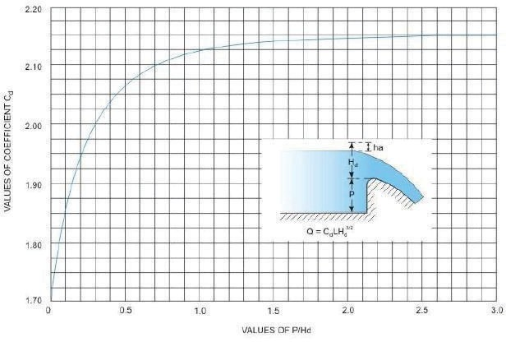

**FIGURE 3.** The Graph of relation between p/hd and Cd for ogee type spillway [11,12].

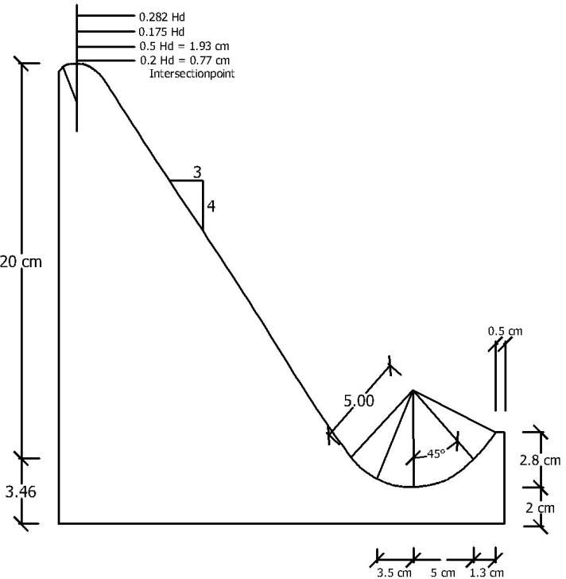

**FIGURE 4.** Ogee spillway with solid roller bucket stilling basin, with downside slope of 3 : 4.

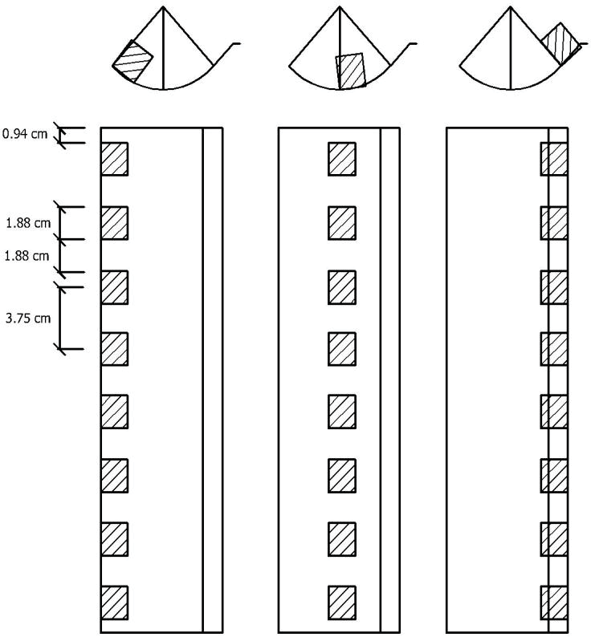

**FIGURE 5.** Variation of baffle blocks formation (series b,c and d).

# ANALYSIS AND DISCUSSION

The experiment in this research was conducted by flowing the water in an open flume over ogee spillway with 5 (five) discharge variations (2.0x10-3 m3/s, 3.0x10-3 m3/s, 4.0x10-3 m3/s, and 5.0x10-3 m3/s) using a water pump, and applied for 16 series of baffle blocks. The results of the analysis are presented below:

## Reynolds number with discharge variation

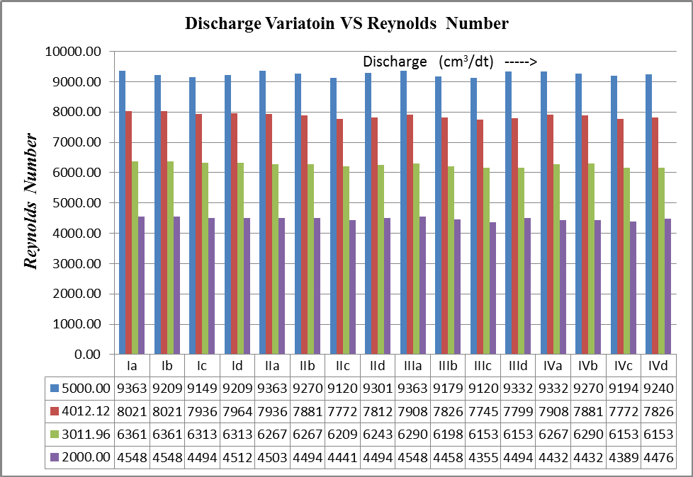

**FIGURE 6.** The relation between discharge variation and Reynolds number.

Figure 6 shows the relation between discharge variation and Reynolds number. The open channel flow is classified as laminar flow if the Reynolds number (Re) is < 500, turbulent if the Re is > 1000, and transition flow if the Re is between 500-1000. The figure shows that the flow of all treatments (variation) is classified as turbulent flow with Re > 1000. The figure also shows that the higher the discharge, the higher the Re at the downstream of the whirl at the hydraulic jump. It also demonstrates that the relation between discharge variation and the velocity downstream of the hydraulic jump is linier, in which the baffle blocks are located in the middle of curve radius (series Ic, IIc, IIIc and IVc) can be claimed as the most effective one. In addition, the downside slope variation applied on the discharge variation has insignificant difference on Reynolds number.

## Head loss and discharge variation

The head loss is the specific energy at the beginning of the flow minus the specific energy at the end of hydraulic jump. The percentage of head loss efficiency is equal to the head loss that can be dissipated at certain flow, as calculated from the result of head loss divided by initial energy and multiplied by 100%. The highest head loss occurs at the flow with the highest Froude number. On the other words, the highest head loss occurs at the downstream flow with perfect/strongest hydraulic jump. In this study, the strongest hydraulic jump occurred at baffle block formation series Ia, IIa, IIIa and IVa where the stilling basin was not supported with baffle blocks.

In the case of downside spillway slope, the highest Froude number occurred at the spillway with slope 4:1 which had the strongest hydraulic jump. The table at Figure 7 shows that the percentage of head loss efficiency increases in line with the decrease in the discharge variation. The highest head loss efficiency occurred at series Ia, IIa, IIIa and IVa where there was no baffle blocks applied in the stilling basin. The downside spillway slope of 4:1 resulted the highest percentage of head loss, although the difference is less significant. The complete graph showing the relation between discharge variation (Q) and head loss (hf) can be seen at the attachment.

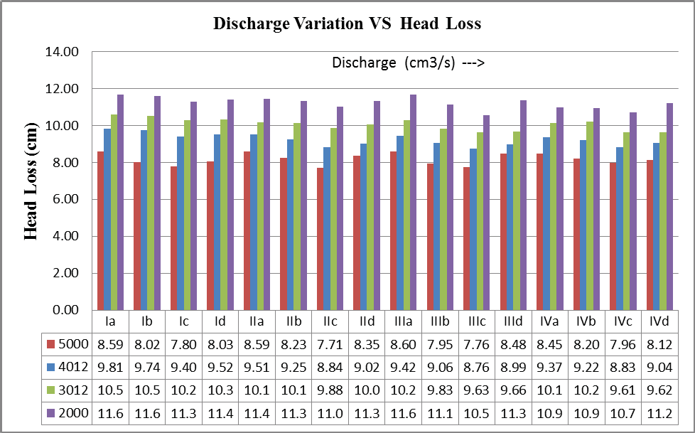

**FIGURE 7.** The relation between discharge variation and head loss efficiency.

## The length of hydraulic jump and discharge variation

The length of hydraulic jump (Lj) is measured from the center of the radius of the weir (R) to the furthest point of the hydraulic jump. The graph in Figure 8 shows the higher the flow, the longer the length of hydraulic jump. The most effective arrangement of baffle blocks occurred in the arrangement located at the center of the stilling basin arc in the Ic, IIc, IIIc and IVc series. The maximum flow velocity occurred in the middle of the arc radius, hence the maximum flow that hit directly into the baffle blocks will result in the minimum length of hydraulic jump, which resulted in series Ic, IIc, IIIc and IVc producing the minimum hydraulic jump lengths among other treatments. The downside weir slope that effectively dissipates the whirling water is generally seen in the table as the 4: 4 slope. The characteristic of falling water flow in the crest of spillway causes the friction between the flow and the spillway wall, causing the decrease of the velocity of falling water flow. Friction between the flow and the largest wall occurred at 4: 4 downstream slope, thus causing the shortest length of the stilling basin among downstream slope models. This statement, however, does not apply to the 4: 3 slope which should result in a smaller stilling basin length between the 4: 2 and 4: 3 downstream slopes.

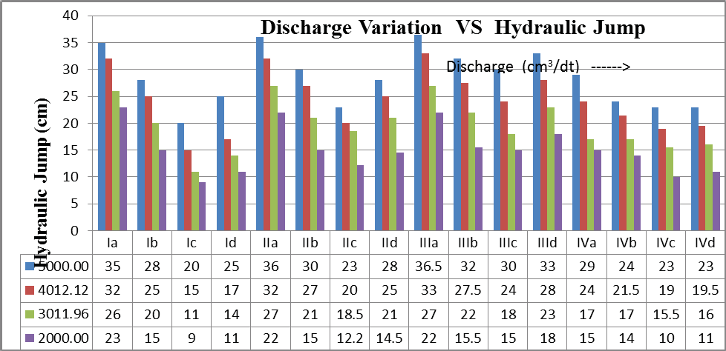

**FIGURE 8.** The relation between discharge variation and the length of hydraulic jump.

# CONCLUSION AND SUGGESTION

## Conclusion

Based on the research result, analysis and discussion, it can be concluded that:

* 1. Using the constant flow, from the variation of the downside weir slope, there is insignificant difference to the flow turbulence. The highest Reynolds number occurred in the discharge of 5.0x10-3 m3/s at series Ia, IIa and IIIa, i.e. 9363.300 that occurred in stilling basin without any baffle blocks, while the lowest Reynolds number occurred in stilling basin with baffles blocks situated in the middle of the radius of the arc at discharge 2.0x10-3 m3/s at series IIIc, i.e. 4355.02. It suggests that baffle blocks placed at the center of the curved radius are the most effective in reducing turbulence of flow downstream of the vortex.
  2. The most efficient baffle blocks to reduce the vortex length is the one fitted in the center of the arc radius,

i.e. series Ic, IIc, IIIc and IVc. The shortest vortex length occurred at series Ic with discharge 2.0x10-3 m3/s,

i.e. 9cm. Furthermore, the slope 4: 4 of downside weir is the most effective slope to reduce the vortex length.

* 1. The efficiency of energy loss increases with the decrease in the variation of discharge, with the arrangement of baffles blocks placed at the beginning of the curved radius is the most effective. The highest energy efficiency downstream of the vortex occurred in the discharge of 2.0x10-3 m3/s at series Ia, i.e. 44.59%. Meanwhile, the smallest one occurred in the discharge of 5.0x10-3 m3/s at series IIc, i.e. 27.20%. At the same flow, the variation of the downstream weir slope, there is insignificant difference in energy loss.

## Suggestion

Based on this research, several suggestions are formulated as follows:

1. For further research, it can be done by adding research on scouring at the downstream vortex.
2. Further research can also be done using diverse forms of baffle blocks, the more diverse of the downstream weir slope, and various weir’s heights.
3. It is required to increase the pump discharge capacity, hence variation of discharge used is more diverse and the range of discharge interval is larger.
4. For further research, the influence of flow temperature (kinematic viscosity) should be considered as well.

# REFERENCES

1. Agnes, “Pengaruh Tataletak Baffle Block Pada Kolam Olakan USBR tipe IV Lantai Miring”, Thesis (Unpublished), Universitas Sebelas Maret (UNS), Surakarta, 1999.
2. S. B. Hermono, et.al., *A Spillway Structure with Stilling Basin Type Solid Roller Bucket and Baffle Block at Embung Wonosari.* Jurnal Dinamika Teknik Sipil, Vol 12 No. 1 January (2012).
3. J. Irawan, “Pengaruh Variation Kemiringan pada Tubuh Hulu Bendung dan Penggunaan Kolam Olak Tipe Solid Roller Bucket terhadap Loncat Air dan Gerusan Setempat”, Thesis (Unpublished), Universitas Sebelas Maret, Surakarta, 2011.
4. L. W. Mays, *Hydraulic Design Handbook*, (McGraw-Hill, New York, USA, 1999).
5. B. Triatmodjo, *Hidrolika II*, (Beta Offset, Yogyakarta, 1995).
6. R. Raju, *Hidraulika Saluran Terbuka*, (Erlangga, Jakarta, 1986).
7. A. J. Peterka , *Hydraulics Design Of Stilling Basin And Energy Dissipaters*, (United States Department Of Interior, Bureau Of Reclamation, Denver, Colorado, 1974).
8. V. T. Chow, *Hidrolika Saluran Terbuka*, (Erlangga, Jakarta, 1992).
9. E. Mawardi, and M. Memed , *Desain Hidraulik BendungTetap Untuk Irigasi Teknis*, (Alfabeta, Bandung, 2002).
10. Anonymous, *Standar Perencanaan Irigasi*, Kriteria Perencanaan Bagian Bangunan Utama KP-02, Yayasan Badan Penerbit Pekerjaan Umum, Jakarta, 1986.
11. Kharagpur, *Hydraulic Structures for Flow Diversion and Storage,* (CE IIT, version 2, New Delhi, 1995).
12. Anonymous, *Module 4 Hydraulic Structures for Flow Diversion and Storage*. Retrieved from: [http://nptel.iitm.ac.in/courses/Webcoursecontents/IIT%20Kharagpur/Water%20Resource%20Engg/pdf/m4l08.](http://nptel.iitm.ac.in/courses/Webcoursecontents/IIT%20Kharagpur/Water%20Resource%20Engg/pdf/m4l08) pdf, (IITM, Kharagpur, 23 April 2013).