AFRICAN CULTURE AND IDENTITY: WHERE DO I STAND?

Abstract
Culture is a subject dear to my heart. Africa is not just an identity; it is also a destiny, a moral obligation. The culture of each ethnic group holds together the authentic social fabric of traditional practices, oral literature, music, art, and rites through which identities are built. African culture is varied and manifold, consisting of various ethnic groups, that each have their unique characteristics from the African continent. This paper explores some of the focal areas of ‘Africanness’ and my position as an “African’. The primary questions raised in this study are: 1) what is the essence of Africa, and the African culture, 2) should we locate black identity in relation to Africa and the African Diaspora, to discover how histories connected with the domination, the imagination and the interpretation of Africa are and have been constructive of a range of political and theoretical parameters around race?, 3) what is the relevance of African culture and identity in Africa? To investigate the meaning of ‘African culture and identity’, and my position in contemporary African society, I conducted research about my genesis and historical roots. The reading of literary texts alongside and against theoretical, political, and ethnographic writings was not intended to lose focus on my ‘Africanness’, but the necessity of approaching literary texts as a nexus for the rearticulation of culturally and socially mediated ideological material. Closer investigation has shown that I am proud of who I am, an ‘African’. Further investigation has also revealed that my love for Africa, my sacred obligation to speak the truth about African religion, music and cultures, and my appreciation of the dimensions of musical practice, be they narrowly technical or social and therapeutic, enjoin many people to ask, what this ‘Africa’ is that means so much to me. It was concluded that central to the idea of African essence is a particular idea of cultural identity associated with indigenous knowledge.
Keywords: African culture, identity, African Diaspora, indigenous knowledge, historical roots, genesis.

Introduction
Africa is also famous for its diverse ethnic groups. My love for African culture and identity inflames my heart. It is my contention that African culture cannot be less than itself. Culture is not static, but dynamic, and keeps on evolving. The preservation of African culture and identity is attributed to the Africans themselves. Although knowledge about African culture is cloudy, there is much that we don’t know. The teaching of African wisdom coincides with the philosophy of African culture. It is impossible to keep our moral practices sound without observing our own culture. Wrong ideas about African culture are misleading. Human character is not stable. Man’s spiritual history reflects a sense of hospitality, good relations, sacred and religion, sanctity of life, respect for elders and authority, morality, language, proverbs, and time. In African culture, cultural heritage and identity are indispensable part of African culture. The whole philosophy of African culture and identity is that the value of cultural heritage is not in cultural manifestation itself, but in the wealth of experience and skills passed down from generation to generation. Without doubt, colonial domination of the continent, fashion, civilization, and Westernization are gradually stealing our cultural heritage through assimilation and hybridization. Our culture is sinking. It is deeply regretted that the negative impact of colonialism which was an earlier form of globalization has had major influence of African cultural traits. The decline of Indigenous Knowledge is a concern to most of us, elderly people in particular. As my humble contribution to the current and future generations, I offer some of the focal areas of ‘Africanness’, and ‘blackness’; and my position or contention as an “African’. The primary question raised in this study is: where do I stand? My love for Africa (see figure 1), my sacred obligation to speak the truth about African religion, music and cultures, and my appreciation of the dimensions of musical practice, be they narrowly technical or social and therapeutic, enjoin many people to ask, what this ‘Africa’ is that means so much to me.
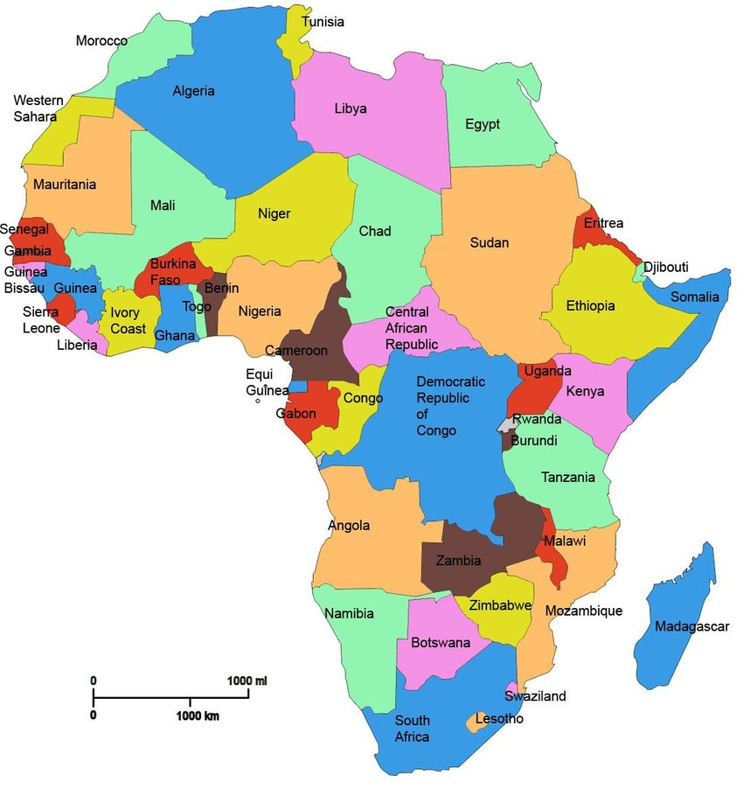
Figure 1: Geographical Location Map of Africa showing different countries.
https://www.nationsonline.org/oneworld/map/africa-political-map.htm [accessed 06 November 2022].

Secondary questions include: 1) how do communal undertaking and African morality harmonize with African cultural heritage and identity? 2) what bearing does cultural heritage have on natural history of a nation. What comes into my mind when I think of African culture and identity is the most important thing. I believe that to do the greatest service to the next generation, it is essential to preserve our cultural heritage to maintain our identity as a nation. It is my opinion that almost all of the African cultural values are derivative of the African communitarianism. This paper is an attempt to answer the questions raised in this study. Nothing will be found contrary to “blackness” in this paper. It is my hope that this study will contribute somewhat to the notion of ‘Africanness’ and ‘blackness’ as incommensurable and mutually exclusive. Following next is the theoretical framework underpinning this study.
Research strategy and Theoretical underpinning
Contextual approach was employed in this study. As an insider ‘an African’ within the African continent, I have ensured that the investigation is contextually and culturally relevant. To reinforce my personal experience and my position of ‘Africanness’, I deemed it necessary to consult with knowledgeable and informative elderly people in Indigenous Knowledge Systems (local context in particular). The primary source for data collection was oral interviews. The participants were selected for interviews in relation to their informative qualities and their dedication, commitment and determination to Local Knowledge and Indigenous Knowledge Systems. Thirteen participants were interviewed for this study, comprised of seven (7) traditional music practitioners, two (2) traditional poets, two (2) creative practitioners and two (2) Anthropologists. The focus of interviews was on African culture and identity, Africanness, blackness and African Renaissance. Adopting this mode of technique, afforded me the opportunity to immerse myself into African culture, not only to live and share African culture with the participants, but also to study and record information about their views, wishes and aspirations about the revival of African cultural heritage and identity. Secondary sources included publications and records.

This study is underpinned by the theory of Negritude as advocated by Aime Césaire (1997) and (1950) 2000. According to Aime Césaire, Négritude inspired the birth of many movements across the Afro-Diasporic world, including Afro-Surrealism, Creolite in the Caribbean, and black is beautiful in the United States. Négritude theory views disavowal of assimilation as a valid strategy for resistance and for its use of the word négre as a positive term. Césaire is of the opinion that the problem with assimilation was that one assimilated into a culture that considered African culture to be barbaric and unworthy of being seen as “civilized”. He asserts that assimilation into this culture would have been seen as an implicit acceptance of this view. He deliberately incorporated this derogatory word into the name of his philosophy. He shared a personal sense of revolt for racism and colonial injustices that plagued their world and their French education with Leopold Senghor’s and Leon Damas’s dissatisfaction, disgust, and personal conflict over the state of the Afro-French experience in France.

Négritude theory reflects a denunciation of Europe’s devastation of Africa, a decrying of the coldness and stiffness of Western culture and its lack of the humane qualities found in African cultures, and an assertion of the glories and truths of African history, beliefs, and traditions. The three major Negritude themes recurring in David Diop’s poetry are criticism of Western civilization and its attendant colonialism, nostalgia for and glorification of Africa, and a firm belief in a future Africa which is prosperous, united, and strong. In the next section, previous related studies will be highlighted and discussed. The intent of this section is not to chronicle all the ideologies, philosophies, and theories about ‘Africanness’ and ‘blackness’, rather, it is to outline the prevalence of political and moral decay within African societies.

The theory is applicable to the context of this study because negative impact of colonialism which was an earlier form of globalization has had major influence of African cultural traits. It is adopted for this study because Aime Césaire and his research partners’ observations and ideologies apply to the context of this study. Colonial domination of the continent, fashion, civilization, and Westernization are gradually stealing our cultural heritage through assimilation and hybridization. Our culture is sinking. Racism and colonial injustices plagued the beautiful and the second largest continent in the world and have caused an irreparable damage. Many families have lost their loved ones because of the revolt for racism and colonial injustices that plagued their continent. There were dissatisfaction, disgust, and personal conflict over the state in different parts of the continent, South Africa inclusive. Acculturation which implies culture change through assimilation and hybridization whereby culture ‘A’ invades culture ‘B’ through language, religion, music, attire, etc. played a prominent role in contaminating and destroying African cultural heritage and identity, by applying the principle of elimination by substitution.
Previous related studies
There seems to be a consensus among scholars of ‘Africanness’ and ‘blackness’ (Agbo 2011; Anthony 2013; Chukwudi 1998; Eze 2014; Eze & Van der Wal 2020; Howe 1998; Idang 2015; Kalua 2020; Ndlovu 2018; Ojaide 1992; Oyebola 1982), and others, that culturally, the notion of a homogenous African identity is an oxymoron as no such ideal even is plausible except in terms of geographical fatality. In particular, Eze and Van der Wal (2020:191) opine that a major distinction between the African and European context is that while in Europe national identities have historically been instrumental in the construction of the state, and therefore align well with political identities, the opposite is true in the African context. Eze and Van der Wal further assert that the idea of a collective identity is therefore a binary product imposed by colonialists and their African counterparts or that emerged as a reaction to colonialism through centralized resistance but not due to any shared history or common descent (2020:193). Based on the foregoing, these scholars argue that the dominant discourse on collective African identity is then racialized in so far as racism constitutes dual pedagogic mandate for oppression and eventual liberation (2020:193). Eze and Van der Wal further postulate that to speak of collective identity in Africa is to look beyond the modern nation-state which is primarily a reflection of European modernity (2020:194). According to them, the pre-colonial African political identity was not a primordial homogeneity (2020:194). They are of the view that collective identity in Africa has always been omorphous, very often grafted on to culture and religious traditions, but as culture is always changing and the gods are never permanent, the identity derived from them must change to reflect changing circumstances (2020:194). Endorsing the above viewpoints, Agbo (2011) published an article titled ‘The crisis of identity and the Quest for Development in Africa: The place of leadership in creating a new culture’. He shares insightful information about the subject. He writes that the missionary leaders also came to Africa and debased our traditional religions and our educational system, introducing foreign languages for education purposes, creating a cultural crisis that is very evident (2011:216). Agbo argues that unfortunately, the concept of ‘development’ prevalent is predominantly materialistic (2011:206). According to him, this emphasizes technology and industry as indices of higher culture and development (2011:206). Posing the following questions to all of us, he asks: 1) does it mean that when a society is an industrial giant, economically viable and technologically sophisticated, it is a developed, and therefore, of a higher culture? 2) the computer hard and softwares, electricity, five-star hotels and skyscrapers, gigantic manufacturing firms, televisions, telephones and all other such paraphernalia of modernization and urbanization the most important indices and proof of development? (2011:207). He remarks that he is not asking these questions with disdain for the material well-being of the African society; rather he calls for caution because it is this “material conception of development’ that has led many an African thinker to wholly lift Western thought systems and claim they are applicable to the African condition (2011:207). His concern is not really to define culture, for it is a compendious term; he believes that once this communication becomes vague, difficult, or impossible, a crisis of culture occurs, whether we realize it or not (2011:212). In what follows, I discuss the findings of this study.
Results and Discussion
The impression created during interviews was that as nothing is easier than to think, we should naturally and correctly think of our roots; where we come from before we can think of where we are going. Science has done much for us, but it is the poor science that hides the Local Knowledge as inherited from our ancestors’ teachings. Comparing culture with culture within the continent will never help us in any way, and shall never take us far, because there is no culture which is superior to the other, and there is no religion which is superior to the other. Equating magic, superstition, and paganism with African culture, is a terrible mistake. African culture and identity are indeed at stake. The above observations are endorsed by Idang (2015:97) who opines that the culture of a people is what marks them out distinctively from other human societies in the family of humanity.

According to Idang, culture as it is usually understood, entails a totality of traits and characters that are peculiar to a people to the extent that it marks them out from other peoples or societies (2015:97). In his view, it can be safely stated that culture is to be understood as a way of life of a people; and there can be no culture without society, and there can also be no people without a culture (2015:99). In answering the question: where do I stand? Closer investigation has shown that I am proud of who I am, an ‘African’. I belong or relate to Black people who are in Africa. What I speak agrees with what I am, and I will never cease to be what I am ‘an African’. In affirming my faith in my native culture, with this study I am making an attempt to defend it against alien encroachment and prejudices; and in asserting my cultural identity, I condemn the infiltration and distortion of culture by former and current missionaries, and Western intervention as disruptive of the growth and development of culture through acculturation and colonialism. In affirming African theological thought and African religion, I am earnestly and humbly requesting fellow Africans to rise and reject the inequality inherent in the idea of a villagized world, and rebuild their national image, and insist on their own cultural preferences and terms of membership in the village; and to assert cultural independence, I advocate for resistance against colonial domination of the continent, infiltration of culture, assimilation, acculturation and distortion of culture.

Further investigation has also revealed that my love for Africa, my sacred obligation to speak the truth about African religion, music and cultures, and my appreciation of the dimensions of musical practice, be they narrowly technical or social and therapeutic, enjoin many people to ask, what this ‘Africa’ is that means so much to me. It has emerged from this study that the culture of Africa is varied and manifold, consisting of a mixture of countries with various tribes that each have their unique characteristics from the continent of Africa. The channel through which it flows is through elderly people within each family circle.

In answering the question: how do communal undertaking and African morality harmonize with African cultural heritage and identity; some participants felt that in African context, good or moral value is determined in terms of its consequences for humankind and human society. They further indicated that African morality originates from considerations of human welfare and interests, not from divine pronouncements. Regarding the question: what bearing does cultural heritage have on natural history of a nation? I believe that the best way to preserve our cultural heritage, whatever it may be, is to share it with others. I am also convinced that cultural heritage and natural history have a high value and are unique. Oral and Literary evidence have shown that Africans are generally a spiritually minded people (Ojaide, 1992:47). According to Ojaide, the supernatural plays an important part in African literature, especially in the drama and fiction (1992:47). He is concerned that this belief in the supernatural is sometimes wrongly dismissed as superstition (1992:47). Furthermore, Ojaide observes that ancestors are highly valued in traditional Africa, and everybody lives to be a deserving one (1992:45).
During the study it was also found that the teachings of our ancestors coincide very well with the revival and appraisal of our traditional culture. It is a solid theological fact that we were born on the cusp of the old and the new, but that does not necessarily mean that we should not fight for the revival or rebirth of our cultural heritage and identity. The concept of ‘African Renaissance’ has been rehearsed by scholars such as Akinola (2018); Anthony (2013); Kalua (2017); Ndlovu (2018) and Ojaide (1992). Anthony (2013:41) opines that one of the greatest instruments for African renaissance is language. According to him, irrespective of where parents find themselves with their children, they should endeavour to teach them their native language (2013:41). He is convinced that language carries with it the culture and worldview of the people who own it (2013:41). He also believes that some African families can be described as ‘expatriate’ even though they live within Africa (2013:41).
- The role of the family in African context
Analysing the data, it was found that the family is very important throughout Africa. Families, not individuals, are the building blocks of African society. For Africans, living a virtuous life is the most important ideal worth living for. The exposition of the study has shown that the family plays a central role in African society. It shapes such daily experiences as how and where individuals live, how they interact with people around them, and even, in some cases, whom they marry. It can determine a person’s political identity and the way money and property are transferred. From this study it is evident that the family is important because members of the family such as grandparents, cousins, uncles, aunts and even unrelated persons remain a principal base for social affiliation and can offer support and security coupled with unconditional love. The most important finding of this study was that the family is important because it gives children a framework for how to behave, but also ensures that children know how to do the right things and behave in a way that reflects their values. From this study it is evident that the family ideally serves several functions for society. It socializes children, provides practical and emotional support for its members, and provides its members with a social identity. The impression created during interviews was that in African context the family is the pillar of the children’s strength who never fall, instead keep them strong so that they become better people.
The study contributes to the notion that children learn traditions, ethics, cultures, caring, hope, faith, respect, and values of love through their families. Reviewing the results yielded thus far, it is clear that as basic and essential building blocks of societies, families have a crucial role in social development. These observations relate closely to how family members bear the primary responsibility for the education and socialization of children as well as instilling values of citizenship and belonging in the society. It is noticeable that the cultural beliefs of individual family members and the entire family inform decisions made about the child and the family. It is also worthwhile to mention here that culture shapes our views on key issues such as the nature of childhood itself, child behaviours, education, learning, caregiving practices and family goals and roles. The study has demonstrated that family relationships promote social cohesion and provide resources that can help an individual cope with stress and loneliness, engage in healthier behaviours, and enhance self-esteem, leading to happy social life and higher well-being.

I have some hope that this study will enlighten policymakers, inspire research and innovations, and provide a solid foundation for sustainable social development and the potential of Africa’s culture by creating an awareness within different cultures about the crucial need to reinforce the role that culture can play in enabling communities to strengthen the ties that could help shape and revive Africa’s rich history and culture which includes a collective sense of peace, and a collective consciousness of opportunities towards the potential of African cultural resources; but also to ensure that African-cultural values, the authentic social fabric of traditional practices and rites, art, music, oral literature, African cultural narratives, norms and practices are growing at the pace of its population.

Concluding Thoughts and recommendations
Indications from the investigation have revealed that central to the idea of African essence is a particular idea of cultural identity associated with indigenous knowledge. Closer investigation has also revealed that representation and identity are personal, and they are political. This observation suggests that in terms of African identity, establishing and fully owning our identity is important for our political, economic, and social progression. Oral accounts and literary evidence have also shown that oral tradition is very important in African culture, as it insures the passage of cultural practices from one generation to another. It has emerged from this study that the family is the school of fundamental anthropology, sociology, and dynamics of culture. Therefore, African renaissance must begin from the smallest sociological unit. This finding resonates well with the expression saying ‘Education starts at home’. Literary evidence has also shown that the idea of ‘Africa’ is conceived in the crucible of colonialism, and points to the fact that the designations of the words ‘Africa’, ‘Africanness’ and ‘African’ are often used to refer to black people who either reside on the African continent, or in the diaspora (Kalua, 2020:1). The impression created during interviews was that Africa is contaminated in the sense that she is not culturally or biologically pure, and to acknowledge her muttness is to concede the presence of the other in her life and to be ready to enter into an I-Thou relationship with this other, to make way for dialogue (Eze, 2014:239).

Based on the findings of this study, being a citizen of the African continent, it is my contention that identity, like culture is not static, but dynamic, and keeps on evolving or changing; and a person’s identity is made up of his/her own character combined with his/her family and social roots. Finally, in my view, identities, whether African or otherwise, are complex and multiple and grow out of a history of changing responses to economic, political, and cultural forces.

References
Agbo, J. N. 2011. The Crisis of identity and the quest for development in Africa: The place of leadership in creating a new culture. UJAH: Unizik Journal of Arts and Humanities, Vol. 12, No. 2 (2011); pp. 204-239.
Akinola, A. O. 2018. Women, Culture and Africa’s Land Reform Agenda. Frontiers in Psychology, Volume 9, Article 2234, pp. 1-8.
Anthony, K. I. 2013. African identity and the emergence of globalization. American International Journal of Contemporary Research, Vol. 3, No. 6 (June 2013); pp. 34-42.
Cesaire, A. 1997. Return to My Native Land, Bloodaxe Books, ISBN: 1-85224-184-5.
Cesaire, A. (1950) 2000. Discourse on Colonialism, Monthly Review Press, ISBN: 1-58367-025-4.
Chukwudi, E. E. 1998. Modern Western Philosophy and Africa Colonialism. In E. E. Chukwudi (ed.), African Philosophy: An Anthropology, pp. 200-215. Oxford: Blackwell.
Eze, C. 2014. Rethinking African culture and identity: the Afropolitan model. Journal of African Cultural Studies, Vol. 26, No. 2, pp. 234-247.
Eze, M. O. & Van der Wal, K. 2020. Beyond Sovereign Reason: Issues and contestations in contemporary African identity. Journal of Common Market Studies (JCMS), Volume 58, Number 1, pp. 89-205.
Howe, S. 1998. Afrocentrism: Mythical Pasts and Imagined Homes. London and New York: Verso.
Idang, G. E. 2015. African culture and values. Phronimon, Volume 16, Number 2, pp. 97-111.
Kalua, F. 2017. Intermediality: A Paradigm for African Identity in the Twenty-First century. Journal of Literary Studies, 33:1, 24-41.
Kalua, F. A. 2020. Re-imagining African Identity in the Twenty-First Century. Cambridge Scholars Publishing, pp. 1-65.
Ndlovu, M. 2018. Cultural villages and their idea of South Africa: A Decolonial Critique. International Journal of Critical Diversity Studies 1(2), December 2018, pp. 33-41.
Ojaide, T. 1992. Modern African Literature and Cultural Identity. African Studies Review, Volume 35, Number 3 (December 1992), pp. 43-57.
Oyebola, A. 1982. Black man’s dilemma. Ibadan: Board Publications.
Thompson, P. 2002. Negritude and Changing Africa: An Update, in Research in African Literatures, Winter 2002.
Wilder, G. 2015. Freedom time: Negritude, decolonization, and the future of the World, Duke University Press, 2015.

Identity has two important features: continuity means that people can count on you to be the same person tomorrow as you are today. Obviously, people change but many important aspects of social identity remain relatively stable such as gender, surname, language, and ethnicity.
Culture is a defining feature of a person’s identity, contributing to how they see themselves and the groups with which they identify. The people’s understanding of their own and other’s identities develops from birth and is shaped by the values and attitudes prevalent at home and in the surrounding community.
Cultural values are the core principles and ideals upon which an entire community exists and protects and rely upon for existence and harmonious relationship. They include morals, rules, values, languages, beliefs, arts, literature, music, social roles, customs, traditions, and many more.
Negritude is a consciousness of and pride in the cultural and physical aspects of African heritage.
Akinola (2018); Kalua (2017).
In the context of this study, acculturation implies culture change through assimilation and hybridization whereby culture ‘A’ invades culture ‘B’ through music, religion, dance, attire, language, etc.
In Africa, music is the highest form of expression and improves people’s quality of life. It is higher than language, since language defines people and culture, but music transcends cultures and breaks all the barriers between different cultures. It is how one can create common grounds and understanding. Musical expression helps them to experience, comprehend and manage their emotions, and this helps maximize their emotional intelligence and improves their relationships with others.
Music seems to be a key to identity because it offers, to intensely, a sense of both self and the collective. Social groups only get to know themselves as groups only get to know themselves as groups (as a particular organization of individual and social interests or sameness and differences) through cultural activity and in this case it would be music.

