CENTELLA ASIATICA, A POTENT HERBAL ANTICANCER AGENT

ABSTRACT
Cancer is a group of diseases involving abnormal cell growth with the potential to invade or spread to other parts of the body. Women with genetic mutation in either BRCA1 or BRCA2 have increased risk of developing breast and ovarian cancer. The lifetime risk of breast cancer of women has been estimated to 82% and lifetime risk of ovarian cancer is 54% for BRCA1 and BRCA2 mutation carriers. Herbal medicine tending to have broad complementary or synergistic action on physiological system. Evidence for effectiveness of herbal medicine is limited although people find them helpful and their use tends to be based on traditional use rather than scientific research. Centella asiatica is medicinal herb that has been widely used in folk medicine to treat various disease. The main constituent for Centella asiatica, ‘asiatic acid and asiaticoside’ is mainly found to show anticancer activity against breast and ovarian cancer. The review shows that, the growth suppression was in concentration dependent manner, relating to cytotoxicity of SKOV-3 and OVCAR-3 cells. Centella asiatica show inhibition of cell proliferation in breast cancer cells, MCF-7. According to studies, there have been no reports documenting negative interaction between CA and medication to date, thus possessing potential anticancer property.
Keywords: Herbal remedy, Centella asiatica, breast cancer, ovarian cancer, asiatic acid, asiaticoside, apoptosis, cytotoxic.
INTRODUCTION:
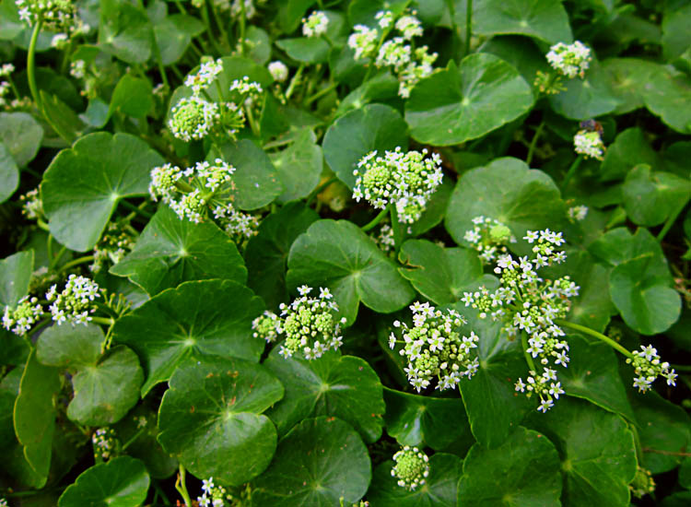
As specialty chemicals, bioactive natural compounds are very important economically. Bioactive natural products find applications as pharmaceuticals, nutraceuticals, biological or pharmacological components, and as raw materials for pharmaceutical manufacturing. Indian Pennywort, or Centella asiatica (Linn.), is a member of the Apiaceae family (formerly known as Umbelliferae). The lengthy history of C. asiatica's medicinal uses has been thoroughly reviewed by Brinkhaus et al. (2000), starting with the Indian physician Sushruta's (c. 1200 BC) use of the plant, traditional herbal medicine systems in Asian and African nations, and its introduction to and scientific study in Europe during the 19th and 20th centuries, and current use of the plant or its derivatives in commercial topical and oral products throughout the world (Brinkhaus et al. 2000). Since Centella offers so many health benefits, like being an antioxidant, an anti-inflammatory, a wound healer, a memory enhancer, and more, its use in food and drink has grown throughout time. [1,2]
Centella asiatica
Kingdom: plantae
Order: Apiales
Family: Apiaceae
Genus: Centella Fig 1: Centella asiatica plant
Species: C. asiatica
The plant has different vernacular names as following: Thankuni (Bengali), Mandookaparni (Hindi), Pegaga (Malay), Kodagam (Malayalam), Gotukola (Sinhalese), Vallarai (Tamil) and Bekaparanamu (Telugu).[3]
Centella asiatica can be found up to 600 meters above sea level in all of India's tropical and subtropical areas. The plant is native to portions of China, the Western South Sea, Islands, Madagascar, South Africa, South East USA, Mexico, Venezuela, Columbia, and Eastern South America. It is also found in South East Asia, India, and Sri Lanka.[3]
Morphological characteristics:
Centella asiatica (L.) is a prostrate, mildly scented, stoloniferous, perennial creeper herb that grows up to 15cm (6 inches). Glabrous, striated, and rooted at the nodes is the stem. The lush green carpet that is created by Centella asiatica develops widely in areas that are shaded, marshy, damp, and wet, such as paddy fields and riverbanks. The most fertile soil for Centella asiatica's regeneration is a sandy loam with 60% sand content, as opposed to clayey soil. The leaves, which are 1-3 from each node of the stem long petioles, are 15–5 cm wide and 2–6 cm long. glabrous on both sides, orbicular-renniform, crenate margin, and sheathing leaf base. Umbels of flower iron fascicles, with three to four white, purple, or pink flowers in each umbel. April through June are the months when flowers appear. Fruits are born throughout the growing season in approximately 2 inch long, oblong, globular in shape and strongly thickened pericarp. Seeds have pendulous embryo which are laterally compressed. [3,4]
Chemical constituents: The scientific literature supports the Indian medical system's assertion that Centella asiatica contains a variety of biochemical components, or secondary metabolites, which are currently highly significant in modern medicine. Centella asiatica is also said to contain the following kinds of chemical compounds: [4,5]
Table 1: Chemical compounds found in Centella asiatica.
Alkaloids | From the dried leaves, hydrocotylin (C22 H33 NO8), an alkaloid, has been identified.
Glycosides | Three glycosides have been identified from plant parts: centelloside, madecossoside, and asiaticoside. These glycosides hydrolyze to produce triterpene acids, asiatic acid, madegascaric acid, and centellic acid. All of the aforementioned compounds are found in the plant in their free state, with the exception of centella acid.
Flavonoids | The leaves have been used to isolate the flavanoids 3-glucosylquercetin, 3-glucosylkaemferol, and 7-glucosylkaemferol. Tannins, sugars, inorganic acids, resin, glutamic acid, aspartic acid, glycine, α-alanine, and phenylalanine have all been reported to be present in the plant Chloride, sulfate, phosphate, iron, calcium, magnesium, sodium, and potassium are all included in the total amount of ash. The leaves are an excellent source of vitamins B, C, and G.
Triterpenoids | Asiatcoside, centelloside, Madecossoside, thankuniside, isothankunic acid, centellose, asiatic acid, centellic, and madecassic acids are examples of triterpenoids. The structure of the genin of brahmoside, brahmminoside, and brahmicacid, brahmic acid (m.p. 293°), has been determined to be 2,6-hydroxy, 23-hydroxy-methyl ursolic acid. Less madecossoside and asiaticoside was found in the roots compared to the leaves.
Volatile oil and fatty acids | Palmitic, stearic, lignoceric, oleic, linoleic, and linolenic acid glycerides make up the fatty oil.

PHARMACOLOGICAL USES:
Antioxidant property: It is commonly known that Centella asiatica has strong antioxidant activity. According to one study, asiatic acid derivatives potentiate the cellular oxidative defense mechanism, which has major neuroprotective benefits on cultured cortical cells. As a result, it was demonstrated that these substances were effective in shielding neurons from the oxidative harm brought on by exposure to too much glutamate. Three of the 28 asiaticoside derivatives, including asiatic acid, demonstrated a potent prevention of cell death caused by free radicals and beta-amyloid. These compounds might be used to treat Alzheimer's disease by shielding neurons from the harmful effects of beta-amyloid. [6,7]
Wound healing: Wound healing has historically been aided by CA extracts (CAE). More and more research back up these assertions. Increased cellular proliferation was the outcome of CAE treatment. Increased production of collagen where there is a wound. Quicker healing process for wounds. Greater rate of wound contraction when compared to control wounds that are left untreated. The most noticeable healing results were seen with gel-based CAE. One of CA's ingredients, Asiaticoside, aids in the healing of wounds. It promotes angiogenesis and collagen synthesis. It also helps to prevent infection and thicken regions of skin. [8,9]
Sedative and anxiolytic property: According to Indian literature, CA has CNS effects that include boosting intelligence, rejuvenating, sedating, tranquilizing, and stimulatory-nervine tonic properties. In many Eastern cultures, it has long been used as a sedative; the effect was attributed primarily to the brahmoside and brahminoside constituents, while the anxiolytic activity is thought to be partially attributed to binding to cholecystokinin receptors (CCK), a class of G protein coupled receptors that bind the peptide hormones gastrin or cholecystokinin (CCK), and were believed to have a potential role in modulating anxiety, nociception, memory, and hunger in both humans and animals.[10,11]
Antidepressants properties: The observation was made on the antidepressant effects of total triterpenes derived from CA on the concentration of amino acids in mouse brain tissue and the immobility period in forced swimming mice. Imipramine and total triterpenes from CA shortened the study's immobility period and corrected the amino acid imbalance, supporting CA's antidepressant properties. By assessing corticosterone levels in mice's brains, the same investigators looked into the potential antidepressant effects of total triterpenes of CA. [12,13]
Antiepileptic property: Leprosy has been treated using the plant's isolated steroids. In one study, the effects of aqueous CAE (100 and 300 mg/kg) were assessed on the development of kindling, learning deficit caused by kindling, oxidative stress markers in rats that had been exposed to pentylenetetrazol (PTZ), the passive avoidance test, spontaneous locomotor activity, and PTZ administration 24 and 48 hours later. Measurements of malondialdehyde (MDA) and glutathione were made throughout the animal brain. The learning deficit brought on by PTZ kindling was improved by the administration of CA (300 mg/kg, p.o.), as seen by a drop in seizure scores and an increase in latencies in passive avoidance behavior. [14,15]
Antinociceptive and anti-inflammatory properties: Rats' paw edema caused by prostaglandin E2 was used to investigate the anti-inflammatory effects of CA, while mice's acetic acid-induced writhing and hot-plate technique was used to examine the antinociceptive effects of the aqueous CAE (10, 30, 100, and 300 mg/kg). Significant antinociceptive efficacy, comparable to aspirin but less strong than morphine, and significant anti-inflammatory activity, comparable to mefenamic acid, were also demonstrated by the aqueous CAE models. These findings supported the traditional use of this plant in the treatment of inflammatory disorders or rheumatism by indicating that the aqueous CA extracts contain antinociceptive and anti-inflammatory properties. [16,17]
Memory Enhancing: The herb's aqueous extract improved learning and memory while decreasing levels of norepinephrine, dopamine, 5-HT, and their metabolites in the brain. Centella asiatica includes brahmicacid, isobrahmic acid, brahminoside, and brahmoside. It exhibits psychotropic, sedative, and anti-convulsant effects. It also helps with dementia, mental illnesses, and anxiety. Mental, a polyherbal formulation that acts synergistically, improves memory, attention, and concentration in children with learning disabilities. [18,19]
Cytotoxic and anti-tumor: Oral administration of the crude extract of C. asiatica and its partially purified fractions caused apoptosis in solid and Ehrlich Ascites tumors and improved the lifespan of these tumor-bearing animals. Asiatic acid was discovered to have an anticancer impact on skin cancer. [20,21]
STRUCTURAL ACTIVITY RELATIONSHIP OF ASIATIC ACID:

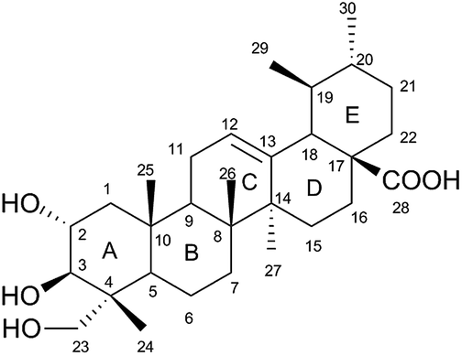
Fig 2: Asiatic acid

- Asiatic acid is chemically Pentacyclic triterpenoid.
- Hydroxide group in ring A reduces the antiproliferation activity.
- If 2 OH group undergoes acetylation it increases the activity.
- Carboxylic group at position 17 has anti proliferation activity but unsaturation in ring E can increase the activity.
- Methyl group at position 25 increases the antiproliferation activity.[22]
EXTRACTION METHOD:
The ethanolic extract was prepared using a modified version of Abdulrahman et al.'s (2004) procedure.
Step 1: The plant's fresh sections were dried in an oven and then finely pulverized using a machine grinder.
Step 2: Ten grams of each plant part were then macerated for 72 hours in 100 milliliters of 100% ethanol, appropriately wrapped in aluminum foil, and labeled.
Step 3: Following a 72-hour extraction process, each extract was run through a different Whatman's filter paper no. 1.
Step 4: The filtrate was refrigerated at 50°C after being evaporated to dryness at room temperature.[23]

QUANTITATIVE ANALYSIS:
Using established methods, the phytochemicals found in Centella asiatica ethanol extracts were identified and quantified.
Total Terpenoids Determination Using Ferguson (1956) Method:
Separately, 10g of plant powder were steeped in alcohol for a full day. Following filtering, petroleum ether was used to extract the filtrate, and the ether extract was then processed like whole terpenoids.[23]

TLC ANALYSIS:
TLC analysis was performed using a modified version of the methodology.
- On a silica plate, 3µL of the standard and samples were placed individually.
- The solvent system that is used is a mixture of water, methanol, and ethyl acetate (8: 2: 1).
- The plate was allowed to develop in the saturated environment after being gradually submerged in a development chamber chromatography section.
- For the purpose of separating the active components, the plate was kept in the chamber for 20 to 30 minutes. After that, the plate was cleaned and dried with a hair dryer.
- At 365 nm, different spots were observed in ultraviolet (UV) light.
- Ultimately, the unknown spots' color and distance were compared to the standards, and they were recognized using Rf values that were computed using the formula.[24]

Rf value: distance travelled by solute
distance travelled by solvent

MECHANISM OF ACTION:

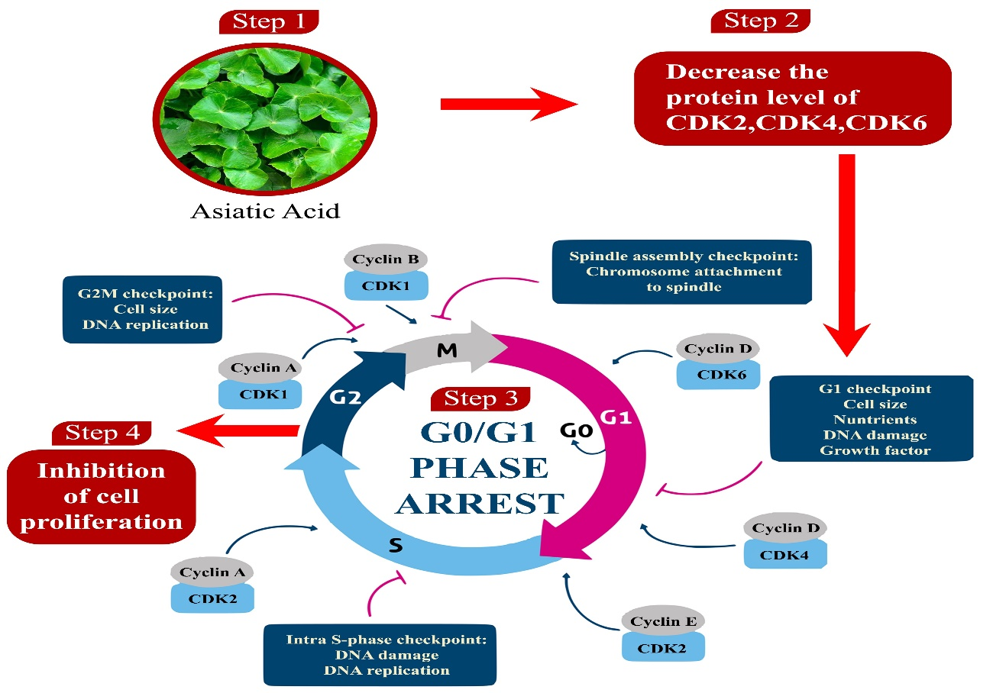
Fig 3: Mechanism of action
- Asiatic acid increases the fraction of cells at the G0/G1 phase in a concentration-dependent manner.
- The proportion of S and G2/M phase cells significantly decreased along with this rise. These imply that G0/G1 phase arrest played a role in the growth-suppressive action of Asiatic acid.
- Treatment with Asiatic acid primarily works by significantly lowering the protein levels of CDK2, CDK4, CDK6, cyclin D, and cyclin E in a concentration-dependent manner.
- Furthermore, treatment with Asiatic acid resulted in a significant rise in the CDN inhibitors p21 and p27. Therefore, cell proliferation can be stopped by arresting the cell cycle.[25]

ANTICANCER ACTIVITY OF PLANT EXTRACT (CENTELLA ASIATICA):
Asiatic acid has been demonstrated to have cytotoxic effects on fibroblast cells and to cause apoptosis in several cancer types.
In MCF-7 breast cancer cells, C. asiatica extract clearly inhibited cell growth in a dose-dependent manner. Following treatment with several quantities of C. asiatica extract, MCF-7 cells showed a concentration-dependent decrease in cell viability (as measured by the MTT assay). Whether asiatic acid can cause ovarian cancer cells to undergo apoptosis was found out. SKOV3 and OVCAR-3 cells underwent concentration-dependent apoptosis upon treatment with varying doses of asiatic acid, according to flow cytometry studies. Compared to cells treated with a vehicle, the percentage of apoptotic cells in the cells treated with 40 µg/ml asiatic acid was 7–10 times greater.
Nevertheless, we did not notice a concentration-dependent decline in cell viability in other cell lines like HeLa, HepG2, or SW 480.In this regard, the enhanced cell death caused by Asiatic acid may result from the production of ROS. On the other hand, the same plant's methanolic extract is recognized to possess antioxidant qualities. [4,26]
HERB-DRUG INTERACTION:
- There have been no reports of harmful interactions between CA and medicines thus far.
- High doses of CA can cause sedation; thus persons should refrain from using them. Combine this herb with drugs that improve sleep or relieve anxiety.
- Theoretically, CA was thought to interfere with blood glucose levels, potentially interfering with existing hypoglycemic and cholesterol-lowering therapies.[7]
CONCLUSION:
The study shows asiatic acid exerting cytotoxic effect against ovarian cancer cells when treated with various concentrations of asiatic acid. At the concentration 40µg/ml asiatic acid caused about 50% reduction in viability of both SKOV3 and OVCAR3 cells and no significant effect on viability of normal OSE cells. Furthermore, the extract did not exhibit cytotoxicity towards the lung carcinoma cell line A and the normal kidney cancer cell line BHK-21. These findings point to a potential selectivity of Centella asiatica's against specific cancer cell lines, which are mostly utilized to treat ovarian and testicular cancer. Although it hasn't been established yet, the variations in morphology and physiology between the examined cell lines may be connected to the selectivity of action. These findings are particularly exciting because the majority of chemotherapeutic drugs available on the market affect both tumor and normal cells, making it impossible to advance a particular cancer treatment without endangering healthy cells. Also, asiatic acid in contrast with methanolic extract of the same plant is known to have antioxidant properties.
REFERENCE:
1) Kim, W. J., Kim, J., Veriansyah , B., Kim, J. D., Lee, Y. W., Oh, S. G., & Tjandrawinata, R. R. (2009). Extraction of bioactive components from Centella asiatica using subcritical water. The Journal of Supercritical Fluids, 48(3), 211-216.
2) Gray, N. E., Alcazar Magana, A., Lak, P., Wright, K. M., Quinn, J., Stevens, J. F., ... & Soumyanath, A. (2018). Centella asiatica: phytochemistry and mechanisms of neuroprotection and cognitive enhancement. Phytochemistry Reviews, 17, 161-194
3) Seevaratnam, V., Banumathi, P., Premalatha, M. R., Sundaram, S. P., & Arumugam, T. (2012). Functional properties of Centella asiatica (L.): A review. Int J Pharm Pharm Sci, 4(5), 8-14.
4) Verma, R., & Gurmaita, A. (2019). A review on anticarcinogenic activity of “Centella asiatica”. endangered species, 6, 7.
5) Singh, S., Gautam, A., Sharma, A., & Batra, A. (2010). CENTELLA ASIATICA (L.): A PLANT W ITH IM M ENSE M EDICINAL POTENTIAL BUT THREATENED. endangered species, 3, 4.
6) Veerendra Kumar, M. H., & Gupta, Y. K. (2003). Effect of Centella asiatica on cognition and oxidative stress in an intracerebroventricular streptozotocin model of Alzheimer's disease in rats. Clinical and Experimental Pharmacology and Physiology, 30(5‐6), 336-342.
7) Gohil, K. J., Patel, J. A., & Gajjar, A. K. (2010). Pharmacological review on Centella asiatica: a potential herbal cure-all. Indian journal of pharmaceutical sciences, 72(5), 546.
8) Poizot, A., & Dumez, D. (1978). Modification of the kinetics of healing after iterative exeresis in the rat. Action of a triterpenoid and its derivatives on the duration of healing. Comptes rendus hebdomadaires des seances de l'Academie des sciences. Serie D: Sciences naturelles, 286(10), 789-792.
9) Rosen, H., Blumenthal, A., & McCallum, J. (1967). Effect of asiaticoside on wound healing in the rat. Proceedings of the society for experimental biology and medicine, 125(1), 279-280.
10) Incandela, L., Cesarone, M. R., Cacchio, M., De Sanctis, M. T., Santavenere, C., D'Auro, M. G., ... & Belcaro, G. (2001). Total triterpenic fraction of Centella asiatica in chronic venous insufficiency and in high-perfusion microangiopathy. Angiology, 52(2_suppl), S9-S13.
11) Kumar, M. V., & Gupta, Y. K. (2002). Effect of different extracts of Centella asiatica on cognition and markers of oxidative stress in rats. Journal of ethnopharmacology, 79(2), 253-260.
12) Gohil KJ, Patel JA, Gajjar AK. Pharmacological Review on Centella asiatica: A Potential Herbal Cure-all. Indian J Pharm Sci. 2010 Sep;72(5):546-56. doi: 10.4103/0250-474X.78519. PMID: 21694984; PMCID: PMC3116297.
13) Chen Y, Han T, Qin L. Rui Y, Zheng H. Effect of total triterpenes from Centella asiatica on the depression behavior and concentration of amino acid in forced swimming mice. Zhong Yao Cai 2003;26:870-3
14) Chen Y, Han T, Rui Y, Yin M, Qin L, Zheng H. Effects of total triterpenes of Centella asiatica on the corticosterone levels in serum and contents of monoamine in depression rat brain. Zhong Yao Cai 2005,28:492-6.
15) Hausen BM. Centella asiatica (Indian pennywort), an effective therapeutic but a weak sensitizer Contact Dermatitis 1993:29:175-9.
16) Gupta YK. Veerendra Kumar MH. Srivastava AK. E1093:29:175-9 asiatica on pentylenetetrazole-induced kindling, cognition and oxidative stress in rats Pharmacol Biochem Behav 2003:74:579-85
17) Somchit MN, Sulaiman MR, Zuraini A, Samsuddin LN, Somchit N, Israf DA, et al Antinociceptive and anti-inflammatory effects of Centella asiatica Indian J Pharmacol 2004:36:377-80
18) Newall CA, Anderson LA, Phillipson JD Hydrocotyle. Herbal Medicines. A Guide for Health Care Professionals. London: The Pharmaceutical Press, 1996. p. 170-72
19) Nalini, K., Aroor, A. R., Karanth, K. S., & Rao, A. (1992). Effect of Centella asiatica fresh leaf aqueous extract on learning and memory and biogenic amine turnover in albino rats.
20)Upadhyay S.K., Saha Abhijeet, Bhatia B.D., and Kulkarni Kala Suhas, Evaluation of the efficacy of mentat in children with learning disability Placebo- Controlled Double-Blind clinical trial, Neurosciences Today, (VI), 3 (2002) 184-188.
21)Babu TD and Paddikkala J., DNA fragmentation in Ehrlich Ascites tumor cells by extract of herbal plant Centella asiatica (L.), Amala Res Bull., 14 (1994) 52- 56
22) Liew, S. K., Malagobadan, S., Arshad, N. M., & Nagoor, N. H. (2020). A review of the structure—activity relationship of natural and synthetic antimetastatic compounds. Biomolecules, 10(1), 138.
23) Biradar, S. R., & Rachetti, B. D. (2013). Extraction of some secondary metabolites & thin layer chromatography from different parts of Centella asiatica L.(URB). American Journal of Life Sciences, 1(6), 243-247.
24) Zainol, N. A., Voo, S. C., Sarmidi, M. R., & Aziz, R. A. (2008). Profiling of Centella asiatica (L.) Urban extract. Malaysian Journal of Analytical Sciences, 12(2), 322-327.
25) Ren, L., Cao, Q. X., Zhai, F. R., Yang, S. Q., & Zhang, H. X. (2016). Asiatic acid exerts anticancer potential in human ovarian cancer cells via suppression of PI3K/Akt/mTOR signalling. Pharmaceutical biology, 54(11), 2377-2382.
26) Lv, J., Sharma, A., Zhang, T., Wu, Y., & Ding, X. (2018). Pharmacological review on asiatic acid and its derivatives: A potential compound. SLAS TECHNOLOGY: Translating Life Sciences Innovation, 23(2), 111-127.

