ENHANCED PRODUCTION OF VASICINE, AN ALKALOID IN CALLUS AND SUSPENSION CULTURES OF Adhatoda zeylanica

(Keep the capital letter of Adhatoda zeylanica as per this title. Your article title should be ENHANCED PRODUCTION OF VASICINE, AN ALKALOID IN CALLUS AND SUSPENSION CULTURES OF ADHATODA ZEYLANICA)

_______________________________________________________________________________________________

ABSTRACT
Adhatoda zeylanica is an important medicinal plant and being used in the rural areas of India for several ailments. It belongs to the family Acanthaceae and is known as Vasaka in Sanskrit, Malabar nut in English. The leaves contain a pyrroloquinazoline alkaloid called Vasicine. It is a powerful expectorant, antiseptic, antiperiodic and antihelminthic. Besides seasonal variations, majority of the plant-based alkaloids can not be chemically synthesized. Tissue culture protocols for a number of medicinal plants were established, and this enabled the analysis of callus/cell suspension extracts for the presence of different classes of secondary products.. Therefore, research attempts for the production of secondary metabolites of pharmaceutical importance through tissue culture approach was taken up to enhance the production of vasicine. Callus cultures were established from leaves and petioles of A.zeylanica on Murashige and Skoog and B5 medium supplemented with auxins (2,4-D and NAA) and cytokinins (6-BA and kinetin).The synthesis of vasicine was more in leaf-derived callus grown on MS medium with 10.7µM NAA and 4.4 µM 6-BA along with 0.5ml/l of Ornithine(4.7mg/gDW). Suspension cultures were treated with different biotic and abiotic elicitors to increase the content of vasicine. Aspergillus niger at a concentration of 1.5ml/l gave maximum yield of 4.72mg/gDW of vasicine after an incubation of 48hrs. Chitosan yielded 5.54mg/gDW of vasicine at a concentration of 150mg/l for 48 hrs incubation.Synthesis of vasicine was detected and confirmed by thin layer chromatography,¹H NMR, ¹³C NMR, electron ionization mass spectra and high pressure liquid chromatography analyses.

Keywords: Cell cultures; Adhatoda zeylanica; vasicine; growth medium; elicitors.

INTRODUCTION

Adhatoda belongs to the family Acanthaceae .It occurs throughout the plains of India and in the sub-Himalayan tracts up to 4000 feet. In the indigenous systems of medicine, Adhatoda is widely used in respiratory illnesses-from simple conditions like cough, cold etc. to more complicated conditions like bronchitis and asthma [1]. In Ayurveda, it is used to control bleeding disorders such as those occurring after child birth. Defective or lost voice due to loud talking or poisonous effect (a condition called Swarasuda in Ayurveda) is improved or sometimes relieved by Adhatoda. The plant is also a good adjunct in the treatment of tuberculosis [2]. Leaves of the plant contains an essential oil and quinazoline alkaloids like Vasicine, Vasicinone and deoxyVasicine. Vasicine is the main alkaloid present in the plant [3]. During Covid-19 pandemic , research was done using an extract of Adhatoda Vasica (AV); which possesses robust anti-hypoxic properties that can reduce severe airway inflammation induced by an augmented hypoxic response in treatment resistant asthmatic mice [4].

The report of presence of Vasicine in the leafs of Adhatoda zeylanica [5], raised the hope of developing such a source, as the plant is widely distributed in India. The use of tissue culture for the biosynthesis of secondary metabolites particularly in plants of pharmaceutical significance holds an interesting alternative for production of plant constituents. This technique is all the more relevant in recent years due to the ruthless exploitation of plants in the field leading to reduced availability [6]. In Adhatoda zeylanica the Vasicine content varies in the intact leaves depending on the season (0.23-0.65 mg/gDW) as was reported by Pandita et al., [7], [8]. Hence to overcome this constraint and also for the enhancement of Vasicine , tissue culture studies have been carried out in A.vasica(L) [9]. The main objective of this study is to produce vasicine from callus cultures and suspension cultures of Adhatoda zeylanica and to enhance the content by invitro manipulations.

MATERIALS AND METHODS

Plant Material

Adhatoda zeylanica was raised in the botanical garden, Department of Botany, Osmania University, Hyderabad,India. Leaves were used for extracting alkaloids and for tissue culture studies.Young leaves and petioles from 3-month old plant were surface sterilized with 0.1%Mercuric chloride for 5 minutes and the explants were washed thoroughly with sterile distilled water three times. The explants were transferred onto 15X2.5cm test tubes containing 15ml of MS medium and in B5 medium supplemented with phytohormones such as 2,4- D(2.20μM, 4.50μM, 9.04μM, 13.57μM, 18.00μM), IAA ( 2.22 μM ), IBA (4.92μM ,9.85μM, 19.70μM) NAA(5.30μM ,10.75μM ,21.50μM) 6-BA (2.22μM ,4.40μM, 8.80μM),KN(2.35μM,4.65μM,9.30μM) either alone or in combinations, 2% sucrose and solidified with 0.8% agar. Callus cultures thus raised were transferred to fresh medium once in every 4 weeks with the same growth regulator concentrations. The cultures were maintained under cool white fluorescent light with 16hrs photoperiod (30μE m⁻²s⁻¹) at 25±2⁰C. The pH of the medium was adjusted to 5.7 with 1N NaOH before autoclaving. For measuring growth, on day 25, callus cultures were taken out and blotted with tissue paper to remove excess water and fresh weight was measured in a pre-weighed aluminium foil. Dry weight was determined after drying the callus at 60⁰C until a constant weight was obtained.

Extraction, Isolation and HPLC Analysis of Vasicine

The isolation of Vasicine was carried out as per the method of Saxena et al. [10]. Using graduated capillary tubes, the samples and the authentic(standard)Vasicine solutions were loaded on to the TLC plates at room temperature. Authentic sample of Vasicine was obtained from the Indian Institute of Chemical Technology, Hyderabad and was spotted on thin layer chromatographic plates. The solvent system comprised of methanol and chloroform in 1:9 ratio [7]. The spot of authentic Vasicine sample developed orange colour. The compound present in the callus sample also developed the same colour and its Rf (Relative front) value was compared with that of authentic compound.

The qualitative and quantitative estimations of the alkaloid in the extracts of callus samples were carried out following the procedure of Sharma et al. (1992) using Vasicine as standard. Purity of the fractions was checked by both TLC and HPLC by simultaneously running the authentic samples. Vasicine was identified by ¹H NMR, ¹³CNMR and by electron-ionization mass spectra and the data were consistent with the authentic compound. Vasicine content in samples was determined in 25-day old cultures by HPLC (Shimadzu - LC-6A and a recorder CR3A). All chromatograms were obtained using a 25 microns - ODS, C18 column with a particle size of 5μm. The chemicals used were HPLC grade water and methanol. Authentic sample of Vasicine was dissolved in 10 ml of methanol and 20μ liters was injected using a Hamilton syringe in to the C18 column with a flow rate of 0.7 ml/min and a run time of 12 min. The peak absorbance was recorded at 298 nm. Quantitative analysis was carried out by comparing the peak area with the authentic sample of vasicine. Different carbohydrates (Glucose, Sucrose, Fructose and Maltose) (3%,4%,5%, 6%), and precursors(Phenylalanine, Tyrosine, Ornithine Anthranilic acid and Glutamic acid) were added to the MS medium containing 10.7µM NAA and 4.4 µM 6- BA with a view to enhance the content of vasicine. All the experiments were repeated twice. Standard error was calculated using student ‘t’ test.

Cell Suspension Cultures

Callus derived from leaves of Adhatoda zeylanica was maintained in 250 ml Erlenmeyer flask containing 60 ml of Murashige and Skoog’s(MS) basal medium supplemented with.10.7µM/l of (NAA), 4.4µM/l 6-BA and 3% Sucrose. Cultures were grown on a rotary shaker at 110rpm with a 16h photoperiod (30µE/m²s at 25+-2⁰. Media pH was adjusted to 5.7 before autoclaving.

All the microbial cultures used in this study (Fungal, Bacterial Elicitors and Yeast elicitor)were obtained from Directorate of Rice Research (DRR) Hyderabad, India. Chitosan (obtained from sigma chemical, USA) was dissolved in 2 ml of glacial acetic acid by adding drop wise at 60⁰C for a period of 15 min and the final volume was made up to 1000ml with double distilled water. The pH of the solution was adjusted to 5.7 with NaOH before autoclaving.Jasmonic acid (Sigma), Methyl jasmonate (Duchefa), were dissolved in absolute ethanol and added directly to the cells in various concentrations.

Elicitation Methodology

Adhatoda zeylanica cell cultures were grown in 250ml Erlenmeyer flasks containing 60ml of growth medium. Varying concentrations of elicitors were added to the cultures during stationary phase of growth and were incubated for 24, 48 and 72 hrs, except for time and culture age experiments. After harvesting the cultures, media and cells were separated and the fresh and dry weights were determined after blotting the cells with tissue paper to remove excess of water. Dry weights were determined after drying the cells at 60⁰C in a hot air oven until a constant weight was obtained.

Vasicine was extracted from both spent media and cells separately and quantified by High Performance Liquid chromatography (HPLC). After each experiment, the medium and the cells were separated by filtration and the spent medium was extracted three times with equal volumes of petroleum ether. The pooled fractions were reduced under vacuum and re dissolved in 1 ml of HPLC mobile phase (Methanol). The cells were extracted thrice with methanol in a porcelain mortar using acid washed neutralized sand. Methanol was reduced under vacuum and re dissolved in 1 ml of HPLC mobile phase and quantified. (Important note : As per my knowledge you have to add the image of Adhatoda zeylanica and the plant should by Authenticated to Botanical Survey India)

RESULTS AND DISCUSSION

The composition of nutrient medium is an important factor for successful establishment of cell and tissue cultures, where each type of explants requires a different formulation [11]. Therefore, it becomes imperative to test several hormonal combinations to elicit callus induction and proliferation. When leaf explants were cultured on MS and B-5 medium supplemented with various combinations of auxins and cytokinins , MS medium was found suitable since it gave rise to CIF of 76%.The biomass yield in terms of fresh and dry weight was 7.445g and 1.498g respectively.6-BA(4.4μM) with NAA(10.7μM ) could give maximum yield of Vasicine, (0.21mg/gDW) (Table-1). Therefore, in subsequent experiments, the same plant growth regulators combination was used. Ten grams of lyophilized callus powder were used for isolation and detection of vasicine (Fig.1A). Vasicine spotted on thin layer chromatographic plates and spotted plates were then placed into a Shandon chromotank containing 200ml of solvent (Methanol:Chloroform::1:9) the tank was allowed to saturate with solvent vapour for 1 hour before use. When the solvent reached the mark of 10mm from the top of the plates, they were removed and allowed to dry. Dragendorffs reagent was used for spraying. The Rf value was found to be 0.58. The ¹H NMR spectrum of the extracted Vasicine was obtained from deuteriated chloroform(CDCl3) at 200MHz.The ¹H chemical shifts of Vasicine from callus was similar to that of the authentic sample of Vasicine Fig. 1B). The coloured spots from the callus samples corresponding to the Rf value of Vasicine were eluted from the TLC plates and subjected to ¹³C NMR analysis (Fig. 1C) and electron-ionization mass spectra (Fig.1 D). The Rf value of the TLC analysis and ¹H MNR studies revealed the presence of Vasicine in the extracts of calli. While the extracts of leaf-derived callus in HPLC showed the presence of alkaloid with a retention time of 10.065 min., the petiolar calli showed the same with a retention time of 9.783 [8] .The concentration of Vasicine in the leaf callus was more (0.2%) compared to that of petiolar callus(0.018%) on gram dry weight basis. In the Electron ionization mass spectrum of Vasicine the M+ appeared at m/z 188 and other intense ions appeared at 187,186 (Base peak),176,148,104,76,65 [8].

Phytohormones in the culture media used for establishing callus showed an influence on the biomass and also on the synthetic machinery for secondary metabolites [13]. Naphthalene acetic acid (NAA) at a concentration of 10.7μM and 4.4μM of 6-BA gave maximum CIF of 76% while 21.5μM of NAA with19.7μM of IBA and9.3μM of Kinetin resulted in 72% of CIF (Table-1).

Fowler and Stafford [14] have observed that sucrose and to lesser extent glucose were by far the best as effective carbon sources, expressed in terms of high growth rate and biomass yield. Carbon sources are known to influence growth of callus [15] as well as secondary metabolites like lignans in Ipomoea [16] and plumbagin in Plumbago rosea [17]. Effect of Different Carbon Sources on in vitro Shoot Regeneration and Multiplication of Cissampelos pareira (L.) an important medicinal plant was reported [18]. MS medium has 3% sucrose inherently. Glucose, Fructose and Maltose were also used to in place of sucrose. For biomass yield 3% sucrose was effective and resulted in 12.100g of fresh weight and 3.081g of dry weight. At 4% concentration sucrose gave maximum yield of 4.8mg/gDW of Vasicine (Table-2). Rashmi et al. [19] observed that vasicine production was higher under in vitro (callus- 5.15 mg/ml and leaf suspension culture 4.09 mg/l) conditions in A. vasica On the contrary psoralen accumulation was more in fructose in Cullen corylifolium [20].

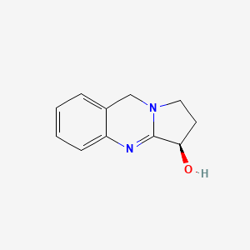

Fig. 1A. Structure of vasicine
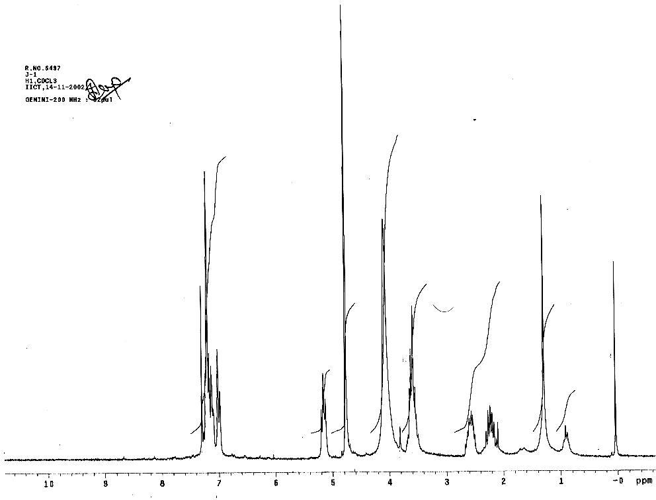

Fig. 1B. ¹H NMR spectrum of vasicine extract from leaf callus cultures of A.zeylanica (A.zeylanica should be italic form)

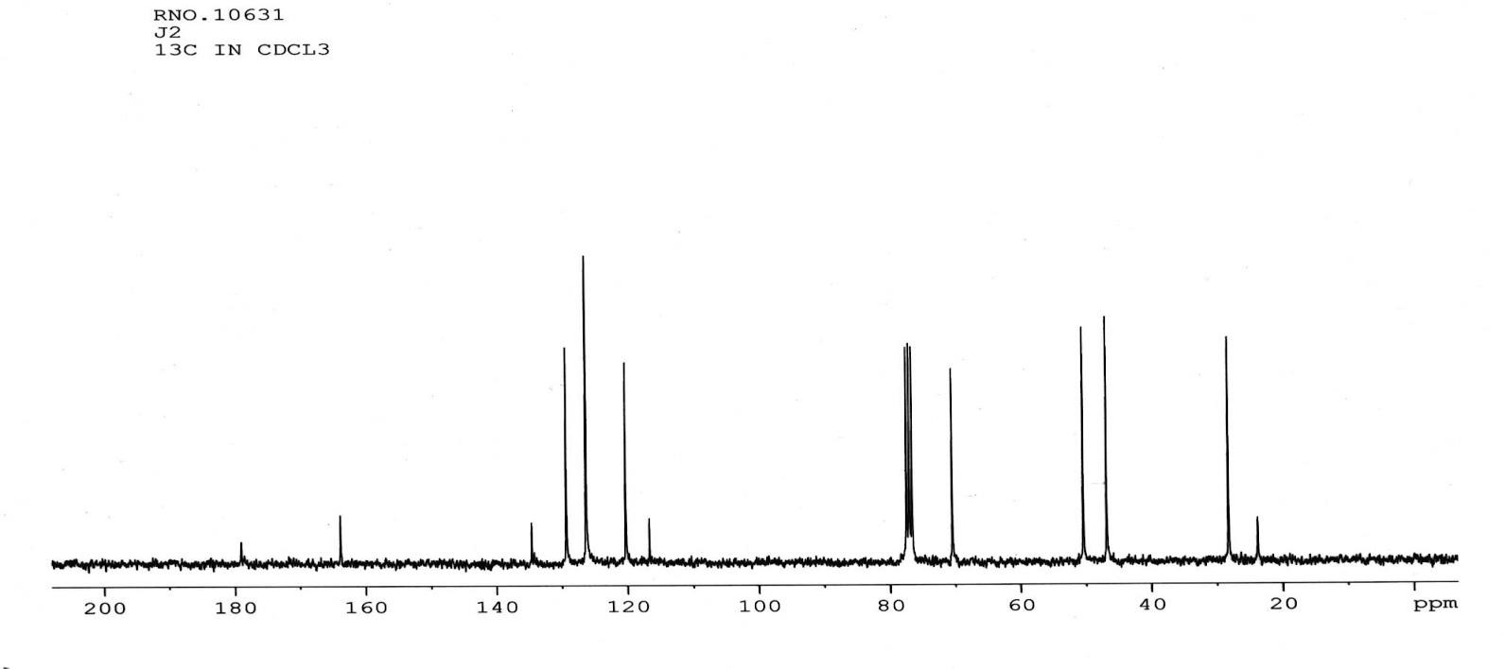

Fig. 1C. ¹³C NMR of Vasicine extracted from Callus samples of Adhatoda zeylanica
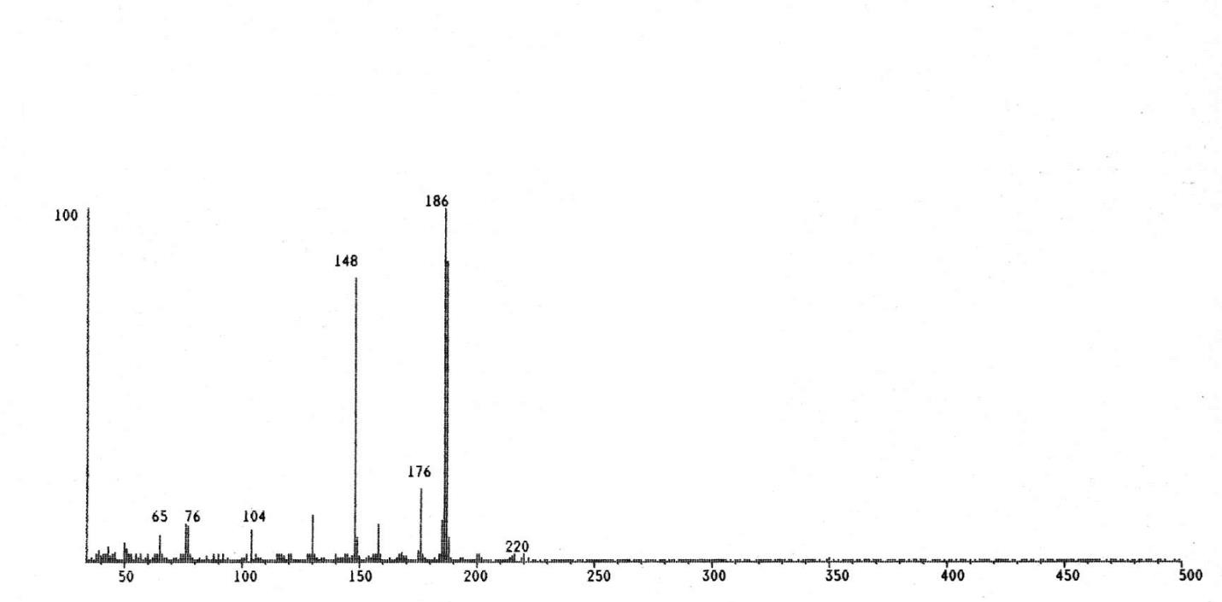

Fig. 1D. Electron Ionization Mass Spectra of Vasicine extracted from Callus samples of Adhatoda zeylanica

Certain aromatic amino acids like viz., Phenylalanine, Tyrosine and Ornithine were incorporated into the medium for enhancing the yield potential of Vasicine in the callus cultures. At a concentration of 0.5mM Ornithine increased the ability of callus to produce Vasicine to an extent of 4.7mg/gDW. In the presence of phenylalanine and tyrosine the callus yielded 4.5 and 3.9 mg/gDW of Vasicine at 1.0mM and 0.5mM concentrations respectively (Table-3). Earlier, phenylalanine was found to renhance the production of taxol in Taxus cuspidate callus cultures [21] and podophyllotoxin in Podophyllum [22]. Elicitors prepared from fungi, bacteria, yeast, chitosan are known to influence the accumulation of secondary plant products in several cultures [23, 24] observed significant effect of iron and copper on the production of betalains in suspension cultures of Beta vulgaris. Elicitors are reported to have a key role in plant defense responses and hence may be acting as powerful signals to induce secondary metabolite synthesis as pointed out by Choi et al. [25], Howe and Schilmiller [26]. Among the fungal elicitors used, (Aspergillus niger and Rhizoctonia solani) elicitors have shown positive response in the yield of Vasicine where Aspergillus is proved to be better at 48hrs of incubation with 1.5ml/l concentration yielded 4.72mg/gDW of Vasicine (Table-4). Among bacterial elicitors Pseudomonas aeruginosa at 24hrs incubation with 1.0ml/l of concentration yielded 4.38mg/gDW of Vasicine which is more when compared to Bacillus subtilis (3.60mg/gDW) (Table-5) .Yeast extract (Saccharomyces cerevisiae) at a concentration of 1.5ml/l when incubated for 48hrs yielded 3.67mg/gDW of Vasicine (Table-6). Elicitors from Rhizoctonia bataticola increased solavetivone production in Hycymus muticus (Ramakrishna et al.,1993).In case of Plumbago rosea cell cultures bacterial elicitors(Bacillus subtilis, Pseudomonas aeruginosa ) showed positive influence on plumbagin production [17]. Maximum accumulation of Vasicine (4.52mg/gDW) was observed at 20μM of jasmonic acid with an incubation period of 48hrs, while methyl jasmonate was effective at a concentration of 150μM yielded4.98mg/gDW (Table-7). In addition to elicitor effect, chitosan can also be used as a permeabilizing agent (Young et al.,1982)[27]. In the present study chitosan, when used at 150 mg/l, produced 1.83 mg of Vasicine extra cellularly (Table-8).. Chitosan has been proved to enhance the production of secondary metabolites in suspension cultures of Mentha piperita [28], Vanilla planifolia(Funk &d Brodelius,1990), and Polygonum tintorum [29]. In the cultures of Polygonum tintorum, 72% higher indurubin was accumulated when subjected to elicitation with chitosan for a period of five days [29]. Our results suggest that carbohydrate source, amino acids and elicitors can enhance the accumulation of vasicine in vitro. Therefore, efforts are taken to improve the yields of vasicine further in cell cultures of A. zeylanica by hairy root cultures, immobilization and permeabilization.

Table 1. Influence of Phytohormones on Biomass yield in the Callus cultures of Adhatoda zeylanica

Hormonal concentration μM | Explant | MS |  | B5
Hormonal concentration μM |  | F.W D.W |  | F.W D.W
2.2μM 2,4-D |  | ----- |  | -----
4.5μM 2,4-D | Petiole | 3.210±0.2 | 0.301±0.02 | 1.235±0.1 | 0.112±0.3
2.2μM NAA |  | ----- |  | -----
4.5μM NAA | Petiole | 4.351±0.3 | 0.362±0.01 | 1.408±0.2 | 0.102±0.01
4.5μM 2,4-D+2.3μM Kn | Petiole | 6.675±0.2 | 0.481±0.02 | 1.523±0.3 | 0.134±0.01
4.5μM 2,4-D+4.6μM Kn | Petiole | 10.370±0.3 | 1.106±0.1 | 4.909±0.2 | 1.359±0.03
9.0μM 2,4-D+4.6μM Kn | Petiole | 9.274 ±0.2 | 0.982±0.04 | 1.756±0.3 | 0.201±0.1
13.0μM 2,4-D+9.3μM Kn | Petiole | 6.333±0.3 | 0.733±0.02 | 3.201±0.1 | 0.783±0.02
5.3μM NAA+2.2μM 6-BA | Leaf | 5.444±0.1 | 1.302±0.1 | 3.224±0.2 | 0.879±0.07
10.7μM NAA+4.4μM 6-BA | Leaf | 7.445±0.5 | 1.498±0.03 | 3.009±0.5 | 0.678±0.04
4.9μM IBA+2.2μM 6-BA | Leaf | 5.342± 0.2 | 1.231±0.02 | 4.021±0.3 | 1.341±0.03
4.5μM 2,4-D+4.6μM Kn+2.2μM 6-BA | Leaf | 4.980±0.3 | 1.007±0.02 | 3.642±0.2 | 0.765±0.02
18.0μM 2,4-D+9.3μM Kn+22.8μM IAA | Leaf | 6.104±0.1 | 0.552±0.1 | 1.966±0.1 | 0.221±0.06
21.5μM NAA+4.9μM IBA+2.2μM 6-BA | Leaf | 6.251± 0.2 | 0.463±0.03 | 1.356±0.5 | 0.321±0.01
21.5μM NAA+19.7μM IBA+8.8μM 6-BA | Leaf | 5.213± 0.2 | 0.692±0.04 | 3.432± 0.2 | 0.364±0.02
21.5μM NAA+19.7μM IBA+9.3μM Kn | Leaf | 6.991±0.3 | 1.034±0.01 | 2.098±0.3 | 0.421±0.08

*F.W = Fresh weight; *D.W = Dry weight

Table 2. Effect of different Carbon sources on the Biomass yield and Vasicine content In the Callus cultures of Adhatoda zeylanica

Concentration | Fresh Weight (g) | Dry Weight (g) | Vasicine yield (mg/g DW)
Sucrose :3% | 12.100±0.5 | 3.081±0.14 | 4.1±0.07
Fructose :3% | 6.513±0.1 | 1.042±0.02 | 3.4±0.01
Glucose :3% | 6.550±0.2 | 2.023±0.21 | 4.5±0.09
Maltose :3% | 4.721±0.1 | 0.938±0.02 | 3.3±0.02
Sucrose :4% | 10.643±0.3 | 2.022±0.11 | 4.8±0.01
Fructose :4% | 6.975±0.1 | 1.116±0.03 | 4.0±0.03
Glucose :4% | 5.253±0.2 | 1.109±0.03 | 3.2±0.01
Maltose :4% | 9.118±0.2 | 2.006±0.12 | 3.9±0.12
Sucrose :5% | 7.211±0.1 | 1.081±0.20 | 3.7±0.03
Fructose :5% | 6.322±0.4 | 1.040±0.01 | 3.6±0.01
Glucose :5% | 3.989±0.2 | 0.923±0.12 | 2.8±0.02
Maltose :5% | 7.277±0.3 | 2.010±0.02 | 2.4±0.03

*F.W = Fresh weight; *D.W = Dry weight

Table 3. Response of Aromatic Amino acids Phenylalanine, Tyrosine and Ornithine on Vasicine ProductionIn the Callus cultures of Adhatoda zeylanica

Con c. (m M) | Phenylalanine |  |  | Tyrosine |  |  |  | Ornithine
Con c. (m M) | F.W | D.W | Yield | F.W | D.W | Yield |  | F.W | D.W |  | Yield
0.1 | 1.093±0.2 | 0.401±0.02 | 2.3±0.03 | 2.061±0.4 | 0.288±0.01 |  | 2.8±0.21 | 2.001±0.3 |  | 1.000±0.03 | 3.4±0.05
0.5 | 2.393±0.3 | 0.720±0.06 | 3.2±0.03 | 3.194±0.2 | 0.479±0.02 |  | .9±0.11 | 2.905±0.2 |  | 0.538±0.22 | 4.7±0.42
1.0 | 2.668±0.2 | 0.803±0.05 | 4.5±0.12 | 2.475±0.2 | 0.346±0.11 |  | 3.4±0.31 | 1.613±0.1 |  | 0.480±0.14 | 3.9±0.21
2.0 | 1.093±0.1 | 0.401±0.08 | 2.1±0.11 | 1.984±0.1 | 0.277±0.12 |  | 3.0±0.21 | 1.081±0.5 |  | 0.613±0.23 | 3.5±0.11

Table 4. Effect of Fungal Elicitors on Vasicine yield (mg/gDW) in Cell suspensions of Adhatoda zeylanica

Incubati- on period | Conc (ml/l) | Aspergillus niger |  |  | Rhizoctonia solani
 |  | Intra | Extra cellular | Total | Intra | Extra | Total yield
 |  | yield |  |  | cellular | cellular
 |  | cellular
24h | 0.5  1.0  1.5  2.0 | 1.74  1.80  1.92  1.72 | 0.32  0.32  0.75  0.38 | 2.06±0.01  2.12±0.02  2.67±0.05  2.10±0.07 | 1.63  1.81  1.94  1.21 | 0.38  0.35  0.51  0.80 | 2.01±0.09  2.16±0.03  2.45±0.8  2.01±0.9
 | 0.5 | 1.86 | 0.81 | 2.67±0.06 | 1.30 | 0.84 | 2.14±0.21
 | 1.0 | 2.01 | 1.06 | 3.07±0.03 | 2.10 | 0.91 | 3.01±0.07
48h | 1.5 | 2.92 | 1.80 | 4.72±0.07 | 2.61 | 1.53 | 4.14±0.08
 | 2.0 | * |  |  | *
 |  | 1.36 | 0.38 | 1.74±0.05 | 1.81 | 1.06 | 2.87±0.12
 | 0.5 | 1.19 | 0.80 | 1.99±0.2 | 1.32 | 1.00 | 2.32±0.05
 | 1.0 | 2.00 | 1.00 | 3.00±0.11 | 2.02 | 0.96 | 2.98±0.15
72h | 1.5 | 2.61 | 0.38 | 2.99±0.15 | 2.16 | 1.04 | 3.20±0.10
 | 2.0 | 0.51 | 0.27 | 0.78±0.05 | 1.00 | 0.93 | 1.93±0.29

Table 5. Effect of Bacterial Elicitors on Vasicine yield (mg/gDW) in Cell suspensions of Adhatoda zeylanica

Incubation period | Conc (ml/l) | Pseudomonas aeruginosa |  |  | Bacillus subtilis
 |  | Intra | Extra | Total yield | Intra | Extra | Total
 |  | cellular | cellular |  | yield
 |  |  |  |  | cellular | cellular
24h | 0.5  1.0  1.5  2.0 | 2.00  2.81  2.06  1.32 | 0.87  1.57  0.98  0.51 | 2.87±0.26  4.38±0.23  3.04±0.12  1.83±0.06 | 1.72  1.93  2.62  1.03 | 0.32  0.71  0.98  0.64 | 2.04±0.06  2.64±0.07  3.60±0.09  1.67±0.09
 | 0.5 | 1.81 | 0.70 | 2.51±0.06 | 1.06 | 0.30 | 1.36±0.07
 | 1.0 | 2.01 | 0.91 | 2.92±0.11 | 1.52 | 0.63 | 2.15±0.01
48h | 1.5 | 1.83 | 0.78 | 2.61±0.03 | 2.00 | 0.86 | 2.86±0.14
 | 2.0 | 0.81 | 0.38 | 1.19±0.04 | 1.00 | 0.45 | 1.45±0.09
 | 0.5 | 0.98 | 0.31 | 1.29±0.08 | 0.98 | 0.28 | 1.26±0.04
 | 1.0 | 1.62 | 0.51 | 2.13±0.12 | 1.31 | 0.53 | 1.84±0.14
72h | 1.5 | 0.73 | 0.28 | 1.01±0.11 | 1.81 | 0.66 | 2.47±0.17
 | 2.0 | 0.81 | 0.28 | 1.09±0.01 | 0.93 | 0.38 | 1.31±0.06

Table 6. Effect of Yeast-extract (Saccharomyces cerevisiae ) on Vasicine yield(mg/gDW) in Cell Suspensions of Adhatoda zeylanica

Concentration ml/l. |  | Yeast Extract(Saccharomyces cerevisiae)
 |  | Intra-cellular | Extra-cellular | Total yield
 | 0.5 | 0.9 | 0.28 | 1.26±0.48
24hrs | 1.0 | 1.31 | 0.53 | 1.84±0.13
 | 1.5 | 1.81 | 0.66 | 2.47±0.09
 | 2.0 | 0.93 | 0.38 | 1.31± 0.26
 | 0.5 | 1.73 | 0.36 | 2.09±0.07
48hrs | 1.0 | 1.94 | 0.72 | 2.66±0.12
 | 1.5 | 2.69 | 0.98 | 3.67±0.34*
 | 2.0 | 1.06 | 0.65 | 1.71±0.17
 | 0.5 | 1.07 | 0.32 | 1.39±0.21
72hrs | 1.0 | 1.52 | 0.66 | 2.18±0.19
 | 1.5 | 2.01 | 0.88 | 2.89±0.53
 | 2.0 | 1.03 | 0.45 | 1.48±0.41

Table 7. Effect of Jasmonic acid and Methyl jasmonate on Vasicine yield(mg/gDW) in Cell suspensions of Adhatoda zeylanica

Incubatio n period | Conc (μM/l) | Jasmonic acid |  |  | Conc. (μM/l) | Methyl jasmonate
 |  | Intra | Extra | Total |  | Intra | Extra | Total
 |  | cellular | cellular | yield |  | cellular | cellular | yield
24h | 5 | 1.82 | 0.81 | 2.63±0.04 | 50 | 1.72 | 0.87 | 2.59±0.06
 | 10 | 2.32 | 0.94 | .26±0.32 | 100 | 2.31 | 1.06 | 3.37±0.03
 | 20 | 2.94 | 1.03 | 3.97±0.03 | 150 | 3.00 | 1.16 | 4.16±0.08
 |  |  |  |  | 200 | 2.10 | 1.06 | 3.16±0.03
 | 5 | 2.13 | 0.95 | 3.08±0.05 | 50 | 2.01 | 1.03 | 3.04±0.05
 | 10 | 2.81 | 1.12 | 3.93±0.1 | 100 | 2.81 | 1.12 | 3.93±0.03
 | 20 | 3.44 | 1.08 | 4.52±0.03 | 150 | 3.74 | 1.24 | 4.98±0.05
 |  | * |  |  |  | *
 |  |  |  |  | 200 | 3.04 | 1.11 | 4.15±0.03
 | 5 | 2.00 | 0.83 | 2.83±0.05 | 50 | 1.93 | 0.92 | 2.85±0.05
72h | 10 | 2.71 | 0.86 | 3.57±0.05 | 100  150 | 2.62  3.24 | 1.00  1.16 | 3.62±0.12  4.40±0.12
 | 20 | 3.07 | 1.02 | 4.09±0.02 | 200 | 2.52 | 0.98 | 3.50±0.05

Table 8. Effect of Chitosan on Vasicine Production in Cell suspensions of Adhatoda zeylanica

Incubation period (hr) | Mg/l | Intra cellular | Extra cellular | Total yield
 | 50 | 3.24 | 1.17 | 4.41(±0.26)
24 | 100 | 3.54 | 1.13 | 4.67±0.23
 | 150 | 3.78 | 1.26 | 5.04±0.12
 | 50 | 3.32 | 1.28 | 4.60±0.07
48 | 100 | 4.00 | 1.18 | 5.18±0.03
 | 150 | 4.58 | 1.52 | 6.10±0.11
 | 50 | 3.01 | 1.02 | 4.03±0.21
72 | 100 | 3.91 | 0.98 | 4.89±0.05
 | 150 | 4.23 | 1.12 | 5.35±0.02

CONCLUSION

Plant tissue and cell culture systems are being exploited for the production of a variety of natural products. Tissue culture protocols for a number of medicinal plants were established, and this enabled the analysis of callus/cell suspension extracts for the presence of different classes of secondary products. The in vitro culture of Adhatoda zeylanica involved two distinct phases. 1. Optimizing a media for the rapid multiplication of callus. 2. Optimizing a media which would support minimal growth of biomass and maximum yield of secondary metabolite. Our results suggest that carbohydrate source, amino acids and elicitors can enhance the accumulation of vasicine in vitro. Therefore, efforts are taken to improve the yields of vasicine further in cell cultures of A. zeylanica by hairy root cultures, immobilization and permeabilization. Based on the results of the present investigation, it can be proposed that a further increase in Vasicine content may be achieved by designing bioreactors for large scale production and genetic transformation studies. The current trend of DNA fingerprinting will also be helpful in correlating the yield of secondary metabolite with the respective genotype of the plant. After a perusal of the present study and above mentioned facts one can assess the importance of plant tissue culture techniques, not only in the biosynthesis of economically important phytochemicals, but also in the conservation of medicinal plants.

DISCLAIMER

The products used for this research are commonly and predominantly use products in our area of research and country. There is absolutely no conflict of interest between the authors and producers of the products because we do not intend to use these products as an avenue for any litigation but for the advancement of knowledge. Also, the research was not funded by the producing company rather it was funded by personal efforts of the authors.

REFERENCES

- Chopra RN. Some Observations on the pharmacological action and therapeutic properties of Adhatoda vasica. Ind J Med Res. 1925;13:205.
- Md. Tofazzal Hossain and Md. Obydul Hoq. Therapeutic use of Adhatoda vasica. Asian J. Med. Biol. Res. 2016;2 (2):156-163.
DOI: 10.3329/ajmbr.v2i2.29005, ISSN 2411-4472 (Print) 2412-5571 (Online)
- Rastogi RP, Mehrotra BN. Chemical constituents .In: Compendium of Indian Medicinal Plants. Rastogi RP , Mehrotra BN, Mukta S, Shradha S and Bela B, editors. Central Drug Research Institute, Lucknow and Publications &Information Directorate, New Delhi. 1989;4:12- 13.
- Atish G, Dhwani D, Sadasivan Kannan, Lipasa P and Ritu Rani. Adhatoda vasica attenuates inflammatory and hypoxic responses in preclinical mouse models: potential for repurposing in Covid-19-like conditions. Respiratory Research. 2021;22Article number:99
- Ghosh TP and Sen JN. Vasicine-an alkaloid present in Adhatoda vasica. Nees. Q. J. Ind. Chem. Soc. 1925;1.315-320.
- Babu KN, Ravindran PN and Peter KV. Spices. In: Biotechnology of Horticultural Crops. V.A. Parthasarthy TK, Bose and Das P, editors, Naya Prakash, Calcutta, India. 2001;3:329.
- Pandita K, Bhatia MS, Thappa RK, Agarwal SG ,Dhar KL and Atal CK. Seasonal variation of alkaloid of Adhatoda vasica and detection of glycosides and N-oxides vasicine and vasicinone. J. Med. Plant Res. 1983;48:81-82.
- Jayapaul K, Kavi Kishor PB, Reddy KJ. Production of pyrroloquinazoline alkaloid from leaf and petiole-derived callus cultures of Adhatoda zeylanica. In Vitro Cell.Dev.Biol. 2005;41:682-685.
- Jayapaul K, Kavi Kishor PB, Reddy KJ. Production of pyrroloquinazoline alkaloid from leaf and petiole-derived callus cultures of Adhatoda zeylanica. In Vitro Cell.Dev.Biol. 2005;41:682-685.
- Roja Gopalakrishnan, B.H Vikrant and Santosh kumar sandur. Accumulation of vasicine and vasicinone in tissue cultures of Adhatoda vasica and evaluation of the free radical- scavenging activities of the various crude extracts, Food Chemistry. 2010;126(3):1033-1038.
- Saxena OP, Meena Kumar, Ananta Nandtirth MA and Shobana Saxena. Identification of bio-active compounds from medicinally important plants grown in vitro. In: Trivedi PC, editor. Plant biotechnology recent advances. New Delhi: Panima Publishing Corporation. 1997;380-388.
- Narayanaswamy S, editor. Regeneration of plants from tissue cultures. In: Applied and Fundamental Aspects of Plant Cell Tissue and Organ Culture, Reinert J and Baja YPS,editors, Springer-Verlag, Heidelberg-New York. 1977;178-248.
- Fowler MW. Process strategies for plant cell cultures. Trends Biotechnol. 1986;4:214-219.
- Fowler MW and Stafford A. Plant cell culture process systems and product synthesis. In: Flowler MW, Warren GS, editors. Plant biotechnology. Oxford: Pergamon. 1992;79-98.
- Kavi Kishor PB, Mehta AR. Effects of different sugars on invertase activity in cotton callus cultures. J. Rec. Adv. Appl. Sci. 1987;2: 244-253.
- Paska C, Innocenti G, Kunavari M, Laszio M, Szilagyi L. Lignan production by Ipomea cairica callus cultures. Phytochemistry. 1999;52:879-883.
- Komaraiah P, Kavi Kishor PB, Ramakrishna SV. Production of plumbagin from cell cultures of Plumbago rosea L. Biotechnol. Lett. 2001;23:1269-1272.
- Narender Reddy CM, Narender Reddy, Venkatesh Palyamand Chaitanya Lakshmi. Effect of Different Carbon Sources on in vitro Shoot Regeneration and Multiplication of Cissampelos pareira (L.) -An Important Medicinal Plant, Journal of Plant Sciences (Science Publishing Group). 2019;7(6):131-136.
- Rashmi PA, John R, Mathew L. Isolation and characterisation of vasicine from in vitro cultures of Justicia adhatoda L.(Article). Int. J. Pharm. Bio. Sci. 2012;3:B58-64.
- Sreelakshmi L, Kavi Kishor PB, Janardhan Reddy K. Enhanced Production of Psoralen, A Furanocoumarin in callus cultures of Cullen corylifolium (L) Medik. Plant Cell Biotechnology and Mol. Biol. 2007;1&2:27-32.
- Fett-Neto AG, Melanson SJ, Nicholson SA, Pennington JJ, Dicosmo F. Improved taxol yield by aromatic carboxylic and aminoacid feeding to cell cultures of Taxus cuspidate. Biotechnol. Bioeng. 1994;44:967-971.
- Archana G, Vikas D, Giri CC, Ajay S, Owen PW, Lakshmi Narasu M. Biotransformation using plant cells, organ cultures and enzymesystems-.Current trends and future prospects.Biotechnology Adv. 2001;19:175-199.
- Dong HD, Zhong JJ. Enhanced taxane productivity in bioreactor cultivation of Taxus chinensis cells by combining elicitation, sucrose feeding and ethylene incorporation. Enz.Microb.Technol. 2002;31:116-121.
- Qian Z, Zhao Z, Xu Y, Qian X and Zhong J. Novel chemically synthesized hydroxyl- containing jasmonates as powerful inducing signals for plant secondary metabolism, Biotech. Bioeng. 2004;86:809-816.
- Choi D, Bostock RM, Avidiushko S and Hildebrand DF. Lipid-derived signals that discriminates wound and pathogen-responsive isoprenoid pathways in plants: methyl jasmonate and the fungal elicitor arachidonic acid induce different 3-hydroxy-3-methylglutaryl-coenzyme A reductase genes and antimicrobial isprenoids in Solanum tuberosum L. Proc. Natl. Acad. Sci. U.S.A. 1994;91:2329-2333.
- Howe GA, Schilmiller AL. Oxylipin metabolism in response to stress. Curr. Opin.Plant Biol. 2002;5:230-236.
- Knorr D, Teutonica RA. Chitosan immobilization and permabilization of Amaranthus tricolor cells. J Agric Food Chem. 1986;34:582-585.
- Chang JH, Lee HJ. Charecteristics of oil production during suspension culture with chitisan elicitation. Ann. Res. Center for Newbio-Mater. Agric. 1992;111-117.
- Kim JH, Shin JH, Lee HS, Chung IS and Lee HJ. Effect of chitosan on indirubin production from suspension cultures of Polygonum tinctorum. J. Ferm. Bioeng. 1997;83:206-208.

_____________________________________________________________________________________

