Study by Fourier Transform Infrared Spectroscopy of the Avocado Oils of the Varieties Hass, Criollo and Fuerte

Abstract: Edible oils are obtained by two procedures: by pressing the fruit and with organic solvents. However, there are reports that indicate that the use of solvents affect the quality of the fatty acids inducing the formation of trans isomers, which are banned in many countries because these consumed in large quantities are cause of cardiovascular diseases and increase the cholesterol. The purpose of this work is to apply FTIR to study the trans fatty acids in the avocado oils of the varieties Hass, Fuerte and Criollo extracted by centrifugation (AHC, AFC and ACC, respectively) and with hexane (AHH, ACH and AFH, respectively). The Infrared spectra were obtained with Fourier Transform Infrared (FTIR) in the mid region (4000-600 cm⁻¹). The AHC, AFC and ACC Oils IR spectra show a very intensity band at the frequency 723 cm⁻¹, which corresponds to the functional group cis with a bending vibration mode. For the AFH the trans functional group was identified in the band sited at 968 cm⁻¹ with a strong intensity. The centrifuge method is an alternative for obtaining avocado oil, because the degradation of the fatty acids is minimum and the green color is maintained.

Key words: Avocado oil, infrared spectroscopy, trans fatty acids.

Introduction
The Mexican avocado is a fruit recognized world-wide level due to the high quality of its nutrients [1]. The main problem of the producers is the short time of maturation and oxidation that presents this fruit, because of it has been demonstrated that the visual appearance a product is the first impact that takes the consumer to acquire it [2].
The avocado in Mexico has begun to industrialize in products such as paste and oil. The main avocado variety cultivated is the Hass, but other varieties such as the Fuerte and Criollo are also important, the last one is in danger of extinction because of it is being replaced in most of orchards by the variety Hass [3]. Various researchers have reported that avocado oil is similar to olive oil in many chemical compounds; however, the

avocado oil has a higher content of β-sitosterol (1-0.45%), vitamin E (130-200 mg/Kg) and chlorophyll (40-60 ppm) [4]. However, the high levels of chlorophyll in the avocado oil affect its stability and quality causing a rapid formation of oxidation products by means of singlet oxygen [5]. The green color in the oil has been identified by the consumers as desirable because it retains almost all the natural components of fruit.
Several investigations are focused on the extraction of oil, with the purpose of minimizing the adverse effects and to obtain a suitable product for the consumers. Generally, edible oils are extracted by drying, mechanical pressure at high temperatures and organic solvents. The use of organic solvents in a commercial scale has been discussed due to air pollution problems. In addition, the solvents affect the quality of the unsaturated fatty acids inducing the formation of trans isomers [6], which are banned in

62

several countries because if they are consumed in great quantities they could be cause of cardiovascular diseases and increase the cholesterol [7]. Therefore, alternative methods in the production of avocado oil are sought, they may include: centrifugation, supercritical fluids and combined methods. For fatty acids analysis from oils chemical and instrumental methods have been used. In the first one are included the acidity indices, peroxide and iodine, but no one of these are able to analyze the type and concentration of fatty acids. However, instrumental methods such as Infrared Spectroscopy not only allow knowing these parameters faster and in versatile way, but also they do not use chemical reagents and it is non-polluting [8]. The aim of this study was to determine the degree of deterioration of the unsaturated fatty acids in the avocado oils extracted by the centrifuge and Hexane methods using infrared spectroscopy.

Experimental Details
The Hass avocado oils were extracted by centrifugation and solvent methods. The centrifugation procedure was as to continuation describes: by 10 minutes the sample was centrifuged at 15.500 gravities and at 40 ºC of temperature, these conditions were applied to Fuerte and Criollo avocado varieties. The solvent procedure was the method reported by AOAC at 70 °C for 4 h [9].
Fig. 1 shows images of the oils obtained for both techniques. In this figure, it is possible to observe how by the centrifugation procedure an oil of clear green
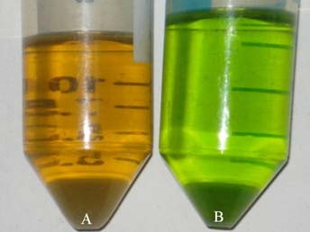
Fig. 1 Avocado oil variety hass extracted with solvent (A) and by centrifugation (B) procedures.
Table 1 Main vibrational frequencies of the commercial oils [10].
Frequency (cm⁻¹) | Functional group | Vibrational mode
723 | -HC=CH- (cis) | Bending
968 | -HC=CH- (trans) | Bending
1654 | -C=C- (cis) | Stretching
1746 | -C=O (ester) | Stretching
3006 | -HC=CH- (cis) | Stretching
3025 | -HC=CH- (trans) | Stretching
color is obtained, whereas when the solvent procedure is used an oil of brown color is obtained.
Transform Infrared Spectrometer (FTIR Bruker Vertex-70) was used in the measurement mode called Attenuated Total Reflectance (ATR). The crystal used was a ZnSe of one reflection. And the exposure time was 150 seconds for each sample. Only 20 µL of each sample were placed in the ATR crystal. The infrared absorbance was measured in the mid-infrared region from 4000 to 600 cm⁻¹.

Results and Discussion
Guillen and Cabo [10] analyzed some edible oils and fats by Infrared vibrational Spectroscopy. In Table 1, their results are summarized.
The band at 723 cm⁻¹ is caused by the bending of the functional group cis [10, 11] and the band at 968 cm⁻¹ is associated to functional group trans, both in the bending symmetric mode outside the plane [10-13]. In the region of 1033-1163 cm⁻¹ is the carboxyl functional group with symmetrical vibration [10, 11, 14]. The group CH₃ in asymmetric vibration mode was found in the region of 1430-1470 cm⁻¹, and the absorption band from 1445 to 1485 cm⁻¹ corresponds to a methylene group in the bending vibration mode [10, 11, 15]. The vibrational bands above of 3000 cm⁻¹ are associated with the functional group cis at 3006 cm⁻¹ [10, 11] and to the functional group trans at 3040 cm⁻¹ [15]. Fig. 2 shows the absorbance spectra of the avocado oil varieties Hass, Fuerte and Criollo, obtained by centrifugation and hexane methods.
Avocado oils spectra are very similar, even though small differences occur in the intensities of their bands and the absorbance peak frequency that makes to them

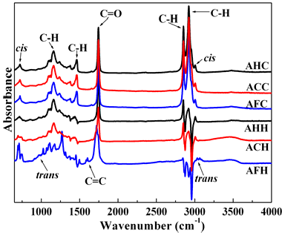
Fig. 2 Infrared spectra of avocado oil varieties hass, Fuerte and criollo obtained by centrifugation and hexane methods (AHC, AFC and ACC, AHH, AFH and ACH, respectively).
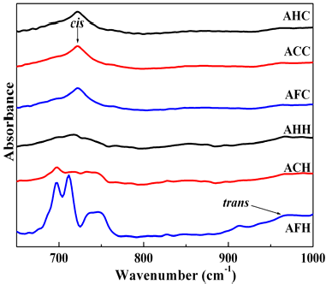
Fig. 3 Infrared spectra avocado oils for the region from 600 to 1000 cm⁻¹.
different in each case. It should be noted that due to these differences, the nature and quality of the product can be determined [10]. In the IR spectra shown in Fig. 2 present almost all peaks in strong or weak intensity predicted by Refs. [10, 11], In fact the trans peak at 968 cm⁻¹ is possible observe in all avocado oils samples, but the peak at 3040 cm⁻¹ is not present in our avocado oils samples. One can see that there are differences of intensity in the regions from 600 to 1000 cm⁻¹ and from 3000 to 3050 cm⁻¹ in the IR spectra. In Figs. 3 and 4, these regions are analyzed at detail. Fig. 3 shows an intense band at 725 cm⁻¹ that was associated to the functional group cis, this peak is more intense for the avocado oils extracted by centrifugation (AHC, ACC and AFC). The trans peak at 968 cm⁻¹ is present only in the avocado oils samples extracted by Hexane solvent, in fact, it is much better to be defined in hass and fuerte

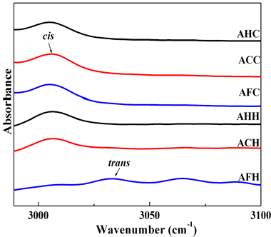
Fig. 4 Infrared spectra avocado oils for the region from 3000 to 3100 cm⁻¹.
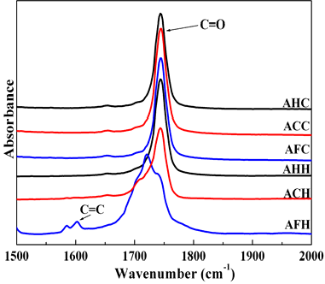
Fig. 5 Infrared spectra of the Avocado Oils in the region from 1500 to 2000 cm⁻¹ that show the carboxylic acid functional group.
varieties (AHH and AFH). Privett et al. [16], Chan and Levett [17] reported that trans and cis systems absorb close to 988 and 950 cm⁻¹, respectively. According with these researchers, one can say that the oils (AHH and AFH) present fatty acids with chemical bonds of conjugated diene. Therefore, they are more reactive to the addition of free radicals.
For the other region, 3000 to 3050 cm⁻¹, the first peak close to 3006 cm⁻¹ is associated to the stretching vibration mode of the cis position in the oils extracted by the two different methods used in this work (Fig. 4). It is also possible to observe a small spectral shift and less intense peaks in the case of the avocado oil from the variety Fuerte. However, none of the avocado oils extracted by centrifugation shows the functional group in the trans mode at 3040 cm⁻¹ in agreement with

64

Coates [15]. The sample that shows the trans stretching peak was the AFH, which is shifted to 3033 cm⁻¹.
Finally, the double bond region from 1500 to 2000 cm⁻¹ was analyzed (Fig. 5). A peak was only observed at the frequency of 1743-1750 cm⁻¹ in all oils. This peak is indicative of the ester functional group with a stretching vibration mode. For the avocado oil variety Fuerte a shift to higher frequencies was observed and the intensity increase approximately 15% for the C=O peak. Yue et al. studied the degradation of triacylglycerols in olive virgin oils and they found an increase in the intensity or the peak associated to the C=O bond at 1726-1748 cm⁻¹ (region of carboxylic acid functional group) due to the formation of free fatty acids [18]. Therefore the shift and increase in intensity observe in the Fuerte oil spectrum for the C=O bond, may be associated with deterioration of triacylglycerols by the effect of solvent extraction.
The only sample that shows the peak associated to the C=C bond is the Fuerte Avocado oil extracted by solvent (Fig. 5).

Conclusions
The Centrifugation method can be an option for the extraction of Avocado Oil because the treatment does not increase significant deterioration of unsaturated fatty acids and green color is maintained. In addition, the FTIR analysis identified a band of lower absorption associated to fatty acids with trans isomer in the band 968 cm⁻¹ for the samples of the avocado oils extracted by centrifugation. The sample that shows a higher concentration of trans was the Fuerte variety Avocado oil extracted by Hexane solvent.

References
- R. Schwentesius, M.A. Gómez, Supermarkets in Mexico: impacts on horticultural systems, Journal of Development Policy Review 20 (2002) 487-502.
- J.A. Guerrero-Beltrán, B.G. Swanson, G.V. Barbosa- Cánovas, Shelf life of HHP-processed peach puree with antibrowning agents, Journal of Food Quality 28 (2005) 479-491.
- J. Sánchez-Pérez, Recursos genéticos de Aguacate (Persea americana Mill.) y Especies afines en México, Revista Chapingo Serie Horticultura 5 (1999) 7-18.
- O.B. Ashton, O.M. Wong, T.K. Mcghie, R. Vather, Y. Wang, C. Requejo-Jackman, P. Ramankutty, A.B. Woolf, Pigments in avocado tissue and oil, Journal of Agricultural and Food Chemistry 54 (2006) 10151-10158.
- M.J. Werman, I. Neeman, Oxidative stability of avocado oil, Journal of the American Oil Chemists Society 63 (1986) 355-360.
- M.A. Ortiz, L. Dorantes, J. Galíndez, R.I. Guzmán, Effect of different extraction methods on fatty acids, volatile compounds, and physical and chemical properties of avocado (persea americana mill.) oil, Journal of Agricultural and Food Chemistry 51 (2003) 2216-2221.
- A.D. Mooradian, M.J. Haas, K.R. Wehmeier, N.C.W. Wong, Obesity-related changes in high-density lipoprotein metabolism, Journal of Obesity 16 (2008) 1152-1160.
- F.R.V.D. Voort, A.A. Ismail, J. Sedman, G. Emo, Monitoring the oxidation of edible oils by Fourier Transform Infrared Spectroscopy, Journal American Oil Chemistry Society 71 (1994) 243-253.
- A.O.A.C. Association Official, Analytical Chemists, Food Composition, Natives, Natural Contaminants, Oils and Fats. A.O.A.C. E.U.A. (2006) 963-967.
- M.D. Guillén, N. Cabo, Relationships between the composition of edible oils and Lard and the ratio of the absorbance of specific bands of their Fourier Transform Infrared Spectra, role of some bands of the fingerprint region, Journal of Agricultural and Food, Chemistry 46 (1998) 1789-1793.
- H. Yang, J. Irudayaraj, M.M. Paradkar, Discriminant analysis of edible oils and fats by FTIR, FT-NIR and FT-Raman Spectroscopy, Journal of Food Chemistry 93 (2005) 25-32.
- D. Firestone, L.P. Bouliere, Determination of isolated trans isomers by Infrared Spectroscopy, Journal of the Association of Official Analytical Chemists 48 (1965) 437-443.
- R.T. Sleeter, M.G. Matlock, Automated quantitative analysis of isolated (nonconjugated) trans isomers using Fourier Transform Infrared Spectroscopy incorporating improvements in the procedure, Journal American Oil Chemistry Society 66 (1989) 121-127.
- F.A. Ahmed, R.O. Osman, H.M. Nomany, S.S. Saadany, Infrared and Ultraviolet Spectra of some lipids of different structures, Revista Grasas y Aceites 37 (1986) 250-253.
- J. Coates, Oils and Fats, Interpretation of Infrared Spectra, a practical approach, Encyclopedia of Analytical Chemistry, John Wiley and Sons Ltd., 2000, pp. 10815-10837.
- O.S. Privett, W.O. Lundberg, N.A. Khan, W.E. Tolberg,
D.H. Wheeler, Structure of hydroperoxides obtained from autoxidized methyl linoleate, Journal American Oil Chemistry Society 30 (1953) 61-66.
- H.W. Chan, G. Levett, Autoxidation of methyl linolenate: analysis of methyl hydroxylinolenate isomers by high performance liquid chromatography, Journal of Lipids 12 (1977) 837-840.
- L. Yue, D.L. García-González, Y. Xiuzhu, F.R.V.D. Voort, Determination of free fatty acids in edible oils with the use of a variable filter array IR Spectrometer, Journal of the American Oil Chemists Society 85 (2008) 599-604.

