PROXIMATE COMPOSITION OF GREEN-LIPPED MUSSEL, PERNA VIRIDIS (LINNAEUS, 1758), FROM MALAD CREEK, MUMBAI

ABSTRACT
Proximate analysis focuses on the nutritional composition to assess their potential as a sustainable food source. The analysis quantifies the protein, carbohydrate, fat, ash, and moisture content of green mussels, providing insights into their dietary value and implications for aquaculture. The green mussels exhibited a high protein content of 15.97 ± 0.0550 mg/mL indicating their substantial contribution to dietary protein intake. Carbohydrate content was measured at 0.9723 ± 0.07559 mg/mL reflecting a low carbohydrate profile. The fat content was found to be 2.34 ± 0.123 mg/mL highlighting the mussels' low-fat nature, while the ash content, which represents the mineral composition, was 2.94 ± 0.6381%. Moisture content was notably high at 84.43 ± 1.454% characteristic of aquatic organisms. These findings underscore the green mussels' nutritional density, with a significant proportion of their composition dedicated to protein and minimal levels of fats and carbohydrates. The results suggest that green mussels are a nutrient-dense, high protein and low-fat food source with potential for inclusion in diets, both for human consumption and aquaculture feed formulations.
KEYWORDS: Proximate analysis, Perna virdis, Green lipped mussel

INTRODUCTION
In the tropical and subtropical regions of the Indo-Pacific region, the Asian green mussel (Perna viridis), a bivalve species found in estuaries and intertidal zones, is extensively spread. It is a sizable, rapidly expanding species with significant commercial potential that has proven to be incredibly viable for production in numerous nations. From 1990 to 2015, the world's output of marine mussels (Mytilidae) increased at an average annual rate of 5%, with 1.1 million tonnes produced globally, of which 85% originated in Asian nations. (Asaduzzaman et al. 2019) Out of the 652 species of marine bivalves that are reported from India, 88 species are endemic to Indian waters (Mohamed and Sasikumar 2016). The demand for mussels as food keeps on increasing especially in developing countries, because of significance as a relatively cheaper source of protein for the human diet compared to other marine and terrestrial sources (Suplicy 2020). India has risen to one among the top 10 cultured mussel producing nations in Asia, with an annual production of 10,060 tons as of 2008 [Kripa and Mohamed 2008]. Bivalves are prominently found on the western coast of India and are cultured for the sole purpose of obtaining food as the mussel soft tissue is considered a delicacy by the coastal population. In India, the two mussel species are prominently found, namely Perna viridis and Perna indica [Chakraborty et al. 2016].
Perna viridis (Linneaus, 1758) commonly known as the Green lipped mussel or the Asian Green mussel, found prominently in the South Asian sub-continent. It is a bivalve mollusc belonging to the family Mytilidae [Chaudhari et al. 2024]. The vibrant green color on the lip of the mussel is a distinguishing characteristic of P. viridis. They are found in the intertidal regions of the coasts, attached to the substratum/rocks by byssus threads. P. viridis is a filter feeder species that feed on phytoplanktons and zooplanktons by pumping water through a set of gill filament through the excurrent siphon. (Jorgensen 1990; Tan and Ransangan 2017)
P. viridis (Linnaeus, 1758) in India is abundantly found in Kozhikode – Kannur area upto Kasargod region, also recognised as the mussel zone of India. Whereas on the east coast of India, it is widely spread from Chilka Lake (Odisha), Vishakhapatnam (Andhra Pradesh), Chennai (Tamil Nadu), and Cuddalore (Pondicherry). On the West Coast of India, it is found in regions like Mangalore, Karwar, Goa, and Ratnagiri, upto Gulf of Kutch. Their presence is seen on the Coasts of Andamans and Nicobar Islands [Chaudhari et al. 2024]. This mussel species is a major fouling organism, causing economic impacts on industries, shipping and maritime as well as it also serves as a valuable food source all over Asia. It is majorly found along the Coasts of Mumbai in the intertidal region attached to the rocky substratum using byssus threads.
They contain good levels of Omega-3-fatty acids chain polyunsaturated fatty acids, particularly eicosapentaenoic acid (EPA) and docosahexaenoic acid (DHA), which is highly known for its benefits to human health (Venugopal and Gopakumar 2017; Carboni et al. 2019; Dalin et al. 2021). They provide high nutrition to the human body with essential proteins and minerals making it a staple diet for the fisherman tribe and coastal populace. According to studies by Sengor, Saritha and Chakraborty, “indicate that mussels are high in protein and their nutritional quality have been made clear and found to contain 18 types of amino acids with considerable proportions of essential amino acids and non-essential amino acids” (Sengor et al. 2008; Saritha et al. 2015; Chakraborty et al. 2016). This also helps us the importance of nutritional value it possesses as it contains amino acids that are not produced or synthesized by the human body which can be supplemented by the P. viridis consumption.

2. Materials and Methods
2.1 Sample Collection and Preparation
Mussels, P. viridis were purchased from the local fish market near Malad Creek, Mumbai as depicted in Figure 1.a and 1.b. The samples were transported to the laboratory in a sterile ice box to prevent contamination and deterioration. The collected mussels were cleaned with a brush to remove all the dirt attached to the outer surface. A stainless-steel scalpel cut open the mussel to remove the soft tissue. The tissue was then cleaned with distilled water to remove any remaining contaminants and homogenized for further analysis.
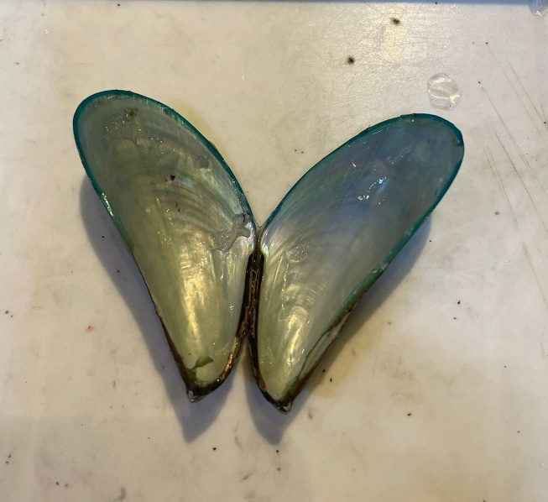 | 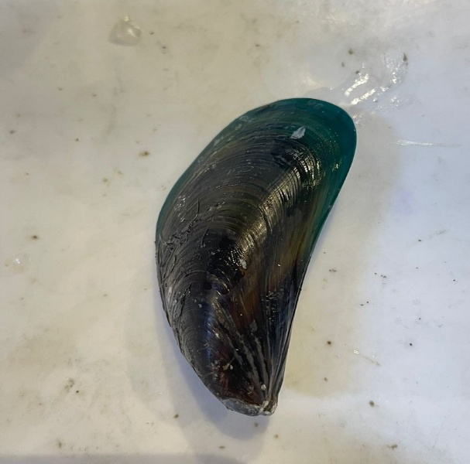
Figure 1.a Green mussel | Figure 1.b Green mussel

2.2 Proximate analysis
Protein, Carbohydrates, Fats, ash, and moisture content were done for triplicates' proximate analysis. The crude protein was determined by the Folin-Lowry method. The sample was treated with Reagent A (2% sodium carbonate and 0.1N sodium hydroxide) and Reagent B (0.5% copper sulfate in 1% potassium sodium tartrate), along with the Folin-Ciocalteau reagent. A standard graph was then used to determine the sample concentration.
Carbohydrates were determined using the Anthrone reagent method. 1g of sample was treated with Anthrone’s reagent (Anthrone reagent in concentrated sulphuric acid) and glucose as standard. A standard graph was then used to determine the sample concentration.
Fat content was determined by drying the sample in an oven at 100°C and subsequently extracting fat with diethyl ether in a Soxhlet Extractor for 3 to 4 hours.
Ash content was determined using the dry Ashing procedure. 1g of each sample was taken in a porcelain crucible and weighed, then kept in a Muffle furnace for 2 hours. After cooling, the crucible is kept in a Desiccator and weighed.
Moisture content was assessed by weighing the differences before and after overnight oven drying at 100°C.

3. Results and Discussion
The results of the proximate analysis of green mussels from the Mumbai market are conducted to understand the major nutritional values of the soft tissue of P. viridis shown in Table 1.
Proximate analysis | Content
Crude Protein | 15.97 ± 0.0550 mg/mL
Crude Fat | 2.34 ± 0.123 mg/mL
Carbohydrate | 0.9723 ± 0.07559 mg/mL
Moisture Content | 84.43 ± 1.454%
Ash Content | 2.94 ± 0.6381%
Table 1. Contents of Crude Protein Crude Fat, Carbohydrates, Moisture and Ash in P. viridis soft body tissue.
The amount of crude protein found in P. viridis is 15.97 ± 0.0550 mg/mL whereas 2.34 ± 0.123 mg/mL of crude fat is seen in the green mussel after performing the methods. The carbohydrate amount found is significantly low than that of protein that is 0.9723 ± 0.07559 mg/mL. Jamila Patterson (Patterson et al. 2018), in a comparative study, observed that Perna viridis had higher protein and moisture content than Perna perna. Also, it was seen that Perna perna and parrot mussel had higher amounts of lipid, ash, carbohydrate and fibre than Perna viridis.
Biochemical changes in the mussel occur because of factors such as temperature, salinity and oxygen levels and physiological changes based on the food availability, gametogenic cycle and spawning [Livingstone 2001]. These factors result in change in proteins, moisture content, carbohydrates and fats, resulting in changes in texture and taste of P. viridis. As these mussels are majorly farmed for food, it is essential to maintain an appropriate amount of the moisture content as the quality of the food product of P. viridis majorly depends on it. This information is important for the people performing aquaculture of the mussels and the Nutritionists.
The ash content is also needed to determine the minerals present in P. viridis and their nutritional values. Some of these minerals make the mussels a source of essential mineral requirement of the human body after consumption. The ash content in P. viridis is seen to be 2.94 ± 0.6381%. This tells us that the organism, P. viridis holds nearly 3% of minerals in the soft body tissue.
Moisture content or water content of P. viridis is observed to be 84.43 ± 1.454% in this research study. This tells us that more than 80% of the soft body tissue of P. viridis is made up of water. Water content of the tissue of bivalves usually gives an indication of the time of spawning and the water content may varies with the reproductive cycle, physiological state and nutritional condition of the organisms itself. (Singh et al. 2012)
Thurgasri (Vella et al. 2023) in Malaysia found that Perna viridis had 55.98 ± 0.95% of protein, 83.83 ± 2.09% of moisture, 7.28 ± 0.05% of ash, 6.86 ± 0.05% of fat. Dhamagaye (Dhamagaye et al. 2018) stated in their paper on Perna viridis, the moisture (63.21 to 85.30%), protein (49.23 to 63.71%), crude fat (9.30 to 17.20) and ash (3.0 to 8.5 %) of P. viridis. Both papers show readings in the same range even though the places of research are miles away from each other, showing the similarity in the green mussels biochemical composition. They also stated an inverse relationship between size and age of the bivalve. This is well established in the research done by Narsimham (Narsimham 1981) and Tuavcharden (Tuavcharden et al. 1988) on P. viridis.
Establishing the nutritional profile of Perna viridis the green lipped mussel is important for the important nutritional characteristics it possesses which are necessary for the human nutrition. It being rich in protein content and minerals, which are essential for the human body, that plays a crucial role in maintaining human health and physiological and chemical processes of the human body. (Vella et al. 2023)

Conclusion
The green lip mussel, Perna viridis is a valuable nutritional source rich in high quality Protein and relatively low in Fats and Carbohydrates. This favourable macronutrient profile makes it an excellent option for those seeking a nutrient dense food with low-calorie intake. Additionally, it is rich in essential amino acids that contribute to potential health benefits. High availability and low costs make this mollusc a dietary staple for the fisherman community in and around the coastline of India. These biochemical compounds play a crucial role in fulfilling the nutritional need of the human body and for maintaince of physiological process and keeping the body in good health condition.

REFERENCES
Asaduzzaman, M., Noor, A. R., Rahman, M. M., Akter, S., Hoque, N. F., Shakil, A., & Wahab, M. A. (2019). Reproductive Biology and Ecology of the Green Mussel Perna viridis: A Multidisciplinary Approach. Biology, 8(4), 88. https://doi.org/10.3390/biology8040088
Carboni, S., Kaur, G., Pryce, A., McKee, K., Desbois, A.P., Dick, J.R., Galloway, S.D.R., Hamilton, D.L. (2019). Mussel consumption as a "Food First" approach to improve omega-3 status. Nutrients, 11:1381.
Chaudhari, S., Upadhyay, A., Saroj, D. K., & Shingadia, H. U. (2024). Biometric Characteristic Study of Green Lipped Mussel, Perna viridis (Linnaeus, 1758) From Malad Creek, Mumbai, India. Uttar Pradesh Journal of Zoology, 45(14), 349-356.
Dalin, M., Saritha, K., Patterson, J. (2021). Lipid and fatty acid profile variations in Perna indica and Perna viridis of Kanyakumari district, Southeast and west coast of India.
H. B. Dhamagaye, A. M. Ranade, S. J. Meshram, S. D. Naik, R. K. Sadavarte, M. J. Gitte, and Sachin Belasare (2018). Proximate Composition and Growth Study of Green Mussel Perna viridis (L.) from Mirya Creek in Ratnagiri, Maharashtra, India.
Immaculate, J. K., Sheeba, W., Narmatha, S., and Jamila, P. (2018). Biochemical Composition and Heavy Metal Content in Mussels of Kadiyapattinam, Kanyakumari District, South West Coast of India. Journal of Nutritional Biology.
Jørgensen, C. B. (1990). Bivalve Filter Feeding: Hydrodynamics, Bioenergetics, Physiology and Ecology. Fredensborg, Denmark: Olsen & Olsen.
Kajal Chakrabortya, Selsa J. Chakkalakala, Deepu Josepha, P. K. Asokanb, and K. K. Vijayana (2016). Nutritional and Antioxidative Attributes of Green Mussel (Perna viridis L.) from the Southwestern Coast of India.
Kripa, V., and Mohamed, K. S. (2008). Green mussel, Perna viridis, farming in Kerala, India—Technology diffusion process and socioeconomic impacts. Journal of the World Aquaculture Society, 39(5), 612–624.
Livingstone, D. R. (2001). Contaminant-stimulated reactive oxygen species production and oxidative damage in aquatic organisms. Marine Pollution Bulletin, 42: 656–666.
Mohamed, K. S. and Sasikumar, G. (2016). Overview of bivalve fisheries of India. In: Nandan, S. B., Oliver, P. G., Jayachandran, P. R., and Asha, C. V., Training manual - 1st International Training Workshop on Taxonomy of Bivalve Molluscs (Directorate of Public Relations and Publications, CUSAT, Kochi, India), pp. 47-53.
Narasimham, K. A. (1981). Dimensional relationships and growth of green mussel Perna viridis in Kakinada Bay. Indian Journal of Fisheries, 28(1&2), 240-248.
Saritha, K., Mary, D., Patterson, J. (2015). Nutritional status of green mussel Perna viridis at Tamil Nadu, southwest coast of India. Journal of Nutrition and Food Sciences, 14:003.
Sengor, G. F., Gun, H., Kalafatoglu, H. (2008). Determination of the amino acid and chemical composition of canned smoked mussels (Mytilus galloprovincialis, L.). Turkish Journal of Veterinary and Animal Sciences, 32: 1–5.
Singh, Y. T., Krishnamoorthy, M., and Thippeswamy, S. (2012). Seasonal variations of Cu, Pb, Fe, Ni, and Cr in the edible wedge clam, Donax faba (Mollusca, Bivalvia) from the Padukere beach, Karnataka. Journal of Theoretical and Experimental Biology, 8: 95-100.
Suplicy, F. M. (2020). A review of the multiple benefits of mussel farming. Reviews in Aquaculture, 12: 204–223.
Tan, K. S., and Ransangan, J. (2017). Feeding Behaviour of Green Mussels, Perna viridis, Farmed in Marudu Bay, Malaysia. Aquaculture Research, 48(3), 1216-1231.
Tuaycharoen, S., Vakily, J. M., Sallow, A., & McCoy, E. W. (1988). Growth and maturation of the green mussel (Perna viridis) in Thailand. ICLARM International Center for Living Aquatic Resources Management Technical Reports (Philippines). no. 20.
Vella, T. V., Alia, T. G., & Keyona, A. S. A. (2023). Analyzing Nutritional Content and Essential Amino Acid Composition of Perna viridis Mussels: Insights from Proximate Analysis and High-Performance Liquid Chromatography-Ultraviolet Analysis.
Venugopal, V., Gopakumar, K. (2017) Last 5 years. Shellfish: nutritive value, health benefits, and consumer safety. Comprehensive Reviews in Food Science and Food Safety, 16:1219–1241.

