WHEAT LEAF SENESCENCE UNDER DROUGHT

Abstract:
Senescence is a genetically programmed developmental phase marked by a coordinated sequence of catabolic events, including the accumulation of reactive oxygen species (ROS), macromolecular degradation, organelle disintegration, and the metabolic shift from nutrient assimilation to remobilization. Leaf senescence in wheat is a fundamental physiological process that significantly influences both grain yield and quality. The study aims to investigate the mechanisms of drought-induced senescence in contrasting genotypes of durum and bread wheat, explore the role of antioxidant enzymes during flag leaf senescence, and identify physiological changes in leaves during senescence dynamics. Seeds of local bread wheat (Triticum aestivum L.) genotypes, including the tolerant Gyrmyzy gul 1 and sensitive Tale 38, as well as durum wheat (Triticum durum Desf.) genotypes, the tolerant Vugar and sensitive Tartar, were obtained from the gene bank of the Research Institute of Crop Husbandry, Baku, Azerbaijan. The plants were grown in controlled environment chambers under controlled and drought conditions using a completely randomized design. Five seeds of each genotype were planted under the ambient temperature between 19-29°C, and the relative humidity between 50% and 65%. The statistical analysis was carried out using SAS software ver9.2. The study revealed that Cu/Zn-SOD expression increased during the senescence process, peaked at 28 DAA, and then significantly decreased in all naturally senescing plants. The findings of this study underscore the pivotal role of antioxidant enzymes and the preservation of cellular integrity in modulating drought-induced leaf senescence in wheat. The differential responses observed between drought-tolerant and drought-sensitive genotypes reflect the multifaceted nature of senescence under abiotic stress conditions. In conclusion, the results highlight critical physiological and molecular traits associated with drought resilience and offer promising targets for wheat breeding programs aimed at improving stress tolerance through the stabilization of redox homeostasis.

Keywords: Leaf senescence, antioxidant defense, Lipid Peroxidation, Gene Expression Analysis,

Abbreviations: ROS, reactive oxygen species; SAGs, senescence-associated genes; DAA, days after anthesis, MSI, membrane stability index; MDA, malondialdehyde; FW, fresh weight; SOD, superoxide dismutase; APX, ascorbate-peroxidase; GPX, guaiacol-peroxidase; BPX, benzidine-peroxidase; CAT, catalase, TEM, Transmission Electron Microscopy

Introduction:

Wheat represents one of the most important staple crops worldwide and plays a crucial role in ensuring global food security and human nutrition (Cheng et al., 2024). Leaf senescence in wheat is a fundamental physiological process that significantly influences both grain yield and quality. Elucidating the regulatory mechanisms underlying this process is essential for improving wheat performance and adaptability under varying environmental conditions (Zhao et al., 2022; Chapman et al., 2021; Hassan et al., 2021). Senescence is a genetically programmed developmental phase marked by a coordinated sequence of catabolic events, including the accumulation of reactive oxygen species (ROS), macromolecular degradation, organelle disintegration, and the metabolic shift from nutrient assimilation to remobilization (Li et al., 2024; Woo et al., 2019). Under natural conditions, senescence is age-dependent and is accelerated during the transition from vegetative to reproductive stages (Aloryi et al., 2023). In this process, nutrients stored in leaves are relocated to metabolically active tissues, particularly to developing grains in cereal crops (Guo et al., 2021). However, when triggered prematurely by adverse environmental stimuli, senescence can detrimentally affect crop productivity. A wide range of abiotic stresses-including drought, temperature extremes, salinity, nutrient imbalances, and light stress-as well as biotic factors such as pathogen attack and insect infestation, can accelerate senescence (Tan et al., 2023). Additionally, genetic determinants and hormonal signaling pathways critically influence the timing and progression of senescence (Cao et al., 2022; Sultana et al., 2021).
The antioxidant defense system plays an essential role in counteracting the deleterious effects of both intrinsic aging and external environmental stressors in plants (Qi et al., 2023; Nousis et al., 2023). Antioxidants are indispensable for maintaining cellular redox homeostasis and protecting plant tissues from oxidative damage, particularly during senescence. The balance between reactive oxygen species (ROS) production and the scavenging capacity of the antioxidant system is a key determinant of leaf longevity and overall plant vitality (Yuan et al., 2023). In plant cells, ROS predominantly originate from three pathways: the electron transport chains in chloroplasts and mitochondria, enzymatic activity of oxidases and peroxidases, and the excitation of photosensitizing pigments such as chlorophyll. Among these, chloroplasts contribute most substantially to ROS production under light exposure, where Rubisco-mediated carboxylation and oxygenation reactions modulate oxygen metabolism (Saed-Moucheshi et al., 2014). As leaf senescence progresses and chlorophyll degrades, photosynthetic efficiency declines, leading to increased ROS accumulation and the onset of oxidative stress (Li et al., 2023; Buet et al., 2019). In response, antioxidant enzymes such as superoxide dismutase (SOD), catalase (CAT), and various peroxidases are activated to neutralize ROS and prevent damage to cellular structures. The regulation of antioxidant enzyme activity during senescence is a multifaceted process modulated by both intracellular metabolic changes and environmental conditions (Sachdev et al., 2021; Hönig et al., 2018). A comprehensive understanding of this regulatory network is essential for elucidating the molecular basis of leaf senescence (Chen et al., 2021).
Leaf senescence is accompanied by extensive transcriptional reprogramming, involving the differential expression of thousands of senescence-associated genes (SAGs) (Cao et al., 2022; Camargo Rodriguez, 2021). A growing body of evidence indicates that this process is tightly regulated by a wide array of transcription factors that modulate the expression of SAGs in response to both internal and external cues (Cao et al., 2023; Borril et al., 2019). Beyond the influence of genetic and environmental factors, epigenetic regulation has emerged as a critical layer of control in the senescence network. Modifications such as DNA methylation and histone modifications significantly affect the transcriptional activity of aging-related genes, providing novel insights and potential targets for modulating senescence (Woo et al., 2019; Yolcu et al., 2018). Integrative multi-omics analyses have further demonstrated that senescence is orchestrated through a complex interplay of regulatory mechanisms, including chromatin remodeling, transcriptional and post-transcriptional control, as well as translational and post-translational modifications (Zhang et al., 2021; Kim et al., 2018).

Current knowledge of the molecular mechanisms underlying leaf senescence has been largely established through investigations in model plant systems, particularly Arabidopsis thaliana (Yumoto et al., 2024; Xie et al., 2021; Zhao et al., 2023; Kim et al., 2018). These studies have demonstrated that the molecular, biochemical, and physiological pathways governing senescence are largely conserved across diverse plant taxa (Guo et al., 2021; Woo et al., 2019). However, extrapolating these findings to agriculturally important cereal crops such as wheat requires direct investigation due to species-specific regulatory differences. Elucidating the senescence-associated networks in wheat is critical for advancing crop improvement strategies aimed at enhancing yield and stress resilience. In recent years, increasing attention has been directed toward the senescence process in wheat, with numerous studies shedding light on its genetic and physiological underpinnings (Yan et al., 2023; Chapman et al., 2021; Sultana et al., 2021; Borril et al., 2019; Joshi et al., 2019). Notably, transcriptomic analyses have provided valuable insights into the gene expression profiles associated with leaf senescence in wheat, revealing complex regulatory interactions and potential targets for manipulation (Sultana et al., 2021; Borril et al., 2019).
Under the ongoing challenges of global climate change, water scarcity is projected to exert the most detrimental influence on crop productivity worldwide. Drought represents a multifaceted stressor capable of inducing premature leaf senescence and accelerating overall plant maturation, ultimately leading to significant yield losses (Tan et al., 2023). In certain species, drought-induced senescence serves as an adaptive strategy that enhances survival under water-limited conditions. This is achieved by (i) promoting the early allocation of assimilates from vegetative to reproductive organs, thus ensuring life cycle completion in monocarpic species; (ii) enabling the remobilization of nutrients from senescing to younger tissues, which supports longevity in perennials; and (iii) reducing transpirational water loss at the whole-plant level (Munné-Bosch and Alegre, 2004). Notably, drought conditions are often accompanied by a decline in soil nitrogen availability, which further stimulates and accelerates the onset of senescence (Hajibarat and Saidi, 2022). Investigations into the mechanisms of drought-induced leaf senescence are essential not only for elucidating plant survival responses to environmental stress but also for informing breeding strategies. Specifically, the development of genotypes with delayed senescence holds promise for sustaining or enhancing crop yields under drought conditions (Joshi et al., 2019; Gregersen et al., 2013).
Overall, managing senescence in crops such as wheat requires a thorough understanding of complex regulatory networks at various levels, including molecular, biochemical, and physiological processes. In this study, we aim to investigate the mechanisms of drought-induced senescence in contrasting genotypes of durum and bread wheat, explore the role of antioxidant enzymes during flag leaf senescence, and identify physiological changes in leaves during senescence dynamics. Gaining deeper insights into different aspects of leaf senescence may allow us to identify potential targets for manipulating these processes.
Seeds of local bread wheat (Triticum aestivum L.) genotypes, including the tolerant Gyrmyzy gul 1 and sensitive Tale 38, as well as durum wheat (Triticum durum Desf.) genotypes, the tolerant Vugar and sensitive Tartar, were obtained from the gene bank of the Research Institute of Crop Husbandry (Baku, Azerbaijan) (Allahverdiyev, 2015). The plants were grown in controlled environment chambers under control and drought conditions using a completely randomized design. Five seeds of each genotype were planted in 5 L plastic pots filled with soil mixture consisting of 40% topsoil and 60% natural sand. Throughout the experiment, the ambient temperature was maintained between 19-29°C, and the relative humidity was between 50% and 65%. The plants were grown in controlled environment chambers with a 16h light/8h dark cycle. The plants were watered 2-3 times weekly to make sure the soil stayed moist. All plants were provided with equal irrigation until the booting stage. Afterward, watering was stopped for the drought-treated plants, while the control plants continued to be watered regularly. Flag leaves were sampled 7, 14, 21, 28, and 35 days after anthesis. Flag leaves were sampled 7 (early grain filling), 14 (mid grain filling), 21 (late grain filling), 28 (milk ripeness), and 35 (dough ripeness) days after anthesis. The leaf samples were immediately frozen in liquid nitrogen and stored at -80°C until analysis.

Chlorophyll Content
The content of photosynthetic pigments chlorophyll a and chlorophyll b- was measured in flag leaves at five time points (7, 14, 21, 28, and 35 days after anthesis, DAA) during natural (age-induced) and drought-induced senescence in wheat genotypes with contrasting stress tolerance (Table 1). The content of pigments was determined spectrophotometrically in the 80% acetone extract according to Porra et al. (1989). In all plants, the quantities of both chlorophyll a and chlorophyll b progressively decreased as senescence advanced. At 7 DAA, although there was a slight reduction in pigment levels in stress-sensitive genotypes, no significant differences were observed in tolerant plants. In contrast to naturally senescing plants, a sharp decline in pigment levels was observed in the flag leaves of drought-stressed wheat at 21 DAA. This decline was particularly pronounced in sensitive genotypes, with the amount of both chlorophyll a and chlorophyll b being more than twofold lower in drought-exposed tetraploid Tartar and hexaploid Tale 38 compared to 14 DAA. A significant decrease in chlorophyll a content was observed in naturally senescing plants at 35 DAA, with reductions of 39%, 40%, 34%, and 40% in Vugar, Tartar, Gyrmyzy gul 1, and Tale 38, respectively. Notably, the reduction in chlorophyll b content in drought-stressed plants was detected earlier: at 14 DAA in the sensitive genotypes (29% in Tartar and 34% in Tale 38) and at 21 DAA in the tolerant genotypes (21% in Vugar and 44% in Gyrmyzy gul 1) compared to the previous stage.

Table 1. Dynamics of changes in photosynthetic pigments during the post-anthesis period.

 |  | Chlorophyll a (mg/g FW)
 |  | 7 DAA | 14 DAA | 21 DAA | 28 DAA | 35 DAA
Vugar | control | 6.89 ± 0.56 | 7.18 ± 0.55 | 6.4 ± 0.53 | 5.8 ± 0.44 | 3.5 ± 0.26
Vugar | stress | 6.51 ± 0.52 | 6.18 ± 0.49 | 4.89 ± 0.39 | 3.5 ± 0.28 | 2.3 ± 0.18
Tartar | control | 7.43 ± 0.61 | 7.09 ± 0.56 | 6.07 ± 0.49 | 4.8 ± 0.37 | 3.3 ± 0.26
Tartar | stress | 6.82 ± 0.55 | 6.06 ± 0.48 | 3.23 ± 0.26 | 2.2 ± 0.18 | 1.3 ± 0.1
Gyrmyzy gul 1 | control | 5.57 ± 0.44 | 5.04 ± 0.41 | 4.35 ± 0.35 | 3.5 ± 0.28 | 2.1 ± 0.17
Gyrmyzy gul 1 | stress | 5.09 ± 0.41 | 4.45 ± 0.18 | 3.02 ± 0.19 | 2.5 ± 0.2 | 1.8 ± 0.14
Tale 38 | control | 5.12 ± 0.41 | 5.06 ± 0.4 | 4.6 ± 0.37 | 2.9 ± 0.23 | 1.9 ± 0.15
Tale 38 | stress | 4.49 ± 0.36 | 4.04 ± 0.32 | 2.21 ± 0.18 | 1.69 ± 0.14 | 1.05 ± 0.08
 |  | Chlorophyll b (mg/g FW)
 |  | 7 DAA | 14 DAA | 21 DAA | 28 DAA | 35 DAA
Vugar | control | 6.51 ± 0.52 | 1.91 ± 0.16 | 1.5 ± 0.12 | 1.2 ± 0.09 | 1.1 ± 0.08
Vugar | stress | 1.87 ± 0.16 | 1.65 ± 0.12 | 1.03 ± 0.08 | 0.7 ± 0.06 | 0.5 ± 0.04
Tartar | control | 2.25 ± 0.18 | 2.15 ± 0.17 | 2.02 ± 0.16 | 1.6 ± 0.14 | 1.1 ± 0.07
Tartar | stress | 1.81 ± 0.14 | 0.98 ± 0.08 | 0.6 ± 0.05 | 0.4 ± 0.03 | 0.19 ± 0.02
Gyrmyzy gul 1 | control | 1.98 ± 0.16 | 1.82 ± 0.15 | 1.5 ± 0.12 | 1.2 ± 0.1 | 0.8 ± 0.06
Gyrmyzy gul 1 | stress | 1.66 ± 0.13 | 1.61 ± 0.13 | 0.9 ± 0.07 | 0.7 ± 0.06 | 0.4 ± 0.03
Tale 38 | control | 2.18 ± 0.17 | 2.04 ± 0.16 | 1.65 ± 0.13 | 0.88 ± 0.1 | 0.6 ± 0.05
Tale 38 | stress | 1.56 ± 0.12 | 0.85 ± 0.07 | 0.61 ± 0.05 | 0.5 ± 0.04 | 0.2 ± 0.02
Note: DAA- days after anthesis; FW- fresh weight. Data represent the mean ± SD (n=3).

Significant chlorophyll degradation occurred concurrently with increased lipid peroxidation and decreased membrane stability. This was further accompanied by enhanced activation of antioxidant system components and a reduction in total soluble protein levels, ultimately affecting the leaf cell ultrastructure. Our findings indicate that chlorophyll loss during natural senescence occurs gradually. Under drought stress, chlorophyll a and b levels in tolerant genotypes sharply declined by 21 DAA, while in sensitive genotypes, chlorophyll b decreased earlier, by 14 DAA. Accelerated leaf senescence in response to drought is considered an important adaptive survival mechanism, as it reduces the plant's overall water requirements (Tan et al., 2023). Chlorophyll degradation is regarded as a precursor to leaf senescence, as it is associated with nutrient remobilization (Guo et al., 2021). Chlorophyll loss may play a role in photoprotection during the early stages of drought-induced leaf senescence when chloroplasts still retain some photosynthetic activity. The loss of chlorophyll reduces the controlled effects of singlet oxygen formation in thylakoids (Španić et al., 2023). This protection may be particularly important in the initial phase of leaf senescence under drought, as it could prevent the rapid dismantling of chloroplasts, which, in the absence of protective mechanisms, could threaten nutrient remobilization (Krieger-Liszkay et al., 2019). Once chlorophyll degradation occurs, the pigment-protein complex dissociates, and enzymes can break down proteins that may constitute a significant amount of the nitrogen present in chloroplasts (Buet et al., 2019). Additionally, some studies suggest that the onset of leaf senescence may occur before chlorophyll degradation becomes apparent Pic et al. (2002) demonstrated that a gene homologous to SAG2 from Arabidopsis, which codes for a cysteine protease and is considered a specific marker of senescence, is expressed in water-stressed potted pea plants before a decline in photosynthesis, chlorophylls, or protein levels.

Membrane Stability and Lipid Peroxidation
During the post-anthesis period, due to the aging process, membrane stability in the flag leaves exhibited a declining trend. Flag leaf samples (2 cm from the middle sections, with three replicates for each sample) were washed three times in deionized water to remove surface electrolytes for measuring MSI. The samples were placed in 10 ml of double-distilled water at 40°C for 30 minutes (Deshmukh et al. 1991). Electrical conductivity (C1) was measured using a conductivity meter. Subsequently, the same samples were placed in a boiling water bath (100°C) for 10 minutes, and their electrical conductivity (C2) was re-recorded. The membrane stability index (MSI) was calculated as
MSI = [1 - (C1 / C2)] × 100.
At 7 DAA, this parameter was at a similar level across all genotypes. However, in the subsequent periods, membrane stability in stressed plants was lower compared to those under normal conditions. Significant decreases in MSI were observed at 21 DAA compared to the previous stage, with reductions of 15% and 12% in the stress-tolerant Vugar and Gyrmyzy gul 1 genotypes, respectively, and 31% and 37% in the stress-sensitive genotypes Tartar and Tale 38, respectively (Figure 1).

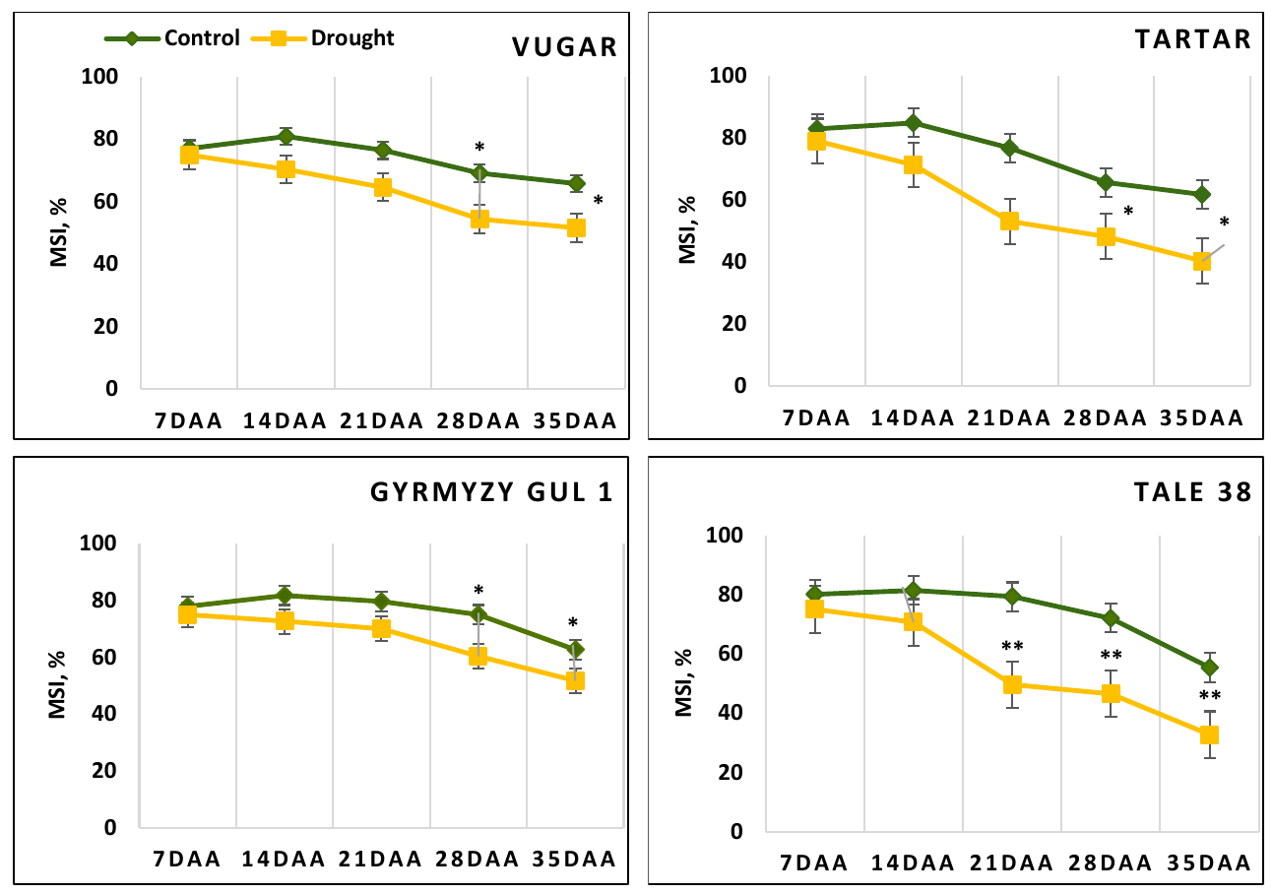

Figure 1. Dynamics of membrane stability index (MSI) in wheat flag leaves during natural and drought-induced senescence. DAA – days after anthesis. Data points represent the mean ± se (n = 5). Asterisks indicate significance difference (*P < 0.05, **P < 0.01, ***P < 0.001) using pairwise t tests.

The intensity of lipid peroxidation in plants was assessed by measuring the quantity of malondialdehyde (MDA) in flag leaf samples under both normal watering and drought stress conditions (Wang, 2011). The MDA content was determined spectrophotometrically using the Thermo Scientific Evolution 350 UV/Vis Spectrophotometer (UK, England) through its reaction with 0.5% thiobarbituric acid at wavelengths 532 nm and 600 nm. The formula used for calculation was: A = (D532 - D600) / (E * m).
Where, A - represents MDA concentration, D - is the optical density, m - denotes plant wet biomass, and E - is a constant coefficient.
An increase in the content of MDA, an indicator of lipid peroxidation, was observed in wheat genotypes during natural senescence (Figure 2). The level of MDA during drought-induced senescence was higher than the level of normal irrigation in all genotypes. This difference was more pronounced and occurred earlier in stress-sensitive genotypes. At 21 DAA, no significant difference in MDA levels was observed between control and stressed variants of the drought-tolerant durum wheat genotype Vugar, while a 2.3-fold increase was noted in the stress-sensitive bread wheat genotype Tale 38. Towards the end of senescence, the difference in MDA content between control and drought-stressed variants became more pronounced, showing increases of 1.55, 1.73, 2.25, and 2.4-fold in Vugar, Tartar, Gyrmyzy gul 1, and Tale 38, respectively.

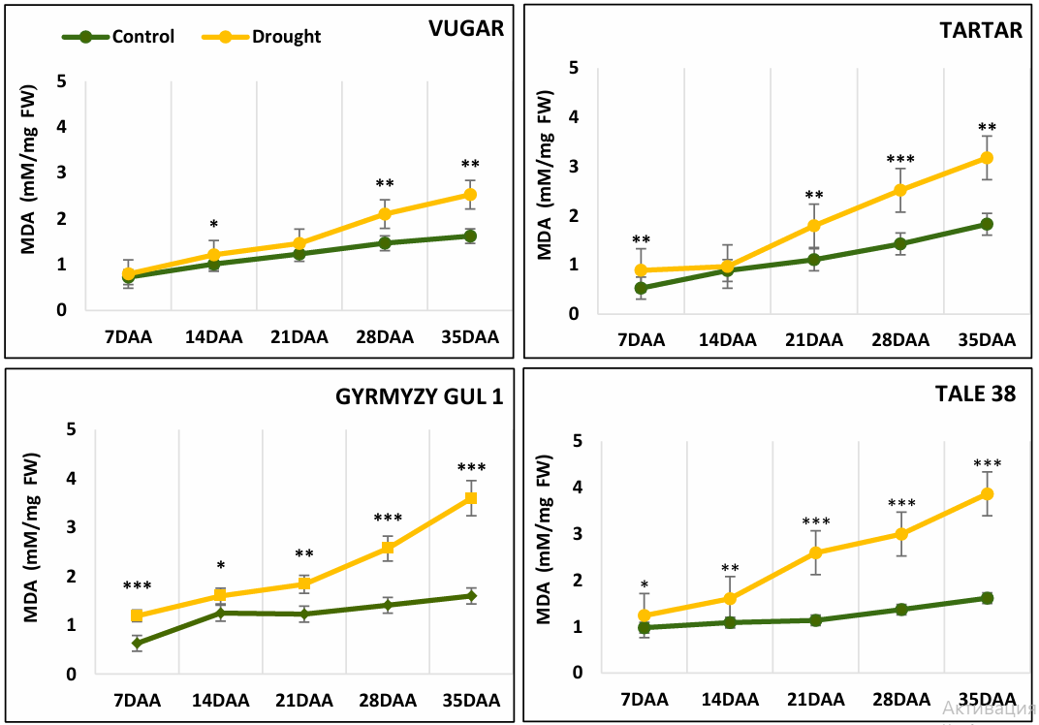

Figure 2. Changes in malondialdehyde (MDA) content in wheat flag leaves during senescence. DAA – days after anthesis, FW – fresh weight. Data points represent the mean ± se (n = 5). Asterisks indicate significance difference (*P < 0.05, **P < 0.01, ***P < 0.001) using pairwise t tests.

Previous research also reported an increase in MDA with elevated O₂ levels during light-induced leaf senescence in wheat (Liu et al., 2019). A premature senescence mutant from a rice mutant library exhibited increased MDA levels (Huang et al., 2016). MDA is a product of lipid peroxidation in cell membranes, indicating damage to the ROS cellular membrane system. Accordingly, our experiments showed a decrease in the membrane stability index with advancing senescence, which was especially pronounced in drought-stressed plants. Interestingly, our study found that the amount of soluble proteins in drought-stressed plants was higher initially compared to those under control conditions. This increase appears to be due to the effect of drought stress rather than the natural senescence process. Similarly, Maqsood et al. (2022) reported that water deficit stress resulted in a significant increase in soluble proteins in wheat genotypes.

Total Protein Content
Soluble protein content was determined using the Bradford method (1976) at 595 nm, with bovine serum albumin used to construct the calibration curve (Figure 3). At 7 DAA, no significant differences were observed between genotypes for this parameter. In naturally senescing plants, the protein content increased until 28 DAA and then sharply decreased at 35 DAA: in the drought-tolerant durum wheat genotype Vugar by 12%, in the tolerant bread wheat genotype Gyrmyzy gul 1 by 25%, and in the susceptible genotypes Tartar and Tale 38 by 24% and 30%, respectively. In stressed plants, the curve reflecting soluble protein content showed changes earlier, at 21 DAA, similar to other parameters. The only exception was Vugar, which, like the control plants, exhibited a decrease in protein content after 28 DAA.
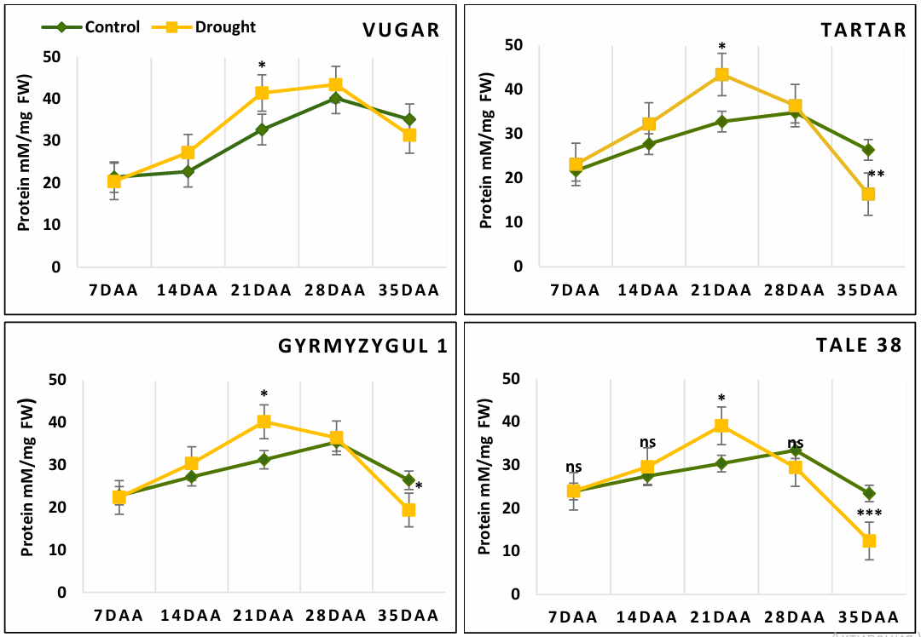

Figure 3. Total soluble protein content in wheat flag leaves during senescence. DAA – days after anthesis, FW – fresh weight. Data points represent the mean ± se (n = 5). Asterisks indicate significance difference (*P < 0.05, **P < 0.01, ***P < 0.001) using pairwise t tests.

Protein degradation is a crucial catabolic process during leaf senescence and plays a significant role in nutrient recycling, particularly nitrogen. Chloroplastic proteases, which increase in synthesis during drought-induced senescence, can mobilize up to 75% of the total cellular nitrogen in leaves (Hajibarat and Saidi, 2022). Increased expression and activity of serine, cysteine, aspartic, and metalloproteases have been detected in senescing leaves (Buet et al., 2019; Díaz-Mendoza et al., 2016; Christiansen and Gregersen, 2014; Hollmann et al., 2014; Roberts et al., 2012). Although many proteins degrade during senescence, some remain intact. The decrease in protein amount was more rapid in early aging lines compared to normal aging lines in wheat (Hongwei et al., 2014). Protein content also decreased in Tropaeolum majus leaves during senescence (Karatas et al., 2010) and in French bean leaves during both natural and dark-induced senescence (Lambert et al., 2017).

Antioxidant Enzyme Activity

Oxidative stress, resulting from an imbalance between ROS and antioxidants, intensifies during plant senescence (Maqsood et al., 2022). Under optimal conditions, constitutive antioxidant levels manage basal ROS production (Laus et al., 2022). The induction of antioxidant synthesis counters increased ROS production at low concentrations during moderate stress (Sachdev et al., 2021). This is also characteristic of the early stages of leaf senescence in plants subjected to drought stress, where enhanced photo- and antioxidant protection is observed (Huseynova, 2012). Flag leaf samples (0.5 g) were crushed in liquid nitrogen and dissolved in a buffer solution containing 100 mM Na-phosphate (pH 7.8), 1 mM EDTA, 2 mM phenylmethylsulfonyl fluoride (PMSF), 1% polyvinylpyrrolidone (PVP), and 0.1% Triton X-100. The homogenized samples were then centrifuged at 15,000 g for 20 minutes at 4°C. The resulting supernatant was used to determine the activity of antioxidant enzymes.

The Activity of Superoxide Dismutase
To determine the activity of SOD enzyme, a specific kit (SOD Assay Kit-WST, Sigma-Aldrich) was employed. In this study, the cytosolic isoform of SOD from plant cells was analyzed. Leaves were homogenized in 50 mM potassium phosphate buffer (pH 7.8), and the homogenate was centrifuged. The supernatant, which contained the cytosolic form of SOD, was used for further analysis. The optical density (OD) of the reaction was measured at a wavelength of 450 nm to assess SOD activity. At 7 DAA, the activity of SOD was similar across all variants (Figure 4). By 14 DAA, enzyme activity increased, with a more significant rise observed in stress-exposed genotypes. In naturally aging wheat, the maximum SOD activity was recorded at 28 DAA. In contrast, during stress-induced senescence, the maximum activity occurred earlier, at 21 DAA. Towards the end of ontogenesis (35 DAA), SOD activity declined. A sharp decrease in enzyme activity was observed in stress-exposed bread wheat (65% and 73% in Gyrmyzy gul 1 and Tale 38, respectively) compared to durum wheat (32% and 50% in Vugar and Tartar, respectively).

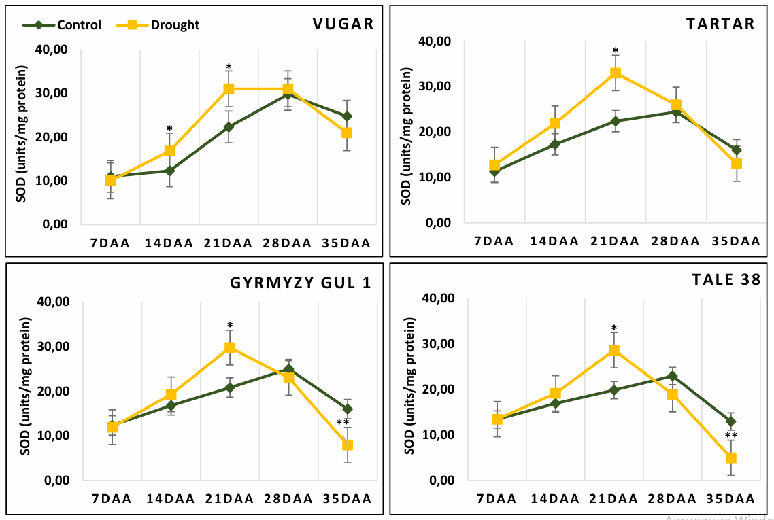

Figure 4. The activity of SOD during natural and stress-induced flag leaf senescence in wheat genotypes. DAA – days after anthesis. Data points represent the mean ± se (n = 5). Asterisks indicate significance difference (*P < 0.05, **P < 0.01, ***P < 0.001) using pairwise t tests.

Senescence may progress further due to higher ROS production, potentially triggered by an oxidative burst (Chen et al., 2021). Cell death can occur when antioxidant defenses are overwhelmed by excessively large, rapid, and uncontrolled ROS accumulation (Qiu et al., 2023). In plants, the antioxidant defense is primarily constituted by the enzymatic actions of superoxide dismutase (SOD, EC 1.15.1.1), which catalyzes the disproportionation of O₂⁻ to H₂O₂ and O₂. SOD is considered one of the first lines of defense (Kohli et al., 2019; Mao et al., 2018). Three main types of SOD are described in plants based on their metal cofactors: Cu/Zn-SOD (found in the cytosol, chloroplast stroma, peroxisomes, and apoplast), Mn-SOD (present in mitochondria, peroxisomes, apoplast, and cell walls), and Fe-SOD (restricted to the chloroplast stroma of certain plant species) (Mittler et al., 2004).

The Activity of Peroxidases
The activity of peroxidase enzymes, including APX, BPX, and GPX was measured in flag leaves at five stages after anthesis. APX activity was measured by monitoring the decrease in optical density at a wavelength of 290 nm using a spectrophotometer (ULTROSPEC 3300 PRO, AMERSHAM, USA), following the method described by Nakano and Asada (1980). The reaction mixture contained 0.1 mM EDTA (pH 8.0), 0.05 mM ascorbate, 0.1 mM H₂O₂, 50 mM sodium phosphate buffer (pH 7.6), and 100 µl of enzyme extract. The molar extinction coefficient used was 2.8 mM⁻¹ cm⁻¹, with enzyme activity expressed in units of µmol ascorbate/ (mg protein·min). The activity of GPX was determined spectrophotometrically by measuring the change in optical density of the reaction solution at 470 nm over 2 minutes, as described by Zelinova et al. (2010). The reaction medium consisted of 50 mM sodium phosphate buffer (pH 7.0), 25 mM guaiacol, 25 mM H₂O₂, and 20 μl of enzyme extract. The molar extinction coefficient (ε) of 26.6 mM⁻¹ cm⁻¹ was used, with enzyme activity expressed in units of µmol guaiacol/(mg protein·min). BPX activity was determined spectrophotometrically by monitoring the increase in optical density of the reaction solution at 590 nm for 1 minute, as described by Gechev et al. (2002). The activity of the enzyme was calculated in units of µmol benzidine/ (mg protein·min), using an extinction coefficient (ε) of 39 mM⁻¹ cm⁻¹. In naturally senescing plants, APX activity increased after anthesis, reaching a maximal level at 28 DAA, and then decreased at 35 DAA. In stress-exposed plants, the enzyme activity in the drought-tolerant durum wheat genotype Vugar increased two-fold, reaching its maximum level at 28 DAA. In the drought-sensitive durum wheat genotype Tartar, the maximum APX activity was observed at 21 DAA, while in both bread wheat genotypes, it was observed at 14 DAA. By 35 DAA, compared to the control, the enzyme activity in stressed plants decreased by 24%, 64%, 59%, and 54% in the Vugar, Tartar, Gyrmyzy gul 1, and Tale 38 genotypes, respectively (Figure 5).

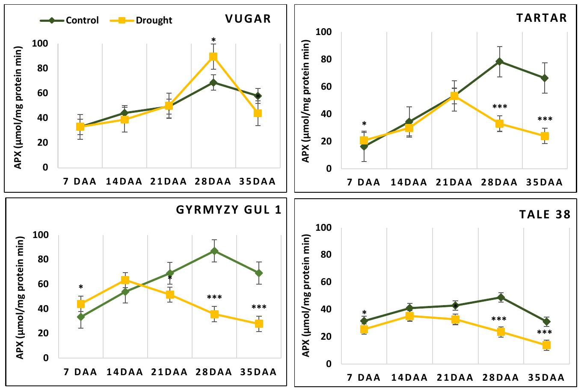

Figure 5. Dynamics of ascorbate peroxidase (APX) activity during natural and stress-induced flag leaf senescence in wheat genotypes. DAA – days after anthesis. Data points represent the mean ± se (n = 5). Asterisks indicate significance difference (*P < 0.05, **P < 0.01, ***P < 0.001) using pairwise t tests.

BPX activity reached a maximum in all genotypes at 28 DAA and sharply decreased at 35 DAA. In this stage under stressed conditions, BPX activity was higher in stressed plants compared to control plants, reaching 92%, 83%, 72%, and 17% in the Vugar, Tartar, Gyrmyzy gul 1, and Tale 38 genotypes, respectively (Figure 6).

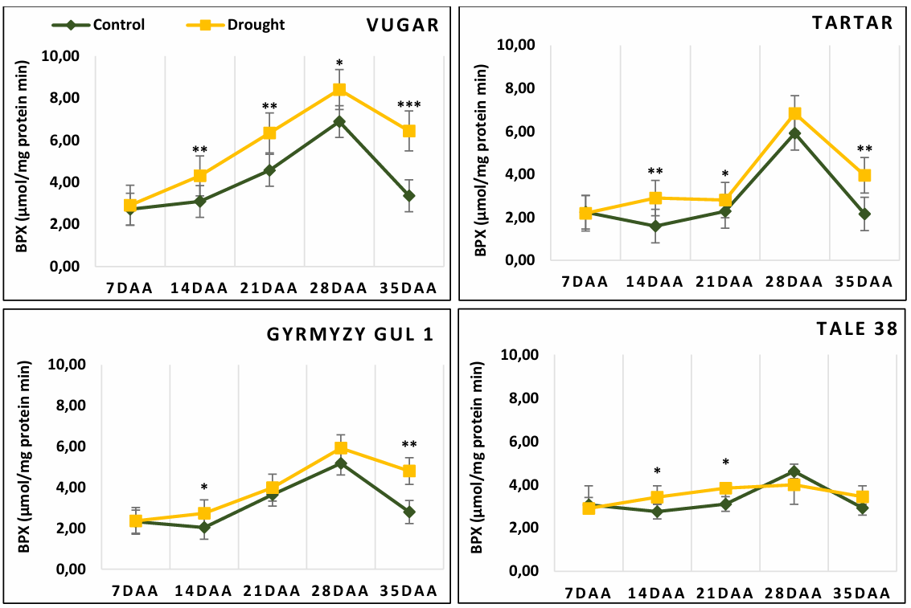

Figure 6. Dynamics of benzidine peroxidase (BPX) activity during natural and stress-induced flag leaf senescence in wheat genotypes. DAA – days after anthesis. Data points represent the mean ± se (n = 5). Asterisks indicate significance difference (*P < 0.05, **P < 0.01, ***P < 0.001) using pairwise t tests.

The activity of GPX in flag leaves of both naturally senescing and drought-stressed wheat genotypes also increased after anthesis, peaking at 28 DAA. Similar to other peroxidases, GPX activity decreased again at 35 DAA, with a significant reduction observed particularly, in bread wheat genotypes (Figure 7). In naturally senescing durum wheat under control conditions, this decrease was 23% in Vugar and 22% in Tartar, while in bread wheat it was 60% and 47% in Gyrmyzy gul 1 and Tale 38, respectively. Under stress conditions, GPX activity in durum wheat decreased by 20% in Vugar and 36% in Tartar, while in Gyrmyzy gul 1 and Tale 38, it decreased by 61% and 57%, respectively.

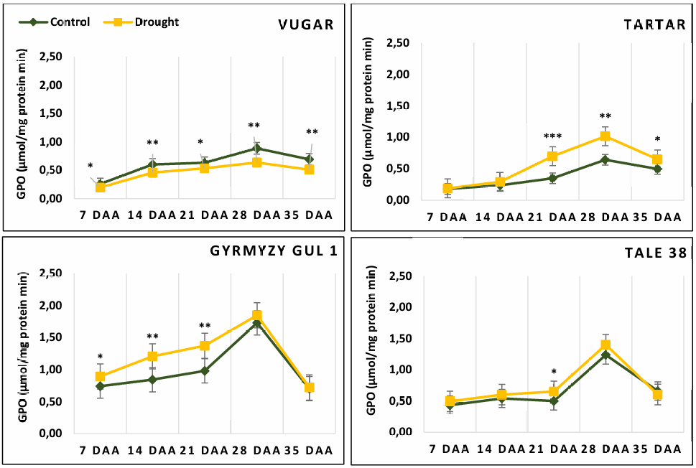
Figure 7. Dynamics of guaiacol peroxidase (GPX) activity during natural and stress-induced flag leaf senescence in wheat genotypes. DAA – days after anthesis. Data points represent the mean ± se (n = 5). Asterisks indicate significance difference (*P < 0.05, **P < 0.01, ***P < 0.001) using pairwise t tests.

Hydrogen peroxide is more efficiently scavenged by ascorbate peroxidase (APX), which has a better affinity for H₂O₂ than CAT and is widely distributed in various cellular compartments, including chloroplasts, where CAT is absent, as well as in the cytosol, mitochondria, and peroxisomes (Dumanović et al., 2021). APX6, in particular, is associated with senescence, being induced in aging leaves and in response to senescence-promoting stimuli like abscisic acid (ABA), extended darkness, and osmotic stress. APX6 is thought to modulate ROS/redox homeostasis and signaling in aging leaves, playing a crucial role in both developmental and stress-induced senescence programs (Chen et al., 2021). In our research, we compared the activity of peroxidases, specifically APX, BPX, and GPX. APX exhibited the highest activity among these enzymes and its activity increased during the senescence process. In drought-induced senescence, APX activity peaked earlier compared to naturally senescing plants, where maximum APX activity was observed at 28 DAA. In the sensitive durum wheat genotype Tartar at 21 DAA and in bread wheat genotypes at 14 DAA, the enzyme showed maximum activity. The only exception was the tolerant durum wheat genotype Vugar, which peaked at 28 DAA, similar to the control variant. Both GPX and BPX reached maximum activity at 28 DAA. GPX activity was comparatively lower in durum wheat genotypes than in bread wheat and showed less fluctuation in activity dynamics. There were no significant differences in GPX activity between stress and control conditions. Conversely, BPX activity was higher in drought-stressed plants. The activity of guaiacol peroxidase was examined in durum wheat genotypes under drought stress during flowering, milk ripeness, and wax ripeness stages, showing increased activity toward the end of ontogenesis. Similarly, benzidine peroxidase activity also reached a maximum during the wax ripeness phase (Huseynova et al., 2014; 2015; 2016). Similar trends for guaiacol peroxidase were observed in bread wheat seedlings acclimated to low temperatures (Scebba et al., 1998). Multiple forms of peroxidases operate under different growth and development stages of plants, oxidizing various substrates and functioning under diverse environmental conditions.

The Activity of Catalase
For the determination of CAT activity, 1 g of flag leaf tissue was homogenized in 10 ml of 50 mM potassium phosphate buffer (pH 7.0). The homogenate was filtered and centrifuged at 8000 g for 10 minutes to obtain a clear supernatant. For the assay, 2.9 ml of phosphate buffer (pH 7.0) was combined with 25 μl of the enzyme extract. To initiate the reaction, 90 μl of 3% hydrogen peroxide (H₂O₂) was added to the solution. The decrease in optical density at 240 nm was measured per minute using a spectrophotometer. The enzyme activity was calculated in µmol/(mg protein·min) using a molar extinction coefficient (ε) of 39.4 mM⁻¹cm⁻¹ (Kumar and Knowles, 1993). In contrast to peroxidases, CAT activity reached its maximum earlier (14 DAA). As senescence progressed, CAT activity decreased in both control and drought-exposed plants. In plants that senesced more rapidly due to stress, with the exception of the drought-tolerant genotype Vugar, which showed a reduction in CAT activity by 9% compared to the control, the other genotypes showed an increase of 32%, 6%, and 26% in Tartar, Gyrmyzy gul 1, and Tale 38, respectively (Figure 8).

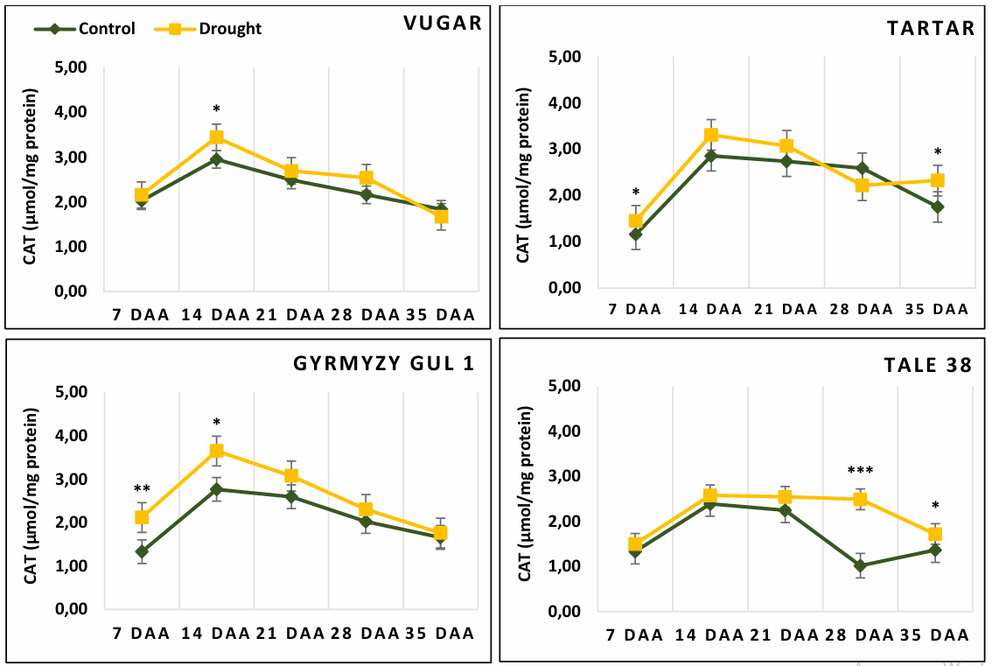

Figure 8. The activity of CAT during natural and stress-induced flag leaf senescence in wheat genotypes. DAA – days after anthesis. Data points represent the mean ± se (n = 5). Asterisks indicate significance difference (*P < 0.05, **P < 0.01, ***P < 0.001) using pairwise t tests.

CAT is a heme-containing enzyme that catalyzes the rapid decomposition of H₂O₂ to H₂O and O₂. It is predominantly found in peroxisomes, where it scavenges H₂O₂ generated during photorespiration and β-oxidation of fatty acids. CAT has also been identified in mitochondria and cytosol, but not in chloroplasts (Dumanović et al., 2021). In our study, CAT activity peaked at 14 DAA and subsequently decreased. This pattern is consistent with reports of increased CAT activity at the beginning of senescence, followed by a decline as senescence progresses (Hongwei et al., 2014). Studies across various plant species have shown a continual decrease in CAT enzyme activity from the onset of senescence in cucumber and bean cotyledons (Manoharan et al., 2005). In maize, CAT activity increased until 25 days after tasseling but decreased thereafter (Prochazkova et al., 2001). In wheat, CAT activity was lower in early aging lines compared to normal aging lines across different sampling times (Hongwei et al., 2014).

Gene Expression Analysis of SOD Isoforms

To determine which SOD isoforms are closely involved in the senescence process, gene expression analysis was performed. Transcript levels of CuZnSOD, FeSOD, and MnSOD were examined (Figure 9). Total RNA was extracted from leaf material using the Monarch Total RNA Miniprep Kit (New England Biolabs, Inc.) following the manufacturer's instructions. Genomic DNA contamination was removed using RNase-free DNase I. The quality and quantity of the extracted RNA were assessed by agarose gel electrophoresis. RNA concentration was measured spectrophotometrically using a NanoDrop Thermo Scientific-2000C (USA). Single-stranded cDNA synthesis was performed from the total RNA using the LunaScript RT SuperMix Kit (New England Biolabs, Inc.) according to the manufacturer’s instructions, in a final volume of 20 µl. PCR was conducted using a Mic Real-Time PCR system in a total reaction volume of 20 µl. Each reaction mixture contained 10 µl of Luna Universal qPCR Mix (New England Biolabs, Inc.), 1 µl of 1:5 diluted cDNA, 0.5 µl each of forward and reverse primers (10 µM), and 7 µl of nuclease-free water. The PCR protocol included an initial denaturation step at 94°C for 60 seconds, followed by 45 cycles of 95°C for 15 seconds and 60°C for 30 seconds. No-template controls (NTCs) were included for each primer pair. Each reaction was performed in triplicate (technical replicates) for each of the three biological replicates. Elongation factor 1 alpha (Elf1-α) was chosen as a housekeeping gene due to its stable and consistent expression across different experimental conditions. Primer sequences used for expression analysis are listed in Table 2. Primer efficiency for each pair was determined by the standard curve method using serial dilutions of cDNA, calculated using the formula: Efficiency (%) = (10^(-1/slope) - 1) × 100. Dissociation curves for each amplicon were analyzed to confirm the specificity of the amplification reactions. Fold change in gene expression (stressed versus control) was calculated using the 2^−ΔΔCt method (Livak and Schmittgen, 2001).

Table 2. Sequences of primers used for qRT-PCR.
Gene | Direction | Sequences
MnSOD | F | AACATCTGGAAGGTGGTGAACT
MnSOD | R | AACTCAAGAGCGAGCGAAGTA
CuZnSOD | F | CTCCATGAGTTCGGTGACAT
CuZnSOD | R | GACGGACTTCATCTTCTGGT
FeSOD | F | GAATTCCACTGGGGAAGCATC
FeSOD | R | GTAAGCGTGCTCCCAAACGTC
Elf1-α | F | CAGATTGGCAACGGCTACG
Elf1-α | R | CGGACAGCAAAACGACCAAG

The transcript level of CuZnSOD was similar across all variants at 7 DAA. In naturally aging plants, the expression of this isoform increased progressively, reached a peak at 28 DAA, and then decreased at 35 DAA. Under stress conditions, the maximum expression of this gene was observed at 21 DAA, after which the expression decreased, reaching a minimum level at 35 DAA. The expression pattern of FeSOD during flag leaf senescence differed. In all genotypes, the transcription of this isoform significantly increased after flowering, peaked at 21 DAA, and then declined sharply. At 35 DAA, compared to control plants, the transcript level of FeSOD decreased by 29%, 21%, 30%, and 48% in the genotypes Vugar, Tartar, Gyrmyzy gul 1, and Tale 38, respectively. MnSOD expression was higher towards the end of ontogenesis, with transcript levels reaching a maximum at 35 DAA. In the tolerant genotypes Vugar and Gyrmyzy gul 1, the transcript level of this isoform increased by 12%, while in the sensitive durum wheat genotype Tartar, it increased by around 39%, and in bread wheat Gyrmyzy gul 1, by nearly 20%.

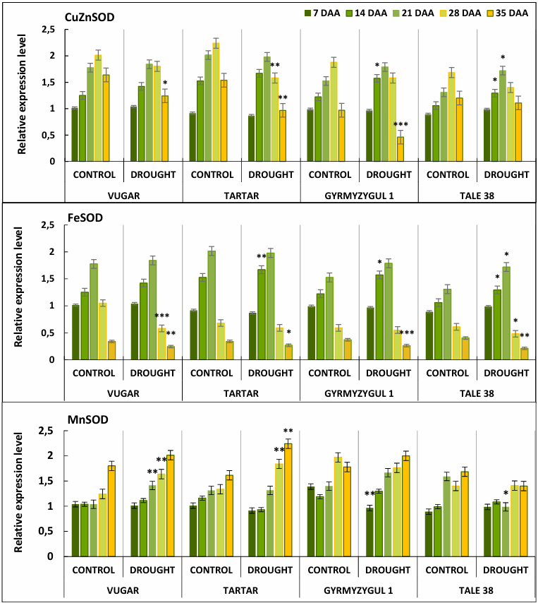

Figure 9. Transcript levels of CuZnSOD, FeSOD, and MnSOD in flag leaves of wheat plants during natural and stress-induced senescence. DAA – days after anthesis. The fold change in expression was calculated using the 2^{−ΔΔCt} method. Bars represent the mean ± se (n = 5). Asterisks indicate significance difference (*P < 0.05, **P < 0.01, ***P < 0.001) using pairwise t tests.

In our study, we investigated the expression levels of Cu/Zn-SOD, Mn-SOD, and Fe-SOD genes to determine which isoform plays a major role during senescence. Cu/Zn-SOD expression increased during the senescence process, peaked at 28 DAA, and then significantly decreased in all naturally senescing plants. In plants that senesced rapidly under stress, it reached its maximum activity at 21 DAA and then sharply declined. In contrast, Fe-SOD expression significantly differ between control and stress variants, remaining high until late grain filling (21 DAA) and then sharply declining as senescence progressed. Mn-SOD transcript levels increased proportionally with the senescence process in almost all variants, reaching a maximum at 35 DAA. A comparison of expression levels between tolerant and sensitive genotypes in control and treatment variants revealed that only Fe-SOD showed a strict association with tolerance, as transcript levels significantly increased in tolerant genotypes of both durum and bread wheat. The transcription level of Cu/Zn-SOD was elevated in the sensitive genotype among durum wheat varieties and in the tolerant genotype among bread wheat varieties. Mn-SOD transcript levels did not differ significantly between tolerant and sensitive genotypes under drought. These findings align with some studies but also contradict others. For instance, Cu/Zn-SOD and Mn-SOD activity increased at the beginning of senescence in bean cotyledons (Prochazkova and Wilhelmova, 2007) but decreased as senescence progressed. Mn-SOD activity continually decreased in pea leaves (Jiménez et al., 1998) from the onset of senescence. In wheat, Cu/Zn-SOD gene expression remained consistent in early and late aging lines immediately after the flag leaf expansion (Hongwei et al., 2014). Aliyeva et al. (2023) demonstrated that SOD activity in wheat leaves under drought stress increased in tolerant genotypes but decreased in sensitive ones. Saed-Moucheshi et al. (2021) found that a tolerant triticale genotype had significantly higher expression levels of Mn-SOD and Cu/Zn-SOD compared to a susceptible genotype, while Fe-SOD levels did not differ. Mn-SOD showed higher expression in shoots, Fe-SOD was more expressed in roots, and Cu/Zn-SOD was higher in the roots of the tolerant genotype but lower in the roots of the susceptible one, indicating genotype specificity. The authors suggested that Mn-SOD is likely a general isozyme responding to stress, while Cu/Zn-SOD is more genotype-specific, with higher expression in certain genotypes like the tolerant triticale in their study. Zhao et al. (2018) found that SOD expression levels and malondialdehyde content in rice were significantly correlated, with SOD levels being much lower in heat-sensitive cultivars compared to tolerant ones. Similarly, Mohammadi et al. (2020) reported that Cu/Zn-SOD was significantly expressed in common bean plants under drought stress, with a higher induction rate in tolerant genotypes. Xie et al. (2019) also noted that Cu/Zn-SOD likely played a crucial role in regulating total SOD activity and ROS detoxification under stress conditions. Based on our findings, Fe-SOD appears to be responsible for responding to drought stress, while Mn-SOD was mainly induced by aging, showing minimal differences between drought and stress conditions. In our opinion, the observed discrepancies depend on the genomic differences between durum and bread wheat genotypes and the developmental stage of the plant. It is shown that the effectiveness of plant antioxidant systems in detoxifying ROS and protecting against oxidative damage depends on plant species and genus, genetic background, stress intensity, and the growth stage of plants exposed to stress (Saed-Moucheshi et al., 2014). Some researchers, such as Awan et al. (2020), Sheoran et al. (2015), and Wang et al. (2018), have suggested that Mn-SOD is crucial for drought tolerance. Sheoran et al. (2015) found that Mn-SOD gene expression significantly increased under drought stress, showing a strong correlation with overall SOD activity, which contradicts our results. A genome-wide analysis by Jiang et al. (2019) identified 26 SOD genes in wheat, including 17 Cu/Zn-SODs, 6 Fe-SODs, and 3 Mn-SODs.

Analysis of Variance

The statistical analysis was carried out using SAS software ver9.2 (SAS Institute, 2008). Standard deviation (SD) values are from at least three biological replicates. The analysis of variance revealed significant differences for all studied parameters across the factors of genotype, treatment, and their interaction (Table 3), highlighting the role of genotypic and physiological differences in the response to stress.

Table 3. Parameter variations under control and drought treatments
Trait | Source of variance | NumDF | DenDF | FValue | ProbF
Cla | Treatment | 4 | 5 | 7,009887 | 0,027812
Cla | Genotypes | 3 | 95 | 76,88884 | 2,55E-25
Cla | Treatment*Genotype | 12 | 95 | 2,972035 | 0,001478
Clb | Treatment | 4 | 5 | 2,55842 | 0,165371
Clb | Genotypes | 3 | 95 | 7,240645 | 0,000199
Clb | Treatment*Genotype | 12 | 95 | 0,988862 | 0,465342
MDA | Treatment | 4 | 5 | 1,717407 | 0,281804
MDA | Genotypes | 3 | 95 | 18,55237 | 1,49E-09
MDA | Treatment*Genotype | 12 | 95 | 1,495899 | 0,139189
MSI | Treatment | 4 | 5 | 2,939509 | 0,13392
MSI | Genotypes | 3 | 95 | 16,68884 | 8,69E-09
MSI | Treatment*Genotype | 12 | 95 | 2,65968 | 0,004059
Total protein | Treatment | 4 | 5 | 5,457763 | 0,045485
Total protein | Genotypes | 3 | 95 | 14,97228 | 4,67E-08
Total protein | Treatment*Genotypes | 12 | 95 | 13,69248 | 5,72E-16
SOD activity | Treatment | 4 | 5 | 5,998624 | 0,037898
SOD activity | Genotype | 3 | 95 | 14,36139 | 8,63E-08
SOD activity | Treatment*Genotype | 12 | 95 | 11,57891 | 5,56E-14
APX activity | Treatment | 4 | 5 | 1,595833 | 0,307119
APX activity | Genotype | 3 | 95 | 33,84412 | 5,74E-15
APX activity | Treatment*Genotype | 12 | 95 | 6,462609 | 2,79E-08
BPX activity | Treatment | 4 | 5 | 6,381422 | 0,033558
BPX activity | Genotype | 3 | 95 | 80,75748 | 4,86E-26
BPX activity | Treatment*Genotype | 12 | 95 | 13,97545 | 3,2E-16
GPX activity | Treatment | 4 | 5 | 27,33506 | 0,001356
GPX activity | Genotype | 3 | 95 | 191,9561 | 3,45E-40
GPX activity | Treatment*Genotype | 12 | 95 | 13,50056 | 8,52E-16
CAT activity | Treatment | 4 | 5 | 9,505715 | 0,014778
CAT activity | Genotype | 3 | 95 | 20,89745 | 1,76E-10
CAT activity | Treatment*Genotype | 12 | 95 | 3,890105 | 7,53E-05
CuZnSOD expression | Treatment | 4 | 5 | 8,020674 | 0,021115
CuZnSOD expression | Genotype | 3 | 95 | 19,27962 | 7,61E-10
CuZnSOD expression | Treatment*Genotype | 12 | 95 | 7,145308 | 3,98E-09
FeSOD expression | Treatment | 4 | 5 | 29,16198 | 0,001164
FeSOD expression | Genotype | 3 | 95 | 10,08343 | 7,88E-06
FeSOD expression | Treatment*Genotype | 12 | 95 | 4,693792 | 5,83E-06
MnSOD expression | Treatment | 4 | 5 | 21,59548 | 0,002355
MnSOD expression | Genotype | 3 | 95 | 10,99319 | 2,92E-06
MnSOD expression | Treatment*Genotype | 12 | 95 | 1,659175 | 0,088501

Conclusion
The findings of this study underscore the pivotal role of antioxidant enzymes and the preservation of cellular integrity in modulating drought-induced leaf senescence in wheat. The differential responses observed between drought-tolerant and drought-sensitive genotypes reflect the multifaceted nature of senescence under abiotic stress conditions. Elevated levels of malondialdehyde (MDA) in sensitive genotypes point to intensified lipid peroxidation and membrane damage under drought stress. Conversely, tolerant genotypes demonstrated enhanced activity and gene expression of antioxidant enzymes, which likely contribute to more efficient ROS detoxification and a delayed onset of senescence. Collectively, these results highlight critical physiological and molecular traits associated with drought resilience and offer promising targets for wheat breeding programs aimed at improving stress tolerance through the stabilization of redox homeostasis.

References

- Aliyeva, D.R.; Gurbanova, U.A.; Rzayev, F.H.; Gasimov, E.K.; Huseynova, I.M. Biochemical and ultrastructural changes in wheat plants during drought stress. Biochem. (Moscow) 2023, 88, 1944–1955.
- Allahverdiyev, T. I.; Physiological traits of durum wheat (Triticum durum Desf.) and bread wheat (Triticum aestivum L.) genotypes under drought stress. Agric. Sci. 2015, 6, 848–859.
- Aloryi, K.D.; Jing, H.C.; Dijkwel, P.P. Comparison of leaf senescence regulation between distantly related plant species uncovers knowledge gaps and opportunities for plant improvement strategies. Environ. Exp. Bot. 2023, 214, 105474.
- Austin, J.R.; Frost, E.; Vidi, P.A.; Kessler, F.; Staehelin, L.A. Plastoglobules are lipoprotein subcompartments of the chloroplast that are permanently coupled to thylakoid membranes and contain biosynthetic enzymes. Plant Cell 2006, 18, 1693-1703.
- Awan, S.A.; Khan, I.; Rizwan, M.; Zhang, X.; Brestic, M.; Khan, A.; El-Sheikh, M.A.; Alyemeni, M.N.; Ali, S.; Huang, L. Exogenous abscisic acid and jasmonic acid restrain polyethylene glycol-induced drought by improving the growth and antioxidative enzyme activities in pearl millet. Physiol. Plant. 2020, 147, 125-136.
- Borrill, P.; Harrington, S.A.; Simmonds, J.; Uauy, C. Identification of transcription factors regulating senescence in wheat through gene regulatory network modelling. Plant Physiol. 2019, 180, 1740-1755.
- Bradford, M.M. A rapid and sensitive method for the quantitation of microgram quantities of protein utilizing the principle of protein-dye binding. Anal. Biochem. 1976, 72, 248-254.
- Buet, A.; Costa, M.L.; Martínez, D.E.; Guiamet, J.J. Chloroplast protein degradation in senescing leaves: Proteases and lytic compartments. Front. Plant Sci. 2019, 10, 747.
- Camargo Rodriguez, A.V. Integrative modelling of gene expression and digital phenotypes to describe senescence in wheat. Genes 2021, 12, 909.
- Cao, J.; Liu, H.; Tan, S.; Li, Z. Transcription Factors-Regulated Leaf Senescence: Current Knowledge, Challenges and Approaches. Int. J. Mol. Sci. 2023, 24, 9245.
- Cao, J.; Zhang, Y.; Tan, S.; Yang, Q.; Wang, H.-L.; Xia, X.; Luo, J.; Guo, H.; Zhang, Z.; Li, Z. LSD 4.0: An improved database for comparative studies of leaf senescence. Mol. Hortic. 2022, 2, 24.
- Challabathula, D.; Analin, B.; Mohanan, A.; Bakka, K. Differential modulation of photosynthesis, ROS and antioxidant enzyme activities in stress-sensitive and -tolerant rice cultivars during salinity and drought upon restriction of COX and AOX pathways of mitochondrial oxidative electron transport. J. Plant Physiol. 2022, 268, 153583.
- Chapman, E.A.; Orford, S.; Lage, J.; Griffiths, S. Capturing and selecting senescence variation in wheat. Front. Plant Sci. 2021, 12, 638738.
- Chen, C.; Galon, Y.; Rahmati Ishka, M.; Malihi, S.; Shimanovsky, V.; Twito, S.; Miller, G. Ascorbate peroxidase 6 delays the onset of age-dependent leaf senescence. Plant Physiol. 2021, 185, 441–456.
- Cheng S.; Feng, C.; Wingen, L.U.; et al. Harnessing landrace diversity empowers wheat breeding. Nature 2024.
- Christiansen, M.W.; Gregersen, P.L. Members of the barley NAC transcription factor gene family show differential co-regulation with senescence-associated genes during senescence of flag leaves. J. Exp. Bot. 2014, 65, 4009-4022.
- Deshmukh, P.; Sairam, R.; Shukla, D. Measurement of ion leakage as a screening technique for drought resistance in wheat genotypes. Indian J. Plant Physiol. 1991, 35, 89–91.
- Díaz-Mendoza, M.; Velasco-Arroyo, B.; Santamaría, M.E.; González-Melendi, P.; Martínez, M.; Díaz, I. Plant senescence and proteolysis: Two processes with one destiny. Genet. Mol. Biol. 2016, 39, 329-338.
- Gechev, T.; Gadjiev, I.; Van Breusagem, F.; Inze, D.; Dukiandjiev, S.; Toneva V., Minkov, I. Hydrogen peroxide protects tobacco from oxidative stress by inducing a set of antioxidant enzymes. Cell Mol. Life Sci. 2002, 59, 708–714.
- Dumanović, J.; Nepovimova, E.; Natić, M.; Kuča, K.; Jaćević, V. The significance of reactive oxygen species and antioxidant defense system in plants: A concise overview. Front. Plant Sci. 2021, 11, 552969.
- Ďúranová, H.; Šimora, V.; Ďurišová, Ľ.; Olexiková, L.; Kovár, M.; Požgajová, M. Modifications in ultrastructural characteristics and redox status of plants under environmental stress: A review. Plants 2023, 12, 1666.
- Gregersen, P.L.; Culetic, A.; Boschian, L.; Krupinska, K. Plant senescence and crop productivity. Plant Mol. Biol. 2013, 81, 1-13.
- Guo, Y.; Ren, G.; Zhang, K.; et al. Leaf senescence: progression, regulation, and application. Mol. Hortic. 2021, 1, 5.
- Hajibarat, Z.; Saidi, A. Senescence-associated proteins and nitrogen remobilization in grain filling under drought stress condition. J. Genet. Eng. Biotechnol. 2022, 20, 101.
- Hassan, M.A.; Yang, M.; Rasheed, A.; Tian, X.; Reynolds, M.; Xia, X.; Xiao, Y.; He, Z. Quantifying senescence in bread wheat using multispectral imaging from an unmanned aerial vehicle and QTL mapping. Plant Physiol. 2021, 187, 2623–2636.
- Hollmann, J.; Gregersen, P.L.; Krupinska, K. Identification of predominant genes involved in regulation and execution of senescence-associated nitrogen remobilization in wheat. J. Exp. Bot. 2014, 65, 4101-4113.
- Hongwei, L.; Gui, W.; Shudong, L.; Qiang, A.; Zheng, Q.; Bin, L.; Zhensheng, L. Comparative changes in the antioxidant system in the flag leaf of early and normally senescing near-isogenic lines of wheat (Triticum aestivum L.). Plant Cell Rep. 2014, 33, 1109-1120.
- Hönig, M.; Plíhalová, L.; Husičková, A.; Nisler, J.; Doležal, K. Role of Cytokinins in Senescence, Antioxidant Defence and Photosynthesis. Int. J. Mol. Sci. 2018, 19, 4045.
- Huang, Q.N.; Shi, Y.F.; Zhang, X.B.; Song, L.X.; Feng, B.H.; Wang, H.M.; Xu, X.; Li, X.H.; Guo, D.; Wu, J.L. Single base substitution in OsCDC48 is responsible for premature senescence and death phenotype in rice. J. Integr. Plant Biol. 2016, 58, 12–28.
- Huseynova, I.M. Photosynthetic characteristics and enzymatic antioxidant capacity of leaves from wheat cultivars exposed to drought. Biochim. Biophys. Acta Bioenerg. 2012, 1817, 1516-1523.
- Huseynova, I.; Aliyeva, D.; Aliyev, J. Subcellular localization and responses of superoxide dismutase isoforms in local wheat varieties subjected to continuous soil drought. Plant Physiol. Biochem. 2014, 81, 54-60.
- Huseynova, I.; Aliyeva, D.; Mammadov, A.; Aliyev, J. Hydrogen peroxide generation and antioxidant enzyme activities in the leaves and roots of wheat cultivars subjected to long-term soil drought stress. Photosynth. Res. 2015, 1125, 279-289.
- Huseynova, I.; Rustamova, S.; Suleymanov, S.; Aliyeva, D.; Mammadov, A.; Aliyev, J. Drought-induced changes in photosynthetic apparatus and antioxidant components of wheat (Triticum durum Desf.) varieties. Photosynth. Res. 2016, 130, 215-223.
- Jiang, W.; Yang, L.; He, Y.; Zhang, H.; Li, W.; Chen, H.; Yin, J. Genome-wide identification and transcriptional expression analysis of superoxide dismutase (SOD) family in wheat (Triticum aestivum). PeerJ 2019, 7, e8062.
- Jiménez, A.; Hernández, J.A.; Pastori, G.; del Río, L.A.; Sevilla, F. Role of the ascorbate-glutathione cycle of mitochondria and peroxisomes in the senescence of pea leaves. Plant Physiol. 1998, 118, 1327-1335.
- Joshi, S.; Choukimath, A.; Isenegger, D.; Panozzo, J.; Spangenberg, G.; Kant, S. Improved wheat growth and yield by delayed leaf senescence using developmentally regulated expression of a cytokinin biosynthesis gene. Front. Plant Sci. 2019, 10, 1285.
- Karatas, I.; Ozturk, L.; Ersahin, Y.; Okatan, Y. Effects of auxin on photosynthetic pigments and some enzyme activities during dark-induced senescence of Tropaeolum leaves. Pak. J. Bot. 2010, 42, 1881-1888.
- Kim, J.; Kim, J.H.; Lyu, J.I.; T, H.R.; Lim, P.O. New insights into the regulation of leaf senescence in Arabidopsis. J. Exp. Bot. 2018, 69, 787-799.
- Kohli, S.K.; Khanna, K.; Bhardwaj, R.; Abd_Allah, E.F.; Ahmad, P.; Corpas, F.J. Assessment of subcellular ROS and NO metabolism in higher plants: multifunctional signaling molecules. Antioxidants 2019, 8, 641.
- Krieger-Liszkay, A.; Krupinska, K.; Shimakawa, G. The impact of photosynthesis on initiation of leaf senescence. Physiol. Plant. 2019, 166, 148–164.
- Kumar, G.M.; Knowles, N.R. Changes in lipid peroxidation and lipolytic and free-radical scavenging enzyme activities during aging and sprouting of potato (Solanum tuberosum) seed-tubers. Plant Physiol. 1993, 102, 115-124.
- Kuo, J. Processing plant tissues for ultrastructural study. Electron Microsc. Methods Protoc. 2014, 39-55.
- Lambert, R.; Quiles, F.A.; Gálvez-Valdivieso, G.; Piedras, P. Nucleases activities during French bean leaf aging and dark-induced senescence. J. Plant Physiol. 2017, 218, 235-242.
- Laus, M.N.; De Santis, M.A.; Flagella, Z.; Soccio, M. Changes in Antioxidant Defence System in Durum Wheat under Hyperosmotic Stress: A Concise Overview. Plants 2022, 11, 98.
- Li, C.; Wu, X.; Wang, P.; Wang, H.; Wang, L.; Sun, F.; Jing, H.C. Genome-wide association study of image-based trait reveals the genetic architecture of dark-induced leaf senescence in rice. J. Exp. Bot. 2024, erae391.
- Li, W.; Yang, Y.; Yu, L. The role of chloroplasts in leaf senescence and related signaling pathways. Int. J. Mol. Sci. 2023, 24, 1147.
- Liu, Y.N.; Xu, Q.Z.; Li, W.C.; Yang, X.H.; Zheng, Q.; Li, B.; Li, H.W. Long-term high light stress induces leaf senescence in wheat (Triticum aestivum L.). Photosynthetica 2019, 57, 3.
- Livak, K.J.; Schmittgen, T.D. Analysis of relative gene expression data using real-time quantitative PCR and the 2−ΔΔCT method. Methods 2001, 25, 402-408.
- Manoharan, K.; Karuppanapandian, T.; Sinha, P.B.; Prasad, R. Membrane degradation, accumulation of phosphatidic acid, stimulation of catalase activity and nuclear DNA fragmentation during 2,4-D-induced leaf senescence in mustard. J. Plant Biol. 2005, 48, 394-403.
- Mao, H.; Chen, M.; Su, Y.; Wu, N.; Yuan, M.; Yuan, S.; Brestic, M.; Zivcak, M.; Zhang, H.; Chen, Y. Comparison on photosynthesis and antioxidant defense Systems in Wheat with different Ploidy levels and Octoploid Triticale. Int. J. Mol. Sci. 2018, 19, 300-306.
- Maqsood, M.F.; Shahbaz, M.; Kanwal, S.; Kaleem, M.; Shah, S.M.R.; Luqman, M.; Farhat, F. Methionine promotes the growth and yield of wheat under water deficit conditions by regulating the antioxidant enzymes, reactive oxygen species, and ions. Life 2022, 12, 969.
- Mittler, R.; Vanderauwera, S.; Gollery, M.; Van Breusegem, F. Reactive oxygen gene network of plants. Trends Plant Sci. 2004, 9, 490-498.
- Mohammadi, M.; Tavakoli, A.; Pouryousef, M.; Fard, E.M. Study the effect of 24-epibrassinolide application on the Cu/Zn-SOD expression and tolerance to drought stress in common bean. Physiol. Mol. Biol. Plants 2020, 23, 1-16.
- Morikawa, S.; Sato, A.; Ezaki, T. A simple, one-step polychromatic staining method for epoxy-embedded semithin tissue sections. Microscopy 2018, 67, 331-344.
- Munné-Bosch, S.; Alegre, L. Die and let live: leaf senescence contributes to plant survival under drought stress. Funct Plant Biol. 2004, 31(3):203-216.
- Nakano, Y.; Asada, K. Hydrogen peroxide is scavenged by ascorbate-specific peroxidase in spinach chloroplasts. Plant Cell Physiol. 1981, 22, 867-880.
- Nousis, L.; Kanavaros, P.; Barbouti, A. Oxidative Stress-Induced Cellular Senescence: Is Labile Iron the Connecting Link? Antioxidants 2023, 12, 1250.
- Paluch-Lubawa, E.; Stolarska, E.; Sobieszczuk-Nowicka, E. Dark-induced barley leaf senescence – a crop system for studying senescence and autophagy mechanisms. Front. Plant Sci. 2021, 12, 635619.
- Pic, E.; de La Serve, B.T.; Tardieu, F.; Turc, O. Leaf senescence induced by mild water deficit follows the same sequence of macroscopic, biochemical, and molecular events as monocarpic senescence in pea. Plant Physiol. 2002, 128, 236-246.
- Porra, R.J.; Thompson, W.A.; Kriedemann, P.E. Determination of accurate extinction coefficients and simultaneous equations for assaying chlorophylls a and b extracted with four different solvents: verification of the concentration of chlorophyll standards by atomic absorption spectroscopy. Biochim. Biophys. Acta Bioenerg. 1989, 975, 384-394.
- Prochazkova, D.; Sairam, R.K.; Srivastava, G.C.; Singh, D.V. Oxidative stress and antioxidant activity as the basis of senescence in maize leaves. Plant Sci. 2001, 161, 765-771.
- Prochazkova, D.; Wilhelmova, N. Leaf senescence and activities of the antioxidant enzymes. Biol. Plant. 2007, 51, 401-406.
- Qiu, H.; Wang, J. Mitochondrial functions in leaf senescence: Insights from metabolic and cellular dynamics. J. Plant Physiol. 2023, 271, 153681.
- Roberts, I.N.; Caputo, C.; Criado, M.V.; Funk, C. Senescence-associated proteases in plants. Physiol. Plant. 2012, 145, 130-139.
- Sachdev, S.; Ansari, S.A.; Ansari, M.I.; Fujita, M.; Hasanuzzaman, M. Abiotic Stress and Reactive Oxygen Species: Generation, Signaling, and Defense Mechanisms. Antioxidants 2021, 10, 277.
- Saed-Moucheshi, A.; Pakniyat, H.; Pirasteh-Anosheh, H.; Azooz, M. M. Role of ROS as signaling molecules in plants. In Oxidative damage to plants, Academic Press 2014, pp. 585–620.
- Saed-Moucheshi, A.; Shekoofa, A.; Pessarakli, M. Reactive Oxygen Species (ROS) generation and detoxifying in plants. J. Plant Nutr. 2014, 37, 1573–1585.
- Saed-Moucheshi, A.; Sohrabi, F.; Fasihfar, E.; Baniasadi, F.; Riasat, M.; Mozafari, A.A. Superoxide dismutase (SOD) as a selection criterion for triticale grain yield under drought stress: a comprehensive study on genomics and expression profiling, bioinformatics, heritability, and phenotypic variability. BMC Plant Biol. 2021, 21, 1-19.
- Scebba, F.; Sebastiani, L.; Vitagliano, C. Changes in activity of antioxidative enzymes in wheat (Triticum aestivum) seedlings under cold acclimation. Physiol. Plant. 1998, 104, 747-752.
- Sheoran, S.; Thakur, V.; Narwal, S.; Turan, R.; Mamrutha, H.; Singh, V.; Tiwari, V.; Sharma, I. Differential activity and expression profile of antioxidant enzymes and physiological changes in wheat (Triticum aestivum L.) under drought. Appl. Biochem. Biotechnol. 2015, 177, 1282-1298.
- Smart, C.M. Gene expression during leaf senescence. New Phytol. 1994, 126, 419-448.
- Španić, V.; Šunić, K.; Duvnjak, J.; Hu, Y.G.; Katanić, Z. Chlorophyll a fluorescence during flag leaf senescence of field-grown winter wheat plants under drought conditions. Ann. Appl. Biol. 2023, 183, 80-92.
- Sultana, N.; Islam, S.; Juhász, A.; Ma, W. Wheat leaf senescence and its regulatory gene network. Crop J. 2021.
- Tan, S.; Sha, Y.; Sun, L.; Li, Z. Abiotic stress-induced leaf senescence: regulatory mechanisms and application. Int. J. Mol. Sci. 2023, 24, 11996.
- Vollenweider, P.; Ottiger, M.; Günthardt-Goerg, M.S. Validation of leaf ozone symptoms in natural vegetation using microscopical methods. Environ. Pollut. 2003, 124, 101-118.
- Wang, H.F.; Zhong, X.H.; Shi, W.Y.; Guo, B. Study of malondialdehyde (MDA) content, superoxide dismutase (SOD) and glutathione peroxidase (GSH-Px) activities in chickens infected with avian infectious bronchitis virus. Afr. J. Biotechnol. 2011, 10, 9213-9217.
- Wang, W.; Xia, M.; Chen, J.; Yuan, R.; Deng, F.; Shen, F. Gene expression characteristics and regulation mechanisms of superoxide dismutase and its physiological roles in plants under stress. Biochemistry 2018, 81, 465-480.
- Woo, H.R.; Kim, H.J.; Lim, P.O.; Nam, H.G. Leaf senescence: systems and dynamics aspects. Annu. Rev. Plant Biol. 2019, 70, 347-376.
- Xie, X.; He, Z.; Chen, N.; Tang, Z.; Wang, Q.; Cai, Y. The roles of environmental factors in regulation of oxidative stress in plant. Biomed Res. Int. 2019, 2019, 435-455.
- Xie, Y.; Ma, M.; Liu, Y.; Wang, B.; Wei, H.; Kong, D.; Wang, H. Arabidopsis FHY3 and FAR1 function in age gating of leaf senescence. Front. Plant Sci. 2021, 12, 770060.
- Yan, F.; Yu, Z.; Shi, Y. Optimized border irrigation delays winter wheat flag leaf senescence and promotes grain filling. Front. Plant Sci. 2023, 14, 1051323.
- Yolcu, S.; Li, X.; Li, S.; Kim, Y.J. Beyond the genetic code in leaf senescence. J. Exp. Bot. 2018, 69, 801-810.
- Yuan, Y.; Zhang, W.; Pang, J.; Zhou, M.; Liu, J.; Zhao, J.; Yang, M. Integrated physiological and metabolomic analyses reveal changes during the natural senescence of Quercus mongolica leaves. PLoS One 2023, 18, e0289272.
- Yumoto, G.; Nishio, H.; Muranaka, T.; et al. Seasonal switching of integrated leaf senescence controls in an evergreen perennial Arabidopsis. Nat. Commun. 2024, 15, 4719.
- Zelinova, V.; Mistrik, I.; Palove-Balang, P.; Tamas, L. Peroxidase activity against guaiacol, NADH, chlorogenic acid, ferulic acid and coniferyl alcohol in root tips of Lotus japonicus and L. corniculatus grown under low pH and aluminium stress, Biologia, 2010, 65, 279-283.
- Zhang, Y.M.; Guo, P.; Xia, X.; Guo, H.; Li, Z. Multiple layers of regulation on leaf senescence: new advances and perspectives. Front. Plant Sci. 2021, 12, 788996.
- Zhao, Q.; Zhou, L.; Liu, J.; Du, X.; Huang, F.; Pan, G.; Cheng, F. Relationship of ROS accumulation and superoxide dismutase isozymes in developing anther with floret fertility of rice under heat stress. Plant Physiol. Biochem. 2018, 122, 90-101.
- Zhao, W.; Zhao, H.; Wang, H.; He, Y. Research progress on the relationship between leaf senescence and quality, yield and stress resistance in horticultural plants. Front. Plant Sci. 2022, 13, 1044500.
- Zhao, X.; Zhuang, W.; Zhang, Y. The relationship between leaf senescence and stress tolerance in plants. J. Plant Growth Regul. 2023, 42, 1-15.

