A Study of Freshwater Ichthyofaunal Diversity of Lakshmipuram Lake in Anakapalli District of Andhra Pradesh,

India

***Original Research Article***

# ABSTRACT

The present study investigates the ichthyofaunal diversity of Lakshmipuram Lake in Anakapalli District of Andhra Pradesh state of India from January 2024 to December 2024, a vital freshwater body supporting ecological balance and local livelihoods. A total of 47 fish species were identified at different sites. Freshly collected fishes were carefully cleansed and photographed. They were preserved in 9-10% formalin solution. Fish species were identified using classical taxonomical observations. Among the identified 12 orders, the order Cypriniformes was dominant with 18

species which contributed to 37% followed by Siluriformes 10 (21%), Perciformes 3 (4%), Channiformes, Cichliformes, Anguilliformes each 3 (6%), Beloiniformes, Synbranchiformes each 2 (4%), while Cyprinodontiformes, Gobiiformies, Osteoglossiformes, Anabantiformes each 1 (2%). The population status of 11 species were abundant which contributed to 23% whereas 25 species were common contributing to 53%, 4 species were moderate by contributing to 8%, and the least percent of species i.e., 7 were represented as rare which contributed to only 14%. According to IUCN 2024, 36 species contributed around 77% are least concern (LC), 8 species contributed about 16% are near threatened (NT), about 2 species contributed to 4% are not evaluated (NE), and 1 species of 2% are data deficient (DD). As per the present study, the Lake is found good potential with variety of freshwater fish fauna.

*Keywords: Freshwater fish; Lakshmipuram lake; Ichthyofaunal diversity; IUCN.*

# INTRODUCTION

India is one of the world's most biodiverse countries, with an extensive network of freshwater ecosystems, including rivers, lakes, ponds, reservoirs, and wetlands. It is renowned for its quantity and richness of biodiversity in the variety of fishes found in both fresh and marine waters. There are over 20,000 fish species worldwide, with 2179 species found in India, in freshwater sources such lakes, dams, and tanks (Telkhade and Jambhule, 2017). The main intention of fish is to supplement the human diet with proteins, lipids, and vitamins such as A and D (Sanapala et al., 2022).

Lake supports a wide variety of fish species that supports commercial fishes. Fish biodiversity of

the lake essentially represents the fish faunal diversity and their abundance. Freshwater fish diversity is a vital component of aquatic ecosystems, playing a crucial role in maintaining ecological balance, nutrient cycling, and water quality. Freshwater fishes are one of the most threatened taxonomic groups that are due to degradation and defragmentation of habitats, introduction of exotic species, pollution, and global climate change impact (Rao et al., 2014). Lack of knowledge about fish fauna is a major barrier to the popularization of lesser-known fish species in each environment (Sanapala et al., 2022). Therefore, knowledge of the fish fauna in freshwater environments is necessary in order to plan scientific approaches for their efficient utilization for fish production (Ramulu and Benarjee, 2013).

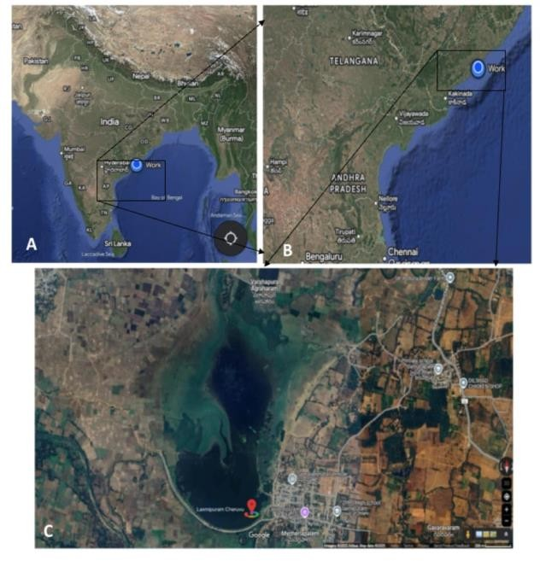

**Image 1. Satellite image of Lakshmipuram lake, Lakshmipuram village, Anakapalli district, Andhra Pradesh, India. Image credits to Google Maps**

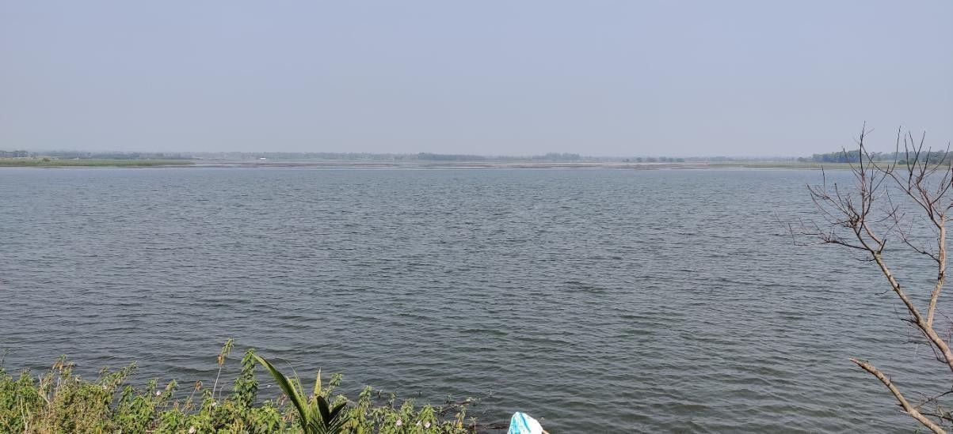

**Image 2. Lakshmipuram lake, Lakshmipuram village Chodavaram Mandal, Andhra Pradesh, India**

The present study on freshwater fish diversity and its ecological significance aims to achieve the diversity and distribution of freshwater fish species in Lakshmipuram Lake, Anakapalli Dist., Andhra Pradesh, India. Also, to analyze the conservation status of fish species to recommend conservation and management strategies for sustaining freshwater fish diversity and promoting sustainable fishery practices.

# MATERIALS AND METHODS

* 1. **Study Area**

Lakshmipuram Lake is situated in the village of Lakshmipuram in Chodavaram Mandal, Anakapalli district, Andhra Pradesh, India. Its 650 acres with a capacity of 195 million cubic meters are highly helpful to all the farmers in the nearby areas. Every year, about 1500 acres are successfully farmed beneath this lake. It is close to National Highway 16 and has a road transit facility. Its average elevation is 30 meters above sea level, and its coordinates are 22.090N, 82.150E. The region has a tropical climate, with reported average temperatures and humidity ranging from 24.2°C to 30°C and 61%, respectively (Pratap et al., 2025).

# Sampling and Collection of Fishes

The fish samples were collected from January 2024 to December 2024 from different sites in Lakshmipuram lake with the assistance of local fishermen using various types of gear (drag nets, push nets, cast nets, stationary gill nets) and bamboo baskets (Traps) (Rama Rao, 2014).

Fishes were also collected from local fish markets and fish sellers. Freshly collected fish were carefully cleansed and photographed. These fish were taken to the lab and fixed in glass jars before being preserved in a 9-10% formalin solution (Jayaram, 1999). Identification of the species was done mainly on the morphometric and meristic characters done by Day (1875), Menon (1988), Talwar (1991), and

Jayaram (2010). The IUCN (2024) conservation status of the fish species has been listed. The lake is nutrient-rich and identified of better quality for fish farming (Pratap et al., 2025).

# RESULTS AND DISCUSSION

The current study analyzed the fish species taxa and diversity in Andhra Pradesh's Lakshmipuram Lake between January 2024 to December 2024. The study reveals the presence of forty seven

(47) species of fishes belonging to twelve (12) orders nineteen (19) families thirty-five (35) genera. List of fish including common names, population status and their conservation status were given in Table 1.

The species which are found in the lake are *Anguilla bengalensis, Anguilla bicolor, Moringua raitaborua, Xenentodon cancila, Hyporhamphus limbatus, Cirrhinus mrigala, Labeo catla, Labeo calbasu, Labeo rohita, Osteobrama cotio, Puntius chola, Puntius ticto, Puntius sophore, Systomus sarana, Garra gotyla, Amblypharyngodon microlepis, Amblypharyngodon mola, Salmostoma bacaila, Rasbora daniconius, Danio devario, Aplocheilus panchax, Channa orienalis, Channa punctata, Channa striatus, Glossogobius giuris, Notopterus*

*notopterus, Mystus cavasius, Mystus gulio,, Mystus tengara, Mystus vittatus, Clarias batrachus, Clarias magur, Heteropneustes fossilis, Ompok bimaculatus, Wallago attu, Eutropiichthys vacha, Anabas testudineus, Pseudetroplus maculates, Etroplus suratensis, Macrognathus pancalus, Mastacembelus armatus, Chanda nama, and Parambassis ranga.*

Out of 47 species recorded from Lakshmipuram lake Four (4) are exotic fishes: *Ctenopharyngodon Idella*, *Cyprinus carpio*, *Hypopthalmicthys molitrix*, and *Oreochromis niloticus*. Earlier studies reported by Chinnababu Sanapala et., al. fish genetic resources found here in the Madduvalasa Reservoir of Srikakulam

district reveals that there are 31 species of fishes belonging to 5 orders, 21 genera of 13 families (Sanapala et al., 2022); a total of 55 species of fishes were identified belonging to 9 orders at Meghadri Gedda (Sharmila et al., 2016); total of 25 fishes are belonging to 7 orders, 11 families and 18 genera reported in Kamalapur lake in Telangana Thirupathaiah et al., (2014); presence of 49 fish species from 12 orders, 19 families, and 33 genera in Gotta barrage at Hiramandalam by Rama Rao, (2023); presence of 92 species of fish belonging to 13 orders, 34 families and 57 genera in Kolleru lake by Simhachalam et al., (2014); a total of 47 fish species across 11 orders and 19 families were observed in Gosthani River by Rama Rao et al., (2024).

|  |  |
| --- | --- |
|  | |
| **Image 3. *Etroplus suratensis*** | **Image 4. *Mystus nigriceps*** |
|  | |
| **Image 5. *Puntius sophore*** | **Image 6. *Puntius chola*** |
|  | |
| **Image 7. *Cirrhinus mrigala*** | **Image 8. *Cyprinus carpio\**** |

|  |  |
| --- | --- |
|  | |
| **Image 9. *Labeo rohita*** | **Image 10. *Labeo catla*** |
|  | |
| **Image 11. *Hypopthalmicthys molitrix\**** | **Image 12. *Ctenopharyngodon Idella\**** |
|  | |
| **Image 13. *Mastacembelus armatus*** | **Image 14. *Oreochromis niloticus*** |

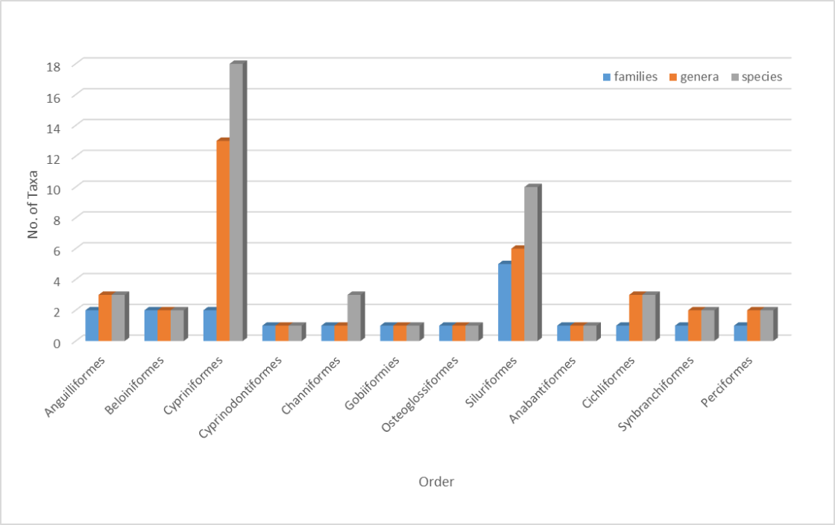

**Image 15. Graphical representation of percentage of taxa reported in Lakshmipuram lake**

**Table 1. List of fishes and their order, family, genus, species, common name, population status, IUCN status in Lakshmipuram Lake**

|  |  |  |  |  |  |  |
| --- | --- | --- | --- | --- | --- | --- |
| **Sl. No** | **Order** | **Family** | **Species Name** | **Common Name** | **Population status** | **Conservation status (IUCN, 2024))** |
| 1 | Anguilliformes | Anguillidae | *Anguilla bengalensis* | Indian mottled eel | R | NT |
| 2 |  |  | *Anguilla bicolor* | Shortfin eel | R | NT |
| 3 |  | Moringuidae | *Moringua raitaborua* | Purple spaghetti eel | M | NE |
| 4 | Beloiniformes | Belonidae | *Xenentodon cancila* | Freshwater garfish | R | DD |
| 5 |  | Hemiramphidae | *Hyporhamphus limbatus* | Congaturi halfbeak | R | LC |
| 6 | Cypriniformes | Cyprinidae | *Cirrhinus mrigala* | Mrigal carp | A | LC |
| 7* |  |  | *Ctenopharyngodon idella* | Grass carp | M | LC |
| 8* |  |  | *Cyprinus carpio* | Common carp | A | LC |
| 9* |  |  | *Hypopthalmicthys molitrix* | silver carp | R | NT |
| 10 |  |  | *Labeo catla* | Catla | A | LC |
| 11 |  |  | *Labeo calbasu* | Black Rohu | C | LC |
| 12 |  |  | *Labeo rohita* | Rohu | A | LC |
| 13 |  |  | *Osteobrama cotio* | Cotio | C | LC |
| 14 |  |  | *Puntius chola* | Swamp barb | A | LC |
| 15 |  |  | *Puntius ticto* | Two-spot barb | A | LC |
| 16 |  |  | *Puntius sophore* | Spotfin swamp barb | A | LC |
| 17 |  |  | *Systomus sarana* | Olive barb | C | LC |
| 18 |  |  | *Garra gotyla* | Sucker head | R | LC |
| 19 |  | Danionidae | *Amblypharyngodon microlepis* | Indian carplet | A | LC |
| 20 |  |  | *Amblypharyngodon mola* | Mola carplet | A | LC |
| 21 |  |  | *Salmostoma bacaila* | Large razorbelly minnow | C | LC |
| 22 |  |  | *Rasbora daniconius* | Slender rasbora | C | LC |
| 23 |  |  | *Danio devario* | Sind danio | C | LC |
| 24 | Cyprinodontiforme | Aplocheiidae | *Aplocheilus panchax* | Blue Panchax | C | LC |
| 25 | Channiformes | Channidae | *Channa orienalis* | Asiatic snakehead | C | NE |
| 26 |  |  | *Channa punctata* | Spotted snakehead | A | LC |
| 27 |  |  | *Channa striatus* | Striped Snakehead | C | LC |
| 28 | Gobiiformies | Gobiidae | *Glossogobius giuris* | Tank Goby | C | LC |
| 29 | Osteoglossiformes | Notopteridae | *Notopterus notopterus* | Bronze Featherback | C | LC |
| 30 | Siluriformes | Bagridae |  | Striped dwarf catfish |  |  |
|  |  |  | *Mystus cavasius* | C | LC |
| 31 |  |  | *Mystus gulio* | Long-whiskered catfish | R | LC |
| 32 |  |  | *Mystus nigriceps* | Two-spot catfish | A | LC |
| 33 |  |  | *Mystus vittatus* | Striped dwarf catfish | A | LC |

|  |  |  |  |  |  |  |
| --- | --- | --- | --- | --- | --- | --- |
| **Sl. No** | **Order** | **Family** | **Species Name** | **Common Name** | **Population status** | **Conservation status (IUCN, 2024))** |
| 34 |  | Claridae | *Clarias batrachus* | Walking catfish | C | LC |
| 35 |  |  | *Clarias magur* | Walking Catfish | C | LC |
| 36 |  | Heteropneustida | *Heteropneustes fossilis* | Indian Stinging Catfish | C | LC |
| 37 |  | Siluridae | *Ompok bimaculatus* | Butter catfish | C | NT |
| 38 |  |  | *Wallago attu* | Wallago catfish | C | NT |
| 39 |  | Schibeidae | *Eutropiichthys vacha* | Batchwa vacha | C | LC |
| 40 | Anabantiformes | Anabantidae | *Anabas testudineus* | Climbing perch | M | LC |
| 41* | Cichliformes | Cichlidae | *Oreochromis niloticus* | Nile tilapia | M | NT |
| 42 |  |  | *Pseudetroplus maculates* | Orange Chromide | C | LC |
| 43 |  |  | *Etroplus suratensis* | Green Chromide | C | LC |
| 44 | Synbranchiformes | Mastacembelida | *Macrognathus pancalus* | Barred spiny eel | C | LC |
| 45 |  |  | *Mastacembelus armatus* | Zig-zag eel | C | LC |
| 46 | Perciformes | Ambassidae | *Chanda nama* | Elongate glassy perchlet | C | LC |
| 47 |  |  | *Parambassis ranga* | Indian X-ray fish | C | LC |

*A= Abundant (76-100%); C = Common (51-75%); M = Moderate (26-50%); R = Rare (1-25%) of the total catch. EN- Endangered; VU- Vulnerable: LC- Least concern; DD- Data deficient; NE- Not evaluated, NT: Near threatened.*

*\*Exotic fishes No’s: 7, 8, 9 and 41*

**Table 2. Percent composition of families, genera, and species of fishes under various orders**

|  |  |  |  |  |
| --- | --- | --- | --- | --- |
| **Sl. No.** | **Order** | **Families %** | **Genera %** | **Species %** |
| 1 | Anguilliformes | 10 | 8 | 6 |
| 2 | Beloniformes | 10 | 5 | 4 |
| 3 | Cypriniformes | 10 | 35 | 37 |
| 4 | Cyprinodontiformes | 5 | 3 | 2 |
| 5 | Channiformes | 5 | 3 | 6 |
| 6 | Gobiiformies | 5 | 3 | 2 |
| 7 | Osteoglossiformes | 5 | 3 | 2 |
| 8 | Siluriformes | 25 | 16 | 21 |
| 9 | Anabantiformes | 5 | 3 | 2 |
| 10 | Cichliformes | 5 | 8 | 6 |
| 11 | Synbranchiformes | 5 | 5 | 4 |
| 12 | Perciformes | 5 | 6 | 8 |

**Table 3. Taxa composition of population status and IUCN**

|  |  |  |  |  |
| --- | --- | --- | --- | --- |
| **Population Status** | **Abundant** | **Rare** | **Moderate** | **Common** |
| **No. of Species and percentage contribution %** | 11 | 7 | 4 | 25 |
| 23% | 14% | 8% | 53% |
| **IUCN** | **Least concern** | **Data deficient** | **Not evaluated** | **Near threatened** |
| **No. of Species and percentage contribution %** | 36 | 1 | 2 | 8 |
| 77% | 2% | 4% | 16% |

In this present study, the percent composition of families, genera and species under different orders are shown in Table 2 and Images 3-14. Among the 12 orders, the order *Cypriniformes* was dominant with 18 species which contributed to 38% followed by *Siluriformes* 10 (21%),

Perciformes 2 (4%), *Channiformes,*

*Cichliformes*, Anguilliformes each 3 (7%), *Beloniformes*, *Synbranchiformes* each 2 (4%), *Cyprinodontiformes, Gobiiformies,*

*Osteoglossiformes, Anabantiformes* each 1 (2%). Recorded genera out of 35 *Cypriniformes* was dominated by 13 (36%) followed by

*Siluriformes* 6 (16%), Anguilliformes,

*Cichliformes*, Perciformes each 3 (8%),

*Beloniformes, Synbranchiformes* each 2 (5%), *Cyprinodontiformes, Channiformes, Gobiiformies, Osteoglossiformes,* and *Osteoglossiformes* each 1 (3%). Among 20 different families, *Siluriformes* was dominated with 5 families contributed to 25% followed by Anguilliformes, *Beloiniformes*, *Cypriniformes,* Perciformes each 2 (10%); *Cyprinodontiformes, Channiformes, Gobiiformies, Osteoglossiformes, Anabantiformes, Cichliformes* each 1 family (5%). The generic composition of fishes

belonging to different families shows that, 13 genera included in *Cyprinidae* followed by 5 genera under *Danionidae*; 4 genera under *Bagridae*; 3 genera under each in *Channidae* and *Cichlidae*; 2 genera each under *Anguillidae, Claridae, Siluridae, Mastacembelidae, Ambassidae and Channidae*; 1 genus each under *Moringuidae, Belonidae, Hemiramphidae, Aplocheiidae, Gobiidae, Notopteridae, Heteropneustidae, Schibeidae and Anabantidae*.

The number and percent composition of population status is as follows; 11 species were abundant which contributed to 23% whereas 27 species were common contributing to 53%, 4 species were moderate contributing to 8%, and the least percent of species i.e., 7 were represented as rare which contributed to only 14% in the total catch (Table 3 and Image 16). According to IUCN 2024, 38 species contributed to 77% are least concern (LC), eight species contributed to 16% are near threatened (NT), two species contributed to 4% are not evaluated (NE), and one species of 2% are data deficient (DD) (Table 3 and Image 17).

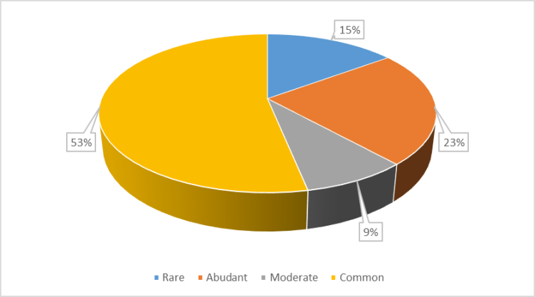

**Image 16. Pie chart showing the percentage of population status**

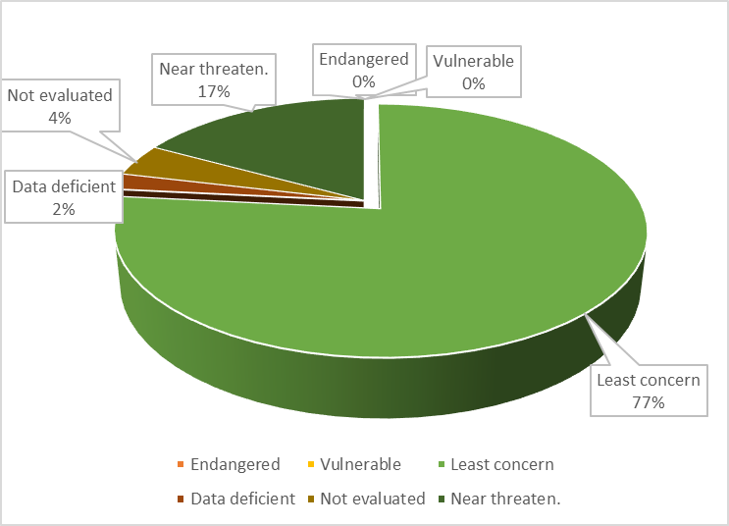

# CONCLUSION

**Image 17. Showing the percentage of IUCN status 2024**

(ChatGPT, COPILOT, etc.,) and text-to-image generators have been used during writing or

This is the first documentation of fish fauna in Lakshmipuram Lake. A comprehensive study of the fish diversity in Lakshmipuram Lake revealed a diverse and abundant collection of species that span several taxonomic groupings and ecological niches. The lake's contribution to local fisheries and livelihood opportunities for nearby residents is highlighted by the presence of commercially valuable species like *Labeo rohita*, *Catla catla*, and *Cirrhinus mrigala*. Furthermore, the presence of species like *Heteropneustes fossilis*, *Channa striatus*, and *Clarias batrachus* suggests that the lake can support a variety of aquatic life in spite of environmental changes. Interestingly, the discovery of species that can withstand pollution, like *Oreochromis mossambicus*, points to the possible effects of environmental stressors and highlights the necessity of preventative conservation efforts.

In conclusion, the diverse fish fauna of Lakshmipuram Lake reflects the region's rich aquatic biodiversity and emphasizes the lake's ecological significance. By promoting conservation initiatives and sustainable fisheries management, we can ensure the long-term stability of this invaluable aquatic ecosystem.

**DISCLAIMER (ARTIFICIAL INTELLIGENCE)**

Author(s) hereby declares that NO generated AI technologies such as Large Language Models

editing of this manuscript.

# REFERENCES

Day, F. (1875). The fishes of India, being a natural history of the fishes known to inhabit the seas and freshwaters of India, Burma and Ceylon., *Biodiversity Heritage Library,* 2 (2), 327-778.

Jayaram, K.C. (1994). The freshwater fishes of India, A handbook, *Zoological survey of India*, Calcutta. 2(63), 57 – 66

Menon, A.G.K. (1988): Checklist of freshwater fishes of India. Zoological Survey of India; (ZSI) Kolkata. pp. 65-66.

Pratap, G. V., Rao, T. B., Krishna, B., Lakshman, P., & Keerthana, B. (2025). Assessment of

Physico-Chemical Characteristics of Lakshmipuram Lake, Anakapalli Dist., Andhra Pradesh, India. *Uttar Pradesh Journal of Zoology*, *46*(5), 9–25.

Raju, C. S., Sekhara, C., & G. Simhachalam. (2012). Biodiversity and Conservation status of Ichthyofauna of Lake Kolleru, Andhra Pradesh, India. *International Journal of Scientific Research*, *3*(5), 555–

562.

Ramulu, N., & Benarjee, G. (2013). Fish Species Diversity of Nagaram Tank of Warangal, Andhra Pradesh. *IOSR Journal of Environmental Science*, *3*(4), 14–18.

Rao, K. R. (2014). Ichthyo faunal biodiversity in the lower Manair Dam at Karimnagar district; Telangana State: India. *Advances in Applied Science Research*, *5*(5), 237–

248.

Rao, K. R. (2023). Ichthyofaunal diversity of gotta barrage at Hiramandalam, Vamsadhara River, Srikakulam Dt. Andhra Pradesh, India. *International Journal of Zoology Studies. 8*(2), 23–28.

Rao, K. R., Jaya, P., Prameela, J., Shyamala, K., Anu Radha, S., & Sharmila, B. (2024). Taxonomic Check List of Ichthyofaunal Diversity in Gosthani River at Tagarapuvalasa, Visakhapatnam, Andhra Pradesh, India. *UTTAR PRADESH JOURNAL of ZOOLOGY*, *45*(10), 57–64.

Rao, S., Raju, C. S., & G Simhachalam. *(2014).* Biodiversity and Conservation Status of Fishes of River Sarada, Visakhapatnam District, Andhra Pradesh, India*. Research Journal of Animal Veterinary and Fishery Science,* 2 (2), 1-8.

Sanapala, C., Pedda, L. C., Babu, K.,

Paidi, S., & K, K. P. (2022). The

study on fish diversity of Madduvalasa reservoir, Srikakulam district, Andhra Pradesh, India. *International Journal of Fisheries and Aquatic Studies*, *10*(2), 122–

124.

*Sayer, C., Hughes, K., Zimmerman, B., & Estupiñán, G. (2024).* Freshwater fish highlight escalating climate impacts on species*. IUCN Red List of Threatened Species*

Sharmila Sree. J and U. Shameem (2016). IchthyoFaunal BioDiversity in the Meghadrigedda Reservoir at Visakhapatnam, Andhra Pradesh: India; International Journal of Innovative Research in Science, Engineering and Technology; 5(3); 4065-4078.

Talwar, P.K. and Jhingran, A.G., 1991. Inland fishes of India and adjacent countries (Vol. 2). *Oxford-IBH Publishing Co. Pvt. Ltd*., 1158 p.

Telkhade, M. P., & Jambhule, H. S. (2017). Fish Diversity of Lohaha Lake, Lohara Dist- Chandrapur Maharashtra, India. International Journal of Researches in Biosciences, Agriculture and Technology, 5 (1) 63-65.

Thirupathaiah, M., Samatha, Chintta., & Sammaiah, Ch. (2014). Diversity and Conservation Status of Fish Fauna in Freshwater Lake of Kamalapur, Karimnagar District, Telangana, India. *IOSR Journal of Environmental Science, Toxicology and Food Technology*, *8*(5), 19–24.

I strongly recommend to cite the below articles

1. [Exploration of fishing gears and temporal distribution of fish species at Shibsa River, Paikgachha, Bangladesh](https://banglajol.info/index.php/JBAU/article/view/73514)
2. [Temporal distribution of fishery resources in Payra River: relationship with climatological changes, ecological assessment, and threat assessment](https://www.cell.com/heliyon/fulltext/S2405-8440(22)01872-2?uuid=uuid%3Ab3dff3cb-489b-47da-8d8d-269c8adcc145)
3. [Ichthyofaunal diversity of Basurabad Beel in regards with threat factors and conservation measures, Bangladesh](https://www.academia.edu/download/91515377/AAES-04-04-015.pdf)