Post Covid – Severe Ileitis

# Keywords:

BCHE, Stomach Adenocarcinoma, Prognosis, Tumor-infil- trating Immune Cells, Mutation

# Abstract

Enteritis as the only manifestation of (COVID-19) in adolescents without features of multisystem syndrome in children (MIS-C) or a prior history of inflammatory bowel disease (IBD) is presented.

We report an adolescent patient (an 18-year-old male) presenting to tertiary-care centers in the ACDS United Arab Emirate with severe enteritis as the only manifestation of post COVID-19 (SARS-CoV-2) infection.

# Introduction

Diagnostic IBD practice has been affected by COVID-19, with

>50% of new diagnoses not having endoscopy in a UK nationwide study [1]. In children COVID 19 usually produces mild respiratory symptoms. However, in a rare subset of pediatric patients a severe post-infectious hyper inflammatory syndrome may arise termed mul- tisystem inflammatory syndrome in children (MIS-C). Gastrointes- tinal manifestations are particularly common and may mimic other gastrointestinal infections or inflammatory bowel disease [2]. There is a paucity of literature describing the histological features of intes- tinal inflammation in MIS-C [3].

# Case Report

An 18-year-old male with no significant past medical history present- ed to our facility (ACDS)August 2022with 6 weeks’ history of acute onset of severe epigastric and lower abdominal pain, nausea, and one.

episode of vomiting, loose bowel motion 1-2 times a day, back ache, sore throat, gases and distension, milk intolerance, chest pain.

Clinically temperature of 36.5°C, heart rate of 100 beats per minute, respiratory rate of 20 breaths per minute. Abdominal examination demonstrated a non-distended abdomen with guarding and tender- ness in the epigastric region and below the umbilicus (more on the right lower quadrant). Patient has history of Covid-19 infection (last Jan 2022) more than 6 months after infection.

# Investigations

Laboratory showed repeatedly high Calprotectin 869& > 1000, CRP high 14.3, Anti-SARS-CoV-2 S1 IgG Quant 40000.0, Anti-SARS- CoV-2 S1 IgG positive, normal < 50. C ANCA negative, ASCA IgA Positive 84.7, ASCA IgG Positive 240. 2, CMV PCR negative. The patient’s nasopharyngeal swab for SARS-CoV-2 RT-PCR was nega- tive.

Chest radiographs were normal, (Figure 1). CT with no contrast showed stag horn calculi both kidnies. (Figure 2 A &B) Ultrasound abdomen and pelvis shows in both longitudinal (A) and transverse

(B) section shows mural thickness of tubular structure in the r4ight lower abdominal quadrant (appendicitis versus ileitis) (Figure 4) Computed tomography (CT) scan of the abdominal pelvis (Figure 3) Mural thickness of cecum and terminal ileum (dotted red) normal appendix (dotted green)

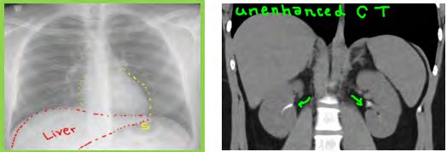

**Figure 1:** CT with no contrast showed stag horn calculi both kidnies

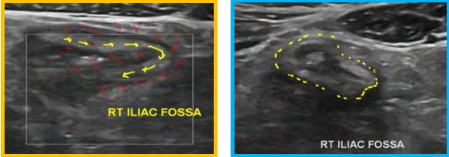

**Figure 2A & B:** Ultrasound abdomen and pelvis shows in both longitudinal (A) and transverse (B) section shows mural thickness of tubular structure in the

right lower abdominal quadrant (appendicitis versus ileitis).

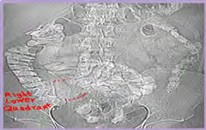

**Figure 3:** Mural thickness of cecum and terminal ileum (dotted red) normal appendix (dotted green)

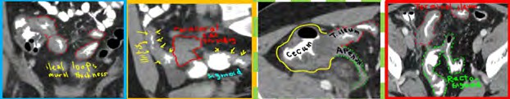

**Figure 4:** Multiple ileal loops (red rings) and recto sigmoid dotted green) mural thickness

# CT Sagittal View Shows

Para-cecal fat stranding (red rectangle) + terminal ileum and sigmoid colon mural thickness (Yellow arrows) (Figure 5, 6 & 7,8), circumfer- ential mucosal thickness of ileal loops (dotted red rings) Multiple ileal loops (red rings) and recto sigmoid dotted green) mural thickness, Gastroscopy showed multiple tiny erosions, HP positive, Colonos- copy shows: Severely ulcerated ilio-cecal valve and terminal ileum, Gastric Biopsy showed helicobacter pylori associated gastritis with intestinal metaplasia, Ileal Biopsy showed chronic Ileitis, moderate activity, normal colonic biopsies

The MRI study (Figures 9, 10, &11) with intravenous Gadolinium

contrast showed: MRI T2 sequence: (Figure 9)

Circumferential mural thickness of terminal ileum (yellow arrows);

para-ileal fluid and fat stranding (F.)

MRI STIR sequence shows: abnormal high STIR signal with fat stranding in right iliac fossa region; representing advanced inflamma- tory process. MRI post contrast shows: Enhancing ileal loops in post gadolinium study consistent with inflammation. Neck ultrasound for thyroid gland (Figure 12), It shows extra-thyroid extension (ETE) nodule in the left lobe with macrocalcification, which has mixed cyst- ic and solid (hypoechoic) composition; consistent with TIRADS [4- 8]. FNA confirmed the presence of Hurthle cell.

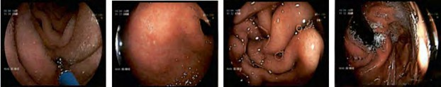

**Figure 5:** Gastroscopy showed multiple tiny erosions, HP positive

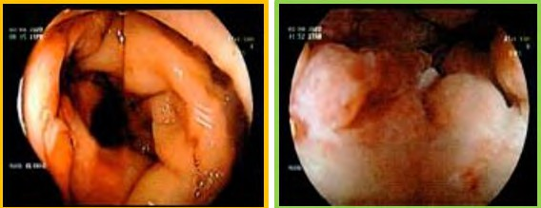

**Figure 6:** Gastric Biopsy showed helicobacter pylori associated gastritis with intestinal metaplasia, Ileal Biopsy showed chronic Ileitis, moderate activity,

normal colonic biopsies

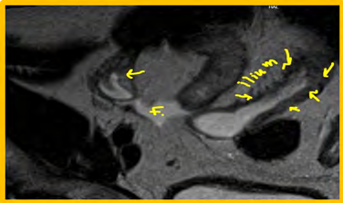

**Figure 7:** MRI STIR sequence shows:abnormal high STIR signal with fat stranding in right iliac fossa region; representing advanced inflammatory process

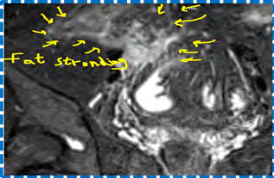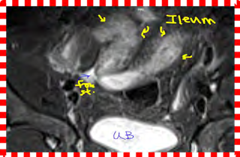

**Figure 8:** MRI post contrast shows: Para-cecal fat stranding

in right iliac fossa region **Figure 9:** MRI post contrast shows: Enhancing ileal loops in post gadolinium study consistent with inflammation

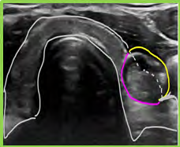

**Figure 10:** Neck ultrasound for thyroid gland

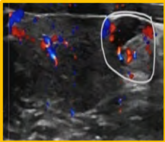

**Figure 11:** Extra-thyroid extension (ETE) nodule in the left lobe with macrocalcification

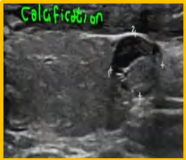

**Figure 12:** FNA confirmed the presence of Hurthle cell

# Discussion

Ileitis is most often caused by Crohn’s disease; however, infectious diseases, vasculitis, ischaemia and spondyloarthropathies can be as- sociated with ileitis. There have been a few reports of new IBD in adolescents after or concurrent COVID-19 infection [9-11]. SARS- CoV-2 is known to bind Angiotensin-converting enzyme-2 receptor on intestinal epithelial cells, causing overproduction of pro inflam- matory cytokines, promoting intestinal inflammation [9-11]. Dysreg- ulated immune response from SARS-CoV-2 will develop an intense intestinal inflammation, triggering onset of IBD [9-11]. Our patient has not had any evidence of IBD but the presence of positive ASCA ANCA and the stag horn calculi in the kidneys may point to a sub- clinical disease uncovered by COVID19 infection.

# Conclusion

A previously healthy patient presented with abdominal pain 6 weeks after COVID 19 infection discovered to have severe ileitis associat- ed with gastric helicobacter pylori infection and bilateral kidney stag horn calculi and thyroid nodules that showed Hurthle cell tumor. The

patient was treated with budesonide and azathioprin. Ustekunamab was started with good response. A positive ANCA and ASCA may point to susceptibility to develop Crohn’s disease triggered by COV- ID 19 virus. Awareness is needed to recognize the non-respiratory manifestations of COVID 19 infection.

# Consent

Consent was obtained from the patients as there are no patient

identifiable data included in this case report.

# Conflicts of Interest

The author does not have any conflicts of interest to declare.

# References

1. [Ashton JJ. Impact of COVID-19 on diagnosis and management of pe-](https://pubmed.ncbi.nlm.nih.gov/32732316/) [diatric inflammatory bowel disease during lockdown: a UK nationwide](https://pubmed.ncbi.nlm.nih.gov/32732316/) [study. Archives of Disease in Childhood. 2020; 105: 1186-1191.](https://pubmed.ncbi.nlm.nih.gov/32732316/)
2. [Gomez IJA, Lopez PP, Duque DC. Abdominal manifestation of mul-](https://pubmed.ncbi.nlm.nih.gov/34545321/) [tisystem inflammatory syndrome in children. J Pediatr Surg Case Rep.](https://pubmed.ncbi.nlm.nih.gov/34545321/) [2021; 74: 102042.](https://pubmed.ncbi.nlm.nih.gov/34545321/)
3. [Sahn B, Eze OP, Edelman MC. Features of intestinal disease associated](https://pubmed.ncbi.nlm.nih.gov/32969960/) [with COVID-related multisystem inflammatory syndrome in children.](https://pubmed.ncbi.nlm.nih.gov/32969960/) [J Pediatr Gastroenterol Nutr. 2021; 72: 384.](https://pubmed.ncbi.nlm.nih.gov/32969960/)
4. [Miller A, Cantor P, Zachariah D, Ahn M. Gastrointestinal symptoms as](https://www.ncbi.nlm.nih.gov/pmc/articles/PMC7270806/) [a major pre-sentation component of an ovel multi system in flamma-](https://www.ncbi.nlm.nih.gov/pmc/articles/PMC7270806/) [tory syndrome in children that is related to coronavirus disease2019:](https://www.ncbi.nlm.nih.gov/pmc/articles/PMC7270806/) [a single center experience of 44 cases. Gastroenterology. 2020; 159(4):](https://www.ncbi.nlm.nih.gov/pmc/articles/PMC7270806/) [1571.e2-1574.e2.](https://www.ncbi.nlm.nih.gov/pmc/articles/PMC7270806/)
5. [Cannon J. The Significance of Hürthle Cells in Thyroid Disease. On-](https://www.ncbi.nlm.nih.gov/pmc/articles/PMC3228061/) [cologist. 2011; 16(10): 1380-1387.](https://www.ncbi.nlm.nih.gov/pmc/articles/PMC3228061/)
6. [Centers for Disease Control and Prevention (CDC), Health Advisory](https://www.cdc.gov/mis/mis-c.html) [on Multisystem Inflammatory Syndrome in Children(MIS-C) Associ-](https://www.cdc.gov/mis/mis-c.html) [ated with Coronavirus Disease 2019.](https://www.cdc.gov/mis/mis-c.html)
7. [Riphagen S, Gomez X, Gonzales-Martinez C. Hyper inflammato-](https://pubmed.ncbi.nlm.nih.gov/32386565/) [ry shock in children during COVID-19 pandemic. Lancet. 2020;](https://pubmed.ncbi.nlm.nih.gov/32386565/) [395(10237): 1607-1608.](https://pubmed.ncbi.nlm.nih.gov/32386565/)
8. [Royal College of Paediatrics and Child Health Guidance, Paediatric](https://www.rcpch.ac.uk/resources/paediatric-multisystem-inflammatory-syndrome-temporally-associated-covid-19-pims-guidance) [Multi system Inflammatory Syndrome Temporally Associated with](https://www.rcpch.ac.uk/resources/paediatric-multisystem-inflammatory-syndrome-temporally-associated-covid-19-pims-guidance) [COVID-19, Royal College of Paediatrics and Child Health Guidance,](https://www.rcpch.ac.uk/resources/paediatric-multisystem-inflammatory-syndrome-temporally-associated-covid-19-pims-guidance) [London, UK, 2020.](https://www.rcpch.ac.uk/resources/paediatric-multisystem-inflammatory-syndrome-temporally-associated-covid-19-pims-guidance)
9. [Verdoni L, Mazza A, Gervasoni A. An outbreak ofsevere Kawasa-](https://www.thelancet.com/journals/lancet/article/PIIS0140-6736(20)31103-X/fulltext) [ki-like disease at the Italian epicentre of theSARS-CoV-2 epidemic: an](https://www.thelancet.com/journals/lancet/article/PIIS0140-6736(20)31103-X/fulltext) [observational cohort study. Lancet. 2020; 395(10239): 1771-1778.](https://www.thelancet.com/journals/lancet/article/PIIS0140-6736(20)31103-X/fulltext)
10. [Whittaker E, Bamford A, Kenny J. Clinical characteristics of 58 chil-](https://jamanetwork.com/journals/jama/fullarticle/2767209) [dren with a pediatric inflammatory multi-system syndrome temporally](https://jamanetwork.com/journals/jama/fullarticle/2767209) [associated with SARS-CoV-2. JAMA. 2020; 324(3): 259.](https://jamanetwork.com/journals/jama/fullarticle/2767209)
11. [Tong CW, Jiwane A. A complicated case of terminal ileitis post-](https://pubmed.ncbi.nlm.nih.gov/36348639/) [COVID-19 infection requiring bowel resection. Journal of Surgical](https://pubmed.ncbi.nlm.nih.gov/36348639/) [Case Reports. 2022; 10: rjac457.](https://pubmed.ncbi.nlm.nih.gov/36348639/)