RDoes a correlation exist between nasal airway volume and craniofacial morphology: A cone beam computed tomography study

ABSTRACT

**Aim:** To find the correlation between nasal airway volume and the craniofacial morphology using cone beam computed tomography (CBCT).

**Materials and Methods:** This study consisted of preorthodontic anonymized CBCT scans of 34 healthy adults in the age span of 18–28 years. The volume was calculated using Dolphin 3DR software 11.5 version using semiautomatic segmentation method to calculate nasal volume after determining the nasal airway boundary. The subjects were grouped according to sagittal skeletal relation, craniofacial width, facial index, and facial form.

**Results:** There was statistically significant correlation between nasal volume and craniofacial width (*P* = 0.009).

**Conclusion:** Nasal volume was correlated only with width of the face and not with width/length ratio of face that could have affected the nasal volume.

**Key words:** Cone beam computed tomography, craniofacial width, Dolphin 3DR, nasal airway volume

**Introduction**

Methods of evaluating nasal airway[1] in orthodontics began with lateral cephalometric radiographs. Acoustic rhinometry introduced by Hilberg in 1989 is one of the methods for measuring the dimensions of the nasal cavity. However, two‑dimensional cephalometric radiographs do not give a clear visualization of nasal area. In the past decade, computed tomography (CT) has become very popular in the diagnosis, but the disadvantages of the CT are exposure to the higher dose of radiation and the high cost of this method. The advent of cone beam CT (CBCT) has opened the opportunity to evaluate the cross‑sectional area of the airway as well as the volumetric three‑dimensional (3D) depiction of the entire airway using a lower radiation.

Address for correspondence:

Dr. Jeenal V Gupta

E‑mail: [jeenugupta85@gmail.com](mailto:jeenugupta85@gmail.com)

CBCT provides 3D reconstructed images[2] from multiple sequential planar projection images. It is possible to visualize the sites of interest by adjusting the image orientation and sculpting. The digital imaging and communications in medicine (DICOM) files are loaded into Dolphin 3DR software to construct 3D volume for nasal airway. This has established the value of Dolphin 3DR as a measurement tool for airway volume. The goal of this study was to examine the hypothesis that the nasal volume differs among the various facial morphologies.

# MATERIALS AND METHODS

This study was conducted on preorthodontic anonymized CBCT scans taken on i‑CATR (Imaging Sciences International, Hatfield, England) machines with 0.3 mm voxel size.

The sample included scans of 34 healthy adults out of which 19 are males, and 15 are females and the age of subjects range from 18 to 28 years.

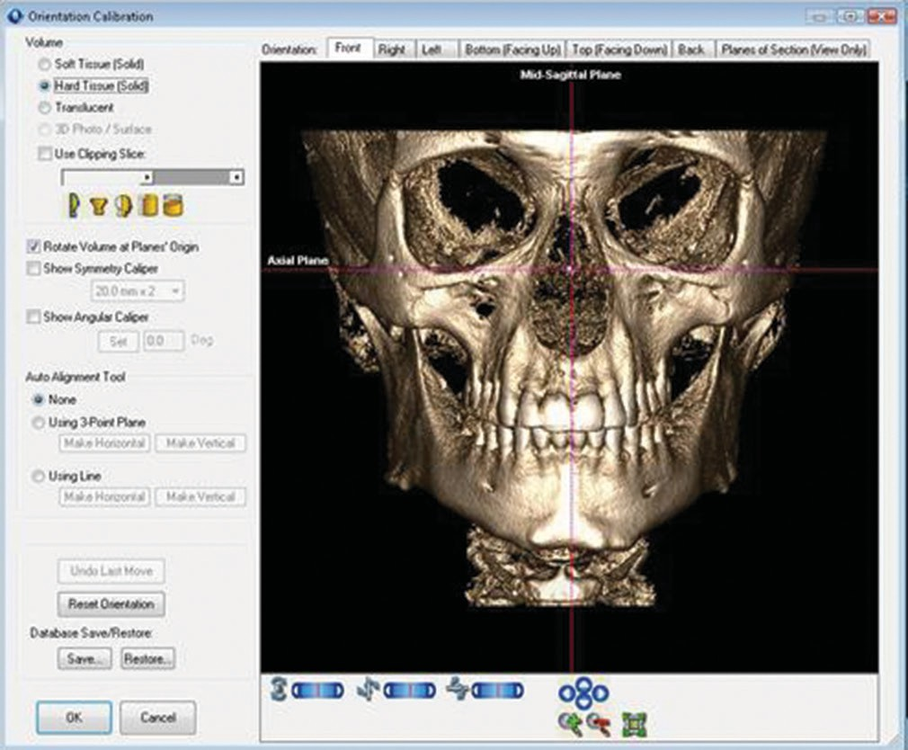

Patients with no history of rapid maxillary expansion or slow expansion, nasal respiratory pathology, and orthognathic surgery were included, whereas scans showing congenital anomalies such as cleft lip and palate, any respiratory pathology, any appliances in the mouth, and scans done by other than i‑CATR machine were excluded from the study.

The CBCT scans were obtained with an i‑CATR scanner with a single 360° rotation producing 306 basis images. DICOM images from each scan were loaded into Dolphin software

11.5 3D software.

Orientation of head was corrected from the front, right, and left side if required [Figure 1]. Data were analyzed for nasal airway volume, facial index, and distribution of groups on the basis of sagittal relation.

The airway was visualized and then digitally segmented by defining a boundary in all orthogonal views using same threshold range in three interactive steps as follows:

1. Boundary in all three orthogonal planes is drawn to limit

the color filling of the airway area

1. Selection of an initial threshold range which was set to

50

1. Placement of initial and subsequent seed regions.

To limit the airway volume to nasal area only, the boundaries as given by Grauer et al.[3] were slightly modified and defined in sagittal view by joining anterior arch of the atlas, posterior nasal spine, anterior nasal spine, subnasale, tracing along the nose to the soft tissue nasion excluding frontal, ethmoidal, and sphenoidal sinus in sagittal view. This process is repeated in remaining two orthogonal views. Each view was scrolled carefully through slices, and any empty, unfilled space was filled by inserting color seeds, and boundaries were slightly modified to control the flow of color into and limited to nasal area. The limits for the segmentation and an example of a virtual model of the airway are shown in Figure 2.

Nasal airway volumes were measured in cubic millimeters with measuring tool provided in Dolphin software. This procedure was repeated for each scan after 1 day to get three such readings for each patient, and mean nasal volume was then recorded.

Frontal bony view from CBCT scan was generated in i‑CATR vision software as shown in Figure 3 and facial height and width were measured with tool provided. The facial form is determined by the facial index given by Martin and Saller.[4] The bony facial index was calculated as the ratio between the nasion‑menton distances divided by the bony bizygomatic width.

**Figure 1:** Orientation of head orienting mid-sagittal and axial planes in the three-dimensional model

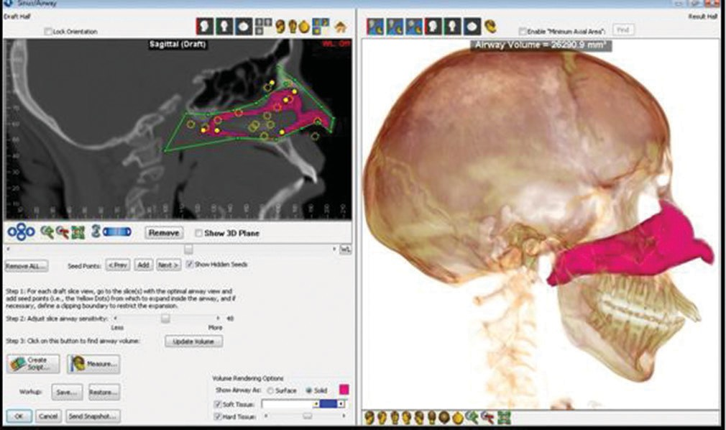

**Figure 2:** Method to determine nasal airway volume

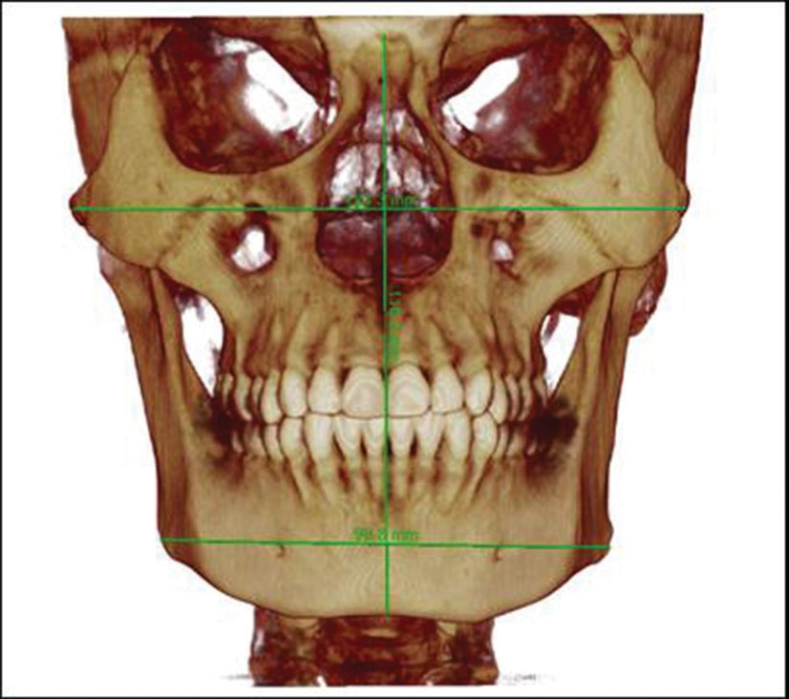

**Figure 3:** Method to determine facial index

Lateral cephalogram was generated from CBCT data through X‑ray developing tool as shown in Figure 4 and (CoA) condylion to Point A and (CoGn) condylion to point gnathion were recorded. Anteroposterior skeletal

**Table 1: Nasal airway volume and facial form**

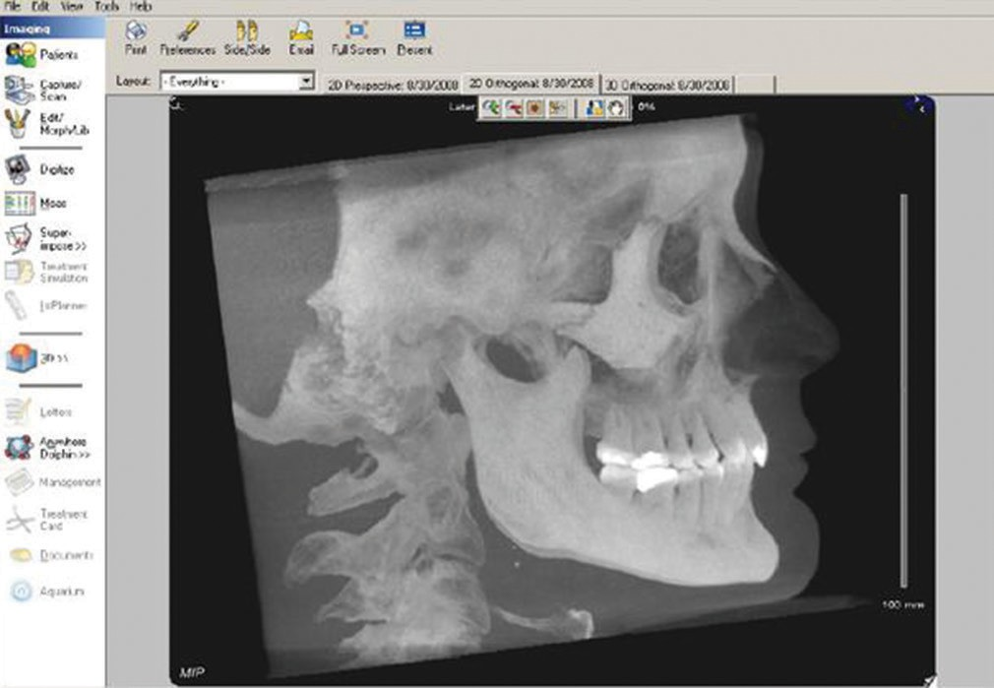

|  |  |  |  |  |
| --- | --- | --- | --- | --- |
| **Facial form** | ***n*** | **Mean** | **SD** | ***P*** |
| Euryprosopic | 5 | 30,908.90 | 6928.24 | 0.936 (NS) |
| Mesoprosopic | 11 | 31,925.35 | 6144.92 |  |
| Leptoprosopic | 18 | 30,923.27 | 8403.56 |  |

SD=Standard deviation

**Table 2: Nasal airway volume and skeletal sagittal relation**

|  |  |  |  |  |
| --- | --- | --- | --- | --- |
| **Skeletal sagittal relation** | ***n*** | **Mean** | **SD** | ***P*** |
| Class I | 16 | 30,46.36 | 6124.96 | 0.572 (NS) |
| Class II | 15 | 32,737.57 | 8218.47 |  |
| Class III | 3 | 29,112.27 | 10,156.47 |  |

SD=Standard deviation, NS=Not significant

**Figure 4:** Derived two-dimensional lateral cephalogram using three-dimensional models

relation (Class I, Class II, Class III) was established using maxillomandibular differential given by McNamara.

## Statistical analysis

Analysis of variance (ANOVA) test was used to assess the correlation between nasal airway volume and facial form and sagittal skeletal relationship.

Pearson’s correlation test was used to assess the relationship between craniofacial width, facial index, and nasal airway volume.

# RESULTS

The nasal airway volume ranges from 18,266 to 52,007 mm3. The subjects were divided according to the sagittal skeletal relation and facial form. The mean nasal airway volume for euryprosopic, leptoprosopic, and mesoprosopic subjects are shown in Table 1.

Test of ANOVA shows ~~that there is~~ no statistically significant correlation for the nasal airway volume and the facial form (P = 0.936). ~~As per ANOVA test,~~ there is no statistically significant correlation for the nasal airway volume and the sagittal skeletal relation (P = 0.572) [Table 2]. ~~The~~ Pearson’s correlation test show no statistically significant correlation for the nasal airway volume and the facial index (P = 0.897) [Table 3]. According to the Pearson’s correlation test, there is statistically significant correlation for the nasal airway volume and the craniofacial width (P = 0.009) [Table 4].

# DISCUSSION

~~This study consisted of 34 CBCT scans of healthy adult patients out of which 19 are males, and 15 are females. The nasal volume ranges from 18,266 to 52,007 mm~~~~3~~~~.~~

No studies until now have documented the correlation of volume of nasal area with craniofacial morphology.

**Table 3: Nasal airway volume and facial index**

**Nasal volume Facial index Form**

Correlation coefficient −0.114 −0.023

*P* 0.520 (NS) 0.897 (NS)

*n* 34 34

NS=Not significant

**Table 4: Nasal airway volume and craniofacial width**

**Nasal volume Craniofacial width**

Correlation coefficient 0.440**

*P* 0.009 (significant)

*n* 34

**Correlation is significant at the 0.01 level (two‑tailed)

Earlier studies[5] have focused on evaluating the pharyngeal airway to determine when its morphologic characteristics might relate to functional disorders, such as with restricted airways that induce mouth breathing or obstructive sleep apnea. In this study, only healthy pharyngeal subjects were selected, with an assumption that the nasal airway volume would reflect only natural anatomic conditions without pathology. To eliminate the influences of growth and aging, postpubertal subjects were selected for the current study. The subjects ranged from 18 to 28 years of age, so they had already undergone their adolescent growth spurt.

With 34 scans available, subjects were divided into three groups that is, euryprosopic, mesoprosopic, and leptoprosopic, the mean nasal volume for euryprosopic subjects was 30,908.9 mm3 whereas for the mesoprosopic subjects it was 31,925 mm3 and for the leptoprosopic subjects, it was 30,923 mm3. The nasal volume for leptoprosopic subjects was less as compared to euryprosopic and mesoprosopic subjects. However, this difference was not statistically significant. Although it was expected that nasal volume in leptoprosopic subjects should be significantly less, it was not so. This may be due to Enlow’s counterpart theory of growth where long and narrow face had protrusive noses leading to overall increase in nasal volume.[6]

Enlow[6] has pointed out “those individuals with dolichocephalic head form sets up a face that is correspondingly narrow, long, and protrusive, so called leptoprosopic facial type. Conversely, individuals with

brachycephalic head form sets up a face that is broad but less protrusive, so called euryprosopic facial type. Thus, the facial complex which attaches to the cranial base should match the template. However, there are instances where the facial form and head form does not match.” This study documents the correlation between nasal volume and facial form although it was statistically nonsignificant. Future investigation on larger sample with equal distribution can be done to find correlation between head form, facial form, and nasal airway dimensions.

According to our assessment for the correlation between nasal volume and skeletal sagittal relation, we found that there was no statistically significant correlation between nasal volume and skeletal sagittal relation [Table 2]. The mean volume for Class I subjects was 30,246 mm3, for Class II subjects 32,737 mm3, and for the Class III subjects 29,112 mm3. The nasal airway volume for Class II subjects was more although expected to be less. The probable explanation as already given above has to be because of protrusive nose as only nasal volume was taken into consideration. When total airway volume is measured in Class II individuals, it is less because of retruded tmandible and posterior position of the tongue. Conversely, in Class III subjects, the volume was less as the depth of nose might be less due to the deficient maxilla. Kerr[7] reported that Class II malocclusion subjects showed narrow nasopharyngeal airway space compared with Class I subjects. There was weak correlation between sagittal skeletal relationship and nasopharyngeal airway volume which collaborate with the results of our study. Kim et al.[8] reported smaller nasopharyngeal airway volume in Class II subjects than those with Class I and III malocclusion and larger volume in Class III subjects but this trend was not statistically significant. In our study, the volume for Class III subjects was less as compared to the Class I and Class II subjects, possibly because of the less protrusive nose in Class III subjects, only nasal volume was taken and unequal distribution of the subjects in ~~the~~ each group. It is possible that with equal numbers of subjects in each group, correlation would have been statistically significant.

Another aspect of our study was to find correlation between the nasal volume and facial index as shown in Table 3. The correlation between facial index and nasal volume was statistically nonsignificant. The probable reason for this could be decrease in width associated with increase in the length of the face or vice versa that does not affect the nasal volume (Enlow).

Table 4 shows the relationship between nasal volume and craniofacial width. In the present study, statistically significant correlation was found between craniofacial width and nasal volume. Volume was correlated only with width of the face and not with width/length ratio of face that could have affected the nasal volume.

~~In this study,~~ we calculated the nasal volume by semi‑automatic segmentation of the airway. The Dolphin 3DR gives more control by allowing the user to increase or decrease the threshold values. By experimenting, we found that 50% threshold value for airway segmentation was better compared to 25% or 100%. At 25% volume visualization was inadequate whereas at 100% volume there was overflow into adjoining areas.

Another way to calculate airway volume is automatic segmentation which is based on Hounsfield units. For automatic segmentation, volume measurements should be done with proper technique and diligence, because the measurement changes depend on the image threshold chosen. A study done by El and Palomo[9] comparing the reliability and the accuracy of three software (Dolphin 3D version 11, in vivo Dental version 4.0.70, On Demand 3D version 1.0.18407, Essential dental products, New delhi) for measuring the airway volume from CBCT found Dolphin 3DR highly reliable in calculating the airway volume and showed high correlation of results but poor accuracy, ~~showing~~ sometimes overestimates or underestimates ~~of~~ the actual volume. All programs showed lower reliability when measuring nasal passage volumes than oropharynx volumes. This may be due to the inability of software to automatically find nasal airway boundaries, unlike semi‑automatic method. They considered calculating the nasal passage volume more challenging than oropharynx with either manual or semiautomatic method. In our study, we were able to calculate the nasal volume using semi‑automatic segmentation by defining the boundaries and threshold more reliably.

~~This study includes~~ volumetric analysis of the nasal area and provides a new perspective on airway evaluation and its relation to craniofacial structure as well as for diagnosis purpose. As orthodontics, we have to check the functional demands of nasal airway reflected as mouth breathing habits in patients rather than measuring total airway as in sleep apnea cases. Further studies on the comparison of the method of calculating the airway volume through different 3D software and accuracy of the method can be carried out in future.

# CONCLUSIONS

1. A significant correlation exists between nasal volume and craniofacial width. Nasal volume was correlated by the width of the face and not by the width/length ratio of the face
2. Semiautomatic segmentation method of calculating nasal volume from Dolphin 3DR software was more appropriate as compared to automatic method.

## Financial support and sponsorship

Nil.

## Conflicts of interest

There are no conflicts of interest.

# REFERENCES

1. Babacan H, Sokucu O, Doruk C, Ay S. Rapid maxillary expansion and surgically assisted rapid maxillary expansion effects on nasal volume. Angle Orthod 2006;76:66‑71.
2. Oh KM, Hong JS, Kim YJ, Cevidanes LS, Park YH. Three‑dimensional analysis of pharyngeal airway form in children with anteroposterior facial patterns. Angle Orthod 2011;81:1075‑82.
3. Grauer D, Cevidanes LS, Styner MA, Ackerman JL, Proffit WR. Pharyngeal airway volume and shape from cone‑beam computed tomography: Relationship to facial morphology. Am J Orthod Dentofacial Orthop 2009;136:805‑14.
4. Martin R, Saller K. Textbook of anthropology 3rd ed. Stuttgart: Fischer; 1957.
5. Tso HH, Lee JS, Huang JC, Maki K, Hatcher D, Miller AJ. Evaluation of the human airway using cone‑beam computerized tomography. Oral Surg Oral Med Oral Pathol Oral Radiol Endod 2009;108:768‑76.
6. Enlow DH, editor. Faces. In: Facial Growth. 3rd ed. Philadelphia: W.B. Saunders Co.; 1990. p. 1‑24.
7. Kerr WJ. The nasopharynx, face height, and overbite. Angle Orthod 1985;55:31‑6.
8. Kim YJ, Hong JS, Hwang YI, Park YH. Three‑dimensional analysis of pharyngeal airway in preadolescent children with different anteroposterior skeletal patterns. Am J Orthod Dentofacial Orthop 2010;137:306.e1‑11.
9. El H, Palomo JM. Measuring the airway in 3 dimensions: A reliability and accuracy study. Am J Orthod Dentofacial Orthop 2010;137 4 Suppl: S50.e1‑9.