Mineral chemistry of Bauxite ore deposits in Yercaud Hill, Salem District, Tamil Nadu

Abstract
The charnockitic suite of rocks underlying the bauxite deposits of Yercaud hill consists of quartz, plagioclase and potash feldspar, ortho and clino-pyroxenes, garnet and secondary hornblende. Bauxite is consisting mainly of aluminum hydroxide minerals. Bauxite occurs in yercaud hill as a part of Eastern Ghats range of Tamil Nadu of the Achaean age. It is formed due to residual weathering and lateritization of Achaean charnockite. In the study area, bauxite is hydrous aluminum oxides, aluminum hydroxides and laterites are mostly found in humid tropic climatic condition due to intense weathering of parent rock. In the present work, the XRD study shows that gibbsite (Al (OH)₃), goethite (FeO(OH)) and hematite (Fe₂O₃) are the major minerals in the bauxites. From the XRF analysis, the major oxides are Al₂O_{3,} Fe₂O_{3,} SiO₂, TiO₂, P₂O₅, and Cr₂O_{3.} Based on theAl₂O_{3,} SiO2, Fe₂O₃ ternary plot, bauxites of this region has undergone strong lateritization. According to the chemical classification of laterites, Yercaud bauxites belong to Ferrite and bauxitic ferrite with some amounts of bauxite. At high Al₂O₃ weight percentage of 86%, low Fe₂O₃ concentration of 10.56% and TiO₂ 0.49% indicate it as a high grade Bauxite of aluminum hydroxides mineral Gibbsite (Exploited mines-III). High Fe₂O₃ constitute of 77.61% by weight, low Al₂O₃ of 18.22% and 0.89 % TiO₂ portrays it as Iron rich laterite (Exploited mines - I). Above geochemistry reveals the site specific Al₂O₃ weight percentage of bauxite ore within study area of Shevaroy hill in Salem district.

Key word: Bauxite ore, Laterite, Aluminum hydroxides, XRD, XRF, Eastern Ghats.
Introduction:
India has an enriched resource of bauxite deposits. Aluminum hydroxide mineral composite is constituted by Bauxite ore mainly. It is the principal Major source of alumina (Al₂O₃) is Bauxite from which by electrolytic process aluminum metal is smelted. Other than as metal both alumina and bauxite are used for several products. Bauxite deposits of India occur as laterite capping overlain by other rock types and are produced by lateritization and sub-aerial weathering of variety of rocks (Patel et al. 2014)¹. Mineral gibbsite and commonly termed as "trihydrate bauxite es" being major composite of Bauxites or "the Suriname type"; "monohydrate bauxite" composed of boehmite or the "European type"; those of a mixture of gibbsite and boehmite composite are called "mixed bauxites." The term "Jamaica type" is very fine grained high-iron gibbsitic bauxite which contain minor quantities of boehmite. The lateritization process is shown as (Desai et al 2018)²:
1. Plagioclase feldsparhalloysitemetahalloysitekaolinitegibbsite.
2. Plagioclase/Olivine/Pyroxenesgoethitehematite. The bed rocks signifies the type of bauxite present as follows: 1. Karstic types for bauxite lying on carbonates and 2. Lateritic bauxite type of bauxite lying on aluminosillicates (Zhang et al 2014)³. Al₂O₃ is extracted from bauxite by Bayer process which is a wet chemical, caustic leaching method (Rao et. al., 2016)⁴. Aluminum’s only ore is Bauxite, it is clay or amorphous like substances, with tin impurities the colour of Bauxite is pink to become brownish. If chemical and mineralogical properties satisfies cut off grade then bauxite is considered as a resource. Al₂O₃ general cut off grade is 30 to 50% (Abzalov and Bower 2014)⁵. The lateritic-type bauxites are residual deposits derived from the underlying alumosilicate rocks and are directly related to the underlying source rocks by their preserved textures and compositions. karstified surfaces of carbonate rock is overliened by more or
less by Karstic-type deposits (N Hanilçi 2013)⁶. The Indian lateritic bauxite belt is one of the seven most important lateritic-bauxite belts of the world. Indian bauxite deposits are grouped into five major Geological–geomorphological regions (Bhukte and Chaddha, 2014)⁷ These are (1) Eastern Ghats, (2) Central India, (3) Western Ghats and west coast, (4) Gujarat and (5) Jammu and Kashmir. This belt is mostly confined to southern India. Almost all bauxite deposits of southern India are associated with laterites which occur on high plateau or capping on the hill ranges of Peninsular India. In India Bauxite –Laterite deposits occurs as capping over charnockite-leptynite rocks of Eastern Ghats. Bauxite of Eastern Ghats are formed from khondalite (Odisha, Andhra Pradesh; Reddy et al 2015)⁸, from charnockite (Shevroy, Kollimalai hills, Tamil Nadu). Bauxite is mainly made up of hydrous aluminum oxides in the Study area is soft, whitish red to brown aluminum ore mineral as aluminum hydroxides and laterites due to intense weathering of parent rock which are mostly found in humid tropical climatic condition.
STUDY AREA
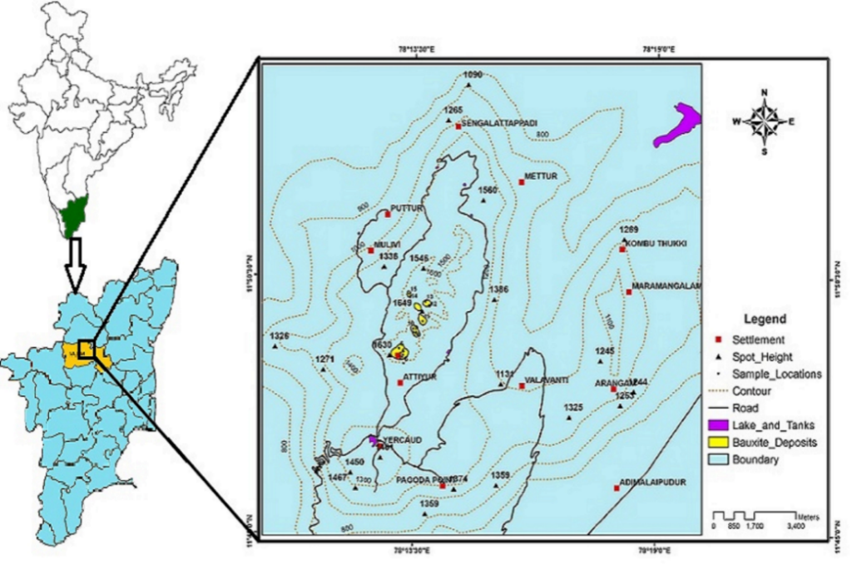
Fig.1 Location map of the study area
The study area Bauxite deposits occur as laterite capping in NNE of Yercaud (11⁰47’: 78⁰ 12’ 30”) at Shevroy hill, Salem district (Fig. 1) in the survey of India Topographic sheet no 58I/1. Yercaud is a hill station which is situated north of Salem by 17 km. Shevroy hill’s altitude vary from 552m to 1640 m above MSL which consist of numerous cappings over the plateau. From the field observation a sharp contact between pinkish white Gibbsite at the bottom is overlaid by brownish red laterite at the top as Bauxite ore. In the NE Veppadi River drains the area.

GEOLOGY OF STUDY AREA
Charnockite’s of Achaean age is occupied in The study area. Southwest part of the study area is found by Dunite of Neoproterozoic. NNE of Yercaud is encountered with bauxite and Laterite of Cenozoic age. Charnockite has the foliation trend in NE-SW direction with variation of dip by 45⁰ to 80⁰ towards SE. In the Shevroy hills six deposits of bauxite capping occur at six hilltops as in (Fig. 2). The aerial extent of the individual deposits range from 22,000sqm to 1, 55,000sqm with an aggregate of 4,05,000sqm. The thickness of the bauxite zone is inferred to be 5 to 15m. The lithostratigraphic succession of Eastern Ghats bauxite is as given below (Singh et al., 2008)⁹.
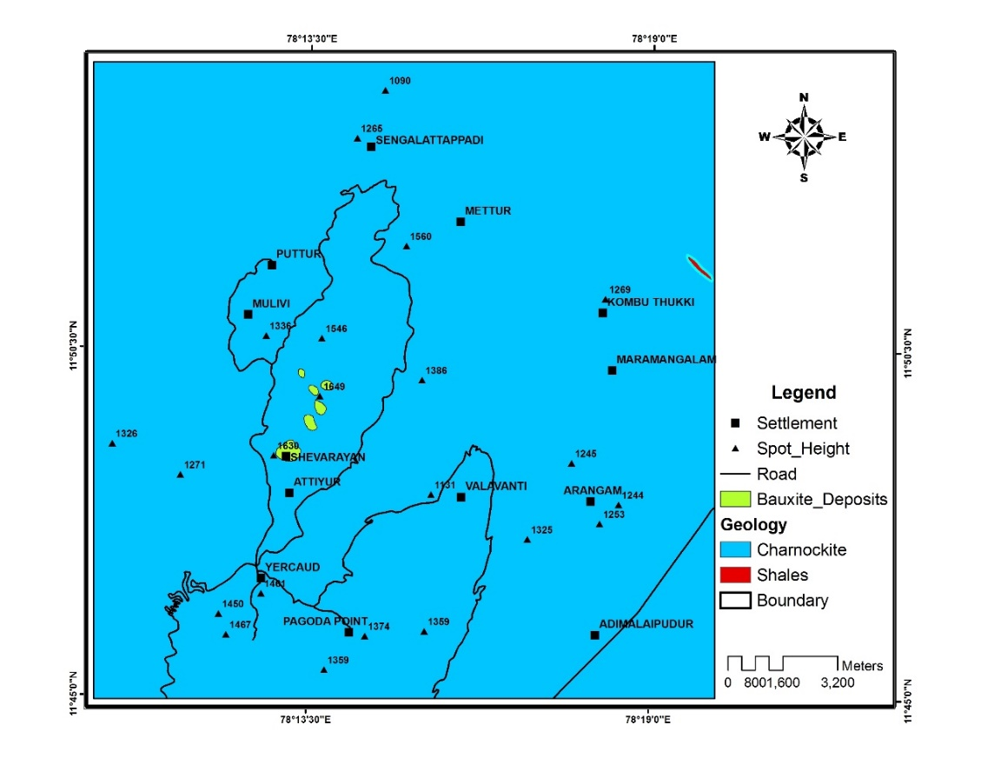
Fig.2. Geology map of study area

Recent - | Soil and Alluvium
Quaternary / Tertiary - | Bauxite/ Laterite
Archean - | Pegmatite & quartz veins, migmatites and gneisses, charnockite suite and khondalite
GEOMORPHOLOGY
In recent years the increasing use of satellite remote sensing has made easier to define the spatial distribution of geomorphology and other associated land form feature. The delineation of the geomorphic units is based on interpretation of remote sensed data as well as observations made in the field. The present day landforms are irregular outlines of various geomorphic processes operating in the study area with ongoing geologic and tectonic process operating below the earth surfaces. The rate of deposition and erosion is ever being uniform which causes uneven topographic outcropping patterns in the surface. By carefully analyzing various outcrop patterns with the help of IRS satellite imageries, the characteristic land form recognized are followed by various landforms present in the study area, 1. Dome type residual hills, 2. Hilltop weathered, 3. Moderately weathered / moderately buried pediplain, 4. Pediment / valley floor, 5. Ridge type structural hills (Large), 6. Shallow buried pediment, 7. Shallow weathered / shallow buried pediplain, 8. Valley fill / filled – in valley, 9. Water body mask (Fig.3).

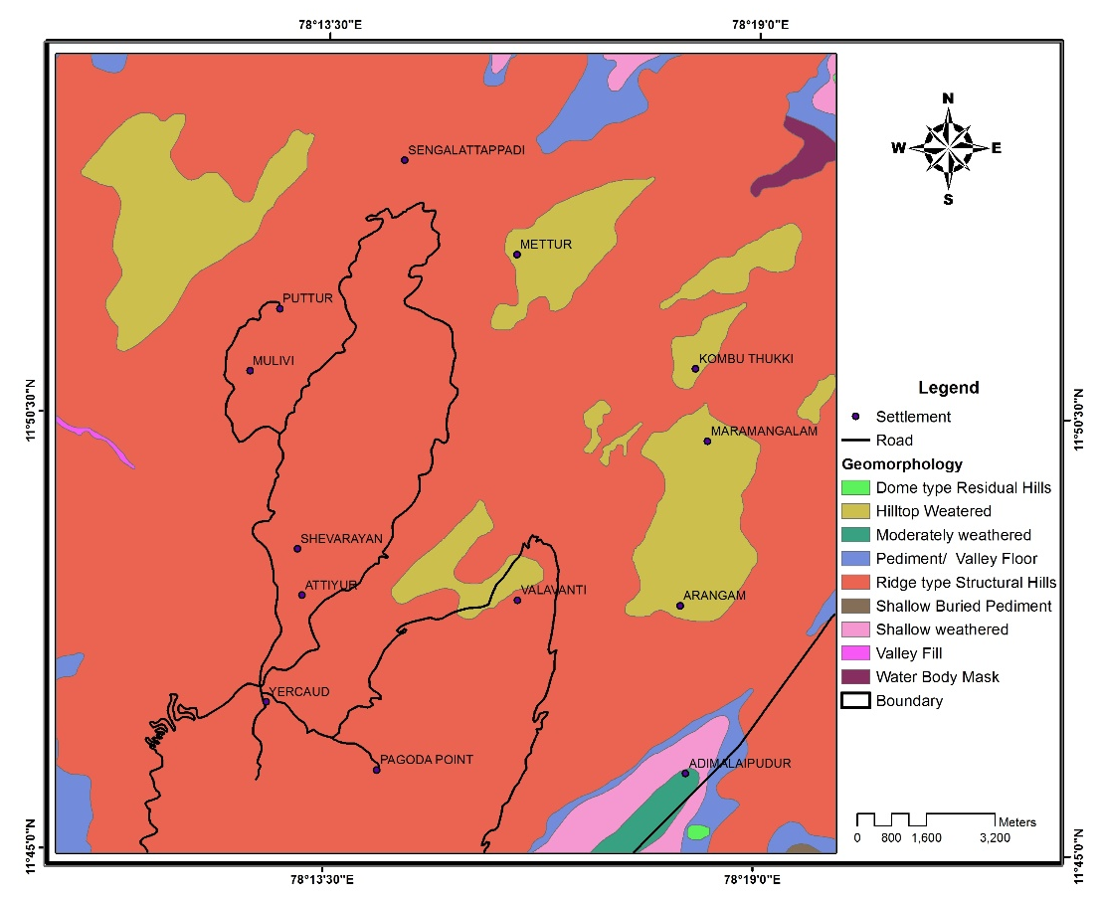
Fig.3. Geomorphology map of study area
METHODOLOGY

Field data methods
Detail field study was carried out in the Yercaud and collected geological data and mapping. A systematic sampling was also taken up. Representative samples of bauxite deposits were collected from the Yercaud. These samples were collected by ourselves and show the variety of samples present in the area. Bauxite deposits are exposed in the laterite, and bauxite samples were collected from different places in the area. Some associated laterites were also collected to establish the type of laterite that is associated with the bauxite deposit. A rock hammer was used for the collection and the samples were stored in a plastic bag. Each sample collected was labeled to determine their locations. About 2 kg of samples was collected from each location.
Sample preparation
Representative samples collected from the Yercaud were gently crushed into powder by a mortar and pestle. These powdered samples were used for both X-ray diffraction (XRD) and X-ray fluorescence (XRF) analyses to determine respective mineralogy and major element composition. The sample amount for the X-ray diffraction was prepared using the backfill techniques to produce a random oriented mount (Moore and Reynolds 1997)¹⁰.
GEOCHEMICAL AND MINERALOGICAL COMPOSITIONS
Geochemical Compositions
Ten samples of bauxite from Shevarory hills in Salem district were collected. Around 3 samples of XRD were analyzed in Department of Earth Sciences, Pondicherry University. Major oxides were analyzed for 5 samples using X-ray fluorescence spectrometry (XRF) at the CSIR Lab, Thiruvanthapuram. The Major Oxides include SiO₂, Al₂O₃, Fe₂O₃, MnO, MgO, K₂O, Na₂O, TiO₂ and P₂O₅. The Al₂O₃, Fe₂O₃, SiO_{2,} ternary diagram after Aleva (1981)¹¹ conveys that the bauxite of the area are bauxite, bauxitic ferrite and ferrite, Fig. 4.
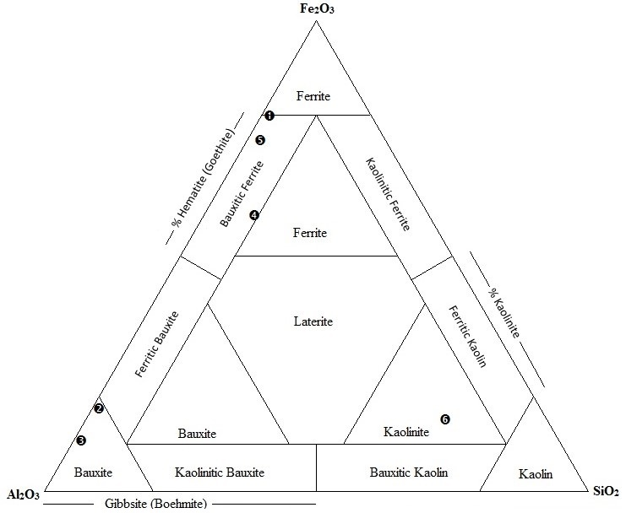
Fig. 4 Chemical classification of Yercaud Bauxite deposit (Aleva 1981)

According to the Al₂O₃, SiO₂ and Fe₂O₃^{T} ternary plot (after Schellman, 1981)¹², the deposits of the area have undergone strong lateritization. This suggests that the early kaolin minerals might haveundergone complete alteration into aluminous sediments and then to bauxite minerals Fig. 5a.
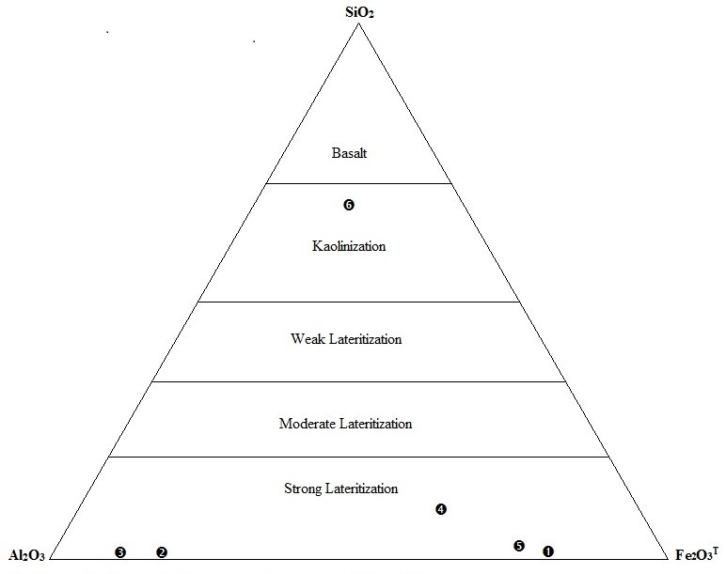
Fig. 5a Triangular diagram showing degree of lateritization (Schellman, 1986)

The major geochemical compositions of bauxite samples are listed in Table 1. It can be seen that the Al₂O₃ (18.22-86.09 %), Fe₂O₃ (10.56-77.61%), SiO₂ (1.21-8.95%) are the major component in the bauxite ores. The other oxides P₂O_{5,} TiO_{2,} Cr2O3 andCdO (<1%). It is characterized by high Fe₂O₃ constitute of 56.8% by weight, low Al₂O₃ of 31% and TiO₂ portrays it as lateritic-Bauxite. It is also characterized by high Al₂O₃ of 79 weight % low Fe₂O₃ concentration of 17% and 0.9% of TiO₂ weight conveys it as a high grade Bauxite(Exploited mines-I) at high Al₂O₃ weight percentage of 86%, low Fe₂O₃ concentration of 10.56% and TiO₂ 0.49% indicate it as very high grade Bauxite of aluminum hydroxides mineral Gibbsite(Exploited mines-III). A high Fe₂O₃ constitute of 72.84% by weight, low Al₂O₃ of 22.31% and TiO₂ portrays it as laterite(Exploited mines-II) and high Fe₂O₃ constitute of 77.61% by weight, low Al₂O₃ of 18.22% and TiO₂ portrays it as Iron rich laterite(Exploited mines-I). Above geochemistry reveals the site specific Al₂O₃ weight percentage of bauxite ore within study area of Shevaroy hill in Salem district.

Table -1. Major oxide of Yercaud Bauxite samples in Weight percentage (%)
Major Oxides | Weight percentage (%)
Major Oxides | Y/B/03 | Y/B/09 | Y/B/10 | Y/B/12 | Y/B/13 | Y/CH/08
Al₂O₃ | 18.22 | 79.02 | 86.09 | 31.04 | 22.31 | 16.61
Fe₂O₃ | 77.61 | 17.08 | 10.56 | 56.86 | 72.44 | 13.68
SiO₂ | 1.32 | 1.21 | 1.27 | 8.95 | 02.33 | 59.15
P₂O₅ | 0.72 | 1.06 | 1.04 | 0.67 | 0.69 | 2.54
TiO₂ | 0.89 | 0.98 | 0.49 | 1.50 | 0.86 | 2.27
Cr₂O₅ | 0.53 | 0.16 | 0.13 | 0.30 | 0.66 | 1.01

Fig. 5b. Bar diagram of major oxides in Bauxite samples

Mineralogical Compositions
Mineralogical investigations show that gibbsite Al(OH)₃, goethite FeO(OH) and hematite (Fe₂O₃) are the major minerals in the bauxite ores, anatase (TiO₂), quartz (SiO₂). It is evident from Semi-quantitative X-ray diffraction data (Table.2 & Fig. 5b) that the mineralogy of bauxite is gibbsite (58%) over other minerals such as hematite (26 %) and goethite (16%). The Al-Laterite contains gibbsite (30%), hematite (50%) and Goethite (20%) while the Fe-Laterite composed mostly of hematite (67%), goethite (16%) and gibbsite (17%). In addition to these minerals small percentage of minerals such as anatase, quartz is also observed. The quartz (2.6-3.2 %) and anatase (2.8-3.5 %) abundance are relatively consistent.
Table – 2. Semi-quantitative mineral abundances (mass %) determined by XRD in the Bauxite samples
SAMPLES | GIBBSITE | HEMATITE | GOETHITE | DISCRIPTIONS
1 | 58% | 26% | 16% | Bauxite
2 | 30% | 50% | 20% | Al-Laterite
3 | 17% | 67% | 16% | Fe-Laterite
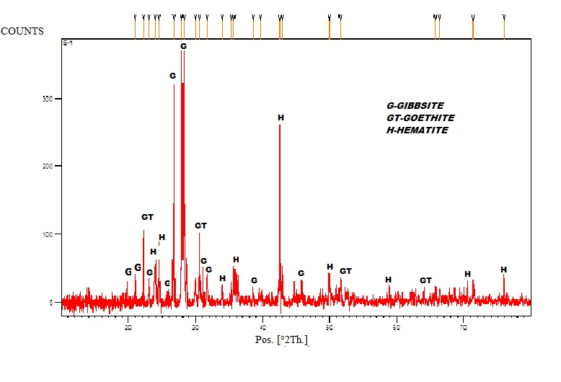
A
3

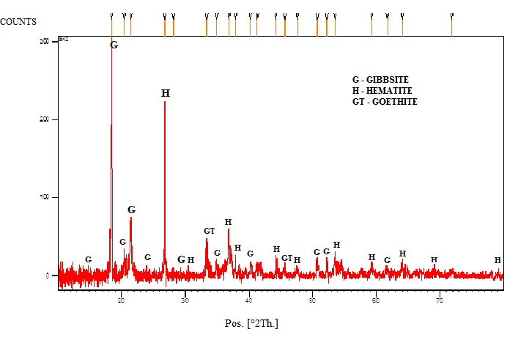
B
1

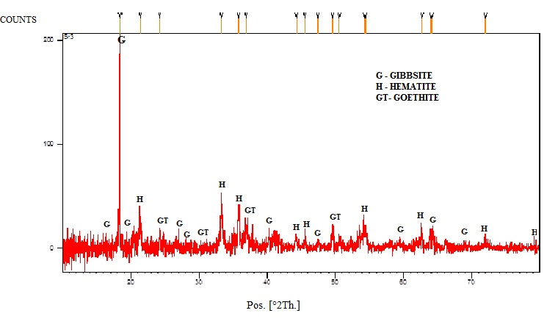
C
2

Fig. 6. A, B, C Representative X-ray diffractogram depicting mineralogy of Fe-laterite (A), Bauxite (B) and Al-laterite (C).
CONCLUSION
Bauxites deposits of Yercaud hill are of bauxitic ferrite, ferrite and bauxite type. Since they have undergone strong lateritization, there might be complete alteration of kaolin minerals into aluminous sediments and subsequently bauxites were formed. By the mineralogical studies on Semi-quantitative X-ray diffraction data the mineralogy of bauxite is gibbsite (58%) over other minerals such as hematite (26 %) and goethite (16 %). The Al-Laterite contains gibbsite (30%), hematite (50%) and Goethite (20%) while the Fe-Laterite is composed mostly of hematite (67%), goethite (16%) and gibbsite (17%). It is characterized by high Fe₂O₃ constitute of 56.8% by weight, low Al₂O₃ of 31% and TiO₂portrays it asanAl- laterite. It is also characterized by high Al₂O₃ of 79 weight % low Fe₂O₃ concentration of 17% and 0.9% of TiO₂ weight conveys it as a Bauxite(Exploited mines-I) at high Al₂O₃ weight percentage of 86%, low Fe₂O₃ concentration of 10.56% and TiO₂ 0.49 % indicate it as a high grade Bauxite of aluminum hydroxides mineral.

Gibbsite (Exploited mines-III) at high Fe2O3 constitute of 72.84% by weight, low Al₂O₃ of 22.31% and TiO₂ portrays it as laterite (Exploited mines-II). Above geochemistry reveals the site specific Al₂O₃ weight percentage of bauxite ore within study area of Shevaroy hill in Salem district.

REFERENCES

- Patel, V. N., Trivedi, R. K., Adil, S. H., & Golekar, R. B. Geochemical and mineralogical study of bauxite deposit of Mainpat Plateau, Surguja District, Central India. Arabian Journal of Geosciences, 7(9), 3505-3512 (2014).
- Desai, R. V., J. V. Khanapurkar, and R. A. Suryawanshi. "Geochemistry of upland laterites of tarale-thoseghar plateau of bamnoli range of Satara District of Maharashtra, India." Journal of Applied Geochemistry 20.4 421-431 (2018).
- Zhang, Y. Y., Hu, P., Zhang, Z. Y., Qi, Y. H., & Zou, Z. S.. Mineralogical and geochemical characteristics of the Guigang Salento-type bauxite deposits, western Guangxi, China. Acta Geodyn. Geomater, 105, 1-7 (2014).
- Rao, M. J., Mohammad, C. H. P. M., & Kakkassery, A. I. Bauxite Mining in Eastern Ghats of Andhra Pradesh, Possible Environmental Implications and Measures for Environmentally Friendly Mining (2016).
- Abzalov, M. Z., & Bower, J. Geology of bauxite deposits and their resource estimation practices. Applied Earth Science, 123(2), 118-134 (2014).
- Hanilçi, Nurullah. "Geological and geochemical evolution of the Bolkardaği bauxite deposits, Karaman, Turkey: transformation from shale to bauxite." Journal of Geochemical Exploration 133: 118-137 (2013).
- Bhukte, P. G., and M. J. Chaddha. "Geotechnical evaluation of eastern Ghats bauxite deposits of India." Journal of the Geological Society of India 84.2: 227-238 (2014).
- Reddy, Maddi Karthik, Vadde Ramesh, and Vipparla Swarup Kumar. "Mode of Occurrence and Distribution of Bauxite Deposits in Andhra Pradesh and Feasibility of Aluminum Industry." Procedia Earth and Planetary Science 11: 115-121 (2015).
- SINGH, V., CHATTERJEE, G. and BEHERA, P. K. An overview of East coast bauxite deposits with special reference to quality control and mine planning at Panchpatmali bauxite mine. Proc. ICSOBA 2008, pp.3-14 (2008)
- Moore and Reynolds, X-ray diffraction and the identification and analysis of clay minerals. Oxford University Press, Oxford (1997).
- Aleva, G. J. J. "Essential differences between the bauxite deposits along the southern and northern edges of the Guiana Shield, South America." Economic Geology 76.5: 1142-1152 (1981).
- Schellmann, W. Considerations on the definition and classification of laterite. In: Proceedings of the International Seminar on Lateritisation Process. IGCP 129 and IAGC Trivandrum, India, Oxford and IBH Publishing Company, New Delhi, pp. 1-10 (1981).

