On the Relationship Between Epileptic Seizures and Cortical Spreading Depression
Significant Scientific Correlation Between Epileptic Seizures and Cortical Spreading Depression
Identified Research Correlation Between Epileptic Seizures and Cortical Spreading Depression
Pre-clinical Research based Correlation Between Epileptic Seizures and Cortical Spreading Depression
Pre-clinical bio-analytics based Correlation Between Epileptic Seizures and Cortical Spreading Depression
Pre-clinical biomarker based Correlation Between Epileptic Seizures and Cortical Spreading Depression
Imbalance between demand and supply of oxygen in brain Correlation Between Epileptic Seizures and Cortical Spreading Depression
Oxygen toxicity and relevant parameters of brain in Correlation Between Epileptic Seizures and Cortical Spreading Depression

Abstract (Minimum 150 words objective to describe what reported research said..and what he/she has proved)
Objectives: The discovery of cortical spreading depression 80 years ago was intimately connected to epilepsy research. In our studies we found that monitoring of brain hemodynamics, metabolic ionic and electrical activities are very similar in the two pathophysiological events. Here we are presenting the coupling between epilepsy and cortical spreading depression while monitoring of mitochondrial NADH together with other physiological parameters in real time in vivo.
Methods: Rats and Mongolian gerbils were used in three models of induction of epilepsy, namely injection of Metrazol, exposure of the rats to hyperbaric oxygenation in a pressure chamber and using a strain of gerbils that are developing seizures spontaneously. We monitored brain oxygen levels, mitochondrial NADH, extracellular potassium levels, DC steady potential and EEG in the very slightly anesthetized animals.
Results: The results could be summarized as follows: 1. In almost all animal tested cortical spreading depression was developed and recorded after 1-3 minutes of seizures activity. 2. Mitochondrial NADH redox state was more oxidized during the two events.
3. The oxidation of NADH during the CSD was 3-4 times relative to the seizures interval. 4. The increase in extracellular potassium levels was also 3-4 times higher during the CSD event.
Significance: Under the two recorded events a clear correlation between the process of oxygen(energy) demand or consumption and oxygen(energy) supply was found. The results suggest that the accumulation of extracellular potassium during the epileptic activity is probably the trigger for the development of CSD in the 3 model used.
Keywords??????
1. Introduction
(what reported research said… and what conclusively your rationle to define the research gap / innovation area in the present article research or review on all research gaps of presently running article innovations/ what year wise the scientific data was reported)
Few years ago a detailed review on the hallmarks in the development of the concept of seizures and epilepsy was published (Patel, P. and Moshe, S.L. 2020). The Key Point of this critical review was as follows:
• The objective of this review is to provide a historical trajectory in the evolution of the concepts of seizure and epilepsy.
• Seizure descriptions and terminology are documented as early as 2500 BC; names have been revised and updated through time but meanings have not changed.
• Our understanding of the pathophysiology and etiology of seizures and epilepsy has remarkably advanced, leading to the development of classification schemes.
• The goal of seizure and epilepsy classifications is that it is relevant to clinical practice and allows us to find a precise diagnosis to guide targeted treatments.
The main parameter that was recorded from the brain of patients under those conditions, in the early years, was the EEG that was discovered by Hans Berger in 1929 (Ince, R. et al. 2021). Rosenblueth and Cannon in (1942) published a detailed paper entitled “cortical responses to electric stimulation” that tried to elucidate what they called “experimental Epilepsy” developed in monkeys.
Somjen in an assay published in (2005) summarized the discovery of cortical spreading depression by Leao as follows:
“Originally, Leaõ intended to study “experimental epilepsy,” specifically the propagation of electrically provoked seizure discharges in the cerebral cortex (Leao, A.A.P. 1944). To this end, he opened the skull of rabbits under anesthesia and arranged a row of chlorided silver wire electrodes in contact with the cortical surface. Of these electrodes, one pair served for stimulation and the others, connected in six staggered pairs, for bipolar recording of the electrocorticogram (ECoG) at increasing distance from the stimulated points. Unexpectedly, instead of seizure-like discharge, the stimulation was frequently followed by a flattening of the spontaneous ECoG waves traced by the Grass oscillograph. The ECoG activity in the electrodes nearest to the stimulated area was silenced first, and then the extinction spread in orderly sequence from one electrode pair to the next, eventually covering almost all the cortex. Recovery of the ECoG waves occurred in the same sequence as their previous depression.”
“In a shorter companion paper, Leaõ described the vasodilatation that accompanies an SD wave (Leão, A.A.P. 1944). Using microscopy and photography of pial vessels to assess cortical circulation rather than the then-customary heated thermocouple method, he was able to see not only that arteries dilated but also that veins “become as scarlet as the arteries” (Leão, A.A.P. 1944). He never saw a darkening of the color of the blood to precede its brightening. This, to my knowledge, was the first realization that increase in cerebral blood flow can exceed the increase in the demand for oxygen—a matter that is occupying the attention of investigators of cerebral circulation to this day.”
In 1944 Leaõ published his first results, of his Ph.D. thesis (Leão, A.A.P. 1943), describing for the first time the phenomenon “cortical spreading depression” – CSD (Leao, A.A.P. 1944). In the introduction to this paper Leao wrote,” This study originated in an attempt to secure more data for the understanding of the cortical electrogram which occurs in “experimental epilepsy” and of the conditions in which it is brought forth by electrical stimulation. Early in the development of the study an interesting response, elicited by electrical stimulation”.
The discovery of cortical spreading depression by Leao in the early 1940’s, was very late relative to the well-known and reported phenomenon, namely, epilepsy or seizures in patients. Actually, He was involved (in 1941) in the study on experimental epilepsy conducted by Arturo Rosenblueth and Walter Canon. They were analyzing the responses to electrical stimulation of the cortex of anesthetized rabbits, with electrodes placed on the cortical surface, and the changes were recorded by electrocorticography (ECoG). They agreed that some of the electrical epileptiform after discharges should be further studied by the newcomer. The analysis of the cycle of excitability of cortical neurons after the convulsive state, under supervision of Arturo Rosenblueth and Hallowell Davis, permitted him to identify a decrease of the excitability spreading in increasing circles around the initial focus, a phenomenon he named “spreading depression” (CSD), the theme of his PhD thesis, (seen in Fig. 1A and 1B) the “Spreading depression of electrical activity in the cerebral cortex” (Leão, 1943). The following year the first record of the study (Fig. 2 and Fig. 4A) was published (Leao, A.A.P. 1944), and soon the phenomenon was named after him (“Leão’s wave” or “spreading depression of Leão”) (Leao, A.A.P. 1944, Teive, H.A. et al. 2005, Maranhao-Filho, P. and Vincent, M. 2009, Gattass, R. and Leão, A.A.P. 2013). In sequence, he published another paper, the same year, focusing on the vasodilatation (see figure 3) accompanying CSD (Leão, A.A.P. 1944). Before leaving back to Brazil, he submitted, together with Robert S. Morison, the “Propagation of spreading cortical depression,” (see Fig. 4) published in (1945). Later, his first international paper developed in his Brazilian laboratory appeared (Leão, A.A.P. 1947).
In 1973, I performed my first study related to the effect of cortical spreading depression of Leaõ (CSD) on brain mitochondrial activity (NADH redox state) monitored in vivo in real time (Mayevsky, A. and Chance, B. 1973). In another study published in (1974) we found that exposing the rat to hyperbaric oxygenation induced the development of epileptic activity followed by a wave of CSD after each seizure event. Since then, we recorded the coupling between seizures and CSD under other experimental protocols while monitoring mitochondrial activity together with other brain functions.
We selected 2 basic pathophysiological events presented in Figure 5 (labeled as 9 and 10) namely, epilepsy and cortical spreading depression. The two selected perturbations are coupled namely that CSD will be recorded after a period of epileptic activity. Those 2 events are affecting the same type of processes in the brain such as CBF, mitochondrial NADH redox state, electrical activities and ionic homeostasis as seen in the scheme. When epileptic activity is induced, the events 1- 8 shown in figure 5 will respond as will be describe in the results section.
We found that the coupling between epilepsy and CSD could be recorded in three different experimental situations as follows:
1. Topical or systemic application of Metrazol.
2. Exposure to hyperbaric oxygenation (100% oxygen).
3. Spontaneous development of epilepsy in Gerbils.
The aim of the current publication is to describe the monitoring technology used as well to present typical results obtained using the above mentioned protocols.
2. Methods (methods utilized flow charts /diagrams)
During the years 1973-2003 various monitoring systems were used in studying epilepsy and CSD were developed in our laboratory. During those years we developed and used 10 different monitoring systems that were used in studying the effects of CSD on the metabolic, hemodynamic, ionic and electrical activities in the brain in vivo, in real time. Figure 6 presents in a schematic way the various parameters (black letters) that were monitored in our laboratory during the years.
2.1 Fiber optic based fluorometer/reflectometer
In order to enable the monitoring of brain NADH fluorescence in anaesthetized or unanaesthetized animals, a flexible means was needed to connect the fluorometer with the tested brain. This was achieved in 1972, when UV transmitting quartz fibers became available (Schott Jena Glass, Germany). We have used the light-guide-based fluorometer for in vivo monitoring of the brain (Chance, B. et al. 1973, Mayevsky, A. and Chance, B. 1973) subjected to anoxia or CSD. The historical development of light-guide-based fluorometry-reflectometry was described previously (Mayevsky, A. and Chance, B. 2007, Mayevsky, A. and Barbiro-Michaely, E. 2013a, b). In order to connect the light guide tip to the surface of the brain, a special cannula (Fig. 7A) was cemented to the skull after drilling the appropriate hole in the skull covers the brain. A step of 0.2 mm in the bottom of the cannula held the light guide in a constant distance from the brain. The thread outside the bottom of this cannula enables screwing it into the skull and also gave a better connection between the cannula and the cement. The cannula used (Fig. 7A), has two compartments in the bottom, the small one for KCI application 3-4 and the large compartment, 1-2, where chemicals such as Metrazol were applied and was affecting larger area. A fifth electrode was located 180° to electrodes 3-4, so the EEG was measured at the same time. Another type of light guide holder is presented in Figure 7B.
2.2 Monitoring of NADH, pO₂, extracellular K⁺, DC and ECoG
The normal functioning brain requires a continuous supply of blood in order to obtain glucose as well as oxygen. Any change in the oxygenation of the tissue will result in an impairment of the normal function. Most of the oxygen taken up by the brain is consumed by the mitochondria in order to supply the large amount of ATP needed. A major part of the ATP is used by the ATPase system to keep the neurons in the polarized state. Figure 5 shows in a schematic way the interrelation between the energy production system and the pumping activity going on in the membranes. In order to understand the connection between various events occurring in the brain in vivo, one has to measure as many parameters as possible from the same site.
Using surface probes, we monitored the metabolic, ionic and electrical activities from a small area of a rat or gerbil brain (Figs. 8A and 8B). The metabolic state and activity was evaluated by monitoring partial pressure of oxygen (pO₂) as well as the intramitochondrial NADH redox state by surface fluorometry. Extracellular K⁺ activity was measured by a surface valinomycin electrode. For electrical activities we measure DC potential and ECoG. Using the multiprobe approach we exposed the animal to various treatment such as, ischemia, epilepsy and CSD while recording the various responses from the brain. All these sensors and electrodes were held in a multiprobe assembly described in detail elsewhere (Friedli, C.M. et al. 1982, Mayevsky, A. 1983, Mayevsky, A. et al. 1986b). Figure 8C shows the results obtained when the monitoring system seen in Figure 8A was used while exposing a rat to anoxia.
2.3 Monitoring the brain inside hyperbaric chamber
Two types of hyperbaric chambers were used in our studies.
- In a small chamber (model 1836 HP, Bethlehem Corp.) we monitored brain NADH redox state, Reflectance and ECoG.
- In the large chamber (model FM-21-A, Bethlehem Corp.) we were able to use the multiparametric monitoring system.
Figure 9A shows the rat located in the small HBO chamber and connected to the time-sharing fluorometer/reflectometer via a bundle of optical fibers and ECoG electrodes penetrating the hole in the wall chamber as well. The excitation and emission separate fibers are connected outside the chamber to the fluorometer.
Figure 10 presents schematically the multiparametric monitoring system located outside the chamber. All the sensors are connected to the animal brain inside the chamber via a special connectors(C). Figure 9B shows a rat operated and connected to the tips of the multiparametric monitoring system. More details could be seen in various published papers (Mayevsky, A. 1975, Mayevsky, A. and Shaya, B. 1980, Mayevsky, A. 1983).
3. Results (collective, correlative, specific to the topic, without scientific name results will be maximum of 200 words)
3.1 Topical or systemic application of Metrazol.
The effects of locally applied Metrazol was tested in awake animals. The Metrazol (100 mg/ml) was applied epidurally using the cannula shown in Figure 7A. The most typical response to Metrazol occurs 3-5 min after the administration of the drug and the results are shown in Figure 11B. The Metrazol was applied to the right hemisphere and the left one served as a control. After application of the Metrazol an increase in electrical activity was found and as a result an oxidation of NADH which was in the range of 5-10% of the normoxic level (between lines A and B). After a period of a very high activity, the EEG became isoelectric (CSD) while the NADH showed a very large oxidation cycle (right side to line B) which then recovered to the normoxic level. In some animals a different response was recorded and it is shown in Figure 11A. in these cases the small oxidation under Metrazol effect was recorded but the recovery to the normoxic level showed no large oxidation cycle. The reflectance changes were very small during the effect of Metrazol. Another example is presented in Figure 12. In this rat three repetitive responses were recorded after the application of Metrazol. Here again the epileptic activity is coupled to the CSD wave as seen in lines A and B as well as in the circles A₁ and B₁.
When Metrazol was applied as above but under hypoxic conditions Figure 13 shows the typical results. The animal was exposed to air (A), 10% O₂ (B), 7.5% O₂ (C), and 5% O₂ (D). The line N.L. represents the normoxic level of NADH. In all oxygen concentrations an increase in activity followed by a flat EEG was recorded. The changes in NADH are the same as in Figure 11B, namely, that two phases in the oxidation were found. By giving the animal lower concentrations of O₂ the baseline shifted to a more reduced level depending on the O₂ level.
3.2 Exposure to hyperbaric oxygenation (100% oxygen).
A typical response of the brain to HBO was previously described (Mayevsky, A. and Chance, B. 1975, Mayevsky, A. 1978) and can be seen in Figure 14. The upper trace (A), which represents the changes in the reflected light, shows the biphasic response, namely, an initial increase and a sharp decrease later on (at T₁). This parameter is well correlated to the blood volume in the tissue under observation (Jobsis, F.F. et al. 1971, Mayevsky, A. et al. 1974, Harbig, K. et al. 1976, Mayevsky, A. 1978), and we use the term “hemodynamic parameter” when analyzing the reflectance trace. The second trace (B) is the measurement of the intensity of the NADH fluorescent light measured from the intramitochondrial space, as shown previously (Gersh, I. and Wagner, C.E. 1945, Jobsis, F.F. et al. 1971, Mayevsky, A. and Chance, B. 1975, Harbig, K. et al. 1976, Hempel, F.G. et al. 1977a). The NADH measurement was corrected for hemodynamic artifact by the subtraction technique described previously by others (Jobsis, F.F. et al. 1971, Mayevsky, A. and Chance, B. 1975, Harbig, K. et al. 1976) and by us (Mayevsky, A. and Chance, B. 1975) and shown in the third trace. This trace (C) showed a decrease of the signal interpreted as an oxidation of NADH. This initial oxidation reached a steady level and later showed oxidation reduction cycles (at T₃). The corrected fluorescence signal showed a large increase (reduction of NADH) when the animal died (T₅). The oxidation-reduction cycles recorded during the epileptic activity period were very similar to those measured during spreading depression (Mayevsky, A. et al. 1974, Mayevsky, A. 1975, Mayevsky, A. and Chance, B. 1975) and named “oxidation cycles” or “SD cycles.” The ECoG responses are identical in the two hemispheres; that is, after a short latent period, tonic-clonic convulsions were recorded until complete cessation of the electrical activity. A clear depression of the ECoG was recorded after the convulsion episode. The cessation of respiration occurred 5-10 min after the flattening of the ECoG signals (T₅).
Four parameters were measured or calculated (Fig. 14), as well as analyzed and are summarized in Table 1.
Table 1. Effects of various levels of hyperbaric pressure on four parameters measured from the awake brain ((Mayevsky, A. and Shaya, B. 1980).

 |  | Tonic Convulsions |  |  | Oxidation Cycles
Pressure, psi |  | Onset  Time, min | No. |  | Onset  Time, min | No.
150 (7) |  | 8±2 | 2±0.3 |  | 10±3 | 2±0.3
120 (9) |  | 12±2 | 3±0.5 |  | 13±1 | 3±0.3
90 (7) |  | 28±9 | 8±1.7 |  | 28±8 | 4±0.6
75 (7) |  | 36±5 | 9±1.0 |  | 37±5 | 3±0.6
60 (9) |  | 38±6 | 18±2.3 |  | 43±7 | 14±2.0
45 (7) |  | 166±24 | 11±2.4 |  | 168±24 | 6±1.0
30 (6) |  | 240±9 | 3±0.3 |  | 242±10 | 2±0.2
Values are means ± SE. Number of rats per pressure level are given in parentheses.
Two types of parameters are shown in Table 1 as follows.
1) Time to occurrence of the 2 events.
a) Time to the onset of convulsion (T₂), representing the latent period until the first tonic convulsion was measured. b) Time-to-oxidation cycles (T₃). This event always occurred after the first tonic convulsion. All measurements were compared to T₀ time at which the needed pressure level was achieved (Fig. 14).
2) Number of the 2 events. a) Number of tonic convulsions. b) Number of oxidation cycles.
Table 2 shows the correlation coefficients of the parameters belonging to type 1 and 2 groups mentioned above. For better understanding, we plotted a few of the significant correlations as shown in Figure 11. It seems that between the two parameters of time: time to convulsions and time to oxidation cycle (A), the correlations are highly significant. The correlation between the number of convulsions and the number of oxidation cycles is very highly significant (r = 0.862).
Table 2. Correlation coefficient values and level of significance between various parameters measured during oxygen toxicity of awake brain (Mayevsky, A. and Shaya, B. 1980).
Time to Convulsion | No. of Convulsions |  | Time to Convulsion Cycle | No. of Oxidation Cycles
Time to  Convulsion | NS |  | 0.999*** | NS
 | No. of  Convulsions |  | NS | 0.862***
 |  |  | Time to Oxidation Cycle | NS
 |  |  |  | No. of Oxidation Cycles
NS, not significant. ***P<0.001.
The effects of pressure on the various parameters measured are demonstrated in Figure 16. The three parameters shown in Figure 16A are probably connected to each other and in most conditions occurred in the same order (i.e., the change in reflectance is the first event, followed by the convulsive activity, and the oxidation cycles, which appeared later). Between 30 and 60 psi the slopes of the changes of all three parameters are very sharp, whereas between 60 and 150 they are more moderate. Thus, the 60-psi pressure is a breaking point of the line. On the other hand, the other three parameters shown in Figure 16B are affected differently by the pressure. The maximum effect was observed at 60 psi, and the curves had a bell shape. The differences between the 60-psi point and the 30- or 150- psi point (Figs. 15 and 16) are statistically significant (P < 0.005), as calculated by the Student’s t test.
Effects of age. A total of 41 rats were used in this set of experiments and were divided into six groups, ranging from 14 to 90 days. Unfortunately, due to technical difficulties, it was impossible to use the same monitoring technique below 14 days. From the analog signals obtained, we calculated the various values of the various parameters as described in the preceding section. Table 3 presents the means and standard error of the mean of the different age groups.
Table 3. Effects of age on the metabolic and electrical responses of the awake brain to 90 psi 100% O₂ (Mayevsky, A. and Shaya, B. 1980).
 |  | Tonic Convulsions |  |  | Oxidation Cycles
Age,  Days |  | Onset  Time, mins. | No. |  | Onset  Time, mins. | No.
90 |  | 30 ± 5 | 12 ± 3 |  | 35 ± 6 | 5 ± 1
60 |  | 21 ± 3 | 7 ± 1 |  | 21 ± 3 | 3 ± 1
35 |  | 28 ± 9 | 8 ± 2 |  | 28 ± 8 | 4 ± 1
21 |  | 28 ± 4 | 7 ± 2 |  | 28 ± 4 | 2 ± 0.3
17 |  | 25 ± 3 | 4 ± 1 |  | 25 ± 3 | 2 ± 0.7
14 |  | 39 ±12 | 4 ± 1 |  | 45 ± 10 | 2 ± 0.2
Values are means ± SE. Number of rats are given in parentheses.
The effects of age on the appearance and duration of convulsions, as well as the oxidation cycles following the convulsions, were not consistent and in most cases were not statistically significant. It seems that the main changes were found in the 14-day-old rats; namely, at this young age the toxicity process developed slower, as was seen from the very long survival time. Although the variation between the groups was not so large and significant, the various parameters showed between various parameters measured in the 41 rats used in this study. From the results, it is clear that the first event taking place after the oxidation of NADH is the decrease in the reflected light followed by the appearance of the convulsion, and then the oxidation cycles took place. The number of oxidation cycles was affected by the length of the convulsive period as well as by the total number of the tonic convulsions.
3.3 Multiparametric monitoring inside the hyperbaric chamber
The first clinical manifestation induced by hyperbaric O₂ conditions (HBO) is the tonic-clonic convulsions (Shilling, C.W. and Adams, B.H. 1933) similar to those observed in grand-mal epilepsy (Bean, J.W. 1945). Despite efforts of many investigators to understand the phenomenon of brain O₂ toxicity, the basic biochemical and physiological mechanisms are still unclear. Due to technical limitations (in most of the studies published) only one to three physiological parameters were monitored simultaneously from the same site in the brain in vivo under HBO. Stein and Sonnenschein (Stein, S.N. and Sonnenschein, R.R. 1950) measured the electrical activity and O₂ partial pressure (pO₂). The same two parameters were measured recently in unanesthetized rabbits (Torbati, D. et al. 1977). Bean et al. (1972) described the correlation between pO₂, blood flow, and electroencephalogram (EEG) in the unanesthetized rat brain. The first biochemical response to HBO recorded in vivo is the oxidation of reduced pyridine nucleotide (NADH). Chance et al. (1965, 1966) described it in detail for the anesthetized rat brain, and later Mayevsky et al. (1974, 1975, 1978, 1980) measured it from the brain of unanesthetized rats. Using the cat brain, Hempel et al. (1977b) described the oxidation of cytochrome aa₃ under HBO conditions. In a recent report we described in detail a proposed mechanism explaining the metabolic, ionic, and electrical activities during the development of brain O₂ toxicity (Mayevsky, A. and Shaya, B. 1980). To elucidate the mechanism of brain O₂ toxicity, it is necessary to measure as many physiological parameters as possible from the same site in the brain. Our present study aimed to develop a new multiparameter monitoring system located in a hyperbaric chamber, using an awake animal. The basic features of the multiparameter assembly used under normal conditions were described previously (Friedli, C.M. et al. 1982, Mayevsky, A. and Sclarsky, D.S. 1983), and in the present study we extended and adapted the system for the hyperbaric chamber. The multiparameter assembly can measure up to eight parameters representing the metabolic, ionic, and electrical activities on the cerebral cortex. Metabolic activity is evaluated by measuring tissue O₂ tension and by monitoring the intramitochondrial NADH oxidation-reduction state. The ionic state of the tissue is evaluated by monitoring extracellular potassium (K⁺) activity. Electrical activity was monitored by bipolar electrocorticography (ECoG) and the DC steady potential. In addition, we monitored the surface temperature with a miniature thermistor. The multiprobe assembly has the following main features.
1) All parameters have the same type of noninvasive surface contact with the cortex.
2) The multiprobe assembly can be removed without any damage from the skull very easily at the end of the experiment, so that repetitive experiments can be performed in a short period of time.
3) All signals monitored by the multiprobe assembly show a very small sensitivity to movements of the animal while exposed to hyperbaric pressure.
To demonstrate the effects of hyperbaric oxygenation, 2 sections were selected from a continuous recording of a rat exposed to 5 ATA 100% O₂ (60 psi). To avoid artifacts in the K⁺ measurement a slow compression rate was found to be necessary. In Figure 17, part of the compression phase and the first tonic-clonic convulsion are shown. After flushing the chamber with 100% O₂ the pressure was increased gradually and 5 ATA was reached after 28 min. In response to the compression, tissue PO₂ was elevated very slowly due to the vasoconstrictive response of the blood vessels in the brain. A small gradual increase was recorded until the first convulsion episode appeared. A few minutes before the seizure the ECoG trace showed a few spikes, which later developed into the seizure. The highly synchronized epileptic activity appeared 35 min after compression. The changes in K⁺ during the epileptic activity can be explained as follows. During the high electrical activity, K⁺ starts to accumulate in the extracellular space followed by a short recovery to the resting level; but the high K⁺ level initiates a wave of cortical spreading depression (CSD) as can be identified by the large K⁺ efflux and the negative shift in the DC potential. The recovery phase from the CSD is characterized by the large undershoot in the K⁺ level, which later recovers to the preconvulsive level. The metabolic responses to the first tonic-clonic event can be explained as follows. During the spiking activity, blood flow to the cortex was increased as indicated by the increase in the pO₂ level and the decrease in the reflectance signal. During the CSD episode the NADH showed a clear oxidation cycle (CF trace). Figure 18, which is a continuation of Figure 17, represents stage C in the same animal showing a few repetitive epileptic episodes. One can see a very clear correlation among the ionic, electrical, and metabolic activities during the epileptic behavior. In the first two episodes (at least), the termination of the seizure by a CSD wave was very clear (Lines A, B and C). After the third episode the K⁺ remained high and accumulated above the resting level for the rest of the experiment.
3.4 Spontaneous development of epilepsy in Gerbils.
Figure 19 presents the progression of seizure activity in a special strain of gerbils, developing epileptic effects as a result of monotonic noise or other factors (Mayevsky, A. et al. 1986a, Mayevsky, A. and Rogatsky, G. 2007). As seen, the exposure of the awake gerbil to noise resulted in the development of epileptic activity (Line A) followed by a CSD wave (Line B). The coupling between the two pathological events is clear, and manifested by the electrical activity (ECoG) as well as extracellular K⁺ levels and NADH redox state. During the epileptic stage, extra cellular potassium increased and started to recover to the baseline, but then a larger elevation was recorded. There is a clear correlation between the various parameters during epilepsy and CSD. The decrease in NADH was smaller during the first stage, followed by an oxidation cycle typical for CSD. The same coupling is presented in Figure 20 (Lines A and B).
Discussion (Research done only in max. 200-250 words needed in discussion)
The aim of the current research was to demonstrate the coupling between two pathophysiological conditions developed in the brain. We used three different methods that led to the development of epileptic activity while monitoring the hemodynamic, metabolic ionic and electrical activities in the brain of rats. It’s important to mention that the discovery of CSD by Leao was related to the studies of epileptic activity induced by direct cortical electrical stimulation (Leao, A.A.P. 1944). This coupling between epilepsy and CSD was discussed previously in relation to the injured human brain (Fabricius, M. et al. 2008). In rats, Koroleva and Bures (1979, 1983) found that focal epileptic activity generates waves of CSD. In the current study the coupling between epilepsy and CSD is demonstrated clearly in 3 different experimental situations.
The effects of Metrazol on brain metabolism and its impact upon the oxidation reduction state of NADH are of great interest. The first evidence that epileptiform activity of brain is accompanied by an oxidation of NADH described by Jobsis and his group (1971). The same effects were described later by O'Connor et al. (1972) and Lewis et al. (1974). The results obtained by us confirm and extend these results to our awake rat brain model with slightly different results. In all our animals, Metrazol convulsions caused an oxidation of NADH (Fig. 11A) and in most animals, following this oxidation, another larger cycle of NADH oxidation was recorded (Figs. 11B and 13). The changes in reflectance, fluorescence and corrected fluorescence have the same pattern as was found under CSD conditions so that the oxidation cycle recorded after the oxidation of NADH induced by Metrazol is closely related to an SD cycle. Various investigators showed that during epileptic activity extracellular potassium was accumulated (Fertziger, A.P. and Ranck, J.B., Jr. 1970, Izquierdo, I. et al. 1970, Moody, W.J. et al. 1974). This increase in extracellular potassium is a potential source of local high potassium and may induce SD to start in a low threshold area in the cortex. It was shown by Janebova (1971) that using threshold amounts of K⁺ applied electrophoretically, one can initiate cortical SD. It seems that in our model in most animals epileptiform activity was followed by an CSD cycle. In a few animals where CSD was not observed it is possible that the threshold of extracellular K⁺ was above the level of K⁺ accumulated during the epileptic activity.
The results presented in this paper demonstrate in detail for the first time the effects of various hyperbaric levels of 100% oxygen, various ages, on the metabolic and electrical activity of the awake brain. The electrical activity was measured by bipolar electrodes measuring the electrocorticogram. This enabled us to observe the tonic-clonic convulsions as well as the depression of the ECoG in the postconvulsive interval (CSD wave). The measurement of the NADH fluorescence and reflected light showed the metabolic activity as well as the blood flow changes in the brain. The tonic-clonic convulsions were identified by the ECoG trace, and the two hemispheres were identical in their responses. This indicates that the time to the first convulsion is a good indicator for the toxicity. The second parameter, i.e., number of convulsions, presented a different correlation to the pressure level; namely, a bell-like curve was found (Fig. 16B). The number of tonic convulsions is maximal under 60 psi. The correlation between the number of convulsions and the convulsive period was highly significant The same interrelationship between the pressure level and convulsions was described previously (Marshall, J.R. and Lambertsen, C.J. 1961, Wood, J.D. 1980). From the fluorescence trace of NADH, two parameters were calculated. The NADH parameters are: the time of the first oxidation cycle and the number of cycles. These two parameters have a very good correlation to the same events in the convulsion episode, as can be seen from Figure 16. The basic phenomena of the HBO were also measured in rats of various ages, and one may conclude that age does not have a significant general effect. However, according to the data presented in Table 3.
We can summarize the various events found during exposure to hyperbaric oxygenation as follows. After pressurization, three different processes were recorded in relation to blood flow, electrical activity, and metabolism. Those three events were described previously, and their significance to the development of the oxygen toxicity is still unknown. Chance et al. (1966) discussed the toxicity phenomenon on the basis of the metabolic activity of the mitochondria. Due to the lack of a correlation between the pressure level and the rate of NADH oxidation, we doubt there is a direct primary relation between mitochondrial activity and the toxicity. It seems that NADH oxidation is only one of the responses of the brain to HBO but not the key one. The main factor in the toxicity, according to the data presented, is the effect on the brain cells and its membrane system. One of the possible initial events is a change in the permeability to ions, and as a result, K⁺ will accumulate in the extracellular space and may lead to convulsive activity (Mayevsky, A. et al. 1974, Mayevsky, A. 1975). From our results, it is not clear what the exact effects of convulsive activity are on the rate of the development of toxicity under hyperbaric oxygenation. As it is clear from Figure 16B, the number of tonic convulsions and the duration of the convulsive period are not correlated to the pressure level. The concomitant event of the convulsions (the oxidation cycles of NADH) is a good indication that the Na⁺-K⁺- ATPase system is working normally and shows the typical response to spreading depression, appearing after convulsions (Mayevsky, A. and Chance, B. 1975).
The development of the multiparameter assembly for studies in the hyperbaric chamber was aimed at studying the mechanism of toxicity developed under hyperbaric oxygenation. The first pathological response to HBO above 2-3 ATA O₂ is generalized convulsions. Many investigators described the EEG activity before, during, and after those episodes (Stein, S.N. and Sonnenschein, R.R. 1950, Torbati, D. et al. 1977). In other studies, blood flow or PO₂ was monitored during the exposure to HBO (Bean, J.W. and Leatherman, N.E. 1969, Torbati, D. et al. 1977). Many investigators believed that the key cause of the toxicity development at the cellular level is the intactness of the membranes. However, it is very difficult to measure it in vivo while the animal is exposed to the HBO condition. The development of the presently described system aimed to provide a tool for testing very indirectly an outcome of the status of membrane function in the awake brain under HBO toxicity. The level of K⁺ in the brain is affected by membrane permeability, energy availability, and the normal function of the adenosine triphosphatase (ATPase) system leading to the low resting level of K⁺. If extracellular K⁺ is elevated (due to any of the factors affecting it), brain excitability will increase and epileptic activity could be developed. It is well accepted that the prerequisites for normal brain function are energy availability and normal ion distribution around the cell membrane. K⁺ is a good indicator for the functional state of the brain, as was shown by several groups (Heinemann, U. and Lux, H.D. 1975, Ookawa, T. and Bures, J. 1975, Somjen, G.G. et al. 1976, Friedli, C.M. et al. 1982). The measurement of the DC steady potential, together with the ECoG, is the best way to evaluate the polarized state of the neuronal elements in the brain (Somjen, G.G. et al. 1976, Friedli, C.M. et al. 1982). The main breakthrough in the present study is that K⁺ was monitored continuously and simultaneously with the surface DC steady potential under hyperbaric conditions. In addition, for the first time so many parameters representing the metabolic, ionic, and electrical activities were correlated in the same site of the awake brain exposed to HBO toxicity. For the convenience of the discussion, the exposure time to HBO is divided into three periods. 1) Proconvulsive period. During this period, a number of events may occur and lead to the development of seizure activity. As we showed in the past (Mayevsky, A. et al. 1974, Mayevsky, A. 1978, Mayevsky, A. and Shaya, B. 1980), it is unlikely that the oxidation of NADH is the key biochemical event leading to the development of the convulsions. Also the level of POT during this period is one to three times greater than that of the air-breathing animal, as was found earlier (Boldt, M. et al. 1980). The reason for the relatively low PO₂ is probably the vasoconstrictive response due to high O₂ pressure. Our hypothesis is that if at this stage of the exposure to HBO cellular membranes are affected by any of the toxicity processes, then the level of KL will show some changes, as was shown in brain slices exposed to HBO (Kaplan, S.A. and Stein, S.N. 1957). The results presented in Figure 17 show that K⁺ did increase slightly above the resting level, but such a change must be proven to be statistically significant after also having a few controls such as pressure effects. 2) Convulsive period. The events occurring during this stage of exposure to HBO contribute to the better understanding of the toxicity process, as well as provide us with basic information regarding epileptic activity in general. The results shown in Figure 18, which represent the convulsive period, show a very clear correlation between ionic, metabolic, and electrical activities in the awake epileptic brain. The results shown here confirm our results published previously (Mayevsky, A. et al. 1974, Mayevsky, A. 1975, Mayevsky, A. and Shaya, B. 1980). The higher electrical activity, as detected by the ECoG, causes an increase in K⁺ level during the seizure episode. The high K⁺ level induced a CSD wave starting at the most sensitive area in the cortex and propagating to the measuring site. The evidence that we have a CSD wave comes from the large increase in K⁺, as well as the negative shift in the DC potential, as described previously (Mayevsky, A. and Chance, B. 1975, Mayevsky, A. and Sclarsky, D.S. 1983). The same connection between epileptic activity and CSD was found in chicken brain exposed to pentylenetetrazole injection (Ookawa, T. and Bures, J. 1975). It seems that the development of CSD may serve as a mechanism to terminate the epileptic seizure. According to Chance and Williams (1955), the oxidation of NADH during the higher ionic pumping activity is due to state 4-to-3 transition in mitochondrial function. Such results were found by other investigators (Jobsis, F.F. et al. 1971, Lewis, D.V. and Schuette, W.H. 1975, Somjen, G.G. et al. 1976) as well. According to our results, we can conclude that during the convulsive period, energy is available for pumping ions after each of the depolarizing episodes.

A high and significant change is requiring… scored more towards “MAJOR CORRECTIONS”

References
Bean, J. W. (1945). "Effects of oxygen at increased pressure." Physiological Reviews 25: 1-147.
Bean, J. W. and N. E. Leatherman (1969). "Cerebral blood flow during convulsions: Alterations induced in animals by high pressure oxygen." Arch. Neurol. 20(4): 396-405.
Bean, J. W., J. Lignell and D. W. Burgess (1972). "Cerebral O₂, CO₂, regional cerebral vascular control, and hyperbaric oxygenation." J Appl. Physiol. 32(5): 650-657.
Boldt, M., K. Harbig, G. Weidemann and D. W. Lubbers (1980). "A sensitive dual wavelength microspectrophotometer for the measurement of tissue fluorescence and reflectance." Pfluegers Arch. Eur. J. Physiol. 385: 167-173.
Chance, B., C. Barlow, J. Haselgrove, Y. Nakase, B. Quistorff, F. Matschinsky and A. Mayevsky (1978). Microheterogeneities of redox states of perfused and intact organs. Microenvironments and Metabolic Compartmentation. P. Srere. New York, Academic Press: 131-148.
Chance, B., D. Jamieson and H. Coles (1965). "Energy-linked pyridine nucleotide reduction: inhibitory effects of hyperbaric oxygen in vitro and in vivo." Nature 4981: 257-263.
Chance, B., D. Jamieson and J. R. Williamson (1966). Control of the oxidation-reduction state of reduced pyridine nucleotides in vivo and in vitro by hyperbaric oxygen. Third International Conference on Hyperbaric Medicine, National Academy of Sciences: 15-41.
Chance, B., N. Oshino, T. Sugano and A. Mayevsky (1973). "Basic principles of tissue oxygen determination from mitochondrial signals." Oxygen Transport to Tissue, Adv. Exp. Med. Biol. 37A: 277-292.
Chance, B. and G. R. Williams (1955). "Respiratory enzymes in oxidative phosphorylation (I- Kinetics of oxygen utilization)." J. Biol. Chem. 217: 383-393.
Fabricius, M., S. Fuhr, L. Willumsen, J. P. Dreier, R. Bhatia, M. G. Boutelle, J. A. Hartings, R. Bullock, A. J. Strong and M. Lauritzen (2008). "Association of seizures with cortical spreading depression and peri-infarct depolarisations in the acutely injured human brain." Clin. Neurophysiol. 119(9): 1973-1984.
Fertziger, A. P. and J. B. Ranck, Jr. (1970). "Potassium accumulation in interstitial space during epileptiform seizures." Exp. Neurol. 26(3): 571-585.
Friedli, C. M., D. S. Sclarsky and A. Mayevsky (1982). "Multiprobe monitoring of ionic, metabolic, and electrical activities in the awake brain." Am. J. Physiol. 243(3): R462-469.
Gattass, R. and A. A. P. Leão (2013). Construtores do Instituto de Biofםsica Carlos Chagas ilho. D. F. Almeida and W. Souza. Rio de Janeiro, Corba: 31-40.
Gersh, I. and C. E. Wagner (1945). "Metabolic factors in oxygen poisoning." Am. J. Physiol.-Legacy Content 144(2): 270–277.
Harbig, K., B. Chance, A. G. B. Kovach and M. Reivich (1976). "In vivo measurement of pyridine nucleotide fluorescence from cat brain cortex." J. Appl. Physiol. 41(4): 480-488.
Heinemann, U. and H. D. Lux (1975). "Undershoots following stimulus-induced rises of extracellular potassium concentration in cerebral cortex of cat." Brain Res. 93(1): 63-76.
Hempel, F. G., F. F. Jobsis, J. L. LaManna, M. R. Rosenthal and H. A. Saltzman (1977a). "Oxidation of cerebral cytochrome aa3 by oxygen plus carbon dioxide at hyperbaric pressures." J. Appl. Physiol. Respir. Environ. Exerc. Physiol. 43(5): 873-879.
Hempel, F. G., F. F. Jobsis, J. L. LaManna, M. R. Rosenthal and H. A. Saltzman (1977b). "Oxidation of cerebral cytochrome aa3 by oxygen plus carbon dioxide at hyperbaric pressures." J. Appl. Physiol. Respir. Environ. Exerc. Physiol. 43(5): 873-879.
Ince, R., S. S. Adanir and F. Sevmez (2021). "The inventor of electroencephalography (EEG): Hans Berger (1873-1941)." Childs Nerv. Syst. 37(9): 2723-2724.
Izquierdo, I., A. G. Nasello and E. S. Marichich (1970). "Effects of potassium on rat hippocampus: the dependence of hippocampal evoked and seizure activity on extracellular potassium levels." Arch. Int. Pharmacodyn. Ther. 187(2): 318-328.
Janebova, M. (1971). "Excitation of Leão's cortical spreading depression by threshold amounts of electrophoretically applied K⁺ ions." Physiol. Bohemoslov. 20(5): 447-451.
Jobsis, F. F., M. O'Connor, A. Vitale and H. Vreman (1971). "Intracellular redox changes in functioning cerebral cortex. I. Metabolic effects of epileptiform activity." J. Neurophysiol. 3465: 735-749.
Kaplan, S. A. and S. N. Stein (1957). "Effects of oxygen at high pressure on the transport of potassium, sodium and glutamate in guinea pig brain cortex." Am. J. Physiol. 190(1): 157-162.
Koroleva, V. I. and J. Bures (1979). "Circulation of cortical spreading depression around electrically stimulated areas and epileptic foci in the neocortex of rats." Brain Res. 173(2): 209-215.
Koroleva, V. I. and J. Bures (1983). "Cortical penicillin focus as a generator of repetitive spike-triggered waves of spreading depression in rats." Exp. Brain Res. 51(2): 291-297.
Leao, A. A. P. (1944). "Spreading depression of activity in cerebral cortex." J. Neurophysiol. 7: 359-390.
Leão, A. A. P. (1943). "Spreading depression of activity in the cerebral cortex." Thesis, Harvard University, USA.
Leão, A. A. P. (1944). "Pial circulation and spreading depression of activity in the cerebral cortex." J. Neurophysiol. 7: 391-396.
Leão, A. A. P. (1947). "Further observations on the spreading depression of activity in the cerebral cortex." J. Neurophysiol. 10: 409-414.
Leão, A. A. P. and R. Morison (1945). "Propagation of spreading cortical depression." J. Neurophysiol. 8: 33-45.
Lewis, D. V., M. J. O'Connor and W. H. Schuette (1974). "Oxidative metabolism during recurrent seizures in the penicillin treated hippocampus." Electroencephalogr. Clin. Neurophysiol. 36: 347-356.
Lewis, D. V. and W. H. Schuette (1975). "NADH fluorescence and [K⁺]_{o} changes during hippocampal electrical stimulation." J. Neurophysiol. 38(2): 405-417.
Maranhao-Filho, P. and M. Vincent (2009). "Professor Aristides Leão. Much more than spreading depression." Headache 49(1): 110-116.
Marshall, J. R. and C. J. Lambertsen (1961). "Interactions of increased pO₂ and pCO₂ effects in producing convulsions and death in mice." J. Appl. Physiol. 16: 1-7.
Mayevsky, A. (1975). "The effect of trimethadione on brain energy metabolism and EEG activity of the conscious rat exposed to HPO." J. Neurosci. Res. 1: 131-142.
Mayevsky, A. (1978). "The responses of an awake brain to HPO under increased CO₂ concentration." Adv. Exp. Med. Biol. 92: 735-740.
Mayevsky, A. (1983). "Multiparameter monitoring of the awake brain under hyperbaric oxygenation." J. Appl. Physiol 54(3): 740-748.
Mayevsky, A. (2023). "The 80th Anniversary of Cortical Spreading Depression of Leão: A Major Component in Experimental and Clinical Neuropathology." Br. J.Healthcare Med. Res. 10(1): 388-408.
Mayevsky, A. and E. Barbiro-Michaely (2013a). "Shedding light on mitochondrial function by real time monitoring of NADH fluorescence: I. Basic methodology and animal studies." J. Clin. Monit. Comp. 27: 1-34.
Mayevsky, A. and E. Barbiro-Michaely (2013b). "Shedding light on mitochondrial function by real time monitoring of NADH fluorescence: II: Human studies." J. Clin. Monit. Comp. 27: 125-145.
Mayevsky, A. and B. Chance (1973). A new long-term method for the measurement of NADH fluorescence in intact rat brain with implanted cannula. H. I. Bicher and D. F. Bruley. New York, Plenum Press. 37A: 239-244.
Mayevsky, A. and B. Chance (1975). "Metabolic responses of the awake cerebral cortex to anoxia hypoxia spreading depression and epileptiform activity." Brain Res. 98: 149-165.
Mayevsky, A. and B. Chance (2007). "Oxidation-reduction states of NADH in vivo: from animals to clinical use." Mitochondrion 7: 330-339.
Mayevsky, A., D. Jamieson and B. Chance (1974). "Oxygen poisoning in the unanesthetized brain: correlation of the oxidation-reduction state of pyridine nucleotide with electrical activity." Brain Res. 76: 481-491.
Mayevsky, A., H. Kaplan, J. Haveri, J. Haselgrove and B. Chance (1986a). "Three-dimensional metabolic mapping of the freeze-trapped brain: Effects of ischemia on the Mongolian gerbil." Brain Res. 367: 63-72.
Mayevsky, A. and G. Rogatsky (2007). "Mitochondrial function in vivo evaluated by NADH fluorescence: From animal models to human studies." Am. J. Physiol. Cell Physiol. 292: C615-C640.
Mayevsky, A. and D. S. Sclarsky (1983). "Correlation of brain NADH redox state, K⁺, PO₂ and electrical activity during hypoxia, ischemia and spreading depression." Adv. Exp. Med. Biol. 159: 129-141.
Mayevsky, A. and B. Shaya (1980). "Factors affecting the development of hyperbaric oxygen toxicity in the awake rat brain." J. Appl. Physiol. 49: 700-707.
Mayevsky, A., N. Zarchin, E. Yoles and B. Tannenbaum (1986b). Oxygen supply to the brain in hypoxic and hyperoxic conditions. Advances in the Biosciences. “O₂-Transport in Red Blood Cells”. C. Nicolau, Pergamon Press. 54: 119-132.
Moody, W. J., K. J. Futamachi and D. A. Prince (1974). "Extracellular potassium activity during epileptogenesis." Exp. Neurol. 42(2): 248-263.
O'Connor, M. J., C. J. Herman, M. Rosenthal and F. Jobsis (1972). "Intracellular redox changes preceding onset of epileptiform activity in intact cat hippocampus." J. Neurophysiol. 35: 471-483.
Ookawa, T. and J. Bures (1975). "Extracellular potassium shifts accompanying epileptic discharge induced in chicken hyperstriatum by systemic injection of Metrazol." Brain Res. 97(1): 171-176.
Patel, P. and S. L. Moshe (2020). "The evolution of the concepts of seizures and epilepsy: What's in a name?" Epilepsia Open 5(1): 22-35.
Rosenblueth, A. and W. B. Cannon (1942). "Cortical responses to electric stimulation." Am. J. Physiol. 135: 690-744.
Shilling, C. W. and B. H. Adams (1933). " A Study of the Convulsive Seizures Caused by Breathing Oxygen at High Pressures." Naval Medical Bulletin 31: 112-121.
Somjen, G. G. (2005). "Aristides Leao's discovery of cortical spreading depression." J. Neurophysiol. 94(1): 2-4.
Somjen, G. G., M. Rosenthal, G. Cordingley, J. LaManna and E. Lothman (1976). "Potassium, neuroglia, and oxidative metabolism in central gray matter." Fed. Proc. 35: 1266-1271.
Stein, S. N. and R. R. Sonnenschein (1950). "Electrical activity and oxygen tension of brain during hyperoxie convulsions." J. Aviat. Med. 21(5): 401-405.
Teive, H. A., P. A. Kowacs, P. Maranhao Filho, E. J. Piovesan and L. C. Werneck (2005). "Leão's cortical spreading depression: from experimental "artifact" to physiological principle." Neurology 65(9): 1455-1459.
Torbati, D., D. Parolla and S. Lavy (1977). "Changes in local brain tissue PO₂ and electrocortical activity of unanesthetized rabbits under high oxygen pressure." Aviat. Space Environ. Med. 48(4): 247-250.
Wood, J. D. (1980). "GABA and oxygen toxicity: A review." Brain Research Bulletin 5: 777–780.

Legend to Figures
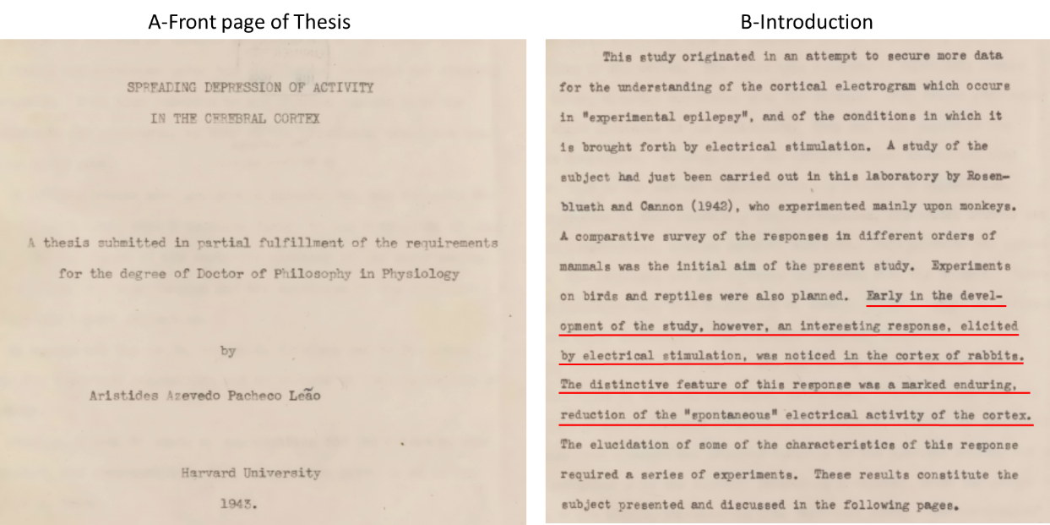
Figure 1: A: The front page of A.A.P Leao Ph.D. thesis submitted to Harvard University in 1943 (Leão, A.A.P. 1943). B: The introduction page of the thesis submitted. (Reprinted with kind permission of “The Brazilian Academy of Sciences Archive”) (Leão, A.A.P. 1943).
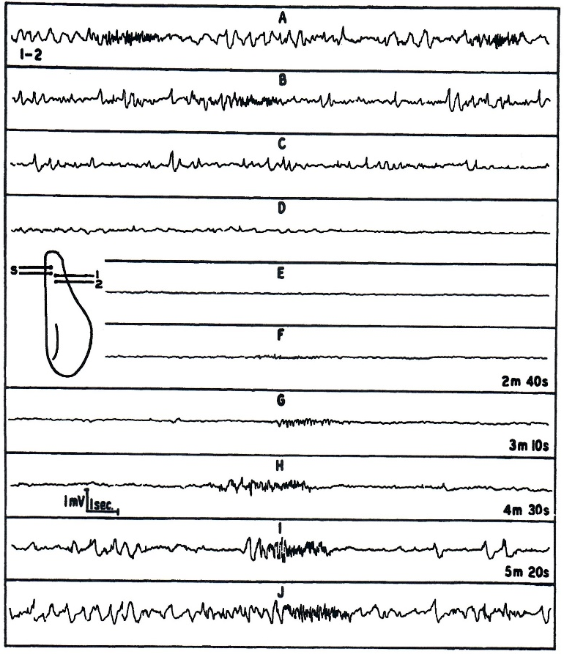
Figure 2: Depression of the spontaneous electrical activity at the region stimulated. Stimulating (S) and recording (1-2) electrodes arranged as shown in the inset. A: Before stimulation. B to E: Continuous record starting less that 1 sec. after the end of stimulaton. F to I: Records, corresponding to the times noted, after stimulation.
J. Complete recovery, 5 min after I (Leão, A.A.P. 1943).
Figure 3: EEG activity recorded in the brain before (A) and during (B) the CSD wave.
C+D: Photomicrograph of the pial vessels in the brain. C: Control before stimulation. The large vessel is an artery, of about 120 μ diameter. D: The wave of depression has reached the region The diameter of the artery is approximately doubled during the wave of CSD (Leão, A.A.P. 1944), E: Graph showing the time course and magnitude of arterial vasodilatation attending a depression. American Physiological Society, reprinted with permission (Leão, A.A.P. 1944).
Figure 4: A: Gradual spread of depression. Electrodes arranged as shown in the inset.
A: Before stimulation L. 7 min after K. In this and the following figures, when a strip is timed, that time indicates the interval from the end of the stimulation period. Upward excursions in the records denote negativity of the more frontal electrode (lower number) with respect to the more occipital electrode (higher number). Unless otherwise mentioned, the stimuli were induction shocks at "tetanizing" frequency, applied for 3 to 5 sec. through electrodes S (Leao, A.A.P. 1944). B: A representative experiment on the slow voltage variation accompanying the spreading depression of activity. The curve was drawn from voltage readings taken with 5 second intervals. In this and the other two figures, an upward deflection denotes negativity of the cortex, with respect to the extra cortical reference electrode. Electrodes arranged as shown in the inset (s: stimulating electrodes). Stimulation, 5 seconds of "tetanizing" current from an induction coil, delivered at the time marked S. In this representative curve is indicated the time of occurrence (from A to B) of the specific electrical activity which often develops during the depression of the "spontaneous” activity. American Physiological Society, reprinted with permission (Leão, A.A.P. 1947).

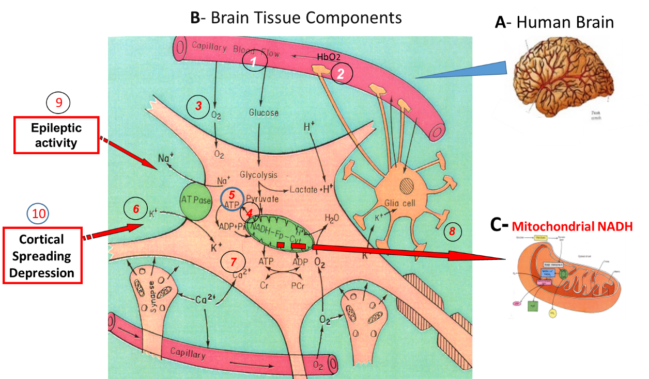

Figure 5: Schematic presentation of the "basic building stones" of a typical cerebral cortex tissue (B) of the human brain (A). In the current paper two pathological states will be discussed namely, Epilepsy (9) and cortical spreading depression (10).

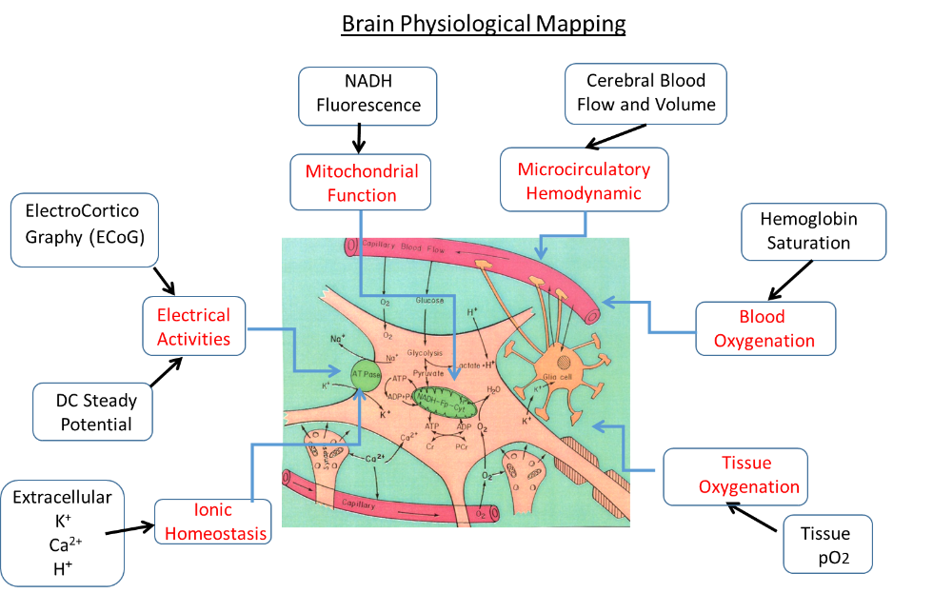
Figure 6: Schematic presentation of the concept "Brain Physiological Mapping". All techniques that are presented were developed and used in our laboratory (see text for details) (Mayevsky, A. 2023).

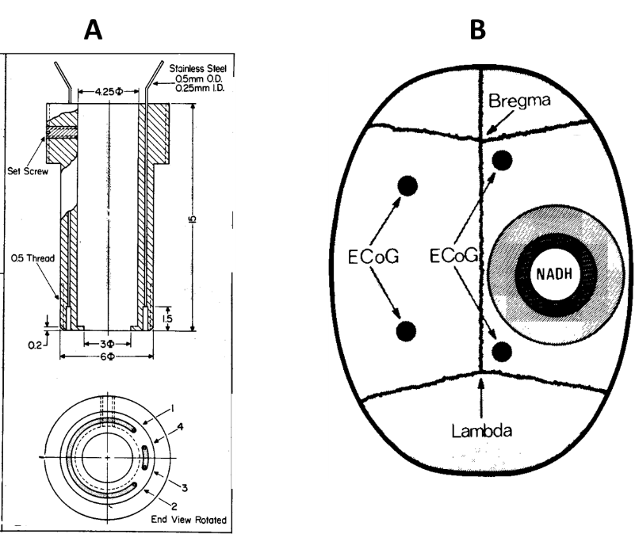
Figure 7: A: Light guide holders (cannulas) for measurement of NADH fluorescence from the surface of the brain of an awake rat (Mayevsky, A. and Chance, B. 1975).
B: Schematic representation of location of cannulas and ECoG electrodes on rat's skull (Mayevsky, A. and Shaya, B. 1980).

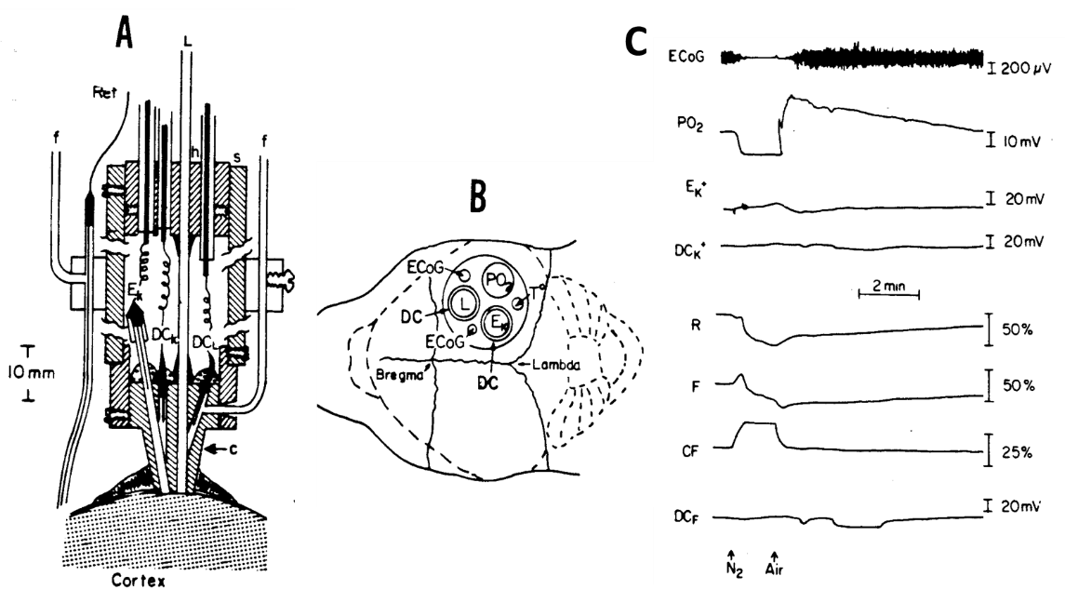
Figure 8: Schematic presentation of multiprobe assembly (MPA) used in hyperbaric chamber. A: longitudinal section of MPA; B: the relative location of various probes above the brain. Ref, reference Ag-AgCI electrode; f, refill tube for Ref or DC electrode;
c, Lucite cannula; s, Plexiglas sleeve; L, light guide; h, cable holder; Ek, K⁺ electrode; DC_{K}, DC_{L}, Ag- AgCI electrode; PO₂. Oxygen electrode; ECoG, electrocorticography electrodes. C - Effects of anoxia (N₂) on metabolic ionic and electrical EK⁺; DCK⁺, DC potential measured near K⁺ electrode or light guide; R, activities in the rat brain. ECoG, electrocorticogram; PO₂ partial pressure of oxygen, R, 366-nm reflectance; F, 450-nm fluorescence; CF, 450-nm corrected fluorescence, of O2; Ek-, potential measured due to net changes in extracellular K⁺ , fluorescence; N₂, Nitrogen breathing (Mayevsky, A. 1983).
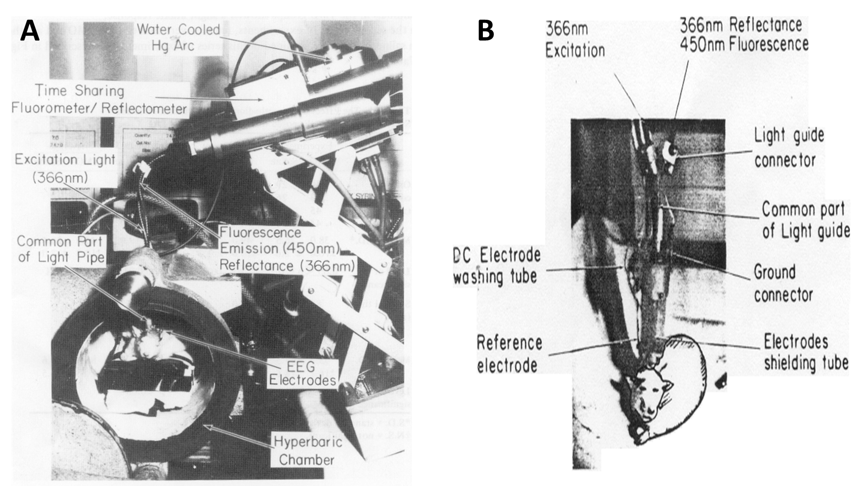
Figure 9: A: Time-sharing fluorometer - reflectometer, attached to the hyperbaric oxygen chamber enables the measurement of NADH from the cortex of the awake rat exposed to HBO (Mayevsky, A. 1975). B: Rat connected to the multiprobe assembly inside hyperbaric chamber (Mayevsky, A. 1983).

Figure 10: Interconnection between multiprobe assembly connected to rat inside the hyperbaric chamber and monitoring system located outside hyperbaric chamber (Mayevsky, A. 1983).
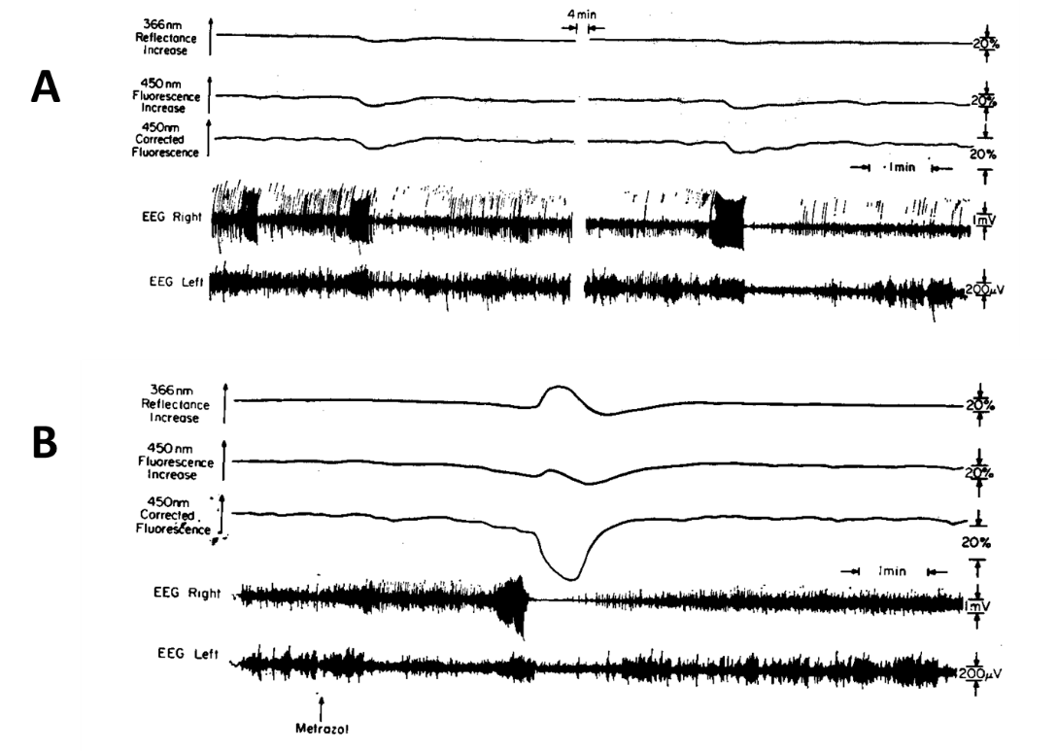
Figure 11: The effects of Metrazol on brain NADH fluorescence, 366 nm reflectance and the EEG of the two hemispheres. Note that the amplitude of the EEG calibration in the right hemisphere is 1 m V and in the left 200 micro-V. The typical response is shown in Part B. Part A shows another types of response to Metrazol applied 10 min before the record was taken (Mayevsky, A. and Chance, B. 1975).
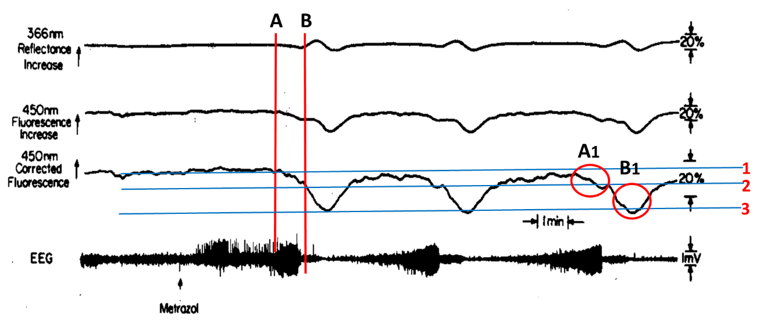
Figure 12: NADH oscillations due to spatiotemporal metabolic heterogeneity represented by periodic electrical and metabolic activity introduced by an intra-venous Metrazol injection in an anesthetized rat (Chance, B. et al. 1978).
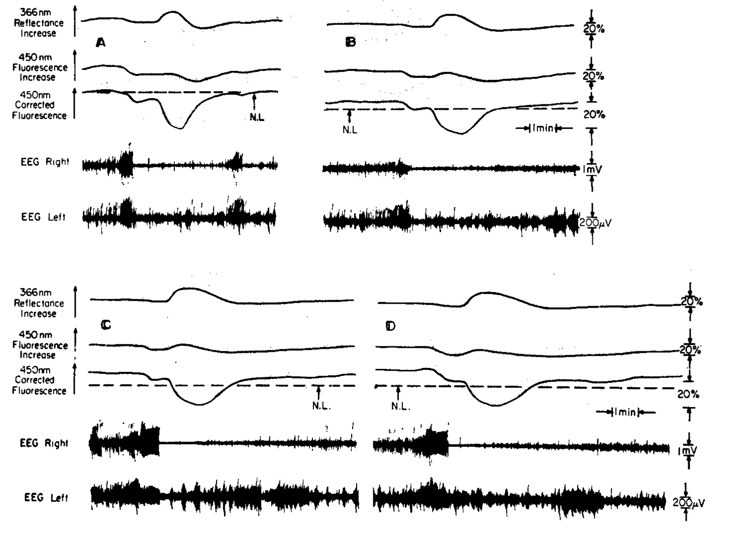
Figure 13: The effects of graded hypoxia on the response of the awake brain to local application to Metrazol. The fluorescence responses occur 3-5 min after the application of Metrazol. The broken (N.L.) represents the normal oxidation-reduction state of the NADH. The levels of O₂ were in A, air; B, 10%; C, 7.5%; and D, 5% (Mayevsky, A. and Chance, B. 1975).
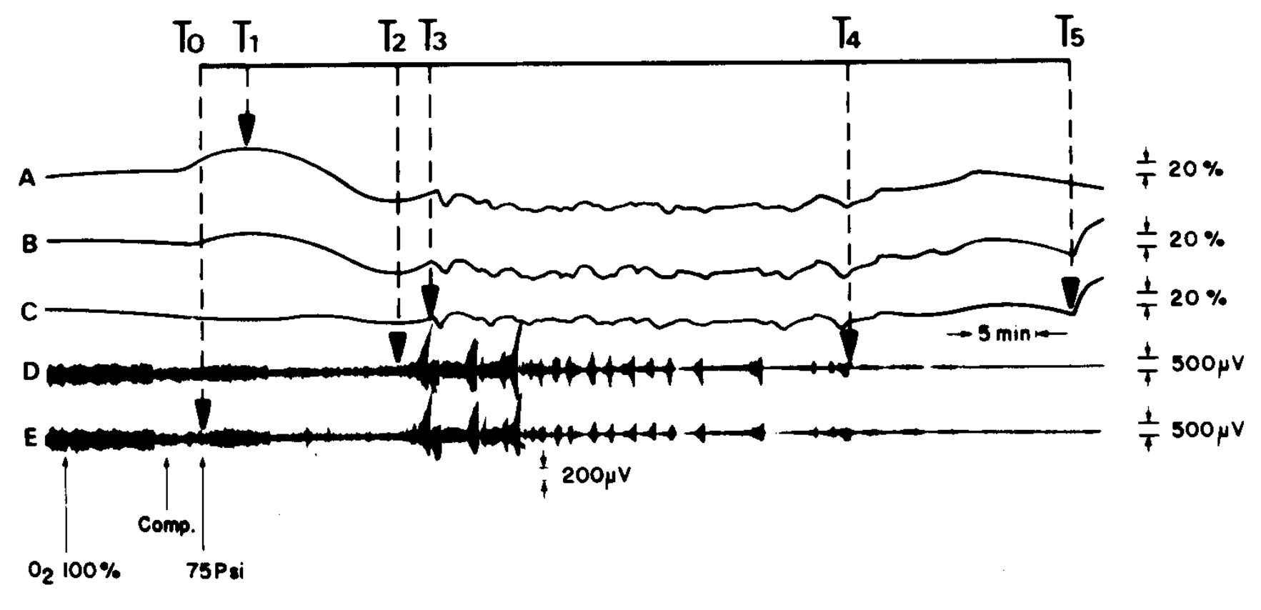
Figure 14: Typical responses of awake rat brain to 6 ATA O₂ (see text for details) (Mayevsky, A. and Shaya, B. 1980).

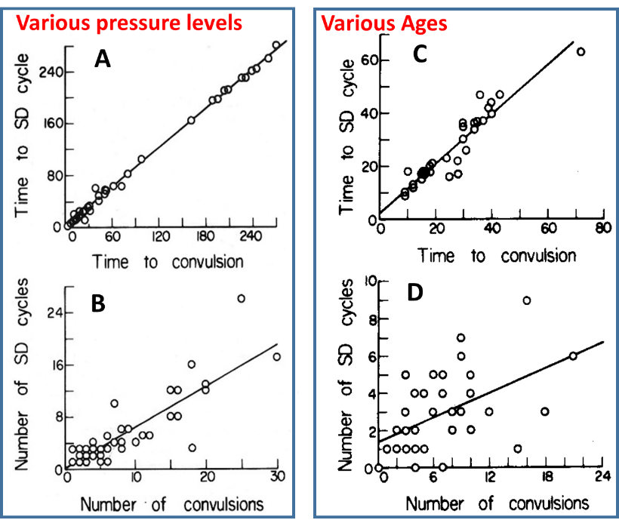
Figure 15: A, B: Interrelation between a few parameters measured from brains of rats exposed to various levels of hyperbaric oxygenation at various ages. C, D: Interrelation between a few parameters measured from brains of rats at various ages (Mayevsky, A. and Shaya, B. 1980).
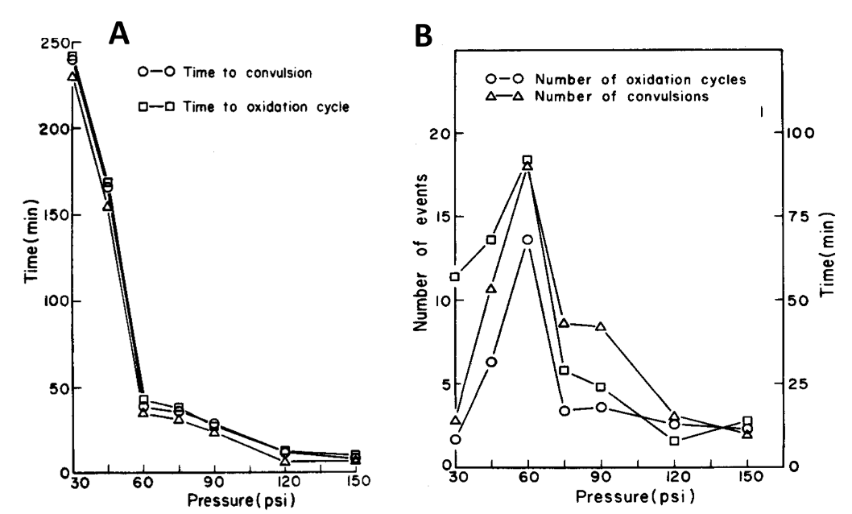
Figure 16: A: Effects of pressure level during hyperbaric oxygenation on hemodynamic, metabolic, and electrical activity of the brain. B: Effects of pressure level during hyperbaric oxygenation on electrical activity and its concomitant phenomena of the brain (Mayevsky, A. and Shaya, B. 1980).
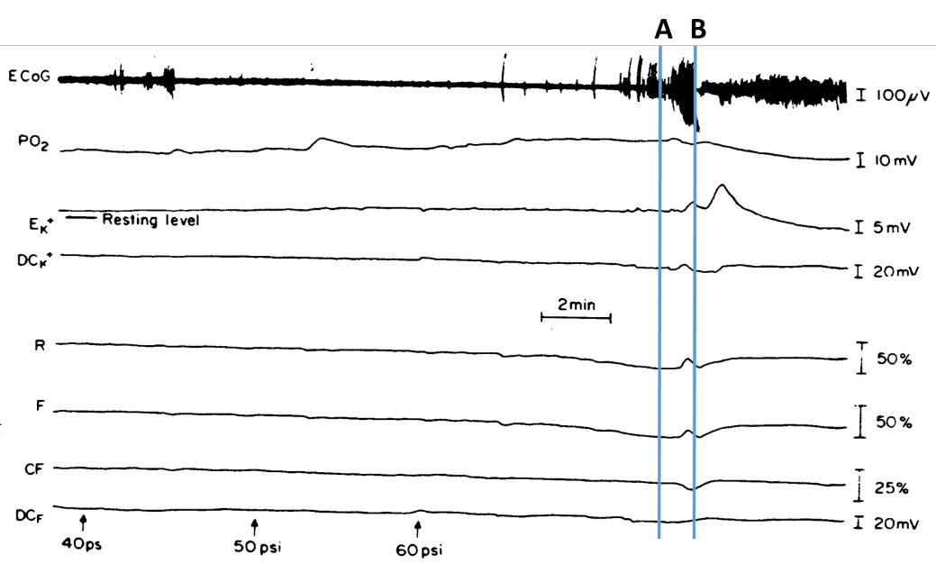
Figure 17: Responses of various parameters measured from awake brain to slow compression with 100% O₂. Line A : initial step of first tonic-clonic episode recorded.
B: the starting point of the developed cortical spreading depression after 10 minutes when the pressure was 60 psi (5 A T A) (Mayevsky, A. 1983).
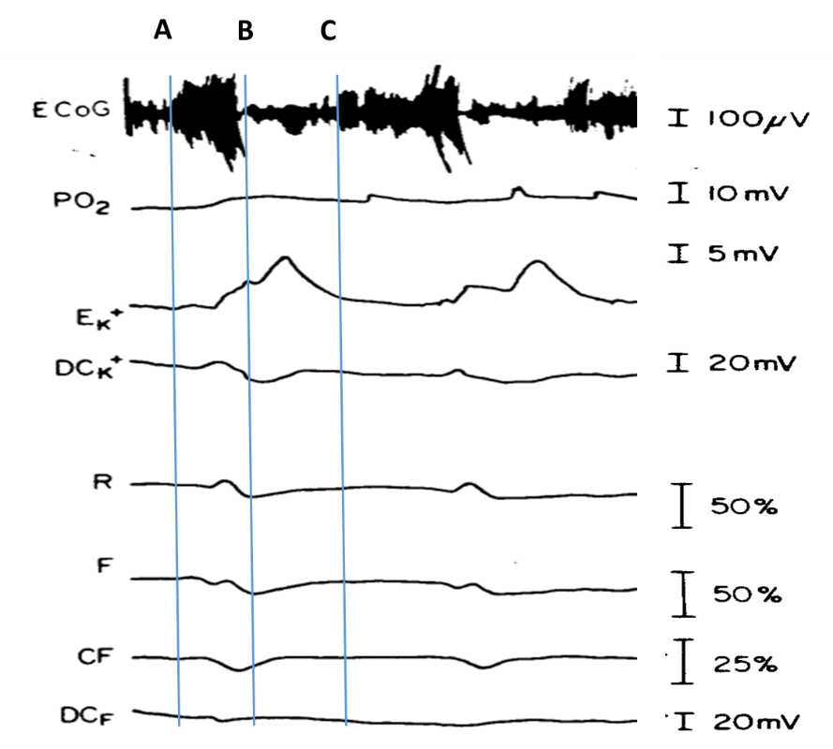
Figure 18: Metabolic ionic and electrical responses to repetitive tonic-clonic episodes appeared under 5 ATA of 100% O_{2.} Ek-, potential measured due to net changes in extracellular K; DC_{K+,} DC_{F}, DC potential measured near K⁺ electrode or light guide;
R, 366-nm reflectance; F, 450-nm fluorescence; CF, 450-nm corrected fluorescence (Mayevsky, A. 1983).
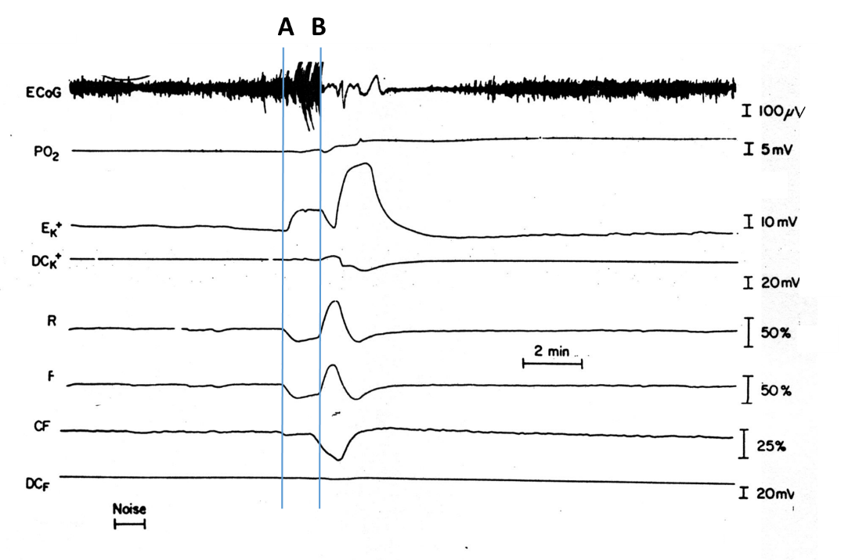
Figure 19: The development of epileptic activity followed by cortical spreading depression (CSD) in the brain of a seizure-prone gerbil. ECoG, electrocorticogram; PO₂, partial pressure of O₂ in the tissue; EK⁺, DCK⁺, extracellular potassium and DC steady potential measured around the K⁺ electrode; R, F, and CF, reflectance, NADH fluorescence, and corrected NADH fluorescence (Mayevsky, A. and Rogatsky, G. 2007).
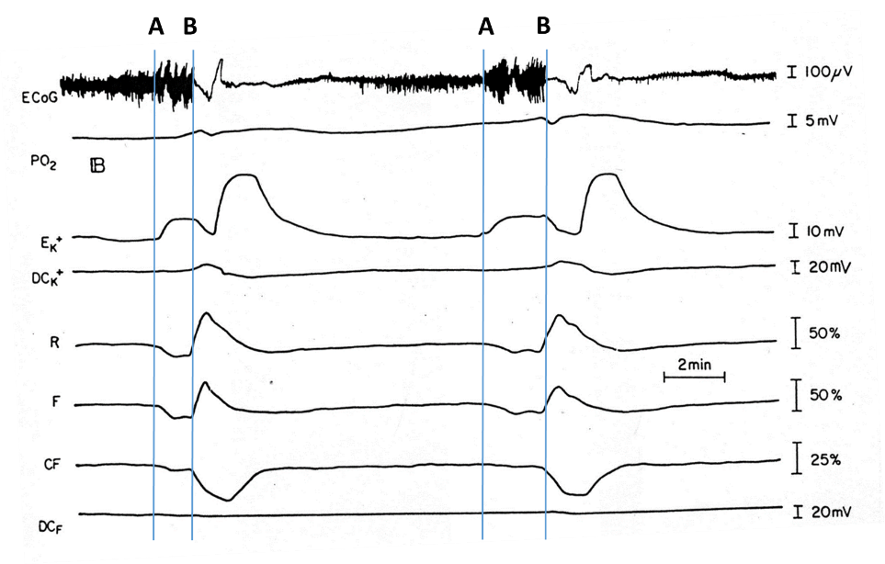
Figure 20: Continuation Record of Figure 19 - The development of epileptic activity followed by cortical spreading depression (CSD) in the brain of a seizure-prone gerbil. ECoG, electrocorticogram; PO₂, partial pressure of O₂ in the tissue; EK⁺, DCK⁺, extracellular potassium and DC steady potential measured around the K⁺ electrode; R, F, and CF, reflectance, NADH fluorescence, and corrected NADH fluorescence (Mayevsky, A. and Rogatsky, G. 2007).

