Parasitic Challenges in Culturable Freshwater Fish: A Comprehensive
Commented [RK1]: Recommended title: A Comprehensive Review of Parasitic Infections in Freshwater Aquaculture.


Review

Review Article

ABSTRACT
Commented [RK2]: The abstract effectively highlights the topic.
This review highlights about Parasitic Challenges in Culturable Freshwater Fish. Fish populations are subject to numerous natural and anthropogenic factors which reduce abundance. In grouper aquaculture, a diverse range of parasitic organisms have been documented to cause substantial issues. Protozoans, particularly ciliates, are the primary source of parasitic illnesses in groupers in the hatchery and nursery phases. Grouper fries are subjected to handling and travel stress when they are transferred to grow-out facilities. Ciliated protozoans, skin, and gill monogeneans and caligid copepods are all common parasites carried by these fish. Protozoans, monogeneans, didymozoid digeneans, nematodes, caligid copepods, isopods and leeches are among the primary parasites of cultivated groupers discussed in this review paper. The study underscores the need for improved management strategies to mitigate the economic losses caused by parasitic infections, highlighting their role in fish mortality, reduced growth rates, and compromised marketability. Furthermore, it contributes to the broader understanding of fish-borne zoonotic diseases, emphasizing their implications for human health and food safety.
Keywords: Major parasitic diseases; culturable freshwater fish; aquaculture; fisheries.

INTRODUCTION
“Knowledge of parasitic infections in fish is not only related to fish health in particular but also to the understanding of ecological problems. Parasites may therefore be considered as a substitute for chemical analysis or conventional biological monitoring (number of bacteria and invertebrates) as an indicator of ecosystem dysfunction” (Nur et al., 2020). “Freshwater ecosystems are among the most diverse and endangered in the world, little attention has been paid to either the importance of parasitic disease as a threatening process for freshwater organisms, or the co-extinction risk of freshwater parasites” (Lymbery et al., 2020). “Parasites can be found in a wide variety of animal species. They are more numerous than free-living creatures and can be found in every animal

phylum, from protists to chordates. Fish can be parasitized by a wide variety of animal species, ranging from minute protozoans to readily apparent crustaceans and annelids. Parasites infect most fish, both wild and cultivated. They are not only hosting for various parasites but also carriers of many larval parasitic forms that grow and cause significant diseases in many vertebrates, including humans. Parasites have amazing adaptive strategies for their hosts. Many parasite species are host-specific to some extent, with the ability to infect only one or a few host species. Individual parasite species may have vastly varied effects on various host species” (Roberts 2012). “Some parasitize the fish's external surface, while others parasitize the internal organs. They can infect fish at all phases of their lives, as well as in a variety of aquatic environments, and they are also thought to be

Commented [RK3]: Parasitic infections in fish are not only significant from a fish health perspective but also reflect broader ecological dynamics.

⁺⁺Project Coordinator, Enterprise Expert;
Commented [RK4]: Parasites can serve as valuable indicators of ecosystem dysfunction, sometimes offering more insight than traditional chemical analyses or biological monitoring tools (Nur et al., 2020).
*Corresponding author: Email: joydeepdaas@gmail.com;


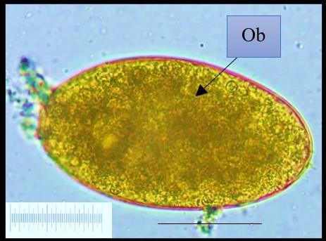
biological indicators of pollution. Parasites disrupt the host's regular reproduction by interfering with the nutrition, metabolism, and secretory function of the alimentary canal. They also harm the neurological system. In the natural world, most
parasite species rarely cause problems, but in aquaculture, parasites frequently cause
significant disease outbreaks” (Roberts 2012). “In finfish aquaculture, parasites produce expenditures for infection management and preventative treatment. The global cost of parasites in finfish aquaculture is estimated to be between $1.05 billion and $9.58 billion per year” (Shinn et al. 2015b). “They are crucial in determining aquaculture's productivity, long-term viability and economic feasibility. In worldwide finfish aquaculture, parasitic infections have major economic, ecological and welfare repercussions” (Menezes et al. 1990, Barber 2007, Shinn et al. 2015a). “They are to blame for direct livestock death, slowed growth rates and feed conversion ratios, treatment expenses, and product rejection during processing. In addition to direct losses, parasites may have a significant impact on fish behaviour, reduced fecundity, resistance to other stressors, susceptibility to other infections, potential legislative burdens, and reduced marketability” (Williams and Jones 1994, Woo 1995, Schäperclaus 1991, Paladini et
al. 2017).

FISHBORNE ZOONOTIC DISEASES
“Many parasites infect fish, but only a handful of them cause illness in humans. Medically important parasitic zoonoses such as trematodiasis, cestodiasis, and nematodiasis are transmitted by a variety of marine and freshwater fish. Some of these illnesses are extremely

Trematodiasis
Trematodiasis is a parasitic infection of humans caused by trematodes. Digenetic trematode infections are the most frequent parasite disorders spread by fish.
Humans may be
infected by many digenean metacercaria from fish. The disease is particularly prevalent in Southeast Asia and the Far East, where freshwater fish provides a key source of nutrition for many people. Clonorchis sinensis, Opisthorchis viverrini, and Opisthorchis felineus are perhaps the most important digeneans (Roberts 2012, Lima dos Santos and Howgate 2011). The infective trematode metacercariae can be transmitted by a variety of freshwater fish species, with Cyprinidae (carps) being the most prevalent (WHO 1995, Touch et al. 2009, Chen et al. 2010). Trematode parasites have also been discovered in farmed fish of several kinds (Chi et al. 2008, Thien et al. 2007, 2009, Thuy et al. 2010).
Commented [RK8]: Humans can become infected with a variety of digenean metacercariae acquired through the consumption of infected fish. These larval trematodes are commonly present in the tissues of freshwater and brackish water fish
Commented [RK5]: While many parasite species do not typically pose serious threats in natural environments, their impact becomes far more pronounced in aquaculture systems, where they are often responsible for widespread disease outbreaks (Roberts, 2012).
Commented [RK6]: Parasitic infections are responsible for direct losses in aquaculture, including fish mortality, educed growth performance, ……..

Fig. 1. Trematode parasites

dangerous. Most of these infections are spread
Commented [RK7]: Some of parasitic infections associated
with fish are considered highly hazardous to human health …...

by eating raw or undercooked fish. Fish can either serve as an intermediate host for parasites with man as the ultimate host or they can harbour larval parasites from other species that can infect human organs. A few parasite species' larval stages, on the other hand, can mature in both animals and humans. The reported incidence of these fish-borne zoonoses has risen in recent years because of improved diagnosis, increased raw fish consumption in countries where such dishes are popular, increased consumption elsewhere of regional fish dishes based on raw or poorly processed fish, the growth of the international market for fish and fish products and the remuneration of fish and fish products” (Keiser and Utzinger 2005, McCarthy and Moore 2000, Nawa et al. 2005, Robinson and Dalton 2009).

Cestodiasis
Infections with cestodes transmitted by fish are uncommon in humans. Cestodes that mature in a human's small intestine are not harmful, and infections are rarely fatal. Freshwater, marine and anadromous fishes all transmit Diphyllobothriasis, the most common cestodiasis. Pseudophyllid cestodes of the species Diphyllobothrium are the source of the disease. From humans, at least 13 species of the cestode genus Diphyllobothrium have been identified. The genus is found in fish, mammals and birds and is mostly found in cold-water environments.
D. latum, which is rather abundant in the Baltic region, the European Alps, eastern Russia and Japan, is the species most frequently reported by people (Dick et al. 2001). It is considered a

benign disease; tapeworm infection might be symptomless in some people, but it can also cause diarrhoea, abdominal pain and anaemia in others (Dick 2007, Scholtz et al. 2009). According to recent estimates, the sickness might afflict nearly 20 million people (Scholtz et al. 2009).

Nematodiasis
The most common cause of fish-borne nematodiasis is an unintentional infection of humans by nematodes whose natural definitive hosts are marine mammals, birds, pigs or other animals. The second intermediate host is freshwater, brackish, or marine fish. After the initial invasion of the gastrointestinal tract, the worms can only live for a short time in most cases. Infectious larvae are found in the muscles, intestine and viscera of fish and are eaten. The worm Capillaria philippinensis causes capillariasis. Initially, the disease was thought to be an indigenous sickness of the Philippines when an epidemic was first documented in 1967. In Thailand, Japan, Taiwan, Indonesia, Korea, Iran, Egypt and India, the disease was
both wild and cultivated fish. All have a straight life cycle, although the period during which they operate as fish parasites varies greatly depending on the species.

Whirling Disease
Whirling disease is a chronic inflammatory condition in salmonid fish caused by the myxozoan parasite Myxobolus cerebralis, characterised by tight circular motions in afflicted fish due to spinal cord constriction and brain stem compression (Rose et al. 2000). The parasite's spores are oval and feature two polar capsules.
Commented [RK9]: The most frequent cause of fish-borne nematodiasis in humans is the accidental ingestion of nematode larvae, where humans serve as incidental hosts instead of the parasites' natural definitive hosts, which are typically marine mammals, birds, pigs, or other animals.

The life cycle of this protozoan is complicated. Infected live fish, as well as dead and decomposing fish, can release spores. Bird droppings can also disseminate the spores. Tubifex tubifex, an annelid worm intermediate host that lives in the bottom muck of ponds, streams, and earthen raceways, consumes spores. The spores mature into actinosporeans, which pierce fish (or the fish ingest the actinosporeans when they eat tubifex worms).
Commented [RK12]: The life cycle of this protozoan is complex, involving multiple developmental stages. Both live infected fish and dead or decomposing fish can serve as sources of infection by releasing spores into the aquatic environment.

discovered. Freshwater fish could be a significant Plasmodia grow in the cartilage of the fish and
Commented [RK10]: The nematode Capillaria philippinensis is the causative agent of human capillariasis. The disease was initially believed to be endemic to the Philippines following the first recorded outbreak in 1967. However, subsequent cases have been reported in several other countries, including Thailand, Japan, Taiwan, Indonesia, Korea, Iran, Egypt, and India.

source of nematode infection in humans (Cross et al. 1972). Adult worms live in humans' guts, where they can cause serious and even fatal sicknesses (Cross 1990).

FISH LEECH
“The only important fish pathogens in the phylum are leeches, which are clitellate annelids. Freshwater and marine aquatic leeches can be found in a variety of settings around the world. Leeches are blood-feeding segmented worms. They may loop over the body of the fish to eat because they have suckers on each end of their bodies. Leeches can harm fish in a variety of ways, although most of them involve blood- feeding activities. Piscicola geometra can reach epidemic levels in rainbow trout and cyprinids raised in earthen ponds in freshwater. Hemibdella sp. has been identified as a concern on cultured Dover sole and turbot in the maritime environment. However, some species can become major fish ectoparasites on rare occasions. Leeches, like Cryptobia, serve as vectors or intermediate hosts for protozoan parasites” (Chandra 2004).

METAZOAN DISEASES
Myxozoans, helminths, crustaceans, annelids and molluscs are frequent parasites found in
produce the distinctive spores.

Proliferative Kidney Disease
The malacosporean parasite Tetracapsuloides bryosalmonae causes proliferative kidney disease (PKD), which is a common disease that causes large losses in farmed salmonids in Western Europe and North America (Hedrick et al. 1984, Morris and Adams 2006). PKD is also thought to be the cause of some population decreases in wild salmonids (Burkhardt-Holm et al. 2005, Sterud et al. 2007). “Infected fish are infected by parasite spores secreted by bryozoans, the parasite's invertebrate hosts” (Feist et al. 2001). “The parasite enters the fish through the skin and gills, then moves on to the inner organs, with the kidney being the primary target organ for future development” (Longshaw et al. 2002, Ferguson 1981, Clifton-Hadley et al. 1986, Kallert et al. 2011). “The temperature of the environment affects infection and PKD clinical symptoms. Although water temperatures above 12°C can cause clinical PKD (Morris et al. 2005), clinical PKD outbreaks typically occur at temperatures above 15°C” (Tops et al. 2006).
Commented [RK11]: feed

Diseases Caused by Crustaceans
A large variety of crustaceans have evolved to rely on specific species for their survival.

Diseases can be spread by those who are intimately associated with fish. Crustaceans that feed on fish's gills and skin are among the most dangerous gill and skin parasites on the planet. Both marine and freshwater fish have these attached to their external surfaces.

Argulosis
Argulids, also known as "fish lice," are obligate
ectoparasites that cause issues in fisheries and
distribution. Several species (L. chackoensis and L. bengalensis) have been reported from the Indian subcontinent” (Chandra 2004).

Disease Caused by Monogenetic Trematode
“Monogenetic trematodes are parasitic flatworms or flukes that reside on the surface of the fish they infect. The penetration of the attachment organ and the browsing motion of the mouth at

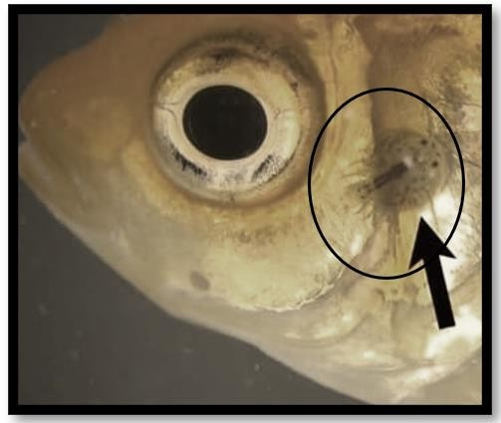
aquaculture around the world (Fryer 1968, the free end cause harm to the host. They have
Commented [RK13]: Argulids, commonly referred to as "fish lice," are obligate ectoparasites that pose significant challenges to fisheries and aquaculture operations worldwide.

Kabata 1970, Ahmed and Sanaullah 1976, Post 1987, Rushton-Mellor 1992). Argulus is a big parasite that may be seen with the naked eye, measuring 5–10 mm. Argulids have a carapace that is oval and flattened. Compound eyes, a pair of huge suckers, four pairs of branched thoracic swimming limbs and a tiny, unsegmented abdomen are all remarkable anatomical traits. While most fish lice are capable swimmers, certain species prefer to move through the water in a loose corkscrew or somersaulting motion. Argulus has a four-stage life cycle (egg, nauplius, meta-nauplius, adult) and need the presence of a fish host at least once. Depending on the temperature of the water, the parasites can complete their life cycle in 30–100 days.

Fig. 2. Argulus parasite in fish

4.3.2 Lernaeasis
“Lernaenid copepodes, sometimes known as "anchor worms," are important ectoparasite parasites in freshwater cyprinid aquaculture, as well as salmonids and other fish. In cultured fish, epizootics are frequently linked with significant mortality. Commercial aquariums are also affected by parasites. Infection with this parasite
been identified as a major fish disease in aquaculture” (Ogawa 2002, Ernst et al. 2002, Grau et al. 2003).

Gyrodactylosis
The genus Gyrodactylus is responsible for the sickness. Skin flukes are parasitic worms that live on the surface of fish's bodies, including fins and gills. They can be found in both marine and freshwater fish. Gyrodactylus salaris is the most commercially significant ectoparasitic flatworm of fish, having caused large mortalities of wild Atlantic salmon when introduced into Norwegian rivers. The Office International des Epizooties (OIE) (World Organization for Animal Health) lists it as the sole notifiable flatworm illness (Bakke et al. 2007). Most gyrodactylid species are host-specific, and some are particularly exclusive to a single place on the host (Cone 1995).

Dactylogyrosis
“Dactylogyrosis is caused by Dactylogyrus species, which are also known as "Gill fluke" in general. Some Dactylogyrus species have proven to be quite harmful in cyprinid culture, particularly in fry, where a few numbers of parasites can cause significant gill injury. Infestation intensifies quickly, reaching several hundred per fish. Dactylogyrid flukes are prevalent in Bangladeshi freshwater fish. Dactylogyrus mrigali, Dactylogyrus chauhanus, Dactylogyrus yogendrai, Dactylogyrus labei, Dactylogyrus kalyanensis, Dactylogyrus yogendrai, Dactylogyrus labei, Dactylogyrus kalyanensis, Dactylogyrus yogendrai, Dactylogyrus labei, Dactylogyrus kalyanensis” (Chandra and Jannat 2002, Chandra and Yasmin 2003).

Diseases Caused by Digenetic
Commented [RK14]: associated with reductions in host weight,

has been linked to decreased weight, growth, Trematode
and fertility in the host” (Kabata 1982, 1985,
Khan et al. 2003). “The common L. cyprinacea
is one of the most invasive species, with a global

Digeneans are endoparasitic flatworms that primarily infect the alimentary canal and adjacent organs. They are also known as "flukes" or "digenetic trematodes." Miracidium, sporocyst, redia, cercaria, metacercaria, transitory migrating larva and adults are the main developmental stages of digeneans (Paladini et al. 2017). They have a long indirect life cycle that includes at least one intermediary host. The larval metacercaria stage is the most common in fish and it can be found in tissue within the cyst or
unencysted, depending on the species. Miracidiums are ovoid and have cilia covering their bodies, which allow them to swim and look for their first intermediate host, which is usually a snail. A piscivorous bird is frequently the final host. When cercarial larvae initially infiltrates through the fish's skin, they can cause damage. Some metacercaria are severely harmful to their target organ, whereas others do little or no harm, even if their appearance is unsightly.

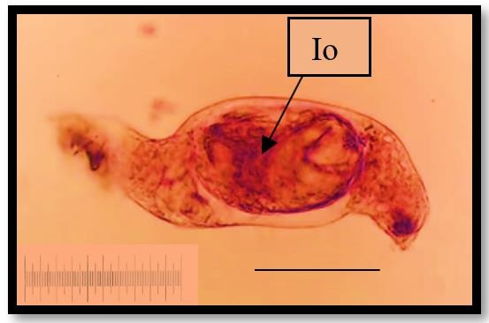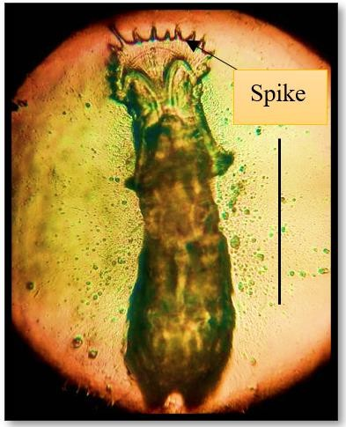
Fig. 3. Presence of Gyrodactylus in fish
Fig. 4. Dactylogyrus species


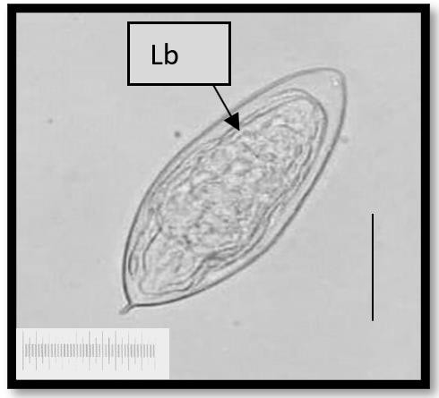
Fig. 5. Miracidium larva

    - Diplostomiasis

Diplostomum spathaceum, also known as the "eye fluke," is the cause of Diplostomiasis. In Europe and North America, the parasite infects the lenses of numerous freshwater fish species. Eye fluke infection can induce cataracts and blindness in a variety of fish species (Dwyer and Smith 1989, Karvonen et al. 2003, Whyte et al. 1991), with Cyprinids and rainbow trout being particularly vulnerable. Lymnaea spp. are the initial intermediate hosts, and gulls are the final hosts (Larus spp.). The metacercariae in the lens develops cataracts and eventually blindness, preventing the fish from feeding and causing it to lose condition. It also becomes more vulnerable to predation by piscivorous birds, which are known to carry adult parasites. The amount of metacercariae necessary to blind a fish varies depending on its size. Although the fish is not killed by being blinded, its development rate may be considerably slowed because of its inability to feed regularly, and it may become malnourished.

DISEASES CAUSED BY PROTOZOANS
Protozoans are microscopic one-celled organisms with specialised locomotion, food collection, and attaching mechanisms. Parasites can be external or inside. They can multiply on or within their hosts. Dinoflagellates, ciliates, myxosporeans and microsporidians are the most common protozoan parasites of grouper. Protozoans make up the most common fish parasites. They are single-celled organisms that live in the aquatic environment, many of which are free-living. Because of their capacity to multiply on or within their hosts, they are often

quite harmful to fish (Chandra 2004). They have a direct life cycle and primarily reproduce through binary fission; however, some species develop cysts that live outside of the host. These parasites are usually seen in great numbers on the fish's surface, within the gills or both. The overall impact of these parasites is to irritate the epithelial surface, causing mucus production to increase. Ciliates, flagellates and amoebae are the three main protozoan types that parasitize fish exterior tissues.

Ciliates
Commented [RK15]: They possess a direct life cycle and primarily reproduce through binary fission, although certain species are capable of forming cysts that can survive outside the host, facilitating transmission.
Ciliophora protozoa have either cilia (short, fine cytoplasmic outgrowths) or a structure developed from cilia through secondary alterations or both. External parasitic ciliates are among the most frequent external parasites that kill a variety of wild and farmed fish. Ciliates can be motile, connected to the epithelium or found within it. While most ciliates are innocuous ectocommensals, in the presence of poor environmental circumstances or stress, certain ciliates can rapidly multiply, causing sickness and mortality.

Ichthyophthiriasis
“Ichthyophthirius multifiliis has a spherical shape with evenly scattered cilia across the entire surface. The parasite's horseshoe-shaped nucleus and rotating movement are distinguishing features. It is an obligate pathogen with a one-of-a-kind direct life cycle that allows infection to spread quickly” (Ewing and Kocan 1992). “An infective front, a parasitic trophont and a reproductive tomont make up the life cycle” (Nigrelli et al. 1976). “Infectious theronts actively swim in water looking for hosts. Theronts

become trophonts after burrowing into the fish epithelium and feed on host tissue until they reach maturity” (McCartney et al. 1985). “Ichthyophthirius multifiliis, often known as 'Ich,' is the organism that causes Ichthyophthiriasis, also known as white spot sickness. It is the most frequent disease of freshwater fish protozoan parasites globally” (Jessop 1995, Dickerson and Dawe 1995, Buchmann et al. 2001, Matthews 2005, Dickerson 2012).


Trichodiniasis

Trichodiniasis is a protozoan illness that affects fish all over the world. A huge assemblage of peritrichous ciliates of trichodinids causes sickness. Trichodina, Trichodinella and Tripartiella are ectoparasites of freshwater and marine fish that are found all over the world (Lom and Dyková 1992).

Trichodinids have a basic saucer-shaped with a fringe of cilia around the perimeter that are utilised for mobility and eating. They can grow to
100 metres in diameter. The chitinoid or denticular ring, a stiff ring of linked discs, supports their bodies. With a spinning motion, the parasite combs across the surface of the gills and skin, destroying the host tissues and
specific areas. The hyperplastic epithelium covers the thin respiratory epithelium, dramatically reducing the gills' respiratory surface.

Flagellates
Small parasitic flagellated protozoans can infect fish both externally and inside. They have one or more flagella, which causes the parasite to move at a jerky or whip-like pace. Flagella are longer and stronger than cilia and they are usually in short supply.

Ichthyobodosis
The disease is caused by parasitic flagellates of the genus Ichthyobodo infecting the skin and gills of fish (Isaksen 2013). It is a serious disease that has wreaked havoc on farmed and ornamental fish all around the world for more than a century (Robertson 1985, Isaksen 2013). Ichthyobodo is one of the most dangerous parasites found in farmed salmon, and it is most likely the leading cause of mortality in salmonid fry and fingerlings (Robertson 1985). Ichthyobodo spp. are obligatory ectoparasites having a direct life cycle on the host (Becker
Commented [RK16]: Using a characteristic spinning motion, the parasite moves across the surface of the gills and skin, causing extensive tissue damage and consuming the resulting cellular debris.

devouring the tissue debris. Excess mucus 1977), which means they cannot survive or

production causes infected fish to have a grey sheen and their fins may shred. The epithelium will eventually be eroded (Roberts 2012).

5.1.3 Chilodonellosis

Chilodonella is a highly pathogenic ciliate that lives on the skin and gills of a variety of temperate and tropical freshwater fish. The parasite has a flattened, ovoid shape, can grow to be up to 80 metres long and is covered in rows of cilia that allow it to glide across the epithelial cells of its fish host. Chilodonella infections are frequently linked to poor water quality. The most typically affected species include carp, salmonids and catfish. Chilodonella hexasticha is a significant disease in overwintered carp and is most likely to be a problem at lower water temperatures (Bauer et al. 1973). When a parasite grows in numbers, it produces a lot more mucus and causes problems with the skin's respiratory system. The fish becomes agitated and rises to the surface of the water. The bluish- white coating covers its entire body; however, it is most evident in the head region. The smear of the parasites on the skin surface indicates many of them. Bacteria, fungi and other pathogens may then infect the skin because of the damage. It induces hyperplasia of the gill epithelium in
reproduce without one. There are two types: a parasitic feeding form that adheres to the epithelial cells of the fish, and a non-feeding, swimming form that lives outside of the animal (Lom and Dyková 1992). The free-swimming version has two pairs of flagella and is kidney- shaped. The pear-shaped connected form attaches to the gill and skin (Southgate 1993). The parasites vanish from a deceased host and die in the free-swimming form outside of a host within 30–60 minutes.

Hexamitasis
Commented [RK17]: Following the death of the host, the parasites quickly detach and enter a free-swimming stage, but they typically survive for only 30 to 60 minutes outside a host

Excessive numbers of flagellated protozoa of the genus Hexamita in the alimentary canal of farmed and wild freshwater fishes cause hexamitiasis (Southgate 1993). Hexamitia sp. is a pear-shaped, pyriform creature with three anterior and one posterior pair of flagella, measuring 10 m in length. In North American trout hatcheries, Hexamita truttae is common, causing widespread fish loss. Clinically, the young fish are anorexic, emaciated, and have stunted growth, as well as trailing faecal casts, increased anxiety, and swollen abdomen. Acute enteritis develops in the fish, resulting in yellowish watery stomach contents with numerous organisms present in the faeces or

gall bladder bile. Ingestion of an infective cyst is the means of transmission. The disease can develop systemic in farmed Chinook and Atlantic salmon, causing anaemia, enlarged kidneys and exophthalmus. Although Hexamita salmonis is seen in large numbers in the pyloric gut of farmed salmonids in freshwater, the extent of the damage it causes is debatable (Uldal and Buchmann 1996).

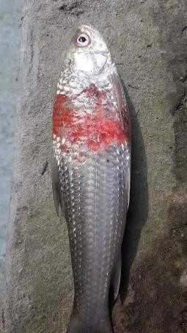
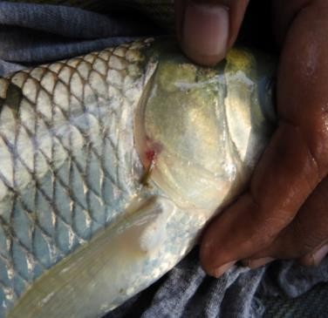
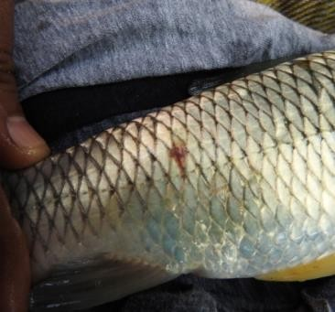
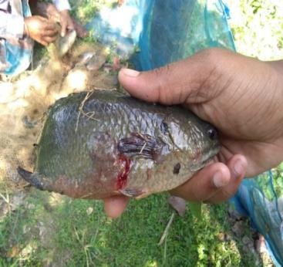
Amoebae
(a) (b)
Commented [RK18]: Describe what each image illustrates in relation to your content.
Some free-living amoebae have the potential to modify their behaviour and become hazardous. Several amoeba species have been linked to salmonid gill illness.

Amoebic gill disease

The free-living, facultative amoeba causes amoebic gill disease (AGD). Paramoeba [=Neoparamoeba] perurans is a severe problem in the aquaculture of sea salmon, causing gill damage and mortality in infected fish (Mitchell and Rodger 2011). It has become a major issue with Tasmania's sea-caged Atlantic salmon and rainbow trout and it has been dubbed the most dangerous infectious disease (Roubal et al. 1989, Munday et al. 1990, Bryant et al. 1995, Findlay et al. 1995).

(c) (d)


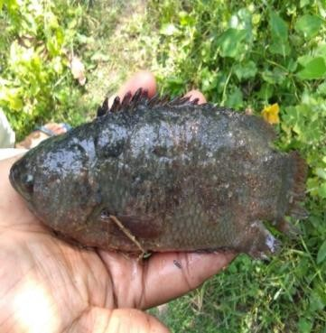
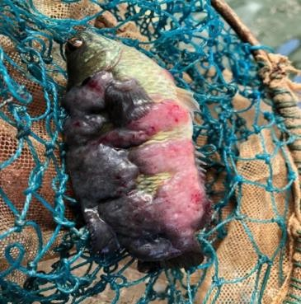
(e) (f)

Fig. 6. Parasitic pathogen affect of Cirrhinus mrigala, Ctenopharygodon idella and Anabas testudineus

- CONCLUSION fossilis and Clarius batrachus. J. Asiat.
Commented [RK19]: Conclusion covers the key points well.
Soc. Bangladesh 2(1): 7–15.

Important management implications for the preservation of freshwater fishes and their natural parasites have also been brought to light by an analysis of the anticipated consequences of climate change on intermittent rivers. The need to preserve, restore, or establish new refuge pools in intermittent systems where streamflow is expected to decrease is highlighted by the extinction risks to fish and parasite fauna that are linked to increased environmental filtering during lentic conditions and decreased dispersal during the lotic phase. Lastly, the significance of control programs for alien hosts and parasites in a changing climate is highlighted by the anticipated rise in generalist species' dominance of intermittent river habitats.

DISCLAIMER (ARTIFICIAL INTELLIGENCE)

Author(s) hereby declare that NO generative AI technologies such as Large Language Models (ChatGPT, COPILOT, etc) and text-to-image generators have been used during writing or editing of this manuscript.

REFERENCES
Ahmed, A.T.A. and Sanaullah, M. 1976. Organal and percentage distribution of some metazoan parasites in Heteropnensies
Bakke, T.A., Cable, J. and Harris, P.D. 2007. The biology of gyrodactylid monogeneans: “the Russian-doll killers”. Adv. Parasitol. 64: 161–218.
Barber, I. 2007. Parasites, behaviour and welfare in fish. Appl. Anim. Behav. Sci. 104: 251– 264.
Bauer, O.N., Musselius, V.A. and Strelkov, Y.A. 1973. Diseases of Pond Fishes. Israel Programme for Scientific Translations, Jerusalem.
Bryant, M.S., Lester, R.J.G. and Whittington, R.J. 1995. Immunogenicity of amoebic antigens in rainbow trout, Oncorhynchus mykiss (Walbaum). J. Fish Dis. 18: 9–19.
Buchmann, K., Sigh, J., Nielsen, C.V. and Dalgaard, M. 2001. Host responses against the fish parasitizing ciliate Ichthyophthirius multifiliis. Vet. Parasitol. 100: 105–116.
Burkhardt-Holm, Giger, P., Guttinger, W., Ochsenbein, H., Peter, U. and Scheurer,
- 2005. Where have all the fish gone? Environ. Sci. Technol. 39: 441A–447A.
Chandra, K.J. 2004. Fish parasitology. K.R. Choudhury, 34/A/2 Ram Babu Road, Mymensingh-2200, 196 pp.
Chandra, K.J. and Jannat, M.S. 2002. Monogenean gill parasites of manor carps from different fish farms of Mymensingh. Bangladesh J. Fish Res. 6: 43–52.
Commented [RK20]: The references need to be updated with more recent sources
Chandra, K.J. and Yasmin, R. 2003. Some rare and new monogenetic trematodes from airbreathing freshwater fishes of

Bangladesh. Indian J. Anim. Sci. 73: 113– 118.
Chen, D., Chen, J., Huang, J., Chen, X., Feng,
D., Liang, B., Che, Y., Liu, X., Zhu, C., Li,
X. and Shen, H. 2010. Epidemiological investigation of Clonorchis sinensis infection in freshwater fishes in the Pearl River Delta. Parasitol. Res. 107: 835–839.
Chi, T.K., Dalsgaard, A., Turnbull, J.F., Pham,
J.F. and Murrell, K.D. 2008. Prevalence of zoonotic trematodes in fish from Vietnamese fish-farming community. J. Parasitol. 94: 423–428.
Clifton-Hadley, R.S., Richards, R.H. and Bucke,
D. 1986. Proliferative kidney disease (PKD) in rainbow trout, Salmo gairdneri: Further observations on the effects of temperature. Aquaculture 55: 165–171.
Cone, D.K. 1995. Monogenea (Phylum Platyhelminthes). pp. 289–328. In: Woo,
T.T.K. (ed.). Fish Disease and Disorders. Volume 1. London: CABI.
Cross, J.H. 1990. Intestinal capillariasis.
Parasitol. Today 6: 26–8.
Cross, J.H., Banzon, T., Clarke, M.D., Basaca- Sevilla, V., Watten, R.H. and Dizon, J-J. 1972. Studies on the experimental transmission of Capillaria phillipinensis in monkeys. Trans, R. Soc. trap. Med. Hyg. 66: 819–27.
Dick, T.A., Nelson, P.A. and Choudhury, A. 2001. Diphyllobothriasis: update on human cases, foci, patterns and sources of human infections and future considerations. Southeast Asian J. Trop. Med. Public Health 32: 59–76.
Dickerson, H.W. 2012. Ichthyophthirius multifiliis.
pp. 55–72. In: Patrick, K.B. and Woo,
P.T.K. (eds.). Fish Parasites Pathobiology and Protection. CABI, Wallingford.
Dickerson, H.W. and Dawe, D.L. 1995. Ichthyophthirius multifiliis and Cryptocaryon irritans (Phylum Ciliophora).
pp. 181–227. In: Woo, P.T.K. (ed.). Fish
Diseases and Disorders. CAB International, Wallingford.
Dwyer, W.P. and Smith, C.E. 1989. Metacercariae of Diplostomum spathaceum in the eyes of fishes from Yellowstone Lake, Wyoming. J. Wildl. Dis. 25: 126–129.
Ernst, I., Whittington, I., Corneille, S. and Talbot,
- 2002. Monogenean parasites in sea- cage aquaculture. Austasia Aquac. 46–8 (February/March).
Ewing, M.S. and Kocan, K.M. 1992. Invasion and development strategies of Ichthyophthirius
multifiliis, a parasitic ciliate of fish. Parasitol. Today 8: 204–208.
Feist, S.W., Longshaw, M., Canning, E.U. and Okamura, B. 2001. Induction of proliferative kidney disease (PKD) in rainbow trout Oncorhynchus mykiss via the bryozoan Fredericella sultana infected with Tetracapsula bryosalmonae. Dis. Aquat. Organ. 45: 61–68.
Ferguson, H.W. 1981. Effects of temperature on the development of proliferative kidney disease in rainbow trout, Salmo gairdneri Richardson. J. Fish Dis. 4: 175– 177.
Findlay, V.L., Helders, M., Munday, B.L. and Gurney, R. 1995. Demonstration of resistance to reinfection with Paramoeba spp. by Atlantic salmon Salmo salar L. J. Fish Dis. 18: 639–642.
Fryer, G. 1968. The parasitic Crustacea of African freshwater fishes; their biology and distribution. J. Zool. 156: 45–95.
Grau, S.C., Pastor, E., Gonzalez, P. and Carbonell, E. 2003. High infection by Zeuxapta Seriolae (Monogenea: Heterarxinidae) associated with mass mortalities of amberjack Seriola dumerili Pisso reared in Sea cages in the Balearic Islands (western Mediterranean). Bull. Eur. Assoc. Fish. Pathol. 23: 139– 142.
Hedrick, R., Kent, M., Rosemark, R. and Manzer,
- 1984. Occurrence of proliferative kidney disease (PKD) among Pacific salmon and steelhead trout. Bull. Eur. Assoc. Fish. Pathol. 4: 34–37.
Isaksen, T.E. 2013. Ichthyobodo infections on farmed and wild fish. PhD thesis, University of Bargen, Norway.
Jessop, B.M. 1995. Ichthyophthirius multifiliis in elvers and small American eels from the East River, Nova Scotia. J. Aquat. Anim. Health 7: 54–57.
Kabata, Z. 1970. Diseases of Fish, Book 1: Crustacea as Enemies of Fishes. Snieszko, S.F. and Axelrod, H.R. (eds.).
T.F.H. Publications, U.S.A.
Kabata, Z. 1982. Copepoda (Crustacea) parasitic on fishes: problems and perspectives. Adv. Parasitol. 19: 1–7.
Kallert, D.M., Bauer, W., Haas, W. and El- Matbouli, M. 2011. No shot in the dark: Myxozoans chemically detect fresh fish. Int. J. Parasitol. 41: 271–276.
Karvonen, A., Paukku, S., Valtonen, E.T. and Hudson, P.J. 2003. Transmission,

infectivity and survival of Diplostomum spathaceum cercariae. Parasitology 127: 217–224.
Keiser, J. and Utzinger, J. 2005. Emerging foodborne trematodiasis. Emerg. Infec. Dis. 11(10): 1507–1514.
Khan, M.N., Aziz, F., Afzal, M.M., Rab, A., Sahar, L., Ali, R. and Naqvi, S.M. 2003. Parasitic infestation in different freshwater fishes of mini dams of Potohar region. Pak. J. Biol. Sci. 6: 1092–1095.
Lima dos Santos, C.A.M. and Howgate, P. 2011. Fishborne zoonotic parasites and aquaculture: A review. Aquaculture 318: 253–261.
Lom, J. and Dyková, I. 1992. Protozoan parasites of fishes. Dev. Aquacult. Fish. Sci. 26, Elsevier, 315 pp.
Longshaw, M., Le Deuff, R.-M., Harris, A.F. and Feist, S.W. 2002. Development of proliferative kidney disease in rainbow trout, Oncorhynchus mykiss (Walbaum), following short-term exposure to Tetracapsula bryosalmonae infected bryozoans. J. Fish Dis. 25: 443–449.
Lymbery, A. J., Lymbery, S. J., & Beatty, S. J. (2020). Fish out of water: Aquatic parasites in a drying world. International Journal for Parasitology: Parasites and Wildlife, 12, 300-307.
Matthews, R.A. 2005. Ichthyophthirius multifiliis Fouquet and ichthyophthiriosis in freshwater teleosts. Adv. Parasitol. 59: 159–241.
McCarthy, J., and Moore, T.A. 2000. Emerging helminth zoonoses. Int. J. Parasitol. 30: 1351–1360.
McCartney, J.B., Fortner, G.W. and Hansen,
M.F. 1985. Scanning electron microscopic studies of the life cycle of Ichthyophthirius multifiliis. J. Parasitol. 71: 218–226.
Menezes, J., Ramos, M.A., Pereira, T.G. and Moreira da Silva, A. 1990. Rainbow trout culture failure in a small lake as a result of massive parasitosis related to careless introductions. Aquaculture 89: 123–
126.
Mitchell, S.O. and Rodger, H.D. 2011. A review of infectious gill disease in marine salmonid fish. J. Fish Dis. 34(6): 41–32.
Morris, D.J. and Adams, A. 2006. Transmission of Tetracapsuloides bryosalmonae (Myxozoa: Malacosporea), the causative organism of salmonid proliferative kidney disease, to the freshwater bryozoan Fredericella sultana. Parasitology 133: 701–709
Morris, D.J., Ferguson, H.W. and Adams, A. 2005. Severe, chronic proliferative kidney disease (PKD) induced in rainbow trout Oncorhynchus mykiss held at a constant 18°C. Dis. Aquat. Organ. 66: 221–226.
Munday, B.L., Foster, C.K., Roubal, F. and Lester, R.J.G. 1990. Paramoebic gill infection and associated pathology of Atlantic salmon, Salmo salar, and rainbow trout, Salmo gairdneri, in Tasmania. pp. 215–222. In: Perkins, F.O. and Cheng,
T.C. (eds.). Pathology in Marine Science. Academic Press, San Diego, California.
Nawa, L., Hatz, Y. and Blum, J. 2005. Sushi delights and parasites: the risk of fishborne and foodborne parasitic zoonoses in Asia. Clin. Infect. Dis. 41: 1297–1303.
Nigrelli, R.F., Pokorny, K.S. and Ruggieri, G.D. 1976. Notes on Ichthyophthirius multifiliis, a ciliate parasitic on freshwater fishes, with some remarks on possible physiological races and species. Trans. Am. Micro. Soc. 95: 607–613.
Nur, I., Idris, M., & Sari, A. I. (2020). Study on the impact of environmental pollution: parasitic infestation and conditions factor of fish living in amalgamation ponds. In IOP Conference Series: Earth and Environmental Science (Vol. 465, No. 1, p. 012042). IOP Publishing.
Ogawa, K. 2002. Impacts of diclidophorid monogenean infections on fisheries in Japan. Intl. J. Parasitol. 32(3): 373–380.
Paladini, G., Longshaw, M., Gustinelli, A. and Shinn, A.P. 2017. Parasitic diseases in aquaculture: Their biology, diagnosis and control. pp. 37–107. In: Austin, B.A. and Newaj-Fyzul, A. (eds.). Diagnosis and Control of Diseases of Fish and Shellfish. First Edition. John Wiley & Sons Ltd.
Paladini, G., Longshaw, M., Gustinelli, A. and Shinn, A.P. 2017. Parasitic diseases in aquaculture: Their biology, diagnosis and control. pp. 37–107. In: Austin, B.A. and Newaj-Fyzul, A. (eds.). Diagnosis and Control of Diseases of Fish and Shellfish. First Edition. John Wiley & Sons Ltd.
Post, G. 1987. Textbook of Fish Health. T.F.H. Publications, Canada.
Roberts, R.J. 2012. The parasitology of teleosts. In: Fish Pathology, Fourth Edition. Blackwell Publishing Ltd.
Robertson, D.A. 1985. A review of Ichthyobodo necator (Henneguy, 1883) an important and damaging fish parasite. pp. 1–30. In: Muir, J.F. and Roberts, R.J. (eds.). Recent Advances in Aquaculture. Croom Helm, London.

Robinson, M.W. and Dalton, J. 2009. Zoonotic helminth infections with particular emphasis on fasciolosis and other trematodiases. Philos. Trans. R. Soc. Lond. B. Biol. Sci. 364: 2763–2776.
Rose, J.D., G.S. Marrs, C. Lewis and G. Schisler. 2000. Whirling disease behavior and its relation to pathology of brain stem and spinal cord in rainbow trout. J. Aquat. Anim. Health 12: 107–118.
Roubal, F.R., Lester, R.J.G. and Foster, C.K. 1989. Studies on cultured and gill attached Paramoeba spp. (Gymnamoebae: Paramoebidae) and the cytopathology of paramoebic gill disease in Atlantic salmon, Salmo salar L. from Tasmania. J. Fish Dis. 12: 481–493.
Schäperclaus, W. 1991. Fish Diseases. Vol. 2.
Oxonian Press Pvt. Ltd. New Delhi.
Scholtz, T., Garcia, H.H., Kuchta, R. and Wicht,
- 2009. Update on the human broad tapeworm (Genus Diphyllobothrium), including clinical relevance. Clin. Microbiol. Rev. 22: 146–160.
Shinn, A.P., Pratoomyot, J., Bron, J. and Brooker, A. 2015b. Economic impacts of aquatic parasites on global Finfish production. Global Aquaculture Advocate, Sept/Oct, 28 pp.
Shinn, A.P., Pratoomyot, J., Bron, J.E., Paladini, G., Brooker, E.E. and Brooker, A.J. 2015a. Economic costs of protistan and metazoan parasites to global mariculture. Parasitology 142: 196–270.
Southgate, P. 1993. Diseases in aquaculture. pp. 91–130. In: Brown, L. (ed.). Aquaculture for Veterinarians. Pergamon Press, Oxford.
Sterud, E., Forseth, T., Ugedal, O., Poppe, T.T., Jørgensen, A. and Bruheim, T. 2007. Severe mortality in wild Atlantic salmon Salmo salar due to proliferative kidney disease (PKD) caused by Tetracapsuloides bryosalmonae
(Myxozoa). Dis. Aquat. Org. 77: 191–
198.
Thien, P.C., Dalsgaard, A., Thanh, B.N., Olsen,
- and Murrell, K.D. 2007. Prevalence of fishborne zoonotic parasites in important cultured fish species in the Mekong Delta, Vietnam. Parasite Res. 101: 1277–
1284.
Thuy, D.T., Kania, P. and Buchmann, K. 2010. Infection status of zoonotic trematode metacercariae in Sutchi catfish (Pangasianodon hypophthalmus) in Vietnam: associations with season, management and host age. Aquaculture 302: 19–25.
Tops, S., Lockwood, W. and Okamura, B. 2006. Temperature-driven proliferation of Tetracapsuloides bryosalmonae in bryozoans hosts portend salmonid decline. Dis. Aquat. Organ. 70: 227–236.
Touch, S., Komalamisra, C., Radomyos, P. and Waikagul, J. 2009. Discovery of Opisthorchis viverrini metacercariae in freshwater fish in southern Cambodia. Acta Trop. 111: 108–113.
Uldal, A. and Buchmann, K. 1996. Parasite host relations: Hexamita salmonis in rainbow trout Oncorhynchus mykiss. Dis. Aquat. Organ. 25: 229–231.
WHO. 1995. Control of foodborne trematode infections. Report of a WHO Study Group: WHO Tech. Rep. Ser. 849.
Whyte, S.K., Secombes, C.J. and Chappell, L.H. 1991. Studies on the infectivity of Diplostomum spathaceum in rainbow trout (Oncorhynchus mykiss). J. Helminthol. 65: 169–78.
Williams, H.H. and Jones, A. 1994. Parasitic worms of fish. Taylor and Francis, London, 593 pp.
Woo, P.T.K. 1995. Fish diseases and disorders. Vol. I. Protozoan and metazoan infections. CAB International.

