Photovoltaics in Micro grids through Distribution Networks

Abstract: Photovoltaic systems are frequently integrated into micro grids, which are controlled local electricity distribution networks that serve both electricity consumers and renewable energy producers. From fundamental definitions to modeling and control of AC and DC micro grids to the use of adaptive protection in micro grids, this course covers a wide range of topics related to DC and AC micro grids. You will gain knowledge of a number of topics pertaining to micro grid implementation and technology, including markets, distribution network types, smart grid and virtual power plants, control strategies, and componentry. Among the components, power electronics interface operation and control receives particular attention. You will become acquainted with DC micro grids' benefits and drawbacks.
Graphical abstract:
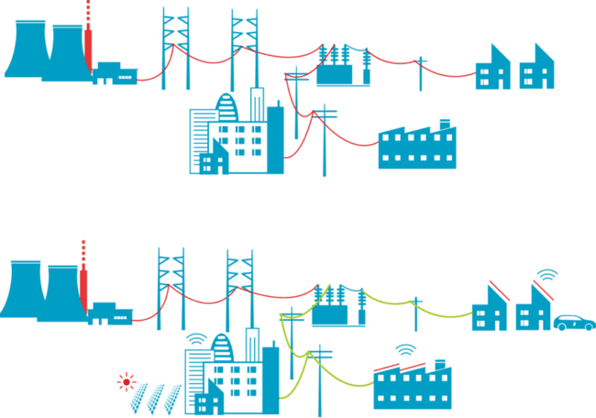
Introduction:
The progression of new technologies is not just one of the factors prompting countries to pursue greener energy supply solutions. Other relevant factors include the increasing energy demands, especially in developing countries like China and India, the heightened environmental awareness, and the dwindling reserves of conventional fossil fuels. These factors have incited a move towards sustainable technologies that utilize renewable energy sources, such as wind and solar irradiation. Nevertheless, due to the irregular and uncontrollable nature of renewable energy sources, their incorporation into power systems remains a sizeable challenge.

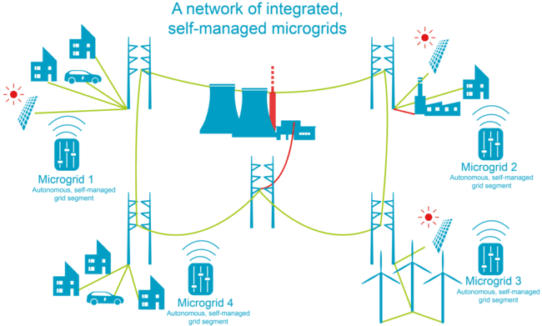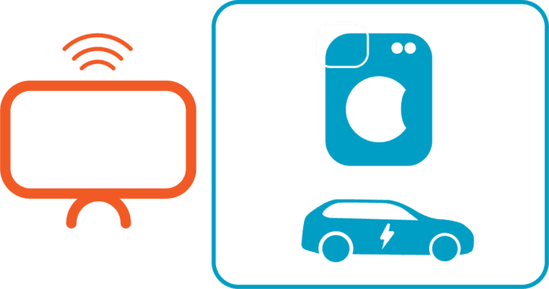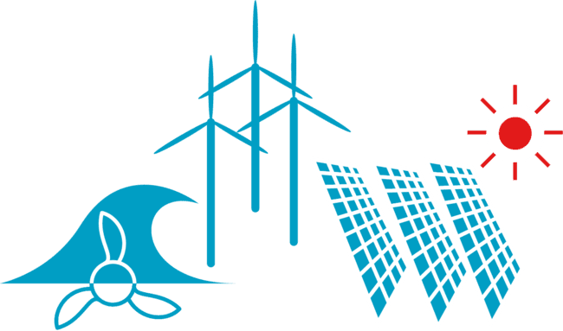 Fig 1.A System Integration, control and Stability components and Protection
2. Operational challenges of Power systems:
First, we'll examine some fundamental ideas regarding the operation of conventional power systems. Next, we will discuss the primary issues and modifications that occur after a significant number of dispersed sources are set up. The three primary components of conventional power systems are distribution, transmission, and generation. Power moves from the generating units to the end users in conventional power systems. Large conventional generating units, such as thermal power plants, are the primary source of electrical energy. High voltage transmission lines carry the energy to medium voltage substations. Lastly, the distribution network transports electricity to final users. Transformers of various sizes are positioned between the transmission lines and generators, between the transmission and distribution areas, and between the lines of varying voltage levels in order to step the voltage levels up or down. In conventional power systems, generation, transmission, and distribution are typically vertically integrated. Large power plants, which are located far from the end users, are where power generation is done centrally. Because of this, power systems are susceptible to unforeseen events like bad weather, accidents, and component failures, which can lead to power outages when the system is not strong enough. Additionally, there is no demand-side flexibility in conventional power systems. This suggests that power is centralized.

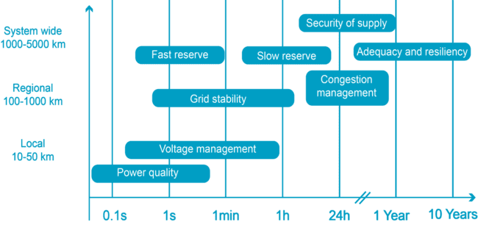
Figure 1.B Operational Aspects of Micro grids
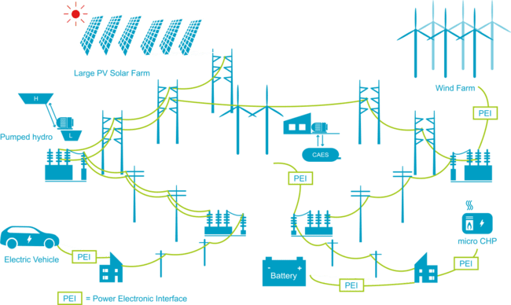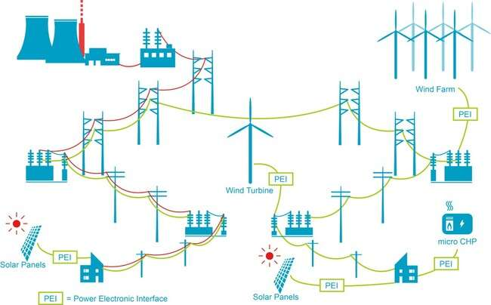

Fig 1.C Control, stability and storage of power systems
2.1 Distribution Networks:
It is worth noting that the transformation of passive networks into active ones presents a pivotal shift in the electrical landscape, offering a more vibrant and vital tapestry for the management of power networks in the future. In conclusion, the active management of distribution networks will enable more intricate and multifaceted control of the electrical grid, leveraging the potential of distributed energy resources and demand side management strategies.

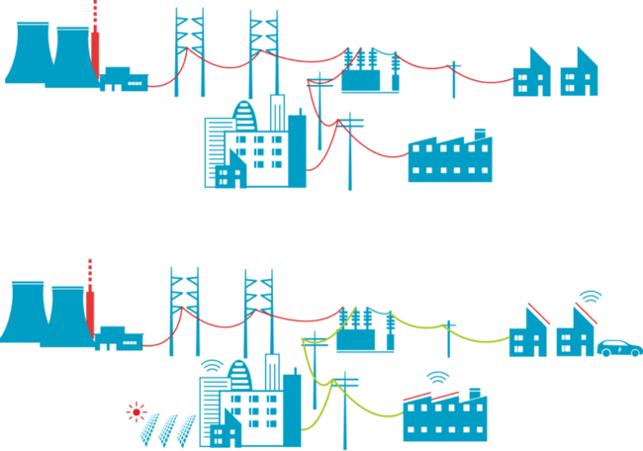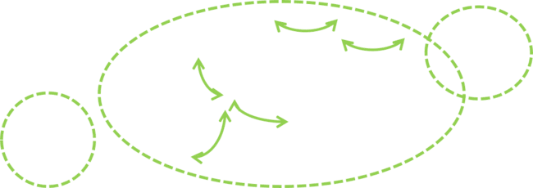

Fig: 1.D Active and Passive Distribution Networks
2.2 Micro grid: A micro grid is a collection of electrical loads, components of a generated power supply, and storage components that are connected to the electric grid via a single point of connection. These components are all connected using a strategy that controls the energy flow within the grid as well as the power exchange with the main supply grid, according to CORDIS Europe. First, within a local distribution grid, a micro grid is a platform for integrating local generation, storage, and demand. Local generation is commonly referred to as micro generation because of its small scale and tendency to occur at low voltage levels. A micro grid should also have the ability to function in two different modes: emergency mode, also known as islanded mode, and grid-connected mode.
Three layers are shown on this slide to illustrate how power systems function. The "power grid" layer, which is the topmost layer, is where distribution, transmission, and generation are done. Large power plants or farms that rely on renewable energy sources, like wind or photovoltaic farms, are usually the ones that produce the electrical power. The produced power is then sent to the loads, which are often found at the distribution network, via the transmission lines. The "utility service area," which can include different residential, commercial, or industrial areas, is the second or intermediate layer of the distribution network. There may be a significant number of micro grids in this second layer as well. A micro grid, which may be made up of a few feeders or electrical components, is the smallest level. Distributed generating units may be connected to a supervisory control system.
After defining a micro grid, we discovered that each micro grid needs to have four key components. A micro grid is a platform that integrates distributed generation and loads; it can operate in both grid-connected and islanded modes, has active operation, and comes in a variety of scales. Next, we determined the layers of the electrical power grid and the possible advantages that micro grids can offer to consumers and the main grid. We identify increased modularity, efficiency, and resilience as some of these advantages.

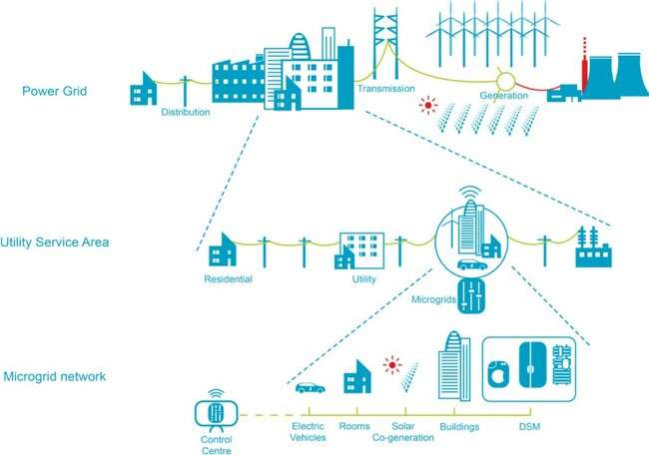

Fig 1.E Network System of Micro grid
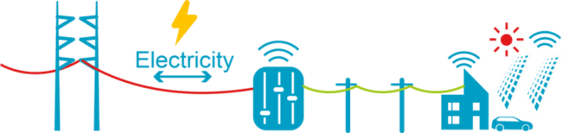

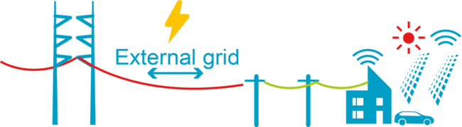

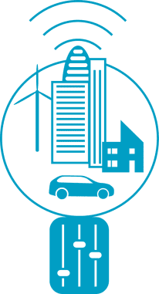
Fig 1.F Advantages of Micro grids
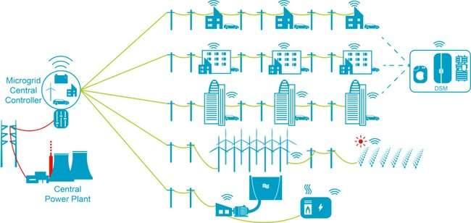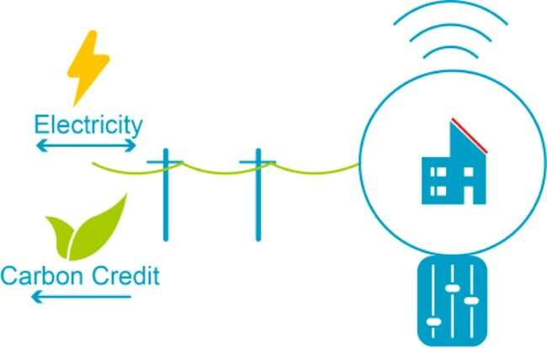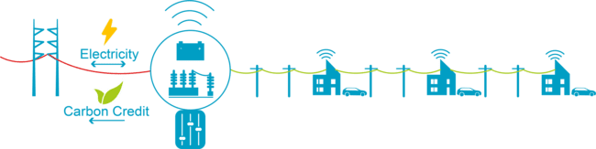Micro grids can be categorized based on their power capacity. The typical power capacity of a high-power micro grid ranges from a few hundred kilowatts to a few megawatts. A central micro grid controller can also be used to link a medium power micro grid to the main grid. A single feeder can be connected to multiple loads and generators to form a low power micro grid. This micro grid's size is generally regarded as being significantly smaller than 1 MW. The primary responsibility for intelligently and sensibly managing and controlling all loads and renewable energy sources lies with the micro grid central control.

Fig 1.G: Classification of Micro grids
2.3 comparisons between Virtual Power plant and Micro grid:
Another way to address the issues brought about by distributed generation is to use a virtual power plant. However, a micro grid and a virtual power plant are very different. This lesson will cover the definition of a virtual power plant as well as the primary distinctions between it and the micro grid. One definition of a virtual power plant, or VPP, is a collection of dispersed energy resources managed by a single controller. A VPP offers greater flexibility than a traditional power plant and can replace it.
It is worth noting that a virtual power plant's energy sources are often dynamic and intricate. Traditional power plants, serving as Dispatchable sources, can be found within the system alongside controllable and non-controllable distributed generators. Fuel cells and micro-turbines are instances of controllable distributed sources, while photovoltaic and wind energy are examples of non-controllable power sources. Backup generators and energy storage systems are usually integrated to sustain a reliable power supply. In conclusion, the energy landscape of a virtual power plant is vibrant and pivotal, necessitating careful management and integration of various sources.
By using optimization techniques and control, a virtual power plant can be made to meet both peak loads and load fluctuations. The Internet of Things and information and communication technologies are crucial for combining the capabilities of multiple dispersed generators.
Then, we saw how to differentiate the concept of virtual power plant from the concept of micro grid. In fact, virtual power plants tend to aggregate distributed generation over a wider geographical area. They typically have a higher installed capacity compared to a micro grid. Finally, virtual power plant tend to consider consumption as a source of flexibility, whereas the aim of micro grids is to meet the local load requirements

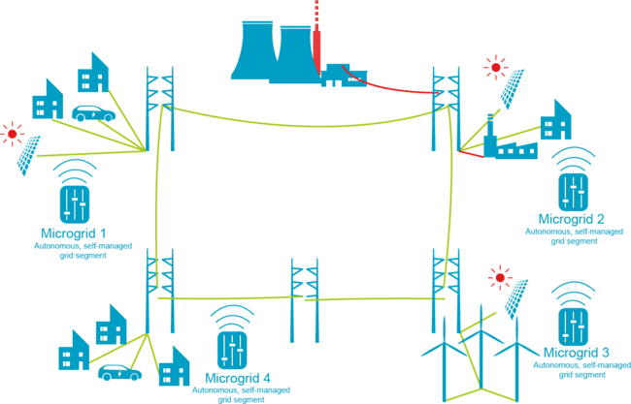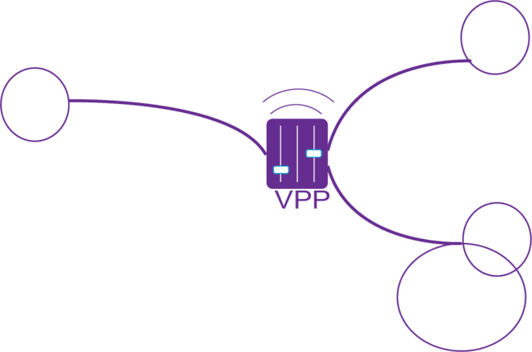
Fig 1.H VPP VS MIROGRID
2.4 General Scheme of Distribution & Transmission
On the other hand, the electricity demand has been increasing due to the global population growth, industrialization, and many other factors. Moreover, new grid-connected technologies like electric vehicles are likely further contribute to the demand growth. Also, to manage the mismatch between the generation and consumption, energy storage technologies are being integrated into electrical networks. The key element to connect all these together is the power electronic interface. First, at the higher voltage levels, Transmission is the main responsible for transmitting electrical power from large centralized power plants to the demand located at distribution areas. Second, at a certain point or bus in the grid, a micro grid is considered to be connected to upstream main power grid that is called “point of common coupling”. In simple words, this point can be seen as a gateway between a micro grid and external upstream grid. Third, distribution is the main responsible for delivering electrical power at lower voltage levels. Fourth, the protection is an essential part of a micro grid for its safe operation during either islanded or grid-connected modes. The protection system detects and removes possible faults or disturbances in micro grids. Fifth, the monitoring system in a micro grid is required to collect relevant signals Like frequency, voltage, and active and reactive power.
, and electricity price signals, temperature, etc. Sixth, power converters make possible different interfaces between AC and DC in micro grids, that flexibly provide fast control over voltage/frequency and active/reactive power in micro grids. Finally, control in Micro grids shall be properly implemented at different control levels, namely upstream main grid level, microgrid, and micro source local level. Here we show a general scheme of Transmission and distribution AC system from transmission side (on the left hand side) to the distribution side (in the middle) and then to the demand side (on the right hand side).
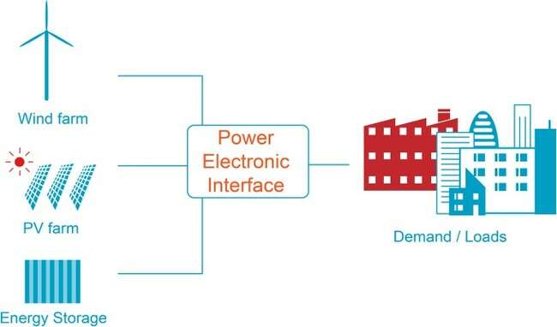

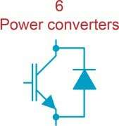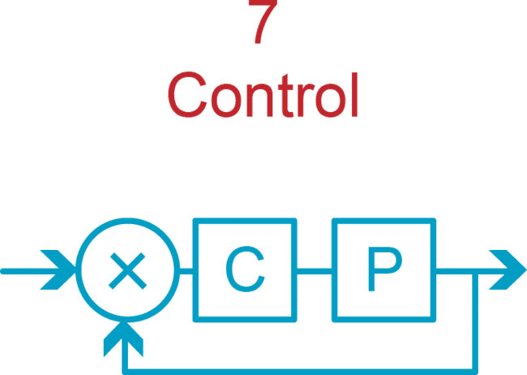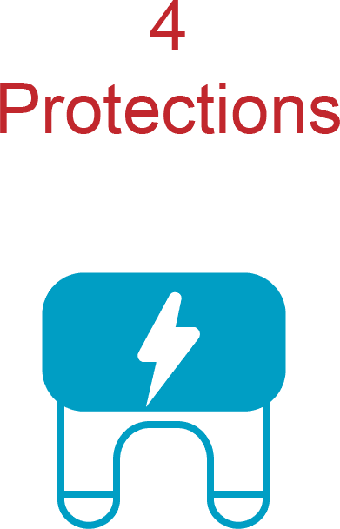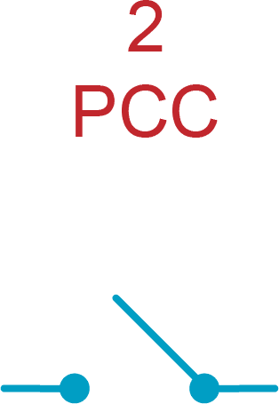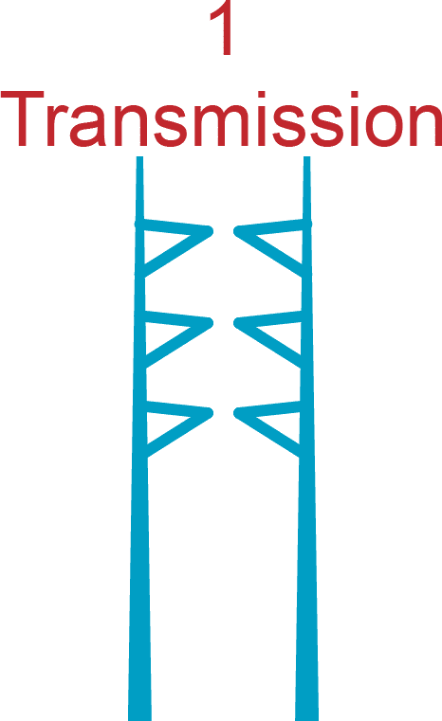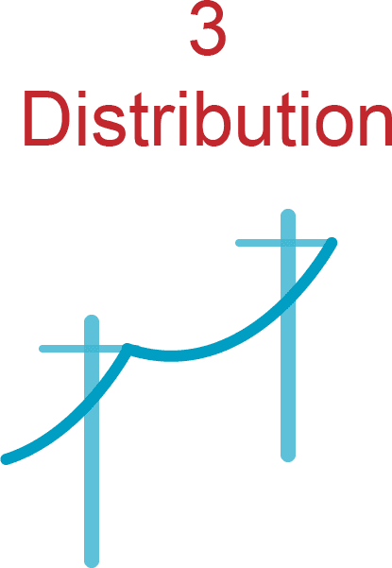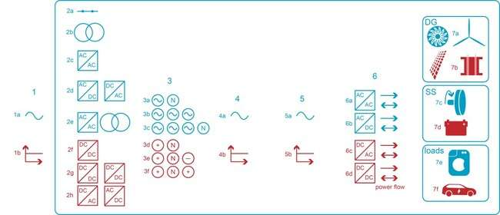
Fig 1.I General scheme of Distribution and Transmission

2.5 A micro grid, if implemented with caution, can significantly impact the economic sustainability of a project. Design considerations: Energy storage apparatuses can enhance the dependability and effectiveness of generators by either storing or supplying the power discrepancy between the load demand and the renewable energy sources' capability. Furthermore, it meets the energy needs for a smooth transition between grid-connected and standalone operations. This micro grid is interconnected with the upper stream external network at the Point of Common Coupling (PCC). The choice of the suitable micro grid architecture is a pivotal matter
Therefore, it is crucial for designers to understand the advantages and disadvantages of the various micro grid topologies, layouts, and architectures. For instance, since an AC-micro grid requires few changes to the current installations, it is likely the best choice in the typical scenario of existing facilities with AC loads. However, there are other options for new installations. G. DC that performs better may be taken into consideration. If the AC or DC conversion steps can be omitted, DC microgrids are comparatively more efficient. Power converters can reverse the current because they are bidirectional and operate in two quadrants. Therefore, in order to achieve two quadrants with current reversal, a technology that can change the direction of the current flow and switch it to negative while maintaining the same polarity of the voltage is required. The majority of distributed generators require a DC/DC or AC/DC power electronic interface in order to be connected to the DC micro grid’s DC-bus, which has a regulated voltage. A DC/AC converter is necessary for the AC loads in order to adjust the bus voltage to the necessary levels. Depending on the bus voltage, DC loads can occasionally be connected straight to the DC bus or may require a DC/DC converter. Without an electronic interface, some capacitors could be added to the bus to provide quick and steady load steps. The primary AC/DC converter controls the DC bus's voltage. This is how the DC micro grid architecture looks.
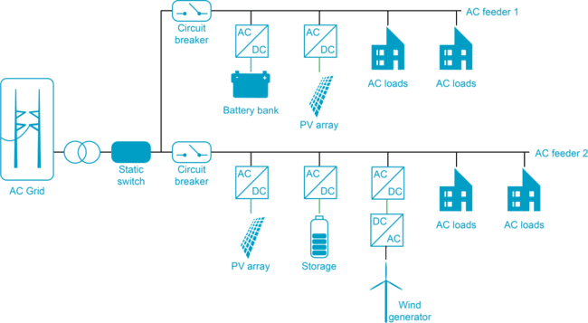

Fig 2.A Layout of an Ac Micro grid
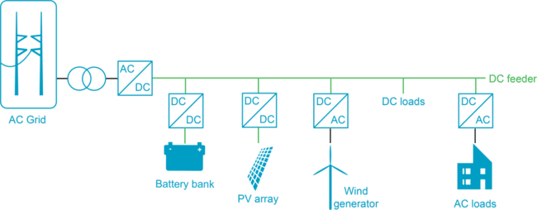
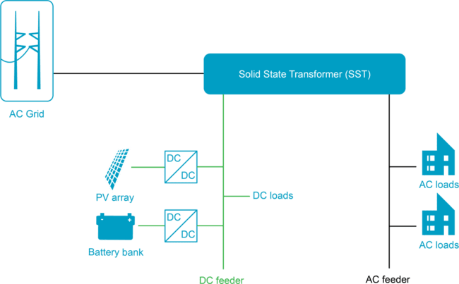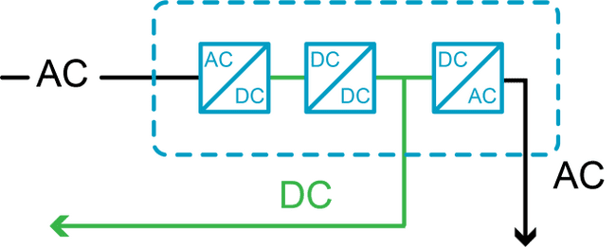
Fig 2.B Layout of an Dc Micro grid

Fig 2.C Layout of an SST based Micro grid
2.6 Efficiency Comparison of Four Micro grid Layouts
To increase the overall efficiency, for this layout it is preferred to directly consume the generated power by wind. The table shows the amount of power which will be send from the PV array to the AC loads. As it is shown, if directly consumed, the generated power by PV unit is multiplied by eta of DC and DC AC converters. If the generated power from PV is indirectly consumed, meaning that it is first stored in the battery, then the eta of battery as well as its DC DC Dc and DC AC converters will be additionally multiplied. Therefore for this layout, similar to wind generator, it is preferred to directly consume the power from PV unit in a more efficient way. If the generated power from diesel generator is indirectly consumed, then the eta of battery, and also two times the eta of DC DC converters and DC AC converters shall be considered, as it is shown. Therefore it is not efficient to store the generated power from diesel engine in the battery. Economically speaking, typically the generated power from diesel has a higher price due to the use of fossil fuels (which are rather expensive), therefore in such cases, diesel engines are to be used mainly during the emergency conditions as a backup.
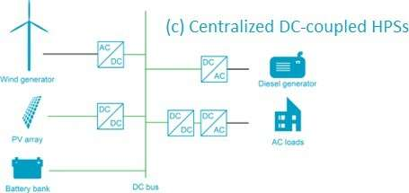

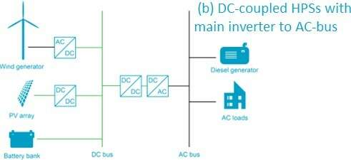
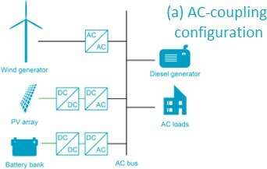
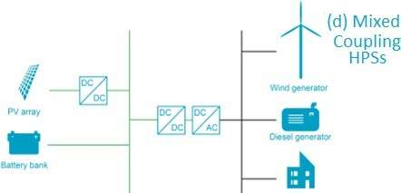

Fig 2.D a, b, c, sd Different Layouts of Micro grids

It is worth mentioning that compered to AC layout, in DC microgrid layout it is relatively more efficient to store the generated power from wind in the battery (as there is no need any more for DC DC and DC AC converters between the battery and the AC bus, and both wind and battery are now connected to the DC bus). If the AC loads are directly supplied by the PV array, then not only the eta of DC DC converter between PV array and the DC bus is considered, but also the eta of DC DC converter and DC AC converter between the DC and AC bus are to be incorporated in the equation.

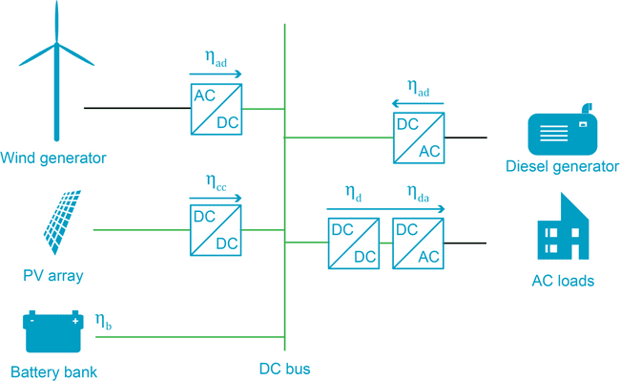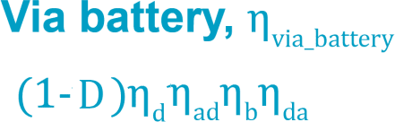

Fig 2.E Efficiency of Dc Micro grid

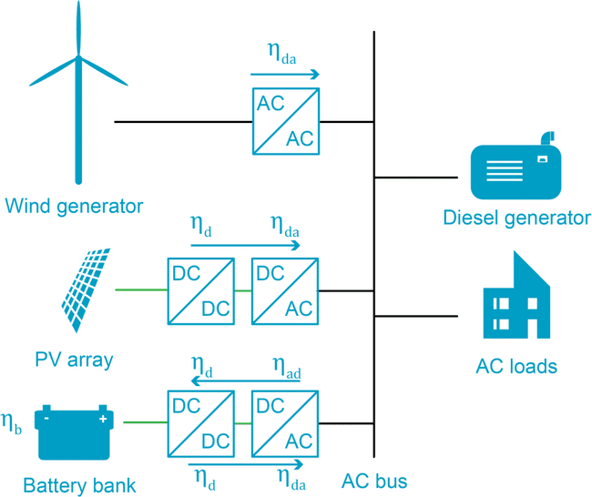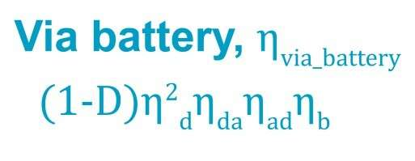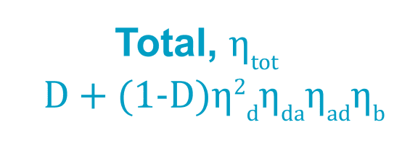

Fig 2.F Efficiency of Ac Micro grid

Centralized and de centralized control
One entity is responsible for carrying out the decision-making processes when internal micro grid control is carried out in a centralized manner. At the transmission system operator level, centralized control in traditional power systems is typically carried out by a single entity. The economic dispatch and unit commitment calculations are also performed by a single entity in the case of a micro grid when centralized control is implemented. A micro grid central controller or the distribution system operator supply the set points to the dispersed sources. One way to define a micro grid central controller is as the controller that establishes the set points for the distributed generation, storage, and loads. Either the distribution system operator or a specialized micro grid operator can oversee a micro grid central controller. Each controllable component of the micro grid is where internal micro grid control occurs in a decentralized control scheme. The various actors in this situation may engage in negotiation, particularly since their objectives differ. Common tasks and computations, such as state estimation, load forecasting, and security monitoring, can still be carried out centrally. The first of the four essential characteristics that determine the control algorithms' performance is the number of nodes. The micro grid's controllable loads and dispersed generators have an impact on computation time and complexity.
Principles of centralized control
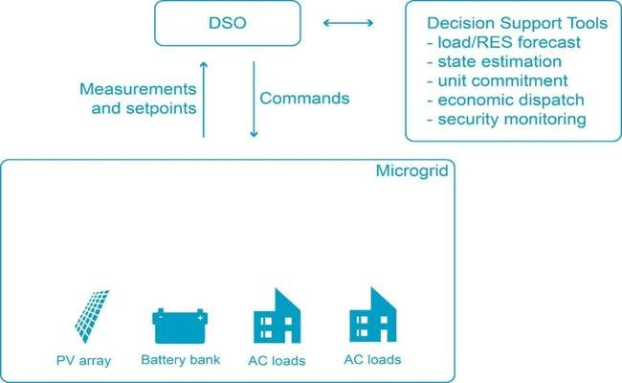

Fig 2.G Principles of centralized control

Fig 2.H Principles of centralized controlPrinciples of Decentralized control
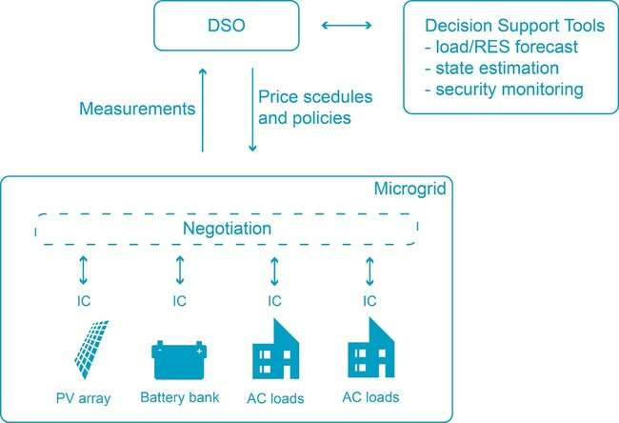

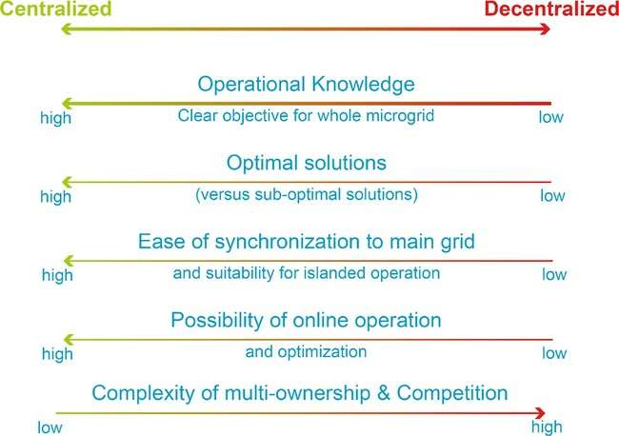
Fig 2.I Principles of centralized control Comparison of centralized and decentralized
Micro grid control scheme:
The primary control, also known as local control, is implemented locally in a centralized scheme, while the secondary control, also known as internal micro grid control, is implemented centrally. The micro grid central controller is responsible for gathering information about the distributed generating units' operations, such as active and reactive power data. The micro grid then uses the communication link to send updated active and reactive power set-points to all local controllers, such as the controllers of the energy storage units and distributed generators, based on the micro grid’s specifications. Internal micro grid control makes the decisions regarding how the distributed generators should operate. To do this, the micro grid central controller has scheduling and optimization features. The goal is to maximize profits by participating in the market and utilizing the grid when it is most efficient, while also optimizing the operation of the distributed generating units to meet the needs of the micro grid. In demand side bidding, the micro grid central controller is crucial because it tells customers about external market prices, including day-ahead, real-time, and ancillary service market prices. Through the upstream network interface, these price signals are transmitted to the central controller. Customers can send the controller their desired bids every hour based on those price signals. So, it is controlled by the micro grid central controller.

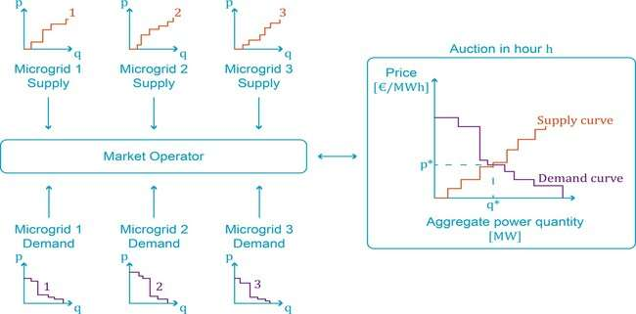

Fig 2.J Centralized control of Micro grid bus
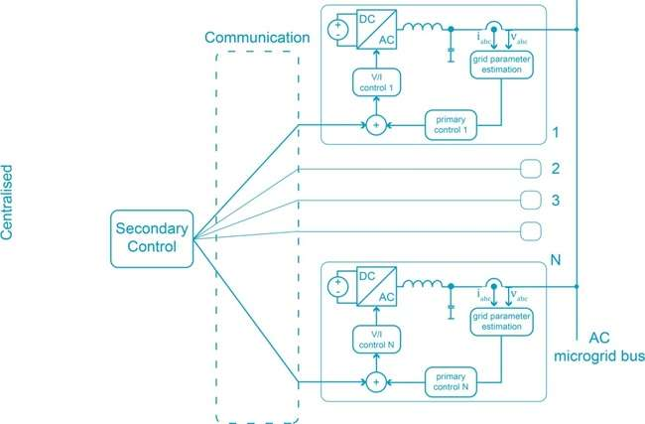

Fig 2.K Micro grid Strategic bidding
Its duties include maximizing the performance of the distributed generating units and playing a key role in demand-side bidding, such as by alerting customers to market prices and collecting their bids in response to these signals. Based on supply and demand power quantities, the market operator can then generate the overall supply-demand curve. We also went over some security considerations that must be made during the various modes of operation, such as meeting voltage and thermal limits and guaranteeing a smooth transition between the modes of operation. Lastly, we observed how a micro grid switches between grid-connected, islanded, and shutdown modes of operation.

References:
[1]Nasruddin et al., “Potential of Geothermal Energy for Electricity Generation in Indonesia: A review,” Renew. Sustain. Energy Rev., vol. 53, no. 2016, pp. 733–740, 2016, doi: 10.1016/j.rser.2015.09.032.
[2] T. Bin Nadeem, M. Siddiqui, M. Khalid, and M. Asif, “Distributed energy systems: A review of classification, technologies, applications, and policies:,” Energy Strateg. Rev., vol. 48, no.
[3].N. Kannan and D. Vakeesan, “Solar Energy for Future World: - A Review,” Renew. Sustain. Energy Rev., vol. 62, pp. 1092–1105, 2016, doi: 10.1016/j.rser.2016.05.022.
[4] S. D. Musa, T. Zhonghua, A. O. Ibrahim, and M. Habib, “China’s energy status: A critical look at fossils and renewable options,” Renew. Sustain. Energy Rev., vol. 81, no. March, pp. 2281– 2290, 2018, doi: 10.1016/j.rser.2017.06.036.
[5] M. E. Meral and D. Çelík, “A comprehensive survey on control strategies of distributed generation power systems under normal and abnormal conditions,” Annu. Rev. Control, vol. 47, no. xxxx, pp. 112–132, 2019, doi: 10.1016/j.arcontrol.2018.11.003.
[6] T. Hickmann, O. Widerberg, M. Lederer, and P. Pattberg, “The United Nations Framework Convention on Climate Change Secretariat as an orchestrator in global climate policymaking,” Int. Rev. Adm. Sci., vol. 87, no. 1, pp. 21–38, 2021, doi: 10.1177/0020852319840425.
[7] D. Xu, S. Abbas, K. Rafique, and N. Ali, “The race to net-zero emissions: Can green technological innovation and environmental regulation be the potential pathway to net-zero emissions?,” Technol. Soc., vol. 75, p. 102364, 2023, doi: https://doi.org/10.1016/j.techsoc.2023.102364.
[8] L. Li et al., “Review and outlook on the international renewable energy development,” Energy Built Environ., vol. 3, no. 2, pp. 139–157, 2022, doi: 10.1016/j.enbenv.2020.12.002.
[9] D. Maradin, “Advantages and disadvantages of renewable energy sources utilization,” Int. J. Energy Econ. Policy, vol. 11, no. 3, pp. 176–183, 2021, doi: 10.32479/ijeep.11027.
[10] K. Hansen, C. Breyer, and H. Lund, “Status and perspectives on 100% renewable energy systems,” Energy, vol. 175, pp. 471–480, 2019, doi: 10.1016/j.energy.2019.03.092.
[11] D. C. Momete, “Analysis of the Potential of Clean Energy Deployment in the European Union,” IEEE Access, vol. 6, pp. 54811–54822, 2018, doi: 10.1109/ACCESS.2018.2872786.
[12] D. Gielen, F. Boshell, D. Saygin, M. D. Bazilian, N. Wagner, and R. Gorini, “The role of renewable energy in the global energy transformation,” Energy Strateg. Rev., vol. 24, no. January, pp. 38–50, 2019, doi: 10.1016/j.esr.2019.01.006.
[13] C. Breyer et al., “On the History and Future of 100% Renewable Energy Systems Research,” IEEE Access, vol. 10, no. June, pp. 78176–78218, 2022, doi: 10.1109/ACCESS.2022.3193402.
[14] Z. Xu et al., “Towards high resolution monitoring of water flow velocity using flat flexible thin mm-sized resistance-typed sensor film (MRSF),” Water Res. X, vol. 4, p. 100028, 2019, doi: https://doi.org/10.1016/j.wroa.2019.100028.

