Clinical Approaches to Pediatric Urinary Incontinence: Current Trends and Challenges

ABSTRACT
Pediatric urinary incontinence is a common condition characterized by the involuntary loss of urine in children beyond the age at which bladder control is typically achieved, usually around five years. It encompasses a range of presentations, including nocturnal enuresis (bedwetting) and daytime incontinence, and can be classified as either monosymptomatic or non-monosymptomatic. The etiology is often multifactorial, involving functional, behavioral, anatomic, neurologic, and sometimes psychological components. A thorough evaluation, including medical history, physical examination, and basic investigations such as urinalysis and ultrasound, is essential to determine the underlying cause. Management strategies focus on education, behavioral interventions, lifestyle modifications, and, when necessary, pharmacologic therapy such as desmopressin or anticholinergic agents. Most children respond well to treatment, and the prognosis is generally favorable, especially with early diagnosis and supportive care.

Keywords: Pediatric urinary incontinence, urinary incontinence during childhood, Etiopathology, Diagnosis, Management

1. INTRODUCTION

Lower urinary tract (LUT) function and malfunction are challenging to identify in children. Incomplete voiding and bedwetting are regarded as natural symptoms in toddlers but pathological in school-age children. Urinary incontinence is the involuntary leakage of urine¹, and is one such symptom. When discussing incontinence in children, it is crucial to take into account the central nervous system's maturity.
Urinary continence in children varies with age, but by age five, more than 90% are continent during the day. Nighttime continence takes more time to achieve². Urinary incontinence can be intermittent or chronic, and is defined as the involuntary voiding of urine at least twice a month, either during the day or at night^{1,3}.
Urinary incontinence during the day: Diurnal incontinence (or diurnal wetting) or daytime incontinence
Urinary incontinence at night: Enuresis/Nocturnal incontinence (or bed-wetting) or night-time incontinence
Enuresis affects about 30% of children at age 4, 10% at age 7, 3% at age 12, and 1% at age 18. About 0.5% of adults continue to have nocturnal wetting episodes. Boys are more likely to experience enuresis, and when there is a family history of it².
Diurnal (daytime) incontinence is usually not diagnosed until age 5 or 6. Nocturnal (nighttime) incontinence (that is, enuresis) is usually not diagnosed until age 7. Enuresis is commonly known as night-time wetting before this point⁵, and considered a part of maturation.
1.1 Development and maturation of lower urinary tract function

The detrusor muscle forms between weeks 9–12 of gestation, while bladder development starts in weeks 4-6. Micturition at birth involves higher CNS centres, and the baby typically wakes up, if only momentarily, to void. Due to detrusor-sphincter dyscoordination, voiding is frequently incomplete during the first few years of life; however, this resolves once bladder control is achieved. About 5–10% of 7-year-olds experience nocturnal enuresis and/or daytime incontinence, and a small percentage are unlikely to outgrow it. Detrusor overactivity is typically the cause of childhood daytime incontinence, though it's not always obvious how much the micturition reflex or the detrusor itself is overactive⁶.
Enuresis– nocturnal incontinence– is caused by either nocturnal polyuria and/or nocturnal detrusor overactivity, in both cases combined with high arousal thresholds.
Childhood bladder problems are associated with an increased likelihood of developing or continuing bladder problems in adulthood.

2. etiology

Compared to adult urine incontinence, pediatric urinary incontinence has a completely different etiology and treatment options. The etiology of incontinence usually differs depending on whether it is primary or secondary, nocturnal or diurnal, even if some disorders cause both.
The majority of primary incontinence, or enuresis, occurs at night and is not caused by an organic disorder⁶.
Enuresis can be classified as either monosymptomatic (occurring solely during sleep) or complex (other abnormalities are present, such as diurnal incontinence and/or urinary symptoms). About 30% of cases have organic illnesses, which are more prevalent in complex enuresis than in monosymptomatic enuresis. Although the cause⁶⁻¹¹ of the remaining majority of instances is unknown, some of the organic causes⁷ are mentioned in Figure 1.

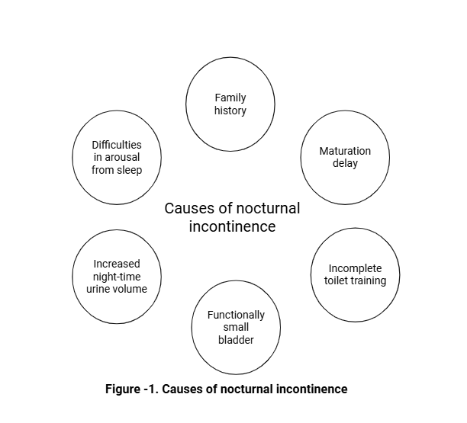

2.1 factors contributing to pediatric incontinence

There are several factors that contribute in causing the pediatric incontinence which are represented in table 1 and table 2.

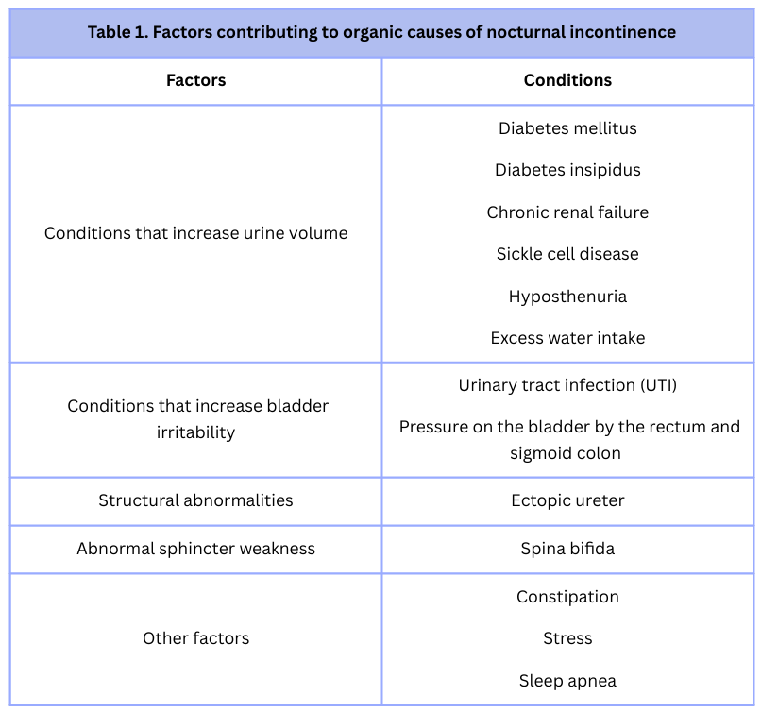

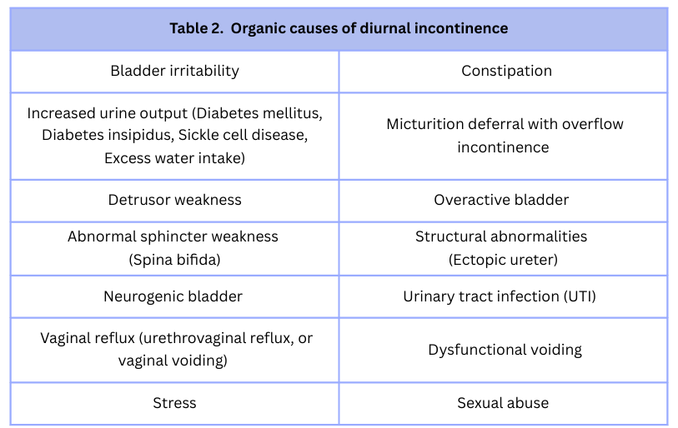

3. Pathophysiology

Bladder function has a storage phase and a voiding phase. Primary or secondary incontinence may result from abnormalities in any phase ¹².
Storage phase: The bladder serves as a reservoir for urine during the storage phase. The size and compliance of the bladder determine storage capacity. Storage capacity increases as children grow.
Recurrent infections or obstruction of the outlet can reduce compliance, resulting in hypertrophy of the bladder muscles. Urine storage may also be reduced if the colon and/or rectum externally compress the bladder.
Voiding phase: The external urinary sphincter and the bladder neck opening coordinate with the bladder contraction during the voiding phase. Incontinence may result from a dysfunction in the coordination or sequence of voiding.
There are numerous causes of dysfunction. For instance, inflammation of the bladder can cause irregular bladder contractions and asynchrony of the voiding pattern, which can lead to incontinence. A urinary tract infection (UTI) or anything pushing on the bladder (such as a dilated rectum caused by constipation) can cause bladder irritation¹³.
The maturation of the voiding pattern is different in infants than in adults. Infant. Infant’s reflex pattern of micturition is when the bladder wall contractions occur due to increased outlet resistance. Meanwhile, in adults, bladder contractions are suppressed by the pontine micturition center.
A transition phase occurs during maturation, in which external sphincter contractions oppose detrusor contractions². The neurotypical patient has voluntary muscle control of the external sphincter. Development of control occurs during toilet training.

4. Classification of pediatric urinary incontinence

Continuous incontinence is constant urine leakage, which is nearly always linked to congenital abnormalities such as ectopic ureters or iatrogenic injury to the external urethral sphincter.
Intermittent incontinence is urine leakage in discrete amounts. Children who are at least five years old are susceptible to it, and it can happen during the day or at night.
Diurnal/Daytime incontinence is incontinence during the day
Enuresis/nocturnal incontinence means intermittent incontinence while sleeping. enuresis is any kind of wetting episode that happens in discrete amounts while asleep.
Monosymptomatic nocturnal enuresis (MNE) is defined as bedwetting that occurs only at night without any accompanying daytime urinary issues.
Complex/Non-monosymptomatic nocturnal enuresis (NMNE) is bedwetting accompanied by other LUT symptoms during the day, such as urgency, frequency, urge incontinence, or daytime incontinence.
Nocturnal Incontinence is classified as:
Primary incontinence: Children have never achieved urinary continence for ≥ 6 months.
Secondary incontinence: Children developed incontinence after a period of at least 6 months of urinary control. It is more likely to have an organic etiology.

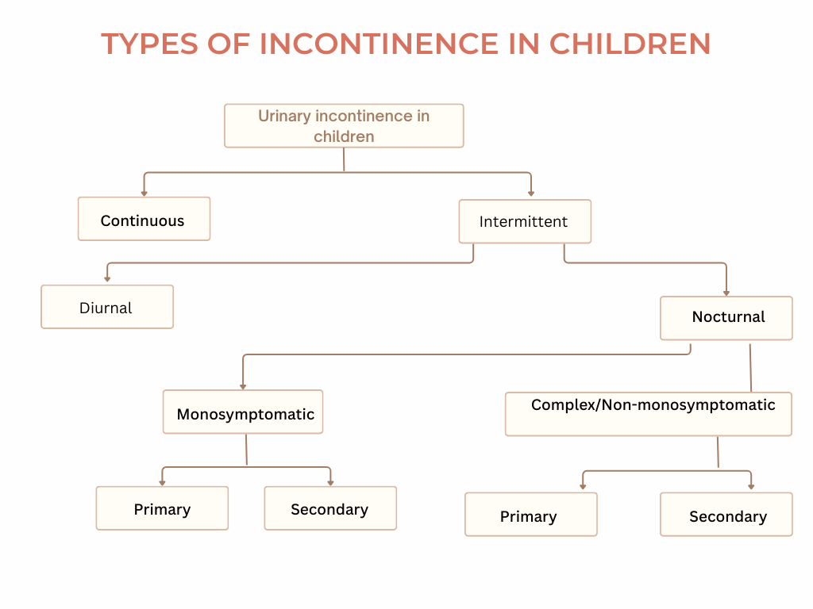

5. Evaluation and diagnosis

The assessment of pediatric urinary incontinence relies on a comprehensive history and physical examination, which also determines which diagnostic tests, if any, should be considered.
5.1 history

History²⁰ is the most crucial diagnostic tool in the assessment of a child with urinary incontinence. The history should be comprehensive yet specific and include information from the child and the caregiver/parent.

History of present illness inquires about the time of day or night, the location (at home or at school/public place), the frequency (daily or once a week), and the amount (small or large volume) of leakage, whether symptoms are continuous (ie, constant dribbling) or intermittent are crucial. Information about bowel habits is also crucial, including the frequency and consistency of bowel movements as well as the existence of any bowel accidents. Assessment for constipation should always be part of the evaluation because it can contribute to both nocturnal and diurnal incontinence. Data regarding elimination and voiding behaviors can be obtained with the use of frequency-volume charts⁷, often known as bladder/voiding diaries, including timing, frequency, and volume of voids, which can be helpful. Polydipsia, dysuria, urgency, frequency, dribbling, and straining are significant concomitant symptoms.
It is important to record the position and strength of the urine stream during voiding. Children who have incontinence may employ holding techniques, including squatting or crossing their legs, to stop leaks (often with their hand or heel put against their perineum). Holding techniques can make some kids more susceptible to UTIs. A stooling diary, like the voiding diary, can be used to detect constipation. It's necessary to record the age at which toilet training began and whether total dryness has been attained since then.
In order to identify a cause, systems should be reviewed for symptoms such as constipation (frequency, size, and consistency of stools); UTI (fever, abdominal pain, dysuria, and hematuria); perianal itching and vaginitis (pinworm infection); and polyuria and polydipsia (snoring or breathing pauses during sleep; diabetes insipidus or sleep apnea). The children should be screened for diabetes mellitus and sexual abuse, which is too significant to ignore despite being a rare cause.
Past medical history⁷ must identify recognized potential causes, like history of UTIs, neurologic conditions, renal disorders, and perinatal traumas or birth defects (such as spina bifida). A potential organic cause (such as diabetes mellitus) is suggested by excessive thirst, diurnal incontinence and enuresis, and weight loss.
In addition to a list of current drug history, it is important to mention any past or present incontinence treatments and how they were implemented.
Developmental history should address developmental delays or other conditions linked to voiding dysfunction (such as attention-deficit/hyperactivity disorder, which raises the risk of incontinence).
Any urologic diseases and enuresis should be noted in the family history.
Social history should include any stressors that occurred up to the start of symptoms, such as problems at home, at school, or with friends. However, incontinence is not a psychological illness, stress can cause a brief wetting episode. In order to make informed treatment options, clinicians should also inquire about the child's experience with incontinence.
5.2 physical examination

A review of vital signs for fever (UTI), weight loss (diabetes), and hypertension (renal disease) is the primary element in the examination. A head and neck examination should reveal mouth breathing, swollen tonsils, or inadequate growth (sleep apnea).
Abdominal examination should detect any masses that could indicate a full bladder or feces.
Examination of the back – to look for the signs of obvious or impending meningo-myelocoele like, sacral dimple, tuft of hairs, etc.
In girls, during genital examination, look for any signs of sexual abuse, such as scarring or labial adhesions. An ectopic ureteral orifice is often difficult to see but should be sought. Infact, vaginal pooling of the urine or continuous dribbling of urine from the vagina can be seen. In boys, it is important to examine boys for meatal irritation and any sores on the glans, anus, or rectum. Perianal lesions may indicate pinworms in either sex. Vaginitis, urethritis, anal or rectal itching (particularly at night), or a combination of these conditions may be a sign of pinworms. Any midline deformities (such as a deep sacral indentation or a sacral hair patch) should be observed on the spine.
Neurologic evaluation⁷ is essential and should focus on lower-extremity strength, sensation, and deep tendon reflexes, sacral reflexes (such as the anal wink), and, in males, the cremasteric reflex to identify possible spinal dysraphism¹⁹.
Rectal examination may help detect constipation or a decrease in rectal tone. Children who have hard or unusually large stools and trouble eliminating (and occasionally palpable feces on examination) should be evaluated for constipation if no other abnormalities are found. Digital rectal examination should be done with the little finger only, if needed, to avoid pain in infants and children.
There are a few red flags (Table 3) that needs to be identified prior to initiating assessment.
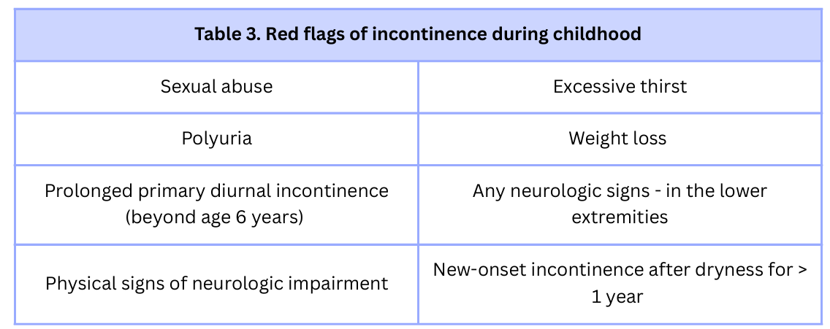

5.3 diagnostic tools

Incontinence is frequently diagnosed following a history and physical examination. For both sexes, routine urine cultures and urinalysis are typically performed. Diagnostic testing is helpful primarily when a physical examination or history indicates an organic cause.
Urinalysis²⁰ should be performed in the majority of instances to identify infection (bacteriuria, pyuria, hematuria), renal damage with high urine output (proteinuria, low specific gravity), or diabetes (glucosuria)
A bladder scan with postvoid residual (PVR)¹⁸ assessment is a simple test to include in any physical examination that provides crucial information about bladder emptying. This will aid the provider in knowing the child’s ability to empty the bladder and can prompt further studies when large PVRs are found on successive tests¹⁶. High PVRs are indicative of renal and bladder ultrasound, voiding cystourethrogram, and/or urodynamic studies.
Uroflowmetry^{14,15} with external sphincter electromyography (EMG) provides details about the coordination of the pelvic floor during micturition²¹.
Urodynamics¹ with external urethral sphincter electromyography and urethral pressure profilometry are indicated for those with a presumed or confirmed neurologic lesion, incontinent adolescent males with late diagnosis of posterior urethral valves, and in patients who fail behavioral or medical therapy. Similarly, anal manometry can be done if Hirschprung disease is suspected.
It is recommended to perform kidney and bladder ultrasonography to examine the anatomy of the renal and urinary tracts¹⁷. It can also be used to measure rectal diameter and an abdominal x-ray may be performed to confirm a high stool burden if constipation is suspected.
Magnetic resonance urography¹⁹ is recommended for patients older than six months in order to identify spinal cord and vertebral disease. A magnetic resonance urography can be done to rule out ectopic ureter or other anatomic causes of incontinence, such as common cloaca, urogenital sinus, or anorectal anomalies.
In adolescents with UI and incontinent children with a history of febrile UTI, a voiding cystourethrogram (VCUG) or MR urography (MRU) should be performed¹⁹.
5.4 Questionnaires used to assess incontinence
The Pediatric Incontinence Questionnaire (PIN-Q) is used to determine the effect of incontinence on a child’s quality of life²². The Bristol Stool Scale can be used for patients to determine the quality and character of bowel movements. It is essential to ascertain whether the chosen questionnaire has been validated in a certain linguistic, social, and cultural environment²³.
6. management

Family education regarding the etiology and clinical progression of incontinence is the most essential component of treatment. Education increases treatment adherence and lessens the detrimental psychological effects of urine incontinence. Parental and child involvement in the treatment plan is also essential for the successful management of urine incontinence. The treatment plan should be delayed until the child is ready to engage if they are immature, do not find the incontinence bothersome, or are unwilling to do so^{25,26}.
Any known cause should be the focus of treatment for urine incontinence, but often no cause is identified. The following therapies might be helpful in such cases.
6.1 Non-pharmacologic management

The term urotherapy is used for all non-surgical and non-pharmacological treatment modalities in urinary incontinence⁷.
Urgency containment exercises are one type of general measure. When a child feels the need to urinate, they are instructed to go to the bathroom. After that, they retain the urine for as long as they can before starting to urinate and pausing to start the urine stream again. By strengthening the sphincter, this exercise helps kids feel more confident that they can get to the bathroom before they have an accident. Voiding intervals are gradually extended (if detrusor instability or dysfunctional voiding is suspected).
The primary line of treatment for enuretic patients should be behavioral changes²⁴. Changes consist of the following: consuming 80% of daily liquids before 5 PM in order to shift fluid intake toward earlier times of the day. consuming fewer beverages two hours prior to bed. Double voiding, or voiding twice in a row, before bed, and properly treating constipation. Behavioral changes (such as delaying urination) brought about by scheduled urine (timed voiding) and positive reinforcement: A clock that vibrates or sounds an alarm reminds kids to go to the restroom. Using the proper voiding techniques will also be helpful.
A bed-wetting alarm²⁷ is a suitable long-term solution when there are no organic causes. Complete symptom relief may require nightly use for four to six months. The alarm triggers when wetting occurs. Despite the fact that children still experience wetting episodes at first, they eventually come to identify the alarm with the feeling of a full bladder and wake up to void before an enuretic event.
Information from the voiding diary can help identify children with reduced functional bladder capacity, frequency, and urgency of urination, and urinary infrequency, all of whom may present with urinary incontinence.
Pelvic floor muscle training (PFMT) in children can be given by using Biofeedback. It becomes difficult to make the children understand the contraction of pelvic floor muscles (PFM) using verbal cues. In order to restore and preserve health, this conservative, nonsurgical treatment is used to address urgency, pelvic pain, fecal incontinence, bladder dysfunction, and re-educate the pelvic floor muscles. To facilitate synergistic coordinated voiding, this treatment allows children to be assessed for and taught how to properly isolate, exercise, and engage the abdominal and pelvic floor muscles^{5,28,29}.
Neuromodulation: The foundation of neuromodulation is the idea that an electrical current can activate neuronal structures in the central nervous system, which can then alter the bladder's innervation^{5,24}.
A number of research projects have demonstrated that electrical current stimulation is an effective therapeutic strategy for treating children with OAB. Given its effectiveness and lack of adverse effects, neuromodulation may be a viable treatment option for OAB in place of medication²⁸. Currently available treatment options include parasacral transcutaneous electrical nerve stimulation (TENS; parasacral), percutaneous tibial nerve stimulation/Stoller afferent neuro-stimulation (PTNS/SANS) and implanted sacral nerve stimulation (implanted SNS). Of them, home-based TENS is the most widely used one. It has also been demonstrated that percutaneous neuromodulation (PTNS) is a successful treatment for OAB^{19,30}. Similar results have been reported for parasacral TENS¹⁹
6.2 Pharmacologic management

If the previously mentioned treatments are insufficient to attain continence, pharmacotherapy is indicated.
Anticholinergics have proven to be an effective first-line treatment for nocturnal enuresis in children. When behavioral therapy or physiotherapy fail to improve diurnal incontinence caused by voiding dysfunction, anticholinergics (oxybutynin, tolterodine and solifenacin) may help^{31,32}.
Antimuscarinic agents^{36,37} inhibit the overactive detrusor muscle by blocking acetylcholine receptors. However, the most frequent adverse effects of these medications are dry mouth, constipation, and impaired vision, all of which can impair compliance. Besides sympathetic system activation with facial flushing, heat stroke, tachycardia, sleepiness, or headache, patients may also exhibit psychological or personality abnormalities. The course of treatment lasts 6 - 12 months, and the dosage should be gradually reduced.
Oxybutynin has been the most frequently prescribed antimuscarinic drug. The U.S. Federal Drug Administration has approved it as the exclusive anticholinergic for treatment in children with OAB.
Propiverine is an antimuscarinic with additional calcium channel modulating properties that can also be used for treating incontinence.
Beta3-receptor agonist: Children with symptoms of urine incontinence caused by overactive detrusor muscles that are resistant to anticholinergics have been treated with mirabegron²⁶.
Tricyclic antidepressants (TCAs) are centrally active medications that have shown efficacy in reducing the symptoms of nocturnal enuresis. Desmopressin and imipramine are common drugs used for relieving symptoms of incontinence in children.
Desmopressin (DDAVP) can reduce episodes of nighttime incontinence. However, Imipramine is not used frequently because of its cardiotoxic effects and the fact that most patients cannot maintain the results after discontinuing medication^{33,34,35}. Now a days, apart from the nasal sprays, oral medications are also available. Oral tablets are better if nasal sprays look cumbersome to the parents or the child.
Botulinum toxin A (BTA): For children with idiopathic detrusor overactivity who have not responded to noninvasive treatments such as urotherapy, PFM training, neuromodulation, and medication, botulinum toxin A (BTA) treatment is a third-line alternative^{38,39,40}.
CONCLUSION
Urinary incontinence in children is a debilitating condition that can have a detrimental impact on them. It could have psychological effects on their social and personal lives. As a result, kids may lose confidence and self-worth. This disorder requires multidisciplinary management. Management strategies in the form of non-pharmacologic interventions are considered first-line management in comparison to pharmacologic interventions (due to the side effects). There are several potential therapy alternatives; however, they lack scientific evidence.

References

- Austin PF, Bauer SB, Bower W, et al: The standardization of terminology of lower urinary tract function in children and adolescents: Updated report from the standardization committee of the International Children's Continence Society. Neurourol Urodyn 35(4):471–481, 2016. doi: 10.1002/nau.2275
- Horowitz M: Diurnal and nocturnal enuresis. In The Kelalis-King-Belman Textbook of Clinical Pediatric Urology, ed. 6, edited by Docimo S, Canning D, Khoury A, Salle JLP. Boca Raton, CRC Press, 2019, pp. 853–872.
- Hashim H, Blanker M, Drake M, et al: International Continence Society (ICS) report on the terminology for nocturia and nocturnal lower urinary tract function. Neurourol Urodyn 38:499–508, 2019. doi: 10.1002/nau.23917
- Wright, AJ: The epidemiology of childhood incontinence. In Pediatric Incontinence, Evaluation and Clinical Management, edited by Franco I, Austin P, Bauer S, von Gontard A, Homsy I. Chichester, John Wiley & Sons Ltd., 2015, pp. 37–60
- Austin PF, Vricella GJ: Functional disorders of the lower urinary tract in children. In Campbell Walsh Urology, ed. 11, edited by Wein A, Kavoussi L, Partin A, Peters C. Philadelphia, Elsevier, 2016, pp. 3297–3316.
- Nevéus T, Sillén U. Lower urinary tract function in childhood; normal development and common functional disturbances. Acta Physiol (Oxf). 2013;207(1):85-92. doi:10.1111/apha.12015
- Schultz-Lampel D, Steuber C, Hoyer PF, Bachmann CJ, Marschall-Kehrel D, Bachmann H: Urinary incontinence in children. Dtsch Arztebl Int 2011; 108(37): 613–20. DOI: 10.3238/arztebl.2011.0613
- Von Gontard A, Schaumburg H, Hollmann E, Eiberg H, Rittig S. The genetics of enuresis: a review. J Urol. 2001;166:2438–2443. doi: 10.1097/00005392-200112000-00117.
- Rittig S, Schaumburg HL, Siggaard C, Schmidt F, Djurhuus JC. The circadian defect in plasma vasopressin and urine output is related to desmopressin response and enuresis status in children with nocturnal enuresis. J Urol. 2008;179:2389–2395. doi: 10.1016/j.juro.2008.01.171.
- Stone J, Mallone PSJ, Atwill D, Mcgrigor V, Hill CM. Symptoms of sleep-disordered breathing in children with nocturnal enuresis. J Pediatr Urol. 2008;4:197–202. doi: 10.1016/j.jpurol.2007.11.011.
- Yeung CK, Diao M, Sreedhar B. Cortical arousal in children with severe enuresis. N Engl J Med. 2008;358:2414–2415. doi: 10.1056/NEJMc0706528.
- Wan J, Kraft K: Neurological control of storage and voiding. In The Kelalis-King-Belman Textbook of Clinical Pediatric Urology, ed. 6, edited by Docimo S, Canning D, Khoury A, Salle JLP. Boca Raton, CRC Press, 2019, pp. 803–819
- Bush N, Shah A, Pritzker J, et al: Constipation and lower urinary tract symptoms. In The Kelalis King-Belman Textbook of Clinical Pediatric Urology, ed. 6, edited by Docimo S, Canning D, Khoury A, Salle JLP. Boca Raton, CRC Press, 2019, pp. 873–883.
- Nevéus T, von Gontard A, Hoebeke P, et al.: The standardization of terminology of lower urinary tract function in children and adoles cents: report from the Standardisation Committee of the International Children´s Continence Society. J Urol 2006; 176: 314–24.
- Nevéus T, Eggert P, Evans J, et al.: Evaluation of and treatment for monosymptomatic enuresis: a standardization document from the International Children’s Continence Society. J Urol 2010; 183: 441–7
- Wintner A, Figueroa TE: History and physical examination of the child. In The Kelalis-King-Belman Textbook of Clinical Pediatric Urology, ed. 6, edited by Docimo S, Canning D, Khoury A, Salle JLP. Boca Raton, CRC Press, 2019, pp. 3–27.
- Coplen DE: Radiologic assessment of bladder disorders. In The Kelalis-King-Belman Textbook of Clinical Pediatric Urology, ed. 6, edited by Docimo S, Canning D, Khoury A, Salle JLP. Boca Raton, CRC Press, 2019, pp. 780–787
- Jansson, U.-B., Hanson, M., Hanson, E., Hellström, A.-L. and Sillén, U.: Voiding pattern in healthy children 0 to 3 years old: a longitudinal study. J Urol, 164: 2050, 2000
- Hoebeke P, Bower W, Combs A, De Jong T, Yang S (2010) Diagnostic evaluation of children with daytime incontinence. J Urol 183:699–703
- Schaeffer AJ, Diamond DA. Pediatric urinary incontinence: Classification, evaluation, and management. African Journal of Urology. 2014 Apr 16;20(1):1-3.
- Van Batavia JP, Combs AJ, Hyun G, Bayer A, Medina-Kreppein D, Schlussel RN, et al. Simplifying the diagnosis of 4 common void ing conditions using uroflow/electromyography, electromyography lag time and voiding history. J Urol 2011;186:1721–6.
- Bower WF, Wong EM, Yeung CK. Development of a validated quality of life tool specific to children with bladder dysfunction. Neurourol Urodyn 2006;25:221–7.
- Lewis SJ, Heaton KW. Stool form scale as a useful guide to intestinal transit time. Scand J Gastroenterol 1997;32:920–4.
- Maternik M, Krzeminska K, Zurowska A. The management of childhood urinary incontinence. Pediatr Nephrol. 2015;30(1):41-50. doi:10.1007/s00467-014-2791-x
- Rae A, Renson, C: Biofeedback in the treatment of functional voiding disorders. In Pediatric Incontinence, Evaluation and Clinical Management, edited by Franco I, Austin P, Bauer S, von Gontard A, Homsy I. Chichester, John Wiley & Sons Ltd., 2015, pp. 145–152.
- Johnson EK, Bauer SB: Neurogenic voiding dysfunction and functional voiding disorders: Evaluation and nonsurgical management. In The Kelalis-King-Belman Textbook of Clinical Pediatric Urology, ed. 6, edited by Docimo S, Canning D, Khoury A, Salle JLP. Boca Raton, CRC Press, 2019, pp. 820–852
- Glazener CM, Evans JH, Peto RE (2005) Alarm interventions for nocturnal enuresis in children. CochraneDatabaseSystRev2005;(2): CD002911
- McKenna PH, Herndon CD, Connery S, Ferrer FA. Pelvic floor muscle retraining for pediatric voiding dysfunction using interactive computer games. J Urol 1999;162:1056–62, discussion 62–3.
- Bachmann C, Heilenkötter K, Janhsen E, et al.: Long-term effects of a urotherapy training program in children with functional urinary in continence: a 2-year follow-up. Scand J Urol Nephrol 2008; 42: 337–43.
- Barroso U, Lordelo P (2011) Electrical nerve stimulation for overac tive bladder in children. Nat Rev Urol 8:402–407
- Nevéus T, Läckgren G, Tuvemo T, Olsson U, Stenberg A (1999) Desmopressin resistant enuresis: pathogenetic and therapeutic con siderations. J Urol 162:2136–2140 20.
- Austin PF, Ferguson G, Yan Y, Campigotto MJ, Royer ME, Coplen DE(2008) Combination therapy with desmopressin and an anticho linergic medication for nonresponders to desmopressin for monosymptomatic nocturnal enuresis: a randomized, double-blind, placebo-controlled trial. Pediatrics 122:1027–1032 21.
- Gepertz S, Nevéus T (2004) Imipramine for therapy resistant enure sis: a retrospective evaluation. J Urol 171:2607–2610
- Glazener CM, Evans JH (2000) Tricyclic and related drugs for nocturnal enuresis in children. Cochrane Database Syst Rev 2000;(3):CD002117
- Hunsballe JM, Rittig S, Pedersen EB, Olesen OV, Djurhuus JC (1997) Single dose imipramine reduces nocturnal urine output in patients with nocturnal enuresis and nocturnal polyuria. J Urol 158:830–836
- Abrams P, Andersson KE (2007) Muscarinic receptor antagonists for overactive bladder. BJU Int 100:987–1006
- Jonville AP, Dutertre JP, Barbellion M, Autret E (1993) Adverse effects of oxybutynin chloride (Ditropan) in pediatrics. Arch Fr Pediatr 50:27–29
- DasGupta R, Murphy FR (2009) Botulinum toxin in paediatric urol ogy: a systematic literature review. Pediatr Surg Int 25:19–23
- DmochowskiR,SandPK(2007)BotulinumtoxinAintheoveractive bladder: current status and future directions. BJU Int 99:247–262
- Hoebeke P, Vande Walle J, Dehoorne J, Raes A, Verleyen P, Van Laecke E (2006) The effect of botulinum-A toxin in incontinent children with therapy resistant overactive detrusor. J Urol 176:328–330

