Isolation and Characterization of Canine-specific Lactic Acid Bacteria from Fecal and Oral Samples of Dogs

ABSTRACT

Lactic acid bacteria constitute a major group of probiotic bacteria to be used as probiotic supplement for animals. The lactic acid bacteria are always species specific, but none of the commercial probiotic product of dogs are of canine origin. The isolation and characterization of lactic acid bacteria from canine fecal samples are important for preparation of species specific probiotic supplement. A total 160 numbers of Canine oral and fecal lactic acid bacteria Strains were isolated from 60 healthy dogs. Lactic Acid Bacteria were found in 37% of canine fecal samples and 9 % of canine oral samples. Then these samples were cultivated on lactobacillus selective media with acetic acid. The pro-biotic strains analysed based on the frequency and quantity in feces, growth density, acid tolerance antimicrobial activity, biochemical test and antibiotic sensitivity test. Among 160 fresh oral and fecal samples, 60 fecal samples and 15 oral samples were showed positive for lactic acid bacteria grown in lactobacillus selective media MRS broth and Rogosa agar. The 160 CFU / ml of culture were obtained by spread plate technique by using fresh fecal samples of healthy dogs but 10 CFU/ml obtained dogs which as having enteritis. The broad spectrum group of antibiotic used to check the antibiotic susceptibility and few of commonly used antibiotic have maximum zone of inhibition in probiotic culture. The isolates shows positive for catalase test, nitrate reduction test, citrate test. The lactic acid bacteria strain present in oral and fecal samples were identified by partial 16s rRNA gene sequencing of a fragment amplifier by PCR using universal primer. 900bp PCR product was obtained in 1% agarose gel. Lactobacillus fermentum, Lactobacillus plantarum, Lactobacillus casei, Lactobacillus mucosae, Lactobacillus delbrueckii and Lactobacillus salivarius were most frequently encountered bacteria in canine oral cavity and feces. Sequence similarity values of 93 % with Lactobacillus casei, 89% with Lactobacillus pentosus, 85% with Lactobacillus delbrueckii were found.

Keywords: Fecal and oral lactic acid bacteria; selective media; species specific; biochemical test.

1. INTRODUCTION

“Pro-biotics are live micro-organism with beneficial effects to human and animal health and production. Lactic acid bacteria constitute a major group of bacteria to be used as probiotic for animals. Probiotic bacteria are host specific but the canine commercial probiotic product are not canine origin and again heat processing of food product inactivate probiotic bacteria. Isolation and characterization of potential probiotic strains from canine faecal samples are needed to prepare canine probiotic food product specific to dogs. Lactobacillus contribute the major group of microbes to be used as probiotics” (Baillon et al., 2004). “The Lactobacillus species used as probiotic supplements should be of canine intestinal origin as these species exhibit host specificity” (McCoy et al., 2007). “Many gastrointestinal diseases are associated with diarrhea. Diarrhea mainly due to the stimulation of mucosal fluid secretion when mucosal absorptive capacity is reduced ingestion of probiotic cocktail reduced convalescence time for acute, self-limiting diarrhea in dogs” (Herstad et al. 2010). “The non-specific dietary sensitivity in dog model shows that the L. acidophilus strain DSM 13241 improved fecal consistency, fecal dry matter, and defecation frequency and increased fecal lactobacilli and bifidobacteria and decreasing the number of C. perfringens and Escherichia spp”. (Pascher et al. 2008). “The canine-derived probiotic B. animalis strain AHC7 significantly shortened the rate of acute idiopathic diarrhea in dogs” (Kelley et al. 2009). “The intestinal cytokine patterns have been studied in dogs with food-associated diarrhea and intestinal cytokine patterns were not associated with the improved clinical features observed after treatment with a probiotic cocktail” (Sauter et al. 2006). Due to the inadequacy of the probiotic research in dogs with clinical symptoms is too restricted to draw reliable conclusions.

2. MATERIALS AND METHODS

2.1 Sample Preparation

Around 160 numbers of fecal oral samples collected from different breeds like Native breeds, Pomeranian, boxer, Bug, Dachshund, German shepherd, Labrador of healthy dogs and 15 samples collected from dogs having diarrhea with the permission of owner (Fig. 1). The samples were transported within 4 hours under optimal conditions and plated on lactobacillus selective medium. All the samples are homogenized and 10fold serially diluted and incubated in rogosa agar slant microaerophilic condition for 24-48 hours at 37 ⁰ C.

2.2 Isolation and Identification

The collected samples were cultivated on lactobacillus selective broth (MRS broth) by both pour plate method and spread plate method. The MRS agar was prepared and the sample was collected and diluted so as to get about 30 to 300 colonies / ml. When the agar was cooled to about 45˚C, the samples were added to the agar and mixed thoroughly, then this was poured into sterile petri-plates and they were allowed to cool on a flat table top. Once the agar is cooled they get solidified and then the plates were inverted and kept in the incubator at 37˚C for about 48 hours. The formation of the colonies were noted and counted on next day. The count of these colonies gives us the number of microbes present in the given volume of the sample (CFU/ml = CFU/plate X dilution factor X 1/aliquot). In case of spread plate method, the samples were separately inoculated on lactobacillus selective MRS broth and they were incubated for 24 hours at 37˚C. Before inoculation of the sample the pH of the MRS broth were adjusted to 6.5 and the lactobacillus species grows well in the broth due to the enrichment and the enriched samples were plated on lactobacillus selective agar (Rogosa agar) and the plates were incubated micro aerobically at 37˚C for 48 hours. After 48 hours the plates were observed for the growth of colonies and the colony morphologic characteristic on MRS agar were also examined. All isolates were presumptively identified as lactic acid bacteria based on the gram staining (Fig. 3) affinity, motility, catalase and oxidase production and anti microbial activity against other pathogens (E.coli and Klebsiella isolates) and antibiotic resistance activity.

2.3 Antibiotic Sensitivity Test

Antibiotic sensitivity test is usually carried out to determine which antibiotic kills the bacteria effectively. Here antibiotic sensitivity test is done in order to determine which drug when consumed kills the essential live bacteria inside the gastrointestinal tract. The drugs which kill the lactobacillus species can be determined and thus we can avoid those drugs. The 1ml of pure culture of the oral and the fecal samples was added to the sterile selective rogosa agar plates. Then it was spread uniformly throughout the plate by swabbing. Then antibiotic discs were plated on the agar at uniform distance throughout the plates. The plates were incubated at 37˚C for 24 hours. The Streptomycin 10mcg/disc, Cephotaxime 30mcg/disc, sulpha 300mcg/disc, Doxycycline hrydrochloride 30mcg/disc, Erythromycin 10mcg/disc were used for the test the percent inhibition were calculated by folley method and based on the zone of inhibition we can identify the antibiotic that kills the beneficial bacteria inside the gastrointestinal system. Single colony in least dilution produced yellow zone where initially separated according to their morphological differences.

2.4 Molecular Confirmation

The pure culture isolates were subjected to phenol chloroform method of DNA extraction. This DNA were quantified then amplified by PCR. The PCR amplification was done by 16s RNA universal Forward Primer: pA 5’-AGA GTT TGA TCC TGG CTC AG-3’, Reverse Primer pE 5’- CCG TCA ATT CCT TTG AGT TT-3’ with following cyclic condition, the initial denaturation 3 minutes at 94˚C Followed by 30 cycles of, denaturation at 94˚C for 45 seconds, annealing at 53˚C for 60 seconds, extension at 72˚C for 60 seconds and final elongation step at 72˚C for 10 minutes. Then the PCR product was taken and run on 1% agarose gel electrophoresis and the bands were studied. The PCR products were purified by Quiagen gel extraction kit and the purified products were subjected in to partial gene sequencing.

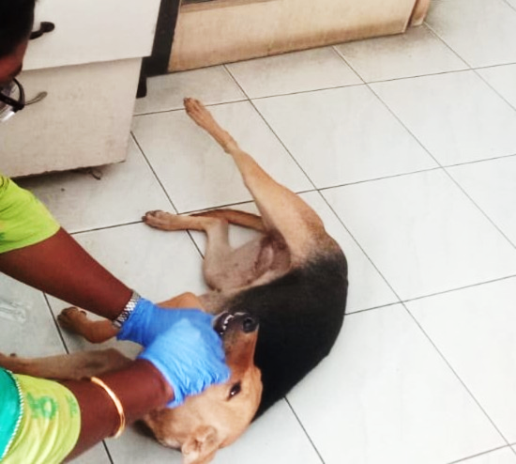

Fig. 1. Collection of samples from healthy dogs

3. RESULTS AND DISCUSSION

Lactic acid bacteria constitute a major group of probiotic bacteria to be used as probiotic supplement for animals. The lactic acid bacteria are always species specific but none of the commercial probiotic product of dogs are not canine origin. Isolation and characterization of lactic acid bacteria from canine fecal samples are important for preparation of species specific probiotic supplement. Among 160 fresh oral and fecal samples, 60 fecal samples and 15 oral samples were positive for lactic acid bacteria grown in lactobacillus selective media MRS broth and Rogosa agar (Fig. 2,4). The lactic acid bacteria strain present in oral and fecal samples were identified by partial 16s rRNA gene sequencing of a fragment amplifier by PCR using universal primer and 900bp PCR product was obtained (Fig. 5). The ABST shows sensitivity towards doxycycline, cephotaxime and gentamicin. The Lactobacillus fermentum, Lactobacillus plantarum, Lactobacillus casei, Lactobacillus mucosae, Lactobacillus delbrueckii and Lactobacillus salivarius were most frequently encountered bacteria in canine oral cavity and feces. Sequence similarity values of 93 % with Lactobacillus casei, 89% with Lactobacillus pentosus, 85% with Lactobacillus delbrueckii were found similar to the finding of Biagi et al. (2007).

“Antibiotic sensitivity test is usually carried out to determine which antibiotic kills the bacteria effectively. Here antibiotic sensitivity test is done in order to determine which drug when consumed kills the essential live bacteria inside the gastrointestinal tract. The drugs which kill the lactobacillus species can be determined and thus we can avoid those drugs. The isolated lacto bacillus species shows sensitivity towards doxycycline, cephotaxime and gentamicin (Fig. 4)” (Raju et al. 2018).

“Bacteria are frequently associated with subclinical abnormalities of canine gastrointestinal tract causes small intestinal bacterial overgrowth (SIBO). Lactic acid bacteria (LAB) constitute a major group of bacteria to be used as probiotic supplement for animals. The probiotic characters of bacteria are linked to host specific and site specific. The probiotic bacteria for canine health ere isolated and characterized from canine feces and oral of the seven most popular dogs in USA like German shepherd, Golden Retriever, Dachshund, Boxer, Labrador, Pomeranian and Pug” (Benno et al., 1991 &Kumar et al.,2016). “Lactobacilli may be present in small quantities in all parts of the canine gastro-intestine and the molecular profiling of lactobacillus species leading to the accurate identification of LAB isolated and partial 16S rRNA gene sequencing of fecal and oral isolates and showed LAB to be present in oral and fecal sample” (Greetham et al., 2002). “The isolated bacteria were cultivated in an anaerobic condition. The probiotic bacteria must tolerate the low pH in the stomach and the pH of the gastric contents of canine gut can fall to a level of two or less, after which the pH gradually increases towards the small intestine and the colon and microbial cultures used as probiotics have been proposed to be screened for their resistance to acidity and bile tolerance. Many lactic acid bacteria strains have the capacity to inhibit other pathogenic bacteria either by producing antibacterial peptides or by secreting other inhibitory compounds such as reuterin” (Taheri et al., 2009 & Tang et al., 2012).

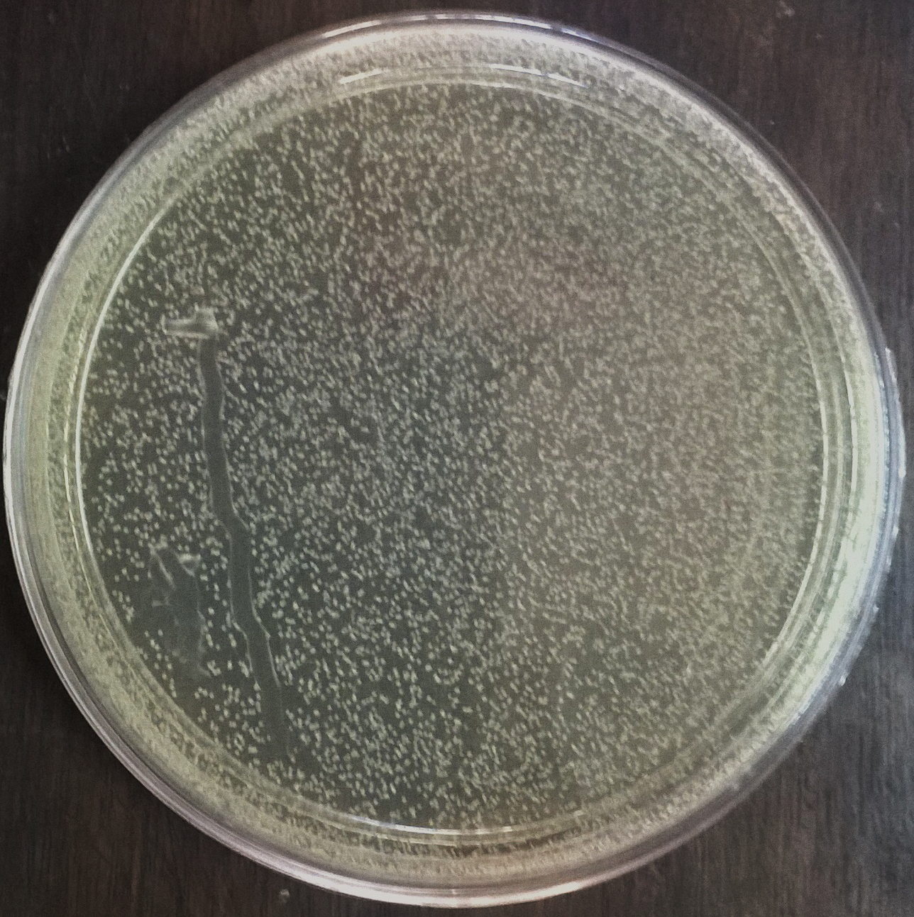

Fig. 2. Isolation of lactobacillus from canine oral sample
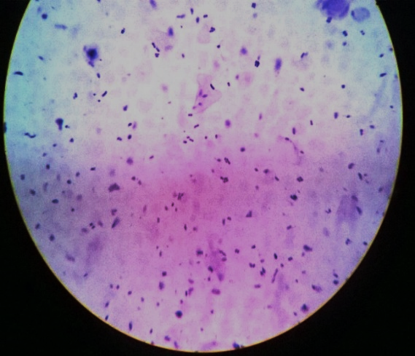

Fig. 3. Gram staining of isolated bacteria shows gram positive bacillus

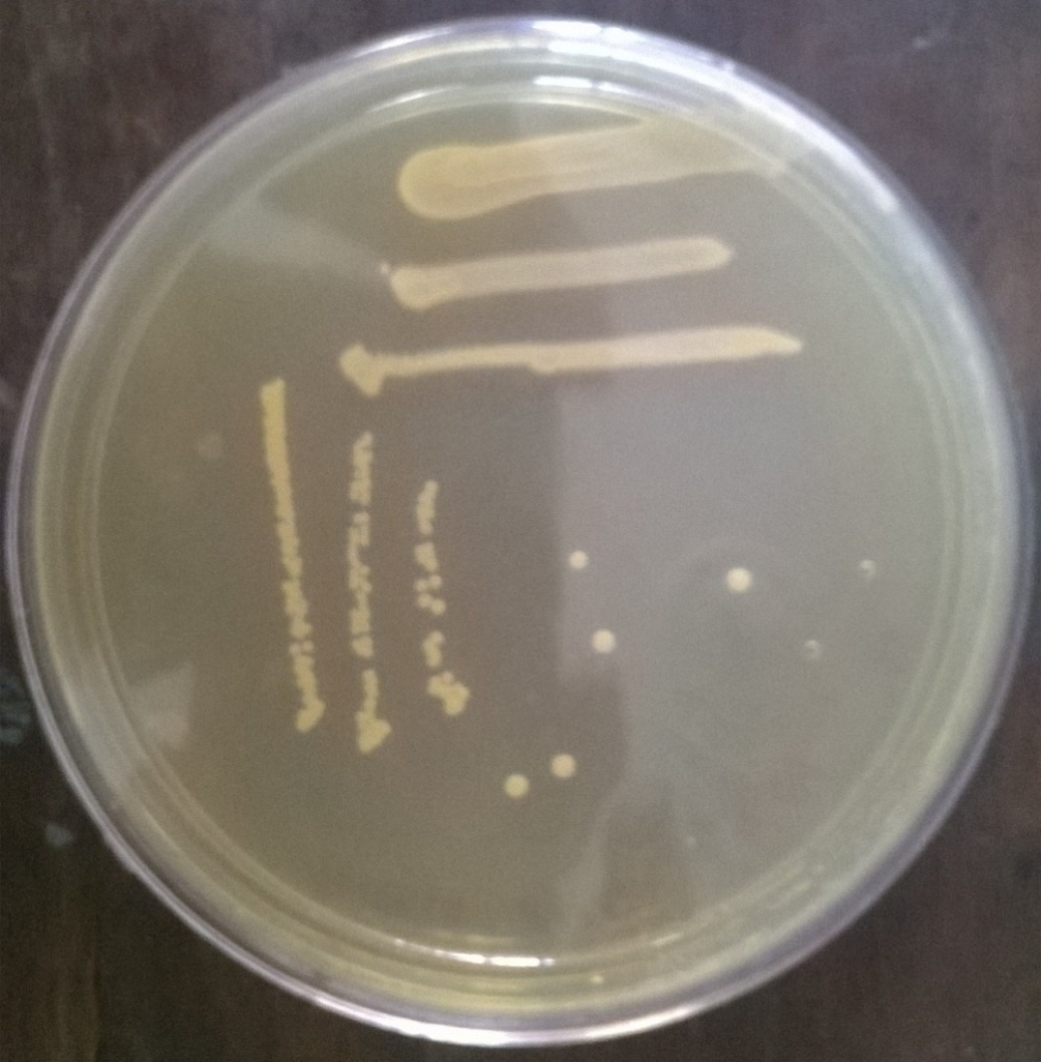

Fig. 4. Isolation of lactobacillus from canine faecal sample

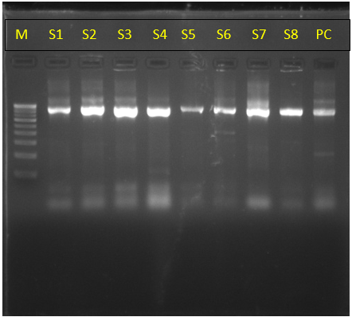

Fig. 5. The 900 base pair product was obtained by PCR amplification in 1% agarose gel
M-Marker, S1 to S8 -test samples, PC- positive control

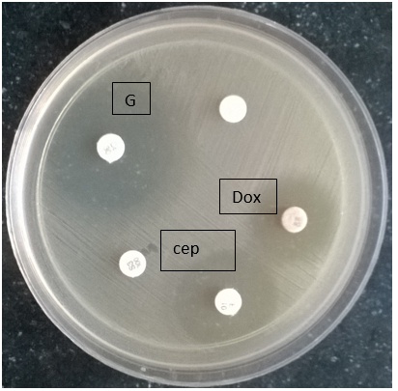

Fig. 6. The isolated lacto bacillus species shows sensitivity towards doxycycline, Cephotaxime and gentamicin

Table 1. Sequences analysis showed significant homology with other lactobacillus isolates

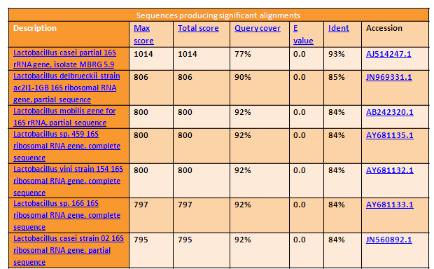

“Probiotic intervention studies have also been conducted on healthy dogs, to investigate probiotic-induced shifts in the microbiota. Most of the studies shows that the an increase in LAB will decrease the amount of potentially pathogenic bacteria. The probiotic L. acidophilus strain DSM13241 increased the number of fecal lactobacilli and decreased the number of Clostridia and improved immune function in dogs by increasing hematocrit levels, hemoglobin concentrations, serum IgG levels, and the number of red blood cells, neutrophils and monocytes” (Baillon et al. 2004). “The canine feces-derived strain L. animalis LA4 led to an increase in fecal lactobacilli while reducing enterococci Canine-derived strain L. fermentum AD1 increased the number of fecal lactobacilli and enterococci as well as total proteins and lipids, and reduced serum glucose levels” (Biagi et al. 2007). “The canine colon-derived strain B. animalis AHC7 significantly reduced carriage of Clostridia in dogs” (O'Mahony et al. 2009). “Prebiotics are substrates that can facilitate the growth and function of probiotics when used with probiotics and symbiotic combinations have rarely been studied in dogs”. (Strompfová et al. 2012).

“The probiotic addition to canine weaning food improve the overall health as well as the dog’s lifespan and particularly the development of its immune system. Ent. faecium is the only one pharmaceutical probiotic on the commercial market for veterinary use in Finland, reported that to the decrease the adhesion and colonization of Campylobacter jejuni on canine intestinal mucus which emphasizing the need of a safer host-specific probiotic for canine. The isolated LAB from canine intestine which adhered to immobilized intestinal mucus and inhibited the adhesion of certain bacterial pathogens” (Perelmuter et al.,2008). Tang et al. (2012) identified seventy-four lactobacilli isolates from beagle dogs by 16S rRNA gene sequencing and he found that L. acidophilus was most dominant followed by L. murinus, L. reuteri, L. johnsonii. Vineetha et al. (2016) reported detection of L. plantarum and L. reuteri from the GI tract of guinea fowl by 16S rRNA gene sequencing. Benno et al. (1992) and Greetham et al. (2002) reported higher Lactobacillus count in indigenous dogs of younger age with colonization resistance against pathogens.

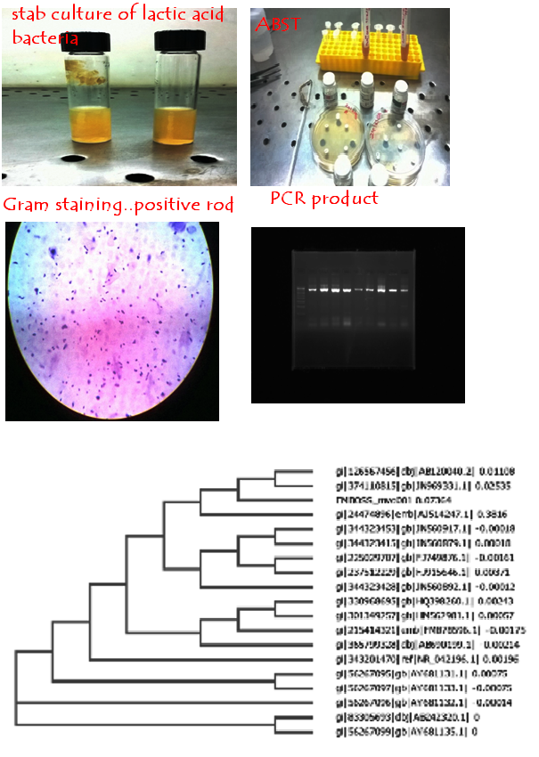

Image 1. Sequencing and phylogenetic analysis of amplified PCR products

Kumar et al. (2016) reported the superiority of canine-origin probiotic over the dairy-origin in improving the metabolic response and overall health of dogs. In this present study, the feacal and oral lactobacillus species isolated from dogs were characterized by PCR and sequencing shows similarity with other canine isolates.

4. CONCLUSION

Probiotic bacteria plays a major role for controlling gut bacterial viral and parasitic infection. Species specific live probiotic bacteria with appropriate does will give better mucosal immunity against enteric pathogens and further indepth detailed studies are needed in this area.

DISCLAIMER (ARTIFICIAL INTELLIGENCE)

Author(s) Here by I declare that NO generative AI technologies such as Large Language Models (ChatGPT, COPILOT, etc.) and text-to-image generators have been used during the writing or editing of this manuscript.

CONSENT

As per international standards or university standards, dog’s owner written consent has been collected and preserved by the author(s).

REFERENCES

Baillon, M. L. A., Marshall-Jones, Z. V. and Butterwick, R. F. (2004). Effects of probiotic Lactobacillus acidophilus strain DSM13241 in healthy adult dogs. Am. J. Vet. Res. 65(3):338-343.
Benno, Y., Nakao, H., Uchida, K. and Mitsuoka, T. (1992). Impact of the advances in age on the gastrointestinal microflora of beagle dogs. J. Vet. Med. Sci. 54(4):703-706.
Biagi, G., Cipollini, I., Pompei, A., Zaghini, G. and Matteuzzi, D. (2007) Effect of a Lactobacillus animalisstrain on composition and metabolism of the intestinal microflora in adult dogs. Vet Microbiol 124, 160-165.
Greetham, H. L., Giffard, C., Hutson, R. A., Collins, M. D. and Gibson, G. R. (2002). Bacteriology of the Labrador dog gut: a cultural andgenotypic approach. J. Appl. Microbiol. 93(4):640-646
Herstad, H.K., Nesheim, B.B., L'Abée-Lund, T., Larsen, S. and Skancke, E. (2010) Effects of a probiotic intervention in acute canine gastroenteritis--a controlled clinical trial. J Small Anim Pract 51, 34-38.
Kelley, R.L., Minikhiem, D., Kiely, B., O'Mahony, L., O'Sullivan, D., Boileau, T. and Park, J.S. (2009) Clinical benefits of probiotic canine-derived Bifidobacterium animalis strain AHC7 in dogs with acute idiopathic diarrhea. Vet Ther 10, 121-130.
Kumar, S., Pattanaik, A.K., Sharma, S. and Jadhav, S.E. (2016). Species-specific probiotic Lactobacillus johnsonii CPN23 supplementation modulates blood biochemical profile and erythrocytic antioxidant indices in Labrador dogs. Indian J. Anim. Sci. 86(8).
Kumar, S., Pattanaik, A.K., Sharma, S., Jadhav, S.E., Dutta, N. and Kumar, A. (2017). Probiotic Potential of a Lactobacillus Bacterium of Canine Faecal-Origin and Its Impact on Select Gut Health Indices and Immune Response of Dogs. Probiotics Antimicrob. Proteins, 1-16.
Martin, R., Olivares, M., Perez, M., Xaus, J., Torre, C., Fernandez, L. and Rodriguez, J. M. (2010). Identification and evaluation of the probiotic potential of lactobacilli isolated from canine milk. Vet. J. 185(2): 193-198.
McCoy, S. and Gilliland, S. E. (2007). Isolation and characterization of Lactobacillus species having potential for use as probioticcultures for dogs. J. Food. Sci., 72(3):M94-M97.
O'Mahony, D., Murphy, K.B., MacSharry, J., Boileau, T., Sunvold, G., Reinhart, G., Kiely, B., Shanahan, F. and O'Mahony, L. (2009) Portrait of a canine probiotic Bifidobacterium--from gut to gut. Vet Microbiol 139, 106-112.
Pascher, M., Hellweg, P., Khol-Parisini, A. and Zentek, J. (2008) Effects of a probiotic Lactobacillus acidophilus strain on feed tolerance in dogs with non-specific dietary sensitivity. Arch Anim Nutr 62, 107-116.
Perelmuter, K., Fraga, M. and Zunino, P. (2008). In vitro activity of potential probiotic Lactobacillus murinus isolated from the dog. J.Appl. Microbiol. 104(6):1718-1725.
Raju, M. K., Kapali, B., JebaSingh, G. V., Subathra, Y., & Nithya, A. (2018). Isolation, Characterization and Sequencing of Lactobacillus from the Oral and Fecal Samples of Healthy Dogs. Research Journal of Pharmacy and Technology, 11(11), 5061-5065.
Sauter, S.N., Benyacoub, J., Allenspach, K., Gaschen, F., Ontsouka, E., Reuteler, G., Cavadini, C., Knorr, R. and Blum, J.W. (2006) Effects of probiotic bacteria in dogs with food responsive diarrhoea treated with an elimination diet. J Anim Physiol Anim Nutr (Berl) 90, 269-277.
Strompfová, V., Lauková, A. and Gancarþíková, S. (2012) Effectivity of freeze-dried form of Lactobacillus fermentum AD1-CCM7421 in dogs. Folia Microbiol (Praha) 57, 347-350.
Taheri, H.R., Moravej, H., Tabandeh, F., Zaghari, M. and Shivazad, M. (2009). Screening of lactic acid bacteria toward their selection as a source of chicken probiotic. Poult. Sci. 88(8): 1586-1593.
Tang, Y., Manninen, T. J., and Saris, P. E. (2012). Dominance of Lactobacillus acidophilus in the facultative jejunal Lactobacillus microbiota of fistulated beagles. Appl. Environ. Microbiol. 78(19):7156-7159.
Vineetha, P.G., Tomar, S., Saxen a, V.K., Sandeep, S., Adil, K. and Mukesh, K. (2016). Screening of Lactobacillus isolates from gastrointestinal tract of guinea fowl for probiotic qualities using in-vitro tests to select species-specific probiotic candidates. Br. Poult. Sci. 57(4): 474-482.

