Evolution of the Arсhaean continental crust in the north-eastern Fennoscandian Shield, Arctic region: isotope (U-Pb, SHRIMP, Sm-Nd and REE) data synthesis

Abstract
The article provides a synthesis of new geological-geochemical and petrological data on Archaean rocks from the basement of the Central Kola and Murmansk Megablocks near the Murmansk city. In addition, some rocks from the Kolmozero-Voronya Greenstone Belt have been studied. Particular attention is given to plagiogranites, tonalities, gneisses, amphibolites, late granitoids, intensely altered rocks and non-stratified rocks from the basement complex. The paper provides novel geological, petrochemical, U-Pb, SHRIMP, Sm-Nd and REE data on rocks and minerals. The new ages are correlated with ancient rocks of tonalite-trondhjemite-granodiorite complexes and grey gneisses in the Fennoscandian Shield and other world regions. The genesis of the oldest continental crust retains a marked trace in the Earth’s evolution over its 4.5 Ga history. Despite ample isotope data on the role of the continental crust in the Earth’s evolution, the origin of grey gneisses and tonalite-trondhjemite-granodiorites (TTG) has been much debated. Precise U-Pb (ID-TIMS) and SHRIMP data on single zircon for paragneisses and TTG (3158.2±8.2 Ma) show the Central Kola and Belomorian (White Sea) megablocks of the Fennoscandian Shield to be 3.16 Ga and 3.70 Ga, respectively. The new ages of zircon from these megablocks indicate the origin of the discrete continental crust to be 3.16 and 3.70 Ga. It is close to the Nordsim zircon data on the Siurua TTG (Finland), i.e. 3.45 and 3.73 Ga in the core. Summarized data on the Earth’s oldest rocks (basement and continental crust) indicate the younger age of the rocks in the Fennoscandian Shield compared to those in Australia.

Keywords: Fennoscandian Shield, ID-TIMS, SHRIMP, Sm-Nd, REE, grey gneiss

Introduction
One of the most crucial tasks of the present-day Precambrian study has been the issue of search and interpretation of basic principles of the ancient Earth crust development. Groups of scientists have been actively engaged in decades-long comprehensive research to obtain new data on signatures of the matter evolution at the early stages of the Earth genesis (Bleeker, 2003; Bogdanova et al., 2008, 2010; Ge et al., 2020b; Halla, 2020; Halla et al., 2009; Hölttä, 2012; Huhma et al., 1995, 2012; Kröner et al., 2016; Moyen and Martin, 2012; Nutman et al., 1996, 2016; Polat, Hofmann, 2003; Reimink et al., 2016a, 2016b; Savko et al., 2021; Timmerman and Daly, 1995; Upadhyay et al., 2019; Yu et al., 2021).
The Fennoscandian Shield is a part of the East European craton (Bogdanova et al., 2008). It is one of the most interesting objects to study the Precambrian. The currently available ages of the earliest rocks in the Fennoscandian Shield refer to the time span of 3.5-3.1 Ga, i.e. 3.5 Ga-old trondhjemite gneisses Siurua hosted by the Pudasjärvi granulite belt in Finland (Mutanen and Huhma, 2000), 3.2 Ga TTG-gneiss in Iisalmi (Hölttä et al., 2008) and 3.1 Ga Tojottamanselkä gneisses in Northern Finland (Jahn et al., 1984; Kröner and Compston, 1990).
In the past two decades new isotope data on TTG complexes in the Kola region have been obtained. In result, comprehensive geochronological, isotope-geochemical, petrological and geophysical data have been collected (Bogdanova et al., 2008; Bridgewater et al., 2001; Dokukina and Mints, 2018; Halla, 2020; Hölttä, 2012; Hölttä et al., 2008; Huhma et al., 2009; Kozhevnikov et al., 2010; Köykkä et al., 2019; Kröner and Compston, 1990; Li et al., 2017; Mikkola et al., 2012; Mints et al., 2020; Myskova et al., 2005; Nitkina et al., 2019). The Archaean Fennoscandian Shield is marked by the TTG association covering about 80% of the area with subordinate greenstone belts, paragneisses, granulite complexes and migmatite amphibolites (Hölttä et al., 2008).
The first Sm-Nd model ages of rocks from the Central Kola and Murmansk Blocks show 2.46-2.96 Ga (Timmerman and Daly, 1995). However, new studies suggest older Palaeoarchaean model ages for protoliths of these rocks in the range of 3.4-3.6 Ga, mainly for rocks in the south-western part of the Fennoscandian Shield (Jahn et al., 1984; Huhma et al., 1995, 2012; Hanski et al., 2001). The presence of the Palaeoarchaean ancient crust is also corroborated by studies of zircons with the ion microprobe analysis (Claesson et al., 1993) and studies of Sm-Nd model ages in the interval of 3.4-3.6 Ga (Hanski et al., 2001). Moreover, finds of detritic zircons dated by SHRIMP analyses of single grains as Hadaean-Archaean (Kozhevnikov et al., 2010; Myskova et al., 2005) provide a deeper insight into the history of the Fennoscandian Shield, still leaving the issue of the origin of these ancient zircons open.
Nd isotope compositions of granitoids and TTG gneisses in the Kola region vary widely from the lowest εNd(T) values of about -11 (Mutanen and Huhma, 2000; Timmerman and Daly, 1995) to the ultradepleted εNd(T) values of +5.3 – +8.2, as recalculated for the measured age of 3.15 Ga, for the TTG-complex of the Ingozero massif (Nitkina et al., 2019). A wide range of Nd isotope compositions is commonly explained by disturbances in isotope systems caused by metamorphic events with a varied degree of contamination by the crustal material, which is typical of not only ancient rocks in the Baltic Shield, but other ancient cratons all over the world as well (Akame et al., 2020; Bruno et al., 2020; Ge et al., 2020a; Neto and Lafon, 2020; Polat et al., 2011, 2009; Teixeira et al., 1996; Upadhyay et al., 2019).

Geological setting
The oldest 35 pieces of the continental crust made of tonalite-trondhjemite-granodiorite gneisses (TTG) mostly imprint the Earth’s evolution during much of its ca. 4.5 Ga history (Bleeker, Ernst, 2006). The study of the Archaean continental crust provides geological and geochemical insights to the early Earth due to asteroid and meteorite impacts (Glikson, 2014).
The Arctic region of the Fennoscandian Shield encompasses large-scale strategic deposits, such as the Neoarchaean banded-iron formations (BIFs, Olenegorsk ore area), Palaeoproterozoic PGE-Cu-Ni and PGE-Cr-Ti deposits (Monchegorsk, Fedorovo-Pana and Imandra ore areas), Cu-Ni deposits (Pechenga) and major Palaeozoic apatite-nepheline and phosphorite deposits (Khibiny, Lovozero, Kovdor, etc.). Thus, the study of their basement or continental crust is essential for understanding of processes that governed formation of the deposits.
Relics of ancient Hadaean, Eo-, Palaeo-, Meso- and Neoarchaean rocks are known in almost every continent in the world (Van Kranendonk, 2019). Table 1 summarizes all ages obtained for deposits in the north-eastern Arctic region of the Fennoscandian Shield (Murmansk region and Karelia).

Table 1. Geochronological data on Eo-, Palaeo- and Mesoarchaean rocks in the eastern Fennoscandian Shield.
Deposit | Rock | Method | Age, Ma | Reference
Vyg-Ruchey, Vodlozero Block | Tonalites | U-Pb TIMS | (3138 ± 63) | (Lobach-Zhuchenko, 1993)
Vyg-Ruchey, Vodlozero Block | Leucosomes of trondhjemite migmatites | U-Pb TIMS | (3210 ± 12) | (Lobach-Zhuchenko, 1993)
Lay-Ruchey, Vodlozero Block | Tonalites | U-Pb TIMS | (3166 ± 14) | (Lobach-Zhuchenko, 1993)
Vodlozero Block | Gneiss | U-Pb TIMS | (3151 ± 18) | (Lobach-Zhuchenko, 1993)
Vodlozero Block | Tonalites | SHRIMP II | (2850 ± 74) | (Chekulaev, 2013)
Vodlozero Block | Tonalites | SHRIMP II | (2767 ± 23) | (Chekulaev, 2013)
Vodlozero Block | Gneiss | SHRIMP II | (2967 ± 7) | (Chekulaev, 2013)
Vodlozero Block | Gneiss | SHRIMP II | (3240 ± 14) | (Sergeev, 2007)
Vodlozero Block | Gneiss | SHRIMP II | (3153 ± 5.4) | (Sergeev, 2007)
Vodlozero Block | Tonalite gneisses | SHRIMP II | (3236 ± 17) | (Sergeev, 2007)
Central Kola Block, Murmansk city area | Garnet-biotite gneisses | SHRIMP II | (2909 ± 9) – (2732 ± 13) | (Myskova et al., 2015)
Central Kola Block, Murmansk city area | Sillimanite-garnet-biotite gneisses | SHRIMP II | (2860 ± 10) – (2636 ± 9) | (Myskova et al., 2015)
Central Kola Block, Murmansk city area | Sillimanite-garnet-biotite gneisses | SHRIMP II | (3202 ± 7) | (Myskova et al., 2015)
Central Kola Block, Murmansk city area | Sillimanite-garnet-biotite gneisses | SHRIMP II | (3341 ± 10) | (Myskova et al., 2015)
Central Kola Block, Murmansk city area | Sillimanite-garnet-biotite gneisses | SHRIMP II | (3461 ± 5) | (Myskova et al., 2015)
Voche-Lambina, Central Kola Block | Tonalite gneisses | U-Pb TIMS | (3158,2 ± 8,2) | (Morozova et al., 2012)
Finland, Siuria | TTG | U-Pb, Nordsim | 3730 | (Huhma et al., 2012)
Finland, Iisalmi complex | TTG, orthogneisses, granodiorite | U-Pb, SIMS | (3181 ± 62) | (Van Kranendonk, 2019)
Finland, Iisalmi complex | Mafic granulite | U-Pb, SIMS | (3197-3168) | (Van Kranendonk, 2019)

Isotope data on zircon (SHRIMP-II) indicate the Eoarchaean age of core areas of zircon separated from garnet-biotite-staurolite-kyanite gneisses of the Central Kola Megablock in the western Baltic Shield (Figs. 1 and 2).

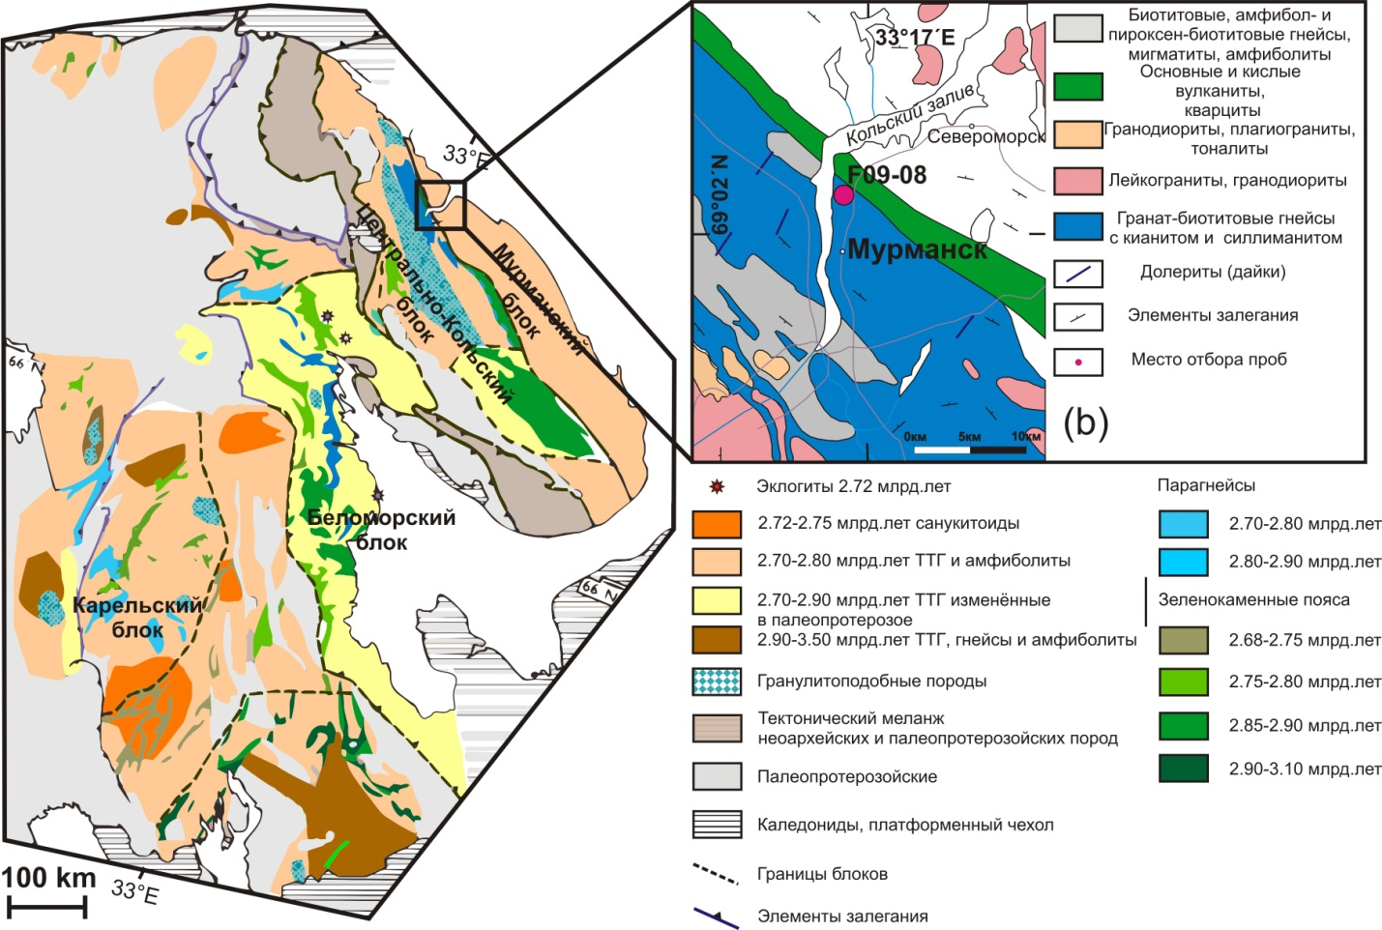
Figure 1. Summarizing geological map of the Fennoscandian Shield (а) after (Holtta et al., 2012) and schematic map of the Murmansk region (b), sampling point F-09-08 dated at 3.7 Ga.

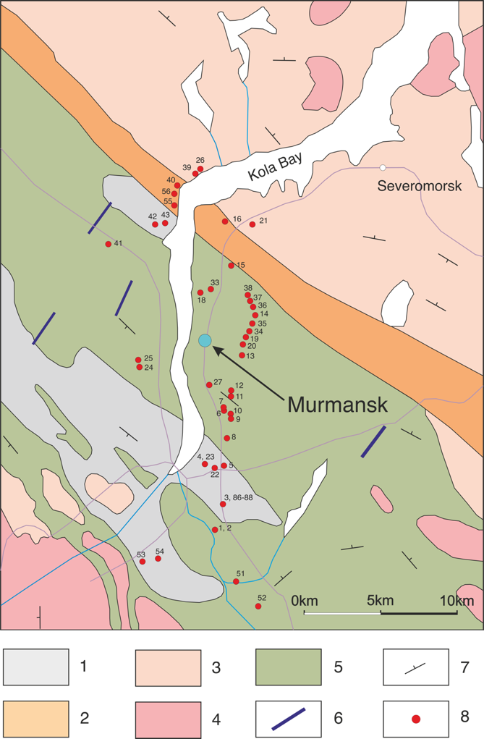
Figure 2. Schematic geological map of the study area in 2017-2020.
1 – biotite, amphibole- and pyroxene-biotite gneisses, migmatites, amphibolites; 2 – basic and acidic volcanites, quartzites; 3 – granodiorites, plagiogranites, tonalites; 4 – leucogranites, granodiorites; 5 – garnet-biotite gneisses with kyanite and sillimanite; 6 – dolerites (dykes); 7 – structural elements; 8 – sampling points.

New U-Pb ID-TIMS and SHRIMP zircon ages of TTG in the Voche-Lambina (Belomorian block) area have been estimated at 2.9 - 2.82 Ga with Sm-Nd model ages of 3.0 Ga for the same rocks with positive εNd values of +0.6 to +3.2 (Morozova et al., 2012). There had been no chance to find a typical TTG complex with Palaeoarchean zircon ages in the Central Kola Megablock for a long time. Only several SHRIMP zircon data had been available for the gneisses, which were not older than 3.6 Ga (Myskova, 2015).
Precise zircon core ages of gneisses and TTG in the north-eastern Fennoscandian Shield (Siurua, Finland) measured at Nordsim at 3.45 and 3.73 Ga (Mutanen, 2003) have revived the study of the oldest rocks in the Central-Kola megablock. According to Holta et al. (Hölttä, 2012), the Fennoscandian Shield hosts the Murmansk, Belomorian, Norbotten and Karelian provinces with TTG and amphibolites with the age range of 2.7 - 2.8 Ga, as well as paragneisses, greenstone belts and sanukitoids, with the age range of 2.72 - 2.75 Ga. The Karelian province comprises the West-Karelian and the Central-Karelian subprovinces. The Vodlozero province is composed of TTG gneisses and amphibolites of greenstone belts with the ages of 2.9 to 3.5 Ga. The Belomorian province comprises TTG and amphibolites (2.7-2.9 Ga) altered in the Palaeoproterozoic. Eclogites have been recently reported to occur there (Van Kranendonk, 2019). The province also hosts the Voche-Lambina geological site. SHRIMP analysis of zircons from TTG has yielded the age of 3158.2 ± 8.2 Ma (Morozova et al., 2012, Chekulaev, 2013).
The studied rocks refer to grey gneisses of the Central Kola Megablock basement in the Murmansk province. They occur near the monument to the Defenders of the Soviet Arctic (Murmansk, Russia). These rocks are composed of garnet-biotite gneisses with kyanite and sillimanite (Figure 3). Besides, there are biotite-amphibole gneisses with migmatites and amphibolites. This subprovince accommodates mafic and felsic volcanics, quartzites, granodiorites, plagiogranites and tonalities (Myskova, 2015; Petrovskaya, 2010).

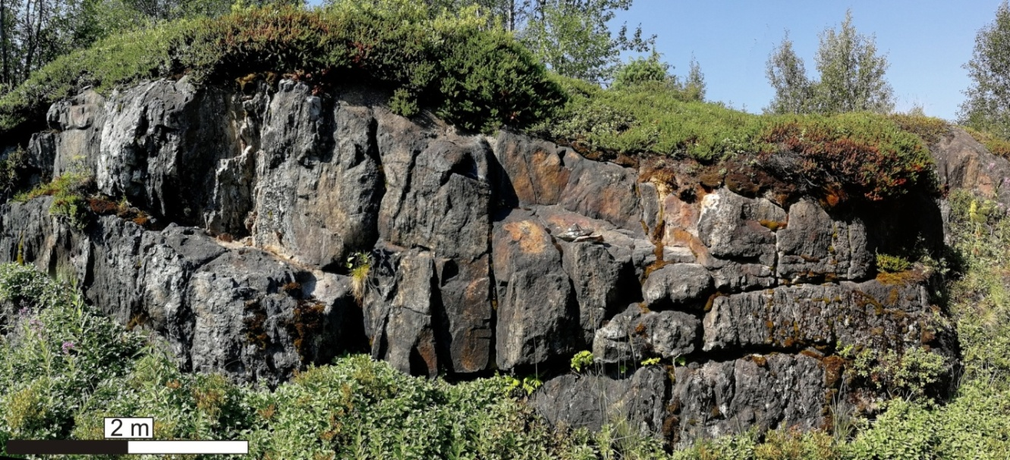
Figure 3. Outcropped staurolite-kyanite-sillimanite-garnet-biotite gneisses of the Central Kola Megablock dated at 3.7 Ga.

Materials and methods
Apart from typical representatives of granite-gneisses and gneisses, the studied rocks encompass various, usually vein, types, such as pegmatites, dolerites and dynamic metamorphism products.

Petrography of the studied rocks
Sample: 05MSK18 dolerite
The background shows large plagioclase in a polysynthetic twinning, generally as plates with the length of up to several mm (Fig. 4).
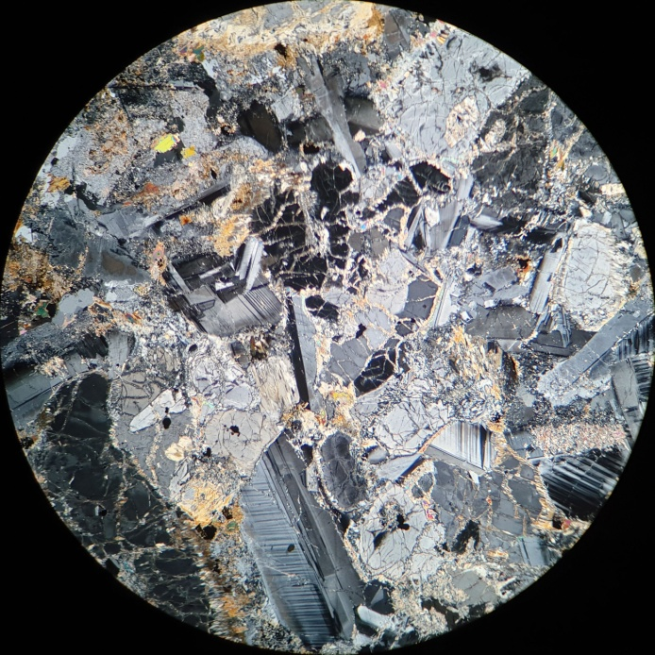 | 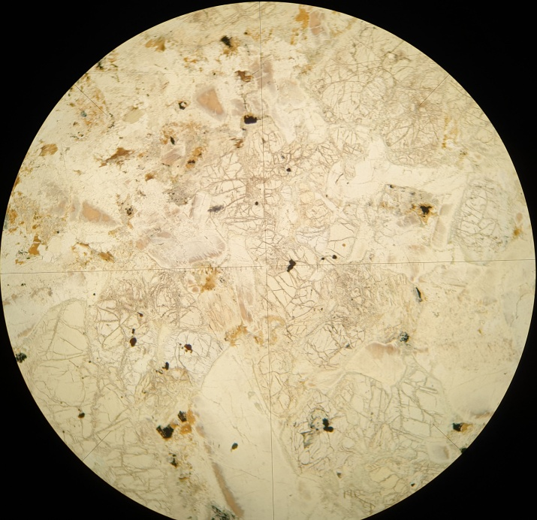
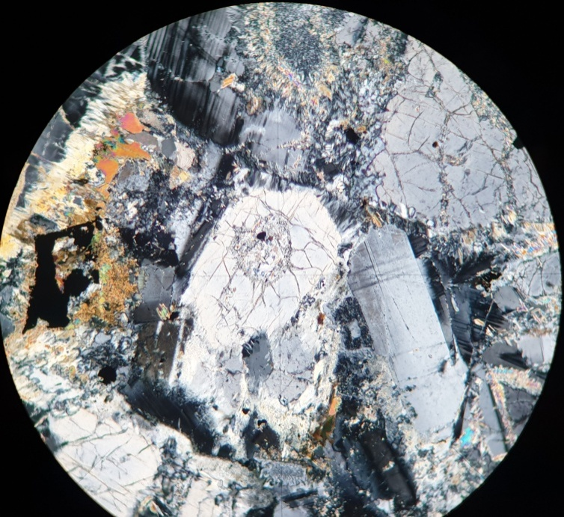 | 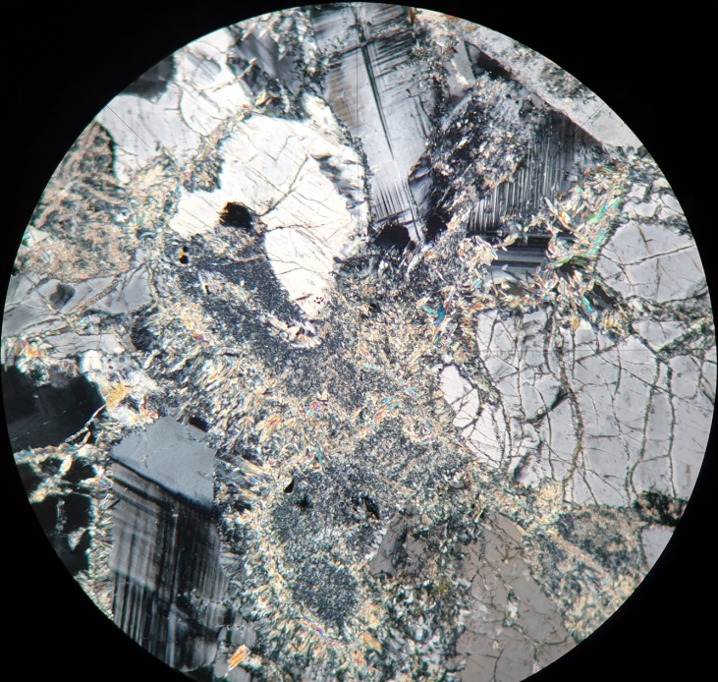
Figure 4. Microscopic images in transmitted and polarized light, showing the structure and mineral composition of the rock. Orthopyroxenes, plagioclases, accompanying microcline and ore minerals with neighbour phlogopite, chlorites and serpentinization zones are observed.

Sample: 05dMSK18 garnet-staurolite-sillimanite gneiss
At the background, the rocks contain quartz crystals with irregular edges up to several mm in diameter, darkening in a wavy, sectoral manner. They are accompanied by plagioclases, polysynthetic twins and orthoclase. Myrmekites occur on edges between quartz and orthoclase (Fig. 5).
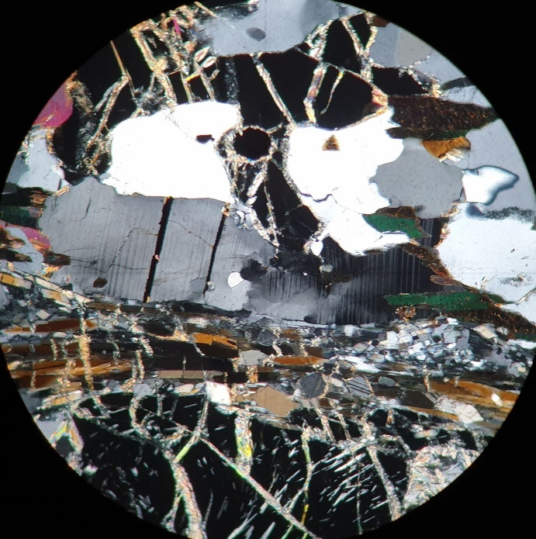 | 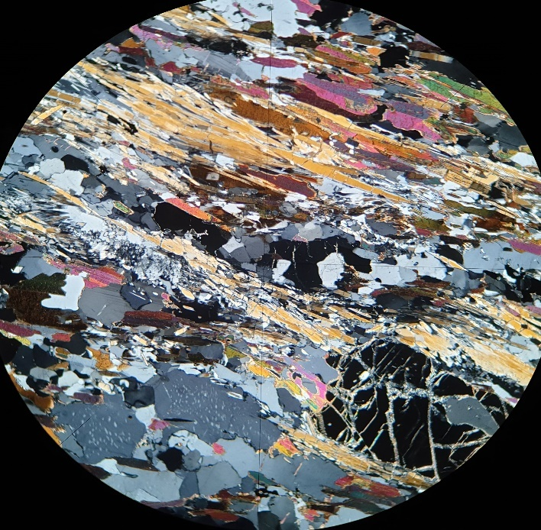
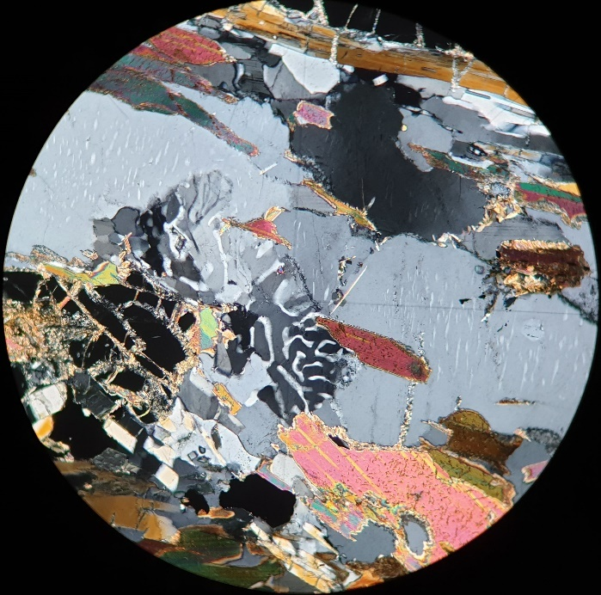 | 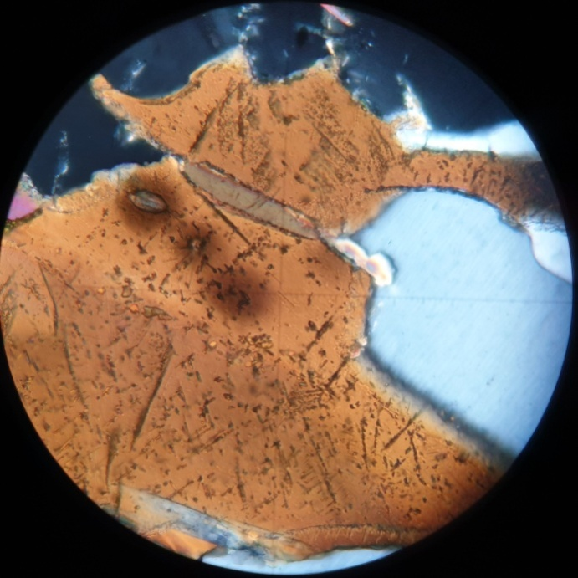
Figure 5. Microscopic images in transmitted and polarized light showing the structure and min-eral composition of the rock. There are visible grenades, ore minerals, myrmekite, sillimanite and staurolite, quartz, plagioclase and biotite with rutile and zircon.

Sample: 8aMSK18 two-mica granitoid
At the background, the rock contains leucocratic minerals, i.e. quartz, plagioclase and orthoclase. Quartz is irregularly shaped and dark-coloured; plagioclase is polysynthetically closed; orthoclase is usually highly sericitized (Fig. 6).
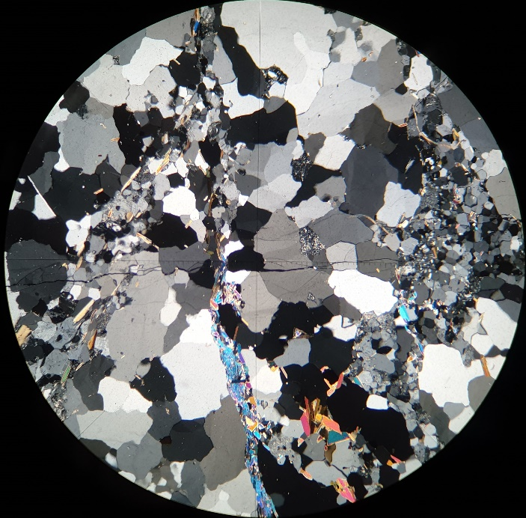 | 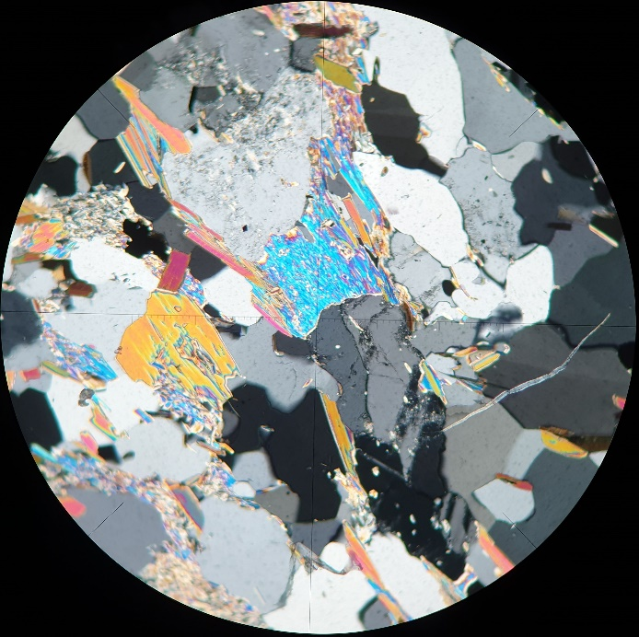
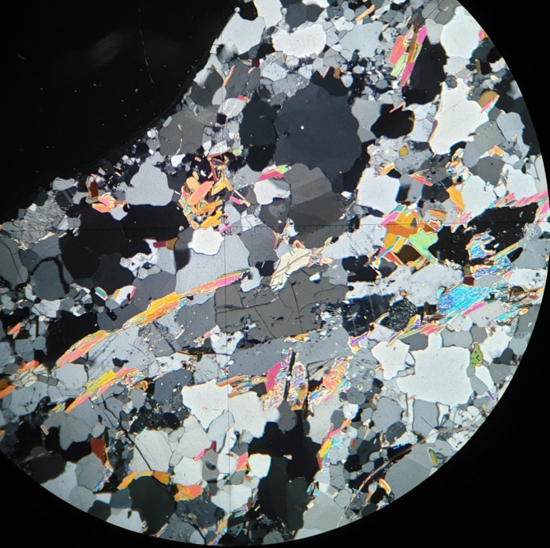 | 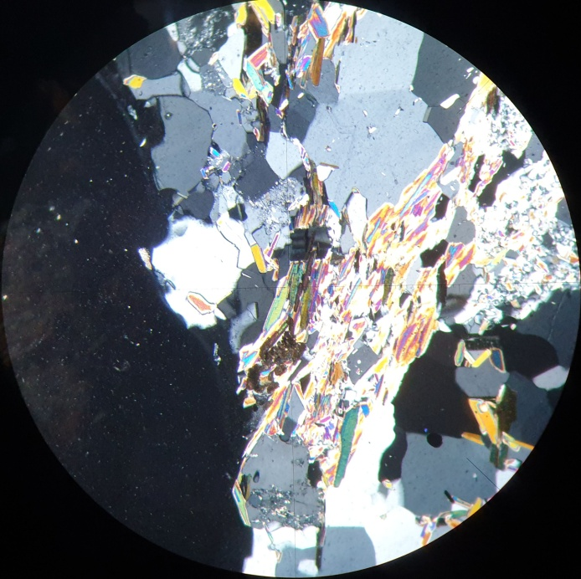
Figure 6. Microscopic images in transmitted and polarized light, showing the structure and mineral composition of the rock. Quartz, orthoclase, biotite, muscovite and admixtures of ore minerals are observed. The microscopic image (top left) shows crack zones underlined by the presence of iron oxides. Provided below is a hypersthene crystal (bottom left) and rutile in biotite (bottom right).

Sample: 17MSK18 granite-gneiss with kyanite
At the background, the rock contains dark quartz crystals with a varied grain size. Some of them host biotite inclusions. In addition to quartz, there is plagioclase, usually polysynthetic and twinned, and quite many cericitized orthoclases (Fig. 7).
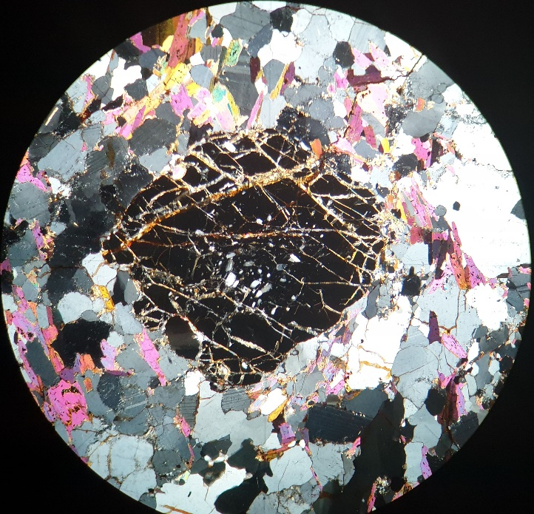 | 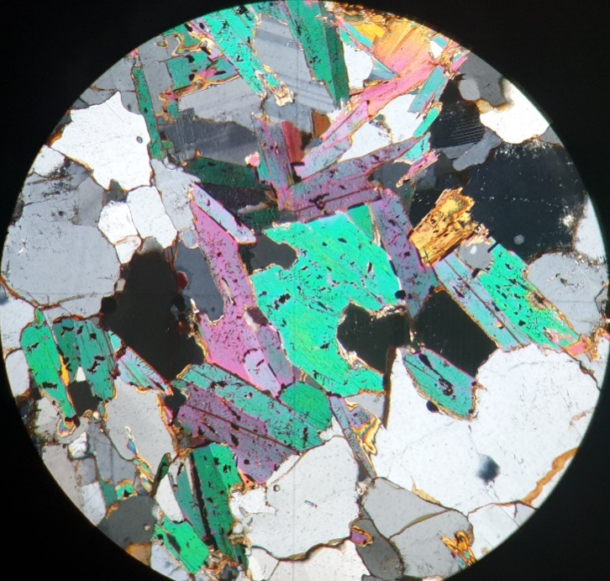
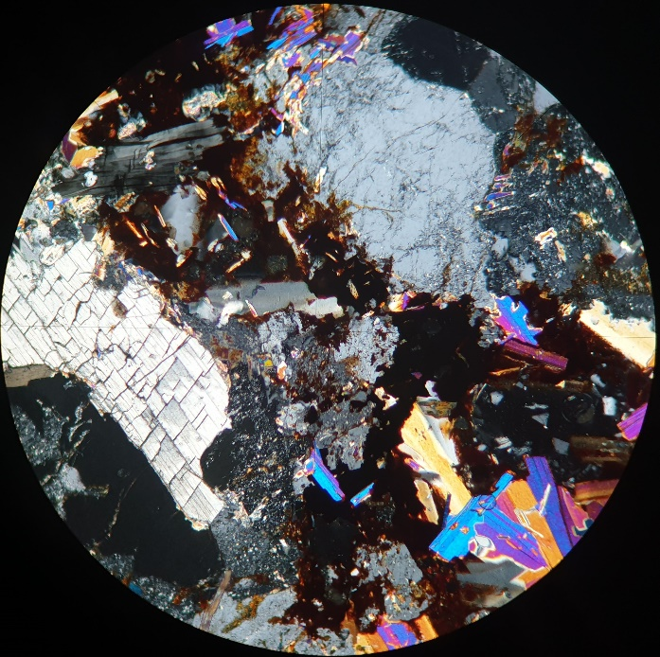 | 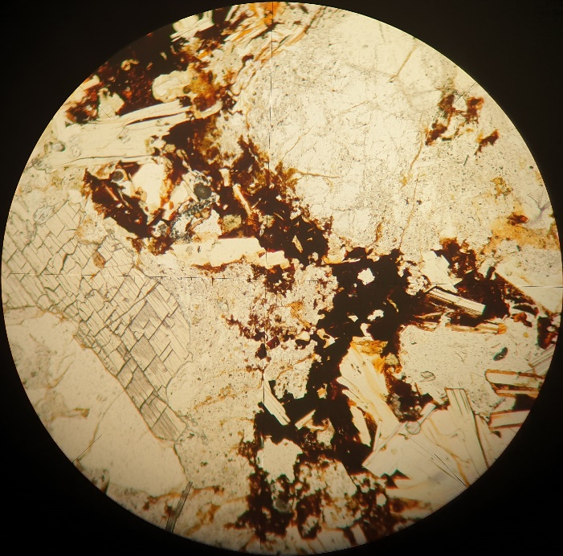
Figure 7. Microscopic images in transmitted and polarized light (a-c), showing the structure and mineral composition of the rock. Garnet, biotite, rutile and ore minerals are observed. The presence of kyanite and orthoclase is also shown in the microphotographs below.

Sample: 24/1MSK18 amphibolized pyroxenite
The rocks contain crystals of orthopyroxenes (hypersthene) and clinopyroxenes (diopside), forming aggregates of dense minerals of different sizes. These crystals occur as diablastic pyroxene intergrowths. Sometimes they have inclusions of apatite and zircon and sometimes also lamellar ilmenite. Minor crystals of talc also appear on edges of the studied minerals. In addition to the above-mentioned pyroxene, there are also numerous amphiboles in the rock, represented mainly by common hornblende, which surrounds pyroxenes, occurs in their interstices and sometimes as inclusions between ortho- and clinopyroxene crystals (Fig. 8).
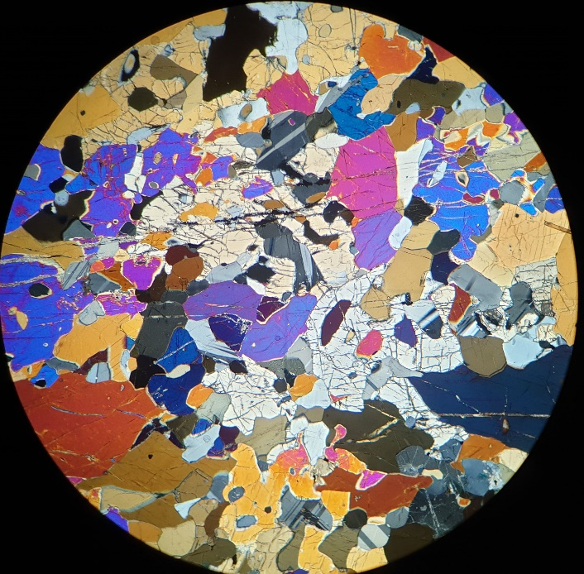 | 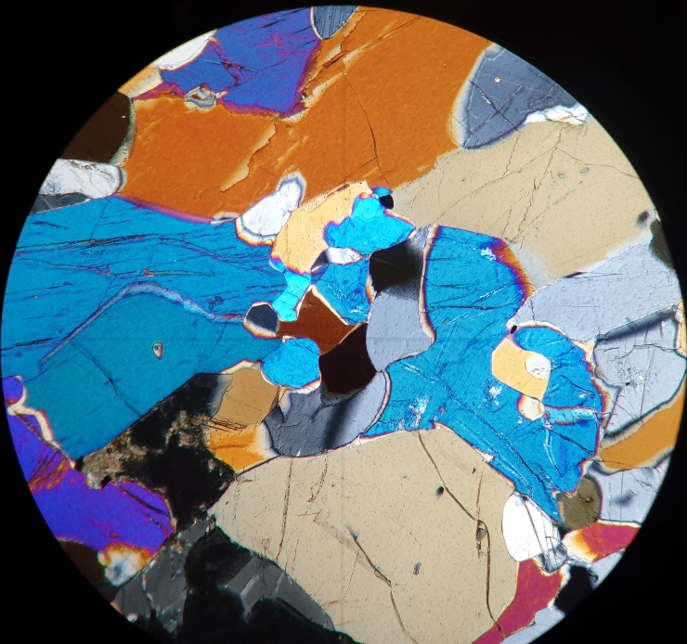
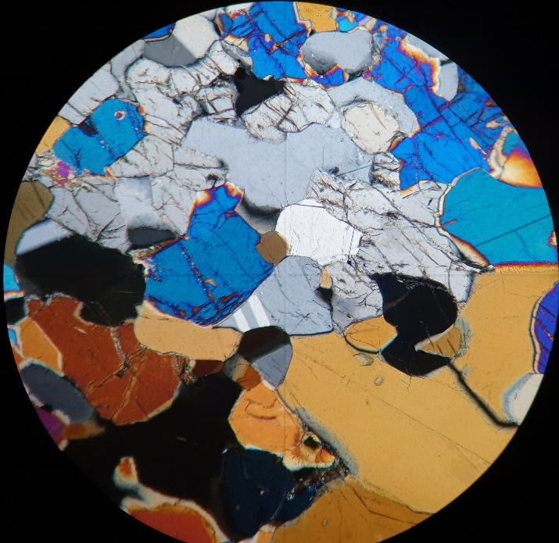 | 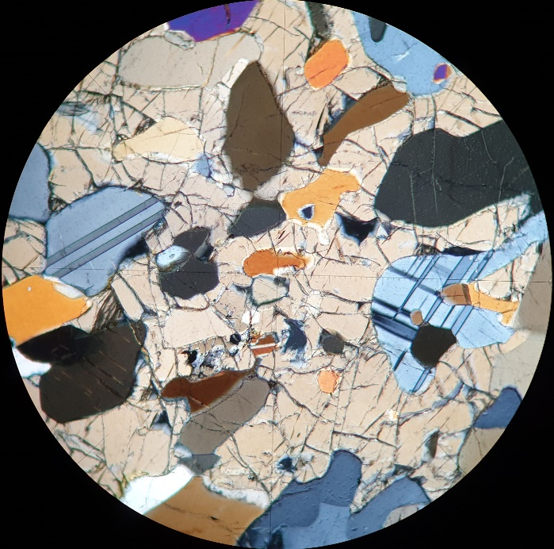
Figure 8. Microscopic images in transmitted and polarized light, showing the structure and mineral composition of the discussed rock. They show ortho - and clinopyroxenes, as well as plagioclases and ore minerals and amphiboles found in their interstices.

Sample: 26/1MSK18 granite gneisses
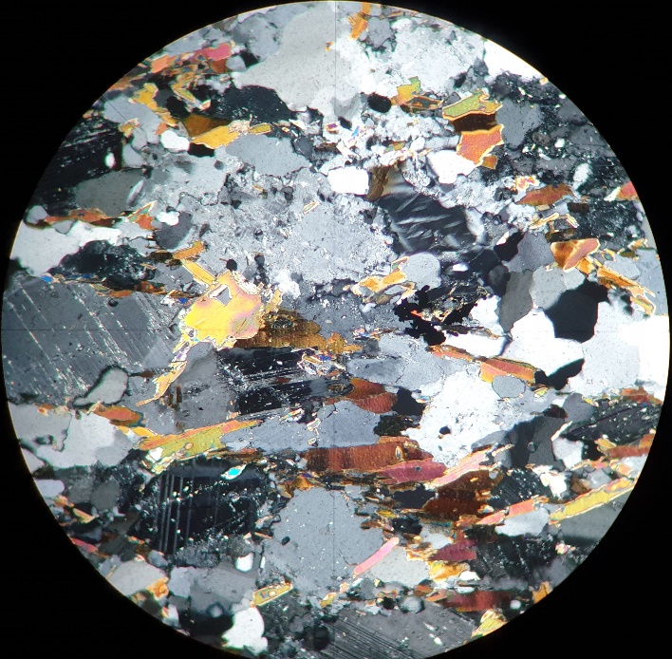 | 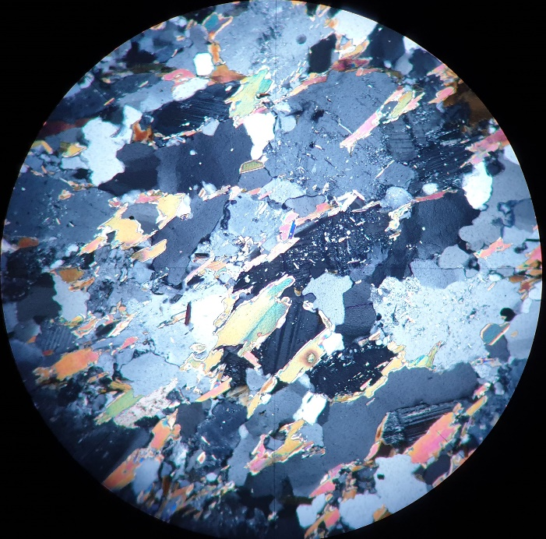
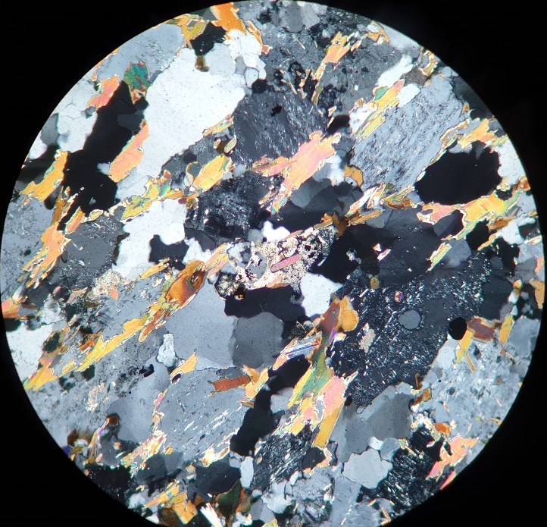 | 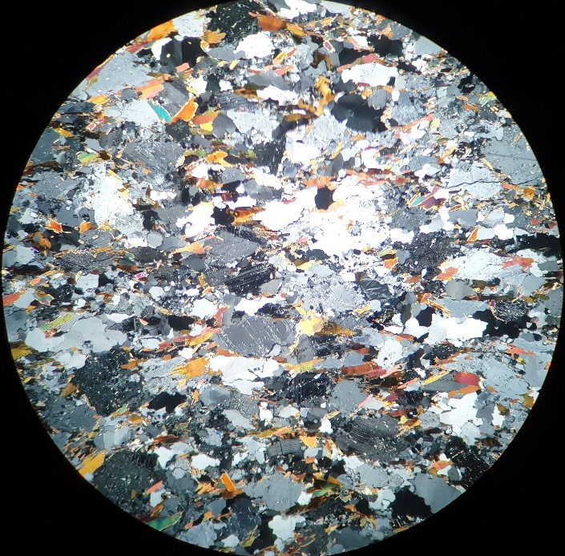
Figure 9. Microscopic images in transmitted and polarized light, showing the structure and mineral composition of the discussed rock with quartz, biotite, plagioclase and orthoclase in it.

Sample: 27/1MSK18 granite gneisses (Fig. 10)

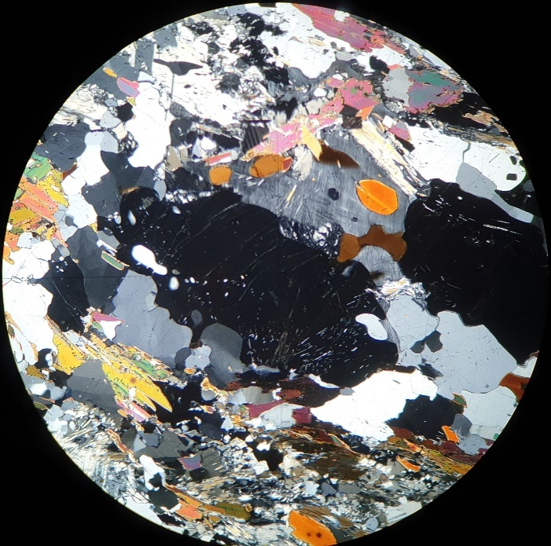 | 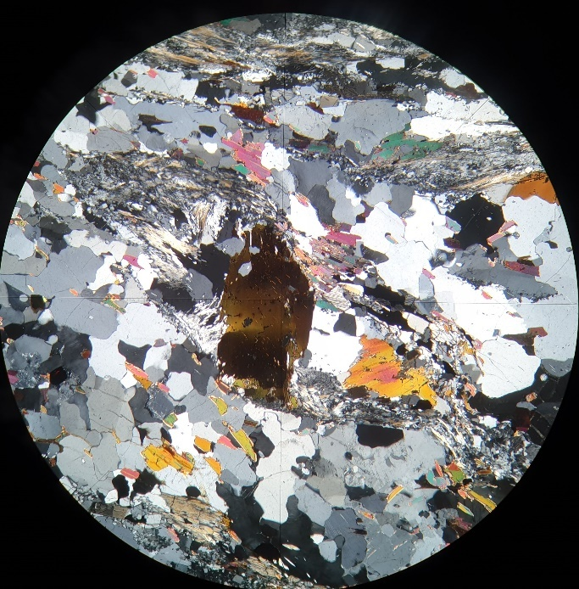
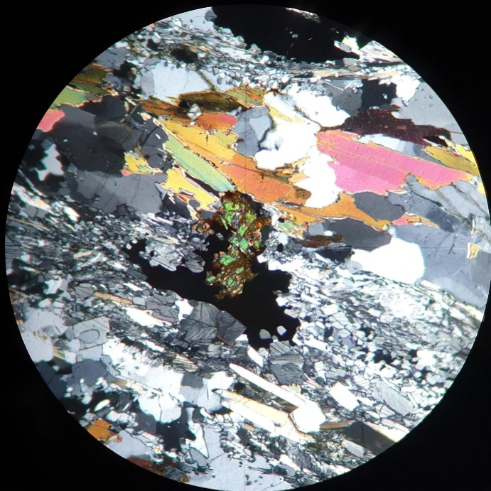 | 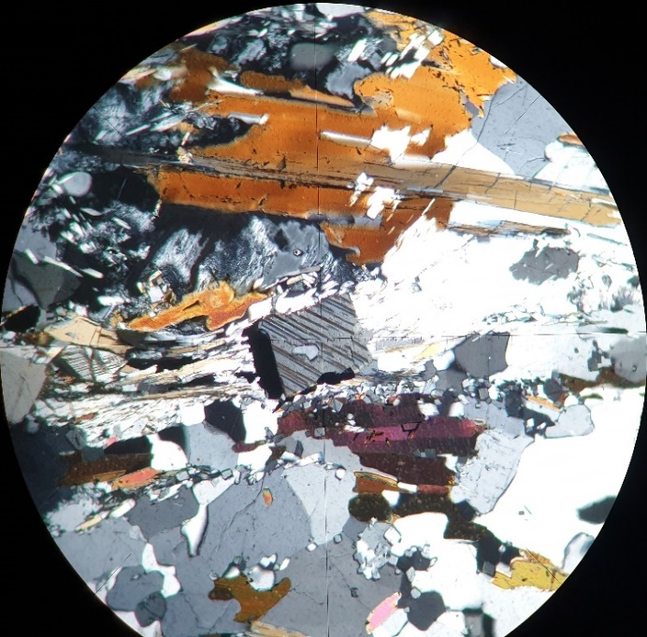
Figure 10. Microscopic images in transmitted and polarized light, showing garnets with quartz and staurolite inclusions. The helicite structure is underlined by biotite and staurolite. Shown below are minerals with titanite and staurolite with biotite, as well as quartz and plagioclases.

Sample: 28MSK18 granite gneisses (Fig. 11)
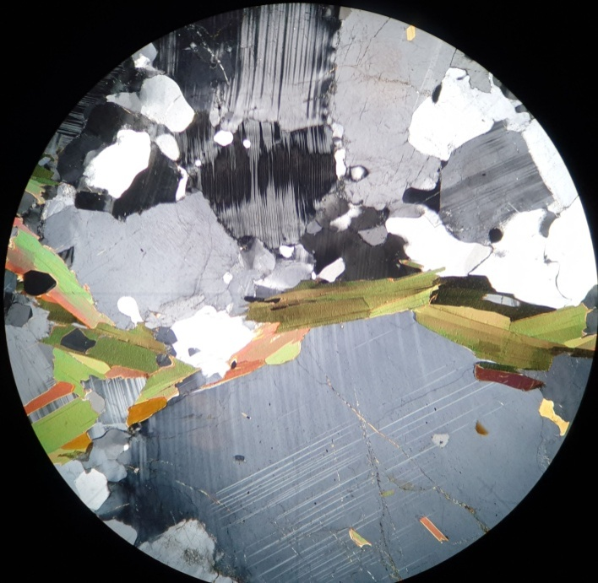 | 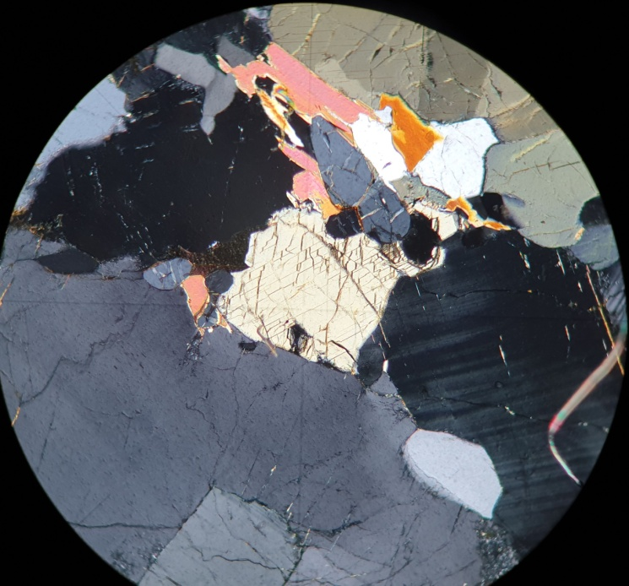
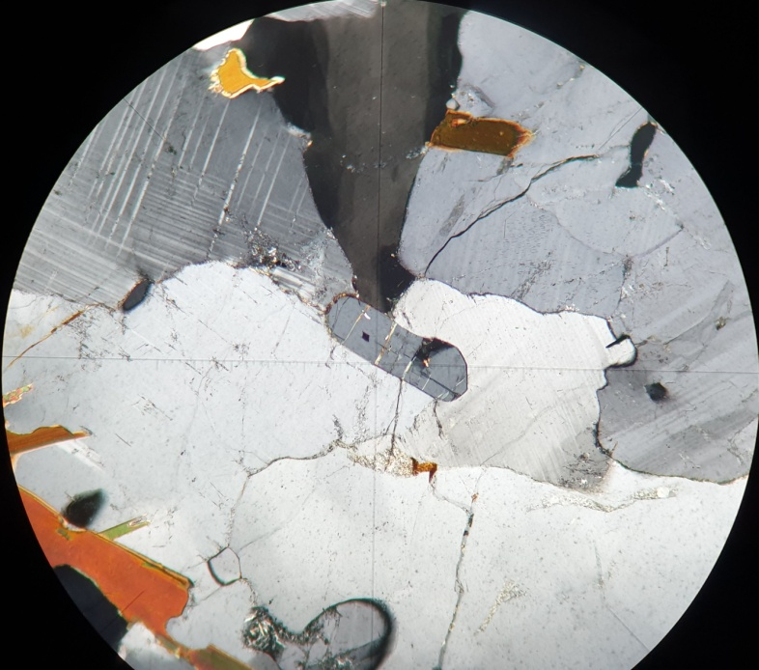 | 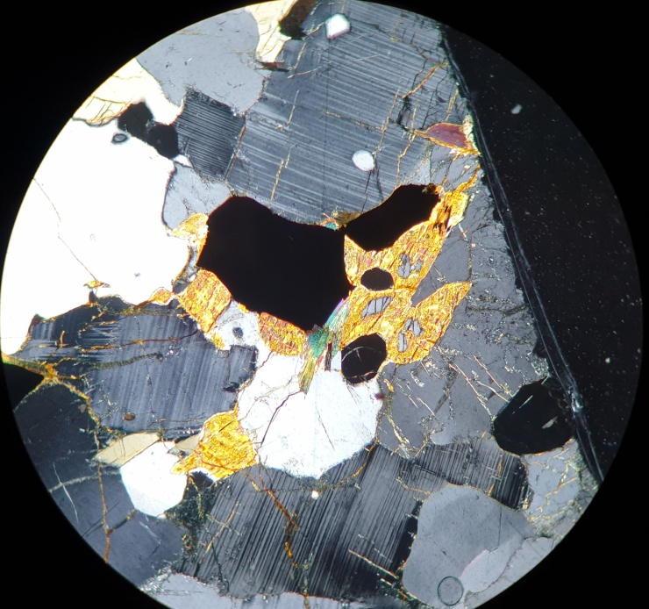
Figure 11. Microscopic images in transmitted and polarized light showing plagioclases, biotite and orthoclase in the studied rock. Next to it there is visible hypersthene, cordierite ore minerals and hematite.

Sample: 31MSK18 two pyroxene-amphibole xenolith (Fig. 12)
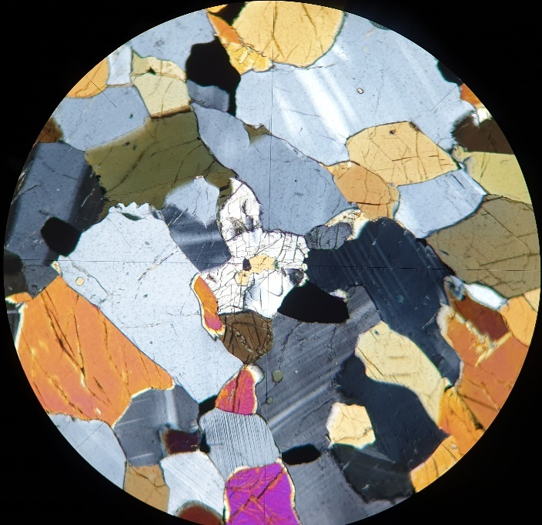 | 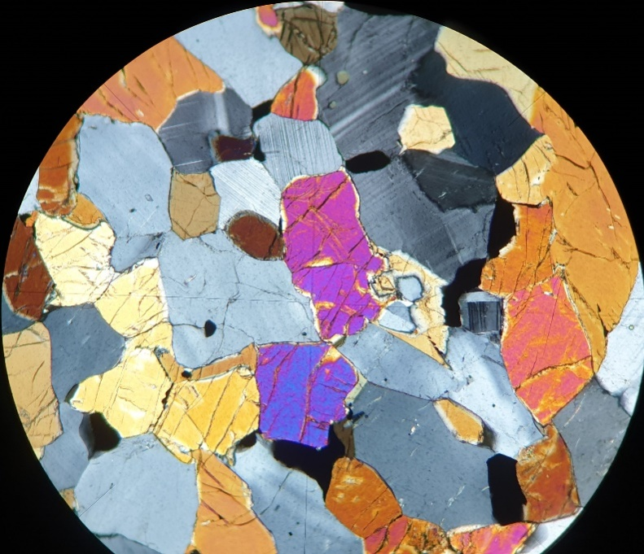
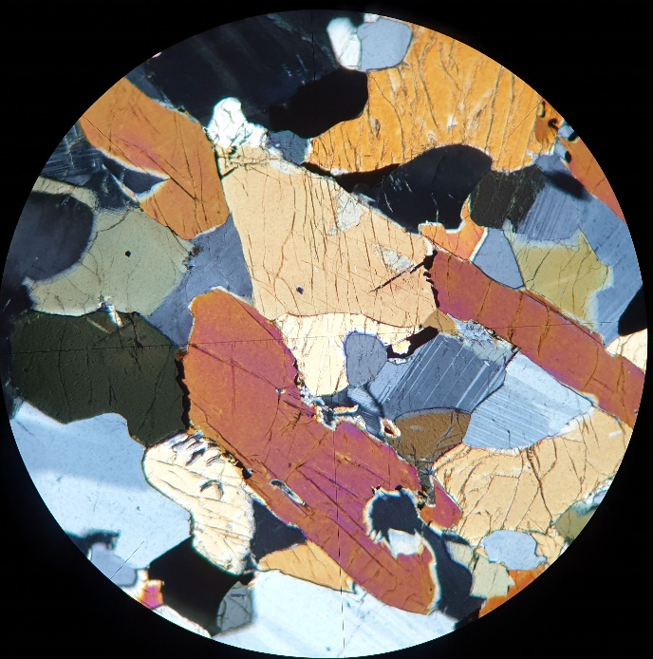 | 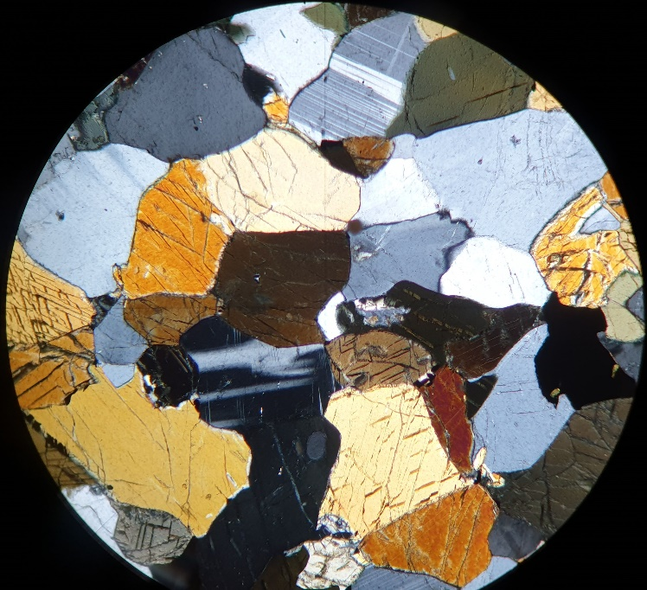
Figure 12. Microscopic images in transmitted and polarized light showing ortho - and clinopyroxene, accompanying plagioclases and ore minerals.

Sample: 32/1MSK18 granodiorite (Fig. 13)
Planimetric analyses show that the studied rock is mainly composed of plagioclase (32% vol.), orthoclase (26%), quartz (19%), hyper-hormone (7%), biotite (9%), epidote and chlorites (2%) and ore minerals prevail (4%).
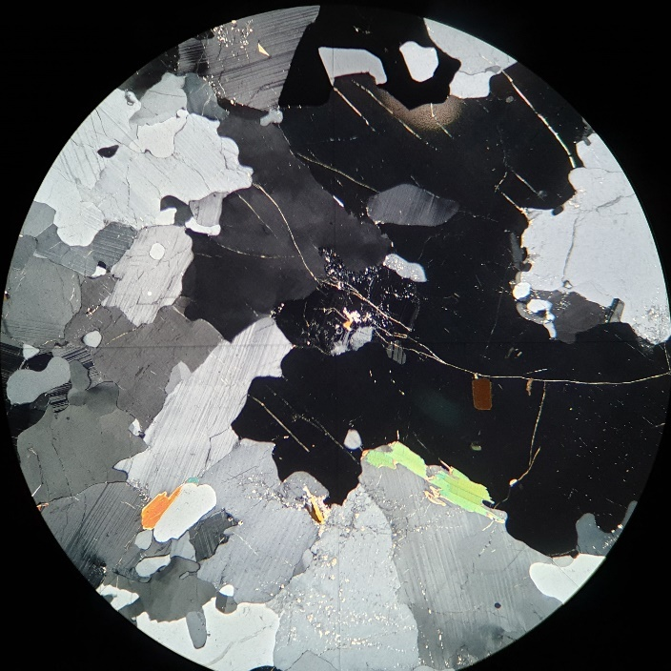 | 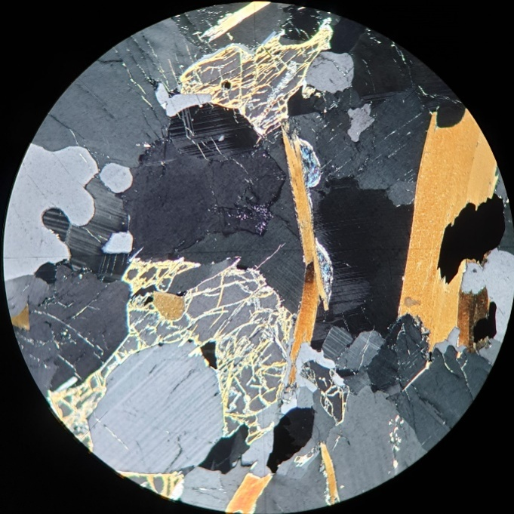
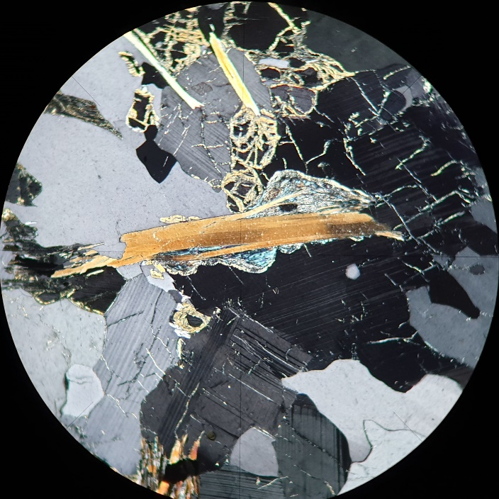 | 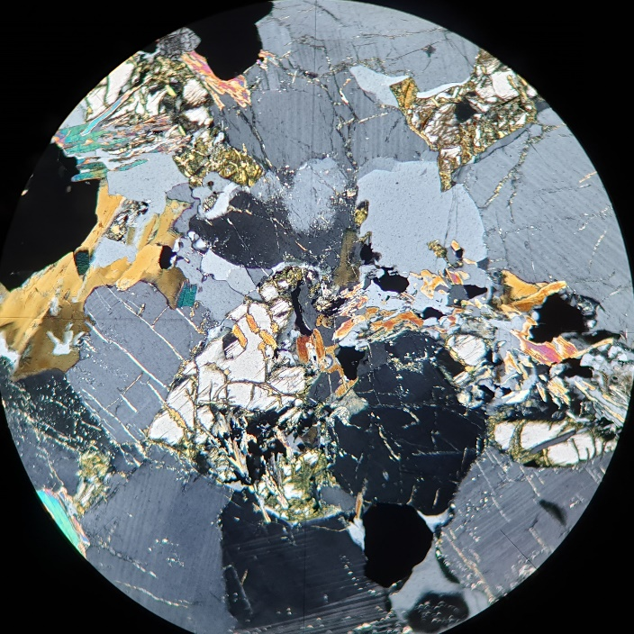
Figure 13. Microscopic images in transmitted and polarized light, showing plagioclases, quartz, hypersthene, biotite with chlorite and tremolite with ore minerals.

Sample: 32/2MSK18 amphibole-hypersthene xenolith (Fig. 14)
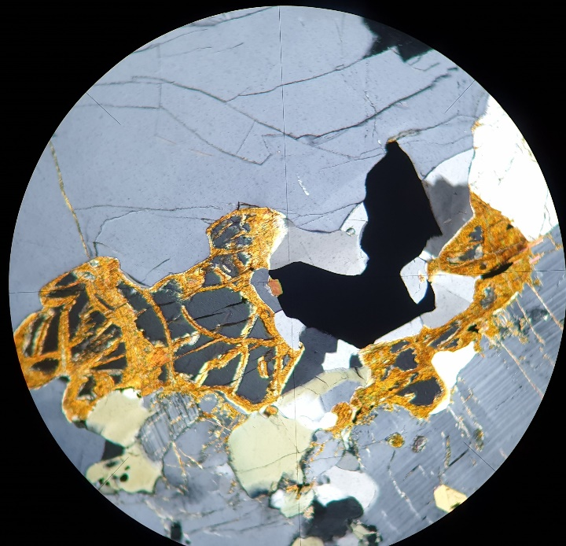 | 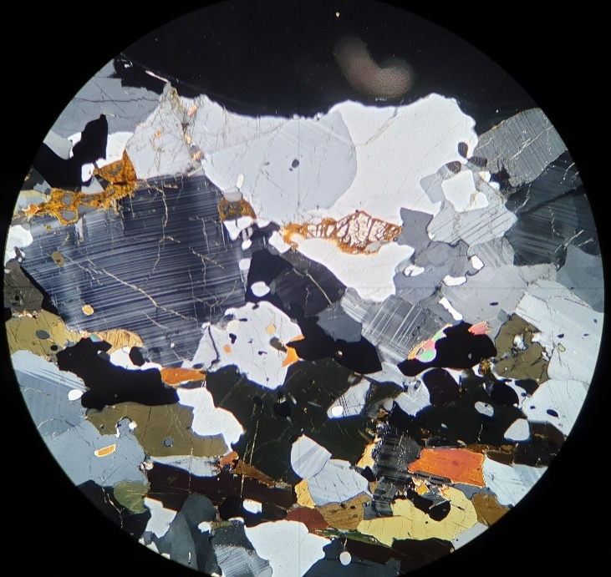
Figure 14. Microscopic images in transmitted and polarized light, showing quartz with biotitization of hypersthene and an accompanying ore mineral. There are also plagioclases, biotite and hornblende.

To summarize the above observations, the studied rocks are mainly gneisses and granite, which mineral composition fluctuates within monzogranite or syenogranite; rocks in the area east of Murmansk range from quartz monzodiorite to monzogranite. The studied rocks were subject to the multistage metamorphism, as indicated by femic minerals in the rocks, i.e. hypersthene, clinopyroxene, garnet, amphiboles, biotite, etc. Additional components of these rocks are sillimanite, staurolite, kyanite and high-pressure minerals found in many gneisses. The polymetal mineralization of these rocks also indicates that they originated as sediments in the first weathered continents in the Earth evolution.
The rocks crossing the studied complex contain metamorphic minerals as well (hypersthene, epidote), which implies similar transformation processes in the rocks. This indicates that they have been repeatedly metamorphosed, though the original rocks had to be consolidated and metamorphosed at the time of intruding into the surrounding rocks (gneiss).
Inline Supplementary Materials provide detailed descriptions of the studied rocks and methods of their analysis.

Petrochemistry of the studied rocks
Comprehensive petrochemical studies were provided for all rocks. Thin sections were described in detail. According to the SiO₂-Na₂O+K₂O plot, the rocks show moderate alkalinity (3-10 wt. %), except several amphibolite samples. Granitoids and granodiorites are characterized by SiO₂ values in the range of 65-75% (Inline supplementary Material, Appendix 1). Ms-Bt gneisses have similar alkalinity and flintiness values, just like Amp-Bt gneisses. Grt-Bt gneisses show widely varied compositions.
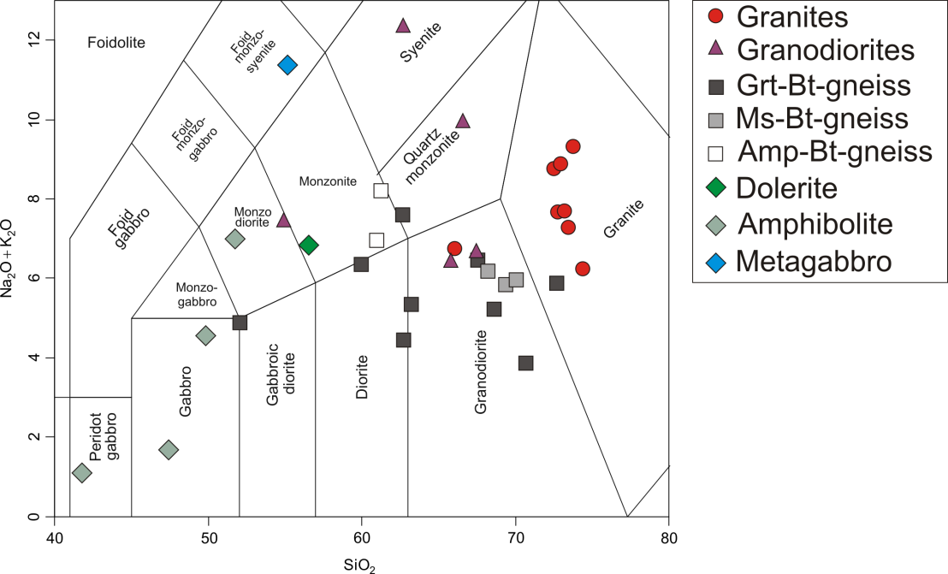
Figure 15. SiO₂ vs. Na₂O+K₂O plot for rocks in the study area. Fields are as per (Middlemost, 1994).

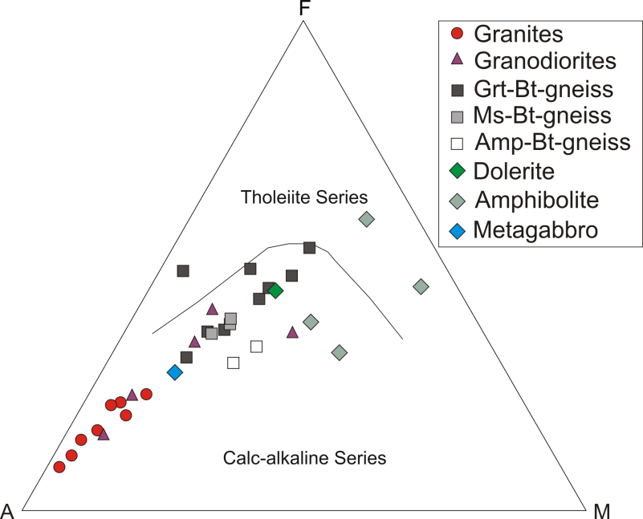
Figure 16. AFM plot (Irvine and Baragar, 1971) for rocks in the study area.

The AFM plot (Irvine and Baragar, 1971) indicates that rocks in the study area are mainly related to the moderately alkaline series, except for one sample of Grt-Bt gneiss and amphibolites. The rocks are characterized by the alkaline component prevailing over the iron and magnesium contents.
Variation plots showing ratios of main rock-forming oxides to the SiO₂ content indicate trends to increased Al₂O₃, MgO, CaO and FeOt contents and the decreased rock flintiness from granitoids to Ms-Bt gneisses, granodiorites and Gr-Bt gneisses. Gr-Bt and Amp-Bt gneisses are also marked by high K₂O values in contrast to Ms-Bt gneisses. Amphibolites show a wider range of compositions of main oxides, though they are generally high compared to the other rocks, except Na₂O and K₂O. Metagabbro and dolerite dikes take an intermediate position between gneisses and amphibolites. A metagabbro sample stands out from the rest rocks with its high Na₂O content.
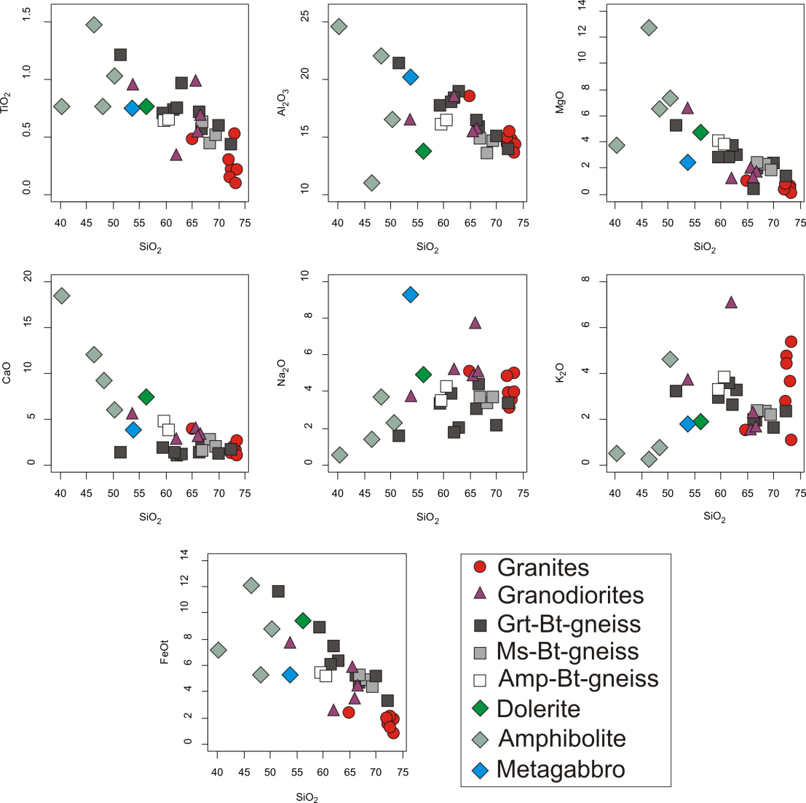
Figure 17. SiO₂ vs. main oxides plot for rocks in the study area.

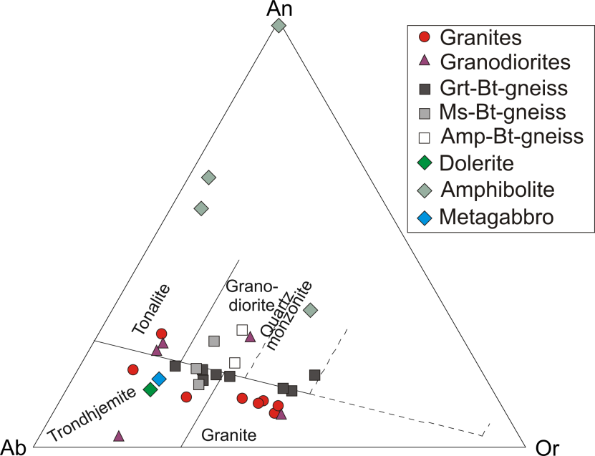
Figure 18. Ab-An-Or plot (O’Connor, 1965) for rocks in the study area.

The Ab-An-Or plot (O’Connor, 1965) shows that gneisses of the Central Kola Block take an intermediate position between fields of tonalities, trondhjemites, granodiorites and granites. Amp-Bt gneisses are characterized by a marked prevalence of An minal, while some samples of Grt-Bt gneisses have dominant Or minal. Granitoids and granodiorites vary widely within the compositional range of tonalities, granodiorites, trondhjemites and granites, tending to the latter group.
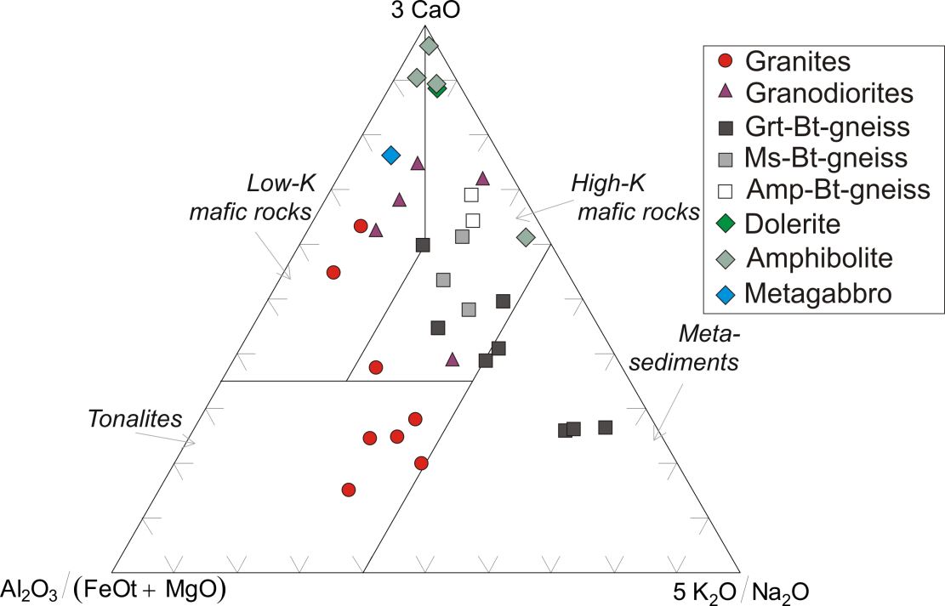
Figure 19. Source diagram. (Laurent et al., 2014) for rocks in the study area.

The source diagram (Laurent et al., 2014) for the studied rocks shows a wide variability in Gt-Bt gneisses compared to Amp-Bt and Ms-Bt gneisses and indicates the affinity to the field of metasedimentary rocks.
Isotope REE investigations
Chemical isotope REE investigations were carried out at two laboratories in Apatity, Murmansk region, and Novosibirsk (Inline Supplementary Materials, Appendixes 3, 4).
Granitoids (plagiogranites, microcline granites) are characterized by high values of total REE of 52.54-199.43 ppm (aver. 121.74 ppm), the steeply inclined distribution spectrum of 13.73-113.17 (44.06) and high ratios of La/Sm and Gd/Yb 2.23-6.43 (3.94) and 3.59-6.92 (5.07), respectively. Besides, the rocks typically show both negative (0.52), and positive (1.85) Eu anomaly with average values close to zero (0.85). One of granitoid samples has high values of total REE (378.97 ppm), strong prevalence of LREE over HREE (La/Yb = 202.62, La/Sm=5.59, Gb/Yb=13.60) and a weak negative Eu anomaly (0.72). Tourmaline granites differ from granitoids significantly. The main difference is reflected in low values of total REE of 11.11-11.20 ppm, gentle and moderately steep inclines of REE distribution spectra, i.e. the La/Yb ratio ranges from 2.56 to 7.04, the La/Sm ratio from 2.30 to 3.51 and the Gd/Yb ratio from 0.97 to 1.26. The rocks are characterized by a weak positive Eu anomaly (1.06-1.31). Granodiorite has the total REE of 176.78 ppm, a steeply inclined distribution spectrum (La/Yb=44.58, La/Sm=6.00, Gd/Yb=4.42) and almost no Eu anomaly. Geochemically, granodiorite is similar to granites.
Gneiss varieties have differences either. Gt-Bt gneisses and their varieties (Gt-Bt-Ms, Gt-Bt-Ms-Sill gneisses) are characterized by total REE values of 83.89 to 151.52 ppm (aver. 115.15 ppm), steeply inclined REE distribution spectra (the La/Yb ratio ranges within 9.23-26.51 (14.82), La/Sm 2.51-6.02 (4.37) and Gd/Yb 1.41-4.98 (2.11)) and no distinct Eu anomaly (0.76-1.23 (0.90)). Among Gt-Bt gneisses, one sample (П-2-17) stands out with a high concentration of REE (303.82 ppm) and a negative Eu anomaly (0.31), while the incline of the REE distribution spectra coincides (La/Yb = 9.59, La/Sm = 4.11 и Gd/Yb = 1.60). Ms-Bt gneisses differ from Gt-Bt gneisses in higher contents of total REE (97.44-264.44 ppm (aver. 163.57 ppm)), a steeper incline of the REE distribution spectra reflected in stronger HREE fractionation (La/Yb ratio ranges within 15.13-48.12 (28.23), La/Sm 2.74-5.47 (3.70) and Gd/Yb 2.49-6.64 (4.28)) and no negative Eu anomaly, i.e. 0.55-0.72 (0.64). Among Ms-Bt gneisses, one sample (MSK-37/2) is characterized by a low value of total REE = 30.89 ppm, a moderately steep incline of the REE distribution spectrum REE (La/Yb=5.26, La/Sm = 1.76 and Gd/Yb = 1.41) and no Eu anomaly (1.02). This sample is geochemically similar to a dolerite dike (MSK-37-5), intersecting it in the MSK-37 exposure. In average, values of geochemical parameters of REE for gneisses in the study area coincide with average values for grey gneisses, according to (Moyen and Martin, 2012).
Metagabbro and dolerite dikes show similar geochemical features. The total REE values of 35.67 ppm and 24.99-35.97 ppm (29.58), gently inclined REE distribution spectra (La/Yb = 2.95 and 1.46-3.46 (2.31), La/Sm = 4.89 and 1.80-2.91 (2.33), Gd/Yb = 0.45 and 0.44-1.03 (0.64), respectively) and a weak negative Eu anomaly (0.78 and 0.78-1.16 (0.92), respectively). Amphibolite is characterized by a high total REE value (449.64 ppm), a steep REE distribution spectrum (La/Yb = 18.68, La/Sm = 3.81 and Gd/Yb = 3.00) and a weak negative Eu anomaly (0.78).
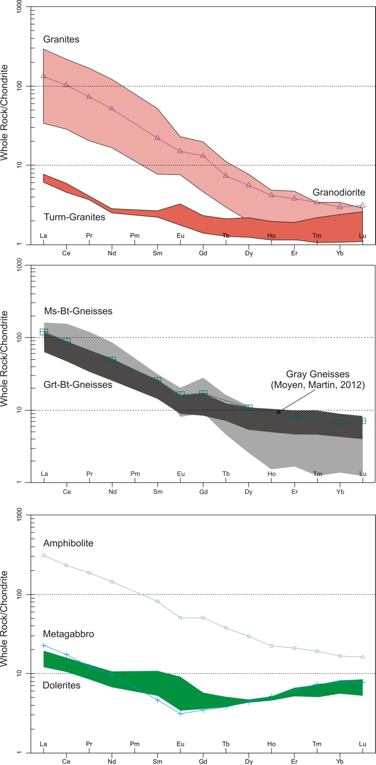
Figure 20. Chondrite-normalized REE distribution plot after (Boynton, 1984) for rocks in the study area.

Results and Discussion
Evolution of the continental crust in the north-eastern Fennoscandian Shield. U-Pb data
New U-Pb (ID-TIMS) data on single zircons from paragneisses of the Central Kola Megablock show the age of 3.17 Ga. The cores of these zircons were dated at 3695±5 Ma (SHRIMP-II) and ca. 100 Ma older ages, as compared to paragneisses of the Central-Kola megablock, according to (Myskova, 2015) (Figure 21a).
The age of the amphibolite facies metamorphism was estimated at 2753 ± 3 Ma. The Voche-Lambina geological site lies at the boundary between the Belomorian Mobile Block and the Central Kola domain (Morozova, 2012). New Neoarchaean U-Pb data on single zircons of the Voche-Lambina TTG yielded the age of 3158.2±8.2 Ma. The zircon has low U and Pb concentration and the low U/Th ratio of 0.2. REE plots for grey gneisses show high fractionation of La/Yb > 30 rich in LREE and poor in heavy Yb (<0.6 ppm). The precise (ID-TIMS) single zircon age of the amphibolite facies metamorphism was estimated at 2704.3±5.9 Ma. Model Sm-Nd WR data indicate the protolith ages of 3.4 to 3.2 Ga, positive εNd of +1.29 to +3.3 and ISr of 0.702 (Morozova, 2012).
Thus, the new data on single zircon grains from TTG and paragneisses of the Central Kola Megablock imply a long-term and discrete evolution of the continental crust in the Fennoscandian Shield (3.17-3.73 Ga). Noteworthy, the oldest part of the Hadaean component is well-preserved in zircons that were subject to high-pressure metamorphism in Finland and granulite facies metamorphism (Glukhovskii, 2017) in Siberia (Aldan Shield, Russia). The latter was dated using the ID-TIMS method; the single zircon age was measured as 3.94 Ga.

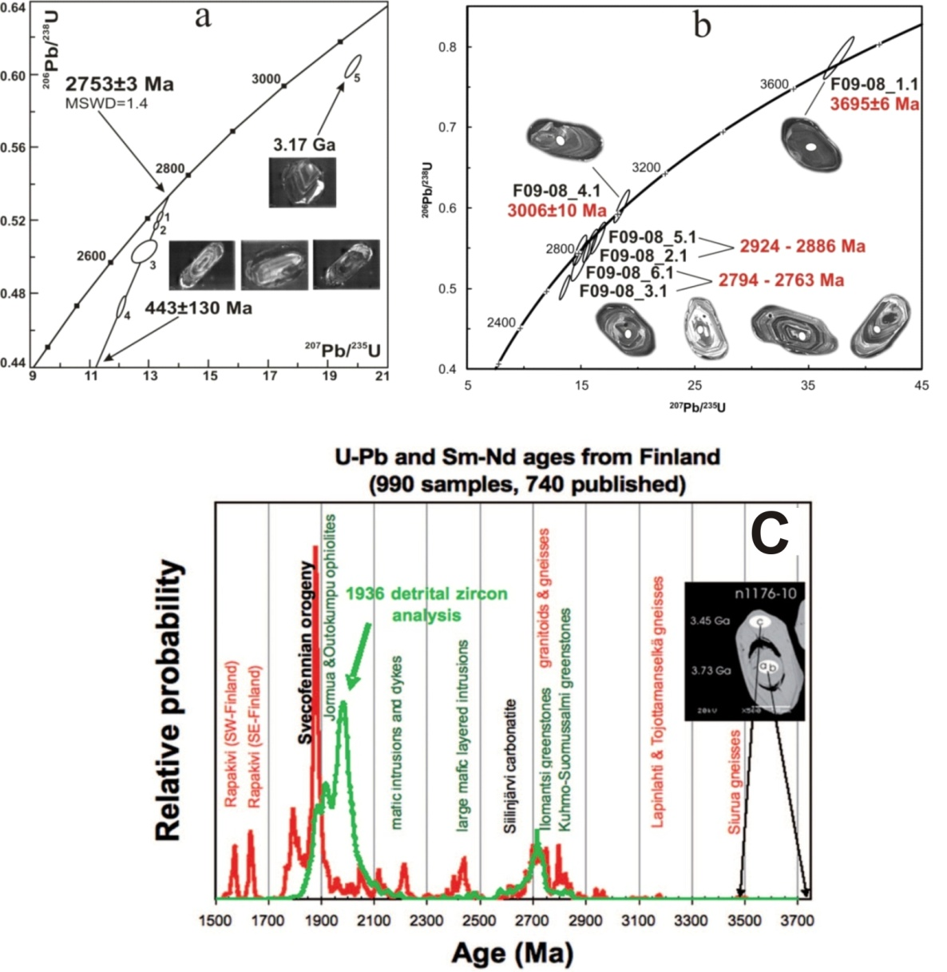
Figure 21. U-Pb (ID-TIMS) concordia diagram for single zircons (a) and SHRIMP-II data for zircon grains from the gray gneisses of the Central-Kola megablock (b), sample F09-08; isotope data are shown in Supplementary 11. Red line indicates the primary rock based on results for 990 samples (data on 740 of them are published) (c). The green line indicates the age distribution of detrital zircons in Paleoproterozoic metasediments based on 1936 U-Pb analyses made by SIMS (ca. 1000 published) and LA-MC-ICPMS (unpublished). Image of ca. 3.5 Ga zircon from the oldest rock in Siurua (Finland) with an older core of ca. 3.73 Ga (Mutanen et al., 2003).

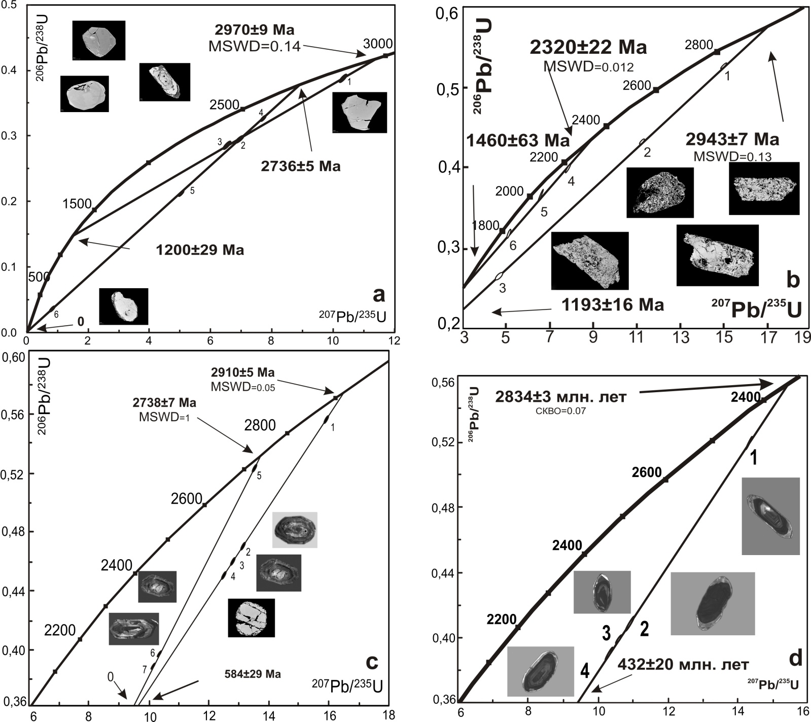
Figure 22. U-Pb isotope data on zircon from biotite gneiss, Murmansk, Central Kola Block (sample МSK-19/2) a, zircon from biotite gneiss, (sample MSK 43/1) b, zircon from biotite gneiss, (sample MSK 17/1) c, zircon from biotite gneiss, (sample MSK 28) d
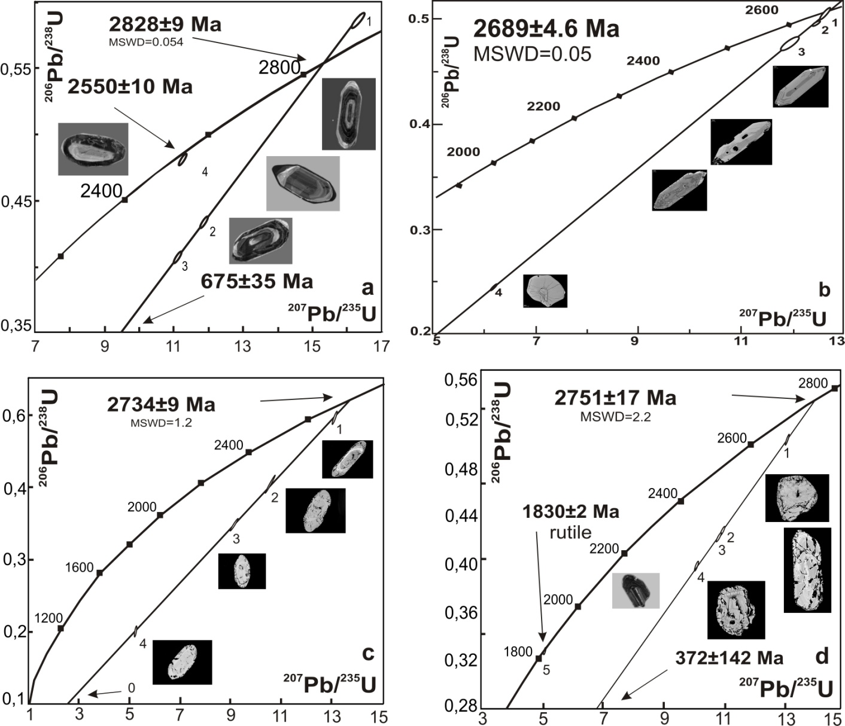
Figure 23. U-Pb isotope data on zircon from plagiogranite with biotite and tourmaline, Murmansk, Central Kola Block (sample MSK 29/1) a, zircon from plagiogranite, (sample MSK 2/3) b, zircon from biotite gneiss, (sample MSK 50/1) c, zircon and rutile from amphibole-biotite gneiss (sample MSK 53/1) d
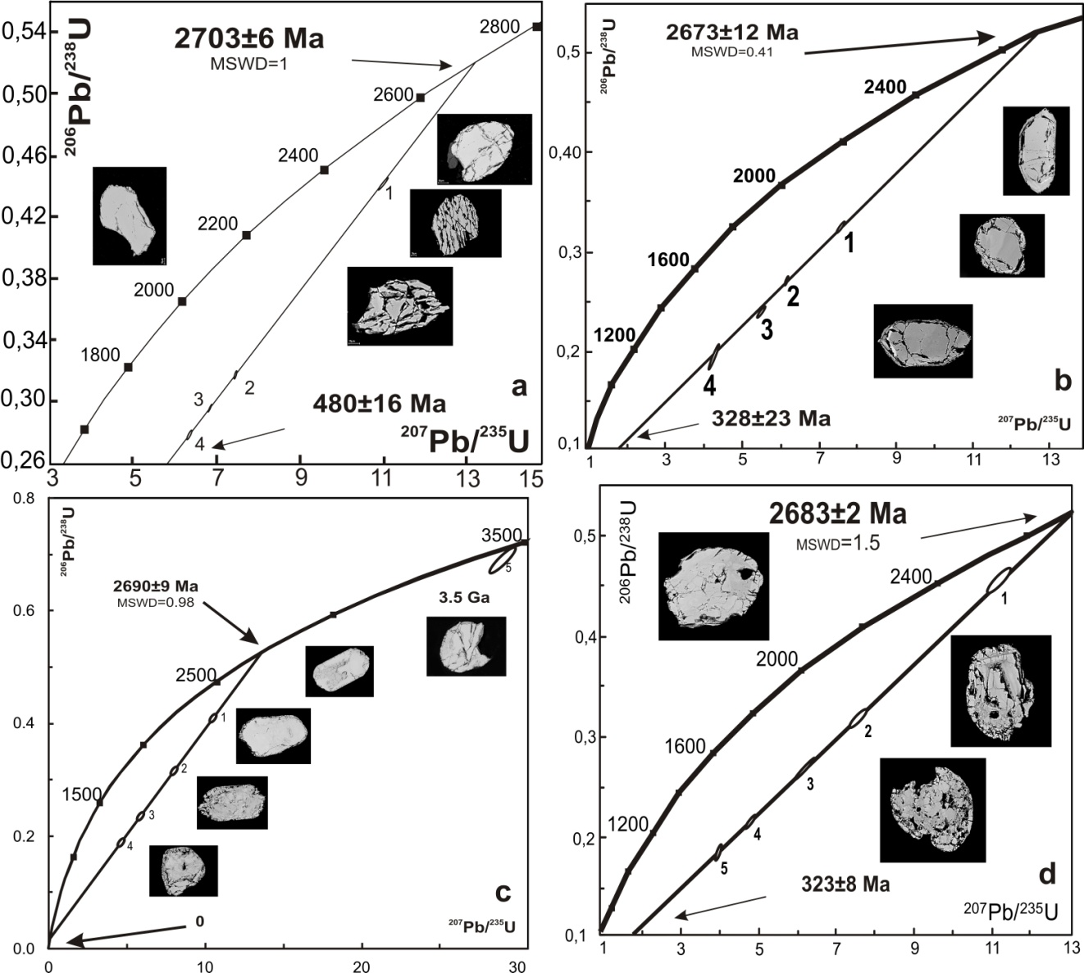
Figure 24. U-Pb isotope data on zircon from tonalites, Murmansk, Central Kola Block (sample MSK 53/2) a, zircon from amphibole-biotite gneiss (metagabbro (sample MSK 26/1) b, zircon from tourmaline granites (sample MSK 19/1) c, zircon from plagiogranite (sample MSK 21/2) d
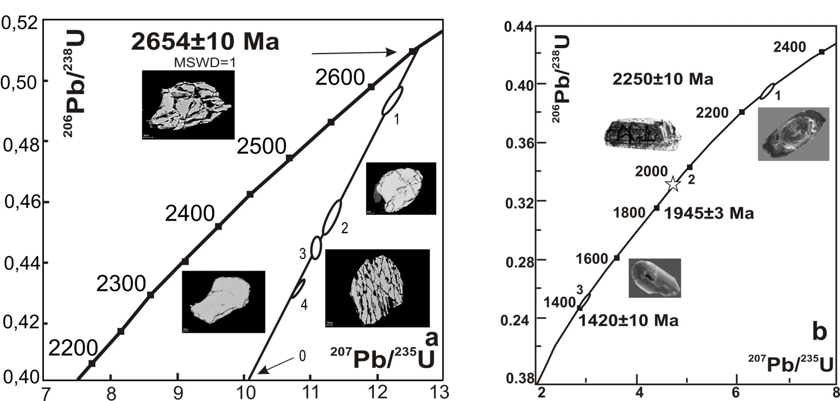
Figure 25. U-Pb isotope data on zircon from amphibolites, Murmansk, Central Kola Block (sample MSK 41/1) a, for single grains of zircon (1, 3) and baddeleyite (2) from dolerite (sample MSK-5/1) b
For the first time, zircons from the Central Kola Megablock were dated using the SHRIMP method. As a result, the oldest age of 3.7 Ga was obtained. Taking into account the age of Siurua TTG, Finland (3.73 Ga), these results suggest the presence of older (Hadaean) rocks with zircon ages of >4.0 Ga. It will also allow specifying the age of the continental crust, which provides the basement necessary for the formation of the regional deposits, such as the Neoarchaean BIF in the Olenegorsk ore area, Palaeoproterozoic PGE-Cu-Ni and PGE-Cr-Ti deposits (Monchegorsk, Fedorovo-Pana and Imandra ore areas) and Cu-Ni deposits (Pechenga, as well as large-scale Proterozoic apatite-nepheline and phosphorite deposits (Khibiny, Lovozero, Kovdor, etc.).

Sm-Nd isotope data
The Sm-Nd isotope analysis was provided for plagiogranites, tonalities, gneisses and amphibolites in the Central Kola and Murmansk Blocks (Inline Supplementary Materials, Appendix 7). In addition, rocks of the non-stratified complex exposed south of Murmansk were studied, e.g. granitoids and pegmatite bodies with sulfide mineralization, intensely altered rock varieties, i.e. talc-chlorite-biotite schists and highly schistose amphibolites registered in many sections of the study area (Figs. 2 and 3). The obtained isotope data are provided in Tables 2 and 3. Isotope investigations were facilitated by Sm-Nd dating of amphibolites (bt-amf gneisses), quartz dolerites (thick dike) and late granitoids developed in the study area (Table 2).

Table 2. Sm-Nd data on geochronological samples from the Central Kola domain.
 | Concentration, ppm |  | Isotope ratios |  | T_{DM},  Ma | ε_{Nd}(T)
 | Sm | Sm | ¹⁴⁷Sm/¹⁴⁴Nd | ¹⁴³Nd/¹⁴⁴Nd | T_{DM},  Ma | ε_{Nd}(T)
Amphibolite
WR | 5.26 | 32.9 | 0.0965 | 0.510904±10 | 2907 | +2.2
Pl | 0.224 | 1.070 | 0.0737 | 0.510491±14
Amf | 4.87 | 24.2 | 0.1249 | 0.511392±23
Sulf | 2.59 | 11.15 | 0.1404 | 0.511701±15
Grt | 99.3 | 79.5 | 0.7554 | 0.523064±14
Dolerite (dyke)
WR | 1.339 | 7.78 | 0.1040 | 0.511230±11 | 2657 | +2.3
Pl | 0.346 | 1.711 | 0.0923 | 0.511033±17
Chr | 0.094 | 0.493 | 0.1157 | 0.511424±7
Cpx | 0.805 | 4.07 | 0.1269 | 0.511601±11
Opx | 0.084 | 0.382 | 0.1325 | 0.511697±14
Late granite (vein)
WR | 10.46 | 80.9 | 0.0781 | 0.510585±9 | 2869 | -6.4
Fsp | 0.396 | 2.91 | 0.0823 | 0.510655±18
Pl | 0.705 | 6.70 | 0.0636 | 0.510385±11
Grt | 92.2 | 194.0 | 0.2874 | 0.513639±13

A dolerite dyke cross-cutting rocks of the TTG-complex was dated at 2495±73 Ma based on the Sm-Nd analyses of heavy concentrate of plagioclase, pyroxene, chrome-spinellid and WR (Fig. 26).
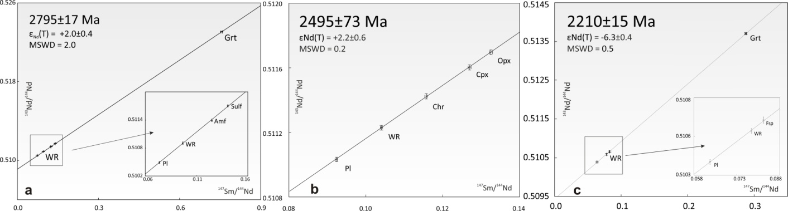
Figure 26. Mineral Sm-Nd isochron for amphibolites (bt-amf gneisses) with sulfide mineralization (a), Mineral Sm-Nd isochron for dolerites (b), Mineral Sm-Nd isochron for late granitoids (c).

The positive εNd(T)=+2.2 value indicates the juvenile source and suggests no significant contamination of the isotope system by the crustal material. The obtained age conforms to the age of quartz dolerites that occur in this area. They were previously dated at 2505 Ma (Samsonov et al., 2019; Stepanova et al., 2019).
The mineral Sm-Nd isochron constructed for late granitoids on plagioclase, feldspar, garnet and WR shows the age of 2210±15 Ma and interpreted as the intrusion time of later granite bodies. The obtained data comply with the start time of the regional metamorphism at 2.0-2.2 Ga (Veselovsky et al., 2020).

Model ages and isotopes
Model ages of palaeogranites and tonalities in the Central Kola block were dated at 2.83-3.43 Ga. Granitoids in the Murmansk block show the age of 2.82-3.26 Ga (Table 3). Later granitoids represented by tourmaline and microcline granites, as well as bodies of later pegmatites with sulfide mineralization, typically have ancient model ages of 2.96-3.8 Ga. Gneisses of Siurua are the oldest-known rocks in Fennoscandia (Pudasjärvi, Finland) with the Sm-Nd model ages to 3.7 Ga (Mutanen and Huhma, 2000; Lauri et al., 2011). The low-crust granulite xenoliths of the Karelian craton show the same ancient age (Peltonen et al. 2006). Notably, in the Central Kola Block, the most ancient model ages (3.3-3.6 Ga) and extremely low εNd(T) values of -13.7 were obtained for tourmaline granites and late vein granite and pegmatite bodies with sulfide mineralization. In general, there is a trend for model ages getting older from tonalities and plagiogranites to later tourmaline granites and pegmatite bodies.

Table 3. Sm-Nd data on rocks in the Kola Peninsula

№ | Sample | Rock type | Concentration, ppm |  | Isotope ratios |  | ±2σ | T, Ma | ε_{Nd}(T) | T_{DM}, Ma
№ | Sample | Rock type | Sm | Nd | ¹⁴⁷Sm/¹⁴⁴Nd | ¹⁴³Nd/¹⁴⁴Nd
Plagiogranites and tonalities
Central Kola Block
1 | MSK-2/3 | Plagiogranite | 10,45 | 80,9 | 0,0781 | 0,510585 | 9 | 2910 | +4.4 | 2869
2 | MSK-11/1 | Granite with sulfide mineralization | 1,442 | 7,946 | 0,1096 | 0,511063 | 14 | 2910 | +1.9 | 3039
3 | MSK-34/1 | Q-K-feldspar-Bt rock with sulfides | 3,079 | 16,41 | 0,1134 | 0,510921 | 8 | 2910 | -2.3 | 3366
4 | MSK-35/1 | Q-feldspar rock with sulfides | 0,754 | 4,113 | 0,1108 | 0,510818 | 13 | 2910 | -3.3 | 3431
5 | MSK-38/2 | Migmatite with sulfides | 3,609 | 19,13 | 0,1140 | 0,511103 | 10 | 2910 | +1.1 | 3112
6 | MSK-52/1 | Migmatite | 1,905 | 11,66 | 0,0987 | 0,510966 | 10 | 2910 | +4.2 | 2880
7 | MSK-52/2 | Q- feldspar rock | 2,44 | 16,16 | 0,0912 | 0,510857 | 9 | 2910 | +4.8 | 2839
8 | MSK-53/2 | Tonalite | 4,223 | 30,73 | 0,0831 | 0,510616 | 9 | 2703 | +0.1 | 2942
9 | MSK-53/5 | Granite | 0,698 | 5,238 | 0,0805 | 0,510566 | 14 | 2703 | 0.0 | 2941
Murmansk Block
10 | MSK-28 | Granodiorite-gneiss | 2,846 | 10,49 | 0,1039 | 0,510817 | 18 | 2834 | -1.7 | 3219
11 | MSK-29/1 | Diorite-gneiss | 1,638 | 8,690 | 0,1009 | 0,510979 | 15 | 2828 | +2.5 | 2919
12 | MSK-30/2 | Granodiorite-gneiss | 4,967 | 23,837 | 0,1260 | 0,511337 | 10 | 2910 | +1.1 | 3134
13 | MSK-31 | Plagiogranite with xenoliths | 12,555 | 26,823 | 0,1829 | 0,512490 | 12 | 2910 | +2.3 | 3257
14 | MSK-46 | Gneiss granite | 2,327 | 15, | 0,0884 | 0,510756 | 16 | 2734 | +1.4 | 2897
15 | MSK-47/1 | Gneiss granite | 1,438 | 9,59 | 0,0906 | 0,510801 | 6 | 2734 | +1.5 | 2894
16 | MSK-47/2 | Gneiss granite | 16,069 | 91,417 | 0,1062 | 0,511032 | 10 | 2734 | +0.5 | 2987
17 | MSK-48 | Plagiogranite gneiss | 5,919 | 36,716 | 0,0974 | 0,510897 | 9 | 2734 | +1.0 | 2938
18 | MSK-49/1 | Plagiogranite | 3,734 | 23,12 | 0,0996 | 0,511025 | 4 | 2734 | +2.7 | 2825
19 | MSK-50 | Plagiogranite | 4,654 | 31,476 | 0,0893 | 0,510666 | 14 | 2734 | -0.7 | 3027
Late granitoids
20 | MSK-54/1 | Microcline granite | 2,71 | 21,805 | 0,0751 | 0,510396 | 4 | 2703 | -1.4 | 3012
21 | MSK-54/2 | Plagiomicrocline granite | 2,276 | 18,435 | 0,0746 | 0,510338 | 8 | 2703 | -2.4 | 3064
22 | MSK-71/1 | Microcline granite, Teriberka | 5,023 | 34,5 | 0,0879 | 0,510691 | 16 | 2700 | -0.1 | 2964
23 | MSK-6/2 | Pegmatoids with sulfide mineralization | 0,423 | 2,003 | 0,1275 | 0,511361 | 15 | 2320 | -4.3 | 3146
24 | MSK-19/1 | Tourmaline granite | 0,35 | 1,808 | 0,1169 | 0,510721 | 17 | 2320 | -13.7 | 3795
25 | MSK-35/2 | Tourmaline granite with sulfides | 1,901 | 4,965 | 0,1214 | 0,510871 | 22 | 2320 | -12.1 | 3735
26 | MSK-36/1 | Tourmaline granite | 1,538 | 5,672 | 0,1239 | 0,511114 | 13 | 2320 | -8.1 | 3433
27 | MSK-40/1 | Q-feldspar rock with sulfides | 0,376 | 1,921 | 0,1084 | 0,511409 | 16 | 2320 | -5.1 | 3054
28 | MSK-43/1 | Plagiogranite with bt and tourmaline | 0,463 | 1,596 | 0,1054 | 0,510783 | 30 | 2320 | -9.0 | 3310
29 | MSK-51/2 | Late granite bodies | 11,172 | 53,442 | 0,1063 | 0,510786 | 11 | 2320 | -9.2 | 3334
30 | MSK-26/2 | Muscovite-KFS pegmatoid rocks from a vein with sulfides | 1,706 | 3,837 | 0,1488 | 0,511604 | 6 | 2320 | -5.9 | 3607
Gneisses and amphibolites
Central Kola Block
31 | MSK-1/1 | Grt-bt-gneiss | 3,316 | 18,688 | 0,1072 | 0,51111 | 15 | 2910 | +3.8 | 2905
32 | MSK-2/2 | Biotite gneiss, medium-grained | 8,006 | 57,817 | 0,0837 | 0,510582 | 11 | 2910 | +2.3 | 2994
33 | MSK-4/1 | Biotite gneiss | 1,049 | 6,086 | 0,1042 | 0,511033 | 11 | 2910 | +3.4 | 2932
34 | MSK-5/4 | Biotite gneiss with garnet (paragneiss) | 3,667 | 21,896 | 0,1012 | 0,510953 | 6 | 2910 | +2.9 | 2961
35 | MSK-7/1 | Grt-bt-gneiss (with sillimanite?) | 2,178 | 12,827 | 0,1026 | 0,510908 | 7 | 2910 | +1.5 | 3059
36 | MSK-8/1 | Biotite gneiss with garnet and sulfide mineralization | 2,204 | 13,048 | 0,1017 | 0,510849 | 4 | 2910 | +0.7 | 3114
37 | MSK-13/1 | Garnet-staurolite-biotite gneiss with kyanite | 2,736 | 12,328 | 0,1041 | 0,510887 | 10 | 2910 | +0.6 | 3129
38 | MSK-14/1 | Grt-bt-gneiss | 2,002 | 16,454 | 0,1235 | 0,511305 | 19 | 2910 | +1.4 | 3101
39 | MSK-17/1 | Biotite gneiss with garnet | 2,698 | 13,583 | 0,1132 | 0,510975 | 21 | 2910 | -1.2 | 3279
40 | MSK-19/2 | Garnet-biotite-staurolite gneiss | 3,913 | 21,892 | 0,1080 | 0,511036 | 5 | 2970 | +2.7 | 3032
41 | MSK-20/1 | Amphibolite with garnet and sulfide mineralization (from a lens) | 5,259 | 32,952 | 0,0965 | 0,510704 | 10 | 2910 | +0.2 | 3162
42 | MSK-24/1 | Bt-Px gneiss | 7,532 | 41,578 | 0,1095 | 0,511047 | 10 | 2910 | +1.7 | 3060
43 | MSK-26/1 | Metagabbroids (amf-bt gneisses?) | 3,88 | 25,336 | 0,0926 | 0,510812 | 12 | 2673 | +0.2 | 2928
44 | MSK-26/3 | Metagabbroids (amf-bt gneisses?) | 3,465 | 19,384 | 0,1080 | 0,510835 | 10 | 2673 | -4.7 | 3317
45 | MSK-27 | Grt-Bt gneiss | 2,669 | 14,928 | 0,1081 | 0,5109 | 15 | 2910 | -0.7 | 3228
46 | MSK-34/2 | Grt-Bt gneiss | 2,012 | 11,822 | 0,1029 | 0,51087 | 10 | 2910 | +0.7 | 3119
47 | MSK-37/1 | Grt-Bt gneiss with sulfides | 4,081 | 23,134 | 0,1066 | 0,510804 | 4 | 2910 | -2.0 | 3318
48 | MSK-38/1 | Bt-gneiss | 2,45 | 14,283 | 0,1037 | 0,510983 | 9 | 2910 | +2.6 | 2987
49 | MSK-39/1 | Amf-Bt-gneiss (metagabbroid) | 4,456 | 26,961 | 0,0999 | 0,510868 | 12 | 2910 | +1.8 | 3040
50 | MSK-40/2 | Two-mica gneiss | 3,419 | 20,663 | 0,1000 | 0,510901 | 5 | 2910 | +2.4 | 2999
51 | MSK-41/1 | Bt-Px gneiss | 2,998 | 6,847 | 0,1447 | 0,511694 | 10 | 2654 | -0.7 | 3200
52 | MSK-42/1 | Two-mica gneisses with interlayers of plagiogranites with sulfides | 4,194 | 15,231 | 0,1065 | 0,511034 | 9 | 2654 | -0.5 | 2993
53 | MSK-51/1 | Bt-Amf gneiss | 10,727 | 48,912 | 0,1325 | 0,511473 | 9 | 2910 | +1.4 | 3131
Intensely altered rocks
54 | MSK-7/2 | Amphibolite with sulfide mineralization | 5,152 | 23,851 | 0,1015 | 0,510858 | 16 | 1980 | -10.6 | 3096
55 | MSK-37/2 | Talc-chlorite-biotite schists | 1,672 | 7,585 | 0,1333 | 0,511414 | 9 | 1980 | -7.8 | 3272
56 | MSK-37/3 | Talc-chlorite-biotite schists with sulfides | 3,086 | 16,568 | 0,1126 | 0,511122 | 11 | 1980 | -8.3 | 3041
57 | MSK-36/2 | Biotite-muscovite gneiss, highly schistose | 2,757 | 14,821 | 0,1124 | 0,510997 | 20 | 1980 | -10.6 | 3220
58 | MSK-38/3 | Amphibolite | 20,574 | 98,895 | 0,1257 | 0,511324 | 16 | 1980 | -7.6 | 3146
Non-stratified complex
59 | MSK-53/1 | Amf-Bt gneiss | 17,682 | 88,36 | 0,1209 | 0,511170 | 4 | 2751 | -1.8 | 3233
60 | MSK-53/4 | Amf-Bt gneiss | 8,184 | 45,059 | 0,1197 | 0,511181 | 10 | 2751 | -1.2 | 3175
61 | MSK-53/6 | Amf-Bt gneiss | 8,72 | 45,948 | 0,1147 | 0,511174 | 23 | 2751 | +0.5 | 3026
62 | MSK-53/7 | Amphibolite | 13,054 | 76,153 | 0,1136 | 0,510914 | 9 | 2751 | -4.2 | 3383
63 | MSK-53/8 | Amphibolite | 22,426 | 70,772 | 0,1215 | 0,511076 | 9 | 2751 | -3.9 | 3407
Kolmozero Voronya Greenstone Belt
64 | MSK-55/1 | Bt-Amf gneiss with sulfides KV | 3,932 | 22,254 | 0,1068 | 0,510997 | 23 | 2830 | +0.7 | 3053
65 | MSK-55/2 | Bt-Amf gneiss with sulfides KV | 2,861 | 16,441 | 0,1051 | 0,511049 | 9 | 2830 | +2.4 | 2934
66 | MSK-56/1 | Bt-Amf gneiss with muscovite KV | 3,755 | 21,941 | 0,1034 | 0,510991 | 8 | 2830 | +1.9 | 2968
67 | MSK-56/2 | Bt gneiss KV | 4,547 | 27,646 | 0,0994 | 0,510954 | 9 | 2830 | +2.6 | 2914
68 | MSK-16/2 | Amphibolite with sulfide mineralization KV | 3,432 | 20,06 | 0,1034 | 0,510943 | 14 | 2830 | +0.9 | 3033
A mean value of 143Nd/144Nd ratio in a JNdi-1 standard was 0.512081±13 (N=11) in the test period.

Nd isotope compositions of rocks from the TTG-complex indicate a wide dispersion, i.e. εNd(T) values vary from -4.7 to +4.8, while plagiogranites and tonalities are characterized by a more radiogenic isotope composition, than gneisses and amphibolites. The lowest εNd(T) values of -13.7 are typical of tourmaline granites and late vein granite and pegmatite bodies with sulfide mineralization dated at 2.32 and 2.70 Ga.

Figure 27. Plot of εNd(T)-T for rocks in the Central Kola and Murmansk domains: 1 – tonalites, gneisses, amphibolites, granites dated at 2.6-2.9 Ga; 2 – late granitoids, pegmatite bodies and tourmaline granites dated at 2.23 and 2.70 Ga; 3 – 2.8 Ga metavolcanites (gneisses on volcanites) of the Kolmozero-Voronya Greenstone Belt; 4 – altered rocks, talc-chlorite-biotite schists dated at 1.98 Ga.

Analyses of data on different isotope systematics (Nd-Hf mainly) of rocks from many ancient regions in the world suggest a common feature of almost all ancient cratons, i.e. the presence of a significant dispersion of isotope compositions from extremely radiogenic to crustal indicators and a significant time span between the crystallization time of rocks in TTG-complexes and their Sm-Nd model age. It may indicate the presence of several sources, the juvenile and crustal ones, which mixture results in the observed diversity of isotope compositions (Hanski et al., 2001; Upadhyay et al., 2019).
Thus, the obtained data suggest that an ancient Palaeoarchaean core could exist in the junction zone of the Murmansk and Central Kola geoblocks. Analogues of this core are known on examples of three isolated areas of tonalities with the age of more than 3.3 Ga in Finland and North Karelia. Jointly, these areas (including the Vodlozero domain) can be fragments of a larger craton (Vrevsky et al., 2019). Recent studies of short-lived ⁸²W, ¹⁴²Nd and ¹²⁹Xe isotopes and the Re-Os system show that the ancient mantle reservoirs could be preserved for a long geological time, while the mantle areas could be convectively isolated for more than 1 Ga (Tusch et al., 2021; Van de Löcht et al., 2018). On the other hand, such fragments can be considered “embryos” of the ancient crust that were further accreted by the continental crust in the Archaean (Bleeker et al., 2003; Reimink et al., 2016a).

References
- Akame, J.M., Oliveira, E.P., Poujol, M., Hublet, G., Debaille, V., 2020. LA–ICP–MS zircon U-Pb dating, Lu-Hf, Sm-Nd geochronology and tectonic setting of the Mesoarchean mafic and felsic magmatic rocks in the Sangmelima granite-greenstone terrane, Ntem Complex (South Cameroon). Lithos 372–372, 105702. https://doi.org/10.1016/j.lithos.2020.105702
- Bayanova T., Mitrofanov F., Serov P., Nerovich L., Yekimova N., Nitkina E. and Kamensky I. Layered PGE Paleoproterozoic (LIP) Intrusions in the N-E Part of the Fennoscandian Shield – Isotope Nd-Sr and 3He/4He Data, Summarizing U-Pb Ages (on Baddeleyite and Zircon), Sm-Nd Data (on Rock-Forming and Sulphide Minerals), Duration and Mineralization / Geochronology – Methods and Case Studies / Edited by Nils-Axel Mörner // INTECH, 2014. P. 143-193. http://dx.doi.org/10.5772/58835
- Bleeker, W., 2003. The late Archean record: A puzzle in ca. 35 pieces. Lithos 71, 99–134. https://doi.org/10.1016/j.lithos.2003.07.003
- Bogdanova, S.V, Bingen, B., Gorbatschev, R., Kheraskova, T.N., Kozlov, V.I., Puchkov, V.N., Volozh, Y.A., 2008. The East European Craton (Baltica) before and during the assembly of Rodinia. Precambrian Res. 160, 23–45. https://doi.org/10.1016/j.precamres.2007.04.024
- Bogdanova, S.V., De Waele, B., Bibikova, E. V., Belousova, E.A., Postnikov, A.V., Fedotova, A.A., Popova, L.P., 2010. Volgo-Uralia: The first U-Pb, Lu-Hf and Sm-Nd isotopic evidence of preserved paleoarchean crust. Am. J. Sci. 310, 1345–1383. https://doi.org/10.2475/10.2010.06
- Boynton, W.V. Cosmochemistry of the rare earth elements; meteorite studies. In Rare Earth Element Geochemistry; Henderson, P., Ed.; Elsevier Sci. Publ. Co.: Amsterdam, The Netherlands, 1984; pp. 63–114
- Bridgwater, D., Scott, D.J., Balagansky, V. V., Timmerman, M.J., Marker, M., Bushmin, S.A., Alexeyev J.S. Daly, N.L., 2001. Age and provenance of early Precambrian metasedimentary rocks in the Lapland-Kola Belt, Russia: Evidence from Pb and Nd isotopic data. Terra Nov. 13, 32–37. https://doi.org/10.1046/j.1365-3121.2001.00307.x
- Bruno, H., Elizeu, V., Heilbron, M., Morisson, C. De, Strachan, R., Fowler, M., Bersan, S., Moreira, H., Dussin, I., Almeida, J., Neto, C., Guilherme, L., Tupinamb, M., Storey, C., 2020. Geoscience Frontiers Neoarchean and Rhyacian TTG-Sanukitoid suites in the southern Sao Francisco Paleocontinent, Brazil: Evidence for diachronous change towards modern tectonics. https://doi.org/10.1016/j.gsf.2020.01.015
- Chekulaev V.P., Arestova N.А., Glebovitsky V.А., Lobach-Zhuchenko S.B., Matveeva L.V., Lepyokhina Е.N. New data on the age of Archaean rocks in the Onega region (Vodlozero domain of the Karelian craton) // Doklady Akademii Nauk. 2013. N. 451. N 6. P. 670-675.
- Claesson, S., Huhma, H., Kinny, P.D., Williams, I.S., 1993. Svecofennian detrital zircon ages-implications for the Precambrian evolution of the Baltic Shield. Precambrian Res. 64, 109–130. https://doi.org/10.1016/0301-9268(93)90071-9
- De Paolo D.J. Neodymium isotopes in the Colorado Frout Range and crust-mantle evolution in the Proterozoic // Nature, 1981. V. 291. P. 193-196. (one-stage model)
- Dokukina, K., Mints, M., 2018. Subduction of the Mesoarchaean spreading ridge and related metamorphism, magmatism and deformation by the example of the Gridino eclogitized mafic dyke swarm, the Belomorian Eclogite Province, eastern Fennoscandian Shield. J. Geodyn. https://doi.org/10.1016/j.jog.2018.11.003
- Ge, R., Wilde, S.A., Kemp, A.I.S., Jeon, H., Martin, L.A.J., Zhu, W., Wu, H., 2020a. Generation of Eoarchean continental crust from altered mafic rocks derived from a chondritic mantle: The ∼3.72 Ga Aktash gneisses, Tarim Craton (NW China). Earth Planet. Sci. Lett. 538, 116225. https://doi.org/10.1016/j.epsl.2020.116225
- Ge, R., Zhu, W., Wilde, S.A., Hailin, W.U., 2020b. Remnants of Earth’s Oldest Continental Crust Formed by Subduction. Acta Geol. Sin. 94, 14. https://doi.org/10.1111/1755-6724.14434
- Glikson, A.Y., 2014, The Archaean: Geological and Geochemical Windows Into the Early Earth. Springer International Publishing Switzerland, 246 p.;
- Glukhovskii, M.Z., Kuz`min, M.I., Bayanova, T.B., Lyalina, L.M., Makrygina, V.A., Shcherbakova, T.F., 2017, The first discovery of Hadean zircon in garnet granulites from the Sutam River (Aldan Shield). Doklady Earth Sciences 476, Part 1, p. 1026-1032.
- Goldstein S.J., Jacobsen S.B. Nd and Sr isotopic systematics of river water suspended material implications for crystal evolution // Earth Plan. Sci. Letters. 1988. V. 87. P. 249-265.
- Halla, J., 2020. The TTG-Amphibolite Terrains of Arctic Fennoscandia: Infinite Networks of Amphibolite Metatexite-Diatexite Transitions. Front. Earth Sci. 8, 1–14. https://doi.org/10.3389/feart.2020.00252
- Halla, J., van Hunen, J., Heilimo, E., Hölttä, P., 2009. Geochemical and numerical constraints on Neoarchean plate tectonics. Precambrian Res. 174, 155–162. https://doi.org/10.1016/j.precamres.2009.07.008
- Hanski, E., Huhma, H., Vaasjoki, M., 2001. Geochronology of northern Finland: A summary and discussion. Spec. Pap. Geol. Surv. Finl. 255–279.
- Hoffmann, J.E., Musese, E., Kröner, A., Schneider, K.P., Wong, J., Hofmann, A., Hegner, E., Kasper, H.U., Tusch, J., Münker, C., 2020. Hafnium-Neodymium isotope, trace element and U-Pb zircon age constraints on the petrogenesis of the 3.44–3.46 Ga Dwalile greenstone remnant, Ancient gneiss Complex, Swaziland. Precambrian Res. 351, 105970. https://doi.org/10.1016/j.precamres.2020.105970
- Hölttä, P., Balagansky, V., Garde, A.A., Mertanen, S., Peltonen, P., Slabunov, A., Sorjonen-Ward, P., Whitehouse, M., 2008. Archean of Greenland and Fennoscandia. Episodes 31, 13–19. https://doi.org/10.18814/epiiugs/2008/v31i1/003
- Hölttä, P., Heilimo, E., Huhma. H., Juopperi, H., Kontinen, A., Konnunaho, H., Lauri, L., Mikkola, P., Paavola, J. & Sorjonen-Ward, P. 2012. Archaean complexes of the Karelia Province in Finland. Geological Survey of Finland, Special Paper 54, 9−20;
- Huhma, H., Hölttä, P., Paavola, J., 1995. Isotopic studies on the Archaean Varpaisjärvi granulites. In: Glebovitsky, V.A., Kotov, A.B. (Eds.) Precambrian of Europe: stratigraphy, structure, evolution and mineralization. 9th Meeting of the Association of European Geological Societies (MAEGS), St.-Petersburg. Abstracts, Russian Academy of Sciences, 42–43.
- Huhma, H., Kontinen, A., Mikkola, P., Halkoaho, T., Hokkanen, T., HöIttä, P., Juopperi, H., Konnunaho, J., Luukkonen, E., Mutanen, T., Peltonen, P., Pietikäinen, K., Pulkkinen, A., 2012. Nd isotopic evidence for Archaean crustal growth in Finland. Spec. Pap. Geol. Surv. Finl. 2012, 176–213.
- Huhma, H., Manttari, I., Peltonen, P., Kontinen, A., Halkoaho, T., Hanski, E., Hokkanen, T., Hölttä, P., Juopperi, H., Konnunaho, J., Layahe, Y., Luukkonen. E., Pietikäinen. K., Pulkkinen, A., Sorjonen-Ward, P., Vaasjoki, M. & Whitehouse, M. The age of Archaean greenstone belts in Finland // Geological Survey of Finland, Special Paper. – 2012. – V. 54. – P. 74–175.
- Huhma, H., Mutanen, T., Whitehouse, M., 2009. Oldest rocks of the Fennoscandian Shield: The 3.5 Ga Siurua trondhjemite gneiss in the Archaean Pudasjärvi Granulite Belt, Finland. GFF 126, 10. https://doi.org/10.1080/11035890401261Sn1
- Irvine, T.N. and Baragar, W.R.A., 1971. A Guide to the Chemical Classification of the Common Volcanic Rocks. Canadian Journal of Earth Science, 8, 523-548.
- Jacobsen S.B., Wasserhurg G.J. // Earth and Planet. Sci. Lett. 1984. V. 67. P. 137-150.
- Jahn, B., Vidal, P., Kröner, A., 1984. Multi-chronometric ages and origin of Archaean tonalitic gneisses in Finnish Lapland: A case for long crustal residence time. Contrib. to Mineral. Petrol. 86, 398–408. https://doi.org/10.1007/BF01187143
- Köykkä, J., Lahtinen, R., Huhma, H., 2019. Provenance evolution of the Paleoproterozoic metasedimentary cover sequences in northern Fennoscandia: age distribution, geochemistry, and zircon morphology. Precambrian Res. 331, 105364. https://doi.org/10.1016/j.precamres.2019.105364
- Kozhevnikov, V.N., Medvedev, P.V., Skublov, S.G., Marin, Y.B., Systra, Y., Valencia, V., 2010. Hadean-Archean detrital zircons from Jatulian quartzites and conglomerates of the Karelian craton. Doklady Earth Sciences. 431, 318-323.
- Krogh T.E. A low-contamination method for hydrothermal dissolution of zircon and extraction of U and Pb for isotopic age determinations // Geochim Cosmochim. Acta. 1973. Vol. 37. P. 485-494.
- Kröner, A., Anhaeusser, C.R., Hoffmann, J.E., Wong, J., Geng, H., Hegner, E., Xie, H., Yang, J., Liu, D., 2016. Chronology of the oldest supracrustal sequences in the Palaeoarchaean Barberton Greenstone Belt, South Africa and Swaziland. Precambrian Res. 279, 123–143. https://doi.org/10.1016/j.precamres.2016.04.007
- Kröner, A., Compston, W., 1990. Archaean tonalitic gneiss of Finnish Lapland revisited: zircon ion-microprobe ages. Contrib. to Mineral. Petrol. 104, 348–352.
- Laurent, O., Martin, H., Moyen, J.F. & Doucelance, R. (2014). The diversity and evolution of late-Archean granitoids: evidence for the onset of 'modern-style' plate tectonics between 3.0 and 2.5 Ga. Lithos 205,208–235.
- Lauri, L.S., Andersen, T., Huhma, H., Hölttä, P., Graham, S., 2011. Evolution of the Ar- chaean Karelian province in the Fennoscandian shield in the light of U–Pb zircon ages and Sm–Nd and Lu–Hf isotope systematics. Journal of the Geological Society of London 168, 201–218.
- Levchenkov, O.A., Levskii, L.., Nordgulen, O., Dobrzhinetskaya, L., Vetrin, V.R., Cobbing, J., Nilsson, L.P., Sturt, B.A., 1995. U-Pb zircon ages from Sorvaranger, Norway and the western part of Kola Peninsula, Russia, in: Roberts, D., Nordgulen, O. (Eds.), Geology of the Eastern Finnmark – Western Kola Region. Norges geologiske undersokelse, pp. 29–48.
- Li, X., Zhang, L., Wei, C., Slabunov, A.I., Bader, T., 2017. Neoarchean-Paleoproterozoic granulite-facies metamorphism in Uzkaya Salma eclogite-bearing mélange, Belomorian Province (Russia). Precambrian Res. 294, 257–283. https://doi.org/10.1016/j.precamres.2017.03.031
- Liew I.C., Hofmann A.W. Precambrian crustal components, plutonic associations, plate environment of the Hercinian Fold Belt of central Europe: indications from a Nd and Sr isotopic study // Contribs mineral and petrol., 1988. V. 98. N 2. P. 129-138. (two-stage model)
- Lobach-Zhuchenko S.B., Chekulayev V.P., Sergeev S.A., Levchenkov O.A., Krylov I.N., Archaean rocks from southeastern Karelia (Karelian granite greenstone terrain) // Precambrian Research. – 1993. – V. 62. – P. 375–397.
- Ludwig K. R. (a) ISOPLOT/Ex - A geochronological toolkit for Microsoft Excel, Version 2.05 // Berkeley Geochronology Center Special Publication. No. 1a. 1999, 49 p.
- Ludwig K.R. (b) PBDAT - A Computer Program for Processing Pb-U-Th isotope Data. Version 1.22 // Open-file report 88-542. US Geol. Surv. 1991. 38 p.
- Middlemost, E.A.K. Naming materials in the magma/igneous rock system. Earth Sci. Rev. 1994, 37, 215–244.
- Mikkola, P., Lauri, L.S., Käpyaho, A., 2012. Neoarchean leucogranitoids of the Kianta Complex, Karelian Province, Finland: Source characteristics and processes responsible for the observed heterogeneity. Precambrian Res. 206–207, 72–86. https://doi.org/10.1016/j.precamres.2012.02.010
- Mints, M. V., Glaznev, V.N., Muravina, O.M., Sokolova, E.Y., 2020. 3D model of Svecofennian Accretionary Orogen and Karelia Craton based on geology, reflection seismics, magnetotellurics and density modelling: Geodynamic speculations. Geosci. Front. 11, 999–1023. https://doi.org/10.1016/j.gsf.2019.10.003
- Mitrofanov, F.P., Balashov, Yu.A., Balagansky, V.V., 1991. New geochronological data on Lower Precambrian complexes of the Kola Peninsula. In: V.V. Balagansky, F.P. Mitrofanov (Eds), Correlation of Lower Precambrian Formations of the Karelian-Kola Region, USSR and Finland. USSR Academy of Sciences, Apatity, pp. 12-16.
- Morozova, L.N., Mitrofanov, F.P., Bayanova, T.B., Vetrin, V.R., Serov, P.A., 2012, Archean Rock Homologs in the Kola Superdeep Borehole Section in the Northern Part of the White Sea Mobile Belt Voche-Lambina Test Site. Doklady Earth Sciences 442 Part 1, p. 28-31;
- Moyen, J.F., Martin, H., 2012. Forty years of TTG research. Lithos 148, 312–336. https://doi.org/10.1016/j.lithos.2012.06.010
- Mutanen, T., Huhma, H., 2000. The 3.5 Ga Siurua trondhjemite gneiss in the Archaean Pudasjärvi Granulite Belt, Northern Finland. Bull. Geol. Soc. Finl. 75, 51–68.
- Mutanen, T., Huhma, H., 2003, The 3.5 Ga Siurua trondhjemite gneiss in the Archaean Pudas-jarvi Granulite Belt, northern Finland. Bulletin of the Geological Society of Finland 75 (1-2), p. 51-68;
- Myskova T.A., Mil’kevich R.I., Glebovitskii V.A., L’vov P.A., Berezhnaya N.G., 2015, New data on the U-Pb (SHRIMP II) age of zircons from aluminous gneisses of the archean Kola group of the Baltic Shield and the problem of their interpretation. Doklady Earth Sciences. Т. 463. № 1. p. 738-745
- Myskova, T.A., Glebovitsky, V.A., Mil'kevich, R.I., Shuleshko, I.K., Berezhnaya, N.G., Lepekhina, E.N., Matukov, D.I., Antonov, A.V., Sergeev, S.A., 2005. Findings of the oldest (3600Ma) zircons in gneisses of the Kola Group, Central Kola Block, Baltic Shield: evidence from U-Pb (SHRIMP-II) data. Doklady Earth Sciences. 402, 547-550.
- Neto, J.M.M., Lafon, J.M., 2020. Crustal growth and reworking of Archean crust within the Rhyacian domains of the southeastern Guiana Shield, Brazil: Evidence from zircon U–Pb–Hf and whole-rock Sm–Nd geochronology. J. South Am. Earth Sci. 103, 102740. https://doi.org/10.1016/j.jsames.2020.102740
- Nikolaev, A.I.; Drogobuzhskaya, S.V.; Bayanova, T.B., Kaulina, T.V.; Lyalina, L.M.; Novikov, A.I.; Steshenko, E.N. REE distribution in zircon from reference rocks of the Arctic region: evidence from study by the LA-ICP-MS method. Doklady Earth Sci. 2016, 470(2), 1037-1041.
- Nitkina, E., Kozlov, N., Kozlova, N., Kaulina, T., 2019. Geochemical features and geological processes timescale of the Achaean TTG complexes of the Ingozero massif and the Pechenga frame (NE Baltic Shield). Minerals 9, 6–9. https://doi.org/10.3390/min9120767
- Nutman, A.P., Bennett, V.C., Friend, C.R.L., Van Kranendonk, M.J., Chivas, A.R., 2016. Rapid emergence of life shown by discovery of 3,700-million-year-old microbial structures. Nature 537, 535–538. https://doi.org/10.1038/nature19355
- Nutman, A.P., McGregor, V.R., Friend, C.R.L., Bennett, V.C., Kinny, P.D., 1996. The Itsaq gneiss complex of southern West Greenland; the world’s mostextensive record of early crustal evolution (3900-3600 Ma). Precambrian Res. 78, 1–39.
- O`Connor, J.T. (1965) A classification of quartz rich igneous rock based on feldspar ratios. US Geological Survey, 525B, B79-B84.
- Peltonen, P., Mänttäri, I., Huhma, H., Whitehouse, M. J., 2006. Multi-stage origin of the lower crust of the Karelian craton from 3.5 to 1.7 Ga based on isotopic ages of kimberlite-derived mafic granulite xenoliths. Precambrian Research 147, 107−123.
- Petrovskaya L.S., Mitrofanov F.P., Bayanova T.B., Petrov V.P., Petrovsky M.N., 2010, Neoarchaean enderbite-granulite complex of the Pulozero-Polnek-Tundra region, Central-Kola block: stages and thermodynamic regime of evolution (Kola Peninsula) – Apatity: Print. Kola Science Centre RAS, – 78 p;
- Polat, A., Appel, P.W.U., Fryer, B., Windley, B., Frei, R., Samson, I.M., Huang, H., 2009. Trace element systematics of the Neoarchean Fiskenæsset anorthosite complex and associated meta-volcanic rocks, SW Greenland: Evidence for a magmatic arc origin. Precambrian Res. 175, 87–115. https://doi.org/10.1016/j.precamres.2009.09.002
- Polat, A., Fryer, B.J., Appel, P.W.U., Kalvig, P., Kerrich, R., Dilek, Y., Yang, Z., 2011. Geochemistry of anorthositic differentiated sills in the Archean (~2970Ma) Fiskenæsset Complex, SW Greenland: Implications for parental magma compositions, geodynamic setting, and secular heat flow in arcs. Lithos 123, 50–72. https://doi.org/10.1016/j.lithos.2010.12.003
- Polat, A., Hofmann, A.W., 2003. Alteration and geochemical patterns in the 3.7–3.8 Ga Isua greenstone belt, West Greenland. Precambrian Research 126, 197–218.
- Reimink, J.R., Chacko, T., Stern, R.A., Heaman, L.M., 2016a. The birth of a cratonic nucleus: Lithogeochemical evolution of the 4.02–2.94 Ga Acasta Gneiss Complex. Precambrian Res. 281, 453–472. https://doi.org/10.1016/j.precamres.2016.06.007
- Reimink, J.R., Davies, J.H.F.L., Chacko, T., Stern, R.A., Heaman, L.M., Sarkar, C., Schaltegger, U., Creaser, R.A., Pearson, D.G., 2016b. No evidence for Hadean continental crust within Earth’s oldest evolved rock unit. Nat. Geosci. 9, 777–780. https://doi.org/10.1038/ngeo2786
- Samsonov, A.V., Stepanova, A.V., Salnikova, E.B., Arzamastsev, A.A., Veselovskiy, R.V., Larionova, Yu.O., Larionov, A.N., Egorova, S.V., Stifeeva, M.V., 2019. Neoarchean “Pechenga-type” mantle plume in the northern Fennoscandia: 2680 Ma mafic dykes in the Murmansk Craton. In: Proceedings of LI Tectonic conference “Issues of tectonics of continents and oceans”. GEOS, Moscow, pp. 216–220 (in Russian).
- Savko, K.A., Samsonov, A. V., Larionov, A.N., Chervyakovskaya, M. V., Korish, E.H., Larionova, Y.O., Bazikov, N.S., Tsybulyaev, S. V., 2021. A buried Paleoarchean core of the Eastern Sarmatia, Kursk block: U-Pb, Lu-Hf and Sm-Nd isotope mapping and paleotectonic application. Precambrian Res. 353, 106021. https://doi.org/10.1016/j.precamres.2020.106021
- Schärer U. and Gower C.F. Crustal evolution in eastern Labrador; constraints from precise U-Pb ages // Precambrian Res. 1988. V. 38. P. 405-421.
- Schärer U., Wilmart E., Duchesne J. The short duration and anorogenic character of anorthosite magmatism: U-Pb dating of the Rogaland complex, Norway // Earth Planet. Scl. Lett. Elsevier. 1996. V. 139. P. 335-350.
- Sergeev S.A., Bibikova E.V., Matukov D.I., Lobach-Zhuchenko S.B., Age of the magmatic and metamorphic processes in the Vodlozero complex, Baltic Shield: an ion microprobe (SHRIMP II) U-Th-Pb isotopic study of zircons // Geochemistry International. – 2007. – V. 45. – № 2. – P. 198–205.
- Stacey J.S. and Kramers J.D. Approximation of terrestrial lead isotope evolution by a two-stage model // Earth and Planet. Sci. Lett. 1975. Vol. 26, № 2. P. 207-221.
- Steiger R.H. and Jger E. Subcommission on geochronology: Convention on the use of decay constants in geo- and cosmochronology // Earth Planet. Sci. Lett., 1977. Vol. 36, № 3. P. 359-362.
- Stepanova, A.V., Salnikova, E.B., Samsonov, A.V., Arzamastsev, A.A., Egorova, S.V., Veselovskiy, R.V., Larionova, Yu.O., Erofeeva, K.G., Stifeeva, M.V., 2019. ﻿Dikes 2.505 Ma of the Kola and Murmansk provinces of Fennoscandia: geochronology, geodynamic implications. In: Proceedings of LI Tectonic conference “Issues of tectonics of continents and oceans”. GEOS, Moscow, pp. 270-274 (in Russian).
- Teixeira, W., Carneiro, M.A., Noce, C.M., Machado, N., Sato, K., Taylor, P.N., 1996. Pb, Sr and Nd isotope constraints on the Archaean evolution of gneissic-granitoid complexes in the southern São Francisco Craton, Brazil. Precambrian Res. 78, 151–164. https://doi.org/10.1016/0301-9268(95)00075-5
- Timmerman, M.J., Daly, J.S., 1995. Sm-Nd evidence for late Archaean crust formation in the Lapland-Kola Mobile Belt, Kola Peninsula, Russia and Norway. Precambrian Res. 72, 97–107. https://doi.org/10.1016/0301-9268(94)00045-S
- Tusch, J., Münker, C., Hasenstab, E., Jansen, M., Marien, C.S., Kurzweil, F., Van Kranendonk, M.J., Smithies, H., Maier, W., Garbe-Schönberg, D., 2021. Convective isolation of Hadean mantle reservoirs through Archean time. Proc. Natl. Acad. Sci. U. S. A. 118, e2012626118. https://doi.org/10.1073/pnas.2012626118
- Upadhyay, D., Chattopadhyay, S., Mezger, K., 2019. Formation of Paleoarchean-Mesoarchean Na-rich (TTG) and K-rich granitoid crust of the Singhbhum craton, Eastern India: Constraints from major and trace element geochemistry and Sr-Nd-Hf isotope composition. Precambrian Res. 327, 255–272. https://doi.org/10.1016/j.precamres.2019.04.009
- Van de Löcht, J., Hoffmann, J.E., Li, C., Wang, Z., Becker, H., Rosing, M.T., Kleinschrodt, R., Münker, C., 2018. Earth’s oldest mantle peridotites show entire record of late accretion. Geology 46, 199–202. https://doi.org/10.1130/G39709.1
- Van Kranendonk, M.J., Bennett, V.C., Hoffmann, J.E. Earth’s Oldest Rocks. // Amsterdam: Elsevier. – 2019. – P. 1112.
- Veselovskiy, R.V., Arató, R., Bagdasaryan, T.E., Samsonov, A. V., Stepanova, A.V., Arzamastsev, A.A., Myshenkova, M.S., 2020. New apatite fission-track data from the Murmansk craton, NE Fennoscandia: An echo of hidden thermotectonic events. Minerals 10, 1095. https://doi.org/10.3390/min10121095
- Vrevsky, A.B., 2019. Non-Subduction Petrological Mechanisms for the Growth of the Neoarcheam Continental Crust of the Kola–Norwegian Terrane, Fennoscandian Shield: Geological and Isotope-Geochemical Evidence. Petrology 27, 146–170. https://doi.org/10.1134/S0869591119020073
- Vrevsky, A.B., Lobach-Zhuchenko, S.B., Chekulaev, V.P., Kovalenko, A. V., Arestova, N.A., 2010. Geological, Petrologic, Isotopic, and Geochemical Constraints of Geodynamic Models Simulating Formation of the Archean Tonalite-Trondhjemite-Granodiorite Associations in Ancient Cratons. Geotectonics 44, 305–320. https://doi.org/10.1134/S0016852110040023
- Yekimova, N.A., Serov, P.A., Bayanova, T.B., Yelizarova, I.R., Mitrofanov, F.P. The REE distribution in sulphide minerals and Sm-Nd age determination for the ore-forming processes in mafic layered intrusions // Doklady RAS, 2011. V. 436. No. 1 P. 75-78.
- Yu, Y., Li, D., Chen, Y., Kang, H., Geng, J., Xu, S., Wang, Y., Sun, M., 2021. Mantle cooling and cratonization of Archean lithosphere by continuous plate subduction: Constraints from TTGs, sanukitoids, and high-K granites, eastern North China Craton. Precambrian Res. 353, 106042. https://doi.org/10.1016/j.precamres.2020.106042
- Yuan, H.; Gao, S.; Liu, X.; Li, H.; Günther, D.; Wu, F. Accurate U–Pb age and trace element determinations of zircon by laser ablation inductively coupled plasma-mass spectrometry. Geostand. Geoanal. Res. 2004, 28, 353-370.
- Zhuravlyov, A.Z., Zhuravlyov, D.Z., Kostitsyn, Yu.A., Chernyshov, I.V. // Determination of the Sm-Nd ration for geochronological purposes // Geochemistry, 1987. No. 8. P. 1115-1129.

