*Review*

The study on the launch impact of farmland reverse mortgage for the welfare of the rural elderly

# This study aimed to initiate a farmland reverse mortgage (FRM) for the welfare of the elderly in rural areas by liquidating the farmland which produces little product or is left uncultivated due to the labor shortage even though the farmland value is relatively high. (indicate your sample size that were used in the models)We built the actuarial model based on housing equity conversion mortgage (HECM) model suggested by Rodda et al. (2000, 2003). Basic factors such as interest rates, farmland value rising rates, loan survival probability and loan termination probability were elaborated on, with historical data (include the period of data coverage), and applied to the actuarial model for estimating a constant monthly payment (pmt) that the borrowers can receive under the condition that present value of estimated loss (PVEL) is equal to present value of mortgage insurance premium (PVMIP). Based on the established model, monthly payment was calculated according to the borrower’s age and his or her farmland value using trial and error method (what was the value gotten. Include it here as empirical figure). Then, the risk that the lender bears in(s) depending on the fluctuation of interest rates was predicted. (what was the recommendation before the suggestions)We can provide one more policy option for the elderly in rural areas that covers the deficiency which is not fulfilled by existing national pension services, basic old age pension and other government welfare policies by suggesting the initiation of FRM.

**Key words:** Farmland reverse mortgage, present value of estimated loss (PVEL), present value of mortgage insurance premium (PVMIP), constant monthly payment (pmt), value at risk.

# INTRODUCTION

The population structure in current South Korea is characterized as an “aging society”. Under this aging society, the prompt and large-scale expansion of welfare for the elderly is required to meet the welfare demand of the elderly and a minimum quality of life for the elderly in KOREA. Particularly, most of the elderly in rural areas are not protected by the national pension service, and even, are not qualified for the basic old age pension which are social safety net provided by the government because the value of the farmland they have usually exceeds the threshold that the basic old age pension is given1 (Cho et al., 2008). To resolve and relieve problems

1 In the case of Gyeongsangbuk-Do (Province), only 23% of the elderly over the age of 65 receive a national pension. Even the average amount of pension is from 150,000 won (about 130U.S $) to 190,000 won (165U.S $) which is far lower than minimum poverty line (basic cost of living for two elderly people) across Si (City)s and Gun (county)s in 2008 (National Statistics Office, 2010). 67.1% of the elderly receive a basic old age pension, but the amount of monthly benefit ranges from 20,000 won (about 17US$) to 88,000 won (76U.S

caused by an aging population in rural areas, we suggest that the initiation of a farmland reverse mortgage (FRM) for the life of the elderly in rural areas by liquidating the farmland which produces little or is left uncultivated due to labor shortage even though the farmland value is high. In this study, we elaborate critical factors such as farmland value rising rates, interest rates, loan survival probability, and loan termination probability, then apply those to the life-time monthly payment plan model, and estimate affordable and proper monthly payment. Then we estimate the value at risk associated with the fluctuation of interest rates applied to the model when the pension is contracted. If the expected interest rate is

$) depending on the sum of his or her evaluated monthly income and an evaluated monthly property income, which is under 740,000 won (about 643U.S $). This high recipient rate implies many of the elderly need some assistance from the government. But the amount of pension is not sufficient to maintain her or his life as we see the maximum payment is only 88,000 won (76U.S $) a month in case the elderly has nothing.

higher than it is applied to the model when the borrower joined FRM (full name or meaning), it increases the risk the lender will have in the future. Interest rates should be considered carefully and properly when the model is established because fluctuation of interest rates may produce risk that the pension provider bears in the future. We provide important information and directions which should be considered when the model is designed by figuring out the stable one among three different types of interest rates, and predicting the amount of risk depending on fluctuation of that interest rate. We can provide one more policy option for the elderly in rural area that covers the deficiency which is not fulfilled by existing government welfare policies by suggesting the initiation of FRM.

# Actuarial model (basic model)

Our actuarial model is based on the HECM (full name or meaning) model which is developed by Rodda et al., (2000, 2003) to estimate constant monthly payment pmt (pmt) which is given to the borrowers. The eligible applicants are citizens who own farmland as well as those over the age of 65. Trial and error method is applied to estimate pmt. As we see the equation (1) below, the amount of monthly payment for the farmland reverse mortgage is calculated under the condition that the presented value of total PVMIP (full name or meaning) is equal to the PVEL (full name or meaning).



(1)

PVMIP = Present value of total projected mortgage insurance premium

PVEL = Present value of expected losses

UP 0 = Up-front mortgage insurance premium at t=0

T(a) = The number of months left for the borrower living until 100 years old

Mip t = Projected monthly mortgage insurance premium at t

Mip t = (OLB t-1 + pmt) * m

pmt = the annuity payment (constant monthly payment), m = % of monthly mortgage insurance premium

OLB t = Expected outstanding balance at t OLB t = [ (OLB t-1 + pmt + mip t) ] (1+i)

P a,t = Loan survival probability for the borrower at age a living until age a+t

q a+t = the probability of loan termination at age a+t i = Interest rates (discount rates)

L t = Expected farmland value at t;

*Corresponding author. E-mail: [chodh@daegu.ac.kr.](mailto:chodh@daegu.ac.kr) Tel: 82-53- 850-6167. Fax: 82-53-850-4440.

L t = L 0 * (1+g)t

g = average farmland value rising rate

There are several important factors that determining the amount of pmt given to the borrowers. To figure out appropriate basic factors and apply those to the model, we elaborate farmland value rising rates using land value data for 1989 to 2009 from the Ministry of Land, Transport, and Maritime Affairs, and elaborate on interest rates with monthly interest rates data for certificate of deposit, treasury bond, and company bond for 2001 to 2009, extracted from the Bank of Korea.2 To figure out loan survival probability and loan termination probability, we use the mortality rate table of 2009 extracted from national statistics office (NSO) of Korea.

# Estimating interest rates

pmt is closely related to interest rates. As interest rates become higher, the pmt that the borrower receives gets lower, because higher interest rates are applied as higher discount rates and lower interest rates are applied as lower discount rates. Thus applying lower interest rates provides more pmt to the borrower, and could be a desirable way to enhance the welfare for the elderly and attractive policy for the elderly in rural areas(back up reference). In addition, applying stable interest rates is also critical to minimize the risk that the lender bears in the future because unstable interest rates could increase the risk the lender bears in managing FRM. To find out stable as well as lower interest rates, we consider monthly interest rates for certificate of deposit, national fund and company fund from 2000 to 2009, and figure out the average interest rates per year and the stability of each using Crystal Ball predictor.

As we see in Table 1, the CD interest rate is the most stable and the value of average annual interest rate is lowest among the three. Thus, we applied the CD interest rate to the model because it is the most stable, and it produces the highest PMT that the borrowers can receive due to lowest average annual interest rate which is applied as discounted rates in the model. In other words, applying the CD interest rate to the FRM model provides more generous pmt for the welfare of the elderly in rural areas and minimizes the risk that the lender bears in the future due to stability.

# Estimating farmland value rising rates

Farmland value rising rates is also a critical factor in determining the amount of pmt because higher farmland value rising rates produce more pmt in the model. We can enhance the effectiveness of FRM model, and

2 We estimate the average farmland value rising rates using ARIMA with E- Views and interest rates using CB predictor with Crystal Ball.

**Table 1.** Average expected rates of interest and stability.

|  |  |  |  |
| --- | --- | --- | --- |
| **Variable Certificate of deposit** | | **National fund**  **Company fund (3 years)** | |
|  | **(91day)** | **(3 years)** |  |
| Annual average interest rates | 4.78% | 5.25% | 6.18% |
| Standard deviation | 1.13 | 1.30 | 1.49 |
| Theil’s U | 0.9847 | 1.01 | 1.01 |

Theil’s U: Theil's U is a statistical measure for the assessment of the forecast quality. If the value of Theil’s U is bigger than 1, we cannot use it for forecasting.

|  |  |  |
| --- | --- | --- |
| **Table 2.** Estimation of farmland value rising rates. |  | |
| **Variable** | **Dried field** | **Rice field** |
| Farmland value rising rates (mean/ standard deviation) | 0.7186/1.8339 | 0.6183/1.6069 |
| Present value | 100,000,000 won | 100,000,000 won |
| *Future value | 272,480,163 won | 236,999,901 |

*1 US dollar=1,150 won; *Future value is the value that the borrower at age 65 reaches 100 years old.

decrease the risk due to inappropriate estimation of follows (Cha and Jung, 2008).

farmland rising rates by estimating proper farmland value

L =(S /S

)1+m (2)

rising rates. To estimate average farmland value rising

x,t

x,t

x,0

rates per year, we use quarterly fluctuation rates of officially assessed land price for farmland which is composed of dried field and rice field from 1989 to 2009.

As we see in Table 2, the average quarterly land value rising rate for dried field is 0.7186%, and for rice field is 0.6183%. When we convert this to the annual farmland value rising rate, the annual farmland value rising rate for dried field is 2.87% and the annual farmland value rising rate for rice field is 2.47%. We apply 2.87% as farmland value rising rates to provide more pmt which meets with the goal of FRM, welfare for the elderly in rural areas (Yeo and Cho, 2010).3

# Loan survival probability and loan termination probability

**Estimating loan survival probability:** We use the mortality rates table which is released by National Statistics Office (NSO) to estimate the loan survival probability. In estimating loan survival probability, we consider 20% as other loan termination reasons except for in the case of death. 4 We use information on the number of survivors per 100,000 people in each age group in the mortality table to estimate the loan survival probability. It can be calculated through Equation 2 as

3 One of the barriers interrupting the successful initiation of FRM is the tendency that parents are likely to inherit their land to children, particularly to the eldest son. To beat this traditional legacy in Korea, the amount of money which is given to the borrowers should be attractive.

4 Cha and Jung (2008) consider 30% as other loan termination reasons except for in the case of death as home equity conversion model for the housing reverse mortgage in the U.S does.

Lx,t = loan survival probability at t

Sx,t = the number of survivors since age x until t

x = eligible age for FRM=65

t = years after the borrower join with FRM

m = loan termination probability except for in the case of death = 0.2

Loan survival probability at the time that the borrower joins FRM is 1 and loan termination probability at the time the borrower joins FRM is 0. Loan survival probability at each age after the borrower joins FRM at 65 years old is calculated as the number of survivors per 100,000 people at each year(t) is divided by the number of survivors per 100,000 people at the year that the borrower joins FRM for the first time(0). Then we apply 1.2 square to consider the loan termination probability due to other reasons except for in the case of death.

**Estimating loan termination probability:** Annual loan termination probability is calculated by the following Equation 3 which uses the estimated annual loan survival probability through Equation 2

Dt=Lx,t-Lx,t+1 (3)

Dt = loan termination probability at t

As we see in Equation 3, loan termination probability at

65 years is the value that the loan survival probability at 66 years old is subtracted from that at 65 years old.

# The basic factors applied to the model

To estimate monthly payment, basic factors in Table 3

**Table 3.** Basic factors applied to the actuarial model.

**Factors Definition**

Up-front mortgage insurance premium 2% of farmland value Monthly mortgage insurance premium (OLB t-1 +pmt)*0.5/12

Monthly interest rate 6.78%(Interest rate for the certificate of deposit 4.78% + spread 200basis points)/12 Monthly farmland value rising rate 2.87%/12

Loan termination probability (Loan survival probability at t) - (Loan survival Probability at t+1) Loan survival probability (Loan Survival Probability) 1.2

**Table 4.** pmt, PVMIP, PVEL and NL.

|  |  |  |  |  |  |  |
| --- | --- | --- | --- | --- | --- | --- |
| **Age** | **Up** | **m** | **Pmt** | **PVMIP** | **PVEL** | **NL (KRW)** |
| 65 | 2% | 0.5%/year | 246,982 | 4,457,185 | 4,457,137 | -48 |
| 75 | 2% | 0.5%/year | 419,374 | 3,827,755 | 3,827,724 | -31 |
| 85 | 2% | 0.5%/year | 757,379 | 3,094,868 | 3,094,861 | -7 |

*L0=100,000,000 won; g=2.87%; i=6.87%; 1 U.S dollar=1,150 won.

are applied to the actuarial model and trial and error method is used to find out pmt meets with the condition that PVEL)is equal to PVMIP or Minimizing the value that PVEL < PVMIP.

We apply 2% of the farmland value as up-front insurance premium, and 0.5% divided by 12 months of outstanding balance as monthly insurance premium as HECM does. We estimate the average annual CD interest rate (4.78%) using historical CD interest rates data and add 200 basis points as spread. We also estimate the average annual farmland value rising rate (2.87%) using historical farmland value data.

# Expected monthly payment

We estimate pmt, PVMIP, PVEL and net liability (NL) depending on the borrower’s age 65, 75 and 85 when the borrower joins the FRM with 100,000,000 Won (about 86,956 U.S $) value farmland. Table 4 shows pmt, PVMIP, PVEL and NL according to the borrower’s age 65, 75 and 85. As we see in Table 4, 246,982 won, 419,374 won and 757,379 won is given to the borrower at the ages of 65, 75 and 85 respectively every month until he or she die, or the loan is terminated due to other reasons. As the borrower’s age that he/she joins FEM gets older, the amount of pmt the borrower receives gets bigger. If farmland value rising rate becomes higher, the amount of money the borrower receives will be bigger, although it will be smaller as interest rates get higher. We add 2% spread to the CD interest rates in actuarial model as the margin the lender can take. If the government manages the FRM itself, the margin could be decreased or

applied to the actuarial model decreases.

Table 5 shows pmt, PVMIP, PVEL and NL according to the borrower’s age 65, 75 and 85 with 200,000,000 won value farmland. One thing we must keep in mind here is that we applied officially assessed land prices to the FRM model in estimating pmt. According to the studies about the realization of officially assessed land prices, the price meets 50 to 70% of the actual real estate market price, although, there is variation across the studies. Especially, officially assessed farmland price is far lower than the actual market price (Koo, 2006; Kim and Kim, 2006). When we consider this, the elderly who joins FRM can receive much more pmt if the real estate market price is applied to the model. If the objective of FRM is welfare for the elderly, applying the real estate market price is a desirable way because it provides more money to the elderly. At the same time, more pmt makes FRM attractive to the elderly and increases their participation.

# Risk analysis

We predict risk that the lender bears depending on the fluctuation of interest rates using Monte-Carlo simulation with Crystal Ball.5 To predict the risk, we estimate the average CD interest rate and probability distribution of the CD interest rate with the historical CD interest rate data. The average mean of CD interest rate is 4.78%, standard deviation is 1.13, and probability distribution follows lognormal distribution. The pictures show the risk that the lender bears according to the borrower’s age 65,

75 and 85 with value of 100,000,000 won farmland. Figures 1, 2 and 3 are charts on the probability of risk. In

removed because the government does not pursue the

surplus. In this case, pmt increases as interest rates

5 100,000 trials are performed.

**Table 5.** pmt, PVMIP, PVEL and NL.

|  |  |  |  |  |  |  |
| --- | --- | --- | --- | --- | --- | --- |
| **Age** | **Up** | **m** | **pmt** | **PVMIP** | **PVEL** | **NL (KRW)** |
| 65 | 2% | 0.5%/year | 493,964 | 8,914,369 | 8,914,274 | -95 |
| 75 | 2% | 0.5%/year | 838,749 | 7,655,513 | 7,655,507 | -6 |
| 85 | 2% | 0.5%/year | 1,514,758 | 6,189,736 | 6,189,722 | -15 |

*L0=200,000,000 won; g=2.87%; i=6.87%; 1 U.S dollar=1,150 won.

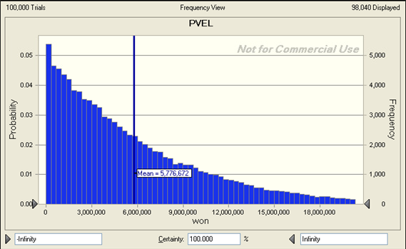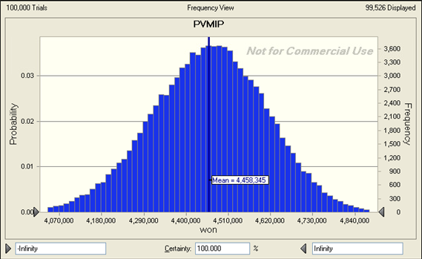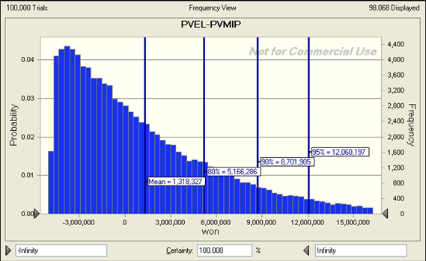

**Figure 1.** Sixty-five (65) years annuity plan.

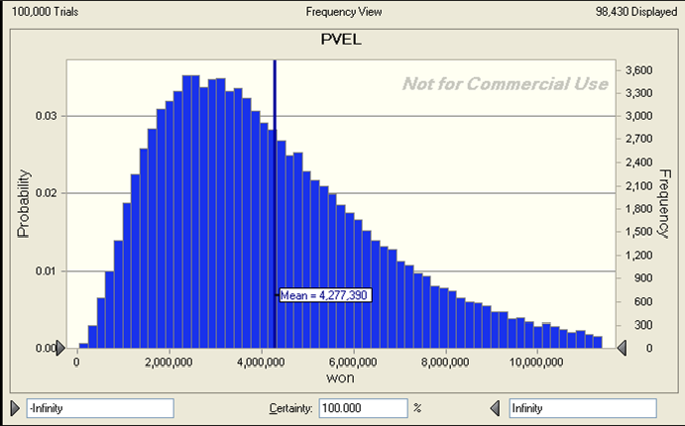

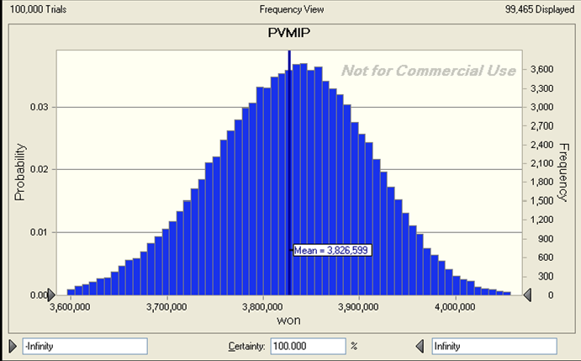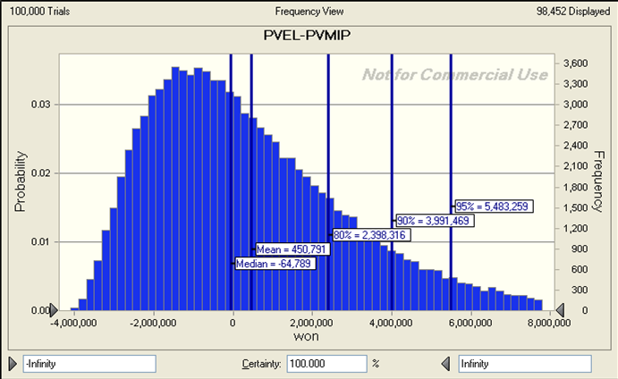

**Figure 2.** Seventy-five (75) years old annuity plan.

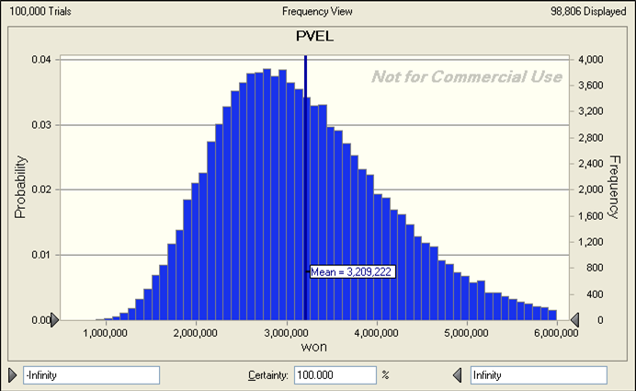

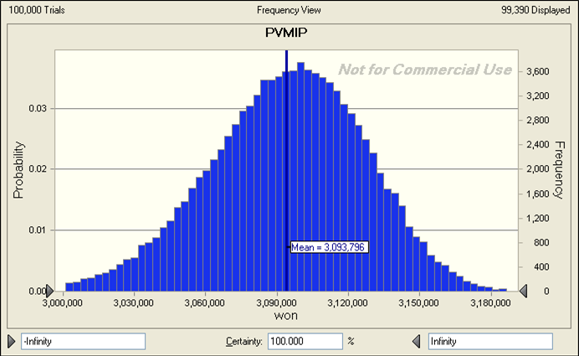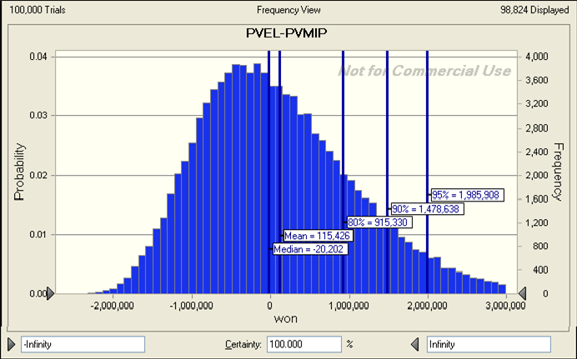

**Figure 3.** Eighty-five (85) years old annuity plan.

**Table 6.** Result of risk analysis.

|  |  |  |  |
| --- | --- | --- | --- |
| **Variable** | **Age 65** | **Age 75** | **Age 85 (KRW)** |
| Average PVEL | 5,776,672 | 4,277,390 | 3,209,222 |
| Average PVMIP | 4,458,345 | 3,826,599 | 3,093,796 |
| Average NL | 1,318,327 | 450,791 | 115,426 |
| 80% VaR | 5,166,286 | 2,398,316 | 915,330 |
| 90% VaR | 8,701,905 | 3,991,469 | 1,478,638 |
| 95% VaR | 12,060,197 | 5,493,259 | 1,985,908 |
| *1 U.S dollar=1,150 won. |  |  |  |

case of a 65 year old borrower who gains pmt 246,982 won a month, predicted mean of value at risk (NL) that the FRM provider can bear is 1,318,327 won, 80% value at risk is 5,166,286 won, 90% value at risk is 8,701,905 won and 95% value at risk is 12,060,197 won. In case of a 75 year old borrower who gains pmt 419,374 won a month, predicted mean of value at risk (NL) that the FRM provider can bear is 450,791 won, 80% value at risk is 2,398,316 won, 90% value at risk is 3,991,469 won and 95% value at risk is 5,493,259 won. In case of a 85 year old borrower who gains pmt 757,379 won a month, predicted mean of value at risk (NL) that the FRM provider can bear is 115,426 won, 80% value at risk is 915,330 won, 90% value at risk is 1,478,638 won and 95% value at risk is 1,985,908 won.

We summarize average of PVEL, average PVMIP, average NL, 80% VaR, 90% VaR and 95% value at risk depending on age 65, 75 and 85 plan in Table 6. As we see in Table 6, as the borrower who joins FRM gets older, the risk value due to fluctuation of interest rate gets smaller. VaR implies expected maximum loss under the given probability distribution.

# DISCUSSION

This study is a pilot study building an actuarial model for the farmland reverse mortgage which is initiated for the first time in the world. We estimate pmt under the condition that PVEL is equal to PVMIP, and predict the risk that the lender could bear depending on the fluctuation of interest rate. As we see in the results, pmt is not that high to attract the farmland owners in rural areas. But applying real estate market prices for farmland makes FRM more attractive as mentioned in previously. In addition, farmland owners (borrowers) still posses the rights of using their farmland and ownership until they die after they joined FRM. Thus they can obtain income by cultivating the farmlands themselves or lending their farmlands to other farmers or farm corporations. Hence, it could be a newly established social security instrument that covers the deficiency of current social security networks like the national pension and basic old age pension. Especially, for the rural elderly who own

relatively high value farmland which produces small profits and are not protected by the current social security networks, FRM could be a policy option to cover the deficiency.

By developing the basic annuity model, we can extend the model in various ways. We can extend the model depending on who manages the FRM by adjusting up- front insurance premium and spread depending on the objectives of initiating FRM. At the same time, we can also extend the model by changing payment-option such as lump-sum payment, combination of lump-sum and pmt payment, and term-payment depending on borrowers’ preferences. This study contributes to the launch of FRM by providing a basic annuity plan model which could be extended to various optional models.

**Conclusion**

We expect to enhance the competence of agricultural sector by restructuring farmlands which are collected through FRM in rural areas in the end. As we discussed, there many small farmlands which produces little profit even though the value of those are high. Through the initiation of FRM, government or a lender can increase the scale of farmlands and enhance competitiveness of rural areas by restructuring rural areas, and settling corporate farmers system in the future. We carefully argue FRM could be applied to many countries in Asia, Africa and other countries which necessitated active government role in developing agricultural sectors, and plays an important role in collecting small and unproductive farmlands for the rural planning. At the same time, it could contribute to welfare of the elderly in rural areas.

**REFERENCES**

Cha I, Hongju J (2008). The Study on the Pricing Model in Reverse Mortgage Insurance Using Option Theory, Risk Management 19(1): 3-49.

Cho D, Seungtyul BK, Gyeongsik J, Gabtae K (2008). The Study on the introduction of Farmland Reverse Mortgage; Final Report, Korea Rural Community and Agriculture Corporation.

Kim Y, Ho-Chul Kim (2006). A Policy Direction for the Readjustment of Officially Announced Standard Land Prices. J. Korean Urban Manag. Assoc. 19(3):3-22.

Koo D (2006). Exploring Alternative Real Estate Assessment Systems in Korea, J. Korean Geogr. Soc. 41(3):257-268.

Rodda DT, Christopher H, Hin-Kin L (2000). Evaluation Report of FHA’s Home Equity Conversion Mortgage Insurance Demonstration Final Report, U.S Department of Housing and Urban Development.

Rodda DT, Hong L, Christopher NR, Corissa T, Andrew Y (2003). Refinancing Premium, National Loan Limit, and Long-Term Care Premium Waiver for FHA’s HECM Program: Final Report, the U.S Department of Housing and Urban Development.

Yeo C, Deokho C (2010). The Study on the Estimating Farmland Value Rising Rates for the Initiation of Farmland Reverse Mortgage. J. Korean Reg. Dev. Assoc. 22(3):63-80.

Park, G.-H., & Cho, D. (2014). The reverse mortgage of farming assets as a viable option for rural welfare. *Journal of Regional Studies and Development*, 23(2), 55–72.

Cho, Deokho (2015): Farmland value forecasting and the estimation of monthly payment of farmland pension considering the regional differences, 55th Congress of the European Regional Science Association: "World Renaissance: Changing roles for people and places", 25-28 August 2015, Lisbon, Portugal, European Regional Science Association (ERSA), Louvain-la-Neuve

Kim, Changki and Kim, Eyunghee and Jeong, Seungyoung, Farmland Backed Annuities: A New Shelter for Aged Farmers (April 29, 2011). Available at SSRN: <https://ssrn.com/abstract=1826463> or [http://dx.doi.org/10.2139/ssrn.1826463](https://dx.doi.org/10.2139/ssrn.1826463)

Li, X., Gao, M., Chu, M., Huang, S., Fang, Z., Chen, T., Lee, C.-Y., & Chiang, Y.-C. (2023). Promoting the well-being of rural elderly people for longevity among different birth generations: A healthy lifestyle perspective. *Frontiers in Public Health, 11*, 1050789. <https://doi.org/10.3389/fpubh.2023.1050789>

Cohen SA, Greaney ML. Aging in Rural Communities. Curr Epidemiol Rep. 2023;10(1):1-16. doi: 10.1007/s40471-022-00313-9.