Anorectal Melanoma: A Rare Cause of Rectal Bleeding and Diagnostic Dilemma a Case Report



**Abstract**

This case highlights the diagnostic challenges of anal canal malignant melanoma, a rare and aggressive tumor often misdiagnosed as hemorrhoids. A 54-year-old female presented with an anal mass and intermittent rectal bleeding for eight months. Initial misdiagnosis delayed proper evaluation until a biopsy and PET scan suggested advanced, unresectable anorectal melanoma, later confirmed by histopathology and immunohistochemistry (HMB-45 and Melan-A positive). A palliative colostomy was performed for symptom relief. This case emphasizes the importance of early diagnosis in patients over 40 with rectal bleeding and anal masses, as timely evaluation can improve management and outcomes, and also notifies the early aggressiveness of the tumour.

**Keywords**

Anorectal Melanoma, Rectal Bleeding, Colostomy, Case Report.

# 1. Introduction

Malignant melanoma within the gastrointestinal (GI) tract is an exceedingly uncommon entity, with around half of these cases localized to the anorectal region [1]. It represents

1Corresponding Author

2Second Author

3Third Author

merely 1% of all malignant tumors in this anatomical area and accounts for just 0.3–1% of all diagnosed malignant melanomas [2]. Anorectal melanoma (AM) is notably aggressive and is associated with a grim prognosis, often leading to fatal outcomes [1]. From an epidemiological perspective, females are approximately 1.6 times more likely to develop rectal melanoma compared to males, with the average age of diagnosis being 71 years [2]. Due to its anatomical position, AM frequently manifests with symptoms such as rectal bleeding, a detectable mass, or altered bowel habits—symptoms that are also commonly seen in benign conditions like hemorrhoids, thereby contributing to diagnostic delays [3]. Research suggests that melanomas are more prevalent in the rectum than the anal canal and tend to progress more aggressively. Nonetheless, anal and rectal melanomas are often grouped together in studies due to their similar clinical characteristics [4]. Surgical intervention remains the primary mode of treatment, typically involving wide local excision or more extensive transabdominal procedures. However, the most effective surgical approach

months. She had experienced similar symptoms a year ago, which had temporarily subsided after taking herbal medicines. However, her current symptoms had worsened, with the addition of tenesmus and spurious diarrhea over the past month. The bleeding was fresh and mixed with stool, and she reported early-morning loose stools over the same period. On clinical evaluation, the patient was noted to be pale; however, she did not report experiencing weight loss, loss of appetite, or any other notable symptoms. Blood tests showed a hemoglobin level of 8 g/dL and an elevated total leukocyte count of 23,000/cmm. Liver and kidney function parameters were found to be within normal ranges. There was no personal history of major illnesses, though it is noteworthy that her husband had passed away due to colonic cancer. On rectal examination, a large, polypoidal, pedunculated, and friable mass was identified on the right lateral surface of the anal canal, approximately 1.5 cm from the anal verge. The mass exhibited areas of alternating black discoloration. Given its suspicious appearance, a biopsy and histopathological examination was performed to rule



remains a matter of clinical discussion [2].

This report details an unusual case of primary anorectal melanoma. The case has been documented in accordance with the Surgical Case report (SCARE) guidelines [5].

**2. Presentation of case**

A 54-year-old female housewife from southern Karnataka presented to our surgical outpatient department with complaints of rectal bleeding and a mass per rectum for eight

out malignancy.

Colonoscopy revealed an ulcerated growth in the anal canal causing partial obstruction, located 1.25 cm from the anal verge on the left lateral wall between the 2o’clock and 4o’clock positions as shown in Fig;1. The findings strongly suggested malignancy.

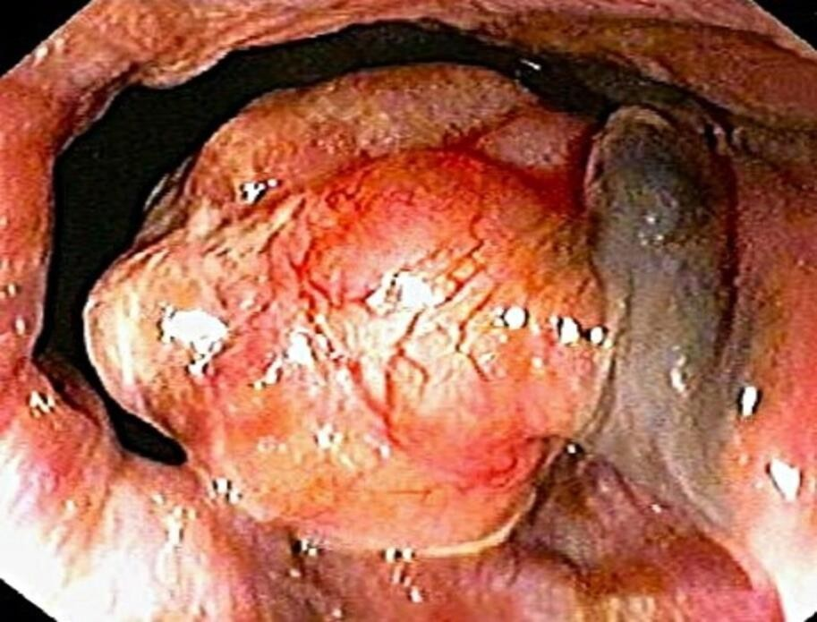

**Fig: 1 Colonoscopy: Ulcerated growth at anal canal causing partial obstruction**

The histopathological examination of the biopsy specimen revealed a focally ulcerated epidermis accompanied by a mixed inflammatory infiltrate. The dermis demonstrated a tumor exhibiting junctional activity, with tumor cells arranged in sheets, lobules, and a trabecular pattern.

The tumor cells were round to oval or spindle-shaped, showing moderate pleomorphism. They displayed vesicular chromatin, prominent nucleoli, and scanty to moderately indistinct

cytoplasm. Numerous cells contained golden-brown pigment consistent with melanin. Additionally, a few multinucleated tumor cells were observed. The impression was that of a poorly differentiated neoplasm, favoring a diagnosis of malignant melanoma.

Immunohistochemical (IHC) staining was performed, revealing that the tumor cells were strongly positive for melanocytic markers, including HMB-45, S-100, and Melan-A, as shown in Figure; 2, confirming their melanocytic origin. Additionally, the cells tested negative for pan-cytokeratin (CK) and CD31, thereby excluding the possibilities of carcinoma, adenocarcinoma, and vascular tumors.

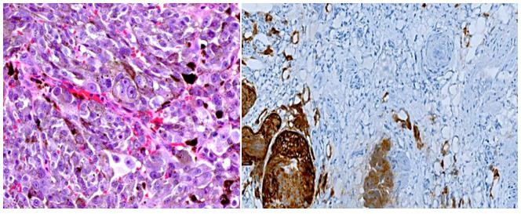

# Fig; 2: Primary anal melanoma composed of spindled and epithelioid cells, some of which are multinucleated. The cells have enlarged nuclei with vesicular chromatin and



**prominent nuclei. There is conspicuous pigment within the tumor, with MelanA positive stains.**

A total-body PET scan was conducted, which demonstrated augmented tracer uptake (hypermetabolic activity) in asymmetric wall thickening and confluent intraluminal lesions in the rectum and anorectum. These lesions extended proximally to the rectosigmoid and inferiorly to the anal canal, causing significant luminal narrowing (metabolic dimensions: 6.1

× 6.1 × 10.6 cm, AP × TR × CC; SUVmax: 27.4). FDG uptake was also noted in the

perirectal and presacral lymph nodes, with the largest right perirectal node measuring 1.9 ×

1.7 cm (SUVmax: 11), s/o metastases. Additional FDG uptake was observed in the left inguinal lymph node (1.9 × 1.5 cm; SUVmax: 12) and the left common iliac lymph node with central necrosis (1.5 × 1.4 cm; SUVmax: 3.1), s/o metastases. FDG uptake in sclerosis T7 vetebra.

Liver appears enlarged in size (span 18.6 cm) and shows diffuse fatty changes, with no evidence of hypodense lesions or focal abnormal FDG uptake. No other significant hypermetabolic lesions were identified elsewhere in the body, as shown in Fig; 3.

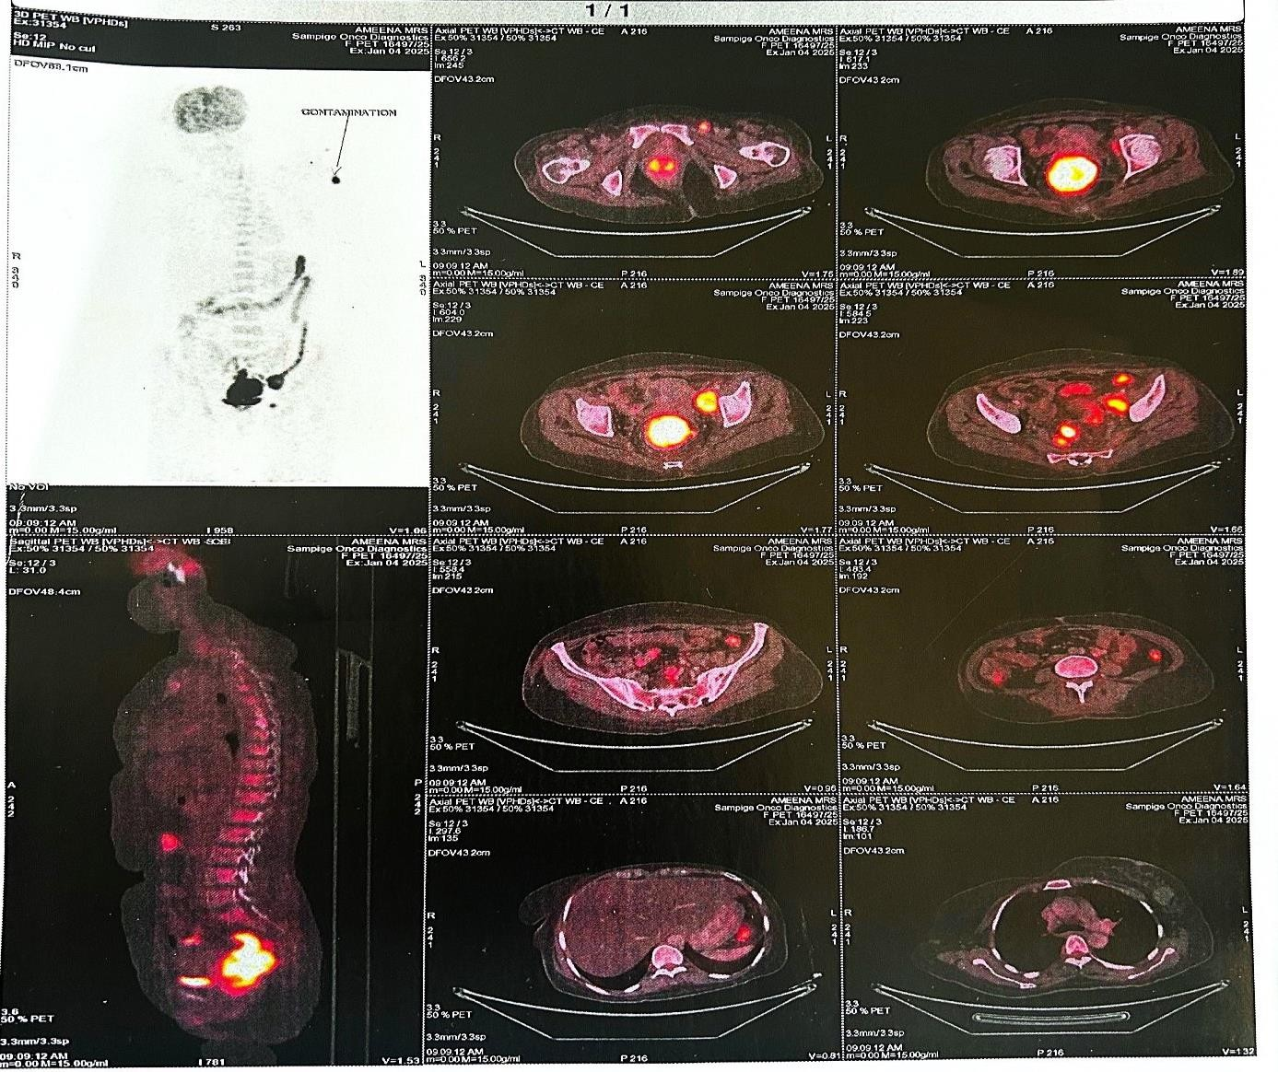

**Fig; 3: Total Body PET Scan**

In recent years, self-expanding metallic stents (SEMSs) have been utilized as a palliative measure for patients with unresectable anorectal tumors, particularly in stage IV disease.

These stents are deployed in a collapsed form and expanded across the obstructing lesion under fluoroscopic, endoscopic, or combined guidance. However, when the tumor is located close to the anal canal—within 3 cm—SEMS placement may lead to complications such as severe anal pain, tenesmus, and incontinence [2]. In such scenarios, a diverting colostomy serves as an effective alternative to relieve obstructive symptoms while avoiding these distressing complications. Furthermore, the presence of a long-segment luminal narrowing with pronounced angulation can render SEMS placement technically unfeasible and potentially hazardous. Challenges such as difficulty in passing the guidewire or performing

balloon dilation may increase the risk of perforation, often necessitating emergency surgical intervention [3]. Given these considerations, a diverting colostomy was performed in this case of advanced anorectal malignancy to safely manage the obstruction and prevent further complications.

Following a multidisciplinary oncologic consultation, a watchful waiting approach was initially adopted, the patient was managing well with a colostomy and in good health, but a follow-up contrast-enhanced CT scan nine months later revealed a hypodense lesion in the right lobe of the liver, indicative of metastatic disease, for which the patient is now undergoing chemotherapy.

# 3. Discussion

The origin of anorectal melanoma has long been debated in medical literature. Initially, rectal melanomas were thought to result from the malignant transformation of melanocytes that had migrated from the anal canal. However, advances in electron microscopy and

around 70 years. Our patient, a 54-year-old woman, was younger than the average age at diagnosis, highlighting the need for clinicians to consider anorectal melanoma even in relatively younger patients presenting with concerning anorectal symptoms.



immunohistochemistry have confirmed the presence of normal melanocytes within the columnar epithelium of the rectum in affected patients, supporting the hypothesis of a primary rectal origin for these tumors [4].

Anorectal melanoma is a rare malignancy, typically diagnosed in individuals during their sixth to seventh decade of life, with a slight female predominance [5]. This demographic trend contrasts with colorectal adenocarcinoma, which generally presents at an older age,

Clinical presentation is often nonspecific, making early diagnosis challenging. Rectal bleeding is the most commonly reported symptom, observed in up to 83% of cases, followed by tenesmus, anorectal pain, and altered bowel habits [6]. In many cases, these symptoms mimic benign anorectal conditions such as hemorrhoids, leading to diagnostic delays. The average interval from symptom onset to diagnosis is approximately four months [7], yet in our case, the patient presented after eight months, by which time the disease had significantly progressed. Such delays are clinically significant, as roughly one-third of patients have metastatic disease at initial diagnosis [7].

A critical diagnostic challenge is the presence of amelanotic melanomas, which account for approximately 30% of anorectal melanomas [2]. These tumors may lack the typical

pigmentation associated with melanoma and can be mistaken for poorly differentiated carcinomas or other malignancies. In such cases, immunohistochemical evaluation becomes essential. The detection of melanocytic markers such as S-100 protein, HMB-45, and Melan- A is crucial for definitive diagnosis. In our patient, strong positivity for all three markers confirmed the diagnosis of malignant melanoma.

This case highlights several key considerations in the diagnosis and management of anorectal melanoma: the importance of maintaining a high index of suspicion in patients with persistent anorectal symptoms, the role of immunohistochemistry in differentiating amelanotic variants, and the impact of delayed diagnosis on prognosis. Early recognition and timely intervention



remain critical, although the overall prognosis for anorectal melanoma continues to be poor due to its aggressive nature and tendency for early metastasis.

This case underscores the aggressive nature and diagnostic challenges of anorectal melanoma, which often presents with non-specific symptoms and can be misdiagnosed as benign conditions like hemorrhoids. Early identification through histopathological and immunohistochemical analysis, along with advanced imaging modalities like PET-CT, is crucial for accurate diagnosis and staging. Given the tumor's proximity to the anal canal and its advanced stage, a diverting colostomy was preferred over self-expanding metallic stents to alleviate obstructive and per rectal symptoms. The subsequent development of hepatic metastasis highlights the high recurrence rate and poor prognosis of anorectal melanoma. This case emphasizes the importance of early detection and a multidisciplinary approach for optimal management and improved patient outcomes [1, 9].

**4. Conclusion**

In conclusion, anorectal melanoma is a rare and aggressive malignancy often misdiagnosed

due to its nonspecific symptoms. Early recognition, accurate histopathological diagnosis, and appropriate surgical intervention are crucial for managing the disease. This case emphasizes the importance of a multidisciplinary approach, as even with initial surgical management, the high risk of recurrence necessitates vigilant follow-up. Timely intervention and individualized treatment strategies can help improve patient outcomes in this challenging condition.

**Patient perspective:** The patient stated that it would be useful to publish and share this case with other healthcare workers, to enable better understanding and correct diagnosis of such rare cases that would cause a specific treatment and follow up.

**Consent:** Written informed consent was obtained from the patient for publication of this case report and accompanying images. A copy of the written consent is available for review by the Editor-in-Chief of this journal on request.

**Ethical approval:** Ethical approval was waived by the authors institution.

# References

1. G. Paolino, D. Didona, G. Macrì, S. Calvieri, S.R. Mercuri, in: Anorectal Melanoma, Exon Publications, 2018, pp. 83–98.
2. H. Menon, R.R. Patel, T.R. Cushman, A. Amini, S.N. Seyedin, A.C. Adams, et al.,

and role of adjuvant radiation therapy, J. Cancer Res. Clin. Oncol. 142 (12) (2016) 2569–2575.



Management and outcomes of primary anorectal melanoma in the United States, Future Oncol. 16 (8) (2020) 329–338.

1. T.J. Dodds, J.S. Wilmott, L.A. Jackett, S.N. Lo, G.V. Long, J.F. Thompson, et al., Primary anorectal melanoma: clinical, immunohistology and DNA analysis of 43 cases, Pathology 51 (1) (2019) 39–45
2. L. Tchelebi, A. Guirguis, H. Ashamalla, Rectal melanoma: epidemiology, prognosis,
3. R.A. Agha, T. Franchi, C. Sohrabi, G. Mathew, A. Kerwan, A. Thoma, et al., The SCARE 2020 guideline: updating consensus Surgical CAse REport (SCARE) guidelines, Int. J. Surg. 84 (2020) 226–230.
4. HOMSI J., GARRETT C. Melanoma of the anal canal : a case series. *Dis Colon Rectum*, 2007, **50** : 1004-10.
5. THIBAULT C., SAGAR P., NIVATVONGS S., ILSTRUP D. M., WOLFF B. G.

Anorectal melanoma – an incurable disease ? *Dis Colon Rectum*, 1997, **40** : 661-8.

1. Seya T, Tanaka N, Shinji S, Shinji E, Yokoi K, Horiba K, Kanazawa Y, Yamada T, Oaki Y, Tajiri T. A Case of Rectal Malignant Melanoma Showing Immunohistochemical Variability in a Tumor. Journal of Nippon Medical School. 2007;74(5):377-81.
2. C. Falch, S. Mueller, A. Kirschniak, M. Braun, A. Koenigsrainer, B. Klumpp, Anorectal malignant melanoma: curative abdominoperineal resection: patient selection with 18F-FDG-PET/CT, World J.Surg.Oncol. 14 (1) (2016) 1–9.



