Essentials of Endodontic Gadgets: Tools for the Modern Practitioner

Introduction
“The art of endodontics lies not just in skillful hands, but in the thoughtful use of science and technology that extend our vision, refine our actions, and protect the biological essence of the tooth.”
Endodontics, the branch of dentistry that deals with the diagnosis and treatment of diseases of the dental pulp and periapical tissues, has evolved dramatically in recent decades. Once limited to tactile sensation and radiographic guesswork, it has now transformed into a precision-based specialty enriched with cutting-edge technologies and gadgets. These tools have not only enhanced clinical outcomes but also reshaped the very definition of predictability and success in root canal therapy.
In the early years of endodontics, clinicians relied heavily on hand instrumentation, two-dimensional imaging, and personal expertise to treat the most intricate of root canal anatomies. Despite the best efforts, treatment failures were not uncommon due to incomplete debridement, undetected canals, procedural errors, and inadequate obturation. The introduction of technological advancements—what we now refer to as gadgets in endodontics—has changed this landscape completely.
The Role of Gadgets in Modern Endodontic Practice
Gadgets, in the context of endodontics, refer to specialized devices and instruments that aid in the diagnosis, treatment, and restoration of endodontically treated teeth. These include magnification devices like dental operating microscopes, imaging tools like CBCT, electronically assisted tools like apex locators and motorized file systems, and irrigation and obturation devices that allow for enhanced cleaning and sealing of root canal systems.
The utility of these gadgets lies not only in their precision but also in the efficiency they bring to practice. What once took multiple appointments can now be accomplished in a single sitting with greater reliability and patient comfort. Root canal treatments, once feared by patients, are now being performed more comfortably and successfully than ever before—thanks largely to these innovations.
For example, the advent of rotary endodontics using NiTi instruments revolutionized canal preparation, reducing procedural errors like ledging, zipping, or transportation. Similarly, the integration of Cone Beam Computed Tomography (CBCT) into endodontic diagnosis and treatment planning has allowed clinicians to visualize complex canal anatomies in three dimensions, making what was once invisible, visible. In a similar vein, the use of warm vertical obturation devices, ultrasonic irrigants, and apex locating motors has made canal obturation and disinfection more complete and effective.
Driving Forces Behind Technological Adoption
Several factors have fueled the rise of gadgets in endodontics. First, the growing demand for high-quality dental care has pushed clinicians to adopt tools that can enhance clinical outcomes and reduce failure rates. Patients today are more aware and educated—they expect pain-free, fast, and long-lasting treatment. Second, with the rapid evolution of dental materials and engineering, companies are continuously innovating tools that improve ergonomics, reduce clinician fatigue, and simplify procedures. Third, the rise of evidence-based practice has provided solid clinical data supporting the superiority of gadget-assisted procedures over traditional methods in many cases.
Educational institutions and postgraduate programs now emphasize the importance of using technology to improve clinical outcomes. Many training centers around the world are equipped with high-end gadgets to ensure that budding endodontists are well-versed with contemporary tools even before they begin private practice. The emergence of workshops, webinars, and online forums dedicated to endodontic gadgets also highlights the global interest and growing reliance on these tools.
Bridging the Gap Between Technology and Technique
However, gadgets are not magical instruments—they are only as effective as the clinician operating them. One of the core messages of this book is that technology should enhance, not replace, the clinical judgment, knowledge, and tactile finesse of the endodontist. A dental operating microscope, for instance, will only aid canal identification if the clinician knows what to look for. An apex locator will only be useful if it is calibrated properly and interpreted correctly.
Thus, it is important that gadgets are not viewed as crutches, but as extensions of clinical skill. The synergy between technique and technology is what ultimately leads to successful outcomes. This book aims to help clinicians achieve that synergy by providing a detailed overview of the most widely used gadgets in endodontics, along with their indications, contraindications, pros, cons, and maintenance protocols.
What This Book Offers
This book, “Gadgets in Endodontics,” is an attempt to compile and simplify the vast array of tools now available to the modern endodontist. Whether you are a postgraduate student, general dentist, or seasoned specialist, this book is designed to provide value by offering:
- A comprehensive review of endodontic gadgets organized by their function—diagnostic, magnification, isolation, preparation, irrigation, obturation, restoration, and sterilization.
- Evidence-based insights into the benefits and limitations of each gadget.
- Practical tips on clinical integration—from choosing the right device for your setup to incorporating it into your daily workflow.
- Troubleshooting guides and maintenance protocols to ensure long-term performance and safety.
- A look into future innovations, including AI, robotics, and digital endodontics.
The format is intended to be both educational and clinically applicable. Wherever possible, real-life clinical examples and photographic representations have been used to reinforce the practical application of these devices. Readers will also find comparison tables, summary charts, and brand recommendations to facilitate decision-making in practice.
The Future is Here—Are You Ready?
We are standing at the threshold of an era where digital endodontics is no longer a distant concept but a present reality. Intraoral scanners, digital workflow management, 3D-printed guides for access cavities, and teledentistry platforms are becoming integral to modern dental practices. The endodontist of the future must therefore be technologically savvy, ethically grounded, and clinically precise.
As with any tool, the true potential of a gadget lies in how it is wielded. While this book will provide a detailed overview of the available tools, the final outcome still depends on the clinician’s commitment to continual learning and adaptation. The aim is not just to impress patients with fancy gadgets but to utilize them meaningfully to improve prognosis, preserve natural dentition, and enhance patient satisfaction.
In the words of the visionary Dr. Herbert Schilder:
“The endodontist’s goal is to clean the entire root canal system—not just the canal.”
Today, with the help of innovative gadgets, we are closer to achieving that ideal than ever before.
Let this book be your companion on that journey—from analog to digital, from conventional to contemporary. Welcome to a new age of endodontics.

Chapter 1: Evolution of Endodontic Technology
"To understand where we are going, we must first understand where we came from."
The evolution of endodontics from a largely tactile, analog procedure to a highly digitized and technologically advanced specialty is nothing short of remarkable. This journey has been driven by the relentless pursuit of better outcomes, patient comfort, and clinical predictability. In this chapter, we explore the historical context, pivotal innovations, and paradigm shifts that laid the foundation for today’s gadget-assisted endodontics.
1.1 The Beginnings: Manual Dexterity and Artistic Skill
In the early 20th century, endodontic treatment was largely dependent on basic hand instruments like barbed broaches, reamers, and K-files. Dentists performed treatments without magnification or modern imaging—relying solely on their anatomical knowledge, clinical intuition, and two-dimensional radiographs. Irrigation solutions were limited, obturation materials were rudimentary, and procedural mishaps were frequent.
Root canal therapy was time-consuming and often met with skepticism by both patients and clinicians. Many teeth with pulpal disease were simply extracted due to the high failure rates of conventional techniques. The lack of visibility, inadequate disinfection, and difficulty in navigating curved or calcified canals made comprehensive treatment a challenging feat.

1.2 The Advent of Radiography and Improved Instrumentation
The introduction of dental radiography in the early 1900s brought a monumental change. Dentists could now visualize the canal morphology, estimate working lengths, and detect periapical lesions. Still, these images were two-dimensional and required interpretation skill. Despite their limitations, radiographs remained the gold standard for endodontic imaging for decades.
Around the same time, better quality stainless steel instruments and standardized instrumentation techniques, such as the step-back method, were introduced. The 1950s and 60s saw the rise of thermoplasticized gutta-percha for obturation, and obturation devices like the Spreader and Plugger improved the sealing ability of root canal fillings.

1.3 The NiTi Revolution: Rotary Endodontics
The most groundbreaking shift in biomechanical preparation came with the introduction of nickel-titanium (NiTi) rotary instruments in the 1990s. NiTi's shape memory and superelasticity properties made it possible to prepare even severely curved canals with greater safety and efficiency. This innovation drastically reduced the risk of canal transportation, ledging, and perforation compared to stainless steel files.
The initial rotary systems required a steep learning curve, but continuous advancements such as variable tapers, controlled memory alloys, and reciprocating motion made them more accessible and safer. With the rise of endo motors and torque-controlled handpieces, canal preparation became faster, more predictable, and less stressful for both clinician and patient.
1.4 Visual Empowerment: The Microscope Era
Vision is arguably the most critical element in successful endodontic treatment. The introduction of the Dental Operating Microscope (DOM) in the late 1980s, popularized by Dr. Gary Carr and others, provided a game-changing advantage. Enhanced magnification and coaxial illumination allowed clinicians to identify additional canals, cracks, and complexities that were previously undetectable to the naked eye.
Microscope-assisted endodontics not only improved accuracy but also elevated the standard of care, particularly in retreatment cases and surgical endodontics. The microscope, once considered a luxury, is now regarded as an essential gadget in modern endodontic practice.

1.5 Precision in Length Control: Electronic Apex Locators
Working length determination has always been a cornerstone of root canal therapy. Initially dependent on radiographic guesswork, clinicians often struggled to identify the precise apical constriction. This led to under- or over-instrumentation, affecting the outcome.
Electronic Apex Locators (EALs) revolutionized this step by allowing accurate real-time length determination without reliance on radiographs. Modern apex locators use impedance and frequency analysis to pinpoint the location of the apical foramen with high precision—even in moist conditions. Some newer endo motors now integrate apex locator functionality, providing a seamless workflow.

1.6 Irrigation and Disinfection: Moving Beyond Syringe Delivery
Traditional syringe irrigation was long considered sufficient, but it often failed to reach the apical third and lateral canals effectively. This limitation led to the development of sonic, ultrasonic, and negative pressure irrigation systems that could activate irrigants, enhance fluid dynamics, and improve canal cleanliness.
The introduction of laser-assisted irrigation, particularly techniques like PIPS (Photon-Induced Photoacoustic Streaming) and SWEEPS, has pushed the boundaries even further, enabling deeper penetration of irrigants and disruption of biofilm in complex anatomical spaces.
1.7 Obturation Advancements: Warm Techniques and Bioceramics
The goal of obturation is to hermetically seal the entire root canal system. Historically, this was done using lateral compaction of gutta-percha—a technique that was reliable but limited in adapting to canal irregularities. The evolution of obturation gadgets introduced warm vertical compaction units, carrier-based obturators, and thermoplasticized gutta-percha injectors.
More recently, bioceramic sealers and hydraulic condensation techniques have gained popularity due to their excellent biocompatibility, dimensional stability, and antimicrobial properties. Delivery systems and obturation guns now allow precise placement of these materials, even in challenging canals.

1.8 3D Imaging and Digital Planning: The CBCT Revolution
Arguably the most transformative gadget in diagnostic endodontics has been Cone Beam Computed Tomography (CBCT). Unlike traditional radiographs, CBCT provides a three-dimensional view of the tooth, supporting structures, and surrounding anatomy. It has become a powerful tool in diagnosing missed canals, root fractures, resorption defects, and complex morphologies.
The use of CBCT has also enabled guided endodontics, where access cavities can be planned digitally and executed with 3D-printed guides—especially useful in calcified canals or surgical endodontics.
1.9 The Digital Integration Era
The past decade has seen the fusion of digital workflows into endodontic practice. Intraoral scanners, cloud-based patient records, AI-based diagnostic tools, and teledentistry platforms have expanded the scope of what an endodontic setup can achieve. Even endo training has seen a shift toward virtual simulators and augmented reality (AR) platforms.
The integration of smart endodontic motors, wireless obturation units, and ergonomically designed chairs and accessories point toward a future where the dental operatory becomes a fully digitized, intelligent workspace.

1.10 Embracing the Past, Innovating the Future
The evolution of gadgets in endodontics is a reflection of our profession’s commitment to excellence. Each advancement has brought us closer to the ideal of preserving natural dentition with minimal discomfort and maximal success. While these tools offer tremendous advantages, they are only as effective as the clinician wielding them.
As we move forward, the endodontist of the future must not only master biological principles and procedural skills but also stay abreast of technological innovations. The next chapters of this book will delve deeper into these gadgets—exploring their functions, features, and how to apply them wisely in your practice.
Let us now begin that journey—starting with the foundation of every successful treatment: accurate diagnosis.

Chapter 2: Diagnostic Devices in Endodontics
“Diagnosis is not the end, but the beginning of practice.” – Martin H. Fischer
Accurate diagnosis is the cornerstone of effective endodontic treatment. No matter how advanced the instruments or obturation techniques used, if the diagnosis is incorrect, the treatment is bound to fail. In the ever-evolving field of endodontics, several diagnostic gadgets have been developed to aid clinicians in detecting pulpal pathology, periapical lesions, canal anatomy variations, and root fractures. This chapter explores the essential diagnostic tools that help ensure precision and confidence in treatment planning.
2.1 The Role of Diagnostic Gadgets in Endodontics
Diagnosis in endodontics involves synthesizing clinical findings, patient symptoms, and radiographic interpretations. However, even with experience, conventional methods like thermal tests or periapical radiographs can sometimes lead to ambiguous or misleading results. This is where gadgets play a critical role by offering quantifiable, reproducible, and sometimes real-time information.
The major diagnostic gadgets discussed in this chapter include:
- Pulp testers (thermal and electric)
- Transillumination devices
- Digital radiography systems
- Cone Beam Computed Tomography (CBCT)
- Tooth Slooth and bite test aids
- Intraoral cameras
- Fiber-optic diagnostic lights
- Diagnostic loops and magnification systems

2.2 Electric Pulp Testers (EPT)
Purpose:
Used to assess the vitality of the pulp based on the sensory response of nerve fibers.
How It Works:
An electric current is delivered to the tooth, stimulating the A-delta nerve fibers. A response indicates the presence of some viable sensory nerve tissue.
Features:
- Adjustable current output
- Audible/visual signal feedback
- Automatic calibration
- Tip adapters for anterior/posterior teeth
Limitations:
- Only indicates nerve response, not actual pulp health (e.g., false positives in irreversible pulpitis or trauma cases)
- Unreliable in immature teeth or heavily restored crowns
Clinical Tips:
- Always test a control tooth
- Dry tooth surface; use a conductive medium (like toothpaste)
- Avoid contact with metallic restorations

2.3 Thermal Testing Devices
Purpose:
Used to simulate hot or cold stimuli and evaluate pulp vitality.
Devices Include:
- Refrigerant sprays (Endo Ice, CO₂ snow applicators)
- Digital pulp testers with heating elements
Pros:
- More reliable than EPT in identifying irreversible pulpitis
- Cold tests are particularly effective on anterior and premolar teeth
Caution:
- Avoid prolonged exposure to cold; may traumatize pulp or surrounding tissue
- Heat tests can be unreliable and risk causing discomfort if poorly controlled
2.4 Digital Radiography Systems (RVG – RadioVisioGraphy)
Advantage Over Film-Based X-rays:
- Instant image acquisition
- Lower radiation exposure
- Image enhancement capabilities (zoom, contrast, filters)
- Easy digital storage and sharing
Clinical Use:
- Assess periapical changes
- Determine working length
- Evaluate post-operative healing
- Monitor treatment progress
Brands: Carestream, Planmeca, Vatech, Acteon

2.5 Cone Beam Computed Tomography (CBCT)
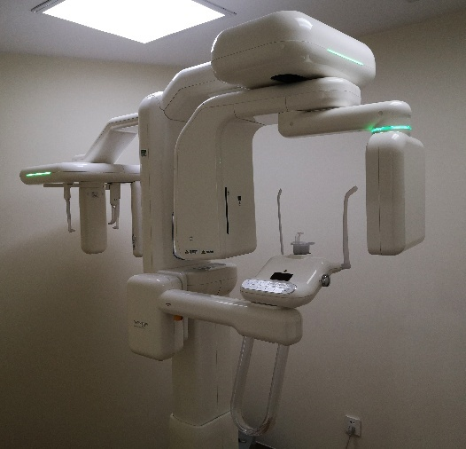
Game-Changer in Endodontic Diagnosis
CBCT offers 3D visualization of dental structures, overcoming the limitations of 2D radiographs. It enables a more accurate diagnosis of:
- Missed canals
- Complex root anatomies
- Internal and external resorptions
- Vertical root fractures
- Periapical cysts vs granulomas
- Calcified canals
Advantages:
- Multi-planar viewing (axial, sagittal, coronal)
- Quantifiable measurements
- Pre-surgical planning and navigation
Clinical Pearl:
Use CBCT selectively to minimize radiation. It is invaluable in retreatment and surgical planning.
2.6 Transillumination and Fiber-Optic Devices
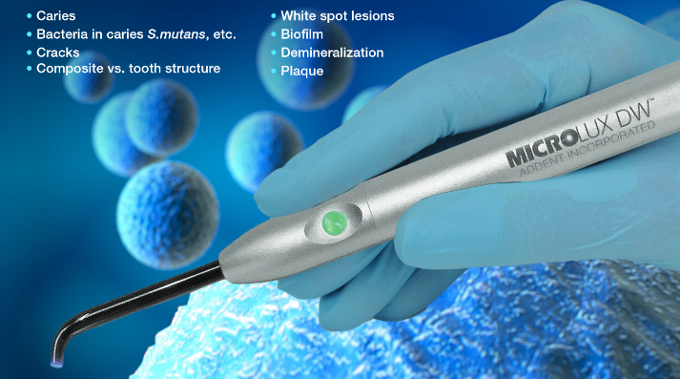
Microlux Transilluminator

Purpose:
Used to detect cracks, craze lines, or caries by illuminating the tooth structure.
Examples:
- Microlux Transilluminator
- Dentsply SureView
Clinical Application:
- Cracks appear as dark lines that block light
- Especially useful in identifying cracked tooth syndrome (CTS)

2.7 Tooth Slooth and Bite Test Devices
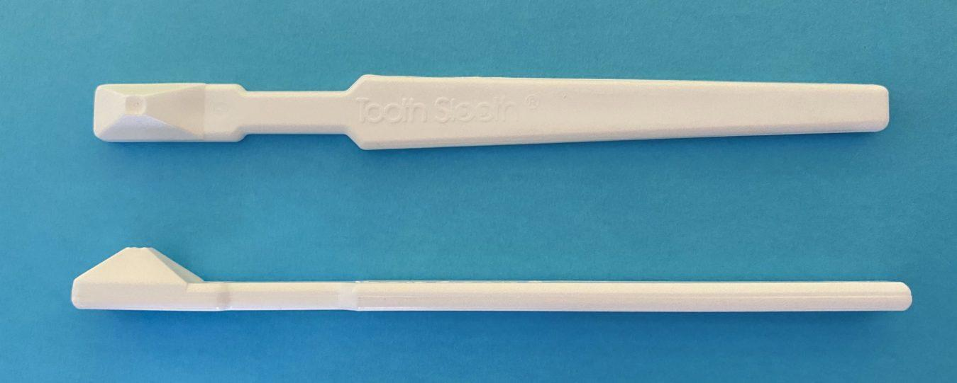
These are simple yet invaluable tools to reproduce biting forces and pinpoint pain, especially in patients with vague symptoms.
Indications:
- Suspected cracked tooth syndrome
- Localized occlusal trauma
- Cuspal fracture
Technique Tip:
Test each cusp individually and compare with the contralateral tooth.

2.8 Intraoral Cameras
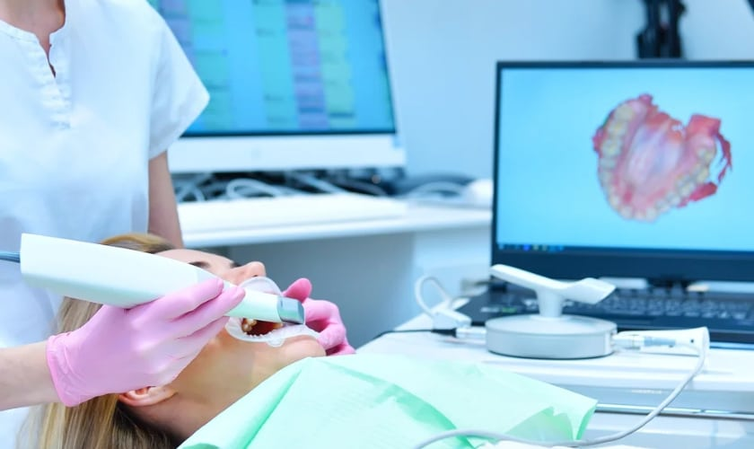
Though not diagnostic in the classical sense, intraoral cameras help document and communicate findings clearly to patients and colleagues.
Advantages:
- High-resolution magnified view
- Useful for patient education
- Visual records for documentation or referrals

2.9 Diagnostic Loops and Magnification Devices
Before the era of operating microscopes, surgical loupes (2.5x to 6x magnification) were instrumental in enhancing visibility.
Applications:
- Canal orifice detection
- Identifying calcifications or micro-fractures
- Minimizing access cavity size
2.10 Future Diagnostic Trends
The future of endodontic diagnostics is rapidly expanding toward:
- AI-based diagnostic tools analyzing radiographs and CBCT data
- Smart sensors integrated with pulp vitality probes
- Fluorescence-based caries and crack detection
- Augmented reality (AR) visualization tools overlaying anatomy in real-time

2.11 Conclusion: Diagnosis Drives Direction
As technology continues to evolve, the diagnostic phase of endodontics is becoming more accurate, non-invasive, and interactive. The key for the clinician is to use these gadgets not in isolation, but as part of a comprehensive diagnostic strategy combining patient history, clinical tests, and advanced imaging. Doing so significantly increases the chances of correct case selection, accurate treatment planning, and long-term success.
Chapter 3: Magnification and Illumination Devices
“You cannot treat what you cannot see.”
In endodontics, success hinges on precision. Whether it's locating an elusive MB2 canal, identifying a vertical root fracture, or performing microsurgical procedures, visibility plays a pivotal role. The integration of magnification and illumination devices has drastically transformed the scope of what is possible in modern endodontic practice.
In this chapter, we delve into the range of visual enhancement tools—ranging from basic magnification loupes to advanced dental operating microscopes (DOMs)—and explore their impact on clinical outcomes, ergonomics, and treatment quality.
3.1 The Importance of Enhanced Visualization
Unlike other dental specialties, endodontics often deals with complex, narrow, and deep anatomical structures. Enhanced visualization enables:
- Identification of extra or accessory canals
- Detection of fine cracks and craze lines
- Removal of pulp stones and calcifications
- Accurate placement of instruments and materials
- Minimal invasive access cavities
Without appropriate visual aids, these tasks are far more error-prone and less predictable.

3.2 Surgical Loupes: The Gateway to Magnification
Overview:
Dental loupes provide magnification ranging from 2.0x to 6.0x. They are generally lightweight and can be worn like spectacles or head-mounted.
Types of Loupes:
- Galilean Loupes: Lightweight, simpler optics, magnification up to 3.5x
- Prismatic (Keplerian) Loupes: Higher magnification (4.0x–6.0x), sharper image clarity
- Through-the-lens (TTL) vs Flip-up Design: TTL offers better ergonomics; flip-up loupes are adjustable and shareable
Key Considerations:
- Working distance
- Field of view
- Depth of field
- Interpupillary distance
- Declination angle (for neck posture)
Advantages:
- Improved posture and ergonomics
- Better visualization than naked eye
- Affordable and accessible for beginners
Limitations:
- Limited magnification compared to DOMs
- Illumination often needs to be added separately
- Depth perception may be compromised at higher magnifications
3.3 Head-Mounted LED Illumination Systems
Most loupes require an external light source for adequate illumination. LED headlamps mounted on the loupes or headbands offer shadow-free, focused light directly into the access cavity.
Features to Look For:
- Adjustable brightness (lumens)
- Color temperature (daylight-balanced light preferred)
- Lightweight, long battery life
- Wireless options for better mobility
Brands: Orascoptic, Designs for Vision, SurgiTel, Zeiss EyeMag Light
3.4 Dental Operating Microscopes (DOM): The Gold Standard
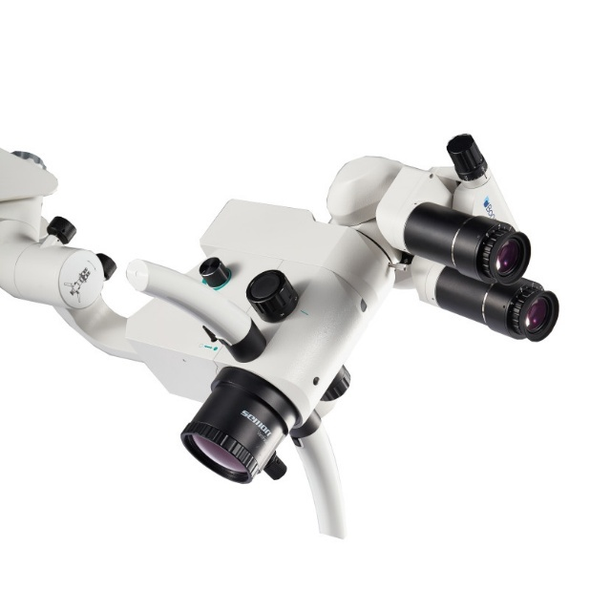
The DOM is the ultimate visualization gadget in endodontics, offering unparalleled magnification (3x to 25x) and coaxial illumination. It transforms the operator’s view from a general overview to a detailed micro-anatomical field.
Key Components:
- Magnification Changer: Manual or motorized zoom
- Light Source: Fiber-optic halogen, LED, or xenon light
- Eyepieces: Binoculars with adjustable diopters
- Objective Lens: Fixed (typically 200–300 mm working distance)
- Mounting: Floor, wall, ceiling, or chair-mounted
- Integrated Camera: For documentation and teaching
Clinical Applications:
- Locating calcified or extra canals (MB2, C-shaped)
- Detecting micro-cracks and internal resorptions
- Retrieval of separated instruments
- Guided microsurgical endodontics
- Repair of perforations
Advantages:
- Superior illumination and magnification
- Better precision and control
- Enhanced ergonomics with adjustable positioning
- Excellent tool for teaching and documentation
Challenges:
- Learning curve for hand-eye coordination
- Initial investment cost
- Requires space and operatory adaptation

3.5 Microsurgical Instruments Under the Microscope
The use of the microscope has also necessitated the development of microsurgical instruments, including:
- Micro-mirrors (for indirect vision)
- Micro pluggers and explorers
- Ultrasonic tips with special angulations
- Long-shank burs
- Perforation repair kits
These instruments are designed to operate within the restricted field viewed through the microscope and ensure delicate handling.

3.6 Enhanced Ergonomics and Operator Health
One of the often overlooked but highly significant benefits of magnification and illumination gadgets is their impact on clinician posture and musculoskeletal health.
- Adjustable microscopes encourage upright posture
- Declination angle in loupes reduces neck strain
- Reduced eye strain from proper lighting and optics
Endodontists working for extended hours benefit from less fatigue, fewer injuries, and improved clinical longevity.

3.7 Documentation, Education, and Tele-Endodontics
Modern DOMs are equipped with HD/4K video cameras and USB or HDMI outputs. This facilitates:
- Case documentation for patient education or legal records
- Real-time projection for teaching and demonstration
- Integration with teledentistry platforms for remote guidance
Some systems allow live streaming of procedures, bringing a new level of interactivity to endodontic education and mentorship.
3.8 Trends and Innovations in Visualization
Microscope Integration with CBCT and Navigation:
Some setups are now integrating real-time navigation overlays from CBCT scans, providing “augmented endodontics.”
Exoscope Systems:
High-definition exoscopes like the Zeiss EXTARO 300 offer ergonomic benefits by allowing clinicians to view the field on a screen rather than through binoculars.
Microscope-Guided Access Cavities:
Precision access can now be designed digitally and executed under magnification to conserve tooth structure—aligning with the principles of minimally invasive endodontics (MIE).

3.9 Choosing the Right Visualization Setup
For beginners or general practitioners:
- Start with 2.5x or 3.0x TTL loupes with LED light
- Upgrade to higher magnification and better optics over time
For endodontic specialists:
- Invest in a good quality DOM with integrated camera
- Choose a configuration that fits your operatory and budget
- Prioritize ergonomics, optics quality, and future expandability

3.10 “See More, Treat Better”
Magnification and illumination are not luxuries—they are essentials for modern endodontic excellence. The ability to visualize intricacies of root canal anatomy not only improves success rates but also elevates the clinician’s confidence, reduces iatrogenic errors, and enhances the overall treatment experience for both operator and patient.
In the next chapter, we shift focus to biomechanical preparation, exploring the gadgets and systems used in cleaning and shaping the root canal system—the heart of successful endodontic therapy.
3.11 Rod–Lens Endoscope (Jedmed, St. Louis, MO)
As the demand for minimally invasive and precise endodontic procedures grows, newer visualization technologies like endoscopes are finding increasing relevance. The Rod–Lens Endoscope, particularly the model manufactured by Jedmed (St. Louis, MO), offers high-resolution intraoral imaging through a narrow, fiber-optic-assisted tube—providing another option for clinicians when microscopes may be inaccessible or impractical.

What Is a Rod–Lens Endoscope?
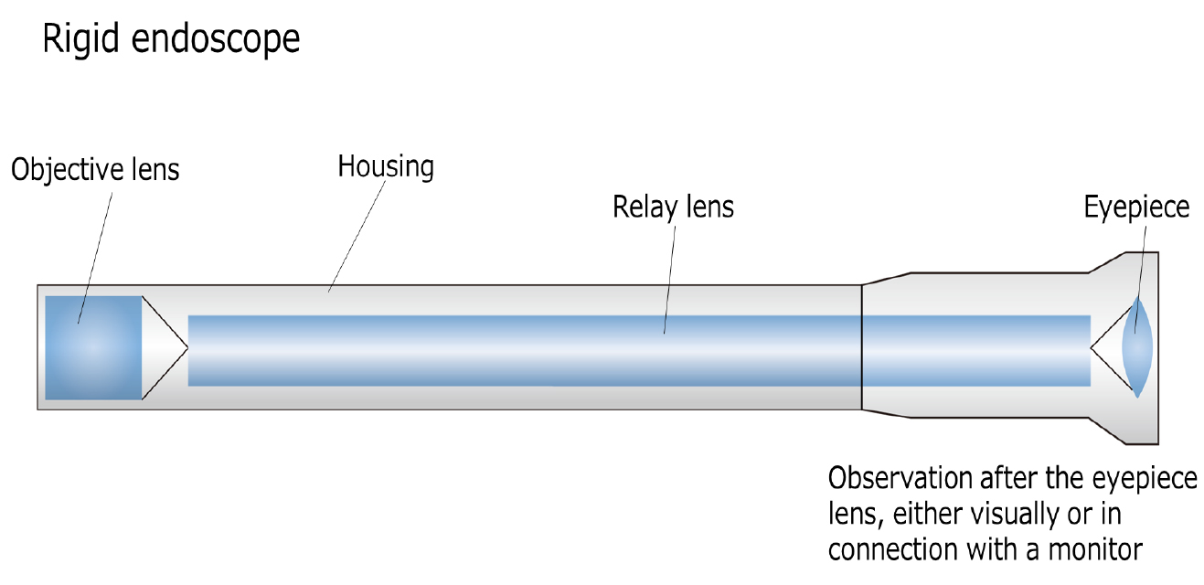
A Rod–Lens Endoscope is a rigid, tubular device that transmits light and visual information using a series of high-quality glass rods (lenses) rather than flexible fiber optics. This technology enhances image resolution and brightness, which is crucial for examining the confined spaces inside root canals or the periapical area during microsurgical procedures.

Key Specifications (Jedmed Rod–Lens Endoscope):
- Diameter: Typically 1.9 mm or smaller
- Viewing Angle: 0° to 30°, depending on model
- Length: Approximately 110 mm
- Optical Clarity: Superior to fiber-optic endoscopes
- Light Source Compatibility: LED or xenon light via fiber-optic cable
- Camera Integration: HD endoscopic camera head with real-time video output

Clinical Applications in Endodontics:
- Endodontic Microsurgery:
  - Used intraoperatively to inspect root apices and retrofilling integrity during apicoectomy.
  - Allows visualization beyond the resection surface, including isthmuses, accessory canals, and root-end filling defects.
- Crack and Fracture Detection:
  - Enables high-magnification inspection of suspected vertical root fractures or craze lines from within the pulp chamber or canal.
- Canal Visualization in Calcified Teeth:
  - When traditional microscopes fail due to canal calcification or obscured anatomy, the endoscope can navigate into deeper or atypical regions.
- Documentation and Teaching:
  - Real-time visual feedback is useful in case documentation, patient education, and live demonstrations for training purposes.

Advantages:
- Excellent Depth of Field: Particularly useful in narrow root canals and complex microsurgical fields.
- Noninvasive: Provides internal visualization without excessive removal of tooth structure.
- Real-Time Display: Enables assistant or trainee participation in procedures.
- Portability: More compact and adaptable than many DOMs.

Limitations:
- Learning Curve: Manipulating an endoscope inside the oral cavity requires new hand-eye coordination skills.
- Cost: High initial investment for the system, camera, and monitor setup.
- Sterilization: Requires careful handling and specific protocols for autoclaving or chemical sterilization.
- Limited Field of View: Compared to a DOM, the endoscope's fixed field can be more restricted.
Feature | DOM | Rod–Lens Endoscope
Magnification Range | 3x–25x | Up to 20x (fixed)
Working Distance | Adjustable | Limited by probe length
Field of View | Wide, binocular | Narrow, monocular
Illumination | Coaxial LED/Xenon | Fiber-optic external light
Recording | Integrated camera possible | External camera needed
Ideal Use Case | Most endodontic procedures | Surgical/endoscopic access areas
Table : Comparative Analysis b/w DOM & Rod–Lens Endoscope

Clinical Tip:
In microsurgical endodontics, especially during apical inspection, use the Rod–Lens Endoscope after retro-preparation to inspect for microleakage, incomplete resections, or missed anatomy not visible under the microscope alone.

Future Potential:
- Integration with 3D navigation systems for guided endoscopy
- Flexible micro-endoscopes tailored to negotiate curved canals
- AI-assisted image recognition to highlight anatomical anomalies in real time

3.12 ZEISS OPMI PROergo
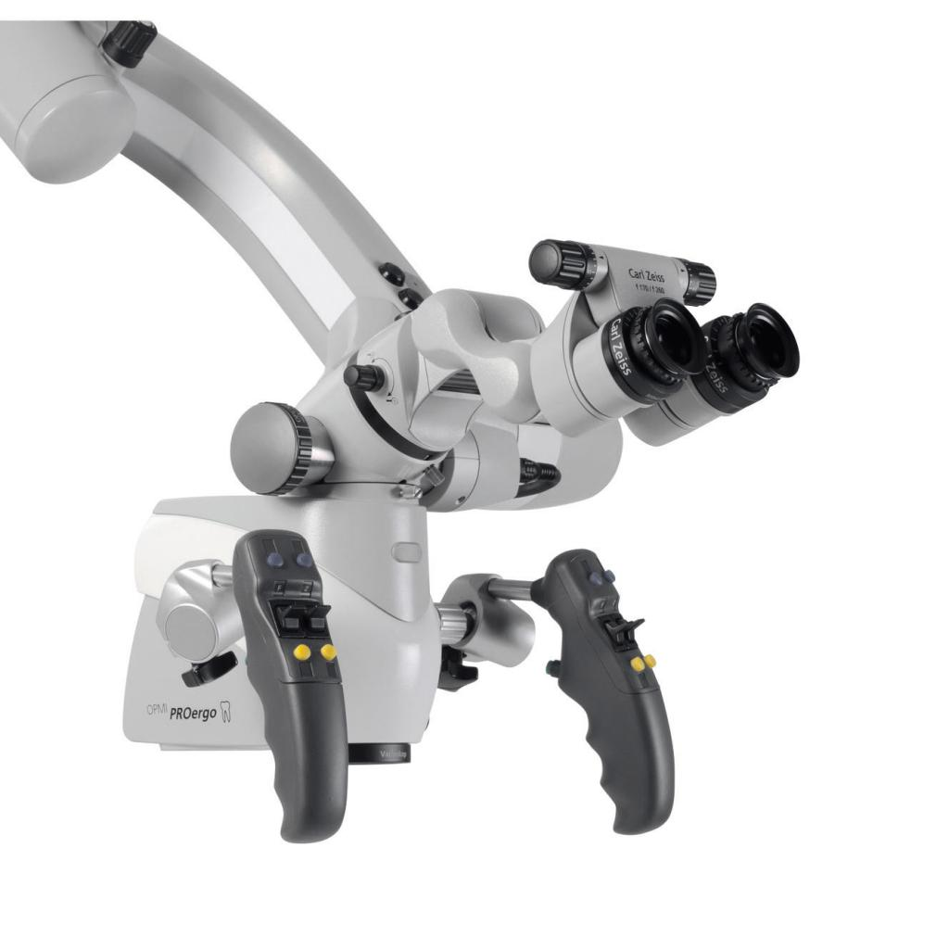
The ZEISS OPMI PROergo is a premium dental operating microscope known for its exceptional optical clarity, ergonomic design, and advanced illumination system. Widely used in endodontics, it features motorized zoom and focus, an integrated light source, and intuitive controls that enhance both visibility and comfort during complex procedures. Its seamless integration with HD video documentation systems makes it an ideal tool for clinicians focused on precision, efficiency, and teaching. Though positioned at the higher end of the market, it remains a gold standard for specialists seeking top-tier visualization.

3.13 ZEISS EXTARO 300
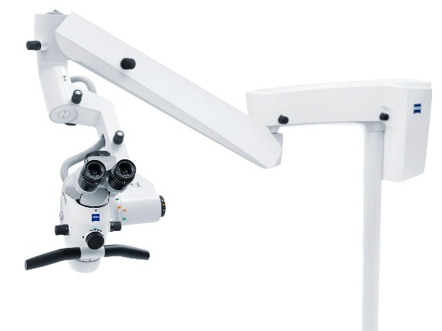
The ZEISS EXTARO 300 is a next-generation dental microscope that merges optical excellence with digital innovation. It offers features such as augmented visualization, digital shade matching, and fluorescence mode to detect carious tissue—all integrated into a sleek, ergonomic design. Its intuitive controls and smart documentation capabilities enhance workflow and precision in endodontic procedures. With its advanced features, the EXTARO 300 is ideal for clinicians who aim to combine clinical accuracy with cutting-edge technology.
Feature | ZEISS OPMI PROergo | ZEISS EXTARO 300
Optics | High-resolution apochromatic optics | Same ZEISS quality optics with digital enhancements
Magnification | Motorized zoom (3x–25x) | Motorized zoom with visual overlay options
Illumination | Internal LED/Xenon with coaxial beam | LED with integrated Fluorescence mode
Ergonomics | Balanced design, integrated motorized adjustments | Compact, lightweight head with enhanced maneuverability
Digital Integration | Optional HD video and photo integration | Smart Documentation, Digital Shade Assist, Fluorescence View
Advanced Features | Trusted for surgical and endodontic precision | Augmented visual guidance, enhanced caries detection
Use Case | Microsurgery, canal location, documentation | Endo + Restorative workflows, enhanced diagnosis
Price Range | Premium (high) | Premium (slightly higher)
Ideal For | Experienced endodontists focused on microsurgery | Clinicians seeking digital innovation and diagnosis

3.14 ZEISS OPMI pico
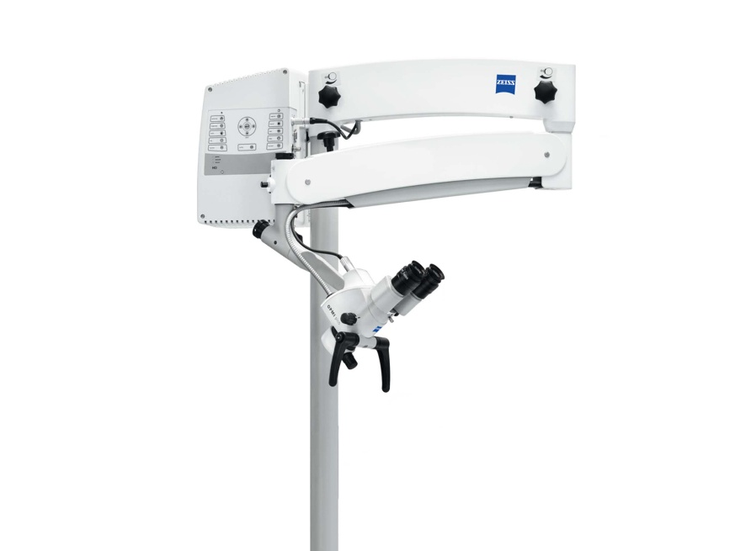
The ZEISS OPMI pico is a compact and user-friendly dental operating microscope designed for clinicians who are new to magnification or seeking a streamlined setup. It offers excellent ZEISS optical clarity, basic manual magnification (5-step changer), and integrated LED illumination. While it lacks the advanced automation of its PROergo or EXTARO counterparts, the OPMI pico is a reliable and cost-effective option for general and endodontic procedures, particularly in smaller operatories where space is a concern.
3.15 MORA Interface – Enhancing Ergonomics in Endodontics
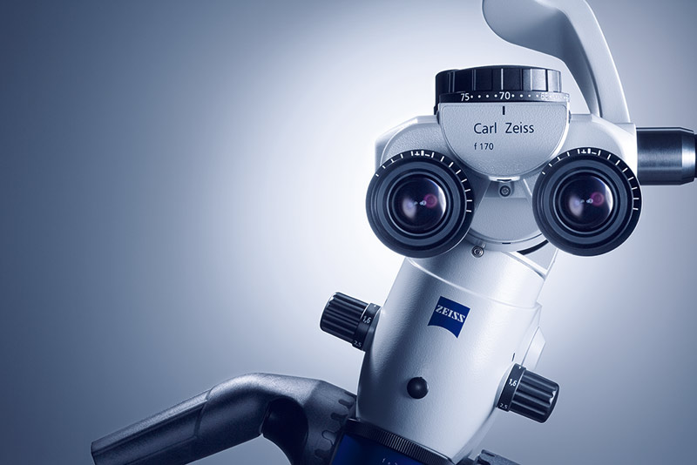
The MORA Interface (Magnetic Optical Rotation Axis) is an advanced optical component designed by ZEISS to improve clinician ergonomics during the use of dental operating microscopes. It is especially valuable during prolonged procedures and in challenging anatomical areas such as maxillary molars, distal roots, or surgical fields.
How It Works:
Traditional microscopes require the clinician to tilt their head or contort their body to follow the angulation of the optics. However, with the MORA Interface, the entire optical body of the microscope can be rotated horizontally, while the binoculars stay fixed relative to the operator’s eyes. This decouples head movement from the microscope’s positioning, enabling the clinician to maintain a neutral, upright posture without compromising the field of view.
Key Benefits:
- ✅ Improved Posture: Allows operators to remain upright even when viewing difficult angles.
- ✅ Consistent Interpupillary Distance: Prevents distortion or the need to adjust binocular spacing.
- ✅ Smooth Rotation: Magnetic coupling allows for effortless and precise realignment of the optics.
- ✅ Reduced Fatigue: Especially useful during long procedures such as retreatments, apicoectomies, or molar RCTs.
- ✅ Ideal for Microsurgery: Provides excellent control and access in posterior or awkward intraoral regions.
Who Benefits the Most?
The MORA Interface is particularly helpful for:
- Endodontists performing multiple RCTs daily.
- Clinicians with chronic neck/back discomfort.
- Microsurgical endodontists needing steep visual angles.
Compatibility:
The MORA Interface is an optional feature available primarily on:
- ZEISS OPMI PROergo
- ZEISS OPMI pico (on select models)
- Custom surgical microscope configurations

3.16 Summary of Ergonomic Features in Modern Endodontic Magnification Systems
Ergonomics plays a critical role in ensuring the clinician's long-term musculoskeletal health. Leading dental microscopes are now designed not only for optical clarity but also for operator comfort.
Key Ergonomic Features to Look For:
Feature | Function | Benefit
MORA Interface | Rotates optics independently of binoculars | Maintains upright posture, reduces neck strain
Tiltable Binoculars (0–210°) | Allows customized viewing angles | Supports various chairside positions
Counterbalanced Arm System | Smooth microscope positioning | Reduces effort and allows hands-free stability
Foot Control Integration | Hands-free zoom/focus or light adjustment | Enhances workflow and sterility
Compact Body Design | Easier integration in small operatories | Space-saving and mobile
LED/Xenon Coaxial Lighting | Shadow-free illumination | Better visibility with reduced eye fatigue
Adjustable Working Distance | Accommodates different procedures and instruments | Operator flexibility
Chapter 4: Instrumentation and Rotary Systems
Introduction
The cornerstone of successful endodontic therapy lies in the effective cleaning and shaping of the root canal system. This crucial phase of treatment demands a combination of precision, efficiency, safety, and flexibility—qualities that have been revolutionized through the integration of advanced rotary and reciprocating systems.
Traditional hand instrumentation, while still relevant in select scenarios, has largely given way to engine-driven systems that offer superior control, reduced operator fatigue, and faster canal preparation. With advancements in metallurgy, file geometry, and motor technology, endodontic instrumentation has entered an era defined by minimally invasive yet maximally effective canal preparation.
From the early days of stainless-steel hand files to the advent of nickel–titanium (NiTi) rotary files, and more recently, heat-treated, controlled-memory alloys, the evolution of instrumentation tools reflects the profession’s commitment to preserving natural tooth structure while enhancing clinical predictability.
This chapter delves into:
- The types of endodontic motors and file systems
- Torque control, speed settings, and built-in safety mechanisms
- Features of reciprocating vs continuous rotary motion
- File design, cross-section, taper, and metallurgy
- Integration of electronic apex locators and built-in irrigation features
- The emergence of smart motors with auto-reverse, glide path modules, and file-specific presets
Whether it is canal negotiation, coronal flaring, apical finishing, or retreatment, the instrumentation gadgets described in this chapter aim to simplify clinical workflow while elevating the standard of care.
4.1 Endodontic Motors
These motors are the powerhouse behind modern rotary instrumentation. They provide torque, rotational speed, and control settings that are critical for both efficiency and file safety.

A. X-Smart Plus (Dentsply Sirona)
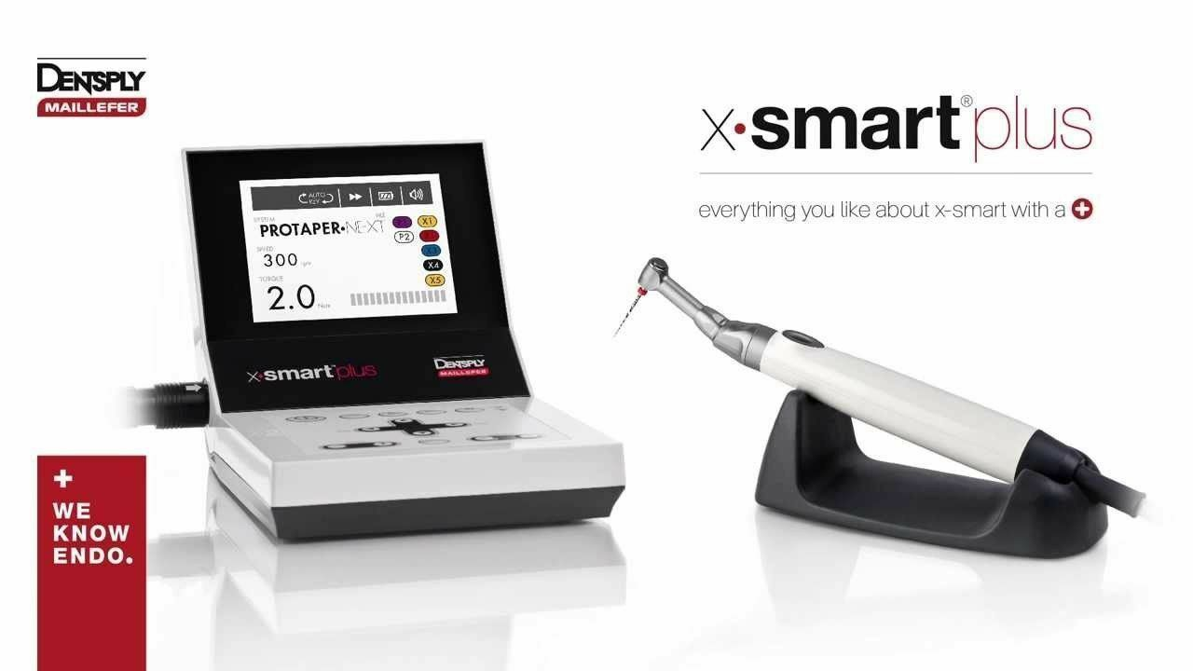
The X-Smart Plus is one of the most popular endodontic motors, widely appreciated for its simplicity, compact design, and compatibility with multiple file systems.
- Torque range: 0.6–4.0 Ncm
- Speed range: 250–1200 rpm
- Reciprocation Mode: Yes (suitable for WaveOne Gold)
- Display: Bright LCD with file system presets
- Foot Pedal: Optional wireless foot control
- Best used with: ProTaper Gold, WaveOne Gold, Reciproc Blue

B. EndoMate TC2 (NSK)
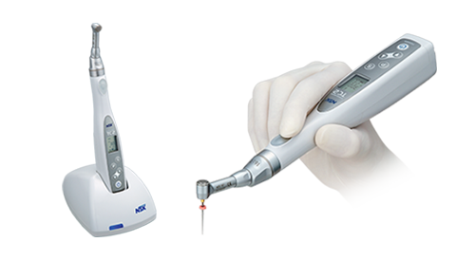
The EndoMate TC2 by NSK is a cordless endo motor that combines portability with precision.
- Torque control: Adjustable from 0.6 to 4.0 Ncm
- Speed settings: 100–650 rpm
- Preset Programs: 5 memory settings
- Rotation Modes: Forward, Reverse, and Auto-Reverse
- Battery Life: Long-lasting with a quick charging dock
- Best used with: HyFlex EDM, ProTaper Next, Mtwo, and others

C. Elements Motor (Kerr)
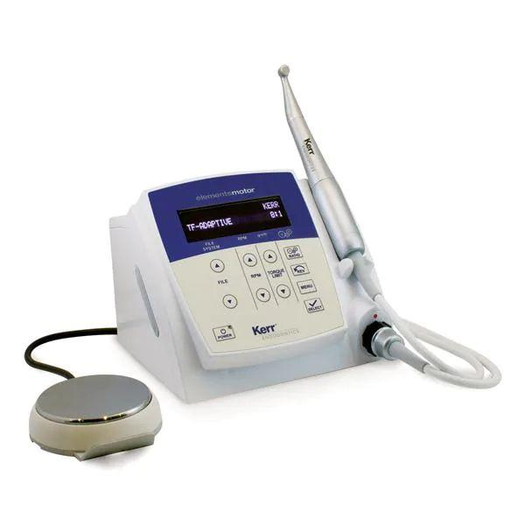
The Elements Motor is designed for advanced shaping protocols and is known for its ergonomic handpiece and digital interface.
- Preset file libraries for TF Adaptive, K3XF, and Vortex Blue
- Touchpad operation and auto-reverse safety mechanism
- Particularly useful in multi-visit endo settings with memory recall features

D. VDW.Gold Reciproc Motor (VDW, Germany)
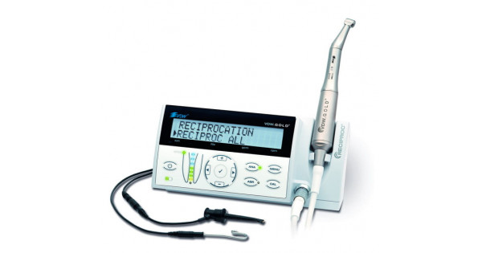
Specialized for reciprocating motion, this motor is ideal for Reciproc Blue and R-Pilot systems.
- Offers both rotary and reciprocation settings
- Has auto-start/stop when the file enters the canal
- Provides integrated file libraries and VDW.CONNECT app compatibility for Bluetooth connection
4.2 Engine-Driven Instruments
Engine-driven instruments have transformed modern endodontic practice by streamlining canal shaping, improving accuracy, and minimizing fatigue. These instruments include rotary and reciprocating NiTi file systems powered by electric motors. Their design, metallurgy, taper, and motion significantly influence clinical performance and outcomes.
Below is an overview of key engine-driven systems used in contemporary endodontics.

A. ProTaper Gold (Dentsply Sirona)
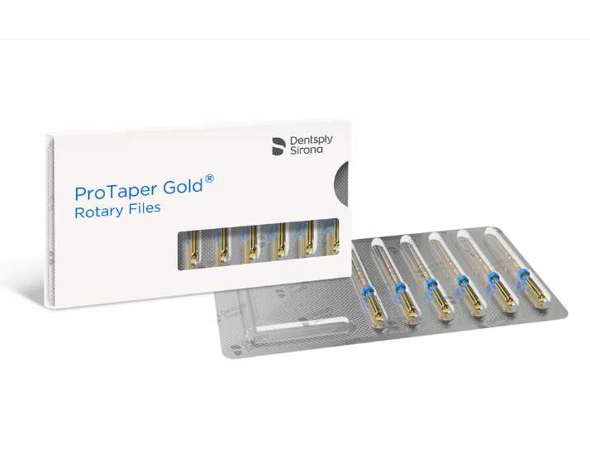
An evolution of the original ProTaper Universal system, ProTaper Gold incorporates advanced metallurgy for increased flexibility and fatigue resistance.
- Motion: Continuous rotary
- Taper: Progressive (increasing taper)
- Key Files: S1, S2 (shaping), F1–F3 (finishing)
- Gold Heat Treatment: Improves resistance to cyclic fatigue
- Indications: Suitable for curved canals and efficient shaping
- Note: Used with X-Smart Plus and similar rotary motors
B. WaveOne Gold (Dentsply Sirona)
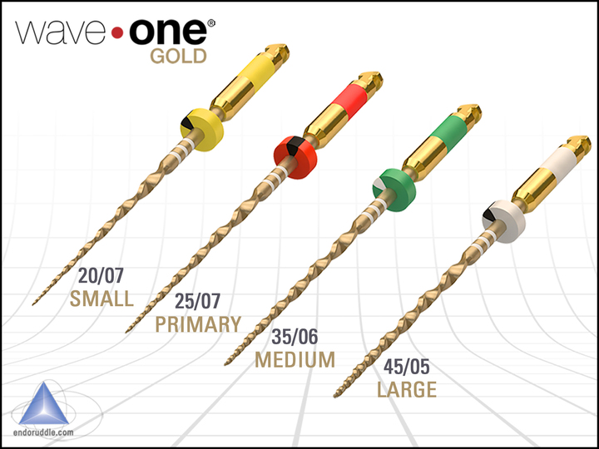
WaveOne Gold is a reciprocating system offering enhanced safety and efficiency, especially for general practitioners.
- Motion: Reciprocation (150° CCW, 30° CW)
- Files: Primary (25.07), Small (20.07), Medium (35.06), Large (45.05)
- Gold Wire Technology: Improved flexibility and tactile control
- Single-file shaping: Reduces instrument fatigue and procedural steps
- Best with: X-Smart Plus with reciprocating mode
C. HyFlex EDM (Coltene)
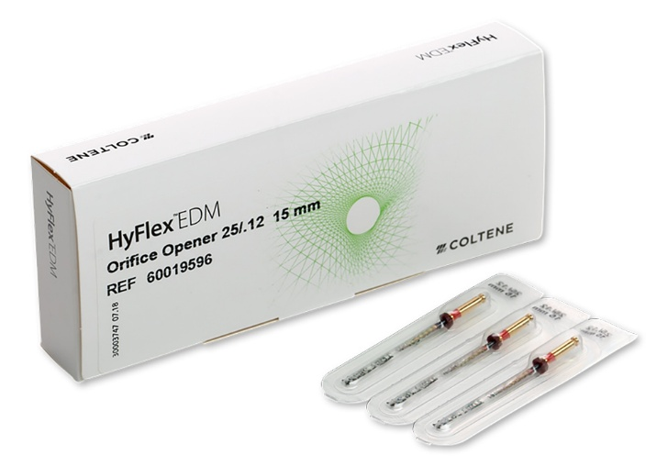
HyFlex EDM (Electrical Discharge Machining) files are known for exceptional flexibility and strength.
- Motion: Rotary
- Metallurgy: Controlled Memory (CM) NiTi with EDM process
- Files: OneFile, GlidePath File, Shaping File
- Feature: Shape-memory recovery – can return to original shape after deformation
- Ideal for: Narrow or calcified canals, and retreatment cases

D. TruNatomy (Dentsply Sirona)
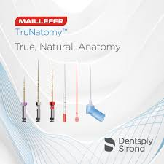
Designed with the principle of minimally invasive endodontics, TruNatomy preserves dentin while maintaining effective cleaning.
- Motion: Continuous rotary
- File Size: Prime (26.04), Medium (36.03), Small (20.04)
- Unique Features: Slim file core, off-centered design
- Benefits: Greater flexibility, less canal transportation
- Use With: Dedicated TruNatomy motor presets or adjustable endo motors

E. XP-endo Shaper (FKG Dentaire)
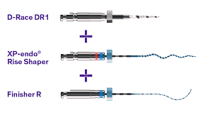
A highly adaptive file that changes shape based on body temperature, ideal for complex anatomies.
- Motion: Rotary
- Material: MaxWire alloy (NiTi that transforms between martensitic and austenitic states)
- Expansion capability: Can adapt up to size 30.04
- Use case: Irregular canals, fins, isthmuses
- Requires: Specific protocol and torque-controlled motor

F. Reciproc Blue (VDW)
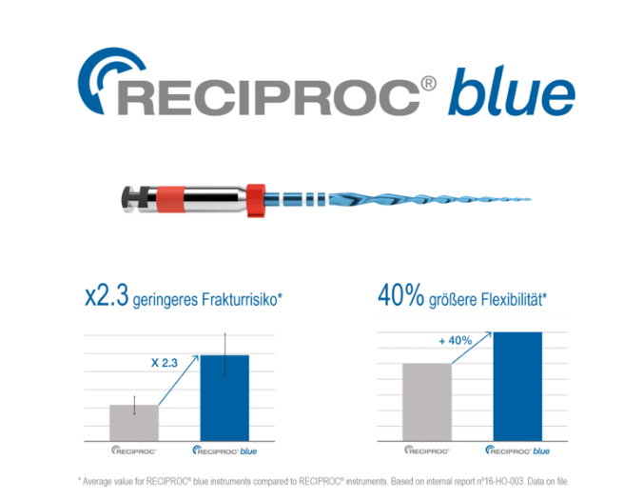
A thermally treated reciprocating system known for strength and simplicity.
- Motion: Reciprocation
- Files: R25, R40, R50
- Blue Wire Technology: Offers enhanced flexibility and cyclic fatigue resistance
- Ideal for: General endodontic practice with minimal shaping files
- Use With: VDW.Gold Reciproc motor or compatible reciprocation modes

G. EdgeEndo File Systems (EdgeTaper, EdgeOne, EdgeX7)
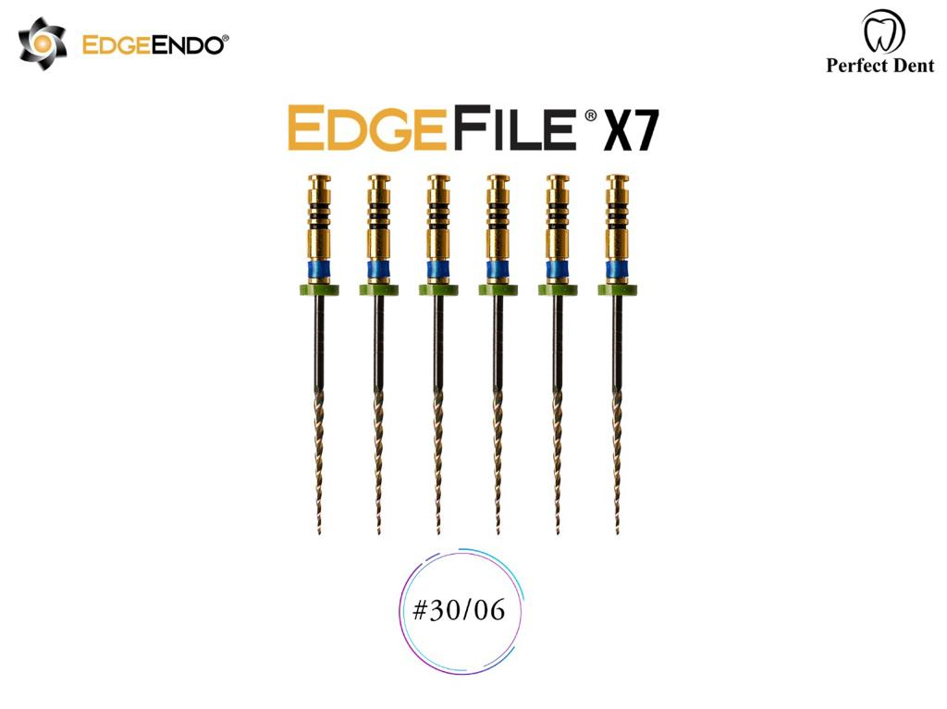
EdgeEndo systems are cost-effective alternatives using Heat-Treated FireWire™ NiTi.
- EdgeTaper Platinum: Equivalent to ProTaper Gold
- EdgeOne Fire: Equivalent to WaveOne Gold
- EdgeX7: Continuous rotary with enhanced cyclic fatigue resistance
- Feature: Smooth cutting, exceptional flexibility at competitive pricing
- Compatibility: Designed to match legacy systems (X-Smart, Elements, etc.)
Parameter | Importance
Motion Type | Rotary vs Reciprocation – affects cutting action and file fatigue
Metallurgy | CM wire, Gold Wire, Blue Wire, EDM – influences flexibility and resistance
Taper & Tip Design | Influences canal shaping and debris extrusion
Number of Files | Single vs multiple – impacts speed and learning curve
Cost & Reusability | Consider overall cost per case and sterility protocols
Motor Compatibility | Ensure presets and motion settings match motor capabilities

4.3 Reciprocating Handpiece
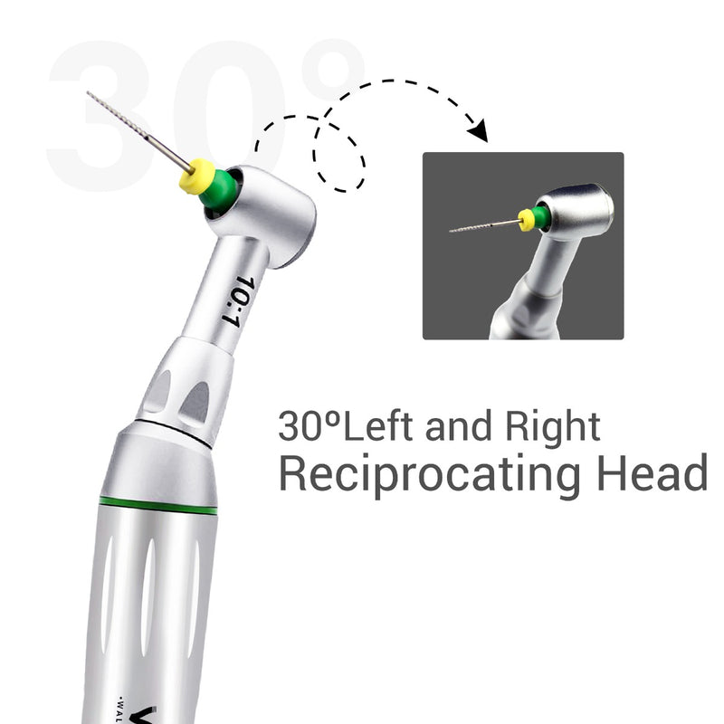
The reciprocating handpiece is a specialized, engine-driven instrument designed to replicate the manual watch-winding motion traditionally used with hand files. It introduces alternating rotational movements—clockwise and counter-clockwise—allowing the file to engage and disengage dentin efficiently while minimizing torsional stress and reducing the risk of file separation.

**A. What is a Reciprocating Handpiece?
A reciprocating handpiece is a low-speed contra-angle attachment or integrated device used with NiTi files that require reciprocating motion rather than continuous rotation.** It is designed to:
- Facilitate mechanical canal preparation using single-file techniques
- Improve accessibility, especially in tight or curved canals
- Reduce file separation risk by minimizing stress points

B. Types of Reciprocating Handpieces
- Standalone Handpieces
  - E.g., NSK Endo-Mate AT, iRoot Pro Reciprocating Handpiece
  - Pre-programmed or adjustable reciprocating angles
  - Lightweight and ergonomic
- Motor-Attached Handpieces
  - Paired with reciprocating endodontic motors like the VDW.Gold Reciproc, X-Smart iQ, or Elements Connect
  - Compatible with specific file systems (e.g., WaveOne Gold, Reciproc Blue)
  - Angle and torque settings adjusted via motor interface
C. Advantages of Reciprocating Handpieces
- ✅ Reduces fatigue on both the clinician and the file
- ✅ Allows single-file canal preparation in many cases
- ✅ Offers enhanced safety in curved or calcified canals
- ✅ Minimizes the screw-in effect seen with some rotary files
- ✅ Simplifies training for newer clinicians or general practitioners

D. Clinical Applications
- Efficient in cases requiring minimal instrumentation
- Ideal for primary treatment, retreatment, or pediatric cases
- Useful in narrow, calcified canals where rotary files might bind

E. Commonly Used File Systems with Reciprocating Handpieces
File System | Manufacturer | Motion
WaveOne Gold | Dentsply Sirona | Reciprocation (150° CCW/30° CW)
Reciproc Blue | VDW | Reciprocation (CCW/CW preset)
EdgeOne Fire | EdgeEndo | WaveOne-compatible motion
Tango-Endo | DentalEZ | Mechanical reciprocation

Important Note : Always verify motor compatibility with file systems. Each reciprocating file is engineered to operate within specific angles and torque thresholds.

F. Limitations
- Less tactile feedback than manual files
- Limited flexibility with advanced multi-file systems
- Not ideal for cases requiring fine apical enlargement or complex canal negotiation without prior glide path preparation
G. M4 Safety Handpiece (Sybron-Kerr, USA)
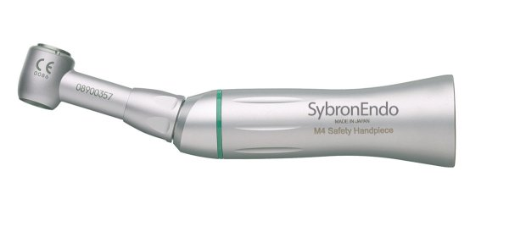
The M4 Safety Handpiece is a unique reciprocating device designed to mechanically advance stainless steel hand files in the canal with a gentle, watch-winding motion. It helps improve efficiency, reduce operator fatigue, and minimize procedural errors during early canal preparation stages.

Key Features:
- Reciprocating Motion: Mimics the hand filing action with a 30° oscillating movement, enhancing file control and reducing the risk of ledging or transportation.
- Compatibility: Accepts standard ISO stainless steel hand files (sizes 06–25).
- Purpose: Designed specifically for glide path preparation and initial canal negotiation.
- Speed: Operates at low speeds (~800–1000 rpm) with minimal torque, suitable for delicate anatomical navigation.
- Attachment: Connects to most standard E-type low-speed motors.

Clinical Advantages:
- ✅ Excellent for creating a reliable and centered glide path before rotary instrumentation
- ✅ Reduces hand fatigue and improves working time efficiency
- ✅ Enhances file control in calcified or narrow canals
- ✅ Minimizes torsional stress and risk of instrument separation

Clinical Protocol (Suggested Use):
- Irrigate the canal thoroughly after access.
- Insert a pre-curved stainless steel K-file into the M4 handpiece.
- Slowly introduce the file with gentle apical pressure.
- Allow the handpiece to guide the file in and out with the reciprocating motion.
- Confirm working length with an apex locator or radiograph.
Limitations:
- ⚠️ Not compatible with NiTi rotary or reciprocating files.
- ⚠️ Limited to glide path formation—does not shape or enlarge canals.
- ⚠️ Must be used cautiously in highly curved canals to avoid transportation.

Giromatic (Medidenta/Micromega)
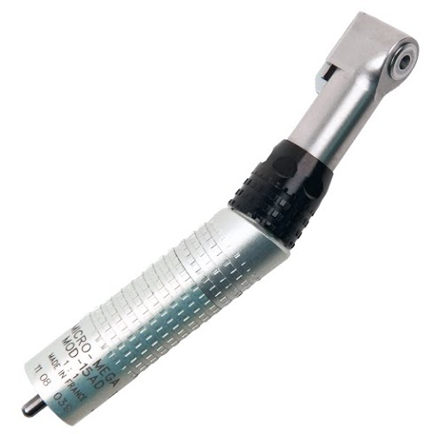
The Giromatic is a pioneering reciprocating handpiece introduced in the 1950s, designed to mimic the manual balanced force technique.
- Motion: Alternating reciprocation (~90°)
- Use: Primarily with stainless steel hand files (ISO sizes)
- Advantage: Reduces torsional stress and minimizes file separation
- Notable: One of the earliest mechanical aids in endodontic instrumentation

Endo-Gripper (Moyco Union Broach, USA)
The Endo-Gripper is a mechanical handpiece designed to securely hold and drive standard endodontic hand files using a powered reciprocating or rotary motion.
- Function: Converts hand files into engine-driven instruments
- Compatibility: Works with ISO stainless steel or NiTi files
- Advantage: Enhances control and reduces operator fatigue during canal preparation
- Use Case: Primarily in earlier phases of root canal instrumentation or with straight canals
EndoLift M4 (SybronEndo)
The EndoLift M4 is a reciprocating handpiece designed by SybronEndo to streamline glide path creation using a gentle reciprocal watch-winding motion.
- Motion: Reciprocating (approx. 30°–40° oscillation)
- Use: Engages standard ISO stainless steel hand files
- Benefits: Enhances glide path control, reduces hand fatigue, and improves canal negotiation—especially in narrow or curved canals
- Ideal For: Early canal instrumentation before rotary shaping

Intra-Endo LUX 3 LD (KaVo, Germany)
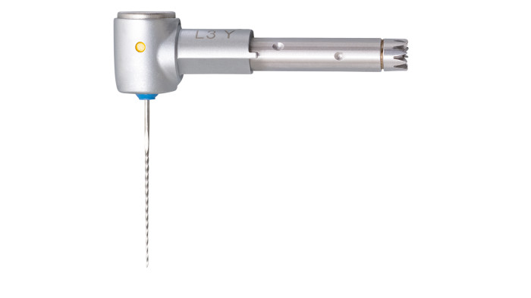
The Intra-Endo LUX 3 LD is a precision-engineered reciprocating endodontic handpiece developed by KaVo for enhanced glide path and canal preparation.
- Motion: Reciprocal rotation (watch-winding motion)
- Compatibility: Accepts ISO-standard hand files
- Features: Lightweight, ergonomic design with smooth file engagement
- Use: Facilitates safe and efficient early canal negotiation, especially in curved or narrow canals
Dynatrak (Dentsply DeTrey, Germany)
The Dynatrak is a reciprocating endodontic handpiece by Dentsply DeTrey, designed to automate the balanced force technique using stainless steel hand files.
- Motion: Reciprocating (watch-winding)
- Compatibility: Standard ISO hand files
- Purpose: Assists in glide path creation and early canal negotiation
- Notable: A reliable option during the transition from manual to mechanized endodontics
Dynatrak (Dentsply DeTrey, Germany)
The Dynatrak is a reciprocating endodontic handpiece by Dentsply DeTrey, designed to automate the balanced force technique using stainless steel hand files.
- Motion: Reciprocating (watch-winding)
- Compatibility: Standard ISO hand files
- Purpose: Assists in glide path creation and early canal negotiation
- Notable: A reliable option during the transition from manual to mechanized endodontics
VDW.CONNECT Drive (VDW, Germany)
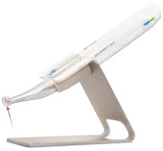
The VDW.CONNECT Drive is a smart endodontic motor that supports both reciprocating and continuous rotary motions, controlled via a Bluetooth-connected mobile app.
- Motion: Reciprocation & Rotary
- Compatibility: Designed for systems like Reciproc, Reciproc Blue, and other rotary files
- Features: Wireless app control, torque/speed customization, file library, and data tracking
- Advantage: Offers mobility, precision, and clinical versatility in a compact design

Vertical Stroke Handpiece
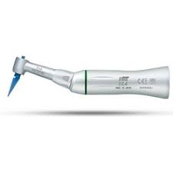
The Vertical Stroke Handpiece is a specialized mechanical device designed to replicate vertical filing or pecking motions, commonly used during canal instrumentation.
- Motion: Controlled in-and-out (axial/vertical) movement
- Use: Enhances the efficiency of manual file penetration into tight or calcified canals
- Compatibility: Typically used with ISO hand files
- Advantage: Reduces operator fatigue and facilitates consistent canal negotiation

X-Smart iQ (Dentsply Sirona)

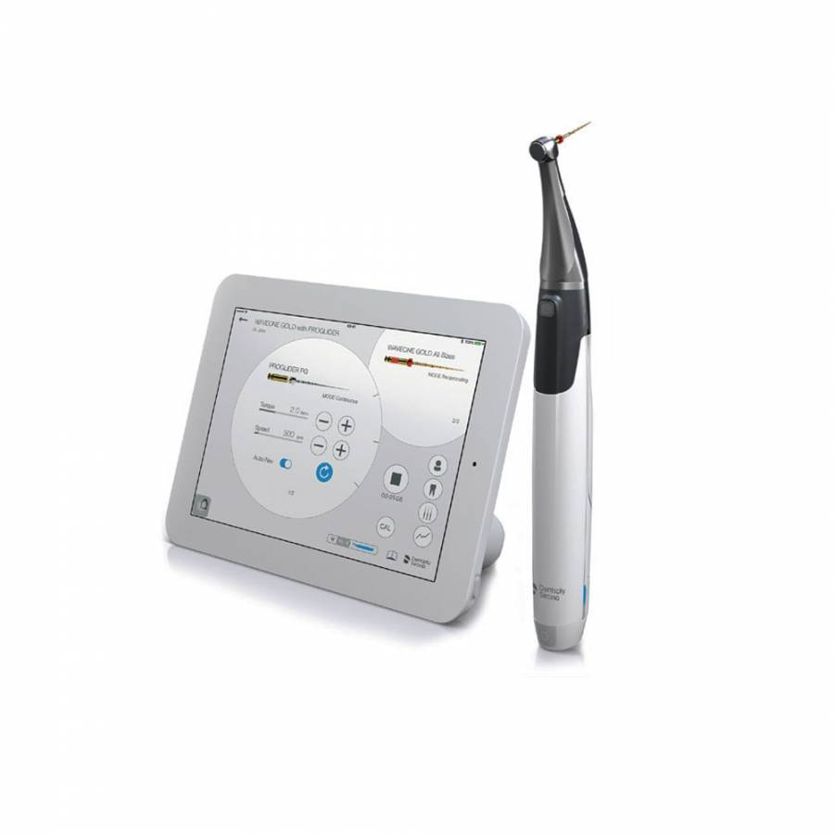
The X-Smart iQ is a Bluetooth-enabled endodontic motor integrated with an iPad app, offering intuitive control over reciprocating and rotary file systems.
- Motion: Reciprocation & Rotary
- Key Features: Custom file library, torque/speed presets, treatment recording, and file sequence guidance
- Use: Compatible with WaveOne Gold, ProTaper Gold, and more
- Highlight: Combines mobility with digital workflow for modern endodontics

Elements Connect (Kerr Endodontics)
The Elements Connect motor provides wireless smart control for both reciprocating and rotary file systems, focusing on ergonomics and integration.
- Motion: Reciprocation & Rotary
- Features: Touchscreen interface, customizable presets, file database
- Use: Compatible with TF Adaptive, K3XF, and other Kerr systems
- Highlight: Seamlessly fits into Kerr’s Elements ecosystem for enhanced operatory efficiency

Eighteeth AI Motor (SmartLite M5/AI Pro)
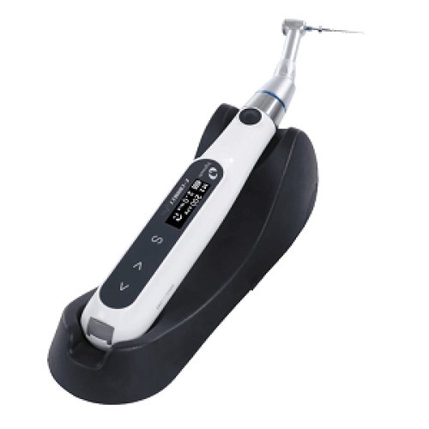
The Eighteeth AI Motor is an AI-integrated cordless endo motor with adaptive motion control and built-in apex locator.
- Motion: Rotary, Reciprocation, Adaptive
- Features: Torque auto-reverse, auto-start/stop, apex-integrated feedback, smart motion shift
- Use: Compatible with most rotary systems
- Highlight: High-tech, budget-friendly motor combining safety and innovation

Canal Finder System (Société Endo Technique, Marseille, France)
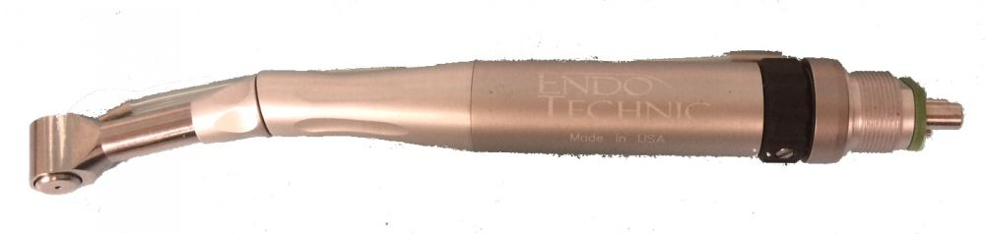
The Canal Finder System is a mechanical glide path and negotiation device designed to safely explore and enlarge root canals, especially those that are calcified or curved.
- Motion: Gentle reciprocating movement
- Components: Handpiece with pre-curved Canal Finder files
- Use: Ideal for difficult-to-negotiate canals
- Advantage: Enhances tactile control while reducing the risk of ledging, transportation, or blockage

Racer (Cardex, via W&H, Bürmoos, Austria)
The Racer is a reciprocating endodontic handpiece system designed to facilitate efficient and controlled canal instrumentation using pre-curved stainless steel files.
- Motion: Reciprocating, mimicking balanced-force filing
- Use: Primarily for glide path creation and initial canal shaping
- Compatibility: ISO standard stainless steel hand files
- Advantage: Allows access in complex anatomies while reducing operator fatigue and canal aberrations

3. Endoplaner (Microna, Spreitenbach, Switzerland)
- Type: Reciprocating handpiece
- Primary Function: Canal negotiation and glide path establishment
- Mechanism: Mimics balanced-force and watch-winding techniques
- Compatibility: Standard ISO stainless steel files
- Key Advantage: Improved control in narrow or curved canals; reduces manual effort

4. Canal Pro Jeni (Coltene, Switzerland)
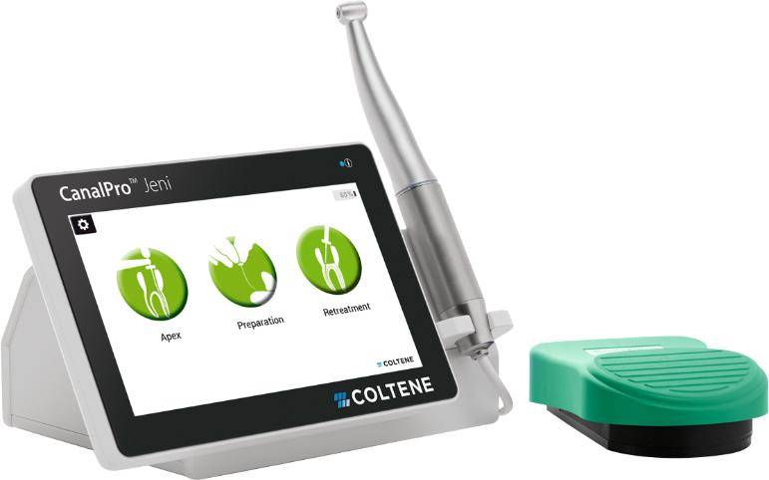
- Type: Smart Endodontic Motor
- Motion: Adaptive, rotary, and reciprocating
- Unique Feature: AI-controlled auto-adjustment of torque, speed, and motion
- Display: Touchscreen interface with visual workflow guide
- Highlight: Automates decision-making based on canal resistance in real time

5. Rooter Universal (Meta Biomed, Korea)
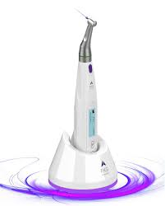
- Type: Cordless endo motor with integrated apex locator
- Motion: Reciprocation & continuous rotary
- Key Features: Auto-reverse, auto-start, real-time apex feedback
- Compatibility: Works with various rotary and reciprocating systems
- Best For: Clinicians seeking versatility and integrated feedback in one device
4. Canal Leader 2000 (Systemvertrieb EndoTechnik, Olching, Germany)
- Type: Motorized endodontic handpiece system
- Motion: Reciprocating (watch-winding)
- Designed For: Glide path creation and initial canal negotiation
- File Compatibility: Standard stainless steel hand files
- Key Benefits: Enhances precision in curved canals, minimizes hand fatigue, and replicates manual technique mechanically
5. EndoEZE AET (Ultradent, USA)
- Type: Adaptive Endodontic Technique (AET) hand instrumentation system
- Motion: Manual-like reciprocation using a handpiece
- Components: Handpiece + specially designed flexible stainless steel files
- Philosophy: Maintains canal anatomy through a crown-down, non-aggressive approach
- Key Benefits: Enhanced tactile feedback, less transportation, and better preservation of dentinal structure
Irrigation Enhancement Gadgets in Endodontics
Effective cleaning and disinfection of the root canal system remain cornerstones of successful endodontic therapy. While mechanical instrumentation shapes the canal, it leaves untouched surfaces, debris, and smear layer in complex anatomies such as lateral canals, fins, and isthmuses. To overcome these limitations, irrigation activation technologies have evolved, enhancing the performance of irrigants like sodium hypochlorite (NaOCl), EDTA, and chlorhexidine.
Irrigation enhancement gadgets improve:
- Debridement efficiency
- Penetration of irrigants into inaccessible areas
- Disruption of biofilms
- Removal of smear layer and dentinal debris
These systems employ sonic, ultrasonic, negative pressure, and photoacoustic mechanisms, each with unique advantages. The following section highlights the most widely used irrigation devices in contemporary endodontic practice.

1. EndoActivator (Dentsply Sirona, USA)
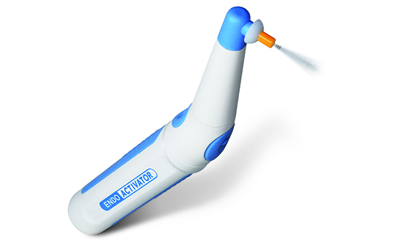
- Type: Sonic irrigant activation device
- Mechanism: Delivers 2,000–10,000 cycles/min through flexible polymer tips
- Tips: Non-cutting, color-coded tips in various sizes
- Purpose: Agitates irrigants (NaOCl, EDTA, CHX) to improve penetration and effectiveness
- Advantages: Safe, user-friendly, enhances biofilm disruption and smear layer removal
- Ideal For: Use after shaping, during final rinse

- EDDY (VDW, Germany)
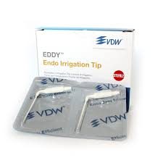
- Type: Sonic irrigation activation system driven by an air scaler
- Mechanism: Polyamide tip vibrates at ~6,000 Hz in 3D motion
- Compatibility: Operated with standard air scalers (≥6 bar pressure)
- Benefits: Minimally invasive, effective in complex anatomies, does not damage dentin
- Key Use: Enhances irrigant activation in curved canals and apical thirds

Passive Ultrasonic Irrigation (PUI)

Passive Ultrasonic Irrigation (PUI) represents one of the most well-established techniques for enhancing endodontic irrigation. Unlike traditional syringe delivery, PUI uses a piezoelectric ultrasonic unit to agitate the irrigant within the canal system, typically at frequencies between 25 to 30 kHz. In this method, a smooth, non-cutting ultrasonic tip or file is inserted passively into a canal already filled with irrigant—most commonly sodium hypochlorite or EDTA—after canal shaping. The tip is activated without contacting the canal walls, producing acoustic streaming and cavitation. These physical phenomena significantly enhance the penetration of irrigants into lateral canals, isthmuses, and apical deltas, facilitating the removal of debris, smear layer, and microbial biofilms. PUI is widely regarded as an evidence-based approach that improves the effectiveness of irrigation in difficult-to-reach anatomical areas while remaining minimally invasive to dentin.
EndoUltra (Vista Apex, USA)
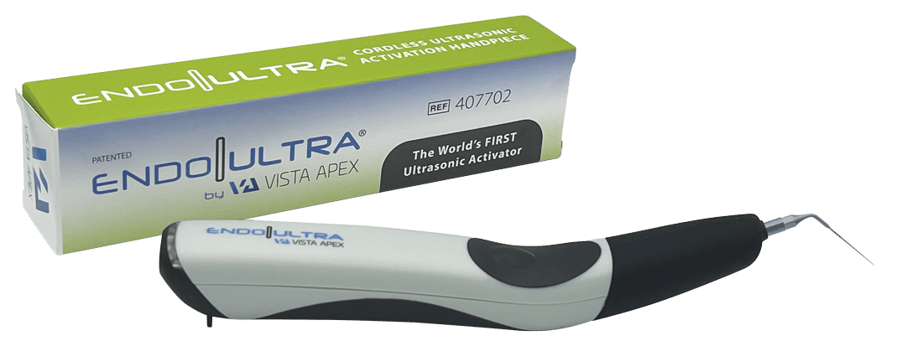
The EndoUltra is a compact, cordless ultrasonic device specifically designed for intracanal irrigant activation. Operating at a frequency of around 40 kHz, the EndoUltra generates intense acoustic streaming and cavitation effects that allow irrigants to penetrate more effectively into complex areas of the canal system. Unlike traditional ultrasonic units that require bulky consoles and cords, the EndoUltra offers a handheld, battery-operated solution, enhancing clinical convenience and maneuverability. Its flexible nickel–titanium tip is designed to navigate curved canals without engaging the dentinal walls, thereby preventing canal aberrations or unnecessary dentin removal. This device is particularly beneficial during the final rinse phase of root canal treatment, where the emphasis is on eliminating residual debris and microbial contamination from inaccessible zones. The portability and user-friendliness of the EndoUltra make it a valuable addition to modern endodontic practice, especially in operatories with limited space or for clinicians seeking to reduce setup time.

Irrisafe (Satelec/Acteon, France)
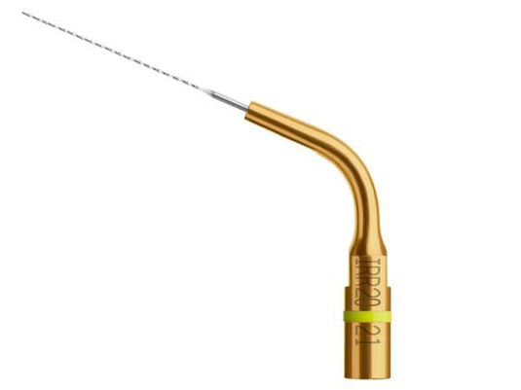
Irrisafe is a specialized ultrasonic tip developed by Satelec (Acteon Group) for the safe and effective activation of irrigants during endodontic procedures. Fabricated from titanium and available in various lengths and tapers, the Irrisafe tip is non-cutting and is used in conjunction with a piezoelectric ultrasonic unit. When activated within the irrigant-filled canal, the tip generates high-frequency oscillations that result in microstreaming and cavitation, which are instrumental in dislodging debris and smear layer from canal walls. Due to its blunt design, the Irrisafe tip minimizes the risk of ledging, perforation, or canal distortion. It is especially effective in cleaning the apical third of the canal and in flushing out necrotic debris from lateral canals and anastomoses. This tool has become a mainstay in ultrasonic irrigation protocols for its ease of use, safety profile, and predictable results.

EndoVac (Kerr Endodontics, USA)
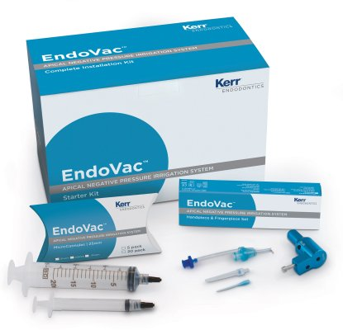
The EndoVac system introduces a fundamentally different approach to irrigation through negative pressure delivery. Unlike traditional positive pressure irrigation, which carries the risk of irrigant extrusion beyond the apex, EndoVac uses suction to draw irrigants apically and out through the microcannula, ensuring effective cleaning without the danger of periapical tissue damage. The system comprises a macro-cannula for coronal and middle third irrigation and a micro-cannula for apical third cleaning. Irrigants are delivered to the pulp chamber, from where they are pulled down the canal and aspirated at the apex using the micro-cannula. This ensures that fresh irrigant continuously reaches working length, improving cleanliness while eliminating vapor lock and enhancing safety. EndoVac has proven especially effective in treating necrotic and infected canals where apical disinfection is critical, and it remains one of the safest methods for deep canal irrigation.

GentleWave System (Sonendo, USA)
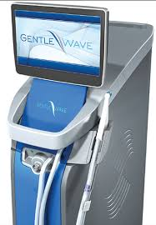
The GentleWave system is an advanced multisonic irrigation technology that departs entirely from conventional irrigation paradigms. Developed by Sonendo, the device combines multisonic sound waves, negative pressure fluid dynamics, and a closed-loop delivery system to clean the entire root canal system. Unlike ultrasonic or sonic devices that rely on tip insertion, the GentleWave system does not require mechanical agitation inside the canal. Instead, it uses a treatment handpiece that seals over the access cavity and delivers a vortex of activated irrigants while concurrently evacuating debris and fluids. The system is designed to create acoustic streaming and cavitation at a microscopic level, reaching into lateral canals, isthmuses, and apical deltas. Clinical studies have shown that GentleWave is capable of cleaning untouched anatomy and biofilm without the need for extensive mechanical enlargement. While the system demands significant investment and setup, it offers unmatched cleaning potential and is a promising tool for minimally invasive endodontics.
PIPS – Photon-Induced Photoacoustic Streaming
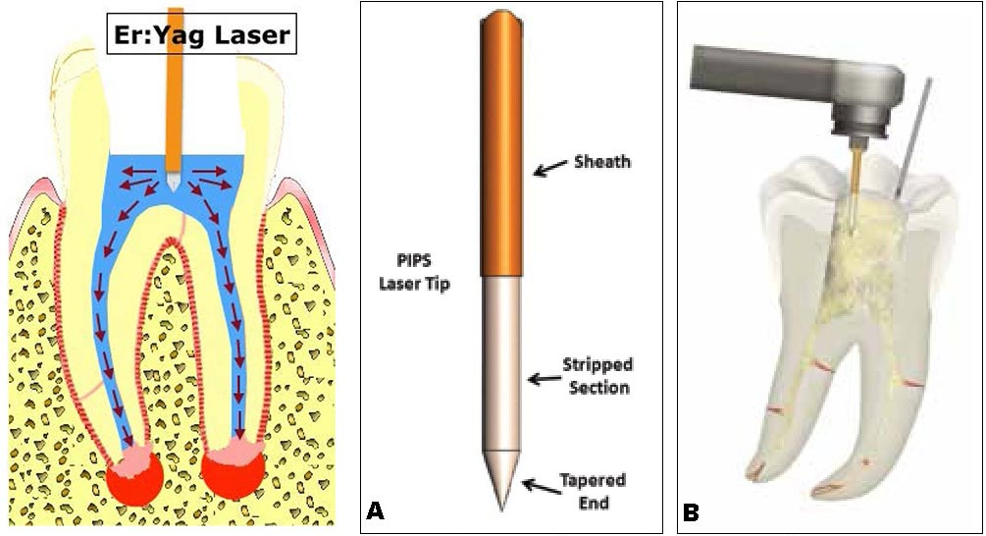
Photon-Induced Photoacoustic Streaming (PIPS) is a laser-activated irrigation method that utilizes an Er:YAG laser to create shockwaves within the irrigant. The laser is pulsed in short bursts at low energy and is applied within the coronal portion of the canal or even in the pulp chamber without deep insertion. The resulting photoacoustic shockwaves propagate through the irrigant, causing it to rapidly expand and collapse, thereby generating powerful shear forces and streaming effects. This technique enhances penetration of the irrigant into complex canal systems, including fins, lateral canals, and dentinal tubules. PIPS is especially useful for conservative canal shaping, as it compensates for the limited mechanical preparation by improving chemical disinfection. It is a safe and efficient method, with minimal risk of canal transportation or irrigant extrusion, and has demonstrated promising clinical outcomes in biofilm removal and apical disinfection.

SWEEPS – Shockwave-Enhanced Emission Photoacoustic Streaming
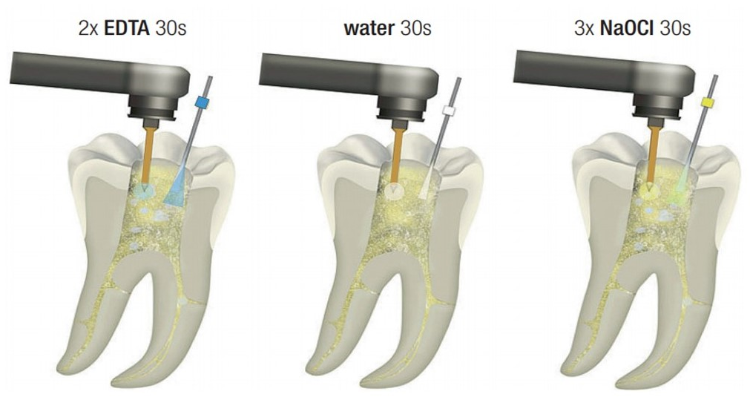
SWEEPS is a further innovation based on the principles of PIPS, also employing Er:YAG laser technology. However, unlike PIPS, SWEEPS uses dual sequential pulses delivered at ultra-short intervals to amplify the generation of secondary shockwaves within the irrigant. This dual-pulse mechanism intensifies the cleaning action, resulting in more effective removal of biofilm, smear layer, and debris even in the most intricate parts of the canal system. SWEEPS is particularly valuable in endodontic retreatment cases and when dealing with complex internal resorptions or anatomies with dense lateral canal networks. The technique is non-invasive and safe for surrounding dentin and periapical tissues, offering enhanced chemical cleaning without the need for over-instrumentation.

Summary Table: Irrigation Enhancement Gadgets in Endodontics :-
Device/System | Mechanism | Frequency/Type | Tip Type | Key Benefits | Notable Limitations
EndoActivator | Sonic activation | ~2,000–10,000 cycles/min | Flexible polymer | Safe, enhances smear layer and biofilm removal | Less powerful than ultrasonic systems
EDDY (VDW) | Sonic, air-scaler driven | ~6,000 Hz | Polyamide | Gentle, 3D activation, effective in curved canals | Requires compatible air-scaler
PUI | Passive Ultrasonic Irrigation | 25–30 kHz | Non-cutting metal | Cavitation and streaming, proven efficacy in complex anatomy | Requires separate ultrasonic unit
EndoUltra | Ultrasonic, cordless | ~40 kHz | Flexible NiTi | Compact, easy to use, deep penetration | Battery-dependent, limited power range
Irrisafe | Ultrasonic tip | Piezoelectric-driven | Titanium blunt tip | High efficiency in apical cleaning | Requires experience in use
EndoVac | Negative pressure | Continuous irrigation | Macro/Micro cannula | Eliminates risk of irrigant extrusion, ideal for apical disinfection | More complex setup
GentleWave | Multisonic + fluid dynamics | Proprietary (broadband) | No intracanal tip | Exceptional canal system cleaning with minimal preparation | Expensive and requires training/setup
PIPS | Er:YAG Laser, photoacoustic | ~20 mJ, 15 Hz | Laser fired coronally | Shockwave disinfection, non-invasive, no canal contact | Requires laser unit and training
SWEEPS | Dual-pulse photoacoustic (Er:YAG) | Ultra-short sequential | Laser fired coronally | Enhanced shockwave action, better cleaning of inaccessible areas | Advanced equipment needed

With the evolution of endodontic technologies, irrigation enhancement devices have dramatically improved our ability to disinfect the root canal system. From sonic and ultrasonic activation to negative pressure systems and laser-activated photoacoustic techniques, clinicians now have a wide array of tools that complement mechanical instrumentation. Choosing the appropriate device depends on anatomical complexity, clinical experience, and availability of technology. As research continues to highlight the limitations of mechanical shaping alone, the role of these gadgets in ensuring successful, long-term endodontic outcomes becomes ever more indispensable.
Chapter 5: Sonic and Ultrasonic Devices in Endodontics
Introduction
Endodontic therapy has evolved beyond conventional hand instrumentation and chemical irrigation. The intricate architecture of the root canal system—comprising fins, isthmuses, lateral canals, and apical deltas—presents significant challenges in achieving complete debridement and disinfection. This complexity necessitates the incorporation of adjunctive technologies such as sonic and ultrasonic activation, which use acoustic energy to agitate irrigants, enhance penetration, and disrupt microbial biofilms.
Both sonic and ultrasonic devices work on the principle of mechanical vibration but differ in their frequency, amplitude, and mode of activation. Sonic devices typically operate at lower frequencies (around 1–6 kHz), producing larger amplitude oscillations, while ultrasonic systems work at significantly higher frequencies (25–40 kHz), producing smaller, more controlled oscillations capable of inducing cavitation and acoustic streaming. These physical phenomena help irrigants reach areas untouched by files, enhance cleaning efficiency, and contribute to successful endodontic outcomes.

Sonic Devices
Sonic devices in endodontics use low-frequency oscillations to activate irrigating solutions within the canal. Their flexibility, ease of use, and gentle action make them suitable for a wide range of clinical scenarios. Though they are less powerful than ultrasonics, their ability to generate hydrodynamic agitation is still highly effective, particularly when used correctly.

1. EndoActivator (Dentsply Sirona)
The EndoActivator is one of the most widely used sonic irrigation systems. It comprises a battery-powered handpiece and a set of flexible polymer tips that oscillate at sonic frequencies between 2,000–10,000 cycles per minute. The tip does not cut dentin but instead agitates the irrigant inside the canal, promoting better distribution and turbulence. The EndoActivator is particularly effective during the final rinse phase, enhancing the removal of the smear layer and residual debris. Its non-cutting tip minimizes the risk of canal aberration, and its ease of use makes it suitable for both novice and experienced clinicians.
2. EDDY (VDW, Germany)
The EDDY system is a newer-generation sonic device powered by an air-scaler, operating at approximately 6,000 Hz. Its flexible polyamide tip is designed to oscillate in three dimensions, creating a dynamic flow of irrigants within the canal. Unlike metallic ultrasonic tips, EDDY's soft tip allows it to safely navigate even curved canals without contacting the dentinal walls. It effectively disrupts bacterial biofilms and facilitates deeper irrigant penetration into complex anatomy. The EDDY system bridges the gap between sonic flexibility and ultrasonic efficacy and has gained popularity for its simplicity and effectiveness.

Ultrasonic Devices
Ultrasonic devices operate at high frequencies (25–40 kHz) and generate energy through magnetostrictive or piezoelectric mechanisms. This energy, when transferred to an irrigant via a vibrating tip, causes acoustic microstreaming and cavitation, significantly improving cleaning efficacy.
1. Passive Ultrasonic Irrigation (PUI)
Passive Ultrasonic Irrigation is a widely validated technique where a non-cutting ultrasonic file is placed into an irrigant-filled canal and activated without engaging the canal walls. The ultrasonic energy, delivered at around 25–30 kHz, creates rapid fluid movement, acoustic streaming, and cavitation, thereby facilitating the removal of debris, pulp tissue remnants, and microbial biofilms. PUI is especially effective after canal shaping and serves as a critical adjunct in disinfection protocols.
2. EndoUltra (Vista Apex)
EndoUltra is a cordless, compact ultrasonic device that offers ultrasonic irrigant activation without the need for a bulky unit. Operating at around 40 kHz, it employs a non-cutting, flexible nickel–titanium tip that is inserted passively into the canal. The vibrations produce deep acoustic streaming and cavitation, effectively enhancing irrigant performance even in the apical third. Its portability and ergonomic design make it ideal for practitioners seeking mobility without compromising efficacy.
3. Irrisafe (Satelec/Acteon)
Irrisafe tips are specifically designed for ultrasonic irrigation and are used with a piezoelectric unit. These titanium tips have a blunt, non-cutting design and are available in various lengths and tapers to suit different canal sizes. When activated, they generate intense acoustic streaming and cavitation, making them highly effective for apical third cleaning, smear layer removal, and canal disinfection. Their safety and efficiency make Irrisafe a staple in many ultrasonic irrigation protocols.

Clinical Applications
Sonic and ultrasonic devices find extensive applications throughout the phases of endodontic treatment. These include:
- Irrigant Activation: Enhancing the chemical action of irrigants like NaOCl and EDTA by improving penetration and circulation within the canal.
- Biofilm Disruption: Breaking up structured microbial colonies that resist conventional disinfection methods.
- Smear Layer Removal: Facilitating more effective removal of the smear layer from canal walls, especially in the apical third.
- Debris Flushing: Expelling dentinal shavings and organic matter from the root canal system.
- Complex Anatomy Cleaning: Improving access to isthmuses, lateral canals, and apical ramifications.
Parameter | Sonic Devices | Ultrasonic Devices
Frequency | 1–6 kHz | 25–40 kHz
Amplitude | Higher (larger oscillations) | Lower (smaller, controlled oscillations)
Energy Source | Air or battery-powered | Electric (piezo or magnetostrictive)
Cavitation Effect | Minimal to mild | Pronounced
Acoustic Streaming | Moderate | Strong
Tip Contact | Non-contact | Non-contact (PUI)
Safety in Curved Canals | High | Moderate to High (depending on tip)
Clinical Efficiency | Good | Excellent

Conclusion
Sonic and ultrasonic devices have revolutionized endodontic irrigation, offering enhanced disinfection capabilities that go far beyond syringe-based delivery systems. While sonic devices provide a gentler and more flexible mode of action, ultrasonic systems deliver powerful cleaning through cavitation and acoustic streaming. When integrated properly into the clinical workflow, these devices significantly improve the outcomes of root canal therapy, particularly in anatomically complex cases. The clinician’s understanding of their principles, appropriate usage, and limitations is essential for maximizing therapeutic success.

Chapter 6: Obturation Devices in Endodontics
Introduction
The final phase of root canal therapy—obturation—serves as the definitive seal to entomb any remaining microorganisms, prevent reinfection, and promote periapical healing. While cleaning and shaping are pivotal in reducing microbial load, failure to adequately fill the three-dimensional root canal space may compromise the long-term prognosis. The complexity of canal anatomy demands not just a biocompatible filling material but also a delivery method that can adapt to intricate morphologies like lateral canals, isthmuses, fins, and apical deltas.
Over the decades, obturation techniques have evolved from cold lateral compaction to more advanced thermoplasticized systems. With this evolution came the development of dedicated gadgets to simplify, standardize, and enhance the efficiency and quality of obturation. These devices provide clinicians with greater control over temperature, flow, compaction force, and delivery direction, thereby increasing precision and reducing operator error.
In this chapter, we explore various categories of obturation devices, ranging from heat carriers and backfill units to integrated obturation systems and modern cordless guns—each engineered to improve the predictability and quality of endodontic fills.

A. Heat-Carrying Devices
These devices are designed to soften gutta-percha and deliver it into the canal system, either for down-pack (apical plug) or backfill (coronal fill) during warm vertical compaction.
1. System B (Kerr Endodontics)
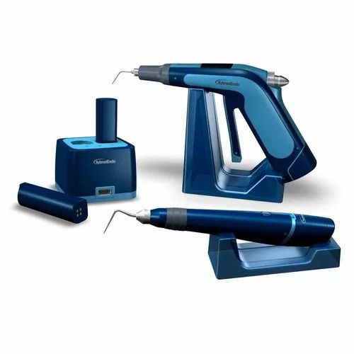
The System B Heat Source is a landmark device that introduced controlled down-pack technology. It allows clinicians to heat pluggers to a preset temperature (commonly 200°C) and condense gutta-percha apically, ensuring a compact and dense fill. The device offers real-time temperature control, auto shut-off, and a wide selection of pluggers in different sizes and tapers. Its precise feedback mechanism makes it highly effective for creating apical plugs in single- and multi-rooted teeth.
2. Elements Free Downpack (Kerr)
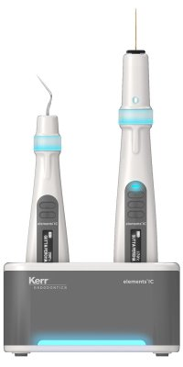
An evolution of the System B, the Elements Free Downpack unit offers cordless convenience while retaining the core functionality of vertical condensation. With rapid heat-up time and ergonomic design, it allows clinicians to easily maneuver within the oral cavity and deliver obturation materials even in posterior regions. Its dual-mode heating system enables both continuous wave and step-down techniques with consistent performance.

B. Backfill Devices
Once the apical plug is established using down-pack methods, backfill devices are employed to deliver thermoplasticized gutta-percha into the remaining canal space.
1. Elements IC (Kerr)
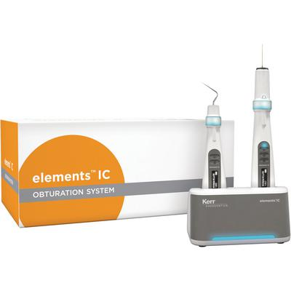
The Elements IC Obturator Unit is a compact backfill device offering precise extrusion of warm gutta-percha through a motorized plunger system. It heats cartridges to a user-defined temperature, ensuring homogeneous flow and minimizing voids. The ergonomic handpiece allows for precise placement of material and is compatible with both 23G and 25G needles.
2. Obtura III Max (Obtura Spartan)
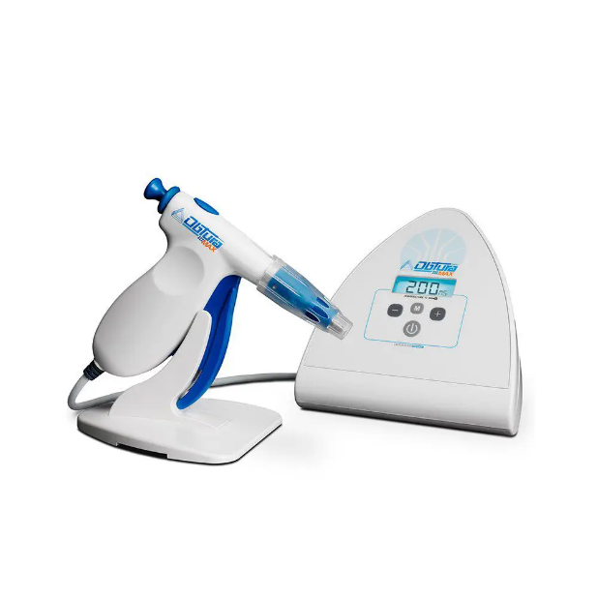
A high-end obturation unit, the Obtura III Max delivers high-flow thermoplasticized gutta-percha via a heated injection needle. With adjustable flow rates and temperatures up to 200°C, it allows seamless backfilling of even the most tortuous canal anatomy. The system is well-regarded for its ability to produce void-free, homogenous obturations, and it's widely used in both clinical and academic settings.

C. Integrated Obturation Systems
These are all-in-one units combining heat source for down-pack and injection system for backfill, offering a streamlined workflow and minimal switching between tools.
1. Elements Free Obturation System (Kerr)
This cordless dual-unit system comprises a Downpack unit and a Backfill gun, both designed to operate independently or together. With its cordless design, quick heat-up, and precise control, it is ideal for clinicians seeking mobility without compromising quality. The intuitive interface and lightweight form enhance clinical ergonomics and reduce fatigue during long procedures.
2. BeeFill 2in1 (VDW, Germany)
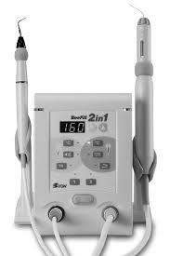
BeeFill 2in1 integrates both down-pack and backfill functions in a tabletop station with separate handpieces. The down-pack plugger delivers vertical compaction heat, while the backfill unit injects heated gutta-percha from pre-filled syringes. The system provides fine temperature and extrusion control, facilitating 3D obturation with minimal operator variability.

D. Cordless Obturation Guns
Cordless guns are favored for their portability and ease of access, especially in posterior teeth and complex canal anatomies.
1. Dia-Gun (DiaDent Group)
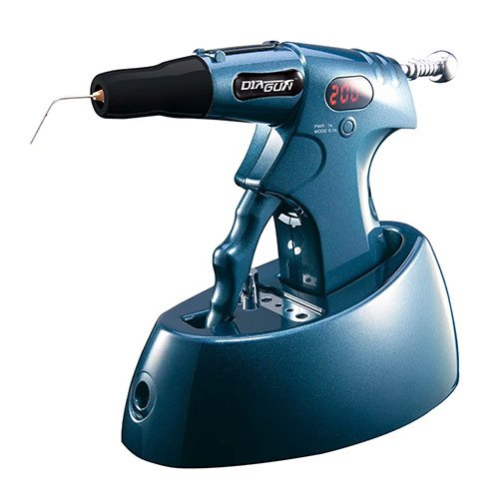
The Dia-Gun is a cordless backfill obturation gun that delivers gutta-percha through pre-filled cartridges. It heats up quickly, maintains stable temperature, and provides smooth extrusion. Its design ensures minimal hand fatigue and offers excellent visibility and access, even in difficult posterior segments.
2. Fi-G (Fanta Dental)
Fi-G is a budget-friendly, cordless obturator gun that features fast charging, precise temperature control, and minimal extrusion lag. It is designed to complement modern endodontic rotary systems and is especially popular in high-throughput practices for its simplicity and cost-effectiveness.

E. Carrier-Based Obturation Heating Units
These devices are used to warm pre-coated gutta-percha carriers like GuttaCore or Thermafil.
1. ThermaPrep 2 (Dentsply Sirona)
Designed for heating carrier-based obturators, ThermaPrep 2 offers preset modes based on obturator size, ensuring uniform core heating and controlled delivery. It significantly reduces preparation time and enables consistent fills when used with compatible carrier systems.
Conclusion
Obturation devices have significantly evolved, shifting from basic compaction tools to highly specialized units capable of delivering warm, flowable, and precisely placed gutta-percha. These devices have redefined the operator’s ability to fill the complex canal system with three-dimensional accuracy. From heat sources like System B, to integrated systems like Elements Free, to cordless backfill guns, the diversity of options today allows clinicians to tailor their technique to each clinical scenario.
Yet, as with all technology, these devices are only as effective as the operator’s understanding of the biological and technical aspects of obturation. Mastery lies in combining sound knowledge of canal anatomy, appropriate case selection, and skillful device handling. When used judiciously, obturation gadgets can greatly enhance the efficiency, predictability, and quality of modern root canal therapy.
Chapter 7: Apex Locators and Working Length Determination Devices
Introduction
Accurate working length determination is one of the most critical steps in endodontic therapy. It directly influences the effectiveness of cleaning, shaping, and obturation. Over-instrumentation may cause apical perforation and extrusion of debris, while under-instrumentation can lead to persistent infection due to inadequate debridement. Traditional methods of working length assessment, such as tactile sensation and radiographs, often lack precision and are limited by anatomical variations or radiographic distortion.
This shortcoming was addressed with the introduction of electronic apex locators (EALs)—devices engineered to determine the location of the apical foramen using electrical impedance or resistance. Modern apex locators have drastically improved in accuracy, reliability, and functionality. They work effectively even in the presence of irrigants, blood, and exudate, thus offering real-time and dynamic measurements.
This chapter delves into the evolution, types, working principles, and leading devices in the category of apex locators and working length determination tools. We explore how these gadgets have revolutionized endodontic length control and enhanced treatment predictability.
Evolution of Apex Locators
The journey of apex locators dates back to the mid-20th century, evolving through multiple generations—each overcoming the limitations of its predecessor. The first generation relied purely on measuring direct electrical resistance between the periodontal ligament and oral mucosa, but these early devices were highly unreliable in the presence of fluid and metallic restorations.
The second generation improved on this by measuring impedance rather than resistance, using a single frequency current. However, these too were hampered by variations in canal contents and moisture levels. It was the advent of third-generation apex locators, using two frequencies to calculate impedance ratios, that brought substantial accuracy even in wet canals. The fourth generation introduced even more refined algorithms and software to interpret multi-frequency signals for enhanced precision and real-time tracking of the file within the canal system.
Today’s apex locators, often categorized under the fifth generation, incorporate advanced microprocessor technology, touchscreens, voice assistance, and wireless connectivity. These modern systems allow seamless integration with rotary endodontic motors, displaying both length and torque on unified platforms. Most importantly, they reduce operator dependence on radiographic estimation and have become an indispensable component of modern endodontic practice.
Root ZX (J. Morita, Japan)
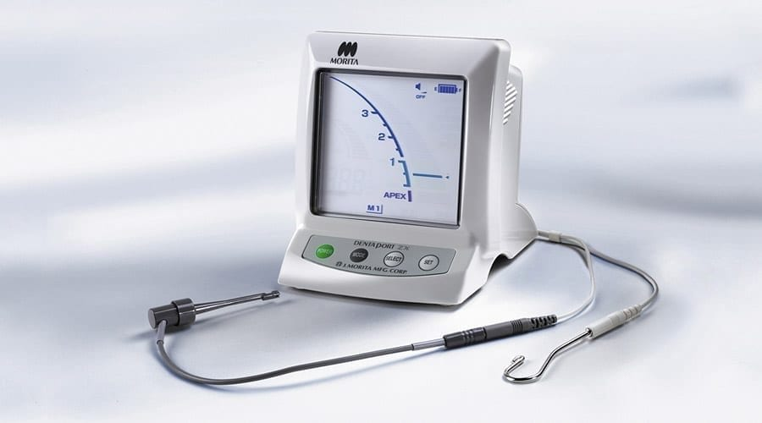
A name almost synonymous with apex locators, the Root ZX was among the first to popularize dual-frequency impedance measurement with a patented "Ratio Method." It remains a gold standard in clinical accuracy, demonstrating over 95% precision across numerous studies. Its intuitive screen displays the position of the file with a colored bar and audible signal, making real-time tracking simple and stress-free. Its later versions, such as Root ZX II and Root ZX Mini, offer portability and motor integration options, turning it into a versatile all-in-one system.

Propex Pixi (Dentsply Sirona)
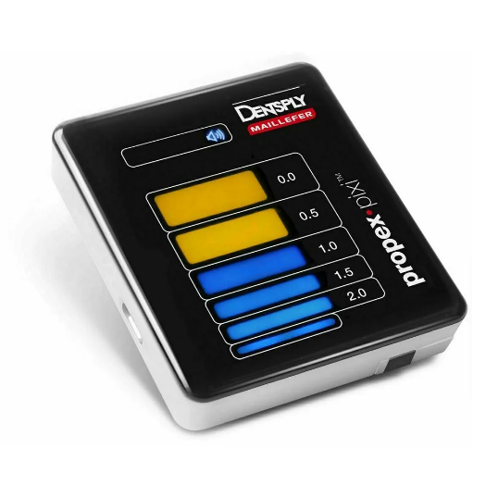
Compact and user-friendly, the Propex Pixi is designed with minimalism in mind, offering an ultra-lightweight solution for busy practices. Its high-contrast LED screen provides intuitive visuals while delivering consistent and reliable measurements. Despite its small size, it maintains high accuracy in moist or bleeding canals and is a favored choice for clinicians who prioritize ergonomics and portability.

Raypex 6 (VDW, Germany)
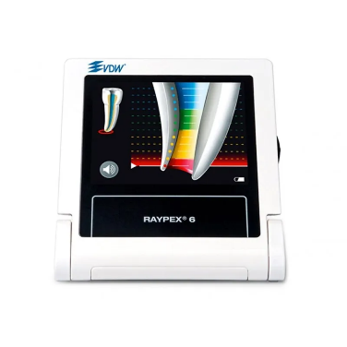
A visually engaging and clinically reliable device, the Raypex 6 features a colorful display that shows the gradual progression of the file towards the apex. It uses advanced multi-frequency technology and presents a two-digit numeric display for enhanced control. The tactile feedback via acoustic signals adds another layer of safety, ensuring precise working length even under challenging canal conditions.

iPex II (NSK, Japan)
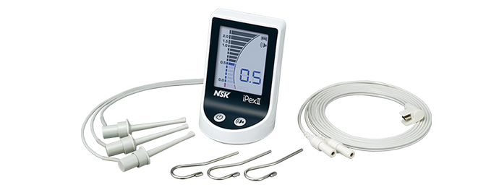
Known for its ergonomic design and intuitive interface, the iPex II uses dual-frequency wave impedance to identify apical constriction. Its user-friendly screen and color-coded bar make it easy to interpret the file’s position, with precise accuracy even when canals are filled with irrigants. Its stability and quiet operation make it a preferred choice in academic and clinical settings.

Woodpex Series (China-based OEM devices)
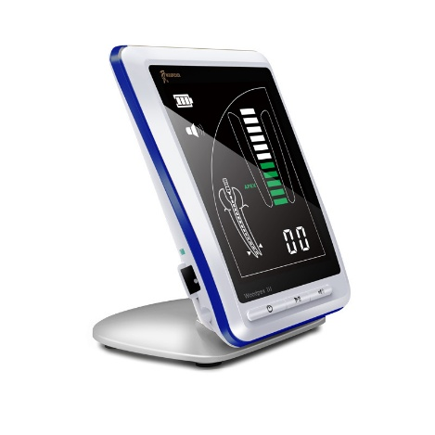
Popular among beginners and cost-conscious users, Woodpex apex locators offer decent accuracy at an affordable price. While they may not match the precision or robustness of high-end systems, models like Woodpex III and Woodpex V have improved considerably and offer LED screens, acoustic alerts, and rechargeable battery operation. These are widely adopted in training institutes and clinics in developing regions.
Smarter Devices: Integrated Apex Locators in Endo Motors
Recent advancements have blurred the lines between standalone apex locators and endodontic motors. Smart endo motors like the X-Smart iQ (Dentsply), VDW Gold Reciproc, and Eighteeth AI Motor now come with integrated apex locators, allowing real-time file tracking during rotary instrumentation. These systems automatically stop or reverse rotation upon reaching the set working length, greatly enhancing procedural safety and efficiency.
The ability to synchronize working length measurements with shaping protocols not only saves time but also reduces fatigue and error, especially in multi-rooted teeth. These hybrid systems represent the future direction of endodontic gadgetry—compact, smart, and multifunctional.

Conclusion
The evolution of apex locators reflects the broader trend in endodontics—toward greater precision, efficiency, and minimally invasive practice. Once considered an adjunct, these devices are now central to successful root canal therapy. Their integration into daily practice has significantly reduced reliance on multiple radiographs, improved safety, and minimized postoperative complications. As technology continues to evolve, we can anticipate even smarter, AI-assisted apex locators with automated documentation and integration with dental software systems.

Chapter 8: Lasers in Endodontics
The integration of lasers into endodontic practice has brought about a transformative shift in how clinicians approach disinfection, debridement, and tissue modulation. Laser technology, once considered a futuristic adjunct, has now become a clinical reality with specific indications and remarkable outcomes. Among the most commonly employed laser types in endodontics are the Er:YAG, Nd:YAG, and diode lasers. Each operates at a distinct wavelength and offers unique interactions with biological tissues and irrigants. For instance, Er:YAG lasers are well-suited for hard tissue ablation and smear layer removal due to their high absorption in water and hydroxyapatite. Nd:YAG and diode lasers, on the other hand, are often used for soft tissue applications and deep canal disinfection due to their penetration depth and thermal effects.
Devices such as the Fotona LightWalker, Biolase Epic X, and Waterlase have been tailored to deliver laser energy with minimal thermal damage while maximizing microbial eradication. In particular, laser-activated irrigation (LAI) and photoactivated disinfection (PAD) have gained popularity. LAI utilizes pulsed laser energy to generate shock waves within irrigants like sodium hypochlorite, enhancing penetration into lateral canals and isthmuses. PAD involves the use of a photosensitizer dye and low-level laser to produce reactive oxygen species that kill bacteria selectively without harming host tissues. These applications extend not only to conventional root canal therapy but also to regenerative endodontic procedures and apical surgeries. While cost and learning curve remain limiting factors, the unparalleled efficacy of lasers in decontaminating complex root canal systems positions them as an invaluable asset in the modern endodontic arsenal.

GentleWave® System (Sonendo)
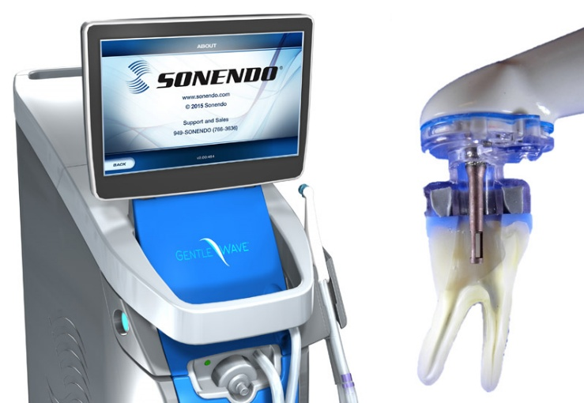
The GentleWave® system by Sonendo has challenged the very foundations of endodontic philosophy by redefining the approach to canal preparation and disinfection. It leverages multisonic ultracleaning technology to deliver a non-instrumentation-centric method that emphasizes cleaning over shaping. The device uses a proprietary combination of fluid dynamics, acoustic cavitation, and broad-spectrum acoustic energy to generate a powerful vortex of irrigants. These microbubbles, upon collapse, exert shear forces strong enough to disrupt biofilms and dislodge debris—even from uninstrumented or minimally prepared areas.
This system’s unique selling point lies in its ability to access and clean complex anatomical variations such as fins, isthmuses, and lateral canals without relying on excessive instrumentation that can weaken dentinal walls. The treatment involves the use of sterile, disposable handpieces connected to the console that delivers and evacuates irrigants simultaneously, thus maintaining a closed-loop negative pressure system. This reduces the risk of irrigant extrusion and postoperative flare-ups. The clinical outcomes associated with GentleWave® have shown promising results in terms of reduced bacterial load, higher healing rates, and fewer postoperative complications. Although it necessitates a paradigm shift and comes with a substantial investment, GentleWave® underscores the future of endodontics—where mechanical shaping takes a backseat and biologic cleaning leads the way.

Chapter 9: 3D Printing in Endodontics
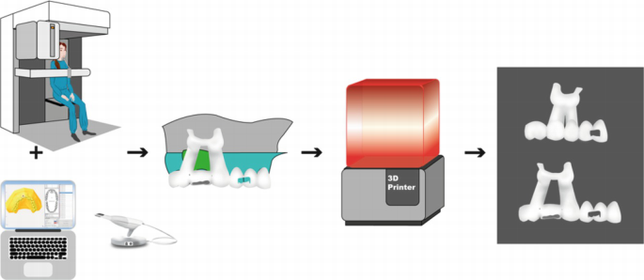
Three-dimensional printing, a revolutionary advancement in digital dentistry, is making significant inroads into endodontic therapy. It has proven particularly valuable in the creation of guided endodontic templates, which facilitate precise access in teeth with pulp canal obliteration (PCO), calcified canals, or unusual curvatures. The workflow begins with acquiring a CBCT scan and an intraoral scan, which are then superimposed using specialized software like Blue Sky Plan or 3Shape Implant Studio. The clinician digitally designs a guide that directs the bur to the desired depth and trajectory, minimizing the risk of perforation or unnecessary removal of dentin.
Beyond access guidance, 3D printing is being utilized to create surgical stents for apical microsurgery, patient-specific anatomical models for preoperative planning, and educational tools for students and professionals alike. Resin printers such as Formlabs, Anycubic Photon, and SprintRay provide high-resolution output with biocompatible materials. These tools are invaluable in cases that require interdisciplinary planning or patient education. As costs continue to decrease and printer accuracy increases, the role of 3D printing in endodontics is set to expand exponentially, transforming both routine procedures and complex interventions into highly predictable outcomes.

Chapter 10: CBCT Integration and Dynamic Navigation Systems in Endodontics
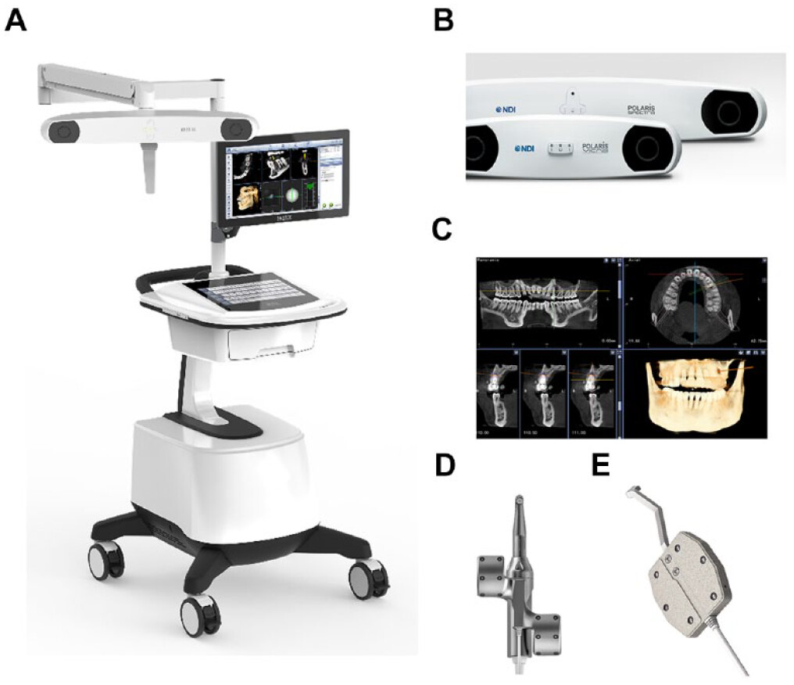
The evolution of diagnostic imaging in dentistry has seen remarkable advancements, particularly in the field of endodontics. Cone-beam computed tomography (CBCT) has revolutionized our ability to diagnose, plan, and treat complex root canal systems. Unlike conventional two-dimensional radiography, CBCT allows for the acquisition of three-dimensional (3D) images, providing clinicians with a detailed, accurate, and comprehensive view of the tooth and surrounding structures. In the context of endodontics, CBCT has become an essential tool in enhancing diagnostic accuracy, identifying hidden anatomical variations, and improving treatment planning.
Understanding CBCT in Endodontics
CBCT technology is based on the principles of computed tomography (CT), but it uses a cone-shaped X-ray beam, which allows for the capture of volumetric data with significantly less radiation exposure compared to conventional CT scans. The images produced by CBCT are reconstructed into 3D models, offering a detailed view of the root canal system, including the pulp chamber, root canal anatomy, periapical region, and adjacent structures. This capability is particularly useful when dealing with challenging cases such as calcified canals, curved roots, or patients with complex anatomy.
The primary advantage of CBCT in endodontics is its ability to visualize structures that are not apparent on traditional radiographs. For example, hidden canals that are often missed on two-dimensional X-rays can be detected in 3D, reducing the risk of incomplete cleaning, shaping, and obturation. CBCT also helps in detecting periapical lesions, external root resorption, and fractures, all of which are crucial factors in treatment planning and prognosis.
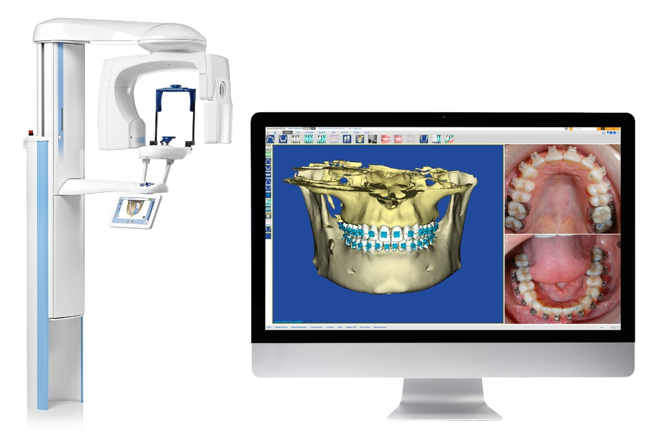
Modern CBCT machines, such as the Planmeca ProMax 3D, Carestream CS 9600, and J. Morita 3D Accuitomo, are designed with advanced features like adjustable field-of-view (FOV), which enables clinicians to capture focused scans of the area of interest while minimizing radiation exposure to other parts of the body. These focused FOVs are particularly beneficial for endodontic procedures, as they allow clinicians to capture high-resolution images of the tooth and surrounding tissues with reduced patient risk.
Clinical Applications of CBCT in Endodontics
One of the most significant clinical applications of CBCT is its role in preoperative diagnosis and treatment planning. By enabling clinicians to view the tooth and its surrounding structures in 3D, CBCT allows for a more accurate assessment of canal morphology, canal length, curvature, and the presence of accessory or hidden canals. This comprehensive view aids in the identification of anatomical complexities that may be difficult to discern through conventional radiographs, such as the presence of isthmuses, lateral canals, or the number of roots in multi-rooted teeth.
In addition to diagnosing anatomical features, CBCT helps to detect periapical pathologies such as cysts, granulomas, and abscesses, which may not be visible on conventional X-rays. The detailed 3D imaging allows the clinician to assess the exact size, location, and extent of these lesions, providing valuable information for deciding whether endodontic therapy alone will suffice or if surgical intervention is required.
Another significant benefit of CBCT in endodontics is its ability to guide the clinician during retreatment procedures. In cases where a previous root canal treatment has failed, CBCT can help identify missed canals, blockages, or areas of insufficient obturation, enabling the clinician to perform a more thorough retreatment. The 3D visualization of the root canal system assists in accurate file placement, reducing the risk of over-instrumentation and ensuring that all infected tissue is removed.
Dynamic Navigation Systems in Endodontics
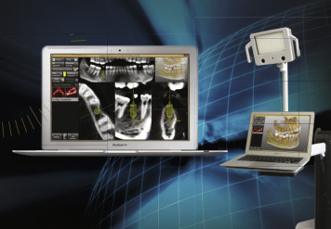
Dynamic navigation systems represent the next frontier in endodontic treatment, enabling real-time guidance during the procedure. These systems combine CBCT imaging with optical tracking technology to provide dynamic, interactive navigation of the root canal system. By integrating the patient’s 3D CBCT data with a dynamic navigation system, clinicians can track the position and orientation of their instruments in real-time, ensuring accurate access, instrumentation, and obturation.
Systems like Navident and X-Guide have been designed to work with CBCT images to provide precise, real-time guidance during endodontic procedures. Navident, for example, uses a small, lightweight handheld device that is tracked by an optical camera during treatment. This system overlays the patient’s preoperative CBCT data onto the live view of the surgical field, providing a “virtual roadmap” that guides the clinician through the procedure. The system continuously tracks the position of the endodontic instrument and provides feedback, helping to prevent errors like perforations or overextension of files.
One of the most valuable features of dynamic navigation systems is the ability to guide clinicians through cases with unusual or complex anatomy. For example, in the case of calcified canals, where traditional methods of access may be more challenging, the dynamic navigation system can assist by offering visual guidance on the optimal pathway to access the canal. Additionally, in curved or highly angled canals, the system ensures that the instruments follow the natural curve of the root, reducing the risk of root perforation or file separation.
Furthermore, dynamic navigation systems can also improve the accuracy of apical surgery. In cases where root-end resection is required, the system can provide real-time guidance to ensure that the resection is performed at the correct angle and depth, optimizing the success of the procedure. This precision not only enhances the outcomes of apical surgery but also reduces the amount of healthy tissue that must be removed, leading to better healing and reduced postoperative discomfort.
Advantages and Limitations of CBCT and Dynamic Navigation
The integration of CBCT and dynamic navigation systems offers numerous advantages, including enhanced diagnostic accuracy, improved treatment outcomes, and reduced risk of procedural errors. By providing a 3D view of the root canal system, CBCT helps clinicians to identify anatomical complexities that may not be visible on conventional radiographs, enabling more accurate treatment planning. Dynamic navigation systems further enhance the precision of the procedure by offering real-time guidance, reducing the risk of errors during instrumentation and obturation.
Another advantage is the ability to perform minimally invasive procedures. With the detailed information provided by CBCT and the real-time guidance offered by dynamic navigation, clinicians can perform procedures with greater precision, preserving more of the surrounding healthy tissue. This approach can be particularly beneficial in cases where a patient’s tooth is at risk of extraction, as it increases the likelihood of successful retention of the tooth.
However, despite the significant benefits, the integration of CBCT and dynamic navigation systems in endodontics comes with certain limitations. The primary challenge is the cost associated with the technology. CBCT machines and dynamic navigation systems require significant investment, which may not be feasible for all practices, especially those with limited resources. Additionally, the need for additional training and expertise to operate these systems can be a barrier to their widespread adoption.
Another limitation is the potential for over-reliance on technology. While CBCT and dynamic navigation systems provide invaluable information and guidance, they are not a substitute for the clinician’s skill and judgment. Overreliance on these tools can lead to a loss of tactile feedback and the intuition developed through years of clinical experience. Therefore, it is important that clinicians continue to apply sound clinical judgment and maintain a comprehensive understanding of endodontic principles, even when using advanced technology.
Finally, while CBCT provides high-resolution images, it still has limitations in terms of image quality in certain situations, such as when dealing with dense calcifications or overlapping anatomical structures. The accuracy of the dynamic navigation system also depends on the quality of the CBCT scan and the calibration of the optical tracking system. Ensuring optimal imaging quality and calibration is crucial for achieving the desired outcomes.
Chapter 11: Artificial Intelligence and Machine Learning in Endodontics
In recent years, the fusion of dentistry with digital technology has brought forth unprecedented transformations. Among these, Artificial Intelligence (AI) and Machine Learning (ML) are redefining diagnostic precision, clinical decision-making, and treatment optimization in endodontics. These technologies, once confined to high-level computing and data science, are now intricately woven into the fabric of dental practice, assisting clinicians not only in identifying pathology but also in enhancing workflow efficiency, treatment outcomes, and patient safety.
AI refers to the simulation of human intelligence processes by machines, especially computer systems. In endodontics, AI primarily operates through machine learning—a branch of AI that involves algorithms learning from data patterns without being explicitly programmed. These technologies can be harnessed to interpret radiographs, predict treatment outcomes, aid in canal detection, and even automate charting and documentation. As AI systems grow more sophisticated, their integration with other technologies such as CBCT, intraoral scanners, and digital patient records is creating a seamless, data-driven ecosystem for clinicians.
AI in Diagnosis and Radiographic Interpretation
One of the earliest and most impactful applications of AI in endodontics is in radiographic interpretation. AI-powered software tools like Diagnocat, Overjet, and Denti.AI utilize convolutional neural networks (CNNs)—a type of deep learning algorithm—to analyze dental radiographs with remarkable speed and accuracy. These systems can detect caries, periapical lesions, root fractures, and abnormal anatomy in periapical, panoramic, or CBCT scans.
In root canal treatment, periapical radiolucencies and anatomical variations such as extra roots or curved canals can easily be missed by the human eye, especially under suboptimal image contrast or observer fatigue. AI mitigates these risks by offering consistent, real-time analysis. For instance, Diagnocat’s AI engine can analyze a CBCT scan and automatically annotate suspected lesions, extra canals, or anatomical landmarks, enabling the clinician to focus on treatment planning with a higher degree of confidence.
Moreover, AI can enhance diagnostic sensitivity for early periapical pathosis before clinical symptoms emerge. Studies have shown that AI tools can match or even surpass experienced endodontists in terms of sensitivity and specificity when interpreting radiographic data. By improving diagnostic accuracy, AI contributes to early intervention, reduced procedural errors, and ultimately, better patient outcomes.
Canal Detection and Treatment Planning
One of the most complex challenges in endodontics is the detection of all root canals, especially in teeth with anatomical anomalies. Missing a canal is a primary reason for treatment failure. Traditionally, locating an extra canal depends heavily on the clinician’s experience and use of magnification tools like loupes or microscopes. AI is now changing this landscape by automatically identifying potential canal pathways from CBCT data.
Software platforms integrated with AI algorithms can reconstruct a 3D map of the root canal system and highlight canal orifices, bifurcations, and atypical curvatures. Some advanced systems offer real-time guidance by overlaying AI-generated canal predictions onto digital imaging systems, allowing for more precise access cavity preparation. In this way, AI not only reduces iatrogenic risks like perforations or missed canals but also shortens chair time and improves procedural predictability.
Moreover, AI can assist in classifying canal configurations using systems like Vertucci’s or Weine’s classification, further refining treatment approaches and helping less experienced clinicians make informed decisions. For postgraduate education and training, these intelligent platforms are invaluable for teaching complex endodontic anatomy and decision-making.
Outcome Prediction and Risk Assessment
Beyond diagnosis and treatment planning, AI is now being used for predicting the prognosis of root canal therapy. By analyzing vast datasets that include patient demographics, tooth type, preoperative pathology, procedural steps, and follow-up data, machine learning models can predict the likelihood of success or failure in a given case. For instance, AI systems can evaluate factors such as root curvature, presence of preoperative radiolucency, and operator skill level to generate a risk profile.
This predictive insight empowers clinicians to engage in more informed discussions with patients regarding treatment choices and expected outcomes. In high-risk cases, patients can be counseled about alternative approaches such as apical surgery or extraction with implant placement. As patient-centered care becomes more data-driven, AI serves as a crucial bridge between clinical evidence and personalized treatment.
In addition, these models can learn from feedback. As more data are added, the predictions become more accurate—making AI a continuously evolving assistant in clinical decision-making.
Clinical Workflow Automation and Data Management
Artificial intelligence is also streamlining clinical workflows by automating routine tasks such as patient charting, progress notes, and procedural coding. Natural Language Processing (NLP)—a subfield of AI—can interpret spoken or written words, allowing clinicians to dictate notes or enter findings verbally while the system transcribes, categorizes, and stores them in real-time.
Dental AI platforms also aid in case documentation for insurance claims, academic purposes, and legal compliance. For instance, AI tools can automatically generate annotated reports from radiographs and CBCT scans, eliminating the need for manual charting and reducing administrative burden.
Furthermore, intelligent scheduling systems powered by AI can optimize appointment slots based on procedure complexity, clinician availability, and equipment usage. These efficiencies not only enhance the patient experience but also reduce chairside fatigue and practice overheads.
Integration with Smart Gadgets and Digital Ecosystems
As smart endodontic motors, apex locators, and obturation units evolve with digital capabilities, AI will play a crucial role in integrating and analyzing data from these devices. For example, endo motors with real-time torque and file stress monitoring could feed data into an AI system that adjusts motor speed, file selection, or irrigation recommendations based on case complexity. This synergy creates a feedback loop where the clinician receives prompts and alerts that reduce the risk of file separation, over-instrumentation, or under-preparation.
Looking forward, AI may enable “adaptive endodontics” where machine learning algorithms analyze the procedural performance during treatment and provide immediate optimization suggestions. Such advancements would essentially provide a digital co-pilot throughout the endodontic procedure.
Challenges, Limitations, and the Future Outlook
Despite its immense promise, AI in endodontics is not without limitations. One major concern is data privacy and the ethical use of patient records, especially when cloud-based AI systems are used. Robust cybersecurity and adherence to health data protection regulations like HIPAA and GDPR are essential for safe AI deployment.
Another concern is the “black-box” nature of some AI models, where the decision-making process is not fully transparent to the user. Clinicians may be hesitant to trust AI recommendations if the rationale is unclear. Addressing this challenge requires the development of explainable AI (XAI) models that provide not only results but also reasoning.
Moreover, AI should never replace clinical expertise and human judgment. Rather, it must be viewed as an assistive tool—augmenting the clinician’s capabilities rather than dictating them. Ethical concerns regarding over-reliance, deskilling of newer clinicians, and the commercialization of AI products also need careful deliberation.
Nevertheless, the future is exciting. As AI and ML continue to learn from vast, diverse datasets and integrate seamlessly with imaging, robotics, and real-time feedback systems, they will inevitably become indispensable tools in modern endodontic practice. The clinician of tomorrow will not only be skilled with rotary files and apex locators but will also be fluent in interpreting AI-driven insights—ushering in a new era of intelligent, precision endodontics.
Chapter 12: Smart Endodontic Motors and Torque-Control Systems
The evolution of endodontic motor systems from simple rotary handpieces to intelligent, feedback-enabled platforms represents one of the most significant technological advancements in root canal therapy. These smart endodontic motors integrate precision engineering with digital intelligence to offer unparalleled control, safety, and efficiency during canal instrumentation. The ability to monitor torque, adjust speed, reverse file direction, and even auto-stop or auto-reverse based on canal conditions has revolutionized the way clinicians approach root canal shaping.
At the core of this evolution lies torque control—the ability of a motor to maintain and adjust the torque applied to a file within the root canal. Excessive torque can lead to file separation, ledging, transportation, or even perforation. Smart motors mitigate this risk by continuously analyzing torque in real time and reacting accordingly. But today’s intelligent motors go beyond torque—they include features such as auto-reverse, adaptive motion, Bluetooth integration, app-based customization, and even AI-guided performance analysis.
Torque Control and Auto-Reverse Mechanisms
In the early generations of rotary endodontic systems, file separation due to torsional stress was a major clinical concern. As files rotated at high speeds, any binding within the canal increased torque dramatically, often beyond the instrument's elastic limit. Modern smart motors incorporate auto-reverse mechanisms that automatically change the direction of rotation when a preset torque threshold is reached. Some systems even stop rotation entirely (auto-stop) or provide a brief back-and-forth movement (auto-reciprocation) to safely disengage the file from canal walls.
These features are crucial when using nickel–titanium (NiTi) rotary files, especially in curved or calcified canals. By regulating torque and rotation dynamically, smart motors extend instrument life, reduce the risk of breakage, and allow for smoother, more controlled instrumentation.
Adaptive and Reciprocating Motion Systems
One of the landmark innovations in this space is adaptive motion technology—where the motor adjusts its movement based on the canal environment. The Elements Motor (Kerr Endodontics), for instance, employs an adaptive motion algorithm that uses rotary motion when there is minimal resistance and switches to reciprocation when higher resistance is encountered. This intelligent behavior reduces file stress and enhances debris removal.
Similarly, reciprocating systems such as the VDW Silver Reciproc Motor and X-Smart Plus use pre-programmed reciprocation angles tailored for systems like Reciproc, WaveOne, and others. Reciprocating motion mimics a balanced-force technique, which is less aggressive than continuous rotation and particularly effective in curved canals. The synergy of motor motion, torque feedback, and file design creates a safer, more efficient instrumentation protocol.
Digital Integration and Bluetooth Connectivity
As dental practice becomes increasingly digital, many smart endodontic motors are now equipped with Bluetooth and app-based interfaces. These allow clinicians to:
- Customize file sequences and motor settings.
- Store and retrieve patient-specific data.
- Receive software updates and new file system presets.
- Monitor usage patterns and receive maintenance reminders.
- For example, the X-Smart iQ by Dentsply Sirona connects to an iPad app that lets clinicians control speed, torque, and reciprocation angles with a few taps. The VDW Connect Drive offers similar capabilities, enabling remote setting adjustments and easy integration with the VDW file library. This level of digital interactivity not only enhances convenience but also allows for evidence-based, data-driven endodontics.
- Ergonomics and Cordless Freedom
- Modern smart motors are designed with ergonomics in mind—lightweight, cordless handpieces with 360° adjustable heads reduce clinician fatigue during prolonged procedures. The Eighteeth AI Motor and Morita TriAuto ZX2 are excellent examples of cordless, compact systems that retain advanced features like torque control and integrated apex location. The cordless design also improves infection control protocols by eliminating cable clutter and simplifying sterilization.
- The Eighteeth AI Motor, in particular, introduces intelligent file recognition and auto-stop functions based on canal resistance. Its smart interface provides intuitive visual feedback during instrumentation, guiding even novice clinicians with real-time alerts.
- Integration with Apex Locators
- Some smart motors now incorporate built-in apex locators, combining two essential gadgets into one device. These motors monitor the file's position in the canal and automatically stop or reverse rotation upon nearing the apical foramen. This integration improves working length accuracy, prevents over-instrumentation, and eliminates the need to switch devices during treatment.
- Systems like Morita’s TriAuto ZX2, EndoPilot, and CanalPro Jeni exemplify this integration, offering real-time working length feedback with automatic motion control based on file position. The CanalPro Jeni, in particular, uses a patented algorithm to guide file movement adaptively depending on the canal anatomy and file stress.
- Data Logging and Cloud Integration
- Some high-end systems now incorporate cloud-based performance tracking, where data from each endodontic procedure—torque values, motor speed, file sequence, and canal negotiation patterns—are logged and stored. This allows for retrospective analysis of cases, clinician performance audits, and even benchmarking for academic or training purposes.
- These smart analytics are particularly useful in teaching institutions and multi-clinician practices. For example, a resident’s use of torque and file stress can be monitored and discussed with supervisors for guided skill development. Cloud integration also enables remote troubleshooting and tech support.
- Future Directions: AI and Machine-Learning Integration
- Looking ahead, smart endodontic motors are poised to integrate with AI and machine learning systems. These motors could potentially learn from past procedures and adjust protocols based on accumulated data. Imagine a motor that recognizes resistance patterns and automatically selects an optimal motion sequence, or one that flags deviations in file usage that may indicate early signs of failure.
- Such systems would enable predictive endodontics, where the motor not only responds to current conditions but anticipates and prevents procedural errors before they occur. When combined with real-time imaging and 3D navigation systems, smart motors will be the cornerstone of robot-assisted endodontics, where precision, safety, and predictability converge seamlessly.
Chapter 13: Endodontic Microsurgery Kits and Armamentarium
Endodontic microsurgery, often termed apical surgery or periradicular surgery, is a refined and minimally invasive extension of traditional endodontic therapy. It serves as a crucial intervention when non-surgical root canal retreatment is not feasible or has failed. With the advent of modern magnification, illumination, and microsurgical instruments, this discipline has undergone a revolutionary transformation. The key to this transformation lies in the specialized microsurgical kits and armamentarium designed to execute apical procedures with unmatched precision, predictability, and tissue preservation.
This chapter explores the fundamental components of endodontic microsurgery kits, their design features, clinical applications, and how they enable practitioners to operate in the microdomain of the periapical tissues with enhanced control and visibility.

The Modern Microsurgical Philosophy
Traditional endodontic surgery, performed with conventional hand instruments and direct vision, often resulted in excessive bone removal, tissue trauma, and unpredictable healing. The microsurgical approach, pioneered by endodontists such as Dr. Gary Carr and others, introduced three key principles: magnification, illumination, and microsurgical instrumentation. These principles, coupled with biocompatible root-end filling materials like MTA and bioceramics, have elevated surgical success rates to over 90% in many studies.
At the heart of this success is the microsurgical kit, a collection of instruments engineered to navigate and operate within small anatomical confines while preserving critical structures.

Essential Components of an Endodontic Microsurgery Kit
A complete microsurgical armamentarium typically includes the following categories:
1. Soft Tissue Management Instruments
Microsurgical soft tissue instruments are designed to handle delicate mucoperiosteal flaps and prevent unnecessary trauma. Common instruments include:
- Micro-blade scalpels (e.g., Bard-Parker blades #15c, #12D, or microsurgical knives) allow precise incisions and reduced flap tension.
- Periosteal elevators with fine, narrow tips enable gentle elevation of full-thickness flaps without tearing the tissue.
- Microsurgical tissue retractors, often T-shaped or L-shaped, provide stable and minimally traumatic retraction of soft tissues to improve visibility.
These instruments are typically made from surgical-grade stainless steel or titanium and are often color-coded or laser-etched for easy identification during procedures.
2. Hard Tissue Instruments
Bone removal and access to the apical region require instruments with robust but conservative cutting action:
- Microsurgical surgical burs (e.g., Lindemann or surgical round burs) used under copious irrigation help in precise osteotomy creation while minimizing thermal damage.
- Piezosurgical units, utilizing ultrasonic microvibrations, allow atraumatic bone cutting with preservation of soft tissue and neurovascular structures. This has become especially valuable in cases where bone thickness is minimal or in close proximity to anatomical landmarks.
3. Apical Resection Instruments
Once the root apex is exposed, root-end resection is typically performed at a 0–10° bevel using:
- Long-shank surgical carbide burs or zirconium-coated tips in a high-speed handpiece under magnification.
- The goal is to resect approximately 3 mm of the root tip, removing most apical delta ramifications and lateral canals.
4. Ultrasonic Retro-Tips and Retrofilling
The creation of a retrograde cavity is one of the most delicate steps in endodontic microsurgery. Modern techniques rely heavily on ultrasonic tips, specifically designed for root-end preparation:
- Ultrasonic tips like KiS tips, ProUltra Surgical Tips (Dentsply), ET series (Satelec), and Start-X tips are angled, coated with diamond or zirconium nitrate, and come in various shapes to access all root surfaces.
- These tips create clean, centered, and conservative Class I cavities of 3 mm depth, suitable for retrofilling with modern bioactive materials.
5. Micro Mirrors and Micropluggers
- Micro mirrors (e.g., Front-surface rhodium-coated) are essential for indirect visualization of the retro-prepared cavity. They allow clinicians to inspect cavity margins for cracks or isthmuses under magnification.
- Micropluggers and carriers are used to deliver and compact root-end filling materials such as MTA or bioceramic putty precisely. Instruments like Micro Apical Placement (MAP) Systems have curved tips for accurate delivery of small amounts of material into apical cavities.

Complete Surgical Kits and Manufacturers
Several dental companies offer comprehensive endodontic microsurgery kits that include pre-selected instruments for every phase of the procedure. Notable examples include:
- Hu-Friedy Endodontic Microsurgery Kit: Offers high-quality stainless steel micro scissors, retractors, mirrors, pluggers, and curettes tailored for endodontic applications.
- Obtura Spartan Microsurgical Kit: Emphasizes minimal invasiveness and includes specialized micro-scalpels and ultrasonic tips.
- Zumax & Global Surgical Kits: Often paired with operating microscopes, these kits feature ergonomic handles, lightweight designs, and titanium construction.
Customized kits may also include bone graft instruments, membrane holders, and suture placement tools, especially in cases requiring regenerative approaches.

Microsutures and Suturing Instruments
Proper flap closure is critical for postoperative healing. Microsutures, typically 6-0 to 9-0 monofilament sutures, are used with microsurgical needle holders to achieve tension-free, primary closure. Modern instruments ensure knot security and precise tissue approximation.
The advent of non-wicking materials such as PTFE (e.g., Cytoplast) has improved healing by minimizing bacterial infiltration along the suture track.

Integration with Surgical Operating Microscope
Perhaps the most transformative adjunct in microsurgery is the dental operating microscope (DOM). By providing up to 25x magnification and coaxial illumination, it enables meticulous inspection and manipulation of apical tissues. Microsurgical instruments are specifically designed to function within the microscope’s focal range and field of vision.
The integration of DOM with high-definition documentation systems also enhances education, documentation, and legal record-keeping.

Conclusion
Endodontic microsurgery has transitioned from a last-resort intervention to a sophisticated, predictable treatment option—thanks largely to the development of specialized microsurgical instruments and kits. These tools allow clinicians to operate with millimetric precision in complex anatomical spaces, preserving vital structures and promoting superior healing outcomes.
The refinement of surgical approaches, combined with improved biomaterials and digital technologies, continues to expand the scope and success of apical microsurgery. As we move forward, innovations such as robot-assisted micro-instrumentation, AI-based planning, and regenerative protocols will further elevate this discipline, affirming its place at the frontier of contemporary endodontics.
Chapter 14: Cryotherapy in Endodontics
Cryotherapy, derived from the Greek words “kryos” meaning cold and “therapeia” meaning cure, refers to the use of cold temperatures for therapeutic purposes. In endodontics, cryotherapy has emerged as a novel adjunctive treatment modality, aimed primarily at minimizing postoperative pain, controlling inflammation, and promoting tissue healing. Though long utilized in sports medicine and post-surgical care, the integration of cryotherapy into root canal therapy is relatively recent. Its biological rationale and clinical advantages are increasingly gaining recognition in the endodontic community.
This chapter delves into the principles, mechanisms, delivery systems, clinical protocols, and the scientific basis for the application of cryotherapy in modern endodontics.

Biological Rationale and Mechanism of Action
The concept of applying cold to biological tissues is rooted in its ability to induce vasoconstriction, reduce cellular metabolism, and decrease the production of inflammatory mediators. In the context of endodontic therapy, where periapical inflammation is a common occurrence—either due to infection or instrumentation—cryotherapy plays a role in modulating the inflammatory response.
When applied to the periapical region or intracanal space, cold temperatures are believed to:
- Suppress nerve conduction velocity, leading to temporary analgesia.
- Inhibit pro-inflammatory cytokines such as IL-1β, TNF-α, and PGE2.
- Minimize edema by reducing capillary permeability.
- Decrease intraosseous and intraligamentary pressure, alleviating patient discomfort.
By these mechanisms, cryotherapy not only reduces postoperative pain but may also contribute to improved periapical healing, especially in cases of symptomatic apical periodontitis.

Modes of Cryotherapy Delivery in Endodontics
In endodontic practice, cryotherapy can be employed in two primary ways:

1. Intracanal Cryotherapy
Intracanal cryotherapy involves the delivery of cold saline solution into the root canal system during or after instrumentation. It is typically used after final irrigation with chemical agents such as NaOCl and EDTA.
Protocol:
- After completing shaping and chemical disinfection, the canal is flushed with cold saline solution (2.5°C – 4°C) for 5 minutes.
- The solution is delivered using side-vented irrigation needles to ensure apical delivery while preventing extrusion.
- Some clinicians utilize automated irrigation systems with controlled temperature outputs for consistent delivery.
This method has shown a statistically significant reduction in postoperative pain in multiple randomized clinical trials. It is a safe, economical, and easy-to-adopt technique that can be integrated into routine endodontic practice without the need for sophisticated equipment.

2. Extraoral Cryotherapy (Cryopack Applications)
Extraoral cryotherapy involves the application of cold compresses or cryopacks externally over the facial region, typically over the area corresponding to the treated tooth.
Protocol:
- A gel-based cold pack or ice wrap is applied over the cheek immediately after endodontic treatment.
- It is applied intermittently (e.g., 15–20 minutes every hour) for the first few hours postoperatively.
- This is especially helpful in managing soft tissue inflammation in cases of acute apical abscesses or post-treatment flare-ups.
This form of cryotherapy is more general in effect and aids in reducing facial swelling and extraoral pain, making it a complementary tool alongside systemic analgesics.

Scientific Evidence and Clinical Studies
Numerous studies have investigated the efficacy of cryotherapy in reducing postoperative pain and inflammation. Highlights include:
- Al-Nahlawi et al. (2016) conducted a clinical trial where patients receiving intracanal cryotherapy reported significantly lower pain scores compared to the control group that received room temperature saline irrigation.
- Keskin et al. (2017) demonstrated that cryotherapy reduced the incidence and intensity of postoperative pain in mandibular molars with symptomatic apical periodontitis.
- Linsuwanont et al. (2018) examined temperature dynamics during intracanal cryotherapy and confirmed that cold saline significantly reduced internal canal temperatures, with safe thermal gradients maintained at the external root surface.
- A meta-analysis by Saatchi et al. (2022) concluded that intracanal cryotherapy is an effective and safe adjunctive method for reducing postoperative endodontic pain in single and multi-visit root canal treatments.

Advantages of Cryotherapy in Endodontics
- Simple and Low-Cost: Requires no specialized equipment; cold saline or ice packs suffice.
- Non-Pharmacological: Offers pain relief without drug interactions or adverse effects associated with NSAIDs or opioids.
- Tissue Friendly: Minimizes tissue trauma and supports healing.
- Patient Acceptance: Especially appreciated by patients with low pain thresholds or those who are medically compromised.

Limitations and Considerations
Despite its many benefits, there are considerations and limitations to be mindful of:
- Standardization: The optimal temperature, duration, and volume of cryotherapy still lack universal consensus.
- Risk of Overcooling: Prolonged exposure to extremely low temperatures can potentially affect periodontal ligament vitality, though such risks are minimal with controlled delivery.
- Lack of Long-Term Studies: While short-term effects are promising, more longitudinal studies are needed to establish its impact on long-term periapical healing.

Future Directions and Innovations
Emerging technologies aim to integrate cryotherapy into more refined endodontic devices. These include:
- Thermo-controlled irrigation systems that allow precise temperature regulation of irrigants.
- Combination protocols involving cryotherapy with laser disinfection or photodynamic therapy to enhance antimicrobial efficacy.
- AI-integrated pain prediction models that could help customize cryotherapy application for individual patient profiles.
The concept of “thermal modulation” in endodontics, involving both cryogenic and thermoplastic techniques, is likely to gain traction as minimally invasive and biologically respectful approaches become the norm.

Conclusion
Cryotherapy in endodontics represents a biologically sound, clinically effective, and economically viable technique for managing postoperative pain and inflammation. Its mechanism of action aligns well with the physiological responses of the periapical tissues, offering a non-invasive adjunct that complements existing disinfection and obturation protocols.
While more robust clinical data and technological advancements are needed to further standardize its usage, cryotherapy has already earned a place in the modern endodontist’s armamentarium. Its integration into routine practice not only enhances patient comfort but also aligns with the evolving trend toward personalized and minimally invasive endodontic care.

Chapter 15: 3D Printing and Its Role in Endodontics
3D printing, also known as additive manufacturing, has revolutionized many fields of healthcare, and dentistry is no exception. Within endodontics, the application of 3D printing technology is redefining precision, predictability, and personalization of treatment. From anatomical models to guided endodontics, the ability to reproduce detailed replicas of complex internal root canal anatomy has elevated both education and clinical outcomes. This chapter explores the principles, applications, clinical implications, and future trajectory of 3D printing in modern endodontic practice.

Understanding 3D Printing Technology
At its core, 3D printing involves building a physical object from a digital 3D model by depositing material layer by layer. In dentistry, the process usually starts with CBCT scans or intraoral scans, which are converted into STL (stereolithography) files via CAD software. These STL files are then processed using slicing software and printed using various 3D printing techniques such as:
- SLA (Stereolithography): Uses UV light to cure resin layer by layer, ideal for high-detail models.
- DLP (Digital Light Processing): Similar to SLA but faster; commonly used in dental applications.
- FDM (Fused Deposition Modeling): A budget-friendly method, though less precise, typically used for prototypes.
In endodontics, SLA and DLP printers are most favored for their superior resolution, which is essential when replicating fine internal canal anatomy.

Clinical Applications in Endodontics
1. Preoperative Planning and Education
3D-printed models derived from CBCT scans allow clinicians to visualize and simulate procedures prior to actual treatment. This is particularly useful in cases involving:
- Complex canal morphology (C-shaped canals, dens invaginatus, dilacerations)
- Retreatment cases with separated instruments or extensive calcification
- Apical surgeries, allowing for precise planning of osteotomies and root-end resections
These models enhance diagnostic accuracy and offer unparalleled value in patient education, making clinical conditions tangible and comprehensible.

2. Guided Endodontics
One of the most impactful uses of 3D printing in endodontics is the development of endodontic guides, similar to surgical guides in implantology. These guides are designed based on CBCT data and allow for ultra-precise access cavity preparation, especially in cases of pulp canal obliteration (PCO).
The process involves:
- Superimposing CBCT and optical scan data
- Designing a virtual drill path targeting the patent canal
- Printing a guide that directs the bur along this exact path
Studies have shown that guided endodontics significantly reduces chair time, improves canal location success rates, and minimizes tooth structure removal, making it invaluable in conservative dentistry.

3. Apical Surgery Simulations
For periapical surgeries, especially involving anatomical challenges such as proximity to neurovascular structures, 3D-printed surgical templates can guide the surgeon with millimetric precision. These guides assist in osteotomy positioning, root-end resection angle, and depth control, enhancing safety and predictability.

4. Custom Post and Core Systems
In complex restorative cases following endodontic treatment, 3D printing is employed to fabricate custom-fit post and core systems, ensuring better adaptation and biomechanical integrity. Digital impressions taken after obturation allow for precise design and fabrication of these posts.

5. Academic and Research Utilization
Dental schools and research institutions increasingly use 3D-printed teeth to simulate clinical procedures. These models offer uniformity, repeatability, and controlled difficulty, thus providing superior training compared to extracted human teeth. 3D-printed root canals with known dimensions are also used to test the performance of obturation materials and rotary instruments.

Advantages of 3D Printing in Endodontics
- Enhanced Visualization: Helps clinicians and students understand complex anatomies better.
- Customization: Patient-specific treatment planning is now achievable.
- Minimally Invasive: Promotes conservative access and targeted surgery.
- Increased Precision: Facilitates higher accuracy in both diagnostic and surgical interventions.
- Improved Patient Communication: Tangible models improve trust and consent processes.

Limitations and Challenges
- High Initial Costs: Despite decreasing prices, entry-level professional printers and compatible software remain costly.
- Learning Curve: Requires familiarity with imaging software, CAD tools, and printing workflow.
- Time Constraints: Design and print times can delay immediate treatments.
- Material Limitations: Biocompatibility and sterilizability of printed materials vary; not all are suitable for intraoral use.

Future Perspectives
With advancements in bio-printing, resorbable materials, and AI-driven modeling, the future of 3D printing in endodontics is expansive. Personalized regenerative endodontic scaffolds, smart surgical templates with sensor integration, and real-time 3D-printed barrier membranes are all under research. Furthermore, with the integration of machine learning, automated segmentation of canal systems from CBCT data is becoming more precise, streamlining the design-to-print process.

Conclusion
3D printing stands as one of the most transformative innovations in modern endodontics. Its ability to translate digital planning into tangible, highly precise tools and models empowers clinicians to deliver safer, more accurate, and patient-specific care. From the management of complex canal anatomies to the execution of guided microsurgeries, 3D printing is no longer futuristic—it is today’s reality in cutting-edge endodontic practice.

Chapter 16: CBCT Integration in Endodontics
The incorporation of Cone-Beam Computed Tomography (CBCT) into endodontics has dramatically enhanced the clinician’s ability to diagnose, plan, and execute complex treatments with unprecedented clarity. Traditional two-dimensional imaging, though valuable, often falls short in representing the true spatial relationships and intricacies of the root canal system and surrounding anatomical structures. CBCT, with its three-dimensional volumetric imaging capabilities, has become an indispensable diagnostic and treatment adjunct in modern endodontic practice.
This chapter explores the fundamental principles of CBCT, its wide-ranging clinical applications in endodontics, associated advantages and limitations, and the future scope of this imaging modality.

Understanding the Basics of CBCT
CBCT is a radiographic imaging method that captures data using a cone-shaped X-ray beam and reconstructs it into a 3D image of the maxillofacial region. Unlike conventional CT scans, CBCT machines used in dental settings emit lower doses of radiation and provide focused high-resolution imaging suitable for endodontic purposes.
The images are rendered into multiple planes—axial, coronal, sagittal, and cross-sectional views—allowing detailed examination of internal dental and surrounding structures, including pulp spaces, periapical tissues, cortical bone, and neurovascular pathways.

Clinical Applications in Endodontics
1. Diagnosis of Periapical Pathology
CBCT has demonstrated superior sensitivity in detecting periapical lesions, especially in cases where traditional periapical radiographs yield ambiguous findings. It reveals early bone loss, periapical radiolucencies confined to cancellous bone, or lesions masked by cortical bone, thereby supporting accurate diagnoses and timely interventions.
2. Identification of Complex Root Canal Morphology
One of the most powerful applications of CBCT is in identifying variations in canal anatomy. Complexities such as:
- MB2 canals in maxillary molars
- C-shaped canals in mandibular second molars
- Dilacerations
- Dens invaginatus and dens evaginatus
- Taurodontism and fused or supernumerary roots
can all be clearly visualized and assessed before initiating treatment. This allows the clinician to anticipate challenges and tailor access preparation and instrumentation accordingly.
3. Detection of Root Fractures and Resorptive Defects
Horizontal root fractures, vertical root fractures, and internal/external resorptions can be visualized much more clearly with CBCT than with 2D imaging. While vertical root fractures are still challenging to detect, CBCT improves diagnostic confidence by revealing patterns of bone loss, separation of root segments, and fracture lines in different planes.
4. Assessment of Treatment Failures and Retreatment Planning
In cases of persistent pain or recurrent periapical pathology post-treatment, CBCT provides critical insight. Missed canals, underfilled or overextended obturations, instrument separations, or untreated lateral canals often become apparent only through 3D imaging. This allows for evidence-based retreatment decisions and more predictable outcomes.
5. Pre-Surgical Planning and Navigation
When planning for periapical surgery, the proximity of roots to the maxillary sinus, mental foramen, or mandibular canal can be crucial. CBCT offers spatial orientation that ensures the surgeon can plan flap design, osteotomy location, and apical resection safely and efficiently. The extent and direction of bone loss or sinus involvement is also clearly visible.
6. Guided Endodontics
CBCT data, when integrated with intraoral scan information, forms the foundation for computer-assisted access cavity preparation in guided endodontics. These combined datasets help in designing 3D-printed guides that direct burs precisely into calcified or obliterated canals with minimal structural compromise.
7. Post-Operative Evaluation and Follow-Up
CBCT is also valuable in evaluating the healing of periapical lesions over time. It enables a three-dimensional assessment of bone regeneration and helps differentiate between healing, persistent pathology, or progression of disease—something not reliably determined through 2D imaging.

Advantages of CBCT in Endodontics
- High Diagnostic Accuracy: Enhances the detection of subtle or hidden anatomical features and pathology.
- Non-Invasive Precision: Allows for a virtual “exploration” of the tooth before intervention.
- Minimally Invasive Outcomes: Facilitates conservative, targeted access and intervention strategies.
- Improved Patient Understanding: The 3D visualizations help explain complex conditions, improving communication and consent.
- Enhanced Research and Teaching: Used extensively in endodontic research, postgraduate education, and advanced training programs.

Limitations and Considerations
Despite its benefits, CBCT should be used judiciously. Key considerations include:
- Radiation Dose: Although lower than medical CT, the dose is still higher than conventional dental radiographs, warranting justification based on the ALARA (As Low As Reasonably Achievable) principle.
- Artifacts: The presence of metallic restorations or obturation materials can cause scattering and beam hardening artifacts, potentially obscuring critical structures.
- Cost and Accessibility: Equipment and software can be expensive, and interpretation requires adequate training.
- Resolution Limits: Fine details such as microfractures or accessory canals may still be beyond detection in lower-resolution scans.

Future Developments in CBCT Technology
The future of CBCT in endodontics is expected to integrate artificial intelligence (AI) for enhanced image interpretation. Machine learning algorithms are already being trained to detect pathologies, trace root canal systems, and even assist in differential diagnosis. Additionally, developments in ultra-low dose protocols, higher resolution sensors, and faster reconstruction algorithms are making CBCT more efficient and widely applicable.
Another exciting development is the fusion of dynamic navigation systems with real-time CBCT data, which may allow for intraoperative guidance during endodontic and microsurgical procedures, akin to technologies used in neurosurgery and orthopedics.

Conclusion
CBCT has redefined the landscape of diagnostic imaging in endodontics. By providing comprehensive and accurate visualizations of internal tooth structures and periapical tissues, it empowers clinicians to elevate the standard of care. When applied appropriately, CBCT not only enhances diagnostic certainty but also leads to safer, more predictable, and minimally invasive interventions. As digital endodontics continues to evolve, CBCT will remain a cornerstone of innovation, precision, and clinical excellence.

Chapter 17: Nanotechnology in Endodontics
Nanotechnology, the science of manipulating materials at the atomic or molecular scale (1–100 nanometers), has entered the realm of dentistry with promising applications, particularly in endodontics. The ability to design and engineer materials at such a small scale opens new frontiers in disinfection, obturation, material strength, and even regenerative procedures.
In this chapter, we explore how nanomaterials and nanodevices are transforming endodontic treatment by enhancing the precision, efficiency, and biological outcomes of care.

1. Nanoparticles for Disinfection
One of the persistent challenges in endodontics is the complete elimination of microbial biofilms within the root canal system. Traditional irrigants and medicaments often fail to reach inaccessible areas, leaving behind bacteria that can lead to reinfection. Nanoparticles, due to their small size and large surface area, can penetrate dentinal tubules and biofilm matrices more effectively than conventional agents.
Silver Nanoparticles (AgNPs):
Silver has long been known for its antimicrobial properties, and in its nanoparticle form, it demonstrates potent bactericidal action. Silver nanoparticles can destroy bacterial cell walls, inhibit DNA replication, and disrupt enzyme functions. They are often incorporated into irrigants or intracanal medicaments to enhance disinfection.
Chitosan Nanoparticles:
Derived from the exoskeletons of crustaceans, chitosan is a biocompatible, biodegradable polymer with antimicrobial and chelating properties. As a nanoparticle, it has been used in endodontic irrigants to promote both smear layer removal and antimicrobial efficacy without compromising periapical tissue compatibility.
Zinc Oxide Nanoparticles and Titanium Dioxide Nanoparticles:
These are being evaluated for their antibacterial activity and potential use as fillers in root canal sealers and obturation materials.

2. Nanoparticle-Enhanced Irrigants and Sealers
Nanotechnology is also being used to improve the physical and chemical properties of root canal filling materials.
Nano-Sealers:
Nanoparticle fillers in epoxy resin-based or bioceramic sealers improve flowability, penetration into lateral canals, and reduce microleakage. Some nano-sealers even exhibit self-adhesive properties and bioactivity, encouraging the formation of hydroxyapatite at the sealer-dentine interface.
Photodynamic Therapy with Nanoparticles:
Photosensitizer-loaded nanoparticles are being explored in adjunctive photodynamic therapy (PDT), where light activation leads to reactive oxygen species formation, killing bacteria in areas unreachable by mechanical instrumentation.

3. Nanorobotics and Targeted Drug Delivery (Future Scope)
Though still in the early conceptual stages, the idea of nanorobots navigating the root canal system offers a futuristic approach to endodontics. These microscopic devices, driven by external magnetic fields or chemical gradients, could theoretically perform tasks like biofilm disruption, pulp regeneration, or targeted drug delivery inside the canal.
For example, magnetically guided nanoparticles could be used to deliver anti-inflammatory or regenerative agents directly to the apex or periapical tissues without affecting surrounding areas. This could be especially useful in regenerative endodontic procedures (REPs), where localized and controlled application of growth factors is critical.

4. Nanotechnology in Instrumentation and Coatings
Nanotechnology also influences the development of NiTi rotary instruments. Nano-level coatings such as:
- Titanium Nitride (TiN)
- Diamond-like Carbon (DLC)
- NanoSilver Coating
have been applied to files to enhance cutting efficiency, improve fatigue resistance, and reduce microbial adherence. These innovations increase instrument longevity and decrease the risk of separation.
Additionally, nanostructured surface treatments improve the bioactivity and integration of endodontic implants or retrograde filling materials like MTA, fostering better healing in periapical surgery.

5. Nanotechnology in Regenerative Endodontics
In regenerative endodontic procedures, scaffolds that support the growth of new tissue are key. Nanotechnology enables the fabrication of:
- Electrospun nanofibrous scaffolds that mimic the extracellular matrix
- Nanohydroxyapatite-based scaffolds for dentin regeneration
- Stem cell-loaded nanospheres for sustained release of growth factors
These advanced materials help in forming a biological replacement for the damaged or necrotic pulp, particularly in immature permanent teeth.

6. Safety and Biocompatibility Considerations
While nanomaterials offer immense benefits, their toxicological profiles are still under investigation. Some nanoparticles may induce oxidative stress or inflammatory responses if not properly formulated. Therefore, rigorous biocompatibility testing, FDA regulations, and long-term in vivo studies are necessary before clinical integration.

Nanotechnology has opened a new era in endodontics, offering microscopic precision with macroscopic impact. From improving disinfection and sealing to aiding in regenerative therapies and futuristic nanorobotics, its applications are vast and growing. While some techniques are already being used clinically, many more are on the horizon, promising to transform root canal therapy from a mechanical procedure into a biologically optimized, minimally invasive intervention.
The integration of nanotechnology into mainstream endodontic practice is not just a possibility—it’s an inevitability. As research continues to mature and devices become more refined, nanotechnology will likely become a cornerstone of personalized, predictive, and precision-based endodontic care.

Future Directions :
The future of endodontics is poised for a technological revolution, guided by emerging fields such as artificial intelligence, nanotechnology, robotics, regenerative biology, and augmented reality. Smart diagnostic tools leveraging AI algorithms are rapidly evolving to assist clinicians in accurately interpreting CBCT scans, detecting periapical lesions, identifying missed canals, and even predicting the success of endodontic treatment based on patient data. These tools are being integrated into chairside software systems that will soon provide real-time assistance during treatment planning and execution. Another promising avenue is the development of robot-assisted endodontics, where semi-autonomous robotic arms and navigation-guided systems may help execute highly precise access cavities or root canal shaping. Augmented reality (AR) and virtual reality (VR) systems are already being introduced into advanced endodontic training platforms and may eventually become part of clinical practice by overlaying live anatomical data onto the operative field. Moreover, nanotechnology-based irrigation systems and nanorobots are being researched for their potential to eliminate microbial biofilms more thoroughly from complex root canal anatomies, especially in inaccessible areas like lateral canals and isthmuses. These futuristic tools, once fully developed and tested for safety and efficacy, could significantly improve treatment predictability and long-term success rates.

In the research domain, endodontic gadgetry is shifting toward bio-integrated smart systems that not only aid in mechanical debridement but also biologically interact with the dentin-pulp complex. Ongoing studies in regenerative endodontics are exploring scaffold delivery systems and stem cell-compatible obturation materials that could replace or regenerate damaged pulp tissues. These advancements will likely be paired with biosensing gadgets embedded within obturation materials or crowns to monitor intracanal pressure, detect reinfection, or even release antimicrobial agents on demand. Additionally, 3D printing technologies continue to revolutionize the way custom endodontic guides, pulp chambers, and simulated training models are designed, with upcoming research focused on bioprinting viable tissue constructs for regenerative procedures. The convergence of biotechnology with digital dentistry will encourage multidisciplinary collaborations between engineers, material scientists, and clinicians. As these innovations move from experimental to clinical applications, future endodontic practice will be characterized by precision, personalization, and predictability, driven by sophisticated, minimally invasive, and biologically respectful gadgets.

Conclusion
The field of endodontics has evolved dramatically from its foundational principles of access, cleaning, shaping, and obturation to a technology-driven specialty fueled by precision, efficiency, and biological respect. The integration of advanced gadgets—from magnification systems like dental operating microscopes and rod-lens endoscopes, to rotary and reciprocating motors, apex locators, and obturation devices—has redefined clinical predictability. These innovations not only improve operator ergonomics but also enhance visualization, instrumentation accuracy, and the overall success rate of root canal therapy. As explored in this book, each category of gadgets contributes to a specific step of endodontic treatment, transforming traditional workflows into streamlined digital and mechanical protocols.
Emerging technologies have begun to blur the line between biology and engineering. The advent of CBCT, 3D printing, lasers, and AI-assisted diagnostics is no longer a futuristic concept but an active part of modern clinical decision-making. From guided access cavity preparation using printed surgical guides to the multisonic irrigation capabilities of the GentleWave system, clinicians are now equipped with an arsenal of tools that can adapt to the challenges of intricate anatomy and complex cases. The development of bioceramic delivery systems, smart endodontic motors, and nanotech-based irrigation shows how gadgetry is not merely about hardware—it is about enhancing biological healing and embracing evidence-based innovation.
As we stand at the intersection of technology and biology, the responsibility lies with the clinician to integrate these tools judiciously. Mastery of gadgets must be complemented by sound clinical judgment, thorough understanding of root canal anatomy, and patient-centric care. With the continuing growth of digital dentistry, artificial intelligence, and robotic platforms, the future of endodontics is promising and profoundly transformative. This book aims to serve as both a guide and a gateway for clinicians, educators, and students to understand and implement gadget-driven excellence in endodontic practice—ensuring precision, efficiency, and biologically respectful care for every patient treated.

📚 References
- Peters OA. Current challenges and concepts in the preparation of root canal systems: a review. J Endod. 2004;30(8):559-67.
- Carr GB, Murgel CA. The use of the operating microscope in endodontics. Dent Clin North Am. 2010;54(2):191-214.
- Rubinstein RA. Magnification and illumination in apical surgery. Endod Topics. 2005;11(1):56–77.
- Plotino G, et al. New technologies to improve root canal disinfection. Braz Dent J. 2016;27(1):3–8.
- Haapasalo M, et al. Irrigation in endodontics. Br Dent J. 2014;216(6):299–303.
- van der Sluis LW, et al. The efficacy of ultrasonic irrigation: a systematic review. Int Endod J. 2007;40(6):415–26.
- DiVito E, et al. Enhanced root canal treatment through laser-activated irrigation. Endod Pract. 2011;4(1):1–4.
- Berutti E, et al. Use of nickel-titanium rotary pathfinding instruments in calcified canals. Int Endod J. 2009;42(9):820–9.
- Connert T, et al. Guided endodontics: a novel approach for guided access cavity preparation and root canal location. Int Endod J. 2018;51(9):955–60.
- Jain SD, et al. CBCT in endodontics—a review. J Adv Med Dent Scie Res. 2014;2(2):112–7.
- Zehnder M. Root canal irrigants. J Endod. 2006;32(5):389–98.
- Dummer PMH, et al. Shaping root canals: instruments and instrumentation. Br Dent J. 2000;188(3):107–10.
- Patel S, et al. Cone beam computed tomography in Endodontics – a review. Int Endod J. 2015;48(1):3–15.
- Torabinejad M, et al. Clinical applications of cone-beam computed tomography in endodontics. J Endod. 2011;37(1):3–15.
- Hülsmann M, Peters OA, Dummer PM. Mechanical preparation of root canals: shaping goals, techniques and means. Endod Topics. 2005;10(1):30–76.
- Schilder H. Cleaning and shaping the root canal. Dent Clin North Am. 1974;18(2):269–96.
- Weller RN, et al. Efficacy of current warm gutta-percha obturation techniques in filling root canal systems. J Endod. 1997;23(9):508–12.
- Johnson WB. A new gutta-percha technique. J Endod. 1978;4(6):184–8.
- Koch KA, Brave DG. Bioceramics: the new paradigm in endodontic obturation. Dent Today. 2015;34(3):98–101.
- Silva EJ, et al. Bioceramic materials in endodontics: a review. Int Endod J. 2019;52(10):1277–1295.
- Velmurugan N, et al. Evaluation of GuttaCore obturator in filling of simulated internal resorption cavities. J Conserv Dent. 2013;16(1):41–4.
- Selem LH, et al. Efficacy of different irrigation activation systems on smear layer removal. J Endod. 2020;46(11):1735–41.
- EndoActivator® System. Dentsply Sirona. [Internet] Available from: https://www.dentsplysirona.com
- GentleWave® System. Sonendo Inc. [Internet] Available from: https://www.sonendo.com
- VDW Gold Reciproc® Motor User Manual. VDW GmbH, Munich.
- Eighteeth AI Endo Motor. Changzhou Sifary Medical Technology. [Internet] Available from: https://www.eighteeth.com
- Kim S, Kratchman S. Modern endodontic surgery concepts and practice: a review. J Endod. 2006;32(7):601–23.
- Peters OA. A micro–computed tomography study of root canal morphology in the mandibular molar. J Endod. 2001;27(12):815–9.
- Yoshioka T, et al. The effect of working length on the efficacy of nickel-titanium rotary instrumentation. J Endod. 2002;28(5):380–3.
- Versiani MA, et al. The anatomy of the root canal system. Endod Topics. 2013;29(1):3–29.
- Reuben J, Velmurugan N, Kandaswamy D. The evaluation of root canal morphology of mandibular premolars in an Indian population using spiral computed tomography. Indian J Dent Res. 2008;19(1):24–7.
- Ricucci D, Siqueira JF Jr. Apical actinomycosis as a continuum of intraradicular and extraradicular infection. J Endod. 2008;34(9):1124–32.
- Mozo S, Llena C, Forner L. Review of ultrasonic irrigation in endodontics: increasing action of irrigating solutions. Med Oral Patol Oral Cir Bucal. 2012;17(3):e512–6.
- Bottino MC, et al. Nanotechnology-based endodontic materials. J Dent Res. 2013;92(11):945–52.
- Lo Giudice R, et al. Evaluation of root canal morphology of maxillary molars using CBCT. Eur J Dent. 2018;12(1):87–93.
- Estrela C, et al. Method to evaluate inflammatory periapical lesions by using cone beam computed tomography. J Endod. 2008;34(11):1325–31.
- Jha P, et al. Guided endodontic therapy in calcified canals using CBCT and 3D printed stents. J Conserv Dent. 2021;24(1):102–105.
- Plotino G, et al. The use of the dental operating microscope in endodontics: present and future. Eur J Dent. 2009;3(1):1–7.
- Krastl G, et al. Guided endodontics: a contemporary approach to management of complex cases. Quintessence Int. 2016;47(2):117–23.
- Nagendrababu V, et al. Guidelines for reporting original research studies on root canal disinfection: a position statement from the SOAP consensus group. Int Endod J. 2020;53(6):764–773. • Siqueira JF Jr, Rôças IN. Clinical implications and microbiology of bacterial persistence after treatment procedures. J Endod. 2008;34(11):1291–301.
- Basrani B, Haapasalo M. Update on endodontic irrigating solutions. Endod Topics. 2012;27(1):74–102.
- Neelakantan P, Romero M, Vera J, Daood U, Khan AU, Fabbro MD. An insight into 3D printing in endodontics. Aust Endod J. 2021;47(1):3–11.
- Fedorowicz Z, et al. Single visit versus multiple visit root canal treatment: Cochrane systematic review. Cochrane Database Syst Rev. 2008;(4):CD004450.
- Azim AA, et al. The application of 3D printing technology in endodontics: A systematic review. J Dent. 2021;107:103610.
- Alrahabi M. Role of modern technologies in conservative endodontic retreatment. Saudi Endod J. 2015;5(1):1–9.
- Jitaru S, et al. The use of lasers in endodontic therapy: review. Lasers Med Sci. 2011;26(2):139–44.
- De Moor RJG, et al. Lasers in endodontics. Int Endod J. 2010;43(6):366–80.
- Meire MA, et al. Evaluation of four irrigation protocols in the removal of calcium hydroxide. Int Endod J. 2009;42(7):612–8.
- Plotino G, et al. Innovative endodontic procedures in the digital era. Br Dent J. 2020;228(7):501–10.
- Arias A, de la Macorra JC, Azabal M. A comparison of working length determination using apex locator versus radiographic method. J Endod. 2010;36(11):1812–5.
- Brunton PA, et al. Contemporary restoration of endodontically treated teeth: evidence-based approach. Br Dent J. 2013;214(7):341–9.
- Koch KA, Brave D. Real-world endodontics: smarter, faster, safer. Dent Today. 2016;35(5):106–12.
- Ricucci D, Siqueira JF Jr. Recurrent apical periodontitis and clinical decisions: guided by biology or gadgets? Oral Surg Oral Med Oral Pathol Oral Radiol Endod. 2010;109(6):854–68.
- Versiani MA, Leoni GB, Steier L, De-Deus G. Micro–CT evaluation of residual filling material after warm vertical compaction and GuttaCore removal. Int Endod J. 2015;48(9):901–12.
- Del Carpio-Perochena AE, et al. Biofilms in endodontics: update on antibacterial strategies. J Endod. 2017;43(8):1309–26.
- Peters OA, Arias A. Cleaning and shaping the root canal system. In: Ingle JI, Bakland LK, Baumgartner JC. Ingle’s Endodontics 7. Hamilton: BC Decker; 2019. p. 881–922.
- Zogheib C, et al. Canal cleanliness and shaping ability of three nickel–titanium rotary instruments in severely curved root canals. Int Endod J. 2012;45(5):475–82.
- Blum JY, Machtou P, Ruddle C, Micallef JP. Analysis of mechanical preparations in extracted teeth using ProTaper rotary instruments: geometrical analysis. J Endod. 2003;29(6):376–9.
- Alves FRF, Almeida BM, Neves MAS, Moreno JO, Rôças IN, Siqueira JF Jr. Disinfecting ability of different endodontic irrigation systems. J Endod. 2011;37(11):1451–5.
- Oliveira H, et al. Comparative evaluation of reciprocating and rotary systems in root canal retreatment: a systematic review. Braz Oral Res. 2022;36:e019.
- Wadhwani CP. Modern obturation techniques. Dent Update. 2003;30(7):362–70.
- Keskin C, Demiral M, Sarıyılmaz E. Artificial intelligence in dentistry: current applications and future perspectives. J Dent Sci. 2021;16(3):1245–53.
- Akhlaghi NM, et al. Accuracy of working length determination by CBCT, digital radiography, and apex locator. Iran Endod J. 2017;12(2):178–82.
- Madarati AA. A clinical update on root canal irrigation devices. Int Dent J. 2016;66(6):395–406.
- van der Vyver PJ, Vorster M, Peters OA. Minimally invasive endodontics using 3D printed guides and conservative shaping. Endod Topics. 2020;33(1):113–30.
- Adorno CG, et al. The effects of working length and root canal curvature on the accuracy of electronic apex locators. J Endod. 2007;33(5):567–70.
- Tay FR, Pashley DH. Monoblocks in root canals: a hypothetical or achievable goal. J Endod. 2007;33(4):391–8.
- Kfir A, et al. The efficacy of a novel laser-activated irrigation technique on biofilm removal from the root canal wall. J Endod. 2017;43(11):1829–33.
- Li G, et al. 3D-printed guide templates for endodontic microsurgery. J Endod. 2020;46(4):636–42. • Kim HC, Cheung GS. Versatility of nickel-titanium instruments and the concept of minimally invasive endodontics. Dent Clin North Am. 2017;61(1):59–73.
- Peters OA, Arias A, Paqué F. A micro–computed tomographic assessment of root canal preparation with a novel instrument, TRUShape, in mesial roots of mandibular molars. J Endod. 2015;41(9):1545–50.
- Schneider SW. A comparison of canal preparations in straight and curved root canals. Oral Surg Oral Med Oral Pathol. 1971;32(2):271–5.
- Dagna A, et al. CBCT in endodontics: state of the art. G Ital Endod. 2018;32(2):68–75.
- Makris N, et al. Nanotechnology and its application in endodontics: a review. J Contemp Dent Pract. 2020;21(9):1035–41.
- Jain A, Bahuguna R. Role of artificial intelligence in endodontics: a review. Saudi Endod J. 2022;12(1):1–7.
- Bruggink A, et al. The effect of canal curvature on the accuracy of 3D printed guides in endodontics. Int Endod J. 2021;54(6):962–70.
- Plotino G, et al. New technologies to improve root canal disinfection. Braz Dent J. 2014;25(3):195–202.
- Versiani MA, et al. Endodontic microsurgery using modern operative microscopes and ultrasonic devices: case series. J Endod. 2012;38(4):509–14.
- van der Vyver PJ, et al. The effect of GentleWave irrigation on root canal disinfection: a review. Int Endod J. 2021;54(5):620–40.
- Ricucci D, Siqueira JF Jr. Apical actinomycosis: a longitudinal case demonstrating changes in root apex morphology. J Endod. 2017;43(9):1543–50.
- Kato H, et al. Application of augmented reality in endodontics: current status and future perspectives. Dent J (Basel). 2022;10(6):112.
- Gu LS, et al. Review of the mechanisms of biofilm resistance and potential treatments for persistent infections in endodontics. Int Endod J. 2017;50(5):529–41.
- Chandra SS, et al. Advances in irrigation activation techniques in endodontics: a review. J Clin Diagn Res. 2016;10(6):ZE06–ZE09.
- Moradi E, et al. Clinical application of AI in endodontic diagnosis and prognosis: a review. Int J Comput Dent. 2022;25(1):21–30.
- Attin T, et al. Modern endodontic materials and their impact on obturation quality. Dent Mater J. 2019;38(1):33–45.
- Hegde V, et al. Bioceramics in endodontics – a review. Int J Contemp Dent Med Rev. 2015;2015:Article ID 340115.
- Moeller H, et al. Use of CBCT and 3D printing in the treatment planning of complex endodontic cases. Aust Endod J. 2020;46(3):302–8.
- Del Fabbro M, Taschieri S, Lorusso M, Weinstein R. Endodontic surgery using ultrasonic retrotips and guided microsurgical techniques: clinical outcomes. J Oral Maxillofac Surg. 2019;77(10):2152.e1–e7.
- Plotino G, et al. The use of the microscope and ultrasonic devices in modern endodontics. Eur J Dent. 2022;16(1):7–17.

