Need for Computerized Automated Machine (CAM) for finding THR issues in Patients

***Abstract: Over time within the overwhelming majority of cases, total hip replacement permits individuals to measure a lot of active lives while not enfeebling hip pain. [34]. In due course, however, a hip replacement can fail due to various factors. To reliably identify the signs of joint instability from Radiographs in those who have undergone Total Hip Replacement by means of Image Recognition algorithms to help monitor long term fate of the implant. Patient attrition at year two of the follow-up is very high, the main reason being easy accessibility to high quality health care. A Computerized Automated Machine (CAM) would help in screening patients who may need further intervention.***

***Keywords: Computerized Automated Machine, Automated Machine, Finding THR Issues, Issues in THR Patients.***

# INTRODUCTION

Marius Smith-Peterson from Boston, Massachusetts, United States of America (USA) fitted molded glass over the ball of patients‟ hip joints then the history of THR in 1925 started. In 1961, Sir Charnley from England demonstrated long-term success by using a prosthetic implant attached to bone with self-curing acrylic cement [37].

Total Hip Replacement (THR) replaces the affected hip joint with an artificial implant. The implant often made from ceramic, polymer or metal components. THR is done when there are no options left to relieve from pain except surgery.

There may be many complications after THR such as loosening, subsidence, and malpositioning. One of the more common long-term complication is loosening. Loosening will result in the need for a revision THR. The national health system within the United Kingdom estimates that before the expected life span of the implant fixation, around 10% of the THR patients require revision surgery.

* 1. *Computerized Automated Machine (CAM):*

CAM is an Expert System that is designed for solving complex problems by following the if-then rule rather than through conventional procedures. Expert system works based on the reasoning about the knowledge [1].

A CAM is specific type of knowledge-based system that follows the knowledge-based architecture. Inference engine and knowledge base are the sub-systems of a Knowledge-based system.

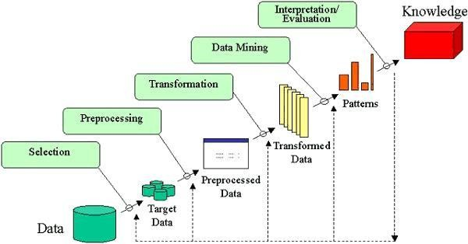

*Knowledge Discovery in Databases (KDD)*

The main objective of the KDD is extraction of information from large databases by utilizing data mining algorithms to mine deemed information as per edge measures by utilizing a database in addition with any preprocessing, sub inspecting, and a changing database .

## Fig.1: Knowledge Discovery in Databases

The sequence of finding and interpreting patterns from data may be repeated according to the pattern.

* The end-user should have a relevant knowledge about the application domain.
* Creating a target data set: The data samples and data variables should be analyzed in order to create a target dataset.
* Data preprocessing and cleaning deals with Noise removal, to gather required information for noise recognition, Methods to handle missing data patterns and Contribution for time sequence analysis.
* Data selection is Selecting the appropriate features for data representation according to the task and Applying noise removal techniques to minimize effective number of variability.
* Data Categorizing is the process of classifying data by using techniques like regression, clustering, etc.
* Formulating data mining algorithm(s) for Process selection to be used for data patterns, Finalizing on appropriate parameters and methods and Matching the data mining method with the KDD process selected.
* Data mining is Adopting data representation methods such as trees, regression, clustering, etc.,.
* Evaluating processed patterns.
* Consolidation of the knowledge base.

The KDD methodology joins data collection, preprocessing, classification, and visualization.

* 1. *Image Processing*

Image processing is processing of images with logical tasks by using any type of signal processing for which the input is a solitary image, an arrangement of images or a video [2]. Most picture handling frameworks incorporate isolating the individual color planes of an image and treat them as two-dimensional signals and applying standard signal processing techniques to them [3]. Images are also arranged as three-dimensional signals with the third estimation being time or the z-axis.

The technique of image processing framework is classified as Analog image processing and Digital image processing.

# ANATOMICAL AND MECHANICAL BASIS OF

**THR**

The surgeon can approach the anterior side of the hip by approaching from the front side. Hence Hip surgery is done without even muscle separation and the surgeon can very well operate through the inter muscular plane, thereby sparing the gluteal musculature. Such a refined approach has evolved over many years with improvements in medical technology which has resulted in adoption of protocols for THR. These techniques are helpful for performing the most updated minimally invasive procedures.

* 1. *Normal Hip Anatomy*

Anatomically, the hip is a ball and socket joint, fusing the hip bone socket and the femoral head.

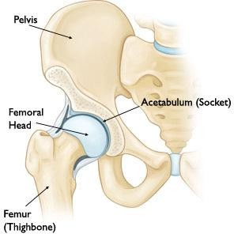

## Fig.2: Anatomy of Hip Joint

Articular cartilage provides a cushioning effect to the joint which enables smooth movement, by avoiding friction [5]. Thin fibrous tissue called “synovium membrane” lines the joint, which secretes the synovial fluid which again is useful for avoiding friction during mobility. Capsular ligaments enable joint stability. Pathologies of the hip joint has increased later and more extensive significance through the fields like Sports Medicine due to its particular nature.

* 1. *Bone Anatomy*

Acetabulum is formed by contributions from ilium, ischium, and pubis. These bones fuse completely by age 14 for girls and age 16 for boys [8]. It has a lunate formed articular ligament which suits the fat filled acetabular fossa in the middle, which is lined by synovial film.

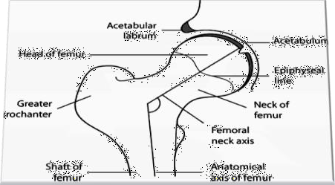

## Fig.3: Anatomy of Hip Joint: Cross-Section View

Attached to the rim of the acetabulum is the fibro cartilaginous labrum, which is highly susceptible to tears, contributing the most common etiology of hip arthroscopy [9]. Most basic labral tears happen at the intersection between the labrum and the articular ligament. The acetabular labrum is exceptionally critical for joint dependability and for compartmenting synovial liquid inside the inward compartment of the hip. Vascular supply to the labrum is from the obturator, inferior and superior gluteal arteries[14].

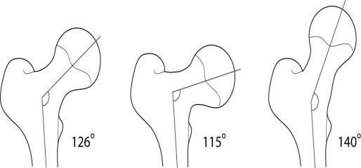

## Fig.4: Femoral neck angle (Normal), Coxavara (angle decreased), Coxavalga (angle increased)

Femoral neck is situated between the head and the shaft and is surrounded by annular ligament (***Fig.3***). The head suits fovea capitis in the middle, where the ligamentumteres is connected, which assumes a job in joint nourishment. Articular ligament encompasses the femoral head.

The neck shapes an edge of roughly 125°with the pole. It diminishes from 150° during childbirth to 125°in adulthood. In coxavalga, the point is expanded to 130° and decreased to 120° in coxavara (Fig. 4). The anteversion is demonstrated by a coronal line drawn through the knee and the femoral head which is regularly around 15°.

Region around the femoral neck is increasingly defenseless to wounds, for example, breaks or disengagement which will most normally lead to avascular corruption because of damage to vein in the ligamentum teres, medullary waterway or the anastomosis around the joint framed by average circumplex and medial circumplex femoral supply routes.

# IMPLANT COMPONENTS FOR SURGERY

Implants used for artificial hip joints [10] comprise of the base part made basically of ceramic and the socket segment which is of plastic, artistic or metal. These inserts can be either encroached into the bone and the bone is additionally permitted to develop around or they can be fixed and solidified. Now and then a blend of both be utilized. Selection of any of these three strategies depends on the bone quality.

# IMPLANT TYPES [11]:

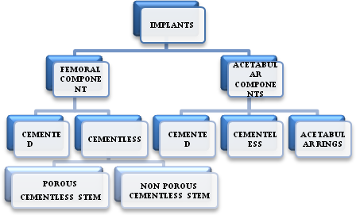

## Fig.5: Types of Implants

The function of implants is to reestablish the ideal essential capacity of the regarded fragment of the bone. The hip framework inserts involve the femoral segment and the acetabular segment.

* 1. *Femoral Components*

The selection of femoral components depends upon three features namely:

* + 1. Achieve prosthesis with the length achieved by the modular femoral head. Proper selection of vertical height has to be ensured to achieve optimal height and flexibility of the femoral neck.
    2. The horizontal or medial offset which is estimated as the separation between the focal point of the head of femur and a line drawn through the hub of the distal stem part. Lacking rebuilding of this segment could prompt the shortening of abductor musculature along these lines prompting limp, bone impingement or disengagement.
    3. Anterior offset or form of the femoral neck which speaks to the introduction of the neck part and is signified as either anteversion or retroversion. Rebuilding of this part is essential as it is exceptionally indispensable in accomplishing the soundness of the prosthesis. Regularly the femur has around 10 to 15 degrees of anteversion with connection to the coronal plane. Satisfactory adaptation with the utilization of prosthesis can be accomplished by pivoting the part inside the femoral canal.
    4. Sizes and shapes of all the three parameters in particular head of femur, breadth of head: neck proportion and that of femoral neck decide the scope of hip development, impingement between the femoral neck and the acetabular edge and furthermore strength. Failure of appropriate determination could prompt separation, quickened wear, loosening, dislodgements or cracks.

*Types of Femoral Components (Biological Fixation Methods):*

1. **Cemented stems** which features such as:
   * Usage of super alloy such as cobalt chrome alloy which will favour elasticity and also reduce stress in the proximal mantle.
   * Broad medial border and lateral border made even broader so as to load mantle in compression and to reduce stress.
   * Collar aid which will help diminish bone resorption on the medial side.
   * Usage of non circular shapes like ellipse or rectangle and presence of irregular surface such as grooves help to improve the rotational stability.

## Cementless stems:

1. **Cementless stems with porous** surfaces allowing bone ingrowths into them. Mechanical stability at the time of surgery and close contact between the porous surface and primary bone are the two major requirements, to consider such type of implants. Hence placemen of such type of implants require much more precision than that of the cemented type. Two materials primarily in use for such type of implants are:
   1. Titanium Alloy with the surface of porous titanium fiber or beads.
   2. Cobalt-Chromium Alloy with the beaded surface.

Titanium is exceedingly indent delicate contrasted with the other, however has the hindrance of being inclined to splits because of metal imperfections at destinations of connection of permeable coatings.

Cementless stems are of two shapes, namely straight and anatomical varieties.

1. **Non-porous Cementless components:** because of the disadvantages of porous surfaces such as ion release, weak strength and adverse bone remodeling, Cementless non porous implant with surface modifications such as roughening and others such as macrointerlocking with bone, which have no room for bone in growth have been considered. But the technique for placement and immediate stability with these implants are similar to those of the porous ones.
   1. *Acetabular Components*

Acetabular components are basically of two types, namely cemented and non-cemented.

1. **Cemented implants** used have thick walled polyethylene cups with both logitudinal and transverse furrows on the external surface which will guarantee security in the mantle. Additionally the plastic utilized have wire markers installed to empower the evaluation of its area on the post surgical images. Further, to guarantee a uniform mantle, PMMA spacers are joined into the bond. proximity of a spine at the edge helps in pressurizing the bond when the cup is fixed. Such types of implants are extremely helpful for elderly patients, those without acetabular disfigurement, tumors reproductions and those circumstances where bone ingrowths‟ into a permeable surface is improbable.
2. **Cementless implants** with porous surface fixed with Trans acetabular screws for bone ingrowths are commonly used but carry risk of damage to intra pelvic organs and blood vessels and also risk of loosening.

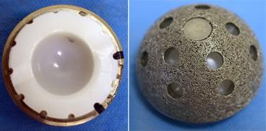

**Fig. 6: The acetabular implant shows the metal shell with plastic (polyethylene) liner inside (Left). The holes around the cup are used if screws are needed to hold the cup in place (Right).**

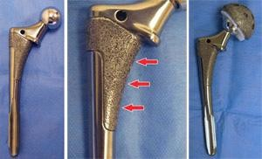

**Fig.7: A standard non-cemented femoral implant (Left). Porous surface for bone in growth (Centre). The femoral implant and the acetabular implant working together (Right).**

# TOTAL HIP REPLACEMENT (THR)

THR procedure has proven to be a boon to those patients suffering from joint dysfunction leading to pain, immobility and affected life quality. Most common group of people experiencing the procedure include those with indications of joint pathology diagnosed through imaging techniques and those with side effects, for example, extreme pain and incapacity not diminished by medications or physiotherapy. Largest group of patients undergoing THR include patients with deterioration due to primary osteoarthritis, fractures, or rheumatoid arthritis [15] THR is one of the greatest advances of the twentieth century in the field of orthopedics and the need for THR is constantly increasing [16-20].

The consistency of the consequences of THR is fantastic in the more seasoned age gatherings, though the life span of the embed in youthful and dynamic patients still stays unsuitable, with disappointment rates going from 20% to 42% [22][23]. Surface substitution is a bone-monitoring option in contrast to standard THR[23-27].

*Indications for THR [4]:*

1. To alleviate unbearable arthritic pain in patients aged above 65 years who are otherwise not benefitted from other non surgical means such as physical therapies and drugs.
2. Degenerative joint diseases such as osteoarthritis or those secondary to slipped femoral capital epiphysis, congenital dislocations of hip, traumatic dislocations such as acetabular fractures, paget disease, coxaplana.
3. osteonecrosis due to long term use of corticosteroids, chronic alcoholism, hemoglobinopathies, metabolic disorders.
4. Infections such as tuberculosis leading to pyogenic arthritis.
5. Tumors involving acetabulum or proximal femur.
6. Hereditary disorders such as Achondroplasia.
7. Idiopathic.
   1. *Contraindications [4]*
      1. Patients with serious fundamental disorders which can contraindicate significant elective surgeries.
      2. Problems requiring corrections before surgery such as cardiac, pulmonary, hepatorenal diseases, or presence or an undetected malignancy.
      3. Active contaminations of the hip joint or some other organ.
      4. Unstable medical conditions which might increase the risk of morbidity and mortality. Unstable ailments which may expand the danger of bleakness and mortality.
      5. Relative contraindications include processes which are rapidly destroying bone, abductor muscle insufficiency, neurological illness.

Functional analysis after joint replacement can be represented by gait analysis, through the criteria designed based on load magnitudes and it can be used in failure analysis and for testing of new implants [23-28]. Success of the procedure depends on both the lack of intra operative complications and a smooth post-operative course. Multimodal rehabilitation or fast-track surgery has been adapted recently to enable smooth recovery and reduce complications. Be that as it may, there is no immediate measure to improve postoperative recovery [29]. The randomized controlled preliminary model is viewed as the highest quality level to assess the impact of an intervention [30-31]. However, it can not be relied upon to create results that are uniform to all patients and all circumstances, consequently, patients and clinicians may embrace a customized methodology.

On progression, patients create torment on starting a development pursued by impermanent mitigation, which again gets exacerbated. Indeed, even at a beginning time of osteoarthritis, hip joint will be twisted prompting changes in joint minutes and power around the lower leg, knee, and hip [32][33].

THR surgery tends to replace the damaged hip joint with an artificial prosthesis, by inserting a stem into femur with a ball on to the top and an artificial socket with plastic liner on inner side of the hip bone socket. The artificial ball, socket and stem are alluded to prosthesis (Fig.8).

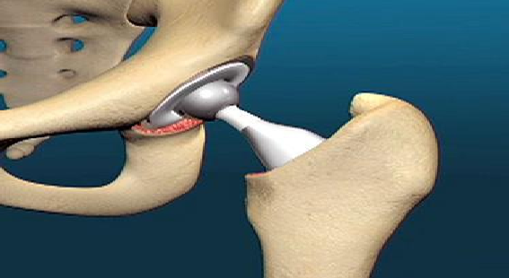

## Fig.8: Total Hip Replacement (THR)

* 1. *Issues in THR*

Revision is a surgical procedure to treat the failure of primary surgery or failure of prosthesis. There exist many reasons for failure of THA. It might result from the poor position of prosthesis in primary surgery, infection and mechanical as well chemical failure. Poor stress transfer and weakened bones are likewise the purposes behind the failures[35]. The revision of THA is finished by X-ray checking, which analyses the position, wear and tear of the prosthesis. Existing techniques are tedious and the outcomes may not be sufficiently exact which are excessively expensive during the diagnosis[36]. Resultantly usage of a programmed framework to do each one of those work precisely and quickly is unavoidable. Fig. 9 represents the careful signs of Revision Total Hip Arthroplasty [10]:

|  |  |
| --- | --- |
| **No.** | **Surgical Indications** |
| **1** | Dislocation |
| **2** | Technical error |
| **3** | Implant fracture |
| **4** | Deep Joint Infection |
| **5** | Aseptic Loosening |
| **6** | Fracture |

**Fig.9: Surgical Indications of the Total Hip Arthroplasty**

# CONCLUSION

THR is an operative procedure to treat significant joint issues viz. rheumatoid arthritis, osteonecrosis etc. In this procedure the damaged femoral and acetabular segments will be replaced by artificial parts[17].

THR is a great option to those who have difficulties with day to day activities or even resting, especially for those who have not benefitted with lifestyle modifications such walking or even with medications [12]. Furthermore, recent advances in diagnostic procedures such as MR Arthrography have facilitated the identification of joint pathologies more easily [6]. This has further led to improved treatment options such as hip arthroscopy, enabling improved life quality to patients with a range of intra articular diseases [7]. The hip has a rich musculature contributed by the outer, inner and the adductor groups [16]. Success of the procedure depends both a lack of intra operative complications and a smooth post operative course. Multimodal rehabilitation or fast-track surgery has been adapted recently to enable smooth recovery and reduce complications. However, there is no direct measure to improve postoperative rehabilitation [29]. By having the CAM for finding the THR issues, helps the doctors and patients in monitoring the upgraded joint security and reclamation of ordinary joint developments

prompting improved patient satisfaction[11-14].

Therefore, the background for the research was in a randomized structure, to assess the viability of a peri-employable multi- modal improvement program on recovery results after THR by utilizing the CAM, and to survey the outer legitimacy and generalizability of the preliminary outcome. Moreover, we set out to assess walk qualities post technique THR surgery in relation to different kinds of implants to assess the productivity of one over.

# REFERENCES

1. Elaine Rich, Kelvin Knight, “Artificial Intelligence,” TMH, 2009.
2. Azriel Rosenfeld, “Picture Processing by Computer,” New York: Academic Press, 1989.
3. Don Fussell, “Image Processing,” University of Texas at Austin CS384G - Computer Graphics Fall, 2010.
4. “Focus on Femoroacetabular” impingement Darren Fern, Point Quay House, Point, Devoran, Truro, Cornwall, TR3 6NLED Fern MR Norton Cornwall Hip Foundation Truro, Cornwall.
5. Schuenke M, Schulte E, Schumacher U, “THIEME Atlas of Anatomy. In: Ross L, Lamperti E, Eds. General Anatomy of the Musculoskeletal System,” New York: Thieme, New York, 2006.
6. Moor0065 K, Ed., “Clinically Oriented Anatomy,” 3rd ed. Baltimore: Williams and Wilkins,1992.
7. Byrd JWT, “Indications and Contraindications. In: Byrd JWT, Ed. Operative Hip Arthroscopy,” 2nd ed. New York: Springer Science +Business Media, Inc. 2005.
8. Tanabe H., “Aging Process of the Acetabular Labrum-An Electron Microscopic Study,” Nippon SeikeigekaGakkaiZasshi 1991, 65(1):18-25.
9. Marius Muja, “Fast Matching of Binary Features,” Laboratory for Computational Intelligence University of British Columbia, Vancouver, Canada.
10. Catherine Ruther, “Current Possibilities for Detection of Loosening of Total Hip Replacements and How Intelligent Implants Could Improve Diagnostic Accuracy,” Recent Advances in Arthoplasty, pp 364-385, 2010.
11. Maheshwari AV, Zlowodzki MP, Siram G, Jain AK., “Femoral Neck Anteversion, AcetabularAnteversion and Combined Anteversion in the Normal Indian Adult Population: A Computed Tomographic Study,” Indian Journal of Orthop, 2010 Jul, 44(3): 277-82.
12. Engelbrecht R., “Expert Systems for Medicine--Functions and Developments,” [ZentralblGynakol,](https://www.ncbi.nlm.nih.gov/pubmed/9381838) 1997, 119(9): 428-34.
13. Garellick G, Malchau H, Herberts P, Hansson E, Axelsson H, Hansson T., “Life Expectancy and Cost Utility after Total Hip Replacement,” ClinOrthopRelat Res(346):141, 1998.
14. Johnston RC, Fitzgerald RH, Jr., Harris WH, Poss R, Muller ME, Sledge CB. “Clinical and Radiographic Evaluation of total Hip Replacement. A Standard system of Terminology for Reporting Results,” J Bone Joint Surg Am, 72(2): 161, 1990.
15. Asayama I, Naito M, Fujisawa M, Kambe T, “Relationship between Radiographic Measurements of Reconstructed Hip Joint Position and the Trendelenburg Sign,” J Arthroplasty, 2002, 17(6):747.
16. Sakalkale DP, Sharkey PF, Eng K, Hozack WJ, Rothman RH, “Effect of Femoral Component Offset on Polyethylene Wear in total Hip Arthroplasty,” ClinOrthopRelat Res, 2001, (388):125.
17. Yamaguchi T, Naito M, Asayama I, Ishiko T, “Total Hip Arthroplasty: The Relationship between Posterolateral Reconstruction, Abductor Muscle Strength, and Femoral Offset,” J OrthopSurg (Hong Kong ), 2004, 12(2):164.
18. Andriacchi TP, Hurwitz DE, “Gait Biomechanics and the Evolution of Total Joint Replacement,” Gait Posture, 1997, 5:256.
19. Bach CM, Winter P, Nogler M, Gobel G, Wimmer C, Ogon M, “No Functional Impairment after Robodoc Total Hip Arthroplasty, Gait Analysis in 25 Patients,” ActaOrthopScand, 2002, 73(4):386.
20. Catani F, Benedetti MG, Binazzi R, De ZM, Leardini A, Giannini S, “Functional Evaluation in Total Hip Replacement Patients,” ChirOrganiMov, 1998, 83(4):349.
21. Hurwitz DE, Foucher KC, Sumner DR, Andriacchi TP, Rosenberg AG, Galante JO, “Hip Motion and Moments during Gait relate directly to Proximal Femoral Bone Mineral Density in Patients with Hip Osteoarthritis,” J Biomech, 1998, 31(10):919.
22. Isobe Y, Okuno M, Otsuki T, Yamamoto K, “Clinical Study on Arthroplasties for Osteoarthritic Hip by Quantitative Gait Analysis. Comparison between Total Hip Arthroplasty and Bipolar EndoprostheticArthroplasty,” Biomed Mater Eng, 1998, 8(3-4):167.
23. Mont MA, Seyler TM, Ragland PS, Starr R, Erhart J, Bhave A, “Gait Analysis of Patients with Resurfacing Hip Arthroplasty compared with Hip Osteoarthritis and Standard total Hip Arthroplasty,” J Arthroplasty, 2007, 22(1):100.
24. Watanabe H, Shimada Y, Sato K, Tsutsumi Y, Sato M, “Gait Analysis before or after Varus Osteotomy of the Femur for Hip Osteoarthritis,” Biomed Mater Eng, 1998, 8(3-4):177.
25. Kehlet H, Wilmore DW, “Multimodal Strategies to Improve Surgical Outcome,” Am J Surg , 2002, 183(6):630.
26. Kehlet H, Wilmore DW, “Fast-track Surgery,” Br J Surg, 2005, 92(1):3.
27. Gomez PF, Morcuende JA, “Early Attempts at Hip Arthroplasty--1700s to 1950s,” Iowa Orthop J, 2005, 25:25.
28. Charnley J, “Arthroplasty of the Hip. A new operation,” Lancet, 1961, 1(7187):1129.
29. G. E. Lewinnek, J. L. Lewis, R. Tarr, C. L. Compere, and J.

R. Zimmerman, “Dislocations after total hip-replacement arthroplasties,” J Bone Joint Surg Am, 1978, 60(2): 217-20.

1. T. Renkawitz, M. Tingart, J. Grifka, E. Sendtner, and T. Kalteis, “Computer-Assisted Total Hip Arthroplasty: Coding the Next Generation of Navigation Systems for Orthopedic Surgery,” Expert Review of Medical Devices, 2009, 6(5): 507-14.
2. T. Renkawitz, M. Haimerl, L. Dohmen, M. Woerner, H. R. Springorum, E. Sendtner, G. Heers, M. Weber, and J. Grifka, “Development and Evaluation of an Image-free Computer- assisted Impingement Detection Technique for Total Hip Arthroplasty,” Journal of Engineering in Medicine, 2012, 226(12): 911-18.
3. Chen-Kun Liawa, Rong-SenYangb, Sheng-MouHoub, Tai- Yin Wuc, Chiou-Shann, “A Simple Mathematical Standardized Measurement of Acetabulum Anteversion after Total Hip Arthroplasty,” ISSN 1748-670X print/ISSN 1748- 6718 online.
4. Joachim PfeilChefarzt, OrthopädischeKlinik, St. Josefs- Hospital, “Anatomy of the Hip Joint,” Minimally Invasive Surgery in Total Hip Arthroplasty, Springer Verlag Berlin Heidelberg, 2010.
5. G. Labek, M. Thaler, W. Janda, M. Agreiter, B. Stockl, “Revision Rates after Total Joint Replacement - Cumulative Results from World Wide Joint Register Datasets,” the Journal of Bone and Joint Surgery, Mar 2011, 93-b(3): 293- 297.
6. IswadiDamasena, Richard Jamieson, Michael Pritchard, “Hip Arthroscopy Has Acceptable Return to Sport Outcomes for the Elite Athlete,” Open Journal of Orthopedics, vol 2, 2012,

pp. 6-12.

1. Gray AJ, Villar RN, “The Ligamentumteres of the Hip: An Arthroscopic Classification of its Pathology,” Arthroscopy 1997, 13(5): 575-8.
2. SumitPramanik, Avinash Kumar Agarwal and K. N. Rai, “Chronology of Total Hip Joint Replacement and Materials Development”, [Trends in Biomaterials and Artificial Organs,](https://www.researchgate.net/journal/0971-1198_Trends_in_Biomaterials_and_Artificial_Organs) vol 19, pp :15-26 · January 2005