# A pH Measurement of Acetic Acid-Sodium Acetate Buffer Solutions Using a pH Meter at Ambient Temperature

## ABSTRACT

|  |
| --- |
| In article, we have reported the preparation of acetic acid-sodium acetate buffer solutions and determined its pH by using pH meter at about 25˚ C, as room temperature. In preparation of buffer solutions, firstly, we have taken 1.5 ml of glacial acetic acid into 100 ml of standard flask for making up 0.2M of acetic acid solution, and 0.64 gm of sodium acetate were dissolved into 100 ml distilled water. Then, taken 36.2 ml prepared solution of sodium acetate into 100 ml of standard flask and added 14.8 ml of prepared acetic acid to make its volume 100 ml by using distilled water, it is a buffer. In measuring the pH of prepared buffer solutions, we have been using a calibrated digital pen pH meter for quick resolution of reading with accuracy. The pH of acetic acid-acetate buffer solutions have gradually raised by adding small quantity of 5N NaOH solution into buffer sample, and adjusted pH was being to 4.7. |

*Keywords: Acetic acid; sodium acetate; pH meter; pH; buffer solution.*

## 1. INTRODUCTION

Indeed, the dissociation of substances also effected by the temperature and have reported earlier, but it proved well by Nernst (1891) with given of partition law, *K* = CA/CB [1]. The solubility of an ionic compounds is decreased by the presence a common ions and obey the Le Chatelier’s principle [2-4]. In pH determination, the various factors that influences the pH of buffer solution are being as changing in temperature, ionic strength, activity of H+ ion, dilution and addition of electrolyte salts etc [5,6]. An acidic buffers have a pH of less than 7, where for neutral buffer solutions the pH is 7 and if any buffers have a pH of more than 7 it is known as basic buffers, respectively [7-9]. In our present article, we have reported and determine the pH (potential of hydrogen) value of the acetic acid-sodium acetate buffer solution at 25˚C (room temperature) by using of digital pH meter. The general pH relationship which was given by Peter Sorensen in 1909, is as-

pH = - log [H+] = log 1/[H+] …………. (1)

Where, the *log* is the base -10 logarithm, and, the [H+] is stands for the concentration of H+ ions in solution, as given in mole per litre. On the basis of above equation (1), the pH is a negative logarithm of hydrogen (H+) ions concentration. The pH or concentration of H+ ions in solution is a measure of the acidity or basicity of solution.

Knowing, a buffer solution is a solution that can resist pH change by addition of an acidic or basic substances. Because of common ion effect in acetic acid-sodium acetate buffer solution which is the suppression of the degree of dissociation of a weak electrolyte by the addition of a strong electrolyte having an ion common with that of the weak electrolyte [10]. The acetic acid (CH3COOH) is a weak acid and undergoes ionization in small extent to give the common acetate (CH3COO-) ion with H+ ion as showing in the following reaction [11-13].

CH3COOH(*aq)* → H+*(aq)* + CH3COO-(*aq*)

……….(2)

Where, the equilibrium or dissociation constant of acetic acid (CH3COOH) is as –

*K*a= [CH3COO-] [H+] / [CH3COOH] ………(3)

## 2. EXPERIMENTAL

In experimental procedure, the required all materials, chemicals and reagents are being an analytical graded and laboratory-based standard which have been used further as without purification for study. Here, the glacial acetic acid (CH3COOH; 99-100%) is of Merck Specialities Private Limited and the sodium acetate (CH3COONa.3H2O) crystal pure of E. Merck (India) Pvt. Ltd., Worli, Mumbai-400018, India. Typically, the carbonate free a basic NaOH solution of 5N is prepared well by adopting of Vogel procedure [14]. Here, firstly, we have prepared a 0.2M of acetic acid by taken 1.5 ml of glacial acetic acid into distilled water and make the total volume upto 100 ml. After then, for preparation of solution of sodium acetate we take a 0.64 gm of sodium acetate was dissolved into 100 ml distilled water. Now, we pipette out about 36.2 ml of prepared sodium acetate solution and pouredit into a 100 ml of standard flask and added 14.8 ml of acetic acid, and by using distilled water make it volume 100 ml, respectively. These mixed both solutions are as buffer solution. Now, we measured the pH of this prepared buffer solution with using Wellon’s digital pen pH meter for accurate and quick resolution of reading. Notably, before measuring of pH, the pH meter is standardized or calibrated first with its electrode tip and junction submerged in buffer and wash the electrode with distilled water and then introduced into prepared 0.2M acetic acid-sodium acetate buffer for well reliability.

## 3. RESULTS AND DISCUSSION

In measurement of the pH, an electrical potential is developed by electrode pair pins in a buffer solutions (Fig. 1; sources from internet). The Fig. 1 (a) is diagram of Wellon’s digital pen type pH tester or meter, and the Fig. 1 (b), as a pH electrodes working representation scheme for buffer solutions.A digital pH meter has a pH probe to conduct the electrical signals to pH meter that voltage count or display in the range of pH value for buffer solution [15,16]. These pH probe contain two electrodes naming as internal or sensor electrode and a reference electrode. Although, the electrode system of pH meter is sensitive to change in concentration of H+ ion for taken solutions [17]. The potential of electrode is raise with pH value in respect of the concentration of H+ of the solution. Hence, a slight variation is show in pH range which provides a significant changing in the quality of using solution. In preparation of 0.2M acetic acid-sodium acetate buffer solution we have taken about 36.2 ml of prepared sodium acetate and 14.8 ml of glacial acetic acid which were mixed well and buffer was prepared. Here, in measuring of pH value of buffer solution the electronic digital pen pH meter was used. In using pH meter, the pH value is measured an initial reading was observed 4.0, which raised upto 3.1 to 4.7 with 5N NaOH [18]. Initially, the pH is due to pure CH3COOH (acetic acid) and as NaOH (sodium hydroxide) is added with CH3COOH forming its conjugate base, the CH3COONasalt. In other words, the buffer of acetic acid-sodium acetate (CH3COOH-CH3COONa) is composed of an equilibrium of weak acid (CH3COOH) and its conjugate base (acetate ion from sodium acetate). When if adding an acid to buffer, the acetate ions neutralized the extra H+ ions to reform an acid and thus it preventing a decrease in pH [19].

Although, there are various factors which influence the pH of buffer solution like as changing in ionic strength, temperature, activity of H+ ion, dilution of the buffer and addition of electrolyte salt etc. A buffer can prevent a sudden drop or increase in the pH of a solution after the addition of a strong base or acid up to its buffering capacity [20]. On dipping a pH meter into buffer solution of acetic acid-sodium acetate there was the pH value of sample solution is suddenly decrease before in fast and then after some gradually increase. But, when we pour the drop by drop of solution of 5N NaOH then the range of pH is raised from from below 3.1 to 4.0 and upto 4.7. In graphically, the Fig. 2 (a) have shown the schematic diagram of acid-base plot which is raised in forward for pKa value, and, (b) a pH of buffer (acetic acid-acetate) with 5N basic NaOH solution, at 25˚C.Here, in our present observation a quite fluctuation were appeared. This fluctuation may occurs when so much acid or base are added to the buffer solution they become the excess reactants. If a preparing buffer having more acid than base, a more H+ ions are likely to be present and then pH fall, and, if a buffer have more base than acid, more OH- ions are present thus pH rise. The acetic acid-sodium acetate buffer is a buffer and having the ability to resist in changing of pH at certain pH range. When we added a small volume (5.0 to 30 ml) of 5N NaOH solution then it effectively provided the OH- ions and increasing the pH of the buffer solution. Thus by adding a salt of the conjugate acid-base pair to a solution increase the pH range due to the common ion effect [21]. This observation has reported for CH3COONa (sodium acetate) which act as base and by adding base to a solution of weak acid (CH3COOH) may increase the pH [22,23].

When sodium acetate (CH3COONa), a strong electrolyte is added to acid ion, then CH3COONa ionizes as-

CH3COONa*(aq)* → CH3COO-(*aq*) + Na+(*aq*)

…..(4)

And,

CH3COOH + NaOH → CH3COONa + H2O

……….(5)

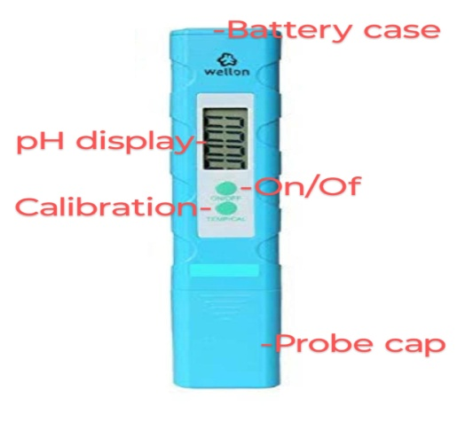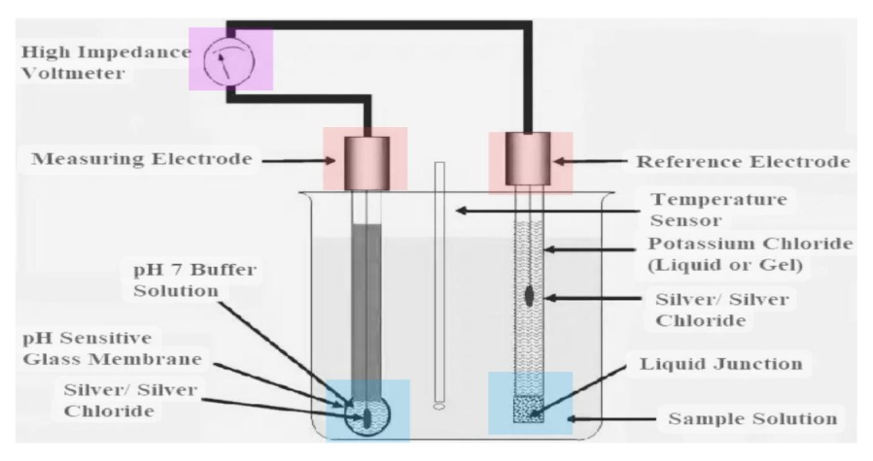

(a) (b)

**Fig. 1. (a)-A digital pen pH meter and, (b)- pH electrodes working representation scheme**

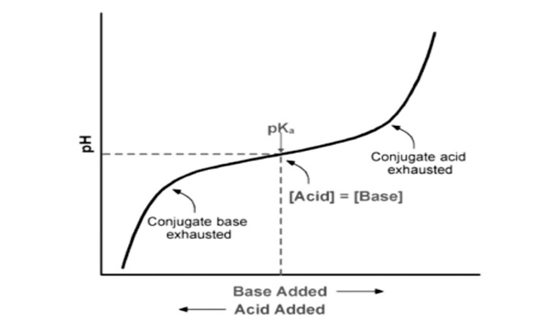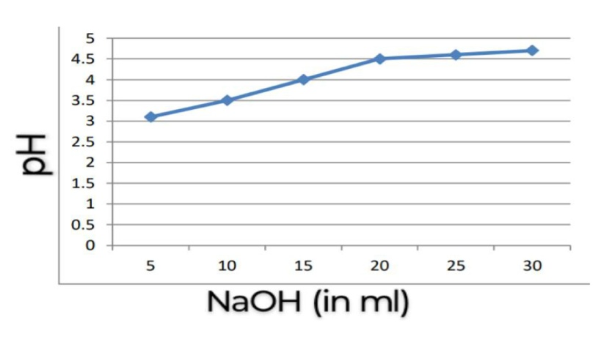

(a) (b)

**Fig. 2. (a)- A schematic graph of buffer solutions and, (b)- pH of acetic acid-acetate buffer with basic 5N NaOH solution, at 25˚C**

By that ionization process, the concentration of CH3COO- ions is increases and equilibrium (equation 2) shifted in backward direction. Hence, the degree of dissociation of CH3COOH is suppressed. Resulting, the concentration of H+ ions is decreases and thus concentration of OH- ions increases [24]. And, therefore, the pH of buffer solution is increases. In buffer, the sodium hydroxide (NaOH) is reacts with acetic acid, a sodium acetate and water (H2O) as product (a typical neutralization reaction). Notably, in CH3COOH-CH3COONa (acetic acid-sodium acetate) buffer solution the role of sodium (Na+) ions are as a spectator ion and it has no effect on position of equilibrium, so can be ignored [25,26]. Here, this study is important because it demonstrates the preparation and accurate measurement of acetic acid-sodium acetate buffer solutions, which are essential in various biological and chemical applications. By meticulously outlining the preparation process and employing a calibrated pH meter for precise pH determination, the study enhances our understanding of buffer systems' behavior when subjected to pH changes. Such insights are crucial for maintaining stable conditions in biochemical experiments and industrial processes, where pH control is vital for optimal performance and reaction outcomes.

## 4. CONCLUSIONS

In conclusions, we have reported the preparation and determination of pH of acetic acid-sodium acetate buffer solutions by using digital pen pH meter at about 25˚ C, as room temperature. For the preparation of buffer solutions, firstly, we have taken 1.5 ml of glacial acetic acid into 100 ml of standard flask for making up 0.2M of acetic acid solution, and 0.64 gm of sodium acetate were dissolved into 100 ml distilled water. After then, a prepared 36.2 ml of sodium acetate solution into 100 ml of standard flask and added 14.8 ml of prepared acetic acid to make its volume 100 ml by using distilled water, it is a buffer. In measuring the pH of this prepared buffer solutions, we have been using a calibrated digital pen pH meter for accurate and quick resolution of reading. By adding 5N NaOH solution in acetic acid-acetate buffer solutions the pH of buffer sample have adjusted to shown about 4.7 as well.

**DISCLAIMER (ARTIFICIAL INTELLIGENCE)**

Author(s) hereby declare that NO generative AI technologies such as Large Language Models (ChatGPT, COPILOT, etc) and text-to-image generators have been used during writing or editing of this manuscript.

## REFERENCES

1. Nernst W. Z. Phys. Chem. 1891;8:110-139.
2. Cotton FA, Wilkinson G, Murillo CA, Bochmann M.Advanced Inorganic Chemistry, 6th Edition, John Welly and Sons, Inc.; 1999.
3. Finar IL. Organic Chemistry, Vol-1, 6th Edition, Dorling Kindersley (India) Pvt. Ltd.; 2007.
4. Mishra SP. Introducing of thermodynamic Van’t Hoff equation in aqueous solubility and dissociation process of benzoic acid at ordinary temperature range. Chem. Sci. Int. J. 2022;31(1):8-14.

Mishra SP, Singh RP. Gibbs free energy change in aqueous dissociation of benzoic acid at temperature ‘K’: A thermodynamic study. Chem. Sci. Int. J. 2022;31(2):44-52.

1. Mishra SP. Titrimetric study of solubility of solute benzoic acid and their partition in water and benzene solvents. Chemical Sci. Int. J. 2021;30(3):40-45.

Mishra SP. Concentration effect of sodium chloride salt on benzoic acid solubility and dissociation into water at 298K temperature. Int. Res. J. Pure & Appl. Chem. 2021;22(6):47-52.

1. Harris KR. The determination of pH of standard buffer solutions: A laboratory experiment. J. Chem. Educ. 1985;62(4): 350.
2. Mishra SP. Phenolphthalein indicator in titrimetric estimation of benzoic acid solubility and distribution in water and benzene-buffer solutions. Asian J. of Chemical Sciences. 2022;11(4):1-7.
3. Paabo M, Robinson RA, Bates RG. Reference buffer solutions for pH measurements in 50% methanol. Dissociation constant of acetic acid and dihydrogen phosphate ion from 10 to 40˚. J. Am. Chem. Soc. 1965;87(3):415- 418.
4. Jordon JH, Ashbaugh HS, Mague JT, Gibb BC. Buffer and salt effects in aqueous host-guest system: screening, competitive binding, or both?. J. Am. Chem. Soc. 2021;143(44):18605-18616.
5. Partanen JI, Covington AK. Determination of stoichiometric dissociation constants of acetic acid in aqueous solutions containing acetic acid, sodium acetate and sodium chloride at (0 to 60) ˚C. J. Chem. & Engineering Data. 2003;48(4):797-807.
6. Arthur W. Davidson, an introduction to the chemistry of acetic acid solutions. Chem. Rev. 1931;8(2):175-190.
7. Harned HS, Hickey FC. The ionization of acetic acid in aqueous sodium chloride solutions from 0 to 40˚. J. Am. Chem. Soc. 1937;59(7):1284-1288.
8. Harned HS, Ehlers RW. The dissociation constant of acetic acid from 0 to 35˚C. J. Am. Chem. Soc. 1932;54(4):1350-1357.
9. Vogel A. Text book of Quantitative Chemical Analysis, 5th Edition, Longman, Harlow, London; 1989.
10. Maclnnes DA, Shedlovsky T. The determination of the ionization constant of acetic acid at 25˚, from conductance measurements. J. Am. Chem. Soc. 1932; 54(4):1429-1438.
11. Kulevich SE, Herrick RS, Mills KV. A discovery chemistry experiment on buffers. J. Chem. Educ. 2014;91(8):1207-1211.
12. Luz Z, Meiboom S. Kinetics of proton exchange in aqueous solutions of acetate buffer. J. Am. Chem. Soc. 1963;85(24): 3923-3925.
13. Hall NF, Meyer F. The acidity scale in glacial acetic acid. II. Buffer solutions-1.6< H0< 3.8. J. Am. Chem. Soc. 1940;62(9): 2493-2500.
14. Green AA. The preparation of acetate and phosphate buffer solutions of known pH and ionic strength. J. Am. Chem. Soc. 1933;55(6):2331-2336.
15. Donahue CJ, Panek MG. Buffer capacity of various acetic acid-sodium acetate systems: A lecture experiment. J. Chem. Educ. 1985;62(4):337.
16. Elwyn. F. Chase. A study of acetic acid –acetate buffers in KCl and NaCl solutions using the quinhydrone electrode. J. Am. Chem. Soc. 1933;55(8): 3072-3075.
17. Guy Schmitz. pH of sodium acetate solutions. J. Chem. Educ. 2002;79(1): 29.
18. Urbansky ET, Cooper BT, Margerum DW. Disproportionation kinetics of hypoiodous acid as catalyzed and suppressed by acetic acid-acetate buffer. Inorg. Chem. 1997;36(7):1338-1344.
19. Pergantis SA, Saridakis L, Lyratzakis A, Mavroudakis L, Montagnon T. Buffer squares: A graphical approach for the determination of buffer pH using logarithmic concentration diagrams. J. Chem. Educ. 2019;96(5):936-943.
20. Hayert M, P.-Cornet J-M, Gervais P. A simple method for measuring the pH of acid solutions under high pressure. J. Phys. Chem. A. 1999;103(12):1785-1789.
21. Bruce M. Thompson, Michael A. Kessick. On the preparation of buffer solutions. J. Chem. Educ. 1981;58(9): 743.

_________________________________________________________________________________