# **Scalable Infrastructure: Building Reliable Distributed Systems**

## **Preface**

In the rapidly evolving landscape of modern computing, distributed systems have become the backbone of our digital world. From the social media platforms that connect billions of users to the financial systems that process trillions of transactions, distributed architectures enable the scale, reliability, and performance that today's applications demand.

This book emerged from years of hands-on experience building and operating large-scale distributed systems in production environments. Having witnessed both spectacular successes and costly failures, we recognized the need for a comprehensive guide that bridges the gap between theoretical principles and practical implementation, particularly within modern cloud platforms.

**Why This Book Matters**

The complexity of distributed systems continues to grow as organizations adopt microservices architectures, serverless computing, and multi-cloud strategies. While numerous resources exist for individual technologies, few provide a holistic view of how these pieces fit together to create robust, scalable infrastructure. This book aims to fill that gap by offering both foundational principles and concrete implementation guidance using AWS and Azure platforms.

**Who Should Read This Book**

This book is designed for:

* Software architects making the transition from monolithic to distributed architectures
* Senior engineers responsible for scaling existing systems
* Platform engineers building internal developer platforms
* Engineering managers guiding technical decisions
* Students studying distributed systems with a focus on practical application

**What You'll Learn**

Throughout eight comprehensive chapters, you'll explore:

* Fundamental distributed systems concepts and trade-offs
* Cloud-native architectural patterns and their implementation
* Strategies for achieving scalability without sacrificing reliability
* Engineering practices for building fault-tolerant systems
* Security considerations unique to distributed environments
* Observability approaches for complex, multi-service systems
* Data management patterns for distributed applications
* Performance optimization techniques across the entire stack

## 

## **Abstract**

**Background and Motivation**

Modern software applications increasingly rely on distributed architectures to achieve the scale, reliability, and performance required by today's users. However, building effective distributed systems presents unique challenges that traditional software engineering approaches cannot adequately address. The complexity of managing multiple independent components, ensuring data consistency across network boundaries, and maintaining system resilience in the face of partial failures requires specialized knowledge and proven patterns.

**Scope and Approach**

This book provides a comprehensive examination of distributed systems engineering, focusing on practical implementation within modern cloud platforms. Rather than treating distributed systems as purely theoretical constructs, we explore concrete architectural patterns, implementation strategies, and operational practices that have proven effective in production environments. The content draws extensively from real-world experience with AWS and Azure platforms, offering specific guidance for implementing distributed systems concepts using cloud-native services.

**Key Contributions**

The book makes several key contributions to the distributed systems literature:

1. **Bridging Theory and Practice**: We connect fundamental distributed systems principles with practical implementation guidance, showing how concepts like the CAP theorem translate into real architectural decisions.
2. **Cloud-Native Focus**: Rather than generic distributed systems advice, we provide specific patterns and practices optimized for AWS and Azure environments, including service selection guidance and configuration recommendations.
3. **Holistic System View**: We examine distributed systems from multiple perspectives—architecture, reliability, security, observability, data management, and performance—showing how these concerns interact and influence each other.
4. **Proven Patterns**: The architectural patterns and practices presented have been validated through implementation in production systems serving millions of users.

**Target Audience and Impact**

This work addresses the needs of software architects, senior engineers, and engineering leaders responsible for designing and implementing scalable infrastructure. By providing both conceptual foundations and practical guidance, the book enables organizations to successfully navigate the transition from monolithic to distributed architectures while avoiding common pitfalls that can lead to system complexity, operational overhead, and reliability issues.

**Keywords**: Distributed Systems, Cloud Computing, Microservices, System Architecture, Scalability, Reliability Engineering, AWS, Azure, Performance Optimization, Data Management

## **Table of Contents**

**Chapter 1: Foundations of Distributed Systems** ............................

* Understanding Distributed Systems Complexity
* The CAP Theorem: Understanding the Fundamental Tradeoff
* Consistency Models: Beyond All-or-Nothing
* Building Blocks of Modern Distributed Architectures
  + Service Discovery and Load Balancing
  + Data Partitioning and Replication
  + Consensus Algorithms

**Chapter 2: Cloud-Native Architecture Patterns** ...........................

* The Evolution Beyond Monoliths
* Microservices: Principles and Practices
* Event-Driven Architecture: Adapting to Change
* API Design and Management
* Infrastructure as Code: Foundation for Cloud-Native
* Serverless: Beyond Infrastructure Management
* Integration Patterns: Connecting Components
* Implementation Considerations for AWS and Azure

**Chapter 3: Scalability by Design** ........................................

* Understanding Scalability Dimensions
* Stateless Service Design
* Database Scaling Strategies
* Caching Patterns and Implementations
* Auto-scaling Policies and Best Practices
* Load Testing and Performance Optimization
* Cost Optimization Strategies
* Scalability in Practice: Case Studies

**Chapter 4: Reliability Engineering** .....................................

* SLOs, SLAs, and Error Budgets
* Chaos Engineering Methodologies
* Failure Modes and Recovery Strategies
* Designing for Graceful Degradation
* Multi-region Deployments
* Observability and Incident Response
* Automated Recovery and Self-Healing Systems

**Chapter 5: Security in Distributed Environments** ........................

* Zero Trust Architecture Implementation
* Secrets Management Across Distributed Systems
* Authentication and Authorization Patterns
* Network Security for Distributed Workloads
* Cloud Security Posture Management
* Data Protection in Distributed Systems

**Chapter 6: Observability and Monitoring at Scale** .......................

* The Observability Imperative
* Distributed Tracing Implementation
* Metrics Collection and Visualization
* Log Aggregation Strategies
* Alerting Philosophies and Practices
* Building Effective Dashboards
* Cost Management for Observability

**Chapter 7: Data Management in Distributed Systems** ......................

* Distributed Database Selection Criteria
* Data Partitioning Strategies
* Handling Eventual Consistency
* Data Migration Patterns
* Backup and Recovery at Scale
* Caching Strategies
* Data Governance and Compliance

**Chapter 8: Performance Optimization** ....................................

* Load Testing Distributed Systems
* Identifying and Resolving Bottlenecks
* Network Optimization Techniques
* Resource Utilization Best Practices
* Database Performance Tuning
* Frontend Performance Optimization
* Performance Testing in CI/CD Pipelines

## **Chapter 1: Foundations of Distributed Systems**

Distributed systems have become the backbone of modern computing infrastructure, underpinning everything from mobile applications to enterprise systems that process millions of transactions per second. A distributed system is basically a collection of independent computing nodes that, to its users, appears to be a single system. The independent computers in this system communicate over a network, coordinating to achieve common goals without shared memory or physical clocks. This seemingly innocuous definition conceals the remarkable intricacy that goes into designing, constructing, and sustaining such systems on a large scale.

There were several drivers that drove the evolution of distributed systems. Traditional monolithic architectures reached scale boundaries as users' needs increased exponentially. Hardware constraints made it impossible to scale single machines infinitely upward. Economic considerations favored commodity hardware distributed across locations rather than enormous supercomputers. And perhaps most importantly, reliability requirements demanded redundancy that single-machine architectures just couldn't provide.

Modern cloud platforms like AWS and Azure are the pinnacle of this achievement—offering managed services that encapsulate a lot of the distributed computing complexity. But the underlying issues still exist, and it is well worth architects and engineers who must design reliable systems knowing about them.

The root issue of distributed computing is coordination: how do autonomous computers, each with their own state, memory, and clock, work together reliably to construct a consistent system? This issue manifests in many guises that every distributed systems engineer has to grapple with:

* **Partial failures**: In a distributed system, components fail independently. The system must continue functioning despite these localized failures.
* **Communication unreliability**: Network connections between components may experience latency, packet loss, or complete failure.
* **Clock synchronization**: Without a shared clock, establishing the order of events across nodes becomes problematic.
* **Consistency maintenance**: Ensuring all nodes have a consistent view of shared data is mathematically impossible under certain conditions.

Those challenges have inspired generations of computer science engineering and research, culminating in a rich collection of patterns, algorithms, and technologies. From Byzantine fault tolerance to gossip protocols, from consistent hashing to vector clocks, the technology has developed sophisticated tools to deal with these fundamental challenges.

Understanding these fundamental principles isn't abstract—it has concrete implications for engineering decisions in the real world. Should your program use a relational database with consistency guarantees or a NoSQL database that prioritizes availability? Should your microservices communicate synchronously over REST or asynchronously over message queues? The choices are based on your specific requirements, but all are informed by the underlying principles of distributed systems.

### **The CAP Theorem: Understanding the Fundamental Tradeoff**

Eric Brewer proposed in 2000 a conjecture that would have profound influence on the design of distributed systems for decades to come. This conjecture, later formally proved mathematically by Seth Gilbert and Nancy Lynch, came to be known as the CAP theorem. It states that there cannot exist a distributed data store with more than two of the following three guarantees at a time:

* **Consistency (C)**: Every read receives the most recent write or an error. In other words, all nodes see the same data at the same time.
* **Availability (A)**: Every request (to a non-failing node) receives a non-error response, without guaranteeing that it contains the most recent information.
* **Partition tolerance (P)**: The system continues to operate despite network partitions that prevent communication between some nodes.

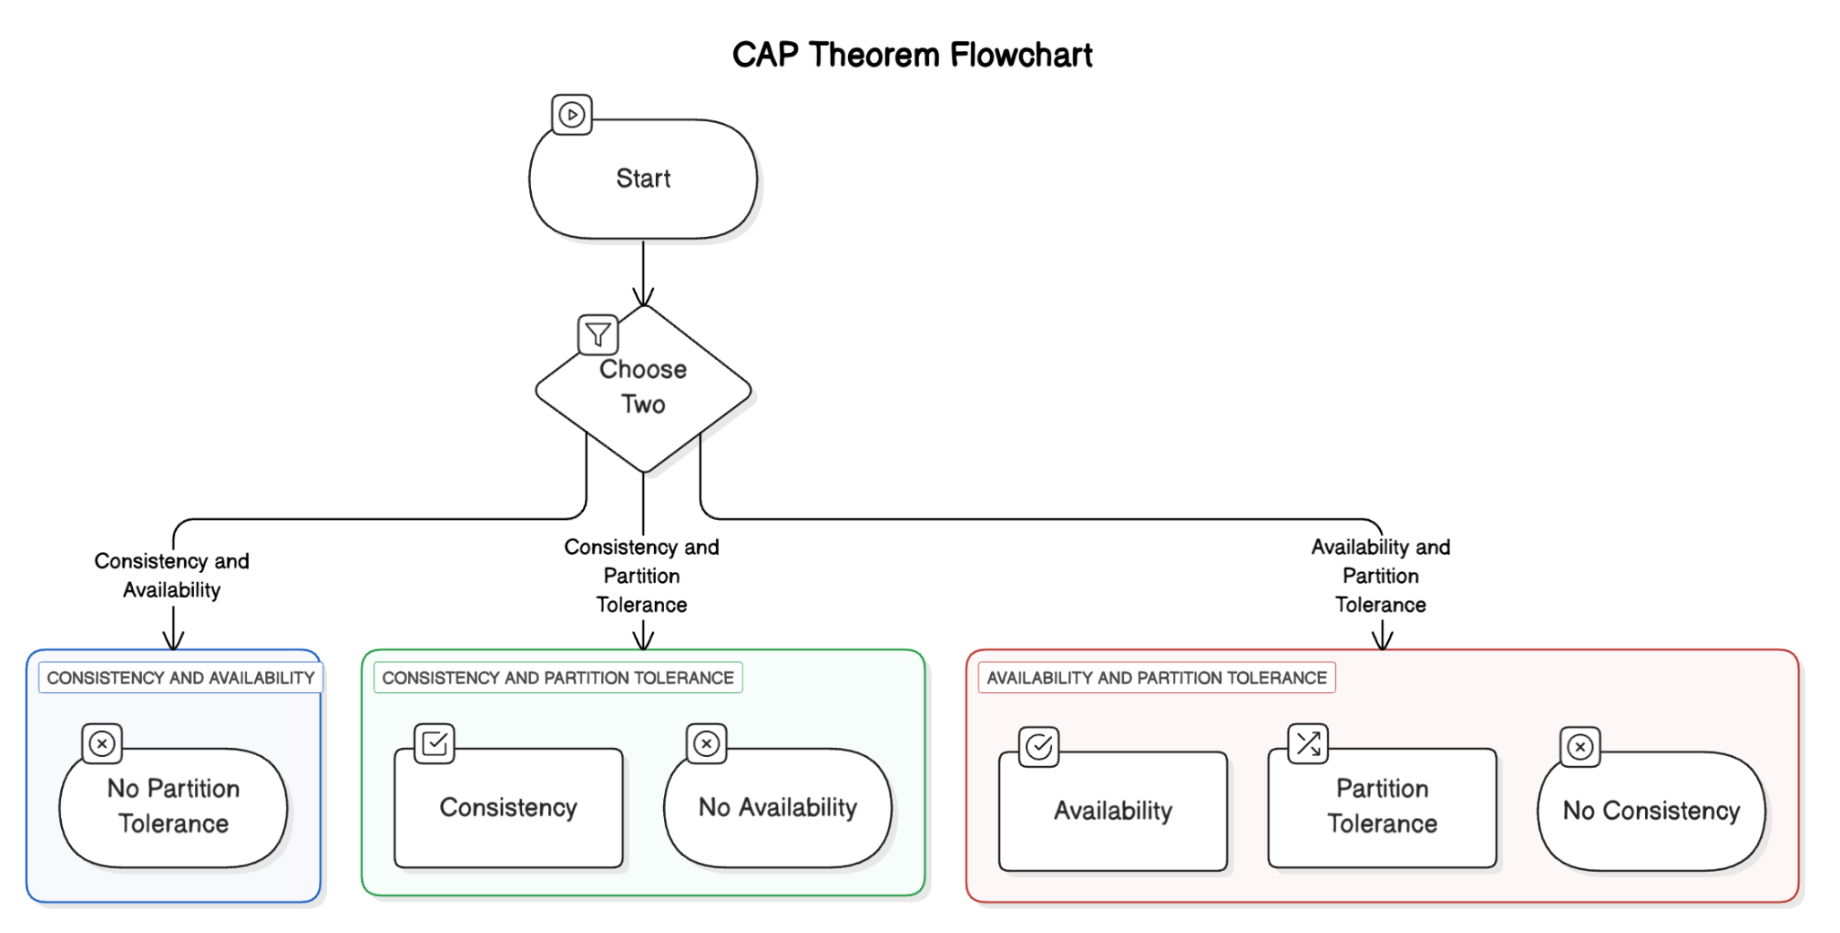

Since network partitions cannot be avoided in real distributed systems, the theorem therefore forces system designers to decide on a design between availability and consistency during partitions. It is not an intellectual exercise but a real design choice with important long-term consequences for system behavior, performance, and users.

Partitioning in a network occurs when the nodes of a distributed system are unable to talk to each other, hence creating "islands" of communication. Network partitions are created by many events like physical infrastructure failure, network overload packet loss, firewalls misconfigured, or failures of cloud provider regions. In spite of very reliable networks, partitioning is inevitable within a sufficiently long time horizon. According to a 2014 Google research, their global infrastructure experienced an average of 5 network partitions per month despite extensive redundancy and engineering expertise.

The CAP theorem is a useful concept, but it only applies to system behaviour in the presence of partitions. Daniel Abadi went further with the PACELC theorem which states that in a partition (P), a system must pick between availability (A) and consistency (C); else (E), in the normal operation of the system, it must select between latency (L) and consistency (C). This extension of the idea is based on the fact that even in the absence of partitions, distributed systems have fundamental characteristics of consistency versus performance. For instance, strong consistency is often achieved at the cost of one or more network round trips, i.e., at the expense of latency.

Knowing CAP doesn’t involve reducing systems to ‘CP’ or ‘AP’. Most systems today are more complex. Some systems have different CAP choices throughout the system. Some systems enable the specification of consistency levels per operation. At the same time, inconsistent systems can employ conflict resolution or compensation transactions. For instance, an e-commerce application may employ a strong consistency database for inventory and payment, a weak consistency database for recommendations, and a cache with variable consistency for products. In practice, effective architects use the CAP theorem as a framework for identifying tradeoffs and pairing technologies with requirements. The design of every distributed system is accompanied by tradeoffs and the CAP theorem helps to make them obvious.

### **Consistency Models: Beyond All-or-Nothing**

The simple dichotomy between strong consistency and eventual consistency which is proposed by CAP does not capture the entire range of consistency models that are available for distributed system designers. Each model is chosen to address particular concerns of efficiency, data accessibility, and ease of development.

Linear consistency is the strongest model of consistency that is easy to understand and use. It is similar to the idea of operations happening instantly at a single point of time and reads always returning the last write. This model is in line with what one would expect from data but comes with a price of latency and availability. Linearizability is usually achieved through coordination protocols like Two-Phase Commit (2PC) or consensus algorithms like Paxos or Raft. AWS Aurora global database with write forwarding, and Google Cloud Spanner offer linearizable consistency across the globe at the expense of latency.

Sequential consistency is a bit less rigorous than linearizability, guaranteeing that operations are applied in some specific order that is coherent when viewed from different nodes. In other words, all the processes receive the same sequence of events, although this sequence may not always correspond to the real time. Causal consistency guarantees that all operations that are related to each other are propagated and executed in the same order to all the nodes. For example, if one message is sent after receiving another message then all the nodes will receive the receive operation before the send operation. This model preserves the cause-effect relationships and allows to disregard other orderings. Azure Cosmos DB is also causal consistent and is one of its consistency models that one can set, thus standing between the strong consistency and the weak consistency.

Eventual consistency only guarantees that replicas will bring themselves into sync with the latest state, if there are no further modifications to the data. This model is rather forgiving in terms of availability and performance but can result in temporary inconsistencies across the system. Eventual consistency is the default for Amazon DynamoDB and many other NoSQL databases. These systems usually rely on methods such as vector clocks, Merkle trees or CRDTs (Conflict-free Replicated Data Types) to detect and solve conflicts.

Session consistency is an intermediate model between strong and eventual consistency that offers better guarantees within a single client session, but relaxes those guarantees across different sessions. This model is most useful for user facing applications, where people expect consistency within their sessions.

They realize that various apps demand varying levels of consistency in the modern cloud platforms. Some offer adjustable consistency levels. Azure Cosmos DB provides five distinct consistency levels: Strong, Bounded staleness, Session, Consistent prefix and Eventual. Developers can then pick the right tradeoffs for each application or even for some operations in the same application. Amazon DynamoDB has configured reads as either eventually consistent (the default) or strongly consistent, with different pricing and performance.

Beyond platform-specific features, several patterns help manage consistency in distributed systems:

* **Read-after-write consistency** ensures that users can immediately see their own updates, even if the system is eventually consistent for other users' updates.
* **Monotonic reads** guarantee that if a process reads a value X, any subsequent reads will never return values older than X.
* **Quorum-based consistency** systems, like Amazon's Dynamo architecture, use configurable read and write quorums to tune the consistency-availability balance.

Understanding consistency models is essential for architects to be able to link data requirements with the right storage technologies. Financial transactions, inventory management, and the concept of a unique username are probably among the features that need strong consistency. The data in social media feeds, product catalogs, and analytics can generally be handled with eventual consistency. The state of shopping carts, user preferences, and games can usually be managed through session consistency.

### **Building Blocks of Modern Distributed Architectures**

With the theoretical foundations established, we can now examine the common building blocks that form modern distributed systems. These components provide practical solutions to the challenges inherent in distributed computing.

In traditional monolithic applications, component locations are typically static and well-known. Distributed systems, however, operate in dynamic environments where instances come and go—whether due to auto-scaling, failures, or deployments. Service discovery mechanisms solve the fundamental problem of how components find each other in this constantly changing landscape.

Client-side discovery places the responsibility on the client to determine the location of service instances. This approach typically uses a service registry like etcd, Consul, or ZooKeeper, where services register their endpoints and clients query to find available instances. AWS implements client-side discovery through its Application Discovery Service, which helps identify dependencies and communication patterns between application components.

Server-side discovery uses an intermediary (often a load balancer) to abstract away the location of service instances. Clients send requests to the intermediary, which then forwards them to an appropriate instance. Azure Traffic Manager and AWS Elastic Load Balancing both implement server-side discovery, making service location transparent to clients.

DNS-based discovery leverages the Domain Name System to provide service location information. This approach works well for coarse-grained discovery but may struggle with rapid changes due to DNS caching. AWS Route 53 and Azure DNS both provide DNS-based service discovery with health checking capabilities.

Load balancers distribute requests across multiple instances of a service, improving both scalability and reliability. Modern distributed systems employ multiple load balancing strategies at different levels:

* **Layer 4 (transport) load balancing** operates at the TCP/UDP level, forwarding packets based on IP address and port without inspecting their contents.
* **Layer 7 (application) load balancing** examines the content of requests (e.g., HTTP headers or URL paths) to make routing decisions.
* **Client-side load balancing** embeds load balancing logic directly into service clients, eliminating the need for dedicated load balancing infrastructure.

As data volumes grow beyond what single machines can handle, partitioning (or sharding) becomes necessary. Data partitioning divides large datasets across multiple nodes, allowing systems to scale horizontally rather than vertically.

Horizontal partitioning splits data rows across multiple nodes based on a partition key. The key challenge lies in selecting an appropriate partition key that evenly distributes data and minimizes cross-partition operations. Amazon DynamoDB automatically partitions data based on the primary key, transparently handling partition management as data volumes change.

Vertical partitioning divides different columns or attributes across separate storage systems. This approach is particularly useful when different data types have different access patterns or consistency requirements. In practice, many systems use a combination of both approaches, horizontally partitioning some data while vertically partitioning others into specialized stores.

The challenges of data partitioning include maintaining referential integrity across partitions, performing distributed joins efficiently, handling partition rebalancing without downtime, and managing transactions that span multiple partitions. These challenges have given rise to specialized patterns like the Saga pattern for distributed transactions and materialized views for efficient cross-partition querying.

Replication creates and maintains copies of data across multiple nodes, serving two primary purposes: improving availability by providing redundancy and enhancing performance by allowing reads from geographically closer replicas.

Synchronous replication ensures that data is written to multiple replicas before confirming the write to the client. This approach guarantees consistency across replicas but increases write latency and reduces availability during network partitions. AWS Aurora's storage layer uses synchronous replication across multiple Availability Zones to ensure durability without compromising performance.

Asynchronous replication updates primary storage immediately while propagating changes to replicas in the background. This approach offers better performance and availability at the cost of potential consistency issues during failures. Azure Cosmos DB uses asynchronous replication with configurable consistency levels to balance performance and consistency requirements.

Multi-leader replication allows writes to occur at multiple replicas independently, with conflicts resolved through various mechanisms. This model suits geographically distributed applications where local write availability is crucial. Both AWS DynamoDB Global Tables and Azure Cosmos DB multi-region writes implement multi-leader replication for global applications.

In distributed systems, many operations require agreement among multiple nodes—whether it's electing a leader, committing a transaction, or updating shared configuration. Consensus algorithms provide mechanisms for reaching such agreements even in the presence of failures.

* **Paxos**, developed by Leslie Lamport, was the first widely recognized solution to the consensus problem.
* **Raft** emerged as a more understandable alternative to Paxos, specifically designed for clarity.
* **Zab** (ZooKeeper Atomic Broadcast) powers Apache ZooKeeper, providing ordered delivery of messages.

These algorithms underpin many critical distributed systems components: leader election in database clusters, configuration management in service meshes, distributed locking services, and metadata management in distributed file systems. AWS uses consensus algorithms in services like ECS for cluster state management and DynamoDB for metadata coordination. Azure similarly relies on consensus in services like Service Fabric for cluster management.

## **Chapter 2: Cloud-Native Architecture Patterns**

Modern distributed systems make increasing use of cloud platforms in order to offer operational efficiency, scalability, and resilience. This move from conventional architectures to cloud-native designs profoundly alters how we design, build, and run apps, not only changing deployment environments. With special focus on their implementation in AWS and Azure settings, this chapter will investigate the main architectural principles that allow successful cloud-native applications.

### **The Evolution Beyond Monoliths**

For decades, the monolithic application—a single codebase implemented as a cohesive unit—was the predominant architectural paradigm. In development, testing, and deployment, monoliths provided simplicity. With parts directly interacting through function calls instead of network interfaces, the full application ran as one coherent unit. When applications were not large scale and change was rare, this strategy worked really nicely.

On the other hand, as digital systems have become more crucial in business operations, the limitations of monolithic architecture began to show as systems grew in complexity. Some larger teams ran into a slow down in the rate of development because of difficulties in coordinating their work off of a common codebase. Since even small changes required testing of the entire application, release cycles stretched out.

Most crucially, monoliths produced larger "blast radiuses" for failures—a fault in any component may perhaps ruin the whole system. As businesses became more dependent on digital technology, such mistakes got more costly and unacceptable.

These challenges drove the field towards ever more modular architectures. Originally aimed at separating software into reusable services, service-oriented architecture (SOA) originally emerged early in the 2000s. SOA evolved simple concepts, but it also regularly contained complex middleware and heavy protocols with their own challenges.

The growth of cloud computing hastened this evolutionary process. Elastic resources, managed services, and worldwide distribution capabilities provided by cloud platforms let traditional designs fall short. This spurred the creation of fresh architectural designs especially meant to maximize these features—what we now refer to as cloud-native designs.

Cloud-native architectures embrace several key principles:

* **Distributed** elements interacting over networks instead than via in-memory capability calls
* **Elasticity** to automatically scale resources depending on demand; **Resilience** by redundancy, isolation, and elegant degradation
* **Operations** and consistent deployment **Automation**
* **Observability** helps one to grasp the behavior of complicated distributed systems.

But the move to cloud-native isn't always black or white. There is a range of methods between traditional and cloud-native that most organizations use. Let's look at the main architectural patterns that current cloud-native systems use.

### **Microservices: Principles and Practices**

At its core, the microservices architectural style breaks down large systems into small, separate services that each handle a specific business task. Such services speak to one another using clear APIs, are self-contained and usually run by small, independent teams that manage the service lifecycle.

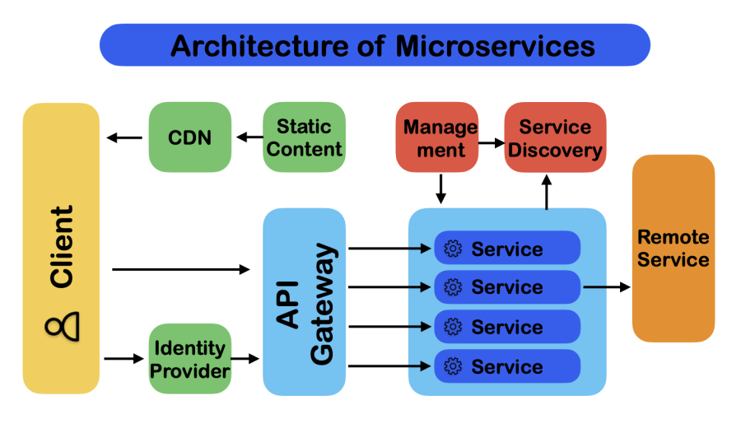

This approach offers several advantages over monolithic architectures:

* **Independent deployability:** Services can be updated independently without requiring system-wide deployments
* **Technology diversity:** Teams can select appropriate technologies for each service's requirements
* **Isolation and resilience:** Failures in one service can be contained without affecting the entire system
* **Targeted scaling:** Resources can be allocated precisely where needed rather than scaling the entire application
* **Team autonomy:** Small teams can own services completely, accelerating decision-making and innovation

However, these benefits come with significant complexity. Monoliths usually avoid the difficulties distributed systems bring in operational complexity, data consistency, and communication. Once a basic method call inside a process, today it becomes a network request across services, adding latency, dependability questions, and perhaps consistency problems.

Microservices adoption should be motivated by specific business and technological requirements rather than industry trends. A well-designed monolith may still be the best architecture for small engineering teams, consistent needs, or simpler applications. Bigger companies with complex domains, many teams, and regular independent deployment requirements will benefit from microservices.

Both AWS and Azure offer complete systems meant to enable microservices designs. Through ECS and EKS, AWS provides container orchestration; via API Gateway, it provides API management; App Mesh provides service mesh capabilities; and DynamoDB provides specialised databases. Through Azure Kubernetes Service, API Management, Service Fabric, and Cosmos DB Azure offers comparable capabilities. Azure provides similar capabilities through Azure Kubernetes Service, API Management, Service Fabric, and Cosmos DB.

Effective microservices implementation requires careful attention to several key aspects:

Service Boundaries: Choosing suitable service boundaries is maybe the most important choice microservices architecture requires. Services should minimise reliance on other ones and capture unified business capabilities under clear ownership of their data. Here, especially the idea of limited contexts—internally coherent models of particular corporate domains—domain-driven design offers insightful direction.

Tight coupling between services made possible by poorly defined service boundaries negates many of the advantages of microservices architecture. While services with too fine-grained create too much communication overhead and operational complexity, too massive services remain the monoliths' difficulties.

**Communication Patterns:** Microservices interact via several patterns, each with different trade-offs. Though it establishes temporal connection between services, synchronous communication via REST or gRPC provides simplicity and immediacy. While it increases resilience and scalability, asynchronous communication via message queues or event streams generates ultimate consistency problems.

Through API Gateway and Application Load Balancer, AWS enables synchronous communication; asynchronous choices include SQS for queues and SNS/EventBridge for event dissemination. Through API Management, Application Gateway, Service Bus, and Event Grid Azure provides comparable features.

**Data Management:** Usually seen in monolithic applications, data exists in a single database under consistent control via transactions. With each service ideally controlling its data just, microservices radically rethink this strategy. This presents difficulties for activities involving several services; how can consistency be maintained without distributed transactions, which are famously difficult to execute consistently?

Patterns like CQRS, which separates read and write models, and the Saga pattern, which arranges a number of local processes, help to overcome these challenges. Both AWS and Azure provide Step Functions/SQS for orchestration in AWS and Logic Apps/Service Bus in Azure to support these trends.

**EDA: Adapting to Change with Event-Driven Architecture**

By emphasizing the movement of events through the system, event-driven architecture (EDA) is a potent paradigm that enhances microservices. When major state changes take place in this model, components release events without knowing which downstream components would find those events interesting. This improves system flexibility by fostering loose coupling between services.

Consider an e-commerce system: when a customer places an order, an "OrderCreated" event might trigger inventory reservation, payment processing, shipping preparation, and customer notification—all without the ordering service needing direct knowledge of these downstream processes.

Event-driven architectures offer several key benefits:

* **Loose coupling**: Services don't need direct knowledge of each other to collaborate
* **Scalability**: Event processing can scale independently based on specific workloads
* **Flexibility**: New capabilities can be added by subscribing to existing event streams
* **Resilience**: Services can continue operating independently even when others are unavailable

Services like EventBridge (event routing), SNS (pub/sub messaging), SQS (queuing), and Kinesis (stream processing) let AWS offer strong support for event-driven architectures. Many of these event sources can be directly triggered by lambda functions, hence producing a smooth event-processing pipeline.

Through Event Grid (event distribution), Event Hubs (event ingestion), Service Bus (messaging), and Stream Analytics (stream processing), Azure provides like capabilities. Like Lambda, Azure Functions offers serverless compute with direct connection to these event sources.

Implementing effective event-driven architectures requires attention to several key aspects:

**Event Design**: Well-designed events are self-contained, providing all relevant information required by customers, without requesting more questions of the publishing business. occurrences should mirror important commercial occurrences rather than only technical changes in government policy. Versioning techniques are absolutely essential to let the event schema change without alienating current consumers.

**Event Sourcing**: Rather than only their present condition, this design records the whole history of domain objects as a sequence of unchangeable occurrences. This method offers strong audit tools and lets temporal searches—that is, "what was this customer's account balance at the end of last quarter?" Though strong, event sourcing calls for careful design to address issues such schema change over time and snapshot creation for speed optimization

**Event Delivery Guarantees**: Various systems call for different guarantees about event delivery. While some situations can allow at least-once delivery with idempotent processing or at-most-once delivery with some message loss, others call for precisely-once delivery. Different delivery guarantees provided by AWS and Azure messaging services help to satisfy these various needs.

**Challenges and Considerations**: Event-driven design brings complexity in system understanding and troubleshooting even if it has advantages. Specialized observability technologies help one to trace the flow of a business transaction over several asynchronous processes. Azure Application Insights and AWS X-Ray both offer distributed tracing to guide across this complexity.

### **API Design and Management**

As systems decompose into microservices and event-driven components, APIs become the primary interfaces between these components. Well-designed APIs enable effective service composition while hiding implementation details that might change over time.

API design approaches vary based on communication patterns:

* **REST APIs** follow resource-oriented design with standard HTTP methods and status codes
* **GraphQL APIs** provide flexible querying capabilities, allowing clients to request exactly the data they need
* **gRPC APIs** use binary serialization and HTTP/2 for high-performance communication
* **Event APIs** define the structure and semantics of events flowing through the system

As API landscapes grow more complex, API management becomes essential. API gateways serve as the entry point for external clients, handling cross-cutting concerns such as:

* **Authentication and authorization**: Verifying caller identity and permissions
* **Rate limiting**: Protecting backend services from excessive traffic
* **Request routing**: Directing requests to appropriate backend services
* **Response transformation**: Adapting backend responses to client requirements
* **Monitoring and analytics**: Tracking API usage patterns and performance

AWS API Gateway supports REST, HTTP, WebSocket, and GraphQL APIs with integrations to Lambda, EC2, and other services. Amazon API Gateway offers built-in request validation, throttling, and authorization controls. AWS AppSync provides specialized support for GraphQL APIs with real-time capabilities.

Azure API Management offers comprehensive API gateway functionality with additional features like developer portals, documentation generation, and extensive policy controls. For GraphQL, Azure API Management can be combined with Azure Functions to create flexible GraphQL endpoints.

### **Infrastructure as Code: Foundation for Cloud-Native**

Cloud-native architectures fundamentally change how infrastructure is provisioned and managed. Where traditional infrastructure often relied on manual configuration, cloud-native systems employ Infrastructure as Code (IaC)—defining infrastructure through machine-readable definition files rather than manual processes.

This approach brings several key benefits:

* **Repeatability**: Infrastructure can be consistently recreated across environments
* **Version control**: Infrastructure changes are tracked alongside application code
* **Automation**: Provisioning and updates can be performed programmatically
* **Documentation**: The code itself documents the infrastructure design

AWS CloudFormation pioneered declarative infrastructure definition, allowing complete environments to be described in JSON or YAML templates. AWS CDK (Cloud Development Kit) extends this approach by enabling infrastructure definition in familiar programming languages like TypeScript, Python, and Java, bringing software engineering practices to infrastructure definition.

Azure Resource Manager (ARM) templates provide similar declarative capabilities within the Azure ecosystem. More recently, Azure has introduced Bicep as a domain-specific language that transpiles to ARM templates, offering improved developer experience similar to the AWS CDK.

For teams seeking cloud-agnostic solutions, Terraform has emerged as a popular multi-cloud IaC tool that works well with both AWS and Azure. Terraform provides a consistent workflow across cloud providers while still accessing provider-specific capabilities.

Effective IaC implementation requires several key practices:

* **Modularization**: Breaking infrastructure definitions into reusable components
* **Environment separation**: Maintaining distinct configurations for development, testing, and production
* **State management**: Securely storing and sharing the state that maps code to deployed resources
* **CI/CD integration**: Automating infrastructure deployment alongside application code

### **Serverless: Beyond Infrastructure Management**

Serverless computing represents perhaps the purest expression of cloud-native architecture—abstracting infrastructure management entirely to focus solely on business logic. Despite the name, servers still exist; they're simply provisioned, managed, and scaled automatically by the cloud provider rather than the application team.

In the serverless model, compute resources automatically scale based on incoming request volume, with billing based on actual execution time rather than provisioned capacity. This approach can dramatically reduce operational overhead and optimize costs, particularly for variable or unpredictable workloads.

The core components of serverless architecture typically include:

* **Functions-as-a-Service (FaaS)**: Short-lived compute instances that respond to events
* **Managed databases**: Automatically scaled storage with minimal operational overhead
* **API gateways**: Managed entry points for HTTP requests
* **Event sources**: Triggers that initiate function execution based on various conditions

AWS Lambda pioneered the FaaS model, with Azure Functions providing similar capabilities in the Microsoft ecosystem. These services execute custom code in response to events from sources like HTTP requests, database changes, message queues, or scheduled triggers.

Beyond compute, both platforms offer complementary serverless services. AWS provides DynamoDB for NoSQL data, Aurora Serverless for relational data, and S3 for object storage. Azure offers Cosmos DB, Azure SQL Serverless, and Blob Storage with similar capabilities.

Serverless architecture introduces several distinct patterns:

* **Function composition**: Building complex processes by chaining together specialized functions
* **Fan-out processing**: Using events to trigger parallel execution across multiple functions
* **State machines**: Orchestrating sequences of functions to implement business processes

AWS Step Functions and Azure Logic Apps provide orchestration capabilities for complex serverless workflows, maintaining state between function executions and handling retry logic for resilient processing.

While serverless offers compelling benefits, it introduces unique challenges:

* **Cold start latency**: Functions that haven't been recently invoked may experience initialization delays
* **Execution limits**: Functions typically have constraints on memory, execution time, and package size
* **Limited state**: Functions are effectively stateless between invocations, requiring external state storage
* **Vendor-specific implementations**: Serverless offerings often feature proprietary APIs and behaviors

Organizations adopting serverless should carefully evaluate these constraints against their specific requirements. Serverless excels for event-driven workloads with variable demand, but may not be optimal for all scenarios.

### **Integration Patterns: Connecting Components**

As systems decompose into specialized services, integration patterns become essential for effective communication between components. Several key patterns have emerged in cloud-native architectures:

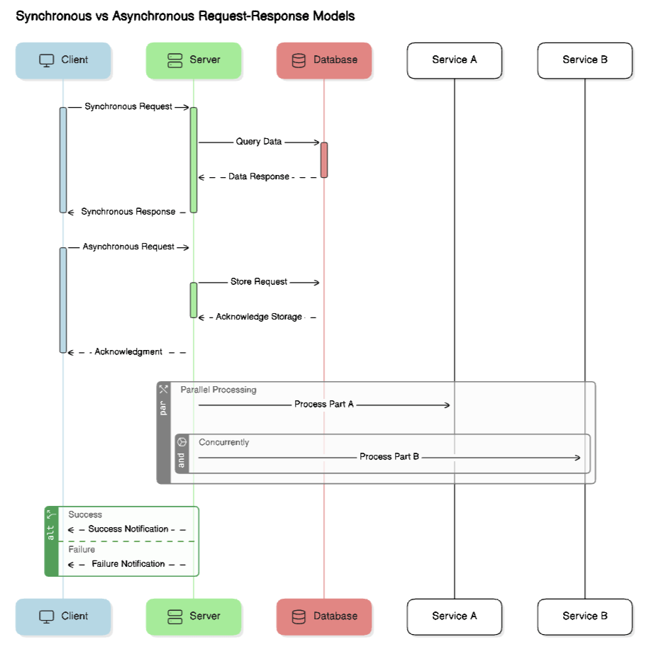

**Synchronous Request-Response**: The most straightforward pattern, where one service directly calls another and waits for a response. While simple to implement, this pattern creates temporal coupling—the calling service can only proceed once the called service responds, potentially creating cascading failures during outages.

AWS and Azure both support this pattern through various mechanisms, including direct HTTP communication, API Gateway/Management services, and service mesh implementations like AWS App Mesh and Azure Service Mesh.

**Asynchronous Messaging**: In this pattern, services communicate by sending messages through intermediate queues or topics. This decouples services temporally—the sender can continue processing without waiting for the recipient to handle the message. This pattern improves resilience but introduces eventual consistency challenges.

AWS SQS provides queue-based messaging, while SNS supports pub/sub messaging. Azure Service Bus offers similar capabilities with both queues and topics. Both platforms support dead-letter queues for handling failed message processing.

**Event Sourcing and CQRS**: These complementary patterns separate write and read operations, with changes captured as immutable events. This approach enables sophisticated audit capabilities, temporal queries, and optimized read models tailored to specific query patterns.

AWS services like DynamoDB Streams, Kinesis, and Lambda can implement these patterns, while Azure provides comparable capabilities through Cosmos DB Change Feed, Event Hubs, and Functions.

### **Implementation Considerations for AWS and Azure**

While the architectural patterns we've discussed apply across cloud platforms, implementation details vary between AWS and Azure. Understanding these variations helps architects select the most appropriate services for their specific requirements.

**AWS Implementation Approaches**:

AWS emphasizes highly specialized, decoupled services that can be composed to meet specific requirements. This approach offers tremendous flexibility but requires careful service selection and integration. For example, a typical microservices architecture might leverage ECS or EKS for container orchestration, API Gateway for external interfaces, DynamoDB for data storage, and CloudWatch for monitoring—each service optimized for its specific purpose but requiring intentional integration.

AWS's approach to managed services often prioritizes scalability and operational simplicity over deep customization. Services like DynamoDB abstract away complex operational concerns but impose certain design constraints that applications must accommodate.

**Azure Implementation Approaches**:

Azure often emphasizes more integrated experiences, particularly for organizations already invested in Microsoft technologies. While offering comparable capabilities to AWS, Azure frequently packages these capabilities into more consolidated services with comprehensive management interfaces.

Azure's approach to managed services often provides more configuration options at the cost of somewhat higher management complexity. For example, Azure Cosmos DB offers multiple consistency models, protocol interfaces, and indexing strategies—providing flexibility but requiring more configuration decisions.

### **Conclusion: Toward Effective Cloud-Native Architectures**

Cloud native architecture patterns are here to stay and have been developed to solve the issues that come with distributed systems. They include microservices, serverless, event-driven design, and infrastructure as code, all of which are proven ways of building scalable and resilient systems on the modern cloud platforms.

Effective cloud-native architecture requires more than just adopting these patterns, however. It demands thoughtful consideration of specific business requirements, team capabilities, and operational constraints. The most successful cloud-native systems typically combine multiple patterns pragmatically rather than dogmatically adhering to any single approach.

In your design and implementation of cloud native architectures on AWS, Azure or any other platform it is important you always have your objectives in mind and not just the architectural trends. Consider your team’s capabilities, your organization’s operational maturity, and your business requirements. Then pick the patterns and technologies that you think will help you achieve those objectives within your constraints.

In the next chapter, we'll explore how to design for scalability from the beginning, examining techniques for building systems that grow gracefully as demand increases—without requiring fundamental rearchitecture at each stage of growth.

## **Chapter 3: Scalability by Design**

Scalability defined as the capacity of a system to scale in response to growing workloads is one of the major reasons for using distributed systems architecture. Systems must be able to accommodate rising loads without performing poorly or incurring the excessive expenses that would come with proportional increases in system resources for gradual or sudden increases in traffic. In this chapter, we will look at ways of designing systems to be scalable from the ground up with emphasis on implementation patterns in AWS and Azure environments.

### **Understanding Scalability Dimensions**

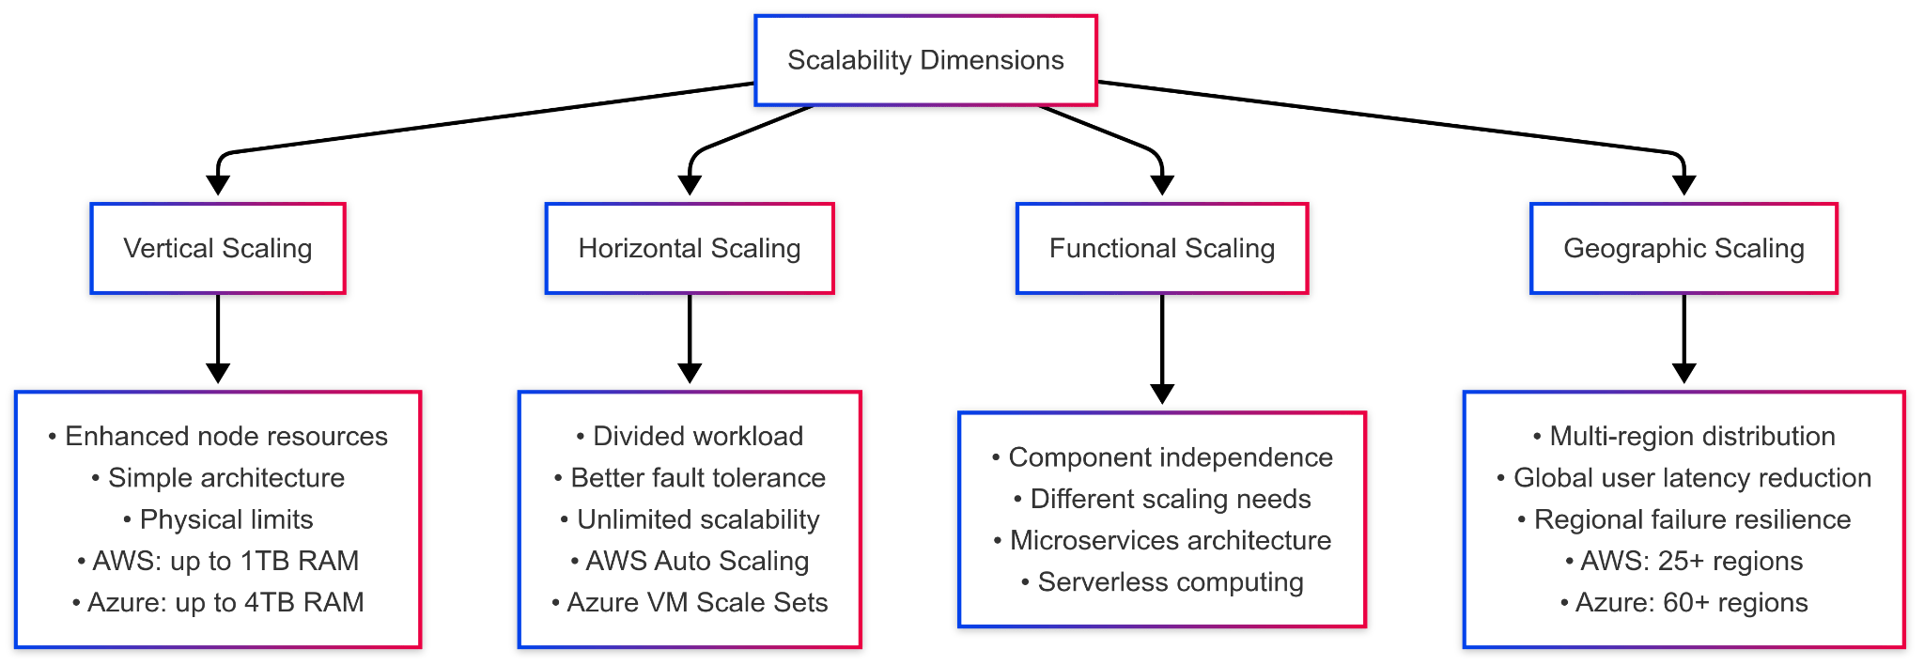

It is a mistake to treat scalability as a one-dimensional concept. There can be multiple axes along which systems can scale, each to address a different constraint and offer different benefits. Knowing these dimensions can help architects pick the right strategies for their particular needs.

**Vertical Scaling** (scaling up) implies enhancement of the resources of the nodes alone (e.g. CPU, memory, storage or network capacity). This approach preserves architectural simplicity but hits some physical limits. For example, there are also finite limits to the largest cloud instances, and the costs are generally non-linearly increasing with instance size.

AWS, instead, offers vertical scaling through its instance families, which include t4g instances all the way up to r6g instances, which are optimized for memory and can have up to 1TB of RAM. Like AWS, Azure also provides a range of options, starting from the budget Bs-series VMs and going up to the memory-intensive M-series instances that can have up to 4TB of memory. Vertical scaling is easy to implement, but it also entails downtime when resizing and does not enhance fault tolerance.

Horizontal Scaling or Scaling out, means dividing the workload among different nodes while in Vertical Scaling more computing power is added to a single node. The theoretical infinity of nodes makes it easier to handle failure and provides near unlimited scalability. Nevertheless, it has a major drawback in the form of increased complexity of workload balancing, state management and data integrity.

Both AWS and Azure excel at horizontal scaling. AWS Auto Scaling groups automatically adjust EC2 instance counts based on demand, while Azure Virtual Machine Scale Sets provide similar capabilities. Container orchestration platforms like AWS EKS and Azure Kubernetes Service further simplify horizontal scaling for containerized applications.

**Functional Scaling** decomposes systems along functional boundaries, allowing components to scale independently based on their specific demands. This approach acknowledges that different functions within a system often have different scaling requirements. For example, in an e-commerce platform, the product catalog might require high read scalability, while the checkout process demands transactional integrity over raw throughput.

Microservices architectures inherently support functional scaling by separating components that can then scale independently. AWS and Azure both support this approach through their container orchestration, serverless computing, and specialized database offerings.

**Geographic Scaling** distributes systems across multiple regions to reduce latency for geographically dispersed users and improve resilience against regional failures. This dimension introduces significant complexity in data replication, consistency, and regulatory compliance.

AWS operates 25+ regions globally, while Azure maintains a similar footprint with 60+ regions. Both providers offer services designed specifically for geographic distribution, including Amazon CloudFront and Azure Front Door for content delivery, and database services with cross-region replication capabilities.

Effective scalability strategies often combine these dimensions based on specific requirements. For instance, a system might use horizontal scaling for stateless web servers, vertical scaling for database instances within certain bounds, functional scaling to separate concerns with different growth patterns, and geographic scaling to serve a global user base.

### **Stateless Service Design**

Perhaps the most fundamental principle for scalable systems is the separation of stateless and stateful components. Stateless components—which don't maintain client-specific state between requests—can scale horizontally with minimal coordination overhead. Each request contains all information necessary to process it, allowing any available instance to handle the request.

This approach offers tremendous scaling advantages:

* Instances can be added or removed without complex state transfer
* Load balancers can distribute requests using simple algorithms like round-robin
* Failures impact only requests in flight rather than accumulated state
* Auto-scaling becomes straightforward to implement

Achieving truly stateless design requires careful attention to several aspects:

**Session Management**: Traditional server-side sessions create statefulness that complicates scaling. Alternatives include:

* Client-side sessions using encrypted cookies or local storage
* Centralized session stores using Redis or DynamoDB
* Token-based authentication (like JWT) that encapsulates session information

AWS ElastiCache and Azure Cache for Redis provide managed services for centralized session storage when client-side approaches aren't suitable.

**Configuration Management**: Application configuration should be externalized rather than embedded in service instances. Both AWS (Parameter Store, AppConfig) and Azure (App Configuration, Key Vault) provide dedicated services for managing configuration across distributed systems.

**Stateless Transactions**: Long-running processes should store intermediate state externally rather than in service memory. AWS Step Functions and Azure Logic Apps provide managed services for workflow orchestration with external state management.

Consider an e-commerce checkout process: a stateless design might generate a unique token for each cart, store cart contents in a distributed cache or database, and include the token in each request. Any service instance can process any step in the checkout flow by retrieving the current state using the token.

### **Database Scaling Strategies**

Databases often become the first scaling bottleneck in growing systems. Unlike stateless application tiers, databases inherently maintain state, complicating horizontal scaling. Several strategies address this challenge:

**Read Replicas** offload read operations to copies of the primary database. This approach works well for read-heavy workloads where some replication lag is acceptable. Both AWS (RDS Read Replicas) and Azure (SQL Database Read Replicas) support automatic replication and connection management for this pattern.

**Sharding** partitions data across multiple database instances based on a partition key. Each shard operates independently, containing a subset of the complete dataset. This approach increases both read and write capacity but introduces complexity in query patterns that span multiple shards.

AWS DynamoDB automatically manages sharding behind the scenes, abstracting the complexity from developers. Azure Cosmos DB similarly provides automatic sharding with configurable partition keys. For relational databases, both platforms offer guidance on implementing application-level sharding.

**Write-Through Caching** accelerates read performance by storing frequently accessed data in memory. When data changes, the cache is updated along with the persistent store. AWS ElastiCache and Azure Cache for Redis provide managed in-memory caching with various eviction policies and persistence options.

**Command Query Responsibility Segregation (CQRS)** separates read and write models, allowing each to scale independently. Write operations use a model optimized for consistency and integrity, while read operations use denormalized views optimized for query performance.

Implementing CQRS in AWS might leverage DynamoDB for the write model with DynamoDB Streams triggering Lambda functions to update ElasticSearch for the read model. In Azure, Cosmos DB can serve as the write store with change feed processors updating Azure Search for optimized read access.

**NoSQL Approaches** often offer better horizontal scaling characteristics than traditional relational databases, though usually with different consistency guarantees. Document databases (AWS DocumentDB, Azure Cosmos DB), key-value stores (DynamoDB, Azure Table Storage), and graph databases (Amazon Neptune, Azure Cosmos DB Graph API) provide specialized models that can scale more effectively for specific use cases.

The optimal database scaling strategy depends on workload characteristics and consistency requirements. Systems with high write volumes, complex transactions, and strong consistency needs face more scaling challenges than those with simpler data models or relaxed consistency requirements.

### **Caching Patterns and Implementations**

Caching significantly improves scalability by reducing the load on backend systems and decreasing response times. Effective caching strategies require careful consideration of data characteristics, update patterns, and consistency requirements.

**Cache Placement** options include:

* **Client-side caching**: Browsers or application clients store responses locally
* **CDN caching**: Edge networks cache content close to users
* **Gateway caching**: API gateways or reverse proxies cache responses
* **Application caching**: Services maintain in-memory or shared caches
* **Database caching**: Database systems cache query results and data pages

Most scalable systems employ multiple caching layers with different characteristics. AWS CloudFront and Azure CDN provide edge caching for static content, while ElastiCache and Azure Cache for Redis support application-level caching.

**Cache Invalidation** strategies determine when and how cached data is refreshed:

* **Time-based expiration**: Cache entries become invalid after a specified duration
* **Event-based invalidation**: Updates to underlying data trigger cache invalidation
* **Version-based invalidation**: Resources include version identifiers that change when content changes

Effective invalidation balances freshness against performance. Too-aggressive invalidation negates caching benefits, while too-conservative policies serve stale data.

**Caching Challenges** include:

* **Cache coherence**: Ensuring multiple cache instances maintain consistent views
* **Thundering herd**: Preventing simultaneous cache rebuilds when entries expire
* **Cache penetration**: Protecting against requests designed to bypass caching
* **Cold start performance**: Managing performance before caches warm up

AWS and Azure caching services provide features to address these challenges, including cluster management for Redis, TTL controls, and integration with eventing systems for invalidation.

**Content Delivery Networks** (CDNs) represent a specialized form of caching focused on static content. By distributing content to edge locations close to users, CDNs dramatically reduce latency and backbone traffic. Both AWS CloudFront and Azure Front Door with CDN provide global edge networks with features like SSL termination, compression, and DDoS protection in addition to basic caching.

### 

### **Auto-scaling Policies and Best Practices**

Automated scaling—adjusting capacity based on actual demand—stands as a foundational capability for cloud-native systems. Effective auto-scaling requires careful policy design based on workload characteristics and business requirements.

**Scaling Metrics** define the signals that trigger scaling actions:

* **Resource-based metrics**: CPU utilization, memory usage, disk I/O
* **Queue-based metrics**: Message backlog, processing latency
* **Custom application metrics**: Concurrent users, business transaction rates
* **Scheduled scaling**: Predictable patterns based on time of day or calendar events

Resource-based metrics provide a straightforward starting point, but application-specific metrics often reflect user experience more accurately. AWS CloudWatch and Azure Monitor collect, aggregate, and alert on these metrics, triggering scaling actions when thresholds are crossed.

**Scaling Policies** define how systems respond to metric changes:

* **Target tracking**: Maintain a target value for a specified metric
* **Step scaling**: Apply different scaling actions based on metric magnitude
* **Scheduled scaling**: Proactively adjust capacity for known demand patterns
* **Predictive scaling**: Use machine learning to anticipate capacity needs

AWS Auto Scaling supports all these policy types for EC2 instances, while Azure Autoscale provides similar capabilities for VMs, App Services, and other resources.

**Scaling Considerations** include:

* **Warm-up periods**: New instances need time to initialize before handling full load
* **Cool-down periods**: Preventing oscillation by waiting between scaling actions
* **Scale-in protection**: Preventing removal of instances handling active work
* **Minimum and maximum bounds: Setting guardrails for capacity limits**
* **Instance distribution: Maintaining availability across failure domains**

These considerations have specific controls through auto-scaling features provided by AWS and Azure.

Auto-scaling Beyond Compute extends to other resource types:

* **Database capacity:** Aurora Serverless (AWS) and SQL Database Serverless (Azure)
* **Provisioned throughput:** DynamoDB Auto Scaling and Cosmos DB Autoscale
* **Event processing:** Kinesis/Lambda in AWS and Event Hubs/Functions in Azure

Cloud-native architectures of today scale their systems throughout every layer of the technology stack instead of only the computing resources.

Load Testing and Performance Optimization

Scalable system development needs knowledge about performance behavior under different loading conditions. Load testing replicates real user traffic to detect operational issues before they reach production users.

The testing methods included in Load Testing Approaches consist of:

* **Steady-state testing:** Consistent load to establish baseline performance
* **Step-load testing:** Incremental increases to identify breaking points
* **Spike testing:** Sudden traffic increases to test recovery capabilities
* **Soak testing:** Long-duration tests are conducted to detect memory-related issues or resource depletion problems.
* **Chaos testing:** Introducing failures while under load to test resilience

**AWS Fargate Distributed Load Testing** is available on AWS but Azure Load Testing is an alternative option. Open-source tools such as Locust, JMeter and Gatling serve as additional testing tools for specific cases.

The identification of performance bottlenecks requires following a systematic methodology.

* Establish baseline metrics across all system components
* Apply controlled load increases while monitoring all metrics
* Identify components showing non-linear resource usage or response time degradation
* Apply targeted optimization to bottlenecks
* Repeat testing to validate improvements

The distributed tracing capabilities of AWS X-Ray and Azure Application Insights help organizations identify latency sources across service boundaries especially in microservices environments.

Common Scalability Bottlenecks include:

* **Database connection pools:** Limited connections causing queuing or failures
* **Thread pool exhaustion:** Insufficient threads to handle concurrent requests
* **Synchronous dependencies:** Services waiting for downstream responses
* **Lock contention:** Processes competing for shared resources
* **Inefficient queries:** Database operations consuming excessive resources

The solution to these bottlenecks requires combining architectural adjustments with system configuration adjustments and code improvements.

**Performance Optimization Strategies span multiple levels:**

* **Code-level optimization:** Algorithmic improvements, caching results, async operations
* **Configuration tuning:** Adjusting thread pools, connection limits, timeout values
* **Resource allocation:** Matching instance types to workload characteristics
* **Architectural changes:** Introducing caching layers, message queues, or read replicas

The performance best practices for AWS services and Azure services are documented in extensive detail with reference architectures that work for particular workload requirements.

### **Cost Optimization Strategies**

The implementation of effective scaling strategies requires organizations to maintain a balance between performance levels and resource expenses when dealing with changing demand patterns

This requires adequate right sizing wherein organizations choose suitable resource types and sizes which match the characteristics of their workload. The cloud platforms AWS and Azure provide different instance families which match specific workload requirements including compute-optimized for processing applications and memory-optimized for caching and in-memory databases and storage-optimized for data warehousing and general-purpose for balanced workloads.

Tools like AWS Compute Optimizer and Azure Advisor analyze actual usage patterns and recommend more cost-effective resource configurations.

**Spot/Low-priority Instances** leverage unused capacity at significantly reduced prices (often 70-90% less than on-demand rates). These instances work well for fault-tolerant, interruptible workloads like batch processing, rendering, or testing environments.

AWS Spot Instances and Azure Spot VMs provide interfaces for requesting and managing these discounted resources, with services like AWS Batch and Azure Batch handling the complexity of job scheduling on interruptible instances.

**Serverless Architectures** align costs directly with actual usage rather than provisioned capacity. Services like AWS Lambda and Azure Functions charge based on execution time and memory usage, with no costs during idle periods. This model works particularly well for variable or unpredictable workloads where maintaining constant capacity would mean paying for unused resources.

**Storage Tiering** applies cost optimization to data management. Both AWS and Azure offer storage classes with different performance characteristics and price points:

* Hot storage for frequently accessed data
* Cool/Infrequent Access storage for less frequently accessed data
* Archive storage for rarely accessed data with retrieval delays

Automated lifecycle policies can move data between tiers based on age or access patterns, optimizing costs without manual intervention.

**Reserved Capacity** offers discounted rates in exchange for longer-term commitments. For predictable baseline workloads, reserved instances or reserved capacity can reduce costs by 40-75% compared to on-demand pricing.

AWS offers Reserved Instances and Savings Plans with 1 or 3-year terms, while Azure provides Reserved VM Instances with similar terms. Both platforms allow reservations to be applied to qualifying usage regardless of the specific instances running.

Effective cost optimization combines these strategies based on workload characteristics:

* Baseline load handled by reserved capacity
* Predictable variations managed with on-demand instances
* Unpredictable spikes addressed with spot/low-priority instances or serverless functions

### **Scalability in Practice: Case Studies**

Theoretical approaches to scalability provide valuable guidance, but real-world implementations often reveal unexpected challenges and solutions. Let's examine patterns from successful scalable systems.

**E-commerce Platform Scaling**

A typical e-commerce platform combines various scaling requirements: product catalog browsing demands high read throughput, while checkout processes require transactional integrity. Inventory updates create write-heavy workloads, and personalization requires complex data processing.

A cloud-native implementation might employ:

* CloudFront/Azure CDN for static content caching
* Distributed session management through ElastiCache/Azure Cache
* Product catalog in a search service (ElasticSearch/Azure Search) updated asynchronously
* Inventory and order processing through CQRS patterns with transactional write stores
* Autoscaling application tiers based on traffic patterns
* Reserved instances for baseline capacity with on-demand for seasonal peaks

**Media Streaming Service**

Media services face unique challenges with large file transfers, high bandwidth requirements, and global user distribution. Video transcoding creates compute-intensive batch workloads, while recommendation systems analyze vast usage data.

Cloud-native implementations typically include:

* Multi-region content distribution through CDN edge networks
* Origin shields to prevent thundering herd problems on content servers
* Adaptive bitrate streaming with client-side quality adjustment
* Serverless architectures for viewer authentication and personalization
* Spot instances for background video transcoding
* Time-shifted regional capacity to leverage global usage patterns

**Financial Transaction Processing**

Financial systems combine extreme reliability requirements with variable transaction volumes and stringent security controls. Peak processing periods (like trading hours or payment deadlines) create predictable but intense demand spikes.

Scalable financial systems often incorporate:

* Queuing systems to smooth processing spikes without data loss
* Multi-tier caching to reduce database load while maintaining data integrity
* Read replicas for reporting queries separate from transaction processing
* Geographic distribution constrained by regulatory boundaries
* Horizontal scaling for stateless processing layers
* Vertical scaling for database systems within availability zones

### **Conclusion: Towards Scalable System Design**

Building scalability into distributed systems requires considering scaling dimensions, stateless service design, database scaling strategies, caching patterns, auto-scaling policies, and cost optimization approaches. By addressing these aspects early in the design process, architects can create systems that grow gracefully with demand.

The most effective scaling strategies combine multiple approaches based on specific workload characteristics and business requirements. Rather than seeking a single scaling solution, successful architects leverage the diverse capabilities of modern cloud platforms to address different scaling challenges with appropriate tools.

Both AWS and Azure provide rich ecosystems of services designed to address scaling challenges at every layer of the application stack. By understanding the underlying principles of scalable system design, architects can effectively leverage these services to build systems that maintain performance and reliability even as demand grows.

In the next chapter, we'll explore reliability engineering—ensuring that systems not only scale to handle increased load but remain available and correct even in the face of inevitable failures.

## **Chapter 4: Reliability Engineering**

In previous chapters, we looked at distributed system foundations, cloud-native architectural patterns, and scaling strategies. These characteristics allow systems to control increasing load; they do not ensure that systems will remain accessible and functional when inevitable errors emerge. This chapter focuses on dependability engineering, the discipline of designing, developing, and running as expected even under demanding conditions.

Reliability is among the most challenging aspects of distributed systems. Unlike monolithic systems whereby elements normally fail together, distributed systems suffer partial failures whereby some components stay operational while others fail. This intricacy demands meticulous answers to both prevent errors at least theoretically and gracefully handle them when they do occur.

### **SLOs, SLAs, and Error Budgets**

Reliability begins with clear, measurable objectives. Three related concepts provide the foundation for reliability engineering:

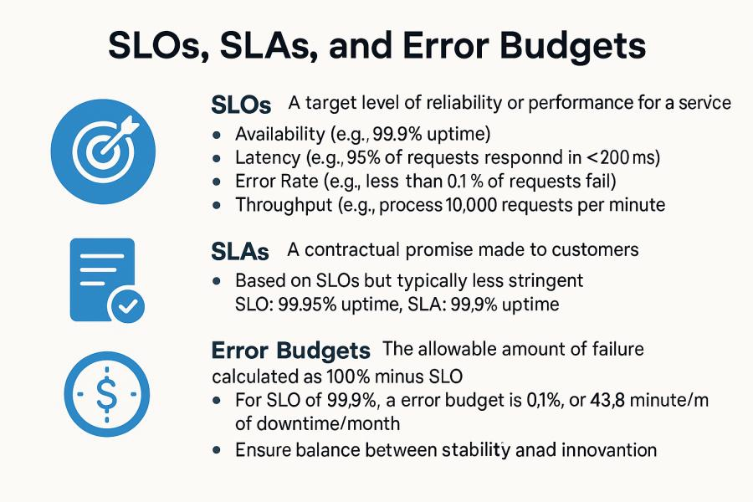

**Service Level Objectives (SLOs)** define the target level of reliability for a service, expressed in measurable terms. Common SLO metrics include:

* Availability (percentage of time the service is operational)
* Latency (response time for requests, often expressed as percentiles)
* Throughput (requests successfully processed per time unit)
* Error rate (percentage of requests that fail)

Well-crafted SLOs strike a balance between implementation expenses and user expectations. For instance, usually incurring significant additional complexity and cost is boosting availability from 99.9% to 99.99% (reducing downtime from 8.8 hours to 53 minutes annually).

**Service Level Agreements (SLAs)** represent contractual commitments to customers regarding service reliability, often including financial penalties for violations. Usually offering smaller assurances than internal SLOs, SLAs give safety buffers. A service might, for example, have a 99.95% availability SLO yet provide a 99.9% availability SLA to consumers.

From 99.99% for critical infrastructure like DNS to 99.9% for more sophisticated services, AWS and Azure both offer SLAs for their offerings. These SLAs guide architectural decisions; when you build on these platforms, the dependability of your system cannot surpass that of its underlying components.

**Error Budgets** quantify the allowable deviation from perfect reliability. If your availability SLO is 99.9%, your error budget is 0.1% of total service time (about 43.8 minutes per month). The fund exists to cover both planned events such as outages and deployments and unexpected actions.

Error budgets enable teams to manage velocity and stability by transforming dependability from a simple yes/no quality into a measurable ongoing metric. Teams should focus on new features and experimental changes when error budgets indicate available capacity. Budget depletion causes attention on dependability enhancements to take the stage.

Usually using CloudWatch metrics and alerts for measurement, using these ideas in AWS systems combines with custom dashboards to monitor SLO compliance. Through Azure Monitor metrics, Log Analytics, and Application Insights Azure offers comparable features.

### **Chaos Engineering Methodologies**

Conventional testing assures us that systems operate as intended. Complementally, chaos engineering proactively tests system behavior under unanticipated circumstances. Originally developed by Netflix with its Chaos Monkey tool, this approach purposefully generates errors to confirm systems react correctly.

Chaos engineering follows a structured approach:

1. Specify the "steady state" that stands for typical system operation.
2. Assume this condition will last through disturbances.
3. Add variables mirroring occurrences from the actual world (server faults, network problems).
4. Look for variations from the steady state.
5. Strengthen the system to solve found flaws.

This method starts with precisely limited blast radius controlled trials in testing contexts then progressively moves to manufacturing situations.

Common chaos experiments include:

* Terminating compute instances to verify auto-recovery
* Introducing network latency or packet loss between services
* Simulating dependent service failures
* Degrading CPU or memory performance to test graceful degradation
* Exhausting disk space or file descriptors

AWS provides several tools to support chaos engineering. AWS Fault Injection Simulator offers a managed service for running controlled fault injection experiments, while AWS Resilience Hub helps identify resilience weaknesses before testing. For custom requirements, Lambda functions can implement specific failure scenarios.

Azure offers similar capabilities through Azure Chaos Studio, which provides controlled fault injection across Azure resources. This service integrates with Azure Monitor to correlate experiments with observed impacts.

Effective chaos engineering requires organizational maturity and a strong monitoring foundation. Without comprehensive observability, it becomes difficult to distinguish between expected experiment impacts and unexpected system failures.

### **Failure Modes and Recovery Strategies**

Distributed systems exhibit complex failure modes that don't occur in monolithic applications. Understanding these patterns helps architects design appropriate recovery mechanisms.

**Transient Failures** occur when components temporarily become unavailable due to factors like network glitches, resource exhaustion, or brief service disruptions. These failures typically resolve automatically after short durations.

Recovery strategy: Retry mechanisms with exponential backoff and jitter help manage transient failures. AWS SDK clients implement these patterns automatically for many services, while Azure provides similar retry handling in its client libraries. For custom implementations, libraries like AWS Retry Throttling Java Client or Polly for .NET provide configurable retry policies.

**Dependency Failures** happen when a system component depends on another service that becomes unavailable or unresponsive. These failures can cascade through a system if not properly contained.

Recovery strategy: Circuit breakers prevent cascade failures by "failing fast" when dependencies become unhealthy. After certain failure thresholds, the circuit opens and immediately rejects requests rather than allowing them to time out. AWS doesn't provide native circuit breaker implementations, though API Gateway throttling offers similar capabilities. Azure API Management provides built-in circuit breaker policies, and both platforms support application-level circuit breakers through libraries like Hystrix or Resilience4j.

**Data Inconsistency** occurs in distributed systems when update operations succeed on some nodes but fail on others, leaving the system in an inconsistent state.

Recovery strategy: Compensating transactions restore consistency by reversing partial updates. AWS Step Functions and Azure Logic Apps support orchestrating these compensation workflows. For eventually consistent systems, conflict resolution policies determine which version prevails—AWS DynamoDB and Azure Cosmos DB both provide configurable conflict resolution strategies for multi-region deployments.

**Capacity Exhaustion** happens when systems receive more requests than they can process, leading to degraded performance or complete unavailability.

Recovery strategy: Load shedding selectively drops lower-priority requests during overload, while rate limiting prevents any single client from consuming excessive resources. AWS API Gateway, CloudFront, and WAF provide rate limiting capabilities, as do Azure API Management, Application Gateway, and Front Door.

**Zone and Regional Failures** affect all resources within a specific availability zone or geographic region due to power issues, networking problems, or natural disasters.

**Recovery strategy:** Multi-zone and multi-region deployments distribute systems across failure domains. AWS recommends deploying across at least three availability zones within a region for zone-resilient architectures, while Azure similarly recommends multi-zone deployments using Availability Zones. For regional resilience, both platforms support active-active or active-passive multi-region architectures with appropriate data replication.

### **Designing for Graceful Degradation**

Perfect reliability is unattainable in complex distributed systems. Recognizing this reality, effective reliability engineering designs systems to degrade gracefully under adverse conditions rather than failing completely.

Graceful degradation preserves core functionality while potentially sacrificing non-critical features during partial failures. This approach maintains acceptable user experiences even when some components are unavailable.

**Feature Prioritization** categorizes functionality based on business impact:

* **Critical functions** must remain available even during significant disruptions
* **Important functions** should remain available during most disruptions
* **Non-critical functions** can be disabled during adverse conditions

For example, an e-commerce platform might consider product browsing and checkout as critical, personalized recommendations as important, and review submission as non-critical.

**Service Decomposition** with reliability boundaries isolates components based on criticality. Less reliable dependencies should never be in the critical path of more reliable services. Both AWS and Azure support this pattern through service segregation, with critical components potentially deployed across multiple regions while less critical components might use single-region deployments.

**Fallback Mechanisms** provide alternative behavior when preferred options fail:

* **Static fallbacks** return pre-computed or cached responses when dynamic generation fails
* **Reduced functionality fallbacks** offer simplified alternatives to normal operations
* **Degraded experience fallbacks** maintain core functionality with reduced performance or features

AWS enables fallback implementations through Lambda destination configuration for error handling, Step Functions error paths, and CloudFront origin failover. Azure provides comparable capabilities through Azure Functions, Logic Apps, and Front Door failover configuration.

**Operational Toggles** (feature flags) allow runtime control of system behavior:

* **Circuit breakers** automatically disable features based on error rates
* **Kill switches** manually disable problematic features during incidents
* **Throttling controls** adjust allowed throughput based on system health

Both AWS AppConfig and Azure App Configuration support feature flag management, with integration into respective monitoring systems for automated control.

An effective implementation of graceful degradation might include:

1. Clear identification of critical vs. non-critical features
2. Automated detection of adverse conditions through monitoring
3. Configurable thresholds for activating degraded modes
4. Isolated failure domains to contain impact
5. Regular testing of degraded modes to ensure they function as expected

### **Multi-region Deployments**

Geographic distribution represents one of the most powerful reliability strategies for cloud-native systems. By deploying across multiple regions, systems can withstand even large-scale disruptions affecting entire cloud provider regions.

Several multi-region patterns offer different reliability/complexity tradeoffs:

**Active-Passive** deployments maintain primary infrastructure in one region with standby capacity in another region. During normal operations, all traffic routes to the active region. When failures occur, DNS or global load balancers redirect traffic to the passive region after failover procedures complete.

This approach minimizes costs but introduces potential recovery time during failovers. Both AWS (using Route 53 DNS failover or Global Accelerator) and Azure (using Traffic Manager or Front Door) support active-passive architectures with health-based routing.

**Active-Active** deployments serve traffic from multiple regions simultaneously. Each region maintains complete application stacks and sufficient capacity to handle at least critical traffic if other regions fail.

This approach eliminates failover delays but increases operational complexity, particularly around data consistency. AWS supports active-active architectures through global services like DynamoDB Global Tables, Aurora Global Database, and CloudFront. Azure provides similar capabilities through Cosmos DB multi-region writes, Azure SQL Database auto-failover groups, and Front Door.

**Data Replication Strategies** represent the most challenging aspect of multi-region deployments:

* **Synchronous replication** ensures consistent data across regions but increases latency and reduces availability during network disruptions
* **Asynchronous replication** offers better performance and availability at the cost of potential data loss during failures
* **Multi-master replication** allows writes to any region but introduces complex conflict resolution requirements

Both AWS and Azure provide various replication options with different consistency/performance tradeoffs. DynamoDB Global Tables and Cosmos DB both support multi-master replication with configurable conflict resolution, while Aurora Global Database and SQL Database auto-failover groups implement asynchronous replication with controlled failover.

**Global Traffic Management** directs users to appropriate regions based on availability, performance, or business rules:

* **DNS-based routing** (AWS Route 53, Azure Traffic Manager) offers simplicity but faces limitations from DNS caching and propagation delays
* **Anycast-based routing** (AWS Global Accelerator, Azure Front Door) provides faster failover and connection maintenance during routing changes
* **Application-level routing** implements custom logic within the application to direct traffic based on complex criteria

Effective multi-region deployments also require:

* **Independent monitoring** that continues functioning even when regions fail
* **Automated or semi-automated failover** procedures to minimize recovery time
* **Regular testing** of region failover to ensure procedures work as expected
* **Regional isolation** to prevent cascading failures across regions

### **Observability and Incident Response**

Even with comprehensive reliability engineering, incidents will occur. Effective observability and incident response processes minimize both the duration and impact of these events.

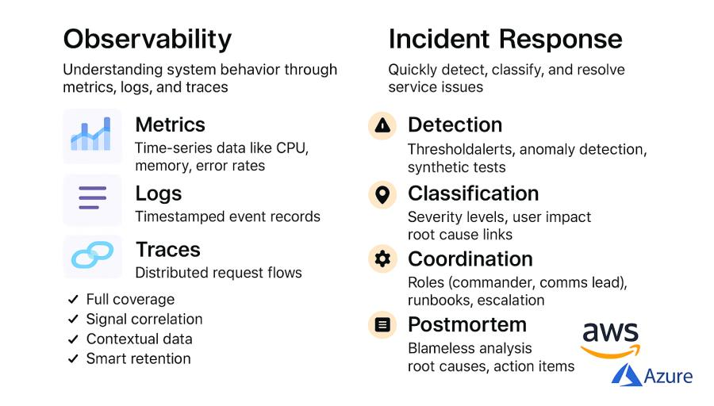

Observability goes beyond basic monitoring to provide deep insights into system behavior through three primary signals:

* **Metrics**: Numerical measurements of system behavior over time
* **Logs**: Detailed records of discrete events within the system
* **Traces**: Information about request flows across distributed components

AWS provides these capabilities through CloudWatch Metrics, CloudWatch Logs, and X-Ray respectively. Azure offers similar functionality through Azure Monitor Metrics, Log Analytics, and Application Insights distributed tracing.

Effective observability implementations share several characteristics:

* **Comprehensive coverage** across all system components
* **Correlation** between different signal types
* **Contextual enrichment** with business-relevant attributes
* **Appropriate retention** balancing troubleshooting needs against costs
* **Actionable alerting** that identifies genuine issues requiring intervention

Incident response processes translate observability insights into effective resolution:

**Incident Detection** identifies potential issues through:

* **Threshold-based alerting** that triggers on metric deviations
* **Anomaly detection** that identifies unusual patterns without predefined thresholds
* **Synthetic monitoring** that simulates user interactions to detect issues before users report them

Both AWS (CloudWatch Anomaly Detection, CloudWatch Synthetics) and Azure (Azure Monitor Smart Detection, Application Insights Availability Tests) provide these capabilities as managed services.

**Incident Classification** prioritizes response based on impact:

* **Severity levels** indicate business impact and urgency
* **User impact assessment** quantifies affected customers or transactions
* **Service health correlation** connects incidents to potential root causes

**Incident Coordination** ensures efficient resolution through:

* **Defined roles and responsibilities** (incident commander, communications lead)
* **Established communication channels** for responders
* **Runbooks** for common scenarios
* **Escalation paths** for particularly complex or severe incidents

**Post-Incident Analysis** drives continuous improvement through:

* **Blameless postmortems** that focus on process improvements rather than individual mistakes
* **Systematic identification** of contributing factors
* **Action items** to prevent similar incidents
* **Knowledge sharing** across the organization

AWS provides incident management tools through Systems Manager Incident Manager, while Azure offers similar capabilities through Azure Service Health.

### **Automated Recovery and Self-Healing Systems**

The ultimate expression of reliability engineering is creating systems that automatically detect and recover from failures without human intervention. While not achievable for all failure modes, automated recovery significantly reduces mean time to recovery (MTTR) for many common scenarios.

**Health Checking and Auto-Recovery** verifies component health and replaces unhealthy resources:

* EC2 Auto-Recovery and Azure VM auto-restart replace failed virtual machines
* Auto Scaling health checks remove unhealthy instances from service
* Kubernetes liveness/readiness probes restart failing containers
* AWS Route 53 and Azure Traffic Manager health checks redirect traffic from unhealthy endpoints

**State Recovery** mechanisms restore proper functioning after transient issues:

* Database point-in-time recovery restores to known-good states
* Event sourcing rebuilds state from event logs
* Snapshot-based recovery restores from periodic backups
* Distributed caches rebuild from primary data sources

**Self-Optimization** adjusts configurations based on observed conditions:

* AWS Auto Scaling with predictive scaling anticipates capacity needs
* DynamoDB adaptive capacity automatically adjusts for partition hotspots
* Aurora Serverless and Azure SQL Serverless adjust capacity based on workload

Designing for automated recovery requires:

* **Clear health indicators** that reliably distinguish between healthy and unhealthy states
* **Idempotent operations** that can be safely retried without unintended side effects
* **State externalization** that allows processes to be restarted without data loss
* **Defensive implementation** that anticipates and handles unexpected conditions

### **Conclusion: Building a Reliability Culture**

Reliability engineering encompasses both technical practices and organizational culture. The most sophisticated recovery mechanisms will fail without organizational commitment to reliability principles.

Key elements of reliability culture include:

* **Shared ownership** of reliability across development and operations
* **Realistic reliability targets** based on business requirements rather than arbitrary numbers
* **Balanced investment** between new features and reliability improvements
* **Learning orientation** that treats incidents as opportunities for improvement
* **Regular practice** through chaos engineering and disaster recovery drills

Both AWS and Azure provide architectural guidance for reliability through their respective Well-Architected Frameworks. These resources offer structured approaches to evaluating and improving system reliability based on cloud provider best practices.

Conclusion

In the next chapter, we'll explore security in distributed environments—ensuring that our reliable, scalable systems also protect data integrity, confidentiality, and availability against increasingly sophisticated threats.

## **Chapter 5: Security in Distributed Environments**

System design requires security as an essential element but distributed architectures present challenges that standard security methods find difficult to handle. The expanded attack surface and complex trust boundaries along with fluid properties of cloud-native systems require fundamental changes to security mechanisms. This chapter examines security approaches made for distributed systems while focusing on their deployment within AWS and Azure environments.

### **Zero Trust Architecture Implementation**

Operating on a "castle-and- moat" concept, traditional security approaches built robust perimeter fortifications around trusted inside systems. This approach has become increasingly inadequate as organizations adopt cloud services, support remote work, and implement microservices architectures that blur traditional network boundaries.

Zero Trust architecture functions as a strategic approach which removes all trust from networks, devices and users with the system operating under the "never trust, always verify" guiding concept. This requires authentication and authorization, whenever any attempts need to be made . This design minimizes attacking chances by hackers/bad actors.

Key principles of Zero Trust include:

**Identity-based Access Control** establishes identity as the main security boundary for both human and service entities. There needs to have a consistent strong authentication and particular authorization regardless of the requester's network position.

Using IAM, AWS uses identity-based access; fine-grained restrictions underlie access to certain resources and actions. Azure similarly manages identities and permissions using Azure Active Directory and Role-Based Access Control (RBAC). For consistent identity management, both systems offer federation including outside identity providers.

**Least Privilege Access** grants the minimum permissions necessary to perform required functions, reducing the potential impact of compromised credentials. This principle applies to both human users and service accounts.

Through VPC security groups, network ACLs, and PrivateLink for service-to--service communication, AWS uses micro-segmentation. Through Private Link, Application Security Groups, and Network Security Groups Azure offers comparable features. Both systems offer service mesh solutions (AWS App Mesh, Azure Service Mesh) with mutual TLS between services extending segmentation to the application level.

**Micro-segmentation** divides networks into secure zones with separate access requirements, containing breaches to limited segments rather than exposing the entire network. In dispersed systems where conventional network perimeters blur, this method is very crucial.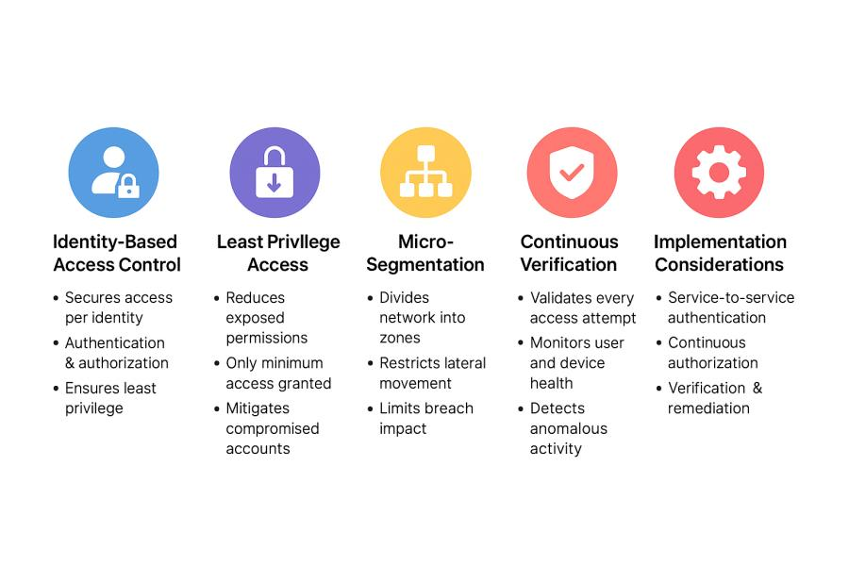

AWS implements micro-segmentation through VPC security groups, network ACLs, and PrivateLink for service-to-service communication. Through Network Security Groups, Application Security Groups, and Private Link Azure offers comparable capabilities. Both systems provide service mesh implementations—AWS App Mesh, Azure Service Mesh—which extend segmentation to the application level and enable mutual TLS across services.

**Continuous Verification** treats every access request as potentially malicious, regardless of previous authentication. Unlike one-time authentication, this method calls for constant monitoring and validation.

AWS provides continuous verification through GuardDuty for threat detection, CloudTrail for auditing, and IAM Access Analyzer for permission validation. Azure offers Azure Sentinel for security information and event management (SIEM), Microsoft Defender for Cloud for threat protection, and Azure Resource Graph for security posture assessment.

Implementing Zero Trust in distributed environments requires careful consideration of several key aspects:

**Service-to-Service Authentication** ensures secure communication between microservices or distributed components. Both AWS and Azure support multiple approaches:

* **Bidirectional authentication** between communicating services is offered by HTTPS with mutual TLS.
* **Token-based authentication** using JWTs or similar mechanisms verifies service identity
* **IAM roles/Managed Identities** for services provide authenticated access to platform resources

**Continuous Authorization** evaluates not just identity but also context when granting access:

* Device compliance status and general condition
* Location and network facts
* Dates and time restrictions
* The sought resource's sensitivity

AWS supports contextual authorization through IAM condition elements, while Azure provides similar capabilities through Conditional Access policies in Azure AD.

**Verification and Remediation** constantly validates security posture:

* AWS Security Hub and Azure Security Center provide centralized security monitoring
* AWS Config and Azure Policy assess resource compliance against security standards
* Automated remediation workflows correct detected security issues

### **Secrets Management Across Distributed Systems**

Distributed systems call for several secrets—API keys, database credentials, encryption keys, certificates—separated across several components. Securing these secrets is quite difficult, especially in dynamic surroundings where events could be generated and deleted automatically.

Effective secrets management addresses several key requirements:

Secure Storage protects secrets at rest with strong encryption. Ad-hoc approaches like hardcoded credentials, config files, or environment variables create significant security risks through accidental exposure or insufficient protection.

AWS Secrets Manager and Azure Key Vault provide specific tools for safe secret storage with fine-grained access restrictions, encryption, and auditing. Both services engage with their own identity systems—IAM roles, Managed Identities—to provide access.

**Automated Distribution** holds secrets for approved services free from human involvement. In auto-scaling systems, where new instances must have quick access to needed secrets, this functionality is very crucial.

AWS provides automated secret distribution through integration between Secrets Manager and services like Lambda, ECS, and EC2 Instance Profiles. Azure similarly distributes secrets through Key Vault integration with services like App Service, Functions, and AKS.

**Regular rotation and versioning** refreshes secrets to reduce possible exposure's effects. Because of operational complexity, manual rotation sometimes results in skipped rotations or disturbance of services.

To allow elegant transitions, both Azure Key Vault and AWS Secrets Manager feature automated secret rotation with version tracking.AWS provides built-in rotation functions for RDS credentials, while Azure offers similar capabilities for SQL Database. Both platforms support custom rotation functions for application-specific secrets.

**Audit and Monitoring** tracks all secret access to detect potential misuse or unauthorized access attempts.

While Azure Monitor records similarly for Key Vault activities, AWS CloudTrail records all API interactions with Secrets Manager. For connection with additional security signals, both systems interface with their own SIEM solutions—Security Hub, Sentinel.

Implementing effective secrets management in distributed systems requires attention to several key patterns:

**Instance Identity** provides a secure foundation for initial secret access. Rather than bootstrapping instances with credentials, both AWS (IAM roles for EC2/ECS/Lambda) and Azure (Managed Identities) provide crypto-verified identities that services can use to request specific secrets.

**Dynamic Secrets** generate temporary, unique credentials for each service instance rather than sharing long-lived credentials. This approach limits exposure and simplifies revocation. Both AWS and Azure provide capabilities for dynamic credential generation for their respective database services.

Unlike continuous access, **just-in- time access** allows concealed access only when absolutely necessary. Through their connection with IAM and Azure AD respectively, Azure Key Vault and AWS Secrets Manager both offer temporary access grants.

### **Authentication and Authorization Patterns**

Distributed systems require robust authentication and authorization mechanisms that work across service boundaries while maintaining security and performance.

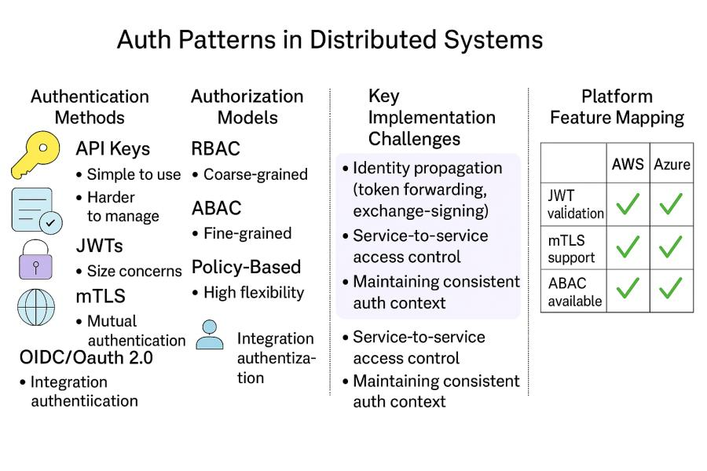

**Authentication Approaches** for distributed systems include:

Though they lack detailed permissions and must be carefully rotated, **API keys** provide basic identity for service-to-service communication. For external-facing APIs, both Azure API Management and AWS API Gateway enable API key authentication.

**Bearer Tokens** (typically JWTs) contain signed claims about identity and permissions. These tokens enable stateless authentication without requiring token validation services to maintain session state. Both AWS AppSync and Azure API Management support JWT validation for API authentication.

**Mutual TLS** (mTLS) provides bidirectional authentication where both client and server verify each other's identities through certificates. This approach works well for internal service-to-service communication. AWS App Mesh and Azure API Management both support mTLS for service authentication.

**OIDC/OAuth 2.0** provides standardized authentication and authorization flows between services. AWS Cognito and Azure AD B2C both implement OIDC/OAuth for customer-facing applications, while Azure AD supports these standards for internal applications.

**Authorization Mechanisms** determine what authenticated identities can access:

**Role-Based Access Control (RBAC)** assigns permissions to roles which are then granted to identities. This approach simplifies permission management for large user bases. Both AWS IAM and Azure RBAC implement role-based access models.

**Attribute-Based Access Control (ABAC)** makes access decisions based on attributes of the requesting identity, the resource being accessed, the action requested, and environmental conditions. This approach offers more flexibility than RBAC but increases complexity. AWS IAM supports ABAC through tag-based access control, while Azure implements similar capabilities through Azure AD Conditional Access.

**Policy-Based Access Control** centralizes authorization decisions through policy evaluation services. This approach ensures consistent access control across distributed components. AWS uses this approach through IAM Policy Evaluation, while Azure implements it through Azure Policy.

Implementing effective authentication and authorization in distributed systems requires addressing several challenges:

**Propagating Identity** across service boundaries ensures consistent authorization decisions throughout request processing. Techniques include:

* **Token forwarding** where incoming identity tokens are passed to downstream services
* **Token exchange** where edge services exchange external tokens for internal service tokens
* **Request signing** where services cryptographically sign requests to downstream services

**Service-to-Service Authorization** controls what services can communicate with each other. Based on service identity, both AWS (by means of IAM policies) and Azure (by means of Managed Identities and RBAC) offer means to grant service-level authorization.

**Consistent Authentication Contexts** ensure that authorization decisions account for all relevant information regardless of which service performs the check. In microservices systems where authentication may take place at the periphery but permission choices happen inside specific services, this consistency becomes more crucial.

### **Network Security for Distributed Workloads**

While Zero Trust architecture reduces dependence on network-level security, network controls remain an important defense layer in distributed systems. Cloud-native networking provides sophisticated capabilities that extend beyond traditional perimeter defenses.

**Network Segmentation** strategies for distributed systems include:

**Virtual networks (AWS VPC, Azure VNet)** build separated network environments for component of applications. Both systems allow several subnets inside these virtual networks to further distribute tasks depending on security needs.

**Network Security Groups** (AWS Security Groups, Azure NSGs) provide stateful filtering of traffic between resources. These groups define allowed traffic based on source/destination, port, and protocol, creating virtual firewalls around resources.

Application-level gateways, with protocol-aware traffic filtering and authentication enforcement, AWS API Gateway, Azure Application Gateway—manage access to application endpoints..

**Private Endpoints** (AWS PrivateLink, Azure Private Link) establish private connections to managed services without traversing the public internet. This approach reduces exposure while maintaining the benefits of managed services.

**Perimeter Security** remains important even in distributed architectures:

**Web Application Firewalls** (AWS WAF, Azure WAF) protect web applications from common exploitation techniques like SQL injection, cross-site scripting, and CSRF attacks. These services provide rule-based traffic filtering at the application layer.

**DDoS Protection** (AWS Shield, Azure DDoS Protection) mitigates distributed denial of service attacks that could overwhelm application resources. Both systems offer always-on traffic monitoring together with automated attack detection and mitigating capability.

**Traffic Encryption** ensures confidentiality and integrity:

**Transport Layer Security** (TLS) encrypts data in transit between components. Both AWS (through Certificate Manager) and Azure (through App Service Certificates) provide managed certificate services to simplify TLS implementation.

**End-to-End Encryption** protects sensitive data throughout processing, not just during network transmission. This method can include application-level encryption whereby data stays encrypted until required by particular processing units.

Implementing effective network security for distributed workloads requires balancing several considerations:

**Performance of security control** must be considered particularly for uses sensitive to delay. WAF rules or cross-region security groups, for instance, can cause obvious delay that compromises user experience.

**Operational Complexity** increases with network segmentation granularity. Highly segmented networks provide stronger security boundaries but require more complex management processes.

**Compatibility with Auto-scaling** ensures that network security adapts to dynamic resource creation and deletion. This part of security administration is simplified by security groups in both AWS and Azure immediately applying to new instances within their scope.

### **Cloud Security Posture Management**

The dynamic, API-driven nature of cloud environments creates both security challenges and opportunities. Cloud Security Posture Management (CSPM) provides continuous assessment and enforcement of security best practices across cloud resources.

**Compliance Monitoring** automatically evaluates resources against security standards:

Systems managing sensitive data are subject to particular security obligations imposed by **regulatory frameworks** such HIPAA, PCI-DSS, and GDPR. Track compliance with these frameworks with help from AWS Audit Manager and Azure Compliance Manager.

**Security Benchmarks** such as CIS (Center for Internet Security) provide industry-standard recommendations for secure configuration. AWS Security Hub and Azure Security Center automatically assess resources against these benchmarks.

The organization defines its particular security requirements through **Internal Policies**. AWS Config Rules together with Azure Policy allow users to create their own policies and perform automated compliance checks.

**Preventative Controls** stop insecure configurations before deployment:

The development process benefits from Infrastructure as Code Scanning to detect security issues. Through AWS CloudFormation Guard and Azure Policy as Code organizations can validate policies within their CI/CD pipelines.

**Service Control Policies** (AWS Organizations) and Management Groups (Azure) enforce security guardrails across multiple accounts or subscriptions, preventing configuration of prohibited services or insecure settings.

**API Authorization Boundaries** restrict what actions administrators can perform, preventing even privileged users from disabling critical security controls.

Detective Controls identify security issues in existing deployments:

**Resource Configuration Scanning** continuously evaluates deployed resources against security policies. AWS Config and Azure Policy provide this capability with detailed compliance reporting.

**User and Service Activity Monitoring** detects suspicious behavior that might indicate compromise. AWS CloudTrail and Azure Activity Logs record all API calls for security analysis.

The system uses **Vulnerability Assessment** to detect software vulnerabilities that exist in running workloads. AWS Inspector together with Azure Defender performs vulnerability scans of resources to detect known vulnerabilities while offering remediation recommendations.

Several essential practices must be implemented to achieve effective CSPM in distributed environments.

The implementation of Multi-account/Subscription Strategies enables organizations to manage workloads with different security needs while providing unified security monitoring capabilities. Through AWS Organizations and Azure Management Groups organizations can create hierarchical resource structures which automatically inherit policy settings.

**Automated Remediation** fixes common security issues without manual intervention. AWS Config Remediation and Azure Policy Remediation automatically correct non-compliant resources according to defined policies.

**Continuous Validation** ensures that security controls remain effective as environments evolve. Both AWS and Azure provide dashboards showing security posture over time with trend analysis.

### **Data Protection in Distributed Systems**

Distributed systems process and store data across multiple components and locations, creating unique challenges for data protection. Comprehensive data security requires controls at multiple layers.

**Data Classification** establishes the foundation for protection by categorizing data based on sensitivity:

**Automated Discovery** identifies sensitive data within storage services. AWS Macie and Azure Purview scan data repositories to locate personally identifiable information (PII), credentials, and other sensitive data types.

**Tagging and Labeling** applies metadata to resources indicating their data sensitivity level. Both AWS and Azure support resource tagging that can be used for data classification purposes.

**Protection Controls** based on classification ensure appropriate safeguards:

**Encryption at Rest** protects stored data from unauthorized access. AWS KMS and Azure Key Vault provide key management for encryption, while services like S3, EBS, Azure Storage, and Azure SQL Database offer transparent encryption.

**Encryption in Transit** protects data moving between components. Both platforms enforce TLS for service APIs and provide tools for implementing encrypted communication between custom components.

**Encryption in Use** protects data during processing. AWS Nitro Enclaves and Azure Confidential Computing provide isolated execution environments where sensitive data can be processed securely.

**Data Lifecycle Management** controls data throughout its existence:

**Retention Policies** define how long data should be kept based on business and regulatory requirements. AWS S3 Lifecycle Policies and Azure Blob Storage Lifecycle Management automate data transitions between storage tiers and eventual deletion.

**Secure Deletion** ensures that deleted data cannot be recovered. Both platforms implement secure deletion practices for their managed services.

**Backup and Recovery** protects against data loss while maintaining security controls. AWS Backup and Azure Backup provide centralized backup management with encryption and access controls.

Implementing effective data protection in distributed systems requires addressing several challenges:

**Consistent Controls Across Services** ensures that data receives appropriate protection regardless of where it resides. Both AWS and Azure provide centralized policy mechanisms that apply consistent controls across services.

**Cross-Component Data Flows** maintain protection as data moves between system components. This often requires application-level controls in addition to platform-provided protections.

**Key Management** becomes critical for encryption at scale. Both platforms provide hierarchical key management with automatic rotation and strong access controls.

### **Conclusion: Security as a Continuous Process**

Security in distributed environments cannot be achieved through point-in-time assessment or static controls. The dynamic nature of cloud-native systems demands a continuous approach to security throughout the system lifecycle.

Key elements of this continuous security process include:

**Shift-Left Security** integrates security into development processes rather than treating it as a post-deployment concern. Both AWS and Azure provide tools that support this approach, including infrastructure-as-code scanning, container image analysis, and CI/CD pipeline integration.

**Continuous Monitoring** provides visibility into security posture and potential threats. AWS Security Hub and Azure Security Center aggregate security information across services to provide unified security visibility.

**Automated Response** minimizes the time between detection and remediation. AWS Security Hub integrations with Lambda and Azure Security Center integrations with Logic Apps enable automated security incident response.

**Regular Assessment** validates security controls through penetration testing, security reviews, and compliance assessments. Both platforms provide permissions for customer-initiated security testing within defined boundaries.

Building secure distributed systems requires balancing security controls against performance, operational complexity, and development velocity. The security strategies outlined in this chapter provide a foundation for this balance, enabling organizations to leverage cloud-native architectures while maintaining appropriate protection for their systems and data.

In the next chapter, we'll explore observability and monitoring at scale—ensuring that distributed systems remain transparent and manageable despite their inherent complexity.

## **Chapter 6: Observability and Monitoring at Scale**

Growing complexity of distributed systems makes comprehending their behavior more difficult. Modern cloud-native systems typically find traditional monitoring methods created for monolithic uses insufficient. With particular regard to implementation in AWS and Azure environments, this chapter investigates observability and monitoring techniques tailored especially for distributed systems.

### **The Observability Imperative**

Traditionally, monitoring has concentrated on tracking known indicators and sounding alarms when they pass pre-defined thresholds. Although this method is helpful, it depends on system operators understanding ahead what can go wrong. This presumption rarely holds in distributed systems, because component interactions produce emergent behaviors and failure mechanisms. Unknown unknowns turn into the most dangerous operational hazards.

Observability helps to grasp internal system states by means of exterior outputs, hence transcending monitoring. Observability offers the tools to examine fresh challenges, grasp complicated behaviors, and find optimisation chances instead of only pointing up established ones. As systems extend horizontally, apply microservices designs, or use serverless components, this capacity becomes especially important.

Three foundational pillars support observability in distributed systems:

**Metrics** quantify system behavior over time numerical values. Good metrics record technical performance ( CPU use, memory consumption) as well as commercial results (transaction rates, mistake percentages). Appropriately combined and visualised, metrics help to find trends, anomalies, and correlations among scattered elements.

Complete metric collection, storage, and visualization options abound on both Azure Monitor and AWS CloudWatch. Both platforms enable applications to deliver technical indications together with business-relevant data, therefore supporting unique metrics outside their core offers.

**Logs** document exactly occurring discrete events inside the system. Unlike measurements, logs preserve the complete backdrop of particular events by compiling data points throughout time. Analyzing specific transactions, errors, or user experiences requires this level of thoroughness—which is highly useful.

Azure Log Analytics and CloudWatch Logs centralise log data from several sources to offer query-capable organised storage. For both long-term archiving for compliance or historical research and real-time analysis, both systems allow log streaming.

**Track** requests as they pass via distributed components. Consistent identifiers across service borders allow traces to show where slowness or errors arise, which components requests interact with, and how they spread through the system.

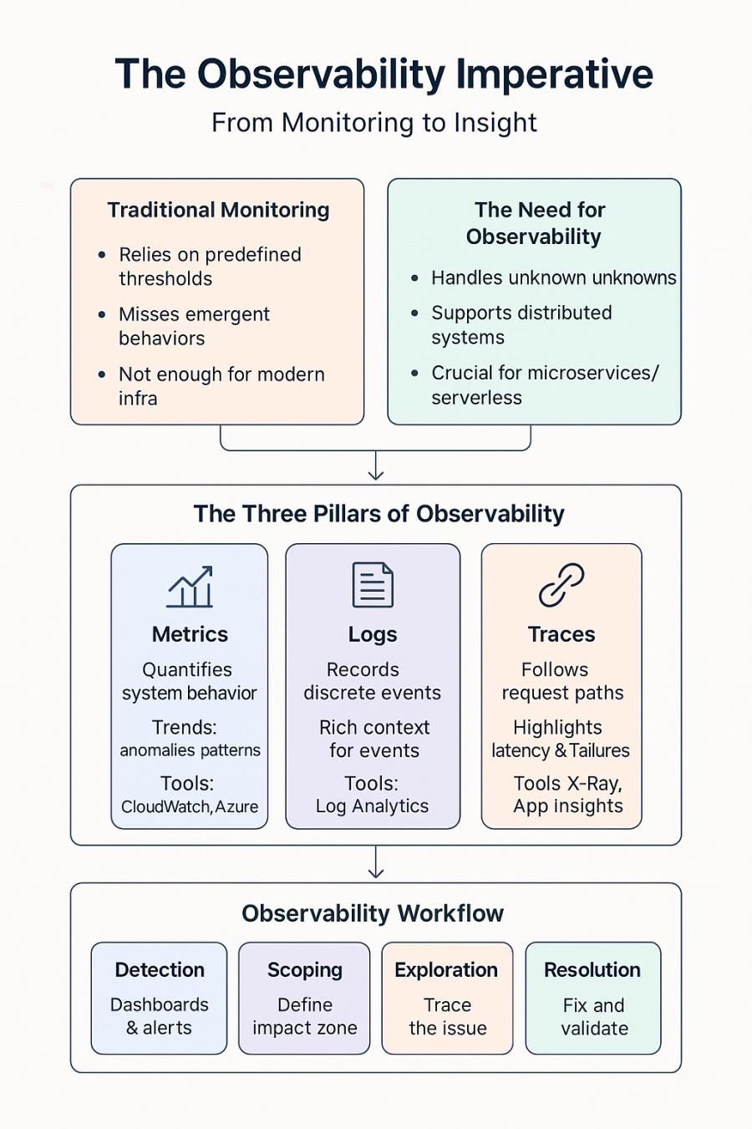

Distributive tracing features of AWS X-Ray and Azure Application Insights highlight these cross-component connections. Both systems enable consistent instrumentation across several services by using common formats like OpenTelemetry.

These three pillars combine to enable what we might call the "observability workflow":

1. **Detection**: Dashboards and alerts highlight anomalous conditions
2. **Scoping**: Metrics and aggregated logs define the problem boundaries
3. **Exploration**: Traces and detailed logs reveal specific failure paths
4. **Resolution**: Root cause analysis leads to specific fixes
5. **Validation**: Observability confirms that fixes address the underlying issues

### **Distributed Tracing Implementation**

Distributed tracing represents perhaps the most significant advancement in understanding complex distributed systems. Maintaining context as requests span many service lines helps to expose the causal links that measurements and logs by themselves cannot find.

Using efficient distributed tracing calls for attention to several important factors.

**Contextual Trace Propagation** keeps constant identities across lines of service. A request transfers from one service to another and the trace context has to accompany it. Later on, this propagation helps the observability system to rebuild the whole request path.

Several standardized formats facilitate this propagation:

* **W3C Trace Context** provides a vendor-neutral standard for HTTP headers
* **AWS X-Ray trace headers** carry context in AWS environments
* **Azure Application Insights headers** serve a similar function in Azure

For maximum interoperability, systems should support both cloud-specific formats and open standards like W3C Trace Context.

**Instrumentation Approaches** capture the timing and relationships of operations:

**Automatic instrumentation** uses language-specific agents or libraries that inject trace code without demanding significant program changes. Agents from Azure Application Insights and AWS X-Ray SDKs offer this feature for several widely used languages and frameworks.

**Manual instrumentation** allows developers exact control over which actions are tracked and which metadata is gathered. When automatic approaches fall short in capturing the necessary information, both X-Ray and Application Insights offer APIs for bespoke instrumentation.

**Sampling Strategies** balance observability against performance overhead:

**Head-based sampling** makes tracing decisions when requests first enter the system. While computationally efficient, this approach might miss important traces that only become problematic later in processing.

**Tail-based sampling** collects all trace data temporarily, then decides which traces to retain based on their complete characteristics. This approach better captures problematic traces but requires more resources.

Both AWS and Azure support configurable sampling rates, with AWS X-Ray specifically offering both head-based and reservoir sampling approaches.

**Trace Visualization and Analysis** transforms raw trace data into actionable insights:

**Service maps** show the topology of distributed systems based on observed traffic. Both X-Ray and Application Insights automatically generate these maps from trace data.

**Dependency analysis** reveals critical paths and potential bottlenecks. Azure Application Insights provides detailed dependency analytics that highlight the impact of service relationships.

**Performance breakdown** identifies which components contribute most significantly to overall latency. X-Ray's subsegment analysis and Application Insights' end-to-end transaction monitoring provide this visibility.

Implementing distributed tracing in AWS typically involves:

1. Adding the X-Ray SDK to each service
2. Configuring appropriate middleware for automatic HTTP/SQL instrumentation
3. Adding custom annotations for business context
4. Configuring X-Ray daemon for trace submission
5. Setting up sampling rules appropriate to the application's traffic volume

The Azure implementation process similarly includes:

1. Adding Application Insights SDK to each service
2. Enabling dependency tracking
3. Adding custom telemetry for business events
4. Configuring connection strings for the Application Insights resource
5. Setting appropriate sampling rates

### **Metrics Collection and Visualization**

While distributed tracing offers deep insights into individual requests, metrics provide the aggregated view necessary for understanding system-wide behavior and performance trends. Effective metrics implementations balance coverage, granularity, and overhead.

**Metric Types** capture different aspects of system behavior:

**Counter metrics** track discrete events or operations, such as requests received, errors encountered, or transactions processed. These metrics continuously increase and typically get visualized as rates (e.g., requests per second).

**Gauge metrics** measure point-in-time values such as memory usage, connection counts, or queue depths. Unlike counters, gauges can increase or decrease over time.

**Histogram metrics** track the distribution of values rather than just averages or totals. This approach captures outliers and percentiles, which often matter more for user experience than averages alone.

**Timer metrics:** The combination of counters and histograms in timer metrics enables the measurement of operational rates and durations. The metrics provide essential value for service performance assessment. AWS CloudWatch enables all these metric types through its custom metrics API and Azure Monitor provides similar capabilities through its metrics system.

**Metric Collection Strategies** determine where and how metrics are gathered:

**Push-based collection** has services actively send metrics to a central service. AWS CloudWatch custom metrics and Azure Monitor custom metrics both use this approach, with applications explicitly publishing measurements.

**Pull-based collection** has a central service periodically request metrics from instrumented components. Prometheus, which can be deployed on both AWS and Azure, exemplifies this approach.

**Agent-based collection** uses local processes to gather metrics from the operating system or application logs, then forwards them to central storage. AWS CloudWatch Agent and Azure Monitor Agent both provide this capability.

Most comprehensive observability implementations combine these approaches based on specific service requirements.

**Metric Aggregation and Storage** handles the volume and retention challenges of metrics at scale:

**Pre-aggregation** combines data points before storage to reduce volume while preserving information density. Both CloudWatch and Azure Monitor automatically aggregate metrics at different time resolutions.

**High-cardinality handling** addresses the explosion of unique time series when dimensions (like instance IDs or customer IDs) create many distinct metric combinations. Azure Monitor specifically offers workbooks for analyzing high-cardinality data without prohibitive storage costs.

**Multi-resolution storage** keeps recent data at high resolution while automatically reducing granularity for older data. This approach balances detail against storage costs. Both AWS and Azure implement this pattern in their respective metrics stores.

**Visualization and Dashboarding** transforms raw metrics into actionable insights:

**Service-level dashboards** present key performance indicators for specific components. AWS CloudWatch dashboards and Azure dashboards support this use case with customizable widgets.

**Business-oriented dashboards** focus on user-visible outcomes rather than technical metrics. Both platforms support custom metrics that can track business-relevant measurements.

**Cross-service correlation** exposes links between several component metrics. Azure Workbooks and AWS CloudWatch Metrics Insights offer query languages meant especially for this type of analysis.

### **Log Aggregation Strategies**

In distributed systems, logs offer the comprehensive, contextual data required to grasp certain events and behaviors. Good log management strikes a compromise between analysis capacity and verbosity against storage expenses.

**Structured Logging** transforms traditional text logs into queryable data:

**JSON formatting** represents log entries as structured objects rather than plain text. This approach enables consistent parsing and indexed querying.

**Semantic logging** emphasizes business meaning and logical operation over merely technical aspects. Semantic logging might, for instance, record "Customer profile retrieved forauthentication" with structured context containing customer ID, query time, and operation outcome instead of logging "Database queryexecuted in 250ms."

**Context enrichment** adds environment and request information to every log entry. This might include trace IDs for correlation, environment indicators (production/staging), or relevant business entities.

Both AWS and Azure support structured logging, with CloudWatch Logs Insights and Log Analytics respectively providing query capabilities optimized for JSON-structured data.

**Log Collection Approaches** address the challenges of gathering logs from distributed sources:

**Agent-based collection** uses local processes to read log files and forward entries to centralized storage. AWS CloudWatch Agent and Azure Log Analytics Agent provide this capability for traditional applications.

**Direct API integration** has applications submit logs directly to the logging service without intermediate agents. AWS CloudWatch Logs SDK and Azure Monitor SDK support this approach.

**Container log routing** captures stdout/stderr streams from containerized applications. AWS FireLens and Azure Container Insights automatically collect container logs with appropriate metadata.

**Serverless function logs** capture output from ephemeral compute environments. AWS Lambda automatically sends logs to CloudWatch Logs, while Azure Functions similarly integrates with Log Analytics.

Most distributed systems implement a combination of these approaches based on their specific component architectures.

**Log Storage and Retention** policies balance analytical needs against costs:

**Hot-warm-cold tiering** keeps recent logs in high-performance storage while moving older logs to progressively less expensive options. AWS CloudWatch Logs can export to S3 for long-term storage, while Azure Log Analytics implements retention period policies with archiving to Azure Storage.

**Index optimization** creates appropriate search indexes based on anticipated query patterns. Azure Log Analytics allows custom table designs with optimized indexing strategies.

**Sampling and filtering** reduce volume by selectively storing logs based on their importance. Both platforms support filtering at collection time to avoid storing low-value log entries.

**Log Analysis and Correlation** transforms raw logs into actionable insights:

**Full-text search** finds all occurrences of specific terms or patterns. Both CloudWatch Logs Insights and Azure Log Analytics support this basic capability.

**Structured queries** filter and aggregate log data based on field values. CloudWatch Logs Insights query language and Azure Kusto Query Language (KQL) provide SQL-like capabilities optimized for log analysis.

**Cross-source correlation** combines logs from multiple services to trace request flows. This capability proves particularly powerful when combined with distributed tracing identifiers embedded in logs.

**Machine learning analysis** identifies anomalies and patterns too complex for predefined rules. Azure Log Analytics includes built-in anomaly detection and pattern recognition.

### **Alerting Philosophies and Practices**

Monitoring and observability data provide limited value without effective alerting to drive action. Modern distributed systems require alerting approaches that balance comprehensiveness against alert fatigue.

**Alert Design Principles** guide the creation of actionable notifications:

**Symptom-based alerting** focuses on user-visible issues rather than internal system metrics. For example, alerting on API error rates directly reflects user experience, while alerting on database connection counts represents an internal implementation detail.

**Actionable alerts** include sufficient context for responders to begin investigation without additional data gathering. Both CloudWatch Alarms and Azure Monitor Alerts support including relevant metric graphs and links to dashboards with alert notifications.

**Alert consolidation** groups related alerts to prevent alert storms during cascading failures. AWS Systems Manager OpsCenter and Azure Monitor Alert Processing Rules both provide mechanisms to correlate and group related alerts.

**Alert Classification** differentiates notifications based on impact and urgency:

**Criticality levels** distinguish between minor issues and system-wide emergencies. Both CloudWatch Alarms and Azure Monitor Alerts support multiple severity levels with different notification channels.

**Business impact indicators** relate technical issues to user or business outcomes. Custom composite metrics in both platforms can combine technical measurements with business relevance scores.

**On-call routing** directs alerts to appropriate teams based on system ownership. AWS Systems Manager Incident Manager and Azure Monitor Action Groups support sophisticated routing rules and escalation paths.

**Alerting Mechanisms** deliver notifications through appropriate channels:

**Push notifications** actively deliver alerts to responders through email, SMS, or dedicated incident management tools. Both platforms integrate with services like PagerDuty in addition to their native notification capabilities.

**Centralized dashboards** provide situational awareness for ongoing incidents. AWS CloudWatch Dashboards and Azure Dashboards support highlighting metrics in alarm state for easier visualization.

**Alert automation** triggers remediation actions without human intervention for well-understood issues. AWS EventBridge with Lambda and Azure Logic Apps provide mechanisms to implement automated responses to specific alert conditions.

**Alert Tuning** maintains signal-to-noise ratio as systems evolve:

**Threshold refinement** adjusts trigger conditions based on observed patterns. Both platforms support dynamic thresholds that automatically adjust based on historical patterns.

**Alert suppression** temporarily disables notifications during known maintenance or deployment activities. Both CloudWatch Alarms and Azure Monitor Alerts provide maintenance window features for this purpose.

**False positive reduction** continuously improves alert accuracy through regular review and refinement. AWS DevOps Guru and Azure Workbooks provide tools for analyzing alert patterns to identify improvement opportunities.

### **Building Effective Dashboards**

Dashboards provide the visual interface through which teams understand system behavior. Effective dashboards transform complex data into actionable insights while supporting different user needs.

**Dashboard Types** serve different operational functions:

**Overview dashboards** provide high-level system health at a glance. These dashboards typically present key performance indicators with simple visualizations focusing on current status.

**Service-specific dashboards** offer detailed metrics for individual components. These views help service owners understand their specific domain without distraction from unrelated systems.

**User journey dashboards** follow request flows across multiple services. These dashboards often combine metrics and trace sampling to show the complete user experience path.

**Business dashboards** emphasize outcomes over technical details. These views help non-technical stakeholders understand system performance in business terms.

Both AWS and Azure support creating multiple dashboards tailored to specific audiences and use cases.

**Visualization Best Practices** transform data into insight:

**Visual hierarchy** emphasizes important information through size, color, and placement. Both platforms support customizable layouts that allow critical metrics to receive visual prominence.

**Consistent scales** prevent misleading comparisons between charts. CloudWatch Dashboards and Azure Dashboard both allow standardizing scales across related visualizations.

**Color semantics** use consistent color coding for status indication. Typically, red indicates problems, yellow warnings, and green normal operations.

**Contextual enrichment** provides reference information alongside current values. Both platforms support displaying baseline metrics or thresholds alongside current measurements.

**Dashboard Organization** manages complexity as systems grow:

**Drill-down patterns** allow navigation from high-level summaries to detailed views. Azure Dashboard links and CloudWatch cross-dashboard navigation support these interaction patterns.

**Consistent naming conventions** make large dashboard collections navigable. Both platforms support folder structures or naming patterns to organize related dashboards.

**Template-based standardization** ensures consistent presentation across similar services. Azure Dashboard templates and CloudWatch Dashboard templates support creating consistent views for similar components.

### **Cost Management for Observability**

Comprehensive observability at scale can generate significant costs without careful management. Balancing observability needs against budget constraints requires thoughtful strategy.

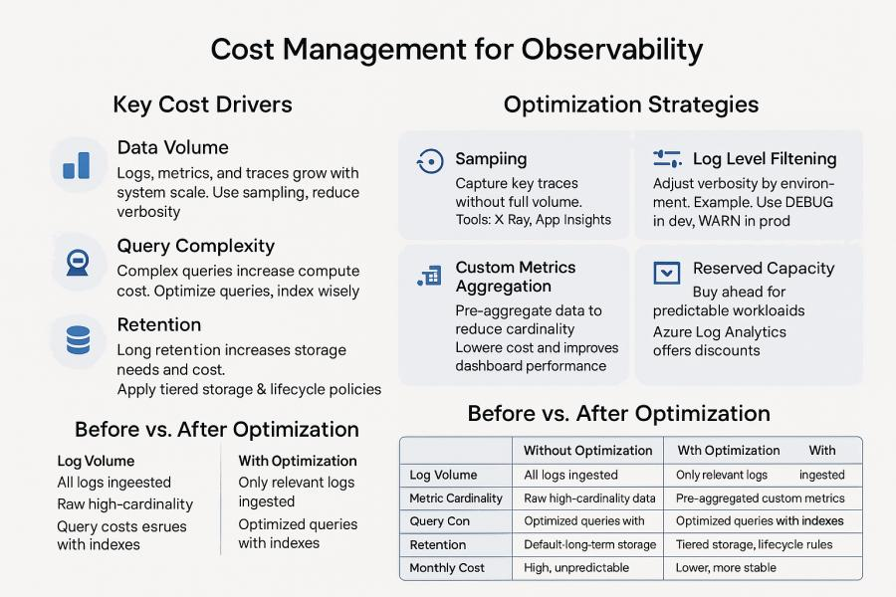

**Cost Drivers** in observability include:

**Data volume** from logs, metrics, and traces grows with system scale. Controlling verbosity, implementing sampling, and setting appropriate retention periods help manage this growth.

**Query complexity** affects computational costs, particularly for log analytics. Optimizing query patterns and creating appropriate indexes can significantly reduce these costs.

**Retention requirements** determine storage volume and tier. Implementing tiered storage with appropriate lifecycle policies ensures that data remains available as long as needed without unnecessary premium storage costs.

**Optimization Strategies** balance observability against costs:

**Sampling approaches** collect comprehensive data for a representative subset of transactions. Both X-Ray and Application Insights support configurable sampling rates to reduce volume while maintaining statistical validity.

**Log level filtering** adjusts verbosity based on environment and current operational needs. Both platforms support dynamic configuration of logging detail.

**Custom metrics aggregation** reduces cardinality by pre-aggregating high-volume metrics. Both CloudWatch and Azure Monitor support publishing pre-aggregated metrics rather than raw measurements.

**Reserved capacity** can reduce costs for predictable observability workloads. Azure Log Analytics offers capacity reservations that provide significant discounts compared to on-demand pricing.

### **Conclusion: Toward Observable Systems**

Observability represents a fundamental shift from traditional monitoring approaches. Rather than just detecting known issues, comprehensive observability enables teams to understand novel problems, identify optimization opportunities, and maintain confidence in increasingly complex distributed systems.

Implementing effective observability requires attention to metrics collection, log aggregation, distributed tracing, alert design, and dashboard creation—all while managing costs as systems scale. Both AWS and Azure provide comprehensive tooling across these domains, with increasingly sophisticated integration between different observability signals.

As distributed systems continue to evolve toward more dynamic architectures with serverless components, containerized microservices, and multi-region deployments, observability becomes not just an operational convenience but an existential necessity. Without the visibility provided by modern observability practices, the complexity of these systems would render them effectively unmaintainable.

In the next chapter, we'll explore data management in distributed systems—ensuring that information remains consistent, available, and performant across distributed components despite the inherent challenges of distributed state.

## **Chapter 7: Data Management in Distributed Systems**

Among the toughest challenges of distributed systems is data management. Data adds complexity surrounding consistency, availability, durability, and performance while stateless application components may be rather easily scaled and recovered. With special reference to AWS and Azure, this chapter investigates methods for data management in distributed systems.

### **Distributed Database Selection Criteria**

The foundation of data management strategy begins with selecting appropriate database technologies. Modern distributed systems often employ multiple specialized databases rather than forcing all data into a single technology. This polyglot persistence method corresponds with suitable storage technologies based on certain data characteristics.

Key selection criteria include:

**Data Model Requirements** determine the fundamental organization of information. Different data models suit different access patterns and consistency needs:

**Relational models** organize data into tables with predefined schemas and relationships. This approach excels for structured data with complex relationships and transaction requirements. AWS Aurora and Azure SQL Database provide highly scalable relational database capabilities, while AWS RDS and Azure Database for PostgreSQL/MySQL offer managed services for traditional relational databases.

**Document models** save semi-structured data in flexible JSON-like form. The method will be suitable for content-centric applications that have variable attribute sets. SQL API, AWS Document Database and Azure Cosmos Database implement document databases with various consistency models and scaling properties.

**Key-value models** provide simple storage and retrieval of values based on primary keys. This model offers maximum performance and scalability for simple access patterns. AWS DynamoDB and Azure Table Storage provide managed key-value storage with different consistency and query capabilities.

**Graph models** maximize for densely connected data including complicated relationships. For social networks, recommendation systems, and knowledge graphs this method shines. There are multiple managed graph database solutions in the market, that support their own query languages to analyze the data and they are engineered towards making it more scalable. Some of the examples include AWS Neptune, Azure Compos and Gremlin API

**Column-family models** organize data by column rather than row, optimizing for analytical workloads with high write throughput and selective column reading. AWS Keyspaces (for Apache Cassandra) and Azure Cosmos DB with Cassandra API implement this model with different consistency guarantees.

**Time-series models** maximize for typical in IoT, monitoring, and financial applications data points indexed by time. AWS Timestream and Azure Time Series Insights offer specialized time-series databases with capabilities including automated data retention policies and time-based query optimization.

**Consistency Requirements** determine how the database handles concurrent updates and distributed state:

**Strong consistency** inherently by default, guarantees the reads are always on the last effective written data. Although this paradigm offers behavior more like those of conventional single-node databases, it could affect availability across network divisions. AWS Aurora and Azure SQL Database offer strong consistency within regions.

**Eventual consistency** guarantees that all replicas will eventually converge to the same state if updates stop. This model improves availability and performance at the cost of potential temporary inconsistencies. DynamoDB (in default configuration) and Azure Cosmos DB (with eventual consistency level) implement this model.

**Causal consistency** guarantees that for all observers operations causally connected show in the same sequence. Without the performance penalty of great consistency, this paradigm offers better assurances than ultimate consistency. Particularly Azure Cosmos Database provides causal consistency at a tunable level.

While permitting eventual consistency across several sessions, **session consistency** offers great consistency during a client session. User experience is balanced in this way against dispersed performance. DynamoDB and Cosmos Database both support this idea via different means.

**Performance and Scaling Needs** determine how the database grows with demand:

Denormalized data models, read replicas, and caches help **read-heavy projects**. Azure SQL read replicas and Aurora Reader instances enable horizontal scalability for read operations.

**Write-heavy workloads** require different approaches like sharding or specialized storage engines optimized for write throughput. DynamoDB and Cosmos DB both provide automatic sharding to distribute write load.

**Query complexity** influences Technology choice; simple key-based access patterns might make advantage of highly scalable key-value storage, while complicated analytical searches could call for column-family or relational models with suitable indexing.

**Operational Requirements** influence database selection beyond pure technical criteria:

**Managed service level** controls the team's administrative overhead capacity. While systems like RDS or Azure Database for Postgres minimize but do not completely remove administrative tasks, fully managed services like DynamoDB or Cosmos Database eliminate most operational chores.

**Global distribution** needs may limit technology choices; some databases offer built-in worldwide replication (DynamoDB Global Tables, Cosmos DB multi-region), while others call for either additional configuration or outside solutions.

**Cost model** varies significantly between technologies, with some charging primarily for provisioned capacity (Aurora, Azure SQL) and others for consumed resources (DynamoDB on-demand, Cosmos DB serverless).

Rather ~~of~~ than forcing all data into a single model, the most successful distributed systems sometimes mix several database technologies depending on particular workload characteristics.

### **Data Partitioning Strategies**

As data volumes grow beyond what single nodes can handle, partitioning (or sharding) becomes necessary. Effective partitioning distributes data and workload evenly while maintaining efficient access patterns.

**Horizontal Partitioning** divides data of the same type across multiple nodes:

**Range-based partitioning** divides data based on value ranges (e.g., customers A-M on one shard, N-Z on another). This approach enables efficient range queries but may create uneven data distribution and "hot spots." Azure SQL Database Elastic Scale supports this model with split-merge capabilities to adjust partition boundaries.

Using a hash function, **hash-based partitioning** divides keys such that data is equally distributed among shards. This method complicates range searches but improves load distribution. Both DynamoDB and Cosmos Database abstract the specifics from applications using hash-based partitioning within.

**Composite partitioning** combines multiple attributes into partition keys. For example, combining tenant ID with date ranges can isolate workloads while enabling efficient date-based queries within each tenant. Both AWS and Azure databases support composite keys with different implementation details.

Vertical partitioning divides several qualities or object types into independent storage systems:

Column-based separation moves rarely accessed columns to more affordable storage while often accessed columns are housed in high-performance storage. This method lowers I/O for standard searches and increases cache efficiency.

Entity-based separation arranges several entity kinds in specialized storage systems fit for their particular properties. User profiles, for instance, might make use of a document database while transaction history makes use of a time-series database.

Polyglot persistence designs whereby applications interact with several specialized data stores instead of a single general-purpose database are supported by both AWS and Azure.

**Partitioning Challenges** include:

**Distributed transactions** become complicated across partition boundaries. Applications often need to implement compensating transactions or saga patterns when operations span multiple partitions. Azure Logic Apps and AWS Step Functions help to coordinate challenging, multi-stage transaction processes.

**Repartitioning** may become necessary as data volumes grow unevenly. Managed services like DynamoDB and Cosmos DB handle this automatically, while other databases require careful planning and potentially application downtime.

**Query routing** ensures requests reach appropriate partitions. Both AWS and Azure databases typically handle this internally for fully managed services, while partially managed services may require application-level routing logic.

**Global vs. Local Secondary Indexes** affect how applications access partitioned data:

**Global secondary indexes** span all partitions and provide access paths independent of the primary partition key. These indexes enable flexible querying but may have higher consistency or performance costs. DynamoDB global secondary indexes provide this capability with eventual consistency.

**Local secondary indexes** are scoped to a specific partition and typically offer stronger consistency guarantees with lower overhead. Both DynamoDB and Cosmos DB support various forms of local indexes with different performance characteristics.

### **Handling Eventual Consistency**

Distributed systems often employ eventual consistency to improve availability and performance. This model accepts temporary inconsistencies with the guarantee that replicas will converge to a consistent state if updates pause. However, eventual consistency introduces application design challenges.

**Conflict Detection and Resolution** becomes necessary when concurrent updates occur:

**Last-writer-wins (LWW)** resolves conflicts by selecting the update with the most recent timestamp. This simple approach may discard valid changes but requires minimal implementation effort. Both DynamoDB and Cosmos DB offer LWW as a default resolution strategy.

**Version vectors/vector clocks** track causal relationships between updates to determine conflicting changes. This approach preserves more information but increases complexity. DynamoDB uses similar mechanisms internally for conflict detection.

**Custom merge functions** apply domain-specific logic to combine conflicting changes. This approach preserves the most information but requires significant implementation effort. Cosmos DB supports custom conflict resolution through stored procedures.

**Application Design Patterns** for eventual consistency include:

**Command Query Responsibility Segregation (CQRS)** separates write and read models, allowing each to use appropriate consistency levels. Write operations might use stronger consistency while read operations use eventually consistent views optimized for query performance.

**Commutative operations** produce the same result regardless of execution order. For example, incrementing a counter is commutative, while setting an absolute value is not. Designing for commutative operations simplifies eventual consistency handling.

Inconsistencies are identified and corrected by **compensation workflows** after they have already occurred. In most cases, these workflows entail operations that run in the background and identify and address any inconsistencies that exist between the planned state and the actual state.

**User Experience Considerations** help manage eventual consistency from the user perspective:

**Optimistic UI updates** immediately reflect user actions in the interface while asynchronously confirming with the backend. This approach improves perceived performance but requires careful error handling if conflicts occur.

When it comes to important processes, **consistent readings** ensure that users are aware of their own most recent modifications, even in systems that eventually become consistent. In order to accomplish this, DynamoDB gives explicit consistent read options, whereas Cosmos DB supports session consistency.

**Indicators of progress** communicate when operations are partially committed as opposed to when they are fully committed. These oblique user interface features provide reasonable assumptions regarding the consistency of the data.

### **Data Migration Patterns**

As systems evolve, data often needs to move between storage technologies, schema versions, or cloud providers. Distributed systems require migration approaches that minimize downtime while maintaining consistency.

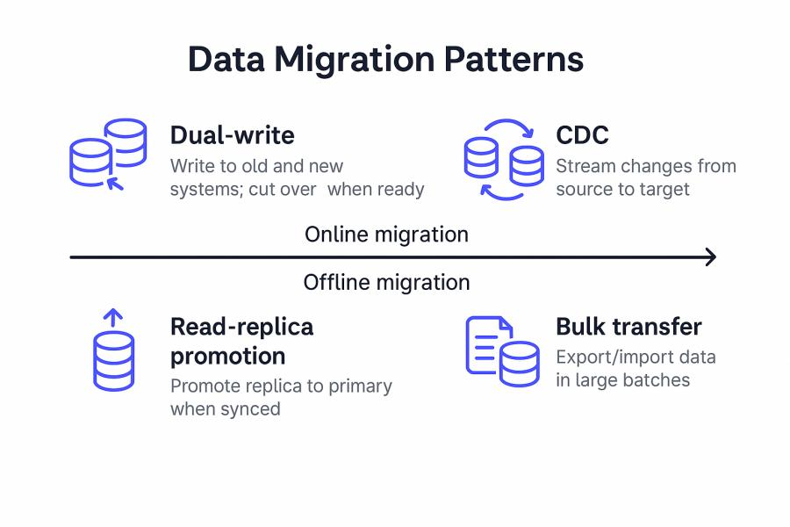

**Online Migration Strategies** minimize or eliminate service disruption:

**Dual-write patterns** write to both old and new data stores during transition periods. Applications continue reading from the original store while verifying consistency with the new store. Once confidence builds, reads transition to the new store, and eventually, writes to the old store cease.

**Change Data Capture (CDC)** streams changes from the source system to the target system. AWS Database Migration Service and Azure Data Factory both support CDC for various database engines, enabling near-real-time replication during migrations.

**Read-replica promotion** first establishes the target system as a replica of the source, then promotes it to primary once replication lag reaches acceptable levels. This approach works particularly well when migrating between compatible database engines or scaling up within the same technology.

**Bulk Transfer Mechanisms** move existing data efficiently:

**Direct database import/export** works for smaller datasets or when downtime is acceptable. Both AWS and Azure provide tools for their respective database services, such as RDS snapshot export and Azure Database for PostgreSQL import.

**ETL pipelines** extract, transform, and load data while applying schema changes or data cleansing. AWS Glue and Azure Data Factory provide managed ETL services for complex migration requirements.

**Incremental loading** breaks large migrations into smaller batches to reduce resource consumption and enable partial verification before committing to the complete migration.

**Schema Evolution Approaches** handle database structure changes:

**Backward compatible changes** allow old and new application versions to work with the same database. These changes typically add optional fields or tables rather than modifying existing structures.

**Database versioning** maintains multiple schema versions simultaneously during transition periods. This approach requires more complex application logic but enables gradual rollouts.

**Schema migration tools** automate change script generation and execution. Frameworks like Flyway or Liquibase integrate with CI/CD pipelines to ensure consistent schema deployment, while both AWS and Azure support various database-specific migration tools.

### **Backup and Recovery at Scale**

Data protection remains essential even in distributed systems with built-in redundancy. Effective backup strategies should address both technical failures and human errors.

**Backup Strategies** for distributed data include:

**Snapshot-based backups** capture the complete state at specific times. AWS RDS automated backups and Azure SQL automated backups use this approach, typically with point-in-time recovery capabilities.

**Continuous backups** capture changes as they occur, enabling recovery to any point in time. Amazon Aurora continuous backups and Azure Cosmos DB continuous backup both provide this capability with varying retention periods.

**Multi-region replication** in Cosmos Database and DynamoDB Global Tables enable this capability. Complete copies in geographically different sites are maintained by cross-region replication. Although they are mostly a disaster recovery tool, under some failure situations replicas can be logical backups.

**Backup Management** grows more complex at scale:

**Centralized backup policies** ensure consistent protection across multiple databases. AWS Backup and Azure Backup both provide centralized management interfaces for defining and monitoring backup policies.

**Backup validation** verifies that backups can actually be restored. Both AWS and Azure provide mechanisms to test recoveries without affecting production workloads.

**Compliance monitoring** ensures backup execution meets regulatory and business requirements. AWS Backup Audit Manager and Azure Policy provide mechanisms to verify backup compliance.

**Recovery Scenarios** extend beyond simple full database restoration:

**Point-in-time recovery** brings back precisely before corruption or unwelcome modifications. With different retention times, most AWS and Azure managed databases let this feature be used.

**Selective data recovery** gets particular data without whole database restoration. Since native cloud services usually concentrate on total database recovery, this capability usually calls for either custom scripting or outside technologies.

**Cross-environment recovery** with suitable data masking brings production data back to testing or development settings. Azure and AWS both offer means to restore backups to other instances or environments.

### **Caching Strategies**

In distributed systems, caching greatly increases performance and lowers database load. Good caching techniques take account of the dispersed character of contemporary applications and balance freshness against performance.

**Cache Placement Options** include:

**Client-side caching** stores data on end-user devices or application instances. This approach minimizes network latency but creates consistency challenges across distributed clients.

**Application caching** puts caches inside application services. Managed in-memory caching at this level comes via AWS ElastiCache and Azure Cache for Redis.

**Database caching** accelerates queries through internal mechanisms like buffer pools or result caches. Aurora and Azure SQL Database both implement various internal caching mechanisms optimized for their respective engines.

**Content delivery networks (CDNs)** cache responses at edge locations. While primarily used for static assets, modern CDNs like CloudFront and Azure CDN can cache API responses with appropriate cache control headers.

**Distributed Cache Consistency** approaches balance performance against freshness:

**Time-based expiration** automatically invalidates cached entries after configured periods. This simple approach works well for data with predictable staleness tolerance.

**Event-based invalidation** actively removes or updates cached data when underlying information changes. This approach maintains better consistency but requires explicit integration between data sources and caches.

**Write-through caching** updates the cache simultaneously with the primary datastore. This approach eliminates cache staleness but may reduce write performance.

**Versioned caching** assigns version identifiers to cached objects, updating references when data changes. This approach enables atomic cache updates without invalidation storms.

**Cache-Aside Pattern** represents the most common implementation approach:

1. Application checks cache for desired data
2. If found (cache hit), application uses cached data
3. If not found (cache miss), application reads from the database
4. Application populates cache with retrieved data for future requests

Both ElastiCache and Azure Cache for Redis support this pattern through their respective APIs and client libraries.

**Cache Optimization Techniques** improve efficiency and hit rates:

**Partial result caching** stores specific high-value query results rather than entire objects. This approach maximizes memory efficiency for large entities where only certain attributes are frequently accessed.

Before periods of significant use, **cache warming** aggressively fills caches. This method avoids thundering herd issues when many cache misses concurrently follow deployments or cache failures.

**Tiered caching** aggregates several layers with varying properties. A small local memory cache might, for instance, front a distributed Redis cache, therefore lowering demand on the main database.

### **Data Governance and Compliance**

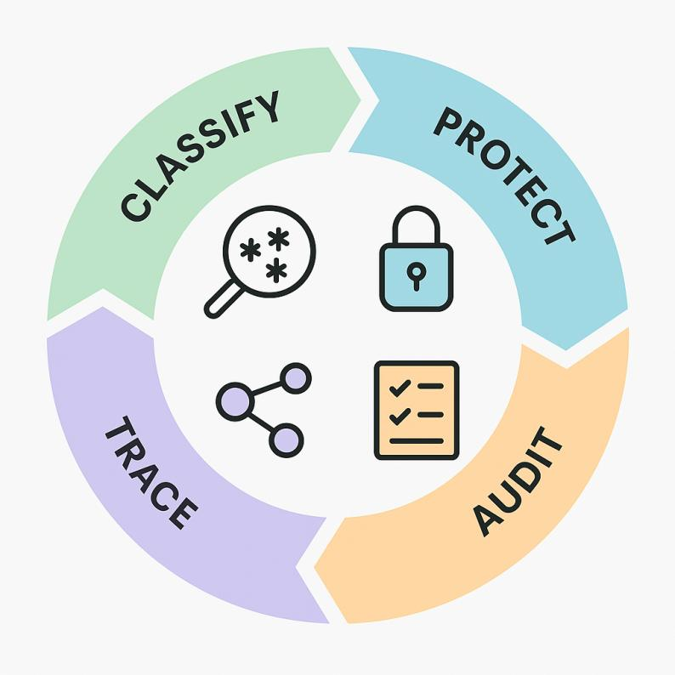

The management of large amounts of sensitive data by distributed systems requires both performance and scalability alongside governance and compliance. Data Classification and Protection ensure appropriate handling based on sensitivity:

Storage systems automatically detect sensitive data

Sensitive data within storage systems is found automatically. **Automated scanning** features of AWS Macie and Azure Purview help to find personally identifiable information, credentials, and other sensitive data categories.

**Protection policies** apply controls based on data classification. Both AWS and Azure support resource policies that restrict access to sensitive data based on user identity, location, or other attributes.

**Encryption implementation systems** guard data both in transit and at rest. While most managed database systems offer transparent encryption capability, AWS KMS/CloudHSM and Azure Key Vault offer key management for encryption.

**Regulatory Compliance** frameworks impose specific requirements on data management:

**Geographic data sovereignty** restricts where specific data types can be stored and processed. Both AWS and Azure provide region-specific deployments with data residency guarantees for regulated workloads.

**Retention requirements** mandate how long certain records must be preserved. S3 Lifecycle Policies and Azure Blob Storage Lifecycle Management enable automated retention policy enforcement.

**Audit capabilities** demonstrate compliance with data access policies. CloudTrail and Azure Activity Logs record administrative actions, while database-specific audit logs capture data-level operations.

**Data Lineage and Provenance** track how data flows through systems:

**Source tracking** records data entry into the system and original sources. Azure Purview and AWS Glue Data Catalog give means to record data sources and changes.

**Transformational auditing** records data changes over its lifetime. For lineage tracing, ETL technologies such Azure Data Factory and AWS Glue log transformation events.

**Access history** records who has viewed or modified data. RDS/Aurora and Azure SQL both provide various audit logging capabilities to track user interactions with data.

### **Conclusion: Toward Effective Data Management**

In distributed systems, data management calls for juggling several conflicting issues: performance vs durability, availability against consistency, flexibility against governance. Based on particular application needs, the strategies described in this chapter offer a basis for efficiently making these trade-offs.

The most effective distributed systems do not seek a single ideal data solution because they instead implement multiple specialized data technologies that match different workload conditions. The combination of suitable caching techniques with governance controls and this polyglot persistence solution enables systems to handle different data needs while maintaining scalability and compliance.

Effective data management becomes ever more important to distributed system success as data quantities keep rising and legal constraints get stricter. Understanding the basic trade-offs and implementation strategies covered in this chapter can help architects design data structures that balance technology capabilities against corporate needs.

In the next chapter, we'll explore performance optimization in distributed systems—ensuring that our carefully designed, reliable, secure, and observable systems also deliver the speed and efficiency users expect.

## **Chapter 8: Performance Optimization**

Performance is fundamental for distributed systems and influences operational costs and user experience greatly. Unlike the last chapters, which addressed scalability and reliability, this one emphasizes system performance to guarantee that distributed systems not only execute correctly but also at optimal speed and with low resource consumption. We will specifically address methods for spotting and fixing distributed system performance problems with reference to implementation in AWS and Azure.

### **Load Testing Distributed Systems**

Performance optimization begins with understanding current system behavior under various load conditions. Load testing systematically measures performance ~~characteristics~~ metrics to establish baselines, identify bottlenecks, and validate improvements.

**Load Testing Approaches** address different performance aspects:

**Steady-state testing** allows one to measure baseline performance and spot trends in degradation by keeping a constant load over long time period. This approach exposes memory leaks, connection pool exhaustion, and other unlikely to be found on quick tests problems.

**Step-load testing** increases demand incrementally to identify breaking points and scaling constraints. This approach helps determine when auto-scaling should commence and guarantees that scaling systems work as expected.

**Spike testing** suddenly increases load to maximum levels to evaluate system recovery capabilities. This approach tests buffer overflows, queue saturation, and throttling mechanisms.

**Endurance testing** runs moderate loads for extended durations (days or weeks) to find subtle performance degradation that occurs over time. This approach can reveal issues like fragmentation, log growth, or background process interference.

**Tools and Platforms** for distributed load testing include:

**AWS Distributed Load Testing** uses AWS Fargate to coordinate load generation across multiple containers, enabling realistic testing of large-scale applications. This service runs test scenarios, automatically supplies resources, and compiles data.

**Azure Load Testing** offers managed infrastructure for extensive performance testing with comprehensive metrics collecting and connection with Azure Monitor.

**Open-source tools** like JMeter, Locust, and Gatling offer flexible testing capabilities deployable on cloud infrastructure. These instruments offer additional personalising choices, but they also call for self-management of the testing environment.

**Testing Best Practices** ensure meaningful results:

**Test from several sites** considering geographic spread and network latency. Global infrastructure available from both AWS and Azure allows load generators to be distributed over multiple areas.

Instead of simple request distributions, **replicate traffic patterns**. Real user behavior patterns can be captured and replicated with tools like AWS CloudWatch Evitably and Azure Traffic Analytics.

During tests, **record thorough measurements** at every level of the system. Distributed tracing in AWS X-Ray and Azure Application Insights links performance across components.

### **Identifying and Resolving Bottlenecks**

In distributed systems, performance bottlenecks can arise at infrastructure, platform service, application code, or component interaction levels. Good optimization calls for methodical discovery and focused fixing.

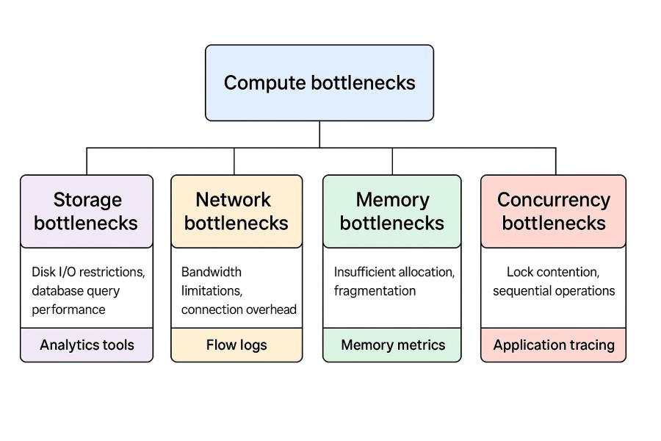

**Common Bottleneck categories** include:

**Compute bottlenecks** occur when processing capacity limits throughput. These could show up as strain on the garbage collecting mechanism, thread pool depletion, or CPU excessive usage. Two instruments provided by AWS CloudWatch and Azure Monitor let one identify these conditions.

**Storage bottlenecks** relate to restrictions on data access or permanence. These cover disk I/O restrictions, database query performance, or object storage throughput limits. For their storage offerings, both systems include specific monitoring tools including Azure SQL Analytics and Amazon RDS Performance Insights.

**Network bottlenecks** constrain communication between components. These include bandwidth limitations, connection establishment overhead, or protocol inefficiencies. VPC Flow Logs in AWS and NSG Flow Logs in Azure help identify network constraints.

**Memory bottlenecks** include insufficient allocation, fragmentation, or cache efficiency issues. CloudWatch Memory metrics and Azure VM Insights track memory usage patterns to identify these limitations.

**Concurrency bottlenecks** arise when synchronization mechanisms restrict parallel execution. Common causes include lock contention, mandatory sequential operations, or inadequate connection pooling. Tools like AWS X-Ray or Azure Application Insights can assist in detecting these issues through application-level tracing.

**Systematic Identification** follows a methodical process:

1. **Create explicit performance benchmarks** based on regular conditions.
2. **Apply deliberate load increases** under observation of every system component.
3. **Identify components** showing non-linear response degradation
4. **Drill down within those components** to isolate specific constraints
5. **Apply specific improvements** depending on found limitations.
6. **Validate improvements** through comparative testing

**Resolution Patterns** apply to specific bottleneck types:

**Database optimization** often provides significant performance improvements:

* Index tuning for query patterns
* Refactor queries to cut complexity.
* For a high reading load, read replicas.
* Configuring connection pooling
* Frequent data access is facilitated by caching.

AWS provides performance-enhancing tools such as DynamoDB Accelerator (DAX) for caching and RDS Performance Insights for analyzing database queries. Similarly, Azure offers Azure Cache for Redis and Azure SQL Query Performance Insight to deliver comparable functionality.

Network optimization aims to enhance communication efficiency through the following methods:

* Ordering batches to cut round trips
* Reversing connections to eradicate overhead handshakes
* Data compression lowers transfer sizes.
* The implementation of efficient protocols such as gRPC or HTTP/2
* The deliberate arrangement of resources leads to latency reduction.

Both cloud platforms provide content delivery networks (CDNs) for edge caching and improve network routing for distributed applications by means of services like AWS Global Accelerator and Azure Front Door.

Computing the optimization enhances processing effectiveness:

* Asynchronous I/O-bound operation processing
* For CPU-bound tasks, parallelism
* Just-in-time compilation for languages interpreted otherwise.
* Memory tweaking for disposal of trash
* Processing-intensive operations: algorithmic enhancements

AWS and Azure both offer compute instances tailored for certain workload characteristics, from CPU-optimized to memory-optimized variations.

**Platform-specific improvements** use cloud provider capabilities:

* Azure and AWS Lambda function concurrency settings
* specialised instance forms for particular workloads
* Provisioned storage services' throughput
* Configuration for auto-scaling to project demand
* Regional placement for lowering of latency

### **Network Optimization Techniques**

Network performance significantly impacts distributed system behavior. Both latency (delay in data transmission) and bandwidth (data volume over time) affect overall system responsiveness.

**Latency Reduction Strategies** minimize the time required for service interactions:

**Geographic distribution** places resources closer to users or dependent services. Both AWS and Azure operate global regions with edge locations for content distribution. Services like CloudFront and Azure CDN cache content at edge locations, while Route 53 and Traffic Manager direct users to optimal endpoints.

**Connection reuse** eliminates the overhead of establishing new connections for each request. HTTP persistent connections, connection pooling, and WebSockets all implement this pattern with different characteristics. Both API Gateway (AWS) and API Management (Azure) support connection reuse for backend services.

The choice of protocol directly influences transmission efficiency. gRPC uses binary serialization to create compact message formats, while HTTP/2 improves performance by multiplexing multiple requests over a single connection and applying header compression.

**Request batching** accomplishes combining several logical operations into one network demand. This approach amortizes network overhead across operations, particularly beneficial for high-latency connections. Services like DynamoDB BatchGetItem and Azure Cosmos DB bulk operations implement this pattern.

**Bandwidth Optimization** techniques maximize effective throughput:

**Compression** lowers transmission data volume. Reducing payload sizes is achieved with both conventional HTTP compression (gzip, Brotli) and specialised binary formats like Protocol Buffers For suitable content categories, both Azure CDN and CloudFront provide automatic compression.

**Selective data retrieval** calls just for needed fields instead of all the resources. GraphQL APIs expressly support this pattern; RESTful APIs can apply it with query parameters. GraphQL is supported for effective data retrieval by both Azure API Management and AWS AppSync.

Large data volumes are moved by **background transfer** under less active times. There is a strong preference towards interactive operations to enhance user experience. Azure Data Box and AWS S3 Transfer Acceleration optimize several aspects of large data transfer.The network transfer becomes more efficient through data caching because it stores frequently requested data locally. The combination of multiple caching tiers produces the most effective results because browser caches and CDNs and API gateways and application caches operate at distinct levels. Both AWS and Azure provide caching capabilities at multiple levels of the application stack.

**Content Delivery Networks** optimize global content distribution:

**Edge caching** places content in globally distributed locations close to users. For constant assets and API responses, this method drastically lowers latency. Global edge networks with configurable cache capabilities abound from CloudFront and Azure CDN

**Accelerating dynamic content** maximizes non-cacheable content routing. Azure Front Door and AWS Global Accelerator keep constant connections across ideal network pathways to origin servers.

**Origin Shielding** protects backend services against high demand. With this approach, an intermediary caching layer is constructed between edge sites and origin servers. This layer helps to lessen the strain on origin servers while ensuring that material remains current. Both the Azure Content Delivery Network (CDN) and CloudFront implement different origin protection measures.

### **Resource Utilization Best Practices**

Effective use of resources guarantees that systems reach highest throughput with lowest infrastructure requirements. As systems grow, when even little per-request inefficiencies can compound into major resource waste, this efficiency becomes especially crucial.

**Compute Resource Optimization** ensures efficient processing:

**Right-sizing instances** enables the proper alignment of computation resources with their actual usage levels. The cloud platforms AWS and Azure provide various instance types that span from compute-optimized to memory-optimized to fulfill different workload needs. AWS Compute Optimizer and Azure Advisor enable users to find optimal instance sizes through analysis of their actual usage patterns.

The implementation of containerization enables higher resource density because it enables multiple workloads to operate from shared infrastructure. The container orchestration tools AWS ECS, EKS and Azure AKS enable efficient deployment and resource management for applications that use containers.

**Serverless architectures** enable direct alignment of computational expenses with actual usage patterns. The automatic scaling feature of AWS Lambda and Azure Functions starts from zero instances to match demand which eliminates unnecessary costs for workloads with changing requirements.

**Aggregate individual processes** into effective processing groups via batch processing. Both AWS Batch and Azure Batch maximize resource use for massive parallel computing.

**Storage optimization** balances cost versus performance**:**

**Tiered storage** systems organize data based on access patterns using appropriate storage media. Both Azure Blob Storage tiers and AWS S3 storage classes offer different price/performance characteristics depending on different access frequencies.

**Lifecycle policies** automatically move or delete data based on age or access patterns. S3 Lifecycle Policies and Azure Storage Lifecycle Management reduce costs by transitioning infrequently accessed data to less expensive storage tiers.

**Compression of data** lowers storage volume needs. While specialized tools like AWS Glue and Azure Data Factory can convert data into ideal formats, both platforms allow compressed storage formats.

**Indexing techniques** strike a mix between query efficiency and storage expense. Whereas Cosmos Database lets you index all characteristics, DynamoDB offers selective indexing depending on query patterns.

**Network Resource Optimization** ensures efficient communication:

**Traffic shaping** prioritizes critical communications during constrained periods. AWS Network Firewall and Azure Firewall allow traffic prioritization based on defined policies.

The data residency in a region restricts the amount of data that is transferred between regions, which is usually more expensive than communication within the region. Both Amazon Web Services (AWS) and Microsoft Azure have region-specific deployments that guarantee data residency.

**Amazon Web Services** provides VPC endpoint services and Microsoft Azure provides Private Link to enable private communication with managed services while avoiding public internet routes. This helps to reduce both costs and latency

**Cross-service integration** across services maximizes data flow between platform offerings. While Azure provides similar optimal pathways across its services, AWS offers integrated event pipelines—e.g., S3 to Lambda to DynamoDB—with low overhead.

### **Database Performance Tuning**

Databases often represent the most significant performance bottleneck in distributed systems.Optimization strategies, vary quite a lot based on the architecture of the database.

**Relational Database Optimization** focuses on query efficiency and resource management: Query optimization rewrites SQL to reduce resource use. Azure SQL Query Performance Insight and AWS RDS Performance Insights examine resource use and execution strategies to find ineffective searches.

**Index techniques** establish a middle ground which optimizes write overhead against read performance**.** Indexing should focus on real query patterns rather than attempting to index everything. The systems include monitoring tools which help identify indexes that are either missing or not properly used.

**Connection management** prevents exhaustion during traffic spikes. Connection pooling at the application level, combined with appropriate maximum connection settings at the database level, prevents connection-related failures. Both platforms offer best practice guidance for connection management.

Through the use of **read/write splitting**, read queries are routed to replicas, while writes are addressed to the primary instance. The read workloads are distributed using AWS Aurora Readers and Azure SQL read replicas, which do not compromise the performance of the write operations.

Different performance aspects are addressed by NoSQL Database Optimization, including the following:

Alignment of access patterns guarantees that data models are in accordance with query requirements. NoSQL systems, such as DynamoDB and Cosmos DB, perform extremely well when the data models are designed explicitly for application access patterns rather than normalized data relationships. This is in contrast to traditional databases, which perform far better.

The selection of partition keys ensures that workloads are distributed uniformly across the database. An efficient partition key eliminates "hot spots" that could restrict the system's ability to scale. Both DynamoDB and Cosmos DB include metrics that can be used to determine the skewness of partitions.

**Consistent operations** minimize consumption of provisioned throughput. For example, using GetItem operations in DynamoDB consumes less capacity than Query operations when retrieving single items. Both systems have operational efficiency developer documentation available.

**Provisioned capacity management** helps one to match resources with workload patterns. DynamoDB Auto Scaling and Cosmos Database Autoscale both adjust the given throughput depending on actual consumption patterns to maximize for both speed and cost.

**Caching Strategies** complement database optimization:

**Application-level caching** reduces database access for frequently requested data. AWS ElastiCache and Azure Cache for Redis provide managed in-memory caching services with high throughput and low latency.

**Database-integrated** caching uses database characteristics to boost performance. Aurora features an integrated buffer cache; SQL Database provides in-memoryoptimization choices.

**Hierarchical caching** uses several layers with various properties. Usually, local in-process caches for maximum frequency access mix with distributed caches for cross-instance consistency.Strategies for write-through versus lazy loading mix freshness against performance. While lazy loading maximizes write efficiency but may serve stale data, write-through guarantees cache coherence but adds overhead to write operations.

### **Frontend Performance Optimization**

Backend performance influences system throughput and operational expenses; frontend performance directly influences user experience. Modern distributed systems drive computation to the client more and more in order to increase responsiveness and lower backend demand.

**Content Delivery Optimization** ensures fast initial page loads:

Payload sizes for JavaScript, CSS, and HTML can be reduced by the use of minification and bundling. Amplify from Amazon Web Services and Static Web Apps from Microsoft Azure both allow automated build procedures that incorporate these optimizations.

In order to adjust visual assets for a variety of devices and connections, image optimization is performed. CloudFront Image Builder and Azure CDN image optimization automatically resize, compress, and convert images to optimal formats.

**Lazy loading** inherently postpones the computation required until they are absolutely necessary. It inherently keeps a record of what it wants to do, but doesn’t do the operations until its required. When this strategy is implemented, the material that is visible to visitors is prioritized, while more resources are gradually loaded in the background with increasing speed. Both CloudFront and Azure Content Delivery Network provide assistance for the loading of resources in a prioritized manner. In addition, both of these services are readily available.

**Caching strategies** retain assets on client devices to avoid repeated downloads. Setting appropriate cache headers allows browsers to reuse assets while maintaining the ability to update when content changes. Both CDN services provide flexible cache control options.

**Application Architecture** affects frontend performance:

**Single Page Applications (SPAs)** provide responsive user experiences by updating content without full page reloads. This approach reduces network traffic and server load for interactive applications. AWS Amplify and Azure Static Web Apps both provide optimized hosting for SPA frameworks.

**Server-side rendering** improves initial page load performance, particularly for content-heavy sites. This hybrid approach renders the initial HTML on the server while allowing client-side interactivity after loading. Both platforms support server-side rendering architectures.

**Progressive Web Apps (PWAs)** combine web and native app characteristics with offline capabilities. This approach improves performance through local storage and background synchronization. Both CloudFront and Azure CDN support the required service worker caching for PWAs.

**Edge computing** lowers latency and enhances responsiveness by bringing dynamic logic right up to end users. Faster distribution of tailored content is made possible by services as AWS Lambda@Edge, CloudFront Functions, and Azure Functions linked with CDN allowing processing at edge locations.

**Performance Measurement** guides optimization efforts:

**Real User Monitoring (RUM)** captures actual user experience metrics. AWS CloudWatch RUM and Azure Application Insights user monitoring track performance as experienced by real users across devices and networks.

**Core Web Vitals** are measuring certain components of the user experience, such as the loading performance, the level of engagement, and the levels of visual stability. There are tools available on both platforms that can measure these indicators, which are becoming increasingly important in terms of search engine rankings and user happiness.

**Synthetic monitoring** simulates user interactions from controlled environments. AWS CloudWatch Synthetics and Azure Application Insights availability tests provide consistent measurements unaffected by variable client conditions.

**Performance Testing in CI/CD Pipelines**

Including performance testing into CI/CD processes guarantees that every release either maintains or improves the performance of the application and helps identify early regressions.

Pipeline Integration Approaches include:

**Baseline comparison testing** runs consistent test scenarios against each build, comparing results against established performance baselines. This method finds small-scale, otherwise invisible deterioration. Load testing technologies are supported for integration both by Azure DevOps Pipelines and AWS CodePipeline.

**Threshold-based quality** gates prevent the deployment of builds that fail to meet performance criteria. For example, pipelines might block promotion if average response time exceeds 200ms or 95th percentile latency exceeds 500ms.Both platforms support conditional deployment stages based on test results.

**The Canary installations** shift traffic to new versions based on performance monitoring results. The method enables quick rollbacks when problems occur which reduces the impact of performance regressions. The canary deployment technique functions through both Azure DevOps and AWS CodeDeploy systems.

**Implementation Considerations** for pipeline-integrated testing:

**Test environment fidelity** ensures meaningful results. Though perhaps at smaller scale, performance test environments should roughly mimic production in terms of service versions, data quantities, and configuration. Consistency between environments is preserved in part via infrastructure as codes.

**Representative test data** provides realistic workload characteristics. Anonymized production data often produces more meaningful results than synthetic test data, particularly for data-dependent operations like database queries.

**Isolated test environments** remove the chance of interference between concurrently running tests or from other surroundings. By means of their respective resource management APIs, Microsoft Azure and Amazon Web Services (AWS) let users construct temporary, isolated environments for testing needs.

**Cost management** balances comprehensive testing against resource expenses. Techniques like time-limited environments, spot instances for load generators, and focused test scenarios help control costs without sacrificing quality.

### **Conclusion: Performance as a Continuous Process**

When it comes to distributed systems, performance optimization requires ongoing attention rather than efforts that are made at a specific point in time. Performance parameters always alter as systems develop depending on usage patterns and dependability changes. The strategies described in this chapter offer a basis for ongoing performance management all through the system’s life.

Effective performance optimization combines multiple techniques across different system layers—from infrastructure configuration to application code, from database queries to frontend delivery. By systematically identifying bottlenecks and applying targeted optimizations, teams can achieve significant improvements without complete system redesign.

From load testing infrastructure to monitoring services, from optimization advice to specialized high-performance components, AWS and Azure both offer complete tooling for performance management. The methods for building and implementing distributed systems that are reviewed in this chapter allow teams to construct distributed systems that are both efficient and responsive as they grow. This is made possible by the qualities that are discussed in this chapter.

## **References**

Adya, A., Bolosky, W. J., Castro, M., Cermak, G., Chaiken, R., Douceur, J. R., ... & Theimer, M. (2002). FARSITE: Federated, available, and reliable storage for an incompletely trusted environment. *ACM SIGOPS Operating Systems Review*, 36(SI), 1-14.

Amazon Web Services. (2022). *AWS Well-Architected Framework: Reliability Pillar*. Amazon Web Services, Inc.

Amazon Web Services. (2023). *Amazon DynamoDB Developer Guide*. Amazon Web Services, Inc.

Amazon Web Services. (2023). *AWS Lambda Developer Guide*. Amazon Web Services, Inc.

Amazon Web Services. (2023). *Amazon RDS User Guide*. Amazon Web Services, Inc.

Bailis, P., & Ghodsi, A. (2013). Eventual consistency today: Limitations, extensions, and beyond. *Communications of the ACM*, 56(5), 55-63.

Baker, J., Bond, C., Corbett, J. C., Furman, J., Khorlin, A., Larson, J., ... & Yushprakh, D. (2011). Megastore: Providing scalable, highly available storage for interactive services. *Proceedings of the Conference on Innovative Data Systems Research*, 223-234.

Bernstein, P. A., & Newcomer, E. (2009). *Principles of Transaction Processing*. Morgan Kaufmann.

Beyer, B., Jones, C., Petoff, J., & Murphy, N. R. (2016). *Site Reliability Engineering: How Google Runs Production Systems*. O'Reilly Media.

Brewer, E. A. (2000). Towards robust distributed systems. *Proceedings of the Nineteenth Annual ACM Symposium on Principles of Distributed Computing*, 7-10.

Burns, B., & Beda, J. (2019). *Kubernetes: Up and Running: Dive into the Future of Infrastructure* (2nd ed.). O'Reilly Media.

Chang, F., Dean, J., Ghemawat, S., Hsieh, W. C., Wallach, D. A., Burrows, M., ... & Gruber, R. E. (2008). Bigtable: A distributed storage system for structured data. *ACM Transactions on Computer Systems*, 26(2), 1-26.

Cloud Native Computing Foundation. (2023). *OpenTelemetry Specification*. CNCF.

Cooper, B. F., Silberstein, A., Tam, E., Ramakrishnan, R., & Sears, R. (2010). Benchmarking cloud serving systems with YCSB. *Proceedings of the 1st ACM symposium on Cloud computing*, 143-154.

Corbett, J. C., Dean, J., Epstein, M., Fikes, A., Frost, C., Furman, J. J., ... & Woodford, D. (2013). Spanner: Google's globally distributed database. *ACM Transactions on Computer Systems*, 31(3), 1-22.

DeCandia, G., Hastorun, D., Jampani, M., Kakulapati, G., Lakshman, A., Pilchin, A., ... & Vogels, W. (2007). Dynamo: Amazon's highly available key-value store. *ACM SIGOPS Operating Systems Review*, 41(6), 205-220.

Fowler, M. (2014). Microservices: A definition of this new architectural term. *Martin Fowler's Blog*. Retrieved from<https://martinfowler.com/articles/microservices.html>

Fowler, M., & Lewis, J. (2014). Microservices. *ThoughtWorks Blog*. Retrieved from<https://martinfowler.com/articles/microservices.html>

Gilbert, S., & Lynch, N. (2002). Brewer's conjecture and the feasibility of consistent, available, partition-tolerant web services. *ACM SIGACT News*, 33(2), 51-59.

Gray, J. (Ed.). (1993). *The Benchmark Handbook: For Database and Transaction Processing Systems*. Morgan Kaufmann.

High Scalability. (Various dates). *High Scalability*. Retrieved from<http://highscalability.com/>

Hohpe, G., & Woolf, B. (2003). *Enterprise Integration Patterns: Designing, Building, and Deploying Messaging Solutions*. Addison-Wesley Professional.

Hunt, P., Konar, M., Junqueira, F. P., & Reed, B. (2010). ZooKeeper: Wait-free coordination for internet-scale systems. *Proceedings of the 2010 USENIX Annual Technical Conference*, 11-11.

Internet Engineering Task Force. (2014). *The WebSocket Protocol* (RFC 6455). IETF.

Internet Engineering Task Force. (2015). *HTTP/2* (RFC 7540). IETF.

Karger, D., Lehman, E., Leighton, T., Panigrahy, R., Levine, M., & Lewin, D. (1997). Consistent hashing and random trees: Distributed caching protocols for relieving hot spots on the World Wide Web. *Proceedings of the Twenty-ninth Annual ACM Symposium on Theory of Computing*, 654-663.

Kleppmann, M. (2017). *Designing Data-Intensive Applications*. O'Reilly Media.

Lakshman, A., & Malik, P. (2010). Cassandra: A decentralized structured storage system. *ACM SIGOPS Operating Systems Review*, 44(2), 35-40.

Lamport, L. (1998). The part-time parliament. *ACM Transactions on Computer Systems*, 16(2), 133-169.

Lamport, L. (2001). Paxos made simple. *ACM SIGACT News*, 32(4), 18-25.

Microsoft Azure. (2022). *Azure Architecture Center: Cloud Design Patterns*. Microsoft Corporation.

Microsoft Azure. (2023). *Azure Cosmos DB Documentation*. Microsoft Corporation.

Microsoft Azure. (2023). *Azure Functions Documentation*. Microsoft Corporation.

Microsoft Azure. (2023). *Azure Service Fabric Documentation*. Microsoft Corporation.

Netflix Technology Blog. (Various dates). *Netflix TechBlog*. Retrieved from<https://netflixtechblog.com/>

Newman, S. (2021). *Building Microservices: Designing Fine-Grained Systems* (2nd ed.). O'Reilly Media.

Ongaro, D., & Ousterhout, J. (2014). In search of an understandable consensus algorithm. *Proceedings of the 2014 USENIX Annual Technical Conference*, 305-319.

Open Container Initiative. (2021). *OCI Runtime Specification*. Linux Foundation.

Pritchett, D. (2008). BASE: An acid alternative. *Queue*, 6(3), 48-55.

Richardson, C. (2018). *Microservices Patterns: With Examples in Java*. Manning Publications.

Tanenbaum, A. S., & Van Steen, M. (2017). *Distributed Systems: Principles and Paradigms* (3rd ed.). Pearson.

Uber Engineering Blog. (Various dates). *Uber Engineering*. Retrieved from<https://eng.uber.com/>

Van Steen, M., & Tanenbaum, A. S. (2017). *Distributed Systems* (3rd ed.). CreateSpace Independent Publishing Platform.

Vogels, W. (2009). Eventually consistent. *Communications of the ACM*, 52(1), 40-44.

World Wide Web Consortium. (2020). *Trace Context* (W3C Recommendation). W3C.