**Evaluation of the resistance of five Tomato varieties to bacterial wilt (*Ralstonia solanacearum*) under the agro-climatic conditions of Katibougou**

**Summary**

The objective of this research is to contribute to the improvement of tomato productivity in Mali. Tomatoes remain one of the most widely grown vegetable crops in the world. It is the most consumed vegetable in the world after potatoes. However, its production faces enormous difficulties such as the extreme poverty of the soil, the low technicality of the producers, the high pest pressure and the scarcity of high-performance varieties. Of these, bacterial wilt is an important factor, as it causes a huge loss of production on average if left unchecked. A study was carried out on the evaluation of the resistance of five varieties of tomato (Anaya, Raja, Tingal, Mona, Petomek) to bacterial wilt (*Ralstonia solanacearum*) in the agro-climatic conditions of Katibougou.The experimental device used was the Fisher block with three (03) repetitions to five (05) treatments. The analysis of biometric observations shows that the Raja variety had the largest diameter at the collar with 12.13 cm at the60th JAR, the highest number of leaves at 40.1, it also gave the highest number of branches with 9.8 and the greatest height of the plants with 82.5 cm. Regarding the incidence of bacterial wilt, the Petomek variety (T5) had the highest percentage with 73%, followed by the Anaya variety (T1) which had 70%. As for the severity, a total of three (03) observations were made, the analysis of variance showed a significant difference between the levels of variation, the Petomek variety (T5) had the highest score with 85.9%, followed by the Anaya variety (T1) which recorded 84.4% and finally the Tingal (T3) and Mona (T4) varieties had the lowest scores 24.4%. In terms of yield, the Tingal variety had the best yield with 45.83 t/ha, followed by the Mona variety with 39.46 t/ha. Finally, the Anaya and Petomek treatments gave the lowest yields with 21.66 t/ha and 20.55 t/ha respectively.

***Keywords****: Tomato, variety, bacterial wilt, severity, yield.*

**1.** **INTRODUCTION**

Tomato is after potato, the most consumed vegetable in the world (Aliou, 2020). It is also one of the most widespread crops in the world. It is grown in all latitudes under various conditions and remains, in the global food context, one of the pillars of the fight against food insecurity (IER-CRRA de Sikasso, 2020). Beyond its nutritional virtues, this market gardening speculation has health virtues because of its important antioxidant properties (Barguini et al, 2009).

According to FAO data, world tomato production broke records in 2016 with 177,042,000 tons. This volume shows an increase of 29.08% in 10 years. The area devoted was 4,782,754 hectares, which represents an average yield per square meter of 3.7 kilograms of tomato (Coulibaly, 2021).

Tomato is one of the main vegetable crops in Mali. Although it is cultivated by all socio-professional strata, most of the production is carried out in rural areas on small areas by women and young people. It has just reached the big cities. It is marketed by rural and urban women (Kelly et *al*, 2005).

Eating tomato fruits contributes to a healthy and balanced diet. Fruits are rich in minerals, vitamins, essential amino acids, sugars and dietary fiber. Tomato contains a lot of vitamins B and C, iron and phosphorus. Tomato is eaten fresh in salads or cooked in sauces, soups or meat or fish dishes. It is possible to make them into puree, juice and ketchup. Dried and canned fruit are processed products that are also economically important (Hilmi et *al*, 2020).

The tomato, given its economic importance, is the subject of much scientific research and is considered a model plant in genetics. It gave rise to hybrids marketed ephemerally in the United States in the 1990s (Anonymous, 2010).

However, tomato cultivation is still faced with major constraints, including high parasitic pressure and a lack of knowledge of high-performance varieties. Faced with these problems, the use of varieties with high genetic potential with appropriate cultivation techniques will improve yield (Kante, 2018).

Currently, one third of the world's agricultural production is destroyed from one year to the next due to various pathogens such as fungi and insects that inflict enormous damage on the crop from seedling to commercialization (Guenaoui, 2008).

*Ralstonia*is among the most aggressive soil bacteria, causing wilting on many cultivated plant species, particularly tomato. Despite economic losses*, Ralstonia solanacearum* is one of the most important species in the bacterial microflora of cultivated soils, accounting for 40 to 70 of the total flora (Bettache 1993).

The agent *Ralstonia* is listed as one of the most harmful plant pathogenic bacteria in the world (H. Sabiriba Alain, 2018). *Ralstonia solanacearum* is invasive of tomato both in greenhouses and in open fields. Thus, bacterial wilt in tomato is a major biotic constraint to tomato production in Mali and the rest of the world. The disease has been reported in 21 African countries, including Kenya, Ethiopia, Nigeria, Mali, Cameroon, Côte d'Ivoire and Uganda. Its incidence can reach 45% to 63% or even 100% depending on the agro-ecological zones.

Aware of these economic losses caused by bacterial wilt in tomato, with multiple methods, bacterial wilt in tomato remains the most severe bacteriosis of nightshades in Mali. In view of the above, it seems essential, in the context of food security and the fight against poverty, to explore new sustainable strategies against bacterial wilt caused by *Ralstonia solanacearum* in order to ensure optimal yields and good quality products.

The general objective of the study is to contribute to the improvement of tomato productivity in the Koulikoro region, republic of Mali.

**1.** **Specific objectives**

* Identify varieties resistant to bacterial wilt;
* Determine the yield of the tomato.

**2.** **Methodology**

The plant material consists of five varieties of tomato (Anaya, Raja, Mona, Tingal Petomek).

The laboratory equipment used is:Autoclave, Aluminum foil, Erlen Meyer tube, Petri dishes, Scalpel, Incubator, Handle, Microscope, Slide and coverslip, Precision balance, Bunsen burner. The autoclaveis usedfor sterilization set at a temperature of 120°C for 20 minutes. The oven is used for dry sterilization. The Incubatoris set at a temperature of 26°C ± used to incubate the petri dishes containing the samples. The laboratory products or inputs used are: Nitrate Agar (NA), distilled water, samples of infested leaves, sorghum seeds, alcohol, bleach.

**a.** **Site and soil of the trial**

The climate is Sudanian, located at an isohyet of 700 to 900 mm/year, characterized by a long dry season (7 to 8 months) from October to May and a rainy season of 4 to 5 months (June-October). The trial was installed in the perimeter of the vegetable garden of the IPR/IFRA of Katibougou on a soil with a silty-clay texture**.**

**b.** **Method of Preparation of the Inoculum in the Laboratory**

NA (Nitrate Agar) medium was used for the cultivation of *R. solanacearum.*We weighed 39 g of NA and added 1000 ml of distilled water and then the products are mixed in an Erlen Meyer for stirring. The solution obtained in this way is autoclaved at 120°C for 20 minutes. The medium is then poured under a luminous hood into the petri dishes after a slight cooling.

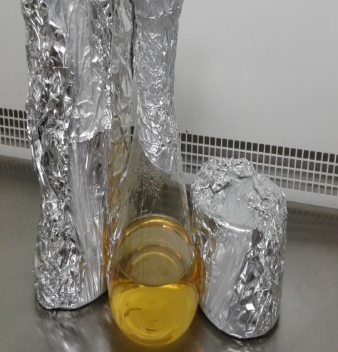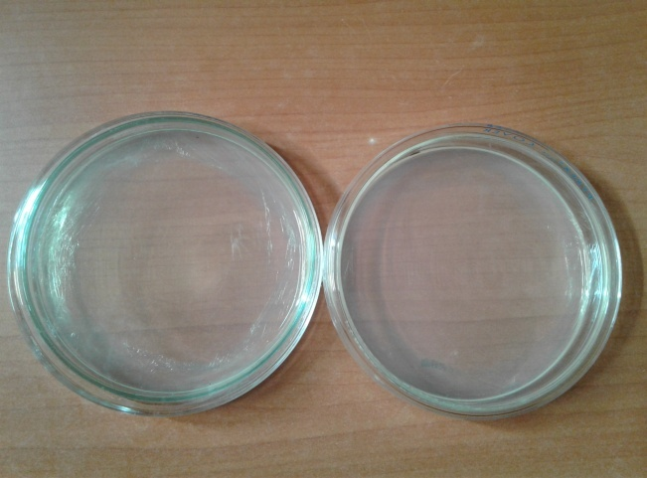

**Figure 1**: Sterilized NA medium (**A**); Middle poured into petri dishes (**B**)

**c.** **Collection of diseased tomato tissues and isolation of the *R. solanacearum* strain.**

Sampling consisted of collecting tomato leaves infected with *R. solanacearum* from the trial plot. The isolation was carried out under a luminous hood while disinfecting the hands, sterilizing the equipment with alcohol and the Bunsen burner which is a source of heat was used to reduce the risk of contamination.

After sampling the part of the leaves contaminated with *R. solanacearum* are cut and disinfected in 2% hypochlorite (98% water and 2% bleach is added) for 15 minutes, then they are removed in hypochlorite and rinsed in sterilized distilled water for 5 minutes, after 5 minutes they are removed from sterilized distilled water and placed on blotting paper to remove water droplets, this avoids contamination, and then the dried leaves were placed in an empty dish and a little distilled water was added then crushed and after grinding the liquid solution obtained is placed on the NA medium in petri dishes using a hip. These boxes are waxed and put in the incubator set at 25° for 72 hours*.*After 72 hours, or even on the5th and7th days, the bacteria develop and colonize the entire dish.

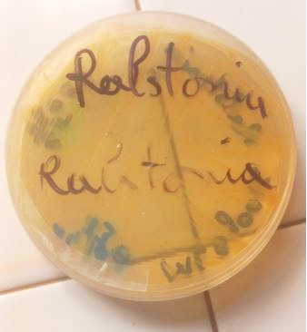

**Figure 2**: *Ralstonia solanacearum* colony

The only factor studied is bacterial wilt taken at five levels of variation.

**d.** **Experimental design**

The device used is the Fisher block with three repetitions with boards 5 m long by 1.4 m wide, i.e. an area of 7 m2separated by alleys 0.40 m wide. The trial plot had an area of 105 m2. The allocation of the different varieties to the plots was made by a random draw. Each elementary plot had three lines and observations were made on 05 plants of the central lines for each treatment. Transplanting was done at spacing of 60 cm between the rows and 40 cm on the line between the plants (60 cm x 40 cm).

* **Test ground plan**

Planks 5 m long by 1.4 m wide separated by 0.40 m wide aisles. The surface of the boards is 7 m2 each and the total area of the test is 105 m2.

Table 1: Test Ground Plan

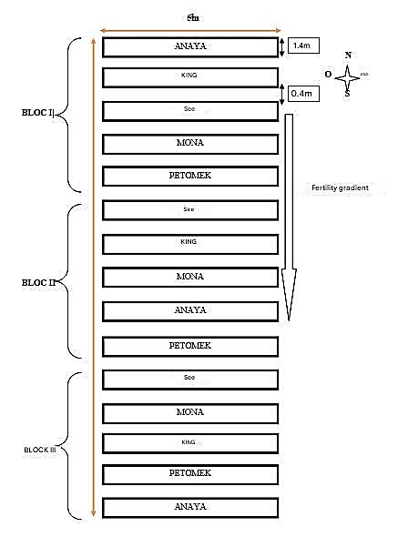

* **Inoculation**

The trial was conducted under the artificial conditions of high pressure of pathogen infestation. Only one source of inoculum was artificially used to infest the plants.

This source of inoculum consists of conidia of *Ralstonia solanacearum*(strain isolated from Sotuba at the ERC). This operation was carried out on 29/11/2023, when the plants are at the 3-4 leaf stage (seedling stage). It consisted of placing 3-5 sorghum seeds under the foot of each plant.

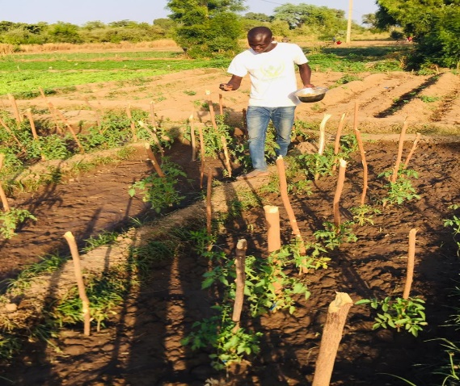 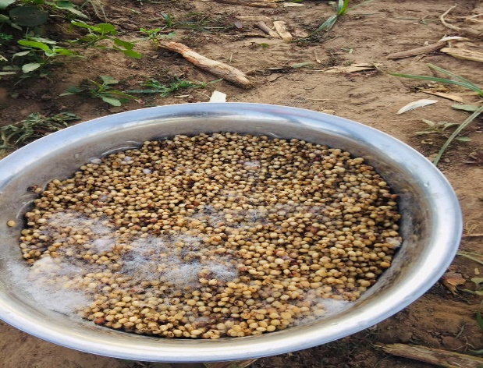

**Figure 3 (A, B):** Inoculation of the Inoculum plot

**2.** **Results**

The parameters observed during this research are: diameter at the collar, average height of the plants, average number of leaves of the plants and the average number of branches of the plants, incidence, severity of the disease and yield.

**a.** **Agronomic observations**

➢ **Average diameter at the collar of the plants (in cm):**

**Figure 4**: Effect of the factor studied diameter at the collar of the plants

In the 30th, 45th and 60th JAR, the variety Raja (T2) had the largest diameter at the collar of the plants (9.27 cm; 11.27 cm and 12.13 cm), followed by the variety Tingal (T3) with (8.53 cm; 9.47 cm and 10.93 cm). At the30th JAR, the Petomek variety (T5) had a small average diameter at the collar (5.83 cm).).

➢ **Average height of plants (in cm)**

**Figure 5:**Effect of the study factor on the average height of the plants

The analysis of variance showed a significant difference (S) between the levels of variation at the45th JAR, the variety Raja (T2) had the greatest height with an average (82.5 cm) and the variety Petomek (T5) had a low mean (49.8 cm). In the 30th and 60th JAR, the Raja variety (T2) had the greatest heights with an average (60.7 cm and 85.5 cm), followed by the Tingal variety (T3) with an average (53.31 cm; 66.1 m and 68 cm).

At the 30th JAR, the varieties Mona (T4**)** and Petomek (T5) had a low average height (38.7 cm).

➢ **Average number of plant leaves**

**Figure 6:**Effect of the factor studied on the average number of leaves of the plants

In the 30th, 45th and 60th JAR, the Raja variety (T2) had the highest number of leaves with an average (20.8; 39.5 and 40.1), followed by the Tingal variety (T3) with an average (17.8; 33.9 and 34.9). In the 30th and 60th JAR, the Petomek variety (T5) had a low average (13.5 and 23.7).

➢ **Average number of plant branches**

**Figure 7:**Effect of the factor studied on the average number of plant branches

The analysis of variance did not show a significant difference (NS) between the levels of variation on the mean number of branching of plants at the15thand 30th, 45thand 60thJAR.

In the 30th, 45th and 60th JAR, the Raja variety (T2) had the largest branches with an average (7.47; 7.47 and 9.8), followed by the Tingal variety (T3) with an average (6.13; 6.13 and 8.73). In the 30th JAR, the varieties Mona (T4) and Petomek (T5) had a low average.

➢ **Incidence of the disease**

**Figure 8:** Histogram of bacterial wilt incidence

Disease expression was monitored every 15 days after transplantation on the various treatments. The scoring is carried out according to the classic scale:

•         1 or more = plant or entirely withered;

•         0 = no symptoms on the plant.

The analysis of variance, showed no significant difference between the levels of variation, the variety Petomek (T5) had the large percentage with 73%, followed by the variety Anaya (T1) which had a percentage of 70%. The Tingal variety (T3) is tolerant of bacterial wilt.

**The impact was calculated using the following formula:**

Number of diseased plants

I%: ------------------------------------------------------- x100

Total number of plants observed

➢ **Effect of the factor studied on the severity of the disease in percentage**

**Figure 9:** Effect of the factor studied on the severity of the disease

Regarding severity, three (3) observations were made to assess the susceptibility of the different varieties to bacterial wilt.

**Table 2:** Severity rating scale

|  |  |
| --- | --- |
| **Note** | **Severity of Injury** |
| **0**  **1**  **2**  **3**  **4**  **5**  **6** | No symptoms    Less than 1% of leaf area affected  1-5% of leaf area affected  6 to 15% of leaf area affected  16 to 33% of leaf area affected  34 to 50% of leaf area affected  51 to 100% of leaf area affected |

At the first observation, the analysis of variance showed a highly significant difference (HS) between the levels of variation, the T5 which corresponds to the Petomek recorded the largest score of 80.5%, followed by the variety Anaya (T1) which had a score of 60.4% and the variety Raja (T2) had the lowest score of severity with 8.9%.

At the second observation, the analysis of variance showed a significant difference (**S**) between the levels of variation, treatment (T5) recorded the highest score with 81.2%, followed by treatment (T1) which had 66.1% and treatment (T3) had the lowest score with 22.2%.

For the third observation, the analysis of variance showed a significant difference between the levels of variation, Q5 had the highest score 85.9%, followed by T1 which recorded 84.4% and finally T3 and T4 had the lowest scores 24.4%.

➢ **Average yield of treatments (in t/ha)**

**Effect of the factor studied on the average yield of treatments**

**Figure 10:** Histogram of average yield in t/ha

The analysis of variance of the performance results showed no significant difference (LOS) between the five treatments. Nevertheless, the Tingal treatment gave the highest yield with 45.83 t/ha, followed by the Mona treatment with 39.46 t/ha. Finally, the Anaya and Petomek treatments gave the lowest yields with 21.66 t/ha and 20.55 t/ha respectively.

**5. Conclusion and Discussion**

The results obtained following the research work on the study of the behavior of five (05) varieties of tomato in the cool dry season under the agro-climatic conditions of Katibougou (Mali) did not reveal significant differences (NS) between some of the variables studied (diameter at the collar of plants, average height of plants, number of leaves, number of of ramifications) and a significant difference (NS) at the 45th JAR in the average height of the plants.

**1.**  Regarding the average diameter at the neck, the Raja treatment **(T2)** had the largest with 12.13 cm. In terms of average plant height, Raja (**T2**) was again the best with 82.5 cm, followed by the Tingal treatment (**T3**) with an average height of 68 cm. Compared to the average number of plant leaves, Raja (**T2**) comes out on top (40.1). Regarding the average number of branches, Raja (**T2**) had the most branched plants (9.8 cm).

**2.**  In terms of the results on disease severity, the analysis of variance showed a highly significant difference (**HS)** between the levels of variation in the first observation, **with Q5** recording the highest score with 80.5% and **Q2** having the lowest score with 8.9%. At the second observation the analysis of variance showed a significant difference (**S**) between the levels of variation, **Q5** gave the largest figure 81.2% and Q3 had the lowest score 22.2%. At the third observation, the analysis of variance showed a significant difference (**S**) between the levels of variation, **Q5** had the highest score 85.9% and finally, **T3** and **Q4** had the lowest scores 24.4%. Despite the strong pressure of the disease, the T3 and T4 treatments performed well against *R. solanacearum*andrecorded the lowest scores. These two treatments can be considered as varieties tolerant to bacterial wilt in the agro-climatic conditions of Katibougou.

Similar results were obtained in Côte d'Ivoire by **L. FONDIO et *al* (2013),**they observed a significant difference between varieties in relation to susceptibility to bacterial wilt, with wilted plants varying from 28% to 57.2% in a study evaluating nine (09) tomato varieties in relation to susceptibility to bacterial wilt and productivity in the south of Côte d'Ivoire. A study evaluating the sanitising potential of 3 green manure service plants and 2 types of organic soil improvers in the management of bacterial wilt in tomatoes revealed that analysis of the results showed a significant difference between the different treatments, with a 78% mortality rate due to bacterial wilt recorded by **S. JUILLIET (2017).**

**3.**  Analysis of variance of the yield results showed no significant difference (NS) between the five treatments. Nevertheless, the Tingal treatment gave the highest yield (45.83 t/ha), followed by the Mona and Raja treatments, which obtained 39.46 t/ha and 22.44 t/ha respectively. Finally, the Anaya and Petomek treatments produced the lowest yields at 21.66 t/ha and 20.55 t/ha respectively.

**Références**

1.  ALIOU S, 2020. Study of the physicochemical and microbiological quality of tomato concentrate, Doctoral thesis, 18 pages.

2.  ANONYMOUS 2, 2007. Sarl CASAP. Tomato varieties. (PDF), 3 pages.

3.  BARGUINI R. et TORRES E., 2009. Tomatoes and tomato products as dietary sources of antioxydants. Food Rev. Int*,*25 (3), 325 pages.

4. Bettache, 1993. Vascular fusarium wilt in the Oran region, Master's thesis in microbiology, phytopathology option.

5.  COULIBALY K., 2021. Study of the behavior of three tomato varieties (lycopersicum esculentum) in the agro-climatic conditions of Katibougou. End of Cycle Dissertation IPR/IFRA of Katibougou 61 pages.

6.  GUENAOUI Y., 2008. First observation of the invasive tomato leaf miner in the Mostaganem region in spring 2008, Phytoma, No. 617, Pp.18-19.

7.  KANTE M., 2018. *Study of the behavior of three tomato varieties (Lycopersicum esculentum) in cool dry periods under the agro-climatic conditions of Katibougou. End of cycle thesis IPR/IFRA of Katibougou, 60 pages.*

8.  Kelly, V. A., Carpenter, J., Diall, O., Easterling, T., Kone, M., Mc Cornick, P. G., et Mc Gahuey, M. 2005. Option for economic growth in Mali through the application of science and technology to agriculture. The United States Agency for International Development initiative to endhunguerin Africa. Report Bas, Pp. 419-426.

9.  Martin HILMI, Shankara NAIKA, Joep van Lidt de JEUDE, Marja de GOFFOU, Barbara van DAM. 2020. Tomato cultivation: production, processing and marketing. Agromisa Foundation and CTA, Wageningen, Agrodok Series No. 17, 6, 9 pages;

10.  Sabiriba Alain H., 2018. Study of the effectiveness of solarization associated with local manures on the incidence of bacterial wilt of tomato (Solanum lycopersicum Lin. 1754) and their effects on soil bacteria and fungi in the western zone of Burkina Faso. End-of-cycle dissertation for obtaining a Master II in Integrated Natural Resources Management at NAZI BONI UNIVERSITY (UNB), 90 pages.