

Gross and histopathological characterization of Ovine Pulmonary

Adenocarcinoma in Libya

***Original Research Article***

# ABSTRACT

**Aims:** To first determining the prevalence rate of ovine pulmonary adenocarcinoma (OPA) in slaughtered sheep at the slaughterhouses located in the East of Libya and investigation of OPA grossly and histopathologically.

**Study Design:** This study was carried out in the El-Beida slaughterhouses located in the Eastern Libya during October (2020) - April (2021).

**Methods:** Lungs of totally 525 native sheep carcasses were examined grossly; and then, subjected to collection the tissue sections from an overall 141samples to be examined histopathologically.

**Results:** OPA was detected in 1.1% of all examined cases and in 2.97% of affected lungs. Also, four out of six sheep (66.67%) were showed the classical form of disease whereas the atypical lesions were detected in two out of six sheep (33.33%). Histopathological changes were almost similar in the two forms of the disease.

**Conclusion:** OPA is well documented for the first time in sheep from El-Beida area and classical and atypical forms of OPA were reported and described. Moreover, this study provides a morphological background necessary for routine differentiation and indicates the necessity for initiating further studies on identifying the epidemiology, etiological agents and pathogenesis of OPA in Libyan sheep

*Keywords: Sheep; adenocarcinoma; morphopathological; Libya.*

# ABBREVIATIONS

*OPA : Ovine Pulmonary Adenocarcinoma*

# INTRODUCTION

In Libya, there are 5,000 heads of cattle, 6,500,000 heads of small ruminants, 110,000 slippers of camels, in addition to 12,000 of the equine species and 15 million chicken birds [1].

Small ruminants are a major source of protein in Libya and many of them are found in the eastern region. The Al-Jabal Al-Akhdar (means Green Mountain), as part of the eastern region of Libya, is characterized as a pastoral area due to the fertility of its soil and the abundance of rainfall. The number of breeders in this region is 2,210, the number of sheep, 580989, and goats is 55,388, while the number of cows is 14,4697, camels 5873, and horses 1137 [2]. However, livestock in that area is not fully exploited due to the spread of some diseases, especially respiratory diseases that cause damage to lung tissue, low growth rate and carcass condemnation and the consequent significant economic impact on animal husbandry due to the need to revitalize chemical treatment programs and immunization in addition to mortality [3]. Pneumonia is the main respiratory disease in Libya, especially in the Jabal Al- Akhdar region, where pneumonia was detected in 141 (26.9%) sheep [4].

In addition to pneumonia, there are other lung diseases and lesions, including sheep lung adenocarcinoma (SLA) or sheep pulmonary adenomatosis (SPA) or ovine pulmonary adenocarcinoma (OPA). The first appearance of the disease was in South Africa with the local name Jaagsiekte, which means literary drive disease [5]. From there it spread to all countries of the world, causing a serious impact on the sheep farming sector in the affected areas [6–8]. OPA has long incubation period so it develops slowly and considers as a chronic respiratory disease of adult sheep characterized by transformation of the bronchiole-alveolar epithelium with transverse metastasis to regional lymph nodes [9–11]. Also it is known as a contagious sheep lung and has a striking similarity to some forms of human adenocarcinoma [11,12],;however, etiology of OPA remains controversial [5,13]. Morphological, biochemical, and immunological changes raise suspicions about the type D- associated retrovirus (Jaagsiekte sheep retrovirus, JSRV) [14,15], however, it cannot be cultured *in vitro* yet. The following researches have proven that type D-associated retrovirus has been consistently detected in the neoplastic pulmonary epithelium of infected sheep both naturally and experimentally [16–18]. After that, Palmarini and Fan, in 2001 cloned and sequenced the jaagsiekte sheep retrovirus (JSRV) [11].

This virus can infect all ages, but due to the long incubation period, clinical signs generally appear in adult sheep between 2 and 4 years old [19]. The incidence of OPA usually ranges from 2 to 5% but in some herds it can reach 30% [20]. Affected sheep suffer from febrile respiratory illness associated with weight loss. Two pathological forms of OPA are recognized including classic and atypical. In classical forms, neoplastic lesions occur mainly in the central cranial parts of all lobes of the lung. Atypical forms tend to be more nodular in both early and advanced tumours [21].

In Libya only one study has been carried out on OPA in Tripoli area by Ali and Abdelsalam (1999) who reported an occurrence of OPA in 4 lung sheep slides pulled from the archive collected ten years ago in the Tripoli region. However, gross feature was examined in one case that was available in the time of study [22].

Since most of lung diseases including OPA are chronic and subclinical diseases, as well as lacking of our understanding of the epidemiology and detailed knowledge of the time of onset of their severely, the clinical diagnosis of these diseases is difficult in the live animal. Thus, the only available and accurate diagnosis for lung lesions is examination at slaughterhouse as an easy and cheap source of data for evaluation of the epidemiological aspects of lung diseases including OPA. Therefore, the purpose of this study was to determine a first estimate of the prevalence of OPA in sheep, by identifying the common pathological gross and histopathological lesions of slaughtered sheep in East of Libya. Also, this study aimed to define morphopathological characteristics of OPA forms in native sheep of Libya. As these steps could give a hint about the epidemiology and detailed knowledge of the time of onset of OPA severely additionally, could give baseline data for future monitoring of this disease.

# MATERIALS AND METHODS

This study was carried out in Municipality of El- Beida which located in the eastern part of Libya and extended between 32°45'N latitude and 21°44'E longitude with an elevation of 623 meters above sea level. This area characterized by a mild Mediterranean climate where the average temperature in the hottest months is 22°C and the annual precipitation is 400 m.

The animal population involved in this study was all sheep and was local breed, mostly male animals, their age more than 4 months and all the animals were submitted for routine slaughter. All sheep are managed under a pastoral production system. Sheep are usually mixed with other types of livestock (goats, cows, dogs and camels in some areas) [4].

Lungs of 525 sheep carcasses were examined in some El-Beida slaughterhouses during October 2020 to April 2021. The gross examination of these lungs was carried out with respect to size, colour and consistency. Then lungs with gross lesions (n = 141) were collected and were subjected to histopathological examination.

The location and pathological description of lungs lesions were examined, recorded and photographed. Representative pieces of tissues (4-5 mm in thickness) were then taken from the affected lungs, fixed with 10% neutral buffered formalin, and transported to Omar El-Mukhtar University, Veterinary Pathology Laboratory. Tissue samples 1 cm3 in thickness were then dehydrated in graded ethanol and embedded in paraffin. Sections 5 µm in thickness using rotary microtome (Leica, Germany) then were stained with Harri's haematoxylin and eosin [23,24] and examined by an ordinary light microscope. Finally, the stained slides were examined systematically at 10X and 100X magnifications for the presence of characteristic and/or suggestive lesions using ordinary light microscope.

# RESULTS

OPA was detected in 1.1% (n = 6/525) of all examined sheep and in 2.97% (n = 6/202) of the lung lesions. Four of these cases had the classical form of OPA whereas the other two had the atypical OPA.

Grossly, lung with classic OPA saw enlarged, heavy, and wet. Also, several firm, pale, variably sized whitish grey to grey nodules (about 1-9 cm in diameter) surrounded by emphysematous lung tissue were seen in the cranio-ventral lobes or diaphragmatic lobes (Fig. 1A). Additionally, there was mucoid secretion in the lumen of airways. In two cases, several lesions tended to coalesce to form larger masses with firm consistency (Fig. 1B & C). In both the lesion was bilaterally located and involving up to 30% of the pulmonary parenchyma (Fig. 1B & C) owing to this the lungs failed to collapse, and they were heavy and dense.

OPA atypical was characterized by greyish- white, dried subdural nodules or confluent lesions about 2–3 cm in diameter (Fig. 2A). Some of these lumps were pearly white and dry (Fig. 2A). There was no pulmonary fluid on the cutting surface or in the bronchial lumen in both cases. In one case, greyish-white, jelly-like, isolated, well-defined and non-encapsulated nodule without areas of haemorrhage or necrosis was observed (Fig. 2B). On the cutting surface, this nodule showed a multilobed appearance, smooth to dense and gelatinous feature and consisted with myxoma- like masses.

Microscopically, the main histopathological features of both types of OPA are hypertrophy and hyperplasia of epithelial cells lining airways and alveoli (Fig. 3A) as well as metaplasia of these epithelial cells to columnar known as neoplastic cells forming non-encapsulated papillary structures (Fig. 3B). These papillary structures extended into the lumen of the alveoli and some of them tend to occlude the lumen of many alveoli partially or completely with cystic acinar structure (Fig. 3C). The alveolar septa were diffusely expanded by lymphocytes and by hyperplastic smooth muscles (Fig. 3C). Neoplastic cells had cytoplasmic vacuolation because of vacuolar degeneration (Fig. 3D).

In addition, variable numbers of desquamated alveolar macrophages were present inside the affected alveoli (Fig. 4A). This carcinomic structure is supported by variable amount of loose to dense connective tissue and chronic inflammatory reactions dominated by diffuse of plasma cells and lymphocytes, which occasionally formed multifocal interstitial and perivascular aggregates in the affected areas (Fig. 4B).

Concerning the presence of small foci of myxomatous tissue in a case with a typical OPA

form, the histological examination revealed that myxoid growth without neoplastic epithelial component, and the neoplasm was composed by short bundles and streams of spindle, stellate or individual cells and abundant extracellular matrix with no mitotic activity, no lipoblasts and delicate blood vessels as shown in Fig. 5.

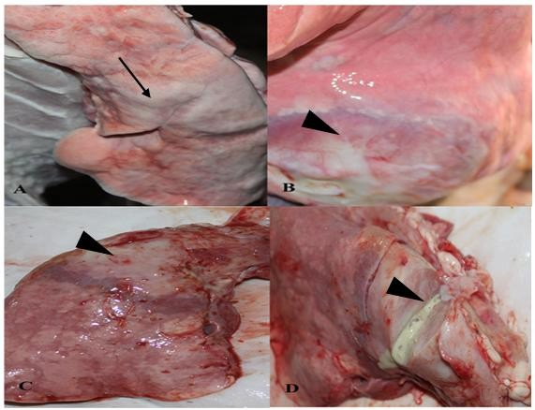

**Fig. 1. Gross picture of classic OPA: A- affected lung has areas of firm, pale, variably sized surrounded by emphysematous lung tissue (black arrow). B& C several lesions tended to coalesce to form larger masses (diffuse consolidation) with firm consistency (black arrowheads). D- mucus secretion came out from cut section of consolidated area of OPA affected lung (black arrowhead)**

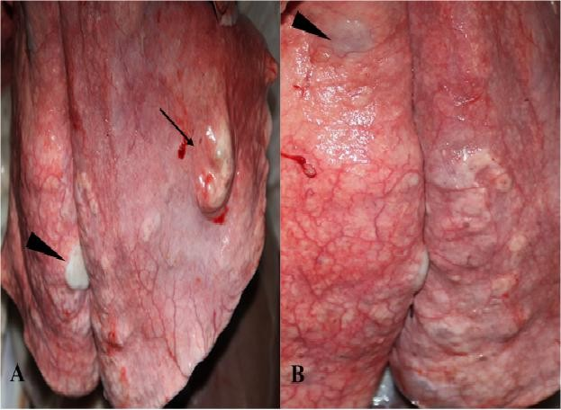

**Fig. 2. Gross picture of atypical OPA: A- affected lung has areas of greyish-white, dried subdural nodules (black arrow) and pearly white and dry (black arrowhead). B. affected lung has areas of greyish-white, isolated, well-defined, non-encapsulated nodule, gelatinous appearance and consisted with myxoma- like masses (black arrowhead)**

26

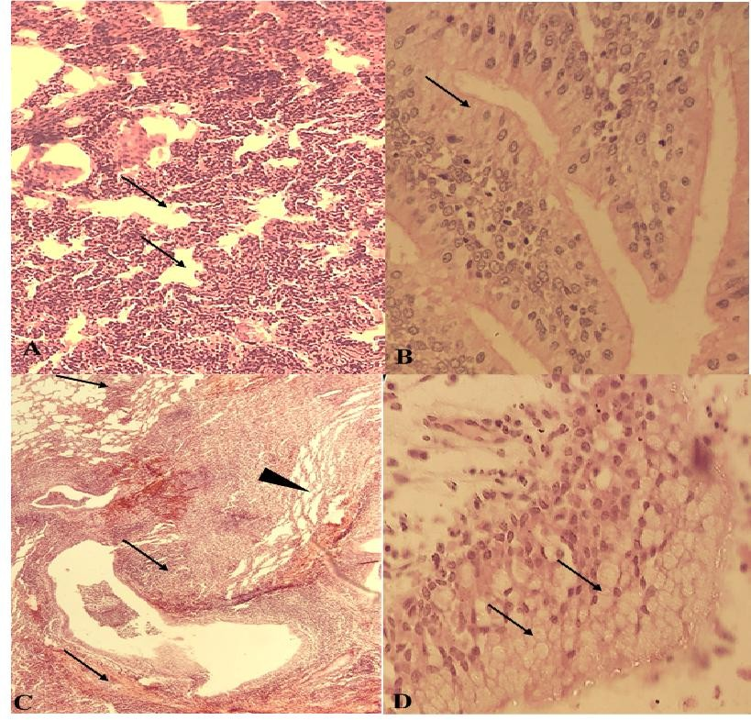

**Fig. 3. Microscopical picture of OPA: A& B- none capsulated papillary structures due to hypertrophy and hyperplasia of epithelial cells lining airways and alveoli (black arrows). B- metaplasia of these epithelial cells to columnar known as neoplastic cells (black arrows). C- papillary structures extended into the lumen of the alveoli causing cystic acinar structure (black arrowhead). The alveolar septa were diffusely expanded by lymphocytes and by hyperplastic smooth muscles (black arrows). D- cytoplasmic vacuolation was seen in neoplastic cells because of vacuolar degeneration (black arrows)**

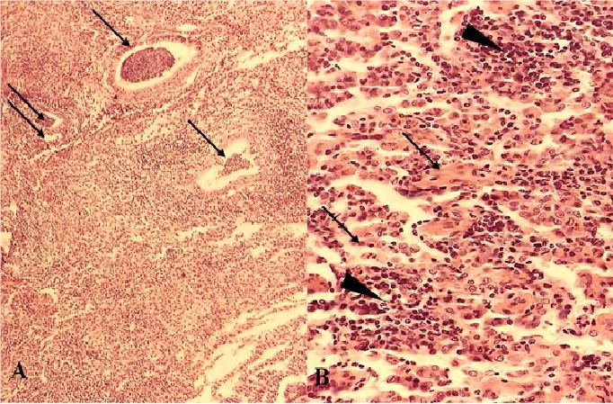

**Fig. 4. Microscopical picture of OPA: A- desquamated alveolar macrophages were present inside the affected acini and alveoli (black arrows). B- amounts of loose to dense connective tissue (black arrow) was noted, inflammatory cells particularly plasma cells and lymphocytes occasionally formed multifocal interstitial and perivascular aggregates in the affected areas (black arrowheads)**

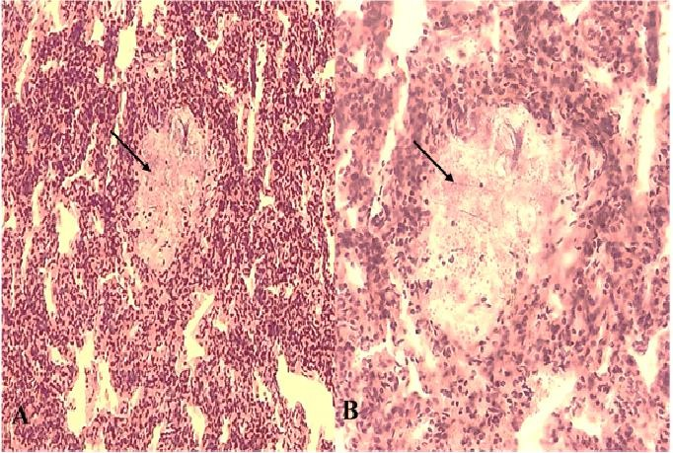

**Fig. 5. Microscopical picture of OPA: A- myxomatous tissue (black arrow). B- Foci of adenomatous proliferations of the alveolar epithelium embedded within the pneumonic parts of the lung tissue (black arrow)**

# DISCUSSION

Respiratory diseases in general and pneumonia in particular are common diseases in various species of domestic animals including sheep leading to retarded growth and reduced weight- gains in recovered animals, slaughterhouse wastage, drugs and labor costs as well as high mortality rate. Last study showed that pneumonia is an important sheep disease in Libya and confirmed the types and frequency of gross and microscopic snwisew of pneumonia observed in sheep slaughtered at Libya [4].

APA as a respiratory disease is of biomedical importance and is a substantial economic problem to sheep producers worldwide [25]. Although, many methods have been used to diagnose OPA using recent techniques [26], necropsy and histopathology remains the gold standard diagnostic test for OPA. Accordingly, the present work conducted to study the incidence of OPA in slaughtered sheep. To our knowledge, this study not just confirms the presences of the disease in Libya but also records for the first time the incidence of OPA in slaughtered sheep in Libya and records for the first time the presence of OPA in east part of Libya. Additionally, this study is the first morphological description of two types of OPA in Libya.

Of 525 sheep examined, OPA was encountered in 1.1% of examined cases and in 2.97% of affected lungs. The results of the present study are consistent with the Kumar and co-workers [27], with the study by Abdelsalam and Al Sadrani [28], with the report of Mekibib and co- workers [29] who reported OPA in 4.87%, 8.6% and 3.4% of the samples respectively. On the other hand, this finding is in disagreement with the report of Woldemeskel and Tibbo [30], who had observed OPA in 22.8% with high incidence whereas low incidence was recorded by the report of Khodakaram-Tafti and Razavi [31] and by the report of Hashemnia and co-workers [32] who had observed OPA in 0.22% and 0.6% of the samples respectively. Local retrospective study in 1999 by Ali and Abdelsalam confined to Tripoli area reported typical microscopic changes of OPA in four cases out of 1114 (0.35%). However, it does not probably reflect the real epidemiological status of the disease in the whole country since it was a retrospective survey and was only confined to Tripoli area [22].

It was of interest that, the incidence of OPA around the world is range from 0.2% to 22% and this due to many factors including countries geography, environmental conditions, health status of flocks, and time of study conducted.

The pathological manifestations of classical form of the disease were reported by several researchers in the world. In general this study was similar to many studies that showed the lesions grossly varied from multifocal greyish nodules to complete consolidation of the entire lungs. Additionally, there was mucoid secretion in the lumen of airways [11, 27, 31, 33-36]. In contrast, there are few reports of atypical OPA. This study reports the atypical OPA as greyish- white, dried subdural nodules or confluent lesions about 2–3 cm in diameter and some of these lumps were pearly white and dry similarly findings of other researchers [21],[31] . Interestingly, this study showed every form present in deferent lung while some reports showed that both forms are present in the same lung [21, 31, 37].

Concerning the microscopic picture of OPA, this study was similar to many studies reporting that the histological changes in the affected areas in classical and atypical OPA were essentially the same and the distinction between the two types is not clear. Also, similar to the studies reported that the lesion develops initially near the bronchioles, where the epithelial lining of both the alveolar septum and bronchioles are simultaneously affected, where cuboidal cells or short columnar cells proliferate abnormally and line the affected alveoli and bronchioles, resulting in the formation of irregular folds and papillary prominence [11, 25, 27, 31, 34–36, 38, 39].

It seems that this uncontrolled proliferation of cells is due to the activation of telomerase that maintains telomeres, repetitive (TTAGGG) DNA– protein complexes at the ends of chromosomes crucial for the survival of cancer cells. Also, telomerase plays role in Akt activation which is important for cell survival, growth, proliferation, angiogenesis, vasorelaxation, and cell metabolism. All these may inhibit cellular senescence and contribute to the accumulation of tumour cells in mixed adenocarcinoma with a bronchioloalveolar component and this has recently been evidenced in OPA and in tumoral lung tissues [40,41].

In the present study, the predominant local immune response was an influx of lymphocytes, macrophages and plasma cells. This lymphatic aggregation found around bronchiole in the affected lungs resulting in decrease the size of bronchi and waning the alveoli around those bronchi. Also, this study showed the accumulation of macrophages within apparently normal alveoli beside affected alveoli. This is in agreement with other reports reporting these features as prominent features in the OPA [42,43]. These features may be activated by transformed cells that produce a macrophage

chemotactic factor which in turn might serve as a mechanism for recruiting macrophages into OPA affected lungs. Foamy macrophages are frequently noted in bronchiolitis and diseases characterized by a clinically and functional obstructive picture coupled to subtle-to-evident inflammation and fibrosis of the small airways. Macrophages may potentiate tumour growth or represent an ineffective cellular cytotoxic mechanism directed against transformed cells as seen in sites of other tumour growth [27].

An interesting finding was the presence of necrosis of the proliferated area, the hyperplasia of smooth muscle cells in the interstitial tissues and variable amount of loose to dense fibrous connective tissue. These features were seen in the interstitial tissue of neoplastic foci in both forms of OPA, these reactive changes in the tumour stroma which seems to be due to a specific immune response of the host [27].

Also, it was of interest, according to De las Heras *et al.* (2006) the stroma of the atypical OPA usually appears heavily infiltrated by mononuclear inflammatory cells and connective tissues compared to classical type [44].

Interestingly**,** the myxomatous changes associated with some adenomatous foci were found in the interstitial tissue of the area affected with OPA. In this study, the presence of small foci of myxomatous in the interstitial connective tissue was similar to those described by others [25,43,45]. The origin of the myxomatous changes remains uncertain. Sharp and Angus (1990) postulated that it is derived from mesoderm, However, it remains unclear whether it is a true component of tumours or is associated with other factors.

To give a brief explanation for the pathology of the disease, OPA has been shown as one of the most common viral diseases of sheep in many regions of the world. JSRV has been reported as the causative agent of OPA [11, 16-18]. Also, JSRV Env glycoprotein (JSRV Env) has been demonstrated to be a tumorigenic protein that induces epithelial cell transformation, as expression of JSRV Env has been reported to be sufficient to transform a variety of cell lines in vitro and induce lung cancer in immunodeficient mice [19]. However, the mechanisms underlying the process by which JSRV Env causing this transformation are not fully understood. In some studies, using cell culture, JSRV Env appeared to activate a number of protein kinase signalling

29

cascades that play role to promote cellular proliferation, with the phosphatidylcholine-3- kinase-Act and MEK-ERK pathways of particular interest. This activation of certain signalling pathways with additional mutations is required for OPA development, and this process may take longer [19]. This would explain the long incubation period of natural OPA. Together they all involve telomerase activation which in turn enables cells to proliferate indefinitely. Telomerase activation has been described in OPA primary tumour cell cultures [19,40,41].

# CONCLUSION

The results of this study confirm and provide clear evidence for the presence of OPA within Libyan sheep flocks as well as a morphological basis for diagnosing these pathologic condition lungs of sheep. However, more specific epidemiological studies are needed to investigate the prevalence of OPA in the whole country and to assess age and breed susceptibility of OPA. Further investigations are needed that examine the factors involved and responsible for the development of OPA. Additional work is also needed to screen for OPA in sheep during the rest of the year. This may help to disclose the complex pathogenesis of this economically important disease, therefore, lead to the establishment of practical control measures in the region as well as indication of the nature and type of prompt control and treatment.

# REFERENCES

1. FAOSTA. FAOSTA. FAOSTA.

Available:[http://www.ipcinfo.org.](http://www.ipcinfo.org/) Published 2017.

1. Ministry of Health and Livestock - Agriculture and Livestock Sector - Municipality of El-beida. Animal Census in Al-Bayda Province.; 2022.
2. Goodwin K, Jackson R, Brown C, Davies P, Morris R, Perkins N. Pneumonic lesions in lambs in New Zealand: patterns of prevalence and effects on production. N Z Vet J. 2004;52(4):175-179. DOI:101080/00480169.2004.36425
3. Mohammed ZM, Ibrahim WM, Abdalla IO. Pneumonia in Slaughtered Sheep in Libya: Gross and Histopathological Findings. Eur J Vet Med. 2022;2(2):4-9. DOI:10.24018/ejvetmed.2022.2.1.18
4. Cowdry EV. Studies on the aetiology of Jaagsiekte. J Expt Med. 1925;42:323-345.
5. Shirlaw JF. Studies on Jaagsiekte in Kenya. Bull Epiz, Dis Afr. 1959;7:287-302.
6. Cutlip R, Young S. Sheep pulmonary adenomatosis (Jaagsiekte) in the United States. Am J Vet Res. 1982;43:2108-2113.
7. Bassett HF, Sheehan P. Outbreak of sheep pulmonary adenomatosis in the Irish Republic. Vet Rec. 1989;124(2):46- 47.
8. Perk K. Slow virus infection in ovine lung. Adv Vet Sci Comp Med. 1982;26:267-288.
9. De Martini JC, York DF. Retrovirus- associated neoplasms of the respiratory system of sheep and goats. ovine pulmonary carcinoma and enzootic nasal tumor. Vet Clin North Am Food Anim Pr. 1997;13:55-70.
10. Palmarini M, Fan H. Retrovirus-induced ovine pulmonary adenocarcinoma, an animal model for lung cancer. J Natl Cancer Inst. 2001;93(21):1603-1614. DOI:101093/jnci/93.21.1603
11. Mornex JF, Thivolet F, De las Heras M, Leroux C. Pathology of human bronchioalveolar carcinoma and its relationship to the ovine disease. Curr Top Microbiol Immunol. 2003;275:225-248.
12. Macky JM. Tissue culture studies on sheep pulmonary adenomatosis (Jaagsiekte). J Comp Path. 1969;97:141- 146.
13. York DF, Vigne R, Verwoerd DW, Querat

G. Isolation, identification, and partial cDNA cloning of genomic RNA of jaagsiekte retrovirus, the etiological agent

of sheep pulmonary adenomatosis. J Virol. 1991;65(9):5061-5067.

DOI:101128/jvi.65.9.5061-5067.1991

1. York DF, Vigne R, Verwoerd DW, Querat

G. Nucleotide sequence of the jaagsiekte retrovirus, an exogenous and endogenous type D and B retrovirus of sheep and goats. J Virol. 1992;66(8):4930-4939. DOI:101128/jvi.66.8.4930-4939.1992

1. Palmarini M, Dewar P, De las Heras M, Inglis NF, Dalziel RG, Sharp JM. Epithelial tumour cells in the lungs of sheep with pulmonary adenomatosis are major sites of replication for Jaagsiekte retrovirus. J Gen Virol. 1995;76(11):2731-2737. DOI:101099/0022-1317-76-11-2731
2. Palmarini M, Holland MJ, Cousens C, Dalziel RG, Sharp JM. Jaagsiekte retrovirus establishes a disseminated infection of the lymphoid tissues of sheep affected by pulmonary adenomatosis. J Gen Virol. 1996;77(12):2991-2998. DOI:101099/0022-1317-77-12-2991
3. Palmarini M, Cousens C, Dalziel RG, Bai J, Stedman K, DeMartini JC, et al. The exogenous form of Jaagsiekte retrovirus is specifically associated with a contagious lung cancer of sheep. J Virol. 1996;70(3): 1618-1623.

DOI:10.1128/jvi.70.3.1618-1623.1996

1. Griffiths D, Martineau H, Cousens C. Pathology and pathogenesis of ovine pulmonary adenocarcinoma. J. Comp. Pathol. J Comp Pathol. 2010;142:260-283.
2. Toma C, Bâlteanu VA, Tripon S, Trifa A, Rema A, Amorim I, et al. Exogenous Jaagsiekte Sheep Retrovirus type 2 (exJSRV2) related to ovine pulmonary adenocarcinoma (OPA) in Romania: prevalence, anatomical forms, pathological description, immunophenotyping and virus identification. BMC Vet Res. 2020;16(296). DOI:10.1186/s12917-020-02521-1.
3. Garcia-Goti M, Gonzalez L, Cousens C, Cartobarria N, Extra- miana, A.B., Minguijon E, Ortin A, et al. pulmonary adenomatosis: characteriza- tion of two pathological forms associated with Jaagsiekte retrovirus. J Comp Pathol. 2000;122:55–65.
4. ALI O, Abdelsalam E. Sheep pulmonary adenomatosis (Jaagsiekte) in Libya : Gross and histopathological evidence. Rev d’élevage médecine vétérinaire des pays Trop. 1999;52(3-4):181-183. DOI:10.19182/remvt.9660
5. Luna L. Manual of Histologic Staining Methods of the Armed Forces Institute of Pathology. *Mc Graw* Hill, NewYork, NY, USA, 7th Ed 1968. Published online; 1968.
6. Gharban HA, Al-Shaeli SJ, Hussen TJ. Molecular genotyping, histopathological and immunohistochemical studies of bovine papillomatosis. Open Vet. J. 2023; 13(1): 26-41. DOI: [10.5455/OVJ.2023.v13.i1.4](https://doi.org/10.5455/OVJ.2023.v13.i1.4)
7. Sharp J, Angus K. Sheep pulmonary adenomatosis: clinical, pathological and experimental aspects. In: *In: Pétursson G.,* Hoff-Jørgensen R. (Eds) Maedi-Visna and Related Diseases. Developments in Veterinary Virology,. Springer. 1990;157- 175.

Available:https://doi.org/10.1007/978-1- 4613-1613-8_9

1. Quintas H, Pires I, Garcês A, Prada J, Silva F, Alegria N. The Diagnostic Challenges of Ovine Pulmonary Adenocarcinoma. Ruminants. 2021;1:58–

71.

DOI:org/10.3390/ruminants1010005

1. Kumar M, Kumar R, Varshney KC, Palanivelu M, Sridhar BG, Sivakumar M. Incidence of ovine pulmonary adenocarcinoma in southern parts of India: A slaughter house based study. Indian J Vet Pathol. 2014;38(3):149. DOI:10.5958/0973-970x.2014.01162.6
2. Abdelsalam EB, Al Sadrani AA. Incidental findings of pathological significance in pneumonic lungs of sheep in Al Qassim Area, Kingdom of Saudi Arabia: an abattoir survey. Comp Clin Path. 2015;24(4):951- 955.

DOI:10.1007/s00580-014-2050-3

1. Hussen TJ, Al-Shaeli SJJ, Al-Mahna BHR, Gharban HAJ. Biochemical and histological effects of long-term administration of estrogen on female mice. Adv. Anim. Vet. Sci. 2024; 12(8), 1563-1572. DOI: [10.17582/journal.aavs/2024/ 12.8.1563.1572](https://dx.doi.org/10.17582/journal.aavs/2024/12.8.1563.1572).
2. Woldemeskel M, Tibbo M. Pulmonary adenomatosis and maedi-visna in Ethiopian central highland sheep : a microscopic study Pulmonary adenomatosis and maedi-visna in Ethiopian central highland sheep: A microscopic study; 2014. DOI:10.1007/s11250-009-9520-7
3. Khodakaram-Tafti A, Razavi Z. Morphopathological study of naturally occurring ovine pulmonary adenocarcinoma in sheep in Fars province, Iran. Iran J Vet Res. 2010;11(2): 134-138.
4. Hashemnia M, Chalechale A, Malmir E. Pulmonary lesions in slaughtered sheep in western iran: Gross and histopathological findings. Vet Ital. 2019;55(1):47-56. DOI:10.12834/VetIt.785.3795.3
5. Sayyari M, Mohamadian B. Histopathological study of naturally occurring ovine pulmonary adenocarcinoma in native goat in khuzestan, iran. Iran J Vet Res. 2012; 13(4):334-338. DOI:10.22099/ijvr.2012.615
6. Lee AM, Wolfe A, Cassidy JP, Messam LLM, Moriarty JP, Neill RO, et al. First confirmation by PCR of Jaagsiekte sheep retrovirus in Ireland and prevalence of ovine pulmonary adenocarcinoma in adult sheep at slaughter. Published online 2017;1-12.

DOI:10.1186/s13620-017-0111-z

1. Oda SS, Youssef SA. Immunohis- tochemical and histopathological findings of ovine pulmonary adenocarcinoma (Jaagsiekte) in Egyptian sheep. Published online 2011;1611-1615. DOI:10.1007/s11250-011-9878-1
2. Radad K, Khalil S. Natural ovine pulmonary adenocarcinoma in an Egyptian sheep farm. Published online 2014:39-43.
3. Al-Hizab FA, Abdelsalam E. Adenomatous Lesion in a Pneumonic Lung of a Local Indigenous Saudi Goat. Pakistan J Biol Sci. 2005;8(4):542-545.
4. Azizi S, Korani FS, Oryan A. Pneumonia in slaughtered sheep in south-western Iran: Pathological characteristics and aerobic bacterial aetiology. Vet Ital. 2013;49(1): 109-10918.
5. Azizi S, Tajbakhsh E, Fathi F. Ovine pulmonary adenocarcinoma in slaughtered sheep: A pathological and polymerase chain reaction study. J S Afr Vet. 2014; 85:932-937.
6. Suau F, Cottin V, Archer F, Croze S, Chastang J, Cordier G, et al. Telomerase acti-vation in a model of lung adenocarcinoma. Eur Respir J. 2006;27: 1175–1182.
7. Jafri M, Ansari S, Alqahtani MH, Shay JW. Roles of telomeres and telomerase in cancer, and advances in telomerase- targeted therapies. Genome Med. 2016; 8(69):1-18.

DOI 10.1186/s13073-016-0324-x

1. Summers C, Norval M, De las Herasm M, Gonzalez L, Sharp J. An influx of macrophages is the predominant local im¬mune response in ovine pulmonary adenocarcinoma. Vet Immunol Immunopathol. 2005;106:285-294.
2. Kojour G, Karimi I. Sheep pulmonary adenomatosis: a study on prevalence and pathological findings. Pajouhesh-va- Sazandegi. 2002;53:64-67.
3. De Las Herasa M, Ortín A, Benito A, Summers C, Ferrer LM, Sharp J. In-situ Demonstration of Mitogen-activated Protein Kinase Erk 1/2 Signalling Pathway in Contagious Respiratory Tumours of Sheep and Goats. J Comp Pathol. 2006;135(1):1-10.
4. Bouljihad M, Drommer W, Leipold H. Pathologic and ultrastructural findings in sheep in Morocco with naturally occurring jaagsiekte (sheep pulmonary adenomatosis). Small Rum Res. 1996;19: 275-280.