**The Impact of the Epidemic on the Learning and Research Output of Graduate Students**

**Abstract** Everyone got the impact from the COVID-19 epidemic on lives and studies to some extent. In order to quantitatively analyze the impact of the epidemic on postgraduate students’ learning and research achievements, this paper focuses on dimensions including “research communication”, “research data acquisition”, “publication and cultivation process”, “financial support and research topics”, “internship and practice”, “graduation and job-hunting”. Structural equation modeling is used to analyze the data collected from questionnaires. The results show significant correlations between “research communication” and any of the three dimensions of “research data acquisition”, “publication and cultivation process”, “financial support and research topics”. It finds out that “access to research data” has a significant effect on “publication and training process”. It also reveals a strong correlation between the following three pairs of dimensions, which are pair of “research data acquisition” and “financial support and research topics”, “publication and cultivation process” and “financial support and research topics”, as well as “publication and cultivation process” and “practice and job-hunting”.

**Keywords:** COVID-19; graduate students; learn and research; structural equation modeling

**1. Introduction**

From the end of 2019 to the end of 2022, the outbreak of COVID-19 epidemic has affected various sectors in the country, especially an unprecedented impact on the education sector. It changed the learning style of students, who had to adapt to online-learning. Graduate students were not exceptions, although they are a bit different from other types of students. Graduate students are usually required to regularly engage in academic discussions with their supervisors, experiments in laboratories, and academic conferences home and abroad. It is of great significance for the mechanism of graduate student training and educational theories to know whether these rapid changes of the learning environment have an impact on graduate students’ learning situation and research output and how to quantitatively describe this impact.

Many research results are found regarding the impact from the epidemic to the students. This paragraph summarizes the results from research perspective and student level. Regarding research perspectives, existing researches mainly focus on the changes in the aspects of students’ learning attitude, academic performance, learning ability and motivation, and learning stress in the context of online learning. Regarding student level, existing researches focus on the changes of undergraduate students and high-school students. Raviv et al (2023) studied the tendency of students to quit in the context of online academic courses offered by schools under the impact of the epidemic. They found that learning in online and online-offline-mixed courses has a significant impact on personal skills and learning abilities, and these factors also affect dropout rates. A survey carried by Rahman et al (2023) found that challenges and difficulties of online learning together with its effectiveness, and students’ motivation, had a substantial impact on students’ attitudes toward online learning. Almomani et al (2023)assessed the impact of online learning on students’ self-directed learning skills and motivation to learn during the COVID-19 and the results showed that online learning had a positive impact on students’ motivation, self-directed learning skills, students’ organizational skills, learning management skills, learning resource utilization skills, and self-evaluation skills. Pérez et al (2023) investigated the impact of sudden changes in the learning environment on students' performance, and found that the change improved students’ academic performance, probably due to more efficient usage of time. A study by Shaiba et al (2023) found that students were stressed regardless of the university they attended or their age. Younger students and those from economically disadvantaged families faced more difficulties compared to other students. Miao et al (2023) conducted a questionnaire survey on 2350 undergraduate-students in Beijing and Shanghai to investigate the changes in their studies as well as physical-and-mental health during the closed and non-closed periods during the COVID-19. They found that the stress levels of senior and living-in-campus students rose significantly during the closed period. And these stresses were mainly due to academics, finances, and relationships with others.

After reviewing the existing studies, it finds that achievements focusing on the changes of learning and research output of graduate students are relative rare. The reasons to these changes have neither been explored. To fill these gaps, this study uses a questionnaire to quantitatively analyze the impact on graduate students' learning and research output during the epidemic using structural equation modeling (SEM).

**2. Problem**

1. The university learning process has been affected by the Covid-19 pandemic, especially with the sudden transition to e-learning, without sufficient preparation in terms of infrastructure or expertise necessary for student researchers. 2. Lack of direct academic interaction between graduate students and supervisors or colleagues, which weakened the quality of scientific supervision and lively research discussions. 3. Disrupting access to research data sources such as laboratories, libraries, or field studies, which negatively affected the progress in the implementation of research plans. 4. The difficulty of participating in academic events such as conferences and seminars, which have often been a source of nurturing ideas and exchanging research knowledge. 5. Delay or difficulty in obtaining funding and scholarships due to bureaucratic procedures hindered by the pandemic. 6. Formal academic processes such as recording proposals, defending theses, and publishing research were affected, affecting academic achievement and on-time graduation. 7. The lack of previous studies that dealt with the impact on graduate students specifically, as most studies focused on undergraduate or basic education students. 8. The lack of accurate quantitative models showing the relationship between the various factors that affected the productivity of students in scientific research during the pandemic, which necessitated the use of the structural equations model (SEM) in this study.

**3. Questions**

1. What is the impact of the COVID-19 pandemic on research communication between graduate students, supervisors and colleagues? 2. How has the pandemic affected graduate students' ability to access data and research resources? 3. To what extent has the pandemic affected the scientific publishing process and the progress of students in the stages of preparing scientific theses? 4. What is the impact of the pandemic on graduate students' access to financial support and research grants? 5. How has the pandemic affected the internship and post-graduate employment opportunities for graduate students? 6. What is the nature of the relationships between different dimensions of influence (e.g. communication, data, financial support) in explaining the change in scientific research outcomes?

**4. Importance**

1. Fills an important research gap by highlighting the impact of the COVID-19 pandemic on graduate students specifically, while most previous studies have focused on other academic levels. 2. Helps in understanding the challenges faced by graduate students in aspects related to learning and research production, such as academic communication, data collection, and scientific publishing. 3. Provides a quantitative analytical model using structural equation modeling (SEM) that links different influencing factors, contributing to a systematic understanding of the causal relationships between them. 4. Provides reliable field data through a questionnaire that included thousands of students in various universities, which enhances the credibility and generalizability of the results. 5. Contributes to the development of higher education policies by providing scientific evidence that helps decision-makers to support graduate students in future crisis situations. 6. Enables universities to improve learning and research environments in light of challenges, whether by developing e-learning tools or promoting alternatives to access research resources.

**5. Terminology**

**• COVID-19 Pandemic:** It is a global health crisis that began in late 2019 as a result of the spread of the novel coronavirus, and resulted in drastic changes in various sectors, especially the higher education sector, including the closure of universities and the transition to distance education**.**

**• Graduate Students:** Students enrolled in master's or doctoral programs, whose studies require intensive research activities that include preparing theses, conducting experiments, and attending academic events, and whose research output is an essential part of the graduation requirements.

**• Research Output:** refers to the research outputs accomplished by graduate students, such as the publication of scientific papers, the preparation of master's or doctoral theses, and the completion of research projects, and is affected by several factors such as financial support, data availability, and academic communication.

**• Structural Equation Modeling (SEM):** An advanced statistical method used to analyze the relationships between latent variables (which are not directly measured) and apparent variables, and is used in this research to explain the relationships between the dimensions of the impact of the pandemic on graduate students.

**6.**

**6.1 Questionnaire Design and Data Collection**

Graduate students’ learning situation, especially the research output, is believed closely related to the factors including communication during the study and research process, the research data obtained, the granted fundings and research topics. And it is reflected through the publication of papers, learning and cultivation process, and internship and job-hunting. During the epidemic, graduate students had restriction for communicating and discussing with their supervisors and classmates, resulting in a worse discussion efficiency and experience. During the epidemic, most of the offline academic conferences, lectures, and seminars could not be held as scheduled, and students lost the opportunity to exchange knowledge face-to-face, which could not be replaced by online meetings with good results. Students’ access to research data through lab experiments, field investigation, and library visiting were also affected. In addition, epidemic also affected the progress of graduate students’ application for scholarships, grants fundings for projects by prolonged procedures and processes for approval (Zhang et al., 2021).

Considering the above analysis, this study conducts an online questionnaire focusing on the following six dimensions, including “research communication”, “research data acquisition”, “publication and cultivation process”, “financial support and research topics”, “internship and practice”, “graduation and job-hunting”. Sociodemographic information of the respondents is also part of the question in the questionnaire. The options to the questions regarding these six dimensions were designed to satisfy the requirements from the SEM.

The online questionnaire was distributed to graduate students for master course or doctor course over the whole country of China. Finally, a total of 2586 respondents answered the questionnaires, from which 2552 responded answers were believed as valid samples. There are almost equal valid male-respondents (45.42%) to the valid females (54.58%). 95.53% of the survey respondents were master course students.

**6.2 Structural Equation Modeling**

SEM is a method for building, estimating, and testing causal models for multivariate statistical data analysis, allowing for the measurement of non-directly observable variables based on multiple observable variables. Non-directly observable variables are also referred to as latent variables in the model. SEM also can do the simultaneous estimation of factor structures and factor relationships at the same time. Therefore, constructing an SEM model is to investigate the relationship between observable variables and latent variables, and the relationship among latent variables (Wu, 2013; Yi, 2008; Guo et al., 2020 ).

Compared with traditional statistical methods, SEM has several advantages. (1) It can consider and handle multiple dependent variables simultaneously. (2) It allows for measurement errors in both the independent and dependent variables. (3) It can estimate the factor structure and factor relationships simultaneously. (4) It can optimize the degree of fit of the entire model.

**6.3 Procedure of Constructing the SEM Structure and Results Analysis**

This study uses the reliability and validity test to check the quality of the data to ensure that the data quality meets the analysis standard of SEM, which could bring trusted results. The structure is kept being adjusted until the fitting index meets the requirements. Then the adjusted structure is believed to be suitable to analyze the impacting factors to the learning and research output of graduate students.

*6.3.1 Initial Structure*

The six dimensions, including “research communication”, “research data acquisition”, “publication and cultivation process”, “financial support and research topics”, “internship and practice”, “graduation and job-hunting” are used as latent variables, which cannot be directly measured. Each latent variable is reflected by different observable variables. The expected structure was initially established as shown in **Fig.1**.

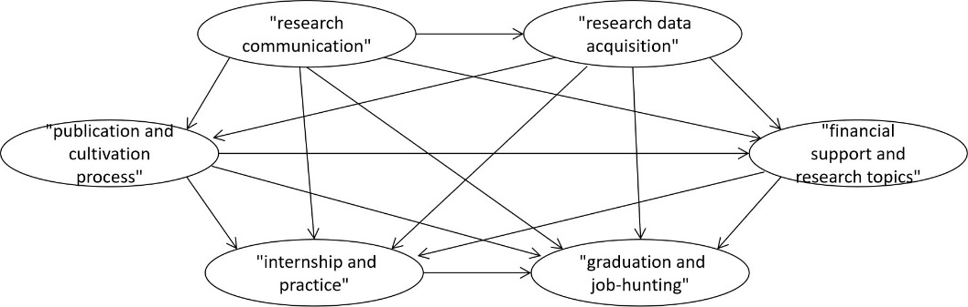**Fig. 1.** Initial Structure of the analysis by SEM

*6.3.2 Reliability Test of Data Structure*

SEM has high requirements for both measurement and influence relationships. So the tests for reliability and validity should be implemented to ensure the relationships satisfy the standards.

Regarding the reliability test on our survey data, the reliability coefficient value, i.e. Cronbach's α value is greater than 0.8, indicating that the reliability quality of our surveyed data is high. Then the validity analysis was carried out. However, the validity analysis of six dimensions shows a result of failed matching with the expectation. As a result, a series of trials including deleting observable variable (i.e. a question in the questionnaire), and merging any two dimensions of the six ones were done, until the results matching with the expectation. In this case, the observable variable of "How do you feel about your participation in international exchanges and cooperation was affected by the epidemic?" was removed, and the dimensions of "internship and practice" and "graduation and job-hunting" were merged as a new dimension named as "practice and job-hunting". Finally, five dimensions were finally formed, as shown in **Fig. 2**.

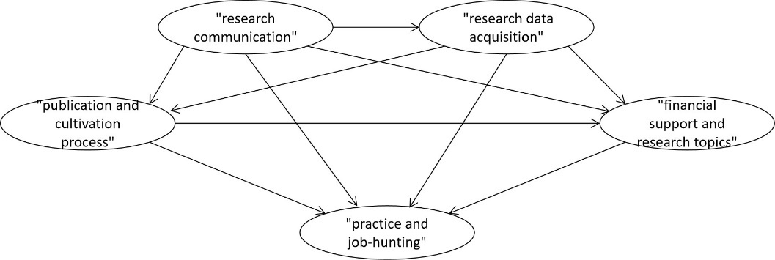

**Fig. 2.** Adjusted Structure of the analysis by SEM

The validity was also verified using KMO and Bartlett's test. The KMO value is 0.921, satisfying the requirement that it should be greater than 0.8, indicating that the surveyed data is very suitable for extracting information for SEM structure construction.

**6.4 Analysis of Fitted Indicators in the Estimated Results**

Based on the adjusted structure of SEM, the interrelationships among the variables were further investigated. During the process, the structure of SEM was kept being adjusted until the index of GFI, RMR, CFI, and NNFI satisfied the standards. The final optimized structure with loading coefficients were achieved, as shown in **Fig. 3**.

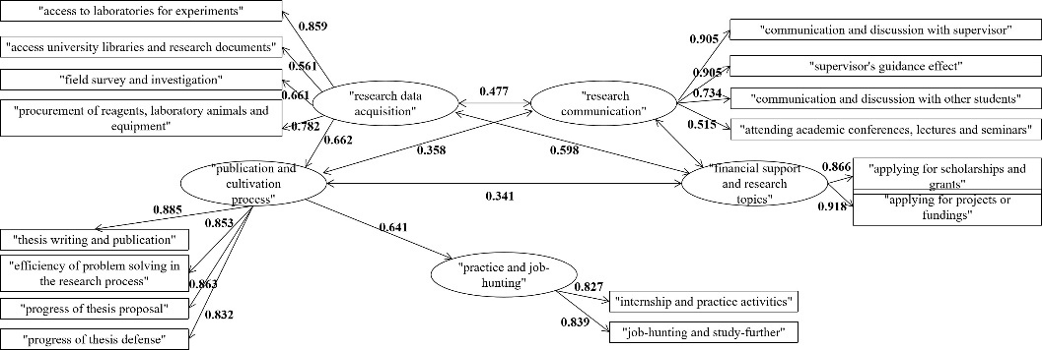

**Fig. 3.** Estimated results of SEM analysis

In this study, the maximum likelihood method was used to estimate the standardized regression coefficients and the corresponding significance level. The results show significant correlations between “research communication” and any of the three dimensions of “research data acquisition”, “publication and cultivation process”, “financial support and research topics”, whose correlation coefficients are 0.477, 0.358 and 0.517, respectively. And “access to research data” has a significant effect on “publication and training process” and its correlation coefficient is 0.662. The results also show that “research data acquisition” and “financial support and research topics” have a significant relationship, whose correlation coefficient is 0.598. And the correlation coefficient between “publication and cultivation process” and “financial support and research topics” is 0.341, demonstrating a significantly relationship. The correlation coefficient of 0.641 between “publication and cultivation process” and “practice and job-hunting” means a significant relationship between these two dimensions of latent variables.

**7. Results Analysis and Discussion**

This section explains the impacts from the observed variable to the latent variables, which demonstrate how the various factors, i.e. the observed variables, influence the five dimensions due to the epidemic. Then the impacts among the latent variables are also discussed.

**7. 1 Relationships between latent and observed variables.**

Regarding the dimension of “research communication”, the correlation coefficients from “communication and discussion with supervisor”, “supervisor’s guidance effect”, “communication and discussion with other students”, and “attending academic conferences, lectures and seminars” are 0.905, 0.905, 0.734, and 0.515, respectively. During the epidemic, students and their supervisors are unable to communicate with each other discuss problems face-to-face, resulting ineffective supervision. Students conducted research at home alone, much less communication with other students, causing great impact on the research exchange. However, the impact on research exchange is smaller. It is because that the frequency of participation in academic conferences, lectures, etc. was generally once or twice a month before the epidemic, which was not very frequent in itself, while most of the conferences were changed to online meetings, which means the students can attend these online events with not much influence.

As far as the dimension “research data acquisition” is concerned, the correlation coefficients from “access to laboratories for experiments”, “access university libraries and research documents”, “field survey and investigation”, “procurement of reagents, laboratory animals and equipment” are 0.859, 0.561, 0.661 and 0.782, respectively. During the epidemic, the students were in isolation at home most of the time, unable to enter the laboratory to conduct experiments to obtain the data needed. Neither purchasing the experimental items nor field survey and investigations is possible, resulting a significant influence on the data acquisition. Although the students could not enter the libraries to investigate or check the documents offline, they could do it online instead. As a result, this factor had less impact on research data acquisition compared to other factors.

Regarding the dimension of “publication and cultivation process”, the correlation coefficients from “thesis writing and publication”, “efficiency of problem solving in the research process”, “progress of thesis proposal” and “progress of thesis defense” are 0.885, 0.853, 0.863, and 0.863 respectively. This indicates that when “research communication” and “research data acquisition” were affected, the “publication and cultivation process” cannot be carried out smoothly. Four observable variables impacted by the epidemic had a significant influence on “publication and cultivation process”.

For the dimension of “financial support and research projects”, the correlation coefficient from “applying for scholarships and grants” and “applying for projects or fundings” are 0.866 and 0.918 respectively. It means that the epidemic has negative influence on the scholarship application, grants, projects and fundings to the graduate students. This influence further made their research and study in a rough way.

Regarding the dimension of “practice and job-hunting”, the correlation coefficient from “internship and practice activities” and “job-hunting and study-further” are 0.827 and 0.839 respectively. This indicates that the great impact on the production and operation of many enterprises due to the epidemic, resulted in the unsuccessful internships and practice activities, as well as the subsequent job-hunting and furthered studies.

**7.2 Influence relationships between latent variables**

The results show significant correlations between “research communication” and any of the three dimensions of “research data acquisition”, “publication and cultivation process”, “financial support and research topics”, whose correlation coefficients are 0.477, 0.358 and 0.517, respectively. These relationships were due to the research procedure of graduate students. Specifically, communication between students and supervisors is important during the whole process of graduate cultivation, which includes project or funding application, data acquisition, experiments of the research, achievements publication and thesis writing.

In addition, the results also show that “research data acquisition” and “financial support and research topics” have a correlation coefficient is 0.598. And the correlation coefficient between “publication and cultivation process” and “financial support and research topics” is 0.341. It means that scholarship application is influenced by the learning status, which could be further reflected as the experiment progress, paper and thesis progress, paper publication and etc.

Further, “access to research data” has a significant effect on “publication and training process” with a correlation coefficient of 0.662. It demonstrates the significance of data acquisition to the paper publication and thesis completion.

The correlation coefficient of 0.641 between “publication and cultivation process” and “practice and job-hunting” means a significant relationship between these two dimensions of latent variables. It means paper publication is directly influence whether the students can graduate successfully.

**8. Conclusions**

This paper investigates the impact of the epidemic on China’s postgraduate students’ learning and scientific research output, with an online questionnaire surveyed more than 2000 students. SEM method was used to construct the relationship among six dimensions of “research communication”, “research data acquisition”, “publication and cultivation process”, “financial support and research topics”, and “practice and job-hunting”, together with their observable variables. The results show significant correlations among these variables.

**Reference**

Almomani, L. M., Halalsheh, N., Al-Dreabi, H., Al-Hyari, L., & Al-Quraan, R. (2023). Self-directed learning skills and motivation during distance learning in the COVID-19 pandemic (case study: The university of Jordan). Heliyon, (9): e20018. https://doi.org/10.1016/j.heliyon.2023.e20018

Guo J, Luo JM, Cui SS. Research on urban residents' travel mode choice based on structural equation modeling. Highways & Automotive Applications. 2020（02）: 30-35+61.

Miao, D., Zhu, M., Zhou, Z., & Zhang, N. (2023). How school closures affected learning and the physical and mental health of Chinese university students during the COVID-19 pandemic?. Building and Environment, 242, 110582. https://doi.org/10.1016/j.buildenv.2023.110582

Pérez, M. A., Tiemann, P., & Urrejola-Contreras, G. P. (2023). The impact of the learning environment sudden shifts on students’ performance in the context of the COVID-19 pandemic. Educación Médica, 24(3), 100801. https://doi.org/10.1016/j.edumed.2023.100801

Rahman, A., Islam, M.S., Ahmed, N.F., & Islam, M.M. (2023). Students’ perceptions of online learning in higher secondary education in Bangladesh during COVID-19 pandemic. Social Sciences & Humanities Open. (8): 100646. https://doi.org/10.1016/j.ssaho.2023.100646

Raviv, A., Amasha, M., & Bader, N. (2023). Arab and Jewish students in the post-Covid-19 era: Learning patterns as a trigger for dropout intent. Social Sciences & Humanities Open. 8: 100637. DOI:10.1016/j.ssaho.2023.100637

Shaiba, H., John, M., & Meshoul, S. (2023). Female Saudi College students'e-learning experience amidst COVID-19 pandemic: An investigation and analysis. Heliyon, 9(1). https://doi.org/10.1016/j.heliyon.2022.e12768

Wu, ML. Operate and Apply Structure Equation Modeling with AMOS, 2013. Chongqing University Press.

Yi, DH. Structural Equation Modeling Methods and Applications, 2008. China Renmin University Press.

Zhang W, Qi ZJ, Leng YX. How to manage research projects under the impact of the new crown epidemic. China Petroleum and Chemical Standard and Quality. 2021, 41(10) : 83-84. DOI:10.3969/j.issn.1673-4076.2021.10.040.