Book Name: | New Horizons of Science, Technology and Culture
Manuscript Number: | Ms_BPR_5953
Title of the Manuscript: | A Framework for Skill Building and Employment Using ICT Tools
Type of the Article | Book Chapter

Special note:

A research paper already published in a journal can be published as a Book Chapter in an expanded form with proper copyright approval.
Source Article:

This chapter is an extended version of the article published by the same author(s) in the following journal.

Asian Journal of Advances in Research, 6(1): 338-346, 2023.
Available: https://jasianresearch.com/index.php/AJOAIR/article/view/280

PART 1: Comments

 | Reviewer’s comment  Artificial Intelligence (AI) generated or assisted review comments are strictly prohibited during peer review. | Author’s Feedback (Please correct the manuscript and highlight that part in the manuscript. It is mandatory that authors should write his/her feedback here)
Please write a few sentences regarding the importance of this manuscript for the scientific community. A minimum of 3-4 sentences may be required for this part. | - To address the issues of Unemployability a good model has been given by the author.  - It is goog to propose a collaboration in between private and Government sectors to meet the challenges.  - Unemployed individuals can acquire the skills to bridge the gaps of the demand of required skills seek by local employers.
Is the title of the article suitable?  (If not please suggest an alternative title) | Title seems to be perfect.
Is the abstract of the article comprehensive? Do you suggest the addition (or deletion) of some points in this section? Please write your suggestions here. | The abstract of the article is comprehensive , it has covered almost all the points depicted in the paper.
Is the manuscript scientifically, correct? Please write here. | Yes
Are the references sufficient and recent? If you have suggestions of additional references, please mention them in the review form.  - | References are not proper. Add some recent researches of 2024 and 2025. These should be arranged in cronological manner.
Is the language/English quality of the article suitable for scholarly communications? | One correction is required in Objectives. Ideally objectives should be framed ponwise, not in a running paragraph.  In few of the sentences grammatical errors are there. Sentence has been wronly frames and creating ambiguity. Example- Red highlighted should be changed appropriately.  This approach not only enhances employability but also strengthens the local economy by fostering a skilled workforce that meets the demands of the job market.  This approach can enhance employability and strengthen the local economy by fostering a skilled workforce that meets the demands of the job market.  In many of the words unnecessarily – has been put in words. Kindly remove these errors. Few of the examples in which corrections have been done are-(One screenshot of the paper has been also attached)  participants,  employment  government  financial  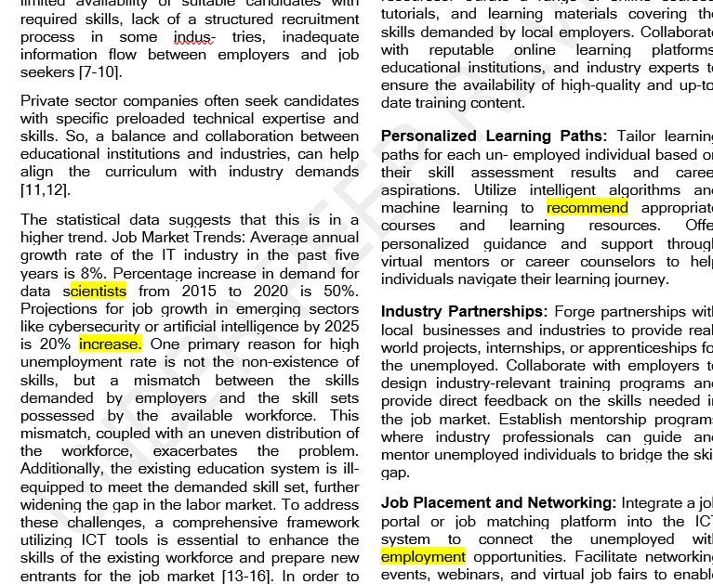
Optional/General comments | Overall paper is good and the author has put good efforts.

PART 2:

 | Reviewer’s comment | Author’s comment (if agreed with the reviewer, correct the manuscript and highlight that part in the manuscript. It is mandatory that authors should write his/her feedback here)
Are there ethical issues in this manuscript?

Reviewer details:
Rinkal Sharma, India

