|  |  |
| --- | --- |
| Book Name: | [**Current Research Progress in Agricultural Sciences**](https://www.bookpi.org/bookstore/product/current-research-progress-in-agricultural-sciences-vol-1/) |
| Manuscript Number: | **Ms_BPR_4747** |
| Title of the Manuscript: | **Climate Change and Small-Scale Agriculture in the Eastern Cape Province: Investigating the Nexus of Awareness, Adaptation, and Food Security** |
| Type of the Article | **Book Chapter** |

**Special note:**

# A research paper already published in a journal can be published as a Book Chapter in an expanded form with proper copyright approval.

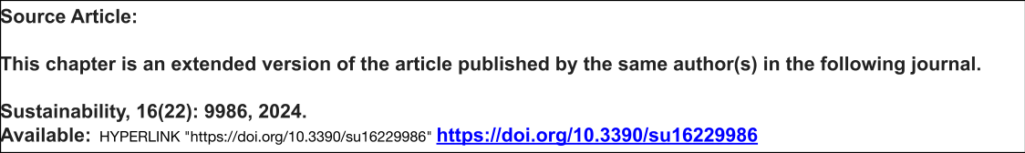

PART 1: Comments

|  |  |  |
| --- | --- | --- |
|  | **Reviewer’s comment**  **Artificial Intelligence (AI) generated or assisted review comments are strictly prohibited during peer review.** | **Author’s Feedback** *(Please correct the manuscript and highlight that part in the manuscript. It is mandatory that authors should write his/her feedback here)* |
| **Please write a few sentences regarding the importance of this manuscript for the scientific community. A minimum of 3-4 sentences may be required for this part.** | **This manuscript is of significant importance to the scientific community as it explores the intricate relationship between climate change and small-scale agriculture in the Eastern Cape Province. By analyzing the vulnerabilities, adaptive strategies, and resilience of smallholder farmers, the study contributes valuable insights into sustainable agricultural practices in the face of climate variability. Furthermore, it provides a regional perspective that can inform policy interventions and climate adaptation frameworks for similar agro-ecological zones. The findings of this research can serve as a crucial reference for policymakers, researchers, and development practitioners working to enhance food security and rural livelihoods under changing climatic conditions.** |  |
| **Is the title of the article suitable?**  **(If not please suggest an alternative title)** | **No** |  |
| **Is the abstract of the article comprehensive? Do you suggest the addition (or deletion) of some points in this section? Please write your suggestions here.** | **No** |  |
| **Is the manuscript scientifically, correct? Please write here.** | **Yes, it's correct** |  |
| **Are the references sufficient and recent? If you have suggestions of additional references, please mention them in the review form.**  **-** | **Not necessary** |  |
| **Is the language/English quality of the article suitable for scholarly communications?** | Good |  |
| **Optional/General** comments | Ensure better transitions, expand policy implications, clarify methodology, and refine language and formatting. |  |

|  |  |  |
| --- | --- | --- |
|  | **Reviewer’s comment** | **Author’s comment** *(if agreed with the reviewer, correct the manuscript and highlight that part in the manuscript. It is mandatory that authors should write his/her feedback here)* |
| **Are there ethical issues in this manuscript?** | *(If yes, Kindly please write down the ethical issues here in detail)* |  |

**PART 2:**

REVIEWERS:

Ajay Kumar Yadav, India