Ecological Changes over a Century in the Western Coastal Area of Jakarta Bay: Based on a Short Core Sample

**Abstract.** Hypoxia is one of the aquatic phenomena caused by natural and/or anthropogenic factors. Coastal areas such as Jakarta Bay are experiencing a lot of environmental pressures due to the continued increase in quality or/and quantity of human activities. Thus, the bay is highly susceptible to the threat of hypoxia triggered by eutrophication. Hypoxia in aquatic leads to a double impact, i.e. low oxygen supply for the biotic respiration process, also increases the toxicity of some metals. This study used the index of benthic foraminifera of Ammonia and Elphidium as hypoxic proxies in the western part of Jakarta Bay (Tangerang). Sampling was conducted in 2016 using short core samples. Scanning with 210Pb was performed to measure the age of sediment deposition. The result showed that there was an increase of index during the period of the late 1970s to the early 1990s. In the same period, four metals Cu, Pb, Ni and Zn concentration increased.

# INTRODUCTION

The acceleration of the development of Jakarta coastal area over a century has affected the ecological state of the waters. The development of Tangerang residence and its surrounding areas since the early 1800s, i.e. in the early days of VOC expansion in Java, has an important role on the ecological status of the waters in that region. Indeed, one of the affected compartments in the environment is bottom sediment along the coastal area. The fine sediments in coastal areas are natural archives that possess a lot of information about the ecological changes in the region since. The sediment holds biotic properties like foraminifera and abiotic properties like heavy metals. Thus, the use of various proxies such as an index of indicator biota and the vertical distribution of metal becomes an approach to understanding the natural archives.

Previous researchers conducted a study on hypoxia from a core sample using the Ammonia-Elphidium index as a proxy used 210Pb to determine the chronology of the sediment layer, and revealed that during these last 200 years, a much higher percentage of abnormal test deformation was recorded on either *Ammonia tepida* or *Elphidium excavatum*[1]*.* It was explained that the indications of eutrophication were caused by the increasing organic matter content. Ammonia and Elphidium are the genera of benthic foraminifera found in coastal waters. Moodley and Hess observation showed that *A. beccarii* is able to withstand in low oxygen environments up to <0.1 mg/L for one week since this species has facultative anaerobic properties [2]. Another research used the A-E index to discover the ecological changes on the coast of Jakarta Bay over a century and found that the west coast was more susceptible to hypoxia than in the east [3].

Among factors triggering hypoxia, eutrophication is affected and/or synergized with metal contaminants in a waters area. The most dramatic examples of hypoxic events occur at the offshore of Louisiana and Texas (USA), which was the second largest eutrophication zone in the world related to hypoxia caused by nutrient loads from the Mississippi and Atchafalaya rivers [4]. In many cases, hypoxia co-occurs with: low dissolved oxygen (DO) and low pH conditions [5]. Hence, some metals are more toxic in acidic conditions [6]. Thus, hypoxia is highly likely to promote the increasing activity of metals in sediment. The effect of that activity may lead to the alteration of community structure of benthic sediment. The Metals Cd, Cu, Fe, Mn, Pb, Hg and Zn in core sediments on the western coast of Jakarta Bay were higher than in the eastern part of Jakarta [7]. This should be a concern related to the condition of hypoxia in waters in this part of the bay. This study aimed to identify the trend of the Ammonia-Elphidium index as a proxy of ecological changes and metal content in the western part of Jakarta Bay (coast of Tangerang) for the period of more than a century.

# METODS

The study was conducted at the mouth of Gosong River, Tangerang, in March 2016. The sampling location is shown in Fig. 1. Sediment samples were taken using a simple core made from PVC pipe, 2 inches in diameter. The cores were stored in the freezer for further analysis. Several series of subsamples on five cm intervals were used to measure chronological age using the 210Pb isotope, the abundance of foraminifera and heavy metal content. Chronological age measurements were carried out at the Natural Materials Technology Research Institute, Indonesian Institute of Sciences. The measurements of the absolute age of the sediment deposition were carried out based on the calculation of 210Pb isotope (half-life time of 22.3 years) which is useful in measuring age in the range of 150-200 years.

Foraminifera and heavy metals (Lead (Pb), Cadmium (Cd), Copper (Cu), Nickel (Ni) and Zinc (Zn)) content in sediments were carried out at the Laboratory of Research Center for Oceanography–Indonesian Institute of Sciences. Identification and calculation of foraminiferal abundance were using Nikon Labophot's low power microscope. The abundance of Ammonia and Elphidium (Foraminifera) was used to calculate the Index Ammonia–Elphidium (A-E)

[8] (eq.1).

𝐴 − 𝐸 𝐼𝑘𝑑𝑒𝑥 = 𝑁𝐴

𝑁𝐴+𝑁𝐸

× 100 (1)

with

NA = The abundance of Ammonia in the sediment sample NE = The abundance Elphidium on the sediment sample

The demineralization of sediment for heavy metals analysis was carried out using acid digestion procedure followed by the measurement using Flame Atomic Absorption Spectrophotometer.

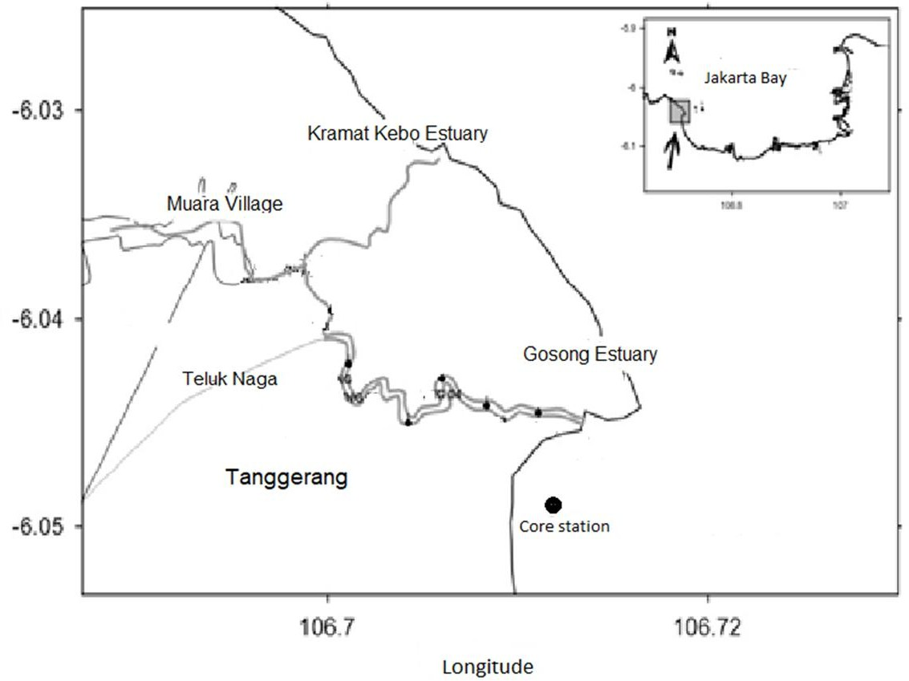

**FIGURE 1**. The location of core sampling at the mouth of Gosong River, Tangerang

# RESULTS AND DISCUSSION

Chronological age, detected by 210Pb, from 40 – 45 cm sediment layer of core samples determined that the layers were deposited in 1856, or dating back 162 years ago. Five identifiable metals of the same layer exhibited fluctuating concentrations. Pb and Cu in the early 1960s rose and peaked in the 1990s. At the beginning of 2000, there was a drastic decline, but the increasing concentration occurred in the period of 2000 to 2009 (Fig. 3). Similar incidence in Ni concentrations, but the increase began at the end of 1970 and peaked after 1990. The decrease of Ni concentration occurred until early 2000, then moved stably without fluctuations until 2009 (Fig. 3). The difference in the vertical distribution of four metals Pb, Cu, Ni and Cd compared to Zn is a tendency of decrease in the period of 1870 to mid-1950s. In contrast to the Zn, its concentrations increased in the period from 1870 to the mid-1950s, then there was a slight decrease until the late 1970s (Fig. 2).

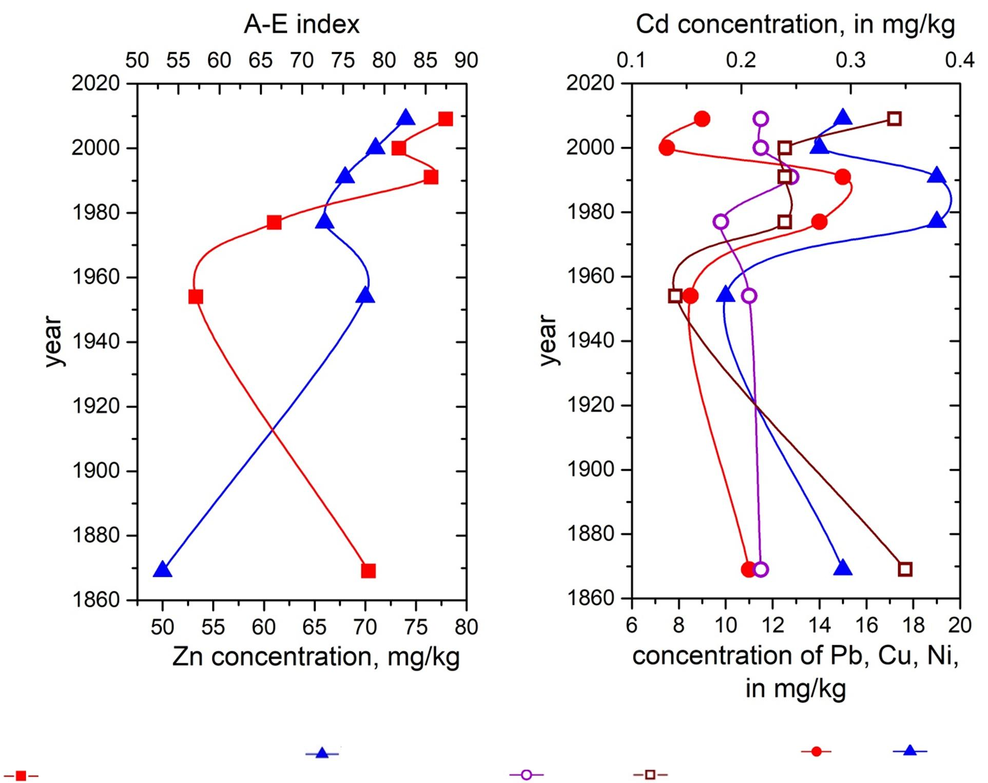**FIGURE 2**. Distribution of Zn ( )and A-E index (

)during the period of 1870 to 2009 in the western coast of Jakarta Bay

**FIGURE 3**. Distribution of Pb ( ), Cu ( ), Ni (

) and Cd ( ) during period of 1870 to 2009 in the western coast of Jakarta Bay.

The A-E index is a representation of the meiobenthic response to sedimentary conditions changes as their habitat. During the period from 1860 to 2009, the A-E index was increased in the late of 1970s to the early 1990s in the western coastal waters of Jakarta Bay (Fig. 2). These conditions indicated the occurrence of hypoxia at the bottom waters within that period. There was a decline in index values in the 1990s to 2000 periods before the value was re-increased until 2009. The A-E index tended to increase since late of the 1950s (Fig. 2) which implicated that the western coast of Jakarta Bay has a tendency to experience hypoxia for several decades. The [9] study on the

northern coast of Puerto Rico revealed that A-E index ranging from 69-100 indicated the occurrence of hypoxia periodically.

In general, the vertical distribution of Ammonia and Elphidium on the western coast of Jakarta Bay indicated the decreased to the upper layers of sediment deposited in 2009. Each sediment layer of subsamples was representations of a period of times, and the decrease of the abundance of the two genera towards the surface layer indicates that there has been a decrease in the quality of the aquatic environment in these waters during the period of 1860 to 2009. The declining quality of these waters may be due to construction activity and/or the increase of anthropogenic contamination in the waters. The results of Rositasari and Suyarso (2014) research on the west coast of Jakarta Bay showed the fluctuation of the Ammonia population with two peaks in the 1880s and the late 1990s to the 2000s.

# CONCLUSION

The study of ecological changes related to hypoxia using the A-E index was indicating there was an increasing trend of hypoxic conditions on the western coast of Jakarta Bay (Tangerang) during the period of the late 1970s to the early 1990s. At the same period, there was a similar trend of four metals Cu, Pb, Ni, and Zn. This condition would be a double threat to the waters due to hypoxia that reducing the availability of oxygen in the subsurface water column that could trigger acidification. The increased of water acidity can lead to the increased of toxicity in some metals.

# REFERENCES

1. A. B. Rotstigen, *Benthic foraminifera as a proxy for natural versus anthropogenic environmental change in the German Bight, North Sea; A record over the last 1000 years*. Master Thesis in Geosciences Faculty of Mathematics and Natural Sciences University of Oslo (2009).
2. J. Murray, *Ecology and application of benthic foraminifera*. (Cambridge University Press, Cambridge, 2006)

pp. 426.

1. R. Rositasari, and Suyarso, Oseanologi dan Limnologi di Indonesia **40**, **3**, 295-309 (2014).
2. N.N. Rabalais and R. E. Turner, [Coast. estuar. studies](https://doi.org/10.1029/CE058) **58**. American Geophysical Union, 1–36 (2001)
3. C.J. Gobler, and H. Baumann. [Biol. Lett.](https://doi.org/10.1098/rsbl.2015.0976) **12, 5**, 20150976 (2016).
4. G.F. Nordberg, R.A. Goyer, and T.W. Clarkson. [Environ Health Perspect.](https://doi.org/10.1289/ehp.8563169) **63**, 169-180 (1985) .
5. Suyarso, Lestari, R. Rositasari, and I. Al Hakim, *Dynamics Study And Evolution of The Jakarta Bay Coastal Environment,* Final Report. Research Center for oceanography-Indonesian Institute of Science (2011).
6. B.K. Gupta, et al. Geology, **24**, 227–230 (1996).
7. M. Martínez-Colón and P. Hallock. [Caribbean Jour. Sci.](https://doi.org/10.18475/cjos.v46i1.a14) **46**, **1**, 106-111 (2010).