Formulation and Evaluation of Physostigmine-Transdermal Patch

ABSTRACT

In present study transdermal drug delivery of Physostigmine was developed to overcome the first pass metabolism and to reduce frequency of dosing compared to oral route. Matrix type of transdermal patches was developed by using polymers Eudragit-L100, HPMCk4M and HPMCk15M.Transdermal patches were prepared by employing solvent casting method. Propylene glycol and Tween80 were selected as permeation enhancer and plasticizer. Among all the formulations P6 formulation was found to be best and shown 96.5% drug release in 12 hours. For P6 formulation release kinetics were applied and it was observed that the

formulation was following peppas mechanism of drug release.

|  |  |
| --- | --- |
| Key words:  Physostigmine, Transdermal patch, Eudragit-L100, HPMCk4M and HPMCk15M. |  |

# INTRODUCTION

The most common form of drug delivery is the oral route. In this route of administration has notable advantages and also has significant drawbacks such as first-pass metabolism, drug degradation in gastrointestinal tract due to enzymes, and pH. To overcome these difficulties a novel drug delivery system was developed1. Transdermal drug delivery systems (TDDS), also known as patches, are dosage forms designed to deliver a therapeutically effective amount of drug across a patient’s skin2. Transdermal delivery not only provides controlled, constant administration of the drug, but also allows continuous input of drugs with short biological half-lives and eliminates pulsed entry into systemic circulation. Transdermal patch uses a special membrane to control the release rate at which the liquid drug contained patch reservoir can pass through the skin and into the bloodstream. Several important advantages of transdermal drug delivery are limitation of hepatic first-pass metabolism, enhancement of therapeutic efficiency, and maintenance of steady plasma level of the drug**.**

# ADVANTAGES

* Transdermal medication delivers a steady infusion of the drug over prolonged period of time, therefore, avoiding adverse side effects and therapeutic failure frequently associated with intermittent dosing can also be avoided.
* Alternative route of administration for the patients who cannot tolerate oral dosage forms such as vomiting patient.
* Increases therapeutic value of many drugs by avoiding specific problems associated with the drug, for example, gastrointestinal irritation, low absorption and drug interaction with food, drink, and other administered drugs.
* Avoidance of first pass metabolism because it bypasses the liver.
* Self administration is possible, and they are non invasive, avoiding the inconvenience of parenteral therapy.
* They are easily and rapidly identified in emergencies (for example, unresponsive, unconscious, or comatose patient) because of their physical presence, features, and identifying markings.

# DISADVANTAGES

* Although transdermal drug delivery systems possess numerous advantages, these also have some disadvantages as follow:
* Difficult to administer the large dose, i.e. more than 10 mg/day.
* Ionic drugs create problems.
* Drugs having size more than 500 Dalton are not suitable for TDDS.
* Drugs in high concentration may cause skin irritation.
* Difficult to achieve high plasma drug concentration.
* Long-term adherence creates discomfort to patients.
* Drugs with very low or high partition coefficient fail to reach systemic circulation.

Physostigmine, as the salicylate salt, is being developed as a drug for the treatment of Alzheimer’s disease. The memory and learning enhancement capabilities as well as other pharmacological effects of physostigmine will be thoroughly reviewed in this paper. Physostigmine (Antilirium®, Isopto®, eserine), an alkaloid from the West African perennial shrub Physostigma venenosum, is the oldest known acetyl cholinesterase (AChE) inhibitor. Naturally occurring physostigmine was initially used clinically for ophthalmic purposes in 1877. Physostigmine was first synthesized in 1935. The general and dominant pharmacology of physostigmine is due to a short-acting inhibition of the enzymes AChE and butyryl cholinesterase (BuChE). Physostigmine exerts a stereo selective inhibition by acting as a pseudo substrate and transferring a carbamate residue to the enzyme’s active site. Spontaneous hydrolysis regenerates the native enzyme and

function. This activity underlies physostigmine use in the treatment of glaucoma and atropine and organophosphate intoxication and its potential role in the amelioration of the symptoms of Alzheimer’s disease. The history of physostigmine has been reviewed by Holmstedt and more recently by Somani and Dube. Physostigmine is extracted from the seeds of Physostigma venenosum. As “ordeal beans” these seeds were used in trials for witchcraft and an early therapeutic use in ophthalmology was described in 1863. The structure of physostigmine (1, 2, 3, 3a, 8, 8a-hexa hydro-1, 3a, 8-trimethyl-pyrrolo [2,3- b] indo-5-ol-methyl carbamate) was determined by Stedman and Barger in 1925 and its effect in prolonging acetylcholine action, subsequently revealed as mediated through the inhibition of AChE, was discovered by Loewi and Navratil a year later. Physostigmine is a lipid soluble tertiary amine with a pKa value of

7.9 and is approximately 75% ionized at the pH of blood and brain.

Present work, an attempt is been made to provide a matrix type Transdermal drug delivery system using water insoluble polymers with model drug as Physostigmine.

The aim of the work is Development and optimization of Matrix Transdermal patches by using water insoluble polymers and to study the effect of various concentration of polymers on In-vitro membrane permeation studies.

# PLAN OF WORK

1. Selection and procurement of drug
2. Construction of standard curve of Physostigmine
3. Selection of polymer
4. Selection of plasticizer
5. Selection of penetration enhancer
6. Preparation of matrix patch
7. Evaluation of prepared Transdermal formulations
   1. Physico – chemical evaluation parameters
   2. In - vitro membrane permeation studies by Keshary - Chien diffusion cell using dialysis membrane.
   3. In - vitro membrane permeation studies was fitted in to kinetic modeling of drug release.

# METHODOLOGY

1. **CONSTRUCTION OF STANDARD GRAPH OF PHYSOSTIGMINE**

Standard graph of Physostigmine was plotted in PBS pH 7.4. Physostigmine was estimated λmax by spectrophotometrically.

## Preparation of standard solution

Stock solution - I was prepared by dissolving Physostigmine 100 mg in 100 ml of methanol, so as to get a solution of 1 mg/ml concentration.

Then stock solution – “II was prepared by taking 10 ml from the previous stock solution i.e. stock solution - I and dissolved in 100 ml of PBS pH 7.4, so as to get a solution of 100 µg/ml concentration.

Accurately measured aliquot portions of standard drug solution, from stock solution -II were taken, like 0.5 ml, 1 ml, 1.5 ml, 2 ml and2.5 ml were transferred in to 10 ml volumetric flasks and were diluted up to the mark with PBS pH 7.4. Absorbance of each solution was measured at λmax of 255 nm against PBS pH 7.4 as the blank, by using UV- spectrophotometer. A graph was plotted by taking concentration of drug vs absorbance was plotted.

## Selection of drug and other ingredients

* Physostigmine was selected as model drug based on its physico-chemical and biological properties and also based on its suitability for Transdermal drug delivery system.
* Eudragit-L100 (mg), HPMCk4M (mg), HPMCk15M (mg) were selected as matrix forming polymers.
* Propylene glycol and Tween80were selected as permeation enhancer and” plasticizer.

# FORMULATION

* **Development of Transdermal patches:** Transdermal drug delivery patches were prepared by solvent casting method.
* **Solvent casting method:** Transdermal patches were prepared according to the formula shown in Table. Eudragit L100, HPMCK4M and HPMCK15M were weighed in requisite ratios and they were then dissolved in dichloromethane and ethanol as solvent using magnetic stirrer. Physostigmine (36mg), Propylene glycol and Tween 80 were added to the above dispersion under continuous stirring. The uniform dispersion was poured in the petri plate. The rate of evaporation of solvent was controlled by inverting cut funnel over the patches.. After 24h, the dried films were taken out and stored in desiccators.

**Tab 1: Formulations of Physostigmine Transdermal Patch**

|  |  |  |  |  |  |  |  |  |  |  |  |  |  |
| --- | --- | --- | --- | --- | --- | --- | --- | --- | --- | --- | --- | --- | --- |
| **S.No** | **INGREDIENTS** | **P1** | **P2** | **P3** | **P4** | **P5** | **P6** | **P7** | **P8** | **P9** | **P10** | **P11** | **P12** |
| 1 | Drug (mg) | 200 | 200 | 200 | 200 | 200 | 200 | 200 | 200 | 200 | 200 | 200 | 200 |
| 2 | Eudragit-L100 (mg) | 100 | 150 | 200 | - | - | - | - | - | - | 100 | 100 | - |
| 3 | HPMCk4M (mg) | - | - | - | 100 | 150 | 200 | - | - | - | 100 | - | 100 |
| 4 | HPMCk15M(mg) | - | - | - | - | - | - | 100 | 150 | 200 | - | 100 | 100 |
| 5 | Dichloromethane (ml) | 8 | 8 | 8 | 8 | 8 | 8 | 8 | 8 | 8 | 8 | 8 | 8 |
| 6 | Ethanol (ml) | 8 | 8 | 8 | 8 | 8 | 8 | 8 | 8 | 8 | 8 | 8 | 8 |
| 7 | Propylene glycol (ml) | 1.2 | 1.2 | 1.2 | 1.2 | 1.2 | 1.2 | 1.2 | 1.2 | 1.2 | 1.2 | 1.2 | 1.2 |
| 8 | Tween-80 (ml) | 1.2 | 1.2 | 1.2 | 1.2 | 1.2 | 1.2 | 1.2 | 1.2 | 1.2 | 1.2 | 1.2 | 1.2 |

# A) EVALUATION OF TRANSDERMAL PATCH BY PHYSICAL METHODS

Physical appearance, Thickness, Weight variation, Flatness, Folding endurance, Moisture uptake, Moisture content Swelling study Drug content determination

# III. B) EVALUATION OF TRANSDERMAL PATCH BY PERMEATION STUDIES

**Diffusion cell:** Permeation studies were carried out on Franz diffusion cells. The Franz diffusion cell contains two compartment, the donor and receptor compartment. The receptor compartment is 5mm and holds a volume of 15 ml. The receptor compartment is attached to a collecting tube which allows easy collection of hourly sample while the process of diffusion. The donor and the receptor compartment are held together with help of a clap and the diffusion cell was placed on the magnetic stirrer while diffusion studies carried. The total area of the receptor compartment that is exposed to the Transdermal patch for diffusion is 3.83 cm2.

**Fig 1: Franz diffusion cell**

# IN VITRO PERMEATION STUDIES USING DIALYSIS MEMBRANE

In vitro permeation of Physostigmine from Transdermal patches through dialysis membrane (Hi-Media) with molecular weight cut off of 12000 was studied. The membrane was mounted over a Franz diffusion cell and a Transdermal patch. The receiver compartment of the diffusion cell was filled with 15.0 ml of PBS pH 7.4 and the setup was placed over a magnetic stirrer with temperature” maintained at 370C. Samples of 3ml were withdrawn and replenished immediately from the receiver compartment at 1, 2, 3, 4, 6 and 12h. They were stored in refrigerated condition till the analysis was performed. The content of Physostigmine in the samples was analyzed by UV- Visible spectrophotometer. The concentrations of drug were determined at 266 nm.

# KINETIC MODELING OF DRUG RELEASE

**Mechanism of drug release**

To analyze the mechanism of the drug release rate kinetics of the dosage form, the obtained data were fitted into zero-order, first order, Higuchi, and Korsmeyer-Peppas release model.

**IV) Drug excipients interaction studies:**

**RESULTS AND DISCUSSION**

**Tab 2: Standard graph of Physostigmine**

|  |  |
| --- | --- |
| **CONCENTRATION (µG/ML)** | **ABSORBANCE (NM)** |
| 5 | 0.123 |
| 10 | 0.210 |
| 15 | 0.320 |
| 20 | 0.411 |
| 25 | 0.501 |

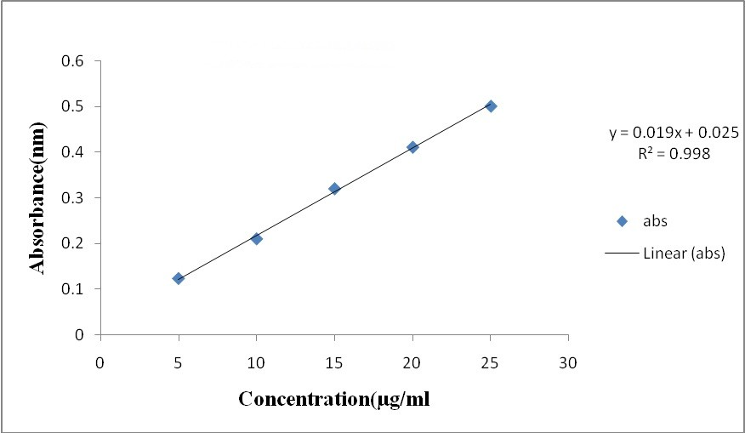

## Fig 2: Standard curve of Physostigmine Evaluation of Physostigmine Transdermal patches

**Physical appearance:**

All the Transdermal patches were visually inspected for color, clarity, flexibility.

**Flatness:** All the Transdermal patches was found to be flat without any foams.

## Tab 3: Evaluation of Transdermal patch by physical methods

|  |  |  |  |  |  |
| --- | --- | --- | --- | --- | --- |
| **Formulation** | **Thickness (mm)** | **Folding endurance** | **Drug content (%)** | **Moisture uptake (%)** | **Moisture content (%)** |
| P1 | 0.3569 | 20 | 45 | 7.98 | 3.77 |
| P2 | 0.3520 | 25 | 65 | 25.05 | 9.2 |
| P3 | 0.3470 | 27 | 57.5 | 13.09 | 5.16 |
| P4 | 0.3496 | 24 | 60 | 15.63 | 5.66 |
| P5 | 0.3460 | 30 | 67.5 | 11.73 | 4.87 |
| P6 | 0.3517 | 32 | 92.5 | 19.65 | 12.67 |
| P7 | 0.3478 | 40 | 101.7 | 9.42 | 3.43 |
| P8 | 0.3437 | 37 | 85 | 10.87 | 4.72 |
| P9 | 0.3503 | 34 | 55 | 16.44 | 6.62 |
| P10 | 0.3532 | 29 | 62.5 | 13.08 | 6.17 |
| P11 | 0.3546 | 26 | 85 | 20.63 | 7.94 |
| P12 | 0.3503 | 31 | 82.5 | 15.73 | 6.55 |

The prepared Physostigmine Transdermal patches were evaluated by physical methods such as Physical appearance, Flatness, Weight variation, Thickness, Folding endurance, Drug content, Moisture uptake and Moisture content and all “the results were found to” be within the pharmacopeia limits.

**Tab 4: Evaluation of Transdermal patch by In-vitro permeation studies using dialysis membrane**

|  |  |  |  |  |  |  |  |  |  |  |  |  |
| --- | --- | --- | --- | --- | --- | --- | --- | --- | --- | --- | --- | --- |
| **Time (hrs)** | **P1** | **P2** | **P3** | **P4** | **P5** | **P6** | **P7** | **P8** | **P9** | **P10** | **P11** | **P12** |
| 1 | 9.05 | 15.1 | 10.1 | 9.49 | 10.9 | 20.2 | 17.5 | 12.0 | 11.1 | 12.7 | 10.0 | 20.4 |
| 2 | 13.3 | 19.8 | 12.8 | 11.3 | 19.6 | 27.8 | 21.9 | 17.5 | 13.0 | 17.9 | 12.5 | 25.4 |
| 4 | 14.6 | 28.3 | 21.5 | 22.6 | 24.9 | 42.8 | 33.5 | 23.4 | 23.3 | 27.4 | 23.6 | 33.0 |
| 6 | 21.9 | 34.1 | 25.9 | 32.3 | 31.2 | 53.5 | 40.0 | 30.9 | 33.4 | 32.7 | 30.9 | 41.7 |

|  |  |  |  |  |  |  |  |  |  |  |  |  |
| --- | --- | --- | --- | --- | --- | --- | --- | --- | --- | --- | --- | --- |
| 8 | 32.7 | 41.1 | 33.4 | 43.9 | 38.0 | 66.3 | 46.5 | 48.1 | 52.7 | 50.6 | 36.7 | 47.9 |
| 10 | 40.4 | 50.1 | 44.5 | 56.3 | 50.3 | 82.0 | 64.2 | 60.0 | 66.4 | 63.0 | 45.9 | 63.0 |
| 12 | 54.2 | 65.8 | 56.7 | 69.4 | 65.9 | 96.5 | 91.9 | 78.7 | 79.1 | 74.8 | 56 | 80.9 |

## Fig 3: Release profile of In-vitro permeation studies using dialysis membrane



120

100

80

60

40

20

0

0

5

10

Time(hrs)

15

%cumulative drug release

of P1

%cumulative drug release of P2

%cumulative drug release of P3

%cumulative drug release of P4

%cumulative drug release of P5

%cumulative drug release of P6

%cumulative drug release

The prepared Physostigmine Transdermal patches were evaluated for In-vitro permeation studies using dialysis membrane, Among all the 12 formulations P6 formulation which contain HPMC K4M 200mg had shown 94% cumulative drug release within 12 hours. And compared to HPMC K15M, HPMC K4M showed better drug release profile.

**Tab 5: kinetics of In-vitro permeation studies using dialysis membrane**

|  |  |  |  |  |  |
| --- | --- | --- | --- | --- | --- |
| **CUMULATIVE (%) RELEASE Q** | **TIME ( T )** | **ROOT ( T)** | **LOG (%) RELEASE** | **LOG (T)** | **LOG (%) REMAIN** |
| **0** | 0 | 0 |  |  | 2.000 |
| 20.2 | 0.5 | 0.707 | 1.305 | -0.301 | 1.902 |
| 27.8 | 1 | 1.000 | 1.444 | 0.000 | 1.859 |
| 42.8 | 2 | 1.414 | 1.631 | 0.301 | 1.757 |
| 53.5 | 3 | 1.732 | 1.728 | 0.477 | 1.667 |
| 66.3 | 4 | 2.000 | 1.822 | 0.602 | 1.528 |
| 82.0 | 5 | 2.236 | 1.914 | 0.699 | 1.255 |
| 96.5 | 6 | 2.449 | 1.985 | 0.778 | 0.544 |

120



100

**Zero**

y = 14.71x + 9.090 R² = 0.981

80

60

**Cumulative % drug relase**

40

ZERO ORDER

20

0

0 2 4 **time** 6 8

## Fig 4: Zero order kinetics

120



**Higuchi**

y = 38.37x - 6.716 R² = 0.969

100

80

60

**Cumulative % drug release**

HIGUCHI

40

20

0

-20

0 0.5 1 1.5 2 2.5 3

**Root Time**

## Fig 5: Higuchi plot

**Peppas**

2.5



y = -0.112x + 1.526

2 R² = 0.005

1.5

**Log Cumulative % drug release**

p… L…

1

0.5

2.500

0

-0.5 0 0.5 **Log Time** 1

## Fig 6: Peppas plot

**First**



y = -0.099x + 1.927 R² = 0.284

2.000

1.500

**Log % drug remaining**

first order

1.000

0.500

0.000

0 1 2 3 4 **time**5 6 7 8

## Fig 7: First order kinetics

The kinetics of In-vitro permeation studies using dialysis membrane for P6 formulation was plotted and the Regression coefficient value was found to be high for Korsmeyer - peppas release model i.e., 0.9892. And the n value was found to be 0.6203 which indicates the drug release pattern was found to be non-Fickian diffusion.

# COMPATABILIY STUDIES

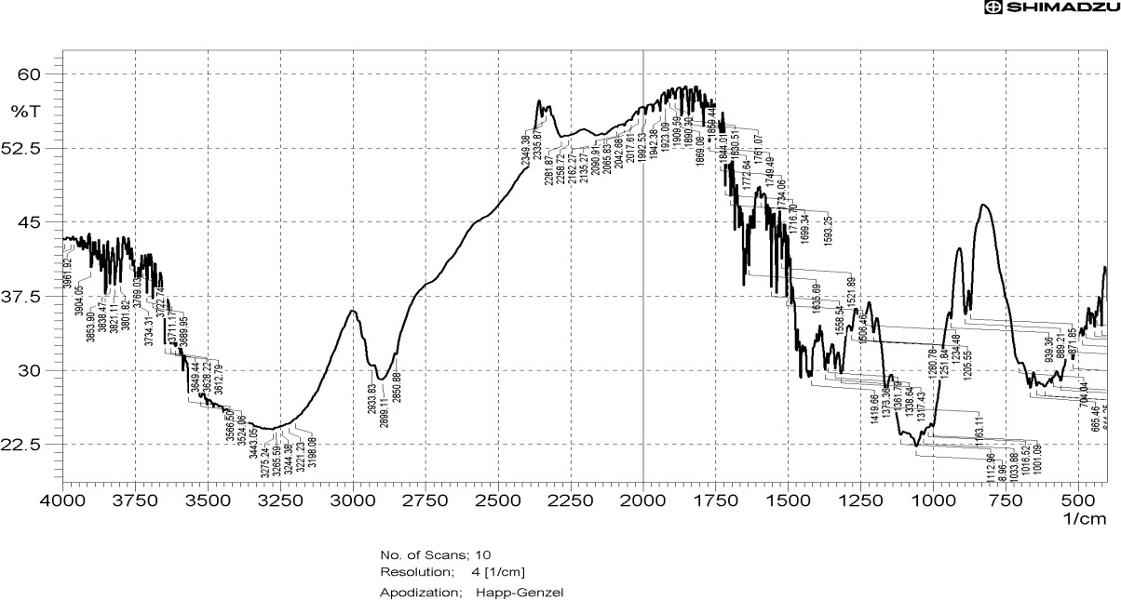

**Fig 8: FTIR spectrum of pure drug**

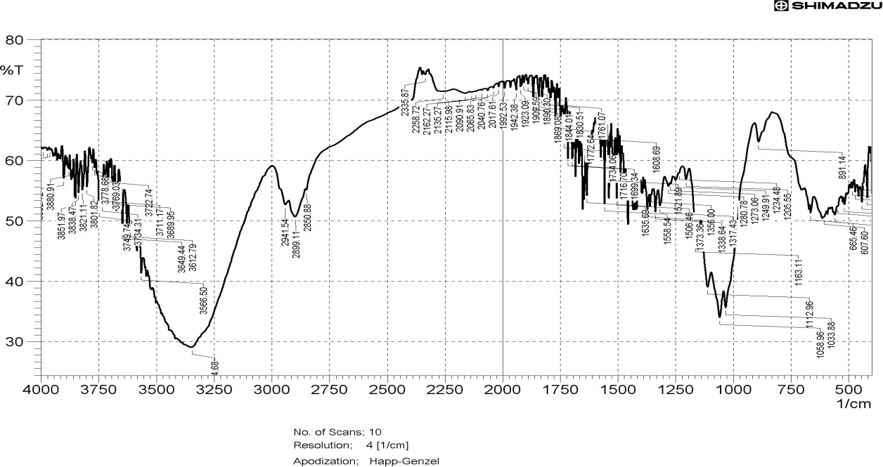

# SUMMARY & CONCLUSION

## Fig 9: FTIR optimized formulation

2. Rakesh Pahwa, Lovely Chhabra , Avneet Kaur Lamba ,

In present study transdermal drug delivery of Physostigmine was developed to overcome the first pass metabolism and to reduce frequency of dosing compared to oral route. Formulations were prepared with the varying concentrations polymers ranging from P1-P12Among all the 12 formulations P6 formulation which contain HPMC K4M 200mg had shown 96.5% cumulative drug release within 12 hours. And compared to HPMC K15M, HPMC K4M showed better drug release profile.

# BIBILOGRAPHY

1. Swathi K.N., Ashok Kumar P * and Suresh V. Kulkarni Development and Evaluation of Controlled Release Microspheres Containing Physostigmine Der Pharmacia Lettre, 2018, 10 [4]: 86-99.

Sumit Jindal and Arvind Rathour Formulation and in- vitro evaluation of effervescent floating tablets of an antiulcer agent Journal of Chemical and Pharmaceutical Research, 2012, 4(2):1066-1073.

1. Md. Haider Ali1 , Mohiuddin Ahmed Bhuiyan2 , Md. Selim Reza3 and Samira Karim1 Formulation and In vitro Evaluation of Oral Floating Tablets of Salbutamol Sulphate: Comparison with Effervescent Tablets Dhaka Univ. J. Pharm. Sci. 15(2): 203-208, 2016 (December)\
2. C Haranath, J Raveendra Reddy, N Devanna. Formulation and In-Vitro Evaluation of Effervescent Floating Tablets of an Antibacterial Drug. Inventi Impact: Pharm Tech, 2016(4):145-151, 2016.
3. AkhlakAhmed, Narendra Kr. Goyal and Pramod K. Sharma Effervescent Floating Drug Delivery System: A Review Global Journal of Pharmacology 8 (4): 478-485,

2014.

1. Ali Raza , Nadeem Irfan Bukhari, Sabiha Karim y , Muhammad Ahsan Hafiz, Uzma Hayat Floating tablets of minocycline hydrochloride: Formulation, in-vitro evaluation and optimization Future Journal of Pharmaceutical Sciences 3 (2017) 131e139.
2. K.Chaitanya, Sellappan Velmurugan Formulation And Evaluation Of Levodopa Effervescent Floating Tablets Int J Pharm Pharm Sci, Vol 7, Issue 5,189-193.
3. Komuravelly Someshwar Kalyani Chithaluru, Tadikonda Ramarao K. K. Kalyan Kumar Formulation and evaluation of effervescent floating tablets of tizanidine hydrochloride Acta Pharm. 61 (2011) 217–226.
4. Harsharan Pal Singh, Ashmeet Kaur , Ishpreet Kaur Formulation and evaluation of effervescent floating tablet of famotidine with natural polymer chitosan Asian Pac. J. Health Sci., 2014; 1(4): 517-523.
5. Ali Kadivar , Behnam Kamalidehghan , Hamid Akbari Javar , Ehsan Taghizadeh Davoudi , Nurul Dhania Zaharuddin , Bahareh Sabeti , Lip Yong Chung , Mohamed Ibrahim Noordin Formulation and In Vitro, In Vivo Evaluation of Effervescent Floating Sustained-Release Imatinib Mesylate Tablet PLOS ONE | DOI:10.1371/journal.pone.0126874 June 2, 2015.