**Title: THE ROLE OF GASTRIC CANCER ADIPOCYTES IN PREDICTING DISEASE OUTCOME?**

**Abstract**

**Background.** There is increasing evidence that the host inflammatory status influences the prognosis of a number of solid tumors. Many cancers are inflammation-related as evidenced by. preoperative neutrophil-to-lymphocyte ratio (NLR). This prognostic biomarker can predict postoperative survival for patients with various tumors, including gastric cancer (GC).

GC is a tumor type that grows in the anatomical vicinity of adipose tissues, inducing adipose dysfunction and low-grade inflammatory response.

**Aim**:The aim of this study was to correlate the relationship between NLR values and adipocite density in the prognostication of patients with GC.

**Materials and Methods**. In this six year retrospective study between 2009 and 2015, a total of 171 patients with immunohistochemically confirmed GC were subjected to statistical analysis to correlate

the relationship between NLR and adipocite density values

Lower values of NLR and adipocite densities was associated with more favourable outcomes. Patients with high density of cancer-associated adipocited (CAAs) had a poor prognosis independent of NLR values.

**Conclusion**. Tumor CAA density influences NLR and reflects unfavorable outcomes of disease and higher mortality. These bio markers must be considered in decisions regarding treatment strategies.

**Keywords.** Gastric cancer, BMI, neutrophil-to-lymphocyte ratio, cancer-associated adipocytes.

**Introduction:**

There is increasing and consistent evidence that the host inflammatory status is associated with prognosis of a number of solid tumors, and that many cancers are inflammation-related. [1]. Various biomarkers for systemic inflammation have been examined over the past decade and some of them, namely neutrophil-to-lymphocyte ratio (NLR), platelet-to-lymphocyte ratio (PLR) and lymphocyte-to-monocyte ratio (LMR) affect prognosis and patient outcomes in GC [2]. Of these, NLR is routinely available to clinicians and a reliable marker of the systematic inflammation response status of a number of cancers [3-6]. NLR is a useful predictor of postoperative survival, lymph node and peritoneal metastasis in patients with earlygastric cancer (GC) [7,8]. There also exists a correlation of pretreatment NLR values with response to chemotherapy [9]. NLR is elevated in patients with more advanced or aggressive disease evidenced by increased tumor stage, nodal stage, number of metastatic lesions. They constitute a particularly high-risk patient population [10]. The prognostic value of preoperative NLR remains controversial [11]. On the basis of pathophysiological studies, there is conclusive evidence of a strong link between obesity and GC tumor type with predominant adipocites in tumor microenvironment [12]. During their interaction with cancer cells, adipocytes differentiate into cancer-associated adipocytes (CAAs) that constitute a potent source of pro-inflammatory cytokines. [13,14]. A key role in this mechanism is played by the onset of low-grade systemic inflammation, highlighting the importance of the interplay between adipocytes and immune system cells [15]. The aim of this study was to investigate whether there is a relationship between prognosis of disease outcome due to value of NLR and density of CAAs in primary tumor of patients with GC.

**Materials and Methods**.

A total of 171 patients with histologically confirmed GC were eligible for retrospective analysis between 2009 and 2015. No patient received any pre-operative therapy. NLR ratios were obtained from a routine peripheral blood test. Expression Perilipin (Plin5+) served as a marker for viable adipocytes and evaluated on deparaffinized slides using specific polyclonal rabid antibodies (Perilipin-5/OXPAT Antibody, Termoscientific, USA) by means of immunohistochemical examination of tumor tissue. Statistical analyses were applied to arrive at significance of the associations.

**Results and Discussion:**

Cut-off value for preoperative NLR was 2.75 (range, 0.9-12.9). The number of patients who had NLR<2.75 and NLR>2.75 was 47.6% and 52.4% respectively. Of these, 40.9% and 57.8% GC patients with NLR<2.75 and NLR>2.75 did not survive.

Survival of GC patients was assessed by Kaplan Meier method in accordance with prognostic value of NLR (Fig.1). It was observed that preoperative high values of NLR was associated with unfavorable outcome and poor survival rates when compared with patients having low value of NLR.. This finding is consistent with current literature data based on uni- and multivariate statistical analysis. This confirmed the relevance of preoperative prognostic value of NLR in the prognosis for patients with GC.

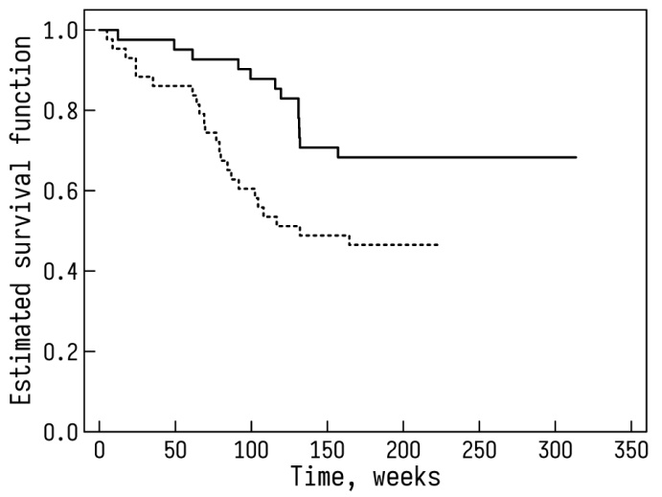

Fig.1**.** Kaplan-Meier OS curves for all GC patients as a function of preoperative prognostic value of NLR (whole line - NLR <2.75; dotted line - NLR>2.75), log-rank test, χ2 = 5.047, р = 0.0247.

Adipocytes are the major component of the microenvironment of GC with high density of CAAs in tumors in patients with higher BMI (p<0.001). The probability of availability of high density of CAAs in tumor of patients with BMI>30 is increased by a factor of 11(OR 11.01, χ2=12.9, 95%CI 28.933-5.749, P<0.01) as compared with BMI<25. The median amount of CAAs in tumors was 26.5%. Only 42.0% of patients with normal body weight had a high density of CAAs in tumors when compared with 88.5% patients with GC and obesity [16]. The prognostic value of NLR was not dependent on BMI but associated with higherdensity of CAAs in primary tumor (Table 1,2).

Table.1. Association of preoperative prognostic value of NLR with CAA density in primary tumors. Survival of GC patients.

|  |  |  |  |  |
| --- | --- | --- | --- | --- |
| Indexes | Patients with low NLR | | Patients with high NLR | |
| Density of CAAs | | | |
| low | high | low | high |
| Patients who died during follow-up (%) | 8.7 | 64.7 | 13.3 | 71.4 |
| Median follow-up time from diagnosis (range, months) | 28.7(9.3 -71.4) | 21.5(7.2-32.5) | 16.2(4.6-41.8) | 20.9(8.1-51.2) |

Prognosis for GC disease outcome by means of preoperative low NLR for patients is the most favorable when tumors are characterized by low density of CAAs. (p<0.05). When tumors have high density of CAAs, median survival rates are higher when compared with patients having low density of CAAs (p<0.05).

Table 2. Association of preoperative prognostic values of NLR with density of CAAs in tumors according to BMI of GC patients. Survival of GC patients.

|  |  |  |  |  |  |  |  |  |
| --- | --- | --- | --- | --- | --- | --- | --- | --- |
| Indexes | BMI <25 | | | | BMI>25 | | | |
| Density of CAAs | | | | | | | |
| Low | | High | | Low | | High | |
| Prognostic value of NLR | | | | | | | |
| Low | High | Low | High | Low | High | Low | High |
| Patients who died during follow-up (%) | 9.1 | 18.2 | 75.1 | 84.6 | 0 | 0 | 53.3 | 60 |
| Median follow-up time from diagnosis (range, months) | 29.7(14.9-48.3) | 19.9(3.9-41.6) | 14.4(10.8-21.1) | 19.4(2.1-37.1) | 44.6(15.2-71.4) | 22.2(12.4-50.5) | 27.5(7.2-36.9) | 22.5(5.5-51.5) |

The most favorable prognosis for disease outcome for patients by means of preoperative low NLR remains when their tumors exhibit low density of CAAs compared with patients having high CAA density in tumor (p<0.05) independent of their BMI. Patients with high density of CAAs have a high risk of early death rates independent of their NLR values. Kaplan-Meier survival analysis demonstrated the absence of differences between survival of patients with high CAAs density in tumors according to different values of preoperative NLR ( low or high) for patients with normal weight (р>0.547) (Fig. 2) as well at overweight ( р>0.668) (Fig.3)

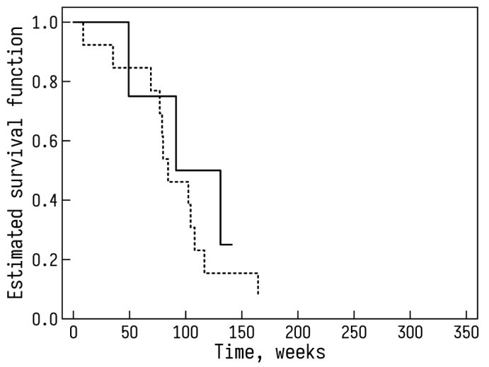

Fig.2**.** Kaplan-Meier OS curves for GC patients (BMI<25)as a function of preoperative prognostic value of NLR (whole line - NLR <2.75; dotted line - NLR>2.75), log-rank test, χ2=1.74, р>0.547. All patients having high density of CAAs in tumor.

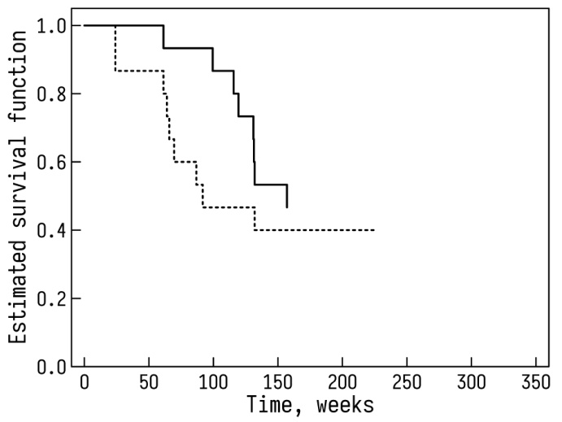

Fig.3**.** Kaplan-Meier OS curves for GC patients (BMI>25)as a function of preoperative prognostic value of NLR (whole line - NLR <2.75; dotted line - NLR>2.75), log-rank test, χ2=2.09, р>0.668. All patients had high density of CAAs in tumor.

It is worth notingthat high density of CAAs has significant predictive potential for negative prognosis of disease outcome, independent of preoperative prognostic value of NLR.

**Conclusion.**

Our study results clearly reflect an association between preoperative prognostic value of NLR and density of CAAs in primary tumor of patients with GC. Prognosis due to preoperative value of NLR is essentially modified by the density of CAAs in primary tumor. Mechanisms of such association is not sacrosanct and warrants further investigations. Therefore special consideration to the ambiguous role of CAA density in primary tumor is critical for effective management of disease outcome using NLR for multiple tumor types. It is the evidence for the expediency of the evaluation of tumor CAA density in operation specimens. Cclinicians need to consider tumor CAA density for decisions on treatment strategy. Larger prospective study is needed to validate our findings.

**References:**

1.  [Xie](https://pubmed.ncbi.nlm.nih.gov/?term=Xie+X&cauthor_id=25410116) X,  [Luo](https://pubmed.ncbi.nlm.nih.gov/?term=Luo+KJ&cauthor_id=25410116) K-J, [Y Hu](https://pubmed.ncbi.nlm.nih.gov/?term=Hu+Y&cauthor_id=25410116)Y . et al. Prognostic value of preoperative platelet-lymphocyte and neutrophil-lymphocyte ratio in patients undergoing surgery for esophageal squamous cell cancer. [Dis Esophagus](https://www.ncbi.nlm.nih.gov/pubmed/25410116" \o "Diseases of the esophagus : official journal of the International Society for Diseases of the Esophagus.) 2016 (1):79-85.doi: 10.1111/dote.12296.

2.  [Stefaniuk](https://pubmed.ncbi.nlm.nih.gov/?term=Stefaniuk+P&cauthor_id=32425606)P,  [Szymczyk](https://pubmed.ncbi.nlm.nih.gov/?term=Szymczyk+A&cauthor_id=32425606)A,  [Podhorecka](https://pubmed.ncbi.nlm.nih.gov/?term=Podhorecka+M&cauthor_id=32425606) M. The Neutrophil to Lymphocyte and Lymphocyte to Monocyte Ratios as New Prognostic Factors in Hematological Malignancies - A Narrative Review. Cancer Manag Res. 2020;12: 2961-77. doi: 10.2147/CMAR.S245928. eCollection 2020.

3. [Tao Z](https://www.ncbi.nlm.nih.gov/pubmed/?term=Tao%20Z%5BAuthor%5D&cauthor=true&cauthor_uid=29865040), [Li SX](https://www.ncbi.nlm.nih.gov/pubmed/?term=Li%20SX%5BAuthor%5D&cauthor=true&cauthor_uid=29865040), [Cui X](https://www.ncbi.nlm.nih.gov/pubmed/?term=Cui%20X%5BAuthor%5D&cauthor=true&cauthor_uid=29865040), et al.The prognostic value of preoperative inflammatory indexes in gallbladder carcinoma with hepatic involvement. [Cancer Biomark](https://www.ncbi.nlm.nih.gov/pubmed/29865040" \o "Cancer biomarkers : section A of Disease markers.) 2018; 22(3):551-7.

doi: 10.3233/CBM-181230.

4. [Hu H](https://www.ncbi.nlm.nih.gov/pubmed/?term=Hu%20H%5BAuthor%5D&cauthor=true&cauthor_uid=27255479), [Yao X](https://www.ncbi.nlm.nih.gov/pubmed/?term=Yao%20X%5BAuthor%5D&cauthor=true&cauthor_uid=27255479), [Xie X](https://www.ncbi.nlm.nih.gov/pubmed/?term=Xie%20X%5BAuthor%5D&cauthor=true&cauthor_uid=27255479), et al. Prognostic value of preoperative NLR, dNLR, PLR and CRP in surgical renal cell carcinoma patients. [World J Urol](https://www.ncbi.nlm.nih.gov/pubmed/27255479" \o "World journal of urology.) 2017;35(2): 261-70. doi: 10.1007/s00345-016-1864-9.

5.  [Zhao](https://pubmed.ncbi.nlm.nih.gov/?term=Zhao+Z&cauthor_id=29368160) Z,  [Zhao](https://pubmed.ncbi.nlm.nih.gov/?term=Zhao+X&cauthor_id=29368160)X,  [Lu](https://pubmed.ncbi.nlm.nih.gov/?term=Lu+J&cauthor_id=29368160)[J](https://pubmed.ncbi.nlm.nih.gov/29368160/" \l "affiliation-1" \o "Department of Obstetrics and Gynecology, Qilu Hospital of Shandong University, 107 Wenhua Xi Road, Jinan, 250012, Shandong, People's Republic of China.) , et al. Prognostic roles of neutrophil to lymphocyte ratio and platelet to lymphocyte ratio in ovarian cancer: a meta-analysis of retrospective studies. Arch Gynecol Obstet 2018; 297(4): 849-57. doi: 10.1007/s00404-018-4678-8.

6. Grenader T, Nash S, Adams R. Derived neutrophil lymphocyte ratio is predictive of survival from intermittent therapy in advanced colorectal cancer: a post hoc analysis of the MRC COIN study. Brit J Can 2016; 114, 612–5. doi:10.1038/bjc.2016.23.

**7.**  [Lin](https://pubmed.ncbi.nlm.nih.gov/?term=Lin+JX&cauthor_id=29982861) J-X, [Lin](https://pubmed.ncbi.nlm.nih.gov/?term=Lin+JP&cauthor_id=29982861) J-P, [Jian-Wei Xie](https://pubmed.ncbi.nlm.nih.gov/?term=Xie+JW&cauthor_id=29982861) J-W, et al. Prognostic importance of the preoperative modified systemic inflammation score for patients with gastric cancer. Gastric Cancer 2019; 22(2): 403-12. doi: 10.1007/s10120-018-0854-6.

8.  [Zhao](https://pubmed.ncbi.nlm.nih.gov/?term=Zhao+G&cauthor_id=32150090)  [G](https://pubmed.ncbi.nlm.nih.gov/32150090/" \l "affiliation-1" \o "Department of Oncology, Affiliated Hospital of Qingdao University, Qingdao Shandong, China.) ,  [Liu](https://pubmed.ncbi.nlm.nih.gov/?term=Liu+N&cauthor_id=32150090) N,  [Wang](https://pubmed.ncbi.nlm.nih.gov/?term=Wang+S&cauthor_id=32150090) S, et al. Prognostic significance of the neutrophil-to-lymphocyte and platelet-to-lymphocyte ratio in patients with metastatic gastric cancer. Medicine (Baltimore)  **2020 ; 99(10): e19405.** doi: 10.1097/MD.0000000000019405.

9. [Liu](https://pubmed.ncbi.nlm.nih.gov/?term=Liu+D&cauthor_id=29694985)D, [Jin](https://pubmed.ncbi.nlm.nih.gov/?term=Jin+J&cauthor_id=29694985) J, [Zhang](https://pubmed.ncbi.nlm.nih.gov/?term=Zhang+L&cauthor_id=29694985) L, et al. The neutrophil to lymphocyte ratio may predict benefit from chemotherapy in lung cancer cell. Physiol Biochem 2018; 46(4):1595-1605. doi: 10.1159/000489207.

10. [Guthrie](https://pubmed.ncbi.nlm.nih.gov/?term=Guthrie+GJ&cauthor_id=23602134) G JK,  [Charles](https://pubmed.ncbi.nlm.nih.gov/?term=Charles+KA&cauthor_id=23602134) KA,  [Roxburgh](https://pubmed.ncbi.nlm.nih.gov/?term=Roxburgh+CS&cauthor_id=23602134) CSD, et al. The systemic inflammation-based neutrophil-lymphocyte ratio: experience in patients with cancer.

Crit Rev Oncol Hematol 2013;1): 218-30. doi: 10.1016/j.critrevonc.2013.03.010.

11. [Dupré A](https://www.ncbi.nlm.nih.gov/pubmed/?term=Dupr%C3%A9%20A%5BAuthor%5D&cauthor=true&cauthor_uid=29530345), [Malik HZ](https://www.ncbi.nlm.nih.gov/pubmed/?term=Malik%20HZ%5BAuthor%5D&cauthor=true&cauthor_uid=29530345). Inflammation and cancer: What a surgical oncologist should know. [Eur J Surg Oncol](https://www.ncbi.nlm.nih.gov/pubmed/29530345" \o "European journal of surgical oncology : the journal of the European Society of Surgical Oncology and the British Association of Surgical Oncology.) 2018; 44(5): 566-70. doi.10.1016/j.ejso.2018.02.209.

12. [Nieman KM](https://www.ncbi.nlm.nih.gov/pubmed/?term=Nieman%20KM%5BAuthor%5D&cauthor=true&cauthor_uid=23500888), [Romero IL](https://www.ncbi.nlm.nih.gov/pubmed/?term=Romero%20IL%5BAuthor%5D&cauthor=true&cauthor_uid=23500888), [Van Houten B](https://www.ncbi.nlm.nih.gov/pubmed/?term=Van%20Houten%20B%5BAuthor%5D&cauthor=true&cauthor_uid=23500888), [Lengyel E](https://www.ncbi.nlm.nih.gov/pubmed/?term=Lengyel%20E%5BAuthor%5D&cauthor=true&cauthor_uid=23500888). Adipose tissue and adipocytes support tumorigenesis and metastasis. [Biochim Biophys Acta](https://www.ncbi.nlm.nih.gov/pubmed/23500888" \o "Biochimica et biophysica acta.) 2013;1831(10):1533-41. doi: 10.1016/j.bbalip.2013.02.010.

13. Huihui Yao, Songbing He. Multi‑faceted role of cancer‑associated adipocytes in the tumor microenvironment (Review). Mol Med Rep 2021;4(6):866. doi: 10.3892/mmr.2021.12506.

14.  [Tilg](https://www.nature.com/articles/s41577-024-01103-8?utm_source=nature_etoc&utm_medium=email&utm_campaign=CONR_41577_AWA1_GL_DTEC_054CI_TOC-250402&utm_content=20250402" \l "auth-Herbert-Tilg-Aff1) H,  [Ianiro](https://www.nature.com/articles/s41577-024-01103-8?utm_source=nature_etoc&utm_medium=email&utm_campaign=CONR_41577_AWA1_GL_DTEC_054CI_TOC-250402&utm_content=20250402" \l "auth-Gianluca-Ianiro-Aff2) G, [Gasbarrini](https://www.nature.com/articles/s41577-024-01103-8?utm_source=nature_etoc&utm_medium=email&utm_campaign=CONR_41577_AWA1_GL_DTEC_054CI_TOC-250402&utm_content=20250402" \l "auth-Antonio-Gasbarrini-Aff2) A, [Adolph](https://www.nature.com/articles/s41577-024-01103-8?utm_source=nature_etoc&utm_medium=email&utm_campaign=CONR_41577_AWA1_GL_DTEC_054CI_TOC-250402&utm_content=20250402" \l "auth-Timon_E_-Adolph-Aff1) TE. Adipokines: masterminds of metabolic inflammation. [Nature Reviews Immunology](https://www.nature.com/nri) 2025;25: 250–65. DOI: [10.1038/s41577-024-01103-8](https://doi.org/10.1038/s41577-024-01103-8" \t "_blank)

15. [Kane](https://pubmed.ncbi.nlm.nih.gov/?term=Kane+H&cauthor_id=31399336) H.,  [Lynch](https://pubmed.ncbi.nlm.nih.gov/?term=Lynch+L&cauthor_id=31399336)L. Innate Immune Control of Adipose Tissue Homeostasis. Trends Immunol 2019; 40(9): 857-72. doi: 10.1016/j.it.2019.07.006.

16. Bubnovskaya L, Ganusevich I, Merentsev S, Osinsky D. Adipocytes as a risk factor for metastasis in patients with gastric cancer and normal weight. *Current Practice in Medical Science 2022; 5: 37-46 .* [doi: 10.9734/bpi/cpms/v5/6831F.](https://doi.org/10.9734/bpi/cpms/v5/6831F.%20)