**Characterization of Phytochemicals and Antioxidant Activity in Leaf and Flower Extracts of *Ruta graveolans* L., an Ethnomedicinal Plant of BR Hills, Chamarajanagar, Karnataka**

**ABSTRACT**

The Rutaceae or rue family is commonly known as citrus family consists of cultivated fruit trees and medicinal herbs. *Ruta graveolens* L. is a scandent highly medicinal herb distributed in various countries around the globe and has drawn attention due to its ethnomedicinal value. In this investigation, *R. graveolens* collected from the wild populations in the Biligirirangana Hills, of Karnataka, a tribal abode of the soligas known for the plant diversity was subjected to extraction, phytochemical analysis and characterization of the components by thin layer charomatography. The phytochemical analysis carried out using leaf, flower and seed extracts of *R. graveolens* showed the presence of flavonoids and cardiac glycosides. The aqueous extract (polar solvent) of leaf showed the presence of flavonoids, steroids and terpenoids. The fresh extract of (methanol) flowers and seeds showed the presence of flavonoids and terpenoids. The leaves, flowers and seed extracts showed the presence of four phytochemicals namely flavonoids, terpenoids, steroids and glycosides. The total phenolic content conducted for the hexane leaf extract detected 45.90 µg GAE/g of total phenolics. The ethanol extract of leaf contained 134.4 µg GAE/g of total phenolics. The aqueous extract of leaf contained 124.34 µg GAE/g of total phenolics, whereas, fresh extract of flower and seeds contained 95.71 µg GAE/g of total phenolic content. High reducing power was found in the ethanol leaf extract which was followed by aqueous and hexane extracts. The highest percentage of radical scavenging activity was found in the ethanolic extract (94.76% µg/mL) and aqueous extract (89.53% µg/mL). Thin layer chromatography carried out for the leaf ethanolic and flower/seed methanolic extracts detected the presence of three phenolic and six flavonoid bands. These are the phytochemicals implicated in various biological activities.

1. **INTRODUCTION**

*Ruta graveolens* L. is a strong scented, small evergreen sub-shrub or semi woody perennial of the family Rutaceae, originally native to Mediterranean region. Rue has been among the key plants of the European pharmacopoeia (Miguel, 2003). *R. graveolens* has been used as a spice and medicine since ancient times (Elansary et al., 2020; Senica et al., 2020). The extracts of *R. graveolens* have been used as an antidote for toxins such as snake and scorpion venoms (Sallal and Alkofahi, 1996). Rue is used in traditional medicine in various countries to treat a variety of ailments, ranging from absence of menstruation to rheumatism and various mental conditions (Tucakov, 1997). In Algeria, the plant is used in traditional medicine as febrifuge, local anti-venom, against nausea and vomiting, constipation, malaria, anemia, rheumatism, gastric pains, intestinal worms, difficult childbirth, eye and ear pain, asthma, and neurosis (Mokhtar et al., 2022).

The presence of phytochemicals and their biological activities are influenced by the environmental conditions, geographical area and soil conditions. The Biligiri Ranganthaswamy hill range known as BR hills (77°–77°16’E 11°47’–12°9’N) is situated in south-eastern Karnataka in Chamarajanagar district, at its border with Tamil Nadu (Erode District) in South India. The BR Hills, in peninsular India are a part of the hill ranges that connect the Eastern Ghats and Western Ghats (Ganeshaiah and Umashaanker, 1998). BR Hills comprises roughly four parallel hill ranges (600–1,816 m a.s.l.) which support habitats ranging from wet evergreen to dry scrub. The major habitat types of BR Hills are—moist and dry deciduous (61.1%), scrub (28.2%), grassland (3.4%), evergreen (6.5%) and shola (0.8%). BR Hills receives rainfall from both the south-western and the retreating monsoon (north-eastern), with an average annual precipitation of c. 600 mm in the periphery and ca. 3,000 mm in the higher elevations (Aravind et al., 2001). Several medicinal plant species including herbs, shrubs and trees are used by the ethnic tribe called the Soligas residing in this region, in ethnomedicinal practices (Sushma et al., 2018). Both Soliga and Betta kuruba tribes are known to use more than 300 herbs for the treatment of various traditional ailments and this forest area has almost 800 plant species. The leaf paste of *R. graveolens* is mixed with black pepper, turmeric and garlic in honey and fed to children during cough symptoms. The same ingredients are applied as paste during cold and fever. From the literature it is clear that phytochemical analysis, antioxidants, anti-inflammatory (Ratheesh and Helen, 2007), analgesic, anti-cancerous (Pathak et al., 2003), anti-diabetic (Toserkani et al., 2011) and insecticidal activities are reported for rue extracts. Therefore, the present work is attempted to study the phytochemicals and antioxidant activity in the leaves, flowers/ seeds in the natural populations of *R. graveolens* found in the Biligiriranga hills, Karnataka.

**2. MATERIALS AND METHODS**

**2.1 Collection of the plant sample**

The healthy leaves of *Ruta graveolens* L. were collected from BR Hills region of Chamarajanagar district during December 2015. The collected leaves and flowers/seeds were washed under running tap water and dried under shade. A herbarium specimen of the plant material has been submitted to the herbarium collection of the department.

**2.2 Extraction of plant materials**

The shade dried plant materials were ground into a fine powder using a mixer. The weight of the sample were recorded and preserved in a polythene zip lock cover for further use.

**2.2.1 Preparation of solvent extracts:** 35g of dried powder of leaves of *R. graveolens* was suspended in 500 mL of clean conical flask and 250 mL of given solvents were added sequentially (hexane and ethanol) and shaken (Akshatha et al., 2015). The flasks were kept in rotary shakers for 24 hours at 150 rpm and filtered through Whatman filter paper no.1. The filtrates were air dried. The extracts were scraped out with scraping needle and transferred to Eppendroff tube, weighed and preserved for further use.

**2.2.2 Preparation of the aqueous extract:** The aqueous extract of leaves of *R. graveolens* L. was prepared by weighing 1g of dried powder. The materials were boiled with water for about 5-10 minutes. The extract was filtered through Whatman filter paper no. 1 into another test tube. The filtrate was labeled and stored for further analysis.

**2.2.3 Preparation of fresh flower and seed extract:** The fresh extracts of flowers and seeds of *R. graveolens* were prepared by weighing 4.5 g of seeds and flowers in 25 mL of methanol and ground using pestle and mortar and filtered using Whatman filter paper no.1. The filtrate was transferred into screw capped bottle, labeled and preserved of further use.

**2.3 Qualitative Phytochemical Screening**

1g of extracts (hexane and ethanol) were taken separately in an Eppendorf tube and dissolved in one mL of respective solvents. These solvent extracts were used for subsequent phytochemical tests. Qualitative phytochemical screening was performed according to the methods of Harborne (1998) to detect the presence of tannins (Ferric chloride test), steroids (Liebermann-Burchard test), flavonoids (Shinoda test), saponins (Foam test), terpenoids (Salkowski’s test), alkaloids (Dragendroff’s test), phlobatannins (HCl test), anthraquinones (Borntrager’s test), cardiac glycosides (Keller-Killiani test) and reducing sugars (Benedict’s test). The extracts were dissolved at a concentration of one mg/ml and tested for the above mentioned tests.

**2.3.1 Test for tannins:** One mg of the extract was dissolved in respective solvents (one mL) and heated on water bath. The mixture was filtered and two drops of ferric chloride was added. A green solution indicated the presence of tannins.

**2.3.2 Test for saponins:** One mL of the extract was taken and two mL of distilled water is added and shaken well. The stable persistent froth indicated the presence of saponins.

**2.3.3 Test for flavonoids**: One mL of the extract was taken in a test tube and few drops of 1% ammonia solution were added and concentrated sulphuric acid was added slowly. The yellow coloration indicated the presence of flavonoids.

**2.3.4 Test for terpenoids:** Two mL of the extract was taken in a test tube and mixed with two mL of chloroform and three mL of concentrated sulphuric acid was carefully added to form a layer. A reddish brown color ring indicated the presence of terpenoids.

**2.3.5 Test for steroids:** Two mL of extracts was added to two mL of acetic anhydride and slowly one mL of concentrated sulphuric acid was added from the sides. The appearance of a green ring indicated the presence of steroids.

**2.3.6 Test for alkaloids:** Two mL of filtrate was warmed with 2% sulphuric acid for about two minutes. Dragendorff’s reagent was added to the sample, the appearance of orange red precipitate indicated the presence of alkaloids.

**2.3.7 Test for cardiac glycosides:** one mL of glacial acetic acid was added to two mL of extract, followed by the addition of one mL of ferric chloride solution and concentrated sulphuric acid. A bluish green colour indicated the presence of cardiac glycosides.

**2.3.8 Test for anthraquinones:** Two mL of extracts was boiled with four mL of 10% hydrochloric acid for few minutes in water bath. The sample was cooled and equal volume of chloroform was added, followed by few drops of 10% ammonia, mixed well and heated again. The formation of rose pink coloration indicated the presence of anthraquinones.

**2.3.9 Test for phlobatannins:** Two mL of extracts was boiled with two mL of 2% hydrochloric acid solution; appearance of red precipitate indicated the presence of Phlobatannins.

**2.3.10 Test for reducing sugars:** Two mL of extracts was boiled with a drop of Fehling’s solution A and B for a minute. An orange red precipitate indicated the presence of reducing sugars.

**2.4 Evaluation of antioxidant activity in leaf, flower and seed extracts**

The antioxidant activity in leaf, flower and seed extracts of *R. graveolens* L. was determined by three assays, determination of total phenolic content (TPC), reducing power assay and radical scavenging activity (DPPH) using standard procedure.

**2.4.1 Estimation of total phenolic content (TPC):** TPC in the extracts were determined using gallic acid as a standard as per procedure of Volluri *et* *al.* (2011). Various concentrations of the standard gallic acid (1.0 mg/mL) ranging from 5-25 µg/mL were prepared. One mg of hexane and ethanol extracts were weighed and dissolved in respective solvents up to one mL. The solutions of one mg/mL of different solvent and aqueous extracts were prepared in various concentrations ranging from 20-100 µg/mL. 0.5 mL of Folin-Ciocalteau reagent was added and one mL of Na2CO3 (20%, w/v) was added. The tubes were kept for 45 minutes in dark condition. The absorbance was measured by 765 nm using UV-Vis spectrophotometer. The absorbance of standard as well as the test sample were recorded and plotted and expressed in terms of gallic acid equivalence (µg GAE/g of extract).

**2.4.2 Evaluation of reducing power assay:** The reducing power of the material extracts were determined by the procedure of Yen and Chen (1995) with some modifications. Butylated hydroxyl toluene (BHT) was taken as standard for preparing a sample for reducing power. Butylated hydroxyl toluene, leaf, flower and seed extracts were dissolved in one mL of methanol solvent. The BHT concentration ranging from 5-25 µg/mL and sample concentration ranging from 20-100 µg/mL, phosphate buffer (480- 400µL) and potassium ferricyanide (500µL) was added to the sample. The mixture was kept it in water bath for 20 minutes incubation at 50ºC. After incubation, TCA was added to the mixture, which was then centrifuged at 3000 rpm for 10 minutes. Then equal volume of distilled water was added to the mixture followed by 0.5mL of ferric chloride solution. The absorbance was measured at 700 nm.

**2.4.3 Radical scavenging activity using 1, 1 diphenyl -2- picrylhydrazyl (DPPH):** The radical scavenging activities of all the extracts were determined by procedure of Pannangpetch et al. (2007) using 1, 1 diphenyl -2-picrylhydrazyl (DPPH). Different aliquots of standard ascorbic acid (5-25 µg/mL) and extracts (20-100 µg/mL) were taken. To this, two mL of DPPH was added and the tubes were kept in dark condition for incubation at room temperature for 20 minutes. The absorbance was measured at 517 nm and the percent radical scavenging was calculated based on the extent of reduction in the color.

Percent radical scavenging activity $=\frac{Ac-As}{Ac}$ × 100

Where, Ac = absorbance of control; As = absorbance of test sample.

**2.5 Thin- layer chromatography (TLC) for plant extracts:**

TLC was carried out to characterize the phytochemicals of *R. graveolens* found positive in the preliminary qualitative phytochemical analysis. The different solvent system indicating polarities were prepared and TLC studies were carried out to select the solvent system capable of showing better separation of phytochemicals.

**2.5.1 Preparation of samples:** 15 mg of leaf, flower and seed (ethanol and methanol) extracts were dissolved in one mL of methanol solvent separately.

**2.5.2 Solvent phase:** For phenolics and flavonoids TLC separation of compounds was performed using n-hexane, ethyl acetate, glacial acetic acid in the ratio 3:1:0.5.

**2.5.3 Spraying reagent:** For the detection of phenolic compounds, 1% potassium ferricyanide and ferric chloride in water were used as spraying reagent. The presence of blue colored bands indicated phenolic compounds. Detection of bands for flavonoids was achieved by exposing the TLC plates in an iodine chamber to develop brown bands.

**2.5.4 Procedure:** The plant extracts were located on pre- coated TLC plates using capillary tubes and developed in a TLC chamber using suitable mobile phase. After the movement of sample up to 3/4th of the TLC plate, it was taken out from the TLC chamber and air dried. Detection of bands was achieved by spraying the respective reagent. The movement of the compound was expressed by its retention factor (R*f*). Values were calculated for different samples and represented.

Distance travelled by solute

R*f* =

Distance travelled by solvent

**3. RESULTS**

**3.1 Collection of plant samples:** The study material was obtained from Biligiriranga hills region where the area is called Biligiriranganatha Swamy Temple Wildlife Sanctuary or BRT Wildlife Sanctuary of Chamarajnagar district. The leaves, flowers and seeds of *R. graveolens* were collected from B.R. Hills region during December 2015 (Fig. 1a, b, and c).

**3.2 Phytochemical analysis:** The phytochemical analysis was carried out using leaf, flower and seed extracts of *R. graveolens.* The hexane extract (non- polar solvent) of the leaf showed the presence of terpenoids and steroids. The ethanol extract of the leaf showed the presence of flavonoids and cardiac glycosides. The aqueous extract (polar solvent) of leaf showed the presence of flavonoids, steroids and terpenoids. The fresh extract of (methanol) flowers and seeds showed the presence of flavonoids and terpenoids (Fig. 2). The leaves, flowers and seed extracts of *R. graveolens* showed the presence of four phytochemicals namely flavonoids, terpenoids, steroids and glycosides. Flavonoids and terpenoids are present in all the solvent extracts except in the hexane extract and ethanol extract respectively. The presence and absence of phytochemical constituents are tabulated in the table 1.

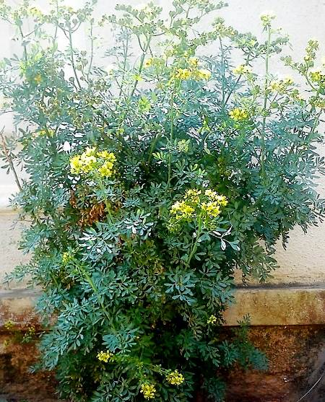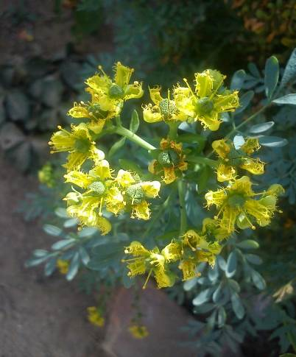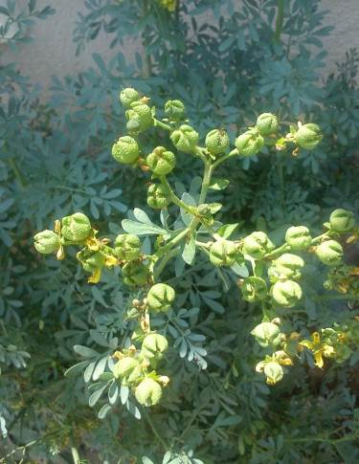

**Fig. 1a: Habit of *Ruta graveolens* L**.

**Fig. 1b: Inflorescence of *R. graveolens* L*.***

**Fig. 1c: Seeds of**

***R. graveolens* L.**

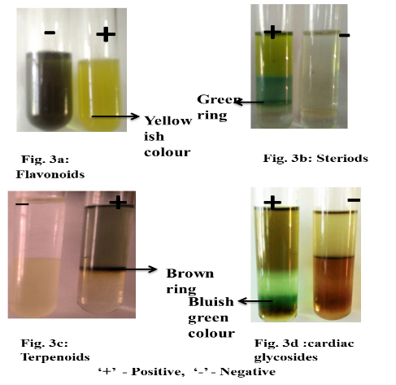

**2d:**

**2c:**

**2b:**

**2a:**

**Fig, 2. Phytochemical tests results for the *R. graveolens* extracts**

**3.3 Evaluation of antioxidant activity:** The antioxidant activity of the sample of *R. graveolens* was evaluated by the total phenolic content, reducing power assay and radical scavenging activities.

**3.3.1 Estimation of total phenolic content:** The total phenolic content of leaves, flowers and seed extracts of *R. graveolens* was determined by Folin-Ciocalteau method with gallic acid as standard. The phenolic concentration of the extract was expressed in microgram of standard gallic acid equivalents per gram of extract (µg GAE/g) (Fig. 3a). The hexane leaf extract contained 45.90 µg GAE/g of total phenolics. The ethanol extract of leaf contained 134.4 µg GAE/g of total phenolics. The aqueous extract of leaf contained 124.34 µg GAE/g of total phenolic content (Fig. 3b). Fresh extract of flower and seeds contained 95.71 µg GAE/g of total phenolics (Fig. 3c). A good co-relation was observed in the aqueous extract of leaf (R2=0.957) and methanol extract of flower and seed (R2=0.964).

**Fig. 3b Total phenolic content in the leaf extracts of *R. graveolens***

**Fig. 3c Total phenolic content in the flower extract of *R. graveolens***

**3.3.2 Estimation of reducing power assay:** The reducing power of leaves, flowers and seed extracts of *R. graveolens*  was determined by the procedure of Yen and Chen (1995) with some modifications. Butylated hydroxyl toluene (BHT) was taken as standard (Fig. 4a). In the ethanol extract of leaves, high reducing power was found which was followed by aqueous and hexane extracts (Fig. 4b). The fresh extract of flowers and seeds reducing power assay was performed using methanol solvent and it was almost equal to that of standard BHT (Fig. 4c).

**Fig. 4a Reducing power of standard butylated hydroxyl toluene (BHT)**

**Fig. 4b Reducing power of leaf extracts of *R. graveolens***

**Fig. 4c Reducing power of flower extract of *R. graveolens***

**3.3.3 Estimation of free radical scavenging activity using DPPH:** The antioxidant activity of *R. graveolens* leaf, flower and seed extracts was determined by 1, 1- diphenyl 2- picrylhydazyl (DPPH) method. The percentage of radical scavenging activity in the leaf extract was ranging from 39.80% to 99.12% µg/mL. The highest percentage of radical scavenging activity was found in the ethanolic extract (94.76% µg/mL) and aqueous extract (89.53% µg/mL) followed by hexane extract (73.71% µg/mL). The percentage of radical scavenging activity in the flower and seed extract was ranging from 85.93% to 94.76% µg/mL. IC50 value of hexane, ethanol and aqueous extracts of leaf were found to be 38.17, 14.63, 30.98 µg/mL respectively (Fig.5a). IC50 value of methanol extract of flowers and seeds are found to be 34.83 µg/mL (Fig. 5b). The percentage of radical scavenging activity and IC50 value of leaf, flower and seed extract was high when compared to the standard ascorbic acid.

**Fig. 5a. IC50 values of leaf extracts of *R. graveolens* L.**

**Fig. 5b. IC50 values of methanolic flower extract of *R. graveolens* L. for radical scavenging activity**

**3.3.4 Characterization of phytochemicals by thin layer chromatography (TLC):** Thin layer chromatography was carried out for ethanol and methanol extracts. The leaf, flower and seed extracts showed the varied colored bands such as blue, brown and green colored bands. Thin layer chromatography profiling of *R. graveolens* L. in n-hexane: ethyl acetate: glacial acetic acid (3:1:0.5) solvent system confirmed the presence of phytochemicals such as phenolic compounds and flavonoids (Fig. 6a). After spraying the reagent, phenolic compounds appeared blue color whereas on exposing to iodine chamber flavonoids developed brown bands.

**TLC for the separation of phenolic compounds:**

The leaf ethanolic extract showed the presence of three phenolic compounds having R*f* values 0.20, 0.25, 0.46 cm. The methanolic extract of flower and seed showed the presence of three phenolic compounds having R*f* values 0.27, 0.36, 0.41cm. After spraying the reagent, phenolic compounds appeared as blue colored bands (Fig. 6a).

**TLC for the separation of flavonoids:**

The methanolic extract of flowers and seeds showed the presence of six flavonoid compounds having R*f* values 0.32, 0.42, 0.51, 0.61, 0.57, 0.61, 0.69 cm. The leaf ethanolic extract showed the presence of five compounds having R*f* values 0.38, 0.48, 0.52, 0.68, 0.74cm. After exposing the TLC plates in iodine chamber flavonoids appeared as brown colored bands (Fig. 6b).

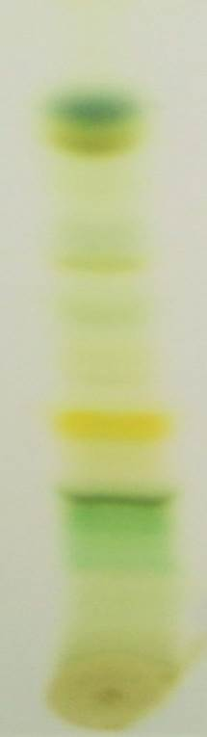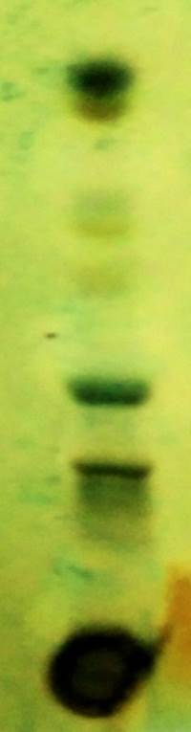

**R*f* 0.95**

**R*f* 0.60**

**R*f* 0.46**

**Before spraying**

**After spraying**

**Ethanol exextract**



**R*f* .36**

**Rf .27**

**R*f* 0.41**

**Before spraying**

**After spraying**

**Methanol eextract**

**Fig. 6a. TLC Characterization of phenolic compounds in solvent extracts**

**4. DISCUSSION**

The genus *Ruta* has been bountifully used in the most ancient systematic records of medical practice of the Mediterranean world. Due to its cultural and medicinal value Ruta has been introduced in various countries of North, Central and South America, China, India, Middle East and South Africa (Miguel, 2003).The active principles are cardiac glycosides, rutin, a flavonoid, terpenoids, essential oil with methyl ketones, alcohols and some other compounds. *R. graveolens* contains approximately 2% of rutin which is the main flavonoid of the plant (Ahmed *et al.,* 2010). Flavonoids, and particularly quercetin derivatives, have received special attention as dietary constituents in the last few years. Rutin exhibits multiple pharmacological activities including antibacterial, anti-tumor, anti-inflammatory, anti-diarrheal, anti-ulcer, anti-mutagenic, myocardial protecting, vasodilator, immunomodulator and hepatoprotective activities (Janbaz *et al.,* 2002).

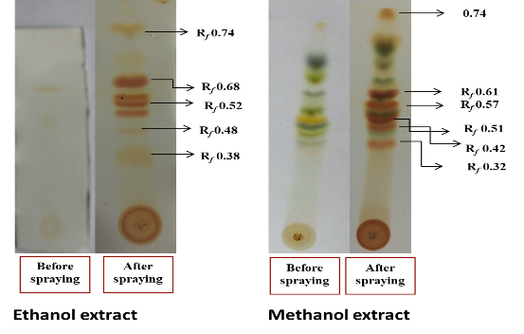

**Fig. 6b. TLC Characterization of flavonoid compounds in solvent extracts**

In the present study *R. graveolens* was collected from the B.R hills region of Chamarajnagar district during December 2015. The hexane, ethanol and methanol extracts were screened for the presence of phytochemicals using standard procedure, which revealed the presence of flavonoids in ethanol, aqueous and methanol extracts, terpenoids in hexane, aqueous and methanol extracts, steroid in hexane and aqueous extracts, glycosides were reported in the ethanol extract. The plant exhibits medicinal properties due to the presence of active principles namely flavonoids, terpenoids, glycosides, steroids, essential oils and some other compounds. These phytochemicals are responsible for treating various ailments and thus they act as anti-microbial, anti-inflammatory, anti-diabetic and anti-cancerous. In the traditional medicine it used to cure eye problems, rheumatism and dermatitis. *Ruta grave*olens L. contains more than 120 compounds of different classes of natural products such as acridone alkaloids, coumarins, essential oils, flavonoids and furoquinolines.

Pandey *et al.* (2011) investigated the phytochemical constituents in the stem part of *R. graveolens* using ethanol, methanol, chloroform and water, which revealed the presence of alkaloids and steroids. From the literature it is clear that some of the phytochemicals like alkaloids, tannins are reported and terpenoids were absent in some cases but in the present investigation terpenoids have been documented in the hexane, aqueous and methanol extracts. This difference in phytochemical constituents is mainly due to the environmental conditions, geographical location and also the solvents used for extraction process. An antioxidant is a substance and when it is present in low concentrations, it gradually delays or prevents oxidation of cell content like proteins, lipids, carbohydrates and DNA. In nature we find many types of naturally occurring antioxidants which differ in their composition, physical and chemical properties, mechanisms and site of action. The use of natural antioxidants from plants does not induce side effects, while synthetic antioxidants were found to have genotoxic effects. Therefore, the investigations of biological activity and chemical composition of medicinal plants as a potential source of natural antioxidants are numerous. In the present study, the hexane leaf extract contained 45.90 µg GAE/g of total phenolics. The ethanol extract of leaf contained 134.4 µg GAE/g of total phenolics. The aqueous extract of leaf contained 124.34 µg GAE/g of total phenolics. The fresh extract of flower and seed contained 95.71 µg GAE/g of total phenolics. A good co-relation was observed in the aqueous extract of leaf (R2= 0.957) and methanol extract of flower and seed (R2= 0.964).

In the present study the Ruta extracts are subjected to the reducing power assay this is based on the principle that a substance which have reduction potential to react with potassium ferricyanide (Fe3+) to form potassium ferrocyanide (Fe2+) then it reacts with ferric chloride to form a ferric ferrous complex which has a maximum absorption at 700 nm (Bhalodia *et al.,* 2011).

Potassium ferricyanide + Ferric chloride Potassium ferrocyanide + Ferrous chloride

In the present study the aqueous extract of leaves exhibited high reducing power which was followed by ethanol and hexane extracts. The fresh extract of flowers and seeds also showed reducing power and it was almost equal to that of standard butylated hydroxyl toluene (BHT) (Fig. 4a).

A rapid, simple and inexpensive method to measure antioxidant potential involves the use of the free radical, 2, 2-Diphenyl-1-picrylhydrazyl (DPPH). DPPH is widely used to test the ability of compounds to act as free radical scavengers or hydrogen donors, and to evaluate antioxidant activity. It has also been used to quantify antioxidants in complex biological systems in recent years. The DPPH method can be used for solid or liquid samples and is not specific to any particular antioxidant component, but applies to the overall antioxidant capacity of the sample. The antioxidant activity was determined by 1, 1- diphenyl 2- picrylhydazyl (DPPH) method for the extracts of *R. graveolens* L high percentage of radical scavenging activity was found in the ethanol and aqueous extracts of leaf for which the IC50 values of 14.63 and 30.98 µg/mL were documented.

Motamed et al*.* (2013) reported the antioxidant potential of *R. graveolens* using DPPH free radical scavenging activity. The IC50 value of the methanol extract in DPPH scavenging was 200.5 µg/mL whicwas acceptable in comparison with BHT (41.8µg/mL). The antioxidant activity of R. graveolens ethanol extract showed a higher DPPH scavenging activity (% inhibition = 59.3%) than hexane extracts (% inhibition = 16.8%) at the same concentration (250 g/mL) (Pavlović et al., 2014). Studies on the phytochemistry of extracts from *Ruta* sp. cultivated in the wild have found the presence of coumarins, phenolic acids, flavonoids, alkaloids, and tannins, among other substances (Gentile et al., 2015; Yu et al., 2021). The antioxidant activity of phenolic compounds is associated with their capability of inactivating reactive radical species. The alcoholic extract of Rue showed the best radical scavenging properties, reaching about 60% anti-radical activity (Molnar et al. 2017). The methanolic and ethanolic extracts of *R. graveolens*, collected in the wild, exhibited significant antioxidant potential (Asgharian et al., 2020; Coimbra et al., 2020). This revealed strong antioxidant activity of *Ruta* species thus the aerial parts of the rue can be recommended for medicine due to the presence of antioxidants and phytochemicals. This difference may be due to the difference in phytochemical constituents present in different species of *Ruta* and also within the species the variation was observed because of the soil and environmental conditions and the area where it was located.

Thin layer chromatography (TLC) is a separation technique for identification of compounds. TLC is used to isolate the principle components that were present in the extracts of plant. The different solvent systems of different polarities were prepared and TLC studies were carried out to select the solvent system capable of showing better resolution. In the present study TLC profiling was carried out for some of the phytochemicals such as phenolic compounds, flavonoids and terpenoids. The ethanolic extract of leaf showed the presence of three phenolic compounds having R*f* values of 0.20, 0.25, 0.46 cm. The methanolic extract of flower and seed showed the presence of three phenolic compounds having R*f* values of 0.27, 0.36, 0.41cm. The methanolic extract of flowers and seeds showed the presence of six flavonoid compounds having R*f* values of 0.32, 0.42, 0.51, 0.57, 0.61and 0.69 cm. The leaf ethanolic extract showed the presence of five compounds having R*f* values 0.38, 0.48, 0.52, 0.68 and 0.74 cm. Benazir *et al.* (2011) studied the separation of secondary metabolites by thin layer chromatography from Ruta saplings collected from Kerala Agricultural University, Vellanikara and Kerala Forest Research Institute in Peechi. The plants were grown in the department nursery under optimal growth conditions. The extracts of root, stem and leaves were prepared by using methanol, ethanol and distilled water. The phenolic compounds were separated using chloroform and methanol (27:0.3) solvent mixture. The colour and R*f* values of these phenols were recorded under visible light after spraying the plates with Folin-Ciocalteu’s reagent and heating at 80°C for 10 min. Phenols and phenolic acids were detected as blue spots. The flavonoid spots were separated using chloroform and methanol (19:1) solvent mixture. The colour and R*f* values of these spots were recorded under ultraviolet (UV 254nm) light and green fluorescent spots indicated the presence of flavonoids (R*f* value - 0.84 cm). Noori et al. (2019) investigated the flavonoid profile of the aerial parts of *R. graveolens* from Iran using 2-dimensional paper and thin-layer chromatography. The following flavonoids, namely quercetin, kaempferol, rutin, apigenin, isorhamnetin, chrysin, vitexin, and myricetin were identified. Phenolic compounds in *R. graveolens*, such as simple coumarins (coumarin, herniarin, umbelliferon, methoxy coumarin, and scopoletin), phenolic acids (vanillic acid, chlorogenic acid, ferulic acid, protocatechuic acid, p-coumaric acid, p-hydroxybenzoic acid, syringic acid, caffeic acid, and gentisic acid) and flavonoids (rutoside) was responsible for its effectiveness (Attia et al., 2018).

Elansary et al. (2020) determined the phenol profile and evaluated the biological activities of *Ruta graveolens* L. The leaf extracts of *Ruta* contained four phenolic acids and two flavonoids such as *p-*coumaric, caffeic, chlorogenic and protocatechuic acids, and high levels of the flavonoids, rutoside and quercetin. Asgharian et al. (2020) identified caffeic acid as the only phenolic acid along with five flavonoids (rutin, quercetin, apigenin, naringenin, and luteolin). In both works rutin was reported as the most abundant phenolic compound. Saeed et al. (2023) detected resorcinol and coumarin as the major phenolic compounds from the ethyl acetate extracts of *R. graveolens* leaves, while, catechol and coumarin were the major phenolic compounds from the ethanol extracts.

The study of phytochemicals and antioxidant indicated *R. graveolens* as a good source of phytochemicals such as phenolic compounds and flavonoids. Further, characterization by TLC has indeed confirmed the presence of the compounds with different R*f* values. Further, identification of the phytochemicals is necessary to unravel the type of phenolic compounds from *Ruta* species collected in the wild.

**DISCLAIMER (ARTIFICIAL INTELLIGENCE)**

Author(s) hereby declare that NO generative AI technologies such as Large Language Models (ChatGPT, COPILOT, etc.) and text-to-image generators have been used during the writing or editing of this manuscript.