CREDIT RISK ECONOMIC PERFORMANCE AND MONETARY POLICY EFFICACY CONTRASTING PREVALENCE OF AN

ARDL MODEL AND A MARKOV SWITCHING REGIME FOR THE CASE OF TUNISIA

**Abstract**

The historical swings between periods of excess credit risk and phase shifts of tranquil periods with relatively easier banking credit conditions stimulating investment up to a certain limit raised the debate of the prevalence of credit risk switching regimes of the type of Markov regime switching models for credit risk exerting a lagged effect on economic performance and drained by monetary policy efficacy breakpoint shifts. From another perspective, it is well documented in the literature that most applied finance models stand as ARDLs autoregressive distributed lag models for auto-regression is a feature displayed by most financial aggregates.

This instance of modeling credit risk is proven to exhibit both patterns although compromisingly contrasting apparently, but with beakpoints in unit root of monetary policy will herald obvious and fathoming key features of recent economic events driven by financial shocks in Tunisia.

The main purpose of the research is to scrutinize the impact of banking sector related effects on economic performance depending on credit to the public sector monetary policy efficacy and economic growth, in order to elucidate the relationship between financial shocks and economic performance and to forecast future short run evolution of economic situation starting from an ARDL model exhibiting the main determinants of credit risk then passing to the diagnostic of a Markov model with jump effect applied to credit risk in a time series. The first model shows a positive auto-correlation of credit risk signaling plausible self sustaining exacerbation, a positive correlation with credit to the public sector as a proportion of GDP, a lagged negative correlation with GDP growth and a negative correlation with monetary policy efficacy. Granger causality

shows that credit risk granger causes GDP growth with a lag of three years. Empirical data and regression results for the case of Tunisia show prevalence of a Markov switching regime for credit risk validating the jump effect hypothesis corresponding with a lag to collapsing of economic performance and heralding a sharp decline in economic performance caused by a phase shift in monetary policy efficacy.

**Keywords:** Credit Risk, Markov Regime Switching, Monetary Policy Efficacy, Economic Performance

# INTRODUCTION

Escalating international and European concern is raised about the necessity of contributing with a financial package to help Tunisia out of its debt crisis.

These concerns are motivated by the prominent role political stability in Tunisia plays in safeguarding regional security and immigration matters that are closely bound to the economic situation of Tunisia facing a debt crisis. These concerns find their roots in the effects of the debt crisis on the borrowing creditworthiness and the credit ranking of Tunisia that help it overcome unemployment and inflation disdain and might trigger events of paramount relevance for regional political and security instability or what we might call the onslaught of a second phase shift of the regional meltdowns of 2011.

The main hindrances that exacerbated the social unrest at that time were mass bankruptcies of enterprises that was due to their inability to borrow from the banking sector with skyrocketed credit risk that picked up to an unprecedented margin in 2008 and ended up with the regional spread political unrests of fall 2011 throughout the Arab world.

1. LITTERATURE REVIEW

In the literature on credit risk the usually adopted Credit Risk composition is about idiosyncratic risk and systemic risk. We assume with reference to Frei (2017) that Credit Risk comprises three main components.

-The point in time component which involves subjection to cyclicality and autocorrelation

-The stable component or through the cycle component which involves innovation due to industrial specificities

-The uncertainty component which is exclusively tributary to uncertainty and is neither subject to cyclicality nor to industry specificities and is distinguished by asymptotic un-correlation and asymptotic neglectibility of innovations.

In credit risk modeling this specific feature as long as it is subjected to uncertainty comprises the Markov switching that is discussed under the scope of this article.

This composition displays the feature of disentangling the aspects depict able through prudential restrictions from those subject able to probabilistic assessments and those retraceable with business cycle related analyses,

As a matter of fact, uncertainty should be subjected to probabilistic assessments or Markov switching type modeling and testing whereas through the cycle aspects should be targeted through prudential restrictions and point in time risk can be traced back by comparing its pattern to that of OG within the framework of business cycle analyses.

* 1. **Credit risk expression and descriptive statistics**

The risk parameters of the banking sector, in this case related to credit, should not be calculated in ratios but in sensitivities. For example, it is virtually impossible to trace the sources of non-recovery of loans due to the staggering of maturities. Credits produced may well be subject to non-recovery at t+1 or t+2 or even t+5, depending on the maturity and term of the credit. So, it makes no sense to measure credit risk, for example, by a ratio such as unrecovered loans/credit production. This is because there is no direct relationship between unrecovered loans on a given date and loan production on the same date, since unrecovered loans are the result of risks incurred at earlier dates. But the increase in the ratio of unrecovered loans to loan production is inversely correlated with credit risk. In other words, an upward trend in unrecovered loans signals to bank management an a priori ex-ante rising credit risk, which they react to by contracting the volume of loan production in the same year, resulting in a decrease in ex-post loan production. So, to put it briefly, when the ratio of unrecovered loans to loan production at time t increases, the credit risk decreases, contrary to what one might think. This is stated for the new variables, i.e. new unrecovered loans and new loan production. However, for cumulative variables, the use of the ratio in itself does not allow us to detect diminishing returns to scale, for example.

In other words, what appears to be a bad sign of an increase in unrecovered credit could turn out to be the result of a smaller marginal increase and be interpreted as a good sign. What we need to do for cumulative aggregates is to use elasticities to detect the dynamism of impacts and deduce

the notion of upward or downward risk variability. The choice of the expression of credit risk: The risk parameters of the banking sector, in this case related to credit, should not be calculated in ratios but in elasticities. In fact, because of the spreading of maturities, it is for example almost impossible to trace the sources of non-recovery of credits and henceforth make use of the expression NPL/CP. Indeed, in this case, the credits produced may very well be subject to non- recovery at t+1 or t+2 or even t+5 depending on the maturity dates and the term of the credit.

Thus, it is absurd to measure the credit risk, for example, by a ratio such as unrecovered credits/credit production. This is because there is no direct relationship between uncollected credits on a date and credit production on the same date since uncollected credits result from a risk incurred at earlier dates. But the increase in the ratio of unrecovered loans to loan production is inversely correlated to the credit risk. In other words, an upward trend in unrecovered loans signals to bank management an ex ante credit risk that is on the rise. This is why the banks' management reacts with a contraction in the volume of credit production in the same year, which results in a decrease in ex-post credit production. So to be brief, when the ratio of uncollected loans to loan production at time t increases, the credit risk decreases, contrary to what one might think. This is stated for the new variables, i.e. the new unrecovered credits and the new credit production.

* 1. **Descriptive statistics: A brief history of credit risk in Tunisia**

**Figure 1.a: Credit risk as a sensitivity of new credit to the private sector to money market rates**

**Credit risk(2004-2010)**

40

30

20

10

0

-10

-20

Credit risk

2004 2005 2006 2007 2008 2009 2010

**Author’s computations Souce : Reuters Excell Datastream**

**Figure 1.b: Credit risk as a sensitivity of new credit to the private sector to money market rates**

**Credit risk(2010-201G)**

0,02

0,015

0,01

0,005

0

-0,005

Credit risk

**Author’s computations Souce : Reuters Excell Datastream**

2010

2011

2012

2013

2014

2015

2016

2017

2018

The two figures 1.a and 1.b show a pike in credit risk in 2008 and a lot of adjustments since end of 2010 pertaining to prudential matters such as hindrances to resilience from financial instability depicted from 2010 to 2013 then benefits of prudential intervention depicted from 2013 to 2016 and problems pertaining to the banking system about circumvention of prudential restrictions heralding from 2016 on.

Usually there is restrictive monetary policy in austerity where monetary policy fights inflation by increases in MMR. But there are cases of Expansionary policy in austerity. When monetary policy is restrictive MMR tends to increase relatively more than NCPS as economic policy is assumed to fight inflation. It follows that NCPS does not increase proportionately due to the economic slowdown which makes e(NCPS/MMR) decrease to tend to zero. Therefore the pike in credit risk occurs when monetary policy is expansionary within the framework of austerity. This is assumed to have occurred at end 2021 13.4 years after 2008 and verifies the jump up hypothesis of the Markov switch regime. As a matter of fact, this coincided with the Invest 2020 government package of incitement to investment that called the urge to slowdown the increase in MMR in a period of austerity where MMR is assumed to increase and has led to a relatively more important boost in NCPS compared to the increase in MMR which led to a tremendous increase in credit risk and the second pike of credit risk in 2021.

The 2020 investment healing package further deteriorated the willingness of the banking system to bear excessive risk and exacerbated after one year credit risk in a noticeable way which verified the Markov switch period of excessive credit risk and resulted in a deteriorating situation for SMEs

in terms of borrowing capabilities which is leading to massive defaults of borrowing due to excessive borrowing rates and will soon end up in a several economic slowdown which is on the way until the forecasted repercussions of the regime switch in credit risk herald within the time span of one more year until borrowing conditions for SMEs and the ensuing joblessness and economic slowdown will herald in a fathomable way and result in riots and socioeconomic problems comparable to the turbulence that occurred at the outburst of the turbulence period of end 2010. In all references of the relevant literature the relationship between financial stability and economic performance as well as corporations’ earnings and economic performance are stylized and valid for all economies. There is no single instance exhibiting differences among countries. This is mainly due to the fact that the mechanisms channeling the impact effect of financial matters to economic performance as expressed by the super-multiplier effect are the same and result in correlations that are valid for all economies.

**Figure 2. Cyclicality of default rates**

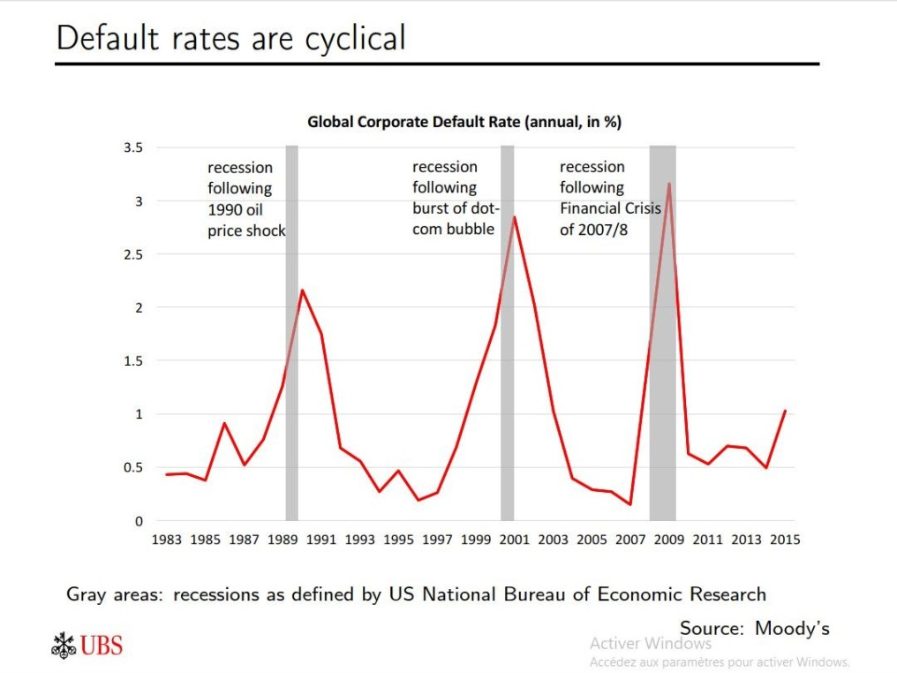

Source: Moody’s database

The figure 2 is plotting default rates that are at their maximum during recessions.

Credit risk is at its maximum during recessions because of the increase in the likelihood of non- repayment of loan as investments perform bad in terms of profitability. Credit risk is assessed in terms of risk premiums that encompass the historical effect credit performance exerts on the banking assessment board of credit worthiness. Past excesses in credit risk signal the predisposition of further likelihood of systemic risk that makes expectations with respect to credit worthiness even worse. This makes credit risk positively auto-correlated. Because of free riding which is an information asymmetry Mishkin 1998 the bank has the tendency not to invest money in credit screening based on project assessment but rather collects affordable historical data that are already available to save money. Therefore the historical performance of credit worthiness will lead to a positive bias as in order for credit assessment to change sign credit screening should be deployed disrespectfully of past performance if ever there are reasons for the bank to believe the credit ought to perform well and its rating should shift accordingly. The expression of monetary policy efficacy or elasticity of ΔOG/MMR expresses monetary policy efficacy as the celerity of output stabilization following a stimulation in money market rates. As output gap stabilizes fasts or approaches zero fast monetary policy efficacy improves. This means that during periods of recession output stabilization occurs at a slow pace. Indeed, during recessions credit risk is at its highest because credit to the private sector is at its slowest production. As credit produced decreases there is a cost push on borrowing rates which explodes additional credit produced and hence incremental increases in credit to the private sector in response to money market rate MMR additional increase. This indeed increases credit risk. Hence during recessions monetary policy efficacy is at its lowest and credit risk is at its highest. This can also be interpreted as an increase in the probability of non-performing loans as during recessions sales are at their lowest and corporations cannot repay their loans. So, for increases in probability of default corresponds increases in credit risk. As monetary policy efficacy improves given that it is transmitted through the credit transmission mechanism the improvement is translated into an accelerated output gap stabilization which requires an acceleration of credit production. This indeed relaxes the average borrowing rate thereby decelerating additional increases in credit production. For an initial increase in money market rate credit to the private sector is decelerated which turns credit risk to

a decrease as credit risk is defined as the sensitivity of credit to the private sector to money market rates changes.

* 1. **The relationship between financial stability and economic performance:**

**Figure 3: Financial stability and economic performance**

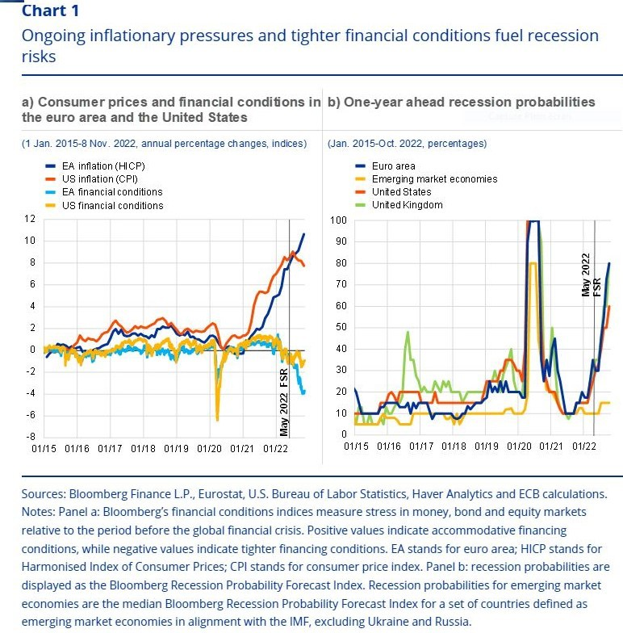

**Source: Dhal Kumar and Ansari J (2011) Financial stability Economic growth inflation and monetary policy linkages**

Credit risk is tremendously compromising for financial stability.

As a matter of fact, it triggers either the risk of non-performing loans or excessive risk premiums that might result in non-performing projects rather than loans when the cost of capital is excessively high the project owner might fail to manage accurately his expenses and looses profitability in such a way that the expected economic benefit from the projects is harmed.

It might also reveal compromising for liquidity risk as overall tolerance to risk from the financial system is limited thus excess credit risk decreases maneuvering liquidity risk and is binding for bearing it up to a certain point.

In many circumstances, credit risk through its effects on the probability of non performing loans, non performing projects and liquidity risk might hinder the financial system stability through increasing the likelihood of outburst of financial meltdowns or merely result in a bank run due to excessive non performing loans or deteriorated profitability of projects that might destabilize the financial system through the financial accelerator effect. Credit risk is conversely related in a synequanone relation and dual causal relationship to financial stability. When credit risk increases financial stability decreases with increased vulnerability and when credit risk decreases financial stability improves through decreased vulnerability. There is scanty theoretical literature and evidence on the relationship between credit risk and economic performance except concerning the argument of increased risk premiums that result in increasing the repayment burden to the borrower and hampers economic projects profitability. But the literature on the relationship between financial stability and economic performance is abundant. At a first period financial development used to be measured in terms of size depth openness and competitiveness of financial institutions. Financial stability did not receive much attention. But afterwards, Kindleberger (1978) and Minsky (1991) put forward a viewpoint about financial instability that indicated a negative influence of financial instability on economic growth. Kindleberger argued that the loss of confidence and trust on institutions could fuel disintermediation and institutional closures and when confidence falls investment profitability falls too. A sound financial system instills confidence among savers and investors sothat resources can be effectively mobilized to increase productivity in the economy. According to Dhal Kumar and Ansari (2011): Financial stability can help monetary policy in terms of enhanced response of growth and inflation to interest rates action. Also financial stability with enhanced output persistence and lower inflation persistence McKinnon (1973) recognized the role of the financial sector in the mobilization of saving and accentuation of capital accumulation thereby promoting economic growth Robinson (1952) argued that financial sector development follows economic growth. The third view maintains a simultaneous causal relationship between financial development and economic growth as shown in figure 3 that is as argued earlier valid for all economies not exclusively EU economies. Patrick (1966) found that the causal relationship between the two was not stable over the development process, when economic growth occurs the demand following response dominates the supply leading response. But this sequential process was not genuine across the industries or the sectors.

* 1. **Relationship between earning expectations for corporations, Real GDP growth, unemployment and inflation:**

**Figure 4: Corporations earnings and economic performance**

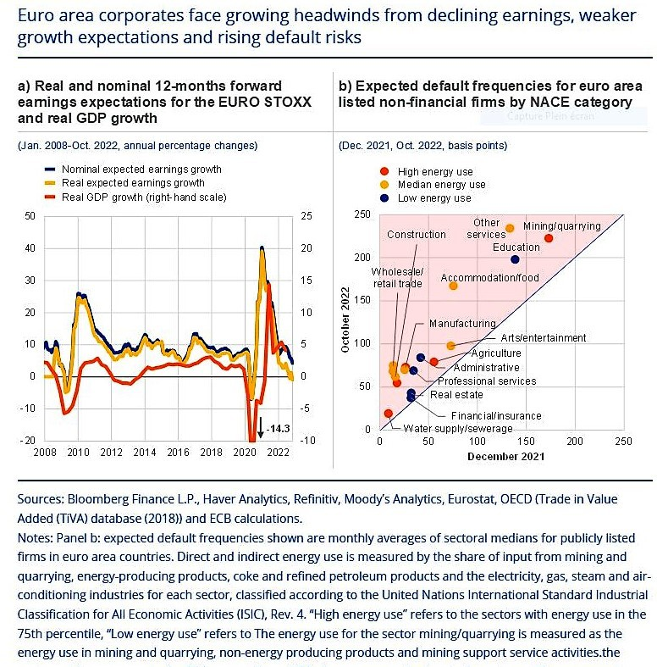

**Souce : Ball, Sadka and Sadka (2009) Aggregate earnings and asset prices**

Alongside with its effects on economic performance through its effects on financial stability credit risk affects economic performance through its effects on earnings expectations of corporations and by a way of consequence as long as earning expectations affect economic performance it affects twofold economic growth firstly through its effects on financial stability that affect positively economic growth and secondly through its effects on earning expectations of corporations that affects positively economic performance. Yet it is quite obvious that credit risk affects negatively earning expectations of corporations as it exacerbates the cost of capital and availability of external borrowing alongside with its effects on investor risk appetite that is triggered upwards and exacerbates imprudence and likelihood of failure of economic projects and hence a slowdown in stock market performance and a decrease in share prices and earnings expectations as well. Not only do aggregate earnings of corporations affect economic performance but they also display a predictive power for economic performance. This shows how far the relationship intertwined is. The correlation is twofold.

In the relevant literature, we find arguments that economic performance does affect earnings of corporations. But only a few articles show that earnings of corporations play an informativeness role on economic performance. Such studies disaggregate earnings and show the predictive power of each item of earnings. In this respect Lipe (1986) suggested that earnings disaggregation have incremental explanatory power for economic growth. Harvey (1989) suggest that aggregate earnings of companies associate positively with economic growth. Ball, Sadka and Sadka (2009) state that earnings and return associate with industrial production change, real GDP growth, unemployment and national inflation. As stated earlier credit risk and corporations earnings are intertwined together with non performing loans. This explains the effect of credit risk on inflation and unemployment. Hence credit risk jumps can result in pikes and troughs in unemployment and inflation which might result in socioeconomic unrest and thereby exhibit overlapping historical patterns in economic performance in accordance with jumps in credit risk and generally the situation of the banking system stability. This indeed constitutes the scope of this article and shows the basic idea lying behind the empirical results. As shown in figure 4 expected earnings exhibit notorious similarity with real GDP growth in shape. Therefore, credit risk which is conversable to expected earnings moves contrariwise to real GDP growth. This is in accordance with theoretical predilections and expected assertions according to which credit risk should behave contrariwise to economic performance. This finding is anyway corroborated by the super-multiplier theory discussed earlier that argues that credit risk and any source of financial instability results in economic performance slowdown.

# CREDIT RISK AND CREDIT TO THE PUBLIC SECTOR CROWDING OUT OR IN

Credit to the public sector offered by the banking sector implies two simultaneous effects one income effect and one substitution effect. The income effect, Credit to the public sector evicts credit to the private sector by ceasing a vast proportion of liquidity that would have been affordable to private borrowing thereby rendering non performing loans of the private sectors excessively compromising for credit risk incurred by the bank as there is risk of draining out of liquidity. Therefore the effect of increases in credit afforded to the public sector evicts or crowds

out credit affordable to the private sector and its effect on credit risk is positive in other words when banks borrow more to the public sector credit risk increases. As long as government assets are low risk low return assets and that banks strive through a search for yield for more profitability, as credit to the public sector increases banks will try to compensate themselves from the shortage in profitability per unit of credit offered by increasing the risk premiums for a certain level of risk incurred by the private sector. As private borrowers tolerance to cost of borrowing is limited therefore credit risk will decrease as part of risk premiums corresponds indeed to the credit screening expressing the risk incurred by the bank. The bank exerts a cost push on borrowing cost and priate borrowers react by a demand pull for risky projects. Therefore the effect on credit risk is negative increases in credit to the public sector will have a tendency to slow down credit risk. The total effect is the aggregation of the income effect and the substitution effect. Its final outcome on credit risk will depends on whether the income effect outweighs the substitution effect or the other way round.

# CREDIT RISK, FINANCIAL INSTABILITY AND THE SUPER- MULTIPLIER EFFECT

The super-multiplier theory first advocated by Samuelson 1970 argues for a deteriorated economic performance for unmitigated financial instability what indeed occurs for high credit risk. Figure 1 shows a pike for credit risk in the jump effect episode which involves high financial instability and economic performance excessive slowdown that heralding after à period of a couple of years the time corporations fall of external borrowing and go bankrupt. This pervasive bankruptcy affects negatively output joblessness and results in economic slowdown and social unrest with respect to excess joblessness. Besides excess credit risk during pikes is associated with slow investor risk appetite. Because investor risk appetite is measured as the inverse of the principal component of the stock index it is associated with high stock market volatility as the tre ndof the stock index is not steep. Therefore by the super-multiplier effect that translates high volatility of stock market sector by slowdown in economic performance low investor risk appetite results in economic performance slowdown.

# LITERATURE REVIEW ON MARKOV SWITCHING REGIMES FOR CREDIT RISK

A vast array of literature documents accurately the Brownian and jump effects of Markov switching regimes for credit risk and equity markets. One main feature of key salient instruments is that they are subject to a brownian motion process or a jump process like credit risk as stated in Tak Kuen Siu (2010) where he discussed a Markov Regime Switching Marked Point Process for short rate analysis with credit risk where he emphasized that it is of commensurate importance to take into account jumping processes such as Markov switching regime processes because their adverse implications herald unexpectedly. According to Tak Kuen Siu (2010) « Some information items such as surprise information and extraordinary market events may have large economic impact on short rates and cause jumps ». He reiterated that : « Short rate models based on Brownian information flows may not be appropriate to describe large movements. Jump diffusion processes or related processes incorporate large jumps such as Markov switching regimes ». They noticed that the intensity of marked point process is q bounded process and is modulated by two observable factors one is an economic factor described by q diffusion process undone is described by a Markov chain. As far as our subject matter is concerned Through analogy credit risk is described by an economic financial diffusion process modeling the risk premium factor or the credit risk factor Implicit by e NCPS/MMR which corresponds to the economic fundamentals which are under the scope of our model the investor risk appetite the monetary policy efficacy and the lag of credit risk as well as the crowding out effect and one factor described by a Markov chain heralding the jump effect manifesting itself in transition periods which is under the scope of this study and is intended to predict future regime switches in credit risk to better explain the behavior of the credit risk phenomenon through time.

# RESEARCH METHODOLOGY

The ARDL methodology was first introduced by Perasan and Shin (2001). The specification is as follows :

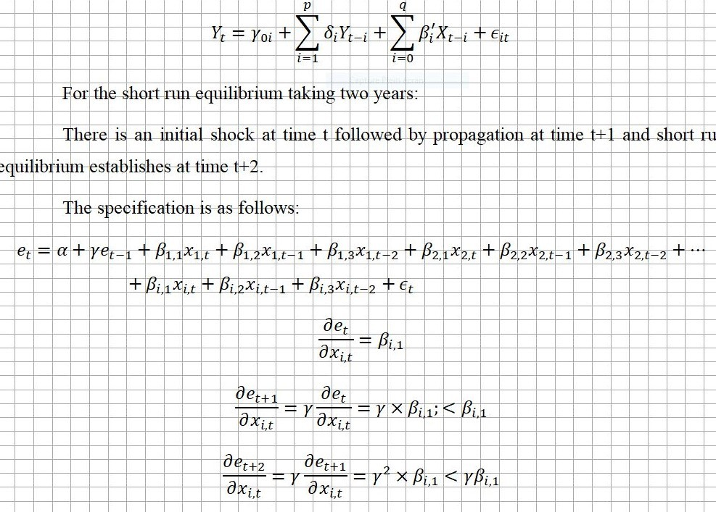

The Markov switch modeling is similar to the one adopted in the jump diffusion process in Tak Kuen Siu (2010). The hypothesis of the prevalence of a Markov switching regime is seemingly likely because monetary policy efficacy unit root tests showed the existence of a breakpoint unit root and that monetary policy efficacy affects tremendously credit risk as the monetary policy conducting relies on the credit channel of transmission mechanism. Indeed, the credit sector in Tunisia accounts for 80 percent of the financial system meaning that the credit channels the main locomotive for Monetary policy conduct especially when such issues as credit risk are dealt with like in this article. But it is noteworthy to state nevertheless that since 2021 the central bank has been relying on an objective of inflation targeting which steps side from a prominent role of the credit channel of transmission mechanism.

# EMPIRICAL RESULTS OF THE ARDL

Data are collected on the Tunisian economy and banking sector for the period spanning from 1980 to 2019. The explained and explanatory variables of the model ARDL are Credit risk or elasticity of NCPS/MMR, Credit to the public sector to GDP ratio, Monetary policy efficacy or elasticity of ΔOG/MMR, GDP growth and their respective lags. Credit risk is positively and significantly auto-

correlated which means that jump effects would be exacerbated tremendously due to the fact that an initial surprise increase would be followed by subsequent increases until the phase shifts or the regime switches. Credit risk adjusts instantaneously to investor risk appetite what might herald a certain ability of the banking sector to grasp investor credit worthiness accurately. It does so also with credit to the public sector due to the relatively high solvency of the public sector although public borrowing from the banking sector is a burden to the banking sector that falls short of liquidity as a consequence. Contrariwise, for monetary policy efficacy all lags are significant meaning that the initial exogenous shock as well as the propagation and equilibrium are significantly correlated to credit risk.

This is essentially due to business cycle dynamics. As a matter of fact, credit to the private sector and investor risk appetite are correlated significantly to the business cycle that explain accurately the dynamics in lags of independent variables of the short run ARDL. Although credit to the public sector as a proportion to GDP is significantly correlated to Credit risk it is insignificant in explaining the regime switching contrariwise to monetary policy efficacy and investor risk appetite. During the regime with skyrocketing credit risk New credit to the private sector is very sensitive to MMR variations. Therefore, risk premiums are very high which means that indeed no additional credit is added and stabilization of output does not occur. By a way of consequence monetary policy efficacy as assessed through the speed of stabilization of output is very low. Contrariwise during the regime with low values of credit risk NCPS is not very sensitive to variations in MMR therefore risk premiums are low and credit demand flourishes which speeds up adjustment of output. Therefore credit risk slowdown is associated with improvement in monetary policy efficacy. In addition, credit risk skyrocketing by slowing down credit supply and demand leads to massive layoffs and bankruptcy and therefore increases in joblessness which might lead to riots further exacerbating the political situation and might lead to political trouble. In definitive, paramount increases in credit risk lead simultaneously to deterioration of monetary policy efficacy and massive riots exacerbating the political situation and eventually leading to a regime destabilization like the Markov model type indicates a regime switching pattern.

**Table 1: Regression results of the ARDL**

|  |  |  |
| --- | --- | --- |
|  | **R2 =0.9957** | **F stat =0.00213** |
| **Variable** | **Coefficient** | **P value** |
| **CREDITRISK(-1)** | **1.213473** | **0.0025** |
| **MONETPOLEFFI** | **-0.003271** | **0.0214** |
| **MONETPOLEFFI(-1)** | **-0.01657** | **0.0002** |
| **MONETPOLEFFI(-2)** | **0.002334** | **0.0729** |
| **CRPUB/GDP** | **1.063189** | **0.0212** |
| **CRPUB/GDP(-1)** | **-0.96616** | **0.0187** |
| **GDPGROWTH** | **0.599785** | **0.1734** |
| **GDPGROWTH(-1)** | **0.184503** | **0.5313** |
| **GDPGROWTH(-2)** | **-0.696403** | **0.0463** |
| **C** | **-8.02785** | **0.3572** |

**Source Output Eviews**

When monetary policy efficacy improves output gap widens. This means that actual output is farther from potential output. Business are having a boom in sales because of expansionary phase of the business cycle or a bust because recession. Hence credit risk which is measured in terms of sensitivity of credit production to the private sector to MMR which is the willingness of the banking sector to bear excessive risk is at its lowest as they are aware that the boom in sales during expansion is transitory and that the bust is overestimating loss of cash inflows but anyway the rhythm of potential output performance is too gradually and slowly improving. Thus the result is a decrease the willingness of the banking sector to bear excessive risk. As the credit risk fathomed from the banking intermediaries is decreasing due to lower credit production they are going to operate cost push by a search for yield motivation. Therefore risk premiums are going to decrease and by a way of consequence entrepreneurs will find it easy to demand credit and their probability not to default is going to decrease as their outstanding debt is going to cost less in interest payments. Therefore credit risk is going to decrease provided new credit screening is implemented accurately. For GDP growth increases the coefficients are insignificant in t and t-1 but negative and significant for t-2 which shows that either GDP growth affects negatively credit risk or credit risk affects negatively GDP growth depending of the sense of causality. We run for that purpose a

Granger causality test and found out as will be shown later that indeed credit risk Granger causes in three years time span GDP growth. Credit to the public sector offered by the banking sector implies two simultaneous effects one income effect and one substitution effect. The income effect, Credit to the public sector evicts credit to the private sector by ceasing a vast proportion of liquidity that would have been affordable to private borrowing thereby rendering non performing loans of the private sectors excessively compromising for credit risk incurred by the bank as there is risk of draining out of liquidity. Therefore the effect of increases in credit afforded to the public sector evicts or crowds out credit affordable to the private sector and its effect on credit risk is positive in other words when banks borrow more to the public sector credit risk increases. As long as government assets are low risk low return assets and that banks strive through a search for yield for more profitability, as credit to the public sector increases banks will try to compensate themselves from the shortage in profitability per unit of credit offered by increasing the risk premiums for a certain level of risk incurred by the private sector. As private borrowers tolerance to cost of borrowing is limited therefore credit risk will decrease as part of risk premiums corresponds indeed to the credit screening expressing the risk incurred by the bank. The bank exerts a cost push on borrowing cost and priate borrowers react by a demand pull for risky projects. Therefore as the effect of the ratio of credit to the public sector to GDP on credit risk is negative at t-1 and positive at t, the substitution effect outweighs the income effect at t-1 and the income effect outweighs the substitution effect at t.

# EMPIRICAL RESULTS OF THE REGIME SWITCH

|  |  |
| --- | --- |
| **Constant transition probabilities** |  |
| **Regime1** | **Regime2** |
| **0.471145** | **0.52885** |
| **0.074330** | **0.925670** |
| **Constant expected durations** |  |
| **1.8908 years** | **13.4535 years** |

**Source Output Eviews**

The expected duration between the two regimes accounting for the time span between the first pike in credit risk in 2008 whose consequences heralded in end 2010 and an expected second pike

would be 13.4535 years which means that around the end of 2024 symptoms of severe economic performance slowdown and socioeconomic unrest would be expected to herald till the hypothesis of a regime switch explaining a two regime Markov switch for credit risk and economic performance is validated. The duration of the pike in transition is expected to be 1.89 years during which credit risk would be in first regime heralding forthcoming socioeconomic unrest. The probability of transition from regime one with jump to regime 2 with steady low credit risk is very significant whereas the probability of transition from regime 2 to regime 1 is expected to be noon significant which means that regime switches of financial and socioeconomic distress are not ascertained but when they happen the return to the steady state is ascertained. The transition probabilities found empirically validate the hypothesis of a persistent hypothesis of a first tranquil regime and a jump effect highly turbulent regime with a severe pike like the one in 2008 whose excessive negative consequences for economic performance and socioeconomic unrest have shown up with a lag of three years round end 2010 at the onslaught of regional MENA economic and sociopolitical meltdowns.

**Granger causality**

Empirical results of Granger causality

|  |  |
| --- | --- |
| **Number of lags=3** |  |
| **Null hypothesis** | **Prob** |
| **GDPGROWTH does not granger cause**  **CREDIT RISK** | **0.1612** |
| **CREDIT RISK does not Granger cause**  **GDPGROWTH** | **0.0786** |

As prob is inferior to 0.05 we reject the null for causality between CREDIT RISK and GDPGROWTH. Therefore credit risk granger causes GDP growth after a three year lag which means that as credit risk pikes in accordance with the regime switch, just three years afterwards, economic performance will observe a sharp decline that justifies the hypothesized second wave of economic and social unrest at the aftermath of the observed sharp decline of economic performance and the social unrest of the 2011 and that presumably would be followed according to the transition computed with the Markov switch at the end of 2024 after 13 years and a half plus 3 years from 2008.

# CONCLUSIONS

Credit risk expressing a financial shock follows a Markov switching regime with jump effects and herald an economic unrest likely to result in social unrest similar to those of winter 2011 around end of 2024 pertaining to social response to excess inflation and unemployment. The empirical findings validate the basic idea of the article according to which financial shocks affect economic performance and when they manifest through jump effects they impact economic performance inflation and unemployment in a fashion that draws a wedge between banking stability and socioeconomic situation. The expected duration between the two regimes accounting for the time span between the first pike in credit risk in 2008 whose consequences heralded in end 2010 and an expected second pike would be 13.45 years which means that around the end of 2024 symptoms of severe economic performance slowdown and socioeconomic unrest would be expected to herald till the hypothesis of a regime switch explaining a two regime Markov switch for credit risk and economic performance is validated. Credit risk is described by an economic financial diffusion process modeling the risk premium factor or the credit risk factor Implicit by e NCPS/MMR which corresponds to the economic fundamentals which are under the scope of our model the investor risk appetite the monetary policy efficacy and the lag of credit risk as well as the crowding out effect and one factor described by a Markov chain heralding the jump effect manifesting itself in transition periods which is under the scope of this study and is intended to predict future regime switches in credit risk to better explain the behavior of the credit risk phenomenon through time. The first pike in credit risk in 2008 whose consequences heralded in end 2010 and an expected second pike would be 13.4535 years which means that around the end of 2024 symptoms of severe economic performance slowdown and socioeconomic unrest would be expected to herald till the hypothesis of a regime switch explaining a two regime Markov switch for credit risk and economic performance is validated. The duration of the pike in transition is expected to be 1.89 years during which credit risk would be in first regime heralding forthcoming socioeconomic unrest. The probability of transition from regime one with jump to regime 2 with steady low credit risk is very significant whereas the probability of transition from regime 2 to regime 1 is expected to be noon significant which means that regime switches of financial and socioeconomic distress are not ascertained but when they happen the return to the steady state is ascertained.

REFERENCES

1. Cristopher Frei (2017) Modeling credit risk and loan portfolios in the presence of autocorrelation UBS university of Alberta
2. Kindleberger (1978) Manias Panics and crashes A history of financial crises Mc Millan London
3. Minsky (1991) Financial crises Systemic or idiosyncratic ? Working paper Hypman P Minsky archive 244
4. Dhal Kumar and Ansari J (2011) Financial stability Economic growth inflation and monetary policy linkages in India An empirical reflexion Reserve bank of India occasional reflexions vol 32 N3 2011
5. McKinnon R (1973) Money and capital in economic development, The brooking institute Washington DC
6. Robinson J (1952) The generalization of the general theory in the rate of interest and other essays 2nd edition McMillan London
7. Patrick H T (1966) Financial development and economic growth in underdeveloped countries. Economic development and cultural change 14, 174-189
8. Ball, Sadka and Sadka (2009) Aggregate earnings and asset prices, Columbia Business School research paper
9. Tak Kuen Siu (2010) On Risk minimizing portfolios under a Markovian regime switching black Sckoles economy Annals of operations research
10. Pesaran, Shin and Smith (2001) Bounds testing approaches to the analysis of level relationships Journal of applied econometrics 16, 289-326

DISCLOSURE OF CONFLICT

The author(s) declare that they have no conflicts of interest.

**Appendix:**

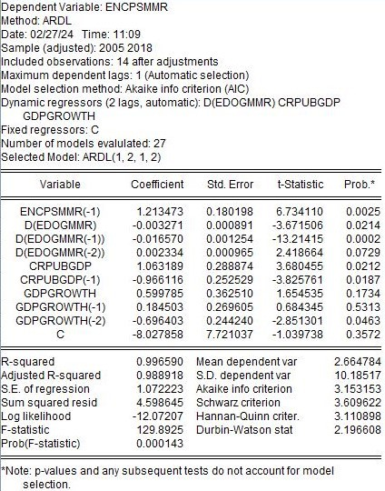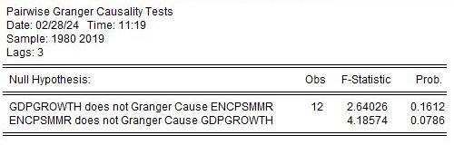**Tables of Results:**

